Jay Mills

Academic and Employability Assignment

Contents
Component 1 2
Presentation 2
Skills Evaluation 3
Note Taking 3
Independent Learning 4
Self-Motivation 4
Time Management 4
Generic & Transferable Skills 5
Personality and Careers Quizzes 6
Action Plan 8
Application, Time Management and Self-Organisation 9
Conclusion and Evaluation 12
Component 2 12
Looking After Your Data 12
Disaster Recovery 14
Equipment Failures 14
Malware and Ransomware 15
Building Damages 16
Fires 17
Floods 18
Health Crises 19
Evaluation 20
Ransomware 20
Bibliography 21

Component 1

Presentation
The presentation overall was good, as it included all necessary detail that was required, and it was also light-hearted enough as to make it not too formal for a presentation about myself. However, as I do not like talking or writing about myself in any way it becomes difficult to add a lot revolving around me and instead became more about the things around me unless it was a point that I generally wanted to talk about and liked writing about, such as my ‘in 5-10 years slide. As this was the case, I had the thought that I might be able to write a minimal amount, so that I could just say my thoughts as they came up in the presentation, but also so that I simply didn’t have to write much about myself to helpfully deal with that.
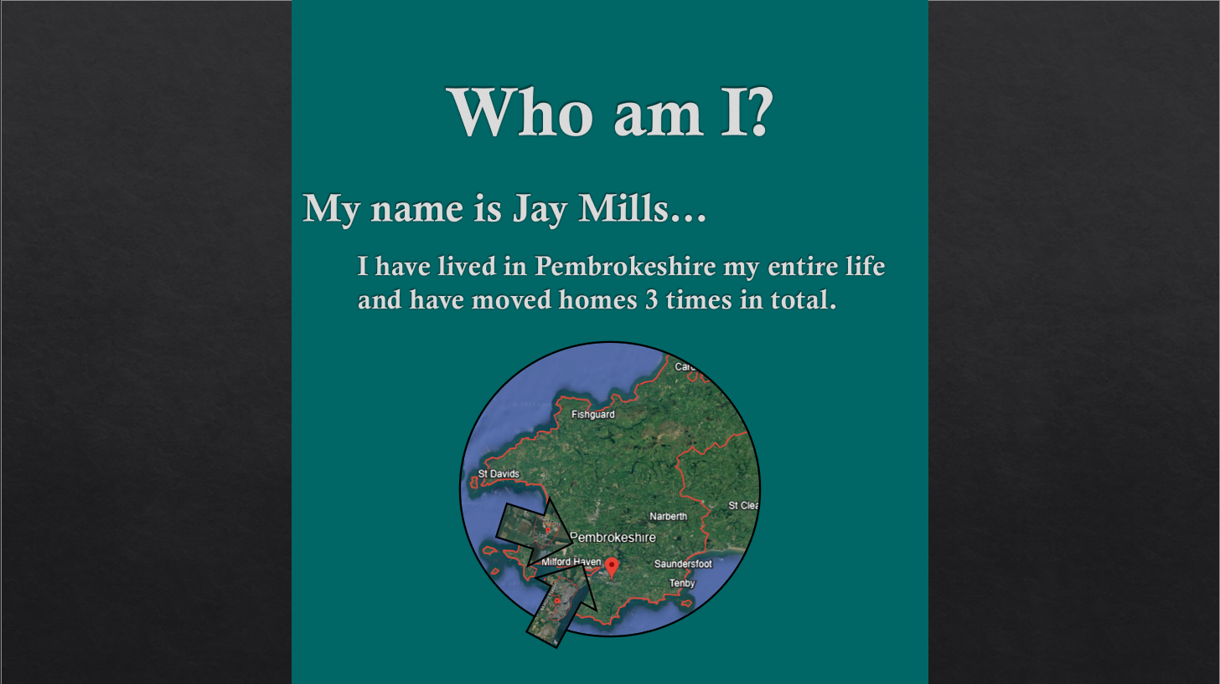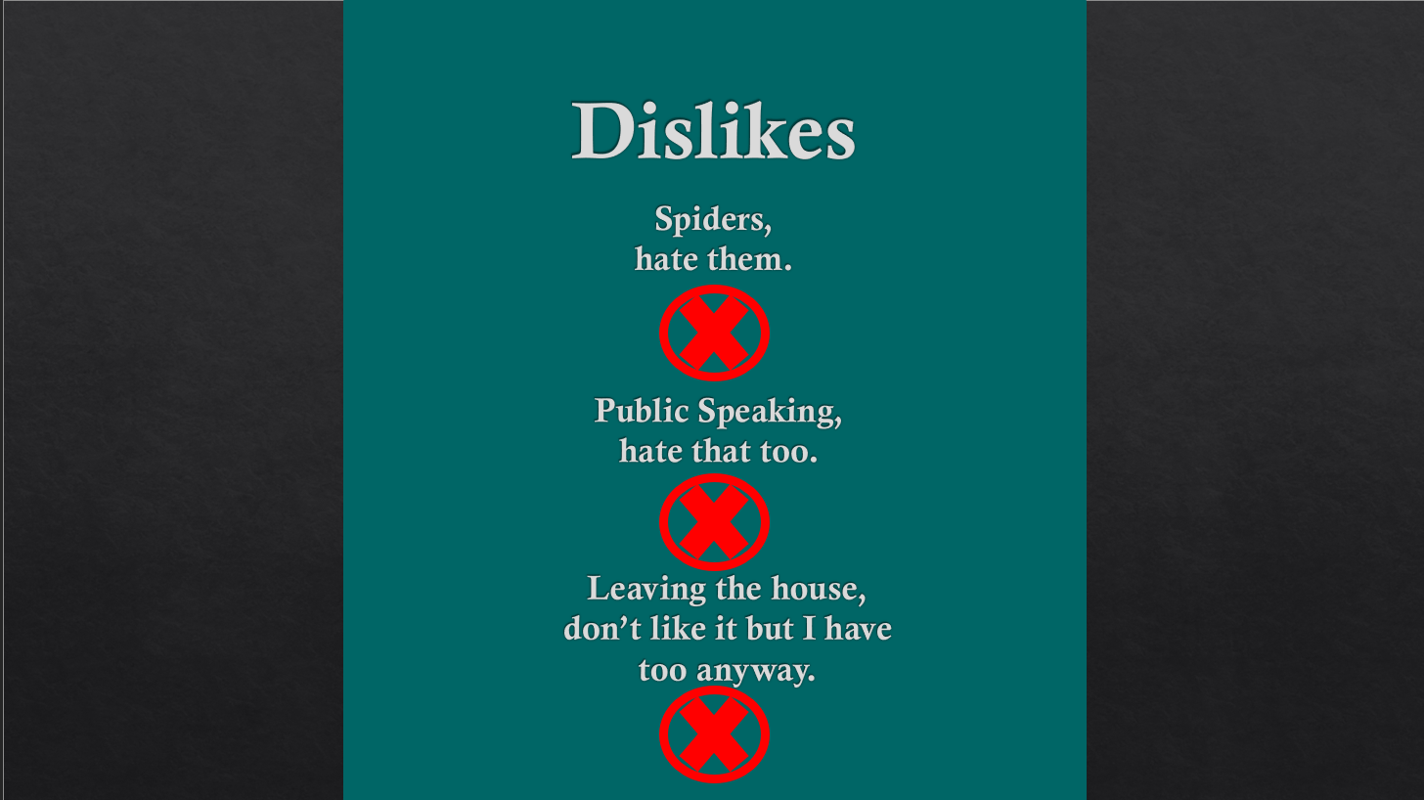
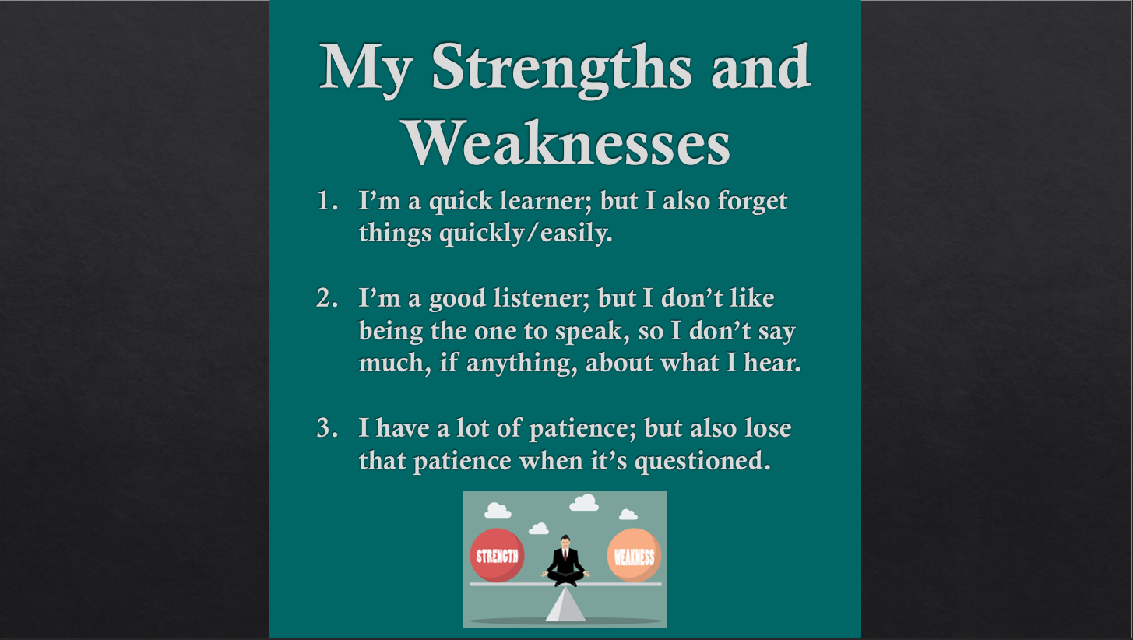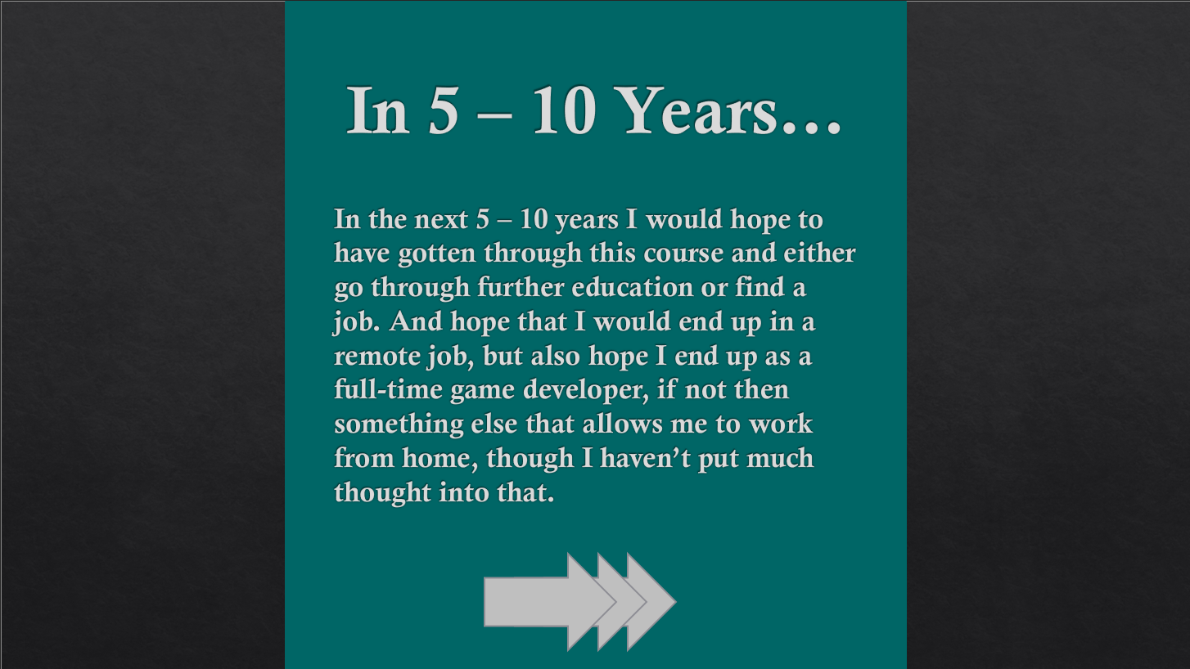
Figure 1 - PowerPoint
The assignment also requires some peer feedback. The main point of the feedback was that during the presentation there was a lack of confidence, and fast speaking making two of the observations being, practice to give confidence in presenting, and to slow down when talking.
The assignment also requires the candidate to describe aspects that could enhance future presentations, practice and experience in doing the actual presentations is a key factor. However, also keeping the attention of the audience is also a major point that most forget about when making the presentation, to do this you need to use the features of a PowerPoint to make it more of a discussion than simply saying what you see. Sometimes this is done by reducing the amount of text, adding more images, and also possibly adding colours that are both complimentary and comfortable for the eyes of the viewers to look at.

Skills Evaluation
This section of the assignment requires research into skills that are essential for successful learning in a higher education environment. Through this the skills found for this were; note taking, independent learning, self-motivation, and time management. Descriptions of what they are and how they could be used for this topic can be seen below.

Note Taking
Oxford Royal explains note taking for successful higher learning well, they make a great point about it by saying; [1] “finding a way to summarise the vast amount of information to which you will be exposed is vital if you are to make any sense of it and commit it to long-term memory”. This is stated as, when in higher education it becomes essential to take in as much information as possible, as the information learned is much more advanced compared to other levels that a student might have previously taken. To do so it is recommended that you do whatever it takes to make that possible, such as writing down important information into notes for further study later, making flash cards for memorisation training, or keeping a video/audio recording of the whatever lecture you took, as long as it allows you to not forget as much information from the given lecture as possible.

Independent Learning
For independent learning, Oxford Royal notes that; [1] “The ability to study independently, without that much guidance from teaching staff, is essential…” and to “learn how to make the most of the resources you’ve been given…”. Taking this into consideration, it is a given that at the higher levels of education, not every bit of information becomes available through a lecture, and thus becomes impossible to know all that is needed from those few hours of learning, therefore, you must be able to research the specifics of whats needed through books, websites, or even previous work on the subject, while remembering to reference what information you did not learn from the lecture.

Self-Motivation
Next, self-motivation, this time instead of skills prioritised for learning, this time it will be skills that are required to make a higher education lifestyle a bit easier to get through as without them a student may be falling behind, late for a lecture, etc. Oxfords view on this is as follows; [1] “Start out with a clear idea of what you want to achieve in the long run; having this end goal in sight at all times will remind you of what you’re working towards.”. This is one of the key factors for helping with self-motivation, as it allows you to realise what you are or were trying to make your way towards, and in doing so you will be able to get yourself back on track by rather than focusing on the difficulties of higher education, but instead, focusing on the future career that you might end up in because of it.

Time Management
Finally, the last skill in my list but not the last skill needed for a better higher education experience, time management. From the beginning of your education to higher education, and even in the workplace, you will find that time management is an extremely essential skill to learn. Oxfords view on this is [1] “With many demands on your time, it’s vital to be sensible about how you manage your schedule to avoid becoming stressed.”. The main thing to note from that is; “to avoid becoming stressed", as organising your time into schedules, and making alarms, as well as specific notes of what is needed of you on any specific day. This makes it easier to clear up as well as add anything to your schedule, making a more stress-free life in both higher education, and just life in general.

Generic & Transferable Skills
This section of the brief also asks for generic and transferable skills which like the previous part, will only be comprised of four skills, two of which I’ve already discussed; self-motivation and time management, and the other two are from a source called prospects on what skills employers want, which the ones that I chose are; resilience and adaptability, as they are skills that any employer would like to see as well as the fact that they can come in handy for general use as well, such as learning.
The first two, although I already discussed them, can come hand in hand as well, and are good for an employer to see, as having both self-motivation and time management allow for you to stick to a designated time schedule that an employer might give you as well as make your own personal schedule revolve around the one given for work so that they both don’t collide and get in the way of each other.
The other two, resilience and adaptability are useful no matter what as well, as resiliency allows you to continue going and get back to whatever you’re doing, for example, learning or work. But then adding adaptability on top of that allows for you to learn from your mistake by changing it entirely or fixing it to make it work with what you’ve got the best of your ability. Swain’s stance on resilience is that; [2] “…be able to show that you react to them positively and are able to develop strategies to deal with them.”. And then for adaptability Swain’s reasoning as to why it’s needed is; [2] “…it's essential to show employers that you're able to adapt to new situations and learn new skills in the workplace.”. This is the reason why having both skills are essential to being an efficient employee, as it allows you to continue working even with failure without slowing efficiency but also then being able to adapt to it and make better decisions for both present and future decisions.

Personality and Careers Quizzes
The brief requires the candidate to take self-evaluation tests for both personality and careers, as such the candidate has provided results from a test taken from a website called [3]16Personalities for the personality section, and a test from the [4]government website for the career section, the personality test for the candidate came with the following statistics shown in the figures below:
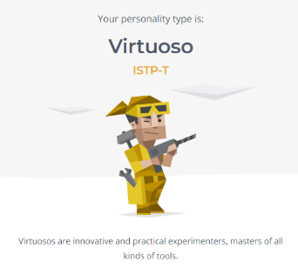
Figure 2 - Personality Type
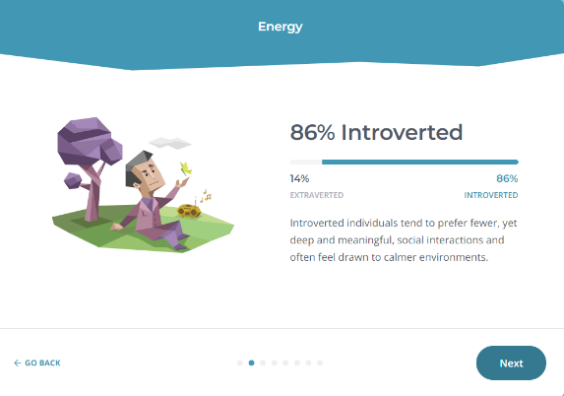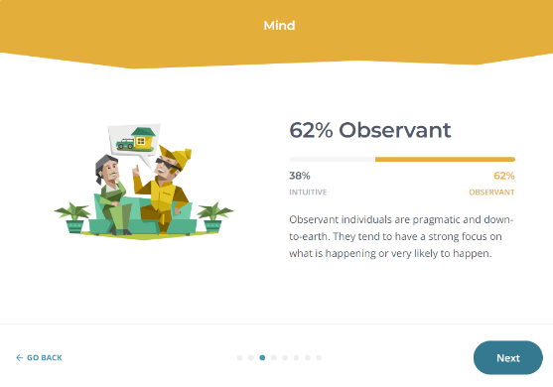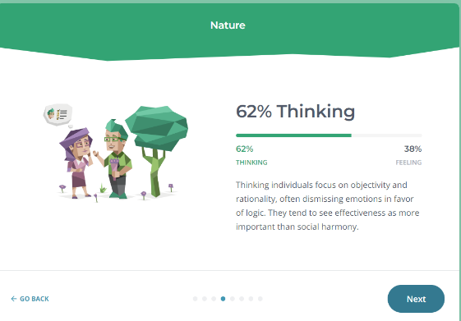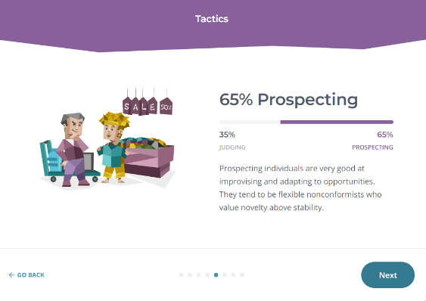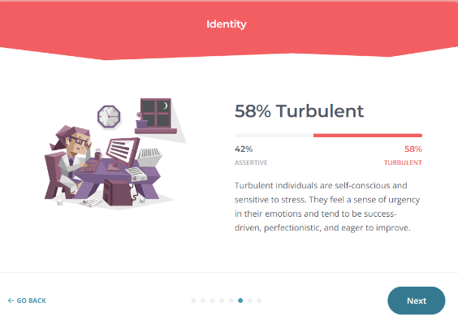
Figure 3 – Personality

And the results from the candidate’s career quiz are shown in the figure below:
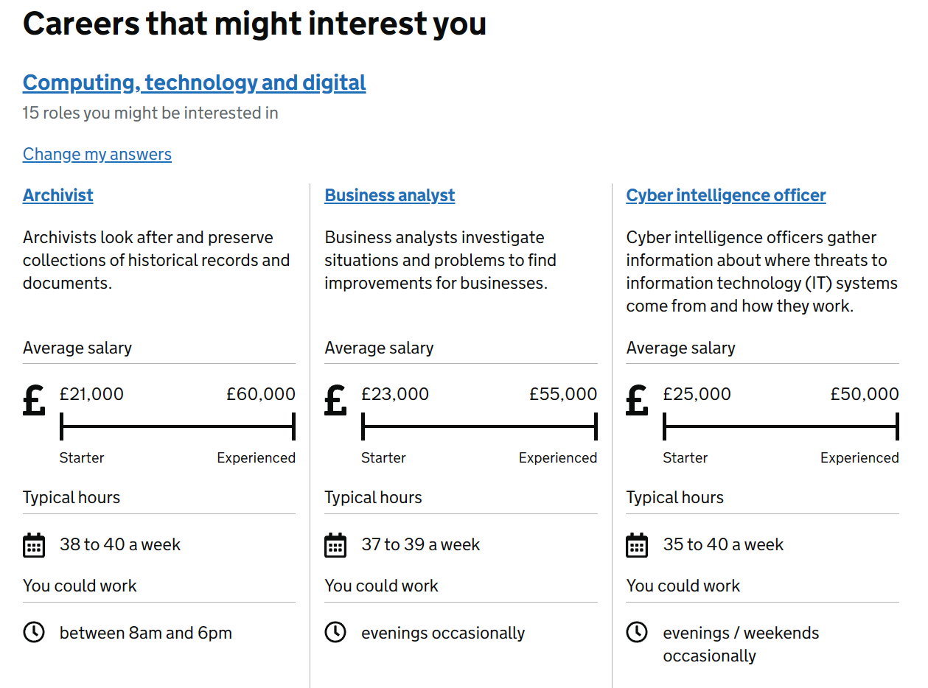
Figure 4 - Careers of Interest
The brief also requires the candidate to compare these results to the presentation that was discussed at the beginning of this report. To start, the personality results compared to the presentation the candidate gave, in a way, makes sense. This is because, although the candidate, based on the personality quiz would prefer to use logic and being rational, that becomes difficult when 86% introverted and doing a presentation in front of a group of people, and that was also mentioned in the presentation as I also mentioned in the presentation that the candidate heavily dislikes public speaking. Next the careers quiz, seems fairly accurate as it mentions either being an archivist, business analyst or a cyber intelligence officer, however, this is just jobs that may be good as a suggestion from the questions that the candidate answered, because as you can see from the presentation section, The candidate would prefer to get into a game development job. However, those jobs are also very uncommon to see, so the suggestions kind of make sense considering current jobs that may be available. So, to approve upon the candidate’s biggest shortcoming, the candidate should do one of two things, either practice presentations about topics of choice to smaller groups to get used to it or talk more in general to larger groups of people rather than to one or two people, the candidate has also learned from this that they should keep options open for possible career paths and not to limit the number of available careers that could be available to them.

Action Plan
Some goals that the candidate wishes to achieve are as follows for personal or professional, improving focus, for the long-term goal, and the candidate also wishes to improve their time-management skill. Then for the academic goals, the candidate wants to improve both their, independent learning and their research skill. Descriptions on the skills/goals, as well as their SMART targets can be seen in the figure below.
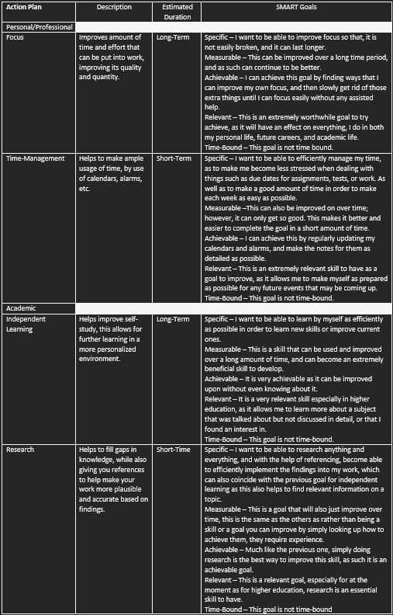
Figure 5 - Action Plan (Goals)

Application, Time Management and Self-Organisation
The brief for this section requires the candidate to discuss, what steps they take or are going to take to improve productivity, self-organisation as well as to reduce stress levels. Speaking of productivity and time-management Sanja discusses the four components that effect productivity, [5] “Focus: You need to be able to focus on the task at hand and avoid any distractions.”. This is extremely important as focus is what allows you to get any work done in the first place, so making sure that you are focused is step one to ensuring high levels of productivity. Next then is, energy, as Sanja remarks that, [5] “...You need the mental and physical energy required to complete the task.” This is because when working on a task for long periods of time it can be not only mentally draining, but physically draining as well. So, making sure you have the capacity to handle a full days-worth of work is extremely important, of which ties into the next component quite well. The next component is time management as Sanja mentions that [5] “…You need to be able to prioritize tasks strategically and manage your time effectively.”. This implies that you must manage what you do and when, to not only make the most of your time but also to make sure that you have a decent amount of time to complete the tasks that you need to do. Finally, Sanja mentions the last component of productivity being, [5] “Consistency: You need to be able to maintain your focus and energy in order to work at a consistent pace.”. This suggests that your consistency requires both the focus and the energy mentioned before to make sure that the work you do is up to standard both in quality and quantity at a consistent rate. All four of these components together are what allow for good productivity and is also what is required to meet the requirements of the work. To try to keep up with these components, to bring them together time management is most important, as it allows you to manage when and how long you give yourself to complete or work on a task, which helps you to prioritize and manage energy, so that you are able to focus during those time periods, so that you can also keep up a good consistency with your work as long as your time management is good. As such, the candidate has given their digital calendar as that is what they most use in their time management, this will be seen in the figure below as well as a completed E-Portfolio and CV.

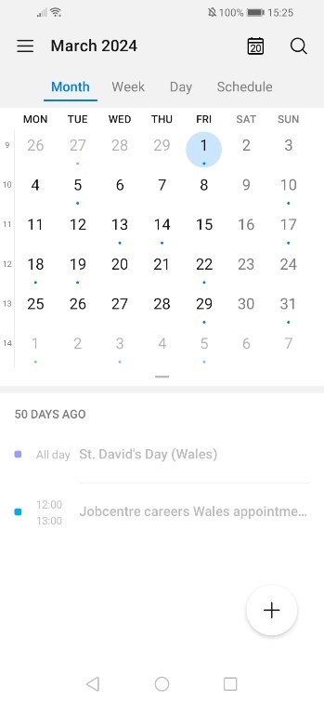
Figure 6 - Digital Calendar
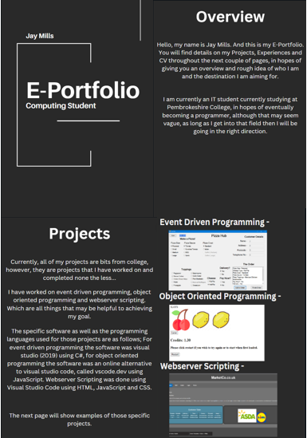
Figure 7 - E-Portfolio

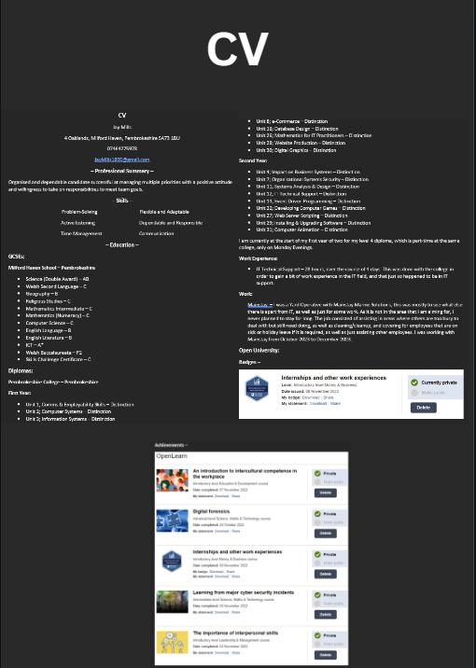
Figure 8 - CV

Conclusion and Evaluation
The key findings of the candidate for this component of the academic and employability skills module is that the candidate can plan a lot more that what they think, such as for improving skills such as focus like in the action plan. As well as this the candidate has also learnt more on their personality and as such is taking information according to those findings and is now finding it a lot easier to understand how they need to do things such as study or manage their time to make it the most effective for them. As such the candidate has found two areas of interest for further study, looking at personality quizes and as such trying to take information according to those tests to see if it makes it easier, or make more sense. The other area then is learning more on how to improve skills such as focus and self-learning in order to make further development in education for themselves at their own pace.

Component 2

Looking After Your Data
In the brief for this assignment, it is mentioned the need to describe how to look after your data, specifically using the “3-2-1 backup rule” rule. As documented by Vanover this backup rule [6] “…was first conceived by U.S photographer Peter Krogh” and a quote that Vanover got directly from Krogh reads as follows, [6] “3 copies of data …On 2 different media… With 1 copy being off-site”. This suggestion is what is currently followed in modern backup procedures, and to give an example of how data is to be kept using this rule, you can store the specified data in a USB stick for the “two different media” rule, you for the second media you can make a folder on your system specifically called backups just to keep another backup on the system in case the issue that causes the data loss isn’t system based, but something like corrupted data. Finally, you can use the cloud as another means of following the other rule of storing the data offsite. This can be done by storing the data on a cloud application such as OneDrive, which will keep your data safe on the cloud servers rather than your own media, which is usually one of the most reliable backup solutions and is only inaccessible when either those servers are down, or you can’t access the internet. All 3 suggestions of storing data, combine into an extremely secure method of data storage, and can also be added to if you have the media to put the data on to.
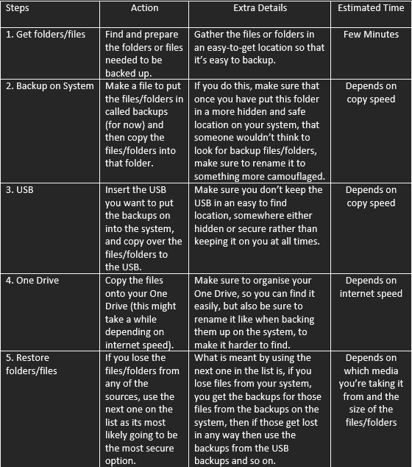
Figure 9 - Action Plan (Disaster Recovery)

Disaster Recovery
The brief next requires the candidate to discuss disaster recovery from various disasters by using the method from the previous section, the disasters that will be discussed are as follows: Equipment Failures, Malware and Ransomware, Building Damages, Fires, Floods, Health Crises. The reason for these specific ones were because I got them from [7]Emergency Management from the “AlertMedia” website, by using a list that they gave me I can use disasters that already exist to come up with my own methods of disaster recover. Some of these recovery plans will be shorter or longer than the rest, but that is simply because of the disaster itself and if it needs a small or big recovery plan.

Equipment Failures
The “equipment failure” disaster can be a multitude of things; however I have focused on three for now, the first is a system outage, which is when a process is disrupted and breaks the system because it was and is unable to complete its task. The next is a power outage, which simply means the power goes out, and the system shuts down improperly, resulting in data corruption or loss. And finally, is IT infrastructure failure which is when the system’s hardware fails resulting it being unable to run properly or at all. The recovery strategy would cope with this as it allows the continued use of any work that is currently being done as long as it is saved, this means OneDrive would be the most reliable for this as it has autosave and does so every few seconds by default.
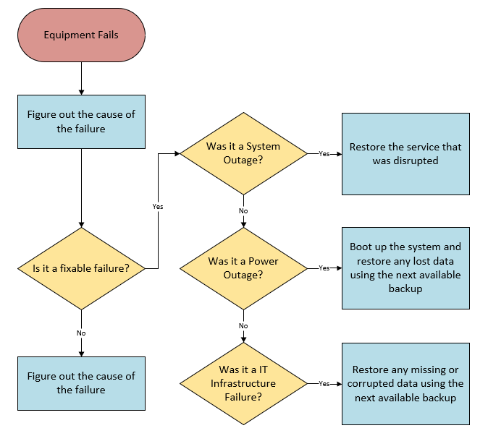
Figure 10 - Equipment Failures

Malware and Ransomware
Malware specifically, can make a variety of things happen to the data, but one of the most common things is that the data becomes corrupt or goes missing, it could even be turned into something that can give you more malware if you click on it. Then ransomware encrypts or steals the data and then blackmails you for money or something similar, to get the data back, though you shouldn’t do that as there is no guarantee of getting anything back once the payment is done. The backup strategy would cope as it allows you to use a separate device to continue your work, while the other “infected” device is dealt with. To avoid something like this from happening in the first place, regularly inform employees, or whoever is using the system, to never click on suspicious links, sites, site banners, emails, etc.
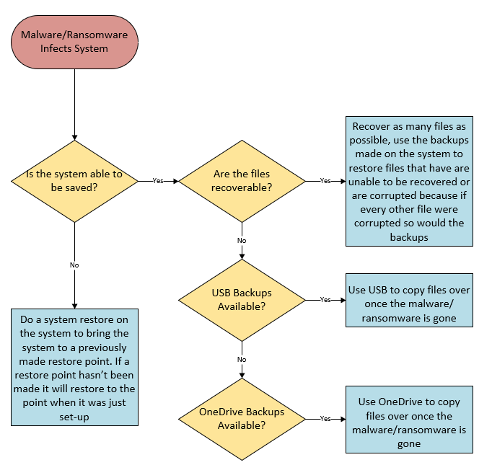
Figure 11 - Malware and Ransomware

Building Damages
The “building damages” disaster, is one that can sometimes cause issues, but when it does, then most likely there’s not much left of what was there. So even when the issue is fixable, you may still need to use the backups to get data back, and if it isn’t fixable and a new system is needed then you still need to use the backups to get the required data onto the new system. To make sure this hopefully doesn’t happen, before this sort of disaster occurs, have regular checks on the buildings integrity and stability and have it fixed or sorted if something comes up bad.
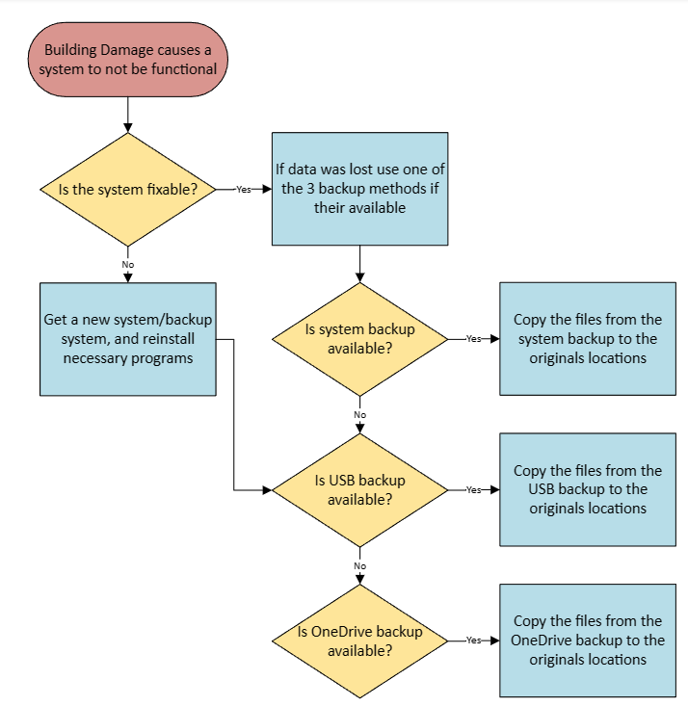
Figure 12 - Building Damages

Fires
The “fire” disaster could do quite a bit of damage to the system depending on the severity of the disaster, but if your lucky you might either end up with corrupt or missing data, or just a burnt system that might need a bit of a clean. The backup strategy would cope as because as long as there is a system available you can still access the data until the problem is sorted, or if it’s just the data that’s corrupt or missing then you can use the backups to get the specific data needed back. To make sure that you are prepared for this before the disaster, you can make sure that you keep a couple or a spare system in another location and use the backups to keep working while the problem is being sorted. As well as making sure there is a fire extinguisher for electrical fires.
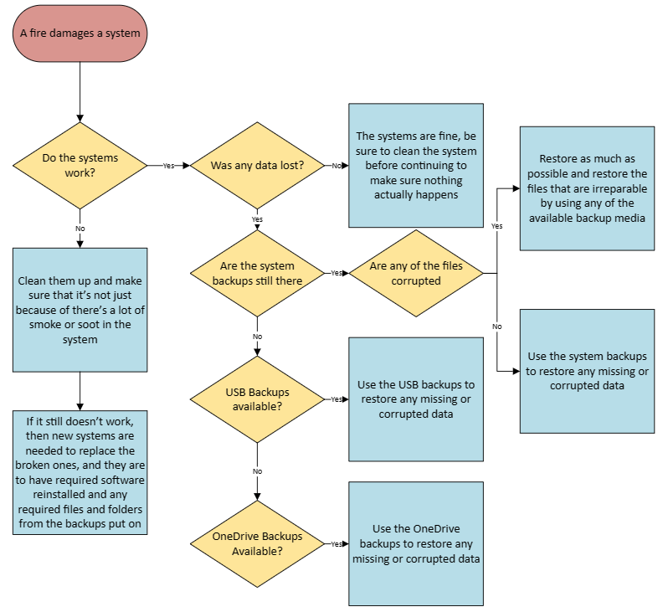
Figure 13 – Fires

Floods
The “flood” disaster could do some damage to the system, this is because in the worst-case scenario the entire system becomes ruined because of water getting to the inside of the system, or the data could end up corrupt or missing. The backup strategy would cope as long as there is the USB and OneDrive backups as with a USB you might of ended up leaving it in a vulnerable place that the flood could get to and it would ruin the USB stick, however, might be fine as long as it dries. A way to make sure that you can recover from this before the disaster happens is to make sure that you keep the systems themselves as high as possible to avoid the systems becoming wet in the first place.
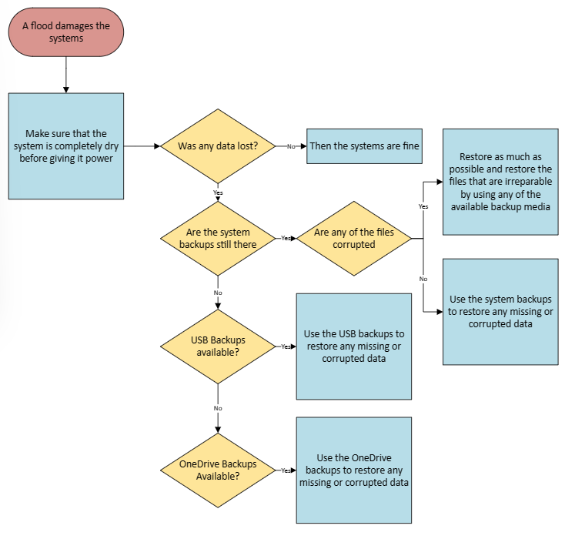
Figure 14 - Floods

Health Crises
The “health crises" disaster wouldn’t do too much to the system itself, but more so how the system or data can be accessed. The backup strategy would cope by mostly relying on the OneDrive backup as its not only the safest backup to get a hold of but also the quickest in this sord of disaster. The USB backup is also an option if everyone has their own backup on their own USB. The way to make sure things can be restored to how they were pre-disaster, is just to make sure that the data is constantly kept up to date, which goes for both backup media, as well as making sure everyone has their own copy of the necessary data if it’s for the USB backup option.
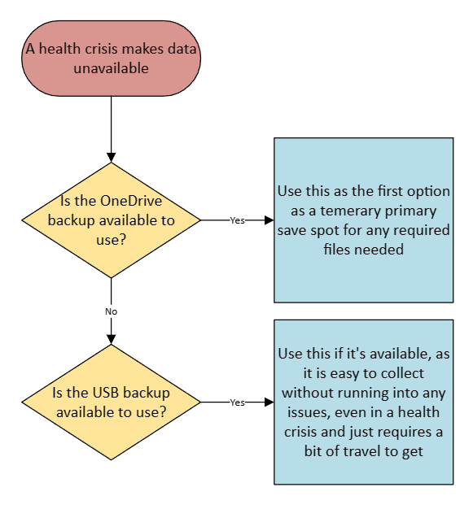
Figure 15 - Health Crisis

Evaluation
The effectiveness of my strategies is only effective if the media for the backups are kept up to date, and because of this a rule could be implemented to help with this to backup saved data more frequently. The software and hardware being used for the strategies are mostly the system itself for its own backup on the system itself, then a USB for a separated media for storing the data, it could also be a external hard drive, and finally the only software being the OneDrive, that gives a free 5 GB of storage, however for a paid plan 100 GB, 1TB as well as 6 TB plans can be bought for more storage for a lot more space to back up a lot more data.

Ransomware
The brief requires the candidate to discuss ransomware. Ransomware is a huge threat to businesses, as it doesn’t corrupt or steal data like malware does which is easily dealt with just by having backups. However, instead it encrypts the data and blackmails the business for money or something of equivalent value to what they want, to return the data. However, what these businesses don’t quite get immediately when seeing it, as if you haven’t dealt with it before it might not be so apparent, is that even if you did do as they said, there is no guarantee in the data being returned making it an extreme danger most companies need to not just hear about but prepare for it as well, as if they are not prepared for it then they might just have to take that risk of giving away a large sum of money just for a chance to retrieve the stolen data. It is unnecessary to discuss how it fits in with my recovery plan as I have it already as the second plan in the disaster recovery section with the plan to deal with malware. It could be slightly improved, by also having a separate bank account made, disconnected from the company, with a decent amount of money in it so that the ransomware hacker can’t get to anything more connected to the business through the bank account details, making it more of a worst case scenario with still having to give away money to make them hopefully leave the company be until the problem can be resolved through other means.

Bibliography

[1] | Oxford Royal, “Oxford Royal,” Oxford Royal Academy, Doesn't Say Doesn't Say Doesn't Say. [Online]. Available: https://www.oxford-royale.com/articles/13-skills-university/. [Accessed 26 February 2024].
[2] | R. Swain, “What skills do employers want?,” Prospects, June 2023. [Online]. Available: https://www.prospects.ac.uk/careers-advice/applying-for-jobs/what-skills-do-employers-want. [Accessed 15 April 2024].
[3] | NERIS Type Explorer, “Free Personality Test,” 16Personalities, 2024. [Online]. Available: https://www.16personalities.com/free-personality-test. [Accessed 23 October 2023].
[4] | Gov, “Discover your skills and careers,” National Careers Service, [Online]. Available: https://nationalcareers.service.gov.uk/discover-your-skills-and-careers. [Accessed 16 April 2024].
[5] | S. Gupta, “8 Ways to Boost Your Productivity,” verywellmind, 19 April 2023. [Online]. Available: https://www.verywellmind.com/ways-to-boost-your-productivity-7480441#:~:text=These%20are%20some%20strategies%20that%20can%20help%20you,multiple%20things%20at%20a%20time.%20...%20More%20items. [Accessed 20 April 2024].
[6] | R. Vanover, “What is the 3-2-1 backup rule?,” Veeam, 5 February 2024. [Online]. Available: https://www.veeam.com/blog/321-backup-rule.html. [Accessed 21 April 2024].
[7] | Emergency Management, “How to Build a Disaster Recovery Plan for Better Business Continuity,” AlertMedia, 9 April 2024. [Online]. Available: https://www.alertmedia.com/blog/disaster-recovery-plan/#:~:text=The%20range%20of%20potential%20disaster%20scenarios%20covered%20by,7%20Building%20damages%208%20Power%20outages%20More%20items. [Accessed 21 April 2024].
[8] | F. Lloyd-Davis, “The Backup Rule Of Three Is A Simple Way To Remember Backup Best Practice,” Acronyms, 16 January 2018. [Online]. Available: https://www.acronyms.co.uk/blog/backup-rule-of-three/. [Accessed 21 April 2024].

Figure 1 - PowerPoint 2
Figure 2 - Personality Type 5
Figure 3 – Personality 5
Figure 4 - Careers of Interest 6
Figure 5 - Action Plan (Goals) 7
Figure 6 - Digital Calendar 9
Figure 7 - E-Portfolio 9
Figure 8 - CV 10
Figure 9 - Action Plan (Disaster Recovery) 11
Figure 10 - Equipment Failures 12
Figure 11 - Malware and Ransomware 13
Figure 12 - Building Damages 13
Figure 13 – Fires 14
Figure 14 - Floods 15
Figure 15 - Health Crisis 16

