Advanced Cyber Security

ACCA6000

Helen Frey

P131560

Lecturer: Dr Carlene Campbell

University of Wales Trinity Saint David

Table of Contents
Table of Figures 3
Part 1: Research & Analysis 6
Abstract 6
Task A: Research 6
1. Introduction 6
2. The Internet 6
3. Internet of Things and Smart Cities 6
4. IoT Technologies 7
5. Smart City Standards 7
5.1 Smart City Security 7
6. Network Security 8
6.1 Physical Security 8
6.2 Unused Ports 8
6.3 Intrusion Detection and Prevention Systems 8
6.4 Security Information and Event Management 8
6.5 Network Flow 8
6.6 Virtual Local Area Networks 8
6.7 Virtual Private Networks 8
6.8 Social Engineering 8
6.9 Access Control Lists 9
6.10 Wireless Access Points 9
6.11 Passwords 9
6.12 Bring Your Own Device 9
6.13 Network Protocols 9
6.14 Layer 2 Security Issues 10
Task B: Analysis of Four Laboratory Exercises 11
1. Lab 1: 3.2.2.4 Navigating the Linux Filesystem and Permission Settings 11
2. Lab 2: 7.3.2.5 Reading Log Servers 16
3. Lab 3: 9.1.1.7 Encrypting and Decrypting Data using a Hacker Tool 19
4. Lab 4: 12.4.1.1 Interpret HTTP and DNS Data to Isolate Threat Actor 21
Part 2: Synthesize a solution to a potential real-life scenario 25
Background 25
Design 25
Firewalls, Demilitarized Zone, and the Internet 25
Basic Security on Switches/Router 26
Wireless Security 26
Bring Your Own Device 26
Smart Classroom 26
Working from Home 27
Car Park 27
5. Network Simulation 28
6. Conclusion 28
Bibliography 29
Appendix I: Smart Campus 34

Table of Figures
Figure 1: Smart City Components [10] 7
Figure 2: BYOD Security Risks 10
Figure 3: Internet Protocol Stack [17] 11
Figure 4: Current Mounted Filesystems 12
Figure 5: Details of Filesystems Currently Mounted 12
Figure 6: Output of mount | grep sda1 12
Figure 7: Results from cd / command 12
Figure 8: Results from ls -l command 13
Figure 9: Results from cd ~ ls -l commands 13
Figure 10: Empty Contents of Second Drive Directory 13
Figure 11: Mounted Second Drive contents 13
Figure 12: Output of the show /dev/sd filesystem 13
Figure 13: Successful Unmount of Second Drive 13
Figure 14: Permission Groups [27] 13
Figure 15: Access Permissions [26] 14
Figure 16: Change Directory and List Files 14
Figure 17: Details of Cyops.mn File 14
Figure 18: Access Permission Denied 14
Figure 19: Permissions List 14
Figure 20: Creation of File using Sudo 14
Figure 21: Read & Write Permissions of Second Drive 14
Figure 22: Permission Formats [26] 15
Figure 23: Change of Permissions 15
Figure 24: Adding 'text' to the end of a file 15
Figure 25: Directory Permissions 15
Figure 26: Seven Linux File Types [26] 15
Figure 27: Directory Files 16
Figure 28: Directory Outputs 16
Figure 29: Hard and Soft Links 16
Figure 30: Soft and Hard Links 16
Figure 31: Soft and Hard Symbolic Links 16
Figure 32: Output of Concatenation File Details 17
Figure 33: Output from 'More' Command 17
Figure 34: Output from the 'Less' Command 17
Figure 35: Output Generated by 'Tail' Command 17
Figure 36: Use of the Journalctl Command 18
Figure 37: The Journalctl Command plus – UTC 18
Figure 38: Entries from Last Boot Time 18
Figure 39: Service Logs for Today for NGINX 18
Figure 40: Journalctl -k results 18
Figure 41: journalctl used with -f 19
Figure 42: Symmetric Encryption/Decryption [30] 20
Figure 43: Zip-Files were created 20
Figure 44: Text Files 20
Figure 45: List of Files Created 20
Figure 46: Zip-File Creation 20
Figure 47: List of Created Files 20
Figure 48: Verification of File Creation 20
Figure 49: Password Incorrect 21
Figure 50: One-Letter Password Decryption 21
Figure 51: Two-Letter Password 21
Figure 52: Three-Letter Password 21
Figure 53: Four-Letter Password 21
Figure 54: Domain Name Server [31] 22
Figure 55: Security Onion Virtual Machine 22
Figure 56: Security Onion Running 22
Figure 57: Verification of sguil Server Running 23
Figure 58: Sguil was opened 23
Figure 59: All Networks to be Monitored 23
Figure 60: Show Packet Data and Rules 23
Figure 61: Alerts 23
Figure 62: Correlated Events 23
Figure 63: Checksum Differences 24
Figure 64: Credit Card Information 24
Figure 65: Find Username 24
Figure 66: Wireshark 24
Figure 67: Follow TCP Stream 24
Figure 68: ELSA HTTP Selection 25
Figure 69: Detailed Information of Alert 25
Figure 70: Username Found 25
Figure 71: DNS 'Bottom' Requests 25
Figure 72: Suspicious Activity 25
Figure 73: Hexadecimal Link 25
Figure 74: Hex String Reverted 25
Figure 75: Campus 26
Figure 76: Demilitarized Zone 26
Figure 77: DMZ Cluster 26
Figure 78: Wiring Closet 27
Figure 79: Switch Security 27
Figure 80: Timeout Session 27
Figure 81: Wireless Security 27
Figure 82: Smart Classroom 28
Figure 83: Classroom IoT 28
Figure 84: DHCP Request Successful 28
Figure 85: VPN 28
Figure 86: Working from Home 28
Figure 87: Car Park 29
Figure 88: Packets moving through network 29
Figure 89: Packets moving through network (ii) 29
Figure 90: Smart Campus 33

Part 1: Research & Analysis

Abstract
This report is made up of three parts. Part 1A is research based and is an introduction to the Internet, the Internet of Things and Smart City Security Issues, Technologies, and Network Security, solutions. Part 1B is the analysis of four laboratory exercises. Part 2 investigates a smart campus simulation and examines cyber security measures taken to mitigate against cyber-attacks, both internal and external.

Task A: Research

Introduction
The information technology and security field are one of the most dynamically developing areas worldwide, and the importance of securing network infrastructures has become paramount [1],[2].
Cyber security is the use of technologies, controls and processes to protect computer systems, networks, devices, and data from attacks [3],[4].

The Internet
To understand cyber security, a brief look into the internet is required. The internet started more than 40 years ago for academic purposes. Its design principles were unsophisticated, and the original architecture lacked basic security principles; this was added as an overlay rather than an integrated feature. This core architecture is difficult to modify so ad hoc patches are implemented. The internet traditional security mechanisms such as lightweight cryptography and secure protocols are insufficient [5],[6].
[5] goes on to state that with the increasing needs for security, mobility, social content, reliability a new design has been put forward by the research community. However, until this has been sufficiently tested the internet remains a series of patches [5].

Internet of Things and Smart Cities
The Internet of Things (IoT) is a networking paradigm that in its simplest form is any device that can be connected through Internet Protocol connectivity and ‘communicate’ with another device ensuring ubiquitous connectivity, allowing them to be controlled, managed and read at any place at any time. This can range from sensors to smart phones used everywhere from agriculture, business, education, to healthcare that transmits a wide range of data such as energy usage, financial data, environmental context and much more. Taken one step further, IOT devices have allowed everything to be interconnected, capable of creating smart cities as illustrated in Figure 1 [5], [7]–[9].
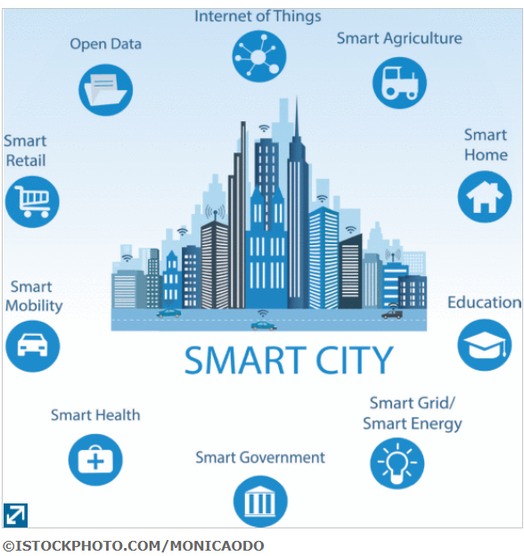
Figure 1: Smart City Components [10]

IoT Technologies
Most IoT devices use wireless communication technologies for example WiFi, Bluetooth Low Energy (BTLE), IEEE 802.15.4, ZigBee, Z-Wave and 6LoWPAN, to mention but a few [9], [11].
The devices’ connectivity to the Internet poses security risks such as eavesdropping on the communication, tampering with devices, privacy risks and unauthorised access [9].
As they can be resource constrained, for example, processing speed or power, limited battery or storage capacity, it can be challenging to apply cryptography algorithms and other security protocols [9],[12].
Sensor/IoT devices are connected to backbone networks giving attackers easy access to the system [12].

Smart City Standards
The British Standards Institute defines smart cities as:
“one that makes optimal use of all the interconnected information available today to better understand and control its operations and optimize the use of limited resources” [13].
The Institute of Electrical and Electronics Engineers (IEEE) created ISO 37120 defining 46 core and 54 performance standards that allow civic bodies to use as a benchmark [10].
The National Institute of Standards and Technology (NIST) have an IoT-Enabled Smart City Framework [14], [15].

5.1 Smart City Security
The Code of Practice for Consumer Internet of Things in the United Kingdom (UK) advocates that security measures be implemented in every device connected to the internet [12]. The UK Department for Digital, Cultural, Media and Sport instigated an investigation into ‘Mandating Security Requirements for Consumer IoT Products that requires security labels to be put on IoT devices [12],[16].
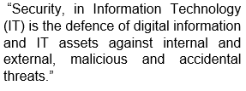[17]
There are four security tenets: Confidentiality: is there unauthorised access to the data. Authenticity: is the data from the stated source. Integrity: was the data changed. Availability: can the information be accessed when required [5].
To assist an organisation with their defence strategy a simple checklist should be created:
- Staff Awareness: social engineering is the most frequent cyber-attack by deceiving the person in charge of the device into executing a task. So, it is imperative that staff are trained to see how threats work, and how to apply the countermeasures in real-world situations [3], [18], [19].
- Web Application Security: as this is a common point of intrusion it is vital that web servers are secure [3].
- Passwords: there should be a management policy in place for passwords. Common passwords such as ‘qwerty’ or ‘password’ should not be allowed [3].
- Management: must be willing to put these measures in place [3].

Network Security
Network security encompasses the policies and procedures for software and physical structures to protect against unauthorised access, modification, misuse, etc.

6.1 Physical Security
Servers are kept in a locked room with limited access, for physical security. Connection between the client and server uses the Secure Shell Protocol (SSH) so that all authentication commands, file transfers and output are encrypted.

6.2 Unused Ports
Unused ports on all servers are shut down to ensure they are not exploited if port scanning occurs.

6.3 Intrusion Detection and Prevention Systems
Intrusion Detection and Prevention Systems work by identifying attack signatures. The signatures would be regularly updated using the National Vulnerability Database, and all alerts. Including false positives, are required to be manually verified.

6.4 Security Information and Event Management
Security Information and Event Management products work in a similar way although they use log data analysis. Anti-virus and anti-spam software that could contain phishing attacks, malware or malicious content are blocked and/or flagged.

6.5 Network Flow
Network flow information flags activity that indicates malware, data exfiltration etc.

6.6 Virtual Local Area Networks
Virtual Local Area Networks are created to ensure the compartmentalisation of departments and to limit broadcast traffic.

6.7 Virtual Private Networks
Virtual Private Networks (VPNs) ensures data encryption and user authentication between communicating parties so devices is connected through an encrypted VPN connection allowing access to the local resources without being exposed directly to the Internet [20].

6.8 Social Engineering
Phishing is the most common social engineering attack as humans trust each other over computer technologies. Social engineering attacks aimed at manipulating people are cleverly designed to trick them into ignoring security protocols or divulging confidential information [21]. The campus ensures security training and awareness of these attacks on a regular basis.

6.9 Access Control Lists
Access Control Lists (ACL) regulate how network traffic passes through an interface with sequential permit or deny statements. The router looks at each packet that is sent and compares the information contained in it against the ACLs.
The ACLs can be filtered on inbound packets or on outbound traffic and should be placed where it can work most effectively so that the router’s resources are not wasted. [22], [23]

6.10 Wireless Access Points
Smart devices can access wireless areas through Wireless Access Points (WAP).
Wi-Fi Protected Access 2 - Pre-Shared Key with Advanced Encryption Standard (WPA2-PSK AES) are security algorithms for wireless networks. Service Set Identifiers (SSID) should be customised to distinguish which networks are allowed access by whom.
Secure Shell (SSH) protocol is a cryptographic system used for accessing networks over an unsecure (usually remote) connection.
Access would be granted to the user as either a guest or an account holder as per the ACL mentioned above. This would be created to allow each user access to only the resources and information that it requires for the carrying out of its legitimate purposes.

6.11 Passwords
Passwords are required on all devices and must be a minimum of 12 characters with symbols, upper and lower case, together with a number to make it harder to crack. These must be changed at regular intervals.
Brute force attacks can be protected against by locking accounts after a set number of incorrect password attempts.

6.12 Bring Your Own Device
Bring your own device (BYOD) is when your personal device is used in the workplace. The need to protect the network’s systems and data can be difficult when confronted with the device owner’s expectations. The network Administrators will have less visibility and control of the device and this makes it much more of a security risk, so BYOD policies require both organisational and employee responsibilities to be set out in a clear manner. As with every other policy, they are of no use unless strictly enforced by management [24].
Figure 2 sets out many more security issues relating to BYOD.
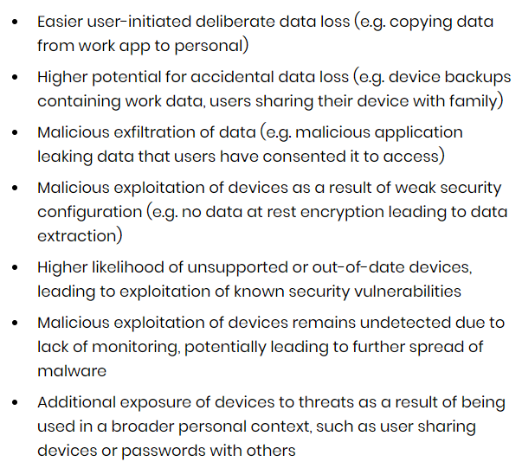
Figure 2: BYOD Security Risks [24]

6.13 Network Protocols
The Open System Interconnection model shown in Figure 3, defines networking protocols that are used to transmit data from one system to another [25].
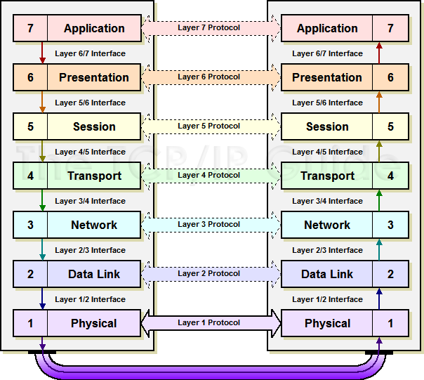
Figure 3: Internet Protocol Stack [25]

6.14 Layer 2 Security Issues
Common attacks on Layer 2 include MAC address table flooding, VLAN, DHCP, CDP Reconnaissance and Telnet attacks.
Firewalls, Intrusion Prevention Systems and VON provide security from Layer 3 through 7.

Part 1A Conclusion
The use of smart devices can bring many benefits to society. There are, however, inherent drawbacks such as the security system changes that are required which will need to become part of cyber security policies and procedures. Sensors require more thought as they are incapable of many of the easier security features due to their size and capacities. Bring Your Own Device brings new challenges and the merging of private and corporate data is difficult to manage. Overall, cyber security is becoming much more important in the overall infrastructure of a company.

Task B: Analysis of Four Laboratory Exercises

Lab 1: 3.2.2.4 Navigating the Linux Filesystem and Permission Settings

Part 1: Exploring filesystems in Linux
There are many types of filesystems in Linux and this lab will focus on the ‘ext’ family.
An operating system organises files on a disk using a filesystem. Linux can access data stored on a range of different filesystems from various operating systems. For the filesystem in Linux to be available it must be ‘mounted’ which means making it accessible in the Linux tree directory. The permissions level required is ‘root’ which is the highest [26].
Step 1: access the terminal window in the virtual machine.
Step 2: a) Display the filesystems currently mounted. Figure 4 shows that there are 3 filesystems mounted: sda, sdb and sr0.
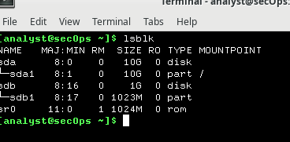
Figure 4: Current Mounted Filesystems
b) The mount command was used to display detailed information about the systems that are currently mounted, shown in Figure 5.

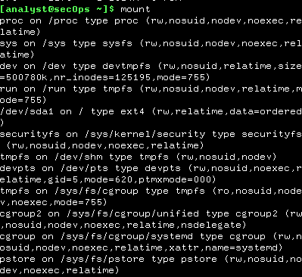
Figure 5: Details of Filesystems Currently Mounted
This lab will focus on the filesystem in the /dev/sda1.
c) The mount command was used with the pipe symbol and grep to filter the command to be specific to the sda1 which will display only the root filesystem as shown in Figure 6.
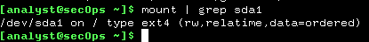
Figure 6: Output of mount | grep sda1
d) The commands ‘cd /’ and ‘ls -l’ were used and the output is shown in Figures 7 and 8, respectively.
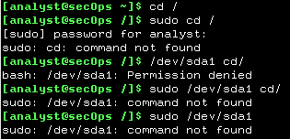
Figure 7: Results from cd / command
Figure 8 shows that it was not possible to access the /dev/sda1.
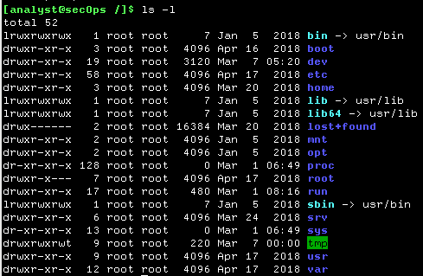
Figure 8: Results from ls -l command
Figure 9 shows that the files are physically situated in the ‘root’ directory. /dev/sdb1 was not shown in the output as it is in a different drive.
Step 3: a) To mount or unmount filesystems similar commands ‘mount’ and ‘umount’ is used.
Figure 9 shows the result from two commands: the first is cd ~ which is the change directory to home directory. The second command is ls -l being the command to list the files in the current directory and the argument after ls is -l being the character not one that shows directory or file size, modified date/time, folder or file name, file owner and permissions.
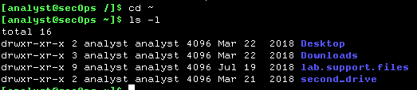
Figure 9: Results from cd ~ ls -l commands
b) list the contents of the second_drive directory is set out in Figure 10.
Figure 10: Empty Contents of Second Drive Directory
c) using the command ‘mount [options] <device to be mounted><mounting point>’ that would read as sudo mount /dev/sdb1 ~/second_drive/ followed by the root user password as set out in Figure 11.
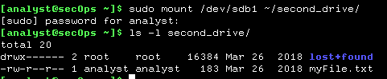
Figure 11: Mounted Second Drive contents
d) The directory is no longer empty because it was filled by mounting the disk. The files are physically stored in a /dev/sdb1 partition on root.
e) Figure 12 shows the output of the /dev/sd filesystem.
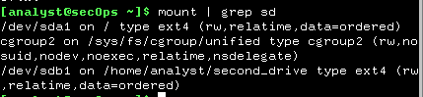
Figure 12: Output of the show /dev/sd filesystem
f) The ‘umount’ command was used to unmount the second drive and Figure 13 shows that this was successful.
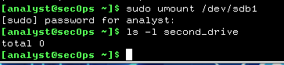
Figure 13: Successful Unmount of Second Drive
Part 2: File Permissions
File permissions restrict who can access files and what they can do with the files they can access and can be used as basic security measures. There are three user-based permission types as set out in Figure 14 [27], [28].
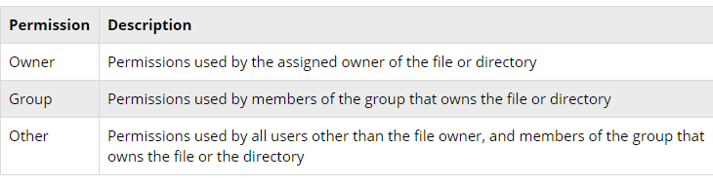
Figure 14: Permission Groups [28]
There are also Access Permission Types as shown in Figure 15.
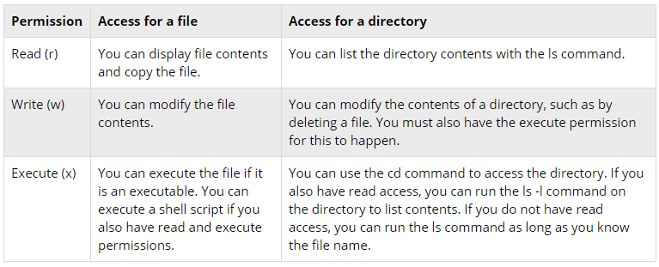
Figure 15: Access Permissions [27]
Step 1: Visualize and Change File Permissions
a) Navigate to the
/home/analyst/lab.support.files/scripts/ this was done by using the change directory (cd) command as shown in Figure 16.

b) Use the ls -l command so the file permissions are displayed as shown in Figure 16.
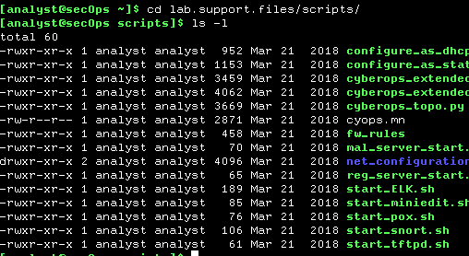
Figure 16: Change Directory and List Files
The cyops.mn file is owned by analyst as shown in Figure 17.
Figure 17: Details of Cyops.mn File
The owner and group are ‘analyst’.
Permissions are
r – read
w – write
x – execute.

The permissions read from left to write and are owner permission, in this case ‘rw’, the second is group permissions and is ‘r’ and the third set is for all other users and is also set to ‘r’. This means that the permissions are to read or write for the owner and the group or other users can read only.
c) To create an empty text file the command is ‘touch’. The touch command was used in the mnt directory as follows and set out in Figure 18. Which was unsuccessful as permission was denied. touch /mnt/myNetfile.txt.

Figure 18: Access Permission Denied
Figure 19 shows that only the root has permissions to change anything within this directory.
Figure 19: Permissions List
Figure 20 shows that if ‘sudo’ is added before the command and the password entered, this can now be created.
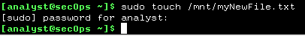
Figure 20: Creation of File using Sudo
d) The command ‘chmod’ is used to change file or directory permissions. Figure 21 shows the second drive being mounted and a list made of its contents.
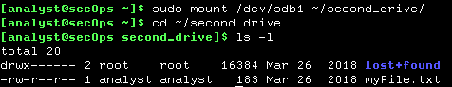
Figure 21: Read & Write Permissions of Second Drive
e) Permissions of the file myFile.txt are read and write for the analyst.
f) Change of Permissions: each file contains an octal (8-bit) format that controls permissions. Therefore 000 states that no permissions of any kind can be granted. A read permission would add 4-bits and would read as 100 in binary. A write permission adds 2-bits making it 010 and execute permissions add 1-bit making it 001. If the permission section is a ‘-’ then this means that there are no permissions allowed for [27].
To set up a permission the numbers are added eg read = 2 and write = 4 therefore to issue a permission for read and write the number 6 would be written as shown in Figure 22.
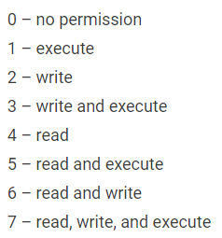
Figure 22: Permission Formats [27]
‘chmod’ is used to change the permissions using 665 as shown in Figure 23.
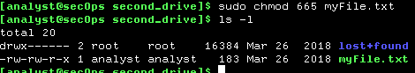
Figure 23: Change of Permissions
Therefore 665 represents a 6 for the owner, 6 for the group and 5 for the other. To grant all permissions for each group chmod 777 would be required.
g) The ‘chown’ command is short for change ownership. This was used as shown in Figure 24. An attempt was made to add the word ‘test’ to the end of myFile which failed as the disk, although accessed, was not mounted.
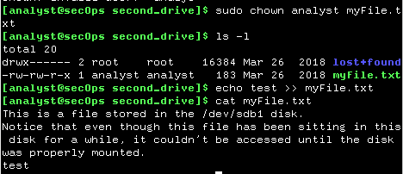
Figure 24: Adding 'text' to the end of a file
Step 2: Directory of Permissions
a) In the same way as files, directories follow a similar pattern of permissions as shown in Figure 25.
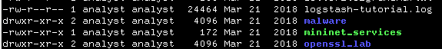
Figure 25: Directory Permissions
The difference between the files malware and mininet is the ‘d’ at the beginning of the permissions list denoting that it is a directory not a file. Some directories are executable files so that it can run a script or program, and this is represented by the final ‘x’.
Part 3: Symbolic Links and Special File Types
There are 7 types of file type placed at the start of the permissions layout as per Figure 26.
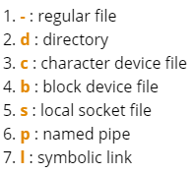
Figure 26: Seven Linux File Types [27]
The regular file and directory are self-explanatory. The character and block device allow programs and users to communicate with peripheral hardware devices such as virtual machines. In a similar fashion block device govern hardware eg memory and hard drives. To communicate between processes a local domain socket is required eg syslog or Xwindows. To communicate between two local processes, local sockets would be used, they are sometimes referred to as ‘named pipes.
The symbolic links are used by administrators to assign files or directories to multiple identities as though they were a pointer to the original file. The two types of symbolic links are hard and soft with the soft link using the file name and the hard link using direct referencing to the original. The drawback with a hard link is that it cannot cross partitions or file systems [27].
Step 1: Examine the file types
a) Figure 27 shows the d indicating a directory.
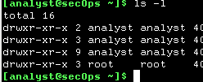
Figure 27: Directory Files
b) Figure 28 shows outputs of ‘b’ – block, ‘c’ – character and the symbolic link is represented by an ‘l’.
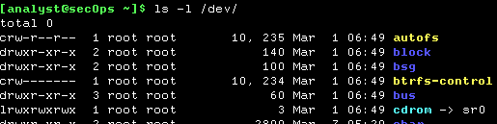
Figure 28: Directory Outputs
c) Two files, one with a hard link and the other with a soft link as shown in Figure 29.
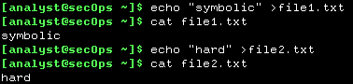
Figure 29: Hard and Soft Links
d) In Figure 30, -s is used to create a symbolic link to file1.txt and ln to create hard link.
Figure 30: Soft and Hard Links
The resulting output (Figure 31) shows a ‘l’ in the first line for the soft symbolic link but nothing by the hard link. It just points to the same inode when looking for it.
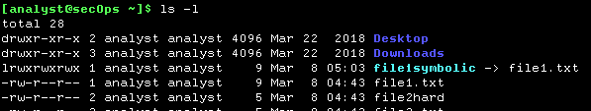
Figure 31: Soft and Hard Symbolic Links
f) The file names were then changed and only the hard file was still able to be found as it pointed to the inode not the name.
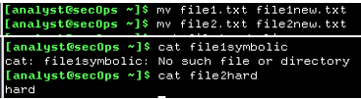
Reflection
File permissions are an essential part of Linux and safety features as if a user can gain permissions to change details they could potentially exclude authorised persons from gaining access, delete them or move them so it would be difficult to access them and so disrupt normal working procedures.

Lab 2: 7.3.2.5 Reading Log Servers
Log files are used to monitor and troubleshoot events and each application generates their own with specific details that apply to that application. The tools used to read them are usually text editors. The events are triggered by services. applications or operating systems.
These logs can assist with optimising network performance, keep a record of which user performs which action and log user authentication challenges or possible attacks [29].
Part 1: Log File Commands: Cat, More and Less
Step 1: a) was carried out to show an operation of the ‘cat’ command (concatenation) that generated an enormous amount of information as shown in Figure 32.
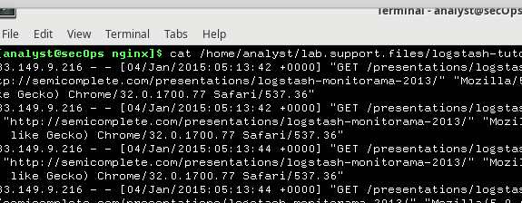
Figure 32: Output of Concatenation File Details
b) the drawback of using the ‘cat’ command with large text files is that it brings back everything and is difficult to look through.
c) another way of requesting this data is by using the ‘more’ command which generates the same results but with a page break that allows the viewer to see the contents one page at a time and to scroll through page by page using the space bar outlined in Figure 33.

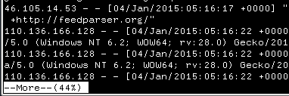
Figure 33: Output from 'More' Command
d) the ‘less’ command still generates too much information as shown in Figure 34.
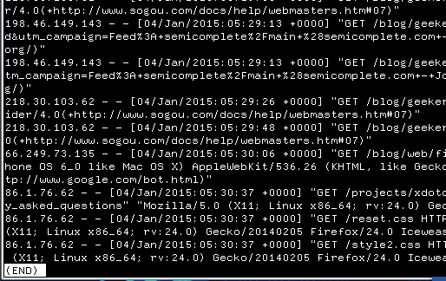
Figure 34: Output from the 'Less' Command
e) the ‘tail’ command displays the last ten lines of a file which will allow the viewer to see if the file is of any importance to them before viewing all the document, Figure 35.
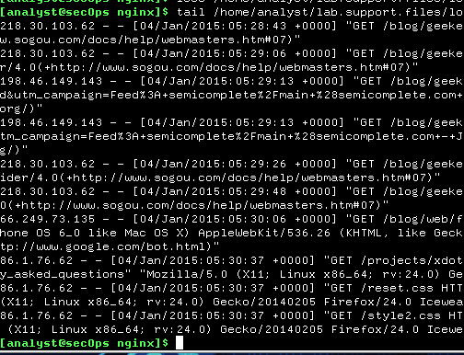
Figure 35: Output Generated by 'Tail' Command
The tail command can be configured to have as many lines as required but the default is 10.
Step 2: a) the difference between the tail command and the tail -f command is that one gives the last few lines and the other displays the last few lines and then continues to monitor the file. New lines are display when any updates are made.
b) when a web browser of ‘echo’ command is written to the log, tail -f should change its output.
Part 2: Log Files and Syslog
a) The ‘sudo’ (superuser do) command was required because the system logs (syslogs) require the user to escalate their privileges to ‘root’ user which is the highest in Linux.

b) It was noted that the /var/log/syslog file periodically rotated their logs and only stored recent entries to enable it to be kept small.

c) The reason for keeping time and date logs correctly synchronised is that if someone wanted to refer to data kept within the logs then they would request data by time and date.

Part 3: Log Files and Journalctl

Step 1: a) The journalctl command was used to log at entry logs stored in the binary log files, Figure 36.

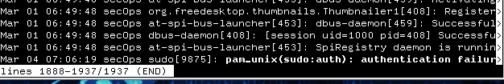
Figure 36: Use of the Journalctl Command
b) using sudo and the journalctl command will display even more detailed information.
Step 2: a) there are different options with in journalctl to display different aspects such as journal -utc will display the timestamps, although this will require the sudo prefix, Figure 37.
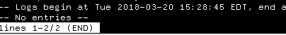
Figure 37: The Journalctl Command plus – UTC
b) Figure 38 illustrates that journalctl can also be used to specify the timeframe for log entries for specific service logs. journalctl can be used to display entries from the last boot using -b.
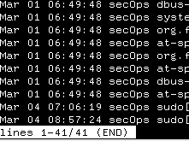
Figure 38: Entries from Last Boot Time
c) Figure 39 shows log entries for the file nginx today.
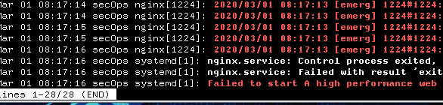
Figure 39: Service Logs for Today for NGINX
d) Figure 40 displays the outcome when a -k is used which changes the display to kernel logs.
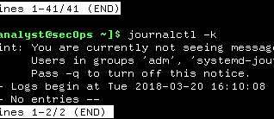
Figure 40: Journalctl -k results
e) In the same way as tail -f the journalctl command can be a continuous process of activity logs, detailed in Figure 41.
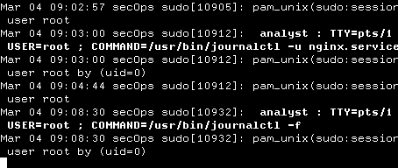
Figure 41: journalctl used with -f
Reflection
Syslogs appear to cover more details but this could give too much information whilst Jounrnalclt allows the systems to be parsed and only specific details to be returned.
The logs can aid an organisation in investigating performance issues, security monitoring to establish that the Internal Policies are being followed. The main use is for searching for known threats, vulnerabilities, or attacks.

Lab 3: 9.1.1.7 Encrypting and Decrypting Data using a Hacker Tool
Encryption is the conversion of data into cipher text and occurs when it is passed through specific software to make it unreadable without a decryption key, Figure 42 [30], [31].
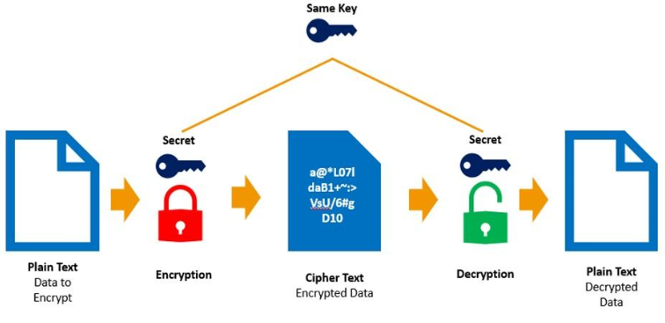
Figure 42: Symmetric Encryption/Decryption [31]
Part 1: Create and Encrypt Files
Step 1: a) A terminal window was opened.
b) The analyst home directory was attained
c) A folder named Zip-Files was created, Figure 43.
d) The cd command was used to move into that directory, Figure 43.
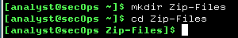
Figure 43: Zip-Files were created
e) Three text files were created, Figure 44.
Figure 44: Text Files
f) Verification that the files were created, Figure 45.
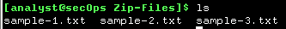
Figure 45: List of Files Created
Step 2: a) An encrypted zip file was created, Figure 46.
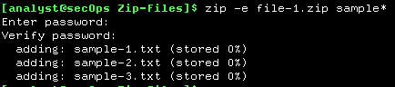
Figure 46: Zip-File Creation
c) 4 more files were created using the same procedure, Figure 47.
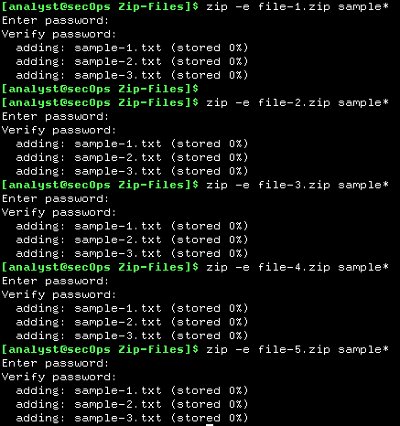
Figure 47: List of Created Files
d) Verification that the files were created is shown in Figure 48.
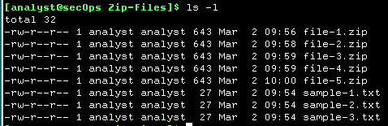
Figure 48: Verification of File Creation
e) To prove that it would not open without the correct password an incorrect password was entered, Figure 49.
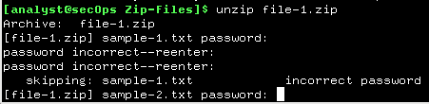
Figure 49: Password Incorrect
Part 2: Recover Encrypted Zip File Passwords
The zipped files were created with passwords of different lengths and strengths to see if this would influence the time it took to crack them.
Step 1: a) Using fcrackzip and a one-letter password, it was found instantaneously, Figure 50.
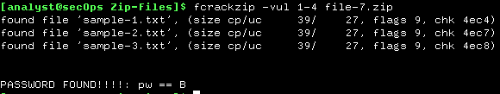
Figure 50: One-Letter Password Decryption
b) The two-letter password was decrypted equally as quickly, Figure 51.
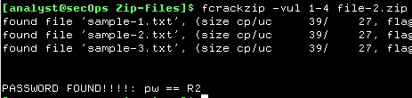
Figure 51: Two-Letter Password
c) The three-letter password was also decrypted quickly, Figure 52.
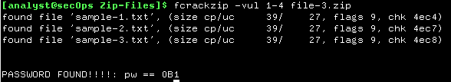
Figure 52: Three-Letter Password
d) The four-letter password took longer, about 15 seconds, Figure 53.
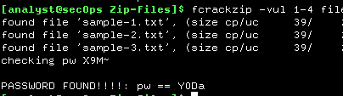
Figure 53: Four-Letter Password
e) the five-letter password took substantially longer, 4 minutes.
f) There is a direct correlation to the length of the password and the time taken to crack it, therefore it is suggested that there is a minimum length of characters for a password to be secure.
g) a six-letter password was created, and it was observed that it took 10 minutes for the cracker to decipher it.
Reflection
The current recommendation for password lengths is between 12 and 16 characters plus the use of capitals and lower case, numbers, and special symbols to make it more difficult to crack.

Lab 4: 12.4.1.1 Interpret HTTP and DNS Data to Isolate Threat Actor
MySQL is an open source Relationship Database Management System which uses Structured Query Language (SQL) to access, manage and add content in databases. SQL Injection is used by attackers to allow malicious SQL statements to be executed to control a web application database server. Domain Name Servers (DNS) provide the Internet Protocol address when queried with a human-readable address/name as per Figure 54 [32], [33].
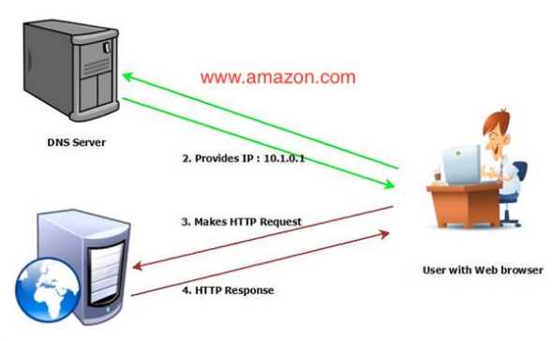
Figure 54: Domain Name Server [32]
SQL Injection attacks often use DNS to exfiltrate data [33].
Part 1: Preparation of the Virtual Environment
a) The Security Onion virtual machine was imported as illustrated in Figure 55.
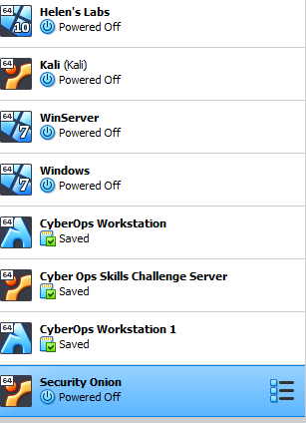
Figure 55: Security Onion Virtual Machine
b) The Security Onion virtual machine (VM) was launched.
c) Login and password were entered to enable access to the WM, Figure 56.
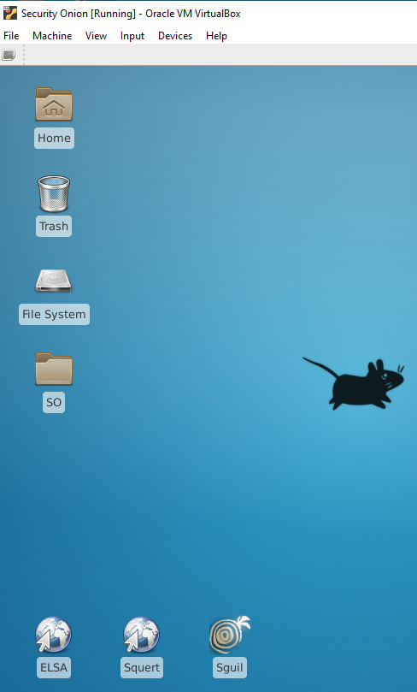
Figure 56: Security Onion Running
d) the ‘sudo service nsm status command’ was entered to ensure that the servers and sensors were available, Figure 57.
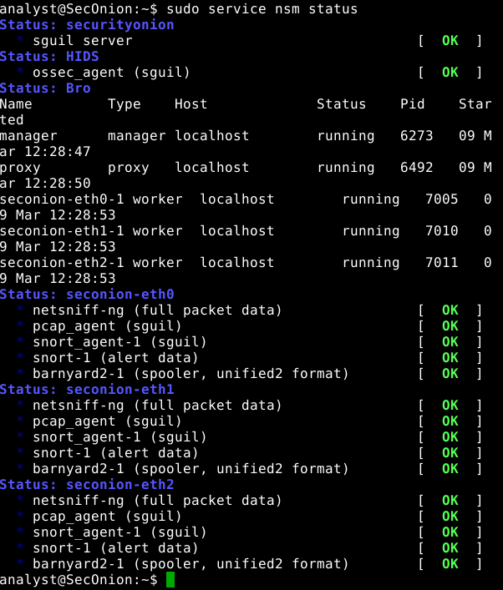
Figure 57: Verification of sguil Server Running
Part 2: Investigate an SQL Injection Attack
Step 1: a) The Sguil logs were checked, Figure 58.
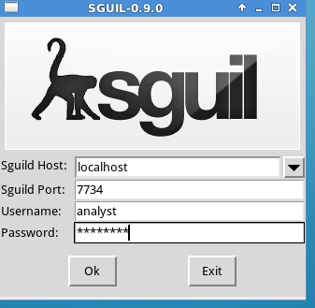
Figure 58: Sguil was opened
b) All the networks to be monitored were selected, Figure 59.
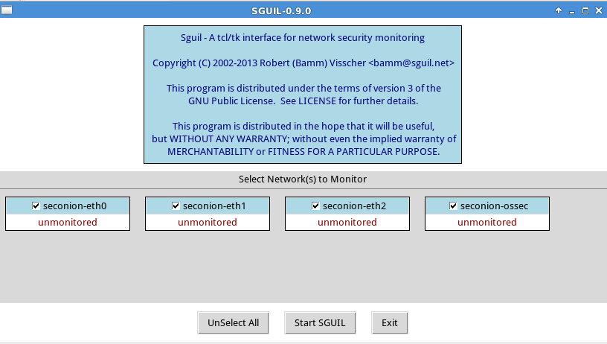
Figure 59: All Networks to be Monitored
c) The show packets and show rules were selected, Figure 60.
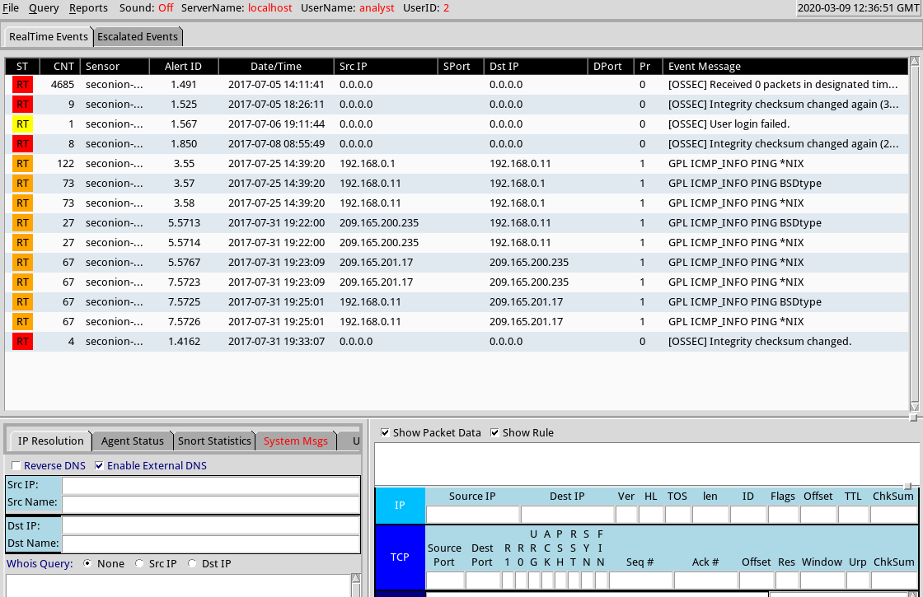
Figure 60: Show Packet Data and Rules
d) Alerts relating to ET WEB_SERVER Possible SQL Injection Attempt were looked for, Figure 61.
Figure 61: Alerts
e) Correlated events were looked for on Alert ID 3.55, Figure 62.
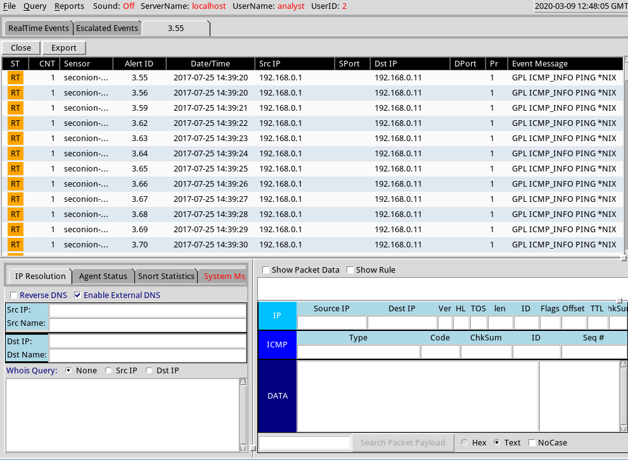
Figure 62: Correlated Events
Figure 63 shows that the checksum was changed.
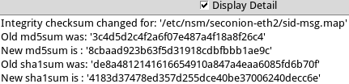
Figure 63: Checksum Differences
g) Credit card details were obtained as can be seen in Figure 64.
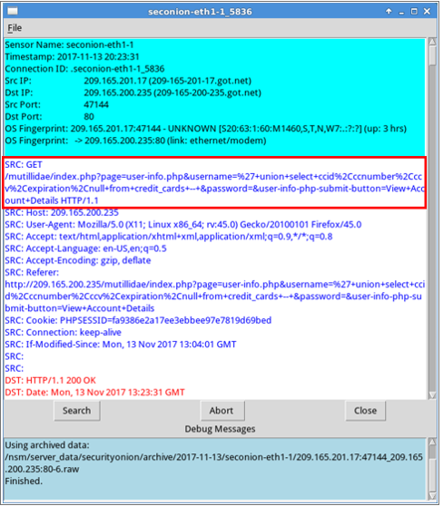
Figure 64: Credit Card Information
The word username was searched for using the find button and again credit card information can be seen, Figure 65.
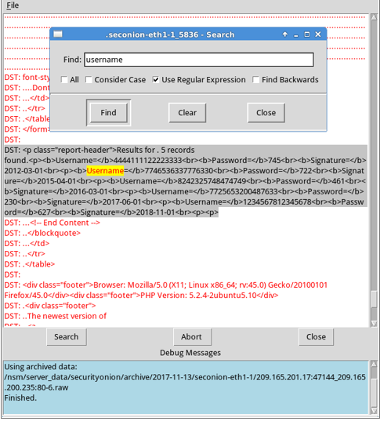
Figure 65: Find Username
j/k) Wireshark was used to follow the TCP stream, Figures 66 and 67.
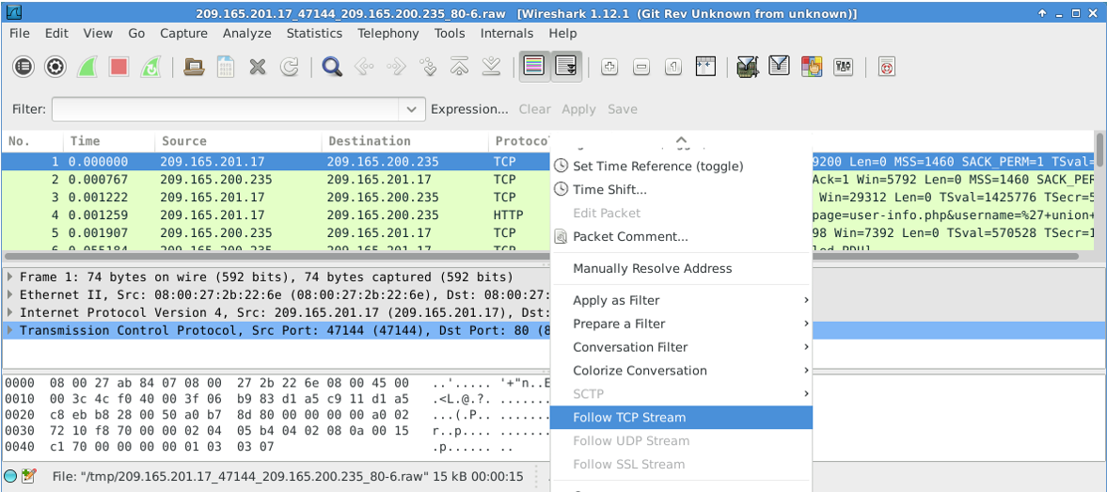
Figure 66: Wireshark
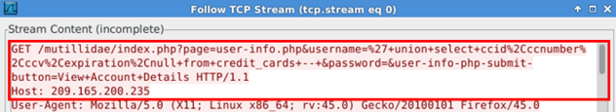
Figure 67: Follow TCP Stream
Conclusion
The source and destination internet addresses, ports, time, and date of any incidents together with the protocols can be logged for security or later analysis.
Step 2: Review ELSA Logs
a-e) The application ELSA was logged into and the HTTP Top – Potential SQL Injection was selected, and the address 209.165.200.235 was selected, Figure 68.
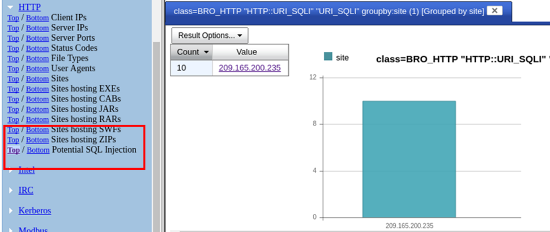
Figure 68: ELSA HTTP Selection
f) Figure 69 shows detailed information about the alert.
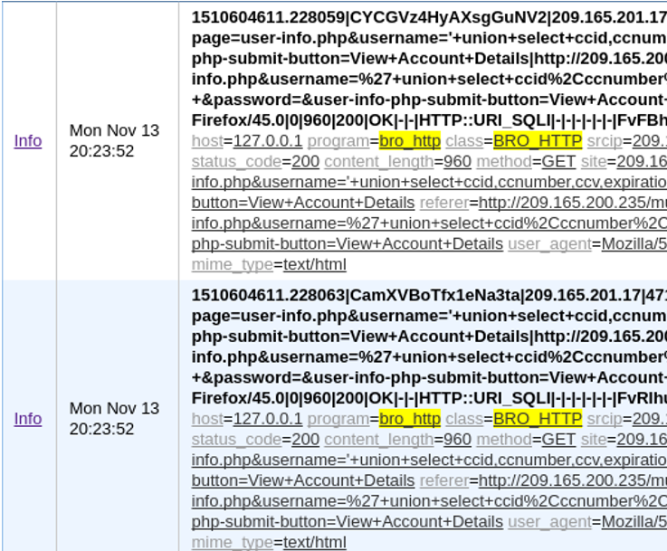
Figure 69: Detailed Information of Alert
g/h) Username information was searched for, Figure 70.
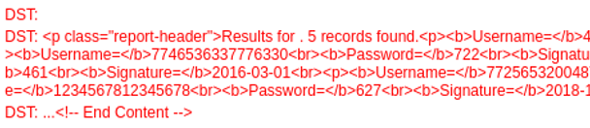
Figure 70: Username Found
Step 3: Analysing Data Exfiltration
a-c) Select the DNS/Bottom on the Requests, Figure 71.
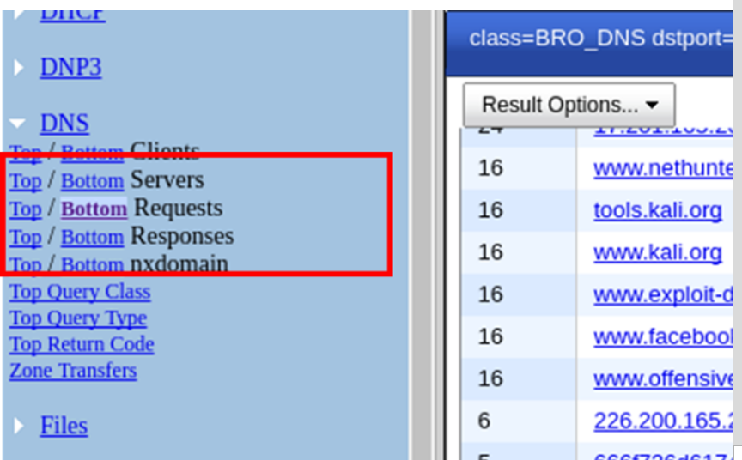
Figure 71: DNS 'Bottom' Requests
Figure 72 shows suspicious activity as the first section is usually a name as Figure 70 and not a string of hexadecimals.

Figure 72: Suspicious Activity
e) Click one of the suspicious links and copy the hexadecimals, Figure 73.
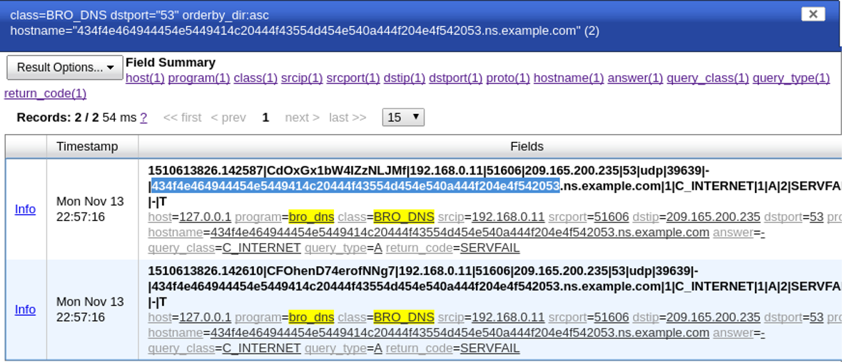
Figure 73: Hexadecimal Link
f) A new terminal window was opened and the echo -n command used for the hex string to be reverted, Figure 74.
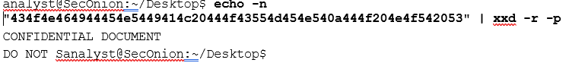
Figure 74: Hex String Reverted

Part 2: Synthesize a solution to a potential real-life scenario

Background
A smart campus was created in Packet Tracer, a simulation tool, that would be used to analyse security techniques.

Design
The campus layout is set out in Figure 75, with a larger version set out in Appendix I.
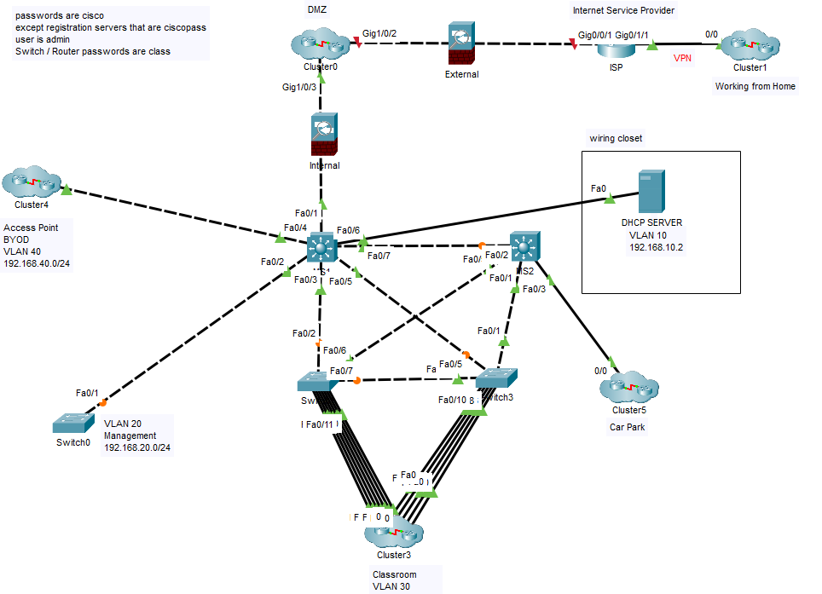
Figure 75: Campus
The hierarchical approach allows users to connect to the network via the access layer. The distribution layer is the connection point between the access layer and the core layer. The core layer is a high-speed backbone that connects to the Internet. The switches are interconnected to allow for redundancy which means that the network is available if a path or device fails or is unavailable.

Firewalls, Demilitarized Zone, and the Internet
There is a Firewall between the Internet Service Provider (ISP) and the servers that are required by external users creating a perimeter network, known as a Demilitarized Zone (DMZ), Figure 76. If a service such as web server, email, DNS, proxy servers VOIP or FTP is provided to a user on the public internet it needs to be put in a DMZ network as these systems are extremely vulnerable to hackers.
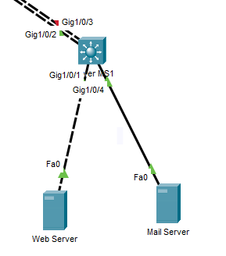
Figure 76: Demilitarized Zone
Figure 77 illustrates the DMZ cluster in Packet Tracer.
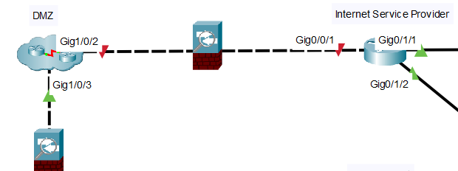
Figure 77: DMZ Cluster
The internal firewall would be configured to only allow traffic from the DMZ into the Local Area Network. An alarm would be set off if the external firewall was breached to allow enough time to avoid a full breach [34].
Firewalls would be configured with IDPS (Chapter 6.3), SIEM (Chapter 6.4) and would be kept in a locked server room (Chapter 6.1).
Cisco Packet Tracer crashed when the firewalls were connected and configured so the author has put them in place without connections to indicate their position within the configuration.
Figure 78 illustrates the wiring closet which was set apart for purely illustrative purposes. In a real world scenario this would be held securely in the same server room as the firewalls and DMZ.
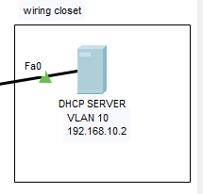
Figure 78: Wiring Closet

Basic Security on Switches/Router
The switches were configured with basic security measures as set out in Figure 79. The commands ensure that when presented with the login a password is required. The password is encrypted so that it is not in plain text if a ‘running configuration’ command is entered or if someone is for example looking over your shoulder. For ease of use all of switch/router passwords are ‘class’. Chapter 6.11 sets out password requirements that would have been used in a real-world environment.
The user is also presented with a message informing them that ‘Unauthorised Access is Prohibited’ so they know that they are not supposed to try and access this area.
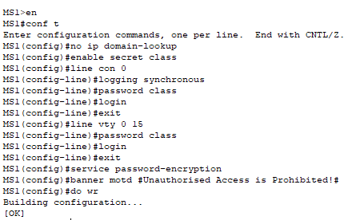
Figure 79: Switch Security
The routers were configured with executive timeout of 5 minutes as per Figure 80. This means that if the console is idle for more than 5 minutes the user has to log back in.
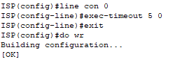
Figure 80: Timeout Session

Wireless Security
Figure 81 documents the SSID for the car park, again this would not be that simple in a real-world scenario. The password would also be changed but is currently ciscopass, using WPA2-PSK as set out in Chapter 6.10.
This ensures that anyone who does not have the SSID and password cannot access the network.
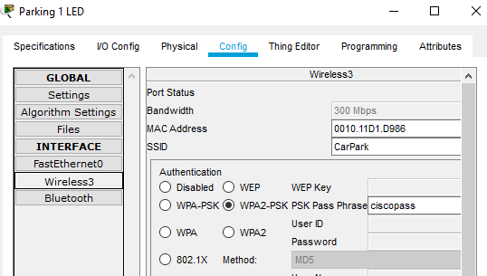
Figure 81: Wireless Security

Bring Your Own Device
This works on the same way as wireless whereby the user can either log in via wireless or ethernet cable. Passwords, ACLs and VLANs control where the user can move within the campus network. Strict policies need to be in place as these place networks at risk and can be found in Chapter 6.12

Smart Classroom
Figure 82 demonstrates key elements that would be found in a smart classroom such as a thermostat, a smoke detector that would trigger an alarm if smoke was detected. For enhanced security, the IoT devices were hardwired rather than using wireless technologies.
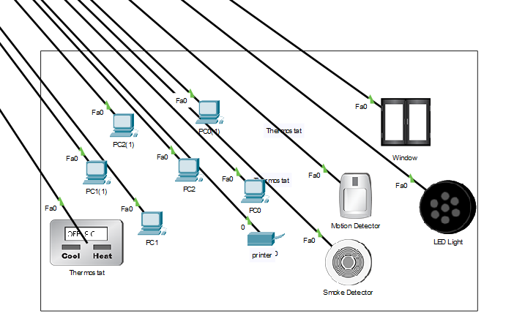
Figure 82: Smart Classroom
The IoT devices were connected to the Registration Server as shown in Figure 83.
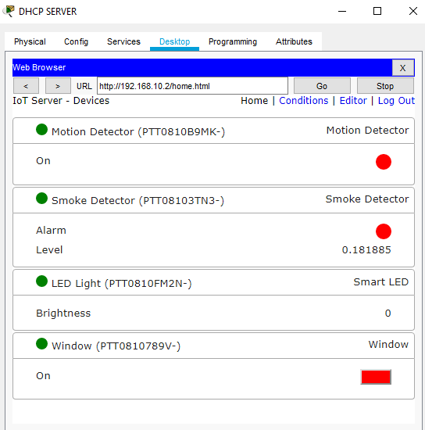
Figure 83: Classroom IoT
Figure 84 illustrates the Dynamic Host Configuration Protocol server working by giving PC1 an IPv4 IP address automatically.
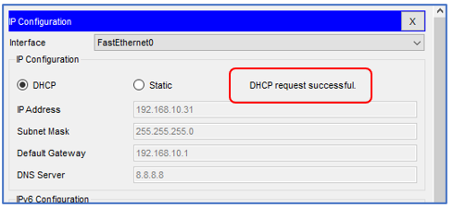
Figure 84: DHCP Request Successful

Working from Home
Working from home is permitted with the use of a VPN as set out in Chapter 6.7. The author was unable to set this up to work in Packet Tracer, but a label was put where this would be in play for illustrative purposes as set out in Figure 85.
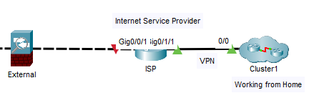
Figure 85: VPN
Figure 86 sets out the home worker’s typical office setup with the printer and laptop being wirelessly connected to the Home Gateway which then traverses the VPN to connect with the Campus.
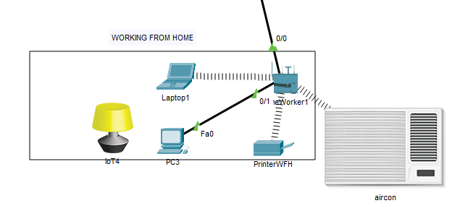
Figure 86: Working from Home

Car Park
A car park was designed as set out in Figure 87. The RGB lights indicate when a car is parked in a bay it turns red and then it is green when empty.
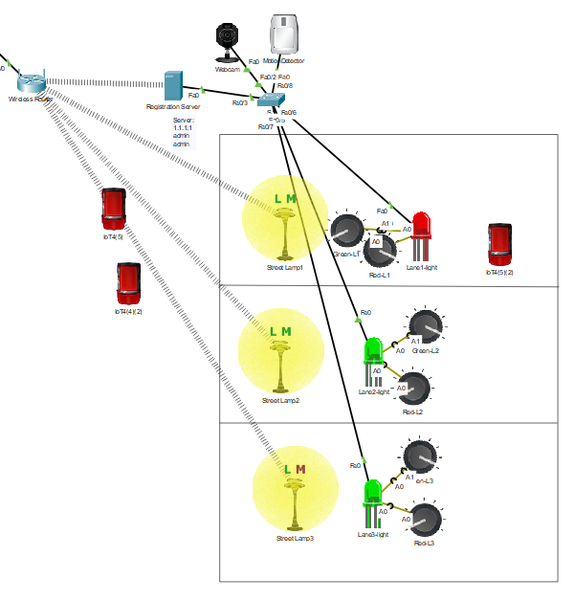
Figure 87: Car Park

Network Simulation
Packets were sent to simulate movement throughout the campus network as illustrated in Figures 88 and 89.
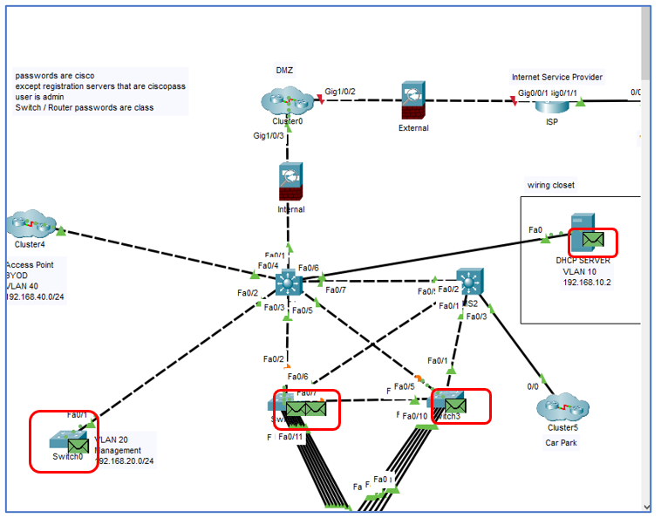
Figure 88: Packets moving through network
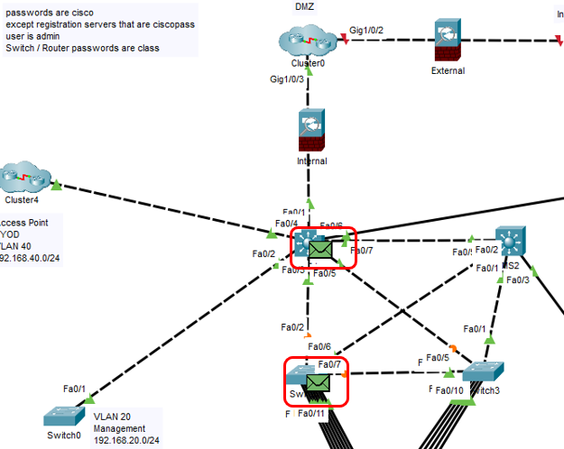
Figure 89: Packets moving through network (ii)

Conclusion
Campus networks, like any network, have their own security related issues. Many of these can be mitigated by using correct security techniques, such as the use of a DMZ, Firewalls, IDPS and SIEMS and all unused ports shut down. Physical breaches can be minimized by putting all servers and other related hardware into a locked room that has limited access.
Wireless devices need to be configured using SSIDs and WPA2-PSK AES standards. BYOD needs to be configured with strict access control to only the areas that are necessary using an Access Control List. The ACL is also configured to deny access to the servers or management areas.
Passwords are required for every device (including routers and switches) and need to be updated regularly. They must conform with the policies set out for them. SSH must be used for remote access to the servers by the administrators. Idle connection time is limited to 5 mins before a new login in required. Login attempts are limited to prevent brute force attacks.
Working from home requires that a Virtual Private Network tunnel be used for encryption purposes.
Virtual Local Area Networks are used to compartmentalise data between departments.
Social engineering tactics are explained to all new network users and reminders are sent to all existing users on a regular basis.
Network flow is monitored for attempts to enter the network surreptitiously or for exfiltration of data or for unusual traffic.

Bibliography

[1] “Cybersecurity: What Everyone Needs to Know - Peter W. Singer, Allan Friedman - Google Books.” [Online]. Available: https://books.google.co.uk/books?hl=en&lr=&id=f_lyDwAAQBAJ&oi=fnd&pg=PP1&dq=cyber+security&ots=DmsZYMvAnh&sig=fM-KPt5cqw2rNmY2DnotR7Pih5M&redir_esc=y#v=onepage&q=cyber security&f=false. [Accessed: 28-Feb-2020].
[2] M. K. Rogers, “A two-dimensional circumplex approach to the development of a hacker taxonomy,” Digit. Investig., vol. 3, no. 2, pp. 97–102, 2006.
[3] I. Governance, “What is Cyber Security?” [Online]. Available: https://www.itgovernance.co.uk/what-is-cybersecurity. [Accessed: 18-Feb-2020].
[4] “review articles Cyber Security in the Quantum Era.”
[5] H. Ning, H. Liu, and L. T. Yang, “Cyberentity security in the internet of things,” Computer (Long. Beach. Calif)., vol. 46, no. 4, pp. 46–53, 2013.
[6] R. Roman, P. Najera, and J. Lopez, “Securing the Internet of things,” Computer (Long. Beach. Calif)., vol. 44, no. 9, pp. 51–58, Sep. 2011.
[7] “1: Smart cities definitions | Centre for Cities.” [Online]. Available: https://www.centreforcities.org/reader/smart-cities/what-is-a-smart-city/1-smart-cities-definitions/. [Accessed: 22-Feb-2020].
[8] J. Pan, S. Paul, and R. Jain, “A survey of the research on future Internet architectures,” IEEE Communications Magazine, vol. 49, no. 7. pp. 26–36, Jul-2011.
[9] S. L. Keoh, S. S. Kumar, and H. Tschofenig, “Securing the internet of things: A standardization perspective,” IEEE Internet Things J., vol. 1, no. 3, pp. 265–275, Jun. 2014.
[10] S. P. Mohanty, U. Choppali, and E. Kougianos, “Everything you wanted to know about smart cities,” IEEE Consum. Electron. Mag., vol. 5, no. 3, pp. 60–70, Jul. 2016.
[11] “The Complete List Of Wireless IoT Network Protocols.” [Online]. Available: https://www.link-labs.com/blog/complete-list-iot-network-protocols. [Accessed: 29-Feb-2020].
[12] “Secure by Design - GOV.UK.” [Online]. Available: https://www.gov.uk/government/collections/secure-by-design. [Accessed: 18-Feb-2020].
[13] “1: Smart cities definitions | Centre for Cities.” [Online]. Available: https://www.centreforcities.org/reader/smart-cities/what-is-a-smart-city/1-smart-cities-definitions/. [Accessed: 04-Nov-2019].
[14] “Smart City Framework.” [Online]. Available: https://pages.nist.gov/smartcitiesarchitecture/. [Accessed: 20-Feb-2020].
[15] “IES Cities Architecture | NIST.” [Online]. Available: https://www.nist.gov/el/cyber-physical-systems/ies-cities-architecture.

[16] T. Winchcomb, S. Massey, and P. Beastall, “Review of latest developments in the Internet of Things Client: Ofcom Riverside House 2a Southwark Bridge Road London SE1 9HA,” 2017.
[17] “What is security? - Definition from WhatIs.com.” [Online]. Available: https://searchsecurity.techtarget.com/definition/security. [Accessed: 18-Feb-2020].
[18] K. Krombholz, H. Hobel, M. Huber, and E. Weippl, “Advanced social engineering attacks,” J. Inf. Secur. Appl., vol. 22, pp. 113–122, Jun. 2015.
[19] A. Ferreira, L. Coventry, and G. Lenzini, “Principles of Persuasion in Social Engineering and Their Use in Phishing.”
[20] “Virtual private networks - IEEE Journals & Magazine.” [Online]. Available: https://ieeexplore.ieee.org/abstract/document/913204. [Accessed: 24-Apr-2020].
[21] F. Salahdine and N. Kaabouch, “Social engineering attacks: A survey,” Future Internet, vol. 11, no. 4. MDPI AG, 2019.
[22] “Dynamic path selection using access control lists via border gateway protocol,” 2010, pp. 1–1.
[23] J. N. Davies, P. Comerford, and V. Grout, “future internet Principles of Eliminating Access Control Lists within a Domain,” Futur. Internet, vol. 4, pp. 413–429, 2012.
[24] “Bring Your Own Device (BYOD) - NCSC.GOV.UK.” [Online]. Available: https://www.ncsc.gov.uk/collection/mobile-device-guidance/bring-your-own-device. [Accessed: 02-May-2020].
[25] “Introduction to Sound Programming with ALSA | Linux Journal.” [Online]. Available: https://www.linuxjournal.com/article/6735. [Accessed: 26-Mar-2020].
[26] “Introduction to mounting filesystems in Linux.” [Online]. Available: https://www.bleepingcomputer.com/tutorials/introduction-to-mounting-filesystems-in-linux/. [Accessed: 07-Mar-2020].
[27] “Understanding Basic File Permissions and ownership in Linux – The Geek Diary.” [Online]. Available: https://www.thegeekdiary.com/understanding-basic-file-permissions-and-ownership-in-linux/. [Accessed: 07-Mar-2020].
[28] “Understanding Linux File Permissions - Linux.com.” [Online]. Available: https://www.linux.com/tutorials/understanding-linux-file-permissions/. [Accessed: 07-Mar-2020].
[29] K. Kent and M. Souppaya, “Special Publication 800-92 Guide to Computer Security Log Management Recommendations of the National Institute of Standards and Technology.”
[30] “Best Free Encryption Software: 35+ Free Tools | Privacy.net.” [Online]. Available: https://privacy.net/best-free-encryption-software-tools/. [Accessed: 09-Mar-2020].
[31] “How does AES-256 encryption work to protect your data.” [Online]. Available: https://www.atpinc.com/blog/what-is-aes-256-encryption. [Accessed: 09-Mar-2020].
[32] “Understanding How DNS Works - the Domain Name System.” [Online]. Available: https://cloudacademy.com/blog/how-dns-works/. [Accessed: 09-Mar-2020].
[33] “What is MySQL Tutorial.” [Online]. Available: https://www.siteground.com/tutorials/php-mysql/mysql/. [Accessed: 09-Mar-2020].
[34] “How to stay safe and private when using public wifi - Privacy.net.” [Online]. Available: https://privacy.net/using-public-wifi-safely/. [Accessed: 22-Apr-2020].
[1] “Cybersecurity: What Everyone Needs to Know - Peter W. Singer, Allan Friedman - Google Books.” [Online]. Available: https://books.google.co.uk/books?hl=en&lr=&id=f_lyDwAAQBAJ&oi=fnd&pg=PP1&dq=cyber+security&ots=DmsZYMvAnh&sig=fM-KPt5cqw2rNmY2DnotR7Pih5M&redir_esc=y#v=onepage&q=cyber security&f=false. [Accessed: 28-Feb-2020].
[2] M. K. Rogers, “A two-dimensional circumplex approach to the development of a hacker taxonomy,” Digit. Investig., vol. 3, no. 2, pp. 97–102, 2006.
[3] I. Governance, “What is Cyber Security?” [Online]. Available: https://www.itgovernance.co.uk/what-is-cybersecurity. [Accessed: 18-Feb-2020].
[4] “review articles Cyber Security in the Quantum Era.”
[5] H. Ning, H. Liu, and L. T. Yang, “Cyberentity security in the internet of things,” Computer (Long. Beach. Calif)., vol. 46, no. 4, pp. 46–53, 2013.
[6] R. Roman, P. Najera, and J. Lopez, “Securing the Internet of things,” Computer (Long. Beach. Calif)., vol. 44, no. 9, pp. 51–58, Sep. 2011.
[7] “1: Smart cities definitions | Centre for Cities.” [Online]. Available: https://www.centreforcities.org/reader/smart-cities/what-is-a-smart-city/1-smart-cities-definitions/. [Accessed: 22-Feb-2020].
[8] J. Pan, S. Paul, and R. Jain, “A survey of the research on future Internet architectures,” IEEE Communications Magazine, vol. 49, no. 7. pp. 26–36, Jul-2011.
[9] S. L. Keoh, S. S. Kumar, and H. Tschofenig, “Securing the internet of things: A standardization perspective,” IEEE Internet Things J., vol. 1, no. 3, pp. 265–275, Jun. 2014.
[10] S. P. Mohanty, U. Choppali, and E. Kougianos, “Everything you wanted to know about smart cities,” IEEE Consum. Electron. Mag., vol. 5, no. 3, pp. 60–70, Jul. 2016.
[11] “The Complete List Of Wireless IoT Network Protocols.” [Online]. Available: https://www.link-labs.com/blog/complete-list-iot-network-protocols. [Accessed: 29-Feb-2020].
[12] “Secure by Design - GOV.UK.” [Online]. Available: https://www.gov.uk/government/collections/secure-by-design. [Accessed: 18-Feb-2020].
[13] “1: Smart cities definitions | Centre for Cities.” [Online]. Available: https://www.centreforcities.org/reader/smart-cities/what-is-a-smart-city/1-smart-cities-definitions/. [Accessed: 04-Nov-2019].
[14] “Smart City Framework.” [Online]. Available: https://pages.nist.gov/smartcitiesarchitecture/. [Accessed: 20-Feb-2020].
[15] “IES Cities Architecture | NIST.” [Online]. Available: https://www.nist.gov/el/cyber-physical-systems/ies-cities-architecture.
[16] T. Winchcomb, S. Massey, and P. Beastall, “Review of latest developments in the Internet of Things Client: Ofcom Riverside House 2a Southwark Bridge Road London SE1 9HA,” 2017.
[17] “What is security? - Definition from WhatIs.com.” [Online]. Available: https://searchsecurity.techtarget.com/definition/security. [Accessed: 18-Feb-2020].
[18] K. Krombholz, H. Hobel, M. Huber, and E. Weippl, “Advanced social engineering attacks,” J. Inf. Secur. Appl., vol. 22, pp. 113–122, Jun. 2015.
[19] A. Ferreira, L. Coventry, and G. Lenzini, “Principles of Persuasion in Social Engineering and Their Use in Phishing.”
[20] “Virtual private networks - IEEE Journals & Magazine.” [Online]. Available: https://ieeexplore.ieee.org/abstract/document/913204. [Accessed: 24-Apr-2020].
[21] F. Salahdine and N. Kaabouch, “Social engineering attacks: A survey,” Future Internet, vol. 11, no. 4. MDPI AG, 2019.
[22] “Dynamic path selection using access control lists via border gateway protocol,” 2010, pp. 1–1.
[23] J. N. Davies, P. Comerford, and V. Grout, “future internet Principles of Eliminating Access Control Lists within a Domain,” Futur. Internet, vol. 4, pp. 413–429, 2012.
[24] “Bring Your Own Device (BYOD) - NCSC.GOV.UK.” [Online]. Available: https://www.ncsc.gov.uk/collection/mobile-device-guidance/bring-your-own-device. [Accessed: 02-May-2020].
[25] “Introduction to Sound Programming with ALSA | Linux Journal.” [Online]. Available: https://www.linuxjournal.com/article/6735. [Accessed: 26-Mar-2020].
[26] “Introduction to mounting filesystems in Linux.” [Online]. Available: https://www.bleepingcomputer.com/tutorials/introduction-to-mounting-filesystems-in-linux/. [Accessed: 07-Mar-2020].
[27] “Understanding Basic File Permissions and ownership in Linux – The Geek Diary.” [Online]. Available: https://www.thegeekdiary.com/understanding-basic-file-permissions-and-ownership-in-linux/. [Accessed: 07-Mar-2020].
[28] “Understanding Linux File Permissions - Linux.com.” [Online]. Available: https://www.linux.com/tutorials/understanding-linux-file-permissions/. [Accessed: 07-Mar-2020].
[29] K. Kent and M. Souppaya, “Special Publication 800-92 Guide to Computer Security Log Management Recommendations of the National Institute of Standards and Technology.”
[30] “Best Free Encryption Software: 35+ Free Tools | Privacy.net.” [Online]. Available: https://privacy.net/best-free-encryption-software-tools/. [Accessed: 09-Mar-2020].
[31] “How does AES-256 encryption work to protect your data.” [Online]. Available:

https://www.atpinc.com/blog/what-is-aes-256-encryption. [Accessed: 09-Mar-2020].
[32] “Understanding How DNS Works - the Domain Name System.” [Online]. Available: https://cloudacademy.com/blog/how-dns-works/. [Accessed: 09-Mar-2020].
[33] “What is MySQL Tutorial.” [Online]. Available: https://www.siteground.com/tutorials/php-mysql/mysql/. [Accessed: 09-Mar-2020].
[34] “How to stay safe and private when using public wifi - Privacy.net.” [Online]. Available: https://privacy.net/using-public-wifi-safely/. [Accessed: 22-Apr-2020].

Appendix I: Smart Campus

Figure 90: Smart Campus

marking criteria and Student FEEDBACK

This section details the assessment criteria. The extent to which these are demonstrated by you determines your mark. The marks available for each criterion are shown. Lecturers will use the space provided to comment on the achievement of the task(s), including those areas in which you have performed well and areas that would benefit from development/improvement.

Common Assessment Criteria Applied (Assignment 1) | Marks available | Marks  awarded
1. Engagement with Literature Skills
Extent of research and/or own reading, selection of credible sources, application of appropriate referencing conventions.
Diversity of appropriate sources used with key concepts discusses. The appropriate referencing used. The peer reviewed articles could be more up to date. (Grade mark: 84.44%) | 45 | 38
2. Knowledge and Understanding Skills
Extent of knowledge and understanding of concepts and underlying principles associated with the discipline.
3. Cognitive and Intellectual Skills
Analysis, evaluation and synthesis; logic, argument and judgement; analytical reflection; organisation of ideas and evidence
You have linked most of your research analysis to how an organisation can aid in their defensive measures. Excellent documentation of your lab results; good reflection at the end of each analysis but not all link to how a company would benefit or could utilise these techniques. (Grade mark: 88.89%) | 45 | 40
4. Practical Application Skills
Deployment of methods, materials, tools and techniques; application of concepts; formulation of innovative and creative solutions to solve problems.
5. Transferable Skills for Life and Professional Practice
Attributes in professional practice: individual and collaborative working; deployment of appropriate media; presentation and organisation.
Very professional work that written, flow and organise excellently. (Grade mark: 90.00%) | 10 | 9

Assignment Mark (Assessment marks are subject to ratification at the Exam Board. These comments and marks are to give feedback on module work and are for guidance only until they are confirmed. ) | Late Submission Penalties (tick if appropriate) |  | 87%
 | Up to four weeks late |  | 87%
 | First Attempt? |  | 87%

marking criteria and Student FEEDBACK

This section details the assessment criteria. The extent to which these are demonstrated by you determines your mark. The marks available for each criterion are shown. Lecturers will use the space provided to comment on the achievement of the task(s), including those areas in which you have performed well and areas that would benefit from development/improvement.

Common Assessment Criteria Applied (Assignment 2) | Marks available | Marks  awarded
1. Engagement with Literature Skills
Extent of research and/or own reading, selection of credible sources, application of appropriate referencing conventions.
2. Knowledge and Understanding Skills
Extent of knowledge and understanding of concepts and underlying principles associated with the discipline.
You have demonstrated coherent knowledge and understanding of the subject area. The report structures excellently following the IEEE report format. (Grade mark: 90.00%) | 20 | 18
3. Cognitive and Intellectual Skills
Analysis, evaluation and synthesis; logic, argument and judgement; analytical reflection; organisation of ideas and evidence
Excellent documentation of the physical packet tracer design. How does this implementation combat or enhance challenges to the University; this could be interrelated more in your discussion. (Grade mark: 80.00%) | 20 | 16
4. Practical Application Skills
Deployment of methods, materials, tools and techniques; application of concepts; formulation of innovative and creative solutions to solve problems.
Your design was labelled (classroom, car park, BOYD, DMZ, ISP, etc.) for ease of understanding. Redundancy considered within the core. It emulated well the case study scenario. All tested areas work, pings were successful. Security measures implemented; firewalls, DMZ, passwords, etc. (Grade mark: 91.67%) | 60 | 55
5. Transferable Skills for Life and Professional Practice
Attributes in professional practice: individual and collaborative working; deployment of appropriate media; presentation and organisation.

Assignment Mark (Assessment marks are subject to ratification at the Exam Board. These comments and marks are to give feedback on module work and are for guidance only until they are confirmed. ) | Late Submission Penalties (tick if appropriate) |  | 89%
 | Up to four weeks late |  | 89%
 | First Attempt? |  | 89%

Backbone networks are the core infrastructure of a network system [12].
Attack signatures are data sequences that are known network intrusions.

