Reflective Account: Multi-Stakeholder Engagement

As a nurse, reflection has been the foundation of my nursing practice, with the Nursing and Midwifery Council (2021) encouraging nurses to reflect on their practise, and use the subsequent learning to identify areas for improvements. Appling this to my academic work through the use of the Gibbs (1988) Reflective Model, the following account will reflect upon my recent engagement with multiple stakeholders as part of service improvement project to digitise the Royal College of Physicians (RCP) (2017) bedside vision assessment tool.

Description
Prior to carrying out engagement events it was essential to identify major and key stakeholder and to categorise them according to their interaction with the tool. the subsequent undertaking of process mapping exercise, illustrated in Table 1. enabled me to develop bespoke communication and engagement strategies for each group was undertaken.
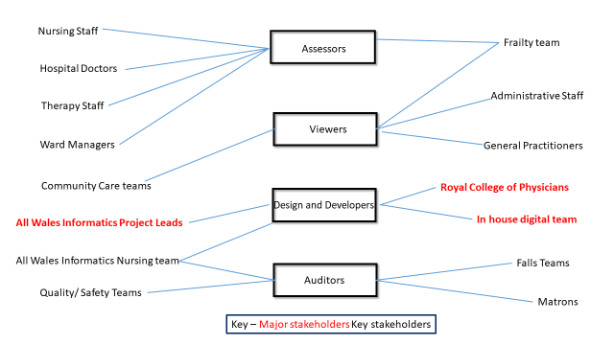Table 1 – Process Map identifying roll requirements

Prior to engagement with key stakeholders, major stakeholders (highlighted in red) were contacted via telephone, email and video conferencing to gain in principle support for the project. Due to the COVID pandemic and social distancing measures in Welsh hospitals, I was unable to hold face to face workshops or in person focus groups. In order to formulate user stories, key stakeholders were initially contacted via emailed, providing them with a description of the background of the project, and asking them to provide information relating to their role and how they would use a vision assessment tools.

This email was followed with an invitation to attend group specific video conferencing events to enable further elucidation of user requirements. Aware of the ongoing pandemic and staffing issues, I grouped together hospital staff and run several sessions for this group to maximum opportunities for engagement. These sessions were very useful, however, grouping together the staff into categories meant there were some very senior staff who very confident and freely expressed their opinions whilst other group members contributed little to the events.

Feelings
As part of the all Wales nursing team implementing the digital Welsh Nursing Care Record, I have significant experience of chairing local engagement meetings. Prior to engaging with stakeholders I had prepared evidence to support the use case for each category of stakeholder. I was confident I would be able to collect the information I needed from stakeholders and be able to gain their consensus for the introduction of the tool.
I felt it was important that the initial engagement with the RCP took place on a 1:1 basis, this allowed them to express their concerns and to ask questions. I was able to use my all Wales experience of working with 3rd party vendors to convert a paper document to a digital solution, assuring them that they would be involved in every stage of the design phase, and that the end product would match the same data standards as the paper tool.
I felt it was essential for nursing staff to engage and understand the rationale behind the development of the tool and to be involved in the design process. I didn’t want staff to feel that this was another document being added to nursing workload, especially as Beadle, Pinkney and James (2018) found that nurses in Wales were burdened with paperwork, with upto 72 documents for each admission.

Evaluation
All staff who attended the stakeholder events were provided with an agenda, a clear summary of the reason for the sessions and a terms of reference for the group. On reflection I feel the presence of senior staff who at times dominated the discussion prevented junior staff from expressing their opinions; I had expected staff to raise concerns relating to the extra workload, but none did, I felt they may have been more open if the senior staff were not present as they didn’t want to appear lazy or unable to manage their workload. I also felt that my senior sisters uniform may have inhibited communication. I have experienced this in practise, with staff not being open and honest when asked for feedback on digital systems, in contrast the digital team appear to get a more balanced opinion.

Analysis
Communication and interaction with stakeholders was essential to the success of the project, this is supported by Sermeus et al. (2016) identifies strategic stakeholder engagement as essential to successful design and implementation of digital solutions, and Knowles et al. (2021) found working directing with key stakeholders utilising human centred co design enabled them to anticipate barriers to implementation. Whilst Shaw et al. (2018) found involvement of stakeholders at every level including end users and those who will not directly use the system as essential to successful to implementation.

Haylor (2005) referring to policy change, identified several steps to help understand key issues with building consensus and securing change, illustrated in table 2.
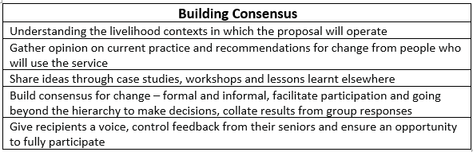
Table 2 – Building Consensus, Haylor (2005)
To achieve consensus, it was essential that all group members had a voice ensuring stronger characters did not dominate events was challenging, and easier to achieve in some sessions than others. As a trained coach I was able to use my coaching skills to elicit some responses from quieter members of the group and going around the group individually for comments helped, I also encouraged individuals to write in the group chat. Hirokawa and Poole (1996) describe how the unique chemistry of group social interaction can facilitate a creative environment leading to a resonance of idea and synthesis of viewpoints from all, whilst the chemistry of other groups can inhibit communication and prevent creativity: this was obvious in some of the sessions I chaired. For future events I feel I should start the session with a checklist, explaining that everyone’s opinion is important and empowering all to communicate openly.

Kraft (1997) identified 11 common pitfalls in gaining consensus, illustrated in table 4, reviewing these I feel I avoided most of these pitfalls, but feel that a mixed venue with differing staff grades present inhibited open communication. Shafritz et al. (2015) describes the inhibition of communication from junior staff members in the presence of managers as a deliberate suppression of thoughts due to fear of external threats of social punishment, Whilst, Syed (2015) highlighting this social hierarchy, found this can lead to mitigated language where staff don’t feel empowered to speak up, he suggests flattening the hierarchy so that all stakeholders can be heard. The resulting status inequality
associated with social hierarchy was identified by Taras and Rowney (2007) who state that inequality depends on a person position in an organisations formal hierarchy, with team
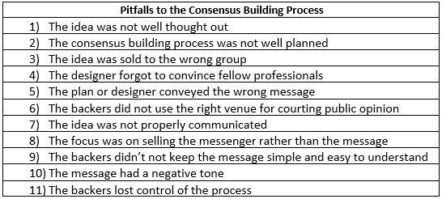
Table 3 -Pitfalls to the Consensus Building Process, Kraft (1997)
members with a higher status tending to assume control of a team even if they represent a minority, this was very evident in the sessions attended by senior medics and matrons.

Due to the group imbalance I felt there was a risk of Groupthink, Janis (1972) defines groupthink as the psychological drive for consensus at any cost, resulting in a defective decision making processes, where individuals performing collective tasks ignore alternatives and make irrational decisions. Janis (1983) identifies three types of Groupthink with eight symptoms illustrated in Table 4, he suggests that the more symptoms that are present the more likely a group is too make a poor decision, and that this inadvertent subtle constraint may prevent group members from openly expressing their doubts when influential group members have appeared to reach a consensus.

Analysing this situation, and reflecting on my recent experiences within my informatics role, I can identify an example of Type 3 Groupthink Janis (1983). In a recent review of a digital document, some group members expressed concerns about the functionality of the document, their doubts were minimised by the chair with direct pressure put on the dissenters to agree or risk delaying deployment of the document. Senior members
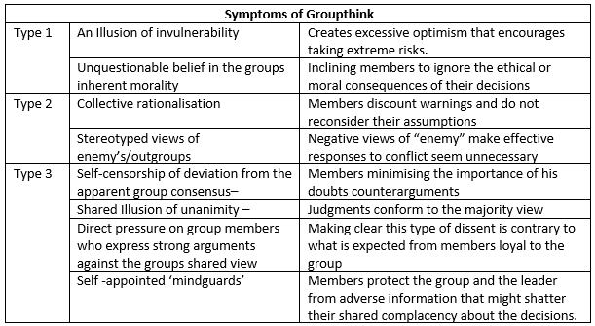
Table 4- Symptoms of Groupthink, Janis (1983)
expressed their happiness with the document, and the chair went forward with a shared illusion of unanimity and approved the release of the document. I feel if these concerns had been acknowledged and worked through we could have built consensus and all agreed a way forward, and ensured all present felt their opinion was valued and that their real life experiences of using similar documents were valued.

Conclusions -
This reflection has emphasised the importance of individualised stakeholders’ engagement and detailed the effects of social hierarchy within an organisation, relating this to the imbalance of communication between individuals has enabled me to formulate strategies for future events. The pitfalls of consensus building and the balance between consensus and groupthink has been highlighted, reflecting on how decisions can be indirectly influenced by the coercion of stronger team members, has enabled me to seen examples from by everyday practice, and how this can lead to decisions being made, which are not always the best for that situation. Finally, the COVID pandemic severely restricted communication strategies, I hope that for future stakeholder engagement I will be able to organise face to face focus group and workshops.
Action Plan
- Start future events with a checklist of rules for the meeting– everyone is equal, no suggestion is wrong

- Encourage attendees to use the chat facility or circulate an ideas document.

- Where possible keep staff groups separate to enable free speech.

- Use breakout rooms for mixed groups to enable team building and allow ideas to develop.

- Wear everyday clothes to flatten the social hierarchy

- Further my reading on the effects of social hierarchy, group think, consensus building and relate this to future stakeholder engagement.

- Review social distancing restrictions within NHS Wales to aim for face to face interactions where possible.

1599 words

Reference List

- Beadle. F, Pinkney. J, James. L (2018) Project Initiation - The digitisation of Nursing Documents (NHS Wales), (unpublished)
- Gibbs, G. (1988) Learning by Doing: A guide to teaching and learning methods. Further Education Unit. Oxford: Oxford Polytechnic.
- Haylor, G.(. (2005) 'Building Consensus, Policy Brief Number 1. Annex D1’, Final Technical Report of project R8363, available at https://assets.publishing.service.gov .uk/ media/57a08c88e5274a27b2001271/R8363Pol1.pdf (accessed on 5/05/2022).
- Hirokawa, R.Y.A. and Poole, S. M. (1996) Communication and group decision making. 2. ed. London: Sage Publications
- Janis, I.L. (1972) Victims of Groupthink, New York: Houghton Mifflin
- Janis, I.L. (1983) Groupthink, 2nd ed. Boston: Houghton Mifflin.
- Knowles, S.E. et al. (2021) 'Participatory co-design and normalisation process theory with staff and patients to implement digital ways of working into routine care: the example of electronic patient-reported outcomes in UK renal services', BMC Health Services Research, 21(1), pp. 1-706. available at: https://bmchealthservres.biomed central.com/track/pdf/10.1186/s12913-021-06702-y.pdf (accessed on 17/05/2022)
- Kraft, W.H. (1997) 'Building a Consensus: how tos and how not tos', Journal of Management in Engineering, 13(2). doi: https://doi.org/10.1061/(ASCE)0742-597X(1997)13:3(20). (accessed on 20/05/22)
- NMC (2021) Written Reflective Accounts, available at: https://www.nmc.org.uk/revalidation/requirements/written-reflective-accounts/ (accessed on 20/05/2022)
- Royal College of Physicians (2017) Look Out! Bedside Vision Check for Falls Prevention, available at: https://www.rcplondon.ac.uk/file/5551/download (accessed on 7/04/2022)
- Sermeus, W. et al. (2016) Nursing Informatics, Washington: IOS Press
- Shafritz, J.M. et al. (2015) Classics of organization theory. 8th ed, Boston: Cengage Learning.
- Shaw, J. et al. (2018) 'Beyond "implementation": digital health innovation and service design', NPJ Digital Medicine, 1(1), pp. 48. doi: 10.1038/s41746-018-0059-8. (accessed on 17/05/2022)
- Syed, M. (2015) 'Black Box Thinking' East Rutherford: Penguin Publishing Group.
- Taras, V. and Rowney, J. (2007) 'Effects of Cultural Diversity on In-Class Communication and Student Project team Dynamics: Creating Synergy in the Diverse Classroom', International Studies in Educational Administration, 35(2), pp. 66. available at: https://www.researchgate.net/profile/Jennie-Billot/ publication/43477192how_principals_manage_ethnocultural_diversity_Learnings_from_three_countries/links/00b49527a94ea31cbb000000/How-principals-manage-ethnocultural-diversity-Learnings-from-three-countries.pdf#page=71, (accessed on 15/05/2022)

