BMSW5013
Creativity and Innovation

Critically detailing and discussing an innovative/creative solution to an operational problem

Name: Sorina Bortos
Student id: 2321394
Table of Contents
Introduction 3
Critical analysis of Creativity, Innovation & Capitalist Business Growth 3
Detailed Explanation of the Innovation and Links to the 4Ps of Innovation 5
Creativity Process and Framework 6
Lewin's Force Field Analysis 7
Organisational Climate and Support for Innovation 8
Conclusion 8
Part 2. 8
How Copilot was used 9
Summary of Copilot’s recommendations. 9
Copilot's recommendation critical appraisal 10
Changes made after using Copilot 11
Issues and successes when applying AI 12
Conclusion 12
References 13
Appendix 1. Prompt 1 15
Appendix 2. Prompt 2. 15
Appendix 3. Prompt 3. 18
Appendix 4. Prompt 4 21
Appendix 5. Prompt 5. 24

Introduction
In the case, Seren Coffi is described as a free-thinking, culturally sensitive and community-focused coffee shop in the Welsh capital of Cardiff. The establishment isn't marketed as a standard café, which sees an emphasis on speed and on price or convenience. Its value proposition is, rather, based on ethical sourcing, bilingual Welsh/English identity, and local engagement and community activities including poetry readings, language exchanges and inclusive social events. This provides Seren Coffi with experiential and relational value since customers are not just purchasing a coffee but also a feeling of belonging, authenticity and local culture (Pine and Gilmore, 1999).
Yet in this case, Seren Coffi is under a lot of pressure as a business and as a brand. There are several issues that indicate the café's problem is not just a lack of demand, including rising input costs, unreliable footfall, equipment issues, slow service, staff fatigue and staff apathy and delayed decision making. Rather, Seren Coffi has established robust cultural and social value which, however, is not now reflected in their operating model that is resilient enough to sustain it. This aligns with the argument of Teece (2010) that a business model should be able to demonstrate where value will be created, how value will be delivered and how value will be captured.
The opportunity for a conventional capitalist response might be to speed up service, standardise and increase customer turnover, but this could lead to a lessening of the community identity and differentiation of Seren Coffi. So this idea is Seren Slow Hour – a mindful coffee & community wellbeing project, which involves small time sessions where people can enjoy mindful coffee tasting, reflective journaling, Welsh poetry mornings and loneliness-support coffee circles throughout quieter trading times. This solution shifts the mindset of the slower pace to one that's valuable instead of being weak.

Critical analysis of Creativity, Innovation & Capitalist Business Growth
Although creativity and innovation go hand in hand, they are not synonymous. Creativity is the process of generating ideas that are original, that have value, and that are useful for an organisation or for other stakeholders (Amabile, 1996; Anderson, Potočnik and Zhou, 2014), whereas Innovation is defined as the application of a value-adding idea that is both creative and useful to an organisation or to other stakeholders (Amabile, 1996; Anderson, Potočnik and Zhou, 2014). This separation is significant for Seren Coffi since the café is already quite creative in terms of its identity, ambience and its engagement with the community. It has imaginative and socially meaningful ideas, as evidenced in its ethical sourcing, bilingual Welsh-English communication, poetry readings, language exchanges and inclusive events. But it's also worth noting that from the case that creativity is not yet translated into operational resilience. In this sense, Seren Coffi is not that uncreative; it is that it cannot come up with an innovation model to safeguard its own values and to have more sustainable operations.
Innovation should not be equated with the launch of a new product either. Innovation is defined by the OECD and Eurostat (2018) as a new or improved product, process or business practice that is available for use. In the same way, Brem (2021) claims that Tidd and Bessant (2021) stated innovation can take place by way of Product, Process, Position and Paradigm shift. For Seren Coffi, this expanded awareness is helpful because the café doesn't necessarily have to develop a new menu item, open up another site or adopt a more aggressive sales strategy. To do this, it must rethink how the space, culture and customers relationships it has can be used to create value. Seren Slow Hour is thus experiential and business model innovation, as it alters the way the café is utilized during those less busy hours and how customers experience the café.
The challenge is that creativity and innovation can be measured by a capitalist logic of growth. Normally in this kind of reasoning, the growth of a business is correlated with the rise in sales, rise in productivity, decrease in service time, standardisation, reduction of cost and expansion. Porter (1985) states that the companies gain competitive advantages by carrying out their activities more efficiently or differently compared to other companies. But for a café like Seren Coffi that operates on the premise of small values, efficiency might not be the best way to gain. Without sacrificing that sense of place and belonging — and the sense of authenticity that goes with it Seren Coffi might risk the ingredients that make it unique if it attempts to replicate chain cafés along the lines of speed, volume and standardisation. It therefore follows that the growth mechanisms of capitalism can give rise to tensions within organizations which have both social and cultural aspects as well as financial.
This doesn't imply that financial viability doesn't matter. Teece (2010) states that a business model needs to illustrate how value is created and how it can be delivered and captured. While the case indicates that Seren Coffi is able to make value through community belonging and ethical identity, it implies that it does not do that very well in a stable manner. As input costs increase, footfall can't be guaranteed, staff get tired, and routines decline, it becomes evident that there's much more to resilience than social value. But the answer should not be to sacrifice the values of the café for a short-term commercial approach. However, Chesbrough (2010) states that it is difficult to implement a business model innovation as it will generally be at odds with the organizational commitments that are already in place. For Seren Coffi, that entails that an innovation should enhance viability whilst keeping itself aligned with its ethically and community dictated goal.
Seren Slow Hour addresses this by posing the question through which growth is not always driven by speed and increased turnover of customers. Acceleration is the dominant form of today's society, Rosa (2013) claims, and speed is a key indicator of success. For cafés, this may lead to pressure to serve customers quickly and move them through the café. But that doesn't necessarily apply to Seren Coffi's identity. The concept of the innovation is to use the slowness as a source of value by designing mindful coffee sessions, journaling mornings, Welsh poetry reflection and community wellbeing activities. This is related to Pine and Gilmore's (1999) experience economy theory, which states that businesses can deliver value through meaningful experiences as well as their goods and services.
However, Seren Slow Hour needs to be taken apart as well. If the use of wellbeing is a mere marketing tactic to drive customers in, without regard for boundaries or care, this approach can be seen as superficial. But there's also a danger that small wellbeing sessions won't generate sufficient income right away to address Seren Coffi's financial dilemmas. The concept must be interpreted as value creation and not as a short-term capitalist growth approach. According to Bocken et al. (2014) sustainable BMIs should lead to economic, social and environmental value creation; Schaltegger, Hansen and Lüdeke-Freund (2016) refer to the fact that sustainable BMIs should pursue a wide field of stakeholder interests. Seren Slow Hour aligns with this view by offering both economic value - repeat visits and differentiation and social value - wellbeing and belonging and local connection.

Detailed Explanation of the Innovation and Links to the 4Ps of Innovation
For Seren Coffi, the innovation will be Seren Slow Hour – a conscious initiative for coffee and community wellbeing during select moments of quieter trading times. This idea is not a reaction to the pressure of operating from an unwillingness to become faster, more standardised or more similar to the chain competition, rather it is one of using slowness as a source of value. Micro sessions like mindful coffee tasting, reflective journaling, Welsh poetry and slow reading mornings, parent quiet mornings, student decompression hours and loneliness-support coffee circles would be available throughout Seren Slow Hour. The sessions would be small and inexpensive to not cause any disruption in the trading or any added pressure for the staff. The concept is not to supplant Seren Coffi's current ethical, cultural and community identity but build upon it.
Tidd and Bessant's (2021) 4Ps of innovation illustrate that innovation can happen in a range of ways, including through a new physical product, process, position and paradigm. All four areas are included in Seren Slow Hour; the best one is position and paradigm innovation. It is a product innovation that makes Seren Coffi's coffee offering not just for people to get coffee and informal services, but formal wellbeing. The customer can make a purchase and also create a calm, reflective and meaningful activity. This relates to Pine and Gilmore's (1999) belief that businesses can produce value not just goods and services, but experiences too. A cultural and emotional moment, for instance, would be a Welsh poetry and mindful coffee morning, which will make coffee drinking more than simply a beverage.
Seren Slow Hour is a process innovation which alters the use of Seren Coffi's time, space and customer interaction. It illustrates that the footfall and operational stress is unreliable, therefore some quieter times are not necessarily wasted time. Rather they might be deliberately utilized for brief wellbeing sessions. This fits in with the Business Model Canvas as it is using existing key resources to develop a better value proposition, for example the physical space, the community trust, the ethical identity and relationship with the local community (Osterwalder, Pigneur 2010). But this process needs to be managed appropriately as the number of sessions may lead to overwork and staff's fatigue.
Apart from tackling the cafe as a position innovation, Seren Slow Hour is a position innovation with regard to the perception of the café. With Seren Coffi, the independent ethical coffee shop is transformed into a mindful community coffee place. That's important because sometimes bigger cafes battle it out on speed and convenience and being a standard place. Porter (1985) has suggested that differentiation is based on the provision of 'value-added' seen as different to the consumer. Seren Slow Hour is a differentiation which places Seren Coffi at calmness, wellbeing, Welsh culture and belonging.

Paradigm innovation is the main element. Paradigm Innovation is the transformation of the logic of an organisation's operations, according to Tidd and Bessant (2021). In Seren Slow Hour, Seren Coffi has reimagined the concept of “sell more coffee faster” to “slow hospitality, wellbeing and community”. It calls into question the capitalist notion that growth has to be primarily driven by speed, volume and turnover. Thus, the innovation is valuable because it fosters emotional loyalty, makes the quiet moments more meaningful and safeguards the community identity of Seren Coffi. If it's to take off, however, the idea will need to be piloted slowly so it's not the one thing that makes resilience more difficult.

Creativity Process and Framework
The idea of Seren Slow Hour was motivated by addressing the problem in the Seren Coffi case with new perspective. It may seem like the obvious response when costs are up and service and reliable footfall are down, to make the café faster, more efficient or more standardised. However, there is a risk that this will dilute the ethical, cultural and community identity that makes Seren Coffi special. So the thinking started: Was it necessary that “slowness” should be seen as a weakness? Rather, slow is reframer into a valuable resource, in the form of mindful coffee, wellbeing, reflection, and community.
Design Thinking can help in this process by establishing a better grasp of people's needs before formulating and experimenting with solutions (Brown, 2008). The empathise stage of the case highlights that Seren Coffi's customers don't just want coffee: They want a sense of belonging, Welsh-English culture, ethical supply and a sense of locality. During the define phase, the actual problem was established as the disagreement between the commercial pressure and preserving Seren Coffi values. A range of potential solutions were explored during the ideate phase, such as wellbeing sessions, journaling mornings, Welsh poetry reflection and student decompression hours. Seren Slow Hour was chosen as an idea based around this as it works with the café's current image but also provides a new type of value.
The prototype phase would test a weekly Slow Hour for four to six weeks at a quiet time of the trading day. The test stage would measure attendance, customer feedback, repeat visits, and whether the idea is authentic or not, and staff workload. This is a line of thought that Liedtka (2015) suggests can decrease the chance of risk through experimentation. Hence, the idea was developed not as a grand slam, but as a small innovation, values-led, to be tried before doing it at large.

Lewin's Force Field Analysis
Lewin's Force Field Analysis can be useful for evaluating Seren Slow Hour as it can map the forces that drive and resist change prior to implementation (Lewin, 1951). The main driving force is Seren Coffi’s existing ethical and community identity. The case demonstrates that the café is already running cultural activities as well as Welsh/English identity and goodwill from its customer base, which would not feel out of place to run a mindful coffee and wellbeing concept. One of the motivators is that during less busy times on the trading floor, Seren Slow Hour can be operated at little expense without the need for a second location or significant capital investment or supplier switch. This strengthens the argument put forward by Teece (2010) that viable business models should be able to create and capture value effectively with the existing resources. The broader social concern of wellbeing, loneliness reduction and slowed experiences also helps to support the notion, as Pine and Gilmore (1999) state that customers are looking for meaningful experiences, rather than just the product.
There are important forces that limit, however. But there is already an overload for Seren Coffi, due to fatigue, lack of routines, late decision-making, and operational pressure. Wellbeing is hard to manage and these factors could make even a small wellbeing initiative difficult to manage. Scott and Bruce (1994) state that innovation requires good ideas, resources, and a supportive climate and implementation support in addition. Also, wellbeing sessions can lead to expectations that café staff are not equipped to deal with as emotional issues may arise. Sessions need therefore to be well structured and where relevant use local partners or facilitators.
As seen from a narrow capitalist methodology, Seren Slow Hour, as a strategy, may seem less viable due to its non-primarily speed, volume or rapid profit growth. But it doesn't mean it's a bad idea. It needs to be substantiated from a wider value creation perspective. Bocken et al. (2014) state that the sustainable business model is the one that generates economic, social and environmental value. Seren Slow Hour offers both economic value and wellbeing: Repeat visits and differentiation creates economic value, and wellbeing, belonging and community connection creates social value. So the concept is workable provided it gets a gradual evolution and a controlled implementation in the form of a pilot rather than a drastic turnaround.

Organisational Climate and Support for Innovation
Organisational climate could partially be a supportive climate for Seren Slow Hour, however, there are also clear limitations to this. However, there is a positive aspect in that the café already has a culture, an ethical identity, focus on the Welsh-English community and experience of cultural activities, all of which are led by the purposes. These all contribute to innovation as it is easier to generate creative ideas in an environment of feeling, shared values and community commitment (Amabile and Pratt, 2016). The existing customer goodwill also serves as a solid basis for a concept revolving around wellbeing.
The climate however is not entirely friendly as the case demonstrates tiredness of the staff, apathy among employees, inadequate routines, equipment problems and delayed decision-making. Creativity is not enough for innovation; resources, as well as leadership support and implementation capacity (Scott and Bruce, 1994), are also essential. Thus, Seren Slow Hour would only be viable if implemented in small steps as a pilot. The concept is aligned to the café's values, but the existing organisational context may be difficult to hold up if there is not more planning and staffing capacity to support it.

Conclusion
The Seren Slow Hour is an innovation that will ensure Seren Coffi maintains its ethical, cultural and community identity in a values-led way. It's not necessarily a quick fix for rapid capitalistic growth however, it adds value in wellbeing, belonging, differentiation and improved customer relationships.

Part 2.
Original concept before using AI
Prior to the use of Copilot, the original idea for Seren Coffi was created, known as Seren Slow Hour. The concept was to create a coffee and community wellbeing program at specific times that are not as busy. It was made up of small things like coffee tasting practise in mindfulness, reflective journaling, reflection on Welsh poetry, student decompression sessions and parent quiet mornings and loneliness-support coffee circles. The point wasn't to commercialise or standardise Seren Coffi or to have it resemble chain cafés. Instead, the emphasis was on adding value through the idea of slowness, wellbeing, belonging and cultural connection.
This concept arose as a result of the case - as Seren Coffi has a strong sense of place and community, but also feels under pressure, stressed with staff, unpredictable footfall and poor routines. My initial thought was that a 'capitalist solution', simply about speed, quantity or efficiency, could go against the café being run in a certain way. So Seren Slow Hour is developed as an innovation based on values, through which, more peace and quiet trading times are created, in order to find deeper value in the customer, through the existing trust in the community.

How Copilot was used
I developed the original concept and tested and refined it with Microsoft Copilot, the AI large language model (LLM). I did not use Copilot to create the innovation or to write the assignment. Instead, I used it as a critical review tool, challenging assumptions and highlighting the risks and making suggestions for improvements. This is crucial as generative AI can serve as a brainstorming and feedback tool, but its generated content must be critically examined and evaluated by humans (Dwivedi et al., 2023; Kasneci et al., 2023).
The prompts were created to steer clear of asking Copilot to adhere to a academic model or compose sections of a report. Rather, I tested Copilot's advice to critically assess strengths, weaknesses and assumptions of Seren Slow Hour, determine practical risks for small café, explore the relationship between community identity and capitalist growth, propose realistic changes, and pinpoint which to reject or approach with caution.

Summary of Copilot’s recommendations.
Weaknesses identified by Copilot: Seren Slow Hour was found to have several strengths. It proposed that it could be beneficial for the community's wellbeing; it could help to distinguish Seren Coffi in a crowded coffee market; it could make more out of quiet times for traders; it could incorporate Welsh poetry and cultural identity; and it could be relatively cheap, due to not needing big machines. These points were helpful as they affirmed that this idea had a logical fit with Seren Coffi's current ethical and community identity. We were also introduced to the concept of differentiation through experience and not speed as Copilot called the idea a “mindful Welsh coffee space”, which supported Seren Coffi's idea.
But Copilot also found weaknesses and assumptions. It asked themselves if customers care about having more structure in a café, if quiet hours could be restructured, if customers would pay or spend more during these hours, and if the brand can move into wellbeing without being confusing. It also highlighted that staff might not be confident or emotionally competent enough or trained to lead reflective or loneliness based sessions. This was crucial because it meant that the innovation was not over-sold.
With regard to practical issues, Copilot referred to the overloading of staff, disruption of delicate routines, lost time for cleaning and preparation, fluctuating attendance and the emotional labour for customers. It cautioned that giving loneliness support groups could also cross over into emotional support, posing safeguarding and boundary challenges. This was very pertinent, given the case already demonstrates weariness amongst staff and suboptimal operational practices, and an innovation that makes work more emotional could exacerbate issues.

The best change that Copilot made was to reduce the need for facilitated Seren Slow Hour. It advised “Slow Corner” moments, Welsh poetry postcards, moments of mindful tasting notes, community journals and low effort cultural touchpoints and short optional activities. This enabled me to further develop the idea in a more viable way for a small café with limited resources.

Copilot's recommendation critical appraisal
What was most helpful in the Copilot response was that it questioned my initial concept – was it practical? The first one had a number of facilitated sessions with loneliness-support coffee circles and student decompression sessions. Copilot highlighted potential for emotional labour, staff burnout and safeguarding issues in these activities. I did accept this critique, as it is appropriate to the context of this case. Staff fatigue and weak routines are enough for Seren Coffi; asking staff to facilitate activities which are emotionally sensitive would be unrealistic.
I also took the Copilot suggestion, to be more self-guided and ambient. For instance, rather than conducting a formal journaling session, Seren Coffi could offer reflection cards, Welsh poetry cards and mindful coffee prompts which customers could use on their own. In so doing it preserves the wellbeing and cultural identity of the idea and yet decreases the requirement for staff facilitation. This brought the ultimate concept into traction and less prone to risk.
But don't always have to follow Copilot's suggestions. For instance, Copilot suggested at Slow Hour add-ons for purchase. This may safeguard revenue but I would take it with a pinch of salt as it could commercialise wellbeing. The concept may seem like a marketing ploy to boost sales, diminishing Seren Coffi's ethical standing if it is perceived as such by customers. So I would only use a more natural one, like free prompt cards you can order with any drink, and not the paid brand.
I would be careful with partnerships with volunteers or students, too. Copilot identified the use of local volunteers (or Welsh literature students/wellbeing societies) to help in running activities. This may assist with community ownership, but also poses issues in relation to reliability and community supervision and quality control. The café's lack of consistency may give the impression that volunteers are absent. Thus, partnerships are to be valued as occasional events, but should not be a foundation for the model.
Copilot also came in handy when highlighting the conflict between Seren Slow Hour and the capitalist visions of growth. It acknowledged that the concept may result in low revenue per seat, involve workforce, and taint the concept of speed and high turnover. But this should not result in rejection of an idea. Rather, it reveals that the evaluation of Seren Slow Hour should be made within the context of the more general value creation. According to the sustainable business model theory, it is not only about short-term profit, but also about the generation of economic, social and stakeholder value (Bocken et al., 2014; Schaltegger, Hansen and Lüdeke-Freund, 2016).

Changes made after using Copilot
With the help of Copilot, I made three major improvements to Seren Slow Hour: I used to facilitate it much more and moved it less in that direction and more in a self-guided direction. The final version would revolve around a small Slow Corner, coffee cards (with mindfulness cues written in Welsh), poetry cards (also in Welsh) and community journals and quiet atmosphere signals. This makes it more feasible for Seren Coffi to have a limited number of staff.
Second, I eliminated the emotional risk. The original concept was to incorporate coffee time groups for supporting people who are feeling lonely. In looking at Copilot's warnings, I would either delete these or only run them with an appropriate community partner. There is an expectation upon Seren Coffi staff that they are not in the position to make or deal with sensitive emotional disclosures.
Thirdly I softened and made more inclusive the commercial model. For Slow Hour, there were no ticketed sessions or paid add-ons, just a blend of Slow Hour materials that customers could access on a normal drink. This prevents Seren Slow Hour becoming a membership or subscription based wellbeing product, or even too commercial.

Issues and successes when applying AI
The greatest achievement I was able to get from using Copilot is that I was able to see some things that maybe I hadn't thought as much about. It demonstrated that nitty-gritty concepts can have hidden costs, in terms of staff time, emotional labour, planning, marketing and interruption of routine. This gave me a better critical thinking as I have taken the concept from being a pretty idea towards a more feasible pilot.
Another good thing was that Copilot helped me to distinguish between useful and risky recommendations. The top recommendations were low effort and community created cultural spots, a Slow Corner and self-guided moments. The fewer confident suggestions were the ones that needed staff facilitation, organised events, volunteers and/or commercialised wellbeing add-on content. This made me make my choices of what to accept, adapt or reject.
But there were limits to Copilot, too. Some advice was quite generic, such as the need to pilot, communicate clearly and monitor attendance. The following were indeed helpful but had to be translated to the case of Seren Coffi. While Generative AI can generate coherent and believable outputs, it cannot know the complete context of an evaluation or organisation (Kasneci et al., 2023). Thus I had to rely on my own assessment.

Conclusion
In sum, Copilot proved to be a valuable asset in the evolution of Seren Slow Hour, raising issues and proposing more realistic enhancements. But the AI was not for me to substitute my thoughts. The final idea was mine, but the idea was enhanced by critiquing Copilot's feedback. The most significant shift was the shift from staff-led wellbeing sessions to low-cost, self led and culturally appropriate wellbeing sessions. This enhanced the potential viability of the innovation for Seren Coffi whilst safeguarding its ethos, its community and Welsh-cultural aspect.

References
Amabile, T.M. (1996) Creativity in Context: Update to the Social Psychology of Creativity. Boulder, CO: Westview Press.
Amabile, T.M. and Pratt, M.G. (2016) ‘The dynamic componential model of creativity and innovation in organizations: making progress, making meaning’, Research in Organizational Behavior, 36, pp. 157–183.
Anderson, N., Potočnik, K. and Zhou, J. (2014) ‘Innovation and creativity in organizations: a state-of-the-science review, prospective commentary, and guiding framework’, Journal of Management, 40(5), pp. 1297–1333.
Bocken, N.M.P., Short, S.W., Rana, P. and Evans, S. (2014) ‘A literature and practice review to develop sustainable business model archetypes’, Journal of Cleaner Production, 65, pp. 42–56.
Brown, T. (2008) ‘Design thinking’, Harvard Business Review, 86(6), pp. 84–92.
Chesbrough, H. (2010) ‘Business model innovation: opportunities and barriers’, Long Range Planning, 43(2–3), pp. 354–363.
Dwivedi, Y.K., et al. (2023) ‘Opinion Paper: “So what if ChatGPT wrote it?” Multidisciplinary perspectives on opportunities, challenges and implications of generative conversational AI for research, practice and policy’, International Journal of Information Management, 71, pp. 1–63.
Kasneci, E., et al. (2023) ‘ChatGPT for good? On opportunities and challenges of large language models for education’, Learning and Individual Differences, 103, pp. 1–9.
Lewin, K. (1951) Field Theory in Social Science: Selected Theoretical Papers. New York: Harper & Row.
Liedtka, J. (2015) ‘Perspective: linking design thinking with innovation outcomes through cognitive bias reduction’, Journal of Product Innovation Management, 32(6), pp. 925–938.
OECD/Eurostat (2018) Oslo Manual 2018: Guidelines for Collecting, Reporting and Using Data on Innovation. 4th edn. Paris: OECD Publishing.
Osterwalder, A. and Pigneur, Y. (2010) Business Model Generation: A Handbook for Visionaries, Game Changers, and Challengers. Hoboken, NJ: John Wiley & Sons.
Pine, B.J. and Gilmore, J.H. (1999) The Experience Economy: Work is Theatre and Every Business a Stage. Boston, MA: Harvard Business School Press.
Porter, M.E. (1985) Competitive Advantage: Creating and Sustaining Superior Performance. New York: Free Press.
Rosa, H. (2013) Social Acceleration: A New Theory of Modernity. New York: Columbia University Press.
Schaltegger, S., Hansen, E.G. and Lüdeke-Freund, F. (2016) ‘Business models for sustainability: origins, present research, and future avenues’, Organization & Environment, 29(1), pp. 3–10.
Scott, S.G. and Bruce, R.A. (1994) ‘Determinants of innovative behavior: a path model of individual innovation in the workplace’, Academy of Management Journal, 37(3), pp. 580–607.
Teece, D.J. (2010) ‘Business models, business strategy and innovation’, Long Range Planning, 43(2–3), pp. 172–194.
Tidd, J. and Bessant, J. (2021) Managing Innovation: Integrating Technological, Market and Organizational Change. 7th edn. Hoboken, NJ: Wiley.

Appendix 1. Prompt 1
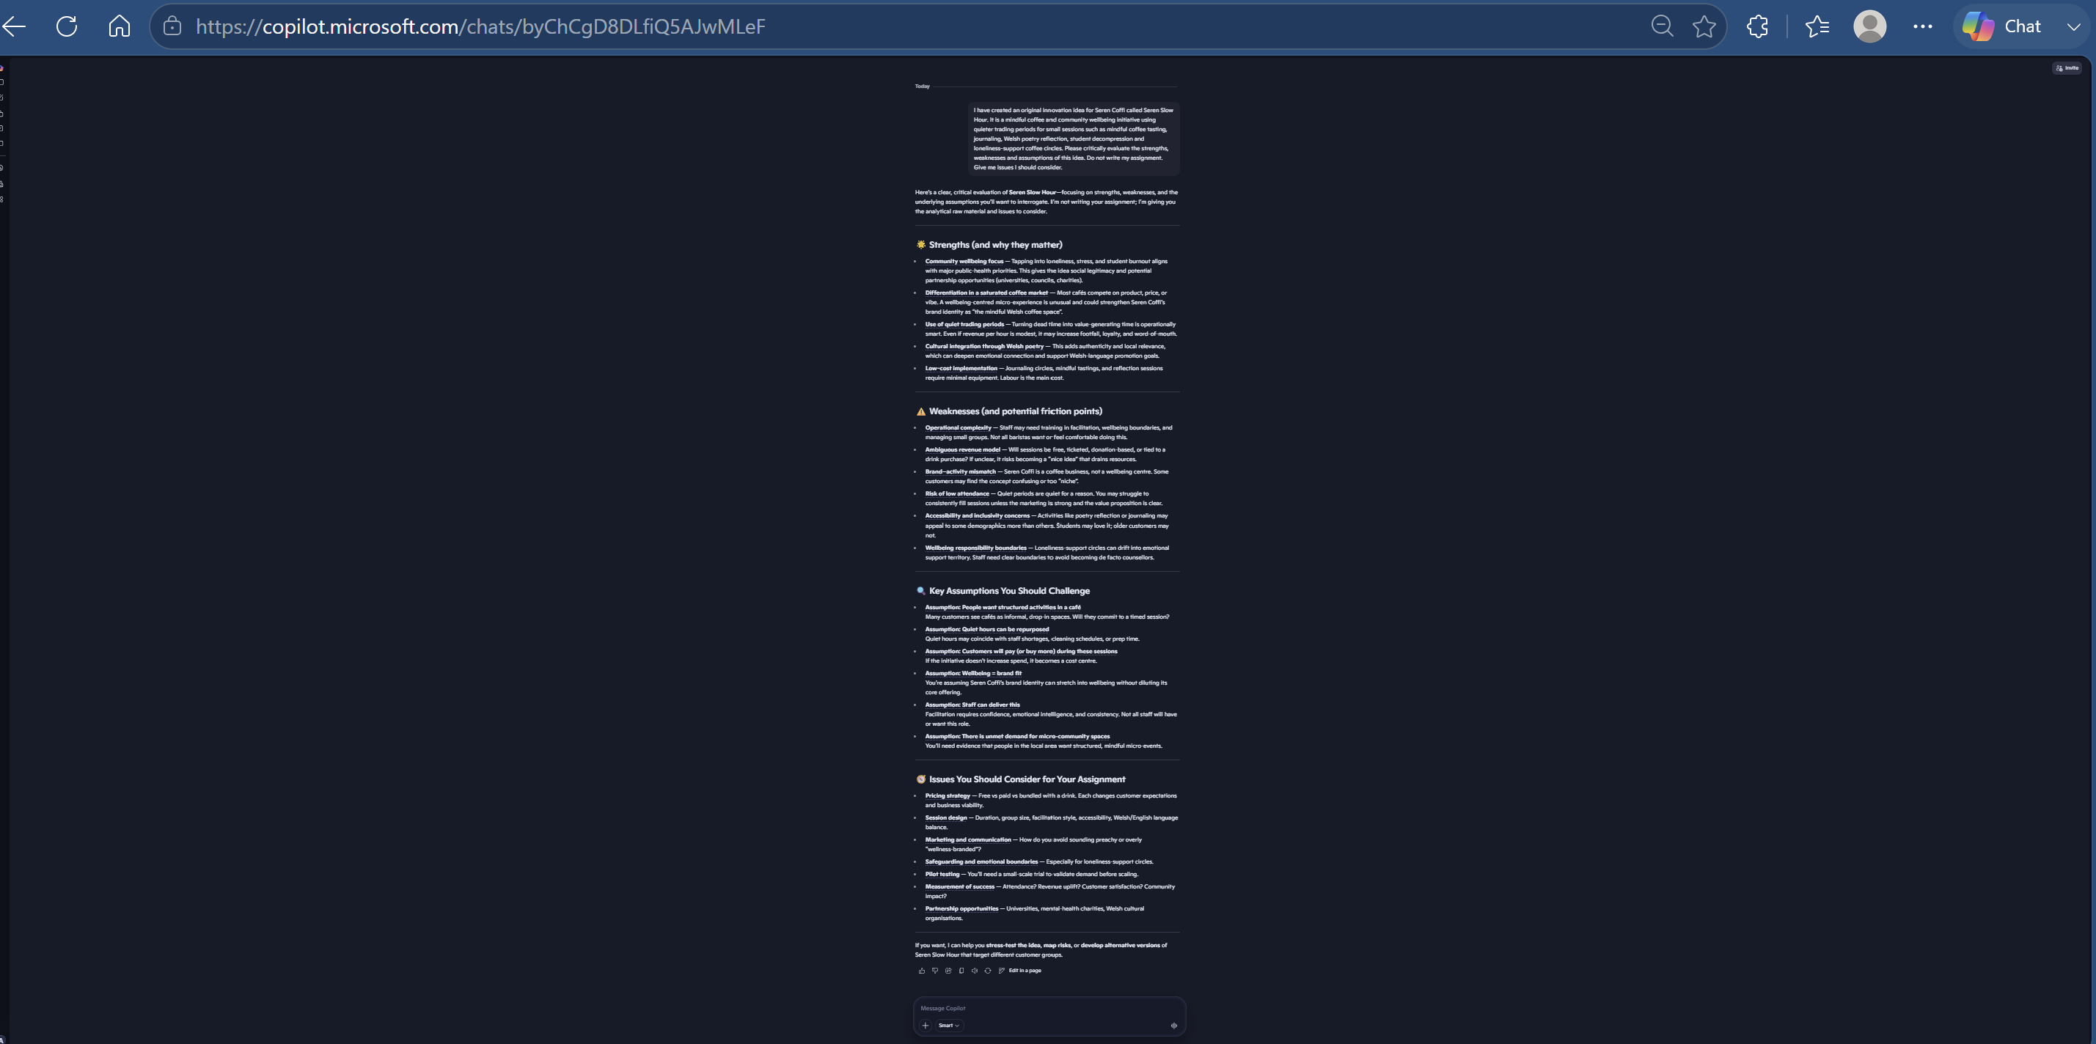

Appendix 2. Prompt 2.
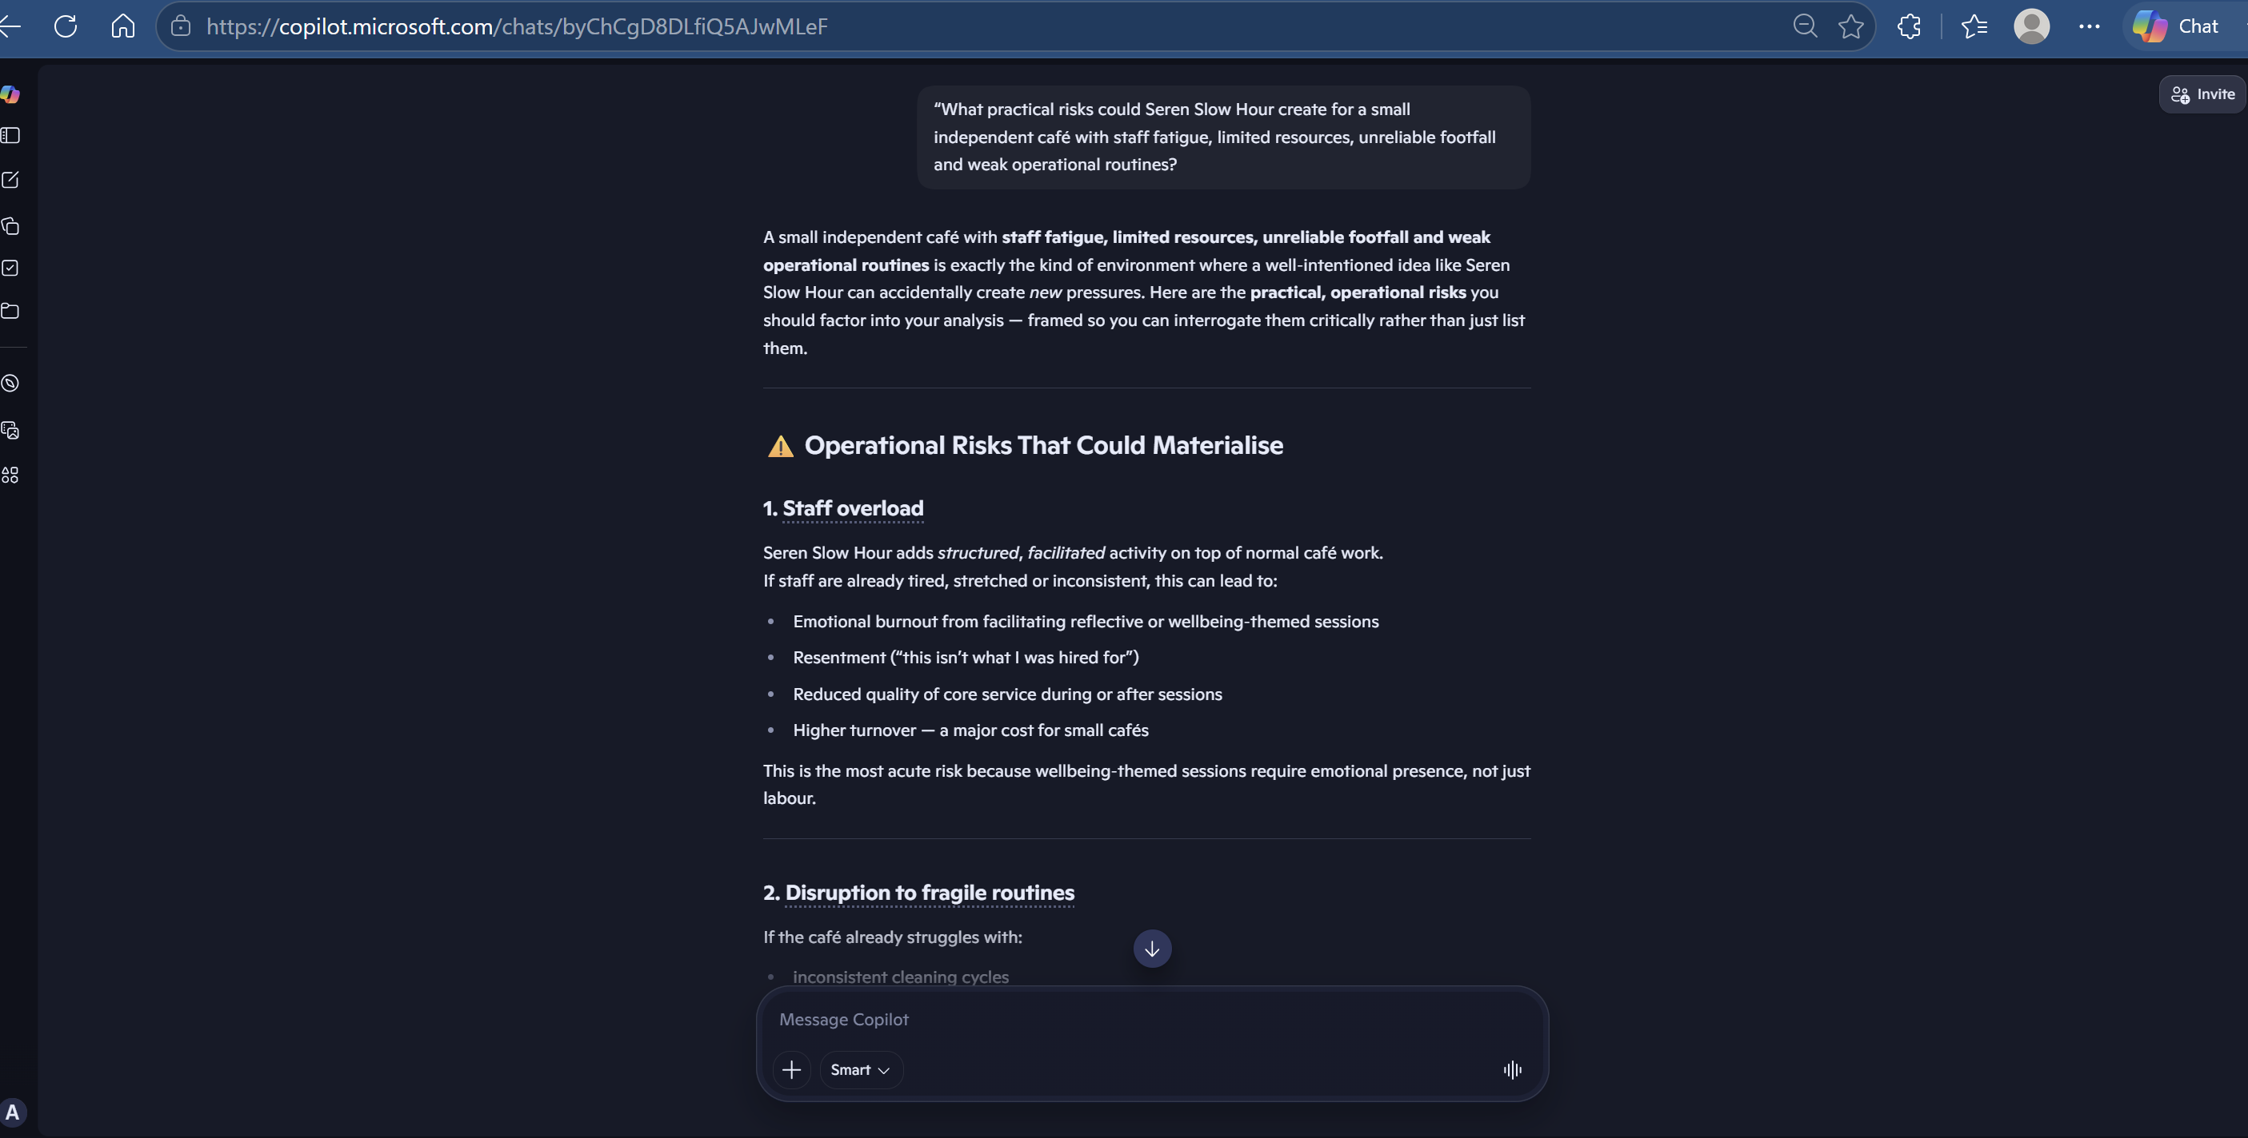
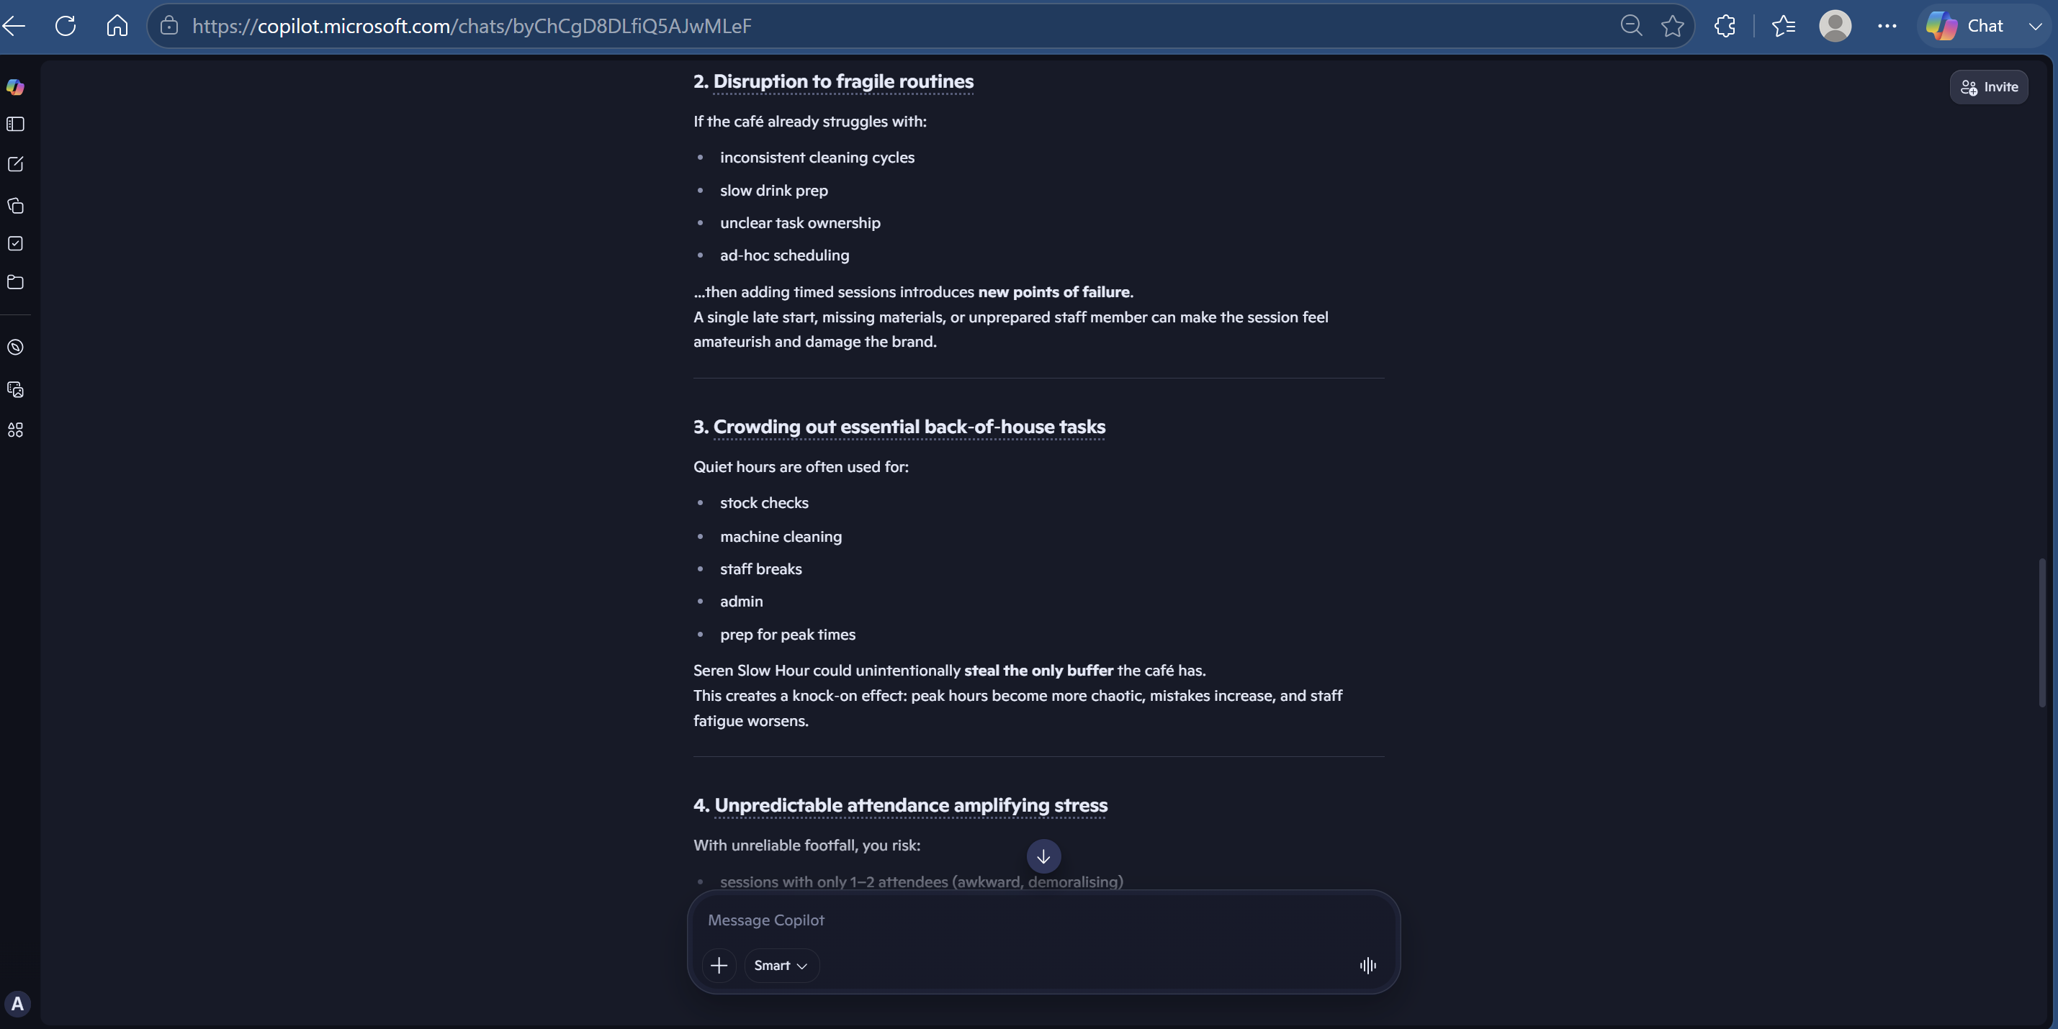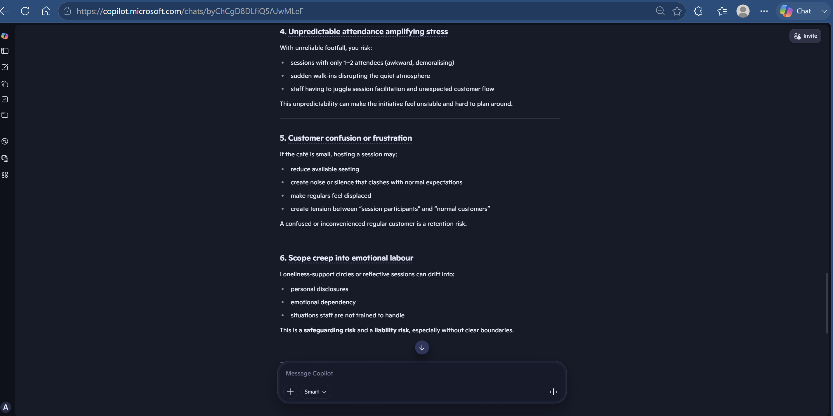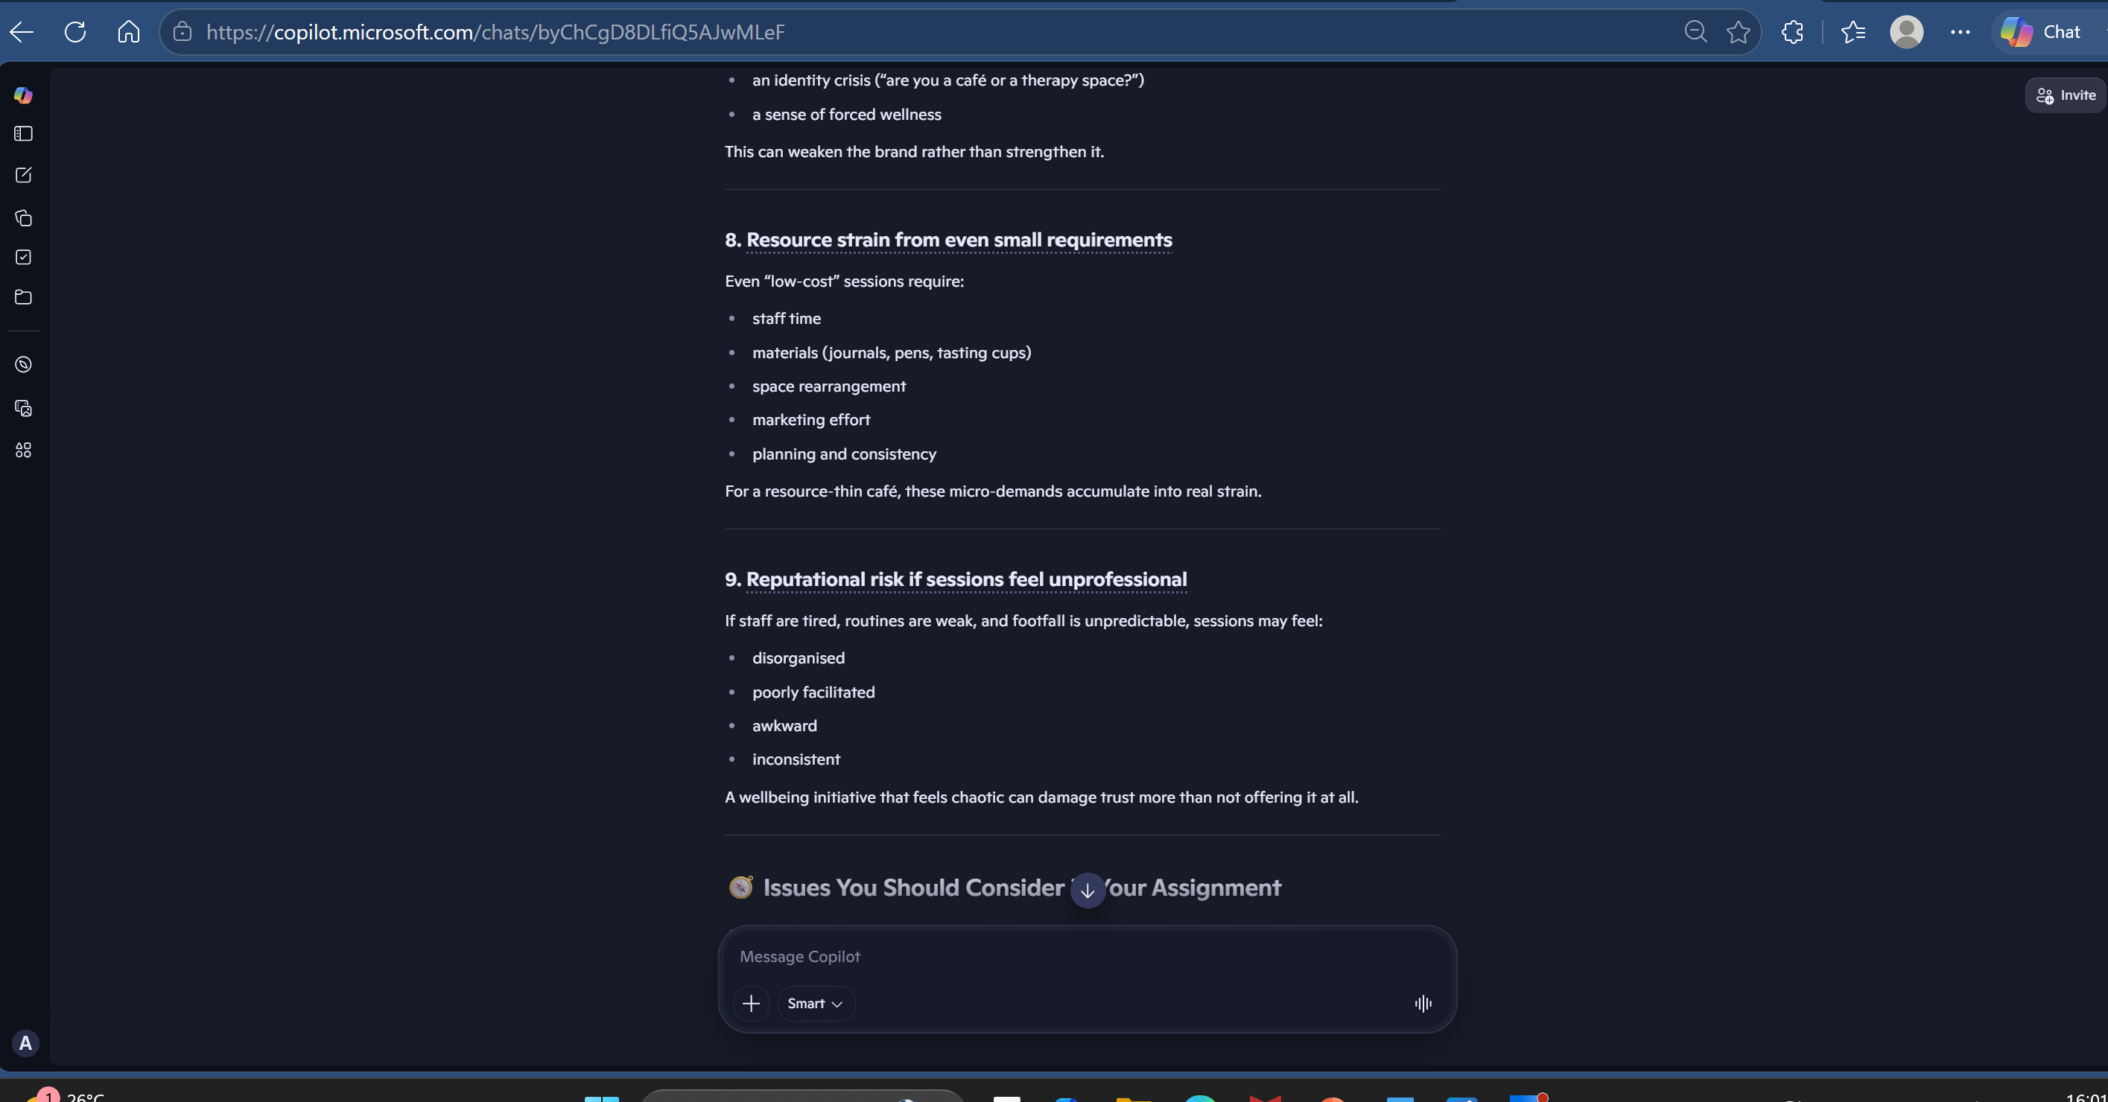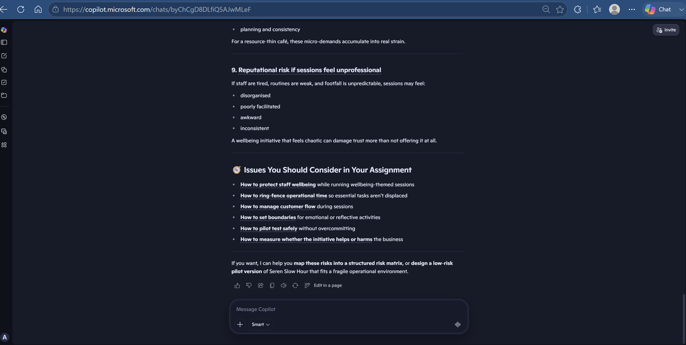

Appendix 3. Prompt 3.
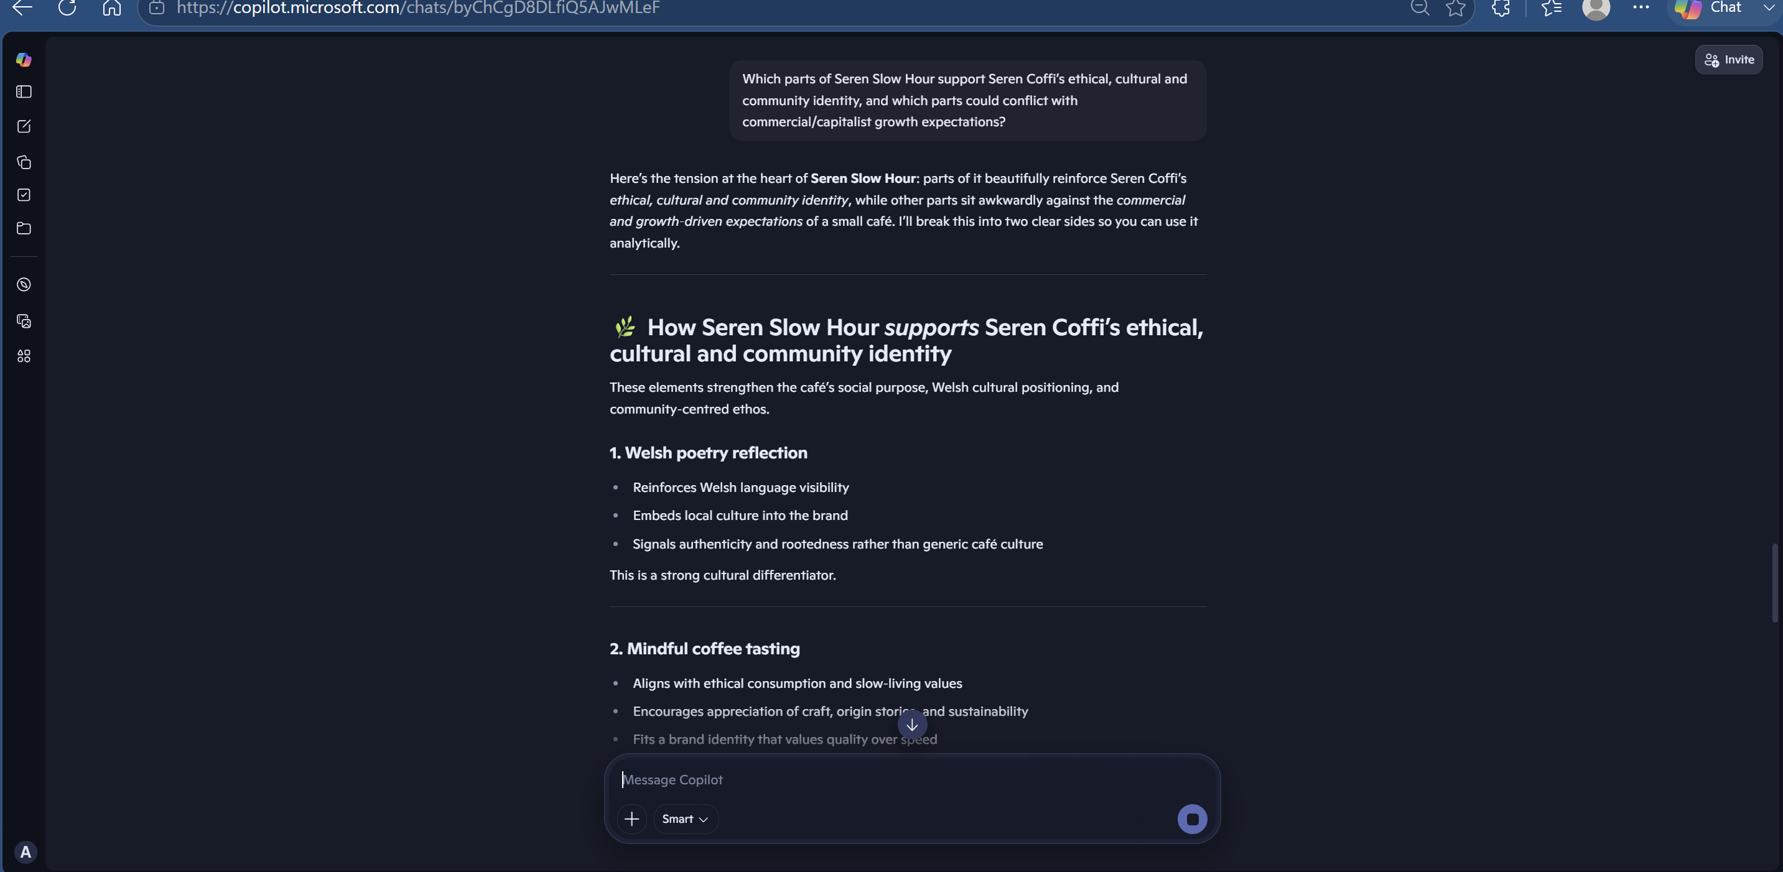
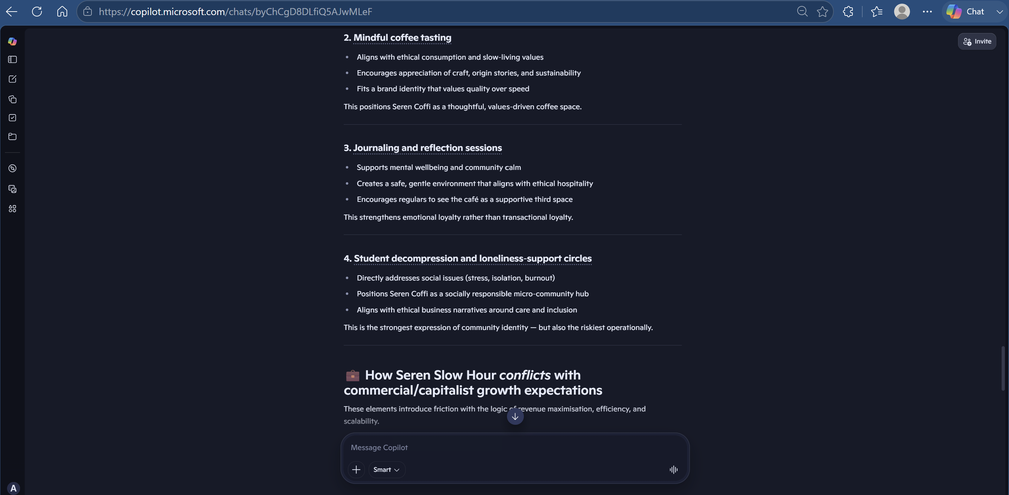
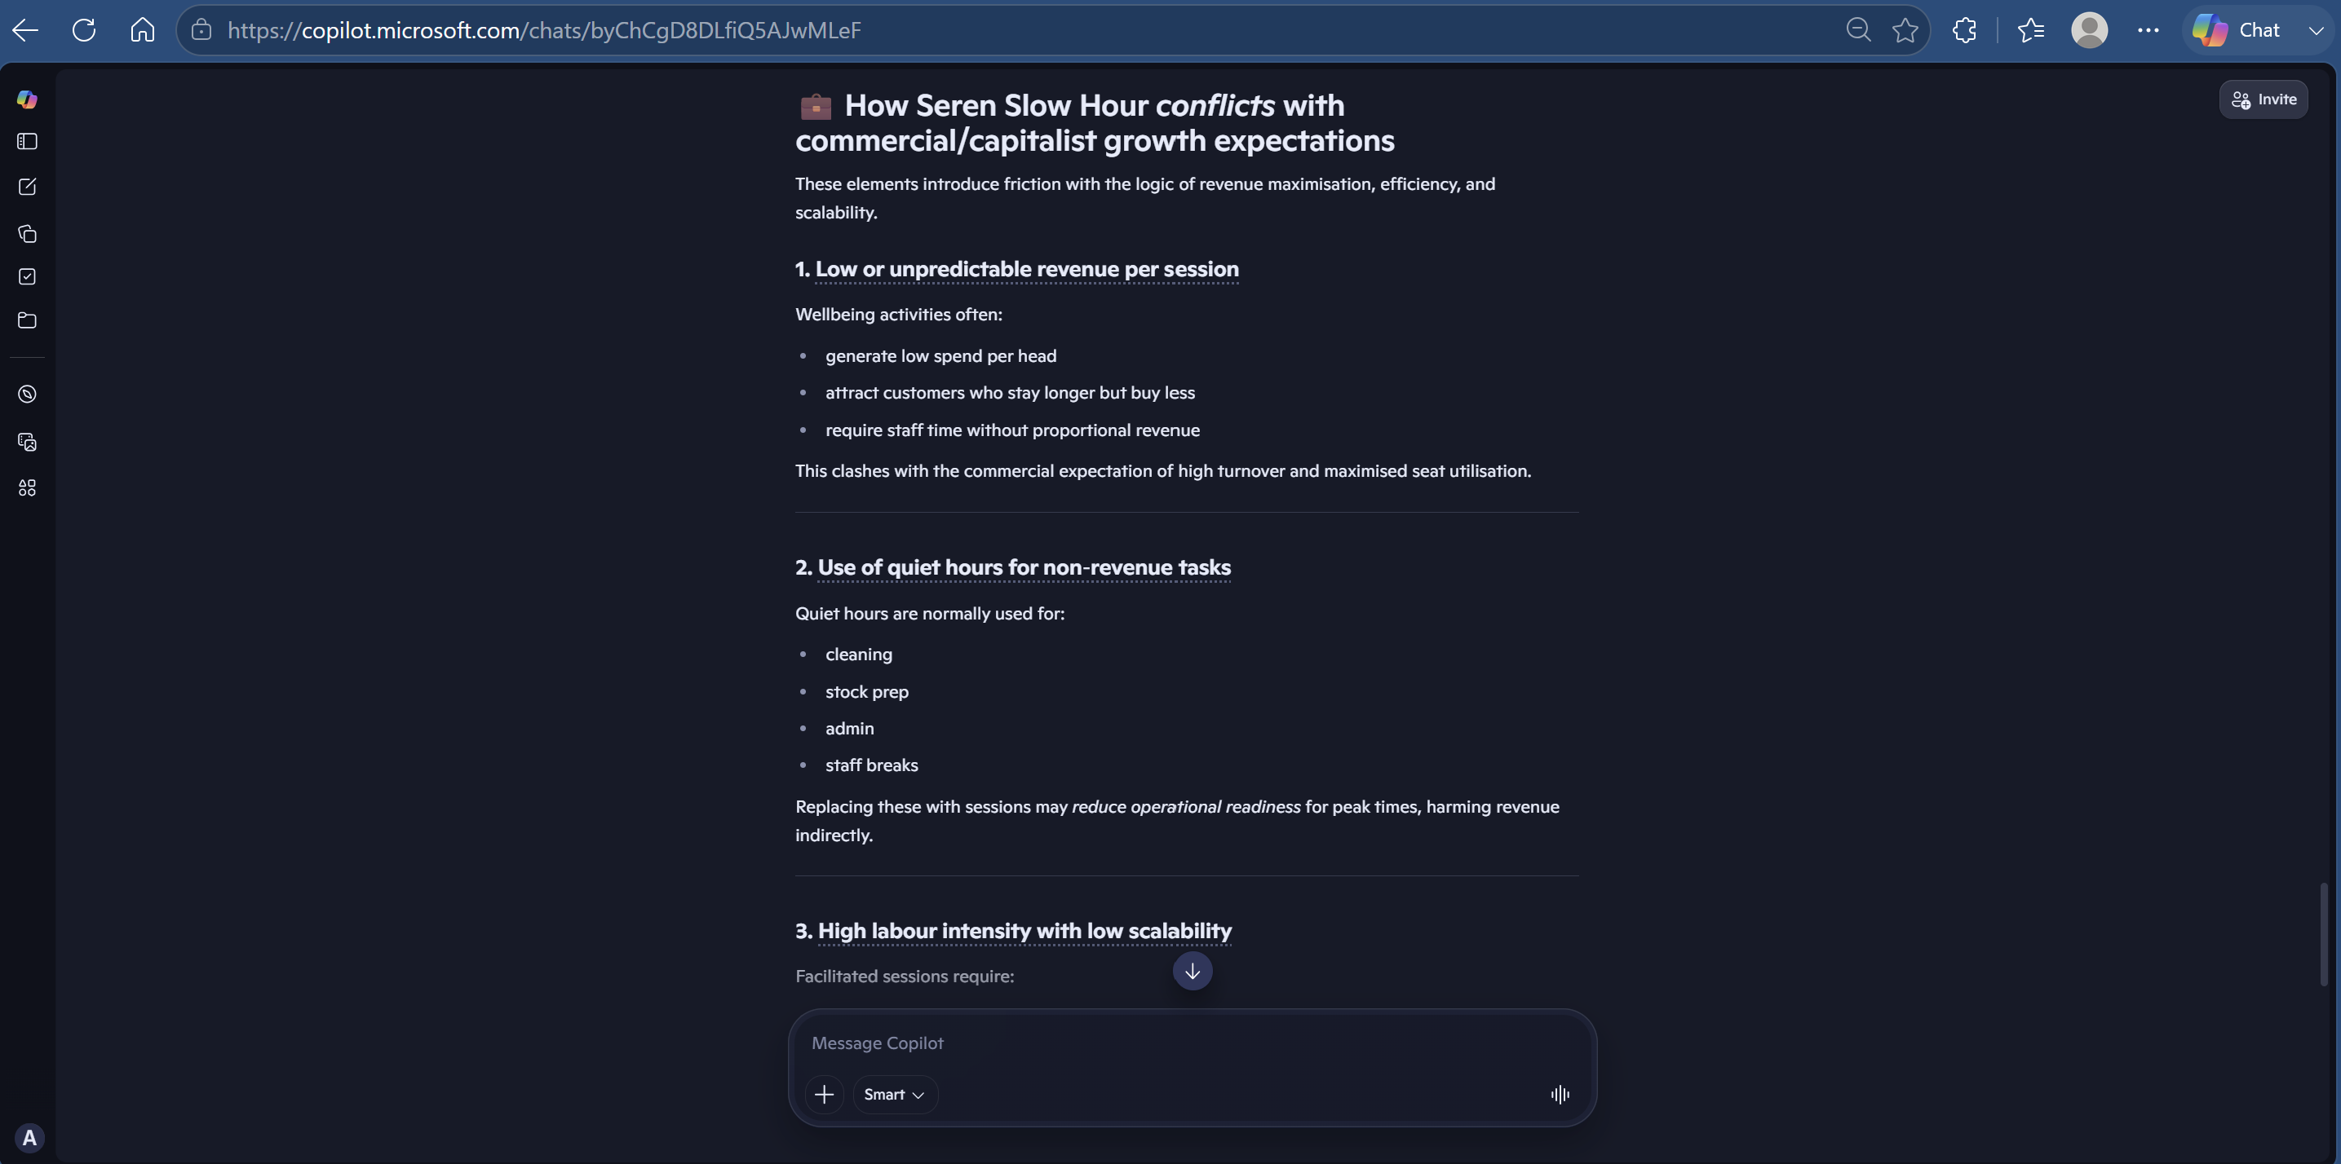
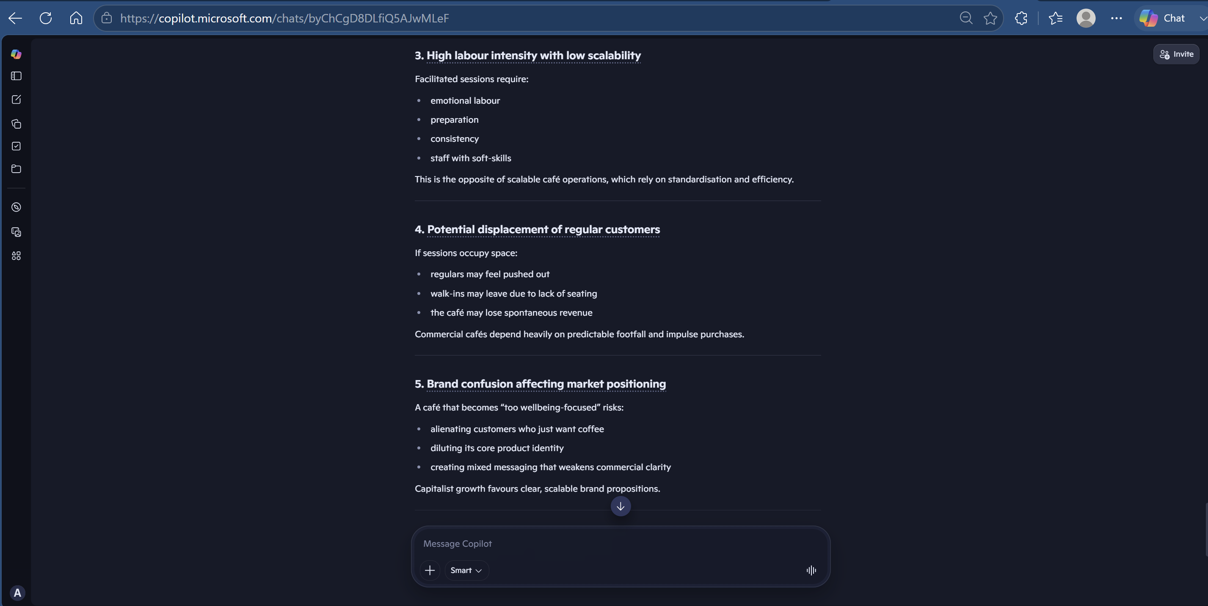
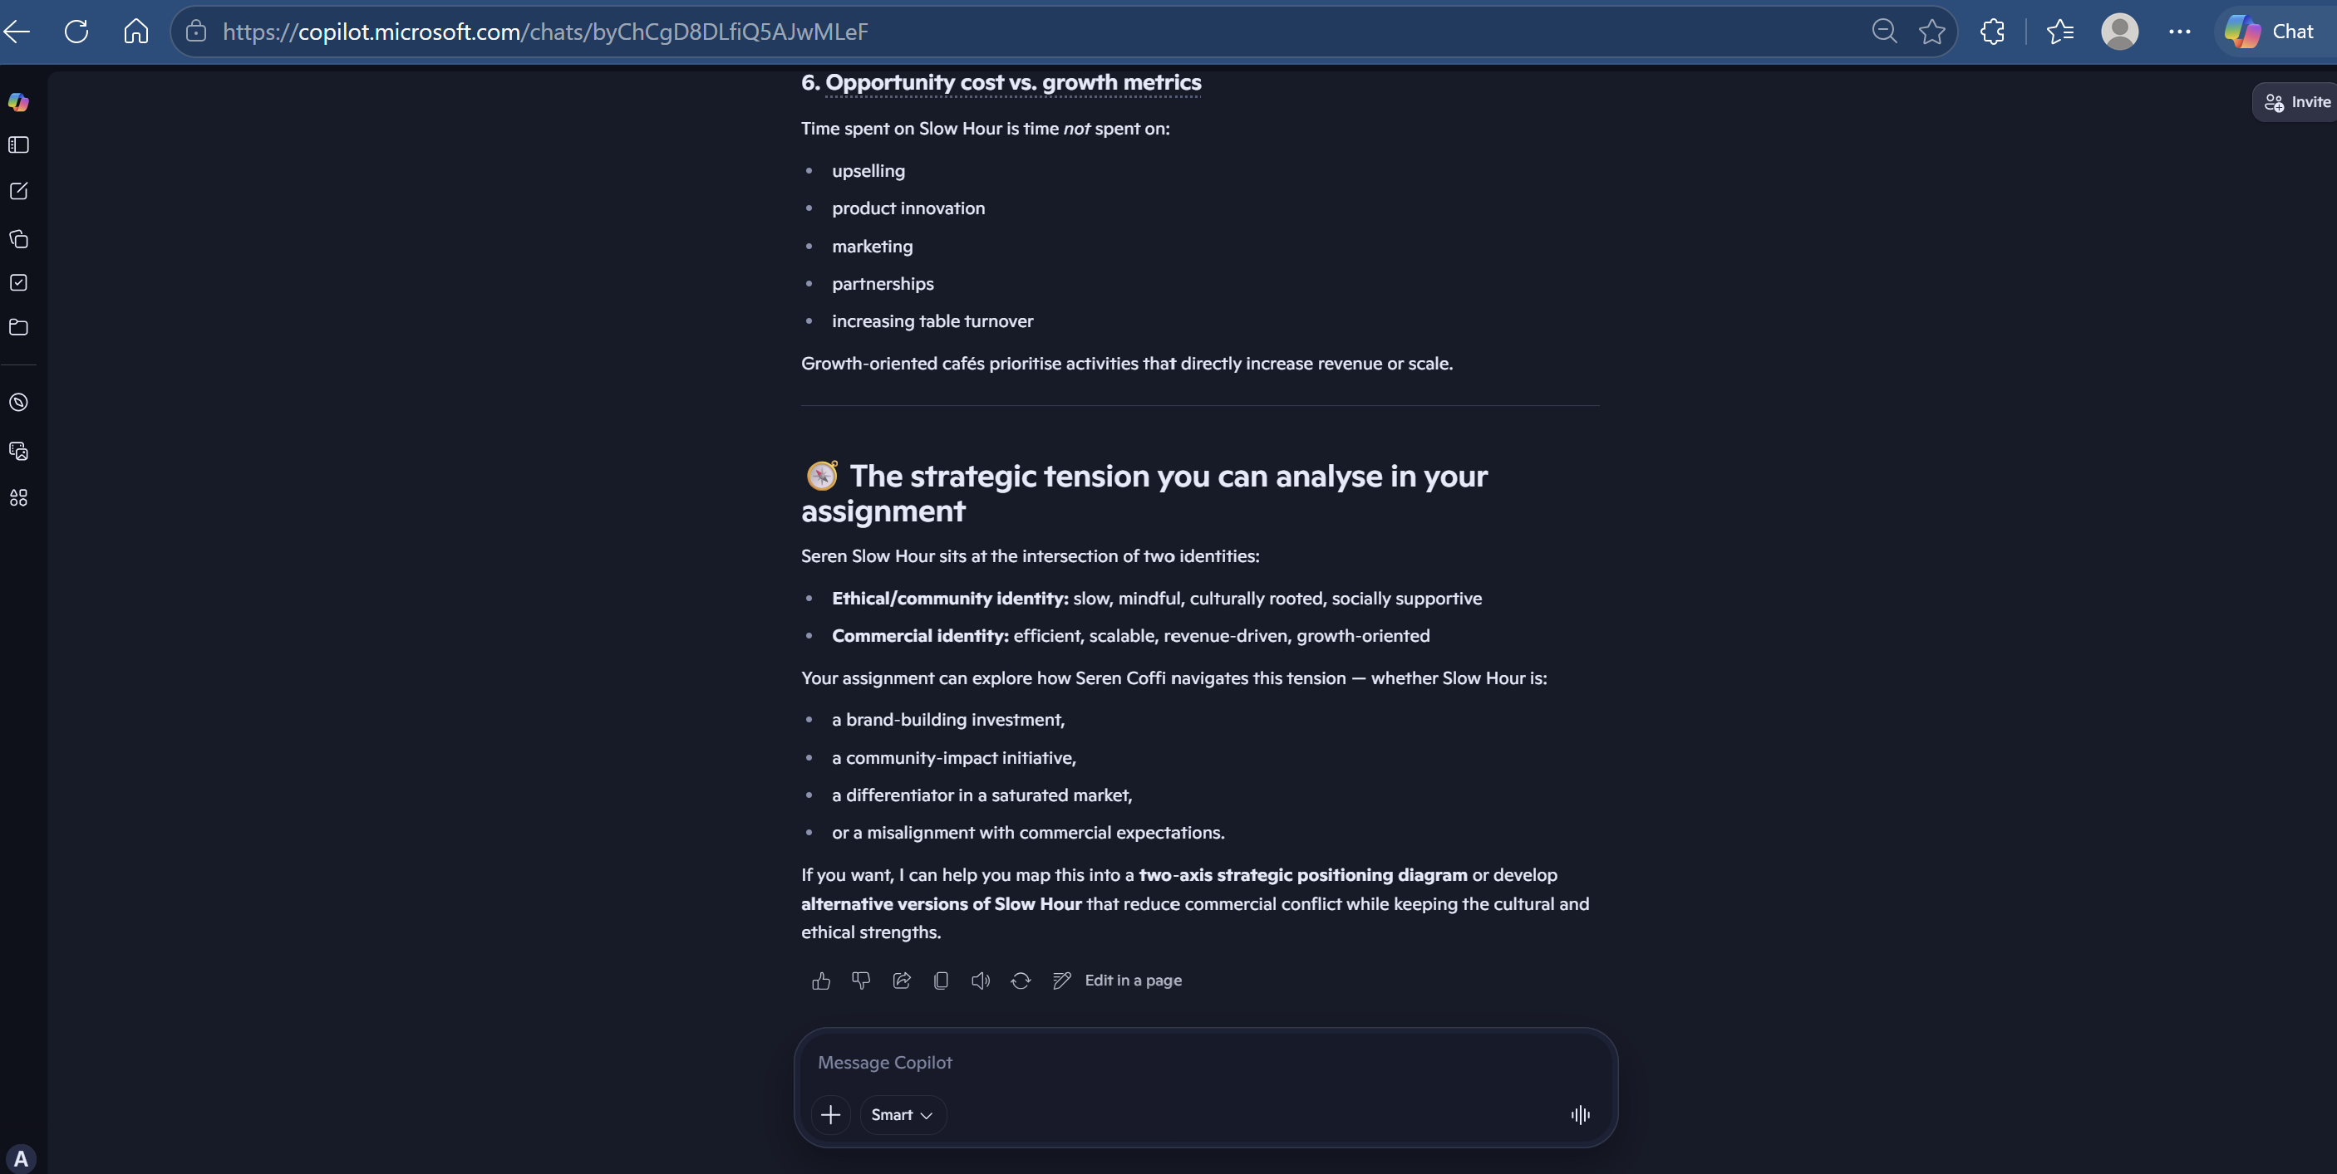

Appendix 4. Prompt 4
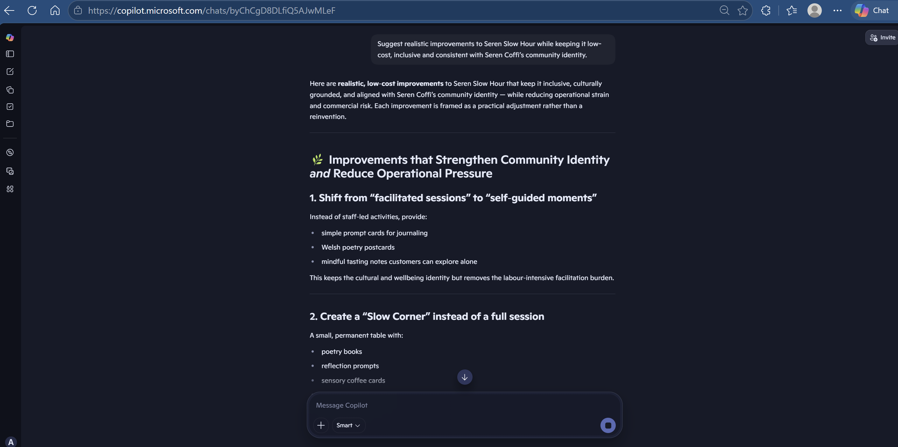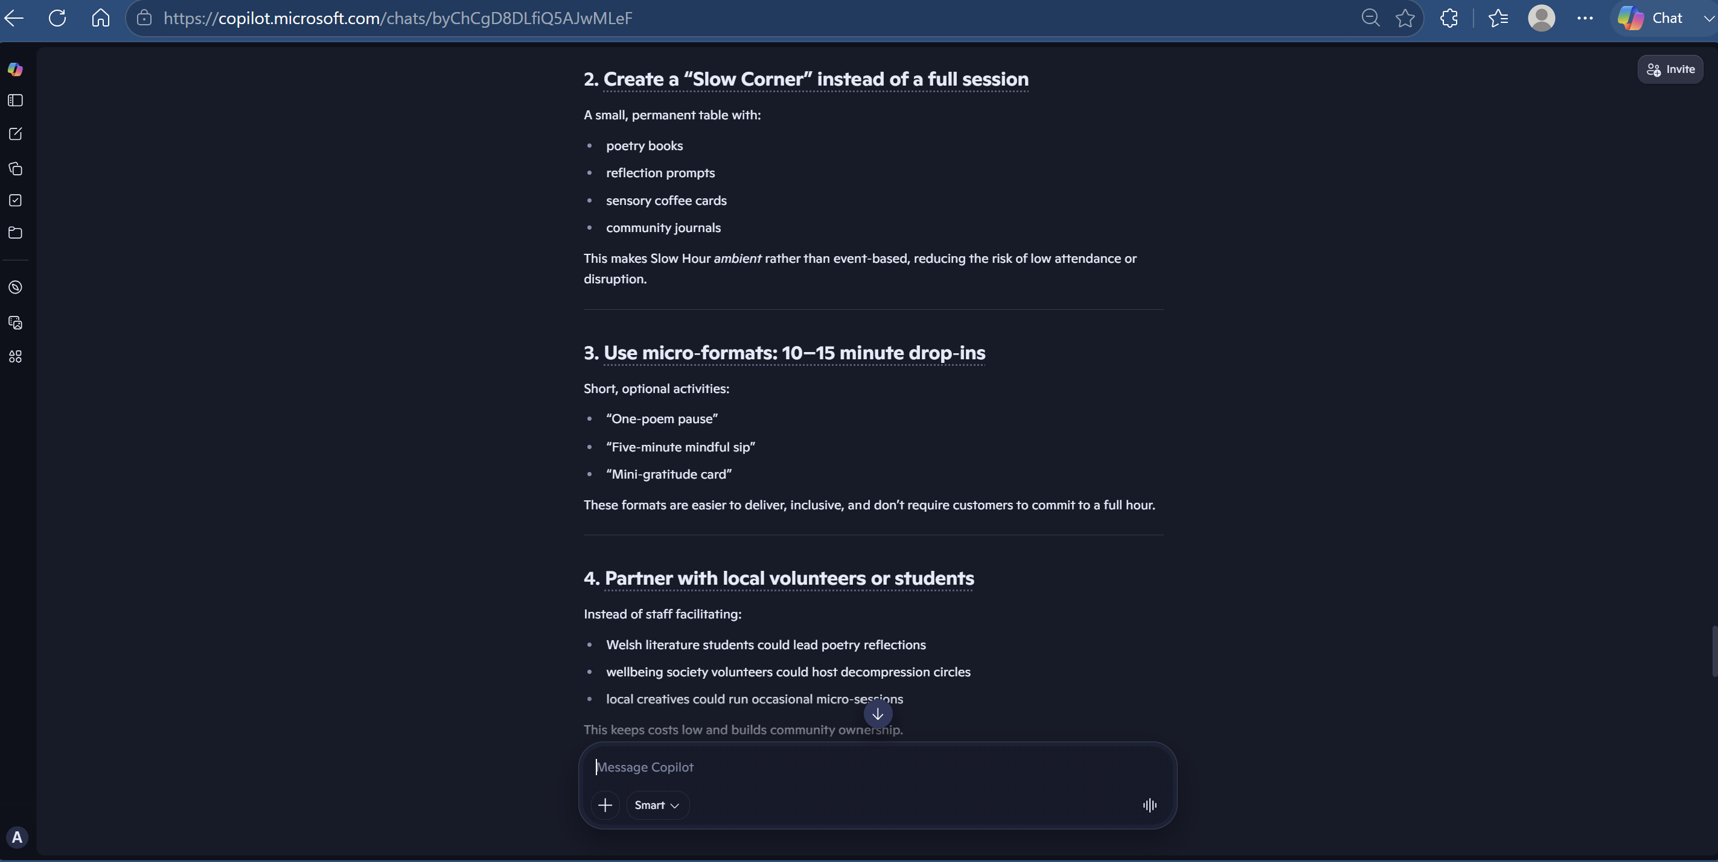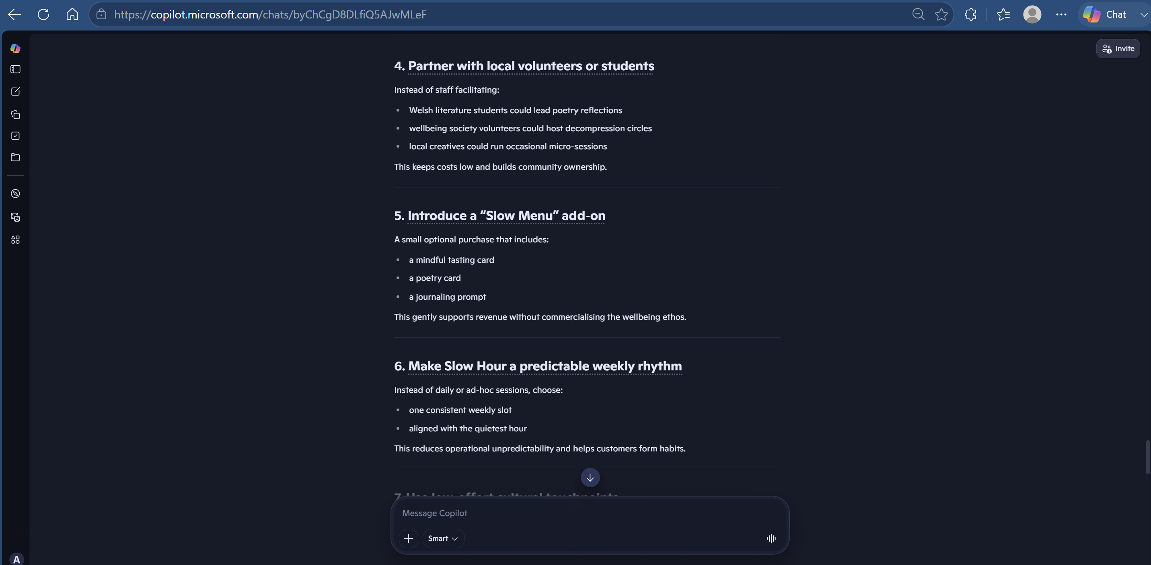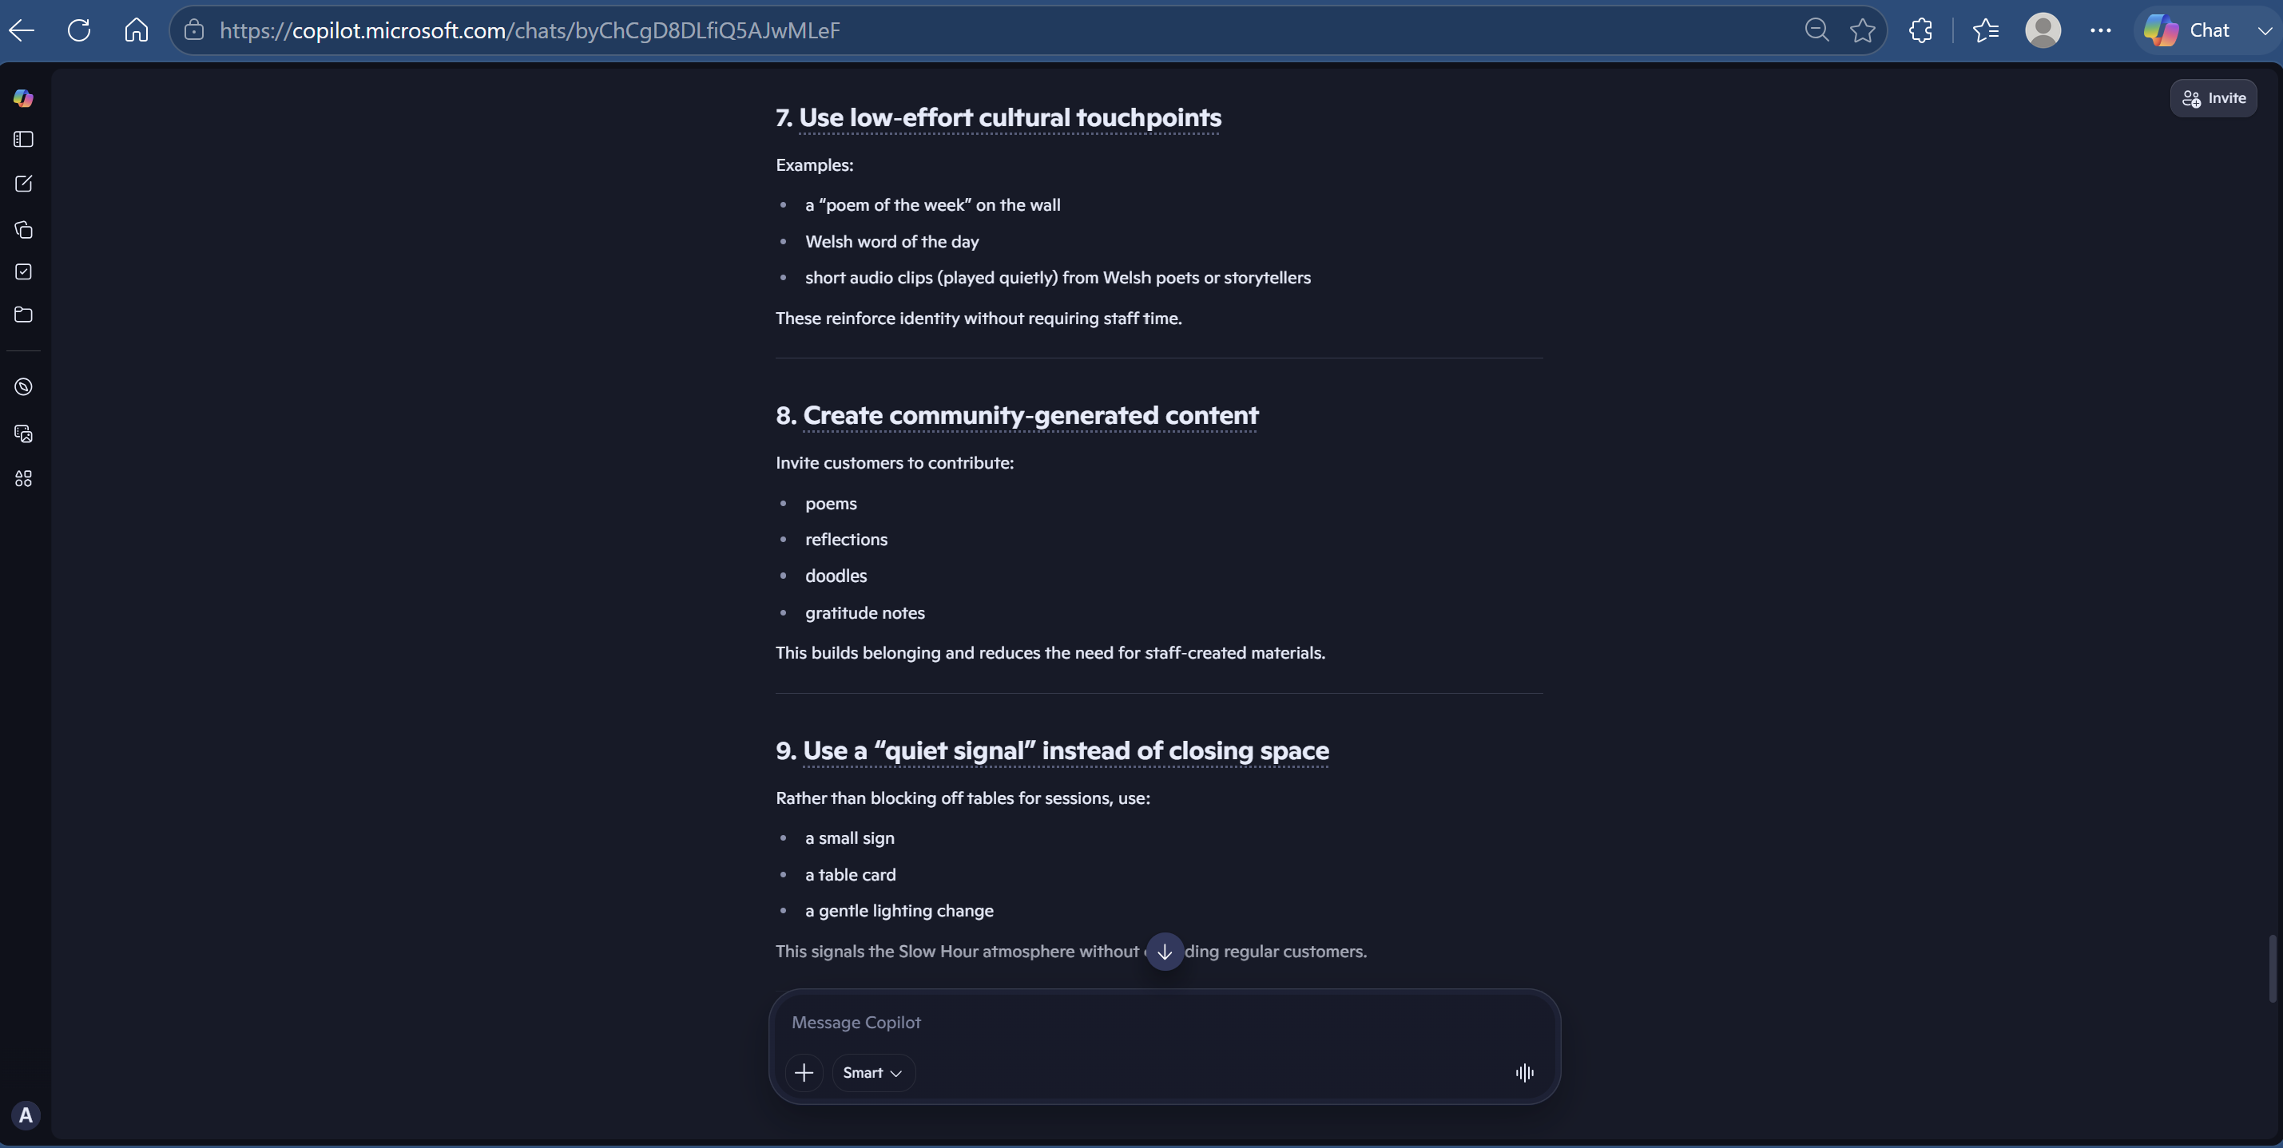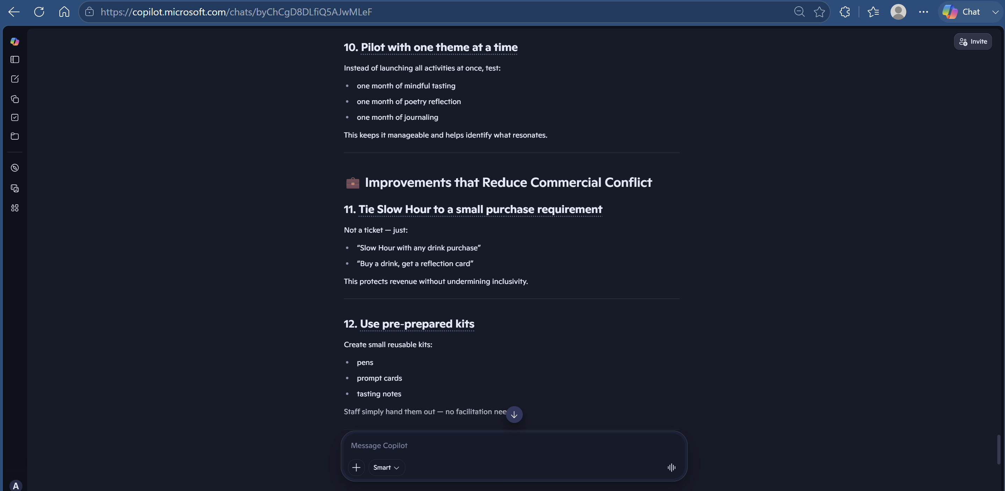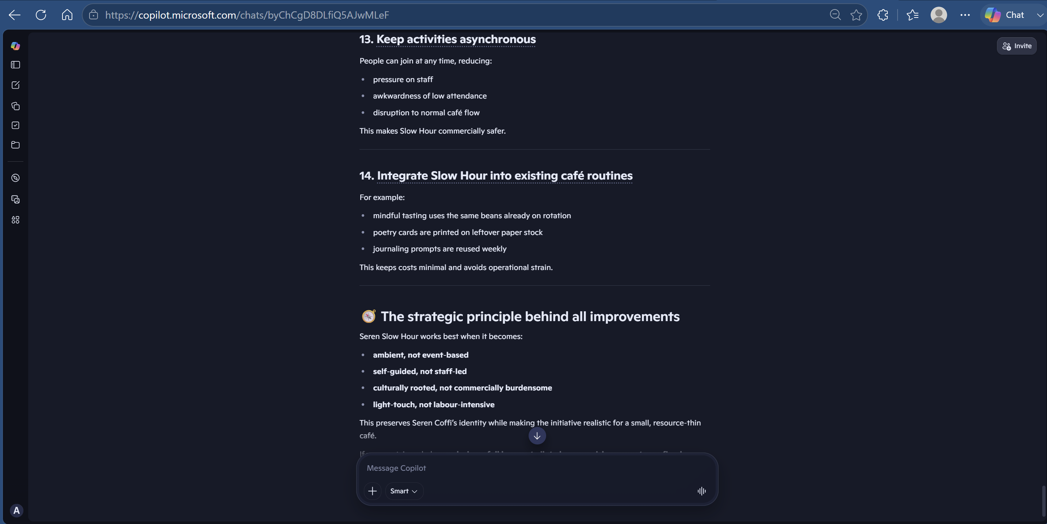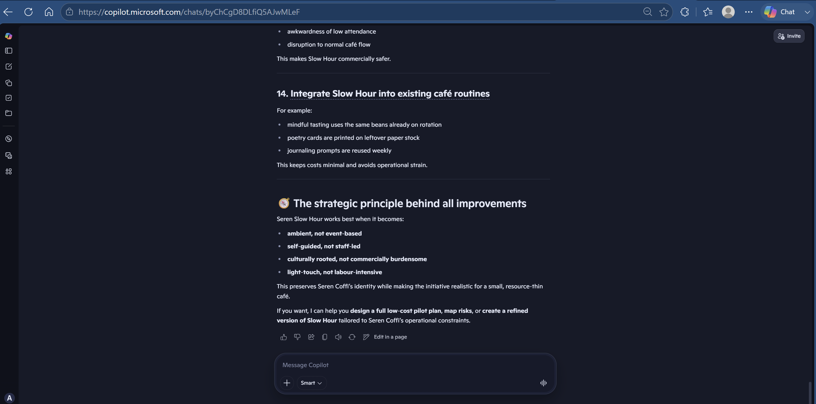

Appendix 5. Prompt 5.


