
Name: Joseph John Williams
Module:
Assessment Number
Assessment title:
Lecturer:
Submission Date:
Word Count:

Knife crime



Abbreviations
ACE – Adverse child experience
CJS – Criminal Justice System
CPS – Crown Prosecution Service
KCPOs – Knife Crime Prevention Orders
LGA – Local Government Association
YOTs - Youth Offending Teams
VRU – Violence Reduction Unit
SVPO – Serious Violence Reduction Orders

Abstract

The purpose of this dissertation was to identify and compact secondary data in relation to knife crime. The aim was to compile up to date data from many sources into one place to display and explain the complexities of knife crime in the United Kingdom. The basis for this dissertation was placed on the ever-increasing rate in which knife crime has been rising, and to display that not any one institution or service can tackle the complexities that knife crime produces.
This was to be achieved by critically evaluating the different ways in which government, local authorities, institutions, and services can offer a collaborative effort to provide a successful outcome.

Findings

Conclusively, the study has discovered that during the last three years there has been an increased effort to tackle knife crime at both a government and local level. This has been seen using a public health approach to knife crime and through the funding of multiple programmes, an increase in multi-agency partnerships and a variety of interventions created to reduce knife crime. However, despite the best efforts taken to reduce knife crime it has been shown that the levels of knife crime have risen since 2016 in all age groups and that reoffending is becoming more common. The data found after March 2020 shows a rapid decrease in the amount of knife crimes being committed, this however is during the time of a global pandemic and so the results must be taken with caution.

Table of Contents
Contents
Abstract 2
Findings 2
Table of Contents 3
1. Introduction 6
2. Literature Review 7
2.1 Serious Violence Strategy 7
2.2 Public Health Approach 10
2.3 Interventions 12
2.3.1 Early Intervention 14
2.3.2 Individual Intervention 15
2.3.3 Environmental Intervention 16
2.3.4 Educational Intervention 17
2.4 Youth Offending Teams 18
2.5 Legislation 21
2.5.1 Knife Crime Prevention Orders 22
2.5.2 Legal Duty 24
2.5.3 Serious Violence Reduction Orders 26
2.6 Stop and Search 27
3. Methodology 28
3.1 Introduction 28
3.2 Research Aims and Objectives 28
3.3 Research Design 29
3.4 Research Philosophy 31
3.5 Research Approach 32
3.6 Research Strategy 33
3.7 Date Collection 34
3.7.1 Ethical Issues 35
3.7.2 Time Constraints 35
3.8 Research Limitations 35
3.9 Summary 36
4. Results 36
4.1 Case Studies 36
4.1.1 Operation Sceptre 37
4.1.2 Operation Fortify 39
4.1.3 Essex Violence Reduction Unit 41
4.2 Knife Crime Statistics in England and Wales 43
4.3 Age of Offender and the Rate of Reoffending 45
4.4 Hospital Admission – England 49
4.5 Cautioning and Sentencing 51
4.6 Covid-19 Impact on Knife Crime in 2020 53
4.7 Stop and Search 54
4.7.1 Reason for Searches 55
5. References 57

Introduction

The United Kingdom has seen the rate of knife crime significantly increase from 2015 and has been under pressure from local authorities and public services to see an increased effort from government. This dissertation will therefore outline the government’s response to knife crime and the public health approach they have taken to address the issues presented by knife crime. Furthermore, knife crime cannot be solved by solely the government and so the interventions introduced at a local level will be outlined. The importance of youth offending teams, multi-agency working, and the law will be a concurrent theme throughout.

Aims and Objectives
The aim of this dissertation is to identify the key issues attributing to an increase in knife crime and to outline key decisions made by government and the police service to help prevent and reduce knife crime. Interventions put in place across the UK will be analysed to determine their usefulness.
- Explore the government’s response to knife crime.
- Critically analyse the interventions introduced in the United Kingdom in relation to reducing knife crime and reoffending.
- Outline legislation that has been introduced in the United Kingdom aimed at reducing and preventing knife crime.
- Explore and evaluate the effectiveness of the powers available to police to tackle knife crime.
- Analyse and provide up to date statistics surrounding knife crime, including the effect of Covid-19.

Literature Review

Serious Violence Strategy

The Government published its Serious Violence Strategy on 9th April 2018. The aim of the report was to publish a coherent analysis of the scale of the problem and to identify potential causes around violent crime. A large portion the strategy is committed to the Government’s analysis of what they believe are the main causes of serious violence. However, it should be noted that the report is largely based on previously collected data and shows no commitment from the Home Secretary in committing further resources into the collection or analysis of new data. The report indicates that serious violence is attributed to several factors. This includes, age, gender, adverse childhood experiences (ACEs) and ethnic background (HM Government, 2018). Within the report are sixty-one actions and commitments that the government would take from 2018 onwards (HM Government, 2018). Some of the more notable commitments include:
Change/Action | Cost | Aim
Early Intervention Youth Fund | £22 Million | Funding increased from £11m to £22m to allow work to be undertaken with the Police and Crime Commissioners and Community Safety Partnerships. This is to allow support in intervention and prevention from an early stage within youth groups and communities.
Trusted Relationships Fund | £13 Million | To be spent over the course of for years (2018-2022) to try and increase support for at-risk young people. The aim to build more positive and trusted relationships with adults.
Trauma Led Policing Model | £7 Million | To be introduced across four Welsh police forces. The objective is to enable police to get a better understanding of adverse childhood experiences surrounding serious violence.
A refocus on Inter-Ministerial Group on Gangs | N/A
Cross-Sector Serious Violence Taskforce | £40 Million | Aimed at overseeing the delivery of the strategy’s programme of work ensuring that key commitments are delivered. The priority is to ensure there is sustained, swift and decisive action against violent crime.

Change/Action | Cost | Aim
Youth Endowment Fund | £200 Million | Aimed to be delivered over 10 years, allowing evidence to be built to target early intervention in 10-14-year olds who are at most risk of youth violence.
Social Media Hub | N/A | Staffed by police officers with the aim of disrupting and removing overt and offensive gang-related online content.
Supporting Families Against Youth Crime Fund | £9.8 Million | To be ran by the Ministry of Housing, Communities and Local Government. The aim is to allow key workers and other professionals to work alongside children and young people to provide early development. A key part of the development is to build up the ability to allow the individuals to make positive life choices and withstand peer pressure.
Youth Advocate Program | N/A | A program aimed by seeking out “respected” members of communities. This includes youth workers with the aim of starting safe and important conversations covering the area of knife crime and to provide a positive alternative to carrying a knife.
Increased Police Funding | £100 Million | A third of the additional money is to go towards violence reduction units, covering 18 areas.
As well as the original commitments set out in the Serious Violence Strategy, the Government have committed to the following to strengthen the strategy, these include:

However, there have been several criticisms of the report. Commissioner of the Metropolitan Police, Cressida Dick stated that while the strategy is fine in nature, there is a lack of government action on the ground (Home Affairs Committee, 2019a). This view is similarly expressed by then Chair of the National Police Chiefs Council , Sara Thornton, who agreed that the strategy understands the drivers of serious crime but that it will require a more co-ordinated response and resources to drive it through government successfully (Home Affairs Committee, 2019b).
Additionally, West Midlands Police and Crime Commissioner, David Jamieson, compares the report to a similar one written in 2015, aimed at ending gangs and youth violence. Comparing the two reports, he argues that they both lack sustainability and are short term solutions to a bigger problem. He argued that the lack of targets was also a problem: “If you really want to engage people and professionals and you want to drive some change, you have to have some aims so you know whether you are on track or not” (Jamieson, 2018, p.1).
Overall, the strategy provided by the government has provided a positive addition to tackling serious and violent crime but has been subject to scrutiny for not following through in real terms with what it aims to deliver. However, the additional commitments made by the government since the strategy was launched in 2018 has shown that they are committed to the strategy, at least in the short-term. Furthermore, the full impact of the strategy long-term remains to be seen, and only time with provide the answer to its long-term success.

Public Health Approach

Following the Serious Violence Strategy from 2018, the Government announced on the 14th of July 2019 its plans to implement a public health approach to serious violence. A public health approach treats violence as a ‘disease’ and therefore requires scientific evidence to provide the causes and connections that attribute to knife crime. The information collected should be further used to provide interventions that can be put in place to prevent the increase of violent crime getting worse, consequently preventing the ‘disease’ from spreading. Policy makers are then encouraged to use the information collected to provide a variety of policy’s that can provide positive change to tackle serious and violent crime (Brown, 2019). More about the importance that interventions play in the reduction of knife crime can be found in Section 2.3
The World Health Organisation (WHO) outline the public health approach in the following chart below (WHO, 2017).
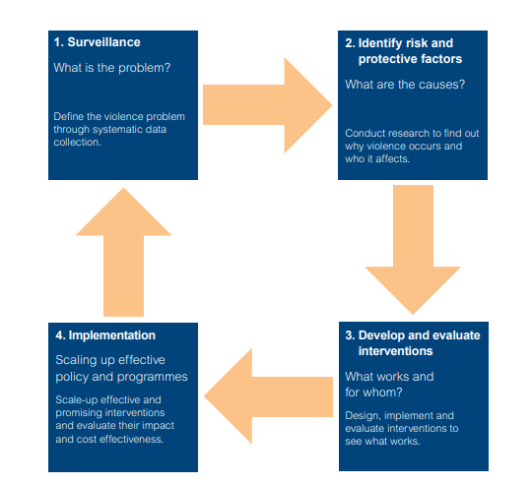
The public health approach is taken from the work conducted in the USA and Scotland. Scotland’s approach has shown to be positive. An important part of the success seen in Scotland was using multi-agency working between community safety, education, social services and the police. Each agency worked in tandem to provide an approach to tackle youth violence. This was in line with legislation being amended to see the average prison sentence for carrying a knife triple between 2005 and 2015 (Association of London Directors of Children’s Services, 2018).
In similar fashion the UK Government have implemented amendments to current legislation as well as a brand-new legal duty introduced for public service providers to collaborate and provide additional planning to prevent and reduce serious crime. See Section 2.5.2
The Local Government Association (LGA) (2018) outline that a public health approach must provide a framework in which the causes of serious violence can be explained. It must also provide positive interventions that lead to the reduction or prevention of violence. The public health approach covers a wide variety of research that can be broken down into two factors: Risk factors and positive factors.
Risk Factor: Used to predict an increase of crime based on a certain factor that is seen, for example, an area with increased poverty may be subject to a higher volume of crime.
Protective Factor: Used to predict a decrease of crime based on certain measures, for example, high-class areas are more likely to have a high employability rate and therefore are at less risk of seeing high levels of violence.
Farrington (2000) does however state the downside with risk factors, stating that it is important yet difficult to determine what risk factors are causes of violence and which are merely markers or correlated with causes.
Therefore, the public health approach provides a framework based on an evidence-led model aimed at reducing and preventing violence. This is done through a multi-faceted approach. Firstly, data is analysed to provide a range of factors that may attribute to the increase of knife crime as well as hot spot areas in which the crimes may be most committed. Secondly, the evidence provided encourages new and improved policies that can provide a positive change towards reducing violence. Thirdly, a multi-agency approach plays a vital role in providing the backbone to any changes made at a government or local level, positive re enforcement from all agencies involved could be the difference on whether the policies and interventions put in place are seen as successful.

Interventions

When considering the use of a public health approach to tackle violent crime and the implementation of interventions introduced to reduce violence, the Local Government Association (2018) state the following should be considered by the government and local authorities:
- Observation: What are the problems?
Define the issue. A rigorous assessment should be undertaken to address the concerns around violence. This should include types of violence as well having a fundamental understanding of risk and protective factors. An understanding of these factors can be used to target individuals and communities to address violence at a population level.
- Recognise risk and protective factors. What are the causes.
Understand the causes of violence. An evidence-led approach should be taken to better understand risk factors that attribute to violence. Successfully achieving this can allow local areas to implement interventions correctly suited for their environment and to lead to more successful results. An approach to address serious risk factors as well as strengthen protective factors should be introduced to reduce violence at a population level.
- Develop and identify interventions. What works for who?
Develop an anti-violence or reducing violence strategy. A strategy should be created to respond to identified problems and focus on tackling the causes of violence, leading to a decrease in violent crime. The strategy created must take into consideration wider strategic and policy context, while also including a multi-agency response. The strategy should be agreed upon between stakeholders and local ownership are to ensure the strategy is implemented as intended.
Commission and fund evidence-based interventions that have been shown to reduce violence. Where possible, local areas are encouraged to support and fund evidence-based interventions that have been shown to reduce violence.
Don’t be afraid to innovate. It is advised that if there are no interventions available from evidence-based research that interventions should be developed based on existing evidence. The interventions should consider reducing risk factors while promoting protective factors in line with what is appropriate for the area being addressed.

- Implementation. Scaling up the effective programmes and interventions.
Implement interventions ensuring that fidelity is maintained in line with what has been demonstrated to work. It is vital that the model that is implemented stays true to the original model and is delivered as accurately as possible. There should be consideration on which intervention is being implemented and the context in which it does so. This must be followed due to interventions that work in one area do not work in another, therefore any changes from the fidelity of the model implemented may produce unfavourable results.

The implementation of interventions takes time to embed in practise and to achieve outcomes. Enough time must be given by local decision makers to allow interventions that have been put in place to achieve an impact or desired outcome. It has been noted that certain programmes may take up to five years to provide an outcome.

Evaluate and monitor the success of public health interventions. There is still a large amount of work required in the development and evaluation of public health interventions aimed at reducing violence. The LGA acknowledge that resources available are limited but encourage a contribution towards evidence-based evaluations. If done successfully there is money to be saved by identifying models that work as well as those that do not. Knowing this may save resources and money in the long-term through having resources used more effectively.
Interventions shown to work effectively are listed below.

Early Intervention

Early intervention involves recognizing and providing early interventions for children and young people at risk of adverse outcomes. This includes mental health problems, low academic performance, or involvement in crime. Effective early intervention acts as a tool to prevent and deter problems that are occurring or tackle them before they get worse (Early Intervention Foundation, 2018).

A report by the Early Intervention Foundation (2018) outlines that early intervention can take place at any point during childhood and adolescence while acknowledging that the years before a child start school is still an important stage of development. There are two early intervention support projects that are supported by the government: Early Intervention Youth Fund and Youth Endowment Fund. The aims of the funds are (Home Office, 2018):
- Services to prevent and support young people from committing crime through positive activities
- Understanding risk factors and developing an understanding of what works to further tackle risk factors.
- Increasing multi-agency partnership working at a local level.
- Reducing levels of serious violent crimes.

There are many different types of early intervention and they can be complex to evaluate. This can be due to there being no standard evaluation measures, instead there are only numerous factors that that are associated with violent crime. To fully understand the impact of early intervention has over a long period of time, there must be several follow ups over many years (O’Connor, 2015). However early intervention is only one of many interventions put in place to tackle serious violent crime, further interventions are shown below.

Individual Intervention

There are a wide variety of services offered to young people through various organisations and charities. The following interventions listed are aimed at reducing individual risk factors and reduce violence:
Mentoring: Bellis et al (2018) display evidence that shows that the role of an adult spending one on one time with a young adult can help to develop resilience as well as reduce childhood adversity. Mentoring has been shown to be productive in reducing levels of violence in young people if they spend enough time with their mentor. However, mentoring has shown to have mental health effects on the mentor and mentee if the mentor is not correctly trained, or if the young person has a long period without support. Overall, the data that shows the success of mentoring is limited, with 350 programmes ran across England the results and context greatly differ depending on geographical area (Children’s Commissioner, 2018)
Specialist children’s services: Additional financial support through multi-agency working should be achieved to help children’s services provide more support for children who have been subject to domestic abuse. Additional resources aimed to help this have shown a positive outcome, with parents reporting abusive behaviour by their child reducing from 25% to 7% over a timescale of 1-3 months (CAADA, 2014).

School: Students at risk of low academic outcomes or risk of exclusion should be flagged to receive an individual intervention to support them. An intervention should be used in place of an exclusion to help better behavioural skills and academic achievements where possible. Overall, this approach has shown to have a positive result, the positive impact has often led to increased community engagement, academic success and more emotional control (Scott and Spencer, 2013)
Overall, the aim of individual interventions is to allow a child or young adult to be able to express emotion and engage in their community successfully. If done successfully this should reduce the violence a young person has and achieve a reduction in violent behaviour and a reduction in knife crime.

Environmental Intervention

Environmental interventions aim to reduce violence in geographical areas by treating violence as a population-level threat. When it comes to targeting young people, there are two main areas environmental interventions are based: community and schools.
Community: The allocation of police resources may play a part in preventing future violent crime. Farrell et al (2011) display research that suggests that policing certain areas correctly shows a decrease in debut crimes and may prevent escalation to more serious crimes in life. This is further supported by Draca et al (2008) who outline that following the 7/7 terrorist attacks police deployment in certain boroughs in London was higher for around six weeks. During this time the boroughs with a higher police presence saw a fall in violent crime of around 3%. However, since 2010 there has been a decrease in police numbers. This has led to criticism of the government with the Metropolitan police commissioner, Cressida Dick, specifically stating that the rise in violent crime is linked to policing numbers (BBC, 2019a).
School: Interventions introduced within schools are aimed and designed to further improve communication, emotional and social skills. This especially has seen to be successful at primary school ages, showing a positive impact on reducing anti-social behaviour, substance abuse and mental health issues (Bermingham and Shipton, 2018). In addition to targeting behaviour, geographical areas with a high rate of violence are targeted with additional programmes. Overall, evaluations from these programmes have shown to have a positive result in reducing violence while also having an improved attitude towards police (Densley et al, 2017). However, not all programmes that were introduced are fit for purpose. Programmes that tried to incite military-style tactics have shown to be ineffective in reducing violence and crime. Furthermore, these programmes have shown to be damaging with some increasing criminal behaviour (Petrosino et al, 2013).
Therefore, an increased police presence in certain areas has provided a positive outcome in preventing crime and police forces across England and Wales require additional police officers to help prevent prime from occurring. Furthermore, the interventions put in place at schools should follow the positive evidence-led approach in primary schools and all negative based interventions should be abandoned to ensure that there are no additional factors contributing towards knife crime.

Educational Intervention

A large amount of educational interventions aims to ensure that young people have a better understanding and awareness around the issues related to carrying a knife and knife crime. This includes physical, emotional and legal consequences, sanctions in place if caught with a knife, and understanding that carrying a knife can increase the risk of being victimised (Booth et al, 2008).
Palasinksi (2013) suggests that there has been a growing concern surrounding personal safety and that greater acknowledgement should be given to addressing fears faced by young adults regarding crime and victimisation. Educational based interventions can provide the necessary information needed to address concerns and issues surrounding knife crime and answer any questions that young adults may have.
Lemos (2004) provides research that suggests that a broad approach to education should be taken. This can be done through approaching educational based interventions in two ways: formal and informal. This approach can allow informal interventions take place at community sites such as health centres while allowing a more traditional educational based programme to be taught in schools.
An informal approach can be seen using communities and events, this is because there is an increased likelihood to reach young adults who have fallen out of education and may be at an increased risk of carrying a knife (Awinger et al, 2003). This approach should aim to provide an interactive programme that is engaging and meaningful for young people who have not responded positively to formal education in school.
A formal approach takes on a more traditional school-based approach to teaching, through delivering an educational programme that outlines the dangers of knives. This should be delivered by someone who has a large amount of experience and knowledge surrounding knife crime (Brookman and Maguire, 2003). The aim of having an experienced person delivering the educational programme is to have the young people that are at the programme appreciate the information being delivered.
Therefore, an educational intervention aims to offer important information surrounding knife crime. This can be done to provide both questions that young adults may have surrounding knife crime, as well as educate them on the dangers surrounding knife crime. Overall, it is hoped that an education-based intervention will allow young adults to see the impacts of knife crime and prevent them from wanting to carry or use a knife.

Youth Offending Teams

Youth offending teams (YOTs) is a service provided at a local level to help young people who get into trouble with the law. This work is done through a multi-agency approach with other sectors some as probation officers, health housing and education authorities. However, it is important to note that YOTs are part of the local council and therefore are sperate from the courts and the police (Home Office, 2020). Funding for YOTs is comes from a variety of sources, partly funded by the Government’s youth justice grant as well as from the local councils in which they operate.
YOTs involvement around violent crime, such as knife crime is aimed at reducing the risk of serious harm or serious violence to others. Serious harm is defined by the youth justice board (2016) as ‘death of serious injury whether physical or psychological’. YOTs have a wide range or resources to try and make this possible. This includes guidance and interventions. An inspection by HM Inspectorate of Probation (HMI Probation, 2017a) found that progress was being made with over half of the cases inspected showing a positive outcome from a YOT intervention. However, the report also outlines the need for more to be done. Specifically, YOTs need to develop a better response to the use of social media (HMI Probation 2017a). Social media is an ever-increasing tool utilised by young people. In October 2017, HM Inspectorate of Probation (HMI Probation) published a separate report summarising the work carried out by youth offending teams (YOTs) in England and Wales. The report specifically focused on young people that are considered a risk to the public. It found that one in four cases of violent offences were tracked back to social media, including some of the most violent offences. The traditional tactics put in place to tackle vulnerability and managing risk are not accustomed to deal with online. Therefore, the report suggests that further frameworks and policy’s need to be created at specifically tackling social media in relation to violent crime (HMI Probation, 2017b).

Due to knives being easy to obtain and conceal they are the most common form of weapon carried by young people in England and Wales. YOTs are an essential part of the interventions and prevention programmes put forward by the government in reducing knife crime and protecting the public. YOTs hold an advantageous position in having relations with multi-agency partners such as schools to help spread information and awareness around carrying a weapon (HMI Probation, 2019).
Due to the increase in knife crime during the past few years, a report carried out by HMIC Probation in 2019 aimed to understand how YOTs in England and Wales are carrying out the following:
- How managers perceived the knife crime problem in their area
- How the issue of knife crime was approached
- What barriers exist to stop effective and positive outcomes
Only half of the total number of YOTs responded. The report found that around 25% of managers had accessed knife crime as being a ‘major problem’ within their local community, with an increased 59% displaying concern that the use of knives was increasing. It also found that the YOTs that responded displayed evidence that 20% of their overall case load involved knife crime offences. Furthermore, 90% of YOTs stated that while they had local programmes in place to tackle knife crime, only 30% of these had been formally accessed.
Half of the total number of Youth Offending Teams responded. A quarter of Youth Offending Team managers assessed knife crime as a ‘major problem’ in their area and a majority (59 per cent) felt it was increasing. Overall, a fifth of their caseloads involved knife crime offences and the great majority (85 per cent) of schemes were supervising children who had also been victims of knife crime themselves. While almost 90 per cent of YOTs told us, they were providing knife crime programmes, less than 30 per cent had formally evaluated these. Overall, they expressed a lack of national direction (HMI Probation, 2019).
The report outlines that many YOTs reported barriers to effective work to tackling knife crime was funding. Displaying either insufficient or short-term funding for programmes. This is supported by the LGA (2019) who state in a briefing paper that YOTs have been a victim of their own success. While it has been shown that the rate of young offenders has fallen, 85 percent fewer young people are entering the youth justice system, compared to 2007, the grant from central government is also falling with it. This stops the continuation of preventative work that caused this fall in the first place. The impact on funding shows a real term cut of more than half to council-run youth services. This is a fall from £145 million in 2010/11 to around £70.7 million in 2019/20. As previously stated, central government used to account for around half the funding towards YOTs, this has been reduced to around a third. If this continues, it has been estimated that the services provided at reducing and preventing youth offending with see a £3.1 billion funding gap by 2025. Therefore, YOTs will be forced into only providing services for young adults and children who are in serious need. This will lead to YOTs not being able to access funding to provide the necessary and successful prevention and intervention schemes that have shown success in the recent years (LGA, 2019).
Overall, central government must provide resources required by local councils so that they may further support YOTs work in the programmes that have shown successful intervention and prevention programmes. If this is not done then more young adults and children are more likely to enter the criminal justice system and will simply be committing resources through other organisations after a crime has already been committed, leading to a ‘picking up the pieces’ after approach.

Legislation

The legislation in table 2 found below outlines legislation that tackles knife crime directly. It should be noted that some of the legislation listed below covers a much wider area than just knife crime and violent crime. However, for the purpose of this research this table will only attribute parts of the legislation linked with knife crime.
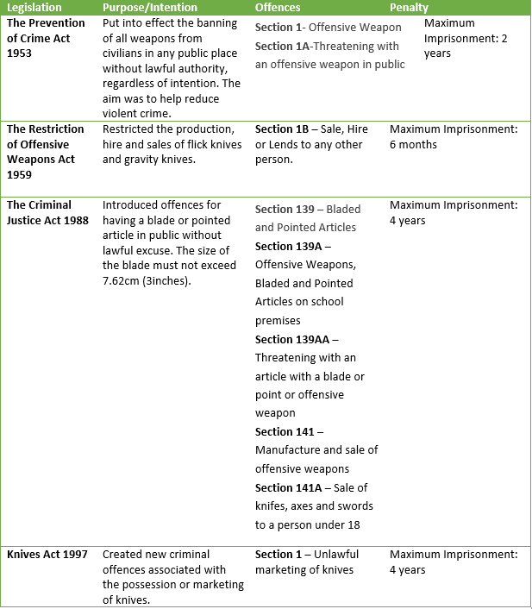
Table 2: legislation (Crown Prosecution Service 2019, Home Office 2020b, Home Office 2020c, Home Office 2020d, Home Office 2020e).

Knife Crime Prevention Orders

The legislation in table 2 displays a straightforward and basic explanation of previous legislation that has been introduced and the offences and penalties relating to knife crime in each. However, it is vital to look at recent legislation that has been introduced. The Offensive Weapons Act 2019 introduced Knife Crime Prevention Orders (KCPOs).
The introduction of KCPOs was to create a new tool that police forces could use to help young people and others to avoid knife crime and serious violence. The aim of the KCPOs is to act as a preventative measure rather than a punitive one, in allowing people to change their behaviour and avoid being drawn into knife crime. Currently KCPOs are being trailed by Metropolitan Police for 14 months, which started April 6th, 2020 (Home Office and Malthouse, 2020a). However, for the strategy of KCPOs to show a successful outcome, a multi-agency approach must be used. Police forces will be expected to be in contact with relevant authorities to ensure that those issued with a KCPO are in relevant positive placements, such as educational courses, life skill programmes and awareness raising courses as well as others (Home Office, 2019a).
A KCPO can be placed on anyone aged 12 or over by the relevant court (Youth Court, Magistrates Court or Crown Court). This can be done by a court regardless of whether there is a conviction, if the relevant sections of the Offensive Weapons Act 2019 are followed :A KCPO on conviction must meet the requirements listed under Section 19 , A KCPO made on other than a conviction must meet the requirements listed under Section 14. The CPS has a responsibility to ensure that where the defendant is under 18 that the views of YOTs are obtained as well as ensuring that the defendant is made aware of the application prior or at the first hearing (Home Office, 2019)
What is made up within the foundation of a KCPO is to be determined by the court. The list of requirements that can be imposed under a KCPO are set out in the Offensive Weapons Act 2019. These prohibitions include curfews and participation in certain activities. Other prohibitions include exclusion zones, non-association with other individuals and preventing the defendant from having specific articles (Home Office, 2019).
However, KCPOs introduced as part of the Serious Violence Strategy and implemented through the Offensive Weapons Act 2019 have been subject to scrutiny from the Standing Committee for Youth Justice and the Prison Reform Trust (2019). In the joint paper provided by these groups, it outlines the negative impact that the new measures will have on young adults and more specifically children and urged MPs to oppose the introduction of KCPOs. Labelling KCPOs as a “knife crime ASBO” they outline that the scope for them is to wide and will have a negative impact by labelling young adults and impose more unnecessary criminal sanctions on vulnerable children and young adults.
Furthermore, they criticise the approach of KCOPs as there are already several interventions in place, better suited to deal with young adults without resorting to restrictive and criminalising orders. A further point outlines the imprisonment for breach is not appropriate for children or young adults and goes against the UN Convention on the Rights of the Child (UNCRC), in such that all avenues must be exhausted before placing a child into a custodial establishment. This punishment will not only have a high cost on the taxpayer but also on the child’s further education and emotional status (Standing Committee for Youth Justice and the Prison Reform Trust, 2019). This is further supported by Damn et al (2017) who state that children as young as twelve who pass through the CJS are less likely to become rehabilitated and has often led to increased levels of criminal activity in future years. Furthermore, the UNCRC have time and again published criticism of the minimum age of criminal responsibility within England and Wales. The Committee on the Rights of a Child (2007) stated that while the age of 12 was internationally acceptable, that they would much rather it be increased to 14 or 16 years of age.
Additional support from the LGA (2019) have also stated that the KCPOs should not contribute towards the unnecessary criminalisation of young people and that additional resources will need to be provided to allow YOTs to allow KCPOs to be fully sustainable. Lastly, Liggins (2019) states that KCPOs are not a necessary development of the law and are seeking to close a gap that does not exist. While it is agreed that the criminal justice system needs a response to knife crime, there is no evidence to suggest that KCPOs will help. Liggins argues that professionals within the criminal justice system need to be seen to be doing something, and that the implementation of KCPOs may help build police and community relations. However, when the Home Office introduced the police of KCPOs it was stated to prevention strategy to tackle knife crime, but again it has been shown that there are more effective systems in place that have been shown to work that are desperate for funding and that the cost of implementing and maintaining KCPOs would be better invested in the areas shown to work (Liggins 2019).
Overall KCPOs aims to be a tool that if used correctly aims to impose restrictions to reduce the chance of a young adult getting caught up in knife crime while simultaneously offering positive requirements to further educate and support young adults with the aim of reducing the overall knife crime committed in England and Wales. However, there have been a large amount of uncertainty surrounding the potential impact they may cause on young people’s lives. Only time will tell if the introduction of KCPOs provide a successful prevention method.

Legal Duty

In 2018, it was put forward that a consultation on a new legal duty to underpin a public health approach to tackling serious violence would be created to place a statutory duty on health care professionals, police forces and local authorities to take action in preventing violent crime. The statutory duty would require all agencies to work together to prevent young people entering the CJS (Home Office and Javid, 2018).
The Home Office (2019b) published the consultation on July 19th, 2019, and was open to responses from:
- Criminal Justice
- Education and childcare
- Police
- Police and Crime Commissioners
- Voluntary and community sector
- Multi-agency boards
- Health and social care
- Housing and construction
- Local government
- Members of the public
The consultation put forward by the Governments response to a legal duty surrounding serious violence offered three choices that responders could choose from, these included:
New duty on specific organisations to have due regard to the prevention and tackling of serious violence. This was the first and preferred option by the Government. This would see an introduction of legislation that would place a new duty of care on specific organisations to have due regard to the prevention and tackling of serious violence. Additionally, it would further set to improve multi-agency working and encourage information sharing (Home Office, 2019b).
New duty through legislating to revise Community Safety Partnerships. This is proposed to be done through amending Community Safety Partnerships and ensuring there is a plan in place for preventing and tackling serious violence. If this option is chosen, it will directly commit organisations to become members and form a partnership. This will legally force organisations to work together rather than just having “due regard”, as listed in option one, to tackling serious and violent crime (Home Office, 2019b).
A voluntary non-legislative approach. Lastly, this option would encourage the relevant authorities to adopt to certain measures, such as multi-agency working, rather than making it a statutory requirement. It would attempt to engage with a wide variety of organisations to make them aware that they have an important role to play in preventing serious violence. Additional support from the Government will be provided through trying to establish local partnerships between authorities and aim to provide cross boundary guidance where appropriate (Home Office, 2019b).
The consultation that offered the three above options closed on the 28th May 2019, and the policies and decisions that will come because of the consultation are still ongoing.

Serious Violence Reduction Orders

The government has issued a consultation in September 2020 seeking to give police new stop and search powers. Serious Violence Reduction Orders (SVROs) would act as an additional power to police to stop and search known offenders with impunity (Home Office and Malthouse, 2020b).
The percentage of offenders who have previously committed one or more knife crime offence has risen from over the previous years and is now at around 26% in the year ending March 2020. Additional information and statistics on reoffending can be found in section 4.3.
The new power would act as a tool that may be used to target individuals who are known to have previously been convicted of a relevant offense, such as carrying a knife or offensive weapon. The aim of SVPOs is to tackle the cycle of weapon carrying (Home Office and Malthouse, 2020b). If the individual carrying a knife knows that the police can search them due to previous offences, then there is a much higher risk of being caught, leading to a custodial sentence in court.
The new power available to police would complement the already existing stop and search powers they currently have. The aim is to make communities safer and allow the police to challenge individuals that are known to carry knives (Home Office, 2020g).
SVPROs would not replace KCPOs but would be available as an additional measure to the courts.
The consultation for SVPOs is currently ongoing. There is still much to be thought out when it comes to SVPOs such as how they might have an impact on particular groups, as well as how they might work in practise (Home Office, 2020g). The results of the consultation will be available at a future date.

Stop and Search

Arguably, one of the most important powers the police have at tackling knife crime is the use of stop and search under Section 1 of the Police and Criminal Evidence and 1984 or Section 60 of the Criminal Justice and Public Order Act 1994. The Metropolitan Police (2020) state the importance of stop and search as being an invaluable tool, in both tackling crime and protecting the public.
Section 60 of the Criminal and Justice Order Act 1994 allows the rank of inspector or above to authorise the use of stop and search in a specific area, such as a town centre. This may be based on the fact there is, or evidence to show that serious violence may take place, or that people may be in possession of offensive weapons. However, as the Section allows the use of stop and search on people without reasonable grounds it may only last for a period of 24 hours, with an extension of 24 hours if appropriate (Brown, 2020).
Since 2018 the rate of knife related incidents has been rising rapidly and therefore has seen an increased use of Section 60. Furthermore, Section 60 was amended by the Home Secretary on the 31st of March 2018 to alter the rank and degree of certainty needed for Section 60 to be authorised and applied, the changes made are:
  - Reducing the level of authorisation required for a Section 60 from senior officer to inspector.
  - Lowering the degree of certainty required by the authorising officer so they must reasonably believe an incident involving serious violence ‘may’, rather than ‘will’, occur.
The two amendments made to Section 60 will allow around 3,000 more officers be able to authorise the use of Section 60 (Home Office, 2019c).
The increased use of stop and search powers under Section 60 have been praised by the Metropolitan Police Commissioner, Cressida Dick, stating that the increased use of stop and search has been successful in the prevention and reduction of knife crime and reduced murders. Dick supported the clams that she made by providing evidence that showed a 15% decrease in knife related injuries on those aged 25 and under, and a fall in homicides by 25%. Commissioner Dick stated that the reason for the decrease within these areas was down to the excellent work that police forces had provided using stop and search (Dodd, 2019).
However, Liberty, an independent organisation who campaign against injustice and defend freedom, have argued that the use of Section 60 is haemorrhaging public trust. While Liberty agree that the tragedy of young death’s in Britain requires a response, they accuse politicians and police chiefs of using discriminatory tactics in the hopes of finding a solution (Robinson, 2018).

Methodology

Introduction

This section of the dissertation aims to provide an acceptable methodology for the research question and explains the decisions taken to approach knife crime through secondary data analysis and the strengths and weaknesses to the chosen approaches.
The secondary data collected has been analysed to offer a clear view on the rising numbers of knife crime and to clarify the impact that interventions, police powers and legislation has had on reducing it.
The researcher has a personal interest in this research after studying law, criminal justice and policing over the last four years.

Research Aims and Objectives

The aim of this dissertation is to identify the key issues attributing to an increase in knife crime and to understand key decisions made by government and the police service to help prevent and reduce knife crime. The interventions put in place across the UK will be analysed to determine their success rate.
A critical evaluation of secondary research will aim to establish an outcome of the following aims and objectives
- Explore the government’s response to knife crime.
- Critically analyse the interventions introduced in the United Kingdom in relation to reducing knife crime and reoffending.
- Outline legislation that has been introduced in the United Kingdom aimed at reducing and preventing knife crime.
- Explore and evaluate the effectiveness of the powers available to police to tackle knife crime.
- Analyse and provide up to date statistics surrounding knife crime, including the effect of Covid-19.

Research Design

Merriam and Tisdell (2015) present the importance of a good research design. A good research design aims to present a precise set of actions that lead to producing results and findings on a chosen topic. Cohen et al (2007) state that a research design is controlled by the notion of ‘fitness for purpose’ and therefore, the methodology and research design of a study is determined by the purpose of the research being taken. This has led to a set of paradigms that can chose when undertaking a research question.
A further explanation of research is presented by Saunders et al (2009) through the display of the research onion (figure 1) (Saunders et al, 2009, p. 108.).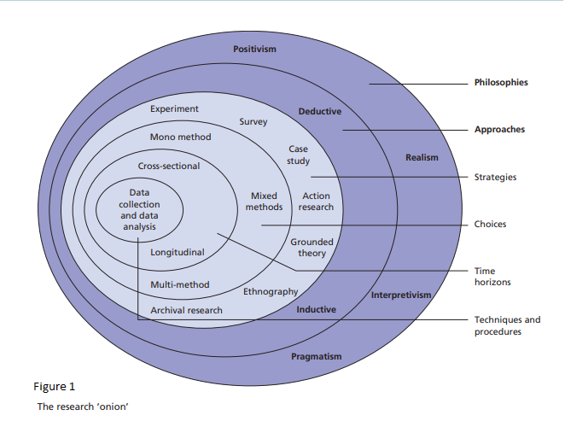
For the purpose of this research, the researcher will take two different research designs for exploring the data: explanatory and descriptive research design. Firstly, the purpose of descriptive research design is as following (Dulock, 1993):
- Describe systematically and accurately the facts and characteristics of a given population or area of interest.
- Aid in providing a more accurate representation and portrayal of characteristics found within a group, individual or situation.
- Discover links and associations between selected variables.
- Attempt to answer questions based on the current situation of events in the present.
The researcher will take note of the important elements of descriptive research. This done correctly should provide an accurate representation and description of the phenomena and characteristics surrounding the aims and objectives of this paper (Dulock, 1993).

Secondly, explanatory research is used in order to identify the extent of cause and effect relationships. This allows for an analysis on a specific situation or problem to explain patterns within variables. Explanatory research contains three important elements (Dudovskiy, 2018):
- Temporal Sequence: The cause must occur before the effect. An example, a previous life event may be the reason somebody commits a crime.
- Concomitant variation: The variation must be systematic between two variables. For example, If the response to knife crime does not change at a legal and policing level, then a change in knife crime statistics would not be because of the legal and policing practises in place.
- Nonspurious association: Any covariation between a cause and an effect must be true and not simply due to other variables. Simply put, there should never be a third factor that related to both, cause and effect.
The researcher will consider the three important elements of explanatory research and allow it to facilitate a more precise approach to the research.

Research Philosophy

A good research philosophy is important to have when conducting research, as this is a system of beliefs and assumptions the researcher undertakes when providing data analysis towards the aims and objectives. In formulating the information in this research, the researcher has taken a positivism philosophy approach (Artino et al, 2020). This benefit of this approach is that it allows the researcher to be disconnected from personal interests around the subject area, leaving the results completely independent and free from the researcher influencing them. This is because the positivism related to the stance of a scientist and works within the realms of social reality to produce law-like generalisations (Saunders, 2009).
The positivism approach often uses quantitative methods to provide analysis. However, if a study has been conducted to examine the effects of an intervention through qualitative analysis, this still fits within the positivism paradigm (Artino et al, 2020).

Research Approach

The research approach sets up the foundation of which the capability of the research question can be answered. Smith (2015) outlines that a research approach must lead to trustworthy and effective data collection and the information and facts collected are accepted. The research approach can be broken down into two different approaches each with its own method of data collection: Inductive approach with a quantitative data collection and deductive approach with a qualitative data collection.
Creswell and Plano Clark (2007) explain that inductive research starts from the bottom up. This is done by collecting new data from participants to generate an interconnecting theme that provides a broader view to the research being taken.
However, for the purpose of this study the researcher has chosen to take the deductive approach in this research, as this will allow the researcher to start from existing secondary research data that will provide information used to contradict or add to the theory presented. A deductive approach commonly uses quantitative research and has an increased chance of providing unbiassed results in line with the positivism philosophy.
Using this approach with allow the researcher to utilise a wide variety of already collected data, such as knife crime statistics. Using the deductive approach, the researcher will attempt to provide an up to date summary of the most up to date information available at the time.

Research Strategy

A research strategy according to Saunders et al (2009) is a general plan in which a researcher will go about answering the question. It facilitates the way in which the researcher provides reasoning for the direction in which data will be collected and analysed and the process in which research is conducted. For the purpose of this research the researcher has undertaken secondary research and will use two strategies: case study and thematic analysis.
Case study is a method that can be used to allow the researcher to closely examine data within a specific context. This method allows the researcher to explore and investigate contemporary circumstances through a detailed and contextual analysis of a limited number of events and conditions (Zainal, 2007)
A case study research method is explained by Yin (1984, p. 23) as “as an empirical inquiry that investigates a contemporary phenomenon within its real-life context; when the boundaries between phenomenon and context are not clearly evident; and in which multiple sources of evidence are used.”.
Therefore, a case study in an approach that can generate an in depth understanding of a complex issue in its real-life context. This has allowed the researcher to obtain a more in-depth understanding of the complexities around knife crime and allowed the researcher to draw a conclusion based on the caste studies analysed.
Thematic analysis could be potentially used by the researcher if opportunity to utilise the method becomes feasible. Nowell et al (2017) outline the need for a research that provides a systematic and diligent method that can be used to create useful results. Thematic analysis allows the researcher to become familiar with the data they have, and to generate consistent themes throughout the data. The researcher may identify re occurring themes or patterns from qualitative data that point to a specific reason why something happens (Braun and Clarke, 2006). Within this research it could present a pattern of data that may aid a better understanding as to why something does or does not work.
The researcher will use thematic analysis to determine any specific patterns that attribute to knife crime that repeat within the data collected. If any patterns repeat themselves, the researcher will take note and explain the patterns in the findings.

Date Collection

The previous sections of the methodology have set out guidelines that support the research question through how data will be collected, the design approach and the strategy that will be used to provide data (Saci, 2014). When combined they all lead to an equally important stage, data collection. The following sections will provide a look at how data collection techniques, ethical issues and time constraints. Teherani et al (2015) state the importance of data collection techniques, explaining that information collected by research aids in providing an analytic approach to the question, leading to explanations on the data collected.
The researcher has chosen to provide a secondary data collection method for this paper. The reason why this data collection method is being used is due to the amount of secondary data being published each quarter in relation to knife crime. Since 2015/16 knife crime has shown to have increased yearly, making it a higher issue to tackle at both a government and local level. This has led to a large amount of secondary research that can be critically evaluated on the topic. Secondary research if summarised correctly can provide an in-depth analysis and compact information from a variety of different sources into one place.
Also, during the time of this dissertation there is a global pandemic, making access to secondary research much more appealing.
The researcher will therefore not be undertaking any form of primary research, such as questionnaires, interviews or surveys. Instead the information collected will be from internet sources, journals, newspapers articles and reports that are trusted and verified. Since the researcher is using secondary research to collect data, the research acknowledges that data could be extracted through these sources to appropriately answer the research question.

Ethical Issues

The researcher understands that due to the nature of only collecting secondary data that the authenticity of the data collected will be credited to the relevant sources to avoid plagiarism concerns. The researcher has followed the guidelines set out in The Data Protection Act 1998 to preserve the authenticity and credibility of research through each phase.

Time Constraints

Using the research onion for reference (figure 1) this dissertation will take a cross sectional approach due to the time constraints to collect, analyse and conclude on research. This is opposed to longitudinal research which is done over a longer time period (Saunders et al, 2009).

Research Limitations

There are many issues faced by the researcher by strictly using secondary research (Boije and Hox, 2005)
- The researcher must be able to retrieve relevant data
- The researcher must locate data that provides useful to their research question
- The researcher must evaluate the quality of the used data, and ensure the methodological criteria of good scientific practise
Therefore, there is a dependency on secondary research material. The researcher cannot rely on primary data that could have been created to directly aid the research question.
Lastly, Creswell and Clark (2011) outline that only having access to one research approach can limit the scope of the study. They have stated that one approach by itself is not enough to answer all the questions that may present themselves during researching a topic. If a researcher is to present a complete and comprehensive study of the research question it is important to have access to all the research tools available.

3.9 Summary

Results

The results chapter of this dissertation will aim to provide two different ways in displaying data. Firstly, case studies will be used to display a more personal and in depth view of some of the key operations that are happening across the country that have shown to have a positive impact in the areas they operate within. Secondly, data will be analysed to provide a fair and balanced view to try and display whether the efforts put forward by the government, public sector and other agencies are having an impact on knife crime.

Case Studies

The following case studies will analyse operations at a ground level, to demonstrate the dedication and seriousness that is being taken to address knife crime at a local level. The three geographical areas that will be shown in these case studies are, South Wales, Essex, and South Yorkshire.

Operation Sceptre
In 2018, Wales saw an increase in knife crime of 23% compared to the previous year. Figure 1 displays the recorded statistics in knife crime from 2011 to 2018 in Wales. It shows a gradual increase to knife crime in Wales from 2015 with two larger spikes in 2017 and more importantly 2018. This is when Operation Sceptre teams in South Wales started to heavily crack down on knives and drugs in their area (BBC News, 2019b).
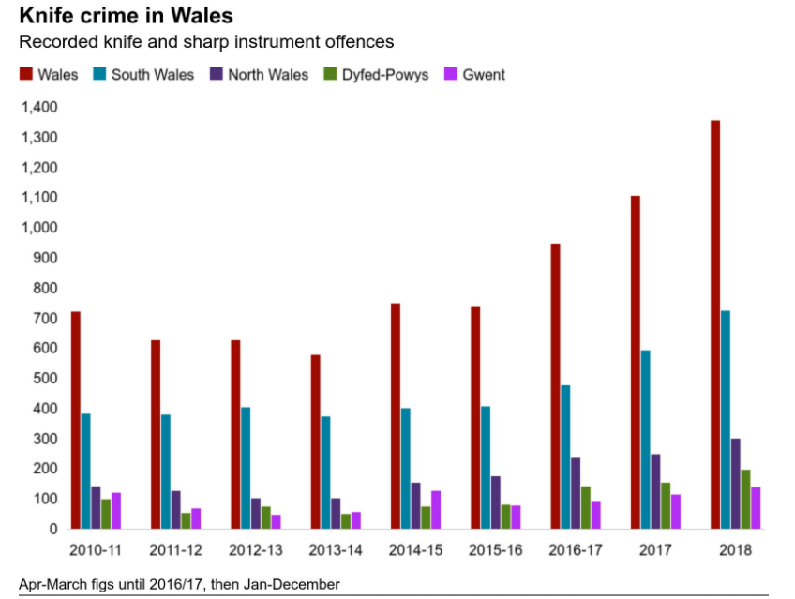
Figure 2 – Knife Crime Statistics – BBC News 2019b
Operation Sceptre was first introduced in 2015 as a nationwide scheme to tackle the rise in knife crime. In 2018 a 12 month ran scheme in Cardiff adopted the nationally led name to tackle and reduce knife crime offences in Cardiff. The operation is split into a variety of sections. Firstly, it encourages anonymous reporting of any suspicion that someone may be carrying knives or drugs. Secondly it aims at education young adults on the laws surrounding knife crime by highlighting key issues such as carrying, selling, and buying a knife as well as outlining other sharp instruments are also classified as an offensive weapon. Thirdly it outlines signs that parents should look out for to suspect whether their son or daughter may be carrying a knife. Lastly, it it’s community outreach it promotes the slogan “Lives not Knives” (figure 2) and encourages that people come forward and report any suspicions surrounding drugs and knives (South Wales Police, 2020).
Figure 2 – “Lives Not Knives” – South Wales Police 2020.

The Operation Sceptre team in Cardiff saw great success during the first twelve months, according to South Wales Police cited by BBC News (2019c) in the twelve months, running from June 2018 – June 2019 the Operation Sceptre Team had:
- Arrested 220 people.
- Removed 90 weapons off the street.
- Seized more than £80,000 of drugs and £77,000 in cash.
- Conducted 758 Stop and Searches.
- Aided in securing 22 years’ worth of custodial sentences.

Since the increase in knife crime took a leap in Wales in 2018, Operation Sceptre has expanded knife crime units from Cardiff into Swansea. This will be paid for by the Home Office who allocated £1.2milllion from the Early Intervention Youth Fund to allow the team to be created.
The creation of the additional team in Swansea has also seen success. During the first ten weeks that the teams were established they have accounted for (South Wales, 2019) –
- 126 arrests
- 459 stop and searches
- 74 weapons removed from the street
- Seized drugs with a value of around £24,000

The teams in Cardiff and Swansea continue to operate daily and keep a presence online via social media, most commonly twitter. Using the hashtag #OpSceptre, South Wales police continually publish their successes and continue to spread their message through this median.
Overall based on the efforts of the Operation Sceptre teams in Cardiff and Swansea, there has been a great focus on reducing knife crime in South Wales. Operation Sceptre has seen hundreds of knives confiscated from the streets of South Wales, making it a safer place than it otherwise would have been. The continuous and relentless campaign continues to this day and it is vital that funding for this project is renewed by the government to allow for the dedicated teams to continue their work.

Operation Fortify

South Yorkshire had displayed one of the largest increases in knife crime in 2018. The chart below (figure 3) shows the statistics for the possession of weapon offences in South Yorkshire ending in March of each year.
The chart displays that possession of weapon offences has risen from 1060 in 2017 to 1683 in 2020. However, the annual increase from 2019 to 2020 (169) is far less than the annual increase from 2018 to 2019 (346). Therefore, this shows that while knife crime numbers are increasing, they are doing so at a much slower rate (ONS, 2020a).
Figure 3 – Knife Crime Statistics in South Yorkshire 2016-2020 Year Ending March

The overall decrease in the possession of weapon offences could be down to Operation Fortify. Operation Fortify was launched in 2018 and is South Yorkshire’s public health multi agency approach to dealing with serious violent crime and organised criminality. One of the key areas that Operation Fortify covers is gang and knife crime. This is done through collaboratively working across the public and private sector and more importantly the community. The Operation Fortify team is a multi-agency team that gathers information and intelligence that allows the monitoring and disruption of criminality and violent crime (South Yorkshire Police, 2020). The strategy provides a strong and clear message “we want to send a clear message to those individuals and gangs involved in knife crime; they are not welcome here.” (South Yorkshire Police, 2020, p.43).
The multi partnership of Operation Fortify has shown to be extremely effective, as it includes Sheffield City Council, public health, social care, teaching hospitals, children’s hospitals and many other. This has allowed the operation to be flexible in reaching a wide variety of people and address issues across multiple sectors. This is supported by a ‘Locality Review’ conducted by the Home Office in 2019. The review states that Sheffield has an advanced status of partnership agreements and has comprehensive knowledge that has been built up from the large number of partners sharing data. Furthermore, due to the extensive use of partnership coordination, Sheffield was listed in the report as being further advanced in this area in comparison to most areas of the UK (HM Government, 2019).
Since the implementation of Operation Fortify, South Yorkshire saw an annual increase in 2019 of crimes involving knives or sharp instruments by 2% while seeing a decrease of 6% in 2020. The success of Operation Fortify has echoed the same response as that of Operation Sceptre in so much that is has secured additional funding of £1.6 million to support the Violence Reduction Unit in 2019/2020. The display of a multi-agency public health approach outlined in the governments Serious Violence strategy had been put to the test through Operation Fortify and has shown great success. The extra funding provided to the Violence Reduction Unit has allowed three other districts to now work under Operation Fortify. This has allowed Operation Fortify to expand its teams and apply what they have learnt to other parts of the country (Home Office, 2019).
Overall, the operation in South Sheffield has proved to be successful. This has proved once again that multi-agency work is vitally important when dealing with knife crime. Through the implantation of three additional teams and the funding secured for the next year, Operation Fortify displays the on-going hard work and dedication of the public sector in reducing knife crime.

Essex Violence Reduction Unit

In 2015-16 knife crime offences in Essex were estimated to be around 1.7k, this increased to 2.3k in 2016-17. This displayed a large increase in knife crime in Essex that caused concern and needed to be addressed quickly and intelligently to attempt to slow down the rate at which knife crime was increasing. One of the solutions for Essex came after the Serious Violence Strategy in 2018, where it was decided that a collective effort from the Police, Fire and Crime Commissioner would work together to produce the Essex Violence and Vulnerability Unit (Essex Police, 2018).

The intentions of the VRU was to aim at reducing violent behaviour and vulnerability. This included two approaches, prevention, and intervention. Prevention was aimed at younger people, by education them and attempt to sway them away from gang culture. Intervention was targeted at those who are most vulnerable of becoming a victim or committing crime.
The success of the Essex VRU is further outlined in the Home Offices independent report of VRUs across the country, published in August 2020. The report outlines that the VRU had successfully outlined the key drivers of serious violence, such as ACEs and austerity and that evidence-led responses to violence are starting to lay the foundation for improved results moving forward (Home Office, 2020f). While this case study focuses on the Essex VRU it is important to note the overall success of VRUs across the country. During 2019-20 the report lists VRUs are actively engaged in over 150 programmes aimed at helping young people being drawn into violent crime. The programmes reached over 100,000 individuals from all parts of the UK and listed 51,000 of those as high risk, providing the needed support to prevent violent crime being committed by individuals in future (Canning, 2020).
However, it is important to look at crime statistics when measuring success. While it is extremely difficult to determine the changes in statistical knife crime data, it may provide a quick review of the overall situation within a certain area. The success of the VRU in Essex saw them receive £664,000 extra funding in 2018-19 (Hirst, 2019) and £1.16 million in 2019-20, secured from the early intervention youth fund as part of the serious violence strategy set out by the government in 2018 (Canning, 2020).
Displaying the change in offence rates and changes in the volume of crimes involving knives or sharp instruments in 2018-19 Essex saw 39 knife crime rates per 100,000 population, displaying a 24% decrease from the previous year (ONS, 2019). However, in the year ending March 2019-20 Essex has seen a substantial spike to 61 knife crime rates per 100,000 population, showing a 51% change over the previous year (ONS, 2020b). This displays that knife crime in Essex is an ongoing problem, showing an increasing need for police forces to adapt and apply the lessons learnt through Operation such as Sceptre and Fortify. It is important to note however, Essex police force has done so, and now have their own dedicated Operation Sceptre team aimed at knife crime exclusively.
Therefore, it is important that funding continues in areas such as Essex where knife crime is increasing rapidly in comparison to other police force areas in England and Wales. This is supported by ONS (2020b) as it displays Essex having the highest annual increase of knife crime in England between March 2019-20. Overall, there is a multitude of approaches being taken across all sectors of Essex. This includes the interventions and prevention schemes offered from the VRU as well as the hands-on approach that Essex police force need to try and reduce the rise in knife crime being seen within Essex. Only time will tell if these approaches provide a long-term success.

Knife Crime Statistics in England and Wales

The following statistics cover the recorded crime in England and Wales, excluding Greater Manchester Police, in relation to knives or sharp instrument offences that resulted in a caution or conviction. This data is taken from the Police National Computer and is updated every quarter with a Knife Crime Statistics Quarterly Briefing, provided by the Ministry of Justice (2020a).
Quarter | Number of Offences
Q1 2016 | 4,668
Q2 2016 | 4,964
Q3 2016 | 4,982
Q4 2016 | 4,687
Q1 2017 | 5,242
Q2 2017 | 5,296
Q3 2017 | 5,391
Q4 2017 | 5,212
Q1 2018 | 5,300
Q2 2018 | 5,435
Q3 2018 | 5,693
Q4 2018 | 5,293
Q1 2019 | 5,811
Q2 2019 | 5,724
Q3 2019 | 5,682
Q4 2019 | 5,208
Q1 2020 | 4,884
Year | Knife and offensive weapon offences resulting in a caution or conviction, in England and Wales
2016 | 19,083
2017 | 20,616
2018 | 21,601
2019 | 22,449

Table (Ministry of Justice, 2020a)

Table (Ministry of Justice, 2020a)
As the data above shows there has been a steady increase on knife crime over the last 3-4 years. However, it should be acknowledged that the annual increase in knife crime appears to be lowering. The table below shows that the annual increase in knife crime is lowering. This could be attributed to the efforts put forward by the government and multi-agency actions that have been taken over the previous few years to tackle knife crime. However, only years more of statistical data will show if the interventions put into place will have an impact on the annual knife crime numbers. However, it should be noted that the year of 2020 will display much different numbers due to the Covid-19 pandemic, the effects of this are explained in section 4.6.

Year | Annual Increase in offences
2016/2017 | 1,533 (7.74%)
2017/2018 | 985 (4.8%)
2018/2019 | 848 (3.7%)

These results however only show an overall picture of knife crime in England and Wales and require further in-depth analysis. This dissertation will take on that responsibility.
Firstly it will aim to provide an in depth evaluation at the types of crimes committed with knives and if that has changed over the previous years as well as looking at hospital admissions, the age of the offender and how there has been an increase in the average prison sentence.
Secondly, this dissertation will use the most up to date statistics available from 2020 to demonstrate a change in knife crime statistics from March 2020 onwards in response to Covid-19.
Lastly, this results section will look at the use of stop and search in relation to knife crime and provide statistics on whether this is an effective tool.

Age of Offender and the Rate of Reoffending

The following tables have been produced by the Ministry of Justice (2020a) using the Police National Computer and will outline the number of knife crime convictions or cautions of three aged groups, 10 to 15, 16-17 and 18 and over. The information from these tables will be used to explain the rise in offences by each age group, and to show the rate at which re-offending occurs.
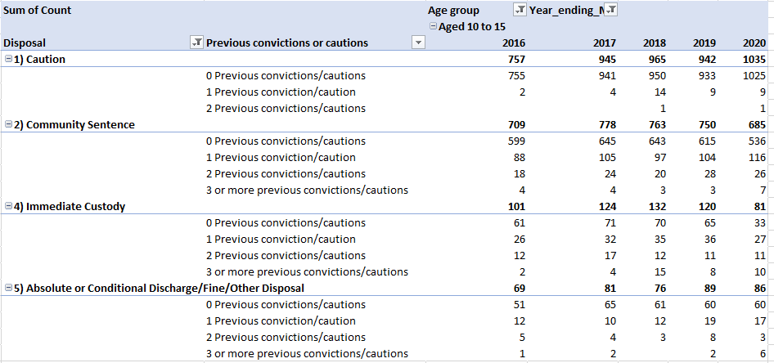
Table A –Number of previous cautions for the possession of knife or offensive weapons offences for offenders convicted or cautioned for a knife or offensive weapon possession offence (Ministry of Justice, 2020a)
Firstly, Table A displays that each year the rate at which 10 to 15-year olds are being cautioned or convicted of knife crime has been increasing, subsequently showing that knife crime is starting to gain an increased attraction to children and adolescent teens.
Secondly it displays the re-offending rates for those ages 10 to 15-years old. It shows an increase in re offending rates of the following:
First Offense – Aged 10 to 15 – Year Ending March
- 2016 -1,466 out of 1,636
- 2017 – 1,722 out of 1,928
- 2018 – 1,724 out of 1,936
- 2019 – 1,673 out of 1,901
- 2020 – 1,654 out of 1,887
This displays an increase in the rate of re-offending for ages 10 to 15, rising from 11.5% in 2016 to 14% in 2020. Therefore, the assumption can be put forward that knives are becoming a greater influence in younger people. The rate at which 10 to 15-year olds are being cautioned or convicted seems to have stabilised after the
The positive information that this table does display is that the number of 10 to 15-year olds who have been cautioned or convicted between 2017 and 2020 seems to have been stable since the rapid increase from 2016.

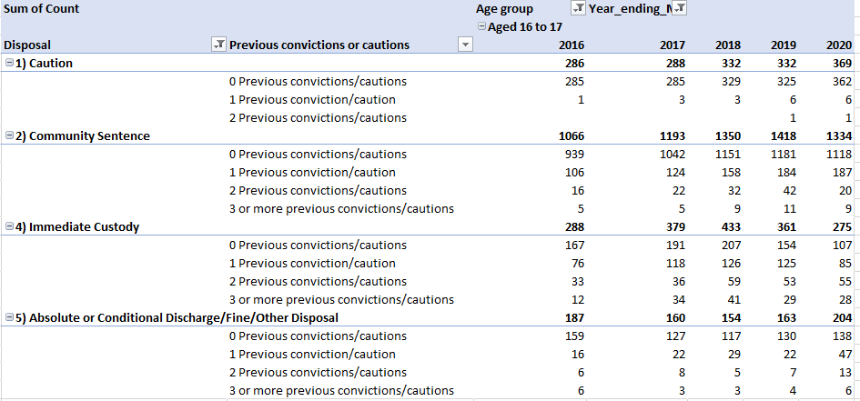
Table B –Number of previous cautions for the possession of knife or offensive weapons offences for offenders convicted or cautioned for a knife or offensive weapon possession offence (Ministry of Justice, 2020a)

Extracting the data from Table B is similar of the data trends shown in Table A. Firstly, it demonstrates an increase in the number of convicted or cautioned 16 to 17-year olds in relation to a knife or weapon offence. Therefore, it also displays the rate at which knives are becoming more popular within this age range.
However, the data that displays re-offending rates for those aged 16 to 17 displays a rather significant increase, the data for this is shown below:
First Offense – Aged 16 to 17 – Year Ending March
- 2016 – 1,550 out of 1,827
- 2017 – 1,645 out of 2,020
- 2018 – 1,804 out of 2,269
- 2019 – 1,790 out of 2,274
- 2020 – 1,725 out of 2,182
The figures show a rather large increase in the number of 16 to 17-year-olds who re-offend. The rate of re-offending in 2016 was 17.8% with this rising to 26.4% in 2020. A rather large increase compared to those in Table A. However, similarly with Table A it suggests that the number of 16 to 17-year olds offending is a steady number after the initial large increase from 2016. Overall, this suggests that the older the person is, the more likely they are to reoffend, this becomes abruptly apparent in Table C.

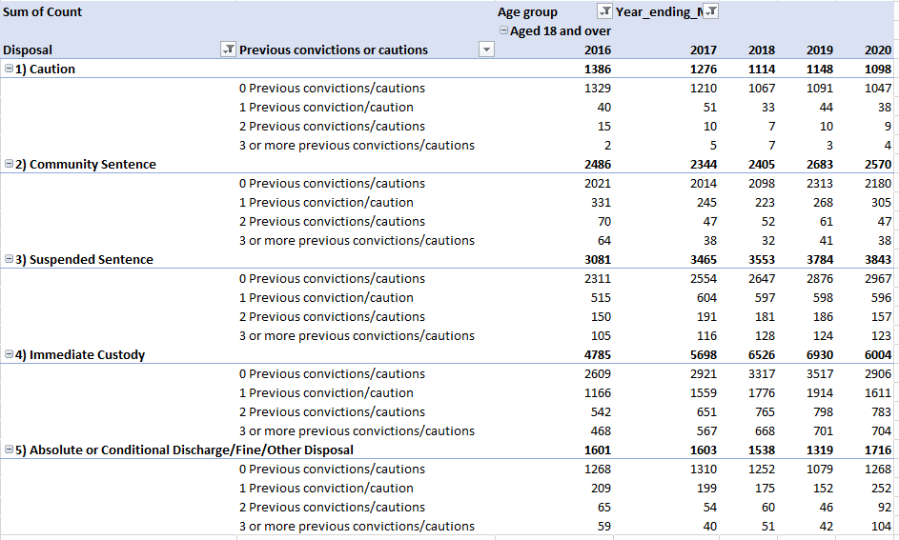
Table C –Number of previous cautions for the possession of knife or offensive weapons offences for offenders convicted or cautioned for a knife or offensive weapon possession offence (Ministry of Justice, 2020a)
The information from Table C contains the data of those aged 18 and over. As expected, it contains the largest amount of quantitative data. The trends set in Table A and B; increased rates of offending and re-offending, can be seen here on a much larger scale.
As shown above, the rate of re offending tends to increase the older the person is, this is certainly the case in this age category. The numbers of offenders and re-offenders is listed below:
First Offence – Aged 18+ - Year Ending March
- 2016 - 9,556 out of 13,339
- 2017 – 10,009 out of 14,386
- 2018 – 10,381 out of 15,137
- 2019 – 10,878 out of 15,864
- 2020 – 10,368 out of 15,231
This displays an increase of re-offending for ages 18 and over going from 39% in 2016 to 46.9% in 2020. Therefore, the rate at which adults are re-offending and entering the criminal justice system is increasing. However the main concern in this age group is the rapid increase of knife crime offences each year , the only year in which this drops is the year ending March 2020 and further explanation for this can be found in 4.6.

The data suggests that there has been a decrease in the number of offenders who have been convicted or cautioned for the first time. When looking at the data over the last decade it would show that the amount of people who have committed their first offense has fallen from 80% in March 2010 and is now at around 71% ending March 2020 (Ministry of Justice, 2020a).
Overall, it can be shown by the patterns in the data that each year the rate of re-offending for every age group is increasing. Therefore it can be confirmed that second time offenders are going to become more and more common and that additional resources including interventions and knife crime strategies need to be aimed at not just the prevention of first time knife crime offences, but also aimed at preventing re-offending.

Hospital Admission – England

One of the weaknesses of recorded data that the police and courts rely upon is having it come to their attention in the first place. It is therefore fair to offer a more completed view on statistics such as knife crime by adding additional data from other sources, such as NHS hospital records (Allen and Wade, 2020). NHS England records the number of incidents in hospitals related to a sharpened object or blade, resulting in a stab wound and is provided in the Hospital Episode Statistics (HES) (NHS, 2020a). The figures included in these publications only include that got admitted to hospital and therefore do not record those who only attended Accident and Emergency
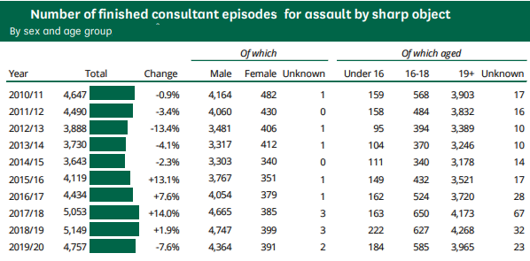
Table D – NHS (2020b)
Table D provides the details on finished consultant episodes (FCE) recorded in English hospitals since 2010 ending in the month September. As shown there has been a -7.6% in hospital admissions so far in 2019/2020 when compared to the previous year. However, this would be expected as it follows the trends set by Covid-19 has had on knife crime during 2020, as can be seen in 4.6 – Link to Covid. Therefore, it is important to consider other viewpoints the data suggests. While there has been a decrease overall in 2019/2020 it is still up 31% over 2015 and 16% over 2016 (Allen and Wade, 2020). This is important as this is the time in which knife crime started to resurface at a much higher rate. This suggests that once the Covid-19 pandemic has passed that those being admitted to hospital after being assaulted with a sharp object could perhaps further rise, and that only further years of recorded data will show this.
In 2019/20, of those admitted to hospital for assault by sharp object 16.2% were aged 18 or younger a rise from 14% in 2015/16. Around 92% of people admitted to hospital for assault by sharp objects are men.
Overall, the recorded of consultant episodes for assault by a sharp object have steadily risen alongside the increase in the use of a knife or sharp object at a regional level. There is a slight bump in the 2020 data due to the circumstances surrounding Covid-19 and more accurate data will have to be collected after the pandemic is over to see whether or not the strategies being used in England will be successful.

Cautioning and Sentencing

It is currently not possible to track every single incident that includes a knife or sharp object that leads to a caution or prosecution as the individual circumstances of each offence are not collected to any one place. Therefore, there are only statistics available for offences that specifically include a knife or sharp object in statute. This means that information is only published for the following (Wade and Allen, 2020):
- Possession of an article with a blade or point in a public place
- Possession of an article with a blade or point on school premises
- Possession of an article with a blade or point without reasonable excuse or authority
- Possession of an article with a blade or point without reasonable excuse or authority on school premises
Due to the high volume of knife crime in the early 2000s, a Court of Appeal judgement in May 2008 suggested that magistrates should start to seek to sentence them convicted of knife crime as opposed to cautioning (Crown Prosecution Service, 2020). Chart 1 below shows the impact of this judgement alongside the Criminal Justice and Courts Act of 2015 which introduced a provision for a minimum custodial sentence of at least 6 months for repeat offenders.
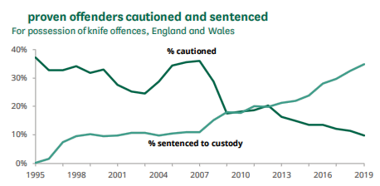
Chart 1 – Ministry of Justice (2020b) Knife and offensive weapon sentencing.
Therefore, the proportion of offenders being sentenced to custody has increased significantly and the use of cautions has dropped significantly. This would support the stance that the government wants to keep knife crime a top priority and does not want to be seen decreasing punishment. This is further supported by Chart 2 which outlines that the average custodial sentence length for possession has also been increasing over the previous years and is currently at an all-time high.
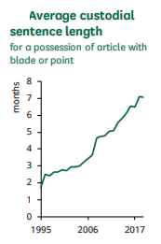
Chart 2 – Ministry of Justice (2020b)

It can therefore be determined that the average custodial sentence length has been increasing from 1995 and that displaying a sharp increase in 2008. This is further supported by an annual report issued by the Ministry of Justice in March 2020, which outlines that there was an increase from 23% to 35% in custodial sentences between March 2010 and 2017 and that the average length of custodial sentences has increased from 6.6 months in 2010 to an all-time high of currently 8.1 months ending March 2020 (Ministry Of Justice, 2020a).
Overall, the criminal justice system is committing to increasing the punishment of offenders in relation to knife crime. This can be seen by increasing the number of custodial sentences passed and the reduction in the percentage of those being cautioned. However, the attempt to pass longer sentences has not had an impact on the overall rise in knife crime. As supported by section 4.3 the age of offenders and the rise in repeat offending has only been seen to increase. Suggesting that an increased length of sentences appears to not act as any sort of deterrent when it comes to reducing the overall knife crime statistics.

Covid-19 Impact on Knife Crime in 2020

Covid-19 has impacted every part of daily life during 2020, including crime. Chart 3 below illustrates the vast drop in crimes committed during the first peak of the virus and how lockdowns and restrictions afforded less opportunity for crime to be committed.
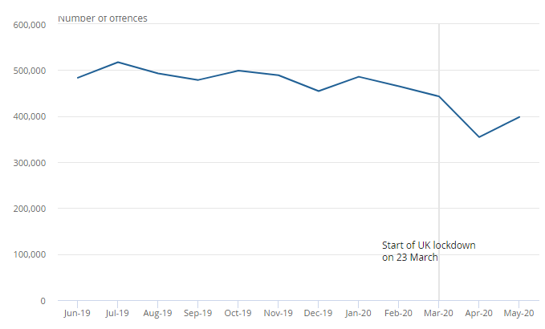
Chart 3 – Crime in England and Wales June 2019 to May 2020 (ONS, 2020c).
This led to a total of 354,334 offences being recorded in April 2020, the lowest over the previous year and a month-on-month decrease of 20%. However, the restrictions set out by the government started to ease from the 13th of May and crime numbers started to climb. As shown by the 12% increase from April to May 2020 (ONS, 2020c).
The effect of Covid-19 on the rate of knife crime can be seen in the figures between April to June 2020, after restrictions came into force on the 23rd of March. Table E indicates a fall of 51% in the number of knife and offensive weapons offences dealt with by the Criminal Justice System compared to the same quarter in 2019. Table E also displays the data from July to September of 2020. Showing the number of offences started to become more familiar to that of previous years, but still displaying an 8% decrease to the same quarter in 2019 (Ministry of Justice, 2020c).
Quarter and Year | Number of Offences
Q2 2019 | 5,720
Q2 2020 | 2,786
Q3 2019 | 5,661
Q3 2020 | 5,190
Table E – Ministry of Justice (2020c)
The data for quarter four is not yet available for 2020 but is expected to show a decrease in the number of offences committed to that of the previous year. This is due to the number of additional restrictions introduced throughout England and Wales. Such as the three-week firebreak in Wales and the four-week lockdown in England.
Overall, until the statistics are released for the final quarter of 2020, and the pandemic ends, the overall impact that Covid-19 has had on knife crime offences will be unknown. The statistics above do however indicate that the lack of opportunity during the initial lockdown and restrictions in March and April displayed a vast decrease in the amount of knife crime offences being committed. Therefore, the data for 2020 in relation to the decrease of knife crime has to be taken carefully, while there has been shown to be a decrease in the overall numbers of knife related crime, it has come at the time of a global pandemic. It is therefore recommended that the data of the previous year should be taken with extreme caution and that future data taken when the pandemic is over may provide the data needed to prove that the systems put in place by the government and local agencies are working.

Stop and Search

Recent governments and the current conservative government have all been in support of the use of stop and search as part of their policy in addressing violent crime. The current Conservative government has perused policy’s in aiding police enforcement, including the use of stop and search. As part of the serious violence strategy, the investments in early intervention have been supported to help youths at risk, but there has also been a call for not just an increase in stop and search, but a fair and effective use (Brown, 2020). The table for stop and searches in England and Wales are displayed below.
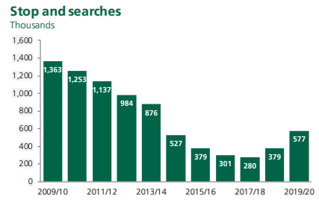
Chart 4 – Stop and Searches (Brown, 2020).
The information from chart 4 has been broken down into the relevant use of stop and search.
Police Power | Number of Searches – Year Ending March 2020 | Increase on Previous Year
Section 1 PACE | 558,973 | 192,061 (52%)
Section 60 Criminal Justice and Public Order Act | 18,081 | 4,667 (35%)

Table F (Home Office, 2020h).
Overall, the combined number of searches in 2019/2020 was 577,054 searches, resulting in 74,121 arrests. This displays a 27% increase in arrests under Section 1 PACE from the previous year. However, the overall arrest rate from the previous year dropped from 16% to 13% due to the increased number of stop and searches conducted under Section 60 leading to no arrest (Home Office, 2020h). Therefore, while the use of stop and search can prove to be an effective tool, officers must try and ensure that the reasonable grounds they believe they have are sufficient for stopping someone, especially as the use of stop and search has shown to sometimes erode public trust.

4.7.1 Reason for Searches

In a Home Affairs Committee (2019a) hearing, police leaders had said that stop and searches had been targeted more towards those who are suspected of carrying a knife or weapon and that the reduced number of stop and searches over the previous years has led to an increase in knife crime. However, this is not reflected in the data. Table G shows 63% of stop and searches with reasonable grounds in 2019/2020 were done so based on the assumption of finding a controlled drug or substance.
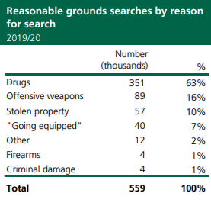
Table G (Brown, 2020).
Furthermore, the assumption that the decrease in the number of stop and search has led to an increase in knife crime is unfounded. While there can be seen a decrease in the number of stop and searches between 2014-2016 in the years that knife crime started to rise, the statistics also display that stop and searches also fell between 2010-2014 alongside a decrease in knife and other sharp instrument offences(Home Office, 2020g). Therefore, there is no way to precisely determine whether one influences the other. However, a study by Bradford et al (2018) used ten years of police crime and other data from London to investigate the potential effect of stop and search on crime. It found that stop and search in the best-case scenario only displayed a very marginal effect on emerging crime problems. Yet it outlines that the use of searches on targeted individuals to identify contraband can be useful. Furthermore, the study highlights that the results would improve by targeting prolific offenders, by doing this it would avoid risking public trust and increase police legitimacy.

5. References
Allen, G. Wade, E. (2020) Knife Crime Statistics [Online] Available at : https://commonslibrary.parliament.uk/research-briefings/sn04304/ Accessed 30th Dec. 2020.
Artino, Anthony. Konge, Lars. Park, Yoon Soo (2020) Available at: https://journals.lww.com/academicmedicine/Fulltext/2020/05000/The_Positivism_Paradigm_of_Research.16.aspx Accessed 28th Aug. 2020.
Association of London Directors of Children’s Services. (2018) The response of London Children’s Services to serious youth violence and knife crime [Online] Available at : https://www.londoncouncils.gov.uk/node/34040 Accessed 21st July. 2020.
Awinger, P. Kodjo, CM. Ryan, SA. (2003) Demographic, Intrisic and Extrinsic Factors Associated with Weapon Carrying at School [Online] Available at : https://jamanetwork.com/journals/jamapediatrics/fullarticle/481222 Accessed 27th July. 2020.
BBC (2019) Knife crime : Cressida Dick says violent crime rise linked to policing numbers [Online] Available at : https://www.bbc.co.uk/news/uk-47452799 Accessed 27th July. 2020.
BBC News. (2019b) Knife Crime: Record levels in Wales in 2018 [Online] Available at: https://www.bbc.co.uk/news/uk-wales-48053575 Accessed 13th Oct. 2020.
BBC News. (2019c) Op Sceptre: South Wales Police expands knife crime units [Online] Available at : https://www.bbc.co.uk/news/uk-wales-48857090 Accessed 13th Oct. 2020.
Bermingham, R. Shipton, E. (2018) Developing Non-Academic Skills [Online] Available at : https://post.parliament.uk/research-briefings/post-pn-0583/ Accessed 27th July. 2020.
Boeije, H. Hox, J. (2005) Data Collection, Primary v Secondary [Online ]Available at : https://www.narcis.nl/publication/RecordID/oai%3Adspace.library.uu.nl%3A1874%2F23634/dd_year/2005/uquery/secondary%20data/id/2/Language/NL Accessed 6th July. 2020.
Booth, C. Black, L. Dear, G. John, G. Johnson, M. Levy, I. Selvan, F. Williamson, H. (2008) The Streets Weapons Commission Report [Online] Available at : https://aashaproject.files.wordpress.com/2008/08/c4_street-weapons-commission-final-report.pdf Accessed 27th July. 2020.
Bradford, B. Quinton, P. Tiratelli, M. (2018) Does stop and search deter crime? Evidence from ten years of London-wide data [Online]Available at : https://academic.oup.com/bjc/article/58/5/1212/4827589#119992510 Accessed 8th Jan, 2021.
Braun, V. and Clarke, V. (2006) Using thematic analysis in psychology. Qualitative Research in Psychology, 3 (2) ISSN 1478-0887 [Online] Available at: http://eprints.uwe.ac.uk/11735/2/thematic_analysis_revised Accessed 28th Aug. 2020.
Brookman, F. Maguire, M. (2003) Reducing Homicide: a review of the possibilities [Online] Available at : https://pdfs.semanticscholar.org/a433/0c2e7c5e44f146922da341b905c559ee64a6.pdf Accessed 27th July. 2020.
Brown, J. (2019) How is the government implementing a ‘public health approach’ to serious violence? [Online] Available at : https://commonslibrary.parliament.uk/home-affairs/crime/how-is-the-government-implementing-a-public-health-approach-to-serious-violence/ Accessed 21st July. 2020.
Brown, J. (2020) Police Powers : Stop and Search [Online] Available at : https://commonslibrary.parliament.uk/research-briefings/sn03878/ Accessed 8th Jan. 2021.
Brown, J. (2020) Police powers: stop and search [Online] Available at: researchbriefings.files.parliament.uk/documents/SN03878/SN03878.pdf Accessed 7th Aug. 2020.
CAADA (2014) In Plain Sight: Effective help for children exposed to domestic abuse [Online] Available at : https://safelives.org.uk/sites/default/files/resources/Final%20policy%20report%20In%20plain%20sight%20-%20effective%20help%20for%20children%20exposed%20to%20domestic%20abuse.pdf Accessed 27th July. 2020.
Canning, K. (2020) Essex Violence and Vulnerability [Online] Available at : https://elsenham-pc.gov.uk/essex-violence-vulnerability-unit-newsletter/ Accessed 16th Oct. 2020.
Children’s Commissioner (2018) Forging futures through mentoring: A risk worth pursuing? [Online] Available at : https://www.childrenscommissioner.gov.uk/report/mentoring/ Accessed 27th July. 2020.
Cohen, L. Manion, L. Morrison, K. (2007) Research Methods In Education [Online] Available at : https://gtu.ge/Agro-Lib/RESEARCH%20METHOD%20COHEN%20ok.pdf Accessed 25th Aug. 2020.
Committee on the Rights of the Child (2007) Children’s Rights in juvenile justice [Online] Available at : https://www.refworld.org/docid/4670fca12.html Accessed 4th Aug. 2020.
Creswell, J. Plano Clark, V. (2007). Designing and conducting mixed methods research. London: SAGE.
Creswell, J. Plano Clark, V. (2011) Designing and Conduction Mixed Methods Research [Online] Available at : https://books.google.co.uk/books?id=YcdlPWPJRBcC&printsec=frontcover&source=gbs_ge_summary_r&cad=0#v=onepage&q&f=false Accessed 28th Aug. 2020.
Crown Prosecution Service (2018) Offensive Weapons, Knives, Bladed and Pointed Articles [Online] Available at : https://www.cps.gov.uk/legal-guidance/offensive-weapons-knives-bladed-and-pointed-articles Accessed 2nd Aug. 2020.
Crown Prosecution Service. (2020) Offensive Weapons, Knives , Bladed and Pointed Articles [Online] Available at: https://www.cps.gov.uk/legal-guidance/offensive-weapons-knives-bladed-and-pointed-articles Accessed 31st Dec. 2020.
Damn, A. Larsen, B. Nielsen, H. Simonsen, M. (2017) Lowering the minimum age of criminal responsibility: Consequences for juvenile crime and education [Online] Available at : https://pure.au.dk/portal/files/118094764/wp17_10.pdf Accessed 4th Aug. 2020.
Densley, J. A., Adler, J. R., Zhu, L., & Lambine, M. (2017). Growing against gangs and violence: Findings from a process and outcome evaluation. Psychology of Violence, 7(2), 242–252. https://doi.org/10.1037/vio0000054
Dodd, V. (2019) Met police chief hails fall in violent crime in London [Online] Available at : https://www.theguardian.com/uk-news/2019/may/02/met-police-commissioner-cressida-dick-hails-fall-in-violent-in-london Accessed 7th Aug. 2020.
Draca, M. Machin, S. Witt, R. (2008) Panic on the Streets of London: Police, Crime and the July 2005 Terror Attacks [Online] Available at : https://www.aeaweb.org/articles?id=10.1257/aer.101.5.2157 Accessed 27th July. 2020.
Dudovskiy, J. (2018) Causal research – explanatory research [Online] Available at: https://research-methodology.net/causal-research/ Accessed 25th Aug. 2020.
Dulock, H. L. (1993) ‘Research Design: Descriptive Research’, Journal of Paediatric Oncology Nursing, 10(4), doi: 10.1177/104345429301000406.
Early Intervention Foundation (2018) Realising the potential of early intervention [Online] Available at : https://www.eif.org.uk/report/realising-the-potential-of-early-intervention Accessed 24th July. 2020.
Essex Police. (2018) Safer Essex Violence and Vulnerability Framework June 2018 [Online] Available at : https://www.essex.pfcc.police.uk/wp-content/uploads/2018/08/Violence-and-Vulnerability-Framework-approved-June-2018.pdf Accessed 15th Oct. 2020.
Farrell, G. Mailley, J. Tiley, N. Tseloni, A. (2011) ‘The Crime Drop and the Security Hypothesis’, Journal of Research in Crime and Delinquency, 48(2), pp. 147–175. doi: 10.1177/0022427810391539.
Farrington, D. (2000) Explaining and Preventing Crime: The Globalization of Knowledge – The American Society of Criminology 1999 Presidential Address. Doi: https://doi.org/10.1111/j.1745-9125.2000.tb00881.x
Hirst, R. (2019) Essex bid for home office funds to tackle violence and vulnerability in Essex successful [Online] Available at : https://www.essex.pfcc.police.uk/news/essex-bid-for-home-office-funds-to-tackle-violence-and-vulnerability-in-essex-successful/ Accessed 16th Oct. 2020.
HM Government. (2018) Serious Violence Strategy [Online] Available at : https://assets.publishing.service.gov.uk/government/uploads/system/uploads/attachment_data/file/698009/serious-violence-strategy.pdf Accessed 20th July. 2020.
HM Government. (2019) A whole-system multi-agency approach to serious violence prevention [Online] Available at : https://assets.publishing.service.gov.uk/government/uploads/system/uploads/attachment_data/file/862794/multi-agency_approach_to_serious_violence_prevention.pdf
HMI Probation. (2017a) The Work of Youth Offending Teams to Protect the Public [Online] Available at: https://www.justiceinspectorates.gov.uk/hmiprobation/wp-content/uploads/sites/5/2017/10/The-Work-of-Youth-Offending-Teams-to-Protect-the-Public_reportfinal.pdf Accessed 30th July. 2020.
HMI Probation. (2017b) HM Inspectorate of Probation for England and Wales ; Annual Report [Online] Available at : https://www.justiceinspectorates.gov.uk/hmiprobation/wp-content/uploads/sites/5/2017/12/HMI-Probation-Annual-Report-2017-2.pdf Accessed 20th July. 2020.
HMI Probation. (2019) Annual report : inspection of youth offending services [Online] Available at : https://www.justiceinspectorates.gov.uk/hmiprobation/wp-content/uploads/sites/5/2019/10/Youth-annual-report-inspection-of-youth-offending-services-2018-2019-1.pdf Accessed 30th July. 2020.
Home Affairs Committee. (2019a) Oral Evidence: Serious violence, HC 1016 [Online] Available at : http://data.parliament.uk/writtenevidence/committeeevidence.svc/evidencedocument/home-affairs-committee/serious-violence/oral/98751.html
Home Affairs Committee. (2019b) Oral Evidence: Serious violence, HC 1016 [Online] Available at : http://data.parliament.uk/writtenevidence/committeeevidence.svc/evidencedocument/home-affairs-committee/serious-violence/oral/98024.html
Home Office, Malthouse, K. (2020a) Introduction of knife crime prevention orders [Online] Available at : https://www.gov.uk/government/news/introduction-of-knife-crime-prevention-orders Accessed 3rd Aug. 2020.
Home Office, Malthouse, K. (2020b) New stop and search powers for convicted knife criminals [Online Available at : https://www.gov.uk/government/news/new-stop-and-search-powers-for-convicted-knife-criminals Accessed 6th Jan. 2021.
Home Office. (2018) Early intervention youth fund [Online] Available at : https://www.gov.uk/government/publications/early-intervention-youth-fund Accessed 24th July. 2020.
Home Office. (2019a) Knife Crime Prevention Orders : Guidance [Online] Available at : https://assets.publishing.service.gov.uk/government/uploads/system/uploads/attachment_data/file/899091/KCPO_Draft_Framework_Guidance_final_2019_08_14.pdf Accessed 3rd Aug. 2020.
Home Office. (2019b) Consultation on a new legal duty to support a multi-agency approach to preventing and tackling serious violence. [Online] Available at : https://assets.publishing.service.gov.uk/government/uploads/system/uploads/attachment_data/file/816885/Government_Response_-_Serious_Violence_Consultation_Final.pdf Accessed 5th Aug. 2020.
Home Office. (2019c) Greater powers for police to use stop and search to tackle violence [Online] Available at : https://www.gov.uk/government/news/greater-powers-for-police-to-use-stop-and-search-to-tackle-violent-crime Accessed 2nd May, 2019.
Home Office. (2019d) Violence Reduction Units [Online] Available at : https://southyorkshire-pcc.gov.uk/app/uploads/2019/08/FOI-1272-Violence-Reduction-Unit-Funding.pdf Accessed 14th Oct. 2020.
Home Office. (2020a) Youth offending teams [Online]Available at : https://www.gov.uk/youth-offending-team Accessed 30th July. 2020.
Home Office. (2020b) Prevention of Crime Act 1953 [Online] Available at https://www.legislation.gov.uk/ukpga/Eliz2/1-2/14/contents: Accessed 2nd Aug. 2020.
Home Office. (2020c) The Restriction of Offensive Weapons Act 1959 [Online] Available at : https://www.legislation.gov.uk/ukpga/Eliz2/7-8/37/contentsAccessed 2nd Aug. 2020
Home Office. (2020d) The Criminal Justice Act 1988 [Online] Available at : https://www.legislation.gov.uk/ukpga/1988/33/contents Accessed 2nd Aug. 2020.
Home Office. (2020e) Knives Act 1994 [Online] available at : https://www.legislation.gov.uk/ukpga/1997/21/contents Accessed 2nd Aug. 2020.
Home Office. (2020f) Process evaluation of the Violence Reduction Units [Online] Available at : https://assets.publishing.service.gov.uk/government/uploads/system/uploads/attachment_data/file/910822/process-evaluation-of-the-violence-reduction-units-horr116.pdf Accessed 16th Oct. 2020.
Home Office. (2020g) Serious Violence Reduction Orders: A new court order to target known knife carriers [Online] Available at : https://assets.publishing.service.gov.uk/government/uploads/system/uploads/attachment_data/file/917277/SVRO_consultation.pdf Accessed 6th Jan. 2021.
Home Office. (2020h) Police powers and procedures [Online] Available at : https://assets.publishing.service.gov.uk/government/uploads/system/uploads/attachment_data/file/935355/police-powers-procedures-mar20-hosb3120.pdf Accessed 8th Jan. 2021.
Home Office. Javid, S. (2018) Home Secretary announces new measures to tackle serious violence [Online] Available at : https://www.gov.uk/government/news/home-secretary-announces-new-measures-to-tackle-serious-violence Accessed 5th Aug. 2020.
Jamieson, D. (2018) Written submission from the Police and Crime Commissioner, West Midlands SVC0020 [Online] Available at : http://data.parliament.uk/writtenevidence/committeeevidence.svc/evidencedocument/home-affairs-committee/serious-violence/written/87516.html Accessed 20th July. 2020.
Lemos, G. (2004) Fear and Fastion: The use of knives and other weapons by young people [Online] Available at : https://lemosandcrane.co.uk/resources/L&C%20-%20Fear%20and%20Fashion.pdf Accessed 27th July. 2020.
Liggins, C. (2019) Knife Crime Prevention Orders and Youths [Online] Available at : https://www.hja.net/knife-crime-prevention-orders-and-youths/ Accessed 4th Aug. 2020.
Local Government Association. (2018) Public health approaches to reducing violence [Online] Available at : https://www.local.gov.uk/sites/default/files/documents/15.32%20-%20Reducing%20family%20violence_03.pdf Accessed 24th July. 2020
Local Government Association. (2019) Impact of government policy on knife crime [Online] Available at : https://www.local.gov.uk/sites/default/files/documents/LGA%20briefing%20-%20Knife%20Crime-%20HoL%20270619%20-%20WEB.pdf Accessed 30th July. 2020.
Local Government Association. (2019) LGA response to the Government’s consultation on Knife Crime Prevention Orders [Online] Available at : https://www.local.gov.uk/parliament/briefings-and-responses/lga-response-governments-consultation-knife-crime-prevention Accessed 4th Aug. 2020.
Merriam, S. Tisdell, E. (2015) Qualitative Research : A Guide to Design and Implementation Fourth Edition [Online] Available at : https://books.google.co.uk/books?hl=en&lr=&id=JFN_BwAAQBAJ&oi=fnd&pg=PA137&dq=merriam+and+tisdell&ots=wN3TJJ_C33&sig=gH3ox7XERPNWyhAj94k6kRddMNE#v=onepage&q=merriam%20and%20tisdell&f=false Accessed 25th Aug. 2020.
Metropolitan Police. (2020) How we use stop and search [Online] Available at : https://www.met.police.uk/advice/advice-and-information/st-s/stop-and-search/how-we-use-stop-and-search/ Accessed 7th Aug. 2020.
Ministry of Justice. (2020a) Knife and offensive weapon sentencing statistics: year ending March 2020. [Online] Available at : https://www.gov.uk/government/statistics/knife-and-offensive-weapon-sentencing-statistics-year-ending-march-2020 Accessed 29th Dec. 2020.
Ministry of Justice. (2020b) Criminal justice system statistics [Online] Available at : https://www.gov.uk/government/statistics/criminal-justice-system-statistics-quarterly-december-2019 Accessed 31st Dec. 2020.
Ministry of Justice. (2020c) Knife and Offensive Weapon Sentencing Statistics: July to September 2020 [Online] Available at : https://www.gov.uk/government/statistics/knife-and-offensive-weapon-sentencing-statistics-july-to-september-2020 Accessed 3rd Jan. 2021.
NHS. (2020a) Hospital Episode Statistics [Online] Available at : https://digital.nhs.uk/data-and-information/data-tools-and-services/data-services/hospital-episode-statistics Accessed 30th Dec. 2020.
NHS. (2020b) Hospital Admitted Patient Care Activity 2019-20 [Online] Available at : https://digital.nhs.uk/data-and-information/publications/statistical/hospital-admitted-patient-care-activity/2019-20 Accessed 30th Dec. 2020.
Nowell, L. S. Norris, J. White, D. 2017) ‘Thematic Analysis: Striving to Meet the Trustworthiness Criteria’, International Journal of Qualitative Methods. doi: 10.1177/1609406917733847.
O’Connor, R. (2015) What works to prevent gang involvement, youth violence and crime [Online] Available at : https://www.eif.org.uk/report/what-works-to-prevent-gang-involvement-youth-violence-and-crime-a-rapid-review-of-interventions-delivered-in-the-uk-and-abroad Accessed 24th July. 2020.
ONS. (2019) Crime in England and Wales: year ending March 2019 [Online] Available at: https://www.ons.gov.uk/peoplepopulationandcommunity/crimeandjustice/bulletins/crimeinenglandandwales/yearendingmarch2019#rise-in-offences-involving-knives-or-sharp-instruments-and-firearms-offences Accessed 15th Oct. 2020.
ONS. (2020a) Crime in England and Wales: Police Force Area data tables [Online] Available at : https://www.ons.gov.uk/peoplepopulationandcommunity/crimeandjustice/datasets/policeforceareadatatables Accessed 14th Oct. 2020.
ONS. (2020b) Crime in England and Wales : year ending March 2020 [Online] Available at : https://www.ons.gov.uk/peoplepopulationandcommunity/crimeandjustice/bulletins/crimeinenglandandwales/yearendingmarch2020#knife-or-sharp-instrument-offences Accessed 15th Oct. 2020.
ONS. (2020c) Coronavirus and Crime in England and Wales [Online] Available at : https://www.ons.gov.uk/peoplepopulationandcommunity/crimeandjustice/bulletins/coronavirusandcrimeinenglandandwales/august2020 Accessed 3rd Jan. 2021.
Palasinski, M., (2013). Security, respect and culture in British teenagers' discourses of knife‐carrying. Safer Communities, 12(2), pp.71-78.doi 10.1108/17578041311315049
Petrosino A, Turpin-Petrosino C, Hollis-Peel ME, Lavenberg JG (2013) Scared straight and other juvenile awareness programs for preventing juvenile delinquency [Online] Available at : https://www.cochrane.org/CD002796/BEHAV_scared-straight-and-other-juvenile-awareness-programs-for-preventing-juvenile-delinquency Accessed 27th July. 2020.
Robinson, R. (2018) Police and Politicians ; Response to violent crime risks being counterproductive [Online] Available at :https://www.libertyhumanrights.org.uk/issue/police-and-politicians-response-to-violent-crime-risks-being-counter-productive/ Accessed 7th Aug. 2020.
Saci, N. (2014) Data collection methods: research methodology [Online] Available at : https://www.academia.edu/7226538/DATA_COLLECTION_METHODS_RESEARCH_METHODOLOGY Accessed 28th Aug. 2020.
Saunders, M. (2009) Understanding research philosophies and approaches [Online] Available at : https://www.researchgate.net/publication/309102603_Understanding_research_philosophies_and_approaches Accessed 28th Aug. 2020.
Saunders, M. Lewis, P. Thornhill, A. (2009) Research methods for business students; fifth edition [Online] Available at : https://eclass.teicrete.gr/modules/document/file.php/DLH105/Research%20Methods%20for%20Business%20Students%2C%205th%20Edition.pdf Accessed 25th Aug. 2020.
Scott, J. Spencer, L. (2013) School meets street: exploring the links between low achievement [Online] Available at : https://www.iser.essex.ac.uk/research/publications/working-papers/iser/2013-25 Accessed 27t July. 2020.
Smith, J.A. (2015) Qualitative psychology: A practical guide to research methods. London: SAGE.
South Wales Police. (2019) Further Success for South Wales Police’s Operation Sceptre Teams [Online] Available at : https://www.south-wales.police.uk/en/newsroom/further-success-for-south-wales-polices-operation-sceptre-teams/ Accessed 12th Oct. 2020.
South Wales Police. (2020) Knife Crime : Operation Sceptre [Online] Available at : https://www.south-wales.police.uk/en/knife-crime/ Accessed 12th Oct. 2020.
South Yorkshire Police. (2020) South Yorkshire Knife Crime Strategy 2018/21 [Online] Available at : https://www.southyorks.police.uk/media/2349/1517_south_yorks_knife_crime_strategy_03.pdf Accessed 14th Oct. 2020.
Teherani, A. Martimianakis, T. Stenfors-Hayes T. Wadhwa A. Varpio, L. (2015) Choosing a Qualitative Research Approach [Online] Available at : https://www.jgme.org/doi/pdf/10.4300/JGME-D-15-00414.1 Accessed 28th Aug. 2020
World Health Organisation (2017) The public health approach [Online] Available at : https://www.who.int/violenceprevention/approach/public_health/en/ Accessed 21st July. 2020.
Yin, R.K. (1984) Case Study Research: Design and Methods. Beverly Hills, Calif: Sage Publications.
Youth Justice Board. (2016) AssetPlus Guidance : Assessment and Planning Interventions Framework [Online] Available at : https://www.iicsa.org.uk/key-documents/7585/view/HMP000340.pdf Accessed 30th July. 2020.
Zainal, Z. (2007) Case Study as A Research Method [Online] Available at http://psyking.net/htmlobj-3837/case_study_as_a_research_method.pdf Accessed 28th Aug. 2020.

