CONSULTANCY REPORT FOR
MARRIOTT HOTEL CANARY WHARF, LONDON
PREPARED BY:
ELEVARE INSIGHTS LTD.

Student Name: Ionela Madalina Cananau
Student ID: 2243593
Module name Organisational Consultancy
Module Code: BMIH6005
Module Lead: Neil Dyer
Wordcount: 6311

I Confirm that I have not used any AI tools in the research and creation of this assignment. I confirm that I have not presented any AI generated materials as my own work. I confirm I have copies of my drafts, notes and other resources I used, which I my be asked to provide in evidence.

Table of Contents
Executive Summary 3
Introduction 5
Analysis 7
Overview of the Identified Issue 7
Impact of the Issue on the Hotel 8
Root Causes of the Problem 9
External Environment Analysis – STEEPLED 10
Internal Analysis – SWOT 13
Recommendations and Change Management 14
Measurement and Success Metrics 20
Conclusion 23
References 25

Executive Summary
Marriott Hotel Canary Wharf commissioned a consultancy report in response to a challenging issue within the organisation: declining employee engagement and a high level of staff turnover in the hospitality sector following the pandemic. Elevare Insights Ltd., the expert consultancy firm in organisational performance and workforce transformation, will deliver the report intended to explore the origins of the problem, its extent, and consequences coupled with providing practical, cost-efficient remedies that are based on the modern theory of HR and change management.
With an unparalleled location in the exclusive neighbourhood of Canary Wharf in London, the hotel is operated by the internationally renowned Marriott International brand. The hotel has a good track record in key service measures, thanks to its more than 300 rooms, strong corporate clientele, consistent occupancy rates, and above-average occupancy performance. Nevertheless, over the past few years the workforce has been affected by an ever-increasing lack of stability in the workforce stability that is manifested through high turnover rates, disengagement among operations level workers, operational overstretch caused by an over-reliance on agency workers and a declining internal culture.
The analysis in the report commences with a thorough study of the nature of the problem and its effects. The projected turnover rate at Marriot Canary Wharf is more than 38%, which is in speaking with the standards of UK hospitality industry. The reasons contributed are identified as an absence of career advancement, insufficient rewards, poor former communication among colleagues, and incomparable pay that is lower than the increasing cost of living in London based on exit interviews, online staff appraisals, and operational information. These internal issues also have to contend with external macro-environmental factors, such as Brexit-related labour shortages, inflation, the demographic makeup of the workforce, and changing employee expectations (Gupta et al., 2023).
The macro-environmental conditions within the hotel in the aspect of the workforce were analyzed using the STEPPED framework to arrange contents of the analysis (Khan et al., 2023). The social factors appeared as a social movement of a generation towards work-life balance, flexibility and meaning-oriented jobs. Technological distraction, as much as it enhances the delivery of services to the guests, has posed problems to undertrained employees. The recruitment has been under pressure because of the economic and political aspects such as loss of EU labour after Brexit and justified wage increments. Ethically and environmentally, there is a lack of appeal on employees to align to sustainability aims of Marriott. Demographically, aged workforce is experienced as well as diminished number of young people coming into the hospitality careers.
SWOT and TOWS analyses were further employed to study the internal strengths and weaknesses as well as opportunities and threats of Marriott Canary Wharf. It has privileged location, brand leadership, guest experience and occupancy, which are considered its key competitive advantages. Nevertheless, the inconsistent internal developments practice, scarce involvement of staff after and during, and use of temporary labour are the weakness that counteradvance these strengths. The opportunities are available in the way of international Marriott training tools, increasing employer branding and sustainability-oriented HR practices. The threats are the pressure of high competition in the labour market, demands of the rising expectations of the staff and the cost of operation.
In an effort to enhance proper execution of these recommendations, the report incorporates the use of Kotter 8-Step Change Model as a guideline. This model offers a systematic plan of organisational change, namely, the need to generate urgency related to the necessity of change, the formation of a guiding coalitions, the development of a shared vision, the motivation of personnel and their empowerment, the celebration of small victories, and the integration of new behaviours in the culture of the hotel.
Measurement is part and parcel of the strategy. The success will be measured using a set of Key Performance Indicators (KPIs). These are to cut labor-turnover to less than 25 percent in 12 months, employee engagement scores reaching 15 to 20 percent, average tenure to at least 18 months, Glassdoor ratings rising to 4.0 or well beyond 3.4, and guest satisfaction scores touching on staff service.
A projected cost of about 136,000 - 140,000 has been estimated to implement the same in Year 1. This encompasses the training development programs, scheduling tools, wellness program, pay increases and the communication platforms. Although in itself this is a serious investment, it is worth it when compared to the economic costs of failure to reduce high turnover rates, customer dissatisfaction, and productivity losses. In addition, there will be long term saving in terms of recruitment, training as well as operational efficiency which will be larger than initial investments. The plan of action, which was part of the report, gives a comprehensive analysis of plans, time period, responsible individuals, and budget thereby enabling the leadership of the hotel to plan and manage the implementation.
In conclusion, the suggested policy considerations outlined in the given report can provide Marriott Hotel Canary Wharf with a practical and forward-looking strategy of enhancing the engagement and retention of the workforce. Incorporating its employment policy with its brand values, in addition to fulfilling the expectations put forward by its employees, can help the hotel create a culture of trust, growth and excellence which would not only prove to be beneficial to the employees and customers, but also to the stakeholder.

Introduction
In today's highly competitive hospitality industry, employee engagement and retention have become crucial factors for achieving operational excellence, ensuring customer satisfaction, and fostering long-term profitability. A consultancy report has been commissioned by Marriott Hotel Canary Wharf, London, in response to growing concerns over high staff turnover and declining employee morale, following the COVID-19 pandemic a year ago. As an organisational consultancy firm, Elevare Insights Ltd. has been commissioned to identify the root causes of this problem and suggest strategic, data-driven solutions that can improve the internal sustainability of the hotel's workforce and its organisational culture.
The Marriott Hotel Canary Wharf is a distinguished feature of London's dynamic business hub. It is a five-star luxury hotel located at 22 Hertsmere Road in Docklands, a member of the international Marriott hotel chain, renowned for its presence in locations worldwide. The hotel features 301 luxury guest rooms, 11 meeting rooms and grand views of the River Thames and Canary Wharf skyline, with its location being convenient to both business travellers and high-end leisure. The hotel is characterised with a modern design, fine dining and Marriott Cuisine. Nonetheless, its privileged location and devoted customers notwithstanding, the premise has suffered serious setbacks in terms of employee retention, both within the frontline and middle-management levels, especially in 2021, when routine operations resumed after the strategic lockdown measures. This has not only created inefficiency in operations and soaring expenses in recruiting talent but has also undoubtedly affected the quality of services as well as guest sentiments (Varkiani et al., 2025).
The company is Elevare Insights Ltd., a small organisational consultancy focused on strategic transformation, employee experience improvement, and performance optimisation within the hospitality and tourism sectors. Our firm was established in 2021, allowing us to leverage academic theory, industry-specific expertise, and modern change management principles to deliver practical and customised solutions. With consultants who have experience in hotel operations, human resource management, and behavioural science, Elevare is expanding the horizons of people and performance in client organisations (Ghani et al., 2022). We aim to achieve sustainable success by engaging in culturally intelligent consulting and collaborating with clients and other stakeholders.
The given report focuses on the study of employee motivation and retention at Marriott Canary Wharf. The problem is appearing on the form of high rates of absenteeism, high exit interviews based on the reasons of lack of growth and work-life imbalance as well as over-dependence on temporary agency workers. The issue of labour scarcity in the hospitality sector in the UK continues even after Brexit and post-pandemic, which has also made retaining skilled talent not only a human resource problem but a necessity of core business concern as well.
This report will utilise several strategic frameworks to address the problem critically. To start with, a STEEPLE analysis will be used to investigate the macroenvironmental forces affecting staffing issues, such as the social trends, economic pressures, and population changes. This model ensures that external contextual factors are not neglected in the interpretation of the hotel's staffing ecosystem. Secondly, the internal and external forces that the hotel will be plotted on a SWOT analysis. This will provide conceptual support to know where leverage points are. Based on the SWOT, the TOWS matrix will be constructed to transform the identified knowledge into strategic approach that can be translated into action and will fall within the range of the operational capacities of the Marriott in the long-term perspective. The consultancy approach will entail a mix of the analysis of primary and secondary data, stakeholder response interpretation (comprising of the Glassdoor reviews, employee satisfaction surveys and trend in exit interviews), as well as benchmarking against best practices of similar London-based hotels within the central London context. To provide both the academic rigor and the external applicability of the recommendations made, all recommendations will be made concerning the organisational behaviour theory and the strategic change literature.

Analysis

Overview of the Identified Issue
The main problem facing Marriott Hotel Canary Wharf is a significant loss of employee engagement and retention after the pandemic, which is now being expressed in terms of high turnover levels and low morale of the workforce, especially of the frontline employees and the middle-management employees (Xuecheng, Iqbal and Saina, 2022). These functions are of utmost importance towards maintaining service consistency and the premium guest experience or the brand, and it is therefore a significant issue that these functions are not highly stable.
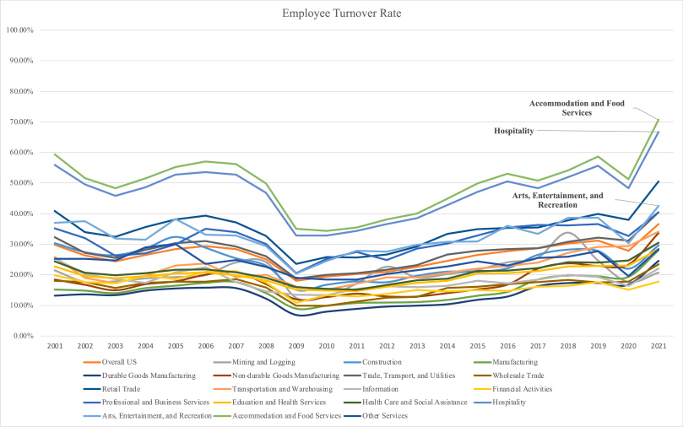
Figure 1: Employee turnover rate on hospitality sector compared to other sectors of the UK
(Source: Dogru et al., 2023)
The rate of staff turnover across the UK hospitality industry has been rising to an annual average of 37.6 to 52 per cent, compared with 35 per cent being the national cross-sector average (Dogru et al., 2023). Furthermore, data received from industry platforms indicates that nearly 42 per cent of new employees quit their job within the first 90 days, and approximately 30 to 40 per cent leave within 30 days of starting work, a phenomenon also known as quick quitting (CIPD, 2024). Such rotational tendencies are mainly observed among younger employees, who primarily seek more flexibility, growth opportunities, or consider alignment with other values, including wellbeing and diversity.
Some of the issues that the hotel industry in London has been struggling with are high attrition rates; research has found that the turnover rates are at 58% and above on an annual basis due to the competition and talented hospitality industry professionals in the capital and the cost of living in the city (Dogru et al., 2023). These numbers have been further increased in a post-COVID labour market that is characterised by labour shortages. At Marriott Canary Wharf, this issue indicates a regular failure to provide efficient services, an increased reliance on agency employees, a decline in institutional experience, and a loss of rapport with regular customers (Marriott, 2025). It also poses an economic burden to the organisation as the cost of replacing any employee may be between 30 and 200 per cent of the annual salary of the player transferring, depending on the job and the seniority of the player.

Impact of the Issue on the Hotel
This case of low employee morale and high turnover at Marriott Hotel Canary Wharf has far-reaching consequences for the hotel's operations, service delivery, brand image, and financial performance (Marriott, 2025). Although the hospitality industry has traditionally had a relatively high level of workforce fluidity, the prolonged post-pandemic attrition has introduced new and significant risks, posing a threat to the long-term sustainability of the high-end service concept provided by hotels (Khan et al., 2023).
Operationally, the hotel has experienced more staff shortages in various departments, including front desk operations, housekeeping, and food and beverage services, among others (Andrade, Miller and Westover, 2020). This results in uneven service quality, increased guest waiting times, and lower guest-to-employee ratios during peak periods. Excessive utilisation of a temporary agency workforce has also impacted team building, output, and the capacity to provide the personalised experience expected of a high-level Marriott property (Mann, Ramirez, and Straus, 2023). Additionally, repeated waves of onboarding and retraining consume management resources and divert attention away from where it is needed.
Reputation and guest satisfaction have also been affected (Seyfi, Thanh and Zaman, 2024). These have included inconsistencies in service offerings, long check-in lines, and room delays, as noted in some of the negative reviews on review sites by guests. These experiences lead to value depreciation, a decline in brand loyalty, and a reduced likelihood of a second booking (Mann, Ramirez, and Straus, 2023). In a highly competitive London hospitality environment where the market primarily serves high-end business travellers and international customers, the loss of reputation is of great concern, even when guest experience scores decrease marginally.
The financial impact is twofold: direct expenditures, including recruitment and the onboarding process, as well as training, and losses due to decreased guest retention and potential upsells (Ahmad and Imam, 2022). It is projected that the total turnover, considering administrative costs, expensive advertising, temporary labour, and even a temporary decrease in performance, would cost thousands of pounds per job opening (Gubler, Larkin and Pierce, 2018). This would create more pressure on the already pressure-strained profit margin, as operating costs increase and occupancy remains unstable since the pandemic.

Root Causes of the Problem
The constant downward trend in employee engagement and retention at Marriott Hotel Canary Wharf is neither a mere reaction to external influences nor a problem buried deep within internal organisational processes, socio-economic forces, and changes in employees' demands (Marriott, 2025). Between structural, cultural, and psychological aspects, a complex interplay has contributed to the vicious cycle that the hotel is experiencing.
Lack of career development and growth opportunities is one of the leading internal causes (Jun and Ming, 2022). Exit surveys and professional studies indicate that hospitality workers, particularly younger generations, value career development opportunities, such as career laddering, coaching, and training (Calinaud, Kokkranikal and Gebbels, 2021). The global activities within Marriott International regarding talent development have not been consistent at the local level in Canary Wharf. As a result, most employees feel undervalued and stuck in their roles (Pillai et al., 2021). This lack of upward mobility undermines long-term commitment and leads to high turnover among promising employees.
Another important contributing factor is the culture at the workplace (Bogale and Debela, 2024). The employees have complained of a lack of closeness with leadership, restricted two-way feedback, and a lack of recognition and transparency in decision-making. It is based on this lack of psychological security and engagement that motivation is seen to decrease (Bandhu et al., 2024). This is thanks to the Two-Factor Theory proposed by Herzberg, which emphasises the importance of intrinsic motivators, such as responsibility and recognition, in driving engagement (Alrawahi et al., 2020).
Also, the burnout and post-pandemic fatigue have been key factors. Understaffing has subjected many hospitality workers to physical burnout, emotional stress, and low job satisfaction due to an increasingly demanding workload (Mitsakis and Galanakis, 2022). Due to the reduced number of breaks, unpredictable schedules, and workload pressure to fill any gaps, employees are seeking opportunities in other industries that offer improved work-life balance and more predictable schedules (Patil et al., 2023). Furthermore, dissatisfaction with pay compensation, particularly about the cost of living in London, has exacerbated attrition (Alrawahi et al., 2020). The remarkable nature of the job, in terms of stress, odd hours worked, and emotional labour required in hotel employment, is considered by employees; yet, it is not acknowledged in the remuneration they receive. Hotels with higher pay or even more flexible work hours are attracting existing employees and also causing a talent haemorrhage.

External Environment Analysis – STEEPLED
Factor | Key Issues and Relevance to Marriott Canary Wharf
Social | - Seventy-two per cent of UK hospitality workers under 35 prefer employers that offer mental health support and schedule flexibility (Rsph.org.uk, 2019).  - Increasing demand for inclusion, belonging, and value-based leadership.  - Work-life balance is now a top priority for 61% of frontline hospitality employees since the pandemic.
Technological | - Over 55% of UK hotels have adopted automation technologies (e.g., mobile check-ins) since the COVID-19 pandemic, leading to workforce restructuring.  - Staff often report digital fatigue or lack of training, contributing to disengagement.  - Only 38% of frontline workers in hospitality say they receive ongoing digital skills training.
Economic | - London’s inflation-adjusted living wage requirement is £13.15/hour, yet average hospitality pay remains below £12/hour for many junior roles.  - Staff turnover in London's hospitality sector costs up to £5,000 per vacancy.  - UK hospitality vacancies remain 48% higher than pre-COVID levels, creating pressure on payroll budgets.
Environmental | - 67% of hospitality staff under 30 say they would stay longer with a company committed to sustainability.  - Marriott’s LEED certification and recycling programs are externally promoted but under-communicated to staff.  - Staff engagement in green initiatives boosts morale and retention by up to 15%.
Political | - Brexit has reduced access to EU workers; 80,000 fewer EU nationals are working in UK hospitality than in 2019 (Parliament.uk, 2010).  - Visa complexities make international recruitment expensive and slower.  - UK policy shifts continue to increase pressure for local hiring despite labour shortages.
Legal | - The National Minimum Wage rose to £11.44/hour in April 2024 for those aged 21+, increasing baseline costs The National Minimum Wage rose to £11.44/hour in April 2024 for those aged 21+, increasing baseline costs (Low Pay Commission, 2024).  - Legal scrutiny around rota fairness, shift lengths, and rest periods is intensifying.  - Failure to comply with wage and hour laws has resulted in £5M in fines sector-wide in 2023.
Ethical | - 58% of UK hospitality jobseekers assess employer ethics via employee reviews (e.g., Glassdoor) before applying (Zhang, Shum and Belarmino, 2022).  - Post-COVID redundancies damaged trust in many brands.  - Ethical HR practices (e.g., transparent promotion criteria) are linked to 22% higher engagement.
Demographic | - 1 in 5 UK hospitality workers is over 50; retirement trends may create skill shortages.  - Fewer young people are entering hospitality; enrolments in related college programs have declined by 18% since 2019 (Rosenberg et al., 2022).  - Diverse, multi-generational teams require inclusive leadership styles.
Table 1: STEEPLED framework
The situation of Marriott Canary Wharf is a complex but innovative environment in the external world. The structural changes in the social value reaction to work imply the impossibility of maintaining the pristine incentives, such as bonuses. The new cohort of Gen Z and millennial employees pay more attention to flexibility, mental health support, and inclusion, compared to the earlier generations (Piecuch-Jodłowiec, 2024). Technologically, the hotel has implemented several technologies aimed at customer-facing applications, but the absence of a commensurate investment in digital training of employees has left them with a gap in ability and comfort, especially where longer-serving staff is concerned, and not conversant with mobile-first models.
On the economic front, although Marriott is paying above the minimum wage in most of its positions, actual wages are not keeping pace with the cost of living in London (Werner and Stephens, 2024). This discourages loyalty and results in employees moving to a more stable work schedule such as supermarkets or call centres where average wages and benefits have improved since the COVID surge. In addition, Brexit immigration rules have severely limited the supply of skilled workers of the European Union (EU) that were once the staple of London hospitality industry (Sargent, 2023). As more than 400,000 jobs in the UK hospitality industry remain open in 2023, the sector is facing tougher competition from a smaller pool of choosier applicants.
It is strategically underutilised, as Marriott needs to leverage the internal sustainability efforts in its employer branding in an environmentally as well as ethically positive way (Santos et al., 2023). Employees are becoming attracted to work in organisations that are vanguards in climate action yet participation in these climatic activities and internal communication thereof is scarce. These macro forces add to internal vulnerabilities and foreshadow a greater need of Marriott Canary Wharf to develop a more responsive and socially sensitive approach to the employees (Marriott, 2025).

Internal Analysis – SWOT
Strengths (S) | Weaknesses (W)
- Strong brand equity and global recognition under the Marriott International umbrella (Marriott International, 2023). | - High staff turnover across frontline and mid-tier roles post-pandemic.
- Prime location in Canary Wharf with excellent transport links. | - Inconsistent implementation of employee development programs at the site level.
- Competitive guest-facing technologies, such as mobile check-in and digital key access (Marriott International, 2023). | - Overreliance on temporary staff reduces continuity and affects team morale.
- High occupancy rates are driven by a strong corporate clientele. | - Internal communication gaps and limited two-way feedback mechanisms.

Opportunities (O) | Threats (T)
- Use of Marriott’s global learning platforms (e.g., Marriott Bonvoy Career Academy) for staff development. | - Competitor hotels in London offering marginally higher wages and better shift flexibility.
- Growing employee demand for sustainability-focused employers—can be leveraged internally. | - Brexit-induced staff shortages and visa limitations for hiring international workers.
- Strong DEI (Diversity, Equity, and Inclusion) potential to engage younger workforce demographics. | - Persistent inflation eroding hospitality wages in real terms.
Table 2: SWOT Analysis
Positive Aspects – What the Hotel Is Doing Well
The company is facing various challenges, the Marriott Hotel Canary Wharf has several good internal strengths to build on that offer a solid foundation to enhance its current situation (Eschenbrenner et al., 2023). First, the hotel boasts a high average occupancy rate, particularly among corporate travellers, as it is strategically located in the financial hub of Canary Wharf within London. This provides stability in terms of demand, irrespective of the off-peak seasons, as well as a steady revenue stream. Second, the accommodation has also implemented digital guest service innovations, including mobile check-in, contactless payment, and app-based room service, which have decreased the burden on front office functions and boosted customer satisfaction ratings (Arapou and Kapiki, 2023).
Third, there is good brand support to Marriott Canary Wharf because of the global HR structure of Marriott International with its defined leadership and training portals, employee training portals, and access to global best practices (Wesley et al., 2024). These frameworks, though not utilised maximally in the country, form a sound basis for enhanced employee retention practices. The current strengths will enable the hotel to implement the appropriate, sustainable changes, leveraging what is already operating successfully (Lu, Du and Peng, 2022).

Recommendations and Change Management
Strategic Recommendations
Marriott Bonvoy Career Academy Closed Career Pathways
Lack of open trajectories of development has been a significant factor of attrition among employees, especially the junior employees (Abdullah and Al, 2023). Although, as a company, Marriott International has been identified as having large learning and development resources, most employees at the Canary Wharf location lack knowledge or access to formal growth opportunities (Lu, Du, and Peng, 2022). It is this disparity that instils a sense of stagnation and the absence of purpose.
To solve this issue, Marriott Canary Wharf ought to localise and implement the Marriott Bonvoy Career Academy completely at the hotel level (Eschenbrenner et al., 2023). Employees need to be exposed to well-defined career ladders that are associated with improving skills, time, and performance. Development plans specific to a role and mentoring on the leadership side can help promote retention further by giving concrete value on the expenses of employee engagement (Moore and Hanson, 2022). Once employees feel they have a future in an organisation, they are willing to stay and to give their best in their offices.
Flexible Work Framework and Wellbeing
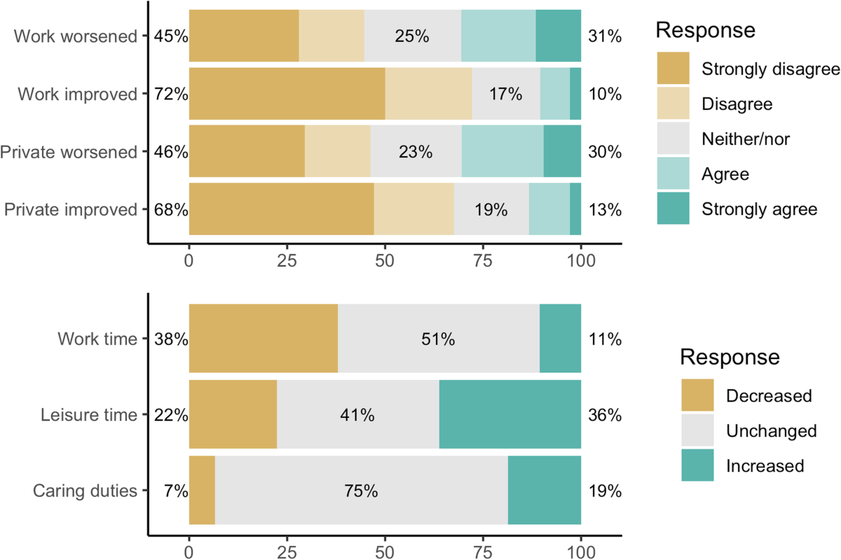
Figure 2: Employee perspective on remote work post-COVID pandemic
(Source: Tušl et al., 2021)
The COVID-19 pandemic has radically changed what employees expect from their employers, with wellbeing, a good work-life balance, and flexibility taking centre stage in hiring and job opportunities (Vyas, 2022). The changes in these needs should mean that Marriott Canary Wharf should embrace a formulated system, which should take proactive measures against these changes.
This must involve flexible scheduling arrangements that utilise technology to accommodate the interests of employees and the business's needs. Specifically, conflict can be minimised and fairness increased by using scheduling software that allows for shift bidding and availability to be entered (Lu, Du and Peng, 2022). Moreover, wellness programs, including mental health services, mindfulness training, and wellness time off, are suitable to minimise burnout and absenteeism (Tušl et al., 2021). These policies will ensure that Marriott is committed to a comprehensive approach to employee health, which studies continue to associate with higher levels of morale, productivity, and loyalty.
Rewards and Incentives
The lack of recognition is a significant deterrent factor that contributes to the high rate of disengagement in hospitality jobs. Workers at Marriott Canary Wharf, especially those in operational departments, complain that they feel undervalued, despite playing a crucial role (Lin, Liu and Li, 2024). Consistent and substantive appreciation is central in the development of a good organisational culture.
Marriott Canary Wharf should implement a multi-level recognition approach, which would involve peer-to-peer recognition, monthly awards based on performance, and leadership call-outs during team meetings (Alfano et al., 2023). These rewards can be associated with tangible benefits, such as Marriott employee benefits, bonus tickets, or professional growth credits. Additionally, an online appreciation platform accessible to all employees has the potential to generate real-time feedback, fostering a culture of support and appreciation (Tušl et al., 2021). When employees are recognised and appreciated, there is a higher likelihood that they will develop a sense of commitment to their work, exhibit better performance, and foster team building.
Modernised Intra-Organisational Communication Processes
Employee engagement is based on effective communication. Comments from employees at the hotel suggest that a lack of communication between managers and frontline staff has led to misunderstandings, frustration, and apathy (Campbell, Campbell-Phillips, and Phillips, 2020). Employees often feel excluded from decisions that affect their day-to-day responsibilities (Lin, Liu and Li, 2024).
To close this gap, Marriott Canary Wharf should adopt regular town hall meetings led by department heads and other senior management, where employees can express their opinions and ask questions. Such forums should be complemented by an anonymous feedback mode, i.e., a virtual suggestion box where employees can express concerns constructively without fear of retribution (Ozmen Garibay et al., 2023). Additionally, regular internal newsletters or message boards can support transparency regarding operational changes, strategic updates, and organisational successes. By making employees feel listened to and informed, the level of trust in leaders is enhanced, and organisational alignment is boosted (Baquero, 2023).
Competitive Compensation and Retention Awards
The issue of wage dissatisfaction also presents itself in exit interviews at the hotel, most notably among the lower-paid staff (Cole et al., 2022). In a large city like London, the distinction between the national minimum wage and the London Living Wage is substantial in terms of quality of life and financial stability.
Marriott Canary Wharf should increase the minimum wage for all entry-level jobs to at least the updated London Living Wage (expected to be £13.15 per hour in 2024) (Personio, 2022). This is an indication of a serious investment in frontline employees, which facilitates the hotel's ability to compete in the labour market. Moreover, the hotel may implement progressive retention bonuses as employees pass milestones of the provided service, such as six and twelve months, to reduce early turnover (Yazdani and Wells, 2018). Transport subsidies or the possibility of living in affordable housing partnerships can also alleviate economic pressure on those employees who have to travel a long distance (Cole et al., 2022). It will hence be more likely to be retained. Declaring its reputation as a just and fair employer, Marriott Canary Wharf will appeal to more new employees and strengthen the loyalty of the current staff members.
Change Management Strategy
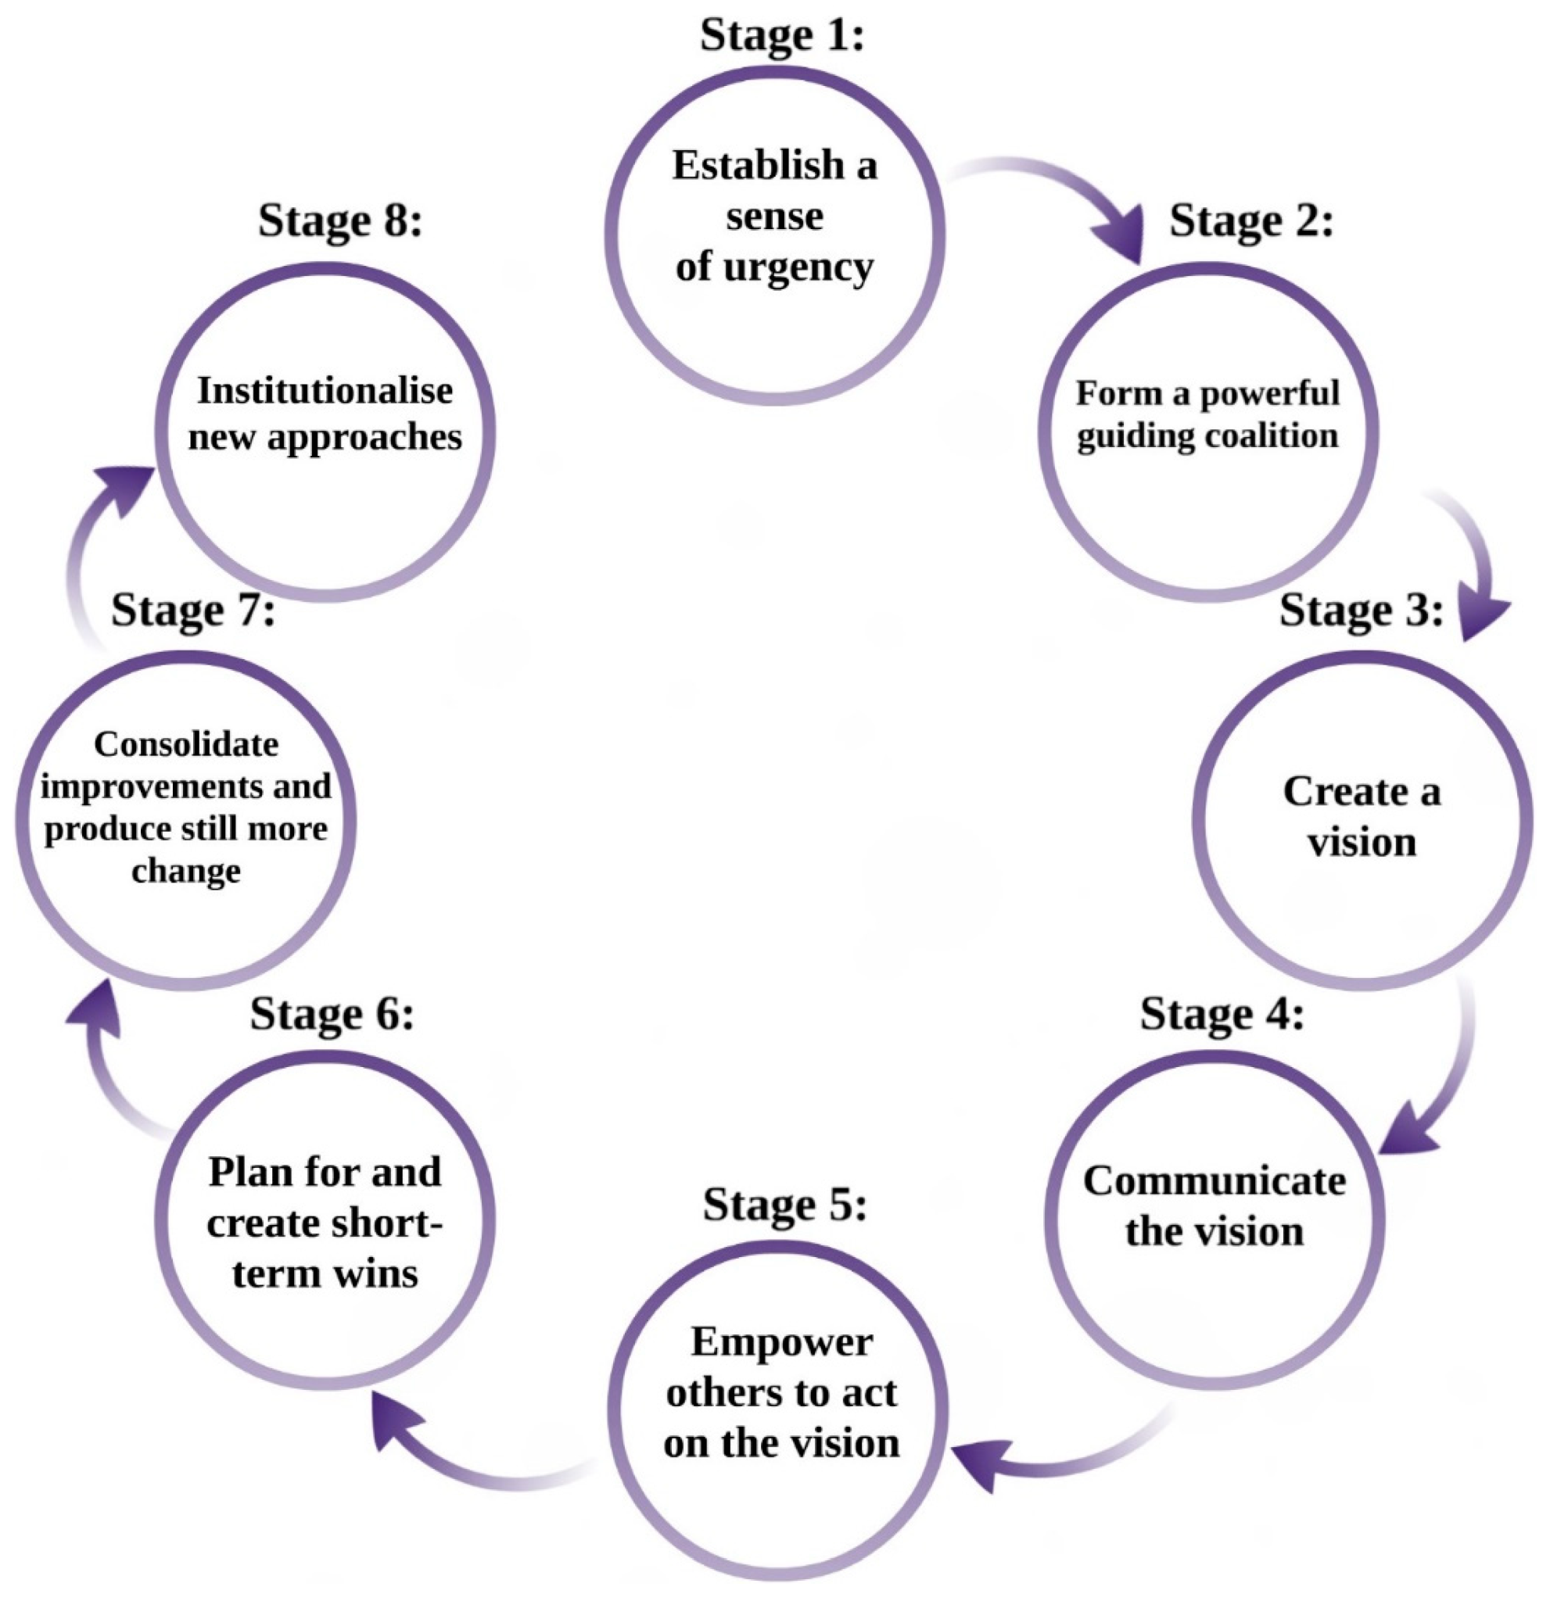
Figure 3: Kotter’s Change Stages.
(Source: Sittrop and Crosthwaite, 2021)
The above change management process will be structured and strong to implement the five strategic recommendations above. To ensure that the intended interventions can be accepted and sustained, this report will follow the Kotter 8-Step Change Model, an effective and admired model for leading change in organisations (Mouazen et al., 2023).
Step 1: Create a Sense of Urgency
The initial task is to explain to all stakeholders, especially workers who have become accustomed to the current traditions, that the need for change is urgent. High turnover rates, absenteeism, and internal recruitment costs should be displayed alongside guest service complaints and reputational risk to make the costs of inaction visible (Mouazen et al., 2023). Such urgency must be incorporated in the communication, both internally and among managers during briefings.
Step 2: Build a Guiding Coalition
Change must be supported by the leaders and bought at a grassroots level (Barrow and Annamaraju, 2022). Marriott Canary Wharf needs a cross-functional task force, comprising a team of senior managers, HR personnel, and employee representatives from various departments. To achieve this, the coalition will oversee the implementation process, enabling the incorporation of multiple opinions into decision-making.
Step 3: Develop a Vision and Strategy
The team can be brought together by a strong change vision, such as One Marriott, One Future. Main strategic goals that will tap into this vision include a 30 per cent decrease in staff turnover, a 20 per cent increase in engagement scores, and an increase in internal promotions. The quantifiable objectives will provide a clear structure and orientation throughout the hotel (Laig and Abocejo, 2021).
Step 4: Communicate the Change Vision
The communication should be continuous, consistent, and multi-channel. Town halls should be used to communicate the change strategy, as well as intranet updates, department briefings and digital staff areas (Laig and Abocejo, 2021). In shift meetings, managers are expected to stimulate messages and encourage open communication by asking for feedback.
Step 5: Empower Employees for Action
Resistance to change, such as fixed rostering procedures or poor access to training, must be eliminated (Yazdani and Wells, 2018). Employees should have the necessary tools, authority, and influence to participate in scheduling systems, mentoring programs, and feedback mechanisms. New platforms and policies training should be accessible and universal.
Step 6: Generate Short-Term Wins
Marriott should celebrate its early victories to maintain momentum. Examples of such rewards are acknowledging the highest improved engagement scores in departments or making the successful promotions publicly known (Rusin and Szandała, 2024). These victories prove the progress and stimulate further involvement.
Step 7: Consolidate Gains and Produce More Change
Change cannot be viewed as a unique project. An ongoing assessment should be an integral part of HR and operations interventions, starting with feedback loops and engagement profiles that lead to policy improvement (Rusin and Szandała, 2024). Effective pilots may be multiplied within departments and trained in basic operations.
Step 8: Anchor New Approaches in the Culture
Lastly, the new practices need to be institutionalised into the Marriott Canary Wharf culture. The essence of core values like 'people first' and 'grow with Marriott' must be evident through programs that recognise employees, a policy of career development, as well as leadership demands. Top management should embody these values, and employees should be made to believe that they are integral to the hotel's long-term success (Donate et al., 2022).

Measurement and Success Metrics
KPI | Baseline | Target | Timeframe | Measurement Method
Employee Turnover Rate | ~38% annually | Reduce to below 25% | Within 12 months | HRIS analytics, exit interviews
Employee Engagement Score | Moderate (internal survey avg. ~60%) | Improve by 15–20% | 12 months | Quarterly engagement surveys (e.g., Gallup Q12)
Average Employee Tenure | <12 months | Increase to ≥18 months | 18–24 months | HR records, payroll data
Employer Brand Rating (Glassdoor) | Approx. 3.4/5 | Improve to ≥4.0 | Within 12 months | Online review tracking (Glassdoor, Indeed)
Guest Satisfaction: Service Experience | 82% positive | Increase to ≥88% | 6–12 months | Guest feedback surveys, Net Promoter Score (NPS)
Internal Promotions to Total Hires Ratio | Low (estimated <20%) | Improve to ≥40% | 12–18 months | HR tracking of internal mobility vs. external hiring
Table 3: Key Performance Indicators and Success Metrics
Estimated Costs and Budgeting
Initiative | Estimated Cost (£) | Notes
Career Pathway Development (customised training modules, mentorship program) | £15,000 | Includes platform localisation, mentor training, materials
Wellbeing & Flexibility Program (AI scheduling, wellness sessions) | £12,000 per annum | Subscription for scheduling software and part-time mental health partner
Recognition & Rewards System (platform setup + monthly awards) | £5,000 setup + £6,000/year | Includes digital platform and small-scale monetary incentives
Communication Strategy (town halls, anonymous feedback software) | £8,000 | Covers software, comms materials, events
Compensation Uplift (adjusting 40 FTE roles to London Living Wage) | £90,000 annually | Based on £1.50/hr uplift for 40 staff working 40 hrs/week
Total Estimated Year 1 Investment | £136,000 – £140,000 | Subject to internal procurement, may be offset through reduced turnover
Table 4: Estimated Implementation Costs – Year 1
Action Plan
Problem | Recommendation | Desired Outcome | Timeframe | Responsible Party | Estimated Cost (£)
High staff turnover across departments | Introduce structured career pathways via Marriott Bonvoy Academy | Increase average employee tenure and internal promotions | 3–6 months | HR Manager & Department Heads | 15,000
Staff burnout and poor work-life balance | Implement wellbeing and flexible scheduling framework | Reduce absenteeism and improve employee satisfaction | 6 months | HR Manager & Operations Manager | 12,000 per annum
Lack of recognition culture | Launch peer and management-led recognition and reward system | Boost morale and improve motivation across all departments | 3 months | General Manager & HR Team | 5,000 setup + 6,000/year
Communication gaps and lack of staff voice | Establish town halls and anonymous digital feedback systems | Improve trust and increase two-way communication | 3–4 months | Senior Leadership Team | 8,000
Wage dissatisfaction compared to London Living Standards | Raise pay for 40 FTE staff to London Living Wage & introduce retention bonuses | Improve retention and talent attraction | Phased over 12 months | HR Director & Finance Manager | 90,000 annually
Table 5: Strategic Action Plan for Employee Engagement and Retention
Activities should be initiated simultaneously, and compensation changes and communication should take precedence to facilitate initial buy-in (Hubbart, 2022). Successful implementation will require ongoing staff communication and transparent progress monitoring, as well as having leadership aligned (Alizadehsalehi and Yitmen, 2021). This plan of action provides a clear guideline on how Marriott Hotel Canary Wharf can capitalise on the approach of enhancing employee experience to reduce expensive turnover and establish itself as a trustworthy and competitive company in the English hospitality sector.

Conclusion
This consultancy report has conducted an elaborate analysis of the eminent problem of employee dissatisfaction and high turnover at Marriott Hotel Canary Wharf. The report has also described the extent and magnitude of how big the problem was, along with its reason behind it, outside factors, and organisational effects after careful evaluation and analysis of the report. These results affirm that this problem is not only a human resource dilemma but also a system-wide strategic risk compromising the operations efficiency, customer satisfaction, hotel brand competitiveness and profitability of the hotel in the long-run.
The review discussed some of the most important reasons that have led to workforce instability today. Inwards, within the company, workers noted failure to succeed in their career advancement, uneven praises, absence of dialogue, and their compensation did not suit the cost of living in London. On the outside, there are external forces on the hotel due to labour shortage as a result of pandemic, rising competition of skilled labour in the hospitality industry, changing employee demands, and macro-economic factors. The STEEPLED analysis put these factors in the context of the overall social-economic and political environment whereas the SWOT and TOWS models gave an idea of how Marriott Canary Wharf could use its strengths to work around limitations that it has and challenges against the external environment.
As a reaction to these results, the report has made five intercontinental strategic recommendations. These are in the form of transparency in career progression, wellbeing and flexibility regime, formalised recognition and rewards, improved internal communication operationalisation, and a remuneration strategy that is pegged in the London Living Wage. All these initiatives have a foundation based on evidence-based best practices and are aimed not solely at increasing retention but also around the promotion of a resilient and motivated high-performing workforce.
In order to facilitate realization of such strategies, the report utilised the model as a guide by the Kotter model of 8-steps change. In this model, a question arises as to whether change has been brought in with a clear message, communicated well, internalised via early wins and eventually registered in the culture of the organisation at Marriott Canary Wharf. Also, the number of success indicators that can be measured and reasonable costs estimations were given so that the hotel could assess the results and undertake the appropriate adjustments during the implementation process.
All of these recommendations are not merely corrective measures, but they are a long-term and sustainable workforce strategy that upholds all the values of Marriott and its commitment to excellence in services across all levels of global operations. Embracing its employees and finding the solution to the issue of disengagement, Marriott Hotel Canary Wharf will be able to improve its own internal culture, cut down the expenses spent on maintaining high turnover, and take its guest experience to even new heights.
Elevare Insights ltd. would like to extend its heartfelt thanks to the management of Marriott Hotel Canary Wharf because of the opportunity presented to work on such important organisational project. I have been honored to evaluate the internal processes of this high-end hotel and have provided a strategic input helping it and ensuring further success. We have a strong belief that effective application of these suggestions would not only enhance employee experience but also create long-term values in all dimensions of performance of hotels. We hope there may be a prospect and further cooperation in assisting Marriott in its operational and cultural excellence journey.

References
Abdullah, M. and Al, M.A. (2023). Employees Attrition During the Transitional Period: A Case Study of Saudi Organizations. International Journal of Instructional Cases, [online] 7(1), pp.193–210. Available at: https://ijicases.com/menuscript/index.php/ijicases/article/view/57 [Accessed 9 Apr. 2025].
Ahmad, R. and Imam, H. (2022). Roles of competencies, career shock, and satisfaction in career commitment: Evidence from project-based organizations. Project Leadership and Society, 3, p.100052. doi:https://doi.org/10.1016/j.plas.2022.100052.
Alfano, V., Mariotti, I., Marra, M. and Vecchione, G. (2023). I want to break free: the influence of the COVID-19 pandemic on work–life balance satisfaction. Regional Studies, Regional Science, 10(1), pp.70–88. doi:https://doi.org/10.1080/21681376.2023.2167608.
Alizadehsalehi, S. and Yitmen, I. (2021). Digital twin-based progress monitoring management model through reality capture to extended reality technologies (DRX). Smart and Sustainable Built Environment, ahead-of-print(ahead-of-print). doi:https://doi.org/10.1108/sasbe-01-2021-0016.
Alrawahi, S., Sellgren, S.F., Altouby, S., Alwahaibi, N. and Brommels, M. (2020). The Application of Herzberg’s two-factor Theory of Motivation to Job Satisfaction in Clinical Laboratories in Omani Hospitals. Heliyon, 6(9), pp.1–9. doi:https://doi.org/10.1016/j.heliyon.2020.e04829.
Andrade, M.S., Miller, D. and Westover, J.H. (2020). Job satisfaction factors for housekeepers in the hotel industry: a global comparative analysis. International Hospitality Review, ahead-of-print(ahead-of-print). doi:https://doi.org/10.1108/ihr-06-2020-0018.
Arapou, D. and Kapiki, S. (2023). Enhancing the Guest Experience in Hospitality Through Technology: An Outlook of the Future. [online] Ssrn.com. Available at: https://papers.ssrn.com/sol3/papers.cfm?abstract_id=4660192.
Bandhu, D., Mohan, M.M., Nittala, N.A.P., Jadhav, P., Bhadauria, A. and Saxena, K.K. (2024). Theories of motivation: A comprehensive analysis of human behavior drivers. Acta Psychologica, 244(1), pp.1–16. doi:https://doi.org/10.1016/j.actpsy.2024.104177.
Baquero, A. (2023). Authentic Leadership, Employee Work Engagement, Trust in the Leader, and Workplace Well-Being: a Moderated Mediation Model. Psychology Research and Behavior Management, 16(16), pp.1403–1424. doi:https://doi.org/10.2147/prbm.s407672.
Barrow, J.M. and Annamaraju, P. (2022). Change management in health care. [online] National Library of Medicine. Available at: https://www.ncbi.nlm.nih.gov/books/NBK459380/.
Bogale, A.T. and Debela, K.L. (2024). Organizational culture: A systematic review. Cogent Business & Management, 11(1). doi:https://doi.org/10.1080/23311975.2024.2340129.
Calinaud, V., Kokkranikal, J. and Gebbels, M. (2021). Career Advancement for Women in the British Hospitality Industry: The Enabling Factors. Work, Employment and Society, [online] 35(4), pp.677–695. doi:https://doi.org/10.1177/0950017020967208.
Campbell, S., Campbell-Phillips, S. and Phillips, D. (2020). Lack of communication between management and employees. [online] ResearchGate. Available at: https://www.researchgate.net/publication/342796387_Lack_of_Communication_between_Management_and_Employees [Accessed 17 Jun. 2025].
CIPD (2024). Benchmarking Employee turnover: What Are the Latest Trends and insights? [online] CIPD. Available at: https://www.cipd.org/uk/views-and-insights/thought-leadership/cipd-voice/benchmarking-employee-turnover/ [Accessed 17 Jun. 2025].
Cole, M., Stuart, M., Hardy, K. and Spencer, D. (2022). Wage Theft and the Struggle over the Working Day in Hospitality Work: A Typology of Unpaid Labour Time. Work, Employment and Society, [online] 38(1), p.095001702211117. doi:https://doi.org/10.1177/09500170221111719.
Dempsey, J. (2023). Hospitality sector ‘anxious’ over summer staffing. BBC News. [online] 9 Jul. Available at: https://www.bbc.co.uk/news/business-66021588 [Accessed 17 Jun. 2025].
Dogru, T., McGinley, S., Sharma, A., Isık, C. and Hanks, L. (2023). Employee Turnover Dynamics in the Hospitality Industry vs. the Overall Economy. Tourism Management, [online] 99(104783), p.104783. doi:https://doi.org/10.1016/j.tourman.2023.104783.
Donate, M.J., González-Mohíno, M., Paolo Appio, F. and Bernhard, F. (2022). Dealing with knowledge hiding to improve innovation capabilities in the hotel industry: The unconventional role of knowledge-oriented leadership. Journal of Business Research, 144, pp.572–586. doi:https://doi.org/10.1016/j.jbusres.2022.02.001.
Eschenbrenner, B., Zlatic, A., Bechtel, M., Collins, B., Straley, C. and Gubbels, G. (2023). Marriott International: A Managerial Strategic Audit. Honors Theses, University of Nebraska-Lincoln. [online] Available at: https://digitalcommons.unl.edu/honorstheses/632/.
Ghani, B., Zada, M., Memon, K.R., Ullah, R., Khattak, A., Han, H., Montes, A.A. and Castillo, L.A. (2022). Challenges and strategies for employee retention in the hospitality industry: A review. Sustainability, [online] 14(5), pp.1–26. doi:https://doi.org/10.3390/su14052885.
Gubler, T., Larkin, I. and Pierce, L. (2018). Doing Well by Making Well: The Impact of Corporate Wellness Programs on Employee Productivity. [online] ResearchGate. Available at: https://www.researchgate.net/publication/305430407_Doing_Well_by_Making_Well_The_Impact_of_Corporate_Wellness_Programs_on_Employee_Productivity [Accessed 17 Jun. 2025].
Gupta, R., Hasan, M.M., Islam, S.Z., Yasmin, T. and Uddin, J. (2023). Evaluating the Brexit and COVID-19’s Influence on the UK Economy: A Data Analysis. PLoS One, [online] 18(6). doi:https://doi.org/10.1371/journal.pone.0287342.
Hubbart, J.A. (2022). Organizational Change: Considering Truth and Buy-In. Administrative Sciences, 13(1), p.3. doi:https://doi.org/10.3390/admsci13010003.
Jun, Z.J. and Ming, S.H. (2022). The Impact of Career Growth on Knowledge-Based Employee Engagement: The Mediating Role of Affective Commitment and the Moderating Role of Perceived Organizational Support. Frontiers in Psychology, [online] 13. doi:https://doi.org/10.3389/fpsyg.2022.805208.
Khan, U., Ali, Y., Petrillo, A. and Felice, F.D. (2023). Macro-environmental factors and their impact on startups from the perspective of developing countries. International Journal of Sustainable Engineering, 16(1), pp.166–183.
Laig, B.D. and Abocejo, F.T. (2021). Change Management Process in a Mining Company: Kotter’s 8-Step Change Model. ResearchGate. doi:https://www.researchgate.net/publication/354614425_Change_Management_Process_in_a_Mining_Company_Kotter.
Lin, M., Liu, Q. and Li, Z. (2024). Perceived superior trust and organizational commitment among public employees: The mediating role of burnout and the moderating role of public service motivation. Heliyon, [online] 10(3), p.e24997. doi:https://doi.org/10.1016/j.heliyon.2024.e24997.
London Government (2024). London Living Wage | London City Hall. [online] www.london.gov.uk. Available at: https://www.london.gov.uk/programmes-strategies/business-and-economy/support-your-business/london-living-wage [Accessed 17 Jun. 2025].
Low Pay Commission (2024). The National Minimum Wage in 2024. [online] GOV.UK. Available at: https://www.gov.uk/government/publications/the-national-minimum-wage-in-2024/the-national-minimum-wage-in-2024.
Lu, G., Du, R.Y. and Peng, X. (David) (2022). The Impact of Schedule Consistency on Shift Worker Productivity: An Empirical Investigation. Manufacturing & Service Operations Management, 24(5), pp.2780–2796. doi:https://doi.org/10.1287/msom.2022.1132.
Mann, R., Ramirez, E. and Straus, M. (2023). Three innovations to solve hotel staffing shortages. [online] McKinsey & Company. Available at: https://www.mckinsey.com/industries/travel/our-insights/three-innovations-to-solve-hotel-staffing-shortages [Accessed 17 Jun. 2025].
Marriott (2025). Canary Wharf Hotel - Hotel in East London | London Marriott Hotel Canary Wharf. [online] www.marriott.com. Available at: https://www.marriott.com/en-us/hotels/loncw-london-marriott-hotel-canary-wharf/overview/ [Accessed 17 Jun. 2025].
Marriott International (2023). Brands. [online] www.hotel-development.marriott.com. Available at: https://www.hotel-development.marriott.com/brands.
Mitsakis, M. and Galanakis, M. (2022). An Empirical Examination of Herzberg’s Theory in the 21st Century Workplace. Organizational Psychology Re-Examined. Psychology, [online] 13(02), pp.264–272. doi:https://doi.org/10.4236/psych.2022.132015.
Mizrak, F., Demirel, H.G., Yaşar, O. and Karakaya, T. (2025). Digital detox: exploring the impact of cybersecurity fatigue on employee productivity and mental health. Discover Mental Health, 5(1). doi:https://doi.org/10.1007/s44192-025-00149-x.
Moore, J.R. and Hanson, W. (2022). Improving leader effectiveness: impact on employee engagement and retention. Journal of Management Development, 41(7/8), pp.450–468. doi:https://doi.org/10.1108/jmd-02-2021-0041.
Mouazen, A.M., Hernández-Lara, A.B., Abdallah, F., Ramadan, M., Chahine, J., Baydoun, H. and Bou Zakhem, N. (2023). Transformational and transactional leaders and their role in implementing the kotter change management model ensuring sustainable change: An empirical study. Sustainability, [online] 16(1), p.16. doi:https://doi.org/10.3390/su16010016.
Ozmen Garibay, O., Winslow, B., Andolina, S., Antona, M., Bodenschatz, A., Coursaris, C., Falco, G., Fiore, S.M., Garibay, I., Grieman, K., Havens, J.C., Jirotka, M., Kacorri, H., Karwowski, W., Kider, J., Konstan, J., Koon, S., Lopez-Gonzalez, M., Maifeld-Carucci, I. and McGregor, S. (2023). Six Human-Centered Artificial Intelligence Grand Challenges. International Journal of Human–Computer Interaction, [online] 39(3), pp.391–437. doi:https://doi.org/10.1080/10447318.2022.2153320.
Parliament.uk. (2010). House of Lords - Brexit and the Labour Market - Economic Affairs Committee. [online] Available at: https://publications.parliament.uk/pa/ld201719/ldselect/ldeconaf/11/1106.htm.
Partridge, J. (2025). Work-life balance more important than pay for employees worldwide. [online] the Guardian. Available at: https://www.theguardian.com/business/2025/jan/21/work-life-balance-pay-workers-covid-pandemic [Accessed 17 Jun. 2025].
Patil, R., Raheja, D.K., Nair, L., Deshpande, A. and Mittal, A. (2023). The Power of Psychological Safety: Investigating its Impact on Team Learning, Team Efficacy, and Team Productivity. The Open Psychology Journal, 16(1). doi:https://doi.org/10.2174/18743501-v16-230727-2023-36.
Personio (2022). What is the UK Minimum Wage for 2022? [online] Personio. Available at: https://www.personio.com/hr-lexicon/uk-minimum-wage/ [Accessed 17 Jun. 2025].
Piecuch-Jodłowiec, J. (2024). Adapting HRM Practices for Generation Z with a Human-centric Management Approach to Mental Health and Employee Development. Human at the Centerof the Organization: Visions, Realities, Challenges, [online] pp.103–115. doi:https://doi.org/10.15611/2024.59.8.07.
Pillai, S.G., Haldorai, K., Seo, W.S. and Kim, W.G. (2021). COVID-19 and Hospitality 5.0: Redefining Hospitality Operations. International Journal of Hospitality Management, 94(1), p.102869.
Research and Markets (2022). Frontline Workers Training Market Size & Forecast to 2030. [online] Researchandmarkets.com. Available at: https://www.researchandmarkets.com/report/frontline-workers-training?srsltid=AfmBOoql5_s_K8Qun7KtVu6MfPUHuDylHV8sLzKgvIQG-Dj72HwgASAW [Accessed 17 Jun. 2025].
Rosenberg, R., Sun, S., Flannigan, A. and O’Meara, M. (2022). Impact of COVID-19 among young people currently and formerly in foster care. Child Abuse & Neglect, 123, p.105383. doi:https://doi.org/10.1016/j.chiabu.2021.105383.
Rsph.org.uk (2019). Service With(out) a Smile? The Mental Health of Hospitality Workers www.rsph.org.uk Key Points. [online] Available at: https://www.rsph.org.uk/static/uploaded/3944abe4-104c-471e-be9f4fd38b91b8f4.pdf.
Rusin, N. and Szandała, T. (2024). The Power of Peer Recognition points: Does It Really Boost Employee engagement? Strategic HR Review, 24(1). doi:https://doi.org/10.1108/shr-06-2024-0040.
Santos, V., Simão, P., Reis, I., Sampaio, M.C., Martinho, F. and Sousa, B. (2023). Ethics and Sustainability in Hospitality Employer Branding. Administrative Sciences, [online] 13(9), p.202. doi:https://doi.org/10.3390/admsci13090202.
Sargent, K. (2023). The Labor Market Impacts of Brexit: Migration and the European Union. Economic Modelling, 121(1), p.106196.
Seyfi, S., Thanh, T.V. - and Zaman, M. (2024). Hospitality in the age of Gen Z: A critical reflection on evolving customer and workforce expectations. International Journal of Contemporary Hospitality Management. doi:https://doi.org/10.1108/IJCHM-01-2024-003.
Sittrop, D. and Crosthwaite, C. (2021). Minimising Risk—The Application of Kotter’s Change Management Model on Customer Relationship Management Systems: A Case Study. Journal of Risk and Financial Management, [online] 14(10), p.496. doi:https://doi.org/10.3390/jrfm14100496.
Tušl, M., Brauchli, R., Kerksieck, P. and Bauer, G.F. (2021). Impact of the COVID-19 crisis on work and private life, mental well-being and self-rated health in German and Swiss employees: a cross-sectional online survey. BMC Public Health, [online] 21(1). doi:https://doi.org/10.1186/s12889-021-10788-8.
Varkiani, S.M., Pattarin, F., Fabbri, T. and Fantoni, G. (2025). Predicting employee attrition and explaining its determinants. Expert Systems with Applications, 272(126575), pp.126575–126575. doi:https://doi.org/10.1016/j.eswa.2025.126575.
Vyas, L. (2022). ‘New normal’ at work in a post-COVID world: work–life balance and labor markets. [online] academic.oup.com. Available at: https://academic.oup.com/policyandsociety/article/41/1/155/6512154 [Accessed 17 Jun. 2025].
Werner, A. and Stephens, S. (2024). The Real Living Wage in the London Hospitality Sector: Opportunities and Challenges. [online] Available at: https://repository.mdx.ac.uk/download/6fa89c21fb1a974c05ddc1e79ab1c7b9d686a227c8d63ae083bb421e507d7dbd/821154/Werner%20and%20Stephens%20-%20The%20Real%20Living%20Wage%20in%20the%20London%20Hospitality%20Sector.pdf.
Wesley, S., Jackson, K.N., Ramos, D.M., Vanbeber, S. and Mujtaba, B.G. (2024). Marriott Hotel’s Practices in Mitigating Discrimination Through Inclusionary Employee Resource Groups. Journal of Business Diversity, [online] 24(1), pp.41–56. doi:https://doi.org/10.33423/jbd.v24i1.6897.
Xuecheng, W., Iqbal, Q. and Saina, B. (2022). Factors Affecting Employee’s retention: Integration of Situational Leadership with Social Exchange Theory. Frontiers in Psychology, 13(872105), pp.1–13. doi:https://doi.org/10.3389/fpsyg.2022.872105.
Yazdani, A. and Wells, R. (2018). Barriers for implementation of successful change to prevent musculoskeletal disorders and how to systematically address them. Applied Ergonomics, [online] 73, pp.122–140. doi:https://doi.org/10.1016/j.apergo.2018.05.004.
Zhang, Y. (Carrie), Shum, C. and Belarmino, A. (2022). ‘Best Employers’: The Impacts of Employee Reviews and Employer Awards on Job Seekers’ Application Intentions. Cornell Hospitality Quarterly, 64(3), p.193896552211307. doi:https://doi.org/10.1177/19389655221130741.

