Elliot Shaw
Student ID: 1705678
Reflective Report
In the following report I shall be commenting on how I believe the project has gone from my point of view and how we performed in general as a group.
Preparation
With the project being broken down into multiple assignments over a 3-month period it provided a steady foothold to come up with and design a reliable ball launcher for the IMEC challenge. By breaking it into smaller assignments we managed to individually work well and provide good information regarding what we were going to do.
Time management
Personally I was lacking a little here, I only turned up to a few group meetings but I understood the design we chose and how I would go about designing my part.
The group as a whole were very good in regard to time management for our meetings. If we set a time and we agreed all agreed to it, everybody did arrive on time and have plenty to add to the project.
My biggest concern was that we didn’t spend enough time in the workshops actually hands on building the launcher. There were only really 2 full days where we worked as a group and I feel like if we had managed our time a little better and booked time in workshop earlier in advance maybe the launcher would have been 100% fully operational by the deadline date.
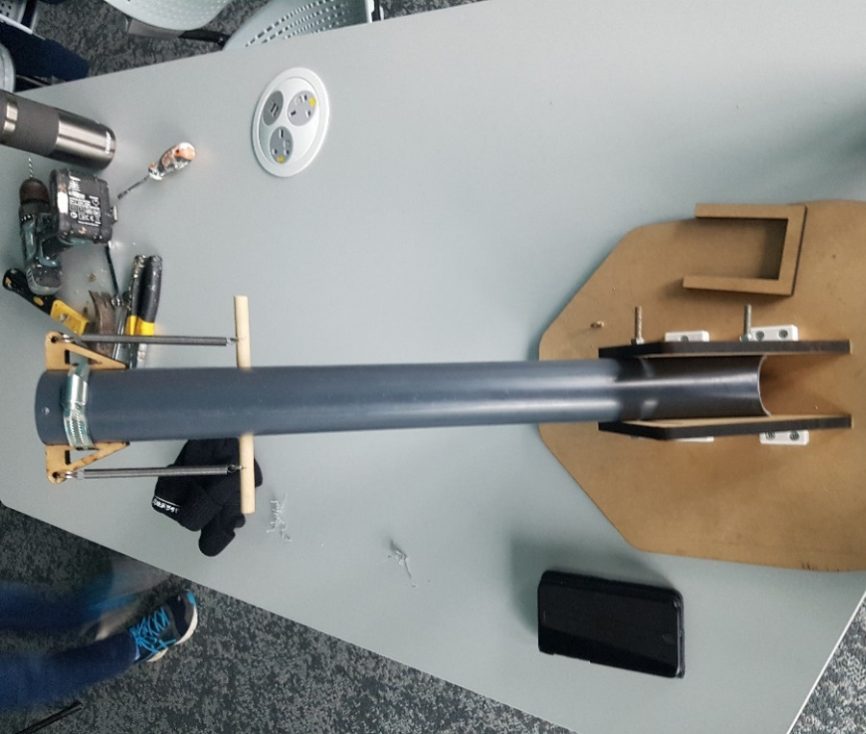
Building Process
As a whole it went ok, the group met up twice to assemble the parts we had made and the ones we made ourselves and apart from one little snag we came across when trying to mount the actuator, the design worked brilliantly.
We managed consist launches to all 3 distances setting the springs on the launcher to 140, 160, 180 millimetres respectively. These settings with the fresh springs in place and with the tube resistance inside, gave us our most consist, accurate shots.

Concept
The basis behind the design was a dual spring setup mounted to a stable 45 degree barrel, an actuator would release an “n” shaped bridge which would in turn, release the springs firing the ball out the end. The springs would be mounted to the clamps via jubilee clips at the tip of the barrel. The barrel was fixed in place and the distance would be solely managed via the pull back distance of the spring.
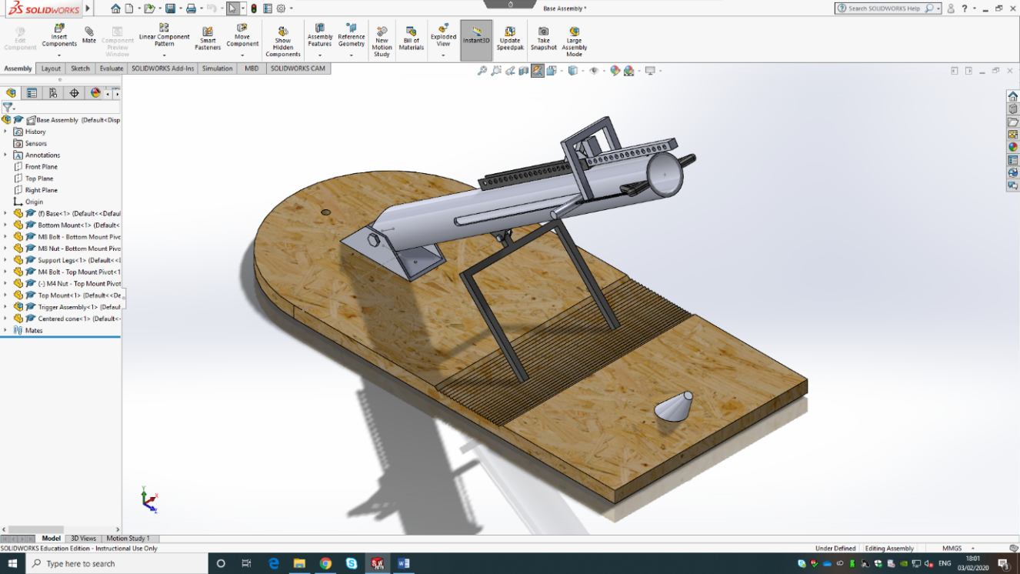
The base at the bottom of the launcher was fastened to the up 2 uprights we had made and that’s what primarily held the launcher stable at 45 degrees. We did cut an arc out in the uprights to be able to adjust the height if we were going to go down that route, but it wasn’t needed in the end.
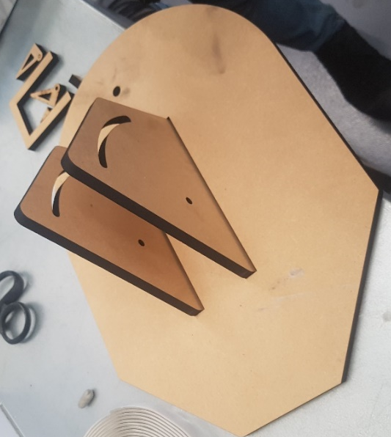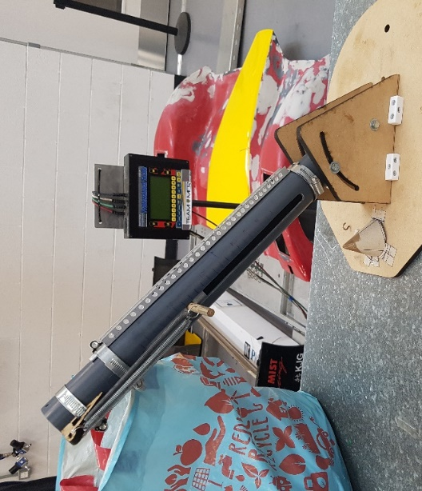
(photos taken from the final lab session)

Conclusion / final thoughts
Overall as a whole, the project went really well and im proud of the group for how well we comunicated and got involved in the worshop and how dedicated we all were when it came to crunch time.
Everybody got really involved , there was a lot of clear communication and everyone took turns to plant their ideas and ways around problems were openly looked at and discussed.
An honorable mention to Richard Parker, who more than carried his own weight and a lot of the slack on the project, without his input the launcher would not of come together at all.
Planned out a bit better and with more scheduled group meetings I do believe the launcher would have been fully operational come the dealine and I think its down to poor time management, but as I said previously when together, the progress and dedication every member put in was more than satisfactory for any given task.

