To Deborah Hughes.
Tim Rees
1807470.
HND Quantity surveying.
ACBA6000
Word count 1200
Submission date: 21/01/2022.

1.0 Table of contents – Page 2.

2.0 Introduction – Page 3.

3.0 Resource overview report – Page 4.

3.0.1 Cost overview report – Pages 5 and 6.

4.0 Effect of strike on the report and how it is dealt with contractually – Page 7.

5.0 Performance, productivity and incentivisation issues and how to address them -Page 8.

6.0 Bibliography – Page 9.

2.0 Introduction.

Th aim of this report is to provide the client with firstly a Gannt chart showing the critical path of the project with a detailed path for my chosen element (substructure). I will also provide the client with site specific reports for time, costs and resources for the work activities shown in my Gannt chart.
In this report I have chosen to address the scenario of a local concrete firm striking which is due to begin on first day they are required. In this report I will show the client how it affects the project regarding the critical path of the project and provide the client with ways of addressing this issue contractually.
In this report I will also provide the client with some possible ways in which they can possibly address issues regarding productivity and incentivisation.

3.0 Resource overview report.

(Appendix 1and 2 showing Recourse overview report)
Name | Start | Finish | Remaining Work
Labourer | Mon 14/03/22 | Fri 02/08/24 | 38,560 hrs
Ground Worker | Mon 25/07/22 | Tue 04/04/23 | 5,400 hrs
Carpenter | Mon 22/04/24 | Fri 14/06/24 | 1,920 hrs
Plumber | Mon 22/04/24 | Fri 14/06/24 | 1,920 hrs
Electrician | Mon 22/04/24 | Fri 14/06/24 | 1,920 hrs
Plasterer | Mon 20/05/24 | Fri 14/06/24 | 960 hrs
Steel fixer | Mon 17/04/23 | Fri 22/03/24 | 15,680 hrs
Foreman | Mon 14/03/22 | Fri 09/08/24 | 5,560 hrs
Cleaner | Mon 12/08/24 | Fri 12/09/25 | 4,320 hrs
surveyor | Mon 29/07/24 | Fri 09/08/24 | 80 hrs
painter | Mon 17/06/24 | Fri 26/07/24 | 2,160 hrs
roof fitter | Mon 01/01/24 | Fri 22/03/24 | 4,320 hrs

3.0.1 Cost overview reports.

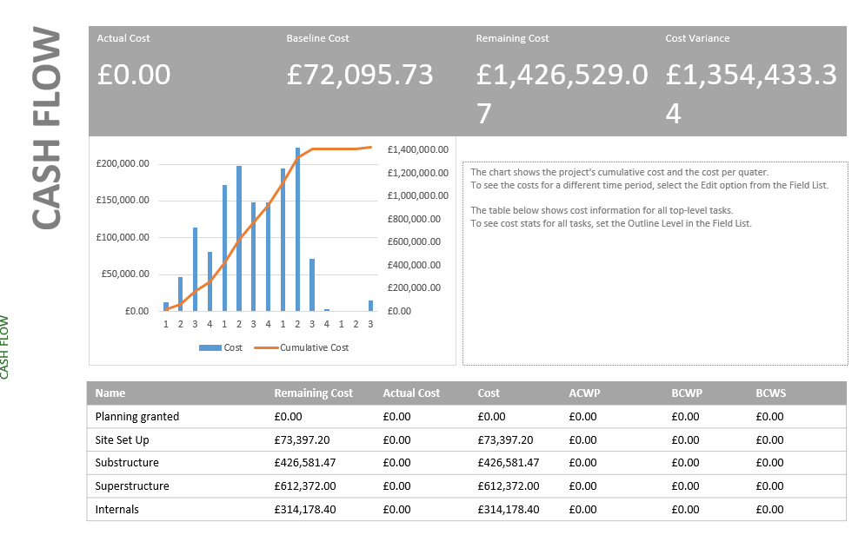
(Appendix 3 showing cash flow)
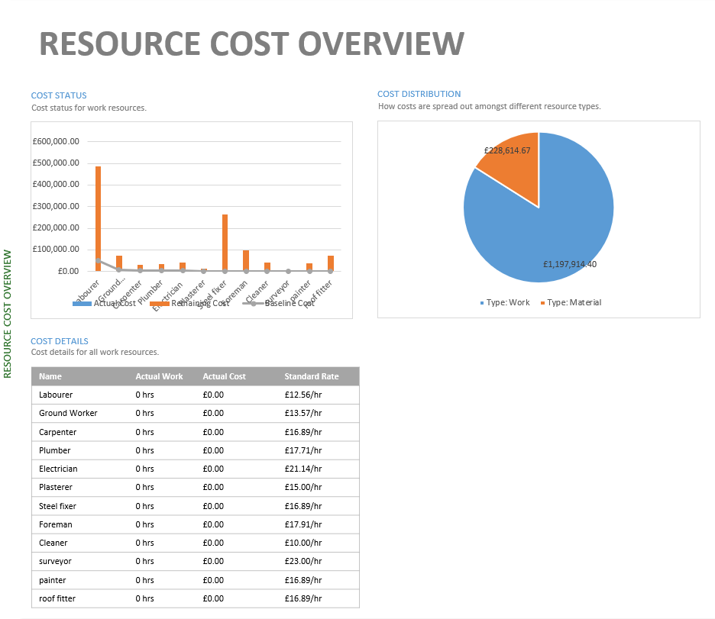
(Appendix 4 showing resource cost overview)
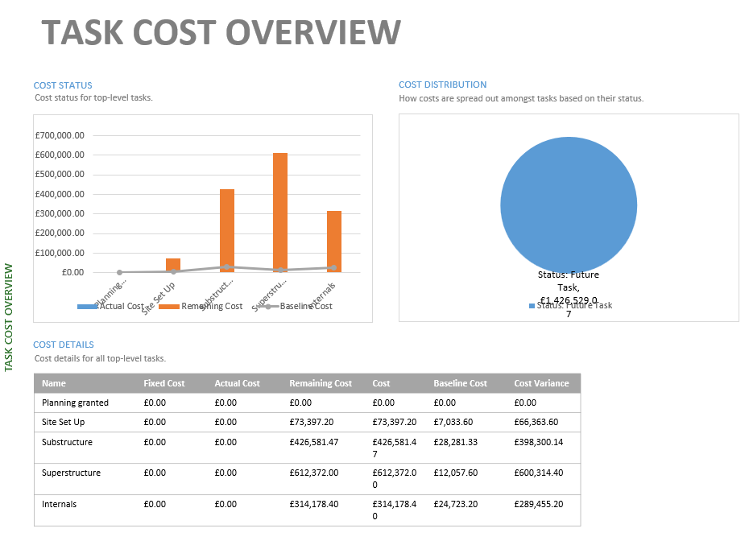
(Appendix 5 showing task cost overview)

4.0 Concrete strike.

The concrete suppliers that are to be used for this project are due to begin a strike that lasts 5 weeks commencing on the first day the project requires concrete. This has a significant impact on the project because below it will cause the project to be delayed at week 40. This will have a significant impact because it means that the superstructure and the consecutive tasks cannot be carried out. This will have an impact on both the completion date and cost as we will be required to continue to pay the overheads of the site while the work has paused due to the strike.

If the client is using an NEC suite of contracts (I assume they are in this instance), then the NEC 3 suite of contracts adopts a different approach in which these events may provide the contractor scope to receive both additional time and money for problems that fall under the required definition. (The NEC 3 suite of contracts) Tells us that industrial action such as a strike in this case, is not always referred to as a compensation event. Due to this, contractors will need to carefully consider if any other provision in the NEC 3 may assist in a claim for additional time or money.
(Clause 80.1 of the NEC 3 suite of contracts) Tells us that Loss of or damage to the works, Plant and Materials due to strikes, riots and civil commotion not confined to the Contractors employees is an employer’s risk, which can then be deemed a compensation event. Because of this clause, the contractor would be entitled to apply for changes to the prices and completion date if the provision applies. However, the clause only applies to physical damage that arises from a strike - and in an unamended contract there is no specific provision that allows for additional time or expense that is not related to such damage.
Alternatively, the contractor might try and prove that the strike is covered under into clause 60.1(19) in the NEC3 suite of contracts. This tells us that it may be classed as an event which stops the Contractor completing the works by the date shown on the Gannt chart or stops the Contractor completing the works in a scenario in where neither Party could prevent.
This clause also tells us that if the contractors claim regarding the strike comes under either of the above clauses then the contractor must provide notification of the event as soon as it is possible.
In this case I would advise the client that as the contract is assumed to be unamended then there is no provision that allows for additional time or expensive on the contractor’s behalf. Due to this I would be seeking to request from the contractor, a revised price due to the impact on the completion date. It may also be possible to

5.0 Incentivisation.
When considering incentivisation and addressing performance issues regarding the scenario of the strike, it may be possible to mitigate the impacts of the strike by providing incentive to the contractor. This incentive could include a clause that will guarantee the contractor further work in the future with the client. This may help to mitigate the impact of the strike as it may allow the contractor to recover some of the costs in the future because they have had to revise the costs as requested by the client. Another method of providing incentivisation to reduce performance issue and productivity might include a shared savings scheme in which the contractor and the client will equally divide any further savings on the cost of the contract. This is beneficial to both parties because the client will firstly be financially compensated for delays caused by the strike and secondly because the contractor may be able to recover some of their costs if they have had to reduce some costs to compensate the client in their revision of costings. The shared saving scheme may also make it possible for both the client and the contractor to make an increased profit on some aspects of the contract and project.
Through incentivisation, we may also be able to recoup some of the time lost in the delay. This can be done by awarding the contractor a bonus if they are able to recover some of the lost time and provide completion on or before the completion date. This falls under option x6 as shown in the NEC3 suit of contracts.
By using positive incentivisation such as these methods we hope that the contractor will be inclined to meet the requirements needed to obtain the incentives offered.

6.0 Bibliography.
Chudley, R., Greeno, R. and Kovac, K., 2020. Chudley and Greeno's building construction handbook. London: Routledge Taylor & Francis Group.
2014. NEC3. London: NEC.
Property.swansea.gov.uk. 2022. 2018/1023/FUL | Construction of purpose built student accommodation between 7 and 9 storeys (645 bedspaces) with ancillary community facilities/services, 1 no. Class A3 ground floor unit, car and cycle parking, servicing area, refuse store, associated engineering, drainage, infrastructure and landscaped public realm | Plot A1 Kings Road Swansea SA1 8PH. [online] Available at: <https://property.swansea.gov.uk/online-applications/applicationDetails.do?previousCaseType=Application&keyVal=P83WP5EVHX000&previousCaseNumber=2021%2F2758%2FNMA&activeTab=summary&previousKeyVal=R1OHCYEV00F00>
2020. SPONS: Architect and Builders price book. AECOM.
2020. SPONS: Civil engineering and highway works price book. AECOM.
2020. SPONS: Mechanical and electrica price book. AECOM.

