
Implementation (Group WORK) + Report
Rhys Davies


Table of Contents
Option 1: Feature Enhancement 3
Part B 4
Stage 2: 5
Stage 3: 6
Stage 4: 10

Figure 1 Image of the first draft of the python script 3
Figure 2 Updated code of the python script. 6
Figure 3 Image of the GitHub Repository 7
Figure 4 Image of Charlie commenting on the recent change 8

Stage 1
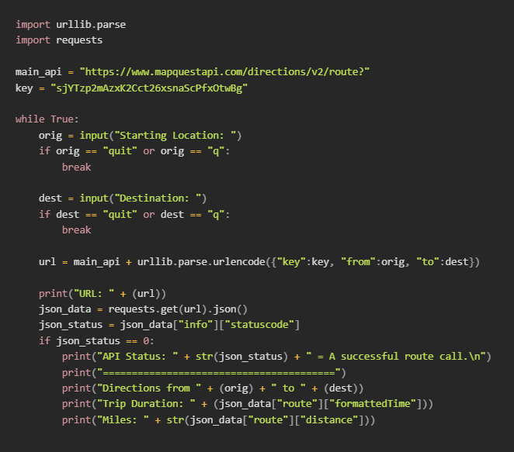
Introduction
Figure 1 Image of the first draft of the python script
In this assignment the team and I will be using the Python code that integrates the Map Quest API and come up with some new features for the code and implement them whilst at the same time testing the code for any possible issues or bugs that may appear. After the coding has been completed, we will evaluate what the team did well and any possible feature enhancements that can be added in the future to make the python script faster, better and more feature rich.

Planned Upgrades
After careful consideration and planning we all agreed on 2 unique features that could really improve the script in terms of feature set and usefulness.
- Real-time traffic updates
- Walking and biking directions
We didn't want to implement too many features to the program which may cause a user to become confused and overwhelmed so we wanted to make sure that the program was simple and easy to understand for any age range from young to elderly.
I believe the team and I have designed a product that will allow us to enhance these features into the python script. We will create a working prototype of the upgraded python scipt and test it to make sure that it meets the customer's requirements.

Initial Research
We researched many different aspects of python and the MapQuest API learning how it properly works and what features we could add onto it, this part was especially tricky because we haven't done this sort of programming beforehand but over time we have grouped together, discovered, and successfully planned how the features were going to be implemented effectively.
We also found out that MapQuest had other functionalities that could be implemented in the future such as:
- Geocoding: This feature can convert addresses into latitude and longitude coordinates.
- Directions: This feature allows you to get directions from one place to another efficiently.
- Routing: This feature allows you to create custom routes for different places.
Before starting the coding aspect it's recommended to get the users’ needs and requirements before implementing any changes because a certain feature may interfere or upset a user which may lead to poor usability, this can be done by asking different people their opinions and feedback on the program and ask if any changes or improvements need to be made in the program.
It's important to keep in mind the technicality of the project because if a certain feature is too complicated to implement then it may cause disruptions in workflow so it's important to stick with features and tools that are not too difficult to implement. Some more advanced features may take more time to add than others so it's important to prioritize certain features over others to keep production going.

Part B
Team Name: ITtakes3

Team Member Roles
 | Name | Skills/ Interests
Facilitator | Rhys Davies | Cybersecurity, Coding
Recorder | Charlie | Writing, Researching
Team Member | Cameron | Coding, Researching
Team Member | Dylan | Writing, Coding

Ice Breaker Questions:
Member Name | Question | Answer
Rhys Davies | How are we going to approach the coding aspect? | By collaborating with each other and solving each other’s problems
Charlie Wilkinson | How are we going to plan the writing aspect? | By focusing on different tasks
Cameron | How are we planning the project? | By sending emails with updates and using GitHub to update the files
Dylan | How are we going to research? | By asking different age groups (young people and elderly people) for their feedback

Stage 2:

Team Name: ITtakes3

Scrum Leader: Rhys Davies

How did your team select the scrum leader?
We selected Rhys to be our scrum leader because he is very good at organizing and is overall a great team player. Communication with the team is very important when putting together a project so having a leader who can express his concerns about different topics is important to adapt and to learn from their mistakes.

Did you define any other agile team roles?
We all worked on different aspects of the project which included coding, testing, writing, and researching. We did discuss that Cameron would be the analyzer for the code to make sure that the code is correct and there were no mistakes present.

Which communication tools did the team use?
Tools | Purpose
Microsoft Teams | To be able to speak to one another when not in person
Google Docs | To create and document the changes and features
Visual Studio Code | To run the code and to write
GitHub | To store the code and add the ability to back up

Stage 3:
Why did we select option 1?
Many of our team members are still brand new to coding and working with Python so we wanted to challenge ourselves but at the same time we wanted to work on a project that won't be too demanding and possibly get completely stuck on a certain section, our team member Cameron has had some coding experience in the past and he has been leading the group in the right direction, we ultimately chose option 1 because it was a task that Cameron has done before and it gave us all an opportunity to learn and understand how the REST API is implemented and how each section worked which was very fun and exciting to see.

Application and its deliverables, Application goals
When adding new features to the application we want the python script to be efficient and easy to use, the UI and the setup is very simple, you add a start location with an end location and the script will display information such as miles from the destination and how long it will take to get there by car. The script will also display real time traffic updates when the script has been run by contacting the MapQuest servers and getting a reply with the answer, this useful for figuring out what is the best time to leave without being stuck in a traffic jam. The app needs to be easy to use so converting latitude and longitude coordinates into a specific address and an address into latitude and longitude coordinates is essential for user experience and ease of use.

We want the design and setup to be quick and easy to use so typing in the address of the start location and the destination location is very straight forward then it outputs and answer very quickly.

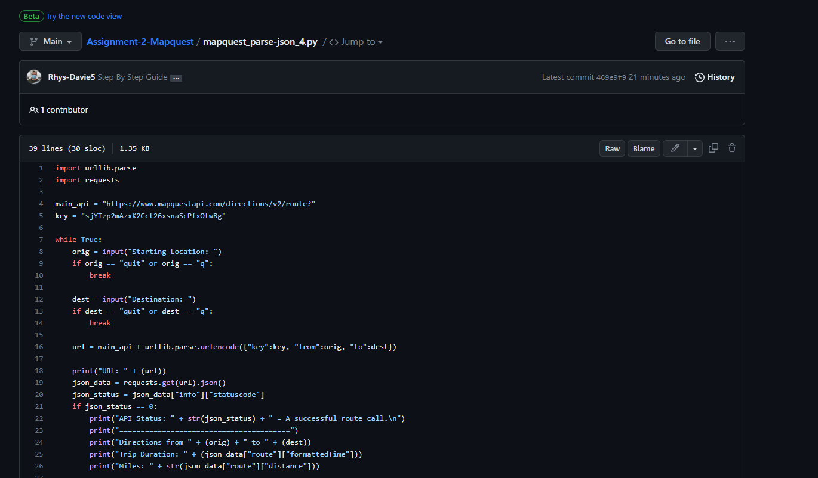
Figure 2 Updated code of the python script.

Team member roles and skill sets

Team Member | Role / Knowledge / Skill Set
Rhys Davies | Coder / Writer, Coding, Organizing and teamwork
Cameron | Writer, Coding, Programming
Dylan | Researcher, Writer, Researching
Charlie | Code Analyzer, Coding, Research

Project Plan
We have come up with a very effective plan when completing this project, 2 of our group members (Rhys and Cameron) will focus mainly on the coding aspect of the project because this section will take long time to complete if it was tasked to only 1 person, the 2 other team members will be the researchers who will gather as much information as possible about the MAPQUEST API, its features and how to implement them which will help out the coders in the project. The last team member will be the code reviewer/writer of the group who is responsible for checking the code to make sure it is free from any issues or bugs and is also responsible for writing down notes.

We will be using GitHub to host and monitor different changes when the new features have been added, GitHub has a feature called version control which allows the group to quickly go back in time before a feature was implemented due to different reasons such as a feature being too difficult to implement or a feature is overlapping with another function which is causing the program to lag or to stop working all together.

If one of the members of the team are absent or unable to attend a few meetings we have created a backup plan for when a member is missing, if one of our coders are missing either Rhys or Cameron will be responsible for the coding section if a writer is missing Rhys or Charlie will take their place if they aren’t available. If Dylan is missing then Cameron and Charlie will be able to do the research part of the project until he is able to come back.

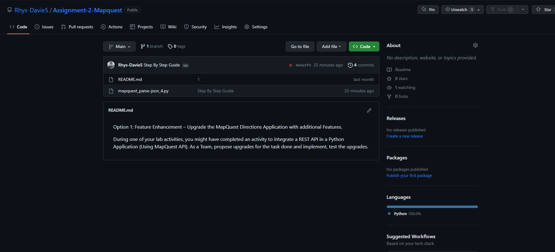
Figure 3 Image of the GitHub Repository

GitHub Repository link
https://github.com/Rhys-Davie5/Assignment-2-Mapquest.git

How was GitHub used in your project?
When performing this project, GitHub has been incredibly useful in our workflow and efficiency overall, before using GitHub the files would be sent manually through OneDrive. Because of GitHub, changing and adding new features is like adding items to a shopping list, easy and convenient. Charlie has been able to comment on one of the features that were implemented which gave a great understanding of what the team liked and what might need to be added in the future.

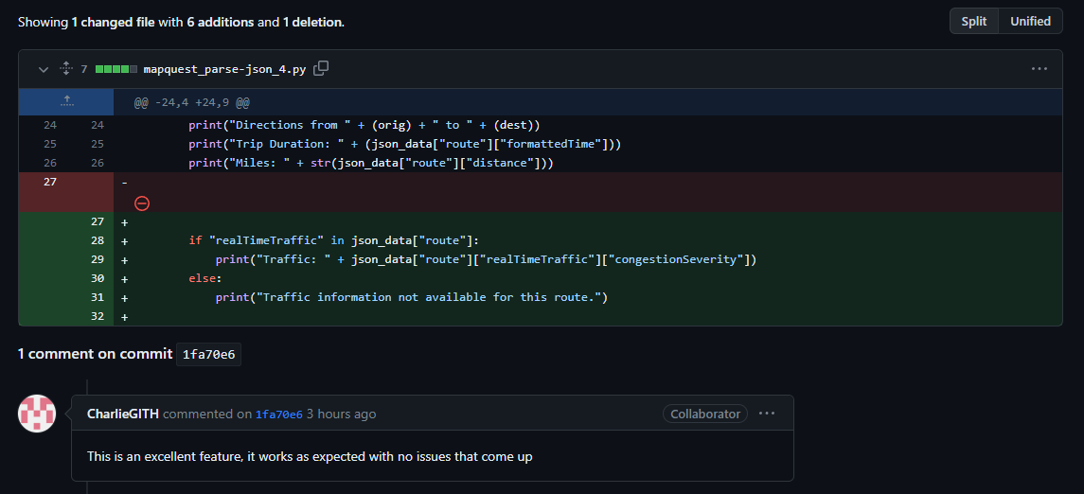
Figure 4 Image of Charlie commenting on the recent change

Possible future enhancements
As a team we are proud of what we were able to accomplish during the project, we worked together and managed to complete the tasks that we were set out to accomplish. There were several issues and struggles along the way, but we managed to overcome them by working as a team and communicating with each other.

If we were able to do this project again, we would add different features such as:

- Unit Conversion - in the future we were thinking of adding a feature where the user can select the unit they want because people may prefer to use kph instead of mph which can cause issues if the person does not know what one of them means.
- Transport Type - The person will be able to select if they are traveling by foot or in a car because the time it takes to arrive at a certain destination may take a lot longer if a person walks then they would by taking a car or even a bus.
- Fuel Type - different fuel types such as petrol or diesel are different when it comes to hills and one of them can be more efficient in certain scenarios, the person may select an option for a patrol car and the API may suggest to take a longer route which may save on fuel but a diesel may take the hill because its more efficient at going uphill.

Stage 4:
Reflection

When working on this project I learned a lot about Python, MapQuest features and different methods of adding features to the script and it was a great learning method for all of us, Cameron who is the most experienced coder in the group partially understood how to implement the features we wanted but with the help of Dylan and Charlie doing the research aspect it made the project less demanding then what we were expecting, At the start of the project all of us were nervous because we didn't know where or what to start on. As we began our research on different sections and asking for help, we slowly began to understand what we should be doing and how to organize it accordingly.

Using GitHub to collaborate on the work has been incredibly fun because of how convenient and easy to use the service is. We were able to roll back a version because one of the features we tried to implement didn't work so we started again without losing much in the process. Charlie and Dylan were not familiar with GitHub and what it offers so me and Cameron helped them learn and utilize the features that GitHub offers.

