

Student Name: Eman Ali Student ID: 2507026
Module: Problem Solving and Innovation (BMSW4014)

Lecturer: Christopher Wilkin
Assessment: Component 2 - Individual Supporting Document

Table of Contents:
Individual Presentation Speaker Script 3
Presentation Slides 5
Critical Reflection on Generative AI Utilization 7
References 9
Evidence of AI Research Interaction 9

Individual Presentation Speaker Script

Hello everyone. Today, I’m going to take you through our Root Cause Analysis of AI Washing in the tech industry. Now, instead of just guessing why these companies tend to exaggerate their tech, our team wanted a structured approach. So, we used a business framework called the '3 x 5 Whys' by Gangidi (2019). What I love about this method is that it forces you to look at a problem from three completely different angles: the technical side of what happened, the human choices involved, and the underlying systemic rules of the organization. While our group slides focus on the broader tech industry to show you the big macro trends, I’ll be using the legacy tech giant IBM as my specific, real-world case study to show you how these theories actually play out in practice.
If you look at our Fishbone Diagram on the screen, it breaks down the root causes of AI washing into four main operational areas, and frankly, we can see every single one of them at play when we analyze IBM.
First, if we look at Methods, public stock market systems put an immense amount of pressure on short-term valuation cycles. They aggressively reward a company the second it announces an AI capability, completely ignoring how slow true engineering actually is. To make matters worse, we are operating in a global regulatory void right now, where clear laws defining what counts as 'authentic AI' simply don't exist yet.
Second, looking at Machinery, the reality is that true software development takes years of capital-intensive research. IBM is sitting on massive, older corporate backend systems that are fundamentally unsuited for rapid, cloud-native scaling of Large Language Models. This creates a really distinct technical speed gap between what they want to do and what they can do.
Third, under People, corporate executives are facing intense institutional pressure and distraction. Management teams end up using strategic AI hype just to look modern to their investors—and quite often, they use this exciting messaging to quietly mask structural cost-cutting and massive workforce layoffs.
Fourth, regarding Mother Nature—or the external environment—fast-moving, AI-native startups like OpenAI are completely dominating the market. This creates extreme competitive velocity and, honestly, a lot of boardroom panic for older tech giants.
To understand the deeper psychology behind this corporate behavior, we applied Cognitive Dissonance Theory from a 2026 research paper by Sun et al. In simple terms, a company experiences a severe internal conflict when its public marketing claims are miles ahead of its actual internal technical capabilities. IBM faces this exact strategic dissonance. So, how do they hide this uncomfortable execution gap from Wall Street? To protect their stock price while their engineering teams scramble to catch up, the company uses high-level,

speculative AI branding as a temporary shield—which basically functions as an artificial valuation buffer.
To wrap things up, our case study proves that AI washing isn't just an isolated marketing mistake. It's a structural survival mechanism driven by intense market valuation pressures. All of our data, framework mappings, and findings are fully backed by our module's core literature, textbook problem-solving theories, and recent regulatory reports from bodies like the Federal Trade Commission. My individual supporting document applies these exact verified academic sources directly to the IBM case study to cross-verify our team's findings.
Thank you so much for your time, and I’m now happy to open the floor to any questions you might have.

Presentation Slides:

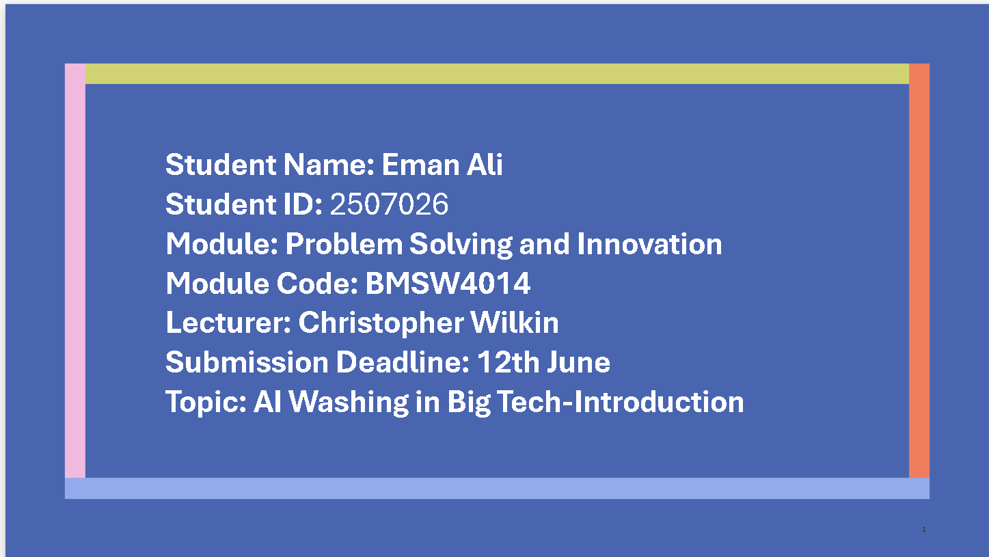
Slide 1:

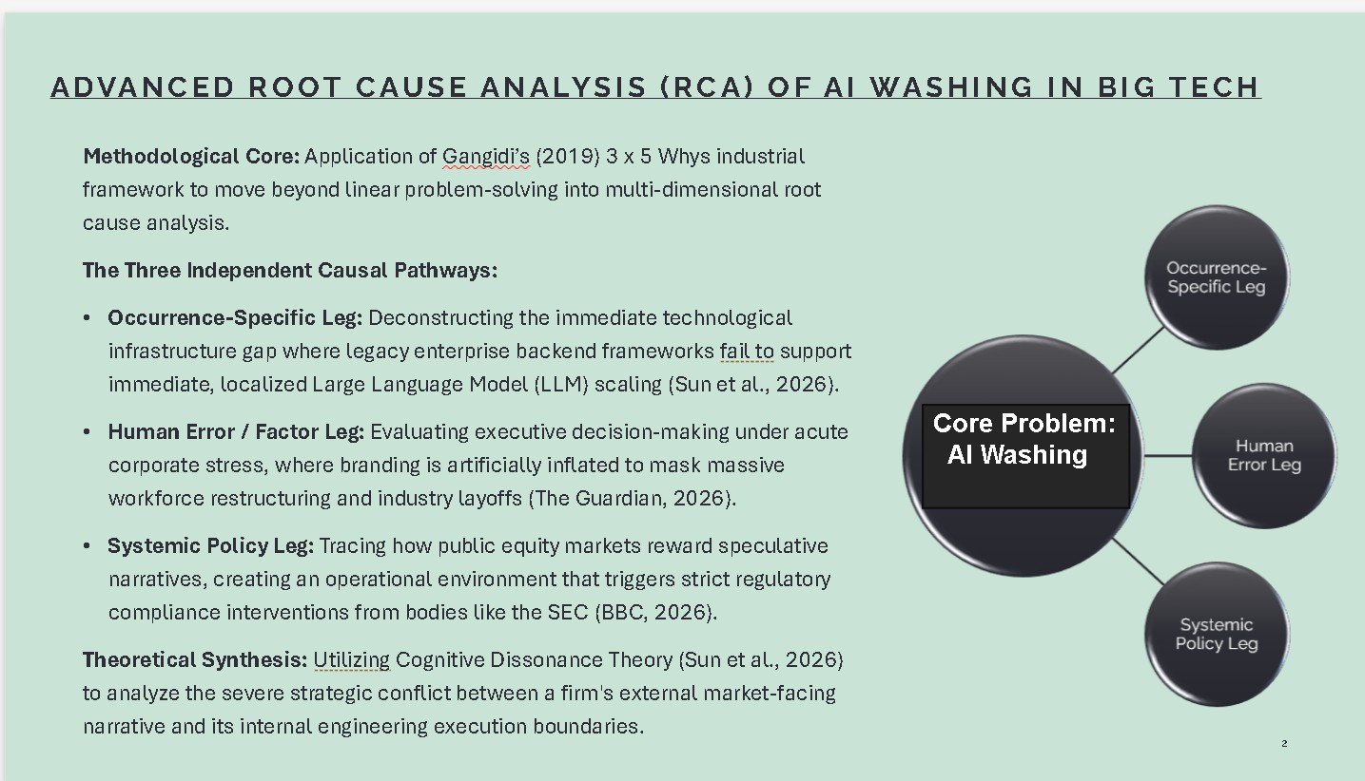
Slide 2:

Slide 3:

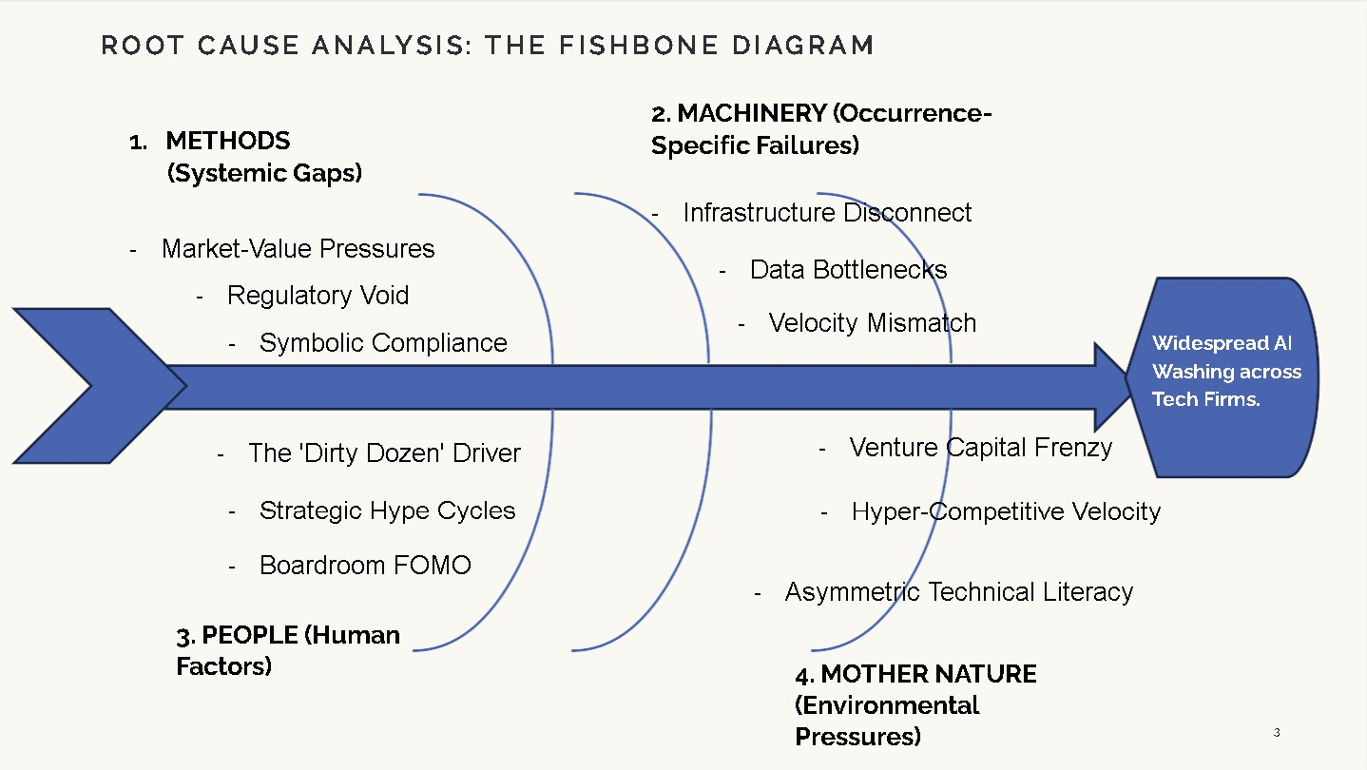

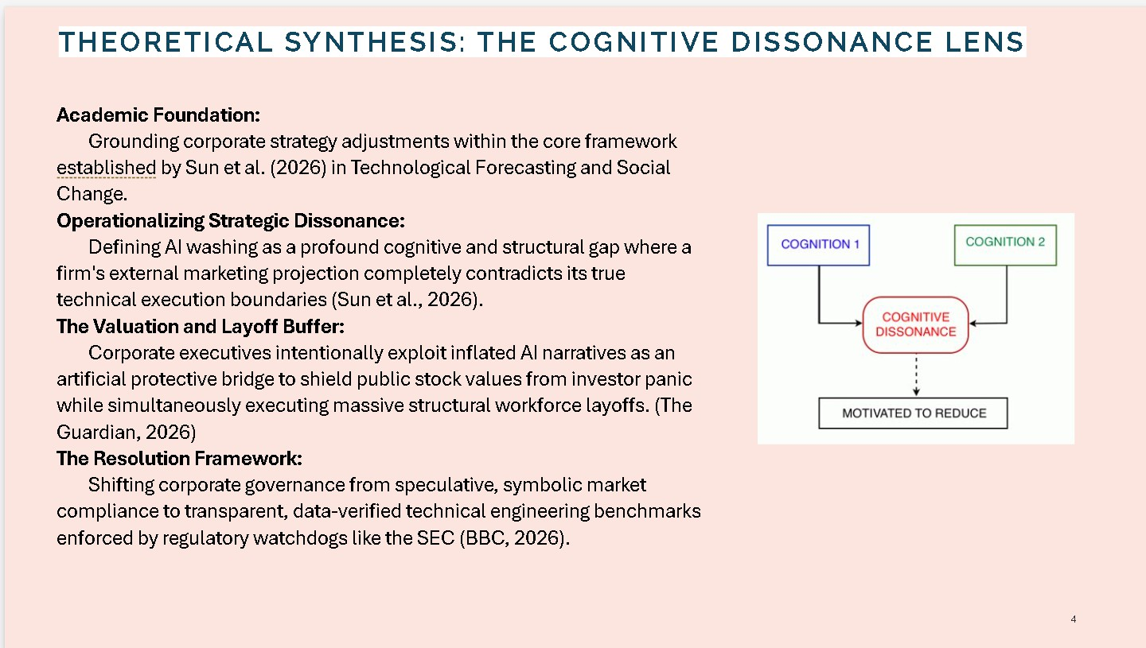
Slide 4:

Slide 5:

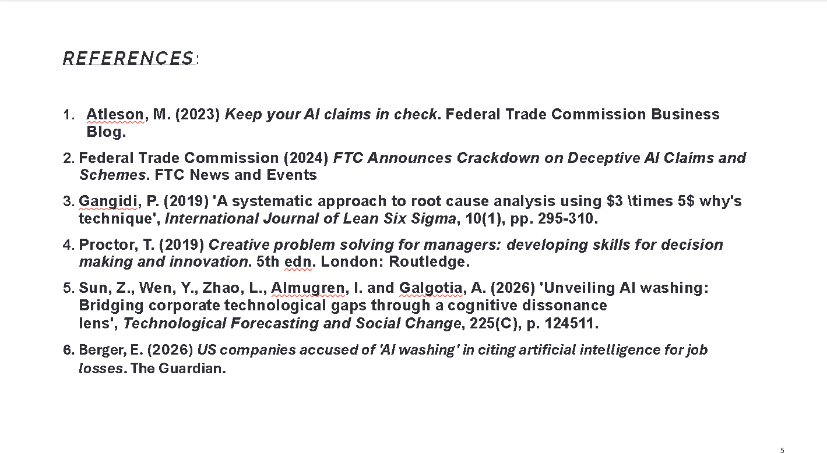

Critical Reflection on Generative AI Utilization
For the research and preparation phase of this module, Generative AI (ChatGPT) was utilized as an interactive brainstorming tool to evaluate theoretical intersections.
Specifically, the tool was prompted to map the mechanical dimensions of Gangidi’s (2019) 3 x 5 Whys framework onto the core structural symptoms of corporate AI washing identified by Sun et al. (2026).
The primary utility of the AI interface was its rapid capacity for multi-dimensional mapping. It successfully aligned Sun’s organizational learning failures with Gangidi's 'Systemic' leg, and correctly categorized executive behavioral drivers under the 'Human' leg. This significantly optimized my early structural outlining. However, critical analytical limitations emerged. While the AI successfully generated localized, linear five-step chains for a superficial problem statement, it completely lacked the processing capability to execute a true, multi-variable root-cause synthesis. It failed to apply the rigorous 'reverse path logic'

verification tests mandatory for authentic Six Sigma quality diagnostics, offering generic corporate explanations rather than deep, operational industry insights.
Consequently, the output was entirely unsuitable for direct academic integration. I had to manually audit the complete transcript, independently restructuring the points to build a rigorous, human-verified framework suitable for university-level evaluation.

References:
- Federal Trade Commission (2024) FTC Announces Crackdown on Deceptive AI Claims and Schemes. FTC News and Events.
- Gangidi, P. (2019) 'A systematic approach to root cause analysis using 3 x 5 why's technique', International Journal of Lean Six Sigma, 10(1), pp. 295-310.
- Proctor, T. (2019) Creative problem solving for managers: developing skills for decision making and innovation. 5th edn. London: Routledge.
- Sun, Z., Wen, Y., Zhao, L., Almugren, I. and Galgotia, A. (2026) 'Unveiling AI washing: Bridging corporate technological gaps through a cognitive dissonance lens', Technological Forecasting and Social Change, 225(C), p. 124511.
- Atleson, M. (2023) Keep your AI claims in check. Federal Trade Commission Business Blog
- Berger, E. (2026) US companies accused of 'AI washing' in citing artificial intelligence for joblosses. The Guardian.

- Appendix: Evidence of AI Research Interaction

Due to the depth of the academic literature synthesis regarding the 3x5 Whys methodology (Gangidi, 2019) and Cognitive Dissonance theory (Sun et al., 2026), the research transcript spans multiple pages. In strict compliance with the assessment specification requirements, the complete, unedited, and sequential chronological conversation history is provided below to maintain full transparency.
Figures 1 to G: Direct transcript excerpts demonstrating interactive concept mapping between Cognitive Dissonance (Sun et al., 2026) and the 3x5 Whys framework (Gangidi, 201G).



