

Individual Research Project
ACBA6002

The Implications of Swansea City & County Council’s Response to Decarbonisation in Retrofitting their Housing Stock

Mark Davies

P152138

May 2020



Author’s Declaration
I declare that the work in this dissertation was carried out in accordance with the regulations of the University of Wales, Trinity Saint David. The work is original except where indicated by special references in the text and no part of the dissertation has been submitted for any other degree.
Any views expressed in the dissertation are those of the author and in no way represent those of the University of Wales, Trinity Saint David.
The dissertation has not been presented to any other University for examination either in the United Kingdom or overseas.
I hereby give permission for my work, if accepted, to be available for photocopying and inter-library loan, and for the title and summary to be made available to outside organisations.

Signed: Mark Davies

Date: 27th May 2020

Copyright statement

The copyright of this dissertation rests with the University of Wales, Trinity Saint David. No information derived from this dissertation shall be published without the prior written consent of the University.

Signature: Mark Davies

Date: 27th May 2020

List of Contents

Acknowledgements………………………………………………………………………………………. |  |  | I
Abstract…………………………………………………………………………………………………….. |  |  | II
List of Abbreviations…………………………………………………………………………………….. |  |  | IV
1. | Introduction………………………………………………………………………………………. |  | 1
 | 1.1 | Purpose of the Research……………………………………………………………... | 1
 | 1.2 | High Levels of Fuel Poverty………………………………………………………….. | 3
 | 1.3 | Standard Assessment Procedure…………………………………………………... | 4
 | 1.4 | Energy Performance Certificate…………………………………………………….. | 4
 | 1.5 | Aim……………………………………………………………...................................... | 5
 | 1.6 | Objectives……………………………………………………………........................... | 5
 | 1.7 | Structure ……………………………………………………………............................ | 6
2. | Literature Review………………………………………………………………………………... |  | 7
 | 2.1 | Better Homes, Better Wales, Better World………………………………………... | 7
 | 2.2 | Welsh Advisory Group………………………………………………………………... | 9
 | 2.3 | Each Homes Count……………………………………………………………………. | 10
 | 2.4 | Homes as Adopted Power Stations ………………………………………………... | 10
 | 2.5 | Active Homes ………………………………………………………………………….. | 11
 | 2.6 | SOLCER House………………………………………………………………………… | 13
 | 2.7 | SOLCER House Energy Consumption…………………………………………….. | 15
 | 2.8 | Retrofitting Research…………………………………………………………………. | 15
3. | Research Methodology…………………………………………………………….................. |  | 17
 | 3.1 | Collection of Research Data…………………………………………………………. | 18
 | 3.2 | Quantitative Research………………………………………………………………… | 18
 | 3.3 | Qualitative Research………………………………………………………………….. | 18
 | 3.4 | Chosen Method – Primary Data……………………………………………………... | 19
 | 3.5 | Interviewee Background...…………………………………………………..……….. | 20
 | 3.6 | Data Reliability…………………………………………………………………………. | 24
 | 3.7 | Ethical Considerations………………………………………………………………... | 24
 | 3.8 | Cost Considerations…………………………………………………………………... | 24
4. | Results and Analysis…………………………………………………………………………… |  | 25
 | 4.1 | Analysis of Results……………………………………………………………………. | 25
 | 4.2 | Summary of Interviews……………………………………………………………….. | 36
5. | Conclusion and Recommendations…………………………………………………………. |  | 37
 | 5.1 | Aim of Research……………………………………………………………………….. | 37
 | 5.2 | Research Findings……………………………………………………………………. | 38
 | 5.3 | Conclusion of Research…………………………………………………………….... | 41
 | 5.4 | Limitations of Study……………………………………………………………........... | 45
 | 5.5 | Recommendations……………………………………………………………............. | 46
6. | References……………………………………………………………....................................... |  | 47
7. | Bibliography…………………………………………………………….................................... |  | 51
8. | Appendices……………………………………………………………...................................... |  | 56
 | 8.1 Appendix 1 – Ffordd Ellen – “A Retrofit Case Study”………………………….. |  | 56
 | 8.2 Appendix 1 – Mechanical Ventilation Heat Recovery…………………………... |  | 60
 | 8.3 Appendix 1 – Ground Source Heat Pump…………….………………………….. |  | 60
 | 8.4 Appendix 1 – Photovoltaic Panels…………………………………………………. |  | 62
 | 8.5 Appendix 1 – TESLA Powerwall Battery………………………………………….. |  | 62
 | 8.6 Appendix 1 – Post Evaluation of the Retrofit……………………………………. |  | 63
 | 8.7 Appendix 2 – More Homes Case Study…………………………………………… |  | 65
 | 8.8 Appendix 3 – Interview Questions…………………………………………………. |  | 67

List of Figures

Figure 1: | SAP / EPC Distribution in Wales (WHQ et al, 2020)……………………………… | 4
Figure 2: | Active Homes Development, Neath (WHQ, 2019)………………………………... | 12
Figure 3: | SOLCER House, Stormy Down, Bridgend (Cenin Renewables, 2019)……….. | 14
Figure 4: | SOLCER House, Internal Design (Cenin Renewables, 2019)………………….. | 15
Figure 5: | Ffordd Ellen Property (SCCC, 2019)…………………………………...…………… | 17
Figure 5.1: | Ffordd Ellen Layout Plan (SCCC, 2019)……………………………………………. | 17
Figure 6: | Key differences between Qualitative and Quantitative data (McLeod, 2017).. | 18
Figure 7: | Ffordd Ellen Property (SCCC, 2019)……………………………………………… | 58
Figure 7.1: | Ffordd Ellen Layout Plan (SCCC, 2019)……………………………………………. | 59
Figure 7.2: | Ffordd Ellen Thermal layout plan (WSA, 2019)…………………………………… | 59
Figure 7.3: | Ffordd Ellen - ASW Weather station (SCCC, 2020)………………………………. | 60
Figure 7.4: | Ffordd Ellen Funding Allocation Table (CCCS, 2019)…………………………… | 61
Figure 7.5: | Ffordd Ellen - No29 – Glazing & EWI (SCCC, 2020)……………………………… | 61
Figure 7.6: | Ffordd Ellen – Newly installed MVHR (SCCC, 2020)…………………………….. | 62
Figure 7.7: | Ffordd Ellen – Newly installed GSHP water storage (SCCC, 2020)…………… | 63
Figure 7.8: | Ffordd Ellen - Borehole drilling machine used for the GSHP (SCCC, 2020)… | 63
Figure 7.9: | Ffordd Ellen – Photovoltaic Panels & New Roof (SCCC, 2020)……………….. | 64
Figure 7.10: | Ffordd Ellen – Tesla Powerwall Battery & Panel App (SCCC, 2020)………….. | 65
Figure 7.11: | Ffordd Ellen – Completed Renewable Energy Retrofit (SCCC, 2020)………… | 65
Figure 7.12: | Ffordd Ellen, Rear Elevation, (SCCC, 2020)…………………………………...….. | 66
Figure 8: | Milford Way, Penderry Ward – Proposed Design (SCCC, 2020)………………… | 67
Figure 9: | Milford Way, Penderry Ward – Technical Outline Brief (SCCC, 2020)…………. | 68

Acknowledgements

I would like to take this opportunity to thank Mr. Allan Nantel, Lecturer at the University of Wales Trinity St David, whose support, guidance and advice have made this dissertation possible.
Most importantly, I would like to thank my wife Sarah, for continually supporting my efforts, even in times of despair her encouragement has never diminished. To my children, Carter and Sophia, who have given my life a sense of purpose and direction.
Further to this, I would like show gratitude to my current employer Swansea City & County Council for allowing me the time to complete my degree, with a special thanks to Mr Darrel Barnes and Mr Andrew Jackett.

I

Abstract

The Welsh Government has made it clear that by 2050 there should be a reduction of emissions in each domestic dwelling by 80%. Housing in Wales should be more energy efficient and by the Welsh Government introducing this legislation then the challenge has already begun. This research study aims to investigate the implications for Swansea City & County Council (SCCC) to carry out decarbonisation to all of their housing stock by 2050. The purpose of this research was to gain a clear understanding of what type of renewable energies SCCC need to install or retrofit into their housing stock, and what are the implications of installing these renewable energies. The author set out to study, analyse and compared different technologies that were more suited to the vast range of the council’s housing stock, and whether retrofitting is feasible and economical for SCCC.

Research was carried out by means of a literature review, this entailed reviewing relevant and documented articles in journals, websites / articles and professional blogs. Research was also obtained by carrying out in-depth interviews with professionals who work in the Housing, Architecture and Renewable Energy Industry. The interviews were arranged for the researcher to discover the thoughts and opinions on the targets set by the Welsh Government and also to see if the interviewees were contributing to achieve this targets. As part of the research a focus group was arranged to take place but due to the Coronavirus (Covid-19) pandemic it was not possible to undertake.

The research and information collected from the literature review and interviews was collated and compared to one another. Valid and useful information was gathered from the Welsh Government website and from the interviews. The interviewees’ professional background impacted the content of the response.

In order to ensure that each objective was achieved, specific literature was chosen and reviewed in-depth to make sure it was beneficial to the research, this was made clear in the Results and Analysis chapter where the researcher compared the outcome with each literature review case study.

II
This research has highlighted that the implications for SCCC to achieve these targets are concerning, the high levels of funding required from the Welsh Government is staggering, and the work required to retrofit the housing stock which dates back to the 1950’s is overwhelming and alarming.

The conclusion for this research is that the target date of 2050 set by the Welsh Government is realistic, only if the correct level of funding is provided on a consistent basis, this means that the Welsh Government will have to commit to providing SCCC with the same level of funding every year until the target is achieved. This is a heavy commitment which the researcher predicts that won’t be approved. A full design plan which will be standardised (similar to the WHQS Standard) throughout each and every Local Authority (LA) in Wales should be introduced, this way the LA’s know exactly what level standard of improvements are required.

The global Coronavirus pandemic was the biggest threat to this research, it proved to cause a disruptive setback in obtaining vital information to carry out this research successfully, the author believes that this research should continue by interviewing a larger audience, this way the feedback will be more varied. The research should also continue on the developments that SCCC have completed or near completion, the data should be analysed and compared to past readings, this will then be monitored against predicted reduction in emissions and energy consumptions. The researcher recommends to carry this research in 3-5 years’ time.

III
List of Abbreviations
- SCCC - Swansea City & County Council
- LA - Local Authority
- WHQS - Welsh Housing Quality Standard
- WG - Welsh Government
- WAG - Welsh Advisory Group
- CCC - Committee on Climate Change
- WHCS - Welsh House Condition Survey
- UK - United Kingdom
- EHC - Each Homes Count
- LCRI - Low Carbon Research Institute
- WSA - Welsh School of Architecture
- PRS - Private Rented Sector
- BRE - Building Research Establishment
- EWI - External Wall Insulation
- MVHR - Mechanical Ventilation Heat Recovery
- GSHP - Ground Source Heat Pumps
- SIPS - Structural Insulated Panels
- LPG - Liquefied Petroleum Gas
- HAPS - Homes as Adopted Power Stations
- PV - Photovoltaic Panels
- Covid-19 - Coronavirus
- HBF - Home Builders Federation
- LCDP - Low Carbon Delivery Plan
- NAW - National Assembly of Wales
- ERAC - Environment and Rural Affairs Committee
- NAWCC - National Assembly for Wales Climate Change
- RIA - Regulatory Impact Assessment

IV

Chapter One

- Introduction

  - Purpose of the Research

The Welsh Government set targets in 2002 for each local authority in Wales to provide suitable living conditions for every one of their social houses by 2020. This bill is named the Welsh Housing Quality Standard (WHQS). The Welsh Government’s long term vision for housing in Wales is that all households shall have the opportunity to live in good quality homes.

The WHQS states that all social houses should be:
In a good state of repair
Dwellings must be structurally stable, free from damp and disrepair with key building components being in good condition such as walls, roofs, windows, doors and chimneys.

Safe and Secure
Dwellings should be free from risks that could cause serious harm and should be secure in key areas of the home. Heating and electrical systems should be up to date and safe, doors and windows to provide good levels of security, any risk of falls from height should be prevented, fire safety measurements should be in a good condition and well designed.

Adequately heated, fuel efficient and well insulated
Dwelling should be capable of being heated adequately by ensuring heating systems are fuel efficient and properties are well insulated.

Up to date kitchens and bathrooms
Kitchen and bathroom facilities are to be relatively modern and in good condition, sufficient to meet the needs of the household and well laid out to prevent accidents.

Located in attractive and safe environments
Homes should be located in an environment which residents can relate to and in which they are proud to live.

Suit the specific requirements of the household
The accommodation provided within the dwelling should as far as possible, suit the needs of the household. (GOV.WALES, 2019).

Swansea council has undertaken a considerable amount of work to achieve this standard in approx. 14,000+ properties owned and managed by the council and progress is being made to ensure full achievement of the WHQS by 2020. A significant amount of money has already been spent on the improvements, by the end of 2020 the council would have spent approx. £200m in total. (GOV.WALES, 2019).

By the council introducing these measures into their housing stock then they have already begun making a change to the carbon footprint. Swansea Council’s WHQS programme will be ending in December 2020, which the Local Authority is on track to complete its objective on time and within budget. With this coming to an end, the Local Authority has started to turn their attentions elsewhere in the decarbonisation field.

The Welsh Government is assessing its long-term emissions targets in response to the Committee on Climate Change (CCC) which published ‘Net Zero – The UK’s contribution to stopping global warming on 2nd May 2019. The Committee’s headline recommendation is for the adoption of a target to reduce UK greenhouse gas emissions to net zero by 2050.

The Welsh Government already has a legally binding target to reduce greenhouse gas emissions by ‘at least 80% in 2050, in the Environment (Wales) Act.
“The advice from the CCC makes it clear the increase from 80% to 95% is a substantial change and requires a serious shift in policy response to match it.” (Jofeh, 2019)

Swansea Council’s housing stock condition is some of the oldest and least thermally efficient housing stock in the UK and Europe. The majority of its housing stock was built before 1930, when there were no construction standards in terms of thermal performance, the times have changed dramatically in the construction industry in regards to energy efficient, sustainability and reducing the carbon footprint.

Swansea Council has already begun to make changes to their carbon footprint, but if they were to meet the Welsh Governments climate targets then their buildings will need to operate at close to zero emissions by 2050. In order for this to be achieved then a substantial change is required in how the buildings are heated and powered. The first step towards this would be to use low carbon sources for electricity and heating such as using Photovoltaic (PV) panels and Bio-methane or hydrogen.

The Welsh Government has stated that ‘to meet the carbon reduction targets, then the local authorities will need to scale up retrofit activity especially with those able to pay for energy efficiency measures. The first step, which is underway, is to develop a long-term, evidence-based programme to improve the quality of homes, reduce emissions and tackle fuel poverty. Based on evidence of what works, there is a programme of action to decarbonise all homes in Wales by at least 80% by 2050, regardless of their tenure’ (Prosperity for All: A Low Carbon Wales, 2019).

This statement is echoed throughout all of the local authorities in Wales, for them to reduce the carbon footprint then the majority of their housing stock will need to be retrofitted. The retro option will be extremely challenging and the cost implications will be huge, the cost to carry out these required works will be close to the value of the dwelling.

  - High Levels of Fuel Poverty

Latest Welsh Government figures published in May 2019 show fuel poverty levels have improved over the last 10 years, but they still remain unacceptably high at 12%.
The geographical spread illustrates that fuel poverty is most prevalent in areas of low incomes and general economic depression. In addition, the prevalence of off gas grid properties in rural areas often results in high fuel costs for LPG, oil or direct electric-based heating. The low EPC / SAP ratings for Welsh homes raise the incidences of fuel poverty. 43% of people living in private rented accommodation are living in houses built before 1919. The Welsh Government is currently reviewing its fuel poverty strategy, and the recommendations in this report seek to provide a contribution to this work. (Decarbonising existing homes in Wales, 2019)
  - Standard Assessment Procedure (SAP)

SAP is used by the UK government to assess and compare the energy and environmental performance of dwellings. Its purpose is to provide accurate and reliable assessments of dwelling energy performances that are needed to underpin energy and environmental policy initiatives. (GOV.UK, 2019). WG have set very ambitious energy / low carbon standards for SCCC, with an expected SAP rating of 92 & EPC Band A for all of the LA’s dwellings.

  - Energy Performance Certificate (EPC)

The Energy Performance of Buildings Directive (2002) required all EU countries to enhance their Building Regulations and to introduce energy certification schemes. Accordingly, in the UK, the SAP energy rating calculation must be documented within an EPC (under Regulation 29 Building Regulations 2010). The EPC is necessary to satisfy Building Control that the proposed or existing dwelling meets the standards set within Building Regulations with regards to the conversation of fuel and power. (Eco-Survey, 2019)

Figure 1: SAP / EPC Distribution in Wales (WHQ et al, 2020)

The Welsh House Condition Survey 2019 (WHCS) shows Welsh homes have an average SAP rating of almost 61. The WHCS also showed social rented dwellings had the highest average SAP rating of 68. Owner-occupied and the private rented sector (PRS) dwellings were both SAP60. Houses in the PRS have improved the most, by 13 points over the last 10 years, demonstrating that investment in energy efficiency measures can make significant efficiency improvements.

  - Aim

The aim of this research project is to critically analyse how Swansea’s Local Authority is going to carry out decarbonisation to all of their housing stock by 2050. The researcher is aiming to achieve the feasibility of this task by carrying out the following objectives.

  - Objectives

The aim will be managed via the following key objectives:

- To analyse available literature / publications by way of a literature review to assess how decarbonisation by means of retrofitting will have an impact on the local authority.

- To identify the views and perceptions of decarbonisation in domestic dwellings by professionals in this field by means of primary research through interviews.

- To evaluate the findings from primary research and highlight areas of concerns and considerations as to whether decarbonisation to Swansea Council’s housing stock is feasible.

  - Dissertation Structure

In order to achieve the Aim and Objectives of this research, then the author will need to conduct a literature review. The literature review will allow the reader to gain a better understanding of decarbonisation and will support the author’s conclusion on the topic.

Research Methods will follow on from the literature review, this chapter breakdowns the variations of methods available to carry out research on decarbonisation. The author will address the advantages and disadvantages of the chosen research method.

Following on from Research Methods will be the Results and Analysis, this chapter demonstrates what the author has discovered throughout the research, it will provide the opportunity for the author to present the research findings. The chapter explains how the results will be complied and how the analysis will be conducted. The purpose of this chapter also provides an analysis of the results which will be compared to the literature review, to see if the results have achieved the aims and objectives which were set out in the beginning.

The final chapter is the Conclusion and Recommendations, the author will be able to provide a review of the whole of the dissertation, whether the aims and objectives were achieved, if so how and if not then why not. This chapter highlights what the author has learned from the research project, what recommendations would be suggested for future similar research projects and where should further research be focused on.

Chapter Two

- Literature Review

This literature review will assist the author to gather information on decarbonisation and the implications it will bring to Swansea Council’s housing stock. In order for the author to address the aims of this dissertation then the findings from this secondary research (literature review) will be compared with the results from the primary research of this study.

The author will conduct a literature search for information related to the subject matter of the research. The author will make use of the Learning Resource Centre (LRC), mostly through electronic means. This will involve searching through numerous journals & construction magazines for any relevant articles; the author predicts that the most useful source of information will come from the Welsh Government website and primary research.

  - Better Homes, Better Wales, Better World

The key objective for this research is how SCCC is going to carry out retrofitting renewable energies into their existing housing stock in order to meet the decarbonisation targets set by the Welsh Government. In order for SCCC to take note of its stock and how it is going to achieve the targets, then it is important for the author to review the objectives set by the Welsh Government.
The author has gone through extensive research to find the most relevant and subjective literature to support both sides of the objective. The author has chosen the following report – ‘Better Homes, Better Wales, Better World – Decarbonising existing homes in Wales’. This report was submitted to the Welsh Minister from the Decarbonisation of Homes in Wales Advisory Group (WAG) on 18th July 2019 by Christopher Jofeh.
This report highlights the challenges and obstacles Wales will find to achieve the decarbonisation targets, however the author of the report states:
“There is real appetite across all parts of Welsh Society to tackle the climate emergency. It is right that Wales takes a lead on this issue, by 1850, there were more people employed in industry in Wales than in agriculture, which made Wales the world’s first industrial nation that makes it moral responsibility. Tackling climate change offers the prospect of real benefits to all our citizens, cleaner air, improved health and new economic opportunities from clean growth” (Jofeh, 2019).
This statement demonstrates Wales’ responsibility into decarbonisation, the Welsh Government acknowledges this and has asked its local authorities to meet the challenge.
The Welsh Government has started to tackle its energy efficiencies and fuel poverty in its social homes, one of the biggest programmes to achieve was through the WHQS which the author talks about in the opening introduction. Since 2003, over £1 billion has been spent on improving over 220,000 social homes through WHQS.
It is true that the amount of funding it will take to introduced decarbonisation into the local authorities housing is extreme. This report states:
“That £0.5b - £1b per year for the next 10 years it will cost to implement these changes. As a matter of urgency, more detailed modelling against stock information must be done to give a clearer picture of total costs by tenure and archetype, where resources should be targeted and how best costs can be met. Potential targets and costs should be kept under regular review, many factors could influence reducing the costs of retrofitting at scale such as new technologies and the decarbonisation of the energy grids”.
The above figures are unknown quantities, there is no definite answer to how much it actually cost, the author believes that once the work starts there will be an endless list of problems and issues in each dwelling to retrofit that would make a negative impact on costs.

  - Welsh Advisory Group
The Welsh Advisory Group objective was to deliver a long-term programme of housing improvements in order to meet the decarbonisation targets. These were:
- Considering the current and long-term evidence needed to develop and deliver a programme.
- Assessing any gaps in the evidence base and how they could be filled.
- Recommending appropriate types of action and support that might be taken by all key stakeholders, and not just Government, to deliver a programme in the short, medium and long-terms.
- Analysing the costs, value, levers, incentives / disincentives, challenges and opportunities represented by individual and collective sets of action.
- Recommending appropriate types of support and interventions needed to achieve the aims of the programme.
- Considering how actions might be implemented e.g. by tenure, area, income or construction type or a combination of all these approaches.
- Engaging with other relevant organisations that are able to provide advice, support and input on these issues.
- Ensuring all activities and recommendations made have clear links to the Welsh Government’s Nation Strategy “Prosperity for All” and the Well-being of Generations (Wales) Act 2015.
While the overall aim is to decarbonise every aspect of energy consumption relating to homes and their occupants, the primary and direct task was to deal with the “regulated” energy used in homes i.e. that used in space heating, water heating and lighting (Jofeh, 2019).
The ‘Better Homes, Better Wales, Better World – Decarbonising existing homes in Wales’ Report is an in-depth report for what the Welsh Advisory Group believes to be the correct measures to tackle decarbonisation and fuel poverty in Wales, it provides evidential documentation to make the necessary requirements the Welsh Governments needs to make in order to meet their target dates of 2050. The report is broad in geographical terms in the whole of Wales. The author has used this report to provide the reader with the basic terms of what Swansea Council faces in the next decade, what the local authority has to commit their workforce, funding and expertise in meeting the Welsh Government targets. Jofeh’s report allows the author to set the foundations for this research by informing the reader of what are the key objectives and targets set by the Welsh Government which transpires down its local authorities. The author will now focus on Swansea Council’s attitude in contributing to decarbonisation by various means of renewable energy schemes whether they be retrofitting existing council homes or building new council homes.
  - Each Homes Counts
The Each Homes Counts (EHC) scheme proposed 27 recommendations aiming to ensure that the right retrofit products and systems are installed correctly, for the right reasons, to the right standards, in the right order, and using the right knowledge, skills and application. EHC is being taken forward in a number of initiatives, including the setting up of technical codes of practice and standards for the installation of home renewable energy and energy efficiency measures. The British Standard is known as PAS 2035: 2018 Specification for the energy retrofit of domestic buildings.
PAS2035 maps out how to retrofit services will be delivered to assess, design, coordinate and evaluate the retrofit works to ensure these achieve the EHC goals. Based on PAS2035 there should be two principles for this new Welsh quality system:
  - Only properly accredited organisations should be allowed to build, install and commission energy efficiency improvements to homes.
  - Only properly accredited individuals should be allowed to survey, design, specify, project manager, monitor and sign-off installation of energy efficiency measures in homes.
(Ministry of Housing, Communities and Local Government, 2016)

  - Homes as Adopted Power Stations

This case study looks at the new concept of integrating renewable energies into new builds. Homes as Adopted Power Stations (HAPS) is a development to use the homes as power stations, this concept aims to make buildings active rather than passive structures which are capable of generating, storing and releasing their own solar energy.

Swansea Council is now being given the funding to start building new houses, there are few developments currently going on. It has nearly been 40 years since any homes were built, so it is exciting times for Swansea Council in terms of creating eco-friendly, sustainable homes.

  - Active Homes

The following article is based on homes in the Neath Port Talbot region, however the author believes that Swansea Council can take note and guidance from it. The article is by Welsh Housing Quarterly, 2019 by Kevin Bygate, CEO of the SPECIFIC Innovation and Knowledge Centre at Swansea University.

Neath Port Talbot Council and Pobl have teamed up to form Active Homes with the collaboration from Swansea University. A total of 16 existing homes (eight houses and eight apartments) in Neath, have been integrated with photovoltaics (PV) panels on the roofs and solar heat collectors on all south-facing walls for water heating. The homes are fitted with industrial batteries that store electricity, there is scope to install a charging point for electrical vehicles. The unique concept of the homes is that the waste heat is captured and then recycled within the building’s ventilation system.

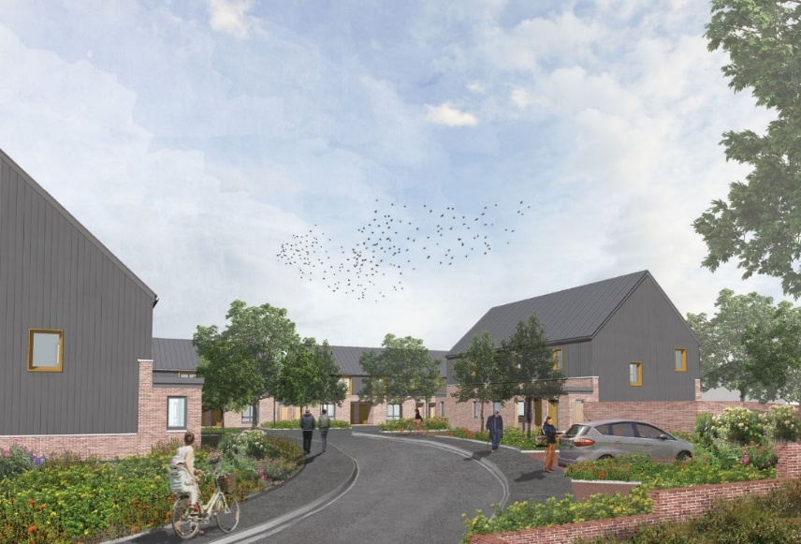
Figure 2: Active Homes Development, Neath (WHQ, 2019)

Mr. Bygate, reported: “that none of the above technologies are new, but the key point in the innovation is the way that they work together and collaborate to generate the same objective which is to reduce energy waste, and more importantly the homes generate enough energy to return back to the national grid for six months of the year”. This in its self is a great incentive to follow through.

Following on from an independent report by Andris Bankovksis on the potential energy and economic impacts of the ‘buildings as power stations’, the report suggests that tenants of the Active Homes Neath development could see their energy consumption reduced by 60 per cent, this results in a saving around £600 per year off their fuel bills.

Mr. Bygate reports that this outcome: “would be a huge saving for anybody, but it is particularly significant in Wales, where 23% of households are in fuel poverty, spending 10% or more of their total income on energy costs”.

The report by Andris Bankovksis states that the impact of Active Homes could have on the national energy system is that “they could reduce peak central power generating capacity by 3,000 MW which is the equivalent to a very large power station and reduce carbon dioxide emissions by nearly 80 million tonnes over 40 years”. By generating this much power and reducing the carbon footprint then it could be the future way of designing retrofitting renewable energies.

The author believes that innovative projects naturally come with challenges and cost is a significant factor. As with any supply and demand products / designs, the costs will reduce as volume increases but for productivity to increase then the results need to be clear and precise, not miss-leading so that private developers can take the design on board and start to introduce renewable energies into their developments. This in-turn will be a step in the right direction for decarbonisation in new builds and retrofitting. It is fair to say that by the ‘Active Homes’ concept developed in Neath will put Wales in a strong position to lead the way in decarbonisation.

The report by Mr. Bygate is very useful and has provided some weight behind this research report, it has allowed the author to consider different concept of integrating renewable energies into homes. It is evident that the report by Mr. Bygate does come across slightly biased and non-objective, simply because Mr. Bygate is the CEO of SPECIFIC, the research developers into the ‘Active Homes’ concept. It would be fair to say that the reporter would not criticise or downgrade his colleagues work, instead the opportunity is taken to promote the concept. By the author realising this then the article has to be questioned and further research is required.

  - SOLCER House

As an alternative viewpoint to this research, the author looks at a different approach of decarbonisation to Swansea Council’s housing stock. The research focuses on retrofitting renewable energies into existing homes, however Swansea Local Authority have been granted funds by the Welsh Government to design new builds which help reduce the carbon footprint. Swansea Council are constructing new builds in Milford Way, Colliers Way and Parc Y Helig through the “More Homes Schemes” which is created by the WG, please see Appendix 2 for more detail. The author believes it is important to look at other developments in local regions, in this case the author will be reviewing the SOLCER House which is based in Stormy Down, Bridgend.

The SOLCER House is designed by the Welsh School of Architecture at Cardiff University. The SOLCER house is the UK’s first purpose-built, low-cost energy house, capable of exporting more energy to the national electricity grid than it uses. The house has been built as a prototype to meet tough targets for zero carbon housing set by UK government. Designed and constructed as part of the Wales Low Carbon Research Institute’s (LCRI) SOLCER and Low Carbon Built Environment (LCBE) projects, and supported by SPECIFIC at Swansea University. (Cenin Renewables, 2019)

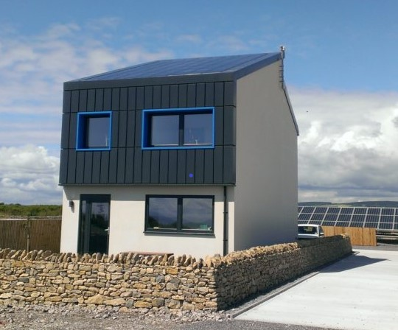
Figure 3: SOLCER House, Stormy Down, Bridgend (Cenin Renewables, 2019)
The article states that the “SOLCER house was built with high levels of thermal insulation, reducing air leakage, and uses an innovative energy efficient design which includes low carbon cement, structural insulated panels (SIPS), external insulated render, transpired solar collectors and low emissivity double glazed aluminium clad timber frame windows and doors. The house’s energy system combine solar generation and battery storage to power both its combined heating, ventilation, hot water system and its electrical power systems which includes appliances, LED lighting and heat pump. The TSC solar air system preheats the ventilation air which is topped up from a thermal water store” (Cenin Renewables, 2016).

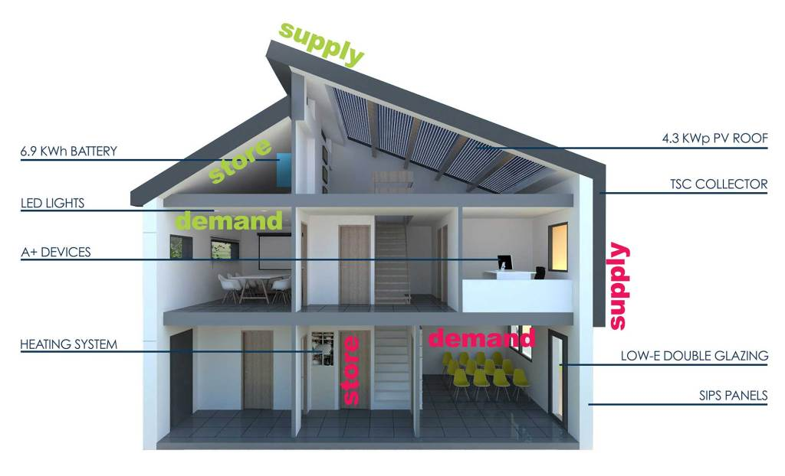
Figure 4: SOLCER House, Internal Design (Cenin Renewables, 2019)

The SOLCER 3-bedroom house is a unique concept, it was constructed in a total of 16 weeks, the total estimated cost is £125,000 which equates to £1,000m2, compared to a social housing benchmark of £800 - £1,000m2) according to BuildUp, 2015.

  - SOLCER House Energy Consumption

“The predicted energy performance is 70% autonomous with a 1.75 grid export-to-input energy ration, for example for every £100 spent on electricity used, it should be able to generate £175 in electricity exports. The embodied CO₂ of the house materials is 340 kgCO₂/m², compared with standard house benchmark of around kgCO₂/m²”. (Buildup, 2015)

The author understands that the SOLCER house is a concept design and even though it has been constructed and is a ‘living, breathing’ building it is not used in a domestic sense. The house is designed specifically to reduce energy costs, to reduce the carbon footprint and to meet the zero carbon targets set by the Welsh Government. The principle of the design looks aesthetically pleasing but the practicality of it as a living space is remain to be seen. The author believes until it is put into domestic use then it will be a gamble for developers to take this concept on board. It has the potential to be a game changer in how the local authority looks to design future new build social housing. By researching this article of literature, the author has gained an insight into how social housing could look and how it can have an impact on our way of living.

  - Retrofitting Research

The author of “Housing Retrofits – A New Start”, Andrew Haslett explains the benefits of retrofitting existing social houses with renewable energies, he states that:
“People spend the majority of their lives within domestic dwellings. Even when we are asleep our dwelling continues to provide a comfortable, secure and serviced environment, with hot water on tap. On average on weekdays people spend more time in a dwelling than at work, at school or travelling. Energy services include comfort, cleanliness, security, entertainment, communications, lighting, cooking, and food preservation.”

This is an important statement, simply because it relates how people living in comfortable conditions. The author agrees with legislation and the CCC (climate committee for change) that the need for decarbonisation, however everyone deserves a quality of life, to live in a home with comfortable surroundings and not worry about fuel prices. There are technologies available which help reduce fuel poverty, these technologies need to be affordable to everyone.

The author continued the research into “retrofitting” and to investigate what type of renewable energy technologies can be installed into a domestic dwelling. The researcher chose to review a case study regarding one of the SCCC properties. The case study is based on a 2no bedroom bungalow in Ffordd Ellen Road, Craig Cefn Parc, Clydach. Please see Fig. 5 & 5.1 for pre and post images of the dwelling. This property was built fifty years ago, the existing conditions were poor and had uneconomical fuel consumption. This case study can be found in Appendix 1, titled “Ffordd Ellen – A Retrofit Case Study” (SCCC, 2019).

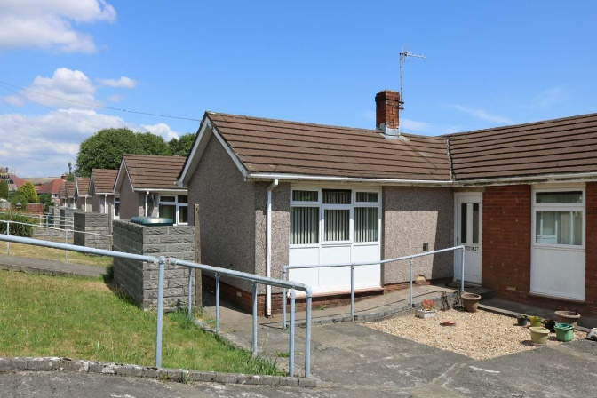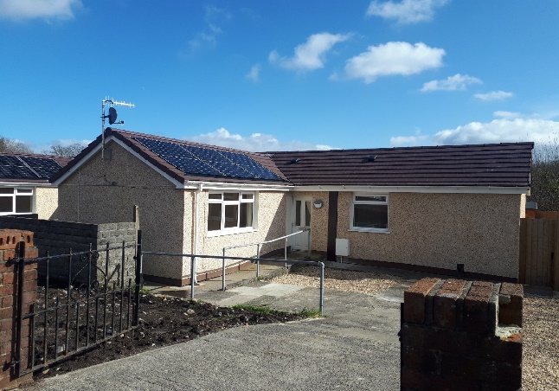
Figure 5 & 5.1: Ffordd Ellen Property (SCCC, 2019)

In relation to the above case studies, the methodology was derived based on primary research, focusing on live projects and professionals who are involved in them.

Chapter Three

- Research Methodology

This chapter will discuss the methods in which the date for the primary research was obtained along with an explanation of how the secondary research (literature review) was collated.

The two principle approaches to research are through, ‘quantitative’ and ‘qualitative’ methods. The main differences between quantitative and qualitative research is “rather like the difference between counting the shape and types of design of a sample of greenhouses as against living in them and feeling the environment”. (Naoum, 1998).

 | Qualitative | Quantitative
Conceptual | Concerned with understanding human behaviour from the informant’s perspective. | Concerned with discovering facts about social phenomena.
Conceptual | Assumes a dynamic and negotiated reality. | Assumes a fixed and measurable reality.
Methodological | Data are collected through participant observation and interviews. | Data are collected though measuring things.
Methodological | Data are analysed by themes from descriptions by informants. | Data are analysed through numerical comparisons and statistical inferences.
Methodological | Data are reported in the language of the informant. | Data are reported through statistical analyses.
Source: Adapted from Minchiello et al. (1990, p.5)

Figure 6: Key differences between Qualitative and Quantitative data (McLeod, 2017)

  - Collection of Research Data

There are three principles techniques for obtaining research data. These are observation, personal interview and mailed questionnaire. The extent of data collection, according to Bell (1992), will be “influenced by the amount of time available to carry out observations and the willingness of people to be interviewed or complete and returned questionnaires”. For this research the “personal interview” technique will be applied.

  - Quantitative Research

The author acknowledges that the percentage of quantitative research in this research is low, however there is some correlation analysis between the responses from the interviewees which the author will be comparing using numerical data.

  - Qualitative Research

The author used qualitative research to gain an understanding of underlying reasons, opinions and motivations of decarbonisation. The author chose qualitative research to gain a better understanding of the topic from personal interviews with professionals in the field of decarbonisation, whilst considered ethic research at all times.

The author acknowledges that qualitative research provides insights into the problem and helps to develop ideas or hypothesis for potential quantitative (putting a value) to research. It uncovers trends in thought and opinions. The downside to primary data is that it can be costly due to starting from scratch rather than using secondary data, you are limited to time, place and number of participants.

  - Chosen Method - Primary Data

In order for the author to collect the primary data required for this research, the author arranged separate interviews with 5no. Individuals who have a vast amount of experience in their chosen professional fields. The author believed that by conducting 5no separate interviews, it allowed the author to gather a varied range of information.

The interviewee’s names are:
Dr Jonathan Williams, Head of Projects, Active Building Centre
Dr Joanne Patterson, Senior Research Fellow, Welsh School of Architecture
Mr Colin King, Director BRE Wales
Mr Darrel Barnes, Architectural Design Manager, Swansea City & County Council
Mr Andrew Jackett, Head of WHQS, Swansea City & County Council

The author arranged to interview each interviewee at their most convenient time, place and date. The author reassured each interviewee that the interviews were arranged around their busy schedule, and to make sure that there was no pressure on them to answer each and every question. All of the interviews were arranged to take place at the interviewee’s place of work.

The following dates and times were scheduled for each interview:
Interviewee | Date / Time
Dr Jonathan Williams | Wednesday 22nd January 2020 @ 14:00pm
Mr Colin King | Tuesday 28th January 2020 @ 9:00am
Dr Joanne Patterson | Thursday 6th February 2020 @ 9:00am
Mr Darrel Barnes | Monday 10th February 2020 @ 9:00am
Mr Andrew Jackett | Friday 14th February 2020 @ 13:00pm

The author chose these particular individuals to interview because they are all have specialist knowledge of decarbonisation and renewable energies. The author believed that it is important to collect a range of answers for the research, and by selecting individuals from different backgrounds from one another then the responses were varied. The research collected from the interviews was non-biased towards the research, however it is worth noting that the answers were the thoughts and opinions of that particular individual and not collectively.

  - Interviewee Background

Dr Jonathan Williams, MEng PhD, is the Head of Projects at the Active Building Centre in Swansea University. Dr Williams has led many successful projects throughout his career, the experience and knowledge that Dr Williams was willing to share in this interview was beneficial to the author. The reason why Dr Williams was chosen was because of his unique experience in bespoke projects, which focuses on solar performance and quality, energy storage (heat and power), electric vehicles, and modern methods of construction, integrated PV and thermal.

Mr Colin King is the Director of BRE Wales which is based in Swansea. Mr King has 14 years of experience in working for the BRE, in which he has been a director since 2015. Mr King specialises in hydrothermal performance of building elements, condensation and mould diagnosis, energy modelling and thermal bridging. One of many reasons why Mr King was interviewed is because of his invaluable knowledge of existing housing conditions and providing diagnosis and solutions.

Dr Joanne Patterson is a Senior Research Fellow at the Welsh School of Architecture, Cardiff University. Dr Patterson has over 19 years of experience and delivery of fundamental and applied research projects in the area of sustainability in the built environment. Dr Patterson was chosen due to her vast specific background in low carbon technologies within retrofitting the built environment.

Mr Darrel Barnes is an Architectural Design Manager at Swansea City & County Council. Mr Barnes has worked for the council for the past 8 years and has a vast knowledge on housing and design specifications. Mr Barnes background is in architecture, the combination of these skills and knowledge make Mr Barnes the ideal candidate to interview. Mr Barnes is pioneering the decarbonisation designs into future project schemes.

Mr Andrew Jackett, Welsh Housing Quality Section Leader of Building Services at Swansea City & County Council. Mr Jackett has worked for the council for 20 years, he has a wealth of knowledge regarding the condition of the council’s existing housing stock. Mr Jackett has been involved in the WHQS programme since the council incorporated the standard back in 2016. Mr Jackett has inside knowledge of the challenge ahead which the council faces in introducing decarbonisation technologies to its housing stock.

The questions set for the interviews are listed below. The author’s objectives for each question have been highlighted in Red.

- May I take your full job title and place of work please?
The author wanted to find out the interviewee’s occupational background.
- In your opinion, ‘how do you think decarbonisation can be introduced and carried out successfully in the Local Authorities housing stock’?
To find out if the interviewee truly believes that decarbonisation in the LA is possible.
- What would you say is the most challenging aspect of introducing decarbonisation into the local authority and how would it be achieved?
To find out the worst case scenario of introducing decarbonisation into the LA.
- May I ask, what is your personal opinion on retrofitting renewables energies into existing dwellings to combat decarbonisation?
To uncover the interviewee’s personal opinions on decarbonisation, this can differ from their professional opinion.
- Where do you think Swansea will be in the next 10 years, do you think that the Local Authority will be leading the way in decarbonisation?
This information presents the interviewee’s opinion on Swansea as a City and how the Council can or if lead the way, if it is capable of such targets.
- What would you say is the best way / method to retrofit existing dwellings with new technologies to achieve decarbonisation?
This question goes into detail on how the Council can carry out retrofitting in their housing stock.
- Do you think it is practical to introduce electrical charging points for electric cars in the local communities, such as installing them in District Housing Office Car Parks?
Electrical cars are becoming ever so popular, so the author believed that this is a relevant question.
- Decarbonisation is the ‘buzz word’ now; it is very relevant and topical. Would it be fair to say that it is aimed at the next generation of young people? Do you think we can educate older people with old-fashioned ways of thinking into new concepts of clean energy saving?
The author asked this question as the age ranges between the interviewees were varied, this provided the research with different outcomes.
- Do you think that the technologies available in decarbonisation is not for everyone, i.e. Passivhaus for social housing, not all tenants will be comfortable with this way of living? They may not have a choice to live in these houses because they are next in-line to be homed.
The author asked this question because it can be used a research for the Council and its designers, as in what can the LA do to assist the tenants in maximising the potential of the dwelling.
- Have you been involved with the local authority in research for decarbonisation, if so, May I ask what?
To find out if the interviewee has had an involvement in the LA.
- What is your opinion on retrofitting, the majority of the Local Authorities housing stock dates back to 1950’s, they have had minor upgrades but generally in poor condition. Would you say that it is cost effective to retrofit these properties with state-of-the-art technologies, which are worth more than the property itself?
This question epitomises the research, the previous questions lead up to this question. The author’s professional opinion on retrofitting is supported by this question, however the author wanted to discover if the interviewees supported the author’s views on retrofitting.

Following on from all of the interviewees the author has compiled the information gathered from each question, the answers will be compared and noted against one another. The author will use the answers from each question as evidence, which will assist the research in the Results and Analysis, and then the Conclusion chapters.

The majority of the questions were derived from methodologies and consideration of good practice established within the e literature review, some were based on the case studies in retrofitting and the new builds. A good example of this is Q3 – “What would you say is the most challenging aspect of introducing decarbonisation into the local authority and how would it be achieved?” The literature review provides adequate answers to this through the Better Homes, Better Wales, Better World report where it states “that £0.5b - £1b per year for the next 10 years it will cost to implement these changes” (Jofeh, 2019). This statement is stating that the most challenging aspect is the high levels of funding it will take.

Another good example would be Q11 – “What is your opinion on retrofitting, the majority of the Local Authorities housing stock dates back to 1950’s, they have had minor upgrades but generally in poor condition. Would you say that it is cost effective to retrofit these properties with state-of-the-art technologies, which are worth more than the property itself?” The literature review supports this question from the Ffordd Ellen Retrofitting case study, please see Appendix 1. The amount of funding the property required to provide and install the GSHP, MVHR, PV Panels, TESLER batteries and intelligent heating system then it didn’t warrant the estate value of the property. This relates to the question as is “retrofitting” cost effective.

The author acknowledges that by carrying out this type of primary research then it is difficult to support the research with formulas, tables and statistics’ however this type of research is from primary resources and the personal interviews provide the reader with a true perspective on the decarbonisation challenges ahead.

  - Data Reliability

The reliability of the data that the author is aiming to gather will be a key attribute to the primary research. It is important that the data collected is reliable, this is to ensure that the stated results in the Results and Analysis section of this research can be checked against hard copies of the questions and answers the author received in the interview process.

3.7 Ethical Considerations

Ethical research is ‘to do things the right way’, it is vital that the author is expected to bring integrity, fairness and honesty to the research. To take into the considerations of the people this research is aimed at and also to take in the considerations of whom were involved in gaining the research. Consent and confidentiality is adhered to at all times.

3.8 Cost Considerations

The cost implications to research a topic such as ‘decarbonisation in Swansea’ would be relatively low compared to other research which might be based on overseas projects. The topic of this dissertation is based on Swansea, so all of the information which is collated can be either collected locally or via electronically means.

Chapter Four

- Results & Analysis

This chapter will concentrate on the results of the interviews, which will then be followed by the analysis of the interviews. In order to do this, an in-depth analysis of the key areas of the primary research will be outlined and discussed individually.

The author’s aims and objectives set out in the introduction focused on the implications of decarbonisation to Swansea Council’s housing stock. The Literature review did assist the author in these aims and objectives. The questions that were asked to each interviewee were based on decarbonisation and how it would affect the local authority. The author used case studies in the literature review to allow the reader to get an insight into how decarbonisation can be retrofitted into the council’s housing stock, the author also provided a case study which demonstrates how new builds can be designed to zero carbon ratings.

4.1 Analysis of Results

The author approached 5no professionals who work in the construction / architectural and design industry (please see Methodology 3.3 for list of interviewees). The author’s objectives were to interview these individuals and assess their professional opinions on the implications on decarbonisation in a Local Authority.

The author set a total number of 11 questions for the interviewees to answer; the aim of the questions chosen was to directly evaluate responses in investigation of the specific issues, which were addressed in the objectives of this research. The author believed that 11no questions was sufficient enough to gain the relevant information which would assist the research, the author thought that any more questions would be too excessive and time consuming for the interviewee.

The purpose of the questions was to explore and compare the thoughts and opinions of the interviewees. The author acknowledges that each interviewee has different occupational backgrounds, and this was one of the key points for the interview’s, to gain a varied perspective on each question.

The author initially set out to complete the interviews ‘face to face’ as this would present the interviewee an opportunity to assess the author’s character and background in a more personal environment. However, unfortunately, this was not the case; the interviews for Dr J. Williams, Mr A Jackett and Mr D Barnes were conducted at their workplace and were transcribed whereas the interviews for Mr C King and Dr J Patterson had to be done via email due to work commitments. The personal interviews took approx. 1 hour to complete; this was more than enough time to answer all of the questions sufficiently. At the completion of each interview the author expressed his gratitude to all interviewee.

The author did ask one interviewee (Dr J. Williams) a different question than the other 4 interviewees, the reason for this was that the interview was conducted prior to the author’s focus group presentation in which the feedback was that all interviewees should be asked the exact same question. Following on from the focus group feedback, the author set the same amount of questions for the other 4no interviews with the exact same questions.

The author believed that all of the interviews went well, each interviewee was very generous with allocating a time slot in their busy schedules to complete the interview, and the author acknowledged and appreciated their involvement. It would have been more beneficial to the research if the interviews took place ‘face to face’ but this can’t be helped and the responses to each question from the interviewee’s were more than acceptable.

The author was able to use all of the answers from each question of each interviewee, some were varied and some were towards the same outcome. This will be addressed in the following Analysis section. For the purpose of this research, it is difficult to compile the results, simply because no data was recorded only answers. There is no data to compare each question to; however, the answers were compared to one another.

In order for the author to achieve a broader view of ‘how decarbonisation can be introduced successfully into the council’s housing stock’ then the interviewee’s were asked the following questions and these were their responses. It is worth noting, that the author has highlighted only one or two responses, however all of the answers were compared to one another, this assisted the author with a more balanced outcome.

4.1.1 In your opinion, how do you think decarbonisation can be introduced and carried out successfully in the Local Authorities housing stock?

According to Colin King, BRE “To introduce any initiative the first step must be to understand the current position of the stock in terms of performance, all buildings will all in likelihood not reach true zero carbon, so it’s important that a route map and plan is defined for all building typologies, based on opportunity and risk to fabric and health. A detailed plan using the whole house approach is needed to ensure that measures are undertaken in the correct order to ensure that the building performance is not locked artificially low”.

The same question was asked to the other 4 no interviewees, Dr Joanne Patterson’s response was somewhat different to Mr. Colin Kings.

Dr Patterson stated that “reducing carbon should be a priority when making any decisions when refurbishing or building new homes. All people involved in the decision-making process should be aware of this and should be trained so that they are aware of how decarbonisation can take place”.

The author agrees with both responses, it is important that all people involved with the design and construction decision-making should be well trained to get the most out of the methods used, however Mr. King’s response is more practical. Mr. King realises the financial implications and how visible it is to introduce decarbonisation into the LA’s housing stock.

4.1.2 What would you say is the most challenging aspect of introducing decarbonisation into the local authority and how would it be achieved?

This question was asked to all of the interviewee’s, the question specifically narrows down the challenges ahead for Swansea Council.

Mr Andrew Jackett responded with “The Council has a well-established system for undertaking all aspects of construction and maintenance of their Housing stock. This would be the vehicle for carrying out decarbonisation process but, all involved would need to be brought up to date with the ever evolving techniques that are coming to the market. With the Council having a Housing stock of 13,500 properties (and growing – due to More Homes construction policy)”.

Whereas Mr Darrel Barnes had an alternative view, Mr Barnes states “the challenges are the capital investment required, and the range of construction types, some of which may simply not lend-themselves to decarbonisation systems / technologies. Also mindful of context / location and orientation (if utilising PV), ground conditions (if utilising GSHP) & off-mains properties”.

The author considers both interviewee’s response to be valid and substantive. It is interesting to see how Mr Jackett’s response was to evaluate the Housing stock and how much work it would take to carry out decarbonisation, whereas Mr Barnes response was the capital implications. Both answers are key in decarbonisation, to convert the Council’s entire Housing stock then the capital budget is going to be un-told.

4.1.3 May I ask, what is your personal opinion on retrofitting renewable energies into existing dwellings to combat decarbonisation?

The purpose of this question was to gain an insight into the personal perception of decarbonisation from each interviewee.

Dr Joanne Patterson commented “From experience they work very well, they reduce carbon emissions by reducing dependency on fossil fuels which is a very good thing”.
This response differed greatly from Dr Jonathan Williams, Dr Williams stated, “This is something we have got to do, from approaching 20 years in practice, I am frustrated that not much has happened, but it is now starting to take shape. The press seem to be more involved but my fear is that we are not doing enough. Fundamental change is required, improvement in Building Regulations and Planning Policies to get property developers and Housing Associations on-board, the houses need to be designed to a certain clean energy standard”.

It is fair to state that both comments are in relation with each other as they both state positive attributes of decarbonisation; however, Dr Williams’s response clearly states his own experience on the lack of progress, whereas Dr Patterson’s response states the obvious positives.

4.1.4 Where do you think Swansea will be in the next 10 years, do you think that the Local Authority will be leading the way in decarbonisation?

The author acknowledges that this question is specifically addressed to Swansea Council, however all of the interviewee’s have a particular interest in Swansea Council whether they work directly or in-directly for the Council.

Mr Darrel Barnes response is “I certainly think Local Authorities will lead the way before private Housing developers – certainty until decarbonisation is mandated across the industry via Building Regulations etc.”

Mr Barnes fellow colleague Mr Andrew Jackett responded, “The Client department is already engaging with Welsh Government on this issue in an attempt to forward plan and be on the leading edge of the programme of Decarbonisation and is undertaking informative work on Housing stock to enable balanced decisions to be made once a definitive policy on decarbonisation is published”.

Whereas Mr King who works for the BRE but has been contracted to the Council as a consultant in decarbonisation states “It is difficult to gauge the capital investment is enormous, there is no doubt the will is there in the Council, but it is unlikely the technical understanding of the risks and opportunities are. The Local Authority is also struggling with a lack of clarity from the Welsh Government on what is actually required”.

There is an agreement between all parties that it will take a great deal of capital investment to implement decarbonisation in the Council and also that all parties do state that Swansea Council can lead the way in implementing these positive changes.

4.1.5 What would you say is the best way / method to retrofit existing dwellings with new technologies to achieve decarbonisation?

This question aims to discover the most practical technologies available and how will they assist the Council in achieving decarbonisation.

Dr Joanne Patterson states “Using a whole system approach for a few homes rather than individual technologies on all homes. This will help to improve the stock as a whole and will prevent duplication of works going forward. Selecting the right solutions for the right homes. Targeting areas of poor quality homes to improve conditions for occupants while reducing emissions”.

The author believes this is a valid point, it makes sense to standardise the technologies used for the Housing stock but it is worth noting that there are many different types of houses in the Councils Housing stock that can’t accommodate the technologies that other houses can.

Mr Colin King argues the fact that “There is no best way, to adopt a one fits all solution is wrong approach, it needs to be based on what is best for the occupants and the property, based on understanding the needs of the residents, the risk to the property construction type and capital availability. To come up with one solution will end up higher running costs, not achieving decarbonisation, or massive outlay of funds for little positive return”.

This conflicts with Dr Patterson’s response, this could be down to how the professions differ, another good example is Dr Jonathan Williams response “Prioritising decarbonisation above the cost, you will need to look at EWI, air tightness, positive ventilation, difficult to retrofit MVHR and heat pumps. Air Source Heat Pumps would be recommended for retrofitting. This will do your fabric and basic heating but there is some work to be done around electricity. Being able to have a demand site response where you can turn off the hot water when there is a flux from the grid if you had a battery (TESLA) you can feed it back into the grid, this would have a positive effect on the electrical grid”.

It is interesting to compare the varied responses from all of the interviewee’s, there are few similar points which are the technology needs to be suitable to maximise the potential of each property type.
4.1.6 Do you think it is practical to introduce electrical charging points for electric cars in the local communities, such as installing them in District Housing Car Parks?

The author predicted that all of the interviewees were in agreement in their responses, they all agreed that it would come down to capital investment to carry this out.

Mr Darrel Barnes states “This is a grant requirement of Welsh Government, however further discussions are required with network supplier (Western Power Distribution) to align Welsh Government’s Electrical Vehicle Car Park aspiration with Western Power Distribution infrastructure investment programme. Electric vehicle capital cost, availability and their own carbon footprint at point of manufacture are also factors”.

Mr Andrew Jackett has a more subtle approach on the matter, Mr Jackett states “I don’t think it matters where the charging points are located, they need to be ready available, easy to access and secure. It will depend on the communities in which they are located in various areas of the country, security of the charging equipment and the vehicle being charged should be a prime consideration”.

Dr Joanne Patterson response was of the similar value, Dr Patterson states “Yes, Electric Vehicles are going to happen so the more prepared we are with the infrastructure the better”.

Dr Jonathan Williams believes that Electric Vehicles points is a very good idea, he states “Welsh Local Authority have been lacking in this area and are behind the rest of the United Kingdom. The success will be down to Supply and Demand, what is the point of putting them in if nobody is using them. It could be a good revenue stream for the local authority if implemented”.

The interviewee’s do agree with the fact that is should be introduced if the funding is available from the Welsh Government to do so.

4.1.7 Decarbonisation is the ‘buzz word’ now, it is very relevant and topical. Would it be fair to say that it is aimed at the next generation of young people? Do you think we can educate the older people with old-fashioned ways of thinking into new concepts of clean energy saving?

The author wanted to ask this question to the interviewees because it is true that the older generation are living longer than that particular age group did years ago, the healthcare is more advanced now which prolongs people’s lives.

The interviewees all had similar theories, for i.e. Mr Barnes states “I believe if all ages groups / residents are presented with the facts regarding the savings which can be directly gained from reduced energy costs – the majority would sign-up to the approach, it is about being clear of the benefits to individuals and the wider community”.

Mr Jackett adds “I think most people have a stake in the future of the Planet as their families will be continuing on to live in it and there will be a willingness to help protect it for future generations”.

Dr Patterson has similar thoughts, she states “No, everyone has to act now. Climate change is happening. It is not only older people it is the majority of the population that have to change”. However, Mr King has a valid point that “behaviour change is a complex problem, but in all reality with an ever growing elderly population, it is essential that this is done. They have access to the greatest capital to fund measures themselves, but the success rate of energy efficiency measures and initiatives is not great and they will be naturally reluctance to spend their hard earned savings on a new agenda with serious convincing”.

This point is really interesting because the investment required to install these renewable energy concepts in our homes can be vast, so why would an elder person be willing to spend their retirement money on an investment in which they won’t benefit from in a short term period.

4.1.8 Do you think that the technologies available in decarbonisation is not for everyone i.e. Passivhaus for social housing, not all tenants will be comfortable with this way of living? They may not have a choice to live in these houses because they are next in-line to be homed.

The author believes that this is an important question which applies to all of the interviewees.

Mr King stated “Passivhaus is not technology, it’s an approach to energy balance, many myths surround Passivhaus and in reality no changes to life style are required, but an understanding that there is no high temperature focal point for heating. I do not honestly believe that Passivhaus is the way forward, but an approach is required to deliver low carbon housing that delivers in reality is, and quality control in the construction phase is the key”.

Mr Barnes has a similar view as he states “Passivhaus is a fabric-first construction form rather than an utilisation of technologies and there is certainly an ‘educational’ element to the operation of these homes e.g. protecting the air-tightness of the external fabric and the MVHR system which removes the need for radiators. I think this is again about communication and education, to explain operating systems and ultimately the cost-saving benefits for the user if systems are operated correctly”.

The author agrees with both statements, Passivhaus is a new kind of energy saving system, it is advanced and the user needs to be trained properly to maximise its full potential. The issue with social housing is that the tenant’s (not all, but a large majority) are not willing to be trained efficiently, some tenant’s move frequently so they have no interest in these changes. Some tenants have old fashioned tendencies and they are used to having radiators and windows that open and close. The Passivhaus concept can be off-putting to some tenants.

4.1.9 Have you been involved with the Local Authority in research for decarbonisation, if so, May I ask what?

This question is off some interest to the research, simply because if the interviewee’s have had any involvement then they can share their opinions and thoughts. As Mr Barnes and Mr Jackett both work in the architectural design department for the Local Authority then it goes without saying that they have had some involvement.

Mr Barnes states “We did engage BRE early in the process when determining an approach to new-build housing – using Building Regulations as a baseline standard and enhanced build-options up to Passivhaus standard. We are doing the same for the retro-fit programme”.

Mr Jackett adds “This is a current issue and we are attempting to gain training and knowledge opportunities for all relevant staff”. Dr Patterson also states “Yes, Ffordd Ellen – the whole house retrofit of six 1970’s bungalows”.

Mr King has had involvement in consulting the Council, Mr King “Only in terms of new build standards and the direction of travel for new housing stock to deliver the Climate Change Commission energy standards ahead of the deadline, assessing what is the optimum approach to balance number of units against capital costs”.

The researcher has concluded that from conducting these interviews it is clear to see that the Council’s best interest are at the fore-front of these professional individuals.

4.1.10. What is your opinion on retrofitting, the majority of the Local Authorities housing stock dates back to 1950’s, they have had minor upgrades but generally in poor condition. Would you say that it is cost effective to retrofit these properties with state of the art technologies, which are worth more than the property itself?

This is the last question which was asked to all of the interviewees, it is probably the most important question. It is aiming for the interviewee to think and realise the actual age of these properties and how much funding it will take to carry out decarbonisation successfully.

Mr King states “Cost effective is a difficult concept to summarise in a few words, the whole debate of knock them down / retrofit is a fine balance, the whole issue or carbon locked in the existing stock has to be considered, if chasing operational decarbonisation is at the expense of massive carbon footprints building new, what is gained, the environment is still being burdened with carbon, just not one the human race measures, but it’s still carbon burden. There is no doubt some older stock will need to be rationalise, but the typical housing stock has massive potential, to simply discard them due to the lack of investment in maintenance is focusing attention in the wrong direction”.

Dr Patterson has a similar view on this question, she states “People should be provided with healthy, decent quality homes. A programme of refurbishment should take place to provide this. WHQS was the target for a long time. This needs to change. Refurbishment should include retrofit to provide occupants with a healthy, affordable, ‘decent’ quality home. Providing renewable energy which can be stored, whilst reducing demand can provide both a healthy and affordable home whilst reducing carbon emissions”.

Mr Jackett and Mr Barnes have a more work-based opinion, i.e. Mr Jackett states “On current information available to us the pilot schemes have shown that the initial trials on retrofitting have not proved cost effective. Designs and types of technologies will have to be reconsidered to ensure cost effectiveness of any retrofit process”.

Similar to this, Mr Barnes adds that “Once we have a detailed analysis of investment costs and payback / savings generated, we will then be in a position to make an informed decision regarding retrofitting. A wider consideration is that, arguably, decarbonising energy supply ‘at source’ is far more (cost) effective than at each property, with fabric improvements where identified”.

4.2 Summary of Interviews

By conducting these interviews, the author has gained a great insight into the challenges ahead facing SCCC in implementing decarbonisation into their housing stock. The author was extremely grateful to the interviewees that participated in the interviews, without their thoughts / opinions / time shared and professional points of views then the author wouldn’t have been able to conduct this research.

The author concluded that from comparing each interview then there was a contrast in opinions between each interviewee. Following the interviews it was evident that the interviewees with a technological design background was focused on “how important it is to install the new renewable energy technologies” whereas the interviewees who are employed by SCCC have a clear idea of “how financially and practically difficult it will be to install these technologies”.

The author believes that the general consensus is that all of the interviewees would like to see decarbonisation introduced into Swansea Council’s housing stock, if the funds are available from the Welsh Government then it should be carried out.

A full transcript of responses is available to view in Appendix 3.

Chapter Five

- Conclusion and Recommendations

  - Aim of Research

The aim of the research was to critically analyse “how Swansea’s Local Authority is going to carry out decarbonisation to all of their housing stock by 2050”. The researcher aimed to achieve the feasibility of this task by carrying out the following objectives.

The aim was managed via the following key objectives:

- To analyse available literature / publications by way of a literature review to assess how decarbonisation by means of retrofitting will have an impact on the local authority.

- To identify the views and perceptions of decarbonisation in domestic dwellings by professionals in this field by means of primary research through interviews.

- To evaluate the findings from primary research and highlight areas of concerns and considerations as to whether decarbonisation to Swansea’s housing stock is feasible.

Following the researcher conducting a literature review then the feasibility of these objectives were partly accomplished. The literature review allowed the researcher to analyse relevant literature of retrofitting decarbonisation technologies in social housing. The author’s research was assisted and enhanced by conducting no5 interviews to professionals who work in the field of decarbonisation and renewable energies. Prior to Covid-19 the researcher arranged to carry out a focus group on the aim of this research, however, due to the severe disruption of Covid-19 then the researcher was unable to carry out the full research required for the focus group process.

The feasibility of achieving the task was always going to be difficult from the start, simply because the targets set by the Welsh Government are new and have not yet been introduced into SCCC’s housing and design departments, there is no clear directions from the WG to demonstrate what or how each social dwelling should be decarbonised. There is no standards as of yet which has been legislated by WG. Therefore it is difficult for the SCCC Housing association to specifically allocate each dwelling with certain technologies to reduce their carbon footprint. The author suggests that each and every dwelling should be surveyed and then a list of what renewable energy technologies would apply to that dwelling.

  - Research Findings

The author acknowledges that the research was successful to a certain degree. The research begun strongly and positively, the author was able to gain momentum in the research by reviewing literature / publications and government legislations on decarbonisation. Decarbonisation is a relatively modern topic, this proven to be the case in gaining research on the topic. There are currently no right or wrong answers available, there is a little research available to argue the fact that decarbonisation is an approach that the local authority should be taken. It is true that everyone should be playing their part in the protecting the environment and the best way to achieve this is in our own homes, but that will come at a cost for the local authority.

The months leading up to Christmas were productive in gain of research, the researcher was able to review many articles and case studies on retrofitting, some were based on introducing new concepts of energy saving and some were based on concepts we already know such as installing PV panels, GSHP and ASHP, these are all good ideas to reduce energy bills. However, to install these technologies then there needs to be a heavy capital investment.

From reviewing available literature on decarbonisation, then the author can predict that by introducing decarbonisation technologies by way of retrofitting into the local authorities housing stock will have a major impact in many ways. It will have an impact on the local authority by ways of having the necessary funding to carry out the work, which properties would be addressed first, is there a way of pinpointing the most depreciated properties and develop those. By conducting this research it seems that the Council awaits a massive task ahead of them to introduce decarbonisation into their housing stock. As mentioned previously, there has to be a clear system or directions from Welsh Government which allocates the local authority with funds that is purposely for decarbonisation.

The author arranged the interviews with professionals in the field of decarbonisation to gain more of understanding on the topic and whether they feel that the aim of this research is viable. The author initially desired to interview more than 5no individuals, however this was not possible due to the COVID pandemic ‘lock down’ period which has caused many communication disruptions. The author focused the interviews on professionals who he assumed would have the most experience in this field, this was extremely important as their answers would allow the author to achieve his objectives.

Initially the interviews should have been in person, they would have been recorded and the transcript would be used as evidence for this research. This was the case for 3no interviews, as they were all exercised in person, however 2no of the interviews had to be done via email.

The author appreciates all of the interviewees’ involvement and was very thankful for them allocating their time accordingly to carry out the interview. The author believes that the interviews were successful, each interviewee had valid points to make and there was agreements and differs in each answer.

The interview questions were specific to the aim of this research, there was a clear separation between the responses from the interviewees who are directly employed by SCCC and for ones who are not.

By analysing the answers to the questions, it is evident to see that the SCCC employees have a better understanding and knowledge of the condition of the existing housing stock. This can be put into an example, Dr Patterson’s response to the question “What would you say is the most challenging aspect of introducing decarbonisation into the local authority and how would it be achieved?” was “Having people understand why the changes are needed and what benefits they bring really help the delivery of the works”. This was an important question and required a more in-depth answer to explain “what is the most challenging aspect of decarbonisation”, the response was vague in the sense that it doesn’t state how the LA can prepare to reduce the carbon emissions in their housing stock. In comparison to Darrel Barnes response which states:
“The challenges are the capital investment required and the range of construction types, some of which may simply not lend-themselves to decarbonisation systems / technologies. Also mindful of context / location (ground conditions for GSHP”. Mr Barnes response was directed to the capital investment required, and then the condition of the construction types which can vary from Airey, BISF, Cornish MK1 & MK2, Airey Duo Slab, Easiform, Hawksley, High-rise Block, Orlit, Resiform, Timber Frame, Trusteel, Wates & WNF.

This response was much more practical and brought the question to life with a realistic answer. From conducting the interviewing with Mr Barnes it is clear to see that Mr Barnes is heavily involved with the new anticipated standards from the WG and has an inside knowledge of the existing conditions of SCCC housing stock.

It could be noted that the interviewees who work for the local authority are more sceptical about introducing decarbonisation into the housing stock because they realise how much capital investment it would require and the level of work and disturbance it will take to each dwelling.

The interviewees were in cohesion with each other in considering that decarbonisation will play as massive part in the future of construction, in the future of the environment and also in the future of the next generation and the generations to follow on after those. It is extremely important that society acts now and not later, the author truly believes that SCCC could be pioneers in this field and they could be the lead for the rest of the UK.

The last objective was to evaluate the findings from primary research and highlight areas of concerns and considerations as to whether decarbonisation to Swansea’s housing stock is feasible. The author states that this is partly true, the primary research does offer many valid points as to the benefits of decarbonisation but also some sobering points and the realisation of the heavy capital investment required for it to be a success.

The author does believe that the research is a key starting point in this development, the research brings together many facts about decarbonisation, the research compares the interviewees thoughts and professional opinions, the research highlights and promotes previous and current construction projects on retrofitting and new builds. These developments have introduced decarbonisation technologies into the scope of works and they have been successful in construction. The proof of whether have been successful and worthwhile will be evident in 3-5 years’ time, when the local authority will be able to assess and compare energy bills.

  - Conclusion of Research

By the author conducting this research then he achieved many positives outcomes, such as learning about a topic which he has very little knowledge and experience on. As this new topic there is limited information available, the author was able to gain information from interviews and certain publications. By carrying out this research the author has achieved a sense of the enormous task ahead for the local authority to implement decarbonisation into their housing stock. The outcome is that if the funding is available then the task is achievable, but it is difficult to predict the sum of funding required. Jules Birch, an award-winning blogger on renewable energies has quoted that the “estimated cost’s to meet these targets are at £500m to £1bn a year between 2020 and 2030 for Wales, the cost is the reason the Welsh Government has accepted the recommendations in principle but not yet in practice”. (Inside Housing, 2019).

A more detailed report provided by National Assembly of Wales Climate Change (NAWCC) states “The Regulatory Impact Assessment (RIA) explained that it anticipated that achieving an 80% reduction in emissions by 2050 would result in additional total costs of £50 billion (£1.5bn annualised). An 85% reduction would result in additional costs of £64bn (£1.9bn annualised).” It also states that “the Welsh Government have not looked at achieving 95% (or net-zero) emissions by 2050”. (National Assembly of Wales Climate Change, 2019).

These statements provide the reader with an insight into the extreme levels of money it will take to achieve these targets. It would be fair to say that there is potential that these costs will reduce over the years, there will be new innovations and technologies that will have an impact on the costs.

The Welsh Government have given their local authorities a target date of 2050 to achieve all domestic dwellings to be fully decarbonised. The WG have stated that:
- Wales will be accountable for all emissions in Wales.
- A decarbonisation pathway for Wales with interim emission reduction targets of 27% in 2020, 45% in 2030 and 67% in 2040.
- The first 2 carbon budgets are an average reduction of 23% between 2016 and 2020 and 33% between 2021 and 2025. (GOV.WALES, 2018).

In March 2019, the first Low Carbon Delivery Plan (LCDP) was published by the WG. Its aim was to create a low-carbon pathway to the 2030 target of 45% in reduction of carbon in domestic dwellings. The LCDP outlined the policies and proposals to meet the WG’s first carbon budget. (GOV.WALES, 2018).

This task can be achievable if the funding is made available, the work will be phased over 30 years so when you think of what can be done in that length of time then it is a strong possibility that the targets will be achieved.

The author is pleased that he chose this topic to base his dissertation on, it is has been an ‘eye-opener’ to the level of work that is required. The author is employed by SCCC and his occupation is a Senior Project Surveyor, he will be carrying out the designs and overseeing the construction work as Project Manager for all of the housing stock. He will be implementing the required levels of decarbonisation to each dwelling, gaining this research prior to when the programme starts is invaluable.

Having seen the retrofitting of renewable energy technologies into dwellings such as the Ffordd Ellen project ref. 2.3.1 & Appendix 1, then the author believes that the aim of the research is possible with minimal implications however it did help the project that all of the properties were vacant, that meant there was no disruption to any tenants. When there is tenants involved and the work is progressing in a live environment then it makes the task completely more challenging.

Jules Birch of Inside Housing has stated that “Done well, decarbonisation has the potential to generate lots of well-paid and highly skilled jobs with economic benefits that are spread around the country at the same time as it cuts carbon emissions, local authorities stand to benefit directly as lower fuels bills for tenants feed through into lower rent arrears for them and they could be well placed as the lead organisation in decarbonisation, for governments worried about the costs, the evidence seems overwhelming that the costs of failing to act will be much greater”. However, Mr Birch also states that “but done badly, or without enough planning, decarbonisation could yet turn into yet another bonanza for cowboy builders and another epic construction industry failure, it could lead to a rush to demolish perfectly good homes because of the costs of improving them without considering the greater environmental impact of new construction”. (Inside Housing, 2019). The author totally agrees with what Mr Birch has stated, the author has proved his agreement throughout this research. If the Welsh and UK Government don’t allocate the appropriate funding into implementing and acting on ‘decarbonisation’ now then the next generation and generations to follow on from those will suffer the consequences.

The publication “Better Homes, Better Wales, Better World” which is referred to under Ref 2.1 in the literature review, points out the benefits of decarbonisation especially in an industrialised country like Wales, this applies to Swansea due to the industrial heritage it holds. The citizens of Swansea will truly benefit from decarbonisation as by reducing carbon emissions then it will bring cleaner air, improved health and low energy consumption.

Retrofitting into SCCC’s housing stock is going to be extremely challenging, the EHC states in the literature review Ref 2.1.2 points out that retrofitting can be successful if “the right retrofit products and systems are installed correctly, for the right reasons, to the right standards, in the right order and using the right knowledge, skills and applications” These technologies will have to be installed to PAS 2035: 2018 Specification for the energy retrofit of domestic buildings. The author agrees with this statement because the technologies are so advanced they need to be installed correctly to maximise its purpose. To back this statement up, The Home Builders Federation (HBF) expressed concerns over the availability of skilled workers to build new types of homes, saying “there will be a lead in period of at least 3 years to allow for people to be upskilled either through college or apprenticeships / training courses” (Low Carbon Housing, 2018). This statement highlights that only skilled trades people can install and build HAPS.

As for the new builds then the author can’t see it being an issue at all, all of the renewable technologies can be designed in from the beginning and the property design will be tailored around the technologies whereas in retrofitting the technologies revolve around the fabric of the dwelling. HAPS are the way forward for new builds in terms of generating revenue for SCCC yet reducing the energy costs at the same time. It is evident that SCCC will have to invest and allocate large quantities of their funding to develop this design for new builds.

HAPS reduce energy waste and generate enough energy to return back to the national grid for six months of the year. The author believes that their concept of new builds will be hugely successful for SCCC as nearly all of their housing stock inhabitants are in fuel poverty.

Similar to this design is the SOLCER house, literature review Ref 2.2.2, the main difference with this concept is that SOLCER house is capable of exporting more energy to the national grid than it uses. Welsh Government have provided SCCC with funding to start building new homes through the “More Homes Scheme”, this has been mentioned in 2.2.2. SCCC has embraced this opportunity to future proof their new builds by making them economical friendly and adaptable but also offering comfort and appealing.

Following the review of the case study on Ffordd Ellen ref. 2.3.1 and Appendix 1, the researcher concludes that the retrofitting of these high specification technologies has been successful in terms of installation and integration into a fifty year old building, however it does come at an expensive cost. To retrofit a 2no bedroom bungalow cost’s approx. £80k in total. Given the location of the property it is highly unlikely that the resale value on this property is much more than the cost to carry out the work.

The author visited the property following completion and handover, the dwelling looked very appealing externally however the biggest drawback was the lack of internal space. Nearly every storage area was full of M&E equipment to power the renewable energy technologies. Even the loft space was congested with pipes and cables spanning the whole roofline of the property. It is all very well saving energy consumption and reducing the carbon emissions which the author believes in passionately but at the same time the dwelling has to habitable, it needs to provide comfort and practicality, due to the serious lack of storage in this dwelling then it doesn’t make it very appealing to the author at all.

An article by WSA states “There are additional benefits from whole-house retrofitting including improving the general aspects and quality of life. The Warm Wales programmes demonstrate the importance of including other socio-economic activities, such as job creation, start-up companies, training and benefits advice, within largescale retrofit programmes”. (WSA, 2019).

Retrofitting these new technologies into a live environment is not ideal, the majority of SCCC’s housing stocks are 2 bedroom houses, so storage is a massive factor in every dwelling. If these technologies occupy space which was used as storage areas prior to installation then it is going to cause distress for the tenant to replace the storage they need. Another concern for retrofitting these technologies is the user friendly instructions to operate them, they need to be easy to use and follow as social housing is occupied by all types of demographics.

5.4 Limitations of Study

In the last three to four months of trying to complete this research, a global pandemic occurred called the Coronavirus (Covid-19) it originated in China and then spread across the World. It hit the UK in February and by Mid-March the UK Government declared a ‘lockdown’ on all social buildings and activities this included the UWTSD SA1 Campus and Library. This caused a massive disruption for the author as he wasn’t able to use the computers on the campus. From March, the author had to complete this research on his work’s small laptop which is not ideal and proved difficult to carry out research successfully. Social distancing was instructed so this made it extremely difficult to complete the research. It is recommended that this research should continue at a later stage when the pandemic stage has cleared and social interaction is safe to do so. As the Coronavirus cases increases dramatically in Swansea, then the LA took the necessary actions to create field hospitals throughout the area to cope and relive the pressure from the main NHS Hospitals of Swansea Bay University Health Board (SBUHB). The author is heavily involved in project managing the field hospitals from March to the present date, this has restricted the author’s ability to carry out this research to its full potential.

There were other limitations to the study which challenges the research such as the sample size of research obtained from the interviews was small, although suitable for the purposes of this research. The author suggests to obtain a more varied response then more professionals in the industry should be interviewed, due to the timescale this was not possible for this research.
5.5 Recommendations

This research study has flagged up a range of positives and negatives regarding decarbonisation in social housing. The author would recommend further research by broadening the primary research over a longer period of time. As the author was limited to the number of interviewees due to the timescale, then further research can include interviewing a larger number of professionals in the field of decarbonisation. These professionals could range from designers, surveyors, Quantity Surveyors, Engineers, Construction workers and politicians. By increasing the number of interviews and collating the information and comparing the answers from each interviewee then there is potential to have a different outcome from this research.

The author believes that this type of research should take place in 2-3 years’ time, by this time, the Council will be in an advance position to analyse the data from their new builds (More Homes Scheme) and their retrofitting schemes i.e. Ffordd Ellen. The Council should by then, see the difference in the energy consumption prior to the build and post construction. Ffordd Ellen had an EPC done prior to when the works begun and a predicted outcome, a copy of this EPC will be in the appendix for future reference.

For future research, the Welsh Government should compare and share their findings / information / statistics with the UK Government, which will probably be the case. It will be interesting to see if Welsh Government is in more of an advance position than its counterparts.

The author suggests that SCCC should look further afield to the rest of the UK and investigate if other local authorities are in a similar position to themselves. Are they being put under unnecessary pressure to meet un-realistic targets / deadlines? It is difficult to predict if these targets can be met if there is no history of implementing decarbonisation technologies into their housing stock. The local authority could seek advice from other authorities and be in a position to compare their knowledge. I think it is fair to say at this point in time that there is no right or wrong way of trying to decarbonise a domestic dwelling. The technology is available, but there will be lessons learned from these schemes and it is only through trial and error that the best solutions can be discovered.

6. References

Build Up. (2020) SOLCER House: Wales First Low-Cost Positive Energy House. [Online] Available at: <https://www.buildup.eu/en/practices/cases/solcer-house-wales-first-low-cost-positive-energy-house> [Accessed 15 December 2019].

Cardiff.gov.uk. (2020) Housing Quality Standards [online] Available at: <https://www.cardiff.gov.uk/ENG/resident/Housing/Housing-Quality-Standard/Documents/WHQS%20Compliance%20Policy%201.1%20WEB.pdf> [Accessed 15 November 2019].

Cenin Renewables. (2020) Solcer House - Cenin Renewables. [Online] Available at: <https://www.ceninrenewables.co.uk/solcer-house-an-educational-centre-for-low-carbon-reseach/> [Accessed 15 December 2019].

Craig Cefn Parc (2019) Ffordd Ellen – A Retrofit Case Study, viewed November 2019. P17 & Appendix 1.

Democracy.swansea.gov.uk. (2020) WHQS Standards [online] Available at: <https://democracy.swansea.gov.uk/documents/s26637/WQHS%20Append.pdf> [Accessed 6 November 2019].

D2umxnkyjne36n.cloudfront.net. (2020) Housing Retrofits [online] Available at: <https://d2umxnkyjne36n.cloudfront.net/insightReports/Housing-Retrofits-A-New-Start.pdf?mtime=20161111100257> [Accessed 10 January 2020].

Eco-survey.com. (2020) What Are SAP & EPCs? Understanding the SAP & EPC Regulatory Requirements. (Eco-Survey). [Online] Available at: <http://www.eco-survey.com/about-us/what-is-sap.shtml> [Accessed 25 November 2019].

Elearning.ufl.udn.vn. (2020) Your Research Project. [Online] Available at: <http://elearning.ufl.udn.vn/home/esp/pluginfile.php/3274/mod_resource/content/1/Judith%20Bell%20-%20Doing_Your_Research_Project.pdf> [Accessed 8 January 2020].

GOV.UK. (2020) Standard Assessment Procedure. [Online] Available at: https://www.gov.uk/guidance/standard-assessment-procedure [Accessed 25 November 2020].

GOV.UK. (2020) Each Home Counts: Review of Consumer Advice, Protection, Standards and Enforcement for Energy Efficiency and Renewable Energy. [Online] Available at: <https://www.gov.uk/government/publications/each-home-counts-review-of-consumer-advice-protection-standards-and-enforcement-for-energy-efficiency-and-renewable-energy> [Accessed 11 December 2019].

GOV.WALES. (2020) Draft Budget – Greener Wales. [Online] Available at: <https://gov.wales/sites/default/files/publications/2019-12/2020-2021-draft-budget-narrative.pdf> [Accessed 19 March 2020].

GOV.WALES. (2020) Better Homes, Better Wales, Better World. [Online] Available at: <https://gov.wales/sites/default/files/publications/2019-07/independent-review-on-decarbonising-welsh-homes-report.pdf> [Accessed 20 November 2019].

GOV.WALES. (2020) Low Carbon Delivery Plan. [Online] Available at: <https://gov.wales/sites/default/files/publications/2019-06/low-carbon-delivery-plan_1.pdf> [Accessed 8 April 2020].

GOV.WALES. (2020) Low Carbon Housing. [Online] Available at: <https://gov.wales/sites/default/files/publications/2019-06/low-carbon-delivery-plan_1.pdf> [Accessed 8 April 2020].

GOV.WALES. (2020) Written Statement: An Update on the Decarbonisation Programme | GOV.WALES. [Online] Available at: <https://gov.wales/written-statement-update-decarbonisation-programme> [Accessed 26 March 2020].

Greenwood.co.uk. (2020) Mechanical Ventilation Heat Recovery Systems | Greenwood Air vac. [Online] Available at: <https://www.greenwood.co.uk/mvhr-heat-recovery-systems> [Accessed 19 February 2020].

Inside Housing. (2020) Decarbonisation: The Opportunities and Risks for Housing. [Online] Available at: www.insidehousing.co.uk/comment/comment/decarbonisation-the-opportunities-and-risks-for-housing-63456> [Accessed 19 February 2020].

Jones, P., Lannon, S. and Patterson, J., (2013) Retrofitting existing housing: how far, how much? Building Research & Information, 41(5), p.46.

McLeod, S. (2017) Qualitative vs Quantitative Research | Simply Psychology. [Online] Available at: https://www.simplypsychology.org/qualitative-quantitative.html [Accessed 8 January, 2020].

Naoum, S.G. (1999) Dissertation Research and Writing for Construction students. (1st edn). Oxford: Butterworth-Heinemann, Reed. P18.

Patterson, J. (2019) Retrofitting and building new homes for a low carbon future. Wales School of Architecture, Cardiff University.

Senedd.wales. (2020) National Assembly for Wales Climate Change. [Online] Available at: <https://senedd.wales/laid%20documents/cr-ld11711/cr-ld11711-e.pdf> [Accessed 6 March 2020].

Senedd.wales. (2020) National Assembly for Wales Climate Change. [Online] Available at:<https://senedd.wales/laid%20documents/cr-ld12934/cr-ld12934%20-e.pdf> [Accessed 6 March 2020].

Solcer.org. (2020) SOLCER House. [Online] Available at: <http://www.solcer.org/files/2014/01/Building-retrofit-paper-2013.pdf> [Accessed 15 December 2019].

Swansea.gov.uk. (2020) Swansea - Welsh Housing Quality Standard - Capital Programme Update - Autumn 2018. [Online] Available at: <https://www.swansea.gov.uk/article/45170/Welsh-Housing-Quality-Standard---Capital-Programme-update---Autumn-2018> [Accessed 10 January 2020].

Swansea.ac.uk. (2020) Turning Homes Into Power Stations Could Cut Household Fuel Bills By £600 Or More - Report. [Online] Available at: <https://www.swansea.ac.uk/press-office/news-archive/2019/turninghomesintopowerstationscouldcuthouseholdfuelbillsby600ormore-report.php> [Accessed 18 December 2019].

Tesla.com. (2020) Tesla Powerwall. [Online] Available at: <https://www.tesla.com/en_GB/powerwall?redirect=no> [Accessed 10 February 2020].

WHQ. (2020) Homes as Power Stations - WHQ. [Online] Available at: <https://whq.org.uk/the-magazine/issue/108/homes-power-stations/> [Accessed 18 December 2019].

WHQ. (2020) Taking a Lead on Climate Change - WHQ. [Online] Available at: <https://whq.org.uk/the-magazine/issue/116/taking-a-lead-on-climate-change/> [Accessed 18 December 2019].

7. Bibliography

Active Building Centre. (2020) Active Building Design: Transforming the Industry One Green Building at A Time | Active Building Centre. [Online] Available at: <https://www.activebuildingcentre.com/expert-blog/active-buildings-for-future-generations/> [Accessed 22 January 2020].

BBC News. (2020) When Council Estates Were a Dream. [Online] Available at: <https://www.bbc.co.uk/news/extra/iZKMPd0wjP/council_housing> [Accessed 10 November 2019].

BBC News. (2020) Gas Heating Ban for New Homes from 2025. [Online] Available at: <https://www.bbc.co.uk/news/science-environment-47559920> [Accessed 10 November 2019].

Build Up. (2020) SOLCER House: Wales First Low-Cost Positive Energy House. [Online] Available at: <https://www.buildup.eu/en/practices/cases/solcer-house-wales-first-low-cost-positive-energy-house> [Accessed 15 December 2019].

Cardiff.gov.uk. (2020) Housing Quality Standards. [Online] Available at: <https://www.cardiff.gov.uk/ENG/resident/Housing/Housing-Quality-Standard/Documents/WHQS%20Compliance%20Policy%201.1%20WEB.pdf> [Accessed 15 November 2019].

Cenin Renewables. (2020) Solcer House - Cenin Renewables. [Online] Available at: <https://www.ceninrenewables.co.uk/solcer-house-an-educational-centre-for-low-carbon-reseach/> [Accessed 15 December 2019].

Craig Cefn Parc (2019) Ffordd Ellen – A Retrofit Case Study, viewed November 2019. P17 & Appendix 1.

Democracy.swansea.gov.uk. (2020) WHQS Standards [online] Available at: <https://democracy.swansea.gov.uk/documents/s26637/WQHS%20Append.pdf> [Accessed 6 November 2019].
Denscombe, M. (2012) Research Proposals – A Practical Guide. Maidenhead: Open University Press.

D2umxnkyjne36n.cloudfront.net. (2020) Housing Retrofits [online] Available at: <https://d2umxnkyjne36n.cloudfront.net/insightReports/Housing-Retrofits-A-New-Start.pdf?mtime=20161111100257> [Accessed 10 January 2020].

Eco-survey.com. (2020) What Are SAP & EPCs? Understanding the SAP & EPC Regulatory Requirements. (Eco-Survey). [Online] Available at: <http://www.eco-survey.com/about-us/what-is-sap.shtml> [Accessed 25 November 2019].

Elearning.ufl.udn.vn. (2020) Your Research Project. [Online] Available at: <http://elearning.ufl.udn.vn/home/esp/pluginfile.php/3274/mod_resource/content/1/Judith%20Bell%20-%20Doing_Your_Research_Project.pdf> [Accessed 8 January 2020].

GOV.UK. (2020) Standard Assessment Procedure. [Online] Available at: <https://www.gov.uk/guidance/standard-assessment-procedure> [Accessed 25 November 2020].

GOV.UK. (2020) Each Home Counts: Review of Consumer Advice, Protection, Standards and Enforcement for Energy Efficiency and Renewable Energy. [Online] Available at: <https://www.gov.uk/government/publications/each-home-counts-review-of-consumer-advice-protection-standards-and-enforcement-for-energy-efficiency-and-renewable-energy> [Accessed 11 December 2019].

GOV.WALES. (2020) Draft Budget – Greener Wales. [Online] Available at: <https://gov.wales/sites/default/files/publications/2019-12/2020-2021-draft-budget-narrative.pdf> [Accessed 19 March 2020].

GOV.WALES. (2020) Better Homes, Better Wales, Better World. [Online] Available at: <https://gov.wales/sites/default/files/publications/2019-07/independent-review-on-decarbonising-welsh-homes-report.pdf> [Accessed 20 November 2019].

GOV.WALES. (2020) Low Carbon Delivery Plan. [Online] Available at: <https://gov.wales/sites/default/files/publications/2019-06/low-carbon-delivery-plan_1.pdf> [Accessed 8 April 2020].

GOV.WALES. (2020) Low Carbon Housing. [Online] Available at: <https://gov.wales/sites/default/files/publications/2019-06/low-carbon-delivery-plan_1.pdf> [Accessed 8 April 2020].

GOV.WALES. (2020) Written Statement: An Update on the Decarbonisation Programme | GOV.WALES. [Online] Available at: <https://gov.wales/written-statement-update-decarbonisation-programme> [Accessed 26 March 2020].

Greenwood.co.uk. (2020) Mechanical Ventilation Heat Recovery Systems | Greenwood Air vac. [online] Available at: <https://www.greenwood.co.uk/mvhr-heat-recovery-systems> [Accessed 19 February 2020].

Harriott, S and Matthews, L (1998) Social Housing – An Introduction. Harlow: Addison Wesley Longman Limited.

Housinglin.org.uk. (2020) Housing Resources [online] Available at: <https://www.housinglin.org.uk/_assets/Resources/Housing/Regions/Wales/housingwhqsguide.pdf> [Accessed 10 May 2020].

Inside Housing. (2020) Decarbonisation: The Opportunities and Risks for Housing. [Online] Available at: <https://www.insidehousing.co.uk/comment/comment/decarbonisation-the-opportunities-and-risks-for-housing-63456> [Accessed 19 February 2020].

Jones, P., Lannon, S. and Patterson, J., (2013) Retrofitting existing housing: how far, how much? Building Research & Information, 41(5), p.46.

McLeod, S. (2017) Qualitative vs Quantitative Research | Simply Psychology. [Online] Available at: https://www.simplypsychology.org/qualitative-quantitative.html [Accessed 8 January, 2020].

Naoum, S.G. (1999) Dissertation Research and Writing for Construction students. (1st edn). Oxford: Butterworth-Heinemann, Reed. P18.

Wales Online (2020) Council Homes Retrofit Could Be ‘Game-Changer’ For Energy Efficiency. [Online] Wales News Online. Available at: <https://walesnewsonline.com/council-homes-retrofit-could-be-game-changer-for-energy-efficiency/> [Accessed 10 May 2020].

Patterson, J. (2019) Retrofitting and building new homes for a low carbon future. Wales School of Architecture, Cardiff University.

Research Rundowns. (2020) Writing Research Questions. [Online] Available at: <https://researchrundowns.com/intro/writing-research-questions/> [Accessed 19 May 2020].

Robins, N. (1992) Homes for Heroes: Early Twentieth-Century Council Housing in the County Borough of Swansea. 1st Edn. Swansea City Council.

Senedd.wales. (2020) National Assembly for Wales Climate Change. [Online] Available at: <https://senedd.wales/laid%20documents/cr-ld11711/cr-ld11711-e.pdf> [Accessed 6 March 2020].

Senedd.wales. (2020) National Assembly for Wales Climate Change. [Online] Available at:<https://senedd.wales/laid%20documents/cr-ld12934/cr-ld12934%20-e.pdf> [Accessed 6 March 2020].

Solcer.org. (2020) SOLCER House. [Online] Available at: <http://www.solcer.org/files/2014/01/Building-retrofit-paper-2013.pdf> [Accessed 15 December 2019].

Swansea.gov.uk. (2020) Swansea - Welsh Housing Quality Standard - Capital Programme Update - Autumn 2018. [Online] Available at: <https://www.swansea.gov.uk/article/45170/Welsh-Housing-Quality-Standard---Capital-Programme-update---Autumn-2018> [Accessed 10 January 2020].

Swansea.ac.uk. (2020) Turning Homes Into Power Stations Could Cut Household Fuel Bills By £600 Or More - Report. [Online] Available at: <https://www.swansea.ac.uk/press-office/news-archive/2019/turninghomesintopowerstationscouldcuthouseholdfuelbillsby600ormore-report.php> [Accessed 18 December 2019].

Tesla.com. (2020. Tesla Powerwall. [Online] Available at: <https://www.tesla.com/en_GB/powerwall?redirect=no> [Accessed 10 February 2020].

Whatdotheyknow.com. (2020) FOI.3 Lisa Wilson SH5.00228839 Non Traditional Property Types Docs. [Online] Available at: <https://www.whatdotheyknow.com/request/421003/response/1028268/attach/html/3/FOI.3%20Lisa%20Wilson%20SH5.00228839%20Non%20Traditional%20property%20types.docx.html> [Accessed 19 March 2020].

WHQ. (2020) Homes as Power Stations - WHQ. [Online] Available at: <https://whq.org.uk/the-magazine/issue/108/homes-power-stations/> [Accessed 18 December 2019].

WHQ. (2020) Taking a Lead on Climate Change - WHQ. [Online] Available at: <https://whq.org.uk/the-magazine/issue/116/taking-a-lead-on-climate-change/> [Accessed 18 December 2019].

8. Appendices

8.1 Appendix 1 – Ffordd Ellen, “A Retrofit Case Study”

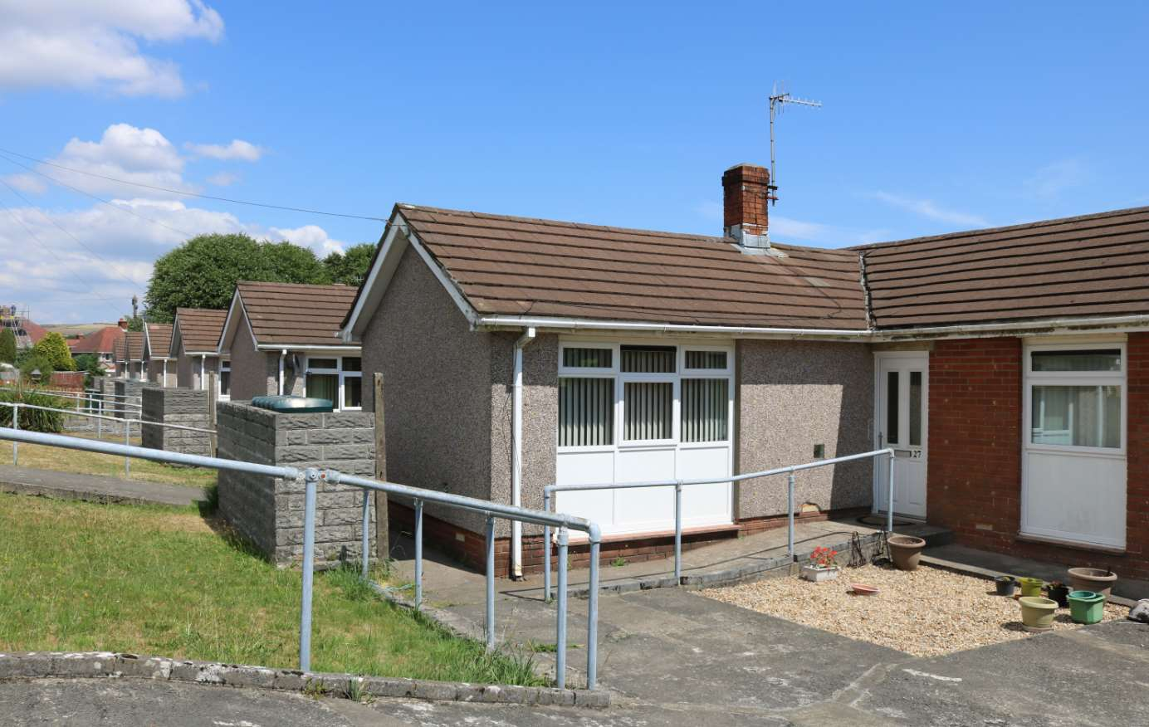
Figure 7: Ffordd Ellen Property (SCCC, 2019)

Swansea Council has invested a significant amount of money into retrofitting 6no - 2 bedroom bungalows in Ffordd Ellen, Craig Cefn Parc. The terraced bungalows were built in 1970’s, they are in poor condition but structurally stable, the floor area of each bungalow is 61m2, they are fed off the main gas grid and not energy efficient due to the fabric of the build. The work commenced in June 2018 as part of the SCCC Phase 2 enveloping works, the works is near completion with just internal decoration to finish. As part of the agreement, the renewable technologies have been gifted to SCCC who will take on all future repair responsibilities. See Appendix 1 - Figure 5.4: Funding Allocation Table.

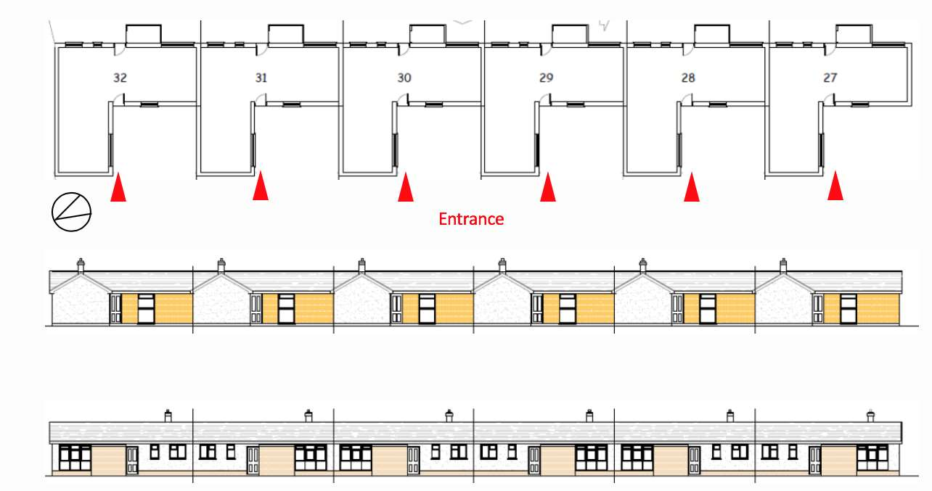
Figure 7.1: Ffordd Ellen Layout Plan (SCCC, 2019)
The council pinpointed these properties as they are in prime location for exposure to all of the elements, and due to the nature of the tenants the buildings are occupied throughout the day and night. They are primarily occupied by the elderly, which means that the properties daily consumption of energies was excessive. The image below illustrates the solar radiation exposed to each property, from this image, it is evident to see that these properties will benefit from photovoltaic panels. Fig 5.2 illustrates that the work is being carried out to 6no properties, however since the design one of the properties has been omitted from the scheme.

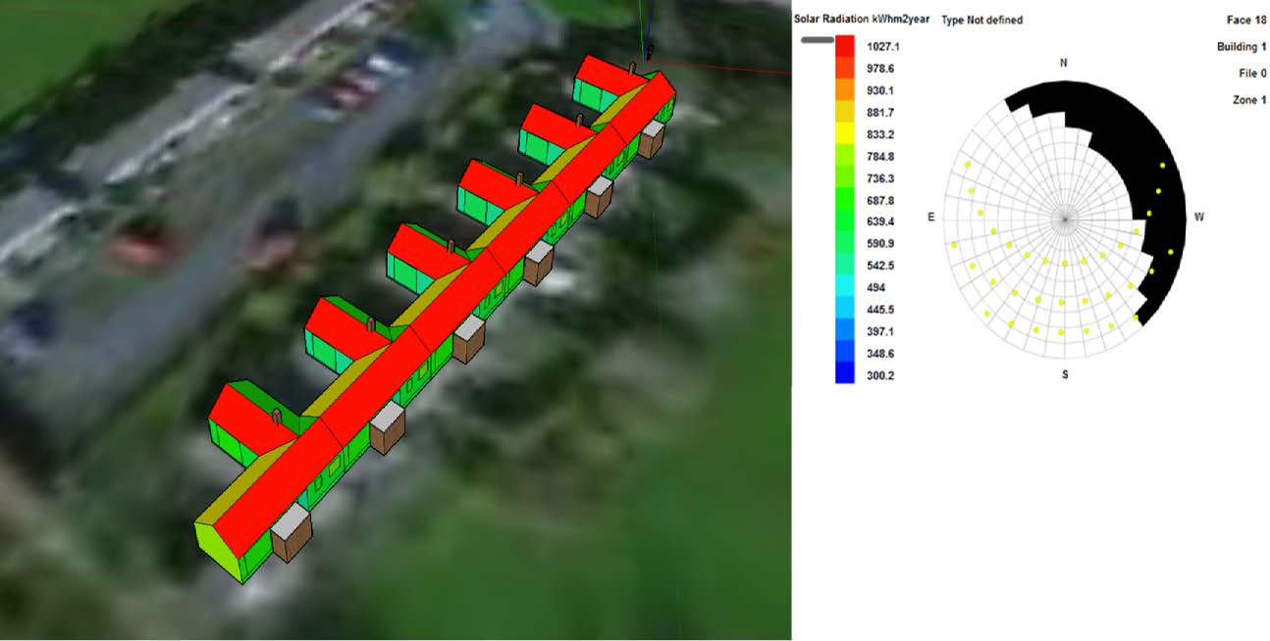
Figure 7.2: Ffordd Ellen Thermal layout plan, (WSA, 2019)

In order, to get the most out of retrofitting these properties with renewable energies it required extensive designing and planning. The council called upon the assistance and knowledge of Cardiff University’s Welsh School of Architecture (WSA). The WSA proposed a joint project with SPECIFIC of retrofitting renewable technologies to SCCC homes to develop a HAPS model that can be applied across future projects throughout Wales. SPECIFIC is an academic and industrial consortium led by Swansea University. SPECIFIC secured European funding for the purposes of trialling renewable technologies that create ‘HAPS’.

As part of the WSA’s agreement with Swansea Council to shadow the design, they allowed WSA to install an energy station (image below) in property No27. This allows WSA to monitor the energy usages of each unit over a period of time.

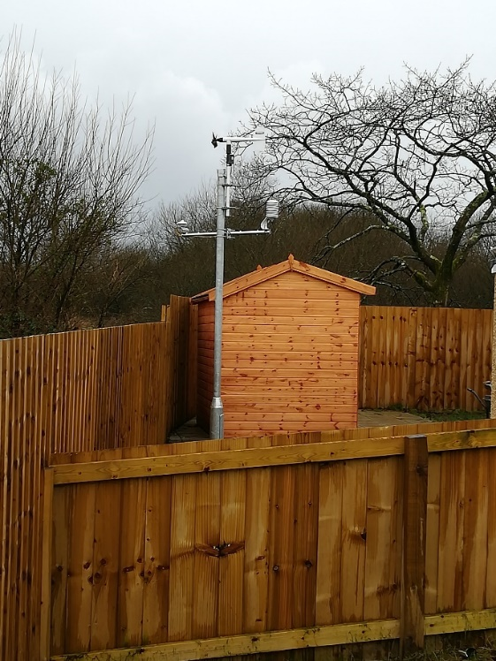
Figure 7.3: Ffordd Ellen - ASW Weather station (SCCC, 2020)

The properties were designed to have the most energy efficient materials and technology available, the solutions and funding proposed to each property is address in the table below.

Strategies | Item | Funded by
Reduced Demand | 300mm loft insulation | SCCC
Reduced Demand | 100mm EWI – whole house. See: Fig 7.5 | SCCC
Reduced Demand | Area under windows to be replaced by block wall and EWI to match | SCCC
Reduced Demand | High quality double glazed windows throughout. See Fig: 7.5 | SCCC
Reduced Demand | Low energy LED lighting | SCCC
Reduced Demand | MVHR. See Fig: 7.6 | SCCC
Reduced Demand | Ground Source Heat Pump. See Fig 7.7 | SCCC
Renewable Energy Generation | Integrated PV roof on 2 roof aspects SE and SW. See Fig: 7.9 | SPECIFIC
Renewable Energy Generation | Re-roofing. See Fig: 7.5 | SCCC
Storage | Lithium ion (TESLA) battery located in the outhouse. See Fig: 7.10 & 7.11 | SPECIFIC
Figure 7.4: Ffordd Ellen Funding Allocation Table (CCCS, 2019)

As part of the energy-reducing programme, all of the properties had External Wall Insulation (EWI) and high quality double-glazing.
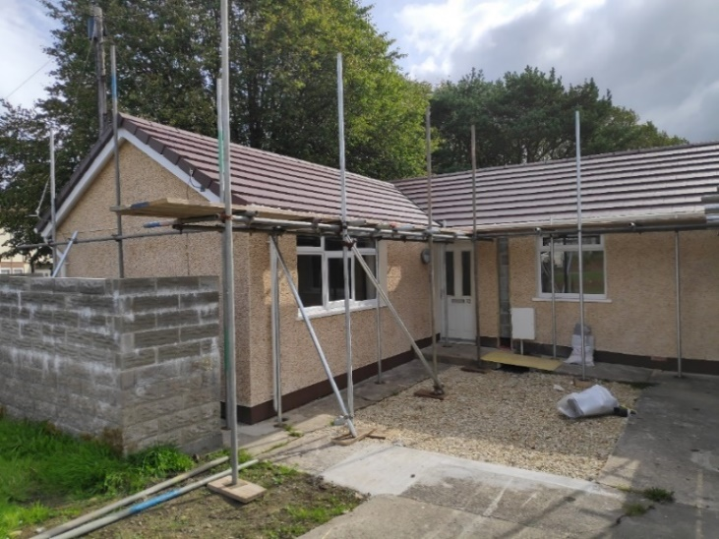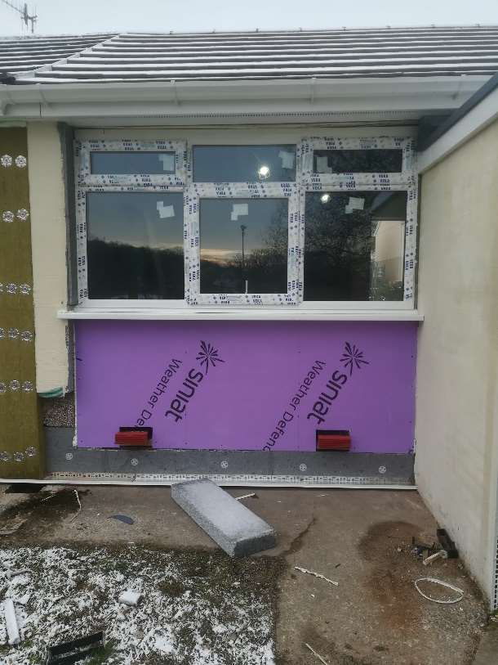
Figure 7.5: Ffordd Ellen – Property No29 – glazing & EWI (SCCC, 2020)

8.2 Mechanical Ventilation Heat Recovery (MVHR)

MVHR is a whole ventilation system that both supplies and extracts air throughout a property. It offers a balanced low energy ventilation solution for new dwellings and re-uses up to 95% of the heat that would have otherwise been lost. (Greenwood, 2019)

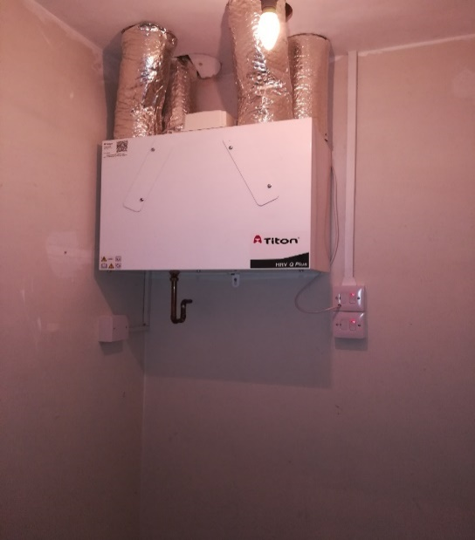
Figure 7.6: Ffordd Ellen – Newly installed MVHR (SCCC, 2020)

8.3 Ground Source Heat Pumps (GSHP)

GSHP system harnesses natural heat from underground by pumping water through it in pipes. The heat pump then increases the temperature, and the heat is used to provide home heating or hot water. They need electricity to run, but the idea is that they use less electrical energy than the heat they produce. The pump performs the same role as a boiler in a central heating system, but it uses ambient heat from the ground, rather than burning fuel to generate heat. GSHPs are the most efficient heat pump due to the relatively stable temperature of the ground. This GSHP is installed by borehole method which descended more than 50m+ into the ground. It was used in a system which heats and cools such that the heat absorbed during the winter for heating can be replaced in the summer while cooling.

In this particular area, the ground temperature at 50m+ down is approx. 20 ⁰c and this is a stable temperature, this means that the temperature doesn’t increase or decrease throughout the year. The water is pumped down into the ground using a loop system which then draws the water back up and is then circulated around the property to heat the radiators, the water for general usage is stored at an ambient temperature of 50⁰c+ in the water tank Fig 5.7. The water is pumped around the house by an intelligent boiler system which is shown on Fig 5.10.

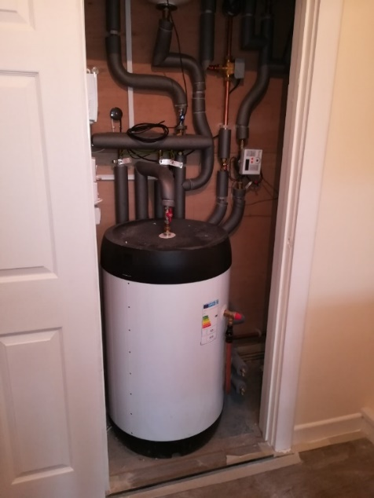
Figure 7.7: Ffordd Ellen – Newly installed GSHP water storage (SCCC, 2020)

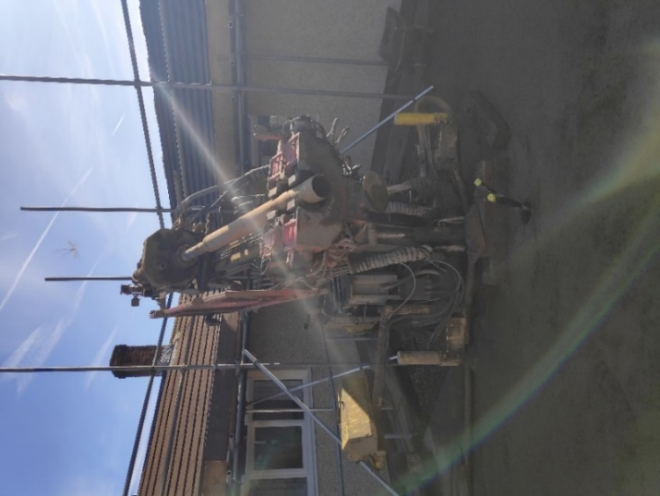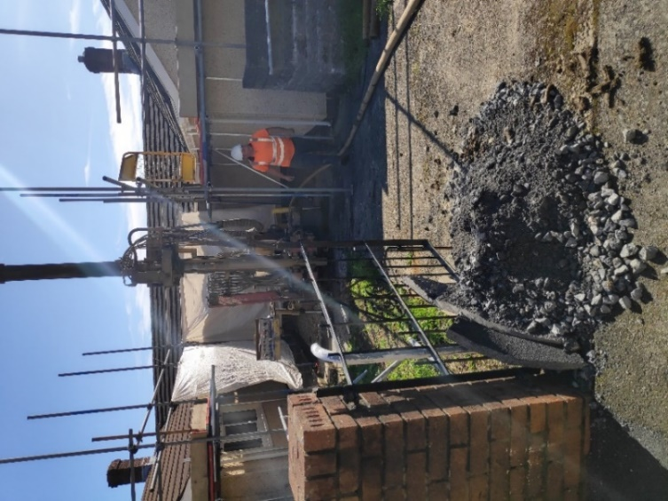
Figure 7.8: Ffordd Ellen - Borehole drilling machine used for the GSHP (SCCC, 2020)
8.4 Photovoltaic Panels (PV)

“PV cells convert light into electricity with and efficiency of around 10-20% depending on the type of cell used. Multiple cells make up a panel and several panels can be an array. Shading can be a major issue as if one cell is in shade then the whole panel does not produce electricity, therefore shading analysis is vital.” (Atkins, 2014). As mentioned above shading plays a big part on the panels, in this case of Ffordd Ellen it didn’t apply as all of the bungalows were fully exposed in all directions.

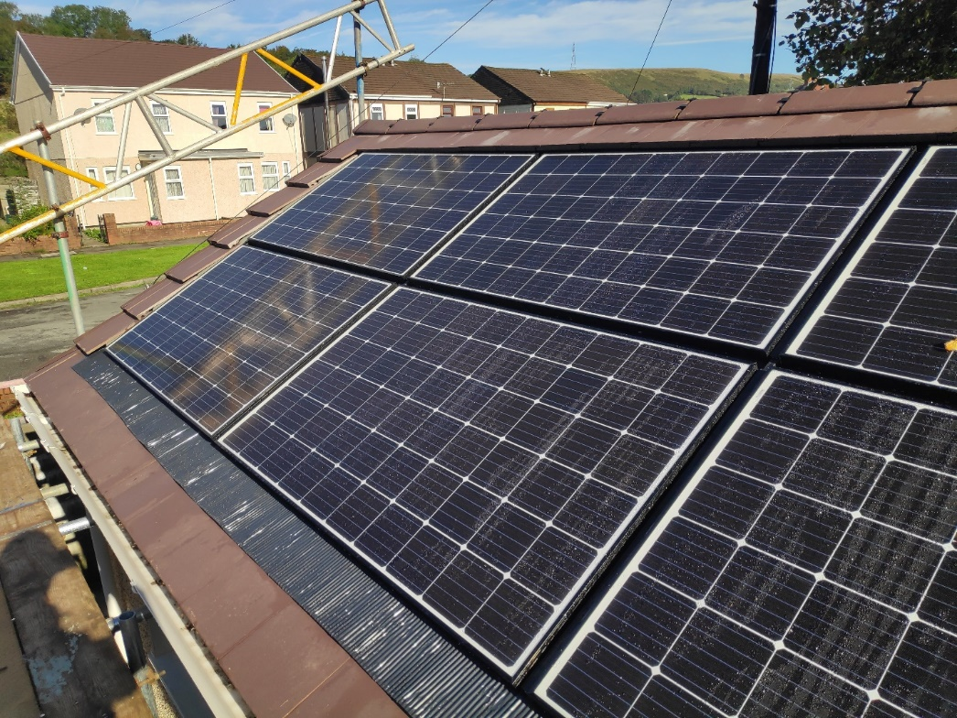
Figure 7.9: Ffordd Ellen – Photovoltaic Panels & New Roof (SCCC, 2020)

8.5 TESLA Powerwall Battery

The TESLA Powerwall allows the user to store excess electricity in the battery system instead of sending it back to the national grid, if the solar panels aren’t producing enough electricity to meet the users’ needs then the electricity stored in the battery can be used at a later stage rather than the user purchasing electricity from their utility company. The Tesla App (Fig5.11) will allow the user to have full visibility of its usage.

The Tesla Powerwall “can detect an outage, disconnect from the grid, and automatically restore power to your home in a fraction of a second. The user will not even notice that the power went out. The lights and appliances will continue to run without interruption. If the user has solar and Powerwall, then solar energy will continue to power the home and recharge the Powerwall. Without Powerwall, solar will shut down during an outage.” (Tesla, 2019)

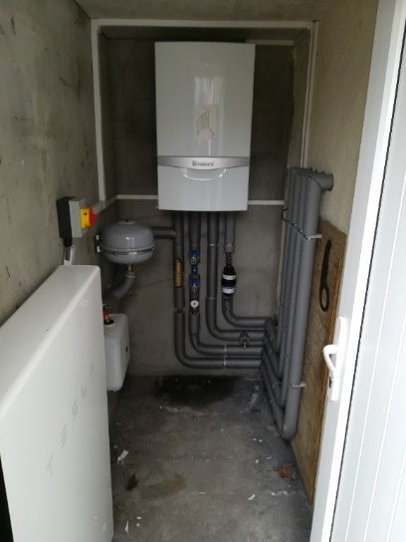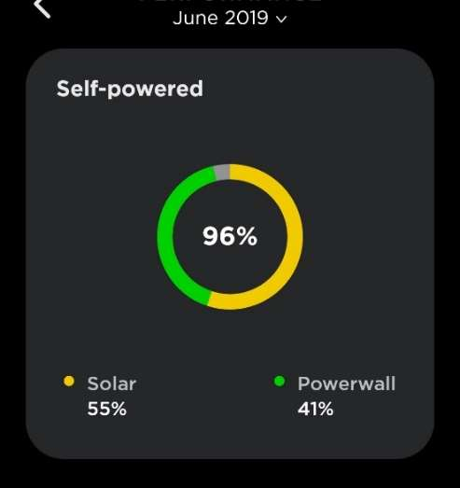
Figure 7.10: Ffordd Ellen – Tesla Powerwall Battery & Panel App (SCCC, 2020)

8.6 Post Evaluation of the Retrofit

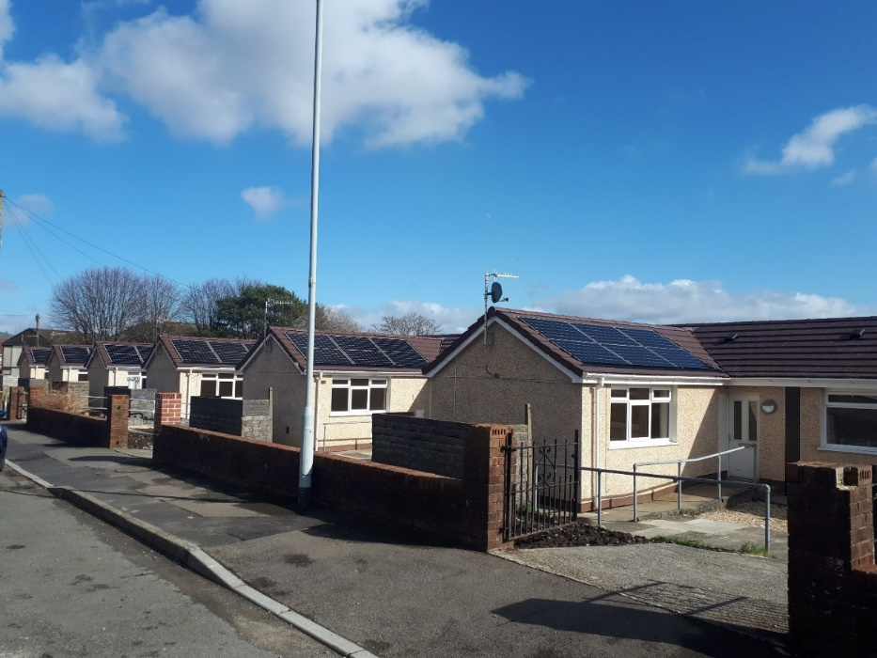
Figure 7.11: Ffordd Ellen – Completed Renewable Energy Retrofit (SCCC, 2020)

The initial total cost to retrofit each property was estimated to between the figures of £23,000 - £40,000, however it is reported that these figures have increased significantly throughout the project, and just for the technologies to be purchased and installed it cost £31,000 plus the EWI, reroofing & windows works of £29,408, and including external facilities works. Therefore, in total, it cost approx. £80k+ to carry out these works per property.
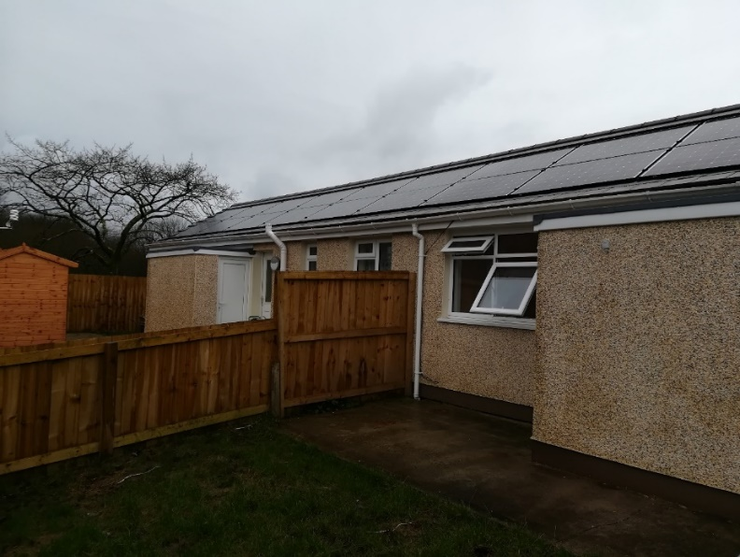
Figure 7.12: Ffordd Ellen, Rear Elevation, (SCCC 2020)

The author believes that the sum of money required to retrofit a two bedroom bungalow In order for the retrofitting of renewable energies to work then there is a need to use integrated systems, they need to installed correctly by certified engineers or tradespeople, they need to be monitored frequently.

8.7 Appendix 2 – More Homes Scheme

Passivhaus Homes under the ‘More Homes Programme’.
Milford Way, Penderry Ward, Swansea. £2m -18no New Build Home Scheme.

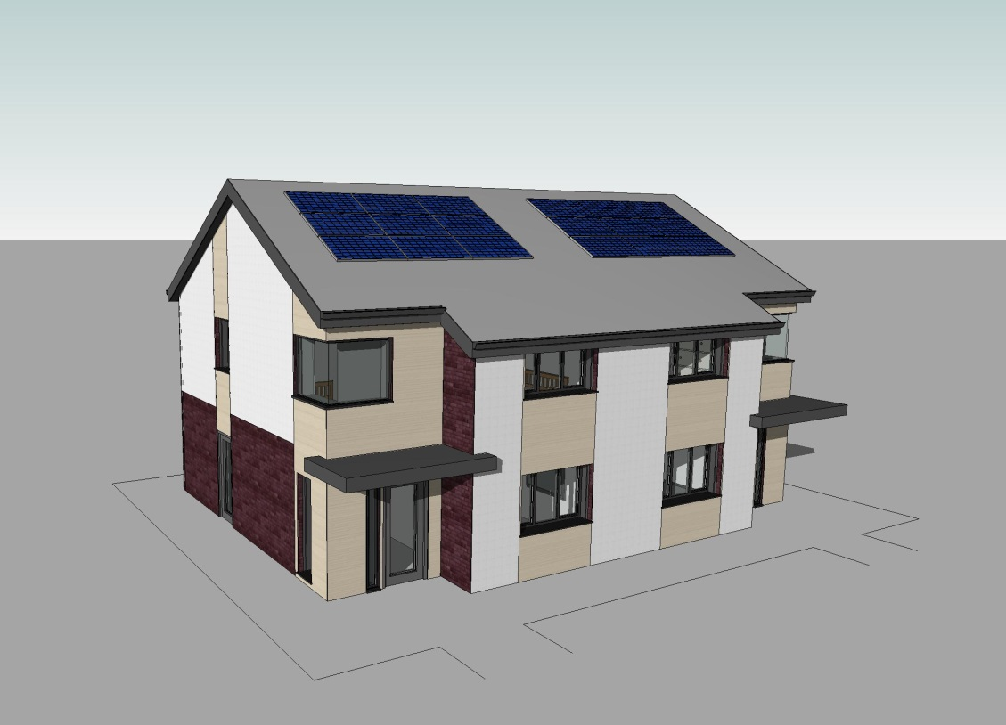

Figure 8: Milford Way, Penderry Ward – Proposed Design (SCCC 2020)

Swansea City & County Council’s Internal Contractor - Corporate Building & Property Services have been commissioned by the Housing Department to initiate and deliver the first ‘pilot’ scheme within Council’s new More Homes Programme on land at Milford Way, Penderry Ward.

These new homes which are designed to Passivhaus standard offer many benefits to SCCC, such as they reduce the housing shortage in the area, they assist in reducing fuel poverty and CO2 emissions. As the internal contractor is carrying out the work then this advertises their aim to provide homes which are sustainable.

Extent of services:
Architectural Design: RIBA Stages 1 – 6 (Inc. sustainable design, contract management, quality control & handover/close-out)
Quantity Surveying: Procurement & cost control
M&E Services: Energy systems design & inspection
CDM Services: Principal Designer function & H&S documentation/notification
Contractor: Construction-phase & management

Commissions:
Architectural Design Group will manage/co-ordinate the following work-streams & commissions:
Planning: formal enquiries (Re. land allocations, s106 arrangements, design & layout considerations)
Highways: formal enquiries (re. TIA scope, site access arrangements, adoption issues & design considerations) & commission Transport consultant to prepare TIA
Site Searches: enquiries regarding easements/ covenants / RoWs; utility/service providers (Re. on & of-site capacity); coal authority.

Element | Consideration factors | Owner
Project Objectives & Required Outcomes | To clearly define project expectations/delivery aspirations | Housing
Project Budget | - Feasibility  - Construction/Build | Housing/  CBPS (Build cost)
Project Programme | - Target Completion date  - Key milestones/gateways | Housing/CBPS
Development | - Development scale/property numbers  - Form/Type/Mix/Spatial arrangement | Housing/CBPS
Design Quality & Standard | - Required standards (DQR/LTH/WHQS/SBD…..other)  - Any specific design features, material finishes to incorporate/exclude (future maintenance)  - External standards – property & streetscape | Housing/ CBPS
Sustainability Strategy | - Technical/environmental standard – Building Regulations (BR), BR+, Passivhaus  - Building fabric (traditional cavity wall, timber-frame, SIPS, system-build…)  - Renewables strategy & systems (e.g. MHVR) | Housing/CBPS
Handover Strategy | Define requirements for ‘soft-landings’/demonstrations for tenants/DHO officers | Housing/CBPS
Other Considerations |  | Housing/CBPS

Figure 9: Milford Way, Penderry Ward – Technical Outline Brief (SCCC 2020)

8.8 Appendix 3 – Interview Questions

Mr. Colin King, BRE Group - Tuesday 28th January 2020
- May I take your full job title and place of work please?
Colin King Director BRE Wales, Based in Swansea.

- In your opinion, ‘how do you think decarbonisation can be introduced and carried out successfully in the Local Authorities housing stock’?
To introduce any initiative the first step must be to understand the current position of the stock in terms of performance, all buildings will all in likelihood not reach true zero carbon, so it’s important that a route map and plan is defined for all building typologies, based on opportunity and risk to fabric and health. A detailed plan using the whole house approach is needed to ensure that measures are undertaken in the correct order to ensure that the building performance is not locked artificially low.

- What would you say is the most challenging aspect of introducing decarbonisation into the local authority and how would it be achieved?
The biggest challenge is stock knowledge and understanding the compatibility of measures with each other and the usability by the residents, otherwise unintended consequences are inevitable, such as higher bills or lower internal thermal comfort.

- May I ask, what is your personal opinion on retrofitting renewables energies into existing dwellings to combat decarbonisation?
To deliver zero carbon renewables must be used a fabric approach is not capable of delivering the reduction. Renewable technology is the only way once the demand has been driven down by fabric improvements. The main issue is recognising the ongoing commitment to replacement in 20-25 years’ time or shorter, as it cannot be a one off installation, everything fails at some stage.

- Where do you think Swansea will be in the next 10 years, do you think that the Local Authority will be leading the way in decarbonisation?
Difficult to gauge the capital investment is enormous, there is no doubt the will is there in the Council, but it’s unlikely that the technical understanding of the risks and opportunities are. The LA is also struggling with a lack of clarity from the WG on what is actually required.

- What would you say is the best way / method to retrofit existing dwellings with new technologies to achieve decarbonisation?
There is no best way, to adopt a one fits all solution is the wrong approach, it needs to be based on what is best for the occupants and the property, based on understanding the needs of the residents, the risk to the property construction type and capital availability. To come up with one solution will end up in higher running costs, not achieving de carbonisation, or massive outlay of funds for little positive return.

- Do you think it is practical to introduce electrical charging points for electric cars in the local communities, such as installing them in District Housing Office Car Parks?
Technically there is no reason why not, but it is about cost, and number of vehicles that could or would run on battery. If the council switch fuels for its own fleet of vehicles it may make sense to do so, but the cost would be significant.

- Decarbonisation is the ‘buzz word’ now; it is very relevant and topical. Would it be fair to say that it is aimed at the next generation of young people? Do you think we can educate older people with old-fashioned ways of thinking into new concepts of clean energy saving?
Behaviour change is a complex problem, but in all reality with an ever growing elderly population, it is essential that this is done. They have access to the greatest capital to fund measures themselves, but the success rate of energy efficiency measures and initiatives is not great and they will be naturally reluctance to spend their hard earned savings on a new agenda with serious convincing.

- Do you think that the technologies available in decarbonisation is not for everyone, i.e. Passivhaus for social housing, not all tenants will be comfortable with this way of living? They may not have a choice to live in these houses because they are next in-line to be homed.
PH is not technology it’s an approach to energy balance, many myths surround PH and in reality no changes to life style are required, but an understanding that there is no high temperature focal point for heating. I do not honestly believe that PH is the way forward, but an approach is required to deliver low carbon housing that delivers in reality is, and quality control in the construction phase is the key.
- Have you been involved with the local authority in research for decarbonisation, if so, May I ask what?
Only in terms or new build standards and the direction of travel for new housing stock to deliver the Climate Change Commission energy standards ahead of the deadline. Assessing what is the optimum approach to balance number of units against capital costs.

- What is your opinion on retrofitting, the majority of the Local Authorities housing stock dates back to 1950’s, they have had minor upgrades but generally in poor condition. Would you say that it is cost effective to retrofit these properties with state of the art technologies, which are worth more than the property itself?
Cost effective is a difficult concept to summarise in few words, the whole debate of knock them down / retrofit is a fine balance, the whole issue or carbon locked in the existing stock has to be considered, if chasing operational decarbonisation is at the expense of massive carbon footprints building new, what is gained, the environment is still being burdened with carbon, just not one the human race measures, but it’s still carbon burden. There is no doubt some older stock will need to be rationalise, but the typical housing stock has massive potential, to simply discard them due to a lack of investment in maintenance is focussing attention in the wrong direction.

Mr Darrel Barnes, SCCC – Thursday 12th March 2020
- May I take your full job title and place of work please?
Architectural Design Manager – Swansea Council

- In your opinion, ‘how do you think decarbonisation can be introduced and carried out successfully in the Local Authorities housing stock’?
Initially we need to gather the evidence/stock asset data, alongside this to identify menu of options/systems/technologies which could be applied – both of which will inform a delivery programme, from easy-wins to hard-to-treat. This will involve detailed vfm/cost-benefit analysis to determine deliverables i.e. what can & can’t/should and shouldn’t be done – capital investment v return. BRE have been engaged to undertake this analysis for us and provide a menu of options and outcomes.

- What would you say is the most challenging aspect of introducing decarbonisation into the local authority and how would it be achieved?
Challenges - capital investment required and range of construction types, some of which may simply not lend-themselves to decarb systems/technologies. Also mindful of context/location – orientation (if utilising PV), ground conditions (if utilising GSHP) & off-mains properties.

- May I ask, what is your personal opinion on retrofitting renewable energies into existing dwellings to combat decarbonisation?
Approach is a positive-step towards carbon reduction across our stock – difficulty may be with ‘local’ supply & maintenance chains (which may mean that sourcing of equipment will have its own carbon footprint) – but must address property fabric first before adding technologies

- Where do you think Swansea will be in the next 10 years, do you think that the Local Authority will be leading the way in decarbonisation?
I certainly think LAs will lead the way before private housing developers – certainly until decarbonisation is mandated across the industry via Building Regulations etc.

- What would you say is the best way / method to retrofit existing dwellings with new technologies to achieve decarbonisation?
Fabric-first approach always – address the thermal envelop before application, if any, of ‘decarb-technologies’

- Do you think it is practical to introduce electrical charging points for electric cars in the local communities, such as installing them in District Housing Office Car Parks?
This is a grant requirement of WG, however further discussions are required with network supplier (WPD) to align WG’s EVCP aspiration with WPD infrastructure investment programme. Electric vehicle capital cost, availability and their own carbon footprint at point of manufacture are also factors.

- Decarbonisation is the ‘buzz word’ now; it is very relevant and topical. Would it be fair to say that it is aimed at the next generation of young people? Do you think we can educate older people with old-fashioned ways of thinking into new concepts of clean energy saving?
I believe if all ages groups/residents are presented with the facts regarding the savings which can be directly gained from reduced energy costs – the majority would sign-up to the approach – it is about being clear of the benefits to individuals and the wider community.

- Do you think that the technologies available in decarbonisation is not for everyone, i.e. Passivhaus for social housing, not all tenants will be comfortable with this way of living? They may not have a choice to live in these houses because they are next in-line to be homed.
Passivhaus is a fabric-first construction form rather than an utilisation of technologies and there is certainly an ‘educational’ element to the operation of these homes e.g. protecting the air-tightness of the external fabric and the MVHR system which removes the need for radiators. I think this is again about communication and education – to explain operating systems and ultimately the cost-saving benefits for the user if systems are operated correctly.

- Have you been involved with the local authority in research for decarbonisation, if so, May I ask what?
We did engage BRE early in the process when determining an approach to new-build housing – using Building Regulations as a base-line standard and enhanced build-options up to Passivhaus standard. As mentioned, we are doing the same for the retro-fit programme.

- What is your opinion on retrofitting, the majority of the Local Authorities housing stock dates back to 1950’s, they have had minor upgrades due to the WHQS programme but not much prior to that. Would you say that it is cost effective to retrofit these properties with state of the art technologies, which are worth more than the property itself?

Similar response to Q2 really. Once we have a detailed analysis of investment costs and payback/savings generated, we will then be in a position to make an informed decision regarding retrofitting. A wider consideration is that, arguably, decarbonising energy supply ‘at source’ is far more (cost) effective than at each property, with fabric improvements where identified.

Dr Jonathan Williams, ACTIVE Building - Wednesday 22nd January 2020
- May I take your full job title and place of work please?
I am head of projects at active building centre, in Swansea /University

- In your opinion, ‘how do you think decarbonisation can be introduced and carried out successfully in the Local Authorities housing stock’?
Well firstly it’s about understanding the scale, housing stock and the wider problems around the housing stock, funding, quality, standards, it’s just about decarbonisation it’s about health and wellbeing. Should be in theory that health benefits, there is studies about retrofitting homes there is less people visiting the GP service which also relieves the strain on the NHS. People tend to feel more comfortable physically and financially because they are paying less energy costs. Challenges about the politics of implementing these changes. Lee Walters, Deputy Minister for economy in Wales, Llanelli AM. Synergies between decarbonisation and health. Quality of life in general. Decarbonisation, holistic approach – whole house, whole street approach, pioneered with Active Building Centre, look at area base scheme – anchor based tenants, Swansea council, coastal and others such as private landlords, package them all up might be easy to get it funded, to showcase Swansea and provide funding. RSL registered social landlords.

- What would you say is the most challenging aspect of introducing decarbonisation into the local authority and how would it be achieved?
Build on the last point, challenging aspect is the money, is number 1. Do some draft design for a few hundred quid but you need to do it at a larger scale. People is the no.2, some people ventilation is not enough, issues with household appliances, behavioural aspects. Proper EWI extended roof lines, services penetrations. Skills is obviously a big aspect. Tenants need to be involved and learned, behaviour of the tenants and the technical aspects. EPCA challenging target, useful target not necessary going to pick up key aspects.

- May I ask, what is your personal opinion on retrofitting renewable energies into existing dwellings to combat decarbonisation?
Something we got to do, built my career on over the last 20 years, approaching 20 years in practice, frustrated that not much has happened, but it is now starting to take shape. The press seem to be more involved, my fear is that we are not doing enough. Doomsday prediction coming etc. need to have more lifestyle choices, try to change smaller lifestyle changes, cycling to work etc. Lot to do with air travelling, could have a bigger plane which would carry more passengers which will cause less planes in the skies. Could have an adverse effect though with a boom in air travel. Fundamental change is required, improvement in building regulations and planning policy to get property developers and housing on board, the houses need to be designed to a certain clean energy standard.

- Where do you think Swansea will be in the next 10 years, do you think that the Local Authority will be leading the way in decarbonisation?
There is an opportunity for the LA to be leading the way, there is some good things in Swansea like the new development and the new arena, economic boom for the city, new builds to embed higher standards, good decarbonisation policies in travelling. In terms of housing, how area based retrofit to get all of the housing associations together along with others sectors to support it all and would be very good in terms of decarbonisation, it does need strong leadership and support at local authority level. Unfortunately there is no weight or momentum behind it but with the Welsh & UK government there will be an opportunity for it.

- What would you say is the best way / method to retrofit existing dwellings with new technologies to achieve decarbonisation?
Prioritising decarbonisation above the cost, you will need to look at EWI, air tightness, positive ventilation, difficult to retrofit MVHR and heat pumps. Air source heat pumps would be recommended for retrofitting. This will do you fabric and basic heating but a lot to be done around electricity. Being able to have a demand site response where there you can turn off the hot water when there is a flux from the grid if you had a battery you can feed it back into the grid, even you will be able to share power between neighbours for instance if one neighbour goes on holiday then the solar roof is still generating and he can export it to his neighbour. There is still a lot to unpack there, early stages but it is a possibility, and this would have a positive effect on the electrical grid.

- Do you think it is practical to introduce electrical charging points for electric cars in the local communities, such as installing them in District Housing Office Car Parks?
Very good idea, Welsh Local Authority been lacking in this area behind the rest of the UK. Supply and demand type, what’s the point in putting them in if nobody is using them. All vehicles in ABC been using them. Previous EV had poor charge but new models have a much better range. It could be a good revenue stream for the local authority, can be stored in the library car park at the civic centre.

- Decarbonisation is the ‘buzz word’ now; it is very relevant and topical. Would it be fair to say that it is aimed at the next generation of young people? Do you think we can educate older people with old-fashioned ways of thinking into new concepts of clean energy saving?
Decarbonisation is one of those big words that has got different meanings to different people like environment or sustainability. Younger people are very motivated about it, professional interest or just concerned in the environment, some old people are into it but less motivated by it simple because they are stuck in their ways and they think they have less of an impact because they be around for less time. There are some older people who are buying into electrical vehicles, proud of their heat pumps and solar systems.

- Do you think that the technologies available in decarbonisation is not for everyone, i.e. Passivhaus for social housing, not all tenants will be comfortable with this way of living? They may not have a choice to live in these houses because they are next in-line to be homed.
Behaviours in people. Educating tenants how to get the most out of the technologies. Issues in some passivhas development, tenants turn of MVHR because they think it is running and using unnecessary energy.

- Have you been involved with the local authority in research for decarbonisation, if so, May I ask what?
We are focus on and funded on new build only, is to dealing with existing stock, key focus on the Active Building Centre commercially financially to secure more money. It needs to be commercially focused. There is £289m of new builds throughout the UK. ABC is currently involved in monitoring Parc Yr Helig but no involvement in Milford Way.

- What is your opinion on retrofitting, the majority of the Local Authorities housing stock dates back to 1950’s, they have had minor upgrades due to the WHQS programme but not much prior to that. Would you say that it is cost effective to retrofit these properties with state of the art technologies, which are worth more than the property itself?
Carol Morgan is sub metering the MVR to get an accurate reading of how much the running cost is compared to large TV’s and other electrical loads. Technologies focus on generation and storage not enough of the actual customer, there is a lot of work that the energy catapult system on the consumer inside. Heating controls, not a social housing thing, should be simple. Hive & Nest a user friendly. Education piece, if someone is moving into a Passivhaus they should be given easy to read instructions from the housing team and not a Ground Source Heat Pump or MVHR manual. Simple instructions and point of contact for advice. Not so much research.

Dr Joanne Patterson, Welsh School of Architecture – Thursday 6th February 2020
- May I take your full job title and place of work please?
Senior Research Fellow, Welsh School of Architecture, Cardiff University

- In your opinion, ‘how do you think decarbonisation can be introduced and carried out successfully in the Local Authorities housing stock’?
Reducing carbon should be a priority when making any decisions when refurbishing or building new homes. All people involved in the decision-making process should be aware of this and should be trained so that they are aware of how decarbonisation can take place. This include those from the top level who finance the projects through to the electricians and plumbers onsite who are doing the installations. By knowing what the benefits are including reduced bills for occupants and improved health can help to support this.

- What would you say is the most challenging aspect of introducing decarbonisation into the local authority and how would it be achieved?
As mentioned above, having people understand why the changes are needed and what benefits they bring really help the delivery of the works.

- May I ask, what is your personal opinion on retrofitting renewables energies into existing dwellings to combat decarbonisation?
From experience they work very well. They reduce carbon emissions by reducing dependency on fossil fuels which is a very good thing.

- Where do you think Swansea will be in the next 10 years, do you think that the Local Authority will be leading the way in decarbonisation?
I very much hope so and I hope that they have learnt a lot from retrofitting Ffordd Ellen – including ways not to do things. I would like to think that they will take every opportunity to reduce emissions when refurbishing the stock.

- What would you say is the best way / method to retrofit existing dwellings with new technologies to achieve decarbonisation?
Using a whole system approach for a few homes rather than individual technologies on all homes. This will help to improve the stock as a whole and will prevent duplication of works going forward. Selecting the right solutions for the right homes. Targeting areas of poor quality homes to improve conditions for occupants while reducing emissions.

- Do you think it is practical to introduce electrical charging points for electric cars in the local communities, such as installing them in District Housing Office Car Parks?
Yes, EVs are going to happen so the more prepared we are with the infrastructure the better.

- Decarbonisation is the ‘buzz word’ now; it is very relevant and topical. Would it be fair to say that it is aimed at the next generation of young people? Do you think we can educate older people with old-fashioned ways of thinking into new concepts of clean energy saving?
No, everyone has to act now. Climate change is happening. It is not only older people it is the majority of the population that have to change.

- Do you think that the technologies available in decarbonisation is not for everyone, i.e. Passivhaus for social housing, not all tenants will be comfortable with this way of living? They may not have a choice to live in these houses because they are next in-line to be homed.
I think we all have to change our way of living going forwards. The key point with new technologies is that they have to be installed correctly and function well. If this happens then the home should provide a comfortable, nice place to live. Someone has to be responsible for the correct installation of the technologies.

- Have you been involved with the local authority in research for decarbonisation, if so, May I ask what?
Yes, Ffordd Ellen – the whole house retrofit of 6 1970s bungalows.

- What is your opinion on retrofitting, the majority of the Local Authorities housing stock dates back to 1950’s, they have had minor upgrades but generally in poor condition. Would you say that it is cost effective to retrofit these properties with state of the art technologies, which are worth more than the property itself?
People should be provided with healthy, decent quality homes. A programme of refurbishment should take place to provide this. WHQS was the target for a long time. This needs to change. Refurbishment should include retrofit to provide occupants with a healthy, affordable, ‘decent’ quality home. Providing renewable energy which can be stored, whilst reducing demand can provide both a healthy and affordable home whilst reducing carbon emissions.

Mr Andrew Jackett, SCCC – Friday 14th February 2020
- May I take your full job title and place of work please?
Andrew Jackett, Welsh Housing Quality Section Leader, Building Services, Swansea Council.

- In your opinion, ‘how do you think decarbonisation can be introduced and carried out successfully in the Local Authorities housing stock’?
The Council has a well-established system for undertaking all aspects of construction and maintenance of their Housing stock. This would be the vehicle for carrying out to decarbonisation process but, all involved would need to be brought up to date with the ever evolving technologies that are coming to the market. With the Council having a Housing stock of 13,500 properties (and growing - due to More Homes construction policy).

- What would you say is the most challenging aspect of introducing decarbonisation into the local authority and how would it be achieved?
Initially the main problem would be to get all relevant Staff, Client Department, Designers, Clerk of Works and all other disciplines involved in the process up to date and fully conversant with the technologies and various applications available. Training and education is essential, also the recruitment of trained Personnel with the ability to pass on knowledge and mentor existing Staff.

- May I ask, what is your personal opinion on retrofitting renewable energies into existing dwellings to combat decarbonisation?
Retrofitting of anything raises a whole raft of issues as it is much easier to install systems as part of the original construction process and designed as part of the building. At retrofit stage there is nothing you can do about size of gardens and their topography or the orientation of the property to allow for Ground source heat pumps and Solar panels.

- Where do you think Swansea will be in the next 10 years, do you think that the Local Authority will be leading the way in decarbonisation?
The Client department is already engaging with Welsh Government on this issue in an attempt to forward plan and be on the leading edge of the programme of Decarbonisation and is undertaking informative work on Housing stock to enable balanced decisions to be made once a definitive policy on decarbonisation is published.

- What would you say is the best way / method to retrofit existing dwellings with new technologies to achieve decarbonisation?
Personally I would think the best way forward would be to either partner with specialist companies or to form a framework of specialist companies to undertake the work, once policy has been set there will be a huge call on specialist resources and materials so supply chains would be a principal consideration. If feasible, with correct training and engagement of specialist staff the best way to guarantee the work is carried out is to undertake as much as possible ourselves as a Council.

- Do you think it is practical to introduce electrical charging points for electric cars in the local communities, such as installing them in District Housing Office Car Parks?
I don’t think it matters where the charging points are located, they need to be readily available, easy to access and secure. It will depend on the communities in which they are located in various areas of the Country, security of the charging equipment and the vehicle being charged should be a prime consideration.

- Decarbonisation is the ‘buzz word’ now; it is very relevant and topical. Would it be fair to say that it is aimed at the next generation of young people? Do you think we can educate older people with old-fashioned ways of thinking into new concepts of clean energy saving?
I think most people have a stake in the future of the Planet as their families will be continuing on to live in it and there will be a willingness to help protect it for future generations.

- Do you think that the technologies available in decarbonisation is not for everyone, i.e. Passivhaus for social housing, not all tenants will be comfortable with this way of living? They may not have a choice to live in these houses because they are next in-line to be homed.
Technologies need to be made as simple as possible to use if they are to be widely accepted by all. As technology advances it will become the new norm, some people will naturally be left behind but, some provision will need to be made for these.

- Have you been involved with the local authority in research for decarbonisation, if so, May I ask what?
This is a current issue and we are attempting to gain training and knowledge opportunities for all relevant Staff.

- What is your opinion on retrofitting, the majority of the Local Authorities housing stock dates back to 1950’s, they have had minor upgrades due to the WHQS programme but not much prior to that. Would you say that it is cost effective to retrofit these properties with state of the art technologies, which are worth more than the property itself?
On current information available to us the pilot schemes have shown that the initial trials on retrofitting have not proved cost effective. Designs and types of technologies will have to be reconsidered to ensure cost effectiveness of any retrofit process.

