Ordinance, Munitions & Explosives (Degree Apprenticeship)
Development and Evaluation of a Trial Using Systems Engineering Approaches.
ACDA4005, L4 Principles of Systems Engineering
Groom Lawrence W - 1810351
[Date]

Contents
Introduction 2
Systems Engineering Process 2
Needs Analysis 2
QFD 3
Customer requirements 3
Functional requirements 4
Identifying Constraints 4
Outlining Constraints 5
Prioritisation 5
Developing Options 6
Pugh Matrix 6
Assessing and managing risk 7
Root Cause Analysis 7
FMEA – Failure Modes Effect Analysis 8
Other Types of Risk and Their Management 9
Conclusion 9
References 10

Figure 1 - SIMILAR diagram [2] 2
Figure 2- QFD House of Quality 3
Figure 3- Kano Table of Constraints 6
Figure 4- Pugh Matrix 7

Table 1 - Five Why Analysis 8
Table 2 - FMEA Example 8

Introduction

Systems engineering is an incredibly powerful tool. In short it is used to bring multiple, often transdisciplinary, elements together to produce a result not achievable by the individual elements alone [1]. For this reason systems engineering is seen as engineering in the widest sense of the term and is a principle that governs all aspects of engineering on any given task package. The correct deployment of systems engineering tools and thinking has nearly limitless positive impacts. These include a reduction in costs and therefore an increase in profit margins, an increase in efficiency as well as the ability to foresee and highlight potential future problems. However, negative aspects also exist within the systems engineering field. While, once set-up and functioning, systems principles are extremely beneficial; it can take an incredibly long time to implement changes and longer still before these functions begin to take effect. It is also very difficult to apply systems thinking to a complex structure, such as an automotive manufacturing plant, that is already in existence. It is quicker, cheaper and easier to build a new system from the ground up and apply systems engineering from the very beginning.
For the purposes of this assignment, systems engineering principles will be assessed, explained and used to inform the development and evaluation of an energetics trial. Specifically a trial that will test a new design for a Fragmenting Warhead.

Systems Engineering Process
The easiest way to visualise Systems thinking is through the use of the “SIMILAR” acronym. this stands for State the problem, Investigate alternatives, Model the system, Integrate, Launch, Assess performance and Re-evaluate. [2]
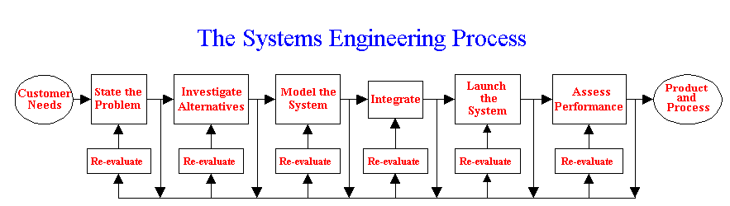
Figure 1 - SIMILAR diagram [2]
Several tools, techniques and approaches can be utilised to build the users understanding of each section of the above diagram.

Needs Analysis
It is often beneficial to carry out a Needs Analysis at the beginning of any given task as it allows the user to highlight their needs as well as state the problem they require the overall system to perform. A Needs Analysis further allows the formation of robust arguments as to why any given task is required and enables the user to better understand, and think through, how they plan to deliver a package of work.
A complete Needs Analysis can effectively act as a business case to justify work to stake holders and financial elements as well as a first step in developing a concept of design for any given system. Several Systems engineering tools can be deployed during a Needs Analysis, these can be used to better understand how a system might operate in addition to helping the user define their parameters and overall objectives.

QFD
A QFD or Quality Function Deployment is a method developed to help transform “qualitative user demands into quantitative parameters” [3]. The “house of quality” tool within QFD allows the customer requirements to be identified and prioritised, it also enables the development of functional requirements which are characteristics that may be relevant to one or all of the customer requirements. The tool further enables the user to view relationships between the customer and functional requirements.
An example of a negative relationship would be the requirements to use strawboards to capture fragments when compared against the requirement to also measure fragment velocities at various distances. As, once the fragment has impacted the strawboard, it is impossible to measure velocity past that point. Because this correlation is now highlighted it can be assessed and problems solved before the system design exits the concept stage. See, Figure 2- QFD House of Quality
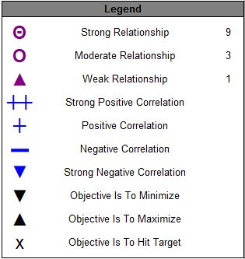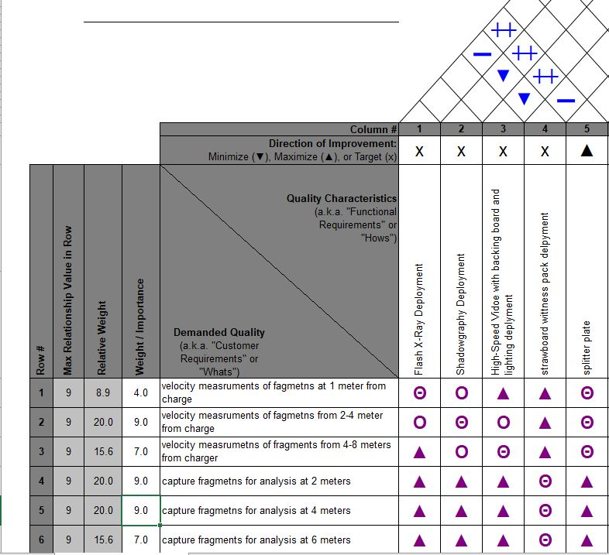
Figure 2- QFD House of Quality

Customer requirements
A customer has a requirement to conduct live fire testing on an experimental fragmenting Warhead. A list of requirements and desired outcomes was produced by the customer team.
- To provide data on fragment velocities at a range of distances. These distances are. 0-1m from charge, 2-4 m and 4-8 m respectively.
- To soft capture any fragments for post firing analysis such as mass and dimension measurements.
Objectives one and two may combine to provide the potential energy of a given fragment and therefore estimate its terminal effects.
- Test the range at which the fragments may be projected from the device upon firing.

Functional requirements
These were solutions that allowed for the delivery of the customer requirements.
In order for the customer to yield accurate and useful data, and therefore meet the outlined requirements, it was accepted that the use of an Instrumentation Team was necessary. This team was treated as a sub-system within the trial which in turn was identified as the overarching “master” system.
The process taken to achieve realistic functional requirements can be further broken down and sub-divided using additional tools such as Pugh matrix. However for the purposes of this assignment it was accepted that the author’s background and experience enabled intuitive leaps to be taken when assessing the customer requirements from an instrumentation perspective.
In order to meet the above stated requirements several different measurement techniques were required to be deployed to the trial. These included Shadowgraphy, Flash X-Ray (FXR), High-Speed Video (HSV) and strawboards. Each of these techniques were selected for a specific area of the trial arena.
In order to yield useable data from 0 – 1 meter from the charge, an FXR technique was selected. Because this was an X-Ray based technique, it was able to capture images of the test item breaking up upon firing and, therefore provided very early (µS time-base) fragment velocity, size and vector estimates.
Shadowgraphy allows the imaging of the shock structure produced when an object approaches and breaks the speed of sound. These shock-cones provide measureable information on velocity as well as any potential rotation the fragment may be undergoing. This technique was deployed at the 2 – 4 meter distance specified in the customer requirements.
Basic HSV filming against a lit backdrop provided silhouetted footage of fragments in flight and enabled a wider field of view than the above mentioned techniques. For this reason HSV was used to cover the last distance (4 – 8 meters) specified in the customer requirements.
Lastly, strawboard packs were used to provide soft capture of the fragments once they had travelled the length of the trials arena. Strawboard was also used to for fill the last requirement of the customer and was set-up to capture fragments at a series of different ranges from the firing point.

Identifying Constraints
When considering the successful delivery on an energetics trial, the master system in this case, there are often more constraints present beyond the customer and functional requirements outlined above. These requirements were derived from a customer perspective, whose objective was to collect measurable data from the energetic trial and therefore may not have been aware of any additional constraints.
Identification of constraints is a vital part of the early phases of a systems design, however this task should be carried out at the completion of each phase of the SIMIALR method in order to repeatedly assess the system as a whole and ensure potential constraints were captured and managed accordingly.

Outlining Constraints
Due to the nature of the trial a great deal of legislation needed to be conformed to. National legislation, such as JSP 482 which is the MOD (Ministry of Defence) overarching guidance on the use, storage and processing of ordinance, munitions and explosives as well as guidance, law and polices governed by HSE (Health and Safety Executive). Local (company specific) rules, policies and guidelines such as staff competency, custody procedures and more specific H&S (health and safety) also contribute to constraints faced when developing the delivery of an energetic test or trial.
It is possible to capture likely constraints present within the local environment through the use of surveys, providing the sample group covers the entire sector relevant to the work, and engagement with the company’s internal teams responsible for the safe delivery of energetic trials. Such as the ESR (Explosive Safety Representative) who’s overarching role is to inform and give advice pertaining to government legislation. Engagement with the companies H&S team is also a vital part of identifying constraints to any energetics trial.
Company structure dictates that an energetic trial requires the deployment and utilisation of several different teams. Each of these teams have a specific role in the delivery of an energetics trial and therefore contribute unique constraints that require assessing and understanding. These constraints can be identified through trials related meetings and requests for information from each of the relevant teams.

Prioritisation
It is necessary to prioritise constraints in order to understand which has the greatest impact to trial delivery, and therefore which necessitated a higher level of management. The prioritisation also helped in the understanding of how constraints relate to one another and recognise whether any given change may have affected several constraints.
There are several constraints related to an energetics trial that cannot be managed or mitigated. Law, polices and guidelines must be followed precisely and therefore other factors must be formed around them. For example the suitability of an available trial location needed to be changed to enable the trial to conform to the above mentioned laws, policies and/or guidelines whereas the law cannot be changed to suit the trial.
The way by which highlighted constraints were prioritised was through the use of group surveys and questionnaires sent to relevant authorities within the company structure, such as the H&S team as well as the Explosive Safety Representative (ESR). Meetings with various teams such as Range Technicians and Instrumentation were also organised and lists from each areas constraints were then combined and assessed. This was to ascertain which constraints afforded more flexibility or mitigation.

Kano
The Kano methodology is an approach to prioritizing features based on customer needs [4]. Items are categorised into three sections. Basic or “must be met”, these are items or things that must be present in a system in order for it to function; for example it is a must that a car starts when the key is turned on. Satisfiers or “More is better” is a section reserved for items that would add a positive attribute to a system or design but is not critical to its working. For example electric windows in a car, they are a nice to have but not a necessity. The final section is the delighter or “surprise” items, these are items that are typically the most attractive to a customer, for example cruise control on a car. This is not needed or a necessity but certainly a desirable attribute of a car.
A Kano style table was drawn up in order to further assist in the prioritisation of the identified constraints. The Kano table was adjusted from its original purpose of a customer satisfaction and desires model in order to visualise which constraints could not be mitigated, through to constraints that had a greater degree of change possible. For this purpose, constraints that have been identified as unchangeable, such as law and policies, have been placed in the “basic” or “needs” category as the trial would not have been able to run without these points. The “delighters” category contains constraints that were easily mitigated, managed or changed such as number of staff present when the trial is active, providing this number is more than the minimum required to deliver the task (six).

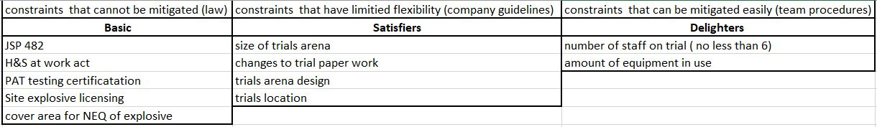
Figure 3- Kano Table of Constraints
Developing Options
While systems engineering is highly effective at bringing together different elements to achieve a common goal, it is important to ensure that each element has been assessed correctly and the best option for that given element is selected. It is also important to ensure that impacts on other elements/sub-systems or components within the overall master system are understood and acceptable. The development of options, whilst relevant throughout the life cycle of a system, can be considered most important within its earliest stages as seen through the SIMILAR method of system delivery, namely “investigating alternatives” as seen in Figure 1 - SIMILAR diagram [2]. It is similarly important to conduct re-evaluation of any options at every stage of a systems development so as to ensure that all relationships between various sub systems and components are understood. This will provide additional information to the management of risk.

Pugh Matrix
A Pugh matrix also known as a criteria-based matrix helps to determine which, in this case, options are more important or “better” than others [5].
A Pugh matrix was built and completed in order to assess the best instrumentation options for the customer requirements. Below is a matrix detailing the list of options identified for the customer’s requirement to measure fragmentation velocity at 0 – 1m from the charge. Through the use of a Kano method the customer also identified an additional requirement to view the initial break-up of the charge and the forming of fragmentation. This was added to the Pugh matrix to further inform on the selection of the best option.
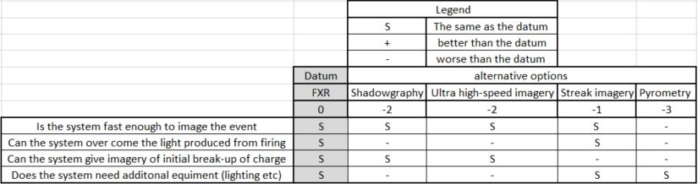
Figure 4- Pugh Matrix
As shown in Figure 4- Pugh Matrix the datum was not exceeded and none of the selected options have scored a positive total therefore the datum was considered to be the best option for this particular requirement. By carrying out this methodology it was possible to not only select the best technique for the requirements, but also highlight the second best, further allowing redundancy to be built into the system. A Pugh matrix could carried out for each component of the trial in order to guarantee the best techniques and procedures were selected for any given task/operation. These Pugh matrixes also inform the design and concept phase of a systems build and can be folded into the needs analysis in order to assist with the formation of robust arguments to stakeholders and customers.
Assessing and managing risk
The objective of the management of risk is to reduce potential risk to an acceptable level. It is desirable to remove risk from a process entirely however it is accepted that this is rarely achievable in realistic circumstances. Beyond simple hazards to humans, risk of property damage/destruction as well as the failure of the system to meet its objectives can also be characterised as a risk factor. Accepting that failures within the system are a risk, several tools, techniques and methods can be applied to a system in order to identify, not only where risk areas may exist, but also the cause of this risk and its effects. Root Cause Analysis is one such methodology that was utilised for the purposes of this assignment.

Root Cause Analysis
The driving goal of root cause analysis (RCA) is to identify the underlying source of a failure so that the correct, and best, solution can be identified and implemented [6]. Through this, risk can be managed by constant use of RCA as a RCA does not need to be carried out once a failure has occurred, but rather as a theoretical assessment of the components of a system process. RCA is an umbrella term that governs several assessment tools, one such tool is the five why or 5W approach. This asks a series of why statements through the fault finding process, for example if a car does not start, the why statement would result in an investigation through the cars ignition system. See Table 1 - Five Why Analysis for an analysis of a failure observed on the explosive trial. While a five whys technique permits the author to find the root cause of the problem it does not permit for the documentation of all the potential failures that have been identified through the process. The construction of a tree diagram will allow for this while providing clear lines following the actual cause once found.

Table 1 - Five Why Analysis
Why 1 | Why 2 | Why 3 | Why 4 | Why 5 – final solution
Fragments produced by charge are larger than anticipated | Charge case is thicker than specification | Need for thickness comes from need to fill case correctly | Explosive selected for fill has different flow rate of that in specification | Specification was not followed at the beginning of the process.

FMEA – Failure Modes Effect Analysis
Another tool widely used is the assessment of risk with regard to failure is a Failure Modes Effects Analysis. This allows the systems engineer to assess what could fail, what a type of failure this would be and what this failure would impact, and further allows the assessment of how this potential failure can be mitigated or prevented entirely. [7]
An FMEA enables to visualisation of all potential failure points within a component or system as a whole. It further allows for recommendations or design controls that will mitigate a particular failure to be identified while also scoring the failure results. This enables the user to build a prioritisation of which failures will be “hard” and result in a complete systems failure or “soft” and result in a partial or local failure. For example the failure of a high speed camera lens experienced on the trial resulted in a soft failure as that lens only affected that camera and not the trial as a whole. While the failure of the firing system could be determined to be a hard failure as it resulted in the trial being halted until another pack could be brought up.
Table 2 - FMEA Example
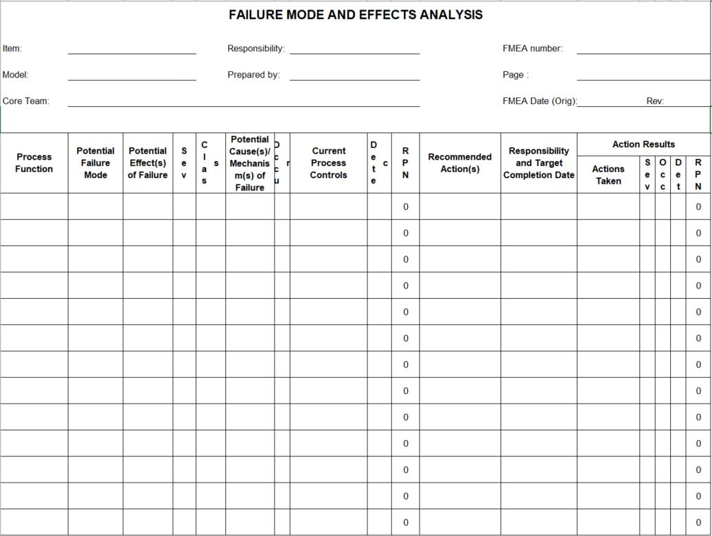

Other Types of Risk and Their Management
It is estimated that approximately 80% of all accident/incidents are caused by human factors. [8] Human error being defined as an action or decision that was not intended, which involved a deviation from an accepted standard, and which led an undesirable outcome. [8] Risk to people such as staff and employees is typically managed through the use of training, procedure and Risk Assessments. Risks were identified with the use of the Shadowgraphy technique deployed to the trial in order to meet and exceed customer requirements, namely the basic “want” of the customer to capture velocity data from fragmentation and further to capture rotational and or yaw speed measurements. The Shadowgraphy system utilised a high output Xenon arc lamp as a light source. This source has the potential to provide damaging levels of UV radiation to the user and surrounding staff and therefore a comprehensive risk assessment was developed for the use of this equipment on a trial. Staff also had to be trained in the safe use of the equipment and further required to attend and pass the internally provided Artificial Optical Radiation course. This equipment’s risk assessment, as well as the staff certification, were added to the overall trial risk assessment in order to allow all staff present on the trial to read and understand the risks that may be involved when working around this particular piece of equipment.

Conclusion

In conclusion, the systems engineering principles applied to the development and delivery of the energetic trial provided a positive impact. The use of Need Analysis enabled the customer to build a set of robust initial requirements and further allowed for the teams involved in the delivery of the trial to assess these requirements against potential solutions. Culminating in a QFD house of quality table that enabled the teams to highlight which techniques might impact one another resulting in the initial concept design meeting all requirements fully.
The constant development of options permitted the trials team to compare and select the best equipment for the customer requirements they wanted to meet. This further allowed for redundancy to be built into the trial as the Pugh matrix used highlighted the second best technique for that requirement. Kano diagrams enabled the identification of constraints and additionally which constraints could be overcome. While FMEA’s and Root Cause Analysis methodology was deployed throughout the process in order to resolve where the failure points might have presented, as well as how these might have been overcome. This information was fully documented in the trials overarching risk assessment and trials plan along with other relevant documentation such as the shadowgraph risk assessment. This gave the trials team, responsible for the delivery of the trial, the ability to identify areas of potential failure and provide mitigations before these could negatively impact the deliverables of the trial.

References

[1] | INCOSE - International Council on Systems Engineering , “incose.org/about-systems-engineering,” INCOSE, [Online]. Available: https://www.incose.org/about-systems-engineering. [Accessed 06 July 2020].
[2] | T. B. a. F. Dean, “What Is Systems Eningeering?,” Universtiy of Arizona , 15 January 2009. [Online]. Available: http://sysengr.engr.arizona.edu/whatis/whatis.html. [Accessed 06 July 2020].
[3] | Y. Akao, “Development History of Quality Function Deployment",” Minato, Tokyo, 1994.
[4] | ISIXSIGMA, “issixsigma,” isixsigma, copyright 2000 - 2020. [Online]. Available: https://www.isixsigma.com/dictionary/kano-analysis/. [Accessed 08 07 2020].
[5] | ISIXSIGMA, “I SIX SIGMA,” ISIXSIGMA, Copywrite 2000-2020. [Online]. Available: https://www.isixsigma.com/dictionary/pugh-matrix/. [Accessed 08 07 2020].
[6] | ISIXSIGMA, “ISIXSIGMA,” I SIX SIGMA, copyright 2000 - 2020. [Online]. Available: https://www.isixsigma.com/tag/root-cause-analysis/. [Accessed 10 07 2020].
[7] | University of Cambridge - IFM - Management Technology Policy , “ifm.eng.cam.ac.uk,” University of Cambridge, 2016. [Online]. Available: https://www.ifm.eng.cam.ac.uk/research/dmg/tools-and-techniques/fmea-failure-modes-and-effects-analysis/. [Accessed 2020 07 10].
[8] | RMS, A Study Book for the NEBOSH National General Certificate, Stourbridge: RMS Publishing , 2019.

