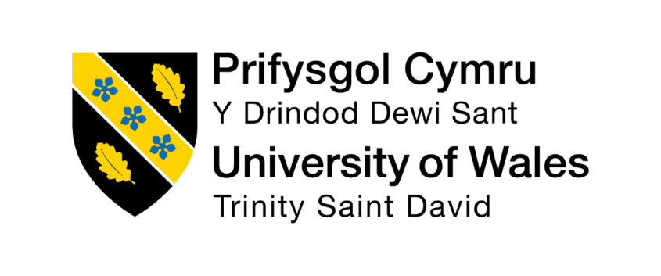

UNIVERSITY OF WALES TRINITY SAINT DAVID
Module: Marketing Management (LCMB7024)
Master of Business Administration
Assessment Component 1: Individual Report

Internal Verifier: Vasilios Tavlaridis, Hoang Nguyen
Lecturer: Taonga Kaonga Sobere-Snithers
Student ID: 2540224
Student Name: Naveen Donakanti
A Strategic Report on the Marketing Environment
Marketing Environment Analysis

Table of Contents
Task 1: Marketing Environment Analysis 3
1.1 Introduction to Codelco and the Marketing Environment 3
1.2 The Natural Environment Actor 3
1.3 The Political Environment Actor 5
1.4 Interplay and Implications for Lower-Carbon Transition 6
Task 2: Strategic Growth and Competitive Positioning 7
2.1 Key Insights from Environmental Analysis 7
2.2 Application of the Ansoff Matrix 7
2.3 Recommended Strategy: Product Development and Market Development 8
2.4 Achieving Competitive Advantage 9
2.5 Implementation Considerations and Risks 9
Task 3: Critical Reflection on AI Usage 10
3.1 Tool Disclosure 10
3.2 Critical Evaluation of AI Output 10
3.3 Contribution Analysis 11
3.4 Ethical and Professional Reflection 11
References 12

Task 1: Marketing Environment Analysis

1.1 Introduction to Codelco and the Marketing Environment
Codelco has a number of large and mature mines such as chuquicamata, el teniente, and andina and radomiro Tomic. Over the last years it has been able to sustain copper production of about 1.33 million tonnes annually though production has some operational strains (Reuters, 2026). The company aims at cutting the Scope 1 and 2 emissions by 70 percent at a 2019 level, the Scope 3 emissions intensity by 25 percent, the renewable electricity supply to 100 percent by 2030, and the carbon and neutrality by 2050 (Codelco, 2025a). These targets are directly responding to the macro environment forces. The macro-environment, in marketing terms, entails Natural Environment and Political Environment that has a profound effect on the companies in the resource-consuming markets (Kotler et al., 2024). Such two players are particularly critical in the case of Codelco due to the company location and ownership structure coupled with the contribution of its products to the process of global decarbonisation.

1.2 The Natural Environment Actor
The closest and most material limitation to the operations and the transition pathway of Codelco is the Natural Environment. The Atacama Desert located in Northern Chile is among the driest on Earth, and mining operations are fighting with communities and ecosystems over limited water resources (Akchurin, 2025). Physical risks such as extended droughts, heavy rainfall, high temperatures and linked floods or avalanche risks are becoming more significant due to climate change. The hazards directly influence the continuity of production, the stability of tailings and infrastructure resiliency (Codelco, 2025a).
Water management has thus been made a strategic priority. Codelco has estimated a decrease by 12% in the unit on the total continental water used compared to the 2019 base as reported and has established a target another 60% by 2030 in high stress basins (Codelco, 2025a). A large-scale desalination and recirculation infrastructure are keys to progress. Desalination investment is technically feasible but has major obstacles due to high-cost capital, energy-intensive and social norms in water-starved places (Fitzsimons and Warren, 2024). The historical accounts of Chilean copper mining confirm that a lack of water has been an incentive to technological and managerial solutions, such as dense tailings and the replacement of seawater, since ancient times (Leiva González and Onederra, 2022).
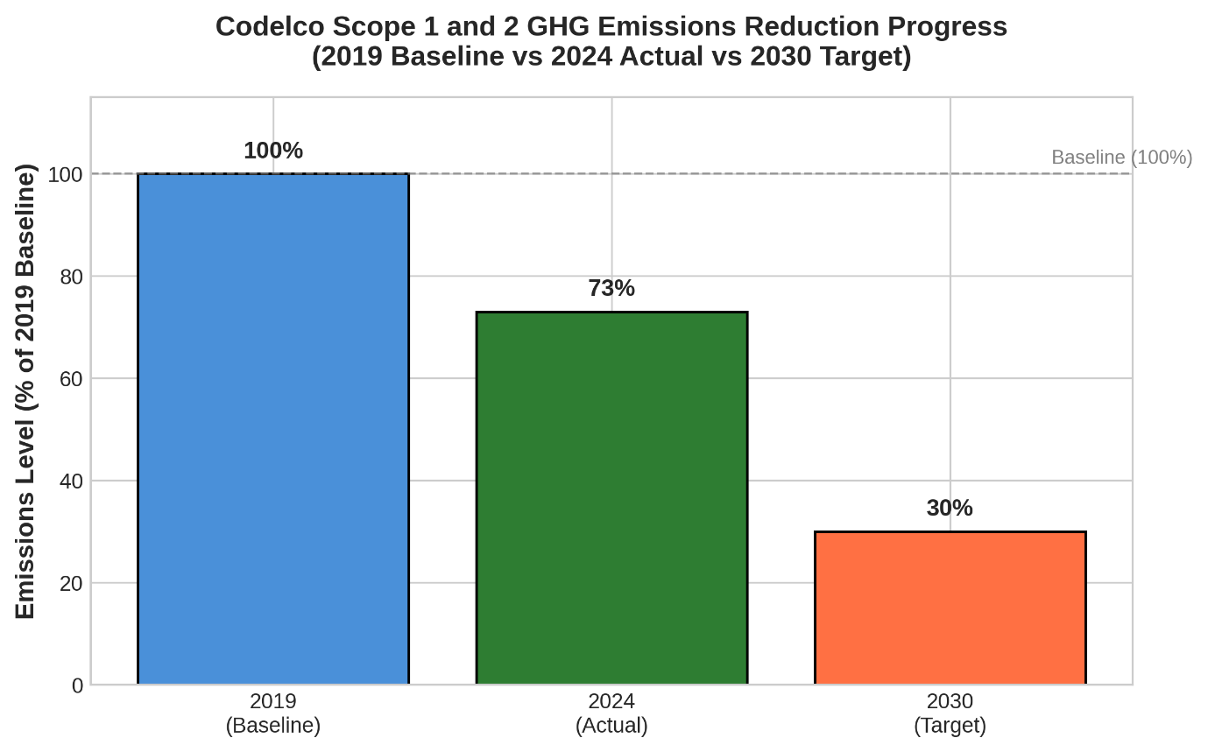
Figure 1 Codelco Scope 1 and 2 GHG Emissions Reduction Progress (2019 Baseline vs 2024 Actual vs 2030 Target)
Source: (Codelco, 2025a)
Other than operational risks, there is the Natural Environment which opens market opportunities. The energy transition is redefining global copper demand and customers are now asking to receive metal that has been produced in a responsible manner and which does have a proven lower embedded emission (Biancardi et al., 2025). In response, Codelco has gained corporate carbon footprint certification via HuellaChile, as well as product-level certification of selected cathodes, and full CopperMark accreditation of its operations (Codelco, 2025a; The Copper Mark, 2024). The credentials enable the company to make its copper a contributor to global decarbonisation efforts and not a deterrent.
More importantly, though, the Natural Environment is a demanding trade-off. The costs of desalination facilities, the renewable energy systems and their emissions -cutting systems are matched with the necessity of significant structural investments to combat low ore grades and aging facilities. Lack of effective management of these pressures may limit the level of production and the social licence to operate in communities where water stress and environmental conflict are already widespread (Akchurin, 2025).
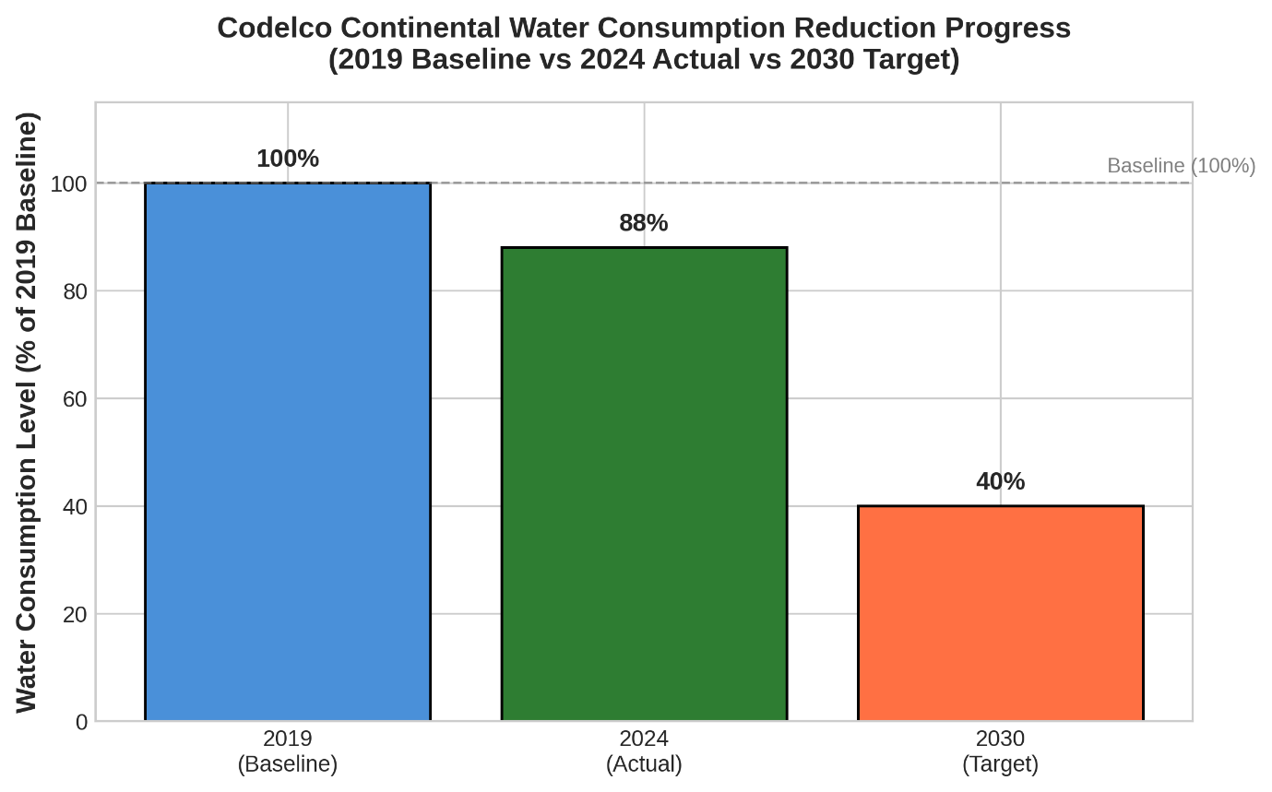
Figure 2 Codelco Continental Water Consumption Reduction Progress (2019 Baseline vs 2024 Actual vs 2030 Target)
Source: (Codelco, 2025a)

1.3 The Political Environment Actor
Political Environment is also a significant factor that has impact to the strategic direction of Codelco. The company is a state-owned enterprise and hence it is directly supervised by the government and significantly contributes in the development of the Chilean economy. As a result, the decisions of investment, the sustainability efforts and long-term corporate goals are highly dependent on political priorities.
The country of Chile has developed ambitious climate policies that help with the process of decarbonisation in the country and the development of the economy. The above policies establish the expectation that large industrial organisations would contribute to the greenhouse gas reduction targets, as well as enhancement of the environmental performance. In the case of Codelco, the alignment to these aims is necessary as the company is supposed to be a leader in responsible mining activities and at the same time create economic value to the nation (Codelco, 2025a).
The government regulations also influence the operations activities due to the requirement of environmental permitting, the emissions controls and water management policies. The nature of mining projects is also undergoing the scrutiny of stringent environmental tests as there is increasing concern on how resources are consumed and environmental issues by the populace. Adherence to these laws tends to raise costs of operation and complexity of the project. Nevertheless, regulatory pressure could either enhance the innovation and pursuit of cleaner technology that would enhance their ability to remain competitive in the long term (Akchurin, 2025).
The political environment also affects the expectations of the stakeholders. There is an increasing pressurising of the mining companies to be transparent, accountable and environmentally responsible by communities, regulators and non-governmental organisation. Being a government-owned company, Codelco is subjected to a considerably great degree of scrutiny since its operations are usually perceived to represent the national priorities and values. Under-performance may cause corporate reputations and undermine the confidence of the population.
There is the impact of the international politics on the strategic decision making. Increasing security issues over critical minerals have made countries producing copper of strategic interest. Governments and industrial clients are turning to sources of well-known production of copper that can be used to complement energy transition goals. Codelco can be at the forefront of these developments by becoming a member of global organisations and following the accepted standard of sustainability, which will help the company keep its image as a responsible producer (ICMM, n.d.).
Nevertheless, a conflict of interest can occur between the economic and environment interests. Any political pressure to retain production levels and create fiscal revenues can at times be in conflict with long-term sustainability investments, which demand huge expenditure and lengthy implementation times. Striking these conflicting ends is an issue that the company is still grappling with.

1.4 Interplay and Implications for Lower-Carbon Transition
Both the Natural and Political environments are closely linked. Water shortage and physical risks of climate (Natural) have encouraged more stricter national regulations (Political) and increased social demands (Social). On its part, the political requirements and global regulations quickens the Codelco spending on renewable energy, desalination and emissions control. This interplay generates urgency and opportunity. On the one hand, the limited resources and regulatory demands increase expenses and complexity in operations, when production is under a headwind (Reuters, 2026). However, effective management of these pressures will allow Codelco to position its copper as metals that promote and not hinder decarbonisation by gaining verified sustainability credentials and fully meeting worldwide demand (Biancardi et al., 2025; Rabbani et al., 2025).
Shifting to products with lower carbon content is hence not merely a technical or environmental problem but a strategic one, crafted between resource conditions and institutional demands. The method of progress reporting as prioritised in the modern scope of marketing becomes crucial in keeping the legitimacy with customers, regulators and communities (Kotler et al., 2024).

Task 2: Strategic Growth and Competitive Positioning

2.1 Key Insights from Environmental Analysis
The environmental analysis indicates that Codelco is in a difficult and yet an opportunity-filled environment. Rising demand driven by sustainable copper creates good growth opportunities, lack of water, climate risks and regulatory pressures in the business present big operational challenges. Emission cutting, renewable energy, and environmental certification activities that the company has made, are signs that it has been making progress in regards to its sustainability goals and enhancing market placement (Codelco, 2025a).
These results imply that the following growth plans must be based on the exploitation of sustainability efforts as the competitive advantage source and the constrained environment and regulations.

2.2 Application of the Ansoff Matrix
Ansoff Matrix is an effective approach to assess strategic growth opportunities, analyzing the product-market relationships. Four tactics are Market Penetration, Market Development, Product Development and Diversification (Kotler et al., 2024).

Table 1: The Ansoff Matrix Growth Strategies
 | Existing Products | New / Enhanced Products
Existing Markets | Market Penetration Focus on increasing sales of current copper to existing customers through pricing, volume or loyalty. | Product Development Enhance or certify existing copper with lower embedded carbon, traceability and stronger ESG credentials.
New Markets | Market Development Enter new geographic or customer segments (e.g., European and North American green manufacturers) with current copper offerings. | Diversification Move into unrelated products or industries (high risk for a specialised mining SOE).
Adapted from Kotler et al. (2024)
In Codelco case, Market Penetration has a low growth prospectivism since an organisation has already assumed dominant positions in the world copper markets. Diversification would deal with the venture into new sectors that are unknown and hence would be very risky. Therefore, Product Development and Market Development are the most suitable strategic choices.

2.3 Recommended Strategy: Product Development and Market Development
The approach that is suggested is a Product Development and Market Development strategy since it coincides with the opportunities in the environmental analysis.
Product Development entails refinement of the existing copper products in terms of the production of products of less carbon, better traceability measures and better sustainability statements. Instead of radically transforming its product lineup, Codelco has an opportunity to differentiate and position itself as an existing product with reduced embedded emissions, and responsible sourcing can create the image. The investments in the renewable energy sources, emission technologies and circular economy developments complement this goal and make products more appealing to the sustainability-oriented customers (Rabbani et al., 2025).
Another strength of the company that it can build this core strength is Market Development by investing in new customer segments, and geographic markets in which sustainability factors have a strong and defining role on a purchasing decision. The industry suppliers dealing in renewable energy business, electric vehicle, electric vehicle, and other high-end electronics demand suppliers who can show that they are environmentally responsible across the supply chain. The industries are appealing growth opportunities since the demand of copper will continue to grow in the coming days as countries across the globe endeavor to decarbonize (Biancardi et al., 2025).
In integrating Product Development, as well as, Market Development, Codelco can generate value more, even as it sticks to its core competencies, which ensures its copper production.

2.4 Achieving Competitive Advantage
The identified strategy will facilitate a differentiation advantage placing Codelco as a suitable supplier of a responsibly produced copper needed to global decarbonisation. Differentiation is possible based upon proven sustainability credentials which not only meet customer and regulatory expectations, but surpass them, which could result in preferred-supplier status and less volatile commercial relations. The ownership of states and volume of production also helps the company provide supply security otherwise not introducible by many competitors in the realm of privatization. Codelco has the opportunity to transform environmental pressures into competitive strengths instead of liabilities by ensuring that water management, adoption and reduction of renewable energy, and the adoption and reduction of emissions are a part of its core services (Rabbani et al., 2025; Cotrina et al., 2026).
This standing also promotes sustainability. High-carbon or high-water-risk producers are progressively being punished by customers and investors, and those that can show plausible transition pathways rewarded. With proper execution, such as continually delivering, Codelco can reap the benefits of early success in certifications and investment in infrastructure.

2.5 Implementation Considerations and Risks
Implementation involves meticulous prioritization of capital ventures in decarbonisation, water facilities and infrastructure mine undertakings. Powerful data platforms and third-party certification will be critical to support lower-carbon assertions and keep up with a more advanced customer base. Active interaction with the impacted communities through water consumption and emissions has been essential in maintaining social licence, especially when conflicts have been reported in the Atacama region (Akchurin, 2025).
Execution delays in key projects, technological or financial overruns, and even changes in political priorities are key risks that may impact the continuity of investment. Financial flexibility can also be limited by the commodity price volatility. These dangers emphasize the need to use staged implementation, effective governance and transparent communication of the successes and other challenges during the transition.

Task 3: Critical Reflection on AI Usage

3.1 Tool Disclosure
The application of Artificial Intelligence (AI) was limited and controlled when preparing this report. Specifically, ChatGPT (OpenAI, 2025) were applied to assist early research works and the proofreading process. In the research phase, AI was able to help in finding the pertinent academic literature, sustainability reports and the industry materials that are pertinent to Codelco, copper mining, and decarbonisation. This contributed to the effectiveness of searching the possibly useful materials to develop some further studies.
Moreover, AI was employed to scan the parts of the report reviewing grammar, sentence framework, spelling, and general readability. The author reviewed and revised the final wording, structure and academic contents but included them in the report. The final submission had no copied AI-generated content without verification and alteration.

3.2 Critical Evaluation of AI Output
AI can be useful in terms of support in research and proofreading; however, the products obtained cannot be regarded as accurate and reliable. The quality of this report was secured by checking all information that was revealed with the help of AI-based studies in the various original academic articles, company-based reports, and other credible publications in the industry, which are mentioned in the reference list.
Extra careful attention was perceived in fact checking statements, publication, statistics and organisational sustainability goals. Deep learning generated summaries in other cases were not contextualized or just included the key points. Such limitations were overcome with references to the original sources and interpretation of the evidence on their own. This validation process aided in minimizing the chances of errors of inaccuracies, misinterpretation or AI delusions causing the end report.

3.3 Contribution Analysis
The ultimate report presents more of a personal production of the author. The choice of the Codelco as the case organisation and the presence of the Natural Environment as well as Political Environment as the important players in the marketing environment, critical analysis of the opportunities and problems, and strategy formulation with reference to the Ansoff Matrix were all created at the author level.
The AI helped in source discovery and proofreading. The author carried through the analysis, evidence interpretation and evaluation of the environmental factors and justification of strategic recommendations after reviewing related literature as well. Therefore, the critical arguments, conclusions as well as general structure of the report constitutes the personal academic opinion of the author.

3.4 Ethical and Professional Reflection
Ethical and professional implications are critical in terms of the application of AI in academic work. Although AI could help to fight incompetence and aid the learning process, an over-dependence on AI can undermine critical thinking and lower academic integrity. It is thus significant to ensure that AI is employed with caution as an auxiliary device and not to replace independent analysis.
This evaluation proved that AI is potentially useful in search of information and enhancement of the written communication provided they are used properly. Nevertheless, the responsibility of the accuracy, quality and originality of the work is still the responsibility of the student. Being transparent about the usage of AI and ensuring that all information is validated through reliable sources are two crucial aspects of conducting business. Therefore, AI was applied in this report in a minimal, ethical and responsible way to enhance and not to substitute independent academic research and critical thinking.

References
Akchurin, M. (2025) ‘Mining, water conflicts, and climate change in Chile’s Atacama Desert’, Current History, 124(859), pp. 61–67. Available at: https://doi.org/10.1525/curh.2025.124.859.61 (Accessed: 24 June 2026).
Becerra, P., Mula, J., Sanchis, R. and Campuzano-Bolarín, F. (2024) ‘Simulation optimisation of a sustainable copper mining closed-loop supply chain’, International Journal of Systems Science: Operations & Logistics, 11(1). Available at: https://doi.org/10.1080/23302674.2024.2311285 (Accessed: 24 June 2026).
Biancardi, A., D’Adamo, E.I. and Varela, F. (2025) ‘A flexible and circular management of copper in Chile: New perspectives toward sustainable development’, Global Journal of Flexible Systems Management. Available at: https://doi.org/10.1007/s40171-025-00464-w (Accessed: 24 June 2026).
Codelco (2025a) Climate Change Report 2025. Available at: https://www.codelco.com/prontus_codelco/site/docs/20251002/20251002120038/climate_change_report.pdf (Accessed: 24 June 2026).
Codelco (2025b) Sustainability Report 2024. Available at: https://www.codelco.com/prontus_codelco/site/docs/20250610/20250610162815/250717_codelco_alta.pdf (Accessed: 24 June 2026).
Cotrina, M., Marquina, J., Rodríguez, B. and Vargas, J. (2026) ‘Electricity and sustainable innovation in copper mining and processing: A bibliometric analysis and systematic literature review’, International Journal of Mining and Mineral Engineering, 17(1), pp. 73–95. Available at: https://doi.org/10.1504/IJMME.2026.152398 (Accessed: 24 June 2026).
Fitzsimons, E. and Warren, P. (2024) ‘Desalination investment for copper mining: Barriers and opportunities in Chile’, The Extractive Industries and Society, 17, p. 101449. Available at: https://doi.org/10.1016/j.exis.2024.101449 (Accessed: 24 June 2026).
International Council on Mining and Metals (ICMM) (n.d.) Codelco. Available at: https://www.icmm.com/en-gb/our-story/our-members/company-members/codelco (Accessed: 24 June 2026).
Kotler, P., Armstrong, G., Harris, L.C. and He, H. (2024) Principles of Marketing. 19th edn. Harlow: Pearson.
Leiva González, J. and Onederra, I. (2022) ‘Environmental management strategies in the copper mining industry in Chile to address water and energy challenges—Review’, Mining, 2(2), pp. 197–232. Available at: https://doi.org/10.3390/mining2020012 (Accessed: 24 June 2026).
Lu, T., Chen, W.-Q., Ma, Y., Qian, Q. and Jia, J. (2023) ‘Environmental impacts and improvement potentials for copper mining and mineral processing operations in China’, Journal of Environmental Management, 342, p. 118178. Available at: https://doi.org/10.1016/j.jenvman.2023.118178 (Accessed: 24 June 2026).
OpenAI (2025) ChatGPT (Version GPT-4o). Available at: https://chat.openai.com (Accessed: 24 June 2026).
Rabbani, M., Nikfar, S., Mousavinezhad, S., Nili, S., Fahimi, A., Nesbitt, C. and Vahidi, E. (2025) ‘Sustainable copper mining: A pathway to emission reduction through renewable energy’, Environmental Science: Advances. Available at: https://doi.org/10.1039/D5VA00043B (Accessed: 24 June 2026).
Reuters (2026) ‘Codelco monthly output dives, sowing doubts about validity of end-2025 production’, 17 March. Available at: https://www.reuters.com/world/americas/codelco-monthly-output-dives-sowing-doubts-about-validity-end-2025-production-2026-03-17/ (Accessed: 24 June 2026).
The Copper Mark (2024) Assessment Summary Report – Codelco Division Gabriela Mistral – Follow-up. Available at: https://coppermark.org/wp-content/uploads/2024/12/CopperMark_AP_Codelco_DivisionGabrielaMistral-_Followup_2024.12.20.pdf (Accessed: 24 June 2026).

