LCHS7006
Quality Asurance and Service Improvements
Service Improvement Report: Mid Staffordshire NHS Foundation Trust
Student Name | MD AKTARUJJAMAN
Student ID | 2512989
Programme | MSc Public Health and Social Care in Practice
Module Lecturer | Dr Fahad Khan
Assignment | Component 2: Service Improvement Report

Table of Contents
1. Introduction and case background 3
2. Quality assurance and service improvement context 3
3. Donabedian analysis of the case 4
4. Fishbone analysis and root causes 5
5. SWOT analysis 6
6. PDSA (Plan-Do-Study-Act) cycle 7
7. Kotter’s 8-step change model 8
8. Recommendation 8
8.1 Benchmarking table 8
9. Conclusion 12
References 14

1. Introduction and case background
The area of severe quality failure is evident in Mid Staffordshire NHS Foundation Trust in the UK. The patients were receiving poor basic care, unattended degradation, unaddressed complaints, and avoidable damage, and the governance and leadership were inadequately responding to the issue between 2005 and 2009 (Francis, 2013). The case itself is very relevant since it demonstrates how the poor care can be normalised by the weak assurance systems instead of being detected and corrected.
Quality assurance Health and social care Quality assurance is the planned application of standards, monitoring, accountability, and improvement to ensure that care remains safe, effective, responsive, and person-centred. It relies not only on compliance: organisations need to process safety signals, implement concerns, and maintain learning throughout the service (Donabedian, 1988; Institute of Medicine, 2001).
Other implications of the case on subsequent reform of the NHS encompassed increased expectations on candour, speaking up, accountability of boards, and safety intelligence. Mid Staffordshire is thus not just a historical scandal but it is a lesson as to what can occur when performance management is not connected to quality of care (Francis, 2013; National Advisory Group on the Safety of Patients in England, 2013).
This report examines Mid Staffordshire as a service improvement and quality assurance failure. It uses the Donabedian model to analyse structural, process and outcome weaknesses; Fishbone analysis to organise the main root causes; SWOT analysis to assess the wider improvement context; and PDSA with Kotter’s 8-step model to support implementation. The main argument is that lasting improvement depends on stronger board-to-ward assurance, safer staffing and supervision, a more credible speaking-up culture, and more reliable organisational learning.

2. Quality assurance and service improvement context
Quality assurance is more extensive than audit or inspection. It links standards, measuring, leading, accountability, and continuous improvement and can only be successful when organisations act on the issues and not gather data (Donabedian, 1988; Dixon-Woods, 2016).
Mid Staffordshire demonstrates why assurance cannot be narrowed down to target conformity. Francis (2013) established that the focus shifted to finance, access goal and the Foundation Trust status as patient experience and warning signs were demoted. This contributes to the bigger claim that formal controls may fall short under the condition that the leadership is more concerned with organisational achievement, rather than with the quality of care (Mannion and Davies, 2018).
Another lesson is that assurance should be the integration of both quantitative and qualitative intelligence. Mortality indicators, complaints, staffing data, and staff concerns were all providing partial warnings but not being assembled fast enough to cause an action. Successful assurance is thus reliant upon triangulation, curiosity and the desire to consider frontline issues as a real indication of danger (Gillespie and Reader, 2018; Schleyer et al., 2016).

3. Donabedian analysis of the case
The Donabedian model is a powerful point of departure since it connects the system design to the care delivery and outcomes. In this case, structural weaknesses were board priorities that placed organisational objectives ahead of patient safety, poor governance supervision, systematic staffing strain, and psychological safety of staff to report (Donabedian, 1988; Francis, 2013; Lawless, Couch and Griffiths, 2019).
These organisational loopholes gave rise to unsafe procedures. The hydration and nutrition, hygiene or the timely observation of the patients were not always supported, the complaints were not used as the learning opportunity, and the incident, audit, and mortality information was not effectively escalated and triangulated (Francis, 2013; Gillespie and Reader, 2018).
The results were terrible: injuries, loss of face, unaddressed grievances, mistrust in the community, and a significant fear of dying and declining the quality of care (Francis, 2013). The usefulness of Donabedian in this case is that it maintains focus on the connexion between the weak systems and the poor outcomes as opposed to blaming the case to personal fault.
Donabedian is useful here because it keeps the focus on organisational conditions rather than isolated moral failure. Minimal staffing, poor supervision, weak board scrutiny, and failure to escalate warning data made basic care fragile long before specialist intervention was required. Mid Staffordshire was therefore not only a failure of compassion but a failure in the environment needed to deliver safe, consistent and respectful care.
Table 1. Donabedian analysis of the Mid Staffordshire case
Dimension | Case evidence | Quality implication | Illustrative sources
Structure | Weak board oversight, poor clinical governance, staffing pressure, target-driven priorities | Reduced organisational capacity to detect and respond to risk | Francis (2013); Aiken et al. (2014); NHS England (2016)
Process | Missed basic care, poor escalation, limited use of complaints and incidents, weak staff voice | Unsafe or delayed care processes became normalised | Anderson et al. (2013); Gillespie and Reader (2018); Hughes (2019)
Outcome | Harm, loss of dignity, unresolved complaints, concerns around mortality and deterioration | Patient safety and experience worsened without timely organisational correction | Francis (2013); Donabedian (1988)

4. Fishbone analysis and root causes
A Fishbone analysis systematises the key contributory factors of the quality failure. The key branches in this case include leadership and governance, staffing and skills, culture and staff voice, communication and escalation, measurement and intelligence and operational pressure. The diagram indicates that interacting weaknesses gave rise to the problem and not a single defect.
The focus was on leadership and governance since the board did not have a clear line of sight to quality and take decisive action on warnings. Staffing, skill-mix pressures undermined the supervision and basic care, and cultural issues diminished the confidence of staff to speak up. Simultaneously, intelligence systems were not successful due to complaints, incidents, and mortality signals being not perceived as an emergency pattern of danger (Francis, 2013; Aiken et al., 2014; Mannion and Davies, 2018).
There was also failure in communication and escalation. Red flags were slow in movement, or not moved at all, between wards, managers and the board, and performance pressure strengthened the focus on patient-experience metrics. Fishbone model is great as it allows seeing these interacting causes, but it is still a simplification, and requires reading along with broader evidence regarding culture and implementation (Kumah et al., 2024; Tagaram et al., 2024).
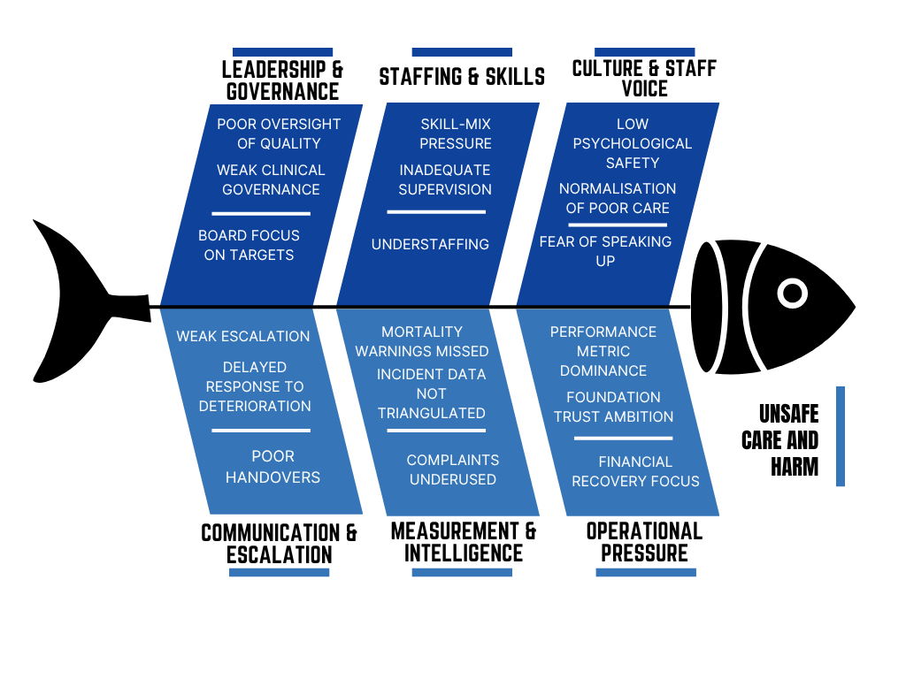
Source: author, based on Francis (2013), Aiken et al. (2014), Mannion and Davies (2018), Mathukia et al. (2015), Schleyer et al. (2016), and NHS England (2022a).

5. SWOT analysis
SWOT analysis can explain the strategic location of service improvement response to this case. One of the strengths is the abundance of inquiry evidence and the articulateness of the lessons that are presently accessible to governance, staffing, speaking up, and mortality review. External opportunities are also clear since post-Francis policy and regulatory expectations are encouraging candour, patient safety learning, and increased board accountability (Francis, 2013; Care Quality Commission, 2025; NHS England, 2022a).
The cultural and operational weaknesses are the primary ones. It is possible to introduce new language to policies without altering the day-to-day practise of large organisations, and the pressure on workforce can even water down improvements effort despite leader support. The primary risk lies in the fact of superficial compliance: in case speaking up, staffing review, and board assurance are not done in a relationship-oriented manner but are done in a procedure-oriented manner, the same blind spots might still be present in another form (Mannion and Davies, 2018; Jones et al., 2022).
Table 2. SWOT analysis for service improvement
Strengths  Rich inquiry evidence; clear lessons on governance, staffing, complaints, and safety; stronger contemporary NHS improvement infrastructure. | Weaknesses  Cultural resistance; inconsistent use of improvement methods; risk of dashboards without interpretation or ownership.
Opportunities  Better triangulation of safety intelligence; stronger candour and speaking-up systems; structured PDSA testing and scaling. | Threats  Workforce pressure, bullying, financial constraint, and competing priorities can weaken improvement sustainability.

6. PDSA (Plan-Do-Study-Act) cycle
The Plan-Do-Study-Act cycle is an iterative improvement method that allows teams to test change on a small scale, review what happened, and adapt before wider spread. It fits this case because Mid Staffordshire showed that policy language and reporting systems do not improve care unless teams can translate lessons into routine practice. In this context, PDSA is stronger than a one-off compliance response because it treats improvement as repeated learning rather than a single corrective event (Taylor et al., 2014; Ogrinc et al., 2021).
A practical PDSA application would be to pilot daily escalation huddles, basic-care checks, and complaint-review triggers on high-risk wards. The plan stage would define measures such as escalation delay, missed-care themes, unresolved complaints, and action completion. The do stage would test the bundle for a short period. The study stage would use run charts and staff and patient feedback. The act stage would standardise, refine, or stop the intervention according to evidence. This disciplined cycle reduces the risk of symbolic reform with no measurable change (Taylor et al., 2014; Reed and Card, 2016).

7. Kotter’s 8-step change model
Kotter’s model addresses the wider leadership and culture work that PDSA alone cannot deliver. For Mid Staffordshire, urgency comes from the scale of avoidable harm and the failure of weak assurance to protect patients. A guiding coalition should therefore include board leaders, nursing and medical leads, governance staff and speaking-up roles. The change vision must be clear that quality and patient dignity take priority over narrow target success, and that bad news will be treated as intelligence rather than threat (Graves et al., 2023; Ravi et al., 2022).
Kotter also helps sustain change by removing barriers, creating short-term wins, and anchoring improved behaviour into routine governance. In practice, this means visible executive sponsorship, safer staffing decisions, protected time for review, feedback to staff who raise concerns, and board monitoring of whether actions are completed. The model is useful here because the Mid Staffordshire failure was cultural and organisational as well as clinical, so change has to reshape expectations and accountability across the whole service rather than at ward level alone (Harrison et al., 2021; Hughes, 2019).

8. Recommendation

8.1 Benchmarking table
The comparison of the historic failure against the governance and safety expectations that are now part of good practise is called benchmarking. It demonstrates how the lack of candour, staffing, escalation, board, and mortality review can be converted into tangible areas of improvement instead of being left as broad lessons (Redinger, 2019; Francis, 2013).
Benchmarking also helps in avoiding the case being handled as a closed historical scandal. Its primary strength is that it poses the question of what modern organisations still need to do to prevent such drift in the face of contemporary challenges like labour scarcity, competitiveness in the target market, and information overload (National Advisory Group on the Safety of Patients in England, 2013; NHS England, 2016).
Table 3. Benchmarking table
Domain | Mid Staffordshire pattern | Current benchmark / expectation | Improvement implication
Openness and candour | Silence, defensiveness, poor response to complaints | Duty of candour requires openness when notifiable incidents occur | Embed candour review into incidents, complaints, and family communication
Speaking up | Staff feared raising concerns and doubted action would follow | National speak up policy and guardians provide formal routes and feedback | Review guardian themes at board level as safety intelligence
Safe staffing | Persistent understaffing and weak ward supervision | Boards should assure the right staff and skills in the right place | Use acuity-informed establishment review and supervisory capacity
Incident response and learning | Complaints, incident data, and warning signs were not triangulated | PSIRF emphasises learning-oriented, systems-based incident response | Integrate complaints, incidents, deterioration events, and mortality review themes
Board accountability | Quality concerns were secondary to targets and organisational ambition | Post-Francis governance expects visible board ownership of quality and safety | Build board-to-ward assurance and track follow-through on action plans
The analysis points to four linked priorities: stronger board-to-ward assurance, safer staffing and supervision, a more credible speaking-up culture, and disciplined implementation. Together they address the structural weaknesses that allowed poor care to persist (Francis, 2013; Ogrinc et al., 2021).
These actions must reinforce one another. Better oversight without safer staffing, or new tools without leadership follow-through, would still leave frontline care exposed.
To start with, the organisation ought to develop a more effective board-to-ward quality assurance mechanism that is founded on triangulated intelligence. Complaints, incident trends, staffing risk, patient experience, and mortality signals should be reviewed by the board on a regular basis as opposed to individually. To enhance line of sight to deteriorating care and reduce the distance between governance and frontline reality, executive walk-rounds, dashboards at the ward level, and enhanced committee escalation can be used (Francis, 2013; Schleyer et al., 2016).
Second, safe staffing, supervision, and dependability of fundamental care ought to be enhanced. This must comprise of acuity informed workforce review, secure leadership ability, and enhanced observation of hydration, nutrition, hygiene, and timely escalation. Staffing is not the only cause of failure, but it has been proven that understaffing and lack of skill mix contributes to the risk of missed care and deteriorated results (Aiken et al., 2014; Halm, 2019; Lawless, Couch and Griffiths, 2019).
Third, the service ought to enhance speaking up, candour and organisational learning. Employees must have easy reporting channels, prompt feedback, observable anti-retaliation measures and the demonstration of concerns resulting in action. The most believable arrangements of Freedom to Speak Up are those associated with regular management behaviour and transparent review procedures and board management instead of a token gesture (Hughes, 2019; Jones et al., 2022; National Guardian's Office, 2025).
Implementation should now follow the PDSA and Kotter approach set out above so that local testing and wider organisational change progress together.
Used together, these methods reduce the risk of announcing reform without changing practice, or running local experiments without organisational backing (Harrison et al., 2021; Ogrinc et al., 2021).
This is more powerful than a pure compliance driven reaction. It was only the trust in information, action and linking the information to the safer staffing and enhanced supervision that would have prevented Mid Staffordshire with more policy or more reporting. The change in staff experience, reliability of escalation, and patient care and the completion of action plans should also be used to assess improvement (Francis, 2013; Dixon-Woods, 2016).
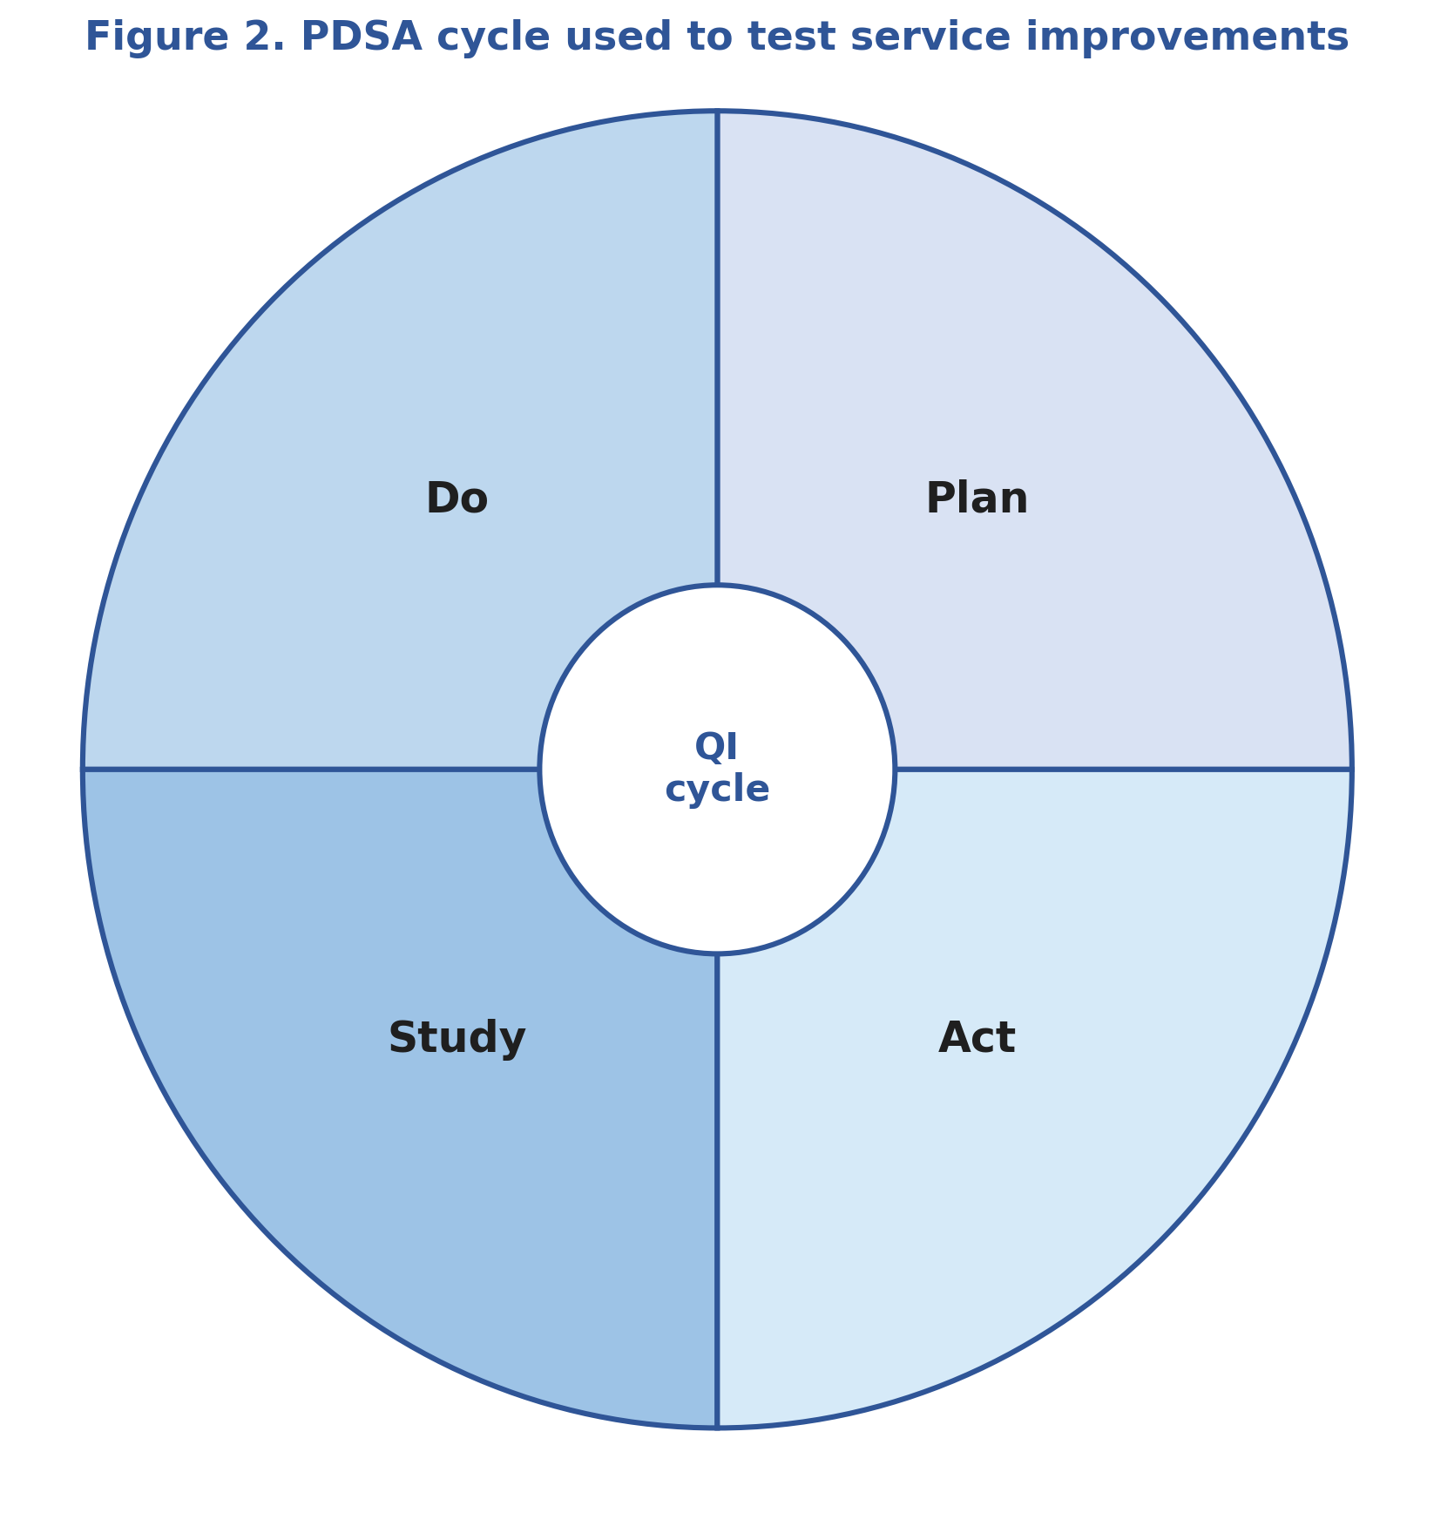
Source: author, adapted from Taylor et al. (2014) and Ogrinc et al. (2021).
Table 4. Priority implementation plan
Priority action | Lead | First 90 days | Measures | Risks / mitigation
Integrated board-to-ward quality dashboard | Chief nurse / medical director | Create one monthly report combining complaints, incidents, staffing, deterioration, mortality, and speaking-up data | Escalation timeliness; repeated theme reduction; action completion | Dashboard overload; mitigate through metric ownership and exception review
Safe staffing and supervisory review | Director of nursing | Review establishment against acuity, protect ward leader time, and introduce daily safety huddles | Fill rate; escalation delays; missed care themes | Workforce shortages; mitigate through phased rollout and escalation controls
Speaking up and candour strengthening | FTSU guardian / HR / quality lead | Refresh policy, simplify routes, guarantee feedback, and review guardian and complaint themes together | Speaking-up confidence; feedback timeliness; candour compliance | Fear of reprisals; mitigate through visible executive sponsorship and feedback
PDSA pilots on high-risk wards | QI lead / ward managers | Run small tests on escalation, a fundamental care bundle, and complaint review huddles | Run charts; completed learning cycles; early wins | Tokenistic PDSA use; mitigate through coaching and documented learning

9. Conclusion
Mid Staffordshire demonstrates that extreme quality failure is a result of the weakening of governance, staffing, culture and learning systems simultaneously. As the case shows, it was not a single mistake but a combination of lax supervision, shaky staffing, lack of spoken concerns, and ineffective utilisation of safety intelligence which made the harm possible (Francis, 2013).
It also indicates that service improvement should not be limited to the retrospective criticism. A higher level of quality assurance implies that organisations perceive the service through the eyes and experience of patients and staff, combine formal and informal intelligence, and act promptly when red flags start to emerge (Gillespie and Reader, 2018; Mannion and Davies, 2018).
The proposed plan thus incorporates board-to-ward assurance, safer staffing and supervision, enhanced speaking-up and candour systems, and disciplined application using PDSA and Kotter. All these actions combined provide a more plausible path to long term betterment compared to individual policy adherence or immediate remedial measures.

References
Aiken, L.H., Sloane, D.M., Bruyneel, L., Van den Heede, K., Griffiths, P., Busse, R., Diomidous, M., Kinnunen, J., Kózka, M., Lesaffre, E., McHugh, M.D., Moreno-Casbas, M.T., Rafferty, A.M., Schwendimann, R., Scott, A., Tishelman, C., van Achterberg, T. and Sermeus, W. (2014) ‘Nurse staffing and education and hospital mortality in nine European countries: A retrospective observational study’, The Lancet, 383(9931), pp. 1824-1830. Available at: https://doi.org/10.1016/S0140-6736(13)62631-8.
Anderson, J.E., Kodate, N., Walters, R. and Dodds, A. (2013) ‘Can incident reporting improve safety? Healthcare practitioners’ views of the effectiveness of incident reporting’, International Journal for Quality in Health Care, 25(2), pp. 141-150. Available at: https://doi.org/10.1093/intqhc/mzs081.
Card, A.J. (2017) ‘The problem with “5 whys”’, BMJ Quality & Safety, 26(8), pp. 671-677. Available at: https://doi.org/10.1136/bmjqs-2016-005849.
Care Quality Commission (2025) Regulation 20: Duty of candour. Available at: https://www.cqc.org.uk/guidance-regulation/providers/regulations-service-providers-and-managers/health-social-care-act/regulation-20.
Dixon-Woods, M. (2016) ‘Does quality improvement improve quality?’, Future Hospital Journal, 3(3), pp. 191-194. Available at: https://doi.org/10.7861/futurehosp.3-3-191.
Dixon-Woods, M., McNicol, S. and Martin, G. (2012) ‘Ten challenges in improving quality in healthcare: Lessons from the Health Foundation’s programme evaluations and relevant literature’, BMJ Quality & Safety, 21(10), pp. 876-884. Available at: https://doi.org/10.1136/bmjqs-2011-000760.
Donabedian, A. (1988) ‘The quality of care: How can it be assessed?’, JAMA, 260(12), pp. 1743-1748. Available at: https://doi.org/10.1001/jama.260.12.1743.
Francis, R. (2013) Report of the Mid Staffordshire NHS Foundation Trust Public Inquiry. Available at: https://www.gov.uk/government/publications/report-of-the-mid-staffordshire-nhs-foundation-trust-public-inquiry.
Gillespie, A. and Reader, T.W. (2018) ‘Patient-centered insights: Using health care complaints to reveal hot spots and blind spots in quality and safety’, The Milbank Quarterly, 96(3), pp. 530-567. Available at: https://doi.org/10.1111/1468-0009.12338.
Graves, L., Doucet, S., Larivière-Bastien, D. and Thériault, A. (2023) ‘Creating change: Kotter’s Change Management Model in action’, Canadian Medical Education Journal, 14(3), pp. 136-139. Available at: https://doi.org/10.36834/cmej.76680.
Halm, M. (2019) ‘The influence of appropriate staffing and healthy work environments on patient and nurse outcomes’, American Journal of Critical Care, 28(2), pp. 152-156. Available at: https://doi.org/10.4037/ajcc2019938.
Harrison, R., Fischer, S., Walpola, R.L., Chauhan, A., Babalola, T., Mears, S. and Le, A. (2021) ‘Where do models for change management, improvement and implementation meet? A systematic review of the applications of change management models in healthcare’, Journal of Healthcare Leadership, 13, pp. 85-108. Available at: https://doi.org/10.2147/JHL.S289176.
Hughes, H. (2019) ‘Freedom to speak up: The role of freedom to speak up guardians and the National Guardian’s Office in England’, Future Healthcare Journal, 6(3), pp. 186-189. Available at: https://doi.org/10.7861/fhj.2019-0031.
Institute for Healthcare Improvement (2024) 5 Whys: Finding the root cause. Available at: https://www.ihi.org/library/tools/5-whys-finding-root-cause.
Institute of Medicine (2000) To err is human: Building a safer health system. Available at: https://www.ncbi.nlm.nih.gov/books/NBK225182/.
Institute of Medicine (2001) Crossing the quality chasm: A new health system for the 21st century. Available at: https://doi.org/10.17226/10027.
Jones, A., Kelly, D., Massey, D., Husang, S., Begley, C., Watkins, E., Pollitt, A. and Martin, G. (2022) Implementation of “Freedom to Speak Up Guardians” in NHS acute and mental health trusts in England: The FTSUG mixed-methods study. Health and Social Care Delivery Research, 10(23). Available at: https://doi.org/10.3310/GUWS9067.
Kumah, A., Yamoah, C.O., Odartey, S., Adohinzin, C., Frimpong, E., Dadzie, R.B. and Boateng, J. (2024) ‘Cause-and-effect (Fishbone) diagram: A tool for generating and organizing quality improvement ideas’, Journal of Healthcare Quality, 46(3), pp. e205-e210. Available at: https://doi.org/10.1097/JHQ.0000000000000425.
Lawless, J., Couch, R. and Griffiths, P. (2019) ‘Towards safe nurse staffing in England’s National Health Service: Progress and pitfalls of policy evolution’, Health Policy, 123(6), pp. 590-594. Available at: https://doi.org/10.1016/j.healthpol.2019.03.011.
Mannion, R. and Davies, H. (2018) ‘Understanding organisational culture for healthcare quality improvement’, BMJ, 363, p. k4907. Available at: https://doi.org/10.1136/bmj.k4907.
Mathukia, C., Fan, W., Vadyak, K., Biege, C. and Krishnamurthy, M. (2015) ‘Modified Early Warning System improves patient safety and clinical outcomes in an academic community hospital’, Journal of Community Hospital Internal Medicine Perspectives, 5(2), p. 26716. Available at: https://doi.org/10.3402/jchimp.v5.26716.
National Advisory Group on the Safety of Patients in England (2013) A promise to learn – a commitment to act: Improving the safety of patients in England. Available at: https://www.gov.uk/government/publications/berwick-review-into-patient-safety.
National Guardian’s Office (2025) Annual report 2024 to 2025. Available at: https://www.gov.uk/government/publications/national-guardians-office-annual-report-2024-to-2025.
NHS England (2016) National Quality Board guidance on safe staffing. Available at: https://www.england.nhs.uk/publication/national-quality-board-guidance-on-safe-staffing/.
NHS England (2022a) Patient Safety Incident Response Framework. Available at: https://www.england.nhs.uk/long-read/patient-safety-incident-response-framework/.
NHS England (2022b) The national speak up policy. Available at: https://www.england.nhs.uk/publication/the-national-speak-up-policy/.
Ogrinc, G., Reed, J.E., Mooney, S.E. and Batalden, P.B. (2021) ‘Different approaches to making and testing change in healthcare’, BMJ, 374, p. n1010. Available at: https://doi.org/10.1136/bmj.n1010.
Pollio, G. and Simonyan, G. (2011) ‘Foundation trust performance: A quantitative study’, British Journal of Healthcare Management, 17(10), pp. 462-469. Available at: https://doi.org/10.12968/bjhc.2011.17.10.462.
Ravi, S., Karpagam, S., Subramanian, S., Koh, W. and Li, J. (2022) ‘Kotter’s 8 stages of change: Implementation of clinical screening protocols for assessing patients for COVID-19 in the pediatric emergency department’, BMJ Leader. Available at: https://doi.org/10.1136/leader-2020-000379.
Reed, J.E. and Card, A.J. (2016) ‘The problem with Plan-Do-Study-Act cycles’, BMJ Quality & Safety, 25(3), pp. 147-152. Available at: https://doi.org/10.1136/bmjqs-2015-005076.
Schleyer, A.M., Perni, S., Li, Y., Dolan, J.G., Song, J., Yu, X., Lin, M., Steinman, M.A. and Gonzales, R. (2016) ‘Preventing hospital-acquired venous thromboembolism: Improving patient safety with interdisciplinary teamwork, quality improvement analytics, and data transparency’, Journal of Hospital Medicine, 11(S2), pp. S38-S43. Available at: https://doi.org/10.1002/jhm.2664.
Scott, T., Mannion, R., Davies, H.T.O. and Marshall, M.N. (2003) ‘Does organisational culture influence health care performance? A review of the evidence’, Journal of Health Services Research & Policy, 8(2), pp. 105-117. Available at: https://doi.org/10.1258/135581903321466085.
Tagaram, S.D., Varacallo, M. and Chu, D.I. (2024) ‘Quality tools and techniques (Fishbone diagram, Pareto chart, and process mapping)’, StatPearls. Available at: https://www.ncbi.nlm.nih.gov/books/NBK607994/.
Taylor, M.J., McNicholas, C., Nicolay, C., Darzi, A., Bell, D. and Reed, J.E. (2014) ‘Systematic review of the application of the Plan-Do-Study-Act method to improve quality in healthcare’, BMJ Quality & Safety, 23(4), pp. 290-298. Available at: https://doi.org/10.1136/bmjqs-2013-001862.

