University of Wales
Trinity Saint David
Community Engagement
Student: Laurentiu Gornic
Student ID: 1817470
Tutor: Christopher Mafuva

Contents
Analytical Report of DSV Global Transport and Logistics 3
Introduction 3
About DSV Global Transport and Logistics 3
Structure and skills found inside the company 4
Pestle Analysis of DSV Global Transport and Logistics 5
Conclusion 6
Appendices: 7
Figure 1: DSV/ Panalpina fusion 7
Figure 2: Global Presence of DSV 8
Figure 3: Strategic areas for developing 9
Figure 4: PESTLE Analysis 10
Figure 5: Training and Development Plan 11
Reference List: 12

Analytical Report of DSV Global Transport and Logistics

Introduction

‘Globalization creates commercial, financial, social, cultural, political and technological cross-border interconnections through trade, investment, migration, and technology (Hamilton and Webster, 2018, p. 4). By analyzing every aspect of globalization, an organization that deals with the transport of goods and serves clients beyond borders, its ability to increase the portfolio, develop new ways in which can improve working conditions and draw the benefits of globalization.
This report aims to present DSV Global Transport and Logistic organization and analyze how is operating through an employee's point of view but also through a structured review about how globalization has succeeded in influencing the success.

About DSV Global Transport and Logistics

DSV is a Danish-based company for transport and logistic founded in 1976 with three areas of coverage:
- Air and Sea transport,
- Road Transport,
- Logistic Department.
The company has managed to grow progressively through the acquisition of other similar companies and ended up in 2016 as the world’s 5th largest company for transport, according to DSV Annual Report 2016 and is listed on Nasdaq Copenhagen (DSV.CO). DSV now owns some of the biggest companies of transport such as UTI World-Wide Inc. since January 2016 and the most recent one Panalpina in April 2019 (Figure 1). This agreement will place DSV at the top of the ranking as global transport organizations with more than 60,000 employees, offices in 90 countries and a pro forma revenue of 118 billion Danish kroner (DSV). This merger will not only create a global company but will provide investment in the development of technological resources and infrastructure improvements over the entire transport sector of the two companies.
Recent educational research ( Hamilton and Webster, 2018) stated that globalization is not yet global in the way that the commerce and trade is divided through four major economic blocs ( E.U., NAFTA, JAPAN, CHINA) and the commercial trade is taking place mainly inside every block , the evolution and geographic spread of DSV is proving the contrary (Figure 2). It is easy to make assumptions without arguments, according to Cottrell (2017, p. 74), but the most recent presentation for investments coming from DVS is proving the wide-scale at which it operates.
The amount of money invested in the past years in the IT sector suggests that DSV is ready to embrace the globalization more than ever and the focus is to provide value-adding service to their customers by improving the database and launching their new app called MyDSV, according to CEO Jens BjØrn Andersen (2016). Furthermore, the company introduced an online service called ‘’Tell us what you think’’ which aims to gather information from the customers directly and to help improve their services through feedback.

Structure and skills found inside the company

As every transport organization, DSV is based on the workforce of the employees and by doing so, the company goal is to achieve high rated standards for training purposes and development such as:
- Established a new global data system for employees and customers alike
- Transfer of former UTI employees and customers to DSV data system (2016)
- HR worked hard to launch an internal and external initiative to recruit and develop new and already employees (LinkedIn, DSV Careers, English language training program). All the above were operational by the end of 2016.
- DSV Academy is offering attractive career opportunities in sales, leadership, language training, etc (DSV).
According to Management Study Guide ‘training is crucial for organizational development and success’, and DSV understands this definition well in such a way that is counting on the training and support provided for the employees. Without proper training, a job in a global company can become a burden for the employer and the employee as well. Furthermore, for DSV one of the main targets in 2017 was to increase the number of employees worldwide and to ensure development training for new ones, support, and further development for all other (Figure 3).
On a closer look over the jobs that a transport company is offering, it is easy to see that the proper training is aim to include Health and Safety procedure, good knowledge of the Employee Hand Book and a smooth transition through different stages of duties carried out inside the job.
A skilled employee is appreciated in an organization of this magnitude as his skills can facilitate the transit of merchandise traded and made available in as short a time as possible and safely and as an example, we can focus on the forklift driver job. A forklift driver operates a forklift used to transport sizeable quantities or goods over short distances. Usually, a forklift driver works in industrial areas, such as warehouses or construction sites. This job requires a certificate as it can be dangerous and to have some good maneuvering skills.
It is necessary to mention that not everyone can become a well-experienced forklift driver and proper training its essential in developing eye-hand coordination skills in such a way that the work is done following the regulations in force in the UK and with the highest ease. It can well be named one of the most important jobs in a transport organization warehouse because all the goods traded and proposed for delivery to customers from different corners of the world are handled by the forklift driver. An employee who will not be able to master this job will cause damage that could jeopardize the good reputation of the company to the extent that the goods will be damaged to the customer in the absence of experienced handling.
To develop very good handling skills as a forklift driver, it is necessary to register few, or all the qualities listed below:
- Able to climb on and off their lifts easily
- Able to lift small loads with hands
- Tolerate loud noises
- Tolerate extremely temperatures
- Be able to react quickly in unpredictable cases
- Be able to work in groups
- Be able to appreciate distances, etc.

Nevertheless, a forklift driver is a well-skilled position to be taken in a company, is also a well-paid one and the fact that DSV became worldwide spread, this job can be developed in different countries around the globe.

Pestle Analysis of DSV Global Transport and Logistics

The PESTLE Analysis aims to demonstrate how DSV has managed to develop through political reasons, strategic trade policy, technology development, modernization and how to deal with globalization (Figure 4).
Political reasons: In 2016, CEO Jens BjØrn Andersen was stating that the fluctuation in the political environment in the USA and EU will probably affect the gross growth of DSV as the exchange rate fluctuate and the international trade agreements are not predictable (DSV, p. 9, 2017). Furthermore, DSV has taken actions regarding Brexit by creating a form that aims to help customers to express their desire as DSV to represent their goods and trades through them. The form is now available on the DSV webpage and it encourages their clients to complete this form in case the UK will leave EU with no deal.
The political involvement is truly serious as DSV is operating globally and bypassing so many borders, it is necessary to trade according to every state policy.
Strategic trade policy: With the UTI merger, DSV added South Africa and North America to their map in road transportation. Furthermore, India and Israel became two important markets where DSV gained important fields. Nevertheless, the EU is still the main activity foundation and the ground that brings the biggest gross income, the expansion of DSV through mergers will bring not only other contracts but also more international recognition.
Technology development: To increase the internal productivity, DSV is concentrating to develop new software to help manage better the database and to improve the quality of services for their customers. By creating new software for the development and growth of the employees, DSV is looking at the future and aims to build one of the best companies of transport and logistics in the world.
Modernization: Already in Sweden, DSV began to embrace the eco-friendly transport for road such as biofuel, in Germany started a trial with e-truck deliveries. In some warehouses, DSV implemented a new system that includes the use of automated ground vehicles (DSV, 2017, p. 6).
How to deal with globalization: DSV doesn't struggle with globalization but embraces its power of improvement and goes with the flow. Being one of the most powerful organizations in the transport and logistics area, the transition from one place to another is smooth and taken with care as the experience has taught his leaders that small steps can bring great achievements. With more than 80 countries in which DSV is present and more than 80,000 employees, it is easy to say that DSV has made a great deal out of globalization.

Conclusion

The globalization is the key to grow in the industrial area such as transport and logistics and DSV Global Transport and Logistics is proving how small steps can lead through great performance. DSV is a Danish-based transport company that was founded in 1976 but has been recognized as a true worldwide strength after the merger with UTI World-Wide Inc. and Panalpina. Those two acquisitions placed DSV on the 5th place largest company for transport and open their market in Africa and North America, also established a leading position in India and Israel. DSV aims to improve the already good rated customer service and further develop its employees by providing new technologies and adapting their systems to 21st Century demands. On a closer analysis, the study some good related job offers from DSV and the one that stood front was forklift driver. This job requires some special skills as it can involve some dangerous maneuvering. The PESTLE Analysis proved how DSV built through each strategic step taken the strength that now has and how has focused on developing the sectors in which globalization is the key to success: Political (by analysing the political ground in the transport sector), Economical (by investing capital infusions which lead to customers data bade growth), Social (by building infrastructure and looking for new ways to attract new employees), Technological (by developing new systems to improve customers experience with them), Legal (by providing support to customers in EU in case of No Deal Brexit), Environmental (by implementing green technology into warehouses and on the Road Department).
DSV showed that its employees can work together and can be built further a greater company than it is now (Figure 5).

Appendices:

Figure 1: DSV/ Panalpina fusion
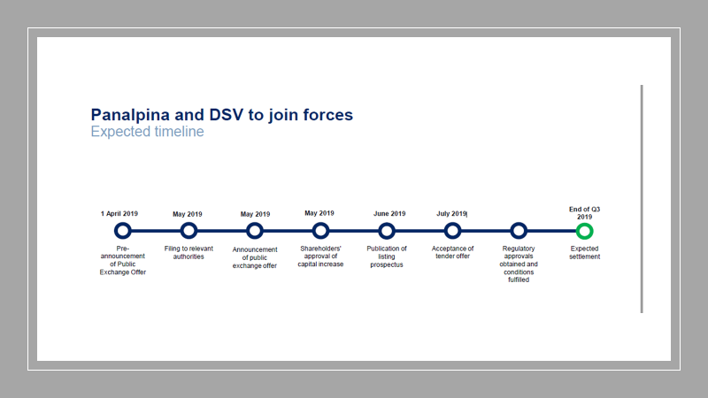
Source: DSV (Panalpina Fusion 2019).

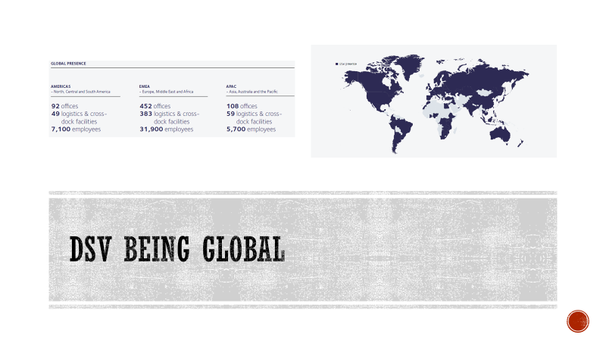
Figure 2: Global Presence of DSV
Source: DSV (Annual Report 2017)

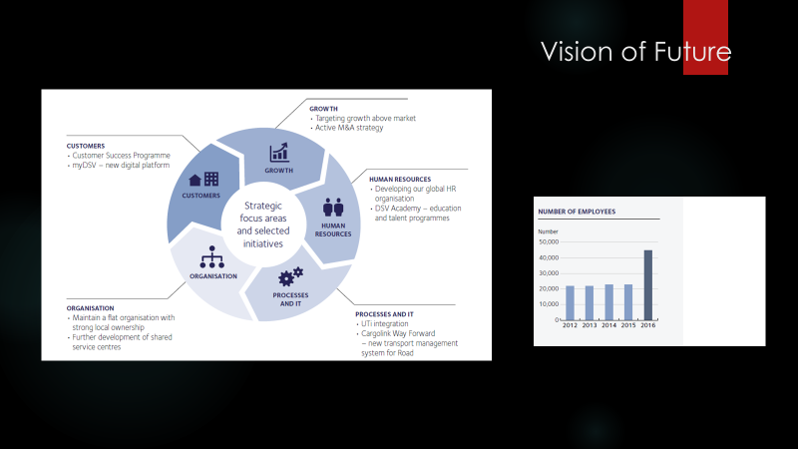
Figure 3: Strategic areas for developing
Source: DSV (Annual Report 2017)

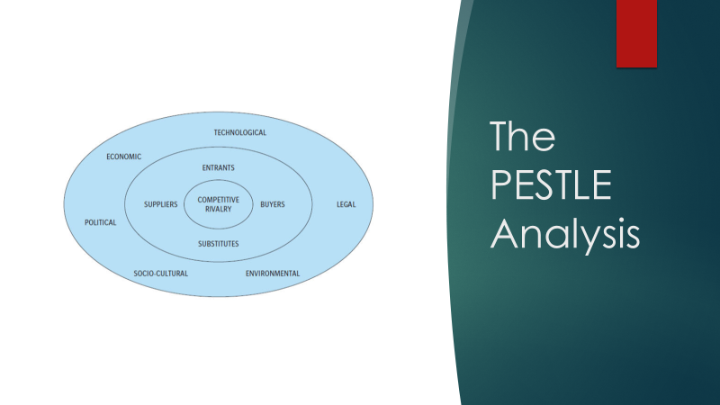
Figure 4: PESTLE Analysis
Source: Hamilton, L., Webster. P., (2015) The International Business Environment. Oxford, Oxford University Press

Figure 5: Training and Development Plan
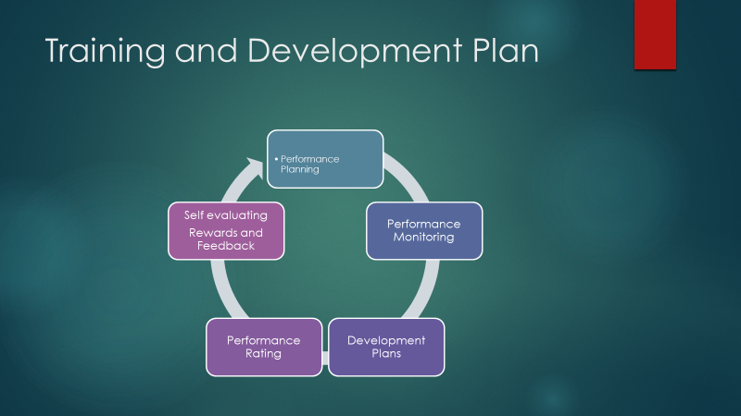

Reference List:

- Hamilton, L. and Webster, P. (2018) The International Business Environment. Fourth Edition. New York: Oxford University Press.
- DSV (2019) Latest News. Available at: https://www.uk.dsv.com/about-dsv/media/News/2019/04/Panalpina-and-DSV-agree-to-join-forces (Accessed: 24 July 2019).
- DSV (2019) Investor: Panalpina Transaction. Available at: https://dsv.gcs-web.com/panalpina-transaction (Accessed: 24 July 2019).
- Hamilton, L. and Webster, P. (2018) The International Business Environment. Fourth Edition. New York: Oxford University Press.
- Cottrell, S. (2017) Critical Thinking Skills. Third Edition. London: Macmillan.
- DSV (2017) Annual Report. Available at: http://www.documents.dsv.com/dsv/1002/html5/ (Accessed: 24 July 2019).
- Management Study Guide: Training of Employees – Need and Importance of training. https://www.managementstudyguide.com/training-of-employees.htm (Accessed: 24 July 2019).
- DSV (2017) Annual Report. Available at: http://www.documents.dsv.com/dsv/1002/html5/ (Accessed: 24 July 2019).
- DSV (2017) Annual Report. Available at: http://www.documents.dsv.com/dsv/1002/html5/ (Accessed: 24 July 2019).

