

BA1
Fortnightly Reflection Guidance and Templates
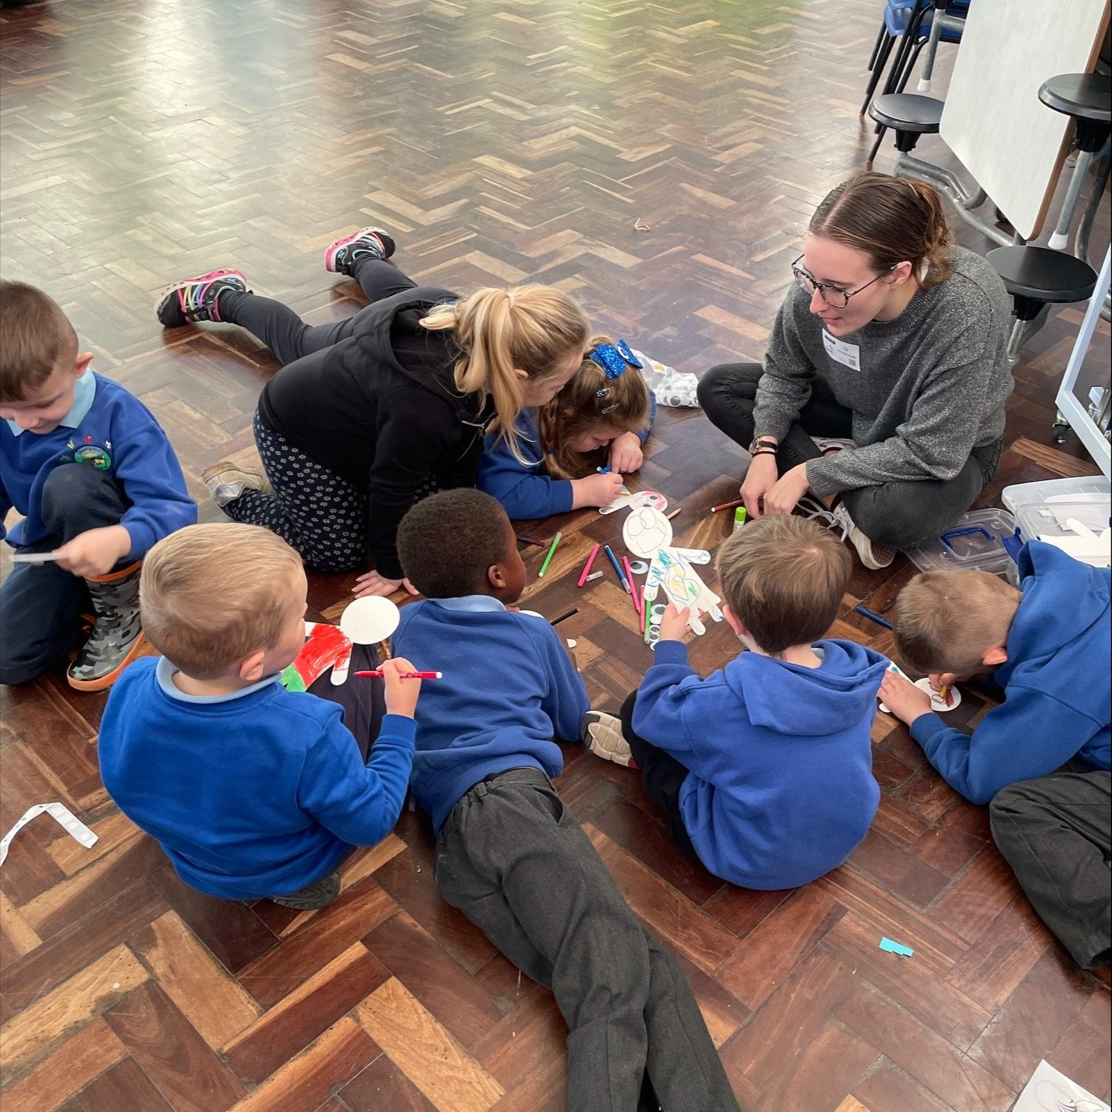

The Fortnightly Reflection Guidance and Templates are designed to support purposeful, evidence-informed professional dialogue between student-teachers and their mentors throughout the year. They provide a consistent structure for identifying areas for development, planning and evaluating actions, and reflecting on the impact of teaching on learners. The guidance encourages student-teachers to make connections between their school experiences, the taught programme, educational research and the Professional Standards for Teaching and Leadership in Wales. Recognising that professional learning is developmental and individual, the templates are intended to support reflective conversations that celebrate progress, identify next steps and promote continual professional growth across the programme.

Contents

Guidance for Fortnightly Reflection Meetings 4
Purpose of the Fortnightly Reflection Meeting 4
Understanding the Fortnightly Reflection Process 4
Before the meeting 5
In the meeting 5
Fortnightly Reflection Cycle 6
Suggested areas for reflection across the BA Programme 7
Suggested evidence base for meetings 8
Quantifiers to support reflection 8
Fortnightly Reflection Templates – PTE1 9
Fortnightly Reflection Template 1 - Week Beginning 11/01/2027 9
Fortnightly Reflection Template 2 - Week beginning 22/02/27 12
Primary Fortnightly Reflection Exemplar 14
Mentoring Mini Guides 18

Guidance for Fortnightly Reflection Meetings

The fortnightly reflection meetings are a required element of Professional Teaching Experience (PTE) and should be timetabled as a part of the mentoring process.

Purpose of the Fortnightly Reflection Meeting

- The fortnightly reflection meeting is intended to help student-teachers build and deepen their reflective practice over time. For the early stages of placement, it offers scaffolds and suggested focus areas, such as lesson planning, to give structure and direction. As they become more confident and experienced, the template encourages a shift towards broader, more complex themes like progression, pedagogy, and assessment. This flexible approach allows individuals to engage in reflective practice in a way that is both meaningful and tailored to their personal and professional development.

- The meeting supports a specific kind of reflective discussion based on the ideas around professional learning conversations (Earl and Timperley, 2008). Student-teachers bring an identified ‘problem to navigate’ to the meeting, which forms the focus of a shared conversation.
The problem is explored in three stages, as represented in the Fortnightly Reflection template:

- First, the student-teacher and mentor discuss and unpack the “problem” itself.

- Then, they think through possible ways it could be approached or addressed.

- Finally, they agree on practical actions to secure professional development.

Understanding the Fortnightly Reflection Process
The fortnightly reflection meeting is structured around two complementary stages of professional learning. Together, these encourage student-teachers to reflect on their developing practice whilst identifying clear priorities for future development.
The orange section of each template focuses on looking back. This part of the meeting encourages reflection on recent teaching experiences, consideration of the impact on learners, and evaluation of actions taken since the previous meeting. Student-teachers and mentors should use evidence from teaching, observations, professional dialogue and other sources to support reflective discussion.
The blue section focuses on looking forward. This part of the meeting supports collaborative planning for the next stage of professional learning by identifying a problem to navigate, agreeing actions to take, and considering how success and impact will be recognised.
At the beginning and end of each Professional Teaching Experience, there is naturally less opportunity either to review a previous cycle or to plan a subsequent one. For this reason, the first and final templates of PTE have been adapted to reflect the developmental priorities at those points in the programme. For example, the first template replaces the usual review stage with activities that support orientation to the school context, learners and routines. Similarly, the final template replaces the planning stage with opportunities to consolidate learning, reflect on progress across the placement and prepare for the transition back to university or into the next stage of professional learning.
Although the emphasis of these adapted templates is different, they continue to support the same overarching aim of purposeful reflection that informs professional growth and the ongoing development of practice.

Before the meeting
- Meetings need to be timetabled on a fortnightly basis and accompanying templates are required to be completed in a timely and effective manner. The meetings are a required element of the Professional Teaching Experience.
- Both parties are to approach the meeting with a professional, open and engaged attitude.
- The student-teacher is expected to make their Learning Journal, lesson plans, relevant ‘university materials’ available for every meeting.
- The Class / Subject mentors are expected to make use of the prompts to support the student-teachers’ reflection.

In the meeting
- Student-teachers and mentors are to draw on pupil feedback, analysis of lesson outcomes, learner conversations, evidence of learning (e.g books) mentor conversations, Learning Journal, taught part of programme (e.g lectures and assignments), wider reading, conversations with peers to inform discussions.
- Previous meetings’ actions are to be discussed and reviewed, using appropriate evidence sources
- The Class / Subject mentor is expected to utilise effective mentoring strategies, including open questioning, active listening, making the implicit, explicit and giving effective feedback to elicit deep and purposeful reflection from the student-teacher.
- An appropriate target is to be agreed upon in each meeting. Please note that this may align to the Professional Standards for Teaching and Leadership but refrain from making this a ‘box ticking’ exercise. The SMART target mini-guide should be used to support this process.
Please note:
If the student-teacher is following ‘Intervention’ Procedures, then that process and its timelines take precedence.
Additional reflection meetings to ensure the student-teacher can achieve the targets set and reflect sufficient depth are at the Class / Subject mentor’s discretion.

Fortnightly Reflection Cycle

🟧 Orange: Part 1 - Reflect on recent experiences, evidence and impact.
🟦 Blue: Part 2 - Agree priorities, actions and intended impact for the next cycle.

Suggested areas for reflection across the BA Programme

We recognise that student-teachers progress through their professional learning journey at different rates. The programme information included within each template is provided as context to support reflection and professional dialogue; it is not intended to be followed rigidly. Student-teachers may be working beyond, or require additional support with, the areas identified at different points in the programme. Reflection should therefore be adapted to individual experiences, strengths and areas for development.
At the same time, we recognise that the programme is designed to support all student-teachers to meet the Professional Standards for Teaching and Leadership and achieve QTS by the end of the programme. The suggested areas below are intended to support student-teachers and Class / Subject Mentors in identifying purposeful areas for reflection at different stages of development.
These suggested areas are intended to support professional dialogue rather than prescribe a fixed sequence of development. They provide a starting point for student-teachers and Class / Subject Mentors to identify meaningful areas of focus within fortnightly reflection meetings, informed by individual experiences, evidence and professional learning needs.
In the early stages of becoming a teacher, there are a number of areas which are foundational to developing an understanding of effective teaching and learning. As a result, it may be that student-teachers and Class / Subject Mentors decide to focus initial fortnightly reflection meetings on these areas:
- Understanding learners and creating positive learning environments
- Planning purposeful learning experiences
- Developing effective classroom routines and relationships
- Making informed pedagogical choices and evaluating their impact
- Beginning to use assessment to understand learner progress
- Developing adaptive approaches to support learner needs

As student-teachers become more confident and experienced, broader, more complex themes may form the focus of the fortnightly reflective process:
- Learner progression and demonstrating impact
- Assessment, feedback and using evidence to support learning
- Adaptive teaching and meeting diverse learner needs
- Curriculum design and progression over time
- Developing learner independence and agency
- Professional collaboration and contributing to the wider school community

Suggested evidence base for meetings

Student-teachers should draw upon a range of evidence to inform discussion. This may include:
- Evidence of learners' progress (e.g. learners' work, books, assessment information, lesson outcomes)
- Learner voice and feedback
- Mentor feedback, lesson observations and discussions
- Reflections recorded in learning journals
- Lesson plans and evaluations
- University learning (e.g. lectures, seminars, assignments and taught programme materials)
- Relevant educational research and professional reading
- Professional dialogue with mentors, peers and university tutors
- Progress against the Professional Teaching Standards for Teaching and Leadership
- Evidence gathered from enquiry or trying new approaches in the classroom

Quantifiers to support reflection
When reflecting on different aspects of learning, such as learners' progress, behaviour, engagement, participation, or understanding, aim to make observations that are as precise as possible. Rather than using vague statements such as "the class understood" or "some pupils were engaged," use the quantifiers below to indicate the approximate proportion of learners your reflection refers to. This helps make reflections clearer, more evidence-informed, and easier to evaluate over time.

Quantifier​ | Proportion​
nearly all ​ | with very few exceptions​
most ​ | 90% or more​
many ​ | 70% or more​
majority ​ | over 60%​
around half ​ | close to 50%​
minority ​ | below 40%​
few ​ | below 20%​
very few ​ | less than 10%​

Fortnightly Reflection Templates – PTE1

Fortnightly Reflection Template 1 - Week Beginning 11/01/2027

Student-teacher development at this stage

Student-teachers progress through their professional learning journey at different rates. The focus below provides guidance for this stage, but reflection should be adapted to individual experiences and areas for development.

At this early stage of placement, student-teachers are continuing to settle into the school context and develop their understanding of learners, routines and expectations. Having completed the initial Mini Bridges, they are beginning to take increasing responsibility for teaching through a combination of supported teaching (30%) and developing independence (20%). Their 100% learning timetable also provides opportunities to learn beyond their own teaching, including observation of others, working with small groups and engaging with senior leaders and curriculum leads. Reflections may draw on these varied experiences to make connections between university learning and practice, notice effective approaches and identify areas for further exploration.

Part 1:
As there is no previous reflection cycle to review, this template focuses on supporting student-teachers’ orientation to their new context. The checklist should be completed collaboratively during the meeting to identify activities that have taken place. Where activities are still outstanding, please record how and when these will be addressed.

Orientation activity | Completed (delete as appropriate)
Orientate yourself to the school context (e.g. routines, expectations, safeguarding, anti-racism training, learning environment) | Yes / No
Understand professional expectations (e.g. arrival and departure times, reporting absence, dress code, communication protocols) | Yes / No
Get to know learners (e.g. strengths, individual needs, relationships, classroom culture) | Yes / No
Observe effective practice (e.g. pedagogy, behaviour support, questioning, assessment) | Yes / No
Make connections with the taught programme (e.g. university sessions, wider reading, Professional Standards) | Yes / No

Part 2:
Problem to navigate
Step 1 - Student-teacher and Class / Subject Mentor to agree on a problem to navigate together
Prompts to support purposeful reflection on a problem

Student-teacher prompts:  I have noticed from my teaching that…  I have noticed from the learners that…  I have noticed in my planning that…  I am challenged by….  I am stuck with….  I’m noticing a pattern in… | Mentor prompts:  What makes you think that this is something we need to reflect upon?  Can you give me specific examples of where this has happened?  Why? Are you sure? Is there another explanation?  Is that always true or just in this example?  Can we connect this to a standard or framework?

Student-teacher to complete summary of discussion from step 1 (maximum of 250 words)

Navigation
Student-teacher and Class / Subject Mentor to consider ways forward
Step 2 - Agree on planned action - what action will be implemented?
Step 3 - Agree success criteria - how will you know if it's worked?
Prompts to support identification of required action or intervention

Student-teacher prompts:  I will… by…. so that…  I’m wondering if I should change…  I want to develop my practice in… | Mentor prompts:  What might we do to move this forward?  What would you like to try?  Is this something you need to read about?  Is there something from the university input that you can revisit?  Would it help if this was a focus of an observation of an experienced practitioner?  How will this be included in your planning?
Impact statement prompts:
Success for me in this area would look like…
I’d know it was working if I saw…
Shall we identify a clear outcome and review it together?
How will you know the learners have benefited?

Agreed next steps from step 2 and step 3 with impact statements (maximum 250 words)

Fortnightly Reflection Template 2 - Week beginning 22/02/27

Student-teacher development at this stage

Student-teachers progress through their professional learning journey at different rates. The focus below provides guidance for this stage, but reflection should be adapted to individual experiences and areas for development.

At this stage of placement, student-teachers are continuing to develop their confidence and independence in teaching, while drawing on a wider range of learning experiences. Time back at university provides opportunities to deepen learning around Welsh, leading learning and cross-curricular approaches, and to consider how this learning can inform practice in school. With a Joint Review Visit approaching, reflections may focus on progress to date, feedback from the Class Mentor and preparation for the visit, alongside consideration of the evidence and development that will inform the End of Placement Report, due 3 March.

Part 1:
Review of previous cycle
Use steps 4 and 5 to complete “reflect” and “review” stage of process following a period of reflective action (maximum of 250 words).
Prompts to support evidence-informed reflection on impact

Student-teacher prompts:  I implemented…  I noticed that most / many / around half / few learners…  The evidence suggests that…  I have demonstrated progress against the Professional Teaching Standards by…  This cycle has helped me develop my understanding of…  Compared with my previous teaching, I noticed…  This strategy was most / least effective when…  I know this because…  I will continue / adapt / stop X, because… | Mentor prompts:  What evidence tells you that this has had an impact?  Which learners benefited most? Which learners benefited least?  If the strategy was only partly successful, what might explain this?  What have you learned about your own practice?  What will you continue, adapt or stop doing as a result?  Does this suggest a new problem to navigate, or should we continue refining this one?  Which Professional Teaching Standard is most closely connected to this reflection?

Student-teacher to complete summary of discussion from step 4 and 5 (maximum of 250 words)

Part 2:

As there is no subsequent reflection cycle to plan, this section of the template focuses on consolidating learning from the placement and reflecting on progress made. Please use the table below to inform discussions and activities during the meeting, considering progress against the Professional Standards, recognising areas of strength and identifying priorities for continued professional learning.

End of Placement Activity | Completed (delete as appropriate)
Review your progress across the placement (e.g. key developments, impact on learners, evidence of growth) | Yes / No
Consider your progress against the Schedule of Expected Progress and the Professional Standards (e.g. celebrate areas of strength and recognise priorities for further development) | Yes / No
Draw together learning from across the programme (e.g. placement experiences, university learning, Bridging, professional dialogue) | Yes / No
Prepare for the next stage of your professional journey (e.g. return to university) | Yes / No

Primary Fortnightly Reflection Exemplar
Review of previous cycle
Use steps 4 and 5 to complete “reflect” and “review” stage of process following a period of reflective action (maximum of 250 words).
Prompts to support evidence-informed reflection on impact

Student-teacher prompts:  I implemented…  I noticed that most / many / around half / few learners…  The evidence suggests that…  I have demonstrated progress against the Professional Teaching Standards by…  This cycle has helped me develop my understanding of…  Compared with my previous teaching, I noticed…  This strategy was most / least effective when…  I know this because…  I will continue / adapt / stop X, because… | Mentor prompts:  What evidence tells you that this has had an impact?  Which learners benefited most? Which learners benefited least?  If the strategy was only partly successful, what might explain this?  What have you learned about your own practice?  What will you continue, adapt or stop doing as a result?  Does this suggest a new problem to navigate, or should we continue refining this one?  Which Professional Teaching Standard is most closely connected to this reflection?

Student-teacher to complete summary of discussion from step 4 and 5 (maximum of 250 words)
I implemented a more deliberate lesson structure using the "I do, we do, you do" model, following my previous action plan to improve the sequencing and clarity of learning. Compared with my previous teaching, I noticed that most learners were able to begin independent tasks more confidently and required fewer reminders about what they needed to do.

The evidence suggests that the clearer lesson structure had a positive impact on learner engagement and understanding. I know this because learner work showed that many learners completed tasks more accurately, transitions between activities were smoother, and very few learners required additional clarification before starting independent work.

This cycle has helped me develop my understanding of how careful lesson sequencing and appropriate scaffolding can reduce cognitive load and support learners to become more independent. I have demonstrated progress against the Professional Teaching Standards by planning learning more purposefully and using evidence from my teaching to evaluate the impact of changes on learners.

The strategy was most effective when modelling was concise and directly linked to the independent task. It was less effective when I spent too long explaining concepts before learners had opportunities to apply their understanding, resulting in a minority of learners becoming less engaged.

Moving forward, I will continue to use this lesson structure because it has improved learner independence. I will adapt my modelling so that it is more focused and allows learners to practise sooner, while continuing to gather evidence of its impact before deciding on the next problem to navigate with my mentor.

Part 2:
Problem to navigate
Step 1 - Student-teacher and Class / Subject Mentor to agree on a problem to navigate together
Prompts to support purposeful reflection on a problem

Student-teacher prompts:  I have noticed from my teaching that…  I have noticed from the learners that…  I have noticed in my planning that…  I am challenged by….  I am stuck with….  I’m noticing a pattern in… | Mentor prompts:  What makes you think that this is something we need to reflect upon?  Can you give me specific examples of where this has happened?  Why? Are you sure? Is there another explanation?  Is that always true or just in this example?  Can we connect this to a standard or framework?

Student-teacher to complete summary of discussion from step 1 (maximum of 250 words)
I have noticed from my teaching that the learning environment can sometimes feel chaotic, with the majority of learners off task and reluctant to participate in learning activities.

Whilst I plan engaging lessons and include behaviour management strategies in my planning to ensure that learners are on task – this doesn’t seem to work in practice. When looking at learners’ work, it is clear that many are often not engaging purposefully with the learning activity and are distracted or disruptive.

It might be that this was due to the nature of the lessons I was teaching and the time of day that I was teaching them (Wednesday PM after PE and Friday afternoon), but it is worthy of further exploration, particularly as I look to develop my practice in line with the Leadership standard.

Navigation
Student-teacher and Class / Subject Mentor to consider ways forward
Step 2 - Agree on planned action - what action will be implemented?
Step 3 - Agree success criteria - how will you know if it's worked?
Prompts to support identification of required action or intervention

Student-teacher prompts:  I will… by…. so that…  I’m wondering if I should change…  I want to develop my practice in… | Mentor prompts:  What might we do to move this forward?  What would you like to try?  Is this something you need to read about?  Is there something from the university input that you can revisit?  Would it help if this was a focus of an observation of an experienced practitioner?  How will this be included in your planning?
Impact statement prompts:
Success for me in this area would look like…
I’d know it was working if I saw…
Shall we identify a clear outcome and review it together?
How will you know the learners have benefited?

Agreed next steps from step 2 and step 3 with impact statements (maximum 250 words)
I’d like to explore more effective strategies for managing low-level disruption, as the current learning environment is unsettled, with the majority of learners often off-task during transitions and starter activities.

I will focus on tightening entry routines and improving task clarity by front-loading expectations, embedding brief retrieval starters, and using consistent signals to establish a calm and purposeful start. To this end, Sherrington and Caviglioli (2019) and Jones (2019) will be really helpful texts as I look to inform my own practice. In discussion with my mentor, we also asked, “What might we do to move this forward?” and agreed it would be useful to observe an experienced practitioner with strong classroom routines, using the feedback to inform my own planning.

Success for me in this area will look the majority of learners entering the classroom calmly, starting tasks promptly, and demonstrating focus throughout the lesson. We will track this through time-on-task checks and informal observations, noting reduced disruption and more consistent engagement. After one week, we will review the impact and establish if clearer routines have started to be embedded and continue to reflect on progress in my learning journal.

Part 2:
Problem to navigate
Step 1 - Student-teacher and Class / Subject Mentor to agree on a problem to navigate together
Prompts to support purposeful reflection on a problem

Student-teacher prompts:  I have noticed from my teaching that…  I have noticed from the learners that…  I have noticed in my planning that…  I am challenged by….  I am stuck with….  I’m noticing a pattern in… | Mentor prompts:  What makes you think that this is something we need to reflect upon?  Can you give me specific examples of where this has happened?  Why? Are you sure? Is there another explanation?  Is that always true or just in this example?  Can we connect this to a standard or framework?

Student-teacher to complete summary of discussion from step 1 (maximum of 250 words)
I have noticed from my teaching that the learning environment can sometimes feel chaotic, with the majority of learners off task and reluctant to participate in learning activities.

Whilst I plan engaging lessons and include behaviour management strategies in my planning to ensure that learners are on task – this doesn’t seem to work in practice. When looking at learners’ work, it is clear that many are often not engaging purposefully with the learning activity and are distracted or disruptive.

It might be that this was due to the nature of the lessons I was teaching and the time of day that I was teaching them (Wednesday PM after PE and Friday afternoon), but it is worthy of further exploration, particularly as I look to develop my practice in line with the Leadership standard.

Mentoring Mini Guides


