BA LEADERSHIP AND MANAGEMENT
Module code: BMSW5007
Module name: BUILDING A SUSTAINABLE MARKETING RELATIONSHIP
Student name: Bogdan Basenco
Student ID: 2311511
Lecturer name: Gwyneth Jones

Executive Summary
The report assesses the role of Customer Relationship Marketing (CRM) in sustainable retention of customers and organisational performance at M&S Food. It discusses the history of the company, its niche and utilisation of data to gain insight into customer behaviour and personalisation of interaction. The analysis examines the main CRM strategies that include segmentation, targeting, positioning, marketing mix, 4Cs framework. It also takes the issue of ethics and sustainability to enhance trust. Results indicate that personalisation based on data, powerful brand values, and digital solutions improves loyalty. The report finishes with suggestions on how personalisation can be enhanced, value-oriented collections should be extended and increased digital interaction.

Table of Contents
Part 1: Report 4
1. Introduction 4
2. Task 1 – Organisational Overview 4
2.1 Company Background 4
2.2 Current Market Position 4
2.3 Mission, Vision and Values 6
3. Task 2 – Data and Customer Relationships 6
3.1 Role of Data in CRM 6
3.2 Data Analysis and Evaluation 6
3.3 Building Sustainable Customer Relationships 7
4. Task 3 – CRM Strategy Analysis 7
4.1 Segmentation, Targeting, and Positioning 7
4.2 Marketing Mix (4Ps) and Differentiation 8
4.3 Meeting Customer Needs: 4Cs Framework 9
4.4 Ethics and Sustainability in CRM 10
5. Task 4 – Conclusions and Recommendations 11
5.1 Key Conclusions 11
5.2 Recommendations for Improvement 11
References 12

Part 1: Report

1. Introduction
This report offers a critical analysis of the means by which Customer Relationship Marketing (CRM) strategies will achieve organisational performance at Marks and Spencer (M&S) Food. The report provides an analysis of the effectiveness of M&S Foods to act as a marketing consultant to assess the success of their data-driven relationship marketing practices based on their contribution to sustainable customer retention and loyalty. The company is analysed in terms of its background, its position in the market and how data can help form customer value in future. It also evaluates the CRM plans like segmentation, targeting, positioning, marketing mix distinction and ethical and sustainability plans. Recommendations to enhance customer centrality and long-term loyalty are put at the end of the report.

2. Task 1 – Organisational Overview

2.1 Company Background
Marks and Spencer (M&S) is a well-established retail brand in the UK, founded in 1884, and has a long reputation in the UK as a quality, trusted and innovative brand. M&S Food has become a multi-channel food retailer, which is still a high-street store but with an enhanced format in terms of higher-quality groceries, convenience lines and ready-to-eat food solutions. The organisation manages more than 1,053 stores owned by the UK franchises, with an increasing outlook in 32 international markets, which reflects its increasing footprint across the globe (Marks and Spencer, 2025).
M&S has tremendously changed within the past ten years; there was modernisation of stores, intensified digitalisation, and a value and quality strategic emphasis. A food segment has been the core of its recovery, as it has a 3.9% market share in the UK food industry and performs better than its sector in other areas like ready-made foods and fresh food (Marks and Spencer, 2025). The solid customer perceptions, such as a high Food Value-for-Money rating and a high Net Promoter Score (NPS) of 54% which indicates strong advocacy and satisfaction, enhance the reputation of the brand.

2.2 Current Market Position
M&S Food holds a positioning that is strong and unique positioning in the UK grocery market as a high-end retailer with high-quality, innovative, and trusted products. Its total market is also lower than that of the supermarkets, but it is always performing better than rival firms in its core lines like luxury ready meals, bakery and prepared foods. The food division continues to be the core of stability and expansion in the broader Marks and Spencer Group.
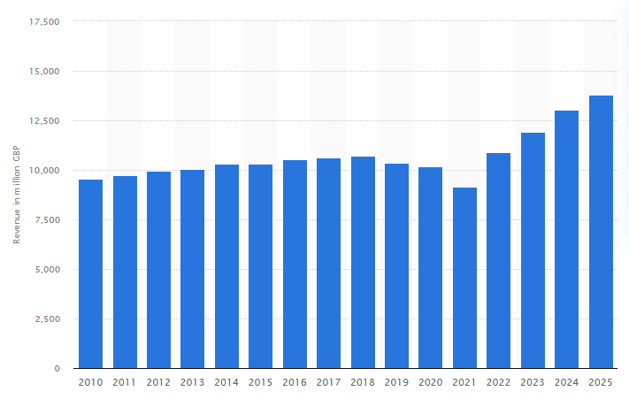
Fig 1: Revenue of Marks & Spencer worldwide from financial year 2010 to 2025
(Source: Statista, 2025)
On the financial front, the organisation has recorded good trends. Marks and Spencer recorded £13.8 billion in total global revenue in the year ending 29 March 2025, with the variance showing an increase of about £800 million year on year (Statista, 2025). This uplift reflects the focus on performance enhancement both in the UK and the international market, where M&S Food remains in the middle of the revenue growth and customer interaction.
The strategy of affordability but a high quality of the M&S Food has made the company competitive among high-end retailers like Waitrose as well as low-price discounters like Aldi and Lidl (Leonards, 2023). Seasonal performance, especially during Christmas, is still one of its biggest strengths. Moreover, the online grocery has also broadened its operations through a strategic alliance with Ocado, following the increasing trend of convenience and online shopping. On the whole, M&S Food remains a strong and differentiated company in the highly competitive market.

2.3 Mission, Vision and Values
Mission
To deliver the magic of M&S to all of our customers by offering them superior quality, value, service and innovation, whether, where or how they desire to shop with us.
Vision
M&S aspires to be a contemporary, sustainable retailer that will innovate to make customer-based growth, transforming based on the development of digital and ongoing product excellence.
Values
Our vision is to be the most trusted retailer, and in doing the right thing for customers and quality products are at the core of what we do.
The mission, the vision and the values together facilitate the aims of M&S Food to achieve loyal customer associations over the long run.

3. Task 2 – Data and Customer Relationships

3.1 Role of Data in CRM
Data is one of the main concepts of Customer Relationship Management (CRM) because it helps organisations to comprehend, predict, and address customer needs better. In the case of M&S Food, data gathered via the Sparks loyalty programme, online shopping trends, and in-store purchase transactions can give a clear view of the individual tastes, purchasing patterns, as well as their value inclinations (M&S, 2024). This data will enable the company to segment the customers, personalise communication, and offer customised product recommendations.
Business organisations need to establish a strong relationship with the customers by using CRM strategies, technologies and data-driven processes (Buttle, 2019). M&S can get the best out of its strategies and overall satisfaction by analysing customer feedback in relation to promotions, customer feedback, and experiences with services.

3.2 Data Analysis and Evaluation
The interpretation and processing of data are necessary in converting raw customer data to practical information, which enhances customer relationship management. M&S Food uses analytical instruments to understand buying patterns, product behaviour, and the level of activity among various groups of customers. Indicatively, the Sparks loyalty programme transactional data is analysed to obtain the identification of high-value customers, determine the frequency of shopping, and determine the effectiveness of personalised offers.
M&S also relies on data analysis in order to learn about customer opinion via feedback questionnaires, online reviews and social media (Li et al. 2023). This helps the company to identify any gaps in service delivery, other quality issues or changing expectations. Predictive analytics also makes forecasting demand and inventory planning more precise and assists M&S in reducing waste and increasing operational efficiency.

3.3 Building Sustainable Customer Relationships
It is necessary to develop sustainable customer relationships through regular contact with customers, personal experiences, and value interactions. M&S Food relies on the loyalty programme of its Sparks customer loyalty to design its personalised promotions, product recommendations and rewards that are based on individual shopping behaviour. This kind of personalisation enables customers to feel acknowledged, which builds emotional loyalty (Maghembe and Magasi).
M&S is another company that promotes relationship sustainability by putting emphasis on transparency and trust. The company tells us, to give an example, about sourcing and production of its products, its quality conditions, and its sustainability goals, including using less plastic on product packages and being in favour of local suppliers. These activities are in keeping with the values of ethics and environmentally friendly brands by the consumer (Sun and Yoon, 2022).
Frequent customer feedback would allow M&S to see emerging issues and adjust services accordingly so that ultimately customers are satisfied with services. In addition, the introduction of digital receipts, convenient click-and-collect methods, and consistent experiences from inside the store are among the measures that can be taken to sustain short-term benefits.

4. Task 3 – CRM Strategy Analysis

4.1 Segmentation, Targeting, and Positioning
Segmentation | M&S Food divides the customer into the following demographics (middle-upper income, family, older shopper), geographic (urban stores, travel hub, regional products variations), psychographic (premium-quality-seeker, health-conscious, sustainability-focused shopper) and behavioural (sparks loyalty users, buy meal deals repeatedly, seasonal shopper, repeat buyers of signature ranges).
Targeting | Customers who place a strong value on premium, fresh, innovative food; professional customers struggling to balance time-constrained meals; health-oriented customers; as well as loyalty-based Sparks members seeking customised value.
Positioning | Positioned as a family-quality, ethical, and innovative food retailer with reliable, high-quality products with a high sustainability score.  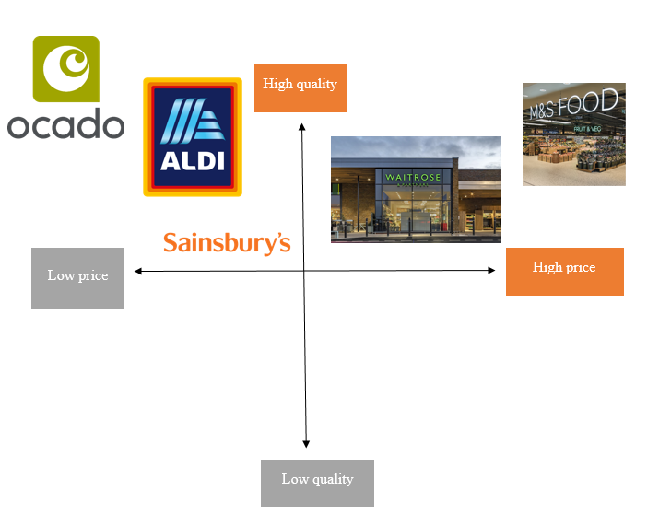  Figure 2: Positioning map  (Source: Self-developed)

4.2 Marketing Mix (4Ps) and Differentiation
The marketing mix is important in the differentiation mix of M&S Food.
- Product: M&S Food separates itself with high-quality products, original recipes and selection criteria. Its ready foods, bakery products and seasonal products are seen to be of better taste and innovation. Differentiation can also be reinforced by a range of limited-edition and special partnerships (Jerab and Mabrouk, 2023).
- Price: M&S sets itself in the high-end segment, but via its Remarkable Value line, it applies competitive prices to core products without reducing quality. The business helps to establish trust using transparency, educational content and inbound strategies (Sheridan, 2019).
- Place: M&S Food has convenience business formats in the form of Food Halls, Simply Food stores and BP fuel station collaborations. Good online presence in the form of Ocado also increases the presence of M&S beyond brick-and-mortar stores. This cross-channel presence provides consistency and convenience of touchpoints to customers (Santos and Gonçalves, 2021).
- Promotion: M&S relies on emotional storytelling, product-oriented advertising, and digital communication based on loyalty. Direct engagement is provided through Sparks app notifications, personalised vouchers, and email campaigns. The key marketing principles include values from the customers, market segmentation and customer behaviour, branding and digital marketing (Armstrong et al. 2020).

4.3 Meeting Customer Needs: 4Cs Framework
A Customer Focused Strategy with a Customer-centred approach and 4Cs Customer needs, Convenience, Cost to Customer, and Communication has a strong clientele orientation and aids in achieving the Principle of customer Relationship Management.
- Customer Needs: M&S Food has witnessed changing customer demands in health, convenience and sustainability. The company modifies the range to incorporate healthier meals, plant-based foods, and allergen-friendly food by applying data insights (Alehosseini et al. 2025). This responsiveness intensifies relevance to different types of customers.
- Convenience: M&S has embraced convenience by offering a variety of store formats, self-checkout services, digital receipts and effective collaboration with Ocado to deliver online. Friction is eliminated through these services and contributes to long-term engagement.
- Cost to Customer: M&S is priced above the rest, but they provide high value in long life, taste and quality guarantee (Morgan, 2023). The Remarkable Value range, personalised Sparks discounts, also help the customer to control costs, but at the same time enjoy high product standards.
- Communication: The communication is data-driven and regular. Promotions, sustainability updates, and new product launches are shared by M&S via the Sparks app, social media, email marketing, and in-store messaging. Open communication fosters trust, an ingredient of long-term customer retention.

4.4 Ethics and Sustainability in CRM
The CRM strategy of M&S Food is entrenched within its Plan A sustainability programme, which aims at streamlining relationships with customers into environmental and ethical responsibility (Marks and Spencer, 2025). Plan A targets M&S to attain net zero in its entire value chain by 2040.
Within the food division, M&S has pledged to reduce food waste by 50% by 2030 (compared to a 2017/18 position) and give all edible surplus to communities by 2025/26. It also strives to ensure that its 100% food packaging can be recyclable by 2025/26, and 1 billion units of plastic packaging will be terminated by 2027/28 (Sofiya Shazal, 2024). M&S has experimented with ready meal-related trays which are made of fibre, which can easily cut the usage of plastic by as much as 75%.
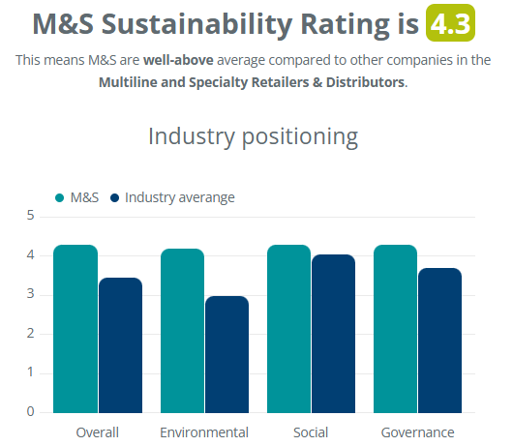
Figure 3: Sustainability Rating
(Source: Ecoscanner, 2024)
Ethical sourcing has become another necessary element, and M&S Food Sources ethically sources and strives to use confirmed sustainable palm oil and deforestation-free soy. By including these sustainable practices into these sustainable practices into their CRM procedures and M&S is able to stand out in a very competitive market with their competitive market with their food company, as well as win over ethically concerned clients and earn their confidence as well as loyalty.

5. Task 4 – Conclusions and Recommendations

5.1 Key Conclusions
As per this report, M&S Food has developed strong and customer-focused CRM strategies supported by high-quality products, data-driven insights and open sustainability commitments.
Its customer data utilisation, specifically the Sparks loyalty programme, allows it to communicate with individual customers, offer them special offers, and make a meaningful segmentation. Premium positioning philosophy, ethical sourcing, and packaging innovations also make the company highly trusted and loyal towards customers. As well, the sustainability activities of M&S Food, such as waste minimisation and recyclable packaging, can meet the needs of customers in the contemporary world, allowing the company to stay relevant and competitive.

5.2 Recommendations for Improvement
To enhance the strength of customer relationships over the long term, M&S Food would infer adding the depth of personalisation of its digital presence by broadening the scope of AI-based recommendations on the apps and online stores. Higher openness of the product carbon footprints and sustainability developments might also help build the confidence of eco-conscious consumers (Gao and Souza, 2022). M&S can also enhance value image by launching cheaper healthy collections that will be aimed at younger and cost-conscious customers. Lastly, a more robust community engagement campaign (ex, local supplier deals or food education courses) would enhance emotional attachment and would legitimise M&S Food as a socially responsible retailer. Such advances would aid the organisation in forming sustainable and customer-focused relations.

References
Alehosseini, E., Mcsweeney, P.L. and Miao, S. (2025). Recent updates on plant protein-based dairy cheese alternatives: outlook and challenges. Critical Reviews in Food Science and Nutrition, pp.1-15.
Buttle, F. (2019). Customer Relationship Management: Concepts and Technologies. 4th Edition. [Online]. Routledge. Available from: Customer Relationship Management: Concepts and Technologies: Amazon.co.uk: Buttle, Francis: 9781138498259: Books
Ecoscanner (2024). M&S Sustainability, ecoscanner.com. Available at: https://ecoscanner.com/ratings/marks-and-spencer/ (Accessed: 22 November 2025).
Gao, F. and Souza, G.C., (2022). Carbon offsetting with eco-conscious consumers. Management Science, 68(11), pp.7879-7897.
Gary Armstrong, P.K. (2020). Marketing: An introduction, Global Edition. 14 th edition. [Online]. Pearson. Available from: Marketing: An Introduction, Global Edition: Amazon.co.uk: Armstrong, Gary, Kotler, Philip, Opresnik, Marc: 9781292294865: Books
Jerab, D. and Mabrouk, T., (2023). Strategic excellence: Achieving competitive advantage through differentiation strategies. Available at SSRN 4575042.
Jobs Marks and Spencer (2025). Sustainability, Marksandspencer.com. Available at: https://jobs.marksandspencer.com/sustainability (Accessed: 21 November 2025).
Leonards, A. (2023). Aldi, M&S and Waitrose beat ‘Big Four’ for customer satisfaction, Retail Systems. Available at: https://www.retail-systems.com/rs/Aldi_M_And_S_And_Waitrose_Beat_Big_Four_For_Customer_Satisfaction.php (Accessed: 22 November 2025).
Li, L., Wang, Y. and Zhang, Y.Y., (2023). A critical examination of M&S's current strategic and marketing position, as well as potential sustainable competitive marketing strategies. International Journal of Science and Business, 18(1), pp.108-117.
M&S (2024). M&S to Spark Global Growth with Roll Out of Loyalty Scheme Across International Markets, Marks & Spencer. Available at: https://corporate.marksandspencer.com/media/press-releases/ms-spark-global-growth-roll-out-loyalty-scheme-across-international-markets (Accessed: 22 November 2025).
Maghembe, M. and Magasi, C., (2024). The Role of Customer Perceived Value, Brand Trust and Service Personalization in Shaping Customer Loyalty. International Journal of Management, Accounting & Economics, 11(9).
Marks and Spencer (2025). Key Facts & Figures, Marks & Spencer. Available at: https://corporate.marksandspencer.com/about-us/key-facts-figures (Accessed: 22 November 2025).
Morgan, T. (2023). M&S comeback: 5 M&S facts that may surprise you - Which? News, Which? Available at: https://www.which.co.uk/news/article/marks-and-spencer-facts-that-may-surprise-you-ac4Gi8A9VXFd (Accessed: 22 November 2025).
Santos, S. and Gonçalves, H.M., (2021). Touchpoints and channels: Classifications, characteristics, and issues for future research. In Marketing and Smart Technologies: Proceedings of ICMarkTech 2020 (pp. 311-323). Singapore: Springer Singapore.
Sheridan, M. (2019). They Ask, You answer: A Revolutionary Approach to Inbound Sales, Content Marketing, and Today’s Digital Consumer. [Online]. Available from : They Ask, You Answer: A Revolutionary Approach to Inbound Sales, Content Marketing, and Todays Digital Consumer, 2nd Edition, Revised and Updated: Amazon.co.uk: Sheridan, Marcus: 9781119610144: Books
Sofiya Shazal (2024). Marks and Spencer commits to 100% net zero across its entire value chain by 2040, Sustainable Food Business. Available at: https://sustainablefoodbusiness.com/marks-and-spencer-esg-report-2024/ (Accessed: 22 November 2025).
Statista (2025). Marks & Spencer revenue 2025| Statista, Statista. Available at: https://www.statista.com/statistics/413349/group-revenue-marks-and-spencer-mands/?srsltid=AfmBOorWauyAFmfb_NMjKmE9LELqXiefGB4qM1ZltBqEqwm8tNIG4Ikv (Accessed: 21 November 2025).
Sun, Z.Q. and Yoon, S.J., (2022). What makes people pay premium price for eco-friendly products? The effects of ethical consumption consciousness, CSR, and product quality. Sustainability, 14(23), p.15513.

