Introduction to Innovation Management

Assessment B – Report

MSc International Innovation Management

Module Code: ACPA7005

Supervisor: Craig White

BIIM Innovation Management Level 7

5th September 2022
Student: Lee Price
Email:Pricey_lee@yahoo.co.uk / Lee.Price@safran group.com
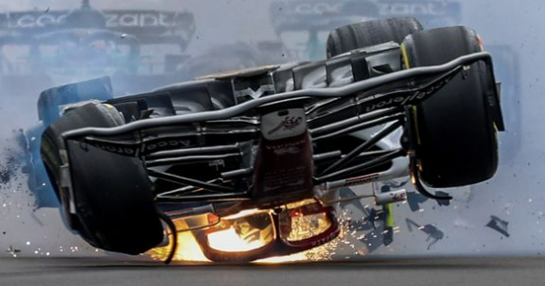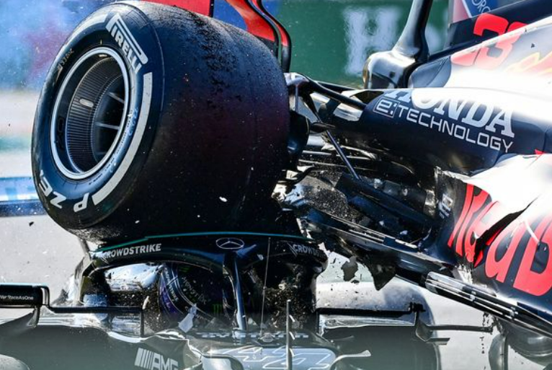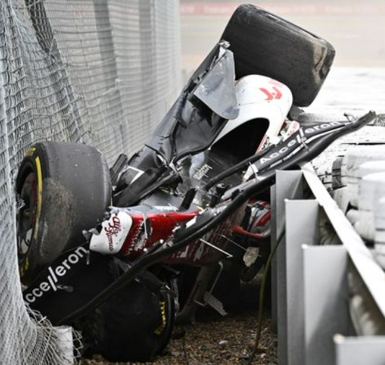
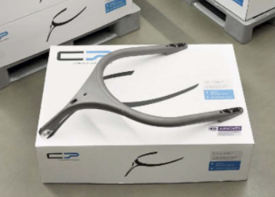

Contents
- Synopsis
- The principal drivers for the innovation.
- The barriers and risks faced by the company in developing this innovation.
- The key determinants in the process of committing to develop the innovation.
- The processes and technologies which the company used to carry this development forward.
- The extent to which the development relied on resources external to the company and the ways in which the deployment of these resources was managed.
- How management overview of the development was maintained.
- The extent to which you feel this innovation process represents best practice.
- Your report should also provide your own critique of the whole innovation process, and an evaluation (to the extent to which one is possible in the case of vey recent innovations) of the success of your chosen innovation

Synopsis
This report focuses on the FIA's halo system implementation in Formula One for the 2018 season. The halo setup consists of a titanium structure covered in carbon fibre fairing that sits above the seat engaged between the cockpit and chassis. This report focuses on the manufacturing barriers, innovation management, and overall product success.

The principal drivers for the innovation.
The main goal of the Halo innovation is to reduce head, neck, arm, and upper body injuries in the sport as a whole. The governing body of the FIA mandated the protection in 2018, (ADMIN, 2022) highlights that this was brought to the forefront of safety in 2009 after Felipe Massa suffered a head injury after a spring from Rubens Barrichello's suspension detached, hitting the Brazilian and rendering him unconscious. Furthermore, Marussia driver Jules Bianchi died in 2014 after losing control in the wet at Suzuka, falling off the racetrack, and colliding with a recovery vehicle. Only carbon fibre monocoques (survival cells) and wheel tethers were part of the car development in the previous decades to protect a driver, previous efforts were applied to either the circuit or clothing, the most recent being biometric gloves with increased fire protection due to the 2020 Bahrain crash involving Romain Grosjean. Prior to 2018, all cars had open cockpits, with only helmets providing the driver with limited protection in the event of a collision. Formula 1 is inherently innovative because the sport relies on progress in all areas, as stated by (Scott, 2013), "We engineer a new part that is completely different for the Formula one car roughly every 15-20 minutes throughout the season. Formula One is unique in its design ethos and willingness to engineer new technologies, processes, and new and better ways of doing things. However, the Formula One approach is applicable everywhere."

The barriers and risks faced by the company in developing this innovation.
The FIA's barriers were divided into two categories: cultural and design. There was a culture within the sport that the halo or other protection devices in the area were unnecessary. Purists within the sport believe that the addition of the halo went against the DNA and thrills of single seat racing (Duxbury, 2021). Others claimed that the design would cause vision problems, particularly where elevation changes were involved.
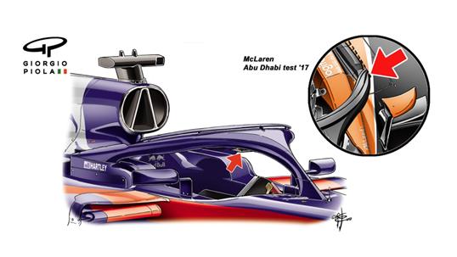
In 2016, the FIA selected Mercedes as the team to develop the halo concept, the design had to provide safety and chassis integration points. According to (JAonF1, 2016), the halo should weigh no more than 13.5kg and be made of a light material rather than steel, it should also not allow a wheel to contact the driver's helmet from any single point. The challenge was to find a material that could withstand high load paths of around 125 Kilonewtons while also being available through a supply chain, as well as the machining capabilities and process for manufacturing the halo. (Allison, 2018) describes how technical and sporting regulations must be reviewed in order to allow the use of the halo on the car. Most cars for the 2018 season were not designed with the halo in mind, with the challenge being how to integrate the halo into the main body of the chassis so that the load paths function properly. The height of the halo is another factor that interferes with the car's aerodynamics, further development is required to add small pieces (fairings) to support that area of the car.

The key determinants in the process of committing to develop the innovation.
(Tribune, 2018) emphasises the need for specialised assistance in constructing the halo from Mercedes' concept. CP Autosport, SSTT's, and V Systems are the only three companies approved by the FIA to build the Halo because they have the cutting-edge machining and welding capabilities required when working with the Grade 5 titanium material.
(Austin-Morgan, 22) specifies +/- 0.1mm tolerances throughout the build, with the main issue being how the Grade 5 titanium is formed for the main hoops without deviating from the FIA's set-out tolerances.
The overall material is difficult, but the information below explains why Grade 5 titanium was chosen over other materials such as carbon fibre, aluminium, or steel.
- First off the Grade 5 titanium is not pure it is a mixture of 6% aluminium and 4% vanadium, pure titanium would not be workable for this design.
- 6AL/4V has a higher young’s modules over the other materials – this is the measurement of stiffness within the material.
- 6AL/4V has a higher yield strength – this is the point of where a material will stop returning to its original position. 6AL/4V has a measure of 1000MPa whereas aluminium 6061 on has a measure of 270MPa. The higher measure allows the material 6AL/4V to perform in the way that it will not bend or buckle in a crash.
- 6AL/4V when welding needs to be carried out in a specific way to obtain the highest properties. Further in the report chamber welding is talked about and the need for this is to eliminate oxygen. If oxygen is present when welding corrosion will form in white power. To eliminate this argon should be purged through and around the pieces when welding.
- Overall weight of 6AL/4V titanium is around a 100grams lighter than steel, this is due to the wall thickness of pieces being reduced due to the strength properties.
- Workability, unlike carbon fibre once this is set there is no additional forming, 6AL/4V can be worked further as lng as the parts have been fully annealed meaning that they are heat treated to reduced brittleness.
With the above three specialists understanding the material capabilities and the process to maintain its properties this has led to the creation of the halo that can protect a driver in the aim set out.

The processes and technologies which the company used to carry this development forward.
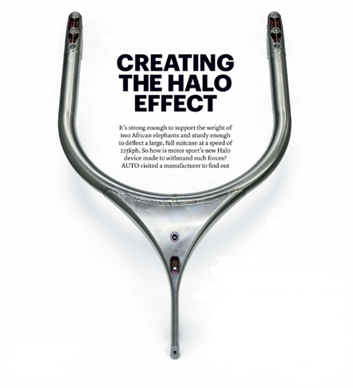
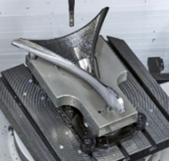
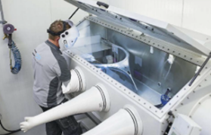
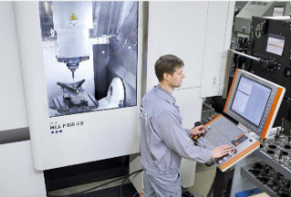
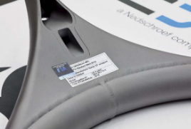

Grade 5 titanium bars were initially suggested for the main hoop, but these cannot be used because the elastic properties are not present; if formed in this manner, the material springs back as it tries to revert to its nominal state. All parts, including the Halo and locking blocks within the chassis, are thus machined directly from billets. There are common pitfalls that result in poor finishes when completing this activity. (D-KODE, 2022) explains the main issues with milling titanium and the proper processes used by the trio when making the halo. Coated carbide tools eliminate the problem of stripping off chunks of billet when machining, additionally through R&D the addition of high temperature coolant to the process helps reduce material build up on the tool and extends the tool's life while cutting. The (FIA, 2018) provides an extensive breakdown of how the halo is manufactured below are some key points through the process,
- Titanium billets are initially heat-treated prior to milling, these have individual CP specifications for withstanding loads.
- Gun-drilling the hoops of the halo, this is to hollow the material allowing it to stay in it’s designed state, utilizing this process removes the need for bending titanium bars which have retaining issues already mentioned.
- After the hoops and additional milled parts are available the parts now require joining through the process of welding however these parts are welded in a closed chamber. This is to provide a clean environment, FOD free with no additional elements to interfere with the welding.
After the preceding process is completed the entire part is subjected to additional heat treatment before being tested. One aspect of the testing, destruction testing, cannot be performed in-house and must be outsourced however all other tests can be performed in-house.
Once the halo has been manufactured this then undergoes static analysis to understand the load bearing on the structure. Secondly a dynamic analysis is complete to understand the load changes through acceleration and deceleration. Finally, a model analysis is carried out to understand the changes on the shape of the halo when either static or dynamic pressures are applied.
(F1beat, 2022) confirms the external work carried out at Cranfield, on its return there is an additional step where the halo is manually shot cleaned to create an abrasive surface. The reason for this is to make it easier for teams to fit aerodynamic parts approved by the FIA to support car performance.

The extent to which the development relied on resources external to the company and the ways in which the deployment of these resources was managed.
Cranfield is an FIA-approved site with expertise in vehicle crashworthiness. They can also integrate virtual testing through simulations if necessary, the destruction testing methods used for FIA parts are for fabrication validation, failure investigation, and critical engineering part assessment.
Cranfield put the halo through fatigue testing, which focused on the joints that were welded through the halo's body. According to (Patel, 2022), a failure point analysis method is commonly used for destructive testing to identify various failure points so that they can be corrected. The halo shown below is fixed in place and must deflect a wheel travelling at 225kph.
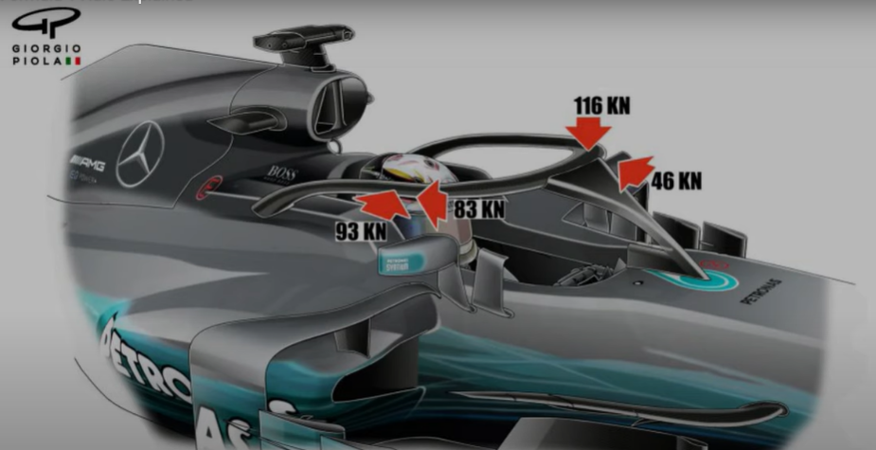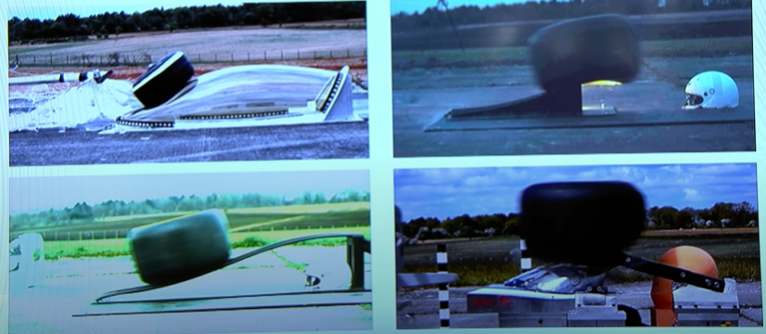
The FIA has accomplished this by having F1 teams and IndyCar share information on testing and improvements via project champions. (Mellssa A.Schilling, 2019) highlights why this was done and how it became effective with the speed with which the halo was implemented.
The functional groups utilized champions to ensure,
- Clear communication through a single thread approach
- Highlight resources for support areas
- Ensure project milestones are completed
- Escalate any constraints within the project
Overall, this part project of the related to an autonomous team set up due to separate project of testing being taken away from the light to heavy weight team structure. As an outcome two paths resulted of the testing that were approved as products one the halo and second the areoscreen. The halo being adopted for formula 1 and the aeroscreen for indycar, the difference being the screen fitted on the aeroscreen and the removal of the v-plate however both have the underpins of the halo.
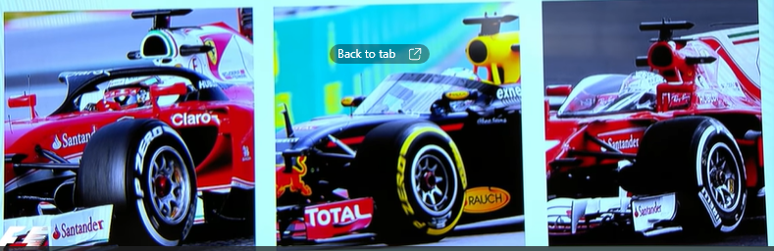

How management overview of the development was maintained.
The partly parallel process set out by (Mellssa A.Schilling, 2019) was adopted by the FIA when looking at the halo innovation along with a heavyweight team structure for the innovation overall. The main reason for this is due to the development and the specialist parties all aligning with the design, testing, manufacture and integration with the chassis of the car. The emphasis on communication between the teams would ensure minimal rework through R&D that could escalate on cost or require additional research to develop new parts.
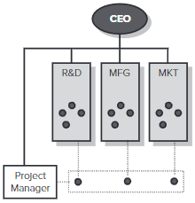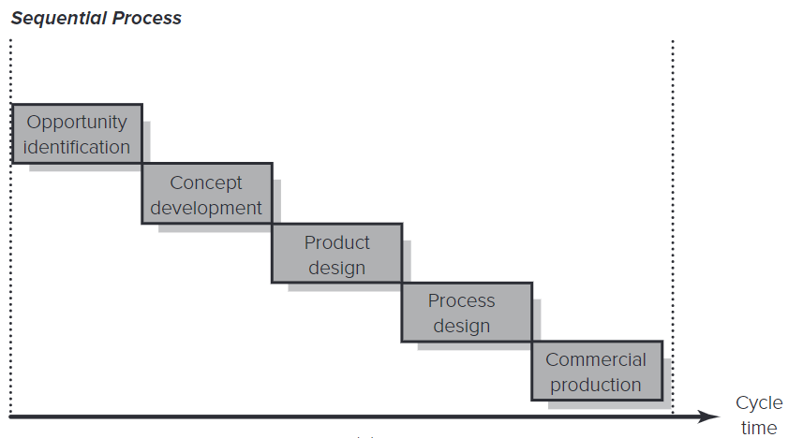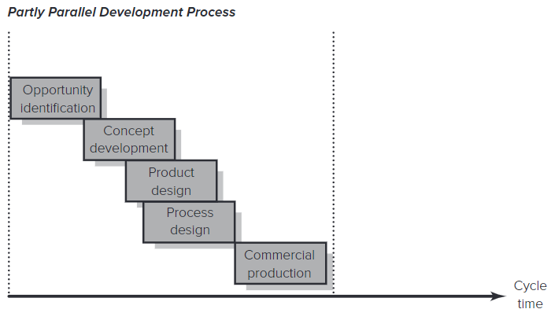
The overall development of this innovation is defined as architectural, (Trott, 2017) describes how this is due to the interaction of core components this being the halo and chassis. In manhours this has been three extensive years of combined work between teams and the FIA.
The average cost of the halo purchase price is in-between 13,000 to 24,000 euro, however in 2018 when the halo was enforced by the FIA some teams had to spend up to £710,000 to develop the fitments for the new chassis stated by (Collantine, 2018).
The below from (Motorsport, 2021) provides data analysis to show that as nearly £700,000 could be removed from the winnings given within a season. Some teams on a larger scale could accommodate this however below shows what the impact is to the teams that could not inherent the cost to which it had a detrimental effect.
Formula 1 prize money shared depending on the final championship placement,
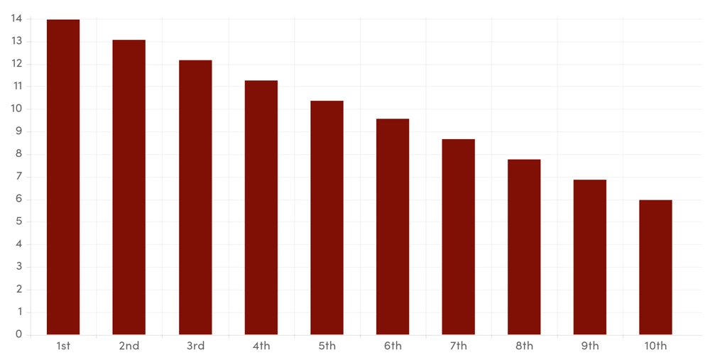

Formula 1 constructor championship results 2016 to 2020,
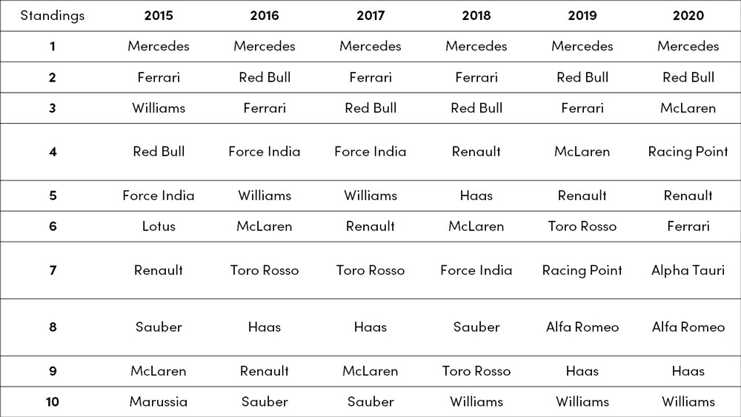
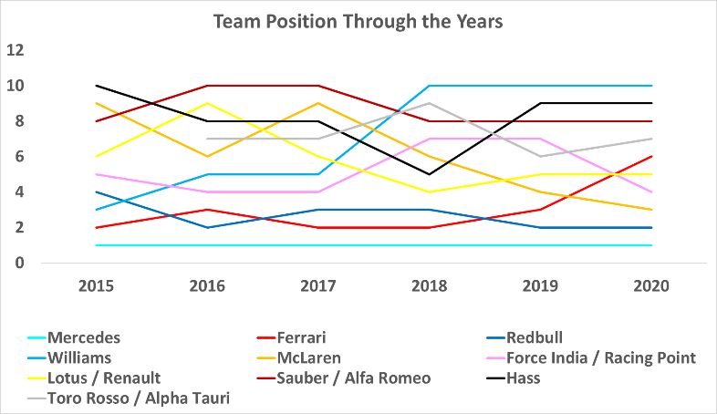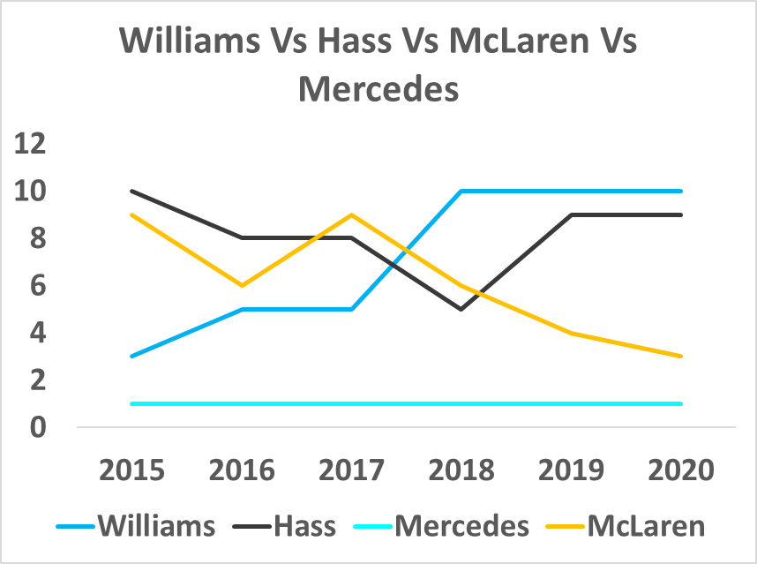
Remove the noise the noise and a clear picture can be seen against the winners and losers where innovation integration has lost its path and not been managed correctly in 2017-18. (Kahn, 2018) highlights that failure can exist if the wrong mindset and culture is not present in the business, above we can see how a company such as Mercedes have embraced the innovation whilst McLaren had to improve its business model which has led to success. On the other side where integration of the innovation was not embraced by Williams and Hass we now see failure. The inability to communicate on the development of the car to accept the halo has caused a heavy amount of R&D where cost has played a part and overall development has stopped on other projects to align the car to the required regulations. Again (Kahn, 2018) describes how mindsets that are on the correct path deliver additional spin off innovations around the initial innovation, below pictures how the halo is now used to support ventilation systems for cooling and support structure for display monitors.

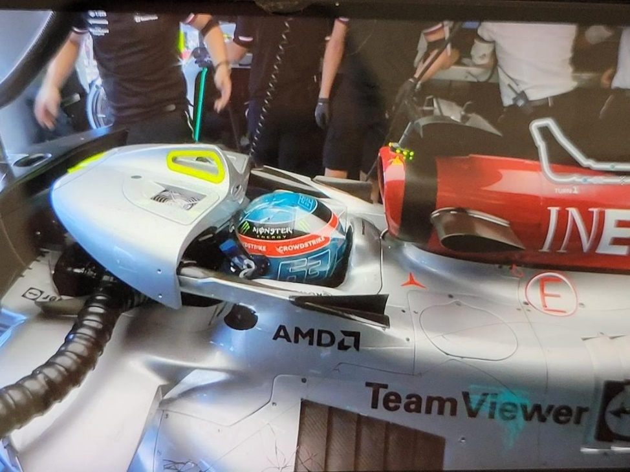

The extent to which you feel this innovation process represents best practice.
(Academic, 2017) goes through the Goffin & Mitchell innovation tunnel, the below has been adapted to show the progression of the halo from cradle to grave. Within the research area we can see key concepts that have been created, in this field the aeroshield has been removed due to concerns around the angle of fitment. Left are the halo and aeroscreen, the halo being developed for F1 and later the aeroscreen was developed for indycar that suited the nature of the race circuits where elevation changes were involved. In the development segment we see where the internal company cannot hold all the expertise in the process and have to rely on outsourcing the destruction testing for the halo to Cranfield. In the commercialisation segment we see that this is a niche market with only three FIA approved suppliers to all teams that race single seaters in any of the FIA race series. There is a spin off with regards to the development of the aero package attached to the halo called the fairing. This has now become and area where teams now utilize to place sponsors, (Collantine, 2021) reads how this was once described by Toto Wolf as an alien that he wishes could saw off , it is now prime location as it is seen by all viewers through media and a key point of contact with the driver.
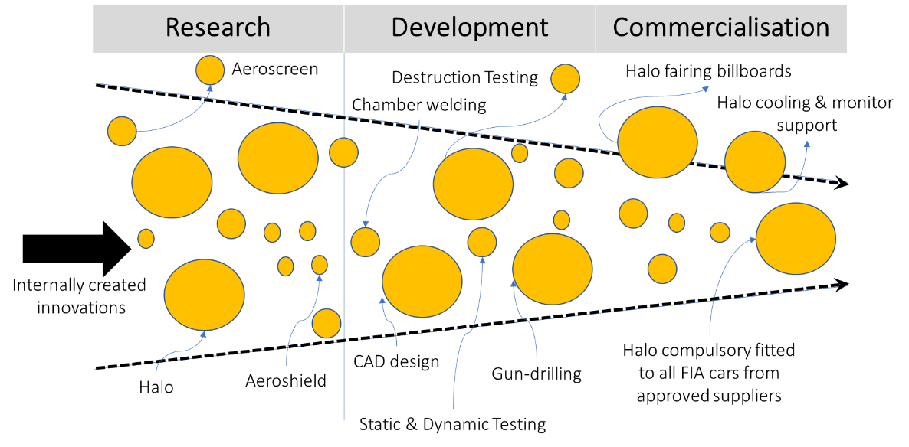
When using Satell’s innovation matrix we can see that we go through all the stages but overall this is a sustaining environment for this innovation. As the halo is in a safety environment it was an evitability that due to the safety reviews around the cockpit area this was one day come to fruition. The demand set out in the principal drivers helps develop the problem and who is best to deal with it, as these are more defined we move from the research and development into the breakthrough / disruptive phase ending with the sustained innovation.
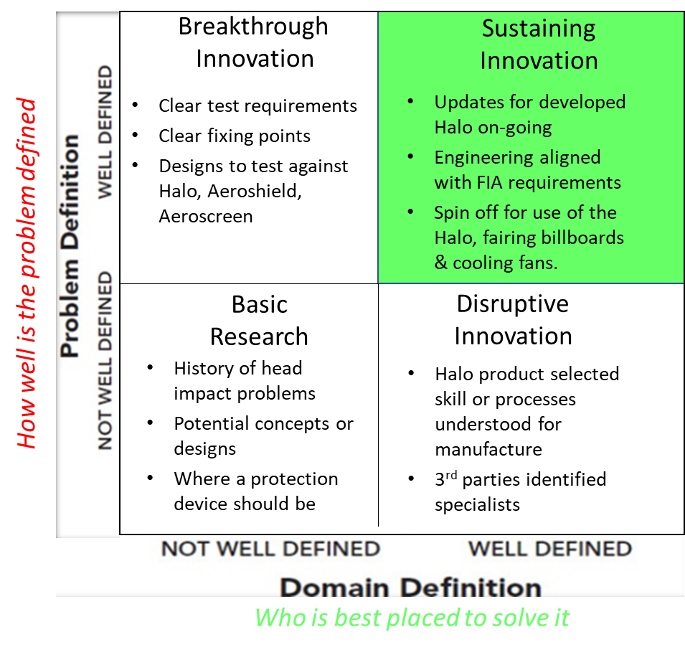
The sustained innovation now requires to continue on its path to develop, (Bessant, 2022) provides the determinants of learning through the team that are required,
Factors that Promote Learning
A. Intent to Learn
1. Competitive posture Cooperate now, compete later
2. Strategic significance High, to build competencies, rather than to fix a problem
3. Resource position Scarcity
4. Relative power balance Balance creates instability, rather than harmony
B. Transparency or Potential for Learning
5. Social context Language and cultural barriers
6. Attitude towards outsiders Exclusivity, but absence of ‘not invented here’
7. Nature of skills Tacit and systemic, rather than explicit
C. Receptivity or Absorptive Capacity
8. Confidence in abilities Realistic, not too high or too low
9. Skills gap Small, not too substantial
10.Institutionalization of learning High, transfer of individual learning to organization
Aligned with this is (Karlsberg, 2005) which looks at the 7 strategies that which were inherent through the innovation of the halo, without these being applied would have developed a roadblock and a delay in the project rollout.
- Establish a clear sense of direction – providing aims and the correct attitude will help achieve targes within the full team. This will also help to make clear improvements that support getting to the end goal efficiently but more importantly at the correct quality standard.
- Open communication – setting out daily meetings with the different team levels support the single thread message approach. Many lower-level meetings start at the beginning of the day so any issues that cannot be resolved roll into the next higher meeting level. Along with this having an open-door policy to support all staff members helps to build trust.
- Reduce bureaucracy – Having a full support team limits an individual to be responsible for additional paperwork or development of documents that may need to be carried out. By opening up the speed of a process we eliminate the loss of non-value added time.
- Instill a sense of ownership – As above a single thread approach helps to provide a clear direction this allowing ownership to be instilled as goals are understood, with the individual now feeling encouraged so they can complete tasks. Providing the links to the main strategy also allows the team to see how the completed achievements make a difference.
- Make sure recognition & rewards are consistent – As the above are achieved recognition is key, this does not always have to be monetarily just the acknowledgement can be enough. This also goes for the same if a task or improvement does not come to fruition, the fact that a route has been tried and we did not stand still will provide learnings.
- A tolerance for risk & failure – As above failures provide learnings and directions to the correct path. It also helps to ensure we do not follow that incorrect path a second time. Working within industry also helps build the teams and individuals skill level, this can then be cross trained into the teams which allows risks to be taken on a more intelligent level.
- Eliminate projects & processes that don’t work – All projects should be reviewed to ensure milestones and tasks are being achieved. If this is not the case due to a change in requirements, business needs or a change in technology we must be able to stop and abandon projects. Resource through data can be used also to highlight where resource would be best placed to push an alternative project.

Your report should also provide your own critique of the whole innovation process, and an evaluation (to the extent to which one is possible in the case of vey recent innovations) of the success of your chosen innovation
The overall project of the halo has been a huge success for the FIA, the people / teams involved, both internal and external, who can confidently say that this innovation has saved lives. Several times since its implementation in 2018 we've seen examples ranging from a minor crash to a major crash where the halo would have been detrimental to the driver. Because the innovation was linked to safety it had a very detailed strategy for how each phase was played out.
The innovation began in 2006 but did not gain traction until the deaths of several drivers in 2014 which prompted a push on development for the innovation to gain traction. The FIA considered several designs, the most important of which were the halo and the aeroscreen. The halo was chosen for F1 after several testing phases, but the aeroscreen was not abandoned it was picked up and used in Indycar. This is because of the constructive work done through communications across global racing platforms.
As discussed in this report there were key materials and processes used in the production of the Halo, the majority of which are uncommon and are now performed only by approved specialists. These were not always the simplest or cheapest methods of crating the Halo, but they were the only way for the Halo to meet the FIA's requirements. Some testing was outsourced because it could not be done in-house, this demonstrates how a separate team from the overall project team worked slightly differently. Although a single thread approach was used, it was structured as an autonomous approach with champions to ensure that all areas communicated and were aligned with the single thread approach..
When returning to the main project a heavyweight approach was used, primarily to keep the project on track by returning to the aims, objectives, and specifications / regulations imposed by the FIA. Once the product had received final approval completing all testing, it was distributed to the teams for use in the 2018 season.
When it comes to the integration of innovation into F1 teams, we've seen winners and losers due to budget constraints and the inability to integrate design due to internal design freeze times. Some teams were able to quickly implement the innovation, while others developed and improved. Others on the other hand were unable to incorporate the safety update into their designs, this was due in part to financial constraints on the team but also to a lack of foresight and understanding of the regulatory changes and the expectations of complying with the rules.
We can see through the innovation funnel that ideas can move in and out of different areas such as research, development, and commercialization as we measure innovation. In the case of this innovation we see on several occasions that the spur offs continue on their own path and eventually become part of the finished product at a later date providing their own benefits. Additionally using the innovation matrix we can see how the project progresses through the phases of research, break through, disruptive, and eventually sustained innovation as we clearly understand the problem definition and domain definition within the innovation matrix.
Finally, we can see how best practises and methods of sustainability have pushed the overall ethos of this innovation. To return to the original question, should the innovation have taken this long? the simple answer is no. However change is difficult, even those for whom this innovation has saved their lives once said it was a no-go and were opposed to it. Today we can see that it has not only saved many lives but will continue to do so. Additional innovations such as fairings for aerodynamics that were later used as billboards and colling cockpit systems were designed, but these are minor victories in comparison to the main innovation that has saved lives.

References
Academic, B., 2017. Goffin and Mitchell Webinar - Innovation Management, 3rd Edition. [Online]
Available at: https://www.bing.com/videos/search?q=goffin+%26+mitchell+innovation+tunnel&&view=detail&mid=15729CAF840C812D77E515729CAF840C812D77E5&&FORM=VRDGAR&ru=%2Fvideos%2Fsearch%3Fq%3Dgoffin%2B%2526%2Bmitchell%2Binnovation%2Btunnel%26FORM%3DHDRSC4
[Accessed 20 9 2022].
ADMIN, 2022. Stadium Review. [Online]
Available at: https://thestadiumreviews.com/blogs/info/what-is-a-halo-in-f1/
[Accessed 5 09 2022].
Allison, J., 2018. mercedesamgf1insight. [Online]
Available at: https://www.mercedesamgf1.com/en/news/2018/02/insight-introducing-the-halo/
[Accessed 5 09 2022].
Austin-Morgan, T., 22. Formula One's lifesaving halo presents unique manufacturing challenges. [Online]
Available at: https://www.imeche.org/news/news-article/formula-one's-lifesaving-halo-presents-unique-manufacturing-challenges
[Accessed 7 9 22].
Bessant, J. T. /. J., 2022. MANAGING INNOVATION. In: J. Manias, ed. INTEGRATING TECHNOLOGICAL, MARKET AND ORGANIZATIONAL CHANGE (SEVRNTH EDITION). s.l.:Lise Johnson, pp. 446, 447.
Collantine, K., 2018. F1 teams spent $1 million adding Halo to their cars. [Online]
Available at: https://www.racefans.net/2018/02/26/f1-teams-spent-1-million-adding-halo-to-their-cars/
[Accessed 19 9 22].
Collantine, K., 2021. F1’s new ‘Halo 4’ for 2022 draws on lessons from Grosjean’s crash and more. [Online]
Available at: https://www.racefans.net/2021/09/22/how-f1s-new-halo-4-for-2022-draws-on-lessons-from-grosjeans-crash/
[Accessed 25 9 22].
D-KODE, 2022. WHY IS MACHINING TITANIUM DIFFICULT?. [Online]
Available at: https://inversesolutionsinc.com/why-is-machining-titanium-difficult/
[Accessed 7 9 22].
Duxbury, A., 2021. History of safety devices in Formula 1. [Online]
Available at: https://www.autosport.com/f1/news/history-of-safety-devices-in-formula-1-the-halo-barriers-more-4982360/4982360/
[Accessed 6 09 2022].
F1beat, 2022. F1beat. [Online]
Available at: https://f1beat.com/the-halo-explained/
[Accessed 05 09 2022].
FIA, 2018. HOW TO MAKE AN F1 HALO. [Online]
Available at: https://www.fia.com/news/how-make-f1-halo
[Accessed 19 9 22].
JAonF1, 2016. Formula 1 driver cockpit protection. [Online]
Available at: https://www.motorsport.com/f1/news/formula-1-driver-cockpit-protection-what-are-the-alternatives-to-halo/3221016/
[Accessed 6 09 2022].
Kahn, K. B., 2018. Understanding Innovation. In: Understanding Innovation. s.l.:Elsevier Inc, p. 459.
Karlsberg, J. A. /. R., 2005. 7 Strategies for Sustained Innovation. [Online]
Available at: https://innovationmanagement.se/2005/06/09/7-strategies-for-sustained-innovation/
[Accessed 25 9 2022].
Mellssa A.Schilling, P., 2019. Strategic Management of Technological Innovation. In: Strategic Management of Technological Innovation. s.l.:McGraw Hill, pp. 255, 257, 258, 285.
Motorsport, S. &. M., 2021. Formula 1 Business Models: How F1 teams make money and stay competitive. [Online]
Available at: https://www.rccdbcars.com/automotive-blog/formula-1-business-models-how-f1-teams-make-money-and-stay-competitive
[Accessed 19 9 2022].
Patel, T., 2022. Knowing Destructive Testing – Methods, Definition, and Examples. [Online]
Available at: https://www.testgrid.io/blog/destructive-testing/
[Accessed 25 9 2022].
Scott, M., 2013. Could innovation in Formula One drive sustainable technology?. [Online]
Available at: https://www.theguardian.com/sustainable-business/innovation-formula-one-sustainable-technology
[Accessed 25 9 2022].
Tribune, M., 2018. How to Make an F1 Halo. [Online]
Available at: https://motorsportstribune.com/how-to-make-an-f1-halo/
[Accessed 7 9 2022].
Trott, P., 2017. INNOVATION MANAGEMENT AND NEW PRODUCT DEVELOPMENT. In: INNOVATION MANAGEMENT AND NEW PRODUCT DEVELOPMENT. s.l.:Pearson, pp. 124,125.

