Economics of Sustainability.
ANTHONY BURNS.

Introduction
This essay will discuss how a solution to a failing market has been found in terms of an externality of a pollutant produced through the consumption of sugar in the UK, focusing specifically on the fizzy drinks industry. It will be looking at the introduction of a sugar tax to solve the problem of an externality, in this case, the impact on health and the increased burden of this impact on the NHS.

An externality is a cost of a different benefit incurred or obtained by a producer that is not incurred or received monetarily by that producer. Externalities can be positive or negative, and they can arise from the production or consumption of commodities or services where the costs and benefits are either private—to an individual or an organisation—or social, in the sense that they have an impact on society.
Environmental externalities, like Natural Resources or Public Health, are examples of externalities. A negative externality, for example, is a business that pollutes the environment, lowers property prices and harms people's health. Actions that minimise disease transmission or avoid the use of treatments that wash into rivers and hence lead to excessive growth of plants in lakes are examples of positive externalities. Externalities are not the same as parkland donations or open-source software. (Kenton2020).
Most externalities are negative. Pollution is known as an example of a negative externality. A corporation may decide its best to decrease costs and increase its profits by implementing new environmentally hazardous operations. The corporation incurs costs as it expands operations, but it would also generate returns that exceed the costs. Some externalities are beneficial. When there is a gain both on personal and social levels, this is referred to as a positive externality. A company's research and development (R&D) can have a positive externality. R&D boosts a company's private profits. But with this in mind, this has had a massive impact on the NHS and other health care professions.
According to research published in the BMJ, individuals continue to purchase and drink less sugar from sugary drinks since the UK implemented a tax on sugary beverages.
The researchers discovered that soft drink sales have not improved. This, along with previous research on the lengthy effect of the tax on sugary drinks' share value and domestic turnover, indicates that the fizzy drinks industry has not been financially harmed because of the tax, which was intended to improve public health. Sugar-sweetened beverages (SSBs) are associated with a higher risk of tooth decay, obesity, type 2 diabetes, and cardiovascular disease. As a result, the World Health Organization estimates taxing these beverages to reduce consumption. (BMJ 2022).
Erosion
When the acid in soft drinks comes into contact with the dental enamel, the outer protective layer on your teeth, erosion begins. In addition, they have the effect of lowering the hardenability of the enamel. Sports drinks and other fruit juices will also cause enamel damage.
Cavities
Soft drinks will also have the potential to harm the next layer, dentin, and even composite fillings. Damage to your tooth enamel can lead to cavities. Cavities, or caries, form over time in people who consume soft drinks on a regular basis. When poor oral hygiene is combined, a lot of damage to the teeth can occur. (BMC2014).

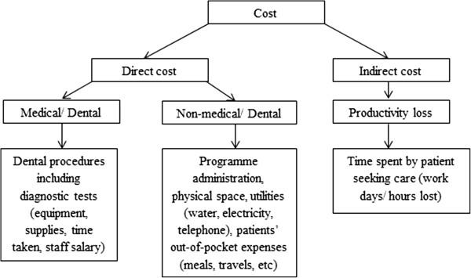
Image 1 The effects of sugar and sugar tax.

Soft drinks are still the most common source of sugar in children's diets, and the UK has one of the highest obesity rates among developed countries. The levy's proceeds will go towards physical education in primary schools, the Healthy Pupils Capital Fund, and a funding boost for breakfast clubs in over 1,700 schools.

Manufacturers were given two years to prepare for the implementation of SDIL. While several producers have lowered the amount of sugar in their beverages, over 450 traders have signed up to pay the charge. Depending on the amount of sugar in the product, there are two tax rates:The ‘standard rate' (18p per litre) applies to drinks containing 5 grammes of sugar per 100ml up to (but not including) 8 grammes of sugar per 100ml.Drinks with a sugar content of 8 grammes per 100ml or more are subject to the 'higher rate' (24p per litre).
Robert Jenrick, the Exchequer Secretary to the Treasury, stated:
The results released today demonstrate the good impact of the soft drinks levy, which has raised millions of pounds for sports facilities and better eating in schools, as well as prompting manufacturers to reduce sugar content in more than half of the beverages sold in UK retailers.
We want to ensure that our children enjoy a healthy and active childhood, and I'm glad to see that the industry is doing its part.
Additional findings from HMRC statistics are as follows:
Since April, almost 90% of traders' net liabilities have been at the higher rate (24p per litre)
Since the introduction of SDIL, 85 percent of gross liabilities have been declared bundled (produced in the UK). (jenrick 2018).
Sugar spikes in the blood caused by soft drink consumption could result in a variety of health problems. Sugar spikes in the blood from soft drink consumption could lead to various health complications, including type 2 diabetes.
Researchers have released the results of a Europe-wide study of nearly 500,000 people, which found that those who drank two or more glasses of soft drink per day were 17 percent more likely to die during the study than those who drank less than one soft drink per month.
Over a 16-year period, a group of researchers led by the International Agency for Research on Cancer in France polled over 450,000 adults (average age 51) from ten European countries about their soft drink consumption.
In the study, soft drinks included sugary and artificially sweetened fizzy drinks like cola, as well as diluted cordial. “This is not the first study to find a link between sugary soft drinks and poorer health," according to an NHS Behind the Headlines analysis of the report. Doctors believe that sugary soft drinks contribute to obesity and increase the risk of type 2 diabetes by causing sugar "spikes" in the blood when consumed.
When it comes to artificially sweetened soft drinks, it is less clear. Various studies have yielded contradictory results. Although artificial sweeteners have no or few calories, some research suggests that they may cause blood sugar spikes. So, there's no need to panic about the headlines implying that diet drinks will shorten your life. However, the study has limitations. Therefore, we should proceed with caution when interpreting the findings. It is a cross-sectional study, which means we only have information about what participants ate and drank at one moment in time. Although the researchers attempted to account for a variety of potential confounding factors, additional factors may have influenced the findings. As a result, we can't say that soft drinks are to blame for greater death rates. One theory is that people who consumed more artificially sweetened soft drinks did so because they were concerned about their weight or other health issues, so they moved from sugary beverages to what they felt were healthier alternatives. That would imply that those who drank artificially sweetened beverages were already less healthful than those who drank sugary drinks. (Wellness 2022).
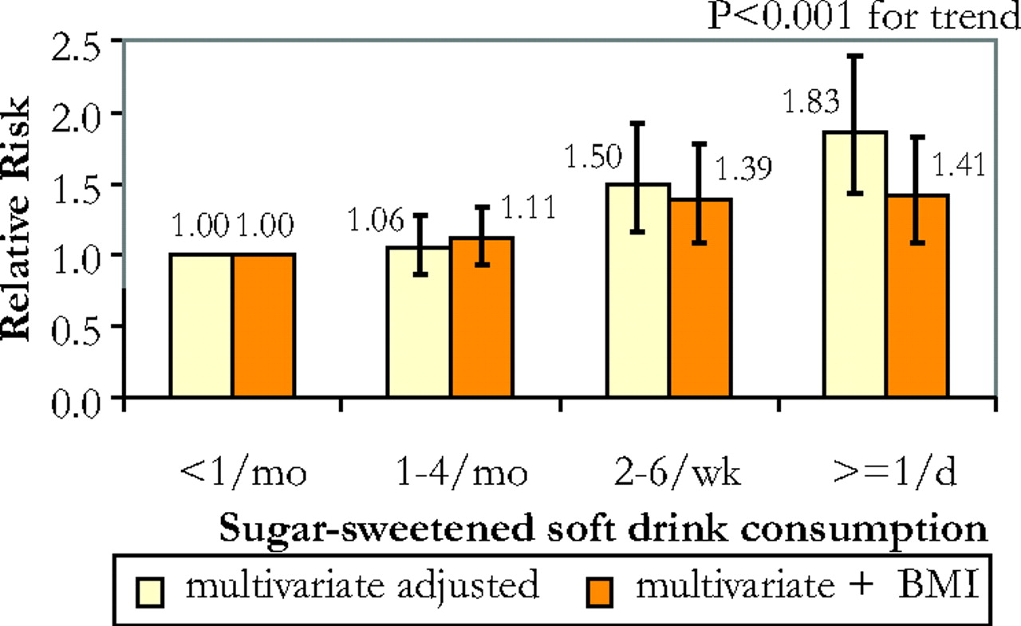
Image 2Sugar-sweetened soft drinks consumption.
According to BBC News, "researchers estimate that a 20% tax on sugary drinks will cut the number of obese adults in the UK by 180,000." According to a study published in the British Medical Journal (BMJ), taxing drinks will lower the population of obese persons by roughly 1%. There would be 180,000 fewer obese adults in the UK because of this.
The researchers calculated that a 20% tax (which would boost the cost of a 70p can to 84p) would reduce sugary drink consumption by around 15% using a series of statistical models based on existing data. According to their calculations, this would result in a reduction of 180,000 (1.3%) obese individuals in the UK and a reduction of 285,000 (0.9%) overweight and obese adults.
The predicted effect was most significant in the study's youngest age group - those aged 16 to 29.
However, because this was a modelling study, we can only provide estimates of change.
A new charge on sugary drinks would almost certainly be politically unpopular. Still, with obesity-related complaints costing the NHS £5 billion each year, a "sugar tax" may be an unpalatable decision that must be made in the future. (Well2020).
This important study used a vast amount of survey data from the United Kingdom to predict the effects of a 20% tax on sugar-sweetened soft drinks on consumption habits.
According to the research, switching one sugary drink per day to unsweetened tea/coffee or water could lower new instances of type 2 diabetes by 14 to 25%.
Between the 1990s and 2006, the researchers monitored over 25,000 adults aged 40 to 79 for roughly 11 years. The participants kept daily food diaries, recording everything they ate and drank. This is a practical technique to examine the situation.
Their findings are based on almost 31 million purchases by an average of 22,183 households who tracked every food and drink taken into the home on a weekly basis throughout this time period (including those ordered online and delivered). When all taxed and untaxed soft drinks were combined, the volume of drinks purchased did not change, but the amount of sugar consumed in these drinks decreased by around 30 g per household per week, or nearly 10% - equivalent to three fewer teaspoons, or one 250 mL serving of a drink with 5 g sugar per 100 mL per person per week.
Overall, they reveal that one year after implementation, the overall volume of all taxed and untaxed soft drinks purchased did not vary compared to pre-announcement patterns.
According to researchers at the George Institute for Global Health, these data suggest that the UK's sugar tax is functioning as intended - and provide lessons for other nations considering strategic regulatory measures to encourage better diets.
They explain how SSB levies have been utilised to improve health and suggest that regulation could be strengthened further. To tax a more extensive range of sugary drinks, for example, and to incorporate taxing thresholds that fall gradually over time to encourage continual sugar reduction. (BMJ2021).
Finally, they state that "the challenge is to establish rules that increase nutritional quality while reducing the environmental effect of the foods we eat" as the globe moves toward policies that promote healthier and more sustainable diets.
According to a new study, UK families purchased 10% less sugar through soft drinks in the year after the government introduced the sugar tax.
Since April 2018, manufacturers producing soft drinks with more than 5g of sugar per 100ml have been required to pay a levy of 18p per litre to the Treasury, or 24p per litre for sugar content exceeding 8g per 100ml. (SKY2021).
Sugar tax on soft drinks has been in place in the United Kingdom for more than a year, and the results so far appear to be positive. However, advocates claim that more can be done and that the next target should be cookies, cakes, and snacks, which contain a lot of sugar.
As of 2019, such tariffs were in place in 28 nations and 12 localities. According to preliminary findings, such tariffs have the potential to cut sugar consumption, which could assist in reducing obesity, diabetes, and dental damage in the future.
Over the last 40 years, the number of people living with obesity has nearly tripled — and is still rising. Obesity is increasing at the fastest rate in low- and middle-income areas. And when a population has both too much food and not enough of the correct nutrients, it results in a twin burden of starvation and obsessive behaviour.
Sugar consumption has been linked to an increase in obesity; hence the World Health Organization recommends that people limit their sugar intake. Sugary drinks, such as carbonated soft drinks, sports drinks, and energy drinks, are one of the most common sources of dietary sugar in children and adolescents. As a result, they've become a primary target for sugar reduction, but there's still more to be done.
Sugary beverage taxes may help to curb sugar consumption. And in the long run, they may help to reduce obesity and diabetes, especially when combined with "snack taxes," according to a recent study published in the British Medical Journal. However, there are a number of obstacles to greater sugary drinks and snack tariffs being implemented globally.
Opposition from the well-funded and influential food and beverage industry, as well as affiliated lobbyists, is a major roadblock. The following are some of their arguments against taxation:
Obesity is a personal responsibility. Thus, rather than taxing, education and improved physical activity should be encouraged.
Taxation is "regressive," which means that it has a greater impact on lower socioeconomic groups than on higher socioeconomic groups.
Taxes can lead to a loss of profit and employment losses, which has a negative influence on the economy.
This was a yearly cross-sectional study that combined nutrient composition data from 7377 goods obtained online with volume sales data from 195 brands offered by 57 companies in an annual cross-sectional analysis. The major outcome measures were total and per capita per day sales volume, sugar content, and volume of sugars sold by firm and category.
Results
During 2015 and 2018, the quantity of sugars sold per consumer per day from soft drinks decreased by 30%, equating to a 4.6 g per capita per day reduction. Soft drinks' sales-weighted mean amount of sugar decreased from 4.4 g/100 ml in 2015 to 2.9 g/100 ml in 2018. The entire volume of soft drink sales subject to the SDIL has more than 5 calories).
Conclusion
The soft drinks industry's efforts to reduce sugar in goods and change product portfolios, together with changes in consumer purchasing patterns, have resulted in a considerable decrease in the total amount and per person sales of sugars sold in soft drinks in the United Kingdom. The rate of change accelerated between 2017 and 2018, implying that the SDIL provided an additional incentive for corporations to reformulate beyond what was already being done as part of voluntary reformulation commitments or sales adjustments driven by consumer preferences. (Bandy 2020).

References

BMJ(2021). Consumption of sugar from soft drinks falls within a year of UK sugar tax.
https://www.bmj.com/company/newsroom/consumption-of-sugar-from-soft-drinks-falls-within-a-year-of-uk-sugar-tax/
Well,(2020). Effects of a fizzy drink tax on obesity rates estimated.
https://www.nicswell.co.uk/health-news/effects-of-a-fizzy-drink-tax-on-obesity-rates-estimated
Skybet(2021). Sugar tax, consumption of sugar from soft drinks falls by 10%.
https://news.sky.com/story/sugar-tax-consumption-of-sugar-from-soft-drinks-falls-by-10-12242372
Bandy L K, 2020, Reduction in sugar sales from soft drinks in the UK FROM 2015 TO 2018.
https://bmcmedicine.biomedcentral.com/articles/10.1186/s12916-019-1477-4
BMJ (2022). Consumption of sugar from soft drinks falls within a year of UKsugar tax.
Consumption of sugar from soft drinks falls within a year of UK sugar tax | BMJ
BMC (2014). Oral health, national library of medicine.
Cost analysis of Periodontitis management in public sector specialist dental clinics - PMC (nih.gov)
Jenrick R (2018). Sugar tax revenue helps tackle childhood obesity .
Sugar tax revenue helps tackle childhood obesity - GOV.UK (www.gov.uk)
Schaefer A (2018). Healthline, what does soda do to your teeth.
What Does Soda Do to Your Teeth? (healthline.com)
Diabetes research and wellness foundation. (2022)
Sugar spikes in blood from drinking soft drinks could lead to a range of health complications such as type 2 diabetes | Diabetes Research & Wellness Foundation (drwf.org.uk)
WichhallsC(2018). The conversation sugary drinks tax is working- now its time to target cakes, biscuits and snacks.
Sugary drinks tax is working – now it's time to target cakes, biscuits and snacks (theconversation.com)

