MATLAB thermal system modelling using finite difference method
Harry Foxton BEng Energy and Environmental engineering
University of Wales Trinity Saint David

Abstract
MATLAB is a powerful tool for solving matrix-based algebra making it the perfect tool for discretised based modelling. This report explores the use of the Finite difference method for the discretisation of the partial differential equation for thermal conduction. It is found that despite the Finite difference method providing a valid analytical model for the problem, has many flaws that if not controlled through code or understood by the user will result in misleading and incorrect predictions for time to reach thermal equilibrium. It is not understated that the use of discretisation through mathematical estimations is still very powerful and used very commonly through the simulation and modelling industry.

Contents

MATLAB thermal system modelling using finite difference method 4
Constitutive equation for Finite Difference Method 5
Finite Difference Method 6
MATLAB and its application 8
Boundary conditions 8
Coding Application of Finite difference method 9
Input Parameters 9
Implementation of Boundary conditions 10
Implementation of FDM 11
Defining Thermal equilibrium 11
Efficiency considerations 12
Plotting 12
Matrix reflection 12
Function implementation 13
Analysis of results 13
Grid spacing 15
Time step 16
Equilibrium definition 17
Limitations of the model and improvements 18
Equilibrium problem 18
Small step problem 19
The Finite Difference Method 19
Truncation Error 19
Alternatives 19
Conclusion 20
Additional Tables 21
Appendices 22
References 28

MATLAB thermal system modelling using finite difference method
The aim of this task is to create a system model that accurately represents how heat propagates through a metal plate of defined thermal properties. The finished result will present a graphical representation of the thermal characteristics through the plate and display the time it took for the plate to reach thermal equilibrium. The code will use the Finite difference method to approximate a second order differential equation on an element-by-element basis where the grid spacing for a given element is defined as h where elements follow the rule described in Equation 1 explaining that elements are square.
$$grid spacing= h=Δx=Δy Equation SEQ Equation \backslash * ARABIC 1$$
The plate that will be modelled is an Aluminium metal plate with negligible thickness, so is assumed to be 2 dimensional. The thermal properties of the modelled plate are as follows:
$$k=143 W{.m}^{-1}C^{-1}$$
$$ρ=2.8×{10}^{3} kg{.m}^{-3}$$
$$C=795 J.kg^{-1}C^{-1}$$

The code will be built with User functionality and reduced solve times in mind.

Constitutive equation for Finite Difference Method
The constitutive equation for thermal transfer through a material which will be the underlying equation used in the model, is derived from both; Fourier’s law of heat transfer which explains a relationship between the conduction rate in a material and the temperature gradient in the direction of energy flow with respect to a change in displacement (Fourier, 1878) described by the equation shown in Equation 2 and the equation for specific heat shown in Equation 3 which describes a proportional relationship between heat transfer and rate of temperature change (Lumen, 2019). A full derivation can be found in the appendices.
Where:
$q$= Vector of local heat flux density
$k$ = Material conductivity
$∇T$ = Temperature Gradient

Where:
$\frac{∂E}{∂t}=$ Rate of change of Energy transfer
$ρ$ = Density
$V$ = Volume
$c_{p}$ = specific heat capacity
$T$ = Temperature

$q=-k∇T Equation SEQ Equation \backslash * ARABIC 2$ $\frac{∂E}{∂t}=ρC_{p}∂V\frac{∂T}{∂t} Equation SEQ Equation \backslash * ARABIC 3$

The equation shown in Equation 4 is the base equation for thermal transfer and will allow for a rate of change of temperature to be found with relation to a change is displacement (Mackowski, 2019).
$$α∇^{2}T+ {\dot{e}}_{gen}=\frac{∂T}{∂t} Equation SEQ Equation \backslash * ARABIC 4$$

The task brief specifies that the width of the plate is negligible, therefore after the Laplace operator is expanded, the z term is 0 and is removed (Lavelle, 2019). The task brief describes no internal energy gains therefore the ${\dot{e}}_{gen}$ term is cancelled, leaving a rearrangement of the equation shown in Equation 5. This means that a change of temperature can be found with relation to a change in x and y displacement. Therefore, if our plate is divided into an equally spaced grid of size h, as described in the appendices, a general equation is generated to find a temperature at a horizontal (x) or vertical (y) displacement.
$$\frac{∂^{2}T}{∂x^{2}}+\frac{∂^{2}T}{∂y^{2}}=\frac{1}{α}⋅\frac{∂T}{∂t} Equation SEQ Equation \backslash * ARABIC 5$$

Finite Difference Method
The finite difference method is used to approximate partial differential equations through means of discretization (Zhou, 1993), this discretization is achieved through means of the Taylor series expansion. The Taylor series equates a function into an infinite series of polynomial equations. The base equation for the Taylor series is described in Equation 6 (Wolfram MathWorld, 2020). The three terms from the base equation for heat conduction (Equation 5) that need to be discretized are described in Equations 7,8 and 9. Both Equation 7 and 8 are in with respect to a change in x and y whereas Equation 9 is with respect to a change in time.
$$f\left(x\right)=\sum_{n=0}^{∞}{f^{\left(n\right)}\left(x_{0}\right)\frac{{\left(x-x_{0}\right)}^{n}}{n!}} Equation SEQ Equation \backslash * ARABIC 6$$
$$\frac{∂^{2}T}{∂x^{2}} Equation SEQ Equation \backslash * ARABIC 7 \frac{∂^{2}T}{∂y^{2}} Equation SEQ Equation \backslash * ARABIC 8 \frac{∂T}{∂t} Equation SEQ Equation \backslash * ARABIC 9$$
A derivation of the Finite difference method equations is described in the appendices which allows for approximations of all three of the above equations. First considering Equations 7 & 8, the approximation will use the equation described in Equation 10, known as the second order central difference approximation. The discretization allows for a grid mask to represent the metal plate described in the task (which will later be quantified using matrices) where h will represent the spacing between intersecting points on the grid and will be constant throughout the matrix. With truncation error of order h, derived from the Taylor series.
$$T_{N}$$
$$T_{S}$$
$$T_{E}$$
$$T_{W}$$
$$T_{P}$$
$$\frac{f\left(x_{0}+h\right)+ f\left(x_{0}-h\right)- 2f\left(x_{0}\right)}{h^{2}}=f^{'}'\left(x_{0}\right)+O(h^{2}) Equation SEQ Equation \backslash * ARABIC 10$$
For this case $x_{0}$ is considered as the temperature at a point p ($T_{p})$ and the points surrounding are described by cardinal directions North ($T_{n})$, South ($T_{s})$, East ($T_{e})$, West ($T_{w})$. Therefore, when applying this approximation to Equation 7, a fully polynomial, discretised equation is generated as shown in Equation 11.

$$\frac{∂^{2}T}{∂x^{2}}≈\frac{T_{e}+T_{w}-2T_{P}}{h^{2}} Equation SEQ Equation \backslash * ARABIC 11$$
The same conclusion can be met when considering the y term shown in Equation 8, to produce the polynomial approximation shown in Equation 12.
$$\frac{∂^{2}T}{∂y^{2}}≈\frac{T_{n}+T_{s}-2T_{P}}{h^{2}} Equation SEQ Equation \backslash * ARABIC 12$$

The forward difference approximation (described in equation 9) is then used to discretise the first order differential described in Equation 9. However, rather than h representing a displacement, h is used to represent a time in the future which is quantified by a time step ($Δt)$, therefore producing the equation described in Equation 14. Where $T_{p}^{'}$ is the temperature at point p at one timestep in the future from the current $T_{p}$.
$$\frac{f\left(x_{0}+h\right)- f\left(x_{0}\right)}{h}=f^{'}\left(x_{0}\right)+O\left(h\right) Equation SEQ Equation \backslash * ARABIC 13$$
$$\frac{∂T}{∂t}≈\frac{T_{p}^{'}-T_{p}}{Δt} Equation SEQ Equation \backslash * ARABIC 14$$
Now all differential parts of the conduction equation have been discretised, the new polynomial forms can be substituted back into the base conduction equation as shown in Equation 15. As the brief explains, this code must estimate the time taken for the aluminium plate to reach thermal equilibrium, therefore, using this discretised method we can find the temperature one timestep in the future until thermal equilibrium, when rearranged for $T_{p}^{'}$ Equation 16 is found. $F$ in Equation 16 is known as Fourier’s number.
$$\frac{T_{n}+T_{s}-2T_{P}}{h^{2}}+\frac{T_{e}+T_{w}-2T_{P}}{h^{2}}=\frac{1}{α}⋅\frac{T_{p}^{'}-T_{p}}{Δt} Equation SEQ Equation \backslash * ARABIC 15$$
$$T_{p}^{'}=F\left(T_{n}+T_{e}+T_{w}+T_{s}+\left(\frac{1}{F}-4\right)T_{p}\right) Where: F=\frac{αΔt}{h^{2}} Equation SEQ Equation \backslash * ARABIC 16$$
This method is known as the explicit finite difference method as it calculates a temperature at point p in the future based on the current temperature.

MATLAB and its application
MATLAB is built, at its core, to perform calculations on large matrices (MathWorks, 2019). As long as the user input for h (grid spacing) complies with the dimensions of the plate, the domain can be divided into equal spaces, which can then be represented by a matrix of temperature values.

Boundary conditions
This first problem of this discretised equation shown in Equation 16 is that it relies on having temperature values in each cardinal direction. However, at the edges and corners of the matrix, there are no values to reference therefore the equation will not hold up. A set of parameters must be decided to understand how the equation will act at points lacking full reference. These are known as boundary conditions and are outlined as follows:
- The top surface of the plate is heated following a normal/Gaussian distribution where the amplitude is 60℃ and both edges are 10℃
- The gaussian distribution will be modelled following Equation 17
- The left, right and bottom edges are fully insulating, meaning no heat is lost on any edges
Where:
$T(x)$= Temperature at point x
$A$ = Amplitude
$x$ = Point of interest
$x_{0}$ = x position of mid plot
$σ$ = Normal distribution

$$T\left(x\right)=A⋅ⅇ^{\left(\frac{-{\left(x-x_{0}\right)}^{2}}{2σ^{2}}\right)} Equation SEQ Equation \backslash * ARABIC 17$$
The top boundary is known as a Dirichlet boundary where the temperature values are constant. The remaining insulating boundaries follow Neumann boundary where the exact quantity at the point is not known, however a differential of temperature is known and, in this case, is 0 (Nuclear Power, 2020).

Coding Application of Finite difference method

Input Parameters
As the task requires, the user must be prompted for both x and y dimensions and a grid spacing (h) that splits the plate equally in both x and y. These dimensions have been implemented with looping and conditional statements to ensure the values inputted will work with the code. The remainder function was used to ensure the grid spacing complies with the inputted plate dimensions.
Figure 1 – Script section – Time step stability conditioning
% Time step input
timeStepLogic = false;
while timeStepLogic == false
prompt = {['please input a time step >0 and <',num2str(timeStepUpperBound),' seconds...']};
dlgtitle = 'Data Input';
dims = [1 60];
timeStep = inputdlg(prompt, dlgtitle, dims);
timeStep = str2double(timeStep);

if timeStep > 0 && timeStep < timeStepUpperBound
timeStepLogic = true;
else
disp('Please pick a timestep between the displayed bounds')
end
end

Stability criteria are an important part of a successful model. If a multiplier of <0 is used when multiplying by $T_{p}$ then the equation has an exponential effect therefore $\left(\frac{1}{F}-4\right)≥0$. Fourier’s number represents one of these criteria and must not exceed 0.25 for a 2-dimensional plate. Fourier’s number follows the equation shown in Equation 18. As grid spacing and thermal diffusivity are already allocated, a timestep is user prompted to ensure that Fourier’s number remains between 0 and 0.25.
Where:
$F$= Fourier’s number
$α$ = Thermal diffusivity
$Δt$ = Time step
$h$ = Grid spacing

$$F=\frac{αΔt}{h^{2}} Equation SEQ Equation \backslash * ARABIC 18$$

Implementation of Boundary conditions
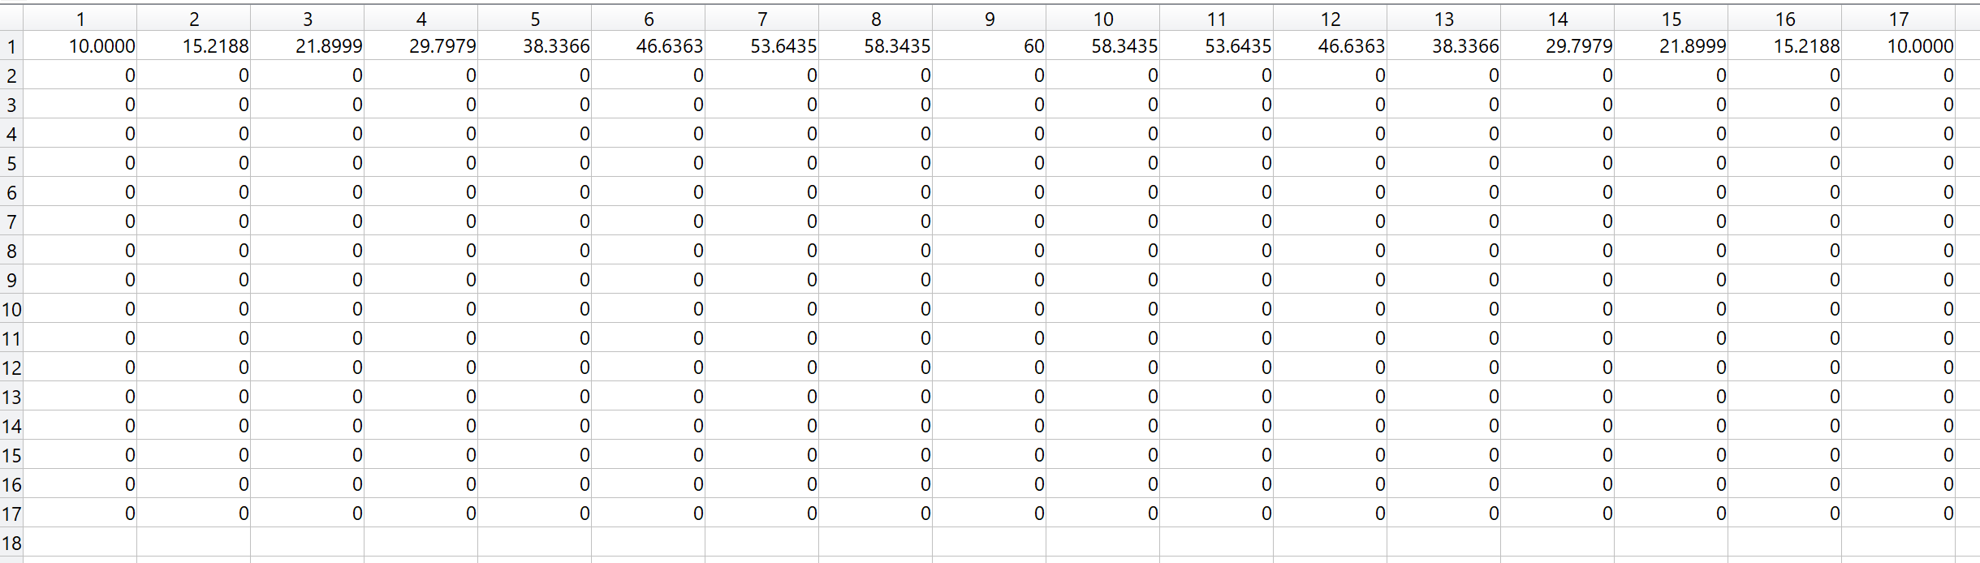
After initialising the matrix based on dimensions and grid spacing, the boundary conditions must be initialised. The top boundary (first row) with the Gaussian distribution is the only set of elements that remain static through the duration of the simulation; therefore, they are pre-allocated to save processing time later in the model. The normal distribution ($σ$) is the only unknown in Equation 17; as the temperature is known at the far-most left and right points (10℃), the normal distribution can be calculated which will be used to calculate the remainder of the top boundary, point by point using a for loop. Once fully allocated the code is ready to start solving. A typical initial matrix is shown in Figure 2.
Figure 2 – Initial setup for matrix
Full insulation in the x direction is described by Equation 19, applying this to the finite difference approximation, it is found that $T_{w}=T_{e}$, this means for points on the left and right boundary the missing points can be replaced by the points in the opposite cardinal direction, the same logic can be applied to the bottom boundary.
$$\frac{∂T}{∂x}=0 Equation SEQ Equation \backslash * ARABIC 19$$
From a coding perspective 2 approaches can be considered: An if statement can be used to check whether a point of calculation lies on a boundary, at which point the boundary condition can be implemented, or the boundaries can be solved independently from the internal elements with the boundary conditions applied. Conditional statements are computationally expensive; therefore, the boundaries will be solved independently from the internal elements in the matrix.

Implementation of FDM
As the time taken to reach thermal equilibrium is unknown, a conditional while loop is used to determine when the solving should end (definition of thermal equilibrium is described in the next section). The start of the solve allocates the current temperature matrix to a second matrix which will be used as a comparator when determining the point of equilibrium. The solve executes in the following order based on the previous temperature matrix:
- Left boundary solves
- Bottom boundary solves
- Lower left corner solves
- Internal elements solve
- Reflection executed (discussed in later section)
- Error calculated
- Plot updated
- Determine equilibrium conditions met

Defining Thermal equilibrium
One of the largest problems with this model is that the elements in a cell never reach true thermal equilibrium, one temperature matrix will never exactly equal another. The alternative to this is to accept thermal equilibrium as a margin of acceptance between two matrices. Once the matrices are below the acceptance margin, the script stops solving. The ‘Analysis of results’ section details the informed decisions made to determine the margin of acceptance.
Two approaches were considered from a scripting perspective:
If the previous temperature matrix is subtracted from the newly generated matrix, a new matrix of differences will be formed, if every value in the ‘differences’ matrix falls below the margin of acceptance, then thermal equilibrium is reached. This method, however, is time consuming as every element must pass a conditional statement to determine equilibrium.
The second alternative is the use of the ‘max’ function; using the same subtraction matrix, the max function will sort the ‘differences’ matrix to determine the largest value in the matrix, this single value then passes the conditional statement to see if it falls below the margin of tolerance.
Figure 3 – Script section – error generation for equilibrium acceptance
%generates error based on comparison of matrices
error = max(max(tempMatrix - prevTempMatrix)));

Efficiency considerations

Plotting
The ‘Run and Time’ function provides a diagnostic tool to indicate which sections of the scripts are taking the most time to process. The contour plot used to visualise the matrix, is proven to be one of the most computationally expensive parts of the script, shown by the percentage of time taken in Figure 4. To overcome this, the ‘drawnow’ function, which forces the drawing of the plot, only takes place every 1 in 150 iterations of the simulation. This largely reduces the impact of the plotting, while still providing visualisation of the matrix.
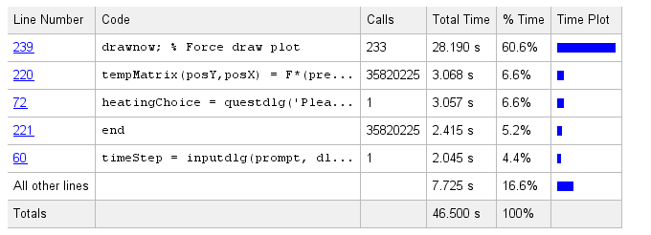

Figure 4 – Run and time diagnostic study

Matrix reflection
Many simulation-based software, such as CFD, utilises symmetry to cut down solve time. As this matrix is symmetrical down the central vertical axis, a reflection can be implemented. The reflection is dependent on the number of elements in the x axis; an even number of elements, results in a complete reflection down the centre. However, an odd number of elements results in a reflection about the central most column, the point of reflection is determined before solving as shown in Figure 5.

Function implementation
Figure 5 – Determining reflection point
% Reflection setup
evenReflect = false;
if rem(xSize,2) == 0
reflectionIndex = xSize/2;
reflectionPos = reflectionIndex + 1;
else
reflectionIndex = round((xSize/2)-1);
reflectionPos = reflectionIndex + 2;
end

The use of a predefined function allows MATLAB to pre-allocate memory and can speed the operation if a bulk of script is repeated often throughout. A function was implemented for the calculation of a temperature at a point, shown in Figure 6. It was later determined after testing, that this was slower than the direct implementation of the equation. This may be due to the function only consisting of 1 line. Functions are best suited for small bulks of repeated script.
Figure 6 – Function designed to optimise program performance
%% Mathematical function definition NOT USED
function tempOut = tempFunction(F, Tn, Te, Ts, Tw, Tp)
%Final equation from approximation method
tempOut = F*(Tn+Te+Ts+Tw+((1/F)-4)*Tp);
end

Analysis of results
Due to the boundary and heating conditions, the task set will generate a relatively unpredictable heat distribution and equilibrium is hard to identify. To analyse the use of the finite difference a simpler case will be used with boundary conditions that will produce a result that is predictable and expected. This case will involve the left boundary being heated to 50℃ and the right boundary being cooled at 0℃, the top and bottom boundaries are heated with a linear decrease from 50℃ to 0℃. The heated plate in equilibrium, will consist of vertical isolines of temperature that match the temperature at the top and bottom of the plate.

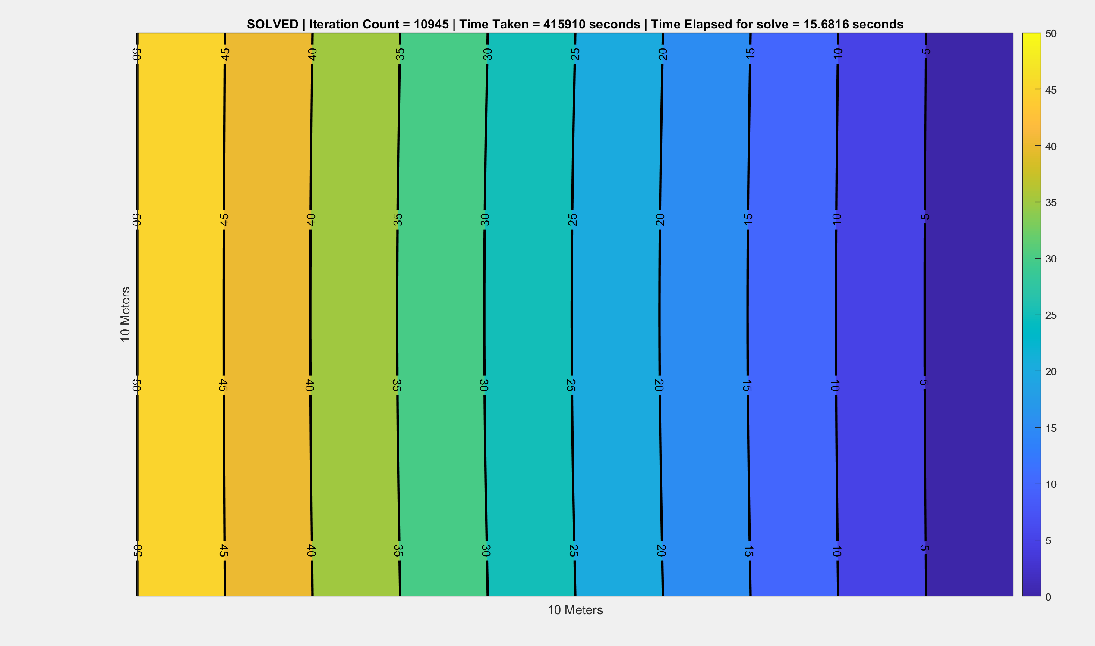
Figure 7 – Linear heat distribution contour plot
A series of tests will be done with varied input parameters to understand whether that set of parameters reaches equilibrium. While each parameter is tested, the remaining variables must be standardised as such:
- X Dimension = 1 meter
- Y Dimension = 1 meter
- Grid spacing = 0.01
- Time step = 0.097
- Equilibrium tolerance = 0.0001℃

These figures will produce a 101x101 matrix, which takes 3 second to solve and reaches thermal equilibrium in an estimated time of 4,300 seconds. This short solve time will allow for an in-depth study of parameter adjustment. The Tables section (at end of paper) describes 2 sets of data taken for changes in x and y. It was found that, providing a compatible grid spacing is used, the model will function with a large variance in plate dimensions. The plate dimensions have no large detriment to any stage of the Finite difference approach so requires no further investigation.

Grid spacing
Grid spacing is used in the generation of the Fourier’s number for the base equations, this contributes to one of the stability factors surrounding the model as it is limited between 0 and 0.25. The grid spacing plays a large part in the generation of the size of the matrix used, which has large implications on the solve time. Table 1 shows a series of runs with varying grid spacing with all other variables following predefined standards described at the start of this section.
Mesh Size h (m) | Iteration count to solve | Time to solve  (seconds) | Estimated time to thermal equilibrium (seconds) | Vertical iso-lines of temperature present
0.005 | 50499 | 42.6769 | 4898.403 | ✖
0.008 | 50499 | 22.379 | 4898.403 | ✖
0.01 | 50501 | 16.977 | 4898.59 | ✔
0.02 | 50507 | 2.6253 | 4899.179 | ✔
0.05 | 50552 | 0.75812 | 4903.544 | ✔
0.1 | 50713 | 0.51475 | 4919.16 | ✔
Table 1 – Table of varying grid spacings
Figure 8 – Graph of vary grid spacings

The first 2 tests ran did not have vertical iso-lines of temperature, thus did not reach full thermal equilibrium. This is shown in the Figure 8 by the change in estimated time to reach equilibrium, over small changes in grid spacing. This issue will be further discussed in ‘Limitations of the Model’ section.
Time step (s)  Max:0.389 | Iteration count to solve | Time to solve  (seconds) | Estimated time to thermal equilibrium (seconds) | Vertical iso-lines of temperature present
0.00389 | 163157 | 41.234 | 634.94 | ✖
0.00486 | 161177 | 78.478 | 783.32 | ✖
0.00778 | 143512 | 40.61 | 1116.95 | ✖
0.01946 | 93425 | 20.49 | 1817.86 | ✖
0.03892 | 60714 | 13.38 | 2362.75 | ✖
0.07783 | 37376 | 8.230 | 2909.04 | ✖
0.19458 | 18664 | 4.436 | 3631.64 | ✔
0.25944 | 14872 | 3.657 | 3858.39 | ✔
0.32430 | 12440 | 3.573 | 4034.29 | ✔
0.389 | 10739 | 2.861 | 4177.47 | ✔

Time step
Table 2 – Table with varying time step

Figure 9 – Graph of varying time step
Figure 9, which represents the time taken to reach thermal equilibrium against a change in timestep, shares very similar charachteristics to the graph shown in Figure 8. Both graphs show that for small values of Fourier’s number, the plate does not reach thermal equilibrium. Where the vertical red line represents the point where a run reaches equilibrium (i.e. vertical isolines of temperature). A simple visual observation was used to indicate if the isolines of temperature were fully vertical. This is not a perfect solution but helps determine whether a model run has achieved equilibrium.

Equilibrium definition
Definition of Equilibrium | Iteration count to solve | Time to solve  (seconds) | Estimated time to thermal equilibrium (seconds) | Vertical iso-lines of temperature present
0.0000001 | 24741 | 5.7539 | 9624.25 | ✔
0.000001 | 20074 | 4.6587 | 7808.79 | ✔
0.00001 | 15407 | 4.1343 | 5993.32 | ✔
0.0001 | 10739 | 3.2879 | 4177.47 | ✔
0.001 | 6073 | 1.8995 | 2362.39 | ✖
0.01 | 1633 | 0.9341 | 635.237 | ✖
0.1 | 168 | 0.7138 | 65.35 | ✖
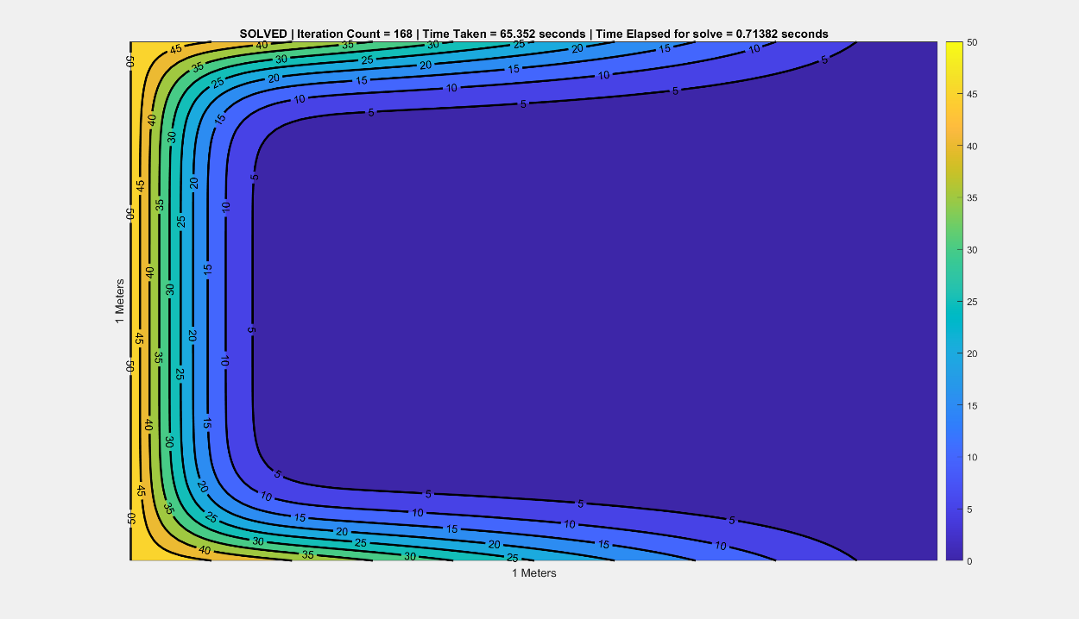
The definition of equilibrium is one of the biggest complications of this model. The way the equation is formed means that one matrix will never exactly equal the last, therefore a tolerance of acceptance must be used to decide when a plate reaches equilibrium. A very small change in thermal equilibrium definition can have large implications on the results of the model. A series of definitions were tested with the base conditions.
Table 3 – Table of varying equilibrium acceptance tolerance
Figure 10 – Plot of 0.1℃ equilibrium tolerance
As Figure 10 suggests a large tolerance of acceptance generates a result that is not close to thermal equilibrium. The use of a 0.0001℃ tolerance is the largest tolerance that results in thermal equilibrium being reached for this case. According to Figure 11, 0.01℃ is the largest equilibrium tolerance that stays with the linear trend displayed. The difference in estimated time to thermal equilibrium between a $1×{10}^{-7}$ and $1×{10}^{-2}$ is 8989.013 seconds, this is 14x bigger than the time estimated at 0.01 equilibrium tolerance and with only a 0.001% accuracy improvement, this a clearly major flaw in the model; a small increase in accuracy changes the result enormously.
Figure 11 – Logarithmic scale of equilibrium acceptance tolerance

Limitations of the model and improvements

Equilibrium problem
As mentioned in the previous section, a small change in equilibrium definition results in a large change in estimated time for equilibrium. This means that the only way to make this process fully objective, is for the user to decide the equilibrium tolerance, however as Table 3 describes, many larger values for equilibrium acceptance do not result in full equilibrium, to reduce user error it is more logical to keep a predefined value for equilibrium acceptance, the data suggests that a 0.00001 tolerance allows for the largest range of parameters to still reach equilibrium while minimising solve times.
A considered alternative involves the use of a trained neural network that, with a large data set could recognise patterns and estimate a time to reach thermal equilibrium, however, this idea has the same fundamental flaw regarding the accuracy of thermal equilibrium definition. An alternative use of a neural network will be discussed in the next section.

Small step problem
Another fundamental flaw of this model demonstrated during analysis is that for small values of $F$ (Fourier’s number) the changes in temperature across the matrix can be so small that the equilibrium condition is met long before equilibrium is obviously reached. As previously mentioned, the use of a neural network could potentially be in order. If a set of parameters are inputted for the gaussian distribution, the code could run the parameters in the linear distribution model and could tell, by means of analysing how vertical the iso-lines of temperature are, the certainty of whether the gaussian distribution will reach equilibrium. A second alternative to overcome the small step problem is, for a set of input parameters, a minimum Fourier’s number is generated which rules out time steps that are certain will not achieve equilibrium, this minimum cap could be generated using the data collected in previous sections. This method however, limits user functionality and may be more beneficial to simply warn the user of the equilibrium issue.

The Finite Difference Method

Truncation Error
One of the flaws the mathematical method itself is the generation of a truncation error from the remainder of the infinite Taylor series. As $h$ is small, $h^{2}<h$, therefore with a truncation error of order $h^{2}$, the central difference approximation is more accurate than the forward difference approximation, however the forward difference approximation must be used to approximate the first order differential part of the equation. It is not possible to calculate the exact value of the truncation error as it is an infinite sum, but rather use the order of magnitude to assess the accuracy of the method.

Alternatives to the mathematical approach
As previously mentioned, this code uses the explicit finite difference method; the implicit finite difference method uses temperatures at a time step in the future to calculate the temperature at the current point of interest. The only way the implicit finite difference method could be used is through means of simultaneous coupled solving of the plate which is harder to implement from a coding perspective, however would eliminate the stability criteria needed for the explicit approach (Dehghan, 1999). There are also developments in meshless FDM approaches which allow for a more versatile application with varying node densities (Gavete, et al., 2003)

Conclusion
Despite its flaws, the finite difference method can be used to predict an otherwise very difficult second order partial differential equation with a means of comparative validation through the linear heat distribution plate generated, allowing for reasonable statements to be made as to whether a set of input parameters will achieve a result that is in relative thermal equilibrium. The Finite difference method and other methods of discretisation are used very commonly throughout engineering to breakdown an infinitely large problem into calculable elements, and like all other discretisation techniques, if the user understands the errors and limitations of its outputs then the results will provide a useful analytical tool for its intended task (Boardman, 2006).

Additional Tables

X Dimension size (m) | Iteration count to solve | Time to solve  (seconds) | Estimated time to thermal equilibrium (seconds) | Vertical iso-lines of temperature present
0.1 | 378 | 1.5108 | 143.64 | ✔
0.2 | 1274 | 0.594 | 484.12 | ✔
0.5 | 5290 | 0.879 | 2010.2 | ✔
1 | 11424 | 2.847 | 4303.12 | ✔
1.5 | 14745 | 5.767 | 5603.1 | ✔
2 | 16568 | 7.386 | 6295.84 | ✔
Y Dimension size (m) | Iteration count to solve | Time to solve  (seconds) | Estimated time to thermal equilibrium (seconds) | Vertical iso-lines of temperature present
0.1 | 392 | 2.1316 | 148.96 | ✔
0.2 | 1289 | 0.757 | 489.82 | ✔
0.5 | 5290 | 1.4976 | 2010.2 | ✔
1 | 11324 | 2.6737 | 4303.12 | ✔
1.5 | 14744 | 9.2696 | 5602.72 | ✔
2 | 16557 | 7.3354 | 6291.66 | ✔
Table 4 – Change values of x

Table 5 – Changing values of y

Appendices
Full derivation of heat conduction equation:
If the basic principles of energy conservation are applied to a cartesian based grid which represents a small element of a material under a heated condition, the following equation can be derived:

$${\dot{q}}_{x}$$
$${\dot{q}}_{x}+{\dot{q}}_{x+dx}$$

$$E_{gen}$$
$$x$$
$$y$$
$$z$$
(Rate of heat conduction @ x, y, z) – (Rate of heat conduction @x+dx, y+dy, z+dz) + (Rate of internal heat gain) = (Rate of change of energy content within the element)
Once Expanded:
$\left({\dot{q}}_{x}-{\dot{q}}_{x+dx}\right)+ \left({\dot{q}}_{y}-{\dot{q}}_{y+dy}\right)+ \left({\dot{q}}_{z}-{\dot{q}}_{z+dz}\right)+ {\dot{E}}_{gen}= \frac{∂E}{∂t}$
Considering just x terms and factorising for q:
${\dot{q}}_{x}-{\dot{q}}_{x+dx}=\frac{∂}{∂x}\left(q_{x}\right)⋅∂x$
Fourier’s Law states:
$q_{x}=-k∇T$ where $∇T=\frac{∂T}{∂x}+\frac{∂T}{∂y}+\frac{∂T}{∂z}$ (Fourier, 1878)
Therefore:
${\dot{q}}_{x}-{\dot{q}}_{x+dx}=\frac{∂}{∂x}\left(-k\frac{∂T}{∂x}\right)⋅\left(∂x∂y∂z\right)$ Where the same can be said for y and z
Also:
$${\dot{E}}_{gen}={\dot{e}}_{gen}⋅∂x∂y∂z={\dot{e}}_{gen}⋅∂V$$

Also:
$$\frac{∂E}{∂t}=ρ⋅∂V⋅c_{p}\frac{∂T}{∂t}$$
Full substitution:
$$\frac{∂}{∂x}\left(k\frac{∂T}{∂x}\right)∂V+\frac{∂}{∂y}\left(k\frac{∂T}{∂y}\right)∂V+\frac{∂}{∂z}\left(k\frac{∂T}{∂z}\right)∂V+{\dot{e}}_{gen}⋅∂V= ρ⋅∂V⋅c_{p}\frac{∂T}{∂t}$$
Dividing by $∂V$ and simplifying differentials:
$$k\frac{∂^{2}T}{∂x^{2}}+k\frac{∂^{2}T}{∂y^{2}}+k\frac{∂^{2}T}{∂z^{2}}+{\dot{e}}_{gen}=ρc_{P}\frac{∂T}{∂t}$$
Thermal diffusivity (Lightfoot, 1960):
$$α=\frac{k}{ρc_{p}}$$
General Thermal conduction equation:
$$\frac{∂^{2}T}{∂x^{2}}+\frac{∂^{2}T}{∂y^{2}}+\frac{∂^{2}T}{∂z^{2}}+{\dot{e}}_{gen}=\frac{1}{α}∙\frac{∂T}{∂t}$$
Simplified to with the use of Laplacian operator:
$${α∇}^{2}T+{\dot{e}}_{gen}=\frac{∂T}{∂t}$$

Derivation of Finite difference method equation (Causon & Mingham, 2010):
The first few terms of the expansion are shown in the below equation, $x_{0}$ describes a point of interest:
$$f\left(x\right)=f\left(x_{0}\right)+f^{'}\left(x_{0}\right)\left(x-x_{0}\right)+f^{''}\left(x_{0}\right)\frac{{\left(x-x_{0}\right)}^{2}}{2!}…$$
If $x$ is considered in terms of $x_{0}+h$ where h is an incremental change in either displacement or time, the following equation is described
$$f\left(x_{0}+h\right)=f\left(x_{0}\right){+f}^{'}\left(x_{0}\right)h+f^{''}\left(x_{0}\right)\frac{h^{2}}{2!}$$
Rearranged:
$$\frac{f\left(x_{0}+h\right)- f\left(x_{0}\right)}{h}=f^{'}\left(x_{0}\right)+f^{''}\left(x_{0}\right)\frac{h}{2!}$$
The remaining term with the second order differential part, is known as the truncation error and is of Order h, this must be considered when evaluating the validity of the Finite different method. The below equation is the final form of the forward difference approximation:
$$f\left(x_{0}-h\right)=f\left(x_{0}\right){-f}^{'}\left(x_{0}\right)h+f^{''}\left(x_{0}\right)\frac{h^{2}}{2!}$$
Therefore:
$$\frac{f\left(x_{0}+h\right)- f\left(x_{0}\right)}{h}=f^{'}\left(x_{0}\right)+O(h)$$
If considering $x_{0}-h$ instead, the following equation is gained, known as the backward difference approximation:
$$\frac{f\left(x_{0}\right)- f\left(x_{0}+h\right)}{h}=f^{'}\left(x_{0}\right)+O(h)$$
When the $x_{0}-h$ term is subtracted from the $x_{0}+h$term, the central difference approximation is found:
$$\frac{f\left(x_{0}+h\right)- f\left(x_{0}+h\right)}{2h}=f^{'}\left(x_{0}\right)+O(h)$$
When adding both $x_{0}-h$ and $x_{0}+h$ an equation is generated to approximate second order differential equations:
$$\frac{f\left(x_{0}+h\right)+ f\left(x_{0}-h\right)- 2f\left(x_{0}\right)}{h^{2}}=f^{'}'\left(x_{0}\right)+O(h)$$

Full code
%% General Initialisation
clc
clear
close all

%% User inputs and Variable definition

%x Dimension input
xDim = 0;
while xDim <=0 || isnan(xDim) == true
prompt = {'Enter x dimension greater than 0:'};
dlgtitle = 'Data Input';
dims = [1 60];
xDim = inputdlg(prompt,dlgtitle, dims);
xDim = str2double(xDim);
end

%y Dimension input
yDim = 0;
while yDim <=0 || isnan(yDim) == true
prompt = {'Enter y dimension greater than 0:'};
dlgtitle = 'Data Input';
dims = [1 60];
yDim = inputdlg(prompt,dlgtitle, dims);
yDim = str2double(yDim);
end

% h input
hLogic = false;
while hLogic == false
prompt = {'Enter mesh size that complies with dimensions of plate:'};
dlgtitle = 'Data Input';
dims = [1 60];
h = inputdlg(prompt,dlgtitle, dims);
h = str2double(h);

% ensuring mesh size fits within domain
if rem(xDim, h) == 0 && rem(yDim, h) == 0 && h >0 && h < yDim && h <xDim
hLogic = true;
else
disp('Ensure grid size complies with the dimensions of the plate and is > 0')
end
end

%Material properties
Cp = 795;
Density = 2800;
k = 143;
thermDiff = k/(Cp*Density);

% Ensuring Fouriers number is within bounds
timeStepUpperBound = 0.25*(h^2)/thermDiff;

% Time step input
timeStepLogic = false;
while timeStepLogic == false
prompt = {['please input a time step >0 and <',num2str(timeStepUpperBound),' seconds...']};
dlgtitle = 'Data Input';
dims = [1 60];
timeStep = inputdlg(prompt, dlgtitle, dims);
timeStep = str2double(timeStep);

if timeStep > 0 && timeStep < timeStepUpperBound
timeStepLogic = true;
else
disp('Please pick a timestep between the displayed bounds')
end
end

% Heating condition option
dims = [5 80];
heatingChoice = questdlg('Please pick a heating condition', ...
'Heat condition','Linear Distribution','Gaussian Distribution','Cancel');

% calculating Fouriers Number for given timeStep
F = thermDiff*timeStep/h^2;

%Initialising Matrix
blankMatrix = zeros(yDim/h+1,xDim/h+1);
matrixSize = size(blankMatrix);
xSize = matrixSize(2);
ySize = matrixSize(1);

%% Solving

switch heatingChoice

% Linear Heat distribution

case 'Linear Distribution'
%initial temp properties
tLeft = 60;

%implementing Boundary conditions
blankMatrix(:,1) = tLeft;
blankMatrix (1, :) = linspace(tLeft, 0, xSize);
blankMatrix (end, :) = linspace(tLeft, 0, xSize);

%Creates initial Matrix
tempMatrix = blankMatrix;
prevTempMatrix = blankMatrix;

%initialising figure
[~, contourMap] = contourf(tempMatrix, 'ShowText','on','LineWidth',2);
xlabel([num2str(xDim),' Meters'])
ylabel([num2str(yDim),' Meters'])
set(gca, 'xtick', []) %remove x tick labels
set(gca, 'ytick', []) %remove y tick labels
colorbar %shows colorbar

% Solver
disp('SOLVING...')
n = 0;
initTime = tic;
matrixEqual = false;
error = 1;
tolerance = 0.0001;
drawCount = 0;
drawnow;

while error > tolerance
prevTempMatrix = tempMatrix;
for posX = 2 : xSize-1
for posY = 2 : ySize-1
tempMatrix(posY,posX) = F*(prevTempMatrix(posY-1,posX)+prevTempMatrix(posY,posX+1)+prevTempMatrix(posY+1,posX)+prevTempMatrix(posY,posX-1)+((1/F)-4)*prevTempMatrix(posY,posX));
end
end
%generates error based on comparison of matricies
error = max(max(abs(tempMatrix - prevTempMatrix)));

%while loop index count increase
n = n + 1;
drawCount = drawCount + 1;

% Contour plot
if drawCount == 125
elapsedTime = toc(initTime);
contourMap.ZData = tempMatrix;
drawnow;
title(['Iteration Count = ',num2str(n),' | Time Taken = ',num2str((n)*timeStep),' seconds | Time Elapsed for solve = ', num2str(elapsedTime), ' seconds']);
drawCount = 0;
end
end
elapsedTime = toc(initTime);
contourMap.ZData = tempMatrix;
drawnow;
title(['SOLVED | Iteration Count = ',num2str(n),' | Time Taken = ',num2str((n)*timeStep),' seconds | Time Elapsed for solve = ', num2str(elapsedTime), ' seconds']);

%Gaussian Heat distribution

case 'Gaussian Distribution'

% Variable definition for Gaussian distribution
x0 = ((xSize+1)/2);
A = 60;
edgeConditionTemp = 10;

% Defining normal distribution (Sigma) based on above parameters degree edge condition
Sigma = (1-x0)/sqrt(-2*log(edgeConditionTemp/A));

% Alocating top row of Matrix with Gaussian distribution
for x = 1 : xSize
blankMatrix(1,x) = A*exp(-0.5*((x-x0)/Sigma)^2);
end

%Creates initial Matrix setup
tempMatrix = blankMatrix;
prevTempMatrix = blankMatrix;

%initilaising contour plot
[~,contourMap] = contourf(tempMatrix, 'ShowText','on','LineWidth',2);
xlabel([num2str(xDim),' Meters'])
ylabel([num2str(yDim),' Meters'])
set(gca, 'xtick', []) %remove x tick labels
set(gca, 'ytick', []) %remove y tick labels
view(180,90) %rotates 180 degrees
colorbar %shows colorbar

% Reflection setup
evenReflect = false;
if rem(xSize,2) == 0
reflectionIndex = xSize/2;
reflectionPos = reflectionIndex + 1;
else
reflectionIndex = round((xSize/2)-1);
reflectionPos = reflectionIndex + 2;
end

% Solver variable pre-allocation
disp('SOLVING...')
n = 1;
initTime = tic;
matrixEqual = false;
error = 1;
tolerance = 0.00001;
drawCount = 0;
drawnow;

% Solver
while error > tolerance

%shifting matrix on 1 timestep
prevTempMatrix = tempMatrix;

% solving left
for posY = 2 : ySize - 1
tempMatrix(posY, 1) = F*(prevTempMatrix(posY-1, 1)+prevTempMatrix(posY, 2)+prevTempMatrix(posY+1, 1)+prevTempMatrix(posY, 2)+((1/F)-4)*prevTempMatrix(posY,1));
end

% solving bottom boundary
for posX = 2 : round(xSize/2)
tempMatrix(end, posX) = F*(prevTempMatrix(end-1,posX)+prevTempMatrix(end,posX+1)+prevTempMatrix(end-1,posX)+prevTempMatrix(end,posX-1)+((1/F)-4)*prevTempMatrix(end ,posX));
end

%lower left corner
tempMatrix(end, 1) = F*(prevTempMatrix(end-1, 1)+ prevTempMatrix(end, 2)+prevTempMatrix(end-1, 1)+prevTempMatrix(end, 2)+((1/F)-4)*prevTempMatrix(end ,1));

%solves internal elements
for posY = 2: ySize - 1
for posX = 2: round(xSize/2)
tempMatrix(posY,posX) = F*(prevTempMatrix(posY-1,posX)+prevTempMatrix(posY,posX+1)+prevTempMatrix(posY+1,posX)+prevTempMatrix(posY,posX-1)+((1/F)-4)*prevTempMatrix(posY,posX));
end
end

%Reflection
tempMatrix(2:end, reflectionPos:end) = fliplr(tempMatrix(2:end,1:reflectionIndex));

%generates error based on comparison of matrices
error = max(max(abs(tempMatrix - prevTempMatrix)));

%Iteration tick counters
n = n + 1;
drawCount = drawCount + 1;

% updating contour plot every 100 iterations of loop
if drawCount == 125
elapsedTime = toc(initTime);
contourMap.ZData = tempMatrix; %updating matrix data
drawnow; % Force draw plot
title(['Iteration Count = ',num2str(n),' | Time Taken = ',num2str(n*timeStep),' seconds | Time Elapsed for solve = ', num2str(elapsedTime), ' seconds']);
drawCount = 0;
end
end
elapsedTime = toc(initTime);
contourMap.ZData = tempMatrix; %updating matrix data
drawnow;
title(['SOLVED | Iteration Count = ',num2str(n),' | Time Taken = ',num2str((n)*timeStep),' seconds | Time Elapsed for solve = ', num2str(elapsedTime), ' seconds']);
disp('SOLVED');
end

%% Mathematical function definition NOT USED
function tempOut = tempFunction(F, Tn, Te, Ts, Tw, Tc)
%Final equation from approximation method
tempOut = F*(Tn+Te+Ts+Tw+((1/F)-4)*Tc);
end

References
Boardman, R., 2006. Discretization. [Online]
Available at: https://www.southampton.ac.uk/~rpb/thesis/node33.html
[Accessed 21st January 2020].
Causon, D. M. & Mingham, C. G., 2010. Taylor's Theorum. In: Introductory Finite Difference Methods for PDEs. s.l.:BookBooN, pp. 14-18.
Dehghan, M., 1999. Fully implicit finite difference methods for two-dimensional diffusion with a non-local boundary condition. Journal of compultational and applied mathematics, Volume 106, pp. 255-269.
Fourier, J., 1878. The Analytical Theory of Heat, New York: Dover Publications.
Gavete, L., Gavete, M. L. & Benito, J. J., 2003. Improvmenets of generalised finite difference method and comparison with other meshless methods. Applied Mathematical modelling, 27(10), pp. 831-847.
Lavelle, R. H. &. M., 2019. The Laplacian. [Online]
Available at: https://www.plymouth.ac.uk/uploads/production/document/path/3/3744/PlymouthUniversity_MathsandStats_the_Laplacian.pdf
Lightfoot, R. B. B. W. E. S. E. N., 1960. In: Transport Phenomena. New York: John Wiley and Sons, Inc., pp. eq. 9.1-7.
Lumen, 2019. Boundless Physics - Specific Heat. [Online]
Available at: https://courses.lumenlearning.com/boundless-physics/chapter/specific-heat/#:~:targetText=The%20heat%20capacity%20and%20the,phase%20of%20a%20given%20substance.
[Accessed 13th December 2019].
Mackowski, D. W., 2019. Conduction Heat Transfer Notes for MECH 7210, Auburn: Mechanical engineering Department Auburn University.
MathWorks, 2019. MATLAB. [Online]
Available at: https://uk.mathworks.com/products/matlab.html
Nuclear Power, 2020. Dirichlet Boundary Condition - Type 1 Boundary Condition. [Online]
Available at: https://www.nuclear-power.net/nuclear-engineering/heat-transfer/thermal-conduction/heat-conduction-equation/dirichlet-boundary-condition-type-i-boundary-condition/
[Accessed 17th January 2020].
Wolfram MathWorld, 2020. Taylor Series. [Online]
Available at: http://mathworld.wolfram.com/TaylorSeries.html
[Accessed 7th January 2020].
Zhou, P.-b., 1993. Finite Difference Method. In: Numerical Analysis of Electromagnetic Fields. Berlin: Springer, p. 63.

