Specialist Employment Law

Task 1

- Explain the reasons in favour of more employment regulation and the role played by the tribunal system in enforcing employment law
AC 1.1, 1.2, 1.3 Employment regulation has historically had a chequered past in terms of how well received it has been. When we look over the last 50 years and see the steady increase, as well as the hard fought battles of unions and employees it is clear we are in a far healthier place now than perhaps could be said of our predecessors. Daniels (2019) considers the balance of power in the 70’s was viewed by the Conservative government as ‘too far in favour of the employee’ and the response of this was to introduce laws reducing the powers of unions in particular. It’s fair to say a more ‘even keel’ has now been reached, in the main due to the carefully crafted Social Charter introduced by the Labour Government (1997). This was an opportunity for government to address fairness and equality in the workplace and protect the vulnerable in the work environment.
As we see the increase of employment law and consider how these laws benefit society as a whole, we think not only of the employee but also the employer, business success and economic growth. The affects in these areas are all positive when we see a workforce that are empowered, well paid, well rested and increasingly aware of one another in the workplace. It’s important to remember that these regulations are for the benefit of all, in fact in 2011 the government specifically set out the rights of employer’s with the purpose of highlighting the rights that exist for employers within the existing legislation (Daniels, 2012). This was set out in the Employer’s Charter and related to the rights employers have to prioritise business need in areas such as leave, return from maternity leave, opt out’s of WTD and pay amongst others. This shows these regulations have a part to play in keeping everyone safe and operating within a fair system in order to get the best from employees without exploiting them and still turning profit, driving businesses forward and creating a strong workforce in the UK.
In the CIPD employment law update (2022), it’s noted that as well as increases in some statutory payment rights there are also limits set out to protect employers from extortionate compensation claims and unrealistic time frames for claims to be relating to. This is a healthy adjustment to address some concerns relating to increased legislation.
The Employment Tribunal role in these regulations is integral to the success of the UK laws and statutory rights that can be enforced. Though it is a more ‘informal’ setting than a criminal or civil court of law it is certainly a process that is robust and consistent in its dealings with all parties. Daniels (2019) lists some specific criteria that the original Industrial Tribunals were working to when Lord Donovan published his report in 1968. They were to be accessible, informal, speedy and inexpensive. In the most part, these criteria are still met today, with the exception of ‘inexpensive’ from July 2013-2017 where fees were introduced, these have now been removed, though there is still a cost to the claimant for any legal representation they may require.
The below image shows the process of conciliation to Employment Tribunal (Citizens Advice, 2016)
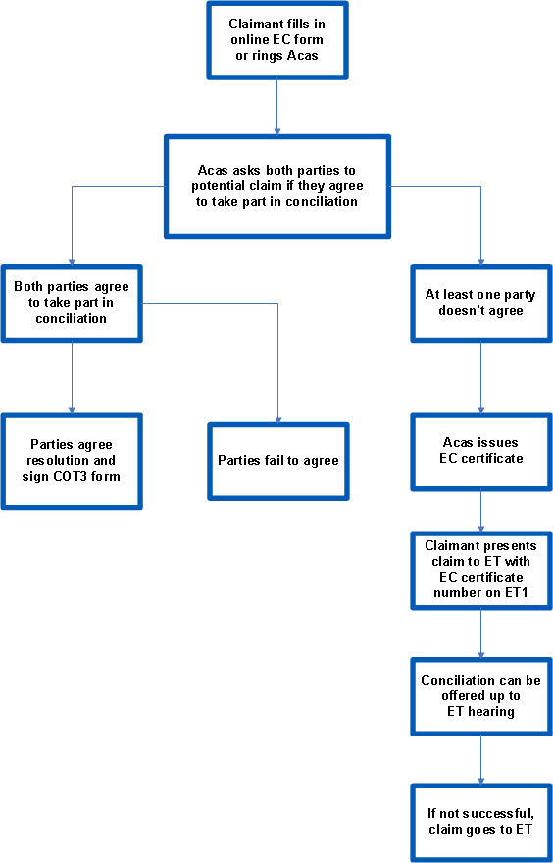

ACAS (Advisory, Conciliation and Arbitration Service: www.acas.org.uk) play a large part in the process of enforcing regulations and a large number of claims will never get to an employment tribunal due to the effectiveness of the initial conciliatory process. This process is free and since 2014 they have had this large part to play in helping avoid high tribunal costs and instead reaching out of court settlements (Taylor, CIPD, 2021). A settlement reached through the early conciliation process with Acas will have terms recorded in a COT3 form, usually this would include a silencing agreement. Other settlement arrangements may be made outside of Acas but will also be legally binding and ‘without prejudice’ meaning they can’t be used in a court or tribunal.
If conciliation is not reached and an ET1 is submitted the respondent has 28 days to respond.
If an employment tribunal stage is reached they can hear the case and reach a decision with either just a judge ‘sitting alone’ in more recent years (Taylor, CIPD, 2021) or a judge and two lay panel members. The claimant can then move to an Employment appeal tribunal (EAT) if they have cause to refute the decision on a point of law and this can be heard and a decision made by the original employment tribunal or a new one.
There are cases in some circumstance which may move up to the Court of Appeal or in some cases leap frog and go straight to the Supreme Court as with Uber BV and others v Aslam and others 2020 alternatively anyone claiming more than £25k may use the High Court and County Court route but that means they cannot go back to the other route if the ruling doesn’t find for them.

- a) Explain the major statutory rights employees have in relation to pay, time off and working time.
AC 4.1, 4.2 Working Time Regulations 1998 have created a platform for all workers to be protected in terms of rest and sickness. These regulations are for workers i.e. not self employed but anyone in a contract or a verbal contract (express or implied) to carry out a service.
Most workers can have 5.6 week of annual leave each year (28 days) and can work no more than a 48 hour working week unless they sign an opt out (averaged over 17 week reference period). There are also rules around rest depending on the amount of hours worked, see the table below;
Period of work | Period of rest
6 hours or more | 20 minutes
24 hour | 11 hours
7 days | 24 hours
Young workers (above school leaving age but below 18)
4.5 hours | 30 minutes
24 hours | 12 hours
7 days | 48 hours
Night Workers
8 hours | 16 hours

For the purposes of the Working Time Regulations 1998, a night worker is working between 11pm and 6am unless a different night period is agreed between the employee and employer. The 8 hours of work in 24 hours can be calculated as an average over 17 weeks.
In the case of Santos Gomez v Higher Level Care Ltd EAT May 2016 a worker was not given the 20 minute break they should have received (CIPD, 2022), as a result the court ruled that she should be compensated with an amount attributable to her financial loss but not compensated with injury to feelings as this was a breach of contract and not discriminatory.
The rules around annual leave and how it should be calculated when workers are on leave can be shaky ground for employers and very expensive. In Flowers and others v East of England Ambulance Trust EAT July 2018 the appeal tribunal found that NHS workers holiday pay should be calculated on both overtime they may work as a normal part of their role (staying later than their shift) as well as voluntary overtime if it is ‘settled and regular enough to be considered as normal remuneration’. (CIPD, 2022) This also applied in the case of Dudley Metropolitan Borough Council v Willetts (2017) where overtime was deemed to be part of holiday pay.
When it comes to sickness there is provision made for employers to be able to pay workers who are off sick for more than 3 days (called waiting days). SSP is paid to workers who are sick for up to 28 weeks in a year. There is a qualifying lower earnings limit for SSP (averaged) and SSP will only be paid for normal working days. There is opportunity for medical suspension pay which is calculated on the normal rate of pay including bonuses, however if the suspended employee is offered alternative suitable work and refuses then this pay will be stopped.
In relation to pay, since 2019 there has been a legal obligation for workers to receive an itemised pay statement with specific information such hours worked and deductions. The minimum rates of pay set by the government have increased the equality of pay between gender (reducing the gender pay gap) at the lower end of pay as well as giving a fair and representative level that meets a statutory ‘living cost’. The table below demonstrates how this has been adjusted in the last two years;
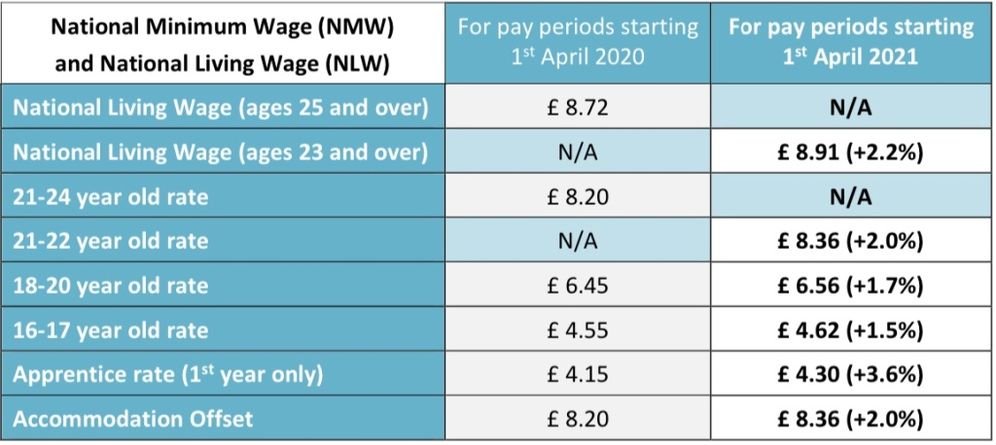
b) Explain the major family-friendly employment rights.
AC 4.3, 4.4 Since the introduction of the Social Charter in 1997 the family orientated employment rights have been ever changing and growing to meet the needs of those working whilst trying to raise children, care for relatives and maintain a healthy work-life balance.
Employers are required to allow time off to employees for dependants, this includes emergencies and bereavements. It allows for; spouse, child, grandchild, parent, partner or anyone who depends on them for care. There is an allowance of two weeks if a child dies before they’re 18 or if the employee has a stillbirth. The right to maternity and paternity pay provides as a minimum the right for the mother to have paid time off for antenatal appointments and the partner to have up 6.5 hours off unpaid to accompany her.
There is also provision for the mother to take a compulsory 2 weeks off from the date of the birth (4 weeks if they are a factory worker), and this can then be up to 52 weeks off but payment will depend on qualifying periods. This maternity leave can be started as early as 11 weeks before the due date. The employee must have;
- earnings that qualify for the lower earning limit of NI contributions – in the last 8 weeks.
- 26 weeks continuous service for the employer, dated 15 weeks before the baby is born.
Payment levels are set out below (CIPD, 2022)
Statutory maternity pay (SMP):
First six weeks – 90 per cent of employee’s average weekly earnings. Remaining weeks at the following rates or 90% per cent of earnings if lower.
From 5 April 2020: £151.20
From 4 April 2021: £151.97
Many organisations will pay more than this statutory allowance and KIT days are also an opportunity for the employee to stay connected to the team. Up to 10 are allowed and do not infringe on maternity pay or rights. The employer is not obliged to offer these and the employee doesn’t have to accept if they are offered (CIPD, 2021).
There’s an opportunity for paternity leave which allows for the partner who expects to share in the child’s upbringing also having up to two weeks with the same qualifying periods applying and the same statutory amounts.
If both employees satisfy the eligibility requirements they can apply for Shared Parental Leave (SPL) which can be taken in turns or together. Though the take up of this rare for financial reasons (CIPD, 2021) as it is paid at a statutory rate unless the employer enhances.
Adoption leave allows for up to 5 appointments paid time off for the primary adopter and up to 2 unpaid for the other adopter. There is also provision for statutory pay for up to 39 weeks with qualifying periods and statutory payments in line with maternity and paternity pay.
Organisations now have a responsibility to offer flexible working to some degree, there is provision for flexible working requests as well paid/unpaid time off to allow for emergencies with dependants and caring responsibilities. This change in legislation has put the onus on employers to provide alternative options for employees and is now a ‘day one’ right, ie it is not reliant on 2 years’ service. Despite this, employers can and do refuse flexible working requests usually on the grounds of service provision and business need. Acas (2014) set out a helpful list of all these reasons in its article on how to handle flexible working requests.

- a) Evaluate the key concepts around: Discrimination law in recruitment, selection and employment.
AC 2.1 The original two key pieces of legislation regarding discrimination are the Sex Discrimination Act 1975 and the Race Relations Act 1976 and then in 1995 with the introduction of the Disability Discrimination Act. It’s important to note that transsexual employees were added into the Sex Discrimination regulations in 1999. In the early 2000’s a number of regulations were introduced around sexual orientation (2003), religion and belief (2003) and age (2006), these were all replaced by the Equality Act 2010 (Daniels, 2019). This was a great leveller for the many pieces of legislation that had been building up over the 35 years previous, making it easier to navigate and more straightforward. There are 9 protected characteristics that are part of the Equality Act – Age, Gender reassignment, Pregnancy and Maternity, Disability (Physical or mental impairment), Religion or Belief, Marriage & Civil Partnership, Race, Sex, Sexual Orientation (ACAS, 2015).

There are 6 types of discrimination; direct, associative, perceptive, indirect, harassment and victimisation. All of these can come into play within the recruitment, selection and employment process. For direct discrimination it is the issue of being treated less favourably and a comparator – real or hypothetical can be used to show this case in point. When a pregnant employee is discriminated against however they do not need to be able to cite a comparator (Daniels, 2019). Associative is similar to direct in that it is the less favourable treatment because of someones association with a person with a protected characteristic, as in the case of Coleman v Attridge Law (2008), the mother of a disabled son was treated less favourably with regard to flexible working than those parents of children without disability.
Perceptive discrimination is similar in that it relates to what others perceive you to be or what group they think you are part of, eg attending Pride events but not being gay. Both associative and perceptive don’t apply to marriage and civil partnership or pregnancy and maternity cases.
Within recruitment it can be quite important to differentiate between fair recruiting processes and necessary discrimination for the purposes of the role. This can relate to someone of a certain religion fulfilling a religious role, such as a church pastor. Or a role involving a specific food or drink option being authentically provided by someone of that race. Indirect discrimination can be inadvertently part of many recruitment and selection processes and often those areas we see as commonly held norms. A good example of this would be mon-fri, 9-5 working patterns which indirectly discriminate against women who in the most part are the primary carers for their school age children and may need to do school runs. Or an advert for a professional ‘early in their career’, indicating age discrimination.
It’s important to note that indirect discrimination must be of a group not an individual (Daniels, 2019) as in Noah v Desrosiers t/a Wedge (2008), it was found that the hairdressers had a requirement for certain hairstyles to be on view which put all Muslims who wear a hijab at a disadvantage when applying for a job. In contrast to Eweida v BA (2010) where a Christian had a personal preference to wear a cross necklace against BA dress code. This was an individual choice rather than a Christian practice.
Harassment is similar to bullying but with the difference of being specific to a protected characteristic. The key element is that it can be with the purpose or the effect of violating dignity or creating intimidating, hostile, degrading, humiliating or offensive environments. (S 26, EqA 2010) The defence for this can be ‘hyper sensitivity’ to protect against ‘banter’ related claims. Victimisation varies from this as it is a detriment to the employee as a consequence of the employee having done or the belief they have or may do a protected act. These acts are related to bringing proceedings or giving evidence in relation to the equality act.
Reasonable adjustments should be made for those employees and applicants who may suffer a detriment because of a disability, this can be for any practice or criteria that would put a disabled person at a substantial disadvantage comparative to someone who does not have a disability.
Within all areas of discrimination there is a difference between positive action and positive discrimination, positive discrimination is not legal, however positive action can be reasonable and be applied to reach people who may suffer a disadvantage from a protected characteristic. For example advertising via traditional recruitment routes as well as via the internet and social media could prevent age discrimination and encourage older applicants. Unconscious bias can creep in to the process of recruitment even when positive action steps have been taken, anonymised CV’s have been noted as a huge success in creating fairer recruitment process (Zheltoukhova, 2018). Standardised questions can also be helpful but Scott (2018) notes repositioning the question can be more helpful so that it fairly represents your company culture as well as being clear to someone ‘outside’ who is applying for the role.
Where discrimination is found to be present there can be Injury to feelings compensations of 3 different bands, these are labelled ‘Vento’ in relation to the landmark 2003 case of Vento v Chief Constable of West Yorkshire Police. These three levels of compensation relate to the severity and long lasting effects on the employee from the discrimination experienced.

b) Evaluate the key concepts around: Equal Pay.
AC 2.2 The Equal Pay Act 1970 was absorbed into the Equality Act 2010 as other discriminatory law was. This is in relation to equal pay between men and women and addresses all gender pay gaps and employment terms and conditions. The main elements to be considered in this type of claim is whether it is ‘like work’, work rated as equivalent or work of equal value. The terms must be individually equal rather than a ‘similar package’ overall (Daniels, 2019).
Tribunals do tend to focus in on the general and most commonly carried out tasks within a role rather than focusing on nuance and specific contractual specifics. This was upheld in the case of Capper Pass v Lawton (1977) where a female cook and two male assistant chefs were deemed to do ‘like work’. Though the specifics of their individual roles differed.
In 2010 it was deemed inadmissible for employers to enforce secrecy around pay discussions. It is unlawful to prevent these discussions within an organisation but can be a requirement to remain confidential outside of work. (CIPD, 2021)
To keep firms accountable in this area there is a requirement for all large organisations in the UK to disclose certain earnings data by gender (CIPD, 2021), though any gaps don’t have a legal requirement to be explained it can be helpful for them to include how jobs have been evaluated in this process. As well as reviewing data and researching disparities within gender and ethnicity groups.
If a gender pay gap report is not filed this will be a breach of the Equality Act 2010 and can be enforced by the Equality and Human Rights Commission (CIPD, 2021).

Word Count – 3216

Bibliography

CHARTERED INSTITUTE OF PERSONNEL AND DEVELOPMENT. (2021) Fairness and Pay Reporting [online] Factsheet. London: CIPD.
Available at: Pay Fairness & Pay Reporting | Factsheets | CIPD [Accessed 3rd March 2022]

CHARTERED INSTITUTE OF PERSONNEL AND DEVELOPMENT. (2021) Maternity, Paternity, Adoption [online] Factsheet. London: CIPD

Available at: Maternity, Paternity & Adoption Rights | Factsheets | CIPD. [Accessed 2nd March 2022]

CHARTERED INSTITUTE OF PERSONNEL AND DEVELOPMENT. (2021) Employment Law in the UK: The court system [online] Factsheet. London: CIPD

Available at: UK Court System & Employment Law | Factsheets | CIPD [Accessed 21st February 2022]

CHARTERED INSTITUTE OF PERSONNEL AND DEVELOPMENT. (2021) Employment Law update for CIPD tutors and students [online] Factsheet. London: CIPD

Available at: Employment law update for CIPD tutors and students [Accessed 21st February 2022]

CHARTERED INSTITUTE OF PERSONNEL AND DEVELOPMENT. (2022) Case Law for Working Time [online] Factsheet. London: CIPD

Available at: Working Time Cases | CIPD [Accessed 2nd March 2022]

DANIELS, K. (2019) Introduction to Employment Law – Fundamentals for HR and Business Studies London: New York: Kogan Page Ltd, 5th Edition (2019)

DANIELS, K. (2012) Employment Law – An Introduction for HR and Business Students London: New York: Kogan Page Ltd, 3rd Edition (2012)

HSE Pregnancy Risk Assessment Flowchart (2020) HSE [online]. [Accessed 1st March 2022] https://moodle.uwtsd.ac.uk/pluginfile.php/572885/mod_resource/content/1/pregnant-workers-flow-chart.pdf

HPMA Mock Employment Trial with Devereaux Chambers and Legal and Risk Services (2022) MS Teams [online]. [Accessed 19th & 20th February 2022] https://nhswales365-my.sharepoint.com/:v:/g/personal/sioned_eurig_wales_nhs_uk/EYNyiwy4f9ZHrHMdTjfXIk4Bc6mOpvXiHuPKOG8xjfoMog?e=d7CpkU

LAMB, P (2018) Unconscious Bias. 18th May 2018. Unconscious bias (cipd.co.uk) [Accessed 23rd February 2022]

National Minimum Wage (2018) YouTube Video, added by ACAS [online]. Available at National Minimum Wage and National Living Wage | Advice and Guidance | Acas - YouTube [Accessed 21st February 2022]

Protected Characteristics (2015) YouTube Video, added by ACAS [online]. Available at Protected characteristics - YouTube [Accessed 22nd February 2022]

Task Two

From: Carly Butler, HR Officer
To: Ian Smith, Managing Director
Date: 3rd March 2022
Subject: Site Closure

Dear Ian,

- AC 3.1 As we consider the closing of site C and the moving of at least 5 staff from site C to either site A or B, we must look at any mobility clause we have written into their contracts (Gov.uk, 2022). If we have not included this then we will need to consult with these staff as a courtesy to see if they will agree to the move. We must consider unilateral variation, is this something we have allowed for contractually? If not we must consider whether an ETO will stand. We could dismiss on the basis of SOSR and re-engage the staff on new contracts but this carries a great risk of unfair dismissal if directly related to the transfer, which it is in this case.
We could also consider a collective bargaining as a tool to talk through with Unions what the proposed changes are and how we are implementing them. To gain agreement from unions is wise and needs careful navigating to avoid claims of bypassing this process as in Kostal UK Ltd v Dunkley, SC, October 2021 (CIPD, 2022).
There are risks (ACAS, 2021) such as some of our most valued employees leaving the organisation or their performance and commitment to ABC Ltd decreasing as they don’t see themselves as part of the process or considered fully. By varying these employee contracts we do put ourselves at risk of a breach of contract claim unless we can consult and show their conduct as implied agreement and will need to manage these conversations sensitively and in a timely way.

- AC 3.1 Redundancy is a consideration for these employees if we have not included the mobility clause within the contract and are not wishing to retain these staff on site A and B, under the Employee Relations Act 1996; ‘Employer has ceased, or intends to cease, to carry on that business in the place where the employees were employed’.
As we have less than 20 employees to consult, there are no set rules as to the length of the consulting period (gov.uk, 2022) however we want to follow best practice and also protect against later claims of unfair dismissal by an employment tribunal. A consultation of 1 to 2 weeks would be reasonable in these circumstances as this is a reasonable time period and no specific requirement exists as the number of employees affected is under 19.
We will need to refer to our previous redundancy pay in order to ensure we are consistent, we cannot follow current statutory caps and guidelines for age and years of service if we have previously enhanced the redundancy pay, as in the case of Peacock Stores v Peregrine, EAT Feb 2014. (CIPD, 2022) In this case the court ruled that because a precedent had been set of enhancing statutory payments, it was implied this would continue. If we have always complied with statutory payments then we will need to talk through the reason and selection method with our chosen employees and show clearly the calculation; notice pay + 1.5 weeks pay for each YOE (41-64 yrs), 1 weeks pay for each YOE (22-40 yrs), 0.5 weeks pay for each YOE (under 21 yrs). We will also need to calculate outstanding holiday pay and add this to the final sum.

- AC 3.2 The legislation for The Transfer of Undertakings (TUPE) were replaced in 2006 and amended in 2014. When we decide if it applies we need to consider if there has been a change in the service provider. In this instance we have seen our competitor buy site C and we understand will now continue to run it as part of their business competing with us in the same market. The exemptions that could apply would relate to it either being shut and assets sold, the customer changing, a one off event or just the sale of shares, none of which are happening here. So this does qualify as TUPE and will follow the automatic transfer principle.
We would need to state an ETO relating to our profitability or performance, or to the change in production process or organisation structure. (Daniels, 2019) These ETO’s are not specifically stated in the new 2014 tightened regulations regarding Transfer of Undertakings (Protection of Employment) Legislation, however we will need to have sound reasons in place for consultation and protection from any future concerns.
A consultation will be required where employees represent themselves (as there are less than 10) and as the automatic transfer principle will apply, all the powers, rights, duties and liabilities become the responsibility of the new owner as they were of ABC Ltd. If any employee objects to the transfer their contracts will end by ‘operation of law’ on the date of transfer. It is integral for the new owners to communicate clearly on any measures that may be envisaged eg new payroll date, within the process of consultation. Though the consultation is only for those on site C as in the case of Ilab Facilities v Metcalfe and others EAT, 2013 (Daniels, 2019) here the court ruled the consultation was only for those who are transferring and not all staff within the existing business.
This consultation is our joint responsibility as ABC Ltd with the new owner and if it is deemed inadequate each employee will be awarded up to 13 weeks’ pay. (Daniels, 2019)

Thank you for your consideration, I hope we can apply this legislation with consideration and navigate the way clearly with these valuable staff members.

Many Thanks

Carly Butler
HR Officer
ABC Ltd

Word Count - 921
Bibliography

CHARTERED INSTITUTE OF PERSONNEL AND DEVELOPMENT. (2021) Transfer of Undertakings (TUPE). [online] Factsheet. London: CIPD.
Available at: Information on TUPE | CIPD [Accessed 3rd March 2022].

CHARTERED INSTITUTE OF PERSONNEL AND DEVELOPMENT. (2021) Case Law on TUPE. [online] Factsheet. London: CIPD.
Available at: TUPE Cases | CIPD [Accessed 3rd March 2022].

CHARTERED INSTITUTE OF PERSONNEL AND DEVELOPMENT. (2022) Case Law on trade union recognition and industrial action. [online] Factsheet. London: CIPD.
Available at: Case law on trade union recognition and industrial action | CIPD [Accessed 28th February 2022].

Considering Employment Contract Changes (2021). ACAS [online]. [Accessed 3rd March 2022] https://www.acas.org.uk/changing-an-employment-contract/employer-responsibilities

Employer Relocation: your rights (2022). Gov.uk [online]. [Accessed 3rd March 2022] Employer relocation: your rights - GOV.UK (www.gov.uk)

DANIELS, K. (2019) Introduction to Employment Law – Fundamentals for HR and Business Studies London: New York: Kogan Page Ltd, 5th Edition (2019)

