Submission Date:
09 May 2022
Word Count: 2018
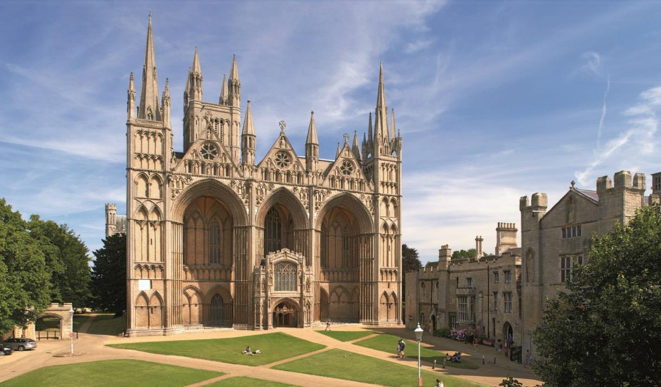  Reflection of Peterborough Community  Lecturer: Molly Jack | Ana Maria Gorgan (2113739)  Community Engagement (LCBB4002)

Table of Contents
Introduction 2
Vision and Revision 3
Strategies and plans 3
The strategy” Increase Economic Opportunity” 3
The strategy “Young People” 4
The strategy “Bringing Communities Together 4
Projects and comments 5
Improvements and suggestions 5
Conclusion 7
References 8

Introduction

My name is Ana-Maria Gorgan, currently studying Business Management at University of Wales Trinity Saint David, term 2. I live in Peterborough, Cambridgeshire since 2016, when I moved from a small community, Hatfield, Hertfordshire, near London.
One of the modules I have studied was Community Engagement and the exam was divided in two assignments. In the first chapter the assignment requirements were to elaborate a report, for, about the community, I started with a brief story of Peterborough to make known what I am speaking about, moving forward to what City Council does for communities, how they are involving in the relationship with their residents, what projects have come up with, what strategies and approaches they have adopted. In this chapter, I will share and analyse my personal thoughts, how I would, act, engage, build trust, what I would done differently, what strategies shall I use, what I consider that have a negative impact on the community, what they need to improve, how I desire to see my communities and my understanding the importance of my implication in the community.
The end of the chapter two I will express what I have learn about my community, based on my research, and analyse, and what awareness should be considered.

Vision and Revision

Strategies and plans

Community engagement can be defined as a process involving local authorities and member or group of members of the community to engage and work together having the goal to improve, secure and maintain the positivity and safety of the community. Every member of the community should be active and participate at different public events or survey to deliver a better understanding of the communities’ members and satisfy their needs. Peterborough is a historical and medieval city hosting a 900-year-old Cathedral, embracing many cultures and different nationalities, developing in one of the smart cities in UK by expanding, implementing smart technology to decrease the cost of energy, offering a wide range of shopping centre, parks, shops even hugging different cultural shops and restaurants to allow non British citizens to get the feeling like home, but yet still voted number one in top “ The worst cities to live in United Kingdom” three years in row, from 2019 to 2021. As Peterborough City Council is aiming to secure the city by adopting 4 strategies as mentioned on assignment one: increasing economic opportunity, bringing communities together, young people and English Language.

The strategy” Increase Economic Opportunity”
City Council is planning to increase economic opportunity by creating job and classes for disabled and non-English speakers to reduce unemployment. The strategy has been successful as unemployment number falls by 20% across the pandemic while The Department of Work and Pension is due to close causing more people losing their jobs. In 2021, In Peterborough, the rate of unemployment benefits and Universal Credit hit the biggest percentage of claimants in the United Kingdom.
What would I do different?
To increase the number of unemployment and reduce the percentage of job seek Allowance and Universal Credit, I plan more job fair with immediate hiring, CEO, directors of local business will be allowed to interview people with job need and hire on a day. The fair would be organised every 3 months to permit business to expand or create new jobs, build new houses or neighbourhood with potential need of school, shops, and recreation facilities, and will include a variety of jobs for skilled and unskilled people and voluntary work for members of community to gain work experience and skills.

The strategy “Young People”
The local City Council is planning to attract young people through a curriculum design” Prepare for Like” to help integration and bullying in school, to have a better understanding and prepare them for real life challenges are facing afterwards.
What would I do different?
Creating a “Get Paid for Stand Out” programme which will attract young people aged between 10-25 years old to group and offering mental support and share their experience and the outcome to schools to prevent bullying and help integration while they are getting paid. As young people the minimum wage is low than the average of 25 years old and will boost their interest to involve with the community but also giving the idea and feeling of responsibility and serosity.

The strategy “Bringing Communities Together
The plan of council is to reduce the number of crimes, domestic abuse, Sexual Abuse and Child Abuse, but also, the chance of the local communities to embrace their members by their culture, same aims, same experience to have access to leisure.
What would I do different?
Their plan is shown as a theoretical very inciting and interesting, but how people are engaging, why would they care? To increase the interest of the members of the communities, as a local council we must do something different, we can create local Markets, where local people can expose their culture, their nationalities to embrace their culture, to be proud of, to look behind the scenes of these countries. Building stands where people will sell their traditional food and desserts, traditional clothing, promoting tourism on their countries, what people can visit there can be English stand, polish, Romanian, Slovakian, Indian, Chinese, and so on. Even if the community is based in England, out there is so many people who have not explore the traditional food, or they have not known that England is made out so many beautiful places. Exploring each other cultures can bring people together and increase harmony of the community.
To reduce crimes across Peterborough, need to implement more CCTV around the city, more police officers on a patrol, especially in the areas with high-rate crime. 24h landline and trained staff to recognise the red flags around people in danger. Implementing leaflets with emergency number and a safety code conversation handed with food delivery to decrease number of people who are fear to speak out due domestic abuse. Creating in every neighbourhood community “Anti-Social-Behaviour” local authority having specialist in mental health and a local officer to look out for the domestic, sexual or child abuse around the community.
Sexual Abuse is very sensible subject, and unfortunately out there is many people suffering from it and facing fear of speaking out. Introducing in schools’ educational films and theory about human body, sexual relation, what approach and how they should behave to young children at age where their curiosity is to experiment and experience sexual life and building healthy relationships. Offering to the parents’ opportunities to learn how to have a life conversation with their children, how to explain, to normalise body parts, intimacy and teach parents to be a role model as a woman and as man, by hosting classes and using this opportunity to raise a voice against sexual abuse.

Projects and comments

Projects run by Peterborough City Council are design to help young generation, NHS staff and developing the largest smart city.
Create the largest smart city from UK. Their project is claiming to cult £2mil. On energy bills and provide green heat, electricity and transport for resident and claim to reduce major carbon emission by 2023. The project must put on hold as “The Future Peterborough Initiative”, launched in 2012 was chosen as one of four UK Future City Demonstrators in 2013 and 2015, the city has won the World Smart City award at the Smart Expo World Congress in Barcelona.
Youth services and Centre 33 are the project destinated for young children, teenagers, and adults between 18-25 years old to help them to increase self-esteem, to reduce risky behaviour to give them the freedom of being an adult with responsibilities.
To reduce unappropriated and risky behaviour, my plan will be to create a centre where parents can learn how to approach their children misbehaving, how to explain the consequences of their behaviour without sound like a lecturer, which can help the child to understand how risky is in different scenarios. To learn to work on mutual agreement rules, to build a trusty, strong relationship with the child, to invite his friends at home, this way you can stay connected and focused on which environment he is going to and friends with.

Improvements and suggestions
Always is place for better when comes to improvements and performance. Peterborough needs to work on safety better, to ensure that residents or visitors are feeling safer. According to the crime figures, one of Peterborough neighbourhood been labelled as the most dangerous place in Cambridgeshire, Peterborough Central area, 4.518 crimes were reported which compared to the number of people living in that area, 359 crimes per day for every 1000 people, Sexual abuse 111crimes/ 1000people, Anti-social behaviour 60 offences/ 1000 people, burglary 9 / 1000, drug offences 13/ 1000 and weapons offences 5/ 1000.
My suggestion is that to reduces the numbers of crimes is to get more supervised by a qualified people to supervise CCTV 24h out 24h with direct line to the police enforcement. When the crime rate too high the city,
- I would require hiring more police officers and supervise the area more in detail. Not all the people who are doing crime are bad people, some of them are hurting or suffering from a mental breakdown, these are the people who need help, I would implement, depends on case to case, a reconciliation with a specialist and offered them session of mental support and creating a programme” Be better for the loved ones” to teach them how to control, behave and grow confidence.
- Creating more recreation parks with catering facilities where parents can take their children to play while they can enjoy a coffee or eating lunch without being disturb.
- Online and compulsory survey to understand the community needs and where improvements need.
- Building More shelters with beds food, clothing, and shower facilities to help people to get easily get a job.
- More volunteer work for the homeless so they can gain experience and skills who might help them to get a job in the future close.

Conclusion

The of this chapter, is moving me backwards where I started to present myself, what I am studying and where. I have shown where my community is based on.
As the assignment 1, where I have shown some of Peterborough City Council and local community strategies, plan and projects are and how they implement and apply them. As the story goes on, to every strategy or plan they have mention, I suggested what I would do different as a community officer, what I would change, what methods shall I apply. Some of the plans I would elaborate and implement that I have framed is promoting multi-cultural markets, increasing security of the city by installing more CCTV and hiring more police officers and security patrol, anti-social behavioural local authority and some of suggestion I have embraced is to create more recreation parks which increase positivity and relaxation, online and compulsory survey to gain a better understanding of the community, more necessities for homeless people and voluntary work for them. . As I have research about my city, about the community I have lived for the past 6 years and applying the theory I learned how important is the community, how engaging with it leads to growth and development of the community, there is people who live in this area need help from others, to be cultural aware encourage the acceptance and the understanding of each other. I cannot expect to see a better community, a change without being involve making something different and I have acknowledged that the participation is more than buying a homeless a meal, or canned food or volunteer at the shelter now and then, the long-time commitment contributed to a real change and can inspire people to be more kind and offer more. To have a good community, authorities and individuals need to be involved in communication, participation, feedback, informed to achieve long term improvements.
Every community is important, the involvement of stake holders and local Council in partnership with local authorities is they key of a successful and happy community and also raising awareness against every type of crime.

References

Dan Bloom & Amy Jones (2022) . DWP to close Peterborough office and 40 others leaving 'thousands' of jobs at risk. [Online]
Available at: https://www.cambridge-news.co.uk/news/cost-of-living/dwp-close-peterborough-office-40-23427362
[Accessed 07 May 2022].
Grinnell, P. (2022) . Unemployment in Peterborough falls by 20 per cent across the pandemic. [Online]
Available at: https://www.peterboroughtoday.co.uk/news/people/unemployment-in-peterborough-falls-by-20-per-cent-across-the-pandemic-3532710
[Accessed 07 May 2022].
Moore, C. (2021) . Unemployment benefit claims well above regional average. [Online]
Available at: https://www.peterboroughmatters.co.uk/business/peterborough-unemployment-figures-much-higher-than-pre-pandemic-85162#:~:text=At%20the%20beginning%20of%20March,in%20England%20as%20a%20whole.
[Accessed 07 May 2022].
Richard Ault & Amy Jones (2022) . Peterborough neighbourhood named as Cambridgeshire's most dangerous. [Online]
Available at: https://cities-today.com/award-winning-smart-city-programme-shelved-over-lack-of-funding/
[Accessed 07 May 2022].
Wray, S.,(2021). Award-winning smart city programme shelved over lack of funding. [Online]
Available at: https://cities-today.com/award-winning-smart-city-programme-shelved-over-lack-of-funding/
[Accessed 07 May 2022].
CityCouncil, P. (2022). Council. [Online]
Available at: https://www.peterborough.gov.uk/council
[Accessed 01 May 2022].

