Project management and research methods
Managing a Hardware/Software Project for Disaster Recovery
Austin Hooper (1700481)

BSc Software Engineering

26/01/2019
Table of Contents
1. Introduction 1
2. Background 1
3. Risk Analysis 2
4. Code of Practice 4
4.1. Sustainability 4
4.2. Ethical Concerns 6
4.3. Ethical and Legal Issues 7
4.3.1. Data Protection Law 7
4.3.2. Information Technology Codes of Conduct and Ethics 8
4.3.3. Brexit Impact 10
5. Quality Assurance 11
5.1. Functionality 11
5.2. Reliability 11
5.3. Usability 12
5.4. Efficiency 12
5.5. Maintainability 13
5.6. Portability 13
6. Conclusion 14
References 15
Appendix 17

Introduction

This report documents the project management aspects of creating a software project. Section 2 provides background information on the software system being developed. Sections 3, 4 and 5 detail Risk Analysis, Code of Practice and Quality Assurance respectively.

Background

The initial project plan was to develop an Android application. As discussed further in section 3, the group was unable to meet the original goal of creating an Android application. As a replacement, a web application was developed, using PHP and JavaScript. Now being a web application, the final application functions as the prototype was initially expected to, adding and updating locations, displayed using the Google Maps JavaScript API [1].
The author’s contribution to the prototype was the PHP and JavaScript development and interfacing with a MySQL database, along with part of the HTML and CSS front end development. The site is based on the Bootstrap framework [2]. See screenshots of the prototype in the Appendix.

Risk Analysis

In the IT industry, threats and risks to IT resources can come in the form of physical threats, such as equipment failure, unauthorized physical or electronic access, as well as authorised access (e.g. misuse of a system) [3].

See below details of the development risks relevant to the project along with risk exposure calculations and a risk evaluation matrix.
Table 1 - Risk details and risk exposure calculations

Figure 1 - Risk evaluation matrix

From the identified risks, two occurred during the project.

The group experienced difficulties meeting the original goal of creating an Android application to communicate with a server. As a result, the backup plan was initiated as shown in table 1, and the project was moved to a web application with the same functionality.

Secondly, progress slowed due to absence / illness of a member of the group. This was part of the reason for difficulties creating the Android application, which overall left the group in a difficult position with little progress being made towards a functional prototype until the application was modified to be web-based.

Code of Practice

This section discusses sustainability considerations and impacts for the development of the project along with ethical and legal concerns.

Sustainability

First order:

- Vehicles using energy and fuel and causing pollution as a result of travel to and from University
- Devices using power (much of which comes from fossil fuels) from running as part of the development of the project, such as a computer running constantly as a server
- There is an environmental impact to manufacturing the devices used for the project such as the smartphones used to test it. Manufacturing a smartphone is expected to discharge almost 16kg of CO₂ [4].
- There will be an energy cost of heating the University space while the group are there working on the project together. The means of acquiring this energy may have an impact on the environment.
- Communication to servers and datacentres – communicating with group members, along with hosting the test site, requires a server machine be constantly running, along with datacentres - power consumption being the main concern. In a datacentre power usage report, Cisco states that 1.8% of all United States power consumption comes from datacentres alone [5], with J. M. Lima of Data Economy warning that datacentres could account for 20% of global energy consumption by 2025 [6].

Second order:

- Higher number of survivors, lower number of injuries from natural disasters as rescue workers can work and travel more efficiently
- Increased rescue worker / emergency services confidence and morale
- Where new devices are implemented, e-waste will eventually be a result. As the devices are upgraded or replaced over time, the old ones will become obsolete and need to be disposed of
- Employment opportunities for the setup and maintenance of the system

Third order:

- If the system proved useful, emergency services may incorporate technology in other ways and move towards more digital solutions, which could make them more efficient and cost-effective in the long term
- Long-term, the application could be modified and adapted for public use. Deployment of emergency aid to a known location would be faster, and a more efficient use of resources
- A number of staff could be laid off as a result of the new system being implemented. If the new system allows for a small number of workers to be as efficient as a larger number of workers without the system, then there is a possibility that less staff will be needed. This has positive and negative consequences. On one hand, some jobs may be lost as a result, however it means less people need to work in a potentially dangerous environment.
- Increased human dependence on technology – the overall dependence on technology in our lives for personal use and provided services will be higher

Ethical Concerns

Tracking personal data, especially location, has ethical concerns associated with it. Should the location data get into the wrong hands, it could be used maliciously.
Corrupt members of staff can cause damage within organisations. With the implemented system, causing damage may be far easier by tampering with the system.
Should the data or statistics of the application get into the wrong hands, this could be presented to the public in a misleading way to misrepresent the system’s uses and change people’s views of the emergency services in the UK. A recent, larger-scale example of data being misused in this fashion was the Facebook and Cambridge Analytica data scandal. Explained by Zunger, Y. of Boston Globe, “To help clients manipulate voters, the company built psychological profiles from data that it surreptitiously harvested from the accounts of 50 million Facebook users [7].”

Ethical and Legal Issues

Data Protection Law

The legal aspect of the project is complicated since it involves storing device location data. Location data, as defined in context by the Information Commissioner’s Office website [8], is “information collected by a network or service about where the user’s phone or other device is or was located.” The website also states that only public communications providers and providers of value-added services may store location data, and only if the data is anonymous or if the user gives their consent for location data to be used.
In this case, the development team would need to set up a public communications provider company, which emergency services would then subscribe to in order to be able to store and use location data. As the current software is web based, web browsers handle user consent to use location data with a pop-up message as seen below.

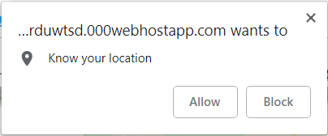
Figure 2 - Web browser location consent

The Data Protection Act 2018 [9] is national law controlling how personal information is used by organisations. It is the UK Government’s implementation of the EU General Data Protection Regulation (GDPR) [10].

The six data protection principles of the Data Protection Act are:
- Processing of data must be lawful and fair
- Purposes of data processing must be specified, explicit and legitimate
- Personal data must be adequate, relevant and not excessive
- Personal data must be accurate and up to date
- Personal data must be kept for no longer than necessary
- Personal data must be processed in a secure manner

As the software system would store emergency workers’ personal details as well as location data, the most relevant and significant of the above principles are that data must be accurate and up to date, kept for no longer than necessary, and must be processed in a secure manner. This implies that after a call-out to an emergency scene, location data should no longer be stored as it is no longer necessary.

Information Technology Codes of Conduct and Ethics

The British Computer Society’s code of conduct [11] lists rules for IT professionals to follow. These rules are divided into four sections, each with a list of rules. From each section, the following are the most important and relevant rules to this software project:

1. Public interest
Point A:
“You shall have due regard for public health, privacy, security and wellbeing of others and the environment.”
This is relevant as the software system itself, along with a network implementation, aims to aid emergency services workers in helping those in need during natural disasters. People’s health and wellbeing may be dependent on the functionality of the software.

2. Professional Competence and Integrity
Points A and F:
“You shall only undertake to do work or provide a service that is within your professional competence.”
“You shall avoid injuring others, their property, reputation, or employment by false or malicious or negligent action or inaction.”
As the software aims to make emergency workers’ jobs easier and help those affected by natural disasters, the software should only be developed by those competent enough, as any error in its functioning could have severe impact, resulting in injury or death. For example, if someone was not treated in time because the system pointed an ambulance to the wrong location.

3. Duty to Relevant Authority
Point E:
"You shall NOT misrepresent or withhold information on the performance of products, systems or services (unless lawfully bound by a duty of confidentiality not to disclose such information), or take advantage of the lack of relevant knowledge or inexperience of others.”
The software product should have its expected performance metrics / benchmarks made very clear upfront as its performance is critical. If a map update only occurred every ten minutes, this may not be of much use to emergency services staff who need near-instant updates. This is especially important as people’s wellbeing is at stake.

4. Duty to the Profession
Point A:
“Accept your personal duty to uphold the reputation of the profession and not take any action which could bring the profession into disrepute.”
A software system to aid rescue / emergency workers and help those in danger, could contribute positively to the IT industry’s reputation as it shows directly that IT can help people.

The IEEE’s code of conduct [12] also focuses on respecting and not harming others, stating that its members shall “Avoid injuring others, their property, reputation or employment.” It also discusses the need to comply with applicable laws from authorities, with similarity to the BCS code of conduct. As with the BCS code of conduct, IEEE’s separate code of ethics [13] discusses the importance of personal development and professional competence. There is, however, no inclusion of rules relating to duty to the profession, IEEE rules appear to be primarily focused on equality to others.
ACM’s code of ethics [14] has more points than the previously mentioned codes of conduct, and discusses them in greater detail. Its content is generally similar to the other two, however it focuses more on the environment. Additionally, it advises whistleblowing where necessary, stating, "If leaders do not act to curtail or mitigate such risks, it may be necessary to ‘blow the whistle’ to reduce potential harm.”

Brexit Impact

It is expected that overall, Brexit will have a negative impact on the IT industry in the UK as a whole. The BCS found through a survey, detailed in its Digital Brexit report [15], that its members generally feel that the UK will become a less attractive place for IT investors, attract less IT talent from across the globe, and be a less attractive place for technology companies. Interestingly, BCS members felt that Brexit will improve the UK’s ability to be a world leader in innovation, with a 2% net positive impact.
Under the Digital Opportunities section of the report, in all areas but one, BCS members identified more issues than opportunities as a result of Brexit. The one exception was “Allowing digital innovation to flourish,” with opportunities outweighing issues 5% to 2%. This links with the previous positive views on innovation as discussed above, which shows a clear view among IT professionals that the UK’s IT industry will be able to be more innovative, though less attractive for employers and investors.
Of particular concern according to BCS members, as a result of Brexit, the UK would attract less IT talent from the globe and become a less attractive place for IT investors (20% and 21% net negatives respectively).
Legally and ethically, Brexit will affect the transferring of data to the UK. As discussed by the Data Protection Network [16], The UK leaving the EU will not affect UK data being transferred to EU countries, however EU data being transferred to the UK will experience some complications. The page states, “there will be a burden for compliance with Articles 46-49 of GDPR on organisations sending personal data to the UK.” Because of this, the system’s servers will need to be UK-based.

Quality Assurance

Software quality assurance is essential, especially software such as the system developed as part of this module. It is critical as it would have many people relying on it during a natural disaster. In the following subsections, the expected ISO 25010 [17] (formerly ISO 9126) qualities of the project are detailed, as discussed by Miguel José P, Mauricio, David and Rodríguez, Glen [18].

Functionality

Suitability – The application must be capable of displaying a minimum of 100 locations within a 10km radius.
Accuracy – The application must display device location with a 10 meter accuracy.
Interoperability – As the application running on the server is web based it will be very interoperable. It should be accessible to any device with an internet connection and web browser.
Security – The application must run on a HTTPS server in order to securely handle client information and request location data. A login using a password must be implemented to further improve security.

Reliability

Maturity – The application should be tested over a one year period to log and fix bugs. Emergency services could test it without relying on it to provide bug reports and feedback to improve the application’s reliability.
Fault tolerance – If one connected device stops functioning, the rest of the system should be unaffected. A backup server should be set up to handle the event of a server crash. The server setup should be capable of tolerating a power outage by running from an uninterruptible power supply. This should be able to be sustained for three hours minimum.
Recoverability – The server and application must be able to reboot and fully restart within five minutes of a system crash. Data should be backed up to two or more on-site data storage mediums as well as at least one off-site medium (cloud-based), as well as another larger, archive storage system on-site.

Usability

Understandability – User experience (UX) testing must be undertaken within the emergency services. A “pass rate” of 80% must be achieved before rolling out the system. The system must initially be available in both English and Welsh.
Learnability – The application must have a simple and intuitive user interface. After passing UX testing as described above, the entire system should be able to be fully explained and taught during a 1-2 hour training course.
Operability – Every function of the application must be no more than four clicks / taps away. Every function should be clearly labelled. Font size must be adjustable with at least three size options, and a suitable font should be used. Sans serif fonts such as Arial are more readable and thus more appropriate for the application.
Attractiveness – The application interface must be visually appealing and attractive to the user, while remaining minimalistic as it is a professional application where functionality is more important than form, and minimalism would help remove distractions.

Efficiency

Time behaviour – The application should provide location updates every five seconds or less. The map must load on the user’s device within ten seconds of the page loading, even on a low-speed connection as discussed below. The map must refresh every 20 seconds.
Resource utilisation – The application running on the server system should require no more than 16GB of system RAM and a 16 thread, low clock speed processor no better than the Intel Xeon Silver 4108 8 core CPU with Hyper-Threading running at 1.8GHz with a turbo speed of 3GHz [19]. As it is not intensive on the client-side, the application should be able to run on a client device with a minimum specification of a 1GHz dual-core processor such as Qualcomm 205 mobile platform CPU [20], with 512MB of RAM. It should require a client internet connection of no faster than 1megabit/s.

Maintainability

Analysability – MySQL, PHP and JavaScript errors should all be logged to the central server to make analysing faults easier. Where possible, the same syntax and languages should be used to avoid confusion. Code must be well commented to aid in analysing it. In the event of a system crash, a crash report must be automatically generated.

Changeability – The system code should take a functional or object-oriented approach, to allow it to be easier to alter certain program functions. The system should be compatible with the three most popular database management systems [21] to allow it to be later moved to another one if needed:
- Microsoft SQL Server
- MySQL
- Oracle
Stability – The system should crash no more than once per month under usual load, and be able to recover from a crash quickly as detailed in 5.2.
Testability – The system should be testable by allowing for simulated inputs (e.g. artificial geolocation addition via scripts). The system would be able to run fortnightly automated tests on itself to check overall system health.

Portability

Adaptability, replaceability and compliance - The application site should be fully accessible on the latest versions of Google Chrome, Firefox, Internet explorer, Edge and Opera, and be accessible. It will achieve this by meeting the WCAG 2.1 web accessibility guidelines [14] and as a result will be able to run on mobile devices as well as desktops.

Installability – The software is web-based so an installation or setup is not required by its users.

Co-existence – There is no expectation that the system will be able to co-exist with other solutions as it is a specialist system.

Conclusion

To conclude, this report has expanded on risk analysis from the initial project initiation document, discussed legal, ethical and sustainability concerns, and quality assurance targets of the SHARD project.

References

[1] Google, “Overview | Maps JavaScript API | Google Developers,” 2018. [Online]. Available: https://developers.google.com/maps/documentation/javascript/tutorial. [Accessed: 07-Jan-2019].
[2] J. Marah, B. Jakobus, M. Lambert, and S. Moreto, Bootstrap 4 - Responsive Web Design. Birmingham: Packt Publishing, 2016.
[3] R. K. J. Rainer and C. A. Snyder, “Risk Analysis for Information Technology,” J. Manag. Inf. Syst., vol. 8, 1991.
[4] L. Borocz, “Care Foundation - Home - Support kids with smartphones in Africa,” 2018. [Online]. Available: https://www.carefoundation.co.uk/understanding-the-negative-environmental-impact-of-mobile-phones/. [Accessed: 19-Jan-2019].
[5] “Cisco IT Insights Do You Know How Much Power Your Data Center Really Uses?,” 2017.
[6] J. M. Lima, “Data centres of the world will consume 1/5 of Earth’s power by 2025 - Data Economy,” 2017. [Online]. Available: https://data-economy.com/data-centres-world-will-consume-1-5-earths-power-2025/. [Accessed: 26-Jan-2019].
[7] Y. Zunger, “Computer science faces an ethics crisis. The Cambridge Analytica scandal proves it. - The Boston Globe,” 2018. [Online]. Available: https://www.bostonglobe.com/ideas/2018/03/22/computer-science-faces-ethics-crisis-the-cambridge-analytica-scandal-proves/IzaXxl2BsYBtwM4nxezgcP/story.html. [Accessed: 26-Jan-2019].
[8] Information Commissioner’s Office, “Location Data | ICO,” 2018. [Online]. Available: https://ico.org.uk/for-organisations/guide-to-pecr/communications-networks-and-services/location-data. [Accessed: 28-Dec-2018].
[9] Government of the United Kingdom, “Data Protection Act 2018 Chapter 12,” 2018.
[10] gov.uk, “Data protection - GOV.UK,” 2018. [Online]. Available: https://www.gov.uk/data-protection. [Accessed: 28-Dec-2018].
[11] British Computer Society, “Code Of Conduct For BCS Members.” 2015.
[12] Institute of Electrical and Electronics Engineers, “IEEE Code of Conduct,” 2014.
[13] Institute of Electrical and Electronics Engineers, “IEEE - IEEE Code of Ethics,” 2018. [Online]. Available: https://www.ieee.org/about/corporate/governance/p7-8.html. [Accessed: 27-Dec-2018].
[14] Association for Computing Machinery, “Code of Ethics,” 2018. [Online]. Available: https://www.acm.org/code-of-ethics. [Accessed: 27-Dec-2018].
[15] British Computer Society, “Digital Brexit - Planning for a successful digital future outside of the EU,” 2018.
[16] Data Protection Network, “Brexit, GDPR and data protection: What happens if the UK becomes a third country? - Data Protection Network,” 2018. [Online]. Available: https://www.dpnetwork.org.uk/brexit-gdpr-data-protection-uk/. [Accessed: 29-Dec-2018].
[17] iso25000.com, “ISO 25010,” 2019. [Online]. Available: https://iso25000.com/index.php/en/iso-25000-standards/iso-25010. [Accessed: 26-Jan-2019].
[18] J. P. Miguel, D. Mauricio, and G. Rodríguez, “A Review of Software Quality Models for the Evaluation of Software Products,” Int. J. Softw. Eng. Appl., vol. 5, no. 6, 2014.
[19] Intel Corporation, “Intel® Xeon® Silver 4108 Processor 123544,” 2018. [Online]. Available: https://www.intel.com/content/www/us/en/products/processors/xeon/scalable/silver-processors/silver-4108.html. [Accessed: 24-Jan-2019].
[20] Qualcomm Technologies, “Qualcomm 205 Mobile Platform | Qualcomm,” 2019. [Online]. Available: https://www.qualcomm.com/products/qualcomm-205-mobile-platform. [Accessed: 15-Jan-2019].
[21] Solid IT, “DB-Engines Ranking - popularity ranking of database management systems,” 2019. [Online]. Available: https://db-engines.com/en/ranking. [Accessed: 19-Jan-2019].

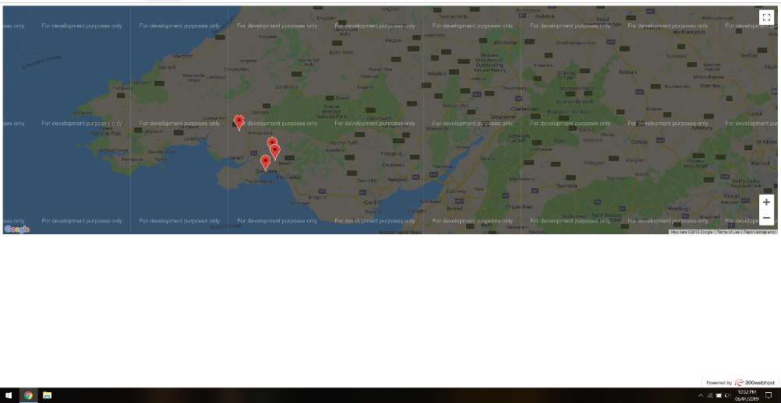
Appendix
Initial implementation with locations being retrieved from a database and added.
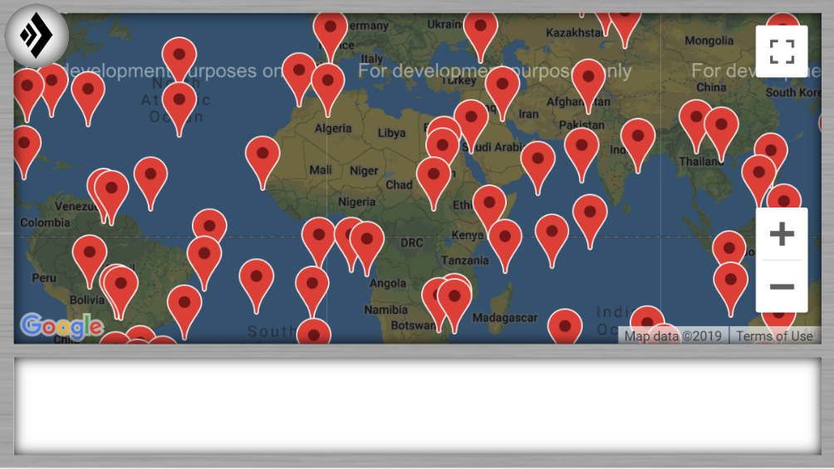
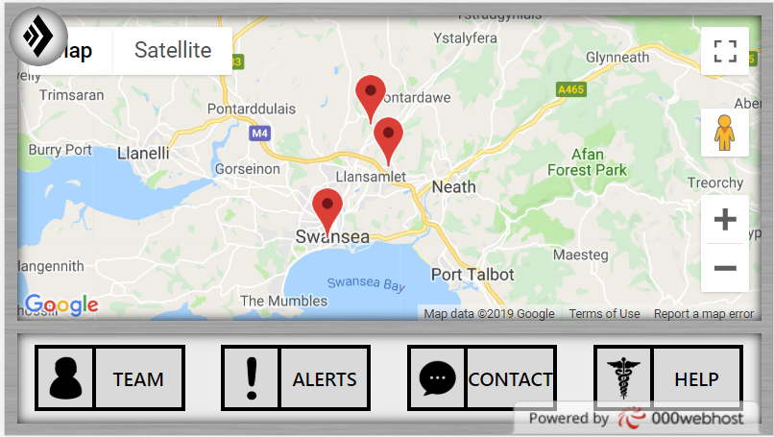
Testing the system by adding random locations using a Python script to test its capability.

The functional prototype as of the demo.

