Reflective review of a learning journey

Etleva Hyka(1817032)

Melanie Squire

UNIVERSITY OF WALES

TRINITY SAINT DAVID

19/11/2019

Executive Summary
A written report of 2000 words summery the entire document, a brief overview of the main findings and a brief summary of the conclusion.
This report be focused on how I would develop my self for the role a manager
Knowledge and understanding of the process
Two learning style questioner applied for my self
Applying swot and go mad framework what else I need to archive skills for becoming a Manager -self-awareness.

Table of Contents

Executive Summary 2
1.0 term of references 3
2.0 Procedure 3
3.0 Introduction 3
4.0 How I will develop my self for the role of the manager? 4
5.0 learning style questionnaire 4
5.1 Vark questionnaire. 5
6. GO MADE FRAMEWORK 5
7.SWOT. 7
8.SMART 7
9.KOLB`S LEARNING CYCLE 8
Teaching activities that support different aspects of the learning cycle 9
10.Conclusion. 9
References 10

term of references
This report was requested by Melanie Squire.this report was complied to reflective on my learning journey how this learning will help me to become a manager. This report has been compiled by Etleva Hyka 1817032 the report is for submission on 1/12/2019

Procedure
To write the report the task description was analysed to discover what was required in terms of knowledge and understanding. Sources of information were found primarily in books and on websites also lecturers’ presentations on Moodle

Introduction
This report is about my personal self-development in relation to my strengths and weakness. Personal development is about to engage in self-knowledge and identity.it involved potential development, development your self-awareness it is a first step of toward learning. How quickly you develop your skills it is how much effort you put into it. Professional development is involved in communication, skills, confident, hard work, rehabilitee, feasibility etc. Employability improves the quality of life playing a role in the realization of aspiration and dreams. Development skills is never an easy thing to do but can be challenging. Challenges to be overcome rather than avoid.

How I will develop my self for the role of the manager?

I am a women, I am a mum, I am a wife I have a part-time job, but I felt it is missing some thing. I have got a degree in agriculture engineer, but I never been able to find a job in my area. I was probably too busy raising my children. It is time for me to think about what I want to do with my future.
I came to the university to do something for myself. To develop my skills and understand how the process of skills work.
First, thooughts that come to my mind were I must develop some goals for myself. What I am going do with my life. Am I going to stay in the job I have got and not be happy or I am going to improve my skills and find a better job better pay better position?
I have been questioned myself?
What is my future?
Where I am going to be in 5 years’ time?
How I am going to archive my goals?
My passion has always been to be a leader in a business company this passion grown since I start work in a retail company. I have always been interesting about how the company works. What the advantages do I have that the others dot have
I have taken the chance to came to the university to learn more about the management, business and the employability works.
With the experience, I have got and the skills I am going to be learning throw this year.

Self-reflection is about reflecting about yourself questioning my self, how I work, what I do well and what I need to improve, it is also about becoming aware of the judgement and relationship (assessmentfor learning, ND)

learning style questionnaire
The questionnaire provides information for people who need help and support through the process of working with their learning style preferences.it will give advice to the manager how to find the talented people and how they know influences their style in the way they manage their people .it will be able to trainers to make the most of training sessions and provides practical information on how to incorporate in into programs of training
As well will give the background of the learning style questioner the guide to help the manager.to know how to mark and interpret the result activities, learning activities consistent with learning style preference, to know how learning style will affect during and after the training process.to know how to use the learning style in creating personal development plans.ref Dr Peter Honey and Alan Mumford
Every student learns differently to now how my learning style is I have complete the learning style questionnaire(appendix 1)
The results it was I am the theorist. Theorist learns best from the activities I totally agree with the result I am a theorist and it is me I like to see a model learn something. I prefer to analyse and synthesise, drawing new information into systematic and logical theory.
This questioner helps me to understand more about me.
The theorist adapts and integrates observations into complex but logically sound theories. I think that logical problems step by step.it is like me that I like thoughts are appropriate to the rational scheme(Peter honey and Alan mumford)

Vark questionnaire.

One of the most understanding of learning style is the student learning style fall in three categories, Visual learners. Auditory learners and Kinesthetic learners. these learning styles are found with educational theorist Neil Fleming”s Vark of student learning.
Vark is a questionnaire that assists learning by suggesting strategies to use. people with a strong visual preference for learning like different formats, space, graphics, tables, diagrams, maps, and plans (VARK,ND).
I have complete the Vark questionnaire(appenix2)
The result of the questionnaire it is I am a kinsthetic learner, I totally agreed with the result. I am a person which likes more examples, I am a person which learns more with practical exercises experiences and I am a person which uses more common sense.
I am a mature student after a long break from the academic learning, I had a difficulty to understand and remembering how a report can be written and how to find the resources after I been given the example how to do it. I am more confident and ready to start to do my thing.
With a vark questionnaire, I totally agreed.

6. GO MADE FRAMEWORK

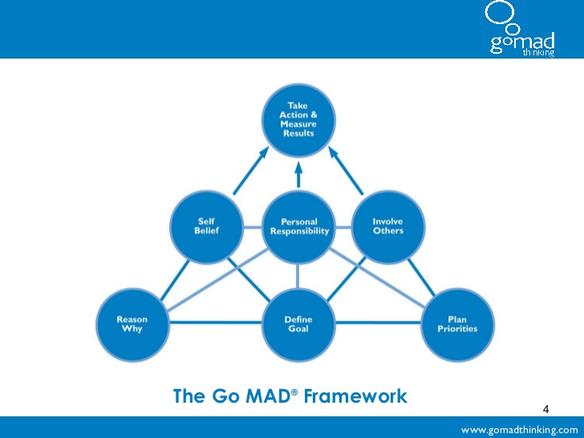

The Go M.A.D Framework and solution-focused thinking methodology allow people and teams to more easily solve problems and improve more productivity(go madthinking)

The main principal.
1.why you want to make a difference
2.Define my goal before I start making a difference
3. Consider possibilities and plan my priorities before making a difference.
4. I have to believe in myself and make a difference
5. I will take personal responsibility on my actions
6.involve others to help.
7. Take action and measure the result to make a difference.
I have applied the GO MAD framework in relation to my personal development. (appendix3)
The DO MAD framework help to reflect on my self it starts with thinking what am I doing why am in this course and after thinking I take action I attend in class I listen to the election I get involved with the group the result it is my feedback and after a busy year I m hoping to have my certificate.

7.SWOT.

To achieve my goal I developed a swot.
What is swot?
Swot analysis is an overview of me. I had to write how are my strength and my weaknesses.and to find opportunities to turn the weaknesses to the strength.

strength | weaknesses
Hard worker | Soft heart
Communication | Sensitive
organisation | Believe in the others
Strick timetable | shyness
happy
observant
Passionate

opportunities | threats
Be in already in business | competition
Help from my partner and support | Poor confident
A good impression from my manager | Language barrier

With this SWOT analysis, I discovered my strengths and weakness which allows me to strengthen and improve myself.
I also could know my opportunities for reaching my future career and how to take approaches to eliminate threats.

8.SMART

SMART goals mean you can have an idea you can focus on your effort to spend more time on learning and be more productive and think about how you can archive what I want in life.
To develop serval goals that will be enabled to be successful. Goals should be
SMART -specific,measurable,agreed,realistic and time-based.SMART it is one of the most effective for achieving goals. With a smart checklist, you can rate your objectives. The more specific your description is the bigger chance you will have exactly smart.
SPECIFIC -what exactly do you want to be completed.
MEASURABLE-how will you know whether you completed it or not?
RESOURCES-do you have enough resources available to you?
TIME-BASED-when do you want to complete this
https://corporatefinanceinstitute.com/resources/knowledge/other/smart-goal/
MY smart goals.
My self believes. I can do because I really want to do it.
I will do it because I want to have a better job.
I am going to give my best
I am going to be a graduate in a year.
Converting weakness to the strength -shyness/sensitive.
Because of this academic year, we are doing a lot of presentation and working in a team and learning more skills will give me a confident and shyness I got I will convert in strength. I am a sensitive person but being around the people wich they seam from me they are thinking how to archive they goal will make me that sensitive weakness I got I will convert on strength dot me sensitive just be more strong.
Convert threat to the opportunity. competition
Archive “certificate of Higher Education; skills for the Workplace will give me the opportunity to reduce the competition for the manager job because to have skills and to be more the confident what the manager position do I think I archive my goals very soon.

9.KOLB`S LEARNING CYCLE

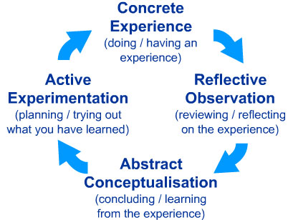

https://www.simplypsychology.org/learning-kolb.jpg
KOLB incorporates this `learning cycle` as a central principle in his theory of experimental learning typically expresses as a four-phase learning cycle in which `immediate or concrete experiences`
Provide a basis for `observations` and reflections`.these `observations and reflections assimilated and distilled into 1abstract concept producing new implications for action that can be `actively tested` by them creating new experiences.

Teaching activities that support different aspects of the learning cycle
Concrete experience  ▼ | Reflective observation | Abstract conceptualisation | Active experimentation
- readings  - examples  - fieldwork  - laboratories  - problem sets  - trigger films  - observations  - simulations/games  - text reading | - logs  - journals  - discussion  - brainstorming  - thought questions  - rhetorical questions | - lecture  - papers  - projects  - analogies  - model building | - projects  - fieldwork  - homework  - laboratory  - case study  - simulations
https://www2.le.ac.uk/departments/doctoralcollege/training/eresources/teaching/theories/kolb

Learning the above theory has given me an understanding of how to apply to my self-learning cycle how to adapt other learning styles in my future to archive my goals. (Appendix 4)

10.Conclusion.
In this report I have reflected and reviewing my learning journey through personal development I have identified my learning style preferences are a theorist and Kinestheticto enabling me to an access learning and development. I have use SWAT analysis which I have also know my strength, weaknesses and threats and how to convert them in opportunity using SMART goals to create a personal development.
there is no doubt that employees who have a good degree will gain an excellent starting point, since a good degree helps employees open the door of finding a job, however, a degree alone is not enough, employers want much more from their graduate employees, they want employees can bring benefits to the company and let the company in an invincible position during the fierce competition. Through extensive research, I summed up eight kinds of employability skills that most needed by companies. And I made a personal SWOT analysis based on employability skills and self-assessment test through the internet and actual experience which made me become more aware of myself. After that, I made an action plan for myself. I’ll stick to the plan and I hope that it would help me improve my employability skills after I finish it. And get a good job in the competitive job market after I graduate

References
https://www2.le.ac.uk/departments/doctoralcollege/training/eresources/teaching/theories/kolb
https://assessment.tki.org.nz/Assessment-for-learning/Assessment-for-learning-in-practice/Reflection-on-the-learning
https://www2.le.ac.uk/departments/doctoralcollege/training/eresources/teaching/theories/honey-mumford
http://vark-learn.com/the-vark-questionnaire/
https://www.gomadthinking.com/
https://corporatefinanceinstitute.com/resources/knowledge/other/smart-goal/
https://www.simplypsychology.org/learning-kolb.jpg
the business students guide to study and employability. Peter Morgan.
Kolbs 1984. Morgan p 2017.

Appendices.
Appendix1 learning style questioner Dr Peter Honey and Alan Mumford
Appendix.2learning style questioner THE VARK QUESTIONER
Appedix3 the GO MAD framework
Appedix4KLOB`s learning cycle
Appedix1
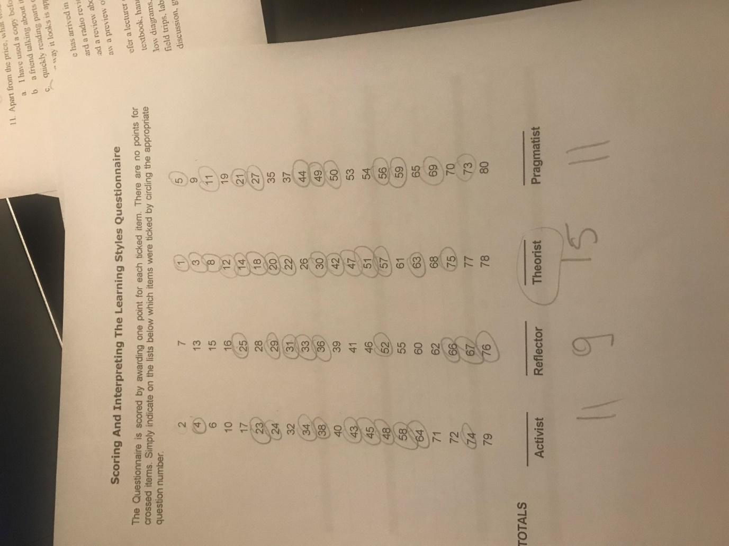

.

Appedix2
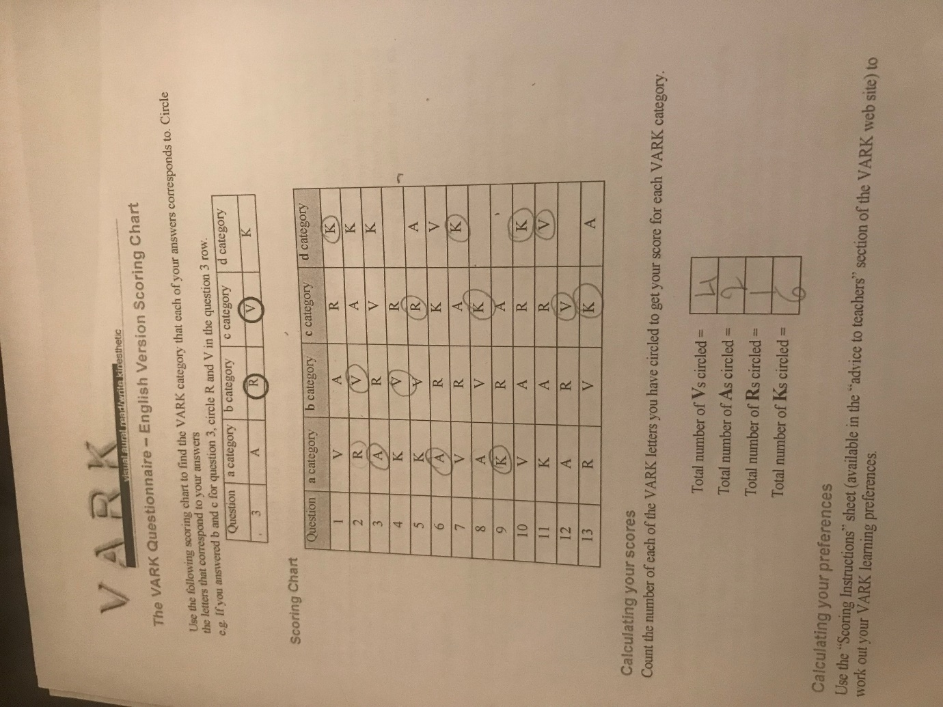

Appedix3
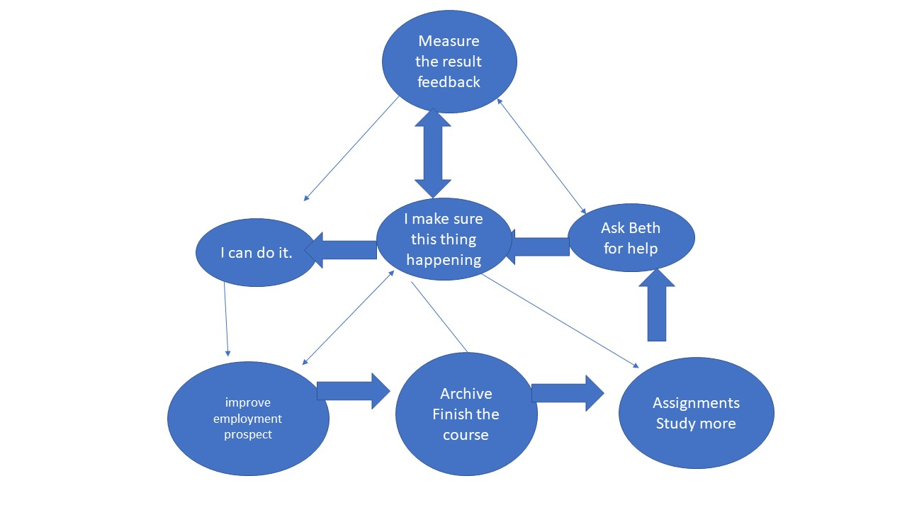

Appedix4
My learning preferences it is Kolb s experimental learning cycle.
Concentrate experience.Do I have experience?
My concentrate experience is my first powerpoint presentation.this was a group presentation each student had a different task which we have to answer 1 questions each
My question was to answer internal communication to a given company I had to know what it was internal communication and how the company communicate with each other it was a limited time for 5.min
Reflective observation.
IT was my first time to prepare a powerpoint presentation I was so nervous .after having done some researching about the company and follow my election adviser I have been able to do the slide of my presentation .i felt so nervous but on a presentation day I thought I was ready I could deliver the information and powerpoint but my confident let me a bit down.

Abstract conceptualization conclude learn experience
From my experience of performing this presentation felt I need to develop
My confidence
More practice to talk in front of the people
More skills.
Active experimentation plan to try out what you learn.
I am planning and try hard in a nex presentation.

