

ACCB6017
Usability Engineering – Component 2 Technical Report

Name: Olimpiu Robu

ID: 2233652

Module Tutor: Nassir Ibrahim

14th November 2025 – 2PM

Contents
Abstract 4
1. Introduction 4
2. Full-Colour Storyboards and Iterative Design 5
Storyboards for Component 1 5
Evolution from Wireframes to Colour Storyboards 6
Colour Scheme and Visual Language 7
Main Menu and Game Mode Storyboards 8
Core Board View and Clue Tracking 11
Suggestion/Accusation and End-Game Storyboards 12
Communication Flow Storyboards 14
3.Feedback Collection Methods and Coverage of Personas 15
Usability and Emotional Response: Findings and Interpretation 16
Impact of Feedback on Design Iteration 17
4.Data Gathering and Analytics for Next-Generation Development 18
Data Required and Rationale 18
Data Collection Mechanisms: Automatic vs Direct 18
Distinguishing Usage Data from Emotional Response Data 19
5.Usability Versus User Experience: Managing Design Conflicts 19
How Would the Storyboards Differ Under a Pure Usability Lens? 19
Conflicts Between Usability and User Experience 20
6. Conclusion 20
References 21
Appendices 23

Figure 1 monochrome storyboards 5
Figure 2 colour storyboards 6
Figure 3 main menu 8
Figure 4 game mode and character selection 9
Figure 5 difficulty selection 10
Figure 6 core board view 11
Figure 7 suggestion storyboard 12
Figure 8 multiple choice after end game 13
Figure 9 chat availability 14
Figure 10 questionnaire sheet 15

Abstract
This technical report details the second critical phase of the design process for the "Murder at UWTSD" mobile game, focusing on the iterative transformation of low-fidelity wireframes into full-colour storyboards and the subsequent validation of these prototypes. The document critically analyses the aesthetic and functional changes implemented in response to usability friction points identified in Component 1, specifically concerning User Control and Smooth Interaction Flow. Furthermore, it provides an academic framework for data collection in a live environment, differentiating between automatically collected usage data and direct emotional metrics. Fundamentally, the report addresses the inherent conflict between rigorous Usability principles and the broader scope of User Experience (UX), concluding that a successful mobile game design is a strategic compromise where UX serves as the essential, fundamental requirement for user involvement. All design decisions and analyses are justified by direct reference to established usability heuristics and academic literature.

1. Introduction
This second component of the Usability Engineering report extends the earlier work on the UWTSD-themed digital CLUEDO style game, moving from low-fidelity monochrome wireframes to full-colour, high-fidelity storyboards suitable for a mobile implementation. Component 1 established the user-centred design foundations: four personas, a structured set of User Experience Requirements (UXRs), and initial wireframe flows for the main menu, game modes, board view, suggestion/accusation flow, communication, and end game states. It also identified key usability issues, particularly high cognitive load in deduction, the need for smooth interaction on constrained mobile hardware, and support for strategic social play.
In this component, those wireframes are refined into colour storyboards that more fully address the usability attributes of effectiveness, efficiency, and satisfaction within the specific context of mobile use, as emphasised in contemporary mobile usability models [1]. These models highlight that mobile usability must reconcile limited screen real estate, resource constraints, and varied contexts of use, while still delivering an engaging and visually coherent experience. The design decisions presented here therefore seek to integrate visual aesthetics (colour, typography, iconography) with the functional requirements elicited in Component 1, grounded in empirical findings on mobile application usability and demographic variation [2], [3].
The report also documents how feedback gathered on the interactive prototype influenced visual and interaction refinements, and how planned data collection in a future working version of the app will support iterative usability optimisation. Finally, it critically reflects on additional usability considerations, including tensions between usability and user experience (UX) and how the design might differ if it pursued usability alone rather than a richer experiential vision.

2. Full-Colour Storyboards and Iterative Design

Storyboards for Component 1

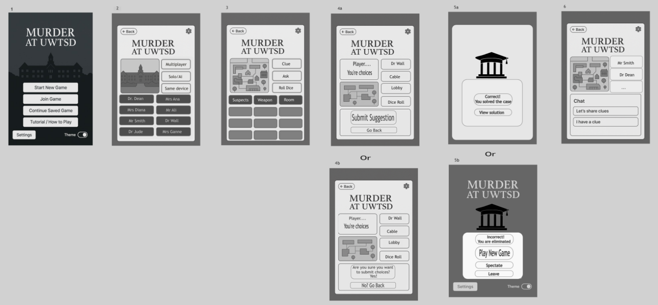
Figure 1 monochrome storyboards

Component 1 introduced monochrome wireframes that established the core interaction flow and information architecture. The main menu prioritised fast access to “Continue Saved Game” (UXR 5) and a tutorial for first-time users; the game mode and character selection screens operationalised flexible modes (UXR 3) and personalisation (UXR 9); the core board view combined a simplified UWTSD campus map with a dedicated clue-tracking panel (UXR 2); the suggestion/accusation flow enforced rules transparently (UXR 1); the resolution screens communicated win/loss outcomes and offered “Spectate” or “Leave” to maintain efficiency (UXR 6); and the communication flow instantiated a private channel for strategic play (UXR 11).
User feedback collected on those wireframes (reported in Component 1) validated the overall flow and the digital notepad concept but exposed gaps in perceived control and awkwardness in the chat flow. These issues became primary drivers for the visual and interaction refinements in the full-colour storyboards presented here.
(Full sets of Component 1 and Component 2 storyboards are referenced in the Appendices.)

Evolution from Wireframes to Colour Storyboards

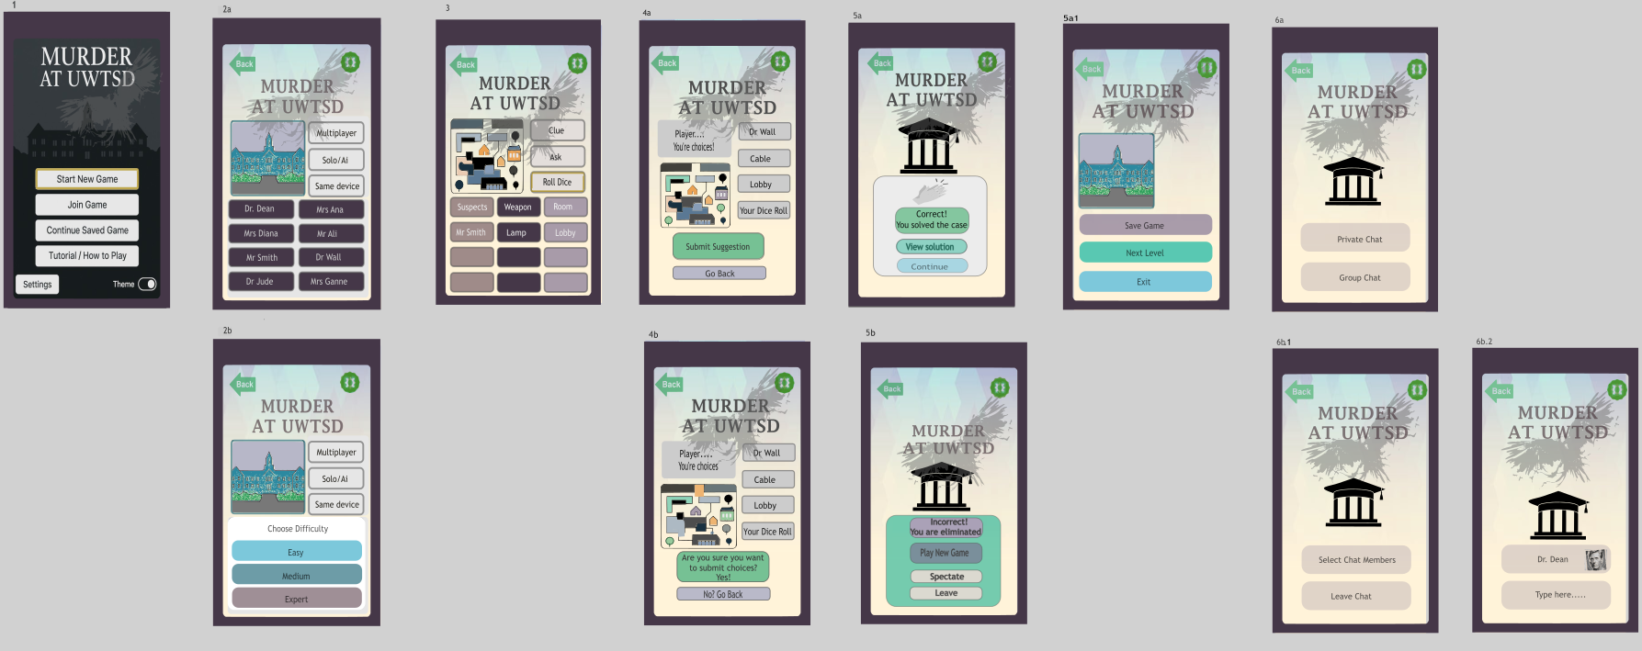
Figure 2 colour storyboards
The transition from monochrome wireframes to colour storyboards preserved the validated navigation structure while addressing three main weaknesses: weak visual hierarchy, insufficient feedback visibility, and limited emotional resonance with the murder-mystery theme. High-fidelity visuals were therefore used not merely as “decoration” but to improve recognition, reduce cognitive load, and support more efficient decision-making attributes repeatedly identified as critical in consolidated models of mobile usability [1], [3].
Across all screens, the layout grid and component positions from Component 1 are maintained to protect learnability and memorability. Changes are mainly in: Colour and contrast to strengthen hierarchy and legibility. Also, Iconography and micro-interaction cues to enhance recognition rather than recall. Furthermore, in Thematic illustration to better communicate narrative context without overwhelming the small mobile screen.

Colour Scheme and Visual Language

The colour palette is an integration of UWTSD brand tones (deep navy and gold) with murder-mystery cues (muted burgundy, dark green, and desaturated neutrals): For the backgrounds: A deep navy or charcoal gradient is used on most primary screens to support a “mysterious” atmosphere while providing a stable dark canvas for high-contrast foreground elements. The primary action colour: A saturated gold accent is reserved for primary call-to-action buttons (“Start Game”, “Roll Dice”, “Confirm Accusation”), reinforcing their importance and aligning with brand identity. The secondary and status colours: Calmer teal tones mark secondary actions (e.g., “Tutorial”, “Spectate”), while error and critical feedback elements use a controlled red, reserved only for destructive or high-risk decisions (e.g., final accusation confirmation).For the information coding: Soft but distinct colour coding is applied to suspects, weapons, and rooms in the clue-tracking system and board highlights to support rapid visual scanning without relying solely on text. This aligns with human–machine interaction research showing that well designed colour coding can accelerate target identification and reduce cognitive effort when used consistently and sparingly [6], [7], [12].
Colour decisions were constrained by contrast and accessibility considerations. Text is predominantly light on dark (off-white on navy/charcoal) with a minimum contrast ratio appropriate for small mobile screens. Colour pairings that are problematic for common forms of colour, vision deficiency (e.g., red/green without luminance difference) are avoided or supplemented by icon and shape cues. This responds directly to the Component 1 concern about high cognitive load: colour here is used to externalise structure and state, not to add visual noise.
Ali et al. highlight that demographic factors (age, experience, device preferences) correlate strongly with perceptions of usability and satisfaction in mobile apps, particularly around clarity of layout and controls [2]. The palette, typography, and spacing are therefore deliberately calm and restrained rather than saturated or “arcade-like”, supporting the older and time-constrained personas identified previously (Sarah, Dr. Vance, Amina) while still allowing moments of “flash” for Liam’s desire for immersion [2], [11].

Main Menu and Game Mode Storyboards
The full-colour Main Menu (Fig.3 Appendix 3) retains its core structure but is visually organised into three horizontal bands: Thematic header: A stylised illustration of the UWTSD campus at dusk with subtle parallax shading introduces the narrative (“Oh no! The Vice-Chancellor has been murdered!”) without occupying interactive space. Primary actions: “Continue Saved Game”, “Start New Game”, and “Tutorial” appear as large, full-width buttons stacked vertically, each will use the primary accent and subtle glow on hover/press to convey interactivity. Secondary utilities: Smaller icon-label buttons for “Settings”, “Theme/Accessibility”, sit at the bottom, using the secondary teal accent to avoid competing with primary tasks. A new, explicit pause control icon is introduced at the top-right, visible on every in-game screen once a session is active. This directly answers earlier user concerns about lacking an obvious way to suspend play during interruptions, thereby improving perceived control, especially for personas juggling study and work schedules.
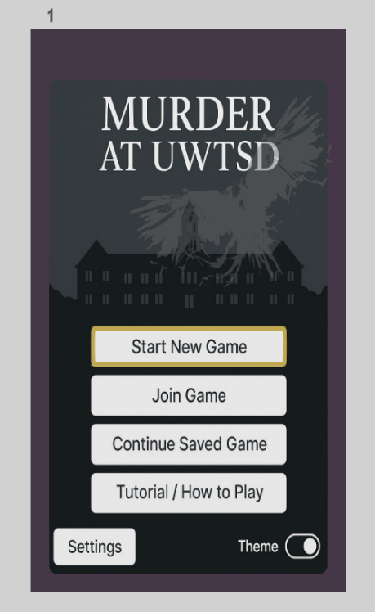
Figure 3 main menu

The Game Mode and Character Selection (Fig4. Appendix4,5) storyboard uses a split layout. The upper segment houses mode selection chips (“Solo vs AI”, “Local Multiplayer”, “Online Multiplayer”), each with short explanatory text and subtle icons. Selected modes are highlighted with gold outlines and a soft glow. Furthermore, the lower carousel displays character cards framed in persona-coloured accents, with tooltip-style micro copy reinforcing personality traits and potential strategy hooks.
Here colour becomes a functional cue linking characters to onboard tokens and their entries in the clue tracking system, supporting efficient cross screen mapping and reducing memory demands.
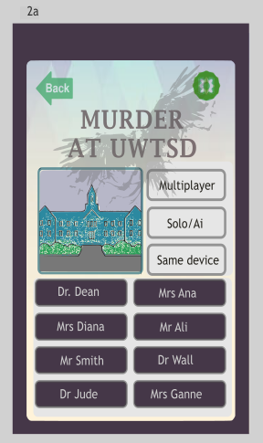
Figure 4 game mode and character selection
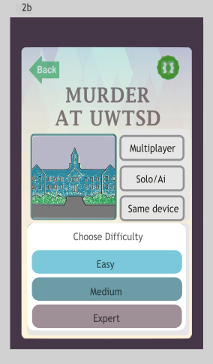
Figure 5 difficulty selection

Core Board View and Clue Tracking
The Core Board View (fig.6, appendix4) storyboard remains the central functional screen. The simplified UWTSD campus board is now rendered in muted desaturated colours with higher saturation reserved for interactive affordances (current room, available movement tiles, active tokens). This respects research suggesting that excessive saturation in background elements competes with task-relevant information and can harm perceived usability [1], [3].
Key visual refinements include dynamic tile highlights: Available movement tiles glow softly in teal; tiles involved in a suggestion/accusation path use a gold outline; recently visited rooms are subtly tinted to support spatial memory. Also, clue tracking pane: The digital notepad uses a structured table with columns for better recollection, with each card row lightly tinted in its category colour. These changes directly support effectiveness (fewer deduction errors), efficiency (faster inference), and satisfaction (less feeling of being “lost”), as emphasised in mobile usability models that treat usability as “quality of use” under real-world constraints[1], [3], [4].
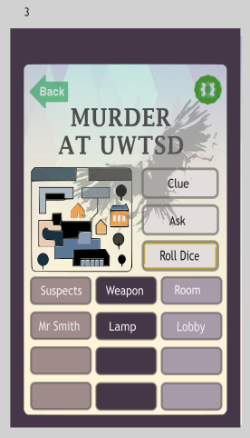
Figure 6 core board view

Suggestion/Accusation and End-Game Storyboards
The Suggestion/Accusation (appendix6,7,8) storyboard extensively uses colour to convey risk and irreversibility. While suggestions use the standard muted primary accent, the final accusation confirmation modal overlays the screen with a darkened backdrop and introduces a red-tinted border and warning icon. The selected suspect, weapon, and room cards are displayed as large, coloured tiles with short explanatory captions, prompting the user to re-check their logic before committing. This reinforces the “user control and freedom” heuristic while signalling seriousness.
The Endgame (appendix9,10,11) storyboards differentiate victory and defeat through both colour and micro-animation. Victory screens use brighter highlights and subtle particle effects; defeat screens rely on cooler, subdued tones while still preserving readability and quick access to “Spectate” or “Return to Menu”. This balances emotional impact with the efficiency required by busy personas who may need to exit quickly.

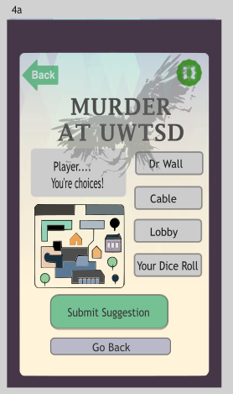
Figure 7 suggestion storyboard
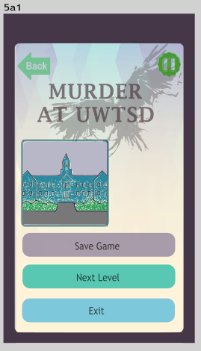
Figure 8 multiple choice after end game

Communication Flow Storyboards
The Communication screen now uses a tabbed layout (“Private Chat”, “Group Chat”), each with distinct tabs (appendix12,13,14). A key refinement arising from earlier feedback is the simplification of recipient selection: player avatars appear alongside their name, reducing mis-taps and improving perceived security of the private channel (appendix 14). This design reflects research within IEEE Transactions on Games that stresses the importance of preserving intended user experience such as narrative immersion and social strategy, alongside strict usability, particularly in AI-mediated and networked games [8], [9], [13].
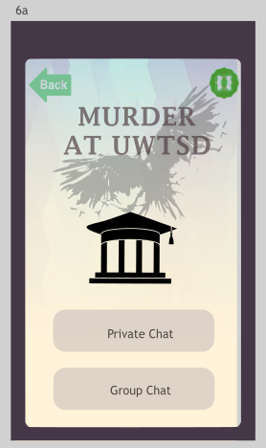
Figure 9 chat availability

3.Feedback Collection Methods and Coverage of Personas

To evaluate the full-colour prototype, a small-scale user study was carried out using a combination of remote moderated sessions and task-based think-aloud protocols. The interaction tasks mirrored those used in Component 1 (start a game, move, make suggestions, track clues, send messages), but now on a clickable, colour storyboard prototype (appendix15).
Participants were purposively sampled to approximate the four personas defined previously:
- One full-time student familiar with board games (Liam analogue).
- One part-time student with limited time and high reliability expectations (Sarah analogue).
- One academic staff member familiar with CLUEDO (Dr. Vance analogue).
- One self-employed professional with irregular availability (Amina analogue).
This mapping ensured that the feedback reflected the spectrum of device preferences, time constraints, and strategic preferences identified in earlier research.
Post task, participants completed a short usability questionnaire (Fig 10, appendix 15) inspired by standard scales used in mobile usability studies (e.g., Likert-type questions on clarity, ease of learning, perceived control and aesthetics), as recommended in empirical work on mobile application usability and demographic [2]. Open questions captured emotional reactions to the visual style, atmosphere, and perceived tension of the murder-mystery theme [2], [4], [8].
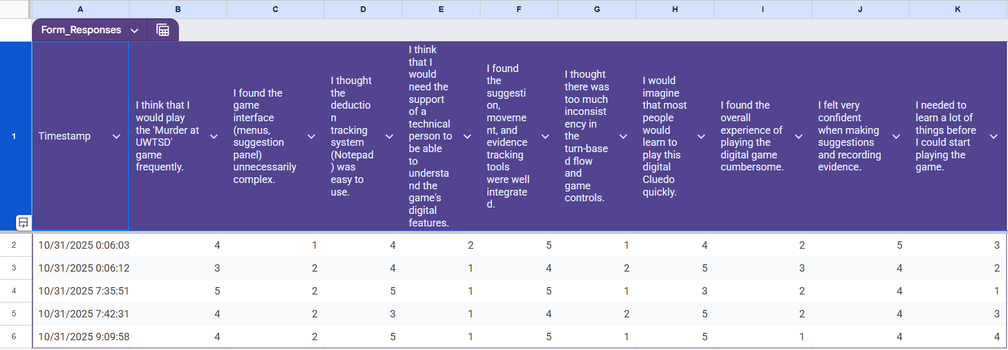
Figure 10 questionnaire sheet

Usability and Emotional Response: Findings and Interpretation
Overall, the quantitative scores indicated improved perceived usability relative to the monochrome wireframes, particularly for visual clarity of available actions (higher ratings for “I always knew what I could do next”). Also, for ease of tracking clues and turns. Lastly perceived professionalism and polish of the interface. Participants consistently stated that the colour coding of suspects, weapons, and rooms in the notepad made deduction “feel easier” and less error prone, supporting the intended reduction in cognitive load. This aligns with empirical findings that carefully structured visual attributes, when used consistently, enhance effectiveness and reduce perceived complexity in interactive systems [1]. However, important issues emerged:
One participant still expressed uncertainty about whether the private chat was genuinely secure, despite the new lock icon and purple accent; they reported briefly worrying that messages might accidentally leak into public chat. This reveals a gap between designer intent and user mental models of security. Another participant noted that the dark campus illustration, while atmospheric, “felt a bit heavy” during longer sessions and suggested a lighter variant or accessibility theme for extended play. The self-employed participant strongly appreciated the global pause control but wanted clearer feedback when resuming (e.g., a recap banner summarising “whose turn it is” and “last action taken”), indicating that mobile interruptions are not just about pausing but also about re orientation after resumption. Interestingly, not all outcomes matched prior expectations. The full-time student assumed to prioritise immersion rated the visual style as “good but slightly restrained”, wishing for more dramatic animations. Yet the academic staff member, predicted to prefer minimalism, explicitly praised the subdued palette for “not distracting from the logic puzzle.” This divergence reinforces findings from game focused UX research that player experience is shaped by complex interactions between aesthetics, mechanics, and individual strategy preferences rather than by demographic factors alone [8], [9], [10], [13].

Impact of Feedback on Design Iteration
The feedback led to several targeted refinements. A short, colour coded inline notice will be added to the chat tab (“Messages here are only visible to selected players”), linked to a persistent lock icon, to stabilise the security mental model. An optional “High-contrast light board” theme was defined for future implementation, allowing users to toggle away from the darker aesthetic while retaining thematic accents. A brief “Turn Recap” banner was designed for future implementation to appear after resuming from pause, summarising recent actions and visually highlighting the current player token on the board. These refinements illustrate a cyclical, evidence-driven approach to usability engineering, consistent with contemporary practice in mobile application evaluation [1], [3],[5].

4.Data Gathering and Analytics for Next-Generation Development

Data Required and Rationale
In a deployed version of the Murder at UWTSD app, data collection must balance three goals: improving usability, supporting fair and engaging gameplay, and respecting user privacy and autonomy. Building on insights from mobile usability research that treat context of use and user characteristics as central variables [1],[3]. the following categories of data are envisaged:
Basic account and device information with minimal user profile (e.g., age band, experience with board games), and device characteristics (screen size, OS version). The rationale is to support demographic sensitive usability analysis and ensure performance is acceptable across diverse devices[2], [11]. Furthermore gameplay and interaction telemetry with turn duration, frequency of pauses, error rates in suggestion/accusation, clue-tracking interactions, and communication channel usage. The rationale for it is to identify bottlenecks (e.g., screens where users hesitate or back out), evaluate whether the clue-tracking system effectively reduces errors, and detect unbalanced difficulty levels. Also, session level usability and experience signals with optional post session micro surveys (two or three items) capturing perceived ease of use, enjoyment, and perceived fairness. The rationale is to triangulate objective performance with subjective experience, as emphasised in consolidated models of mobile usability attributes [1], [3]. Ultimately emotional and experiential indicators (optional and consent-based) self-reported tension, satisfaction, or frustration ratings at key milestones (e.g., after accusations, defeats). The rationale behind it: better understand how colour, pacing, and feedback affect emotional engagement in a deduction heavy game, in line with broader game UX research [7], [8], [14], [15].

Data Collection Mechanisms: Automatic vs Direct

Most gameplay and interaction telemetry implicitly also for Murder at UWTSD can be collected automatically on the client and transmitted to a secure backend in aggregated form. Events such as “open notepad”, “edit clue state”, “send message”, “press pause”, or “resume game” can be logged with timestamps and anonymised user IDs. This minimises user burden and reflects standard practice in mobile game analytics. However, subjective usability and emotional response data cannot be inferred reliably from logs alone. Short, optional in-app questionnaires at the end of key sessions are therefore required. Empirical evaluations show that combining behavioural logs with self-report yields richer, more actionable models of user experience than either alone [1],[2]. Crucially, such questionnaires must remain lightweight to respect time constrained personas: a single multi item questionnaire per week of active play might be sufficient, with users incentivised through cosmetic rewards (e.g., alternative token colours).

Distinguishing Usage Data from Emotional Response Data
Usage data (e.g., number of games completed, average turn time, notepad interactions) primarily inform effectiveness and efficiency: whether users can successfully complete games and perform tasks without excessive effort. Emotional response data (e.g., enjoyment ratings, perceived tension, trust in private chat) speak to satisfaction and long-term engagement [1], [4]. For example, telemetry may show that users rarely use the private chat feature; this could be interpreted as a usability issue (difficult to find) or a preference for solo play. By correlating this with subjective reports of “feeling unsure if private chat is truly private”, the design team can differentiate between disuse driven by poor affordances and disuse driven by deliberate preference and adjust either UI cues or feature prominence accordingly.

5.Usability Versus User Experience: Managing Design Conflicts

How Would the Storyboards Differ Under a Pure Usability Lens?
If the design were driven purely by a narrow interpretation of usability, maximising immediate task performance while deprioritising narrative and atmosphere the storyboards would likely look more utilitarian. The campus illustration would be replaced by a minimal, high-contrast grid with only essential room labels, reducing visual richness but slightly improving raw target acquisition speed. Character art would be abstract icons with strong colour differentiation, with less emphasis on personality traits or narrative backstory. Animations would be minimised to only those strictly necessary for feedback (e.g., piece movement), with no decorative transitions or particle effects. Such a design might score higher on efficiency for some tasks, but it would undermine the experiential qualities that motivate regular engagement with a murder-mystery game. Both empirical work on mobile usability and research in game oriented human computer interaction stress that perceived quality and willingness to continue using an app depend on a broader constellation of attributes than speed alone [1], [3], [8], [9].

Conflicts Between Usability and User Experience
Several explicit trade-offs surfaced during the design process like, atmospheric darkness vs readability (appendix3). Dark themes enhance the mystery atmosphere and reduce eye strain in low-light contexts, but some participants found extended sessions visually “heavy” and slightly harder to read. To mitigate maintain the dark default for thematic consistency but plan an optional high contrast variant, allowing users to self-optimise based on context and preference. Furthermore, information density vs cognitive load. Rich clues, animations, and narrative overlays can deepen immersion but risk overwhelming users during deduction (appendix 6). So, the resolution would be to keep the board visually subdued and push narrative richness into optional elements (e.g., character dossiers accessible from the main menu) so that core deduction remains visually clean. Finally, expressive Chat vs interaction efficiency (appendix12,13,14). Providing rich chat features (emoji reactions, threaded chats) might support sophisticated social strategies but also increases interface complexity and potential errors. The resolution would be to deliberately limit communication to three clear channels (private, notes, group) with simple, consistent layouts, favouring reliability and learnability over maximum expressiveness.
These trade-offs echo observations in IEEE Transactions on Games that balancing usability with experiential goals is central to successful game design, particularly when AI behaviour, social interaction, and UI design jointly shape the overall player experience [7], [8], [13], [14].

6. Conclusion
The overall design journey, from the theoretical framework of Component 1 to the full-colour validation of Component 2, has been a robust exercise in applied Usability Engineering. The process confirms that while theoretical usability, informed by heuristics and standards, provides the necessary foundation for effectiveness and efficiency, User Experience is the ultimate arbiter of success for a mobile game. The design’s most critical interventions, the streamlined suggestion flow, and the visual security cues were all driven by the iterative feedback loop, confirming the intrinsic value of user inclusion in the UCD process. The tensions identified, particularly the conflict between visual density and the need for abstraction, underscore the complexity of designing for a diverse persona group with conflicting aesthetic and efficiency goals. In conclusion, the final storyboards represent a functional, aesthetically informed, and strategically compromised design that acknowledges the primacy of engagement. The next development phase must ensure that the technical implementation translates this delicate balance between Usability and User Experience into a commercially viable, high-performance mobile application.

References
[1] P. Weichbroth, “Usability of Mobile Applications: A Consolidated Model,” IEEE Access, vol. 12, pp. 62378–62391, 2024, doi: 10.1109/ACCESS.2024.3395528.
[2] W. Ali, O. Riaz, S. Mumtaz, A. R. Khan, T. Saba, and S. A. Bahaj, “Mobile Application Usability Evaluation: A Study Based on Demography,” IEEE Access, vol. 10, pp. 41512–41524, 2022, doi: 10.1109/ACCESS.2022.3166893.
[3] P. Weichbroth, “Usability of Mobile Applications: A Systematic Literature Study,” IEEE Access, vol. 8, pp. 55563–55577, 2020, doi: 10.1109/ACCESS.2020.2981892.
[4] S. Wang, Y. Liu, F. Song, X. Xie, and D. Yu, “Research on Evaluation System of User Experience With Online Live Course Platform,” IEEE Access, vol. 9, pp. 23863–23875, 2021, doi: 10.1109/ACCESS.2021.3054047.
[5] J. Zhu and H. Hou, “Research on User Experience Evaluation of Mobile Applications in Government Services,” IEEE Access, vol. 9, pp. 52634–52641, 2021, doi: 10.1109/ACCESS.2021.3070365.
[6] S. Cano, N. Araujo, C. Guzman, C. Rusu, and S. Albiol-Perez, “Low-Cost Assessment of User eXperience Through EEG Signals,” IEEE Access, vol. 8, pp. 158475–158487, 2020, doi: 10.1109/ACCESS.2020.3017685.
[7] S. Graja, P. Lopes, and G. Chanel, “Impact of Visual and Sound Orchestration on Physiological Arousal and Tension in a Horror Game,” IEEE Trans. Games, vol. 13, no. 3, pp. 287–299, 2021, doi: 10.1109/TG.2020.3006053.
[8] R. Epp, D. Lin, and C.-P. Bezemer, “An Empirical Study of Trends of Popular Virtual Reality Games and Their Complaints,” IEEE Trans. Games, vol. 13, no. 3, pp. 275–286, 2021, doi: 10.1109/TG.2021.3057288.
[9] M. Foxman, D. Beyea, A. P. Leith, R. A. Ratan, V. H. H. Chen, and B. Klebig, “Beyond Genre: Classifying Virtual Reality Experiences,” IEEE Trans. Games, vol. 14, no. 3, pp. 466–477, 2022, doi: 10.1109/TG.2021.3119521.
[10] J. Wang, H.-N. Liang, D. Monteiro, W. Xu, and J. Xiao, “Real-Time Prediction of Simulator Sickness in Virtual Reality Games,” IEEE Trans. Games, vol. 15, no. 2, pp. 252–261, 2023, doi: 10.1109/TG.2022.3178539.
[11] J. E. Muñoz et al., “Development of Classifiers to Determine Factors Associated With Older Adult’s Cognitive Functions and Game User Experience in VR Using Head Kinematics,” IEEE Trans. Games, vol. 17, no. 3, pp. 604–612, 2025, doi: 10.1109/TG.2023.3317825.
[12] E. J. Pretty, R. Guarese, C. A. Dziego, H. M. Fayek, and F. Zambetta, “Multimodal Measurement of Cognitive Load in a Video Game Context: A Comparative Study Between Subjective and Objective Metrics,” IEEE Trans. Games, vol. 16, no. 4, pp. 854–867, 2024, doi: 10.1109/TG.2024.3406723.
[13] H. Warpefelt, C. Salge, M. P. Eladhari, M. S. El-Nasr, and J. Zhu, “Guest Editorial Special Issue on User Experience of AI in Games,” IEEE Trans. Games, vol. 14, no. 4, pp. 539–542, 2022, doi: 10.1109/TG.2022.3225731.
[14] D. M. Hansen and K. D. Hansen, “Clues About Bluffing in Clue: Is Conventional Wisdom Wise?,” IEEE Trans. Games, vol. 13, no. 3, pp. 310–314, 2021, doi: 10.1109/TG.2019.2957353.
[15] H. Cecotti, M. Leray, and M. Callaghan, “Countdown VR: A Serious Game in Virtual Reality to Develop Mental Computation Skills,” IEEE Trans. Games, vol. 17, no. 1, pp. 40–51, 2025, doi: 10.1109/TG.2024.3357452.

Appendices
Appendix1
Appendix 2

Appendix 3

Appendix 4

Appendix 5

Appendix 6

Appendix 7

Appendix 8
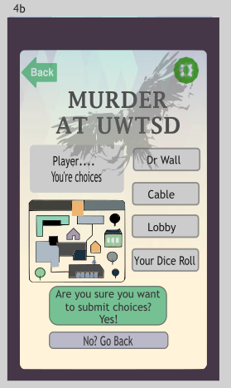

Appendix 9
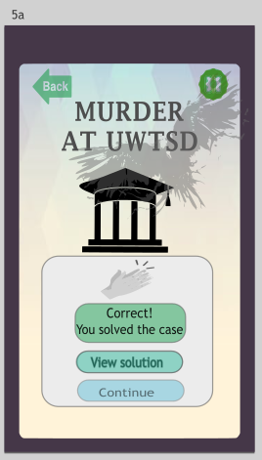

Appendix 10

Appendix 11
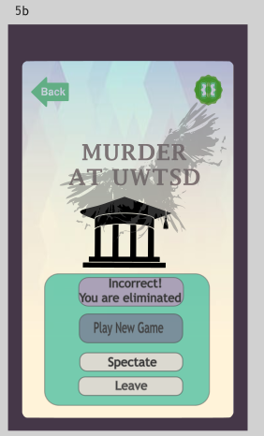

Appendix 12

Appendix 13
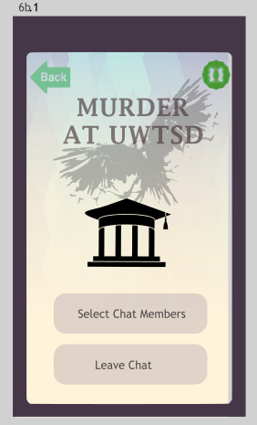

Appendix 14
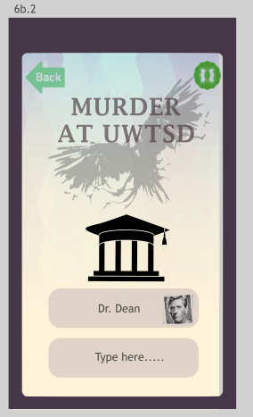

Appendix 15



