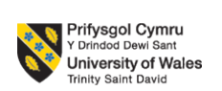

PROGRAMME: BUSINESS MANAGEMENT
MODULE: CHANGEMAKERS BUILDING YOUR PERSONAL BRAND FOR SUSTAINABLE
MODULE CODE: BMBM5021
ASSIGNMENT TITLE : EMPLOYABILITY SKILLS AND SEMESTER ABROAD REFLECTION
STUDENT NAME: HARSHINI A/P JANASINGGAM
STUDENT ID NUMBER: 2426418
LECTURER : ROBYN GRIFFITHS
SUBMISSION DEADLINE: 23:59 ON FRIDAY 2/5/25

Table of Contents
PART 1: EVALUATION OF EMPLOYABILITY SKILLS 1
Introduction 2
Main Body 2
Industry and Employers Research 2
Skills Evaluation 3
Current employability skills 3
Conclusion 4
References 5
Appendices 6
Appendix 1: Public Relations Manager post of TOEMPLOYMENT PTE. LTD. 6
Appendix 2: Marketing Communications Manager post of PLENITUDE IPOH SDN. BHD. 7
PART 2: REFLECTIVE ESSAY ON SKILL DEVELOPMENT 8
1. Introduction 9
2. Expectations vs Reality 9
3. Academic Learning 10
4. Personal Growth 10
5. Cultural Experience 10
6. Challenges Faced 11
7. Conclusion 12
References 14

PART 1: EVALUATION OF EMPLOYABILITY SKILLS

Introduction
Concept of employability skills
Employability skill is one of the soft skills that includes qualities and ability of an individual to Excel in their workplace in adopting job demand based skills and expertise. This employability skill also includes teamwork, communication, and problem solving activity maintenance in managing key job roles and efficiency (Asefer and Abidin, 2021). In managing job and activity in a dynamic market, the employee skill refers to transferable skills, which are vital in managing individual activity to maintain meaningful employment.
Importance of skills in obtaining and sustaining employment
In managing competitive industry based professional activity as a marketing and public relations executive the employability skill can differentiate candidates as well as ensure continuous growth within the job role. Employers in Malaysia in industries such as employment consultant marketing, and hotelier, and hotel-related activities skills candidates who only have technical proficiencies with the right blend of strategic and interpersonal skills. This analysis further explores employability skills as a marketing, and peer manager aligned with industry expectations in Malaysia to maintain employer need and job trend.

Main Body

Industry and Employers Research
Research on two industries of interest and identify employers within fields
The Malaysia market has several job opportunities along with prominent activity and career opportunities maintenance for candidates. Along with public relations organisation in managing employment of others is one of the major industries. The employment provider industry plays an effective role in managing key customer relationships in managing appropriate services (Al-Gasawneh et al. 2021). On the other hand, the hospitality sector is one of the prominent industries in managing working activities and managing roles of businesses. This industry operates with numerous hotels as well as the hospitality sector in offering the role of Management in providing help in event coordination. Both of these industries seek professionals with strong communication skills, customer centric approach as well as strategic planning ability to enhance services.
Outline job opportunities available and key employability skills required
In the Malaysia vibrant employment market, the hospitality, and public relationship industry stand out as a key sector in offering a range of marketing opportunities. As inspired by Berestetska et al. (2021), increasing in digitalisation with changing customer behaviour provides impact in managing strategic communication that provide impact in managed organisational branding. The decent job listing, and employer insight there has obtained employers offering different roles in “Toemployment Pte Ltd”, and “Plenitude Ipoh Sdn. Bhd”. “Toemployment Pte. Ltd” Is presently recruiting for a public relations manager post in Kuala Lumpur (Jobstreet, 2025). Candidates are also expected to have strong story lining skills in having experience with press releases that manage deeper understanding of international context. The company also include importance of cross cultural communication as well as capability to expand into overseas media platform business activity maintenance that require a blend of creativity and strategic planning
“The Plenitude Ipoh Sdn. Bhd” is based on the hiring of a Marketing Communications Manager to oversee marketing efforts to maintain hospitality properties. This role For candidate involves crafting marketing strategy, social media platform as well as managing brand presence events. “The Plenitude Ipoh Sdn. Bhd” business values candidates who are organised, creative and have experience with hotel revenue strategies (Jobstreet, 2025). The job role of marketing communication manager also requires guest engagement technique as well as collaboration with stakeholder maintenance. In terms of job posting and skill activity maintenance, excellent communication is one of the major case skills that are required to implement within candidates. Digital marketing as well as strategic thinking are also required to maintain as a key skill of employees (Rodríguez et al. 2023). In this context public speaking as well as creativity skills are also required to maintain in handling content development to manage key motivation of the public.

Skills Evaluation

Current employability skills
My present employability skills include media relation strategic communication digital marketing and team activity management. I have analytical thinking skills, which provide impact in managing creative problem solving. I also can effectively manage campaigning along with coordinating with a professional functional team that provides impact in managing literature and even insight to maintain brand visibility.
Compare skills with those listed in job descriptions that align with job opportunities.
Along with comparing my present employability skill and the requirement in the selected job, I have several skills similarities in managing the job world. For example both “Toemployment Pte. Ltd. PR Manager role”, and my manager role emphasize strategic communication requirements with handling media relations. I have developed the press release as well as media knowledge which provide impact in managing communication activity and initiative. However, in terms of job listing for international media engagement my experience has been largely regional that provides an impact in managing my working activity and decision maintenance in terms of the international market. On the other hand, digital marketing capability is also important in managing warning practices in using social media marketing (Apasrawirote et al. 2022). The key roles in Plenitude Ipoh Sdn. Bhd includes digital focus in managing target campaigns, where I have skill in managing coordination with cross functional teams. In contrast, the hospitality sector also plays an additional role in managing revenue driven strategies that are less developed for me which I needed to mitigate. Further, I have strength in managing digital marketing as well as strategic communication that can contain opportunities for me in managing my job role and hospitality revenue management for development.

Conclusion
Job opportunities align best with existing skills.
From the evaluation, the public relations sector aligns most with my existing professional experience. Inclusion of employability can maintain key attributes, and competences that provide impact in managing an individual role like the PR Manager at “Toemployment Pte. Ltd workplace”. This position can help to maintain strong relationships building activity with local and international media which maintain corporate reputation and my job opportunities in this field.
Personal brand and professional identity fit the chosen job to meet the employer's needs.
My personal brand can be built in managing creativity, data-driven activity, and adaptability in managing communication activity that are highly valued in the PR industry. This position is also particularly focused on people oriented, where candidates need to demonstrate strong customer service experience in managing overall performance tracking skill. My track record in relation to executing campaigning, and team roles can handle my commitment in delivering results as a peer, and marketing manager. I also need to process relevant digital marketing activity, which are applicable in managing my job role to ensure that I can meet and exceed employer expectations.

References
Al-Gasawneh, J.A., Anuar, M.M., Dacko-Pikiewicz, Z. and Saputra, J., (2021). The impact of customer relationship management dimensions on service quality. Polish Journal of Management Studies, 23(2), pp.24-41.
Apasrawirote, D., Yawised, K. and Muneesawang, P., (2022). Digital marketing capability: the mystery of business capabilities. Marketing Intelligence & Planning, 40(4), pp.477-496.
Asefer, A. and Abidin, Z., (2021). Soft skills and graduates’ employability in the 21st century from employers’ perspectives: A review of literature. International Journal of Infrastructure Research and Management, 9(2), pp.44-59. https://iukl.edu.my/rmc/wp-content/uploads/sites/4/2022/02/5.-Al-Asefer_compressed.pdf
Berestetska, O., Iankovets, T., Orozonova, A., Voitovych, S., Parmanasova, A. and Medvedieva, K., (2023). Using CRM systems for the development and implementation of communication strategies for digital brand management and internet marketing: EU experience. International Journal of Professional Business Review: Int. J. Prof. Bus. Rev., 8(4), p.36.
Jobstreet.com (2025). Marketing Communications Manager. Available at: https://my.jobstreet.com/hotel-marketing-manager-jobs?jobId=83234307&type=standard. [Accessed on 24.03.2025]
Jobstreet.com (2025). Public Relations Manager / Media Manager. Available at: https://my.jobstreet.com/job/82782134?type=standard&ref=search-standalone&origin=cardTitle#sol=3900aa7f4434d6505381caf0f9c14dece85997ab. [Accessed on 24.03.2025]
Rodríguez, L.F.M., Bazán, Z.A., Dante, A.C., Cueva, F.E.I., Calla, W.C. and Chota, R.M., (2023). Digital Marketing Strategies and Their Impact on Competitive Advantage: A Focus on Strategic Management. Migration Letters, 21, pp.624-637.

Appendices

Appendix 1: Public Relations Manager post of TOEMPLOYMENT PTE. LTD.
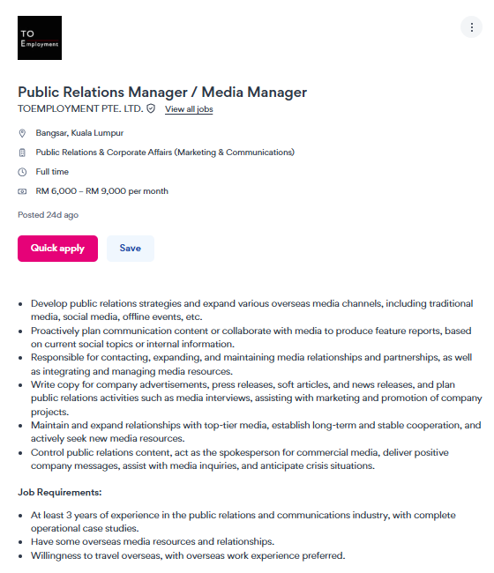

Appendix 2: Marketing Communications Manager post of PLENITUDE IPOH SDN. BHD.
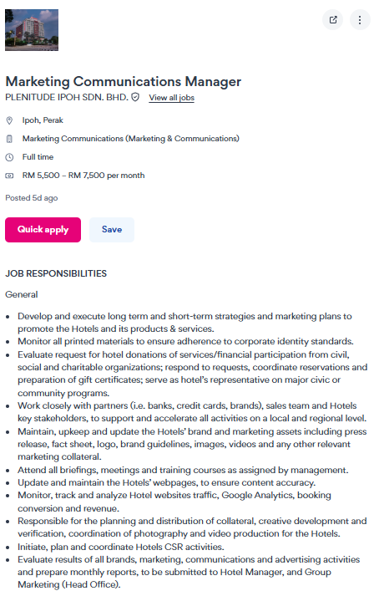

PART 2: REFLECTIVE ESSAY ON SKILL DEVELOPMENT

1. Introduction
The opportunity to study abroad helps to connect with the different cultures in cross-boundary areas as well as being able to learn within an advanced academic environment which has a preferable environment to provide learning in selective areas. My primary motive to study abroad is related to career growth. In 2024 approximately 562,403 study visas were issued in the UK showcasing a high number of student arrivals to study in England (Clark, 2025). I have also started my study abroad in the UK due to the high educational facilities following my compassion and dreams to study in a well-established UK University. I have joined the University of Wales Trinity Saint David in Swansea, UK. In the University I have been involved in diverse activities including dragon den activity, join weekend events as well as take part in out of the University events especially Eid Mubarak event with Malaysian association Swansea university students.
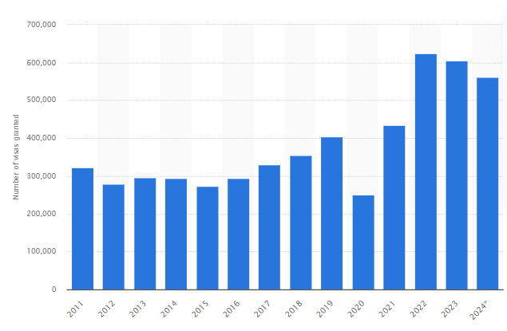
Figure 1: Number of Student Visa issues in the UK over the years
(Source: Clark, 2025)

2. Expectations vs Reality
The expectation and reality of mine to study abroad in the UK mostly contrasts in few areas which are related to climate and weather, culture, food and mostly the teaching style. Before starting study at the University of Wales Trinity Saint David I had expected barriers to communicate with teachers and cope with their teaching process due to high cultural differences. However, in reality, I have experienced an amusing teaching process that mostly focuses on inclusion, empathy, and interaction with the pupils. In addition, I have expected more wintery weather where I could experience snow. Although, I have witnessed clear and bright weather in the UK. In addition, my worries regarding cultural differences and food habits have proven wrong and I have experienced a rich English culture and appreciable food in the UK. It helps me to enhance my comfort and learning comfort while studying abroad at the University of Wales Trinity Saint David.

3. Academic Learning
The academic system in the UK significantly differs from the academic process in Malaysia. As per my personal experience in the UK, a student gets more innovative assessment and coursework which are developed through evidence-based practices that are mostly helpful for the learning growth of a student. As mentioned by O’Dea et al. (2024), peer assessment evaluation, and application of digital technology in a course with a user-friendly interface help to enhance the learning growth of a student. In a few sections of my academic learning, I have faced critical challenges to understand, especially in Contract Law. However, it became easier for me once I got the subject effectively. The enhanced assessment and coursework at the UK University supports me in developing efficiency in critical thinking, group work, research, and communication skills.

4. Personal Growth
The enhanced critical thinking, teamwork, collaboration, and communication skills developed through my academic learning help me to foster my personal growth. I have good experience living independently in Malaysia. That practice provides key support for me to adjust my living independently as well as in the UK. Most importantly I have been able to develop effective English communication skills through studying abroad at the University of Wales Trinity Saint David. I have effectively maintained self-management and life discipline while studying abroad which enhances my personal growth opportunity. However, a few times I have felt homesickness. I focus on my own goal to study abroad to enhance my career and support my family. It helps me to cope with my homesickness and foster my personal growth.

5. Cultural Experience
My decision to study abroad in the UK mostly assists in developing a cross-cultural orientation. An optimistic effort of the students with reflective practice provides key assistance in improving intercultural competence (Tarchi and Surian, 2022). I have been involved in making international friends, taking part in social gatherings, conducting events and activities for Malaysian associations of Swansea university. It mostly supports me to improve my cross-cultural competency. It signifies that my decision to study abroad makes a significant impact towards improving my ability to cope with cross-cultural situations. I have visited many places in the UK to witness the scenic, cultural beauty of those places and to be aware of the heritage of the UK. A few places I have visited are respectively London, Mount Titlis, Paris, Switzerland and Italy, Scotland, and Ireland. It helps to enhance my cultural experience. As mentioned by Sintawati and Shadiev (2025), an optimistic practice to respect different cultures helps to improve cultural understanding as well as supports increased adaptability to a changing situation. I have been able to connect with many cross-cultural people during my study in the UK, which increased my respect towards different cultures. This practice enhances my cross-cultural understanding and ability to cope with change management situations efficiently. It mostly helps to mitigate future career barriers associated with cultural differences and diverse situations.

6. Challenges Faced
I have also faced a few major challenges that affect my learning growth and comfort while studying abroad. The temperature difference between the UK and Malaysia was the most critical challenge for me in the initial days. 86% of people in the UK prefer to eat meat daily (Buchholz, 2023). Following the food preferences of the majority in the UK, it is difficult to find vegan-based food. However, as a vegan, I have faced challenges in managing food in the UK. In addition, the language barriers have also brought critical challenges for me to spend my studentship in the UK. However, I have enhanced my English communication skills further and that helps to mitigate the language barrier. I buy my foods from Asian markets that support the challenge regarding the availability of vegan-based food.
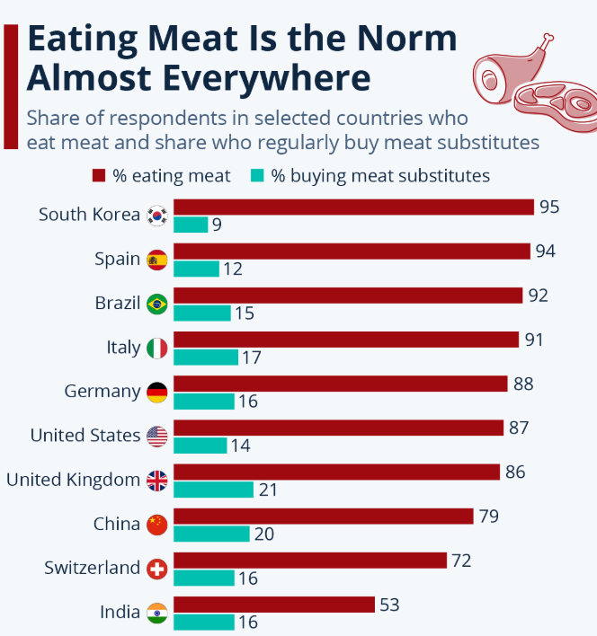
Figure 2: Practice of eating meat products
(Source: Buchholz, 2023)

7. Conclusion
As per the reflection, I have gained a positive experience while studying abroad. I have developed effective English communication skills, cross-cultural collaboration skills, effective assessment, and coursework. The weather difference and food habits bring challenges to managing my studies in the UK. In conclusion, the overall experience I have achieved through studying at the University of Wales Trinity Saint David in Swansea helps me improve my skills and career growth.

References
Buchholz, K., (2023), Eating Meat Is the Norm Almost Everywhere Available at: https://www.statista.com/chart/24899/meat-consumption-by-country/ [Accessed on 24.03.2025]
Clark, D., (2025), Number of study visas granted in the UK 2011-2024 Available at: https://my.jobstreet.com/hotel-marketing-manager-jobs?jobId=83234307&type=standard. [Accessed on 24.03.2025]
O’Dea, X., Tsz Kit Ng, D., O’Dea, M. and Shkuratskyy, V., (2024). Factors affecting university students’ generative AI literacy: Evidence and evaluation in the UK and Hong Kong contexts. Policy Futures in Education, p.14782103241287401.
Sintawati, W. and Shadiev, R., (2025). Promoting UAV autonomous aerial video to improve cross-cultural understanding, historical knowledge, and students’ perception. Interactive Learning Environments, 33(1), pp.132-153.
Tarchi, C. and Surian, A., (2022). Promoting intercultural competence in study abroad students. European Journal of Psychology of Education, pp.1-18.

