
University of Wales Trinity Saint David
CASE QT-AI-2025
Task 1: Research Report & Task 2: Digital Forensic Investigation Report
Corporate IP Theft — Quantum Tech AI Chip Design Patent
Student Name | Mohammadsadab Mohammadyunus Kureshi
Student Number | 2530072
Module | ACCA7031 Digital Forensics Analysis
Programme | MSc Cybersecurity & Digital Forensics
Institution | University of Wales Trinity Saint David

Table of Contents
TASK 1 5
1. Introduction 5
2. Current State of Digital Forensics 5
3. Digital Forensic Tools: Features and Capabilities 6
4. Intersection of Digital Forensics and Cybersecurity 6
5. Emerging Trends in Digital Forensics 6
6. Key Challenges 7
7. National Job Market 7
8. International Job Market 7
9. Conclusion 7
References 8
TASK 2 9
1. Case Background and Summary 9
2. Investigation Scope and Objectives 9
3. Evidence Inventory 9
4. Evidence Integrity and Chain of Custody 10
5. Evidence Acquisition and Hash Verification 10
6. Communication Analysis 13
7. Chronological Timeline 15
8. Call Log and Email Correlation 15
9. File and Metadata Analysis 16
10. Suspect Analysis 17
11. Critical Evaluation of Findings 18
12. Evidence Limitations 19
13. Conclusion 19
14. Recommendations 20
References 20

List of Figures
Figure 1. Order of volatility (RFC 3227) — most volatile to least volatile evidence sources 5
Figure 2. UK forensic science regulatory timeline — FSR Act 2021 to ISO/IEC 17025 7
Figure 3. Combined multi-device extraction summary, all four exhibits hash-verified 10
Figure 4. EX-01 (Huawei POT-LX1 P Smart) extraction summary and hash panel 11
Figure 5. EX-02 (Nokia C2 2nd Edition) extraction summary and hash panel 11
Figure 6. EX-03 (Samsung Galaxy A13) extraction summary and hash panel 12
Figure 7. EX-04 (Ulefone “Note 14”) extraction summary and hash panel 12
Figure 8. EX-05 case-details form (practical exercise) 12
Figure 9. EX-05 own-device properties (practical exercise) 13
Figure 10. EX-05 extraction summary (practical exercise) 13
Figure 11. EX-01 WhatsApp: opening proposal, 21 Aug 2024 14
Figure 12. EX-01 WhatsApp: demo/breakdown discussion, 31 Jan 2025 14
Figure 13. EX-01 WhatsApp: continuation of thread, 31 Jan 2025 15
Figure 14. EX-01 native call log (15 entries) 16
Figure 15. EX-01 Gmail review (71 items) 16
Figure 16. EX-02 geotagged photograph, South Wales 17
Figure 17. EX-03 route screenshot with camera metadata 17
Figure 18. EX-01 Contacts: “Joe Marsh” 18
Figure 19. EX-03 About Phone screen 18
Figure 20. EX-03 anomalous 2005-dated location cluster 19
Figure 21. EX-03 installed-application review 19

List of Tables
Table 1. Digital forensic tools comparison 6
Table 2. Case information 9
Table 3. Evidence inventory 9
Table 4. Android ID and IMEI by exhibit 10
Table 5. SHA-256 hash verification by exhibit 11
Table 6. Chronological timeline 15

TASK 1
Strategic Evolution and Operational Realities of Digital Forensics

1. Introduction
Digital forensics (DF) has evolved from a post-mortem, disk-centric investigative process into a foundational pillar of organisational resilience and legal accountability [1]. Sitting at the intersection of computer science and law, DF encompasses the identification, preservation, collection, examination and reporting of digital evidence [2]. As intrusion techniques grow more sophisticated, static, after-the-fact analysis alone is no longer sufficient; DF is now central not only to criminal prosecution but to civil litigation, regulatory compliance and active cyber defence [3]. This report critically evaluates the current forensic landscape: tool capability, integration with cybersecurity, emerging trends, operational challenges and job-market dynamics.

2. Current State of Digital Forensics
The contemporary DF environment is defined by a rapid shift from static hardware to dynamic, virtualised and distributed infrastructure [1]. The proliferation of cloud computing, IoT devices and ephemeral data fundamentally challenges traditional "pull-the-plug" acquisition [4]. In practice this compels investigators to prioritise live analysis and volatile memory (RAM) forensics, capturing cryptographic keys, active connections and unencrypted artefacts before shutdown erases them [5]. Adhering to the Order of Volatility (RFC 3227) is critical: evidence should be collected broadly in the sequence shown in Figure 1, moving from CPU registers through memory to disk and finally to stable, off-host records; failing to follow this order often causes irretrievable loss of context. The discipline is therefore defined by tension between an escalating volume of heterogeneous data and the need for rapid, forensically sound triage [3].
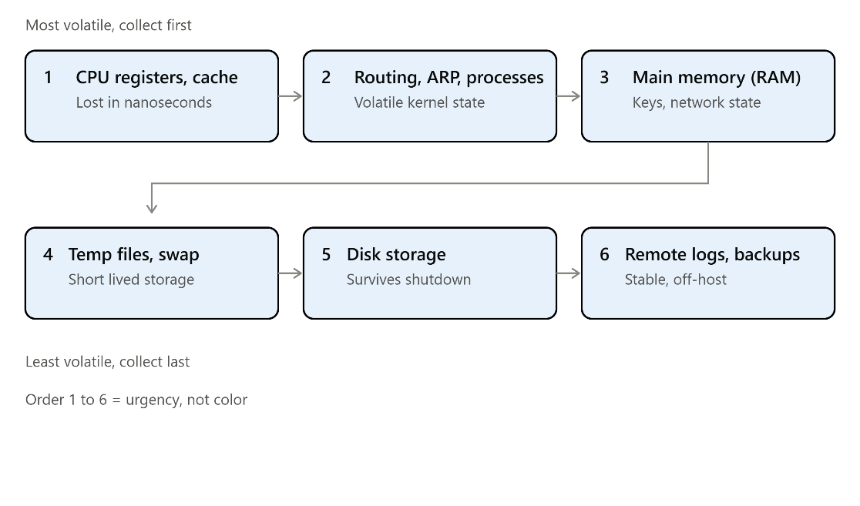
Figure 1. Order of volatility (RFC 3227) — most volatile to least volatile evidence [5].

3. Digital Forensic Tools: Features and Capabilities
Investigation quality depends heavily on tool selection; no single platform offers universal coverage, so practitioners must weigh analytical depth, platform support and court admissibility [6]. Table 1 compares three widely used tools. Commercial suites such as EnCase excel at strict evidential verification and enterprise scale, while open-source platforms such as Autopsy match them for general-purpose disk analysis at far lower cost [7]. For specialised workloads such as mobile extraction, device-oriented tools like Cellebrite UFED are close to essential [6]. The practical implication is that investigators must maintain a diversified, interoperable toolkit: relying on a single vendor limits operational capability and risks evidence being overlooked [7].
Tool | Core strengths | Key limitations | Primary use
EnCase Forensic | Court-grade reporting, robust hashing, deep acquisition, strict custody controls | Premium pricing, steep learning curve, heavy hardware needs | Enterprise/law-enforcement investigations requiring defensible workflows
Autopsy | Open-source, multi-user via PostgreSQL, extensible modules | No native physical mobile extraction; GUI can be sluggish on older hardware | Rapid disk triage, academic instruction, budget-conscious IR teams
Cellebrite UFED | Advanced mobile physical/logical extraction, encrypted backup handling, app-level parsing | High licensing cost; mobile/IoT-focused, needs pairing with other tools | Mobile forensics, law enforcement, complex communications decoding
Table 1. Digital forensic tools comparison. Source: Author-created based on [6], [7].

4. Intersection of Digital Forensics and Cybersecurity
The convergence of these domains has produced Digital Forensics and Incident Response (DFIR), bridging proactive defence and reactive investigation [8]. While conventional cybersecurity focuses on monitoring and prevention, DF supplies the rigorous post-incident analysis needed to understand a breach [1]. Integrating DF into the security lifecycle enables root-cause analysis, tracing initial access, lateral movement and exfiltration [1]. DFIR workflows can reduce adversary dwell time by surfacing dormant malware or persistence mechanisms that SIEM tooling alone misses [9]. Practically, evidence-backed containment reduces breach cost and secures the provenance needed for regulatory reporting [1].

5. Emerging Trends in Digital Forensics
The integration of AI and machine learning is arguably the most disruptive current trend, used for automated threat recognition, OSINT triage and parsing large unstructured datasets [10]. However, reliance on algorithmic automation introduces evidential risk: large language models can "hallucinate" with no intrinsic marker of falsehood, potentially bypassing conventional hashing validation [11]. This has driven an industry pivot toward Explainable AI (XAI), keeping automated decisions transparent and mathematically justifiable — a necessity given that black-box models sit uneasily with the burden of proof required in court [12].

6. Key Challenges
Technically, strong encryption and the volatility of cloud-hosted data continually complicate evidence acquisition [1]. Legally, practitioners in England and Wales face intensified scrutiny following the Forensic Science Regulator Act 2021; the statutory Code of Practice, in force from October 2023, requires forensic units to maintain robust quality systems and, for many activities, achieve ISO/IEC 17025 accreditation [13], [14]. Figure 2 sets out this regulatory chain. While this raises evidentiary reliability, the administrative and financial burden of maintaining accreditation risks forcing smaller providers out of the market [15].
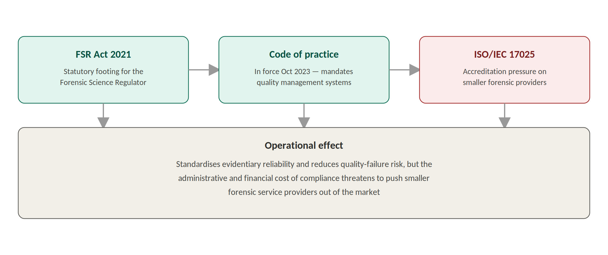
Figure 2. UK forensic science regulatory timeline — FSR Act 2021 to ISO/IEC 17025 [13], [14], [15].

7. National Job Market
The UK market is undergoing a paradoxical transformation. The UK Cyber Security Council has formalised clear pathways from Associate to Chartered status across sixteen specialisms [16]. Remuneration is competitive: entry-level roles typically command around £30,000, rising to a median of roughly £55,000 for experienced practitioners and £65,000 or more in senior posts [17]. Despite a growing overall cyber workforce, core cyber security job postings fell by around 33% in 2024 versus 2023 [18], yet nearly 30% of businesses still report critical skills gaps in incident response and forensics [18] — vacancy volumes are contracting even as demand for genuinely competent DFIR specialists stays acute.

8. International Job Market
Comprehensive global comparison data is Not Available in the Supplied Material. Isolated industry metrics suggest a contraction in private-sector demand internationally, with some surveys reporting forensic salaries falling by around 3.55% [19], attributed to corporations investing in proactive, in-house incident response rather than reactive third-party consultancy.

9. Conclusion
Digital forensics has become an indispensable, increasingly regulated function for both criminal justice and enterprise resilience. Powerful tooling and AI-driven analytics grant unprecedented processing capability, yet their practical value remains subordinate to evidential integrity and legal admissibility. The FSR Act 2021 is forcing the UK sector to mature, but ISO 17025 compliance costs risk narrowing the pool of accredited providers, while the operational merger of DF with proactive cybersecurity (DFIR) reflects a necessary adaptation to threats that post-incident analysis alone is too slow to contain.

References
[1] SISA, "Digital Forensics in Cyber Security 101." [Online]. Available: https://sisa.ai/resource/cyberpedia/digital-forensics-in-cyber-security-101. [Accessed: Aug. 14, 2026].
[2] CYFOR, "What is Computer Forensics?" [Online]. Available: https://cyfor.co.uk/what-is-computer-forensics/. [Accessed: Aug. 14, 2026].
[3] SentinelOne, "What is DFIR (Digital Forensics and Incident Response)?" [Online]. Available: https://www.sentinelone.com/cybersecurity-101/services/what-is-digital-forensics-and-incident-response-dfir/. [Accessed: Aug. 14, 2026].
[4] Ekantara Journal, "Cloud and IoT Forensics for Strengthening Cybercrime Investigation." [Online]. Available: https://journal.ekantara.com/forsec/article/view/2. [Accessed: Aug. 14, 2026].
[5] Cybrary, "RAM Memory Forensic Analysis." [Online]. Available: https://www.cybrary.it/blog/ram-memory-forensic-analysis. [Accessed: Aug. 14, 2026].
[6] Gitnux, "Best Data Forensics Software: Ranked for 2026," 2026. [Online]. Available: https://gitnux.org/best/data-forensics-software/. [Accessed: Aug. 14, 2026].
[7] DevOpsSchool, "Top 10 Digital Forensics Tools: Features, Pros, Cons & Comparison." [Online]. Available: https://www.devopsschool.com/blog/top-10-digital-forensics-tools-features-pros-cons-comparison/. [Accessed: Aug. 14, 2026].
[8] Splunk, "What Is DFIR? Digital Forensics & Incident Response." [Online]. Available: https://www.splunk.com/en_us/blog/learn/digital-forensics-incident-response-dfir.html. [Accessed: Aug. 14, 2026].
[9] Group-IB, "What is Digital Forensics and Incident Response (DFIR)?" [Online]. Available: https://www.group-ib.com/resources/knowledge-hub/dfir/. [Accessed: Aug. 14, 2026].
[10] NAVS Law Journal. [Online]. Available: https://elar.navs.edu.ua/bitstreams/82ef8702-a825-4d44-8974-5a1d066a2f27/download. [Accessed: Aug. 14, 2026].
[11] "AI Hallucination Forensics and Legal Admissibility Framework for Generative AI Evidence: Proposing the Hallucination Evidence Reliability Assessment Model (HERAM)," ResearchGate. [Online]. Available: https://www.researchgate.net/publication/404703330_AI_Hallucination_Forensics_and_Legal_Admissibility_Framework_for_Generative_AI_Evidence_Proposing_the_Hallucination_Evidence_Reliability_Assessment_Model_HERAM. [Accessed: Aug. 14, 2026].
[12] "Leveraging AI for enhanced cybersecurity: a comprehensive review," ResearchGate. [Online]. Available: https://www.researchgate.net/publication/392311753_Leveraging_AI_for_enhanced_cybersecurity_a_comprehensive_review. [Accessed: Aug. 14, 2026].
[13] Crown Prosecution Service, "Forensic Science Regulator Act 2021 and the Forensic Science Regulator’s Code of Practice 2023," 2023. [Online]. Available: https://www.cps.gov.uk/prosecution-guidance/forensic-science-regulator-act-2021-and-forensic-science-regulators-code. [Accessed: Aug. 14, 2026].
[14] GOV.UK, "Forensic Science Regulator: Code of Practice (accessible)," 2023. [Online]. Available: https://www.gov.uk/government/publications/statutory-code-of-practice-for-forensic-science-activities/forensic-science-regulator-code-of-practice-accessible. [Accessed: Aug. 14, 2026].
[15] SYTECH Consultants, "Enhancing Trust in Digital Evidence: The Role of Forensic Science Regulator’s Code and ISO 17025." [Online]. Available: https://sytech-consultants.com/enhancing-trust-in-digital-evidence-the-role-of-forensic-science-regulators-code-and-iso-17025-2/. [Accessed: Aug. 14, 2026].
[16] SFIA, "UKCSC specialisms mapped to SFIA and CyBOK." [Online]. Available: https://sfia-online.org/en/tools-and-resources/standard-industry-skills-profiles/ukcsc-and-cybok/ukcsc-specialisms-mapped-sfia-cybok. [Accessed: Aug. 14, 2026].
[17] National Careers Service, "Forensic computer analyst." [Online]. Available: https://nationalcareers.service.gov.uk/job-profiles/forensic-computer-analyst. [Accessed: Aug. 14, 2026].
[18] Department for Science, Innovation and Technology, "Cyber security skills in the UK labour market 2025," GOV.UK, 2025. [Online]. Available: https://www.gov.uk/government/publications/cyber-security-skills-in-the-uk-labour-market-2025/cyber-security-skills-in-the-uk-labour-market-2025. [Accessed: Aug. 14, 2026].
[19] Cybershark Recruitment, "UK Cyber Security Salary Survey 2025," 2025. [Online]. Available: https://cybersharkrecruitment.squarespace.com/s/Cybershark-Recruitments-UK-Cyber-Security-Salary-Survey-2025.pdf. [Accessed: Aug. 14, 2026].
TASK 2
Digital Forensic Investigation Report

1. Case Background and Summary
Quantum Tech's IT security team detected unauthorised access to its proprietary patent database, specifically records relating to the AI chip design patent QT-AI-2025. Emma, a recently joined senior engineer, was identified as the primary suspect, believed to have attempted to sell the design to competitor NexGen Circuits through an intermediary referred to as Joe. Norman and NexGen's R&D Director, Vanessa, were identified as suspected buyer-side parties. The matter was formally reported to law enforcement, and four Android devices were seized under continuity-of-evidence protocols for forensic examination.
Evidence recovered from EX-01 (Huawei POT-LX1 P Smart) supports the proposition that its user negotiated by WhatsApp, from 21 August 2024 to 31 January 2025, to sell technical information described as relating to an AI-based product, and that a payment arrangement was discussed, corroborated internally by an unanswered-call pattern preceding the first written contact. However, close examination of the underlying screenshots — not just the summary captions — shows three identity-attribution claims in the source material are unsupported: the EX-03 SIM-registration match to EX-01 was claimed but not evidenced, the “WIG → MCZ” route reference lacks any context establishing its relevance, and the EX-03 “About Phone” number does not match the “Joe Marsh” contact saved on EX-01 (see Sections 6, 9, 10 and 11; classified UNRESOLVED). Confidence that a Quantum Tech-related negotiation occurred is MODERATE-TO-HIGH; confidence in the specific identification of the buyer-side parties is LOW on the evidence supplied.
Field | Detail
Case reference | QT-AI-2025
Organisation affected | Quantum Tech
Nature of incident | Suspected unauthorised access to a proprietary patent database and attempted sale of the AI chip design patent QT-AI-2025 to a competitor (NexGen Circuits)
Suspected parties | Emma (primary suspect); Joe (alleged intermediary); Norman (alleged buyer-side contact); Vanessa, R&D Director, NexGen Circuits (alleged buyer-side contact)
Examiner | Mohammadsadab Mohammadyunus Kureshi
Seizure date/time/location, exhibit numbering origin | UK-2026
Table 2. Case information.

2. Investigation Scope and Objectives
- Forensic acquisition and hash verification of four seized Android devices (EX-01–EX-04), plus a separate own-device acquisition (EX-05) as a required practical skills exercise.
- Communication analysis of artefacts actually recovered (WhatsApp on EX-01; email on EX-01).
- Call log correlation across exhibits.
- File and metadata analysis of photographic material recovered from EX-02 and EX-03.
- Suspect profiling for Emma, Joe and Norman, and Vanessa where evidenced.

3. Evidence Inventory
Exhibit | Device | Attributed role | Extraction type | Extraction window
EX-01 | Huawei POT-LX1 P Smart | Emma – alleged perpetrator | File System / Android ADB | 28/10/2025 16:12:56–16:53:34
EX-02 | Nokia C2 (2nd Edition) | Norman – alleged buyer | Android Backup | 28/10/2025 16:01:06–16:03:26
EX-03 | Samsung Galaxy A13 (SM-A137F) | Joe – alleged intermediary | Android Backup | 28/10/2025 11:57:02–12:36:47
EX-04 | Ulefone “Note 14” | Peripheral / unattributed | Android Backup | 28/10/2025 11:25:18–11:27:40
EX-05 | Examiner's own device (CPH2213) | Practical exercise – excluded from case findings | Cellebrite UFED | Not timestamped in the supplied evidence
Table 3. Evidence inventory.
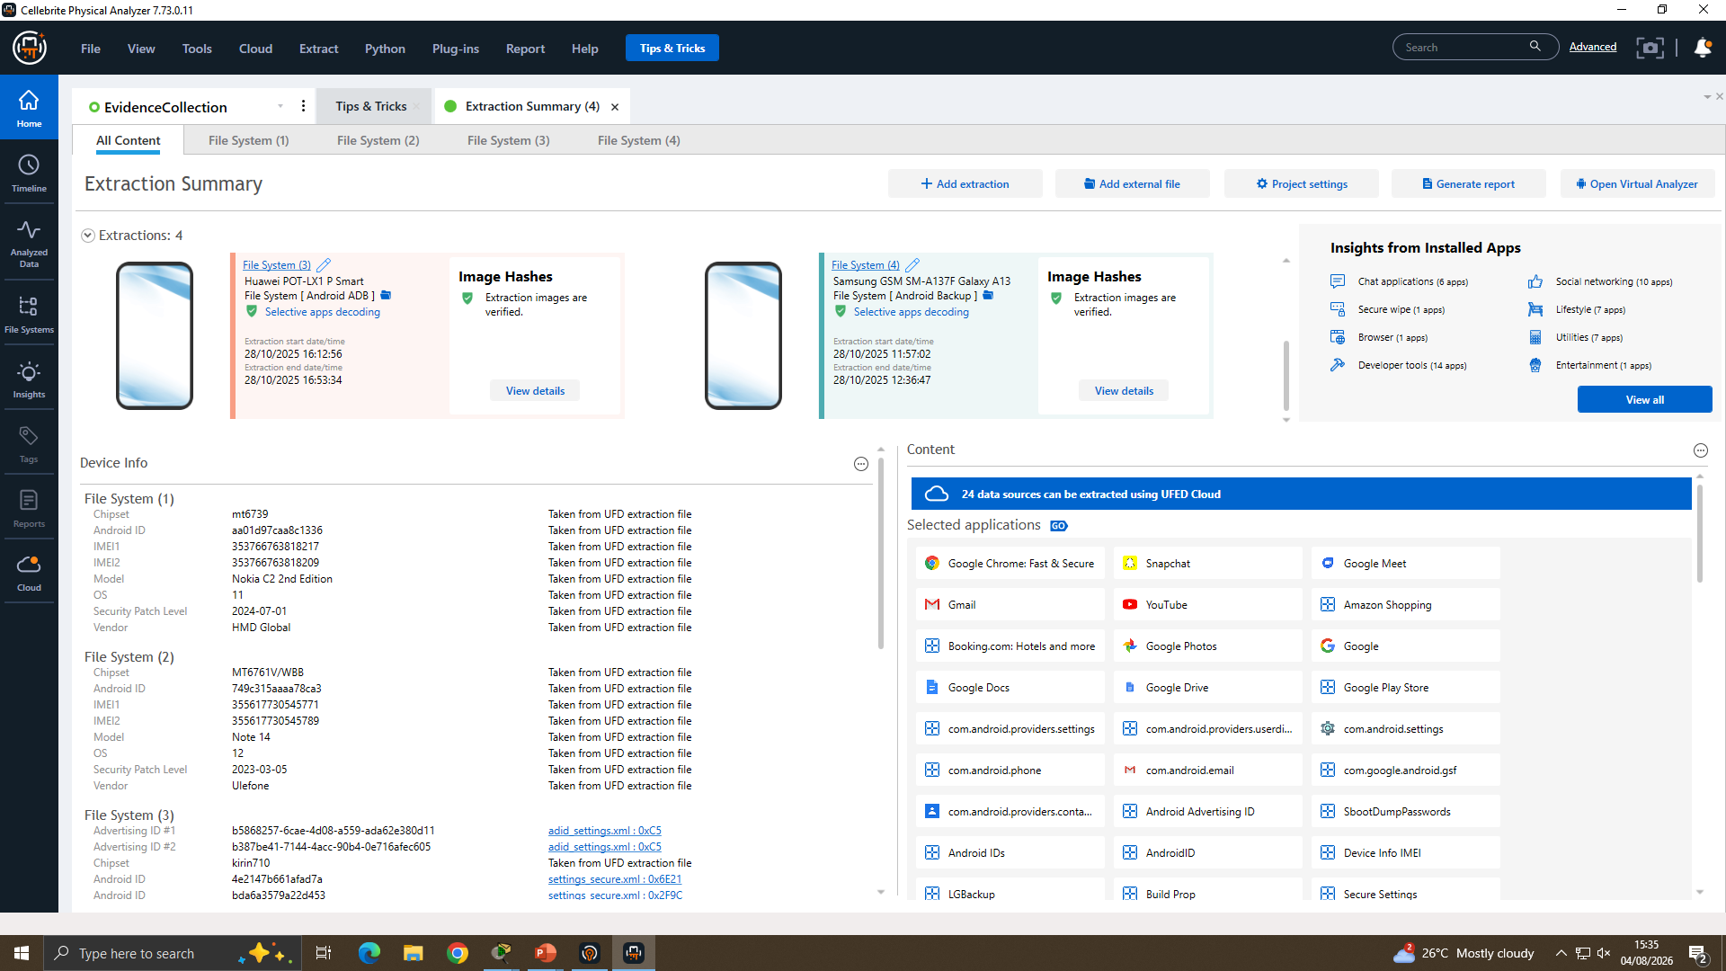
Figure 3. Combined multi-device extraction summary, all four case exhibits hash verified.

4. Evidence Integrity and Chain of Custody
Each exhibit's Android ID, IMEI and extraction timestamp was recorded directly from the Cellebrite Device Info panel at the point of acquisition, providing an audit trail from that point onward (OBSERVED).
Exhibit | Android ID | IMEI 1 / IMEI 2
EX-01 | 4e2147b661afad7a / bda6a3579a22d453 | Not shown in supplied Device Info panel
EX-02 | aa01d97caa8c1336 | 353766763818217 / 353766763818209
EX-03 | f50a68ff1f9da28 | 357898921470825 / 357712351470827
EX-04 | 749c315aaaa78ca3 | 355617730545771 / 355617730545789
Table 4. Android ID and IMEI by exhibit.

5. Evidence Acquisition and Hash Verification
Acquisition of the four case exhibits was performed using Cellebrite Physical Analyzer v7.73.0.11 [20] (File System / Android ADB and Android Backup extractions). Every exhibit image was SHA-256 hash-verified immediately after acquisition, with a “Verified” status shown on-screen for each (OBSERVED). Analysis of the recovered artefacts was carried out within Physical Analyzer's Contacts, Call Log, Chat, Emails, Device Locations/media metadata and Installed Applications panels, cross-referenced across exhibits; no other forensic tool (e.g. Autopsy, FTK, XRY) is evidenced in the supplied material.
Exhibit | Hash type / source | SHA-256 value
EX-01 | File Dump | d5193dbf8246c09fdde73be8558343985ab24a2e1c142e4d64e16e2b6507e31f
EX-02 | Backup | a693656c260e339069756be8005346e97033d0ccf2f79add56cd69c9eade13ab
EX-03 | Backup | 0e585c4fe8160254253be515a16ff94b7fdf88b248b67d45cfdef8753a9a3195
EX-04 | File Dump | 630724e2f8863adb9c4f7df1ab645e56c19a832d546fe7ab55b0cebf8ea7befd
Table 5. SHA-256 hash verification by exhibit.
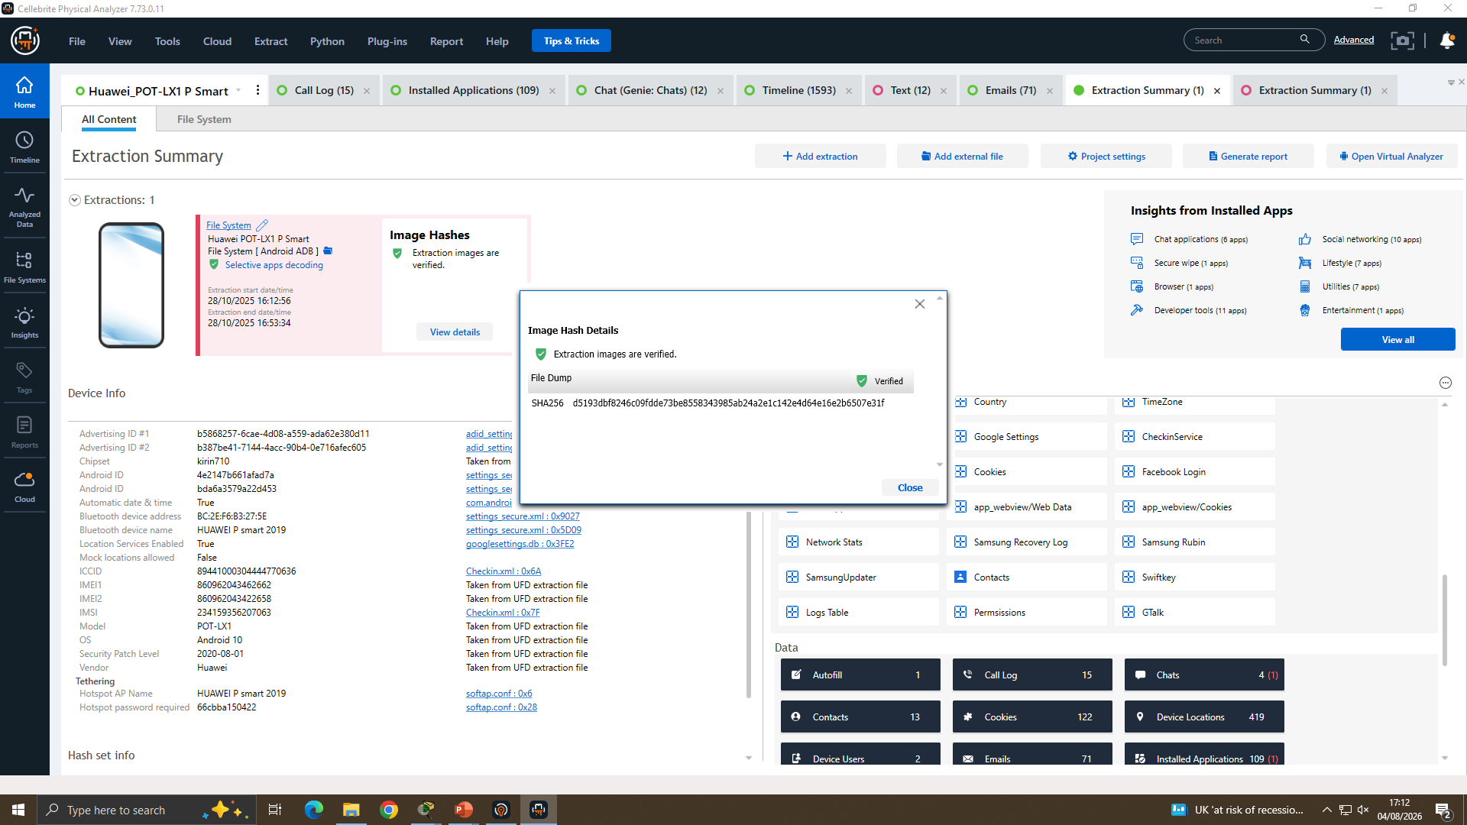
Figure 4. EX-01 (Huawei POT-LX1 P Smart) extraction summary and Image Hash Details panel.
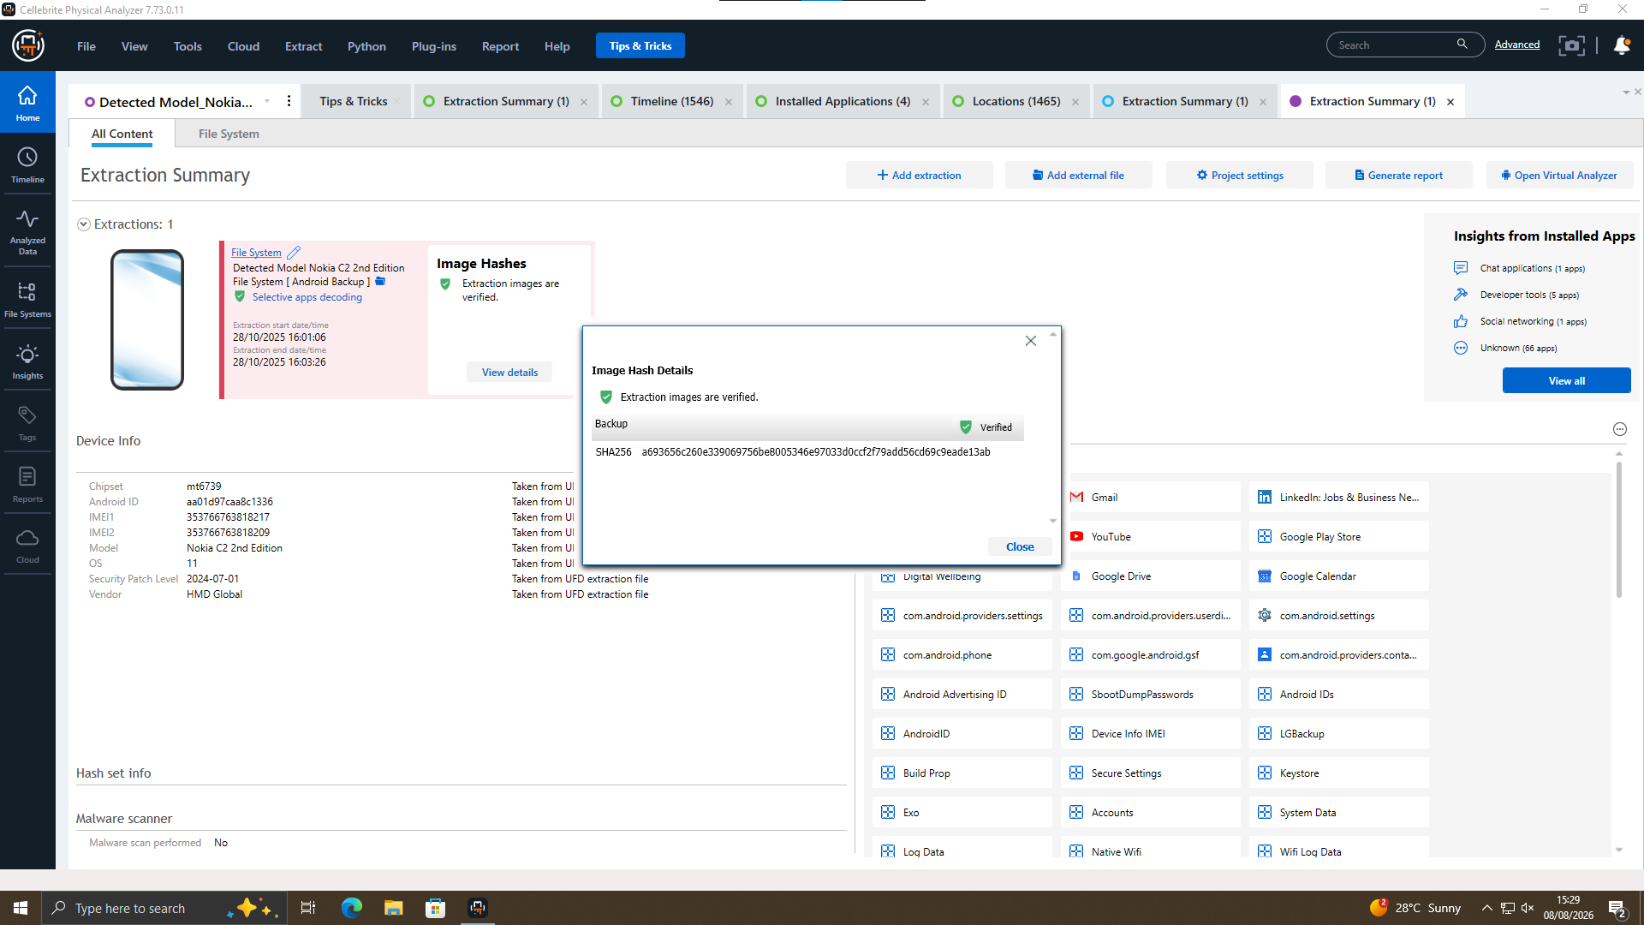
Figure 5. EX-02 (Nokia C2 2nd Edition) extraction summary and Image Hash Details panel.
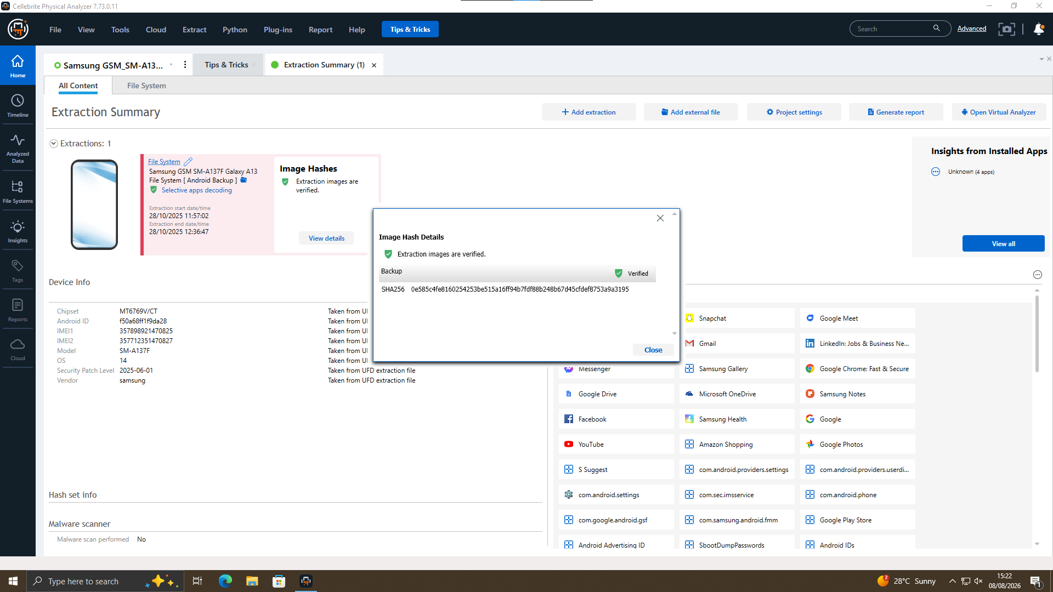
Figure 6. EX-03 (Samsung Galaxy A13) extraction summary and Image Hash Details panel.
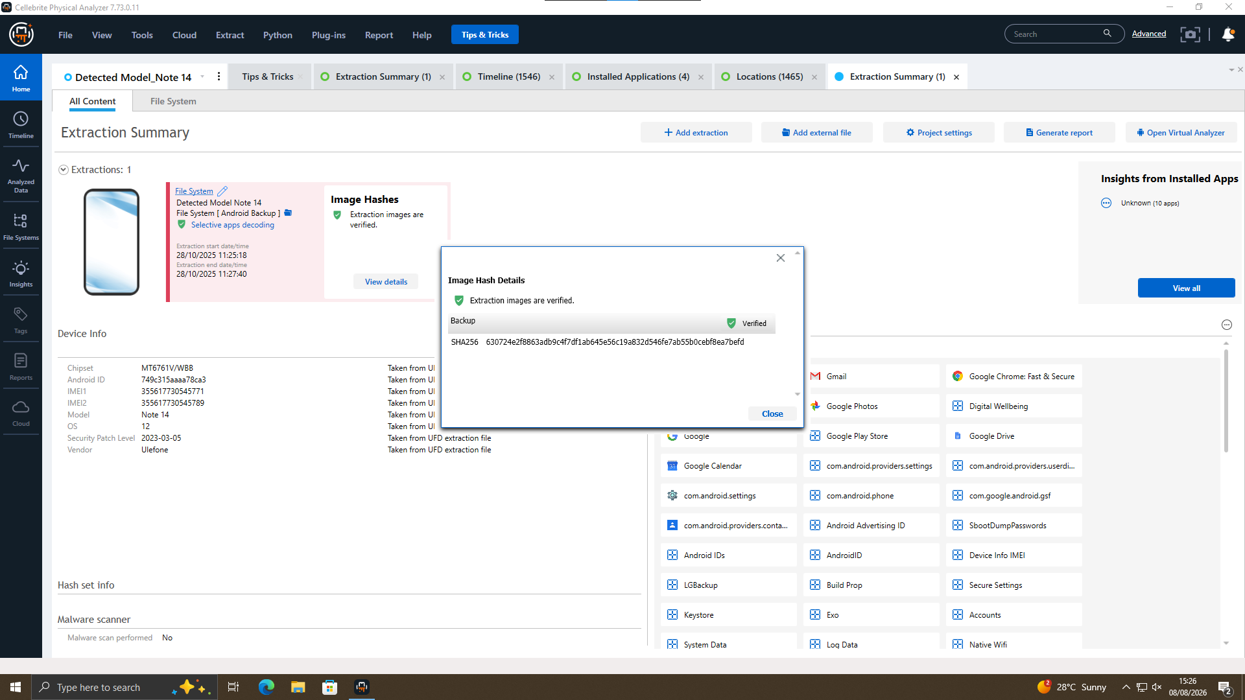
Figure 7. EX-04 (Ulefone “Note 14”) extraction summary and Image Hash Details panel.

Own-device acquisition (EX-05) — practical exercise
A separate own-device acquisition (EX-05) was performed using Cellebrite UFED [21] as a practical skills exercise, kept entirely apart from case evidence and excluded from case findings. No hash value was available for this exhibit.
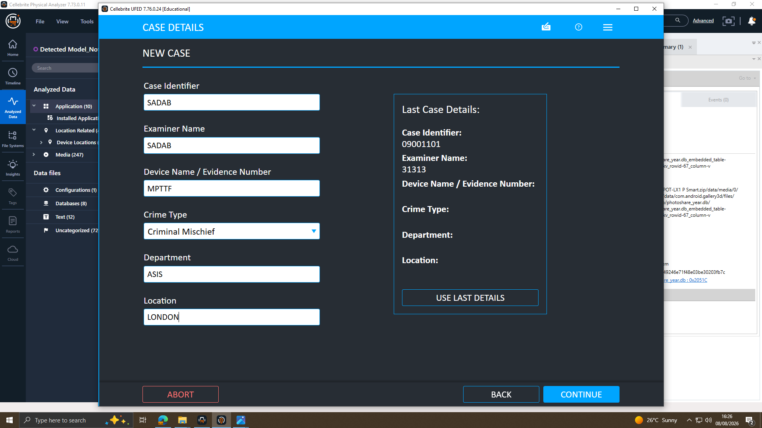
Figure 8. EX-05 case-details form: examiner and evidence identifiers entered before acquisition — practical exercise, separate from case evidence.
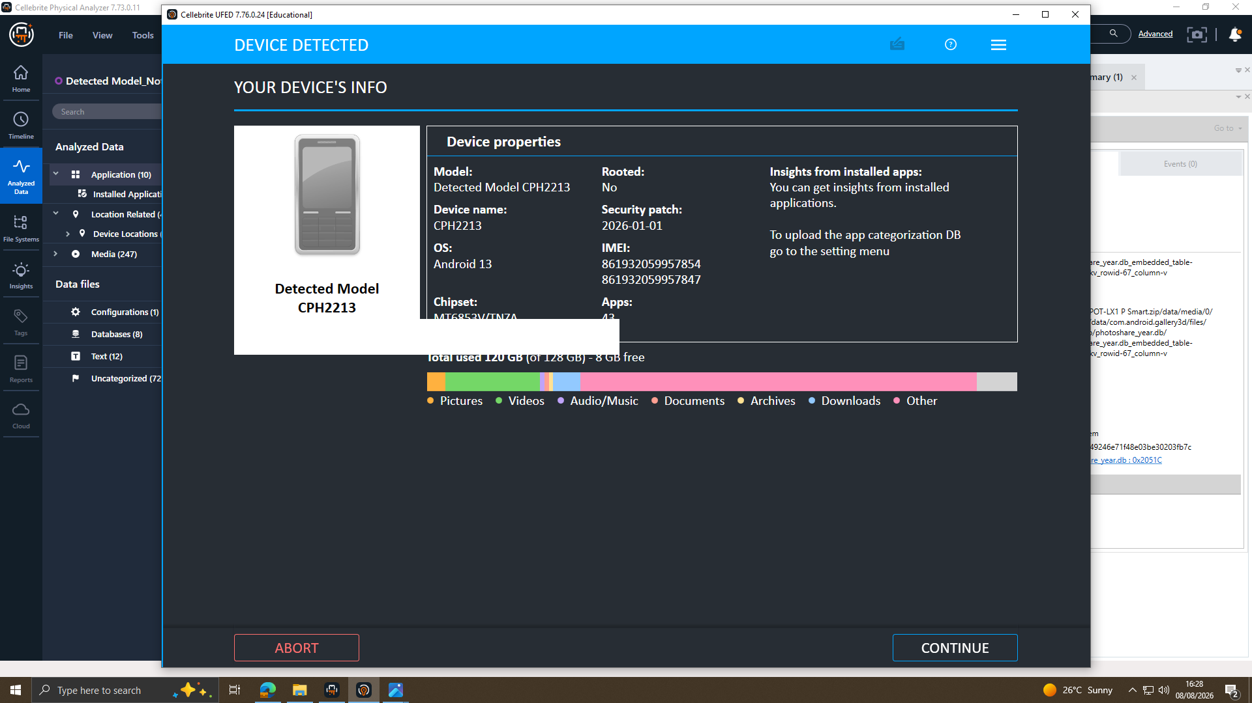
Figure 9. EX-05 own-device properties confirmed (model, OS, IMEI, chipset) — practical exercise, separate from case evidence.
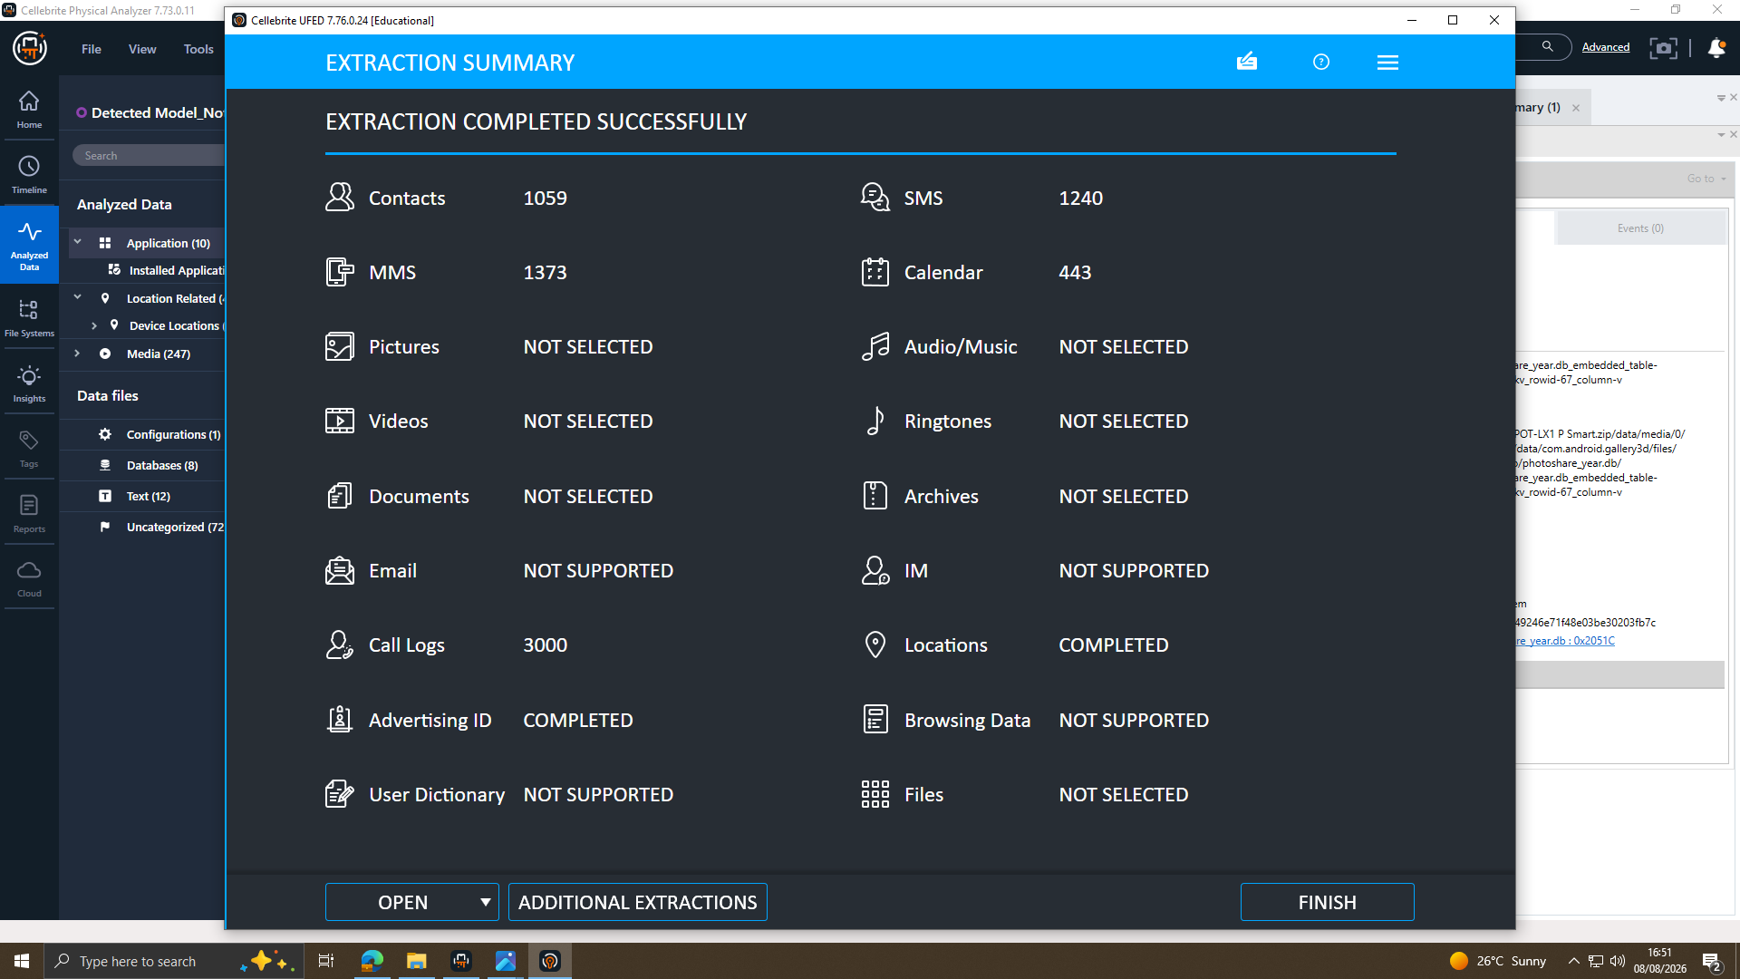
Figure 10. EX-05 extraction summary — practical exercise, separate from case evidence.

6. Communication Analysis
The only communication content supplied for analysis is a WhatsApp conversation recovered from EX-01, between the device user and a contact saved under the non-descriptive name “Top-up”, number 447917162788. No Facebook, Instagram, or SMS/MMS message content was supplied.
21 Aug 2024, 09:58:21 (UTC+0) — EX-01 outgoing: sender states access to “highly valuable information” from “ABC technologies” relating to a “new AI based Neuro product” and raises selling it. OBSERVED opening of a sale proposal.
21 Aug 2024, 10:06–10:10 — EX-01: counterparty addresses the sender as “Emma”; reply states “Not exactly Joe, but I trust you can find the right buyer.” OBSERVED naming of “Emma” and “Joe” within the chat. Limitation: this shows the names were used in conversation, not that the account holders of EX-01/EX-03 are those individuals — see Section 11.
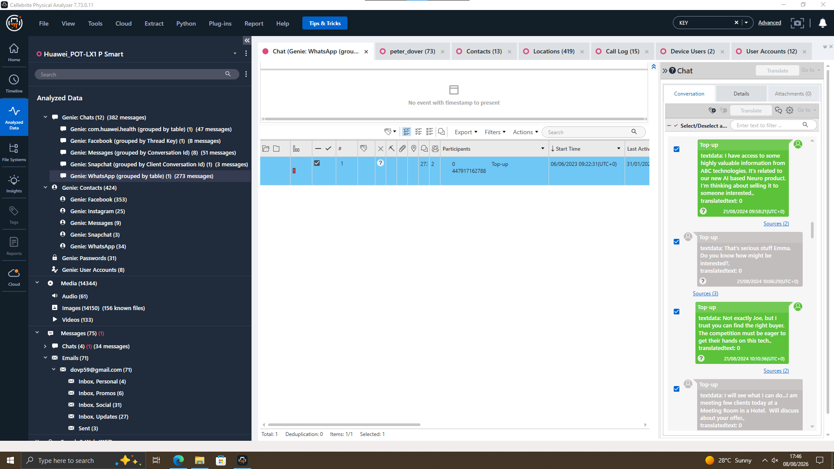
Figure 11. EX-01 WhatsApp: opening proposal, 21 Aug 2024, 09:58–10:10 (UTC+0).
31 Jan 2025, 10:18–10:24 — EX-01: counterparty states “No, he's serious. Wants a demo sample. Can we do that?”; reply: “Impossible. But a detailed breakdown? Yes. How's the offshore arrangement?”; counterparty: “He's good with it. 5M secured. Waiting for confirmation. The rest?” OBSERVED discussion of a demo and payment figure; no financial records were supplied to confirm any payment was made — UNRESOLVED.
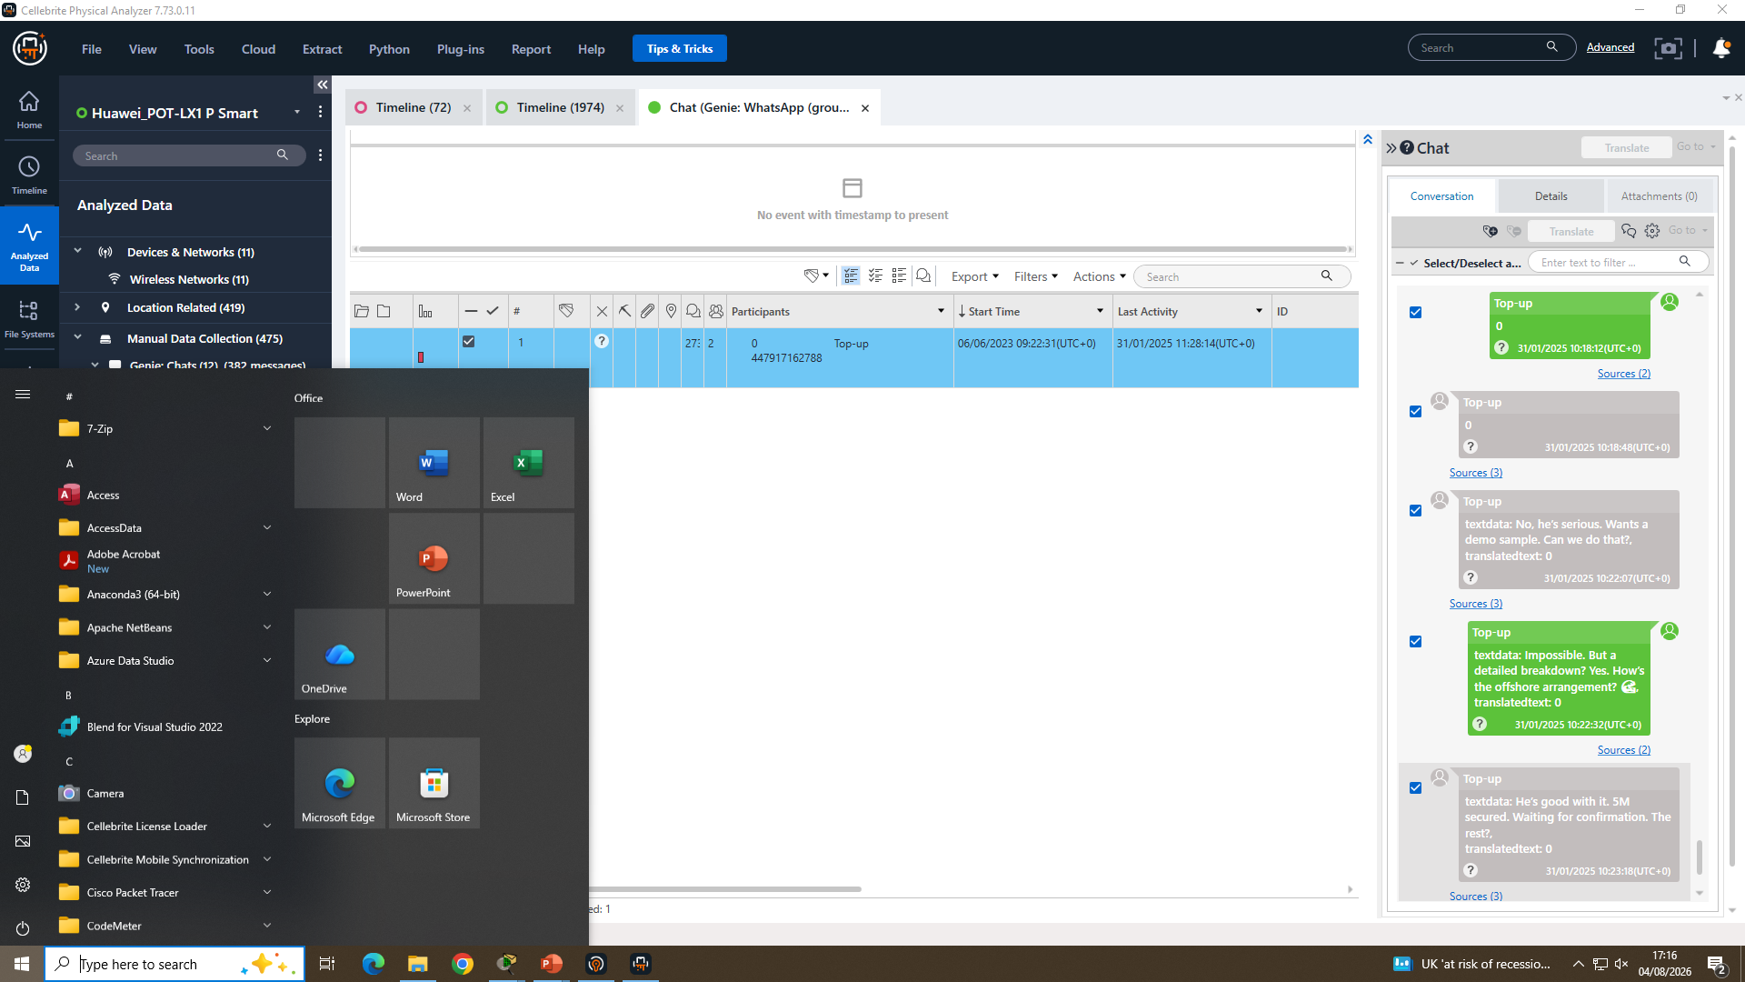
Figure 12. EX-01 WhatsApp: demo/breakdown discussion and “5M secured” statement, 31 Jan 2025, 10:18–10:24.
31 Jan 2025, 10:23–11:28 — EX-01: thread continues (“Local part stays as planned” / “It's all about patience” / “Keep me posted” / “We'll be watching”). OBSERVED continuation of the same negotiation.
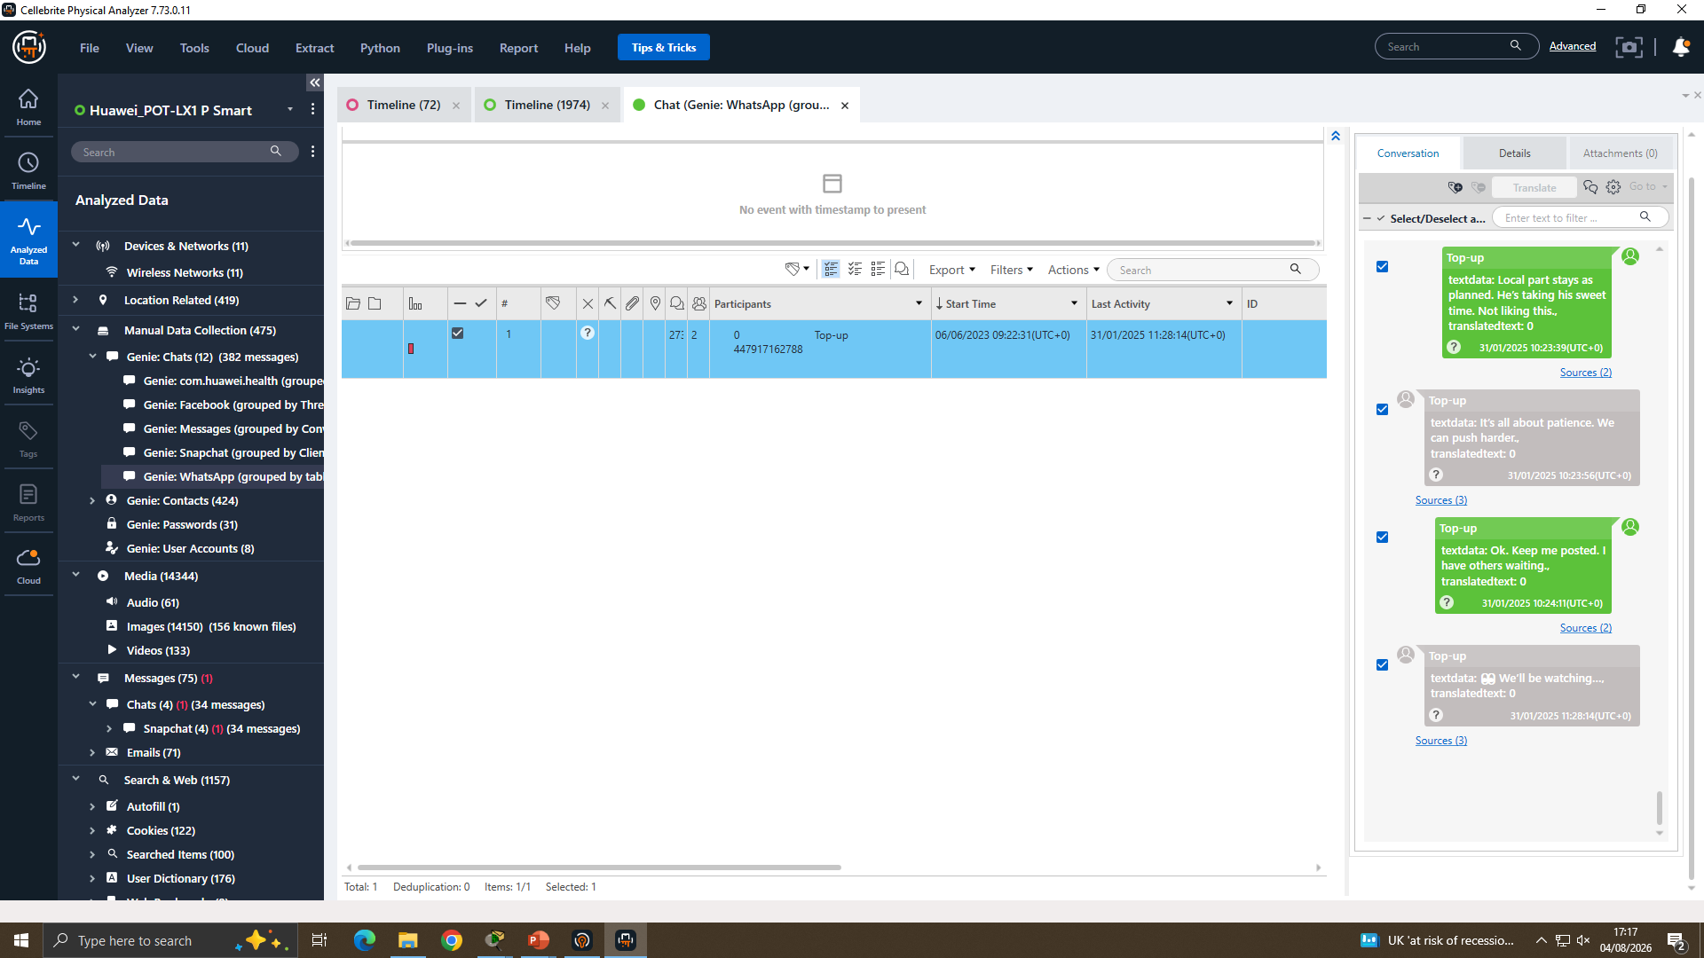
Figure 13. EX-01 WhatsApp: continuation of the thread, 31 Jan 2025, 10:23–11:28.

7. Chronological Timeline
Date/time | Source | Event | Confidence
02–19/08/2024 (multiple) | EX-01 native call log | 15 calls to/from three distinct numbers, mostly “Not answered” | OBSERVED (calls); INFERRED (recipient identity)
21/08/2024 09:58–10:10 | EX-01 WhatsApp | Sale proposal opened; counterparty addresses “Emma”, references “Joe” | OBSERVED
04/09/2024 12:38:04 | EX-02 photo EXIF | Geotagged photograph, South Wales (51.625252, –3.996134) | OBSERVED
22/11/2024 11:21:58 | EX-03 photo EXIF | Screenshot of route “WIG → MCZ” captured | OBSERVED (capture); NOT AVAILABLE (relevance)
31/01/2025 10:18–11:28 | EX-01 WhatsApp | Demo/“detailed breakdown” agreed; “5M secured” stated by counterparty | OBSERVED (content); UNRESOLVED (payment fact)
Table 6. Chronological timeline.

8. Call Log and Email Correlation
The EX-01 native call log contains 15 entries between 02/08/2024 and 19/08/2024 (not solely 17–19 August as the source summary states), to three distinct numbers: 00917907025586 (3 calls) and a number saved as “SA No.”, shown variously as 07917162891 / +447917162891 / 0447917162891 (11 calls, 10 not-answered and 1 missed inbound).
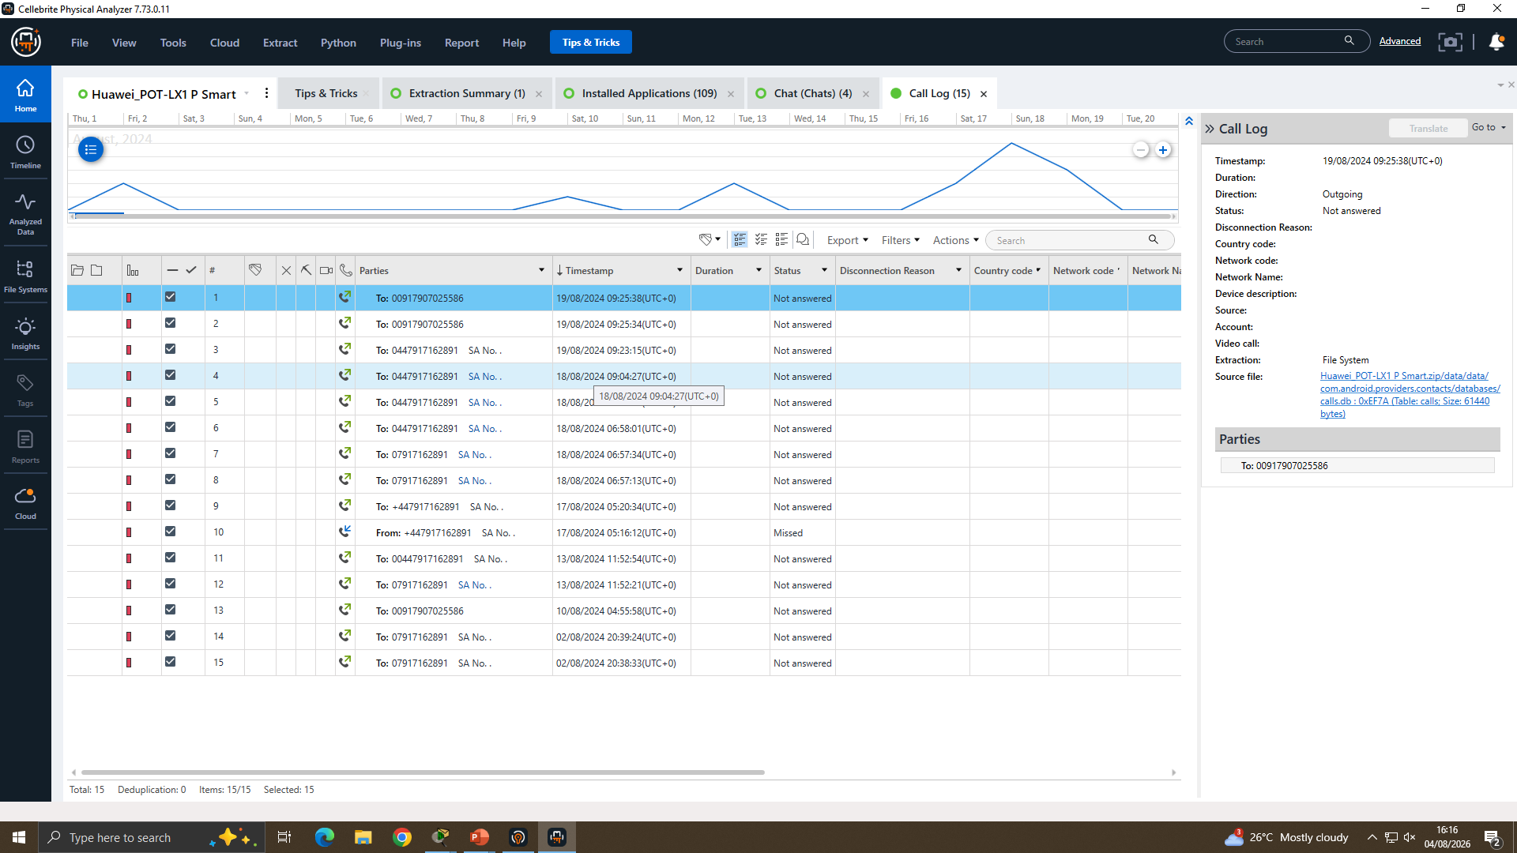
Figure 14. EX-01 native call log (15 entries, 02–19/08/2024), showing calls to “00917907025586” and “SA No.” (…162891).
Critical point: the “SA No.” number ending …162891 is not the same as the WhatsApp counterparty …162788 (Section 6) — they differ in their final three digits, and no supplied artefact (e.g. a linked-account or call-forwarding record) reconciles this. The “calls → messaging → sale” escalation is a reasonable INFERENCE from timing, and the shared “SA” save-name, but is not proven and is classified UNRESOLVED.
All 71 emails on EX-01's Gmail account (dovp59@gmail.com) were reviewed; every message was automated or promotional (SIM alerts, gaming, Instagram/retail); none referenced QT-AI-2025 (OBSERVED – confirmed absence). This supports, without proving, an inference that case-relevant communication was confined to WhatsApp; an alternative explanation is that the account was simply unused for any substantive purpose.
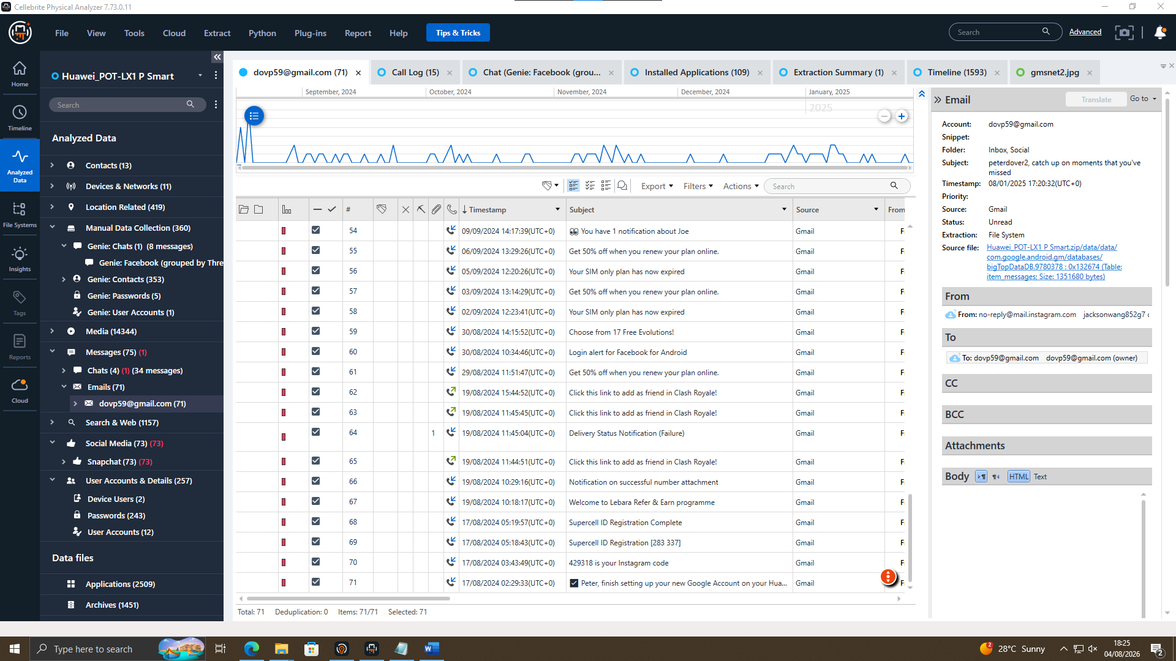
Figure 15. EX-01 Gmail account (dovp59@gmail.com), all 71 messages reviewed; contents automated/promotional only.

9. File and Metadata Analysis
EX-02: one JPEG image with EXIF GPS coordinates 51.625252, –3.996134 (South Wales, UK), captured 04/09/2024 12:38:04; camera metadata is consistent with the source device (OBSERVED). This places the EX-02 device in the UK on this date but does not itself evidence any transaction.
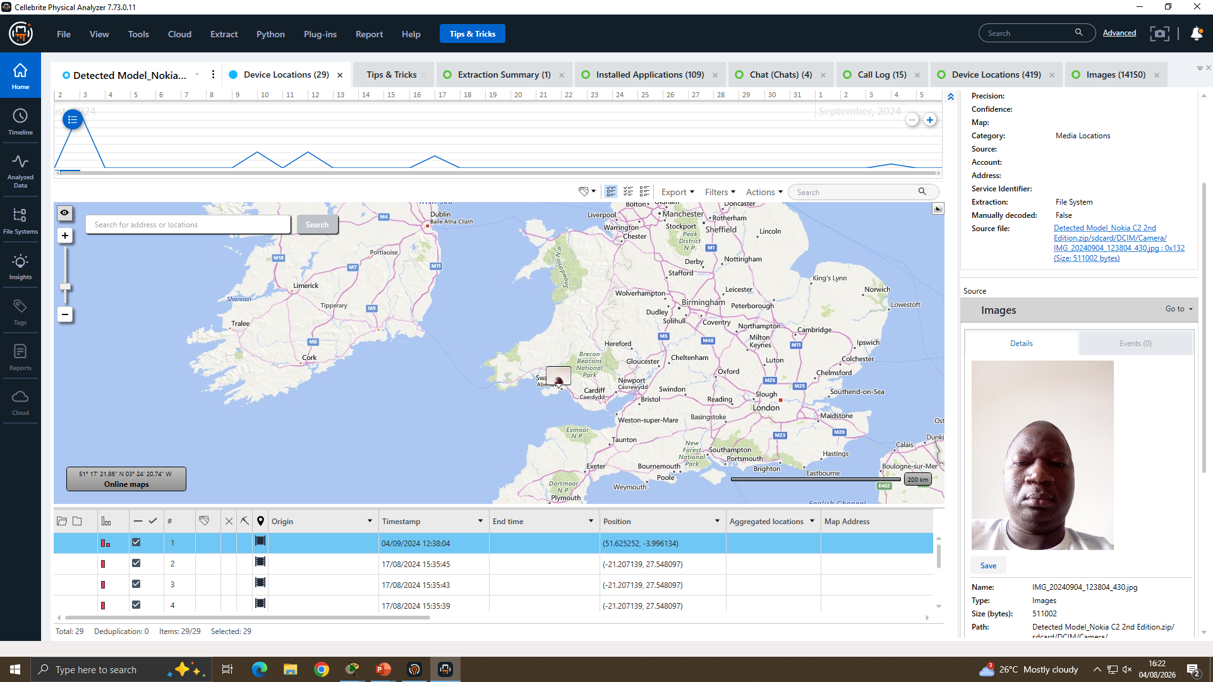
Figure 16. EX-02: photograph geotagged 51.625252, –3.996134, captured 04/09/2024 12:38:04, EXIF/device match confirmed.
EX-03: one JPEG screenshot (20241122_112158.jpg) showing a route reference “WIG → MCZ”, camera make/model (Samsung SM-A137F) consistent with the source device, captured 22/11/2024 11:21:58 (OBSERVED). The real-world meaning of “WIG → MCZ” and its relevance to the case, if any, is Not Available in the Evidence.
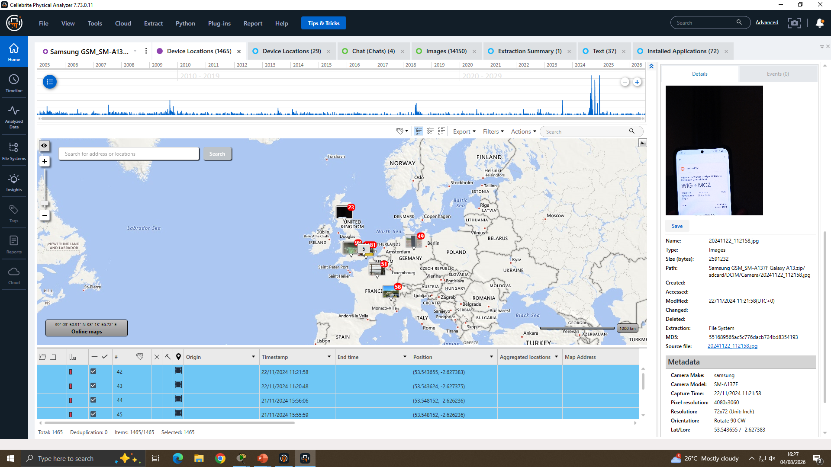
Figure 17. EX-03: screenshot referencing route “WIG → MCZ”, camera metadata confirms device of origin, captured 22/11/2024.

10. Suspect Analysis

Emma
Supporting evidence: WhatsApp messages sent from EX-01, addressed by the counterparty as “Emma”, open a sale proposal on 21/08/2024 and continue through a payment discussion on 31/01/2025 (OBSERVED). Internal inconsistency: the Google account registered on EX-01 is associated with the name “Peter Dover” (dovp59@gmail.com), not “Emma”; the supplied evidence does not explain this discrepancy (NOT AVAILABLE). Access/opportunity: no Quantum Tech system or database access log was supplied. Limitation: the identification of the EX-01 user as “Emma” rests solely on being addressed by that name within the chat, not on independent account, biometric or HR identity evidence.

Joe
Joe: named as contact "Joe Marsh" (00447476538686) in EX-01; SIM-registration match to EX-03 was claimed but not supplied (Section 9).
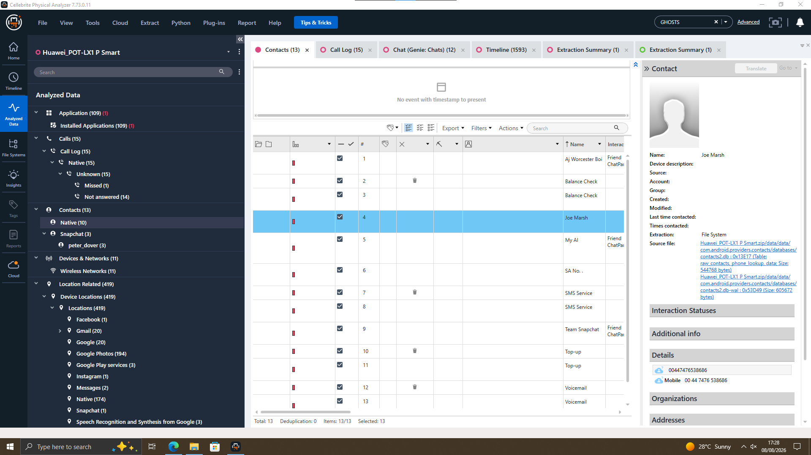
Figure 18. EX-01 Contacts: “Joe Marsh”, number 00447476538686.
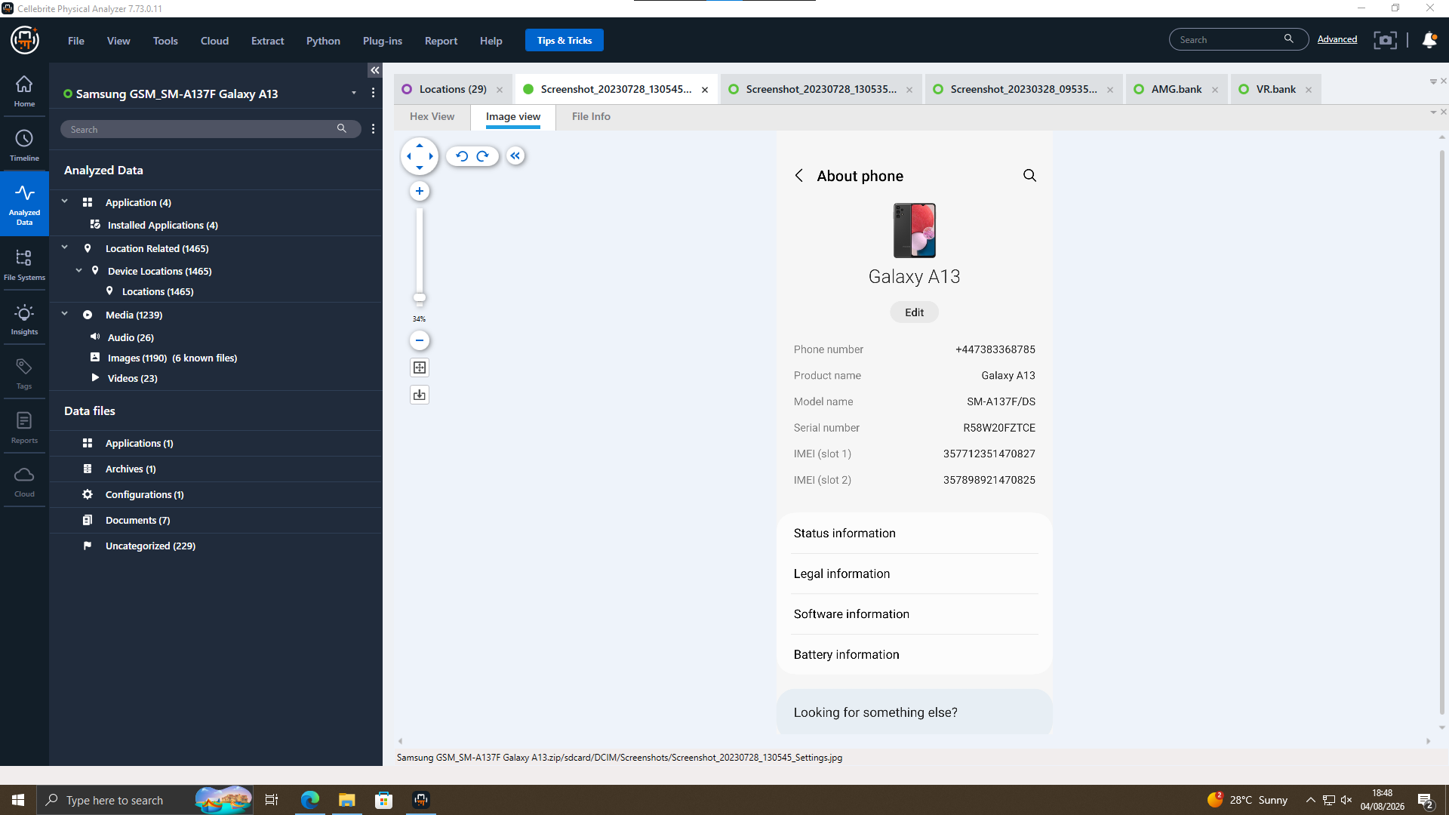
Figure 19. EX-03 About Phone: registered number +447383368785 — does not match Figure 18.

Norman
Norman: assigned buyer role; EX-02 geotag places device in South Wales, 04/09/2024 (Section 8), consistent but not conclusive of buyer identity.

Vanessa
No device, call log, message, or account artefact for Vanessa was included in the supplied evidence. Her involvement is referenced only in the case background narrative, not in any exhibited artefact. Status: NOT AVAILABLE IN THE EVIDENCE. Any suggestion of her participation is an inference from the case briefing only and should not be treated as a forensic finding.

11. Critical Evaluation of Findings
Three attribution claims — the EX-03 SIM registration screenshot, the "WIG → MCZ" route reference, and the EX-01/EX-03 number mismatch — fail against the underlying screenshots (see Sections 6, 9 and 10); each is classified UNRESOLVED.

12. Evidence Limitations
- Chain-of-custody detail beyond seizure — see Section 4.
- EX-03 user attribution unverified — see Section 10.
- No Evidence Found related to Vanessa
- No Patent File Found
The two figures below are included for transparency: they show anomalous artefacts on EX-03 that were identified and correctly excluded from the case findings rather than being mis-reported as genuine evidence.
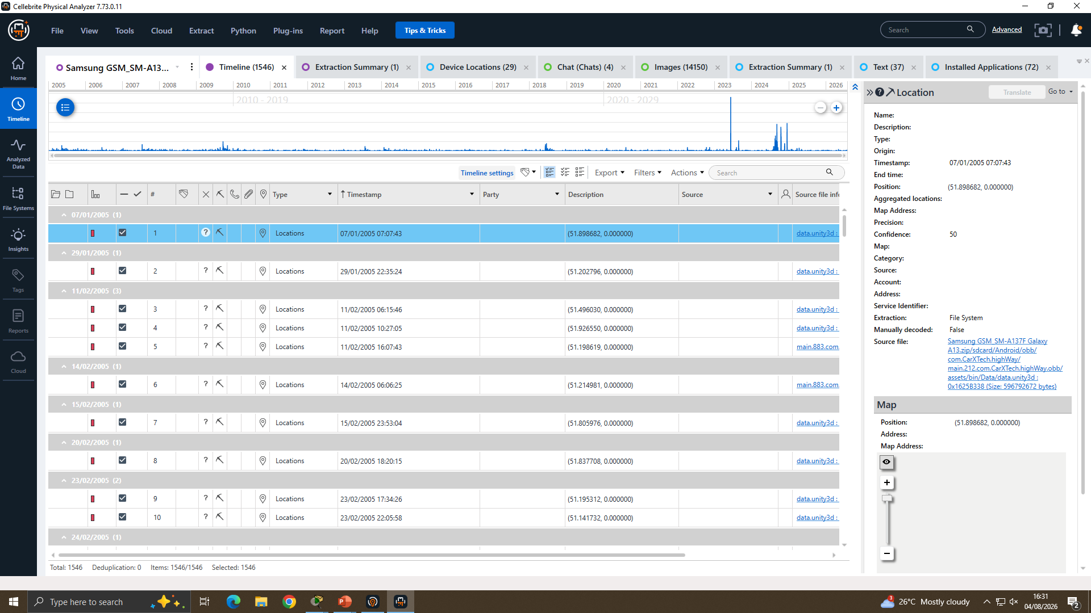
Figure 20. EX-03 Timeline: anomalous 2005-dated location cluster traced to a game asset (com.CarXTech.highWay) — not genuine device movement.
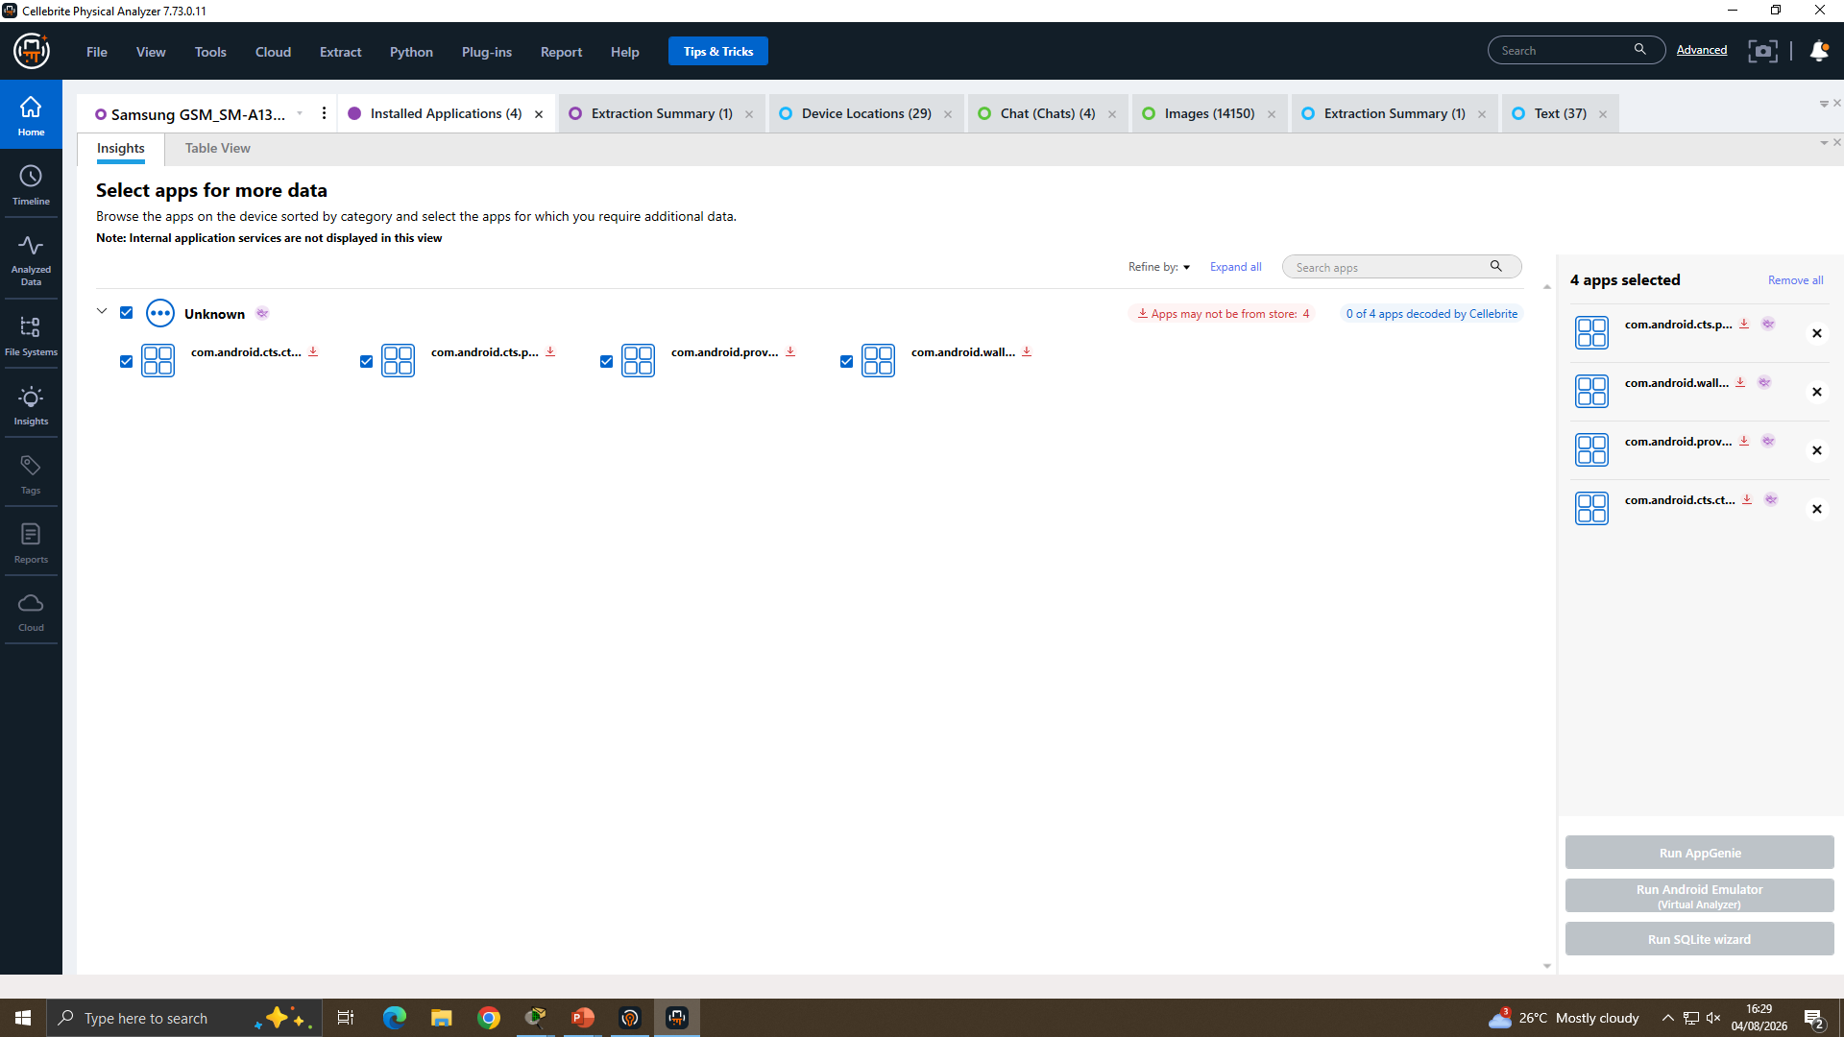
Figure 21. EX-03 Installed Applications: “Unknown” category packages identified as AOSP system/test components, not user-installed apps.

13. Conclusion
The forensic examination of EX-01 supports, with moderate-to-high confidence, that its user engaged in a WhatsApp negotiation (21 Aug 2024 – 31 Jan 2025) to sell QT-AI-2025-related information for a payment figure. Cross-device attribution to "Joe" and "Norman" is UNRESOLVED (see Sections 10-11). The investigation demonstrates a defensible acquisition and hash-verification process, but buyer-side attribution requires further corroboration before being treated as conclusive.

14. Recommendations
- Re-verify and re-capture the SIM-registration screenshot claimed for EX-03 before relying on it as identity-attribution evidence.
- Seek the missing context for the “WIG → MCZ” route reference and any device or account artefact for Vanessa.
- Obtain the underlying QT-AI-2025 design file(s) allegedly transferred, with full metadata, to evidence actual data exfiltration rather than discussion alone.
- Request subscriber records for …162788 and …162891 to establish whether they are linked (e.g. multi-SIM, call-forwarding, or genuinely separate contacts).
- Preserve all five device images (EX-01–EX-05) under a documented retention policy pending any legal proceedings.

References
[20] Cellebrite Physical Analyzer (Version 7.73.0.11). Cellebrite DI Ltd., 2025. [Software].
[21] Cellebrite UFED (Version 7.76.0.24). Cellebrite DI Ltd., 2025. [Software].

