How has post-capitalism affected the role of the Artist in the last 30 years.
Connor Tudor
1603696
Word Count: 3731
Fine Art – Coexistent Perspectives

From the idea of the tortured genius that was once considered the summit of the art world to the self-marketing, social media manager, website designing, marketing manager that we consider as the artist today. The artist’s role has changed significantly in the past 50 years. Necessary changes have had to be made to keep up with a fast-paced consumerist society. In terms of entertainment there has never been more for people to consume, but adversely when something becomes readily available it becomes expected. The over-consumption or “bingeing” of entire seasons of tv series, no longer released weekly, but in bulk, to give in to the demand of the consumerist mass, has become the norm. Watching entire seasons of tv in a day unable to resist the temptation of cliffhangers. This is the essence of the modern consumerist society. The exponential growth and demand of new technology has changed consumerist behaviour into a game of cat and mouse. Always pursuing the newest, quickly shifting from one to the next. Perhaps it is this demand-led growth that has led us to, perhaps the source of the change’s artists have had to face, the commodification of culture or cultural products. Harvey states “we distinguish cultural artefacts and events because we cannot bear to think of them as anything other than authentically different, existing on some higher plane of human creativity and meaning than that located in the factories of mass production and consumption”. Many artists have tackled mass production from a critical perspective however there are e a few who now produce works in a similar fashion. From Murakami, to Kaws and Hirst. Hirst’s is a good example of how the progression and encroachment of both technological innovation and consumerist based practice’s have changed the way in which artists work in the last 30 years.
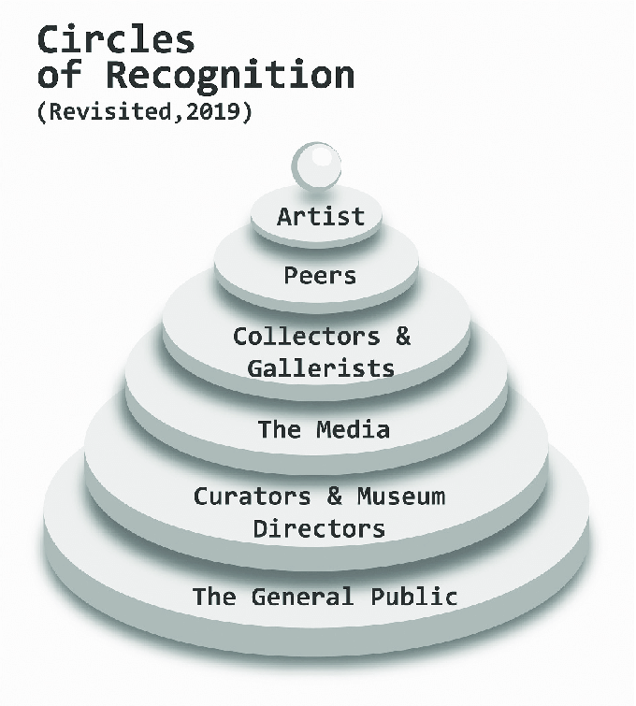
The YBA’s
Hirst is considered one of the founding members of the Young British Artist movement which swept over London during the 90’s. They garnered a lot of media attention perhaps due to the way in which they were presented to the public in journals such as ArtForum. While mentions their “British character was largely linked to a focus on the media as it was considered a media strategy focused directly on the art market”. If we consider the way in which the Young British Artists were publicly presented to society, as rebellious, young British artists pushing the boundaries of contemporary art. It’s easy to draw similarities with the way in which popular musicians’ market themselves (or are marketed) almost as an aesthetic or a cultural product. Perhaps the most noticeable commercialised “movement” being the punk rock of the 60’s. With most high streets clothes retailers these days readily selling look-a-like leather jackets and Dr Martens being the footwear of choice for many these days regardless of historical sentiment of the former working-class boot. In the same way the aesthetics of punk have been commercialised so were the YBA’s as the young, rebel/genius, working class artists at the forefront of art. This act of journalistic sensationalism positioned the YBA’s as success stories already in the eyes of the public. Bowness’ circles of recognition pose that there are six stages of legitimisation. Beginning with the artist themselves, then recognition from peers followed by collectors and gallerists, the media, curators and museum directors and finally the general public.
Freeze arguably helped the YBA’s jump quite a few of these stages due to the way Freeze was marketed and Michael craig martins influence on the attendees. Freeze had mixed review both addressed by Martin one as being “calculated and cleverly manipulated”. Of course, Martin disagreed with such claims stating, “it was a combination of youthful bravado, innocence, fortunate timing, good luck, and, of course, good work” (Martin 2007). Once again, the belief in the artistic genius raises its head here, and while there may well be truth to these claims it’s fair to consider the art market and media influence of a show as ambitious as Freeze. So as such, it’s also fair to say, the way in which the YBA’s were marketed or commodified for consumption by the public was arguably misleading. The iconic ‘Freeze’ show that outwardly opposed the “white cube” and the “market” was marketed in the same fashion by hirst himself. It offered the product of the “higher plane of artist creativity” in the context of a derelict east London dock building. However, as Bush said “YBA lingered only momentarily on the margins, soon to be eagerly embraced both by the institutions and by the market” and arguably opened a new artist led, self-sustaining practice that proved artists didn’t need representation to gain attention. Instead, perhaps it was smart marketing and media attention.

This is the essence of what the artist’s role or practice revolves around today and what this essay will focus on through the lens of post-capitalist consumerism and the demand-led growth market that has arguably emerged since the 90’s. Hirst arguably may well be the driving force in the changes both established and emerging artists have had to make. Including ideas of self-representation, what role the gallery currently plays, and how artists must market themselves due to the rise of social media.

Social media
A time span of 30 years may seem like a short amount of time compared to the entirety of art history however since the early 90’s it is obvious the role of the artist has changed. Picketty talks on growth stating if we consider “the time frame to that of a generation, that is, about thirty years, which is the most relevant time scale for evaluating change in the society we live in, the same growth rate (1% per year) results in an increase of about a third, which represents a transformation of quite substantial magnitude”. Here he is speaking of economic change however this directly translates to our advancements in technology and the growth of the art market. The rapid growth of technology since the industrial revolution has had a large part to play in our current society with growth rates pre-1700 being nigh existent comparative to now. Ultimately the creation of computers followed by the internet and finally the commodification of the internet eventually leads us to social media and the ability for individuals to freely market themselves on a globally accessible scale. Due to these developments along with the role artists are expected to play the steps required to climb Bowness’ supposed circles of recognition have changed. But how exactly do artists gain the recognition of collectors, gallerists and the media?
This brings us to our contemporary predicament of the production output of artists. Historically speaking many pieces revered as masterpieces took a lot of time to create. Michelangelo’s Sistine chapel taking 4 years to complete is still considered an extremely important part of Italy’s history and culture. However, how would such a project be received now? Beyond the measure of those who exist in the art world: collectors, curators, critics etc. How do the public engage with such pieces? The immediate parallel in terms of production time could be tv programmes or films. However, the durational expectations of video vs painting or sculpture for instance are drastically different. Presenting a painting that took four years to create vs a film that took four years to create presents a problem within contemporary media, of expectations. These problems range from how people engage with art, plagiarism, censorship etc. The affects have been observed and questioned since the early days of facebook and Instagram, Martin speaks of this in an article titled How social media Is Shaping Art – The Impact of an Instagram Obsessed Culture
“When visiting a museum or exhibition it is now mundane to observe viewers walk past the artwork, phone in hand, ready to snap and promptly post with the appropriate hashtag – looking at the art itself through the windowpane of their device rather than directly with their own eyes. But is this longing for the perfect Instagram post – or story – standing in the way of a candid experience and genuine appreciation of the art, or is it a sign of different kind of engagement with the work?”
These questions once again bring us back to the omni present existence of marketing in the 21st century. The idea of posting the perfect Instagram post and an obsession with attention and validation. These aspirations and pressures exist both socially but also now professionally within an artists practice. To garner attention now is to constantly feed the demand for content, for progress and now takes a starring role in the artists road to recognition. In a time when even the most exclusive galleries and museums all have social media accounts, artists must conform, in order to gain attention. The perks of social media don’t stop just there, advertising on Instagram is practically free from cost if you have a large follower base. Making it a perfect place for galleries, publications and anyone seeking contributions from artists to advertise. Thus, there are more opportunities than ever before for artists to apply to. The problem for artists then is for them to keep up and garner attention they must overcome the restraints of said social media.
“When using such platforms, it has become increasingly difficult for artists to navigate rules, policies and practices that unilaterally censor communication of their images.” (Lydiate, H). The platforms that monopolise the vast majority of attention from the public have a steep downside. The censoring of art is an issue that has been pushed against by artists since the creation of the sites. Instagram being perhaps the main platform used by artists, allows users to browse content via images and videos. A visual social media content site, perfect for artists of almost any sort, would be the ground for many a debate whether the censoring was for nudity; a tradition ingrained in the arts is the study of life models and anatomy and as such deals with nudity. Political standpoints, artists have always taken controversial stands on political issues.
The failings of censorship have been at the forefront of media attention more than a few times, yet a universal solution is more than likely impossible to attain. From Racism, famously Saka the England football team player who missed a penalty in the world cup, was subject to racial abuse on the social media platform Instagram. His comments were flooded with both slurs and monkey emoji’s yet Instagram response “said content had "mistakenly" been identified as within guidelines instead of referred to human moderators.” This acknowledgment of using bot detection when seeking out guideline infringements has proven to be un-subtle in its determination of what needs censoring. The problem presented with censorship especially in the age of social media is that what we are shown has been vetted to certain extent. Baudrillard’s simulations and simulacra addresses the problems faced with representation in a society so absorbed by consumerism. One passage states “Hyperreality and simulation are deterrents of every principle and every objective, they turn against power the deterrent that it used so well for such a long time” (pg 23 Baudrillard 1981). This questions both the authenticity of images we are presented with, the actual reality behind the image but also the unseen censoring of social media sites. Is what we see the accumulation of our own independent will (accounts we’ve followed) or is it what the site has decided we should see? Instagram, in particular, is known for its ever-changing algorithm that dictates what gets seen by who based on what particular media they want to push for the most engagement. And so, artists are left at the mercy of marketing to try and both, stay seen by the ones they need to gain the recognition of, while also supplying the content that will allow them to safely navigate the constant censoring.

This brings us back to the second problem with social media. Which is the pressure of keeping up with providing content by constantly creating. There are few artists who have successfully converted from the traditional studio-based practice to a consumer based more factory like mode of creation. Perhaps the most prolific of such artists are Hirst along with Koons and Murakami. All three studio practices employing many individuals to both create and design work under the given artists name. Hirst in particular comes under fire for his spot and more recently his flower paintings. His spot painting series have been both praised and scrutinised mainly due to the nature of their production or re-production as “these were Hirst’s first forays into the world of art ‘fabrication’ – a divisive artistic method explored by American Pop Artist Andy Warhol, and later by the inimitable ‘king of kitsch’, Jeff Koons.” Perhaps the inevitability of fabricated art was only a matter of time. First, as mentioned above, came Warhol with his literal ‘Factory’ and the jabbing at ownership and authenticity his practice offered. So the relinquishing of the artists interference and instead the conceptual framework of the spot paintings offered hirst the opportunity to have a very large body of these paintings made. The point here is by capitalistic like employment of other artists he was able to exploit his worth and both create and meet the needs of his own market. There are two modes of thinking when it comes to this sort of production in contemporary art. The first being the concept of the piece stands for itself, it’s a reflection of the very market and economy we live in. The second is that by removing the artist from the physical production of the piece the piece becomes nothing more than décor. For the sake of this argument the actual function of the artwork isn’t of importance. Instead, we turn our head to the market performance of such pieces. The image below indicates the success of the pieces in terms of sales from 1998 to 2013 and shows the consistency at which the pieces were sold for.
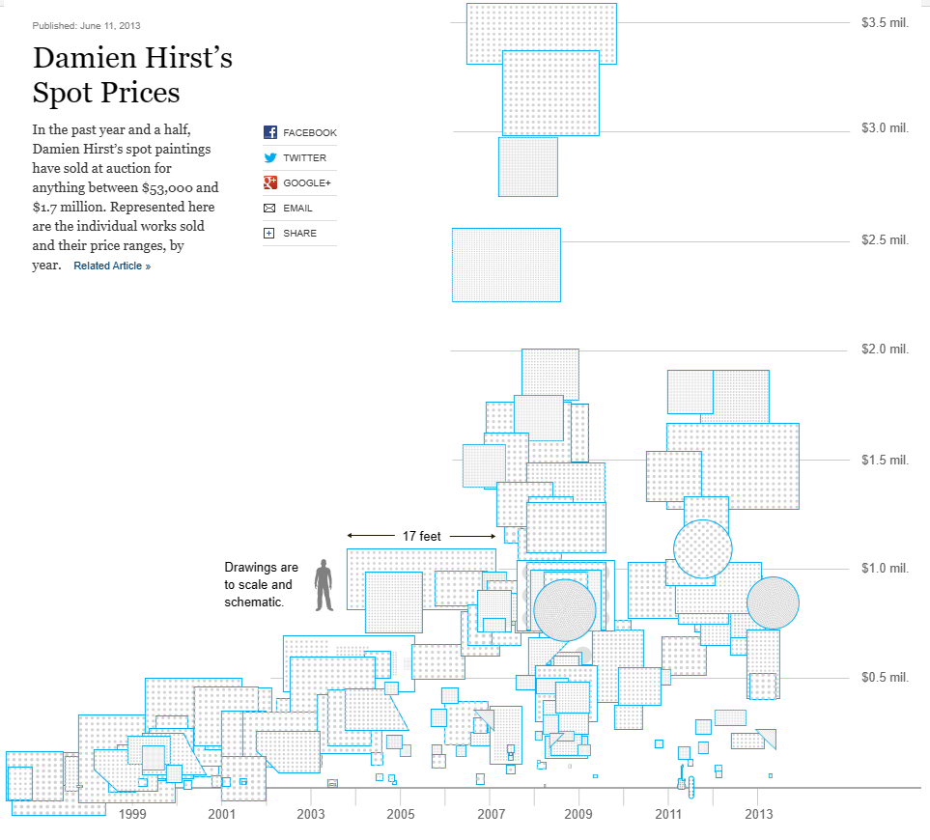

From this we can determine that the established dot painting series steadily increased in price as time went on. We can put this down due to the growth of Hirst’s notoriety. As hirst became more well known and was supported by the bigger art galleries his name grew and as such so did his prices. So now Hirst was meeting the demand of the collectors interested in him, having created around 1400 dot paintings. The use of other artists as part of the creation process in the dot paintings is arguably justifiable as the piece itself is created following hirsts rules and conditions. However, his recent flower paintings came under fire not for the use of assistants or other artists but the use of their paintings. The flower paintings consist of carefully depicted arrangements of flower reminiscent of Richters realism pieces with paint splattered over the top in a pollock like manner. The problem many have taken up with this is that the painstakingly depicted paintings underneath the splatter are all created by other artists. So, unlike the dot paintings which could arguably be completed by anyone the flower paintings require the skills of a capable painter.
The reason for breaking down hirst’s painting is to investigate the production method for such large volume and successful pieces. They reflect the market around contemporary art and remove the need for impersonal replications like prints. The problem is the accessibility of these methods. For the production methods and output to be arguably the closest (in quantity) to the actual consumer market there remains a divide that unsurprisingly relies on money. To be able to commission artists or pay assistants to play a working part in the production of a piece is a privilege few artists can afford. The problem for emerging artists becomes a case of production of quantity vs quality. Of course, there are many methods of creating pieces of quality en masse, however these are print process’ that aren’t tailored to all. Galleries in particular are fond of print runs as they’re an easy way of meeting the demand of their collector clientele.

The Galleries Role
Stepping away from the processes of singular artists the role of the gallery is something that has changed a lot in 30 years as well. Art galleries have historically always been quick on the uptake of new formats from the emergence of the white cube to house the modernists which still persists to this day, to New York city in the 70’s with the emergence of alternative art space like FOOD which “was a performance space that hosted FLUXUS, among other notable actors on the art scene. Here, artists took turns cooking meals for the public, and preparation and consumption of food were put on display to be enjoyed as art.” The evolution and persistence of galleries from long standing museums to short lived venues, all lead the way in terms of how we present art. This is no different from the galleries establishing themselves today amongst contemporary art.
GUTs gallery is a relatively young gallery currently housed in London with a focus on representation. The following is a quote from their website;
“At Guts we believe that true change requires ongoing evolution. Our adaptive business practices have established Guts as one of the leading galleries championing contemporary voices. We flip the traditional power dynamics between gallerist and artist, standing alongside them, rather than merely representing them. By creating a safe and accessible space for constructive dialogue, we're able to develop truly unique relationships with our artists. In an art world that's scared to talk about inequality, Guts Gallery speaks up.”
While the focus so far has been on the consumer market effects on the artist individual. Guts is an interesting example of rebellion towards a market that inwardly re-cycles the same artists. With a historically massive lack of diversity in art history guts gallery looks not to address the issue but fix it. The issue nowadays may not seem as prominent as it has before however, to put it into perspective, the 50 top selling artists of Sotheby’s, 45 are males. This is just the tip of the 1% iceberg. Many galleries still lack a truly diverse selection of artists. But is this a problem caused by a demand led market? In an review posted by the guardian on diversity in the arts they found “The rarity of strong and empowered Black and Asian leadership is another issue, with an Arts Council report revealing last week that in all NPO funded organisations in 2020-21, 9% of managers were from Black, Asian and ethnically diverse backgrounds (compared with 21% of artists).” This is perhaps a look into the behind the scenes running of cultural spaces and galleries and while artist representation may be on the rise due an increasing demand from collectors and the public. The actual running of said spaces might be being shadowed by the focus on who is being represented by said spaces. Which does support the theory that due to the meeting of demand and expectation of the consumer the level of diversity is perhaps overlooked. Even with the artists being presented by the galleries it is arguably being done for the publics expectation of diversity and as such the representation of a diverse selection of artists could be argued to be more for the benefit of the gallery’s relevance than for the moral obligation it should have.

Post capitalism and the Market.
The purpose of this essay was to identify why and how the roles that exist in the art world have been affected by post-capitalism and the rise of a demand-led growth market. The problem with identifying the link between capitalistic notions and artists work is the intrinsic resistant artists have towards compliance. Addressed in the book Resistance of the Arts it states “All arts, whether poetry, painting or prose, represents and interprets the world. It resists the numbing of the sense, it helps us to live more fully, engaged with the world and critical of it”. So, to take the beauty of what art does and can do and reduce it to fit the bill of capitalist consumption is something that only capitalism could accomplish. There are benefits to the existence of the topics discussed. Social media allowing artists to take control of how they are perceived and find the representation they are looking for, without needing the connections to the who’s and what’s of the art world, is obviously a boon for any artist. But the constrictions of creating ‘content’ as opposed to art is where the compromise begins. And these compromises between creating for the sake of consumption and creating for the purpose of making art come into conflict. The affects of social media to society as a whole has completely changed how we live, to instantaneous messaging making us all accessible all of the time, to the level of information we share about ourselves. As such the arts have followed suit and adapted to these spaces, as they always do, trying to make best use of the opportunities that they present. The same can be said of galleries with the rise of technology and its rapid development what seemed impossible 20 years ago is now constantly applied in the art world. Augmented reality as an example, being able to present 3d projections (albeit on a screen) in any 3d space is just one of the technologies being implemented more and more.
Capitalism as much as the art world is a constantly evolving unseeable entity with only the idea of growth in mind. The art world is very similar to this and as such surprisingly the two are almost a good match. The problem therein is the role of the artist. How does an individual keep pace with the exponential growth presented to us in the last 30 years? Hirst proved that large scale production of art is possible, though arguably, through the exploitation of other artists (who are never credited. On the other hand, he provided jobs to these artists which is still some manner of representation for them to use in their own practice. In summary the role of the artist may forever be entwined with the progress of capitalism and perhaps the role of the artist now, is to adapt to the constant change and progress of the spaces they inhabit.

Bibliography

Sherwin, Brian. "Art Space Talk: Michael Craig-Martin", Myartspace, 16 August 2007.
The art of rent - David Harvey (generation-online.org) (accessed 21/04/24)
A While (2003) Locating art worlds: London and the making of young British art. Area, 35(3), 251–263. https://doi.org/10.1111/1475-4762.00174
www.artforum.com/columns/young-british-art-169731/ Kate bush, accessed 22/04/24
Freeze: 20 years on | Art | The Guardian
Pickett, 2013, le capital for the 21st century, pg 97
How Social Media Is Shaping Art - Artland Magazine (accessed 26/04/24)
Circles of recognition (revisited). due to the transformation in order... | Download Scientific Diagram (researchgate.net)
LYDIATE, H., 2021. Censorship: Don't Delete Art. Art Monthly, (445), pp. 46.
Instagram admits moderation mistake over racist comments - BBC News (accessed on 27/04/24)
C, Criddle
Baudrillard, 1981, Simulacra and Simulation, pg 23
Damien Hirst's Spot Paintings | Article | MyArtBroker Erin Argun (accessed on 28/04/24)
Alternative art spaces: Art off the Beaten Track | ARTmine (art-mine.com) Maria Doubrovskaia, 2019 (accessed on 29/04/24)
It takes Guts to transform the art world | Guts Gallery (accessed on 29/04/24)
The Guardian view on diversity in the arts: continuity matters | Editorial | The Guardian 2022 (accessed on 29/04/24)
Arts of Resistance, 2020, A. Moffat, A. Riach, L. Macdonald-Lewis, Pg 4

