

BA (Hons) Youth Work and Social Education

(
ETS Endorsed, leading to JNC professional
qualification)

Institute of Education and Humanities:

Childhood and Education

Yr Athrofa

Level
5

Placement Handbook

202
4
-
2
5

(
This
document is also available in Welsh)

CONTENTS

INTRODUCTION _____________________________________________________________________________ 3
NATIONAL OCCUPATIONAL STANDARDS FOR YOUTH WORK _________________________________________ 4
SUMMARY FUNCTIONAL MAP FOR YOUTH WORK _________________________________________________ 5
SETTING UP AND MANAGING THE PLACEMENT ___________________________________________________ 7
Learning Mentor __________________________________________________________________________ 8
Practicum Supervisor ______________________________________________________________________ 8
Placement Coordinator ____________________________________________________________________ 9
DBS PROTOCOL ____________________________________________________________________________ 12
STUDENT PLACEMENT PROTOCOL _____________________________________________________________ 13
Student Responsibilities ___________________________________________________________________ 13
Placement Provider Responsibilities _________________________________________________________ 16
University Responsibilities _________________________________________________________________ 18
COMPLAINTS PROCEDURE ___________________________________________________________________ 21
FITNESS TO PRACTISE POLICY _________________________________________________________________ 21
LEAVING A PLACEMENT BEFORE THE AGREED END DATE OF THE PLACEMENT _________________________ 22
SICKNESS AND ABSENCE POLICY _______________________________________________________________ 23
NON-FAULT HOURS _________________________________________________________________________ 23
SOCIAL MEDIA GUIDANCE ___________________________________________________________________ 24
FREQUENTLY ASKED QUESTIONS ______________________________________________________________ 24
MODULE ASSESSMENT ______________________________________________________________________ 26
ORGANISING YOUR PROFESSIONAL JOURNAL ____________________________________________________ 27
WORKPLACE RISK ASSESSMENT _______________________________________________________________ 28
Risk Assessment Matrix ___________________________________________________________________ 29
Risk Assessment Table ____________________________________________________________________ 30
PROFESSIONAL DEVELOPMENT PLAN __________________________________________________________ 31
PROFESSIONAL DEVELOPMENT PLAN TEMPLATE _______________________________________________ 33
PRACTICUM PLACEMENT SUPERVISION _________________________________________________________ 34
PRACTICUM PLACEMENT SUPERVISION CONTRACT _____________________________________________ 35
SUPERVISION RECORDING FORMAT _________________________________________________________ 36
Appendix 2: Standards in the Level 5 Practicum Placement _________________________________________ 37
Full-time student timeline _________________________________________________________________ 39
Twilight student timeline __________________________________________________________________ 41
Appendix 3: Placement Hours Monitoring Sheet _________________________________________________ 43
Appendix 4: Final Reports ____________________________________________________________________ 44
PRACTICUM SUPERVISORS FINAL REPORT ____________________________________________________ 44
LEARNING MENTORS FINAL REPORT _________________________________________________________ 47

INTRODUCTION
The Key purpose of Youth Work is clear and was agreed by the youth work sector during 2008 (LLUK, 2008), and it encompasses the outcomes of delivering youth work (what is achieved). The key purpose of youth work is to…
Enable young people to develop holistically, working with them to facilitate their personal, social and educational development, to enable them to develop their voice, influence and place in society and to reach their full potential.
(CLD Standards Council Scotland, 2019 p.4)
This statement refers to the holistic development of young people, recognising that personal, social and educational development can also include, for example, physical, political and spiritual development (Lifelong Learning UK, 2008; Learning and Skills Improvement Service, 2012, Community Learning and Development Standards Council Scotland, 2019).
Practicum is undertaken as an integral part of the programme, where the achievement of the learning outcomes for the placement is dependent on the arrangements made with the Practicum Placement Provider; where the student is enrolled at the University during this period; and where there is a transfer of direct supervision of the student to the Placement Provider (Academic Quality Handbook). Placement is defined as a planned period of learning, normally outside the University, on a full or part-time basis where the learning outcomes are an intended part of a Programme of Study. Placement is an integral part of many of the University’s programmes and when credit is earned, because the activity is part of a Programme of Study, the guidelines set out in this section shall normally inform the development and delivery of such module(s) (Student Placement Protocols, Academic Quality Handbook).
It is the intention of the programme team to create thoughtful and reflective youth workers. Practicum Placement will provide a huge range of learning experiences for you. The University will ensure that the work that students undertake in such contexts reflects the precepts of the UK Quality Code. This will be linked to the guidelines and benchmarks set by QAA and the Association of Sandwich Education and Training (ASET) (Academic Quality Handbook). It is the responsibility of the student to utilise these opportunities as learning experiences and to be an active participant in their professional development. There are a tremendous variety of placements open to students, and you are encouraged to experience as many different Youth Work contexts as possible to increase your understanding of how modern organisations and people work. It is expected that students have at least one contrasting placement arrangement throughout the duration of their studies.
Where the placement learning leads to professional accreditation on successful completion of the award additional policies and procedures relating to such programmes are available from the relevant Institute offices and in programme handbooks (Academic Quality Handbook).

NATIONAL OCCUPATIONAL STANDARDS FOR YOUTH WORK

Youth and Community Work is a value driven occupation. The sector has agreed a
set of values which underpin excellent Youth Work (CLD Standards Council
Scotland, 2019)
.

•
Young people choose to be involved, not least because they want to
relax, meet friends, make new relationships, to have fun, and to find
support,
•
The work starts from where young people are in relation to their own
values, views and principles, as well as their own personal and social
space,
•
It seeks to go beyond where young people start, to widen their
horizons, promote participation and invite social commitment, in
particular by encouraging them to be critical and creative in their
responses to their experience and the world around them,
Participation and active involvement
•
It treats young people with respect, valuing each individual and their
differences, and promoting the acceptance and understanding of
others, whilst challenging oppressive behaviour and ideas,
•
It respects and values individual differences by supporting and
strengthening young people’s belief in themselves, and their capacity
to grow and to change through a supportive group environment,
•
It is underpinned by the principles of equity, diversity and
interdependence,
Equality, diversity and inclusion
•
It recognises, respects and is actively responsive to the wider
networks of peers, communities, families and cultures which are
important to young people, and through these networks seeks to help
young people to achieve stronger relationships and collective
identities, through the promotion of inclusivity,
•
It works in partnership with young people and other agencies which
contribute to young people’s social, educational and personal
development,
•
It recognises the young person as a partner in a learning process,
complementing formal education, promoting their access to learning
opportunities which enable them to fulfil their potential,
Partnership with young people and others
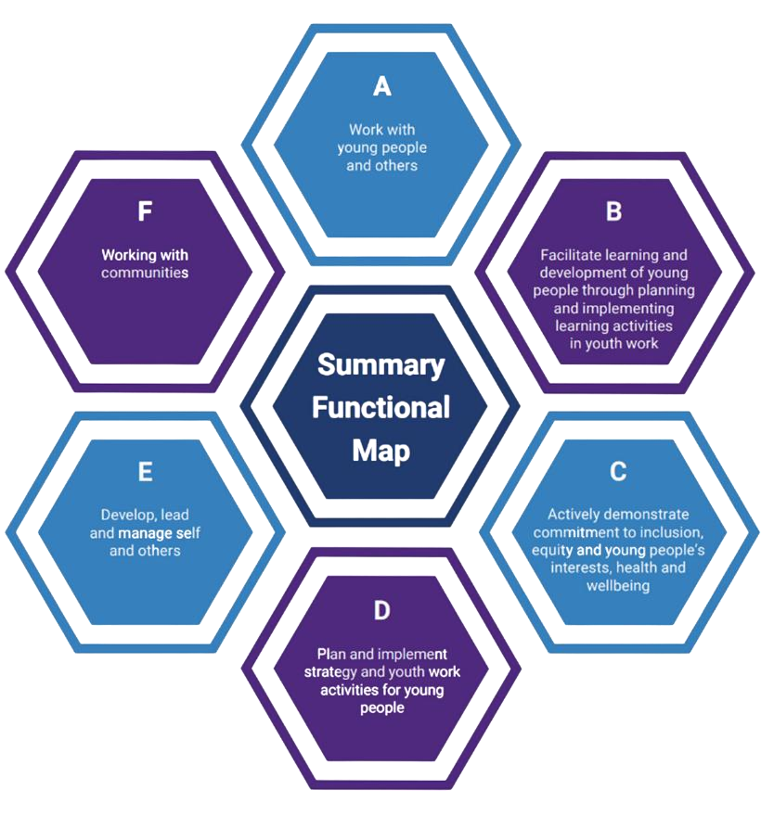

These values underpin and are to be reflected within the requirements of the
relevant standards (CLD Standards Council Scotland, 2019).

SUMMARY FUNCTIONAL MAP FOR YOUTH WORK

The following summary map identifies the functions and principal areas of activity
undertaken in achieving the key purpose. The functional areas are proposed as the
full range of those undertaken by youth workers. However, it is unlikely that any
individu
al youth worker will
carry out

all of the activities; rather the Map expresses
the full range of activities that may be undertaken in order to deliver youth work.

The areas suggested are not of equal size/complexity, as they reflect activities and
roles undertaken by individuals of varying levels of experience, responsibility and
seniority. It is also recognised that many of the functions/activities are inter
-
relate
d,
such that the outcomes of one will impact upon another.

•
It is concerned with how young people feel, and not just with what
they know or can do,
•
It is concerned with facilitating and empowering the voice of young
people, encouraging and enabling them to influence the environment
in which they live
•
It safeguards the welfare of young people, and provides them with a
safe environment in which to explore their values, beliefs, ideas and
issues
•
It’s commitment, in particular by encouraging them to be critical and
creative in their responses to their experience and the world around
them,
Personal, social and political development
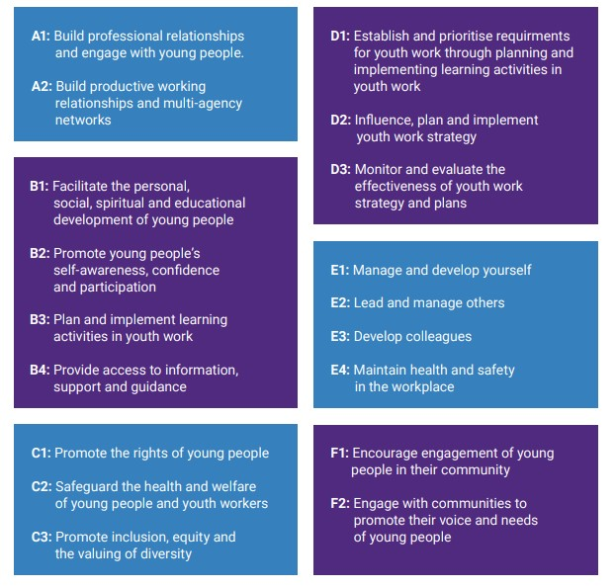

(
NYA Youth, Youth Work in England: Policy, Practice and the National
Occupational Standards , 2023: page
8

-

9
)

Best practice, as set out by the NOS requires youth workers to be aware of the local,
social and political context within which youth work
activities are undertaken.

In addition, youth workers will be required to demonstrate a commitment to the Values
and principles which underpin and support all activities across youth work.

SETTING UP AND MANAGING THE PLACEMENT
The purpose of the practicum aspect of the programme is to ensure that students have the opportunity to acquire skills and develop knowledge and understanding appropriate to their prospective role as a professionally qualified youth and community worker. The nature and purpose of Youth Work is defined by the Education and Training Standards Committee (ETS) in the following way:
The Youth Worker's task, therefore, is to plan and provide appropriate experiences, to take advantage of those which arise spontaneously, and to foster learning by employing a range of interpersonal skills such as group work, mentoring and advocacy. Relevant themes and issues such as health, housing and employment are incorporated as appropriate. This task, and the understanding and skills to deliver it, form the bedrock for all education and training programmes for Youth Workers

(ETS, 2020: p.6)
Student placements are a partnership between the student, the University and the Placement Provider in which each has specific responsibilities. During your time of study on the programme you will engage in a minimum of three placements, two of which must be in different locations and adhere to the requirements set out by the University and ETS. Students wishing to undertake their placement in Welsh are able to do so.
At level 5, students are expected to act as a functioning member of the placement providers team, observing the work of others and actively contributing to the smooth functioning of the work. At this stage, the student will be expected to be responsible for seeking opportunities to help and assist others and undertake leadership opportunities where appropriate.
Your task at Level 5 is to successfully complete a placement of 400 hours, at least 50% of which must be face to face work with young people.
When setting up and managing your placement there are key people that need to be in place to support your professional development. All students will benefit from the support of The Placement Coordinator, Learning Mentor and Practicum Supervisor, who will be confirmed before the commencement of your Practicum
Placement hours. It is the student's responsibility to inform the Placement Coordinator of any challenges or issues in placement, as soon as possible.

Learning Mentor
This person is based within your placement, having a day-to-day responsibility for the student's standard of practice. The Learning Mentor plays an important role in the students' learning on placement - as in, the student's learning doesn't merely take place in the lecture room. The Learning Mentor is responsible for the following;
•Health and safety, including signing of the risk assessment;
•Safeguarding and Insurance;
•Managerial supervision (crucial and included in the final assessment;
•Clearly outlining the role and responsibilities of the host placement and in supporting the students' learning through the process of shadowing and observation; •Including the student into the host organisation, ensuring a workplace induction is completed in the first week;
•Drawing up a work agreement with the Fieldwork Coordinator and the student on the basis of their learning needs and the requirements of the programme;
•Signing off the student's collected hours at the end of each session - outlining the hours collected as evidence for the completion of the module requirements;
•This person will attend the two three-way meetings, with the student and Fieldwork Coordinator, and will produce a final report with clear recommendation of the student's grade.

Practicum Supervisor
This person is responsible for ensuring the professional development of the student through a formal process of supervision. This person may be based either within the placement organisation or be an experienced Practicum Supervisor who is not connected to the placement host itself. The Practicum Supervisor will be responsible for the following;
•Maintain a professional, supportive but challenging relationship with the student;
•Meet regularly (a minimum of 6 times) with the student;
•Discuss the student's reflective recordings and use these as a learning tool;
•Contribute to the assessment of the student's practice in conjunction with agreed learning outcomes;
•If necessary, attend and participate in placement meetings with the student and Fieldwork Coordinator to discuss the student's progress.
•This person will produce a detailed final report once the supervision process has been completed (after the minimum number of sessions have been completed).

Placement
Coordinator

This person has a linking role between the University and the placement provider.
The Fieldwork Coordinator is your first point of contact in relation to placement. The
Fieldwork Coordinator will be responsible for the following;

•Supporting the student to source an appropriate placement provider;

•Ensuring students, Learning Mentors and Practicum Supervisors have copies of all
relevant documentation;

•Learning agreements are negotiated and recorded on a central online system by the
student in a timely manner;

•Take the necessary steps to ensure that all placements meet the requirements of
the Health and Safety policy;

•Placement meetings are agreed by the Student and Fieldwork Coordinator;

•Students, Learning Mentor and Practicum Supervisors are briefed on assessment
procedures and regulations regarding students' recordings and the final reports;

•Any issues concerning the placement are discussed and resolved at the earliest
possible opportunity;

•The Fieldwork Coordinator will support you through at least two three
-
way meetings
with the Learning Mentor and challenge you through discussions to demonstrate the
highest standards while on placement. These meetings can take place in person or
online.

It is the student's responsibility to inform the Placement Coordinator of any
challenges or issues in placement, as soon as possible.

THE PLACEMENT PROCESS
The University, in conjunction with local employers has a responsibility to ensure that the student exhibits principles, values and behaviours during the course of their studies that demonstrate that they are ‘fit to practice’ and is adequately prepared to function at a professional standard upon successful completion of the Programme of Study.
The Placement Coordinator will identify a placement for you at Level 4, and wherever possible the team will suggest a placement of interest that is accessible for students. Sometimes, however, it may be necessary for students to travel some distance to placement, using personal or public transport. Students must understand the need to travel within the region may be unavoidable, and that commitment to placement is fundamental to their progress. This commitment to practicum and gaining experience is regarded as a sign of commitment to the programme and to the process of Youth Work in general. Students are encouraged to utilise support provided by Student Services who can, in some circumstances, offer guidance to access emotional and financial support to students during their studies.
Prior to placement: Students cannot commence a placement until they have completed all the necessary preparatory work detailed below, and received authorisation from the Placement Coordinator. It is the student’s responsibility to ensure that the following processes are complete before the commencement of placement.

University The DBS (Disclosure and Barring Service) provides background
DBS checking for those wishing to work with children and young people. The Registry department will hold a record of your
Disclosure completed DBS. It is your responsibility to ensure that the
University and your placement provider has seen a copy of your DBS before beginning your placement. It is the placement provider’s responsibility to ensure the student does not begin placement until a copy of your DBS has been reviewed. Be sure to provide a copy of your DBS details prior to the commencement of placement.

The student will retain the original and submit a copy to the University. The student must make the Placement Provider aware of any issues arising from the DBS check and discuss any convictions with the Placement Coordinator. Delay in applying for a DBS Disclosure will delay the start of your placement and could jeopardise your place on the programme.

Students will receive an email from Registry to begin this process before/during induction week. If you have not received this, contact; registry@uwtsd.ac.uk
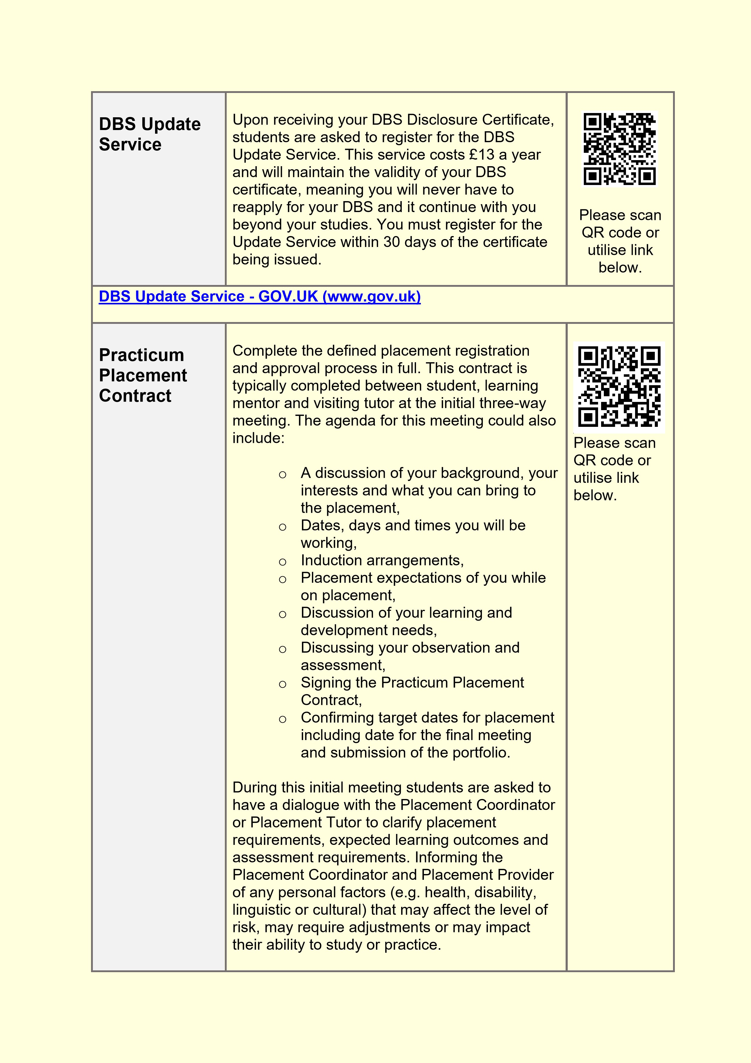
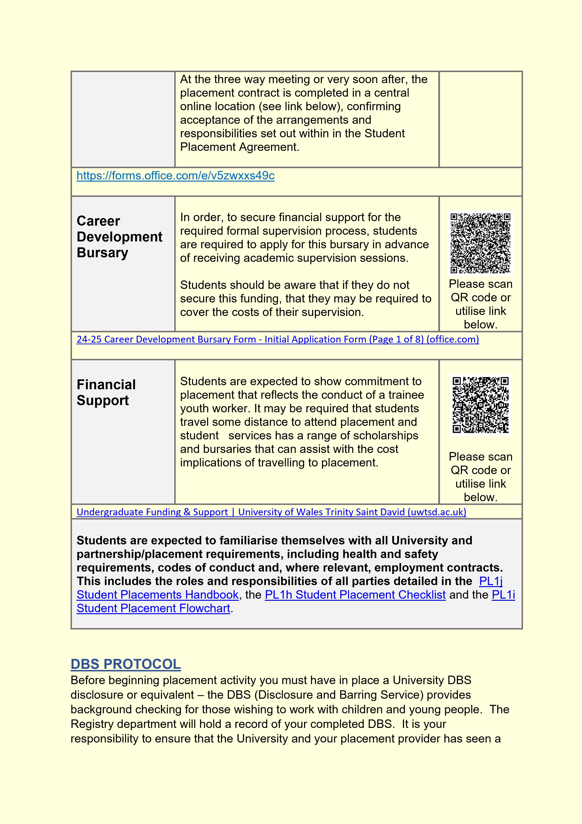

copy of your DBS before beginning your placement. It is the placement provider’s responsibility to ensure the student does not begin placement until a copy of your DBS has been reviewed. Be sure to provide a copy of your DBS details prior to the commencement of placement. Additionally, all staff and students involved will work within a value base of anti-discrimination and equal opportunities, in all aspects of their practice and across the programme. At the three-way meeting, it is vital that the student provides their DBS certificate to the placement provider. The student cannot begin face-to-face working with young people until this certificate has been reviewed by the placement provider.
Similar to level 4, students at level 5 must ensure an initial three-way meeting has been held between the student, learning mentor and placement coordinator before the placement can commence or hours can be accrued. With consent from the placement coordinator, students may wish to begin their placement arrangement before the start of the academic term, in these cases students should be aware that they cannot accrue over 50% of their total hours before lectures have resumed.
The purpose of the fieldwork aspect of the programme is to ensure that students have the opportunity to acquire skills and develop knowledge and understanding appropriate to their prospective role as a professionally qualified youth and community worker. The Nature and Purpose of Youth Work is defined by the Education and Training Standards Committee (ETS) in the following way:
The Youth Worker's task, therefore, is to plan and provide appropriate experiences, to take advantage of those which arise spontaneously, and to foster learning by employing a range of interpersonal skills such as group work, mentoring and advocacy. Relevant themes and issues such as health, housing and employment are incorporated as appropriate. This task, and the understanding and skills to deliver it, form the bedrock for all education and training programmes for Youth Workers

(ETS, 2020: p.6)

STUDENT PLACEMENT PROTOCOL
Student placements are a partnership between the student, the University and the
Placement Provider in which each has specific responsibilities which are detailed below. This information can also be found in Chapter 11 of the Academic Quality
Handbook (Academic Quality Handbook | University of Wales Trinity Saint David (uwtsd.ac.uk)).
Student Responsibilities
Prior to placement
Students cannot commence a placement until they have completed all the necessary preparatory work detailed below and received authorisation from the Placement Coordinator.
Prior to the commencement of the placement, students are required to:
- Take a proactive and positive approach to securing their own suitable placement. Students will be permitted until the end of October to source their own placement arrangements, after which, one will be appointed to them at the discretion of the Placement Coordinator.
- Seek advice on sourcing and securing a placement opportunity from appropriate sources. This should include a dialogue with the Placement Coordinator or Module Lecturer to clarify placement requirements and assessment requirements. c) Actively engage in preparatory activities associated with all University and Placement Provider requirements, including health and safety requirements, wellbeing, equality and diversity, codes of conduct and, where relevant, employment contracts. This includes the roles and responsibilities of all parties detailed in the PL1c Student Placement Information and Personal Details form, the PL1h Student Placement Checklist and the PL1i Student Placement Flowchart.
- Attend placement preparation briefings, including those covering health and safety.
- Familiarise themselves with the PL1j Student Placement Handbook that details placement information, including guidance and support routes for, inter alia, general and specific student services support, e.g. support for mental health and well-being, disability, bursaries available.
- Complete the PL1c Student Placement Information and Personal Details online form. This form captures the placement details such as the name and address of the Placement Provider, the duties to be undertaken on placement, and the duration of the placement, among other things. It also requires consideration of any personal factors and protected characteristics that may affect the level of risk, may require reasonable adjustments or may affect the students ability to study or practice. Protected characteristics include race, sex, sexual orientation, gender reassignment, religion or belief, pregnancy or maternity, marital status, age and disability. Linguistic and cultural issues should also be considered.

- Complete a Disclosure and Barring Service (DBS) check, (as required and stated above). The student will retain the original DBS certificate and must submit a copy to the University. The student must make the Placement Provider aware of any issues arising from the DBS check and discuss any criminal convictions with the Placement Coordinator.
- Complete the ethics approval processes, where relevant.
- Liaise with the Learning Mentor and Practicum Supervisor to develop suitable learning objectives for the placement, within the context of the learning outcomes specified within the placement module specification.
- Complete the defined placement registration and approval process in full. See Appendix PL1c Student Placement Information and Personal Details.
- Confirm acceptance of the arrangements and responsibilities set out in Appendix PL1c Student Placement Information and Personal Details.

During the placement
During the placement, the student is required to:
- Comply with all placement organisation policies and procedures.
- Report to the University any accidents or incidents in which they are involved or any health and safety concerns, including mental health and wellbeing, they have that are not addressed by the Placement Provider, e.g. an appropriate induction and health and safety training is not provided.
- Where changes occur during the placement that might require amendments to the student’s Statement of Compensatory Measures (SCM), liaise with Student Services for a review of the SCM/reasonable adjustment.
- Carry out the work programme specified by the Placement Provider under the supervision of the Learning Mentor. e) Keep a log of hours worked.
- Monitor their progress in achieving the identified learning outcomes and arrange to meet regularly with the Practicum Supervisor and Placement Tutor (as appropriate) to discuss workload, challenges and ideas.
- Conduct themselves in an appropriate manner that reflects positively on their self and the University, adhere to the Student Code of Conduct, ensure confidentiality and treat others with respect and dignity.
- Act in a professional manner, including notifying the Placement Provider in a timely fashion in the event that they are unable to attend their placement due to illness etc.

- Respect any other requirements of the workplace such as dress codes.
- Participate in regular discussion with the University and report any issues or concerns that arise during the placement promptly to the Placement Provider, Placement Coordinator or Module Lecturer, as appropriate.
- Consult with the Placement Coordinator prior to seek any changes in the terms and duration of the placement.
- Embrace all learning opportunities during the placement with enthusiasm, and capture learning through personal reflection. Complete all relevant academic assessment relating to the placement experience.
- Should legal or ethical concerns arise during the placement, raise concerns with the Placement Co-ordinator or Tutor, to consult about the use of the University’s
Placement Whistleblowing (Public Interest Disclosure) Procedure.
Placement Provider Responsibilities
A Placement Provider is a third party (usually an employer), who, during the placement, has responsibility for the direct supervision of the student. Placement providers are required to:
- Confirm acceptance of the arrangements and responsibilities set out in Appendix PL1a Placement Provider Agreement.
- Provide a safe working environment by meeting all relevant obligations under the Health and Safety at Work Act 1974 or other relevant country specific safety legislation. Complete Appendix PL1b Placement Provider Questionnaire.
- Respect equality and diversity and ensure that the student is treated with dignity. Adhere to the responsibilities set out in the Equality Act 2010, e.g. for protected characteristics such as age, disability, gender reassignment, marriage and civil partnership, pregnancy and maternity, race, religion and belief, sex, sexual orientation, and liaise with the University regarding reasonable adjustments if they find that the reasonable adjustments appear not to be appropriate.
- Carefully consider student mental health and wellbeing and ensure that the placement setting has a culture that supports disclosure and provides clear routes for support. The provider should raise with the University any serious signs of concern relating to the wellbeing and safeguarding of a student using the Cause for
Concern reporting process so that the University can ensure that the student receives suitable support – see UWTSD Wellbeing Service (uniticms.com) .
- Work within the student-facing policy framework for the University especially in relation to the Non-Academic Misconduct Policy, the Support for Study Policy, the Fitness to Practise Policy and the Safeguarding Policy. Providers need to inform themselves fully of the University’s student-facing policy framework in order to adhere to it. If a Provider wishes to terminate or temporarily suspend a placement, they should contact the University as soon as possible to discuss the situation. f) Provide a designated Learning Mentor who will:
- act as the first point of contact for regular communication and collaboration with the University, including recruitment and selection of placement students; the organisation of University visits to the Placement Provider (where relevant), any problems or queries during a student’s placement, and who will contact the University immediately in cases of serious accidents, incidents or breaches of discipline involving the student;
- conduct or make arrangements for the day-to-day supervision of the student including periodic progress checks and instruction regarding hazards and health and safety precautions;
- provide the University with student attendance data, where required, and in the event of unexplained or unnotified absence, to flag to the University, concerns for a student’s welfare as soon as possible.
- Support staff development for workplace supervisors of students on placement, liaising with the University for its provision, where appropriate.
- Provide the student with a full and clear induction to the organisation and its working practices, procedures and requirements, including layout of the work environment, different areas of work activity, health and safety, safeguarding issues, introductions to supervisors, and expectations for interactions with clients of the Placement Provider. For example, the need for client confidentiality (where appropriate), intellectual property rights and compliance with regard to data protection. Post-induction, provide the University with the completed PL1f Induction Checklist.
- Ensure that the student is fully informed about responsibilities, including those contained in any statutory legislation and/or honorary contract.

j) Provide the student with appropriate instruction and training in working practices

to enable them to carry out their duties efficiently and safely. Where possible, offer

opportunities to assist students with career choices.

k) Liaise with the Stu
dent and Placement Coordinator to ensure the placement offers

opportunities for learning and development and to develop suitable learning

objectives (which must be agreed by the student, the Learning Mentor and

the University).

l) Facilitate access to the student for visits by the Visiting Tutor, where

appropriate.

m) Maintain clear and accessible records of any issues raised with the student
and/or Placement Tutor in line with the Cause for Concern process of the Fitness to

Practise Policy.

n) During and on completion of the placement, provide feedback to the University on

the student’s performance and confirmation of the hours in practice, (where

required) with any suggestions/recommendations for future enhancement.

Appendix PL1g Post
-
placement Review and Feedback is available for this

purpose.

University Responsibilities

The University has a responsibility to:

a) Recognise that students remain students throughout the placement and commit

appropriate levels of staff and other resources to placement governance activity to

ensure strategic oversight for the learning to be delivered and managed by the

Placement Provider. Th
is will normally include the identification of (i) a Placement

Coordinator, whose duties would normally include the authorisation of placements

including organising and managing the placement arrangements in liaison with

the Placement Provider and student, and (ii) a
Placement Coordinator/
Visiting Tutor,
who will act as

the student’s first point of contact, and will be responsible for providing training for

the Practicum Supervisor, visit the student on placement, (where appropriate) and

assess the student.

b) Provide training for University staff (Placement Coordinator and Visiting Tutor)

who design and manage placement activity in order to develop their competenc
e

in supporting the process and enhancing practice. The Placement Coordinator or

Placement Tutor will offer training to the Workplace Supervisors.

c) Provide guidance on sourcing, securing and learning from placement

opportunities.

d) Provide students with an appropriate briefing on physical and mental health and

well
-
being, the importance of maintaining a positive work
-
life balance, self
-
care ,

health and safety support, equality, diversity and inclusion prior to commencement

of any placement. Students must be advised and supported in the transition from

student to working environments and vice versa.

e) Ensure that any placement learning that forms part of a programme of study has

associated learning outcomes which:

-

are clearly defined;

-

contribute appropriately to the overall aims of the programme;

-

are appropriately assessed. In cases where it is considered appropriate for

the assessment to be jointly conducted by the University and the Placement

Provider, the
Visiting
Tutor will provide training for the Workplace

Supervisor and will establish and document the procedure by which this shall

be achieved.

f) Assess the suitability of a proposed placement through appropriate and

proportionate placement due diligence procedures using a risk
-
based assessment

process. The approval process will require the Placement Coordinator or

Placement Tutor to undertake a Risk Profile for each placement using the PL1d

Placement Risk Assessment Guidance and record the outcomes in Appendix

PL1e Placement Risk Assessment Template. This risk assessment activity will

include consideration of the information supplied in Appendix PL1a Placement

Provider Agreement, Appendix PL1b Placement Provider Questionnaire and

Appendix PL1c Student Placement Information and Personal Details (online

form).

g) Ensure that Disclosure and Barring Service (DBS) checks are conducted, where

relevant.

h
)
Offer access to wider support services to all students and provide specialist
advice

and guidance for those with additional support needs. This includes consideration of students mental health and wellbeing and the provision of clear routes for support. Access to counselling is not available outside the UK.
- Ensure any students with additional requirements are referred to the appropriate expert colleagues within the University for resolution. Where there are unique learner needs, reasonable adjustments are to be negotiated with the Placement Provider in cases where students are assessed under the terms of the Equality
Act, 2010. This relates to a range of ‘protected characteristics’ including race, sex, sexual orientation, gender reassignment, religion or belief, pregnancy or maternity, marital status, age and disability.
- Comply with the requirements of the General Data Protection Regulations, 2016. Ensure that explicit consent is sought from students to share relevant personal information (such as protected characteristics) with the Placement Provider. This information should only be passed to people to whom it is relevant (e.g. to HR managers or Placement Provider Workplace Supervisors).
- Provide a PL1j Student Placement Handbook that details placement information, including guidance and support routes for, inter alia, student services support, mental health and well-being, disability, bursaries, etc.
- Clearly define appropriate points of contact and lines of communication between the University, the Placement Provider and the student. These should include:
- Mechanisms for the Placement Provider to raise concerns or complaints about any aspect of the placement, including an individual student's performance or conduct.
- University emergency contact details.
- a schedule for maintaining contact (check-ins) with students and Placement Providers, including frequency and method.
- Retain a full and detailed record of each placement.
- Ensure that any concerns, complaints, incidents or breaches of codes of conduct or discipline are dealt with in line with its student-facing policy framework, Safeguarding Policy and the Placement Whistleblowing (Public Interest Disclosure) Procedure.
- Monitor all placement activity, ensuring that milestones are established, maintained and recorded, and identifying and addressing promptly any issues of

concern and promoting the sharing of good practice.

n
)
Liaise with PSRBs or external accreditation bodies to ensure that placement

opportunities meet their requirements

o
)
Ensure that all parties are clear about the arrangements that will be made in the

event that a placement terminates prematurely.

p
)
Encourage connections and networks between placement students before they

begin their placement to create a supportive environment for individuals in similar

circumstances.

q
)
Arrange appropriate opportunities for gathering feedback from students,

Placement Providers and Placement Tutors, including suggestions for

improvement (see Appendix PL1g Post
-
placement Review and Feedback).

r
)
Support students in the transition back to the University, e.g., by reviewing

reasonable adjustments or offering refresher sessions.

COMPLAINTS PROCEDURE

In the event that a student has a complaint about a placement, they should seek to

discuss the matter, in the first instance, informally with the
Module Lead
,

Placement Coordinator or Academic Director. In the event that the student is

dissatisfied with the response, they shall follow the formal Student Complaint Policy

associated with Chapter 12 of the Academic Quality Handbook.

The University can only consider student complaints about a placement where the

service provided by the placement provider has impacted on the learning experience
for which the University is responsible. The University may advise the student to
raise their complaint directly with the placement provider in the first instance, e.g. to
s
eek a local remedy or allow a comprehensive investigation. More information about
this can be found in Chapter 11 of the Academic Quality Handbook (
Academic Quality

Handbook | University of Wales Trinity Saint David (uwtsd.ac.uk
)
)
.

FITNESS TO PRACTISE POLICY

The University, in conjunction with the placement provider, has a responsibility to

ensure that the student exhibits principles, values and behaviours during the course

of their studies that demonstrate that they are ‘fit to practise’ and are adequately

prepared to function at a professional standard upon successful completion of the

Programme of Study.

The University expects that concerns relating to a student’s fitness to practise are

raised in the first instance through the Cause for Concern process outlined in the

Fitness to Practise Policy. Actions and outcomes of cause for concern should be

recorded by the Placement Provider and communicated to the University.

Where there are serious concerns in relation to the fitness to practise of a student,

the Fitness to Practise Policy and/or Support for Study Policy will be instigated.

LEAVING A PLACEMENT BEFORE THE AGREED END DATE OF THE

PLACEMENT

Should a Placement student need to leave the Placement earlier than the agreed

date, they must seek approval from the Placement Coordinator who will evaluate the
circumstances in liaison with the student. Approval should usually be sought in

advance of the departure but in urgent circumstances may be as soon as possible

afterwards. Placement Coordinator approval will be granted only in cases where
there are valid or exceptional circumstances and any further Placement opportunities
will be undertaken without penalty, which may be subject to the usual Extenuating

Circumstances application approval.

Should a Placement student leave the
Placement early, either (i) without valid reason and approval by the Placement
Coordinator or (ii) as a result
of dismissal by the Placement Provider arising from
poor performance or inappropriate behaviour, the student will receive a mark of zero
for the Placement module or specific component(s) thereof. At the discretion of the
Examining Board, the student may be

eligible for a resit opportunity, which may be
with an alternative Placement Provider, at a time determined by the Examining
Board. In such instances, all resit Placement related paperwork must be submitted
by the student and approved by the Placement

Co
ordinator

before the
commencement of the resit Placement

SICKNESS AND ABSENCE POLICY
Students are expected to approach placement in a committed and professional manner, which will reflect their future practice as a qualified youth worker. The dates students are expected to attend placement, in order to fulfil the number of hours required for the module, will be discussed within the initial three-way meeting with the student, Learning Mentor and Visiting Tutor. Should the student be unable to attend placement unexpectedly due to sickness or personal emergency, it is the student’s responsibility to inform the Learning Mentor and Placement Coordinator in a timely and appropriate manner. This can be in the form of phone call, to be followed by an email as written evidence of notification of absence. Any absence should also be recorded within the Placement Hours Monitoring Sheet (Appendix 3), the Learning Mentor documenting when and how they were contacted regarding the student’s absence and the reason given for this.
The University, in conjunction with local employers has a responsibility to ensure that the student exhibits principles, values and behaviours during the course of their studies that demonstrate that they are ‘fit to practice’ and are adequately prepared to function at a professional standard upon successful completion of the Programme of Study. Should the student display a pattern of inconsistency or lack of commitment to the requirements of the practicum placement, the ‘Ensuring Standards of Practice’ protocols should then be followed and the student may jeopardise their place on the programme. In cases of serious anxiety, a student may discuss problems confidentially with the Programme Director or the Director of Discipline. Contact numbers for all relevant staff and Student Services are in the Programme of Study Handbook.

NON-FAULT HOURS
Due to nature of youth work today, students may find they have difficulty accruing their hours. All measures will be taken by the University in ensuring that students are in a setting that will minimise this risk, however, there may be circumstances in which the student has been unable to accrue hours due to no fault. Should the student feel this has occurred, they must arrange a meeting with Placement Coordinator to discuss the possibility of attaining ‘non-fault hours’. The matter must be discussed with the Placement Co-ordinator and Learning Mentor and joint decision to be agreed upon how many hours of the student’s planned day can be considered as completed. Please note, this will be a small percentage of the days’ hours and will only be offered under specific circumstances. These hours will only be considered under the following two circumstances;
- An act of God leading to an unexpected placement setting closure.
- The unpredictability of the placement setting has led to hours being unable to be accrued, through no fault of the student.

Students should be aware the University has measures in place under such circumstances, and should the student feel they are unable to meet the module

requirements by the deadline, they should immediately contact the Placement
Coordinator and Programme Director for further
advice.

SOCIAL MEDIA GUIDANCE

In a society that utilises social media as an integral part of

everyday

life, students are
reminded to use social media responsibly, and to remember they are representing
the University whether they are on or off campus. The University recognizes that
many organizations may use social media within their work, and that students

may
wish to use social media within their private lives. However, social media is never
truly private.

Young people can intentionally or unintentionally cross professional

boundaries with the adults in their lives, such as initiating contact via

social

media or via personal means of communication. It is important

that you think carefully about the implications and potential

consequences of this, and

remove yourself from

any inappropriate

contact or conversation.

4).
Education Workforce Councill, 2020, p.
(

Students must not post pictures that identify young people or the locations that they
frequent on their personal social media accounts. Taking pictures of young people
would require permission and written consent from the placement provider, the
young per
son and their parents/guardians.

Youth Workers hold a unique position of trust, care, responsibility and
influence with young people, and must be active in protecting young people,
and respecting their right to privacy.

FREQUENTLY ASKED QUESTIONS

1.

How many hours do I
have to complete on
Placement?

4
hours at level
00
5
, with at least
2
hours face
00
to face.

2.

Can I use residential
hours towards my
placement?

Residential hours can be
utilised

at Level 5
.

3.

Can I use hours I have
worked previously
towards placement?

No
, you may not use any hours that have
occurred before the completion of the initial
meeting between the student, learning mentor
and placement coordinator or visiting tutor.

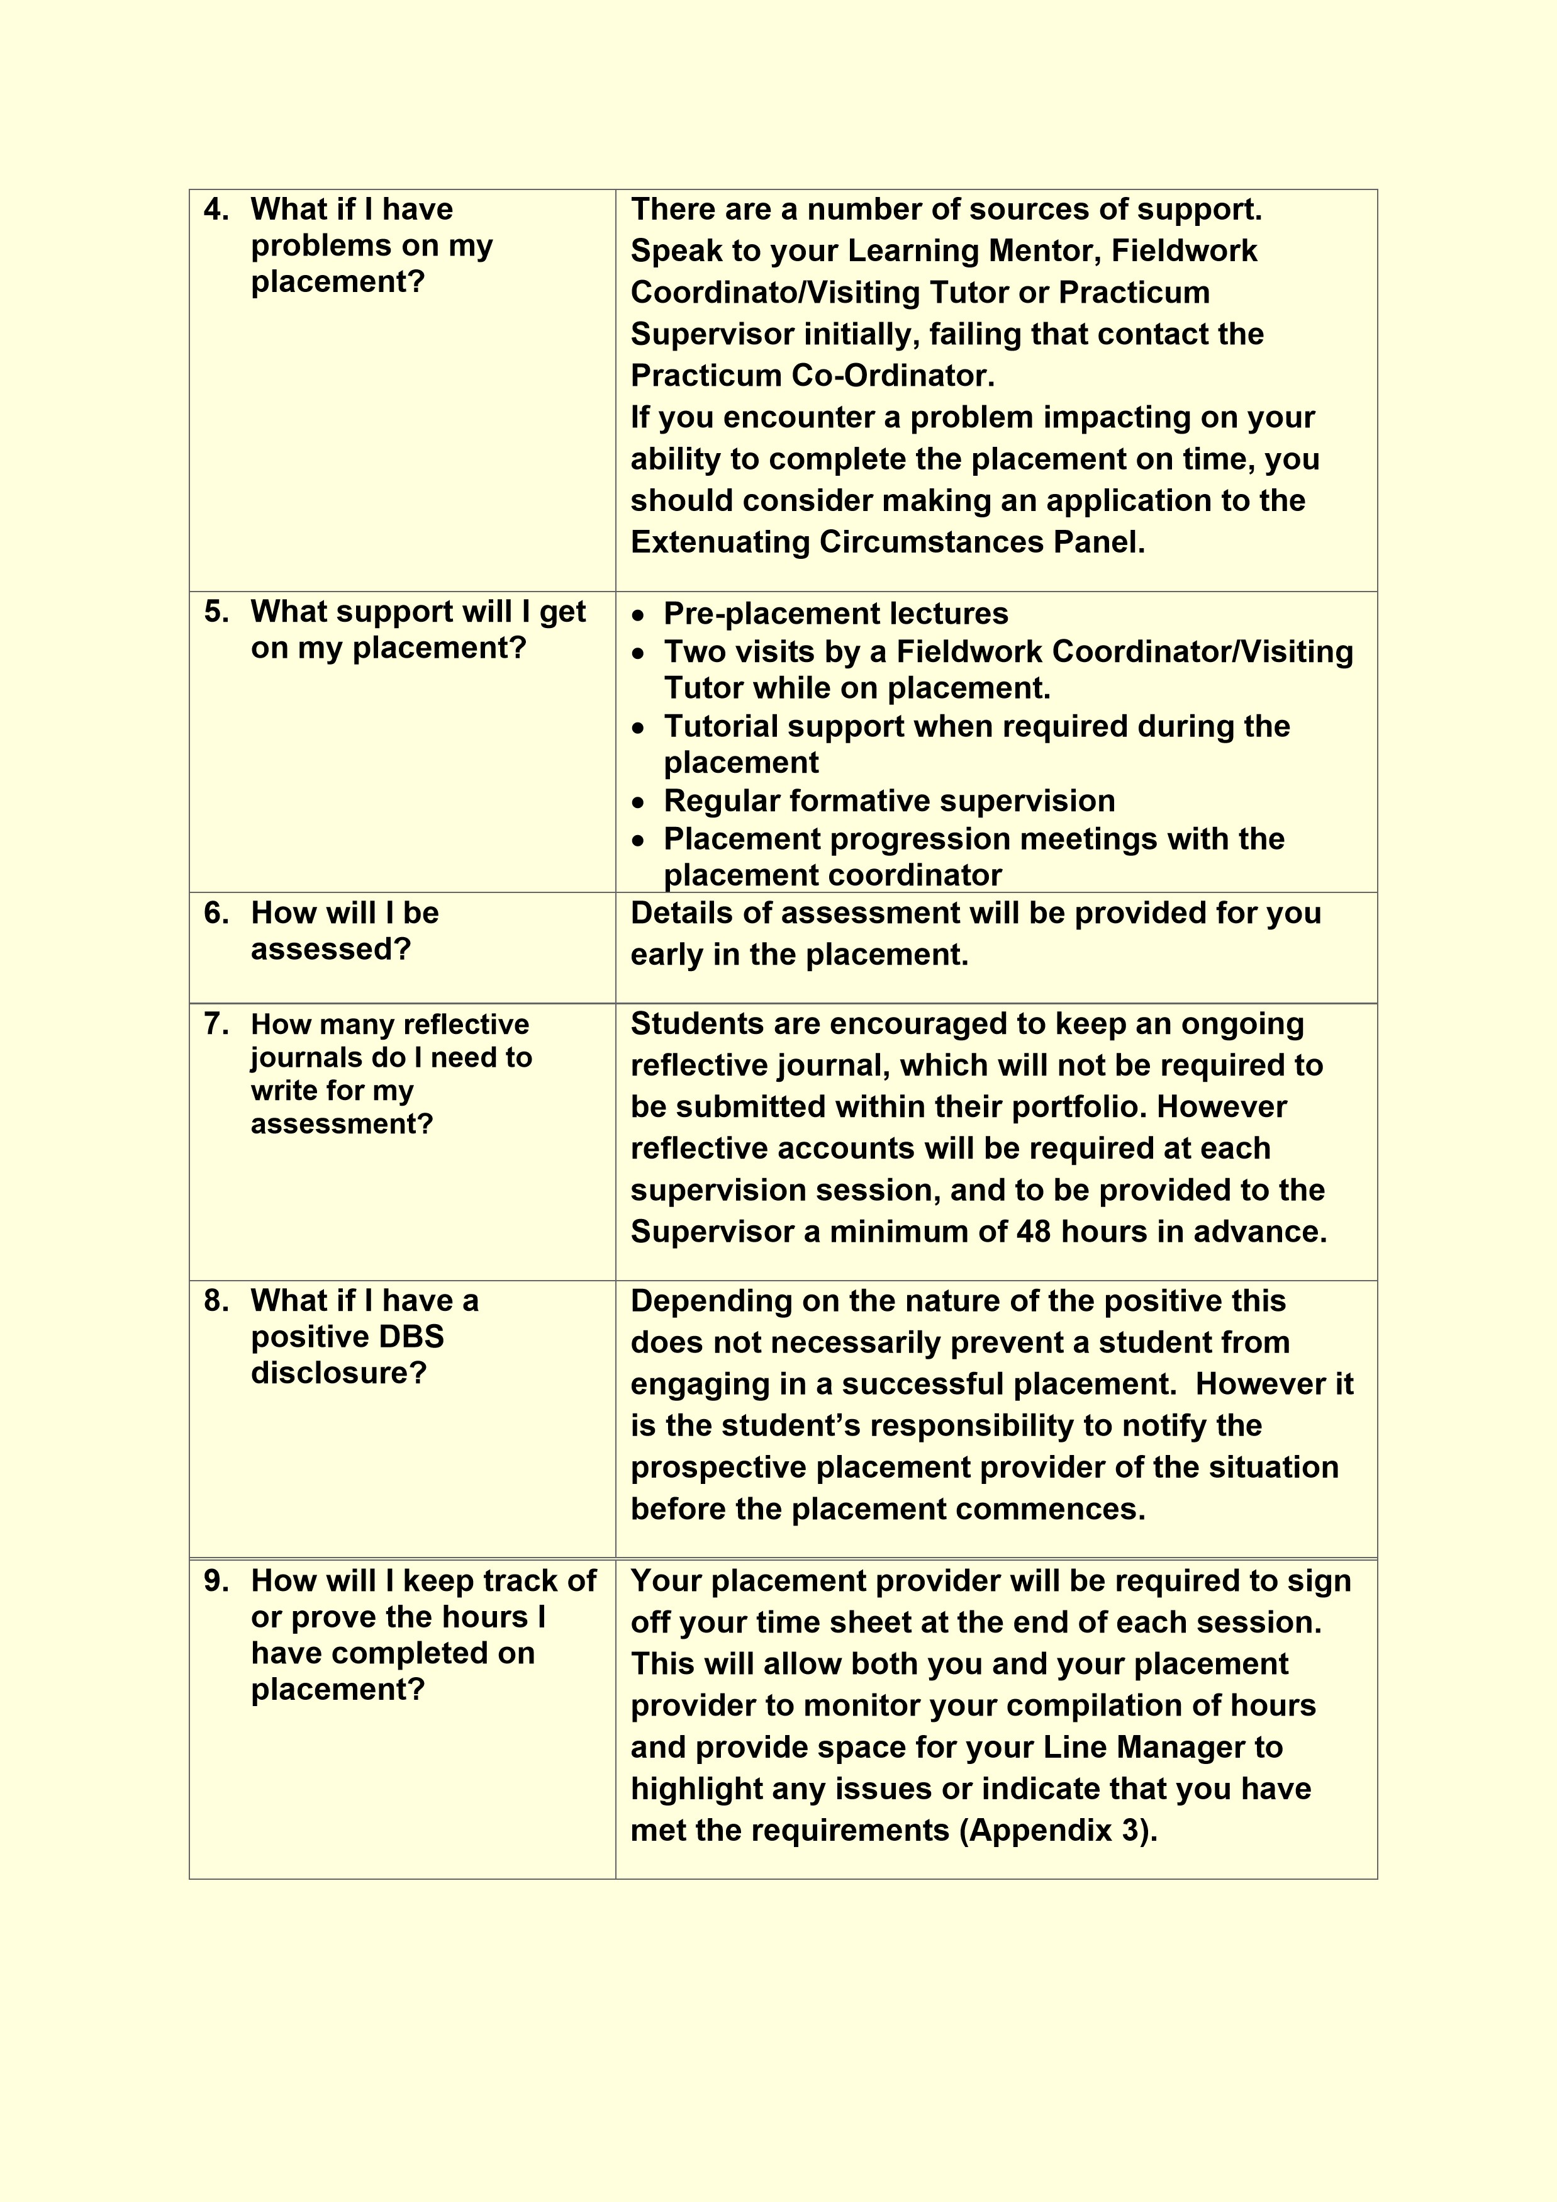

MODULE ASSESSMENT
To further provide students with an understanding of the key approaches and practices linking the theory and practice of Youth and Community Work, with the opportunity to develop students’ youth work skills, knowledge and understanding within an appropriate 400 hour placement, 50% of which will be face to face with young people. The module is assessed completely through course work, and the elements of the assessment are clearly stated below.
Upon the successful completion of this module, the student should be able to:
- Successfully complete a 400-hour placement in accordance with the principles and values of youth work.
- Engage in reflection and supervised practice.
- Begin to identify the development needs of young people in communities and responses associated of youth work in the voluntary and maintained sectors.
- Organise their knowledge and learning through use of a range of information resources, present their work at the appropriate level, and reflect upon sustainable literacy skills developed.
- Be aware of the nature and scope of Youth Work in different sectors and critically analyse, interpret and evaluate relevant information, concepts and ideas.
- Identify the development needs of young people and communities, and through youth work practice provide responses to these needs and taking responsibility for planning and developing programmes of work with young people.
- Use relevant research or developments in Youth Work to analyse and inform actions.
- To further provide students with an understanding of the key approaches and practices linking the theory and practice of Youth and Community Work.
- To provide students with an opportunity to engage in supervised professional practice of 400 hours duration, 50% of which to be face to face with young people.

Please note: At the discretion of the module lecturer, students may have the opportunity to submit their work via a staggered approach. However, students should ensure all these components are submitted in your journal and submit all components together by the final submission. This date will be shared with you during your first week of lectures. You should share these dates with your Learning Mentor Visiting Tutor and Practicum Supervisor so that they have the time to write the necessary reports. You will not be able to submit your portfolio without the completed reports.

ORGANISING YOUR PROFESSIONAL JOURNAL

From your first day on placement begin to build up evidence of your work, your notes
from your induction, team meetings you may attend, planning notes, to do lists,
contacts you make with others, and any form of evidence that demonstrates what
you have tak
en part in while on placement.

The purpose of the professional journal is to enable you to demonstrate learning and
development, of yourself and of your practice. The journal allows you to
demonstrate a structured approach to showing your increasing understanding of the
knowledge, skil
ls and attitudes necessary for effective Youth Work, informed by
relevant policy, values, theory and National Occupational Standards (CLD Standards
Council Scotland, 2019). The journal should be organized into clearly marked
sections before submission.

Your Professional Journal required to be 4500 words in total, including the following
elements:

•

An information sheet of the work placement identifying the aims, objectives,
vision and background of the organisation, along with roles and
responsibilities of the trainee youth worker whilst on placement.

•

A community profile.

•

An example of a needs assessment, for example NAOMIE.

•

An in
-
depth analysis of a piece of work planned and developed by the
student, demonstrating its links to policy.

•

A

summary of your own learning and development, linked to your professional
development plan and underpinned with reference to examples from your
practice and appropriate literature such as National Occupational Standards
for Youth Work.

WORKPLACE RISK ASSESSMENT
In preparing for placement you must read your University Regulations
Undergraduate Student Guide, specifically the sections on your responsibilities with regard to health and safety. If you have any concerns about health and safety prior to or during placement then please contact your Learning Mentor or Visiting Tutor. During the first week of your placement, you will be required to complete the relevant sections of your Practicum Health and Safety handbook. It is the students’ responsibility to submit the Health and Safety paper work to the Practicum CoOrdinator on time. Failure to do this will impact upon your ability to continue on your placement.
There will be other risk assessment procedures in place within the host organisation which you will be required to adhere to. Please draw on the support of your Learning Mentor to complete the exercise below.

How to calculate the level of risk
A hazard is anything with the potential to cause harm e.g. a fall from height - perhaps a few feet from a stepladder or a considerable distance from a cliff edge. The risk is the likelihood that an unplanned event involving the hazard will occur. The likelihood reduces in proportion to the precautions taken - training, safety equipment, planning etc. By carrying out a risk assessment, you can direct attention and resources where they are most needed to prevent injuries or ill-health. The five steps to carry out a risk assessment are:
Step 1. Identify the hazards - find out about where and how you will be working.
Step 2. Identify who might be harmed and how - think about risks to yourself and others, including young people. People with health problems, disabilities or lacking experience may be at greater risk and need extra protection.
Step 3. Evaluate the risks (likelihood) and risk level (severity) - (likelihood x severity) taking into account the present precautions and consider if and how the risk levels of harm can be reduced (if they need to be) - i.e. what extra arrangements, equipment and training etc. will help to avoid accidents or illness and ensure a ‘low’ RA scoring using the matrix.
Step 4. Record your findings - on the risk assessment form below. This assessment should be included in your placement portfolio. Don’t just fill in the form and forget it - make sure everyone in the team knows about the risks and how to avoid them.
Step 5. Review and revise your assessment where necessary - you should do this when there are significant changes in materials, equipment, work methods, location or people involved or in changing weather conditions. Assessments should also be reviewed if there are accidents, near-misses or complaints associated with the work.
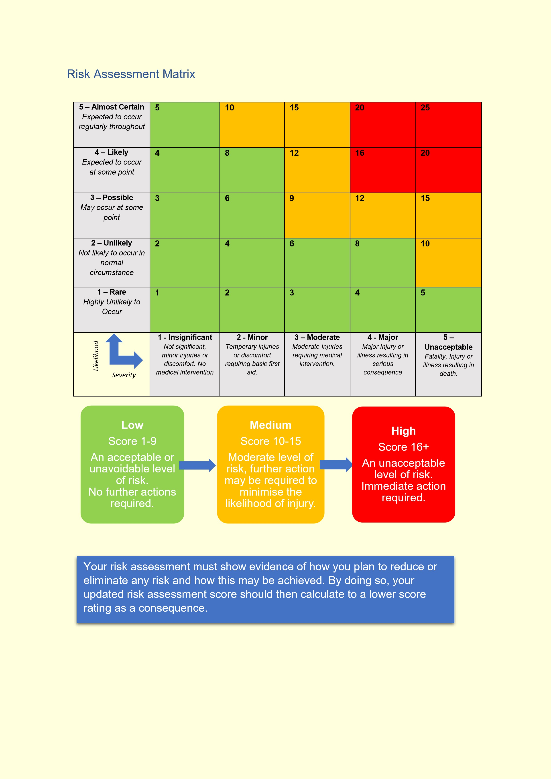

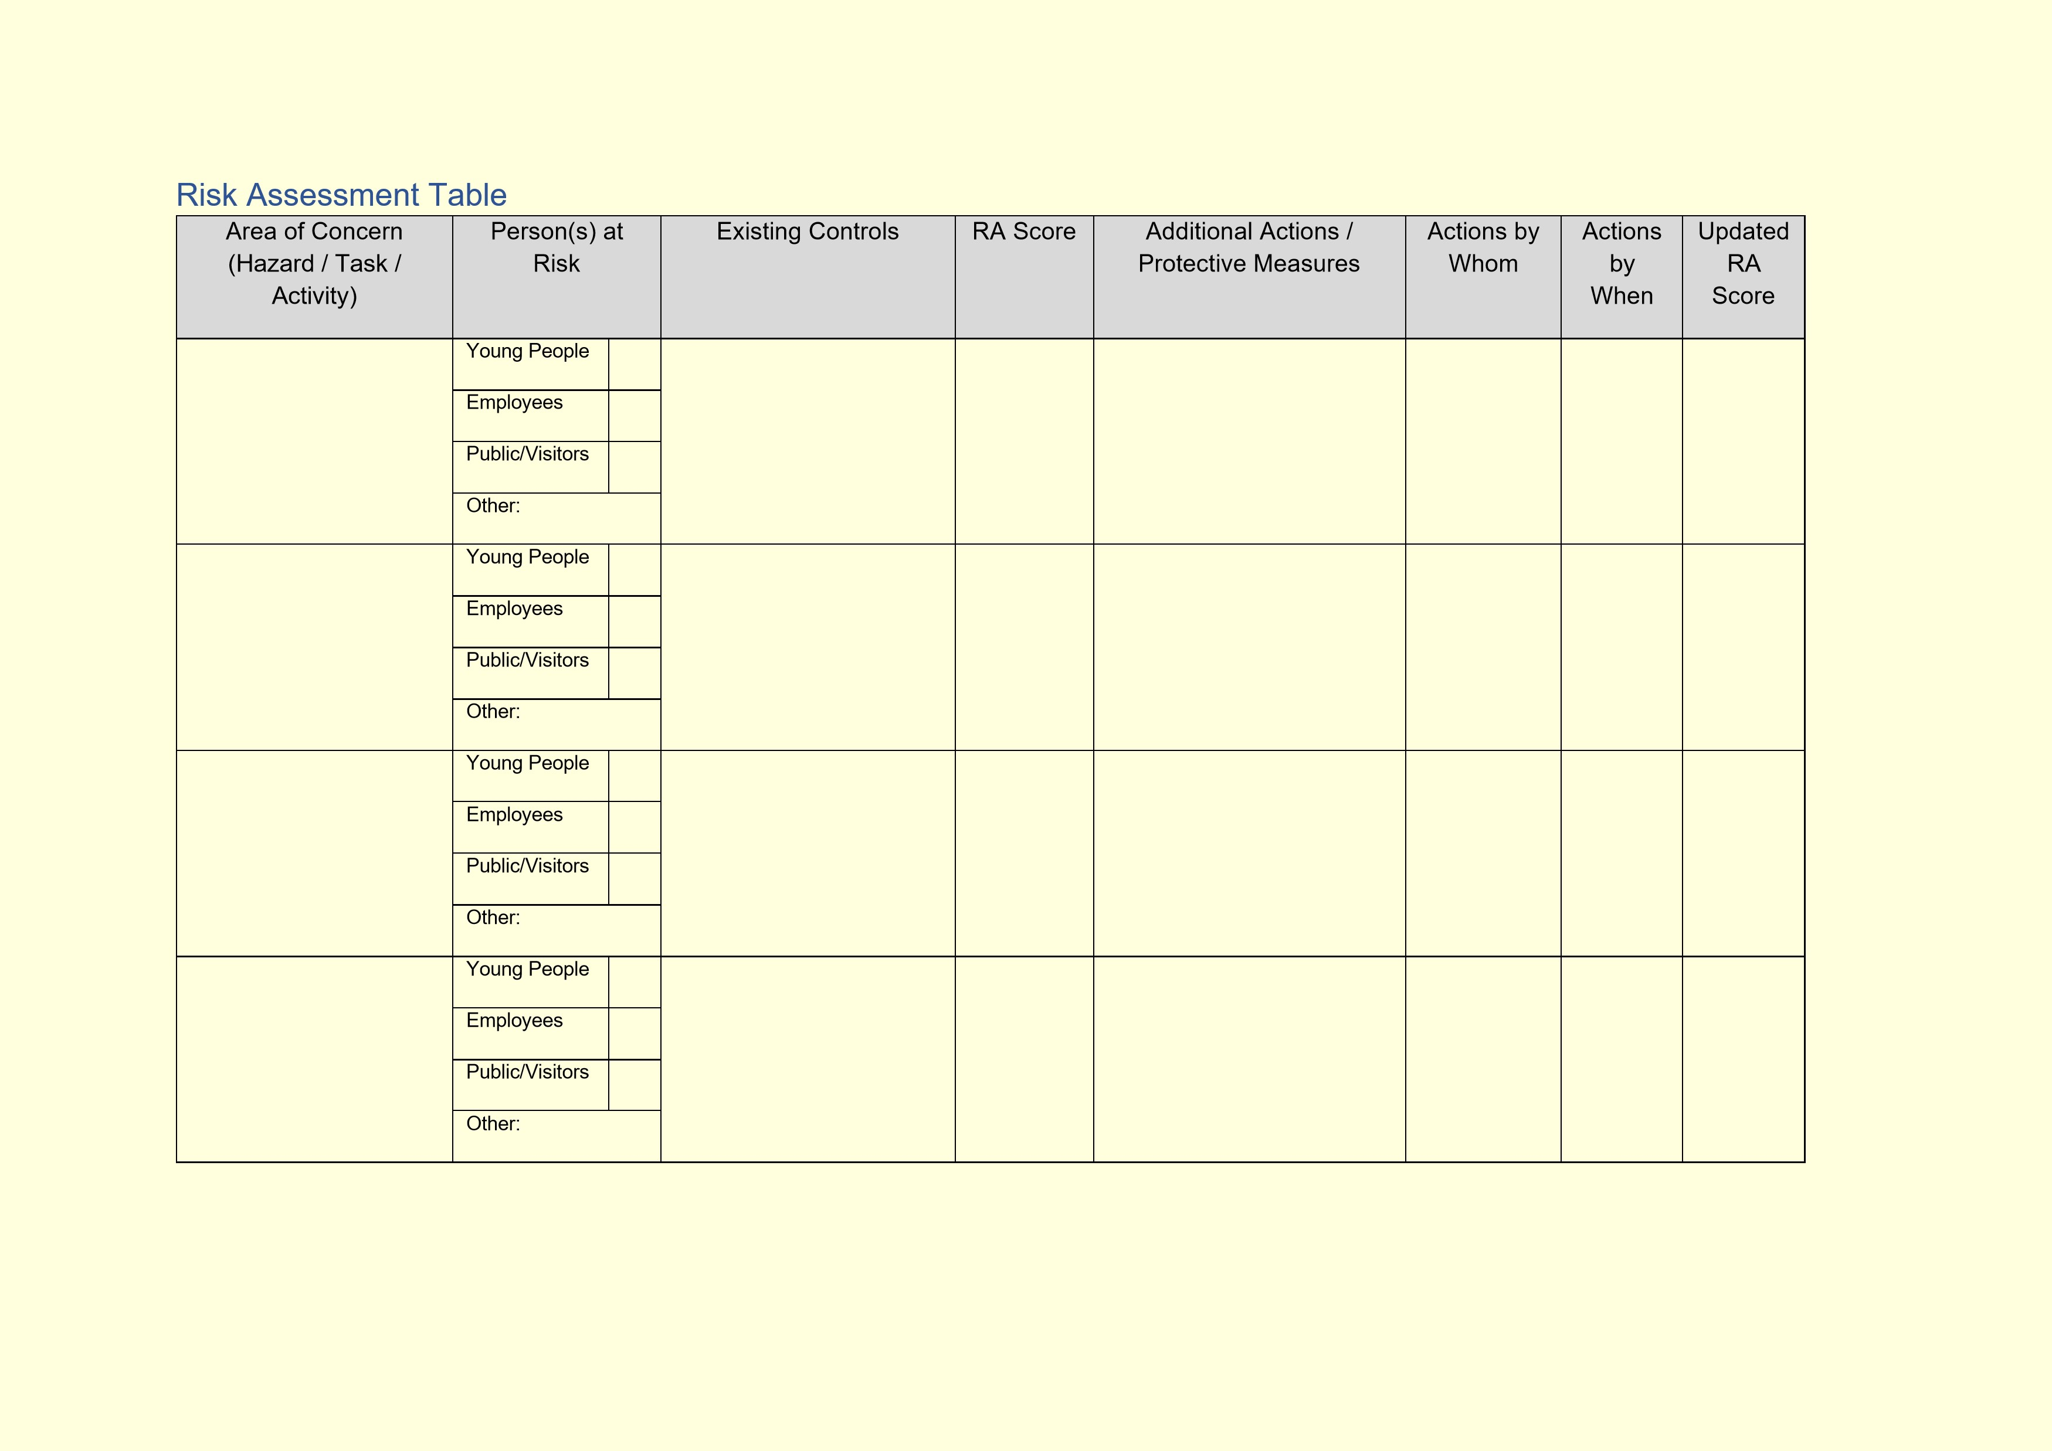
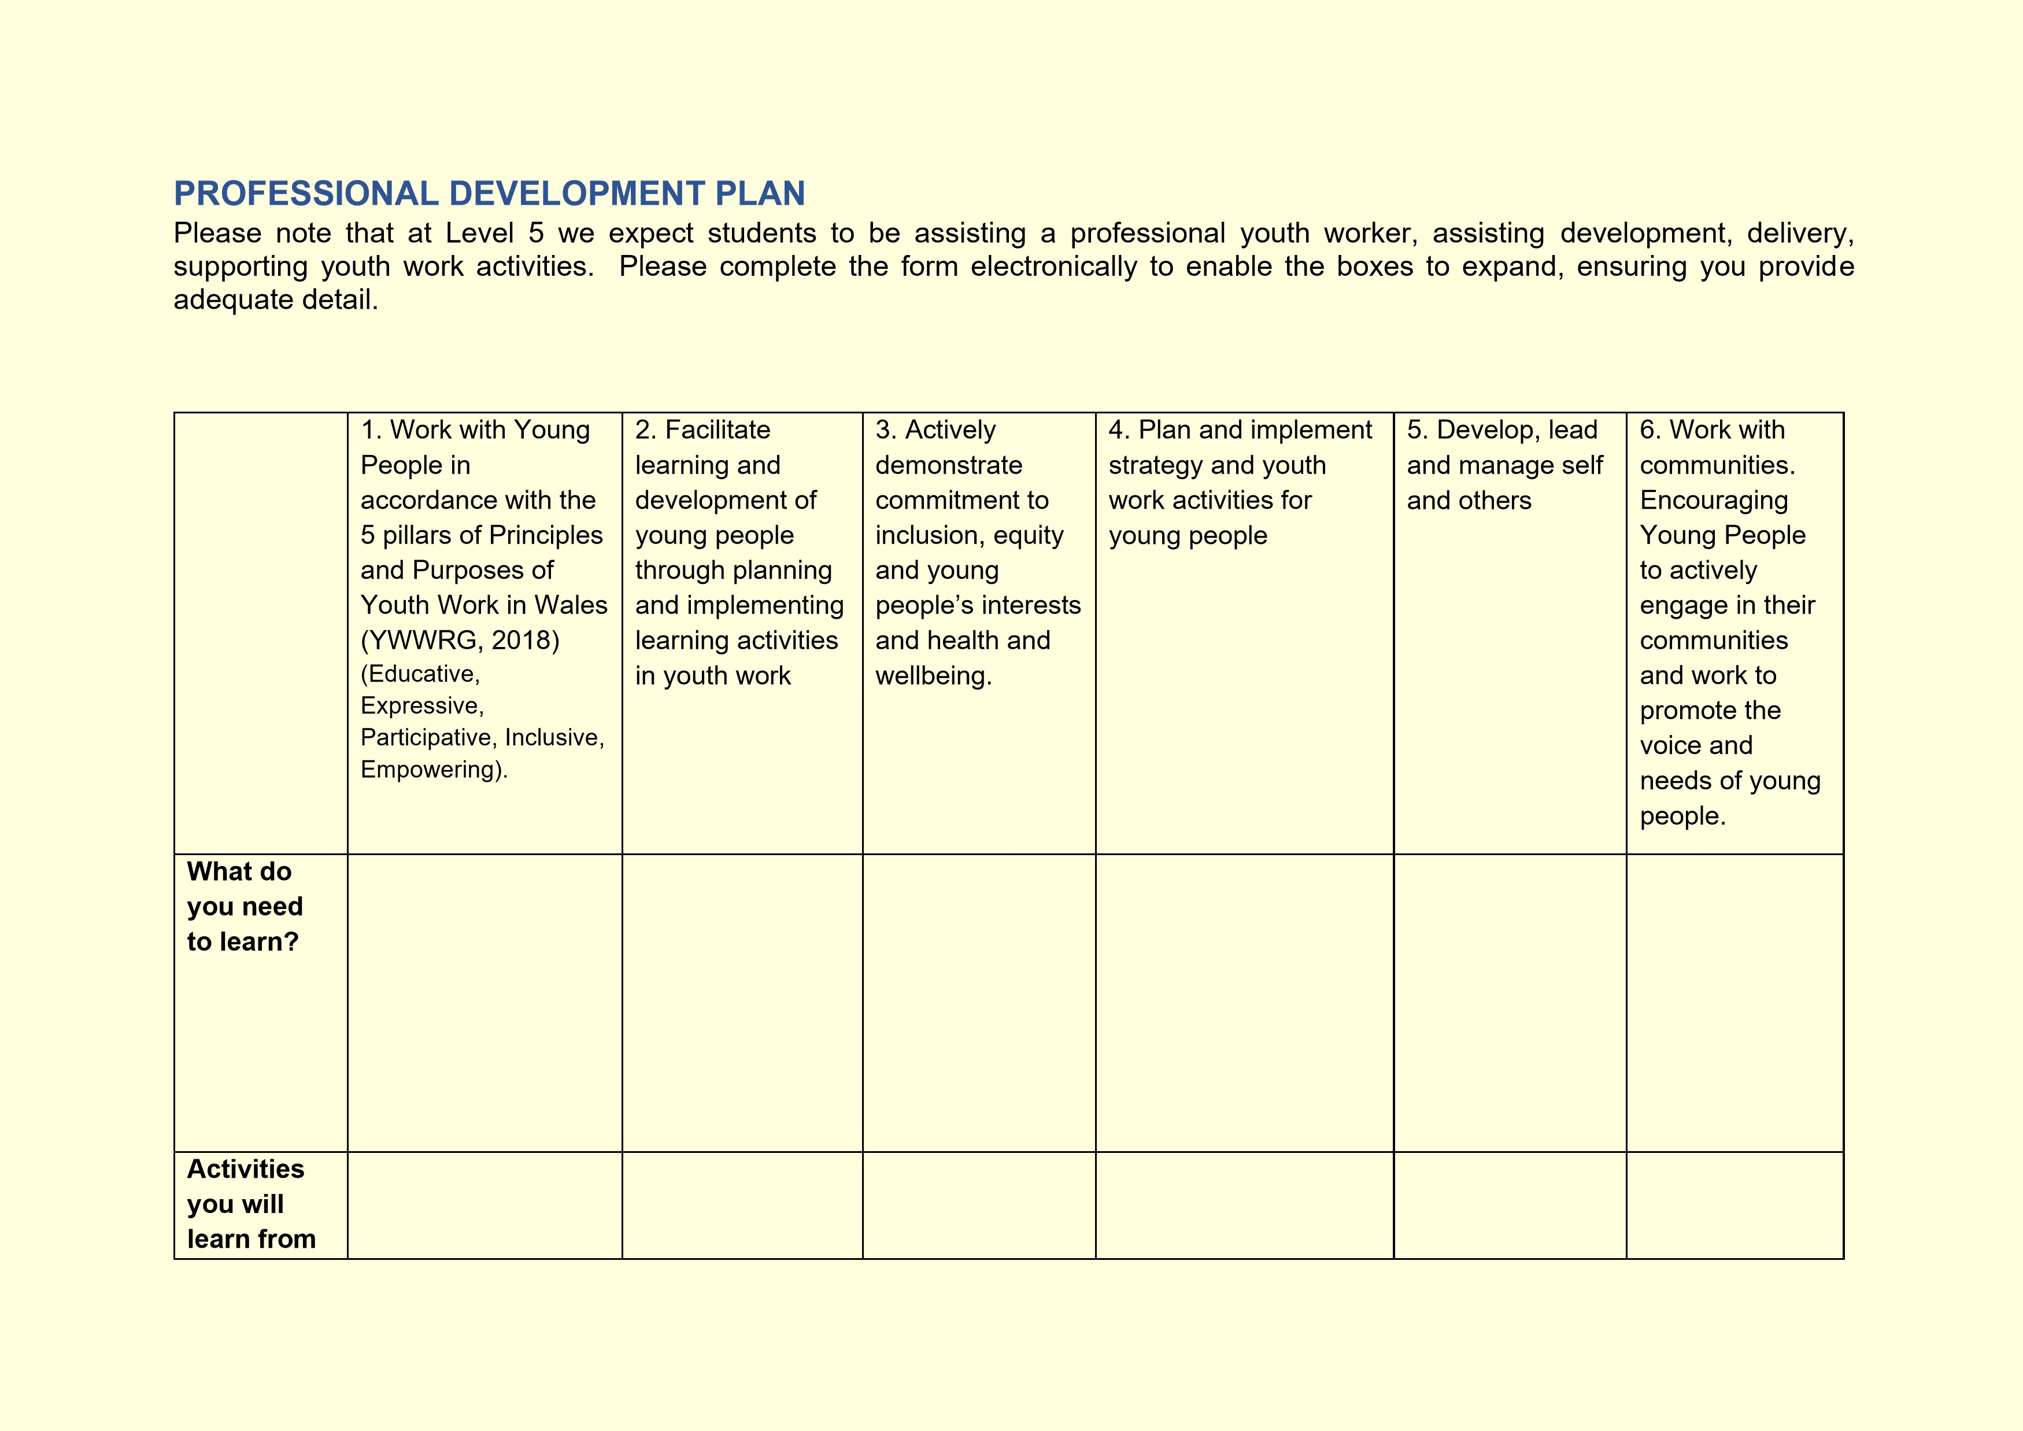

how
(
will
you learn,
what will
you learn
from)

Student

Supervisor

Date

PROFESSIONAL DEVELOPMENT PLAN TEMPLATE

For completion by the student after consultation with the Learning Mentor and
Practicum Supervisor at the outset of the Placement

Student

Learning
Mentor

Placement

Date

Students will be expected to consider their placement
experience to demonstrate
competence in the key aspects of youth work outlined in the table below based on
the National Occupational Standards for Youth Work (CLD Standards Council
Scotland, 2019) and the Youth Work in Wales: Principles and Purposes Docume
nt
(
YWWRG,
2
022
).

Learning Mentor’s opening comments about the placement
–

exactly what type of
work will the placement involve?

Student initial comments about the Placement.

PRACTICUM PLACEMENT SUPERVISION
Supervision is a crucial aspect of the placement and helps the student gain deeper understanding of the profession and its ideals. The purpose of practicum supervision is to enable the student to ultimately deliver the best possible service possible to young people. The supervisor has a key part to play in both ensuring that the student is making progress but also enabling this progress to take place.
These functions of supervision can be achieved by supervisors being clear of their educational role in the development of the student. However, as individuals learn differently it may be necessary for the supervisor to adapt their approach to suit the needs of the student in order to achieve the desired learning outcomes.
This ability may at times involve adopting a person-centered approach, being mindful of the restorative function of supervision and at other times being more task focused and focusing on the normative function and being concerned with achievement of standards.
However, the overwhelming focus of the supervision must be on the learning and development of the student. This learning may be achieved in a number of ways through supervision but must remain the overall priority of practicum supervision.
When preparing for a Supervision meeting
When preparing for supervision students can ask themselves a number of questions including:
· Have I prepared examples from my reflective journal for discussion?
· Have I set aside adequate time to prepare for supervision and to identify agenda items?
· Am I open to feedback from my supervisor?
· Am I able to acknowledge my own strengths and areas for development?
· How well do I respond to new ideas, challenges or constructive criticism?
· Would I like my supervisor to do anything differently?
· What could I do differently next time?
· What learning have I gained?
· How will I improve my practice as a result of this supervision session?

On the next page is a supervision contract and supervision recording pro forma.
Please ensure you are addressing agreed learning outcomes in your discussions. These are an important source of evidence for the student’s portfolio of evidence.

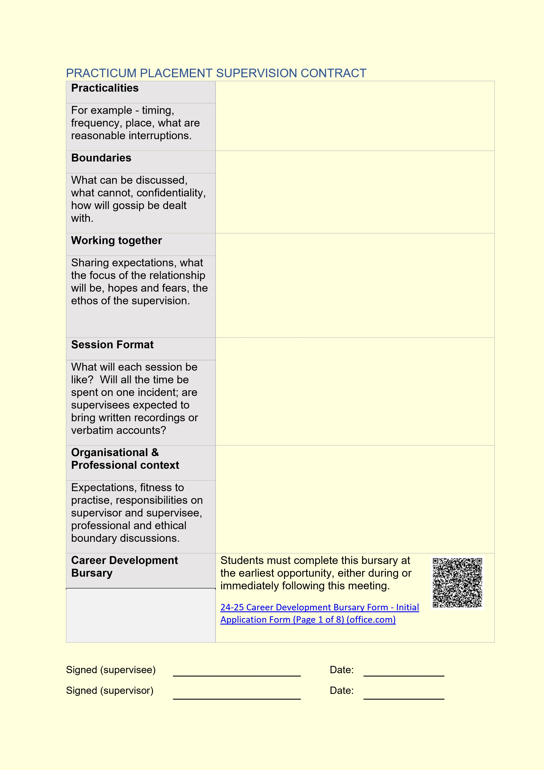
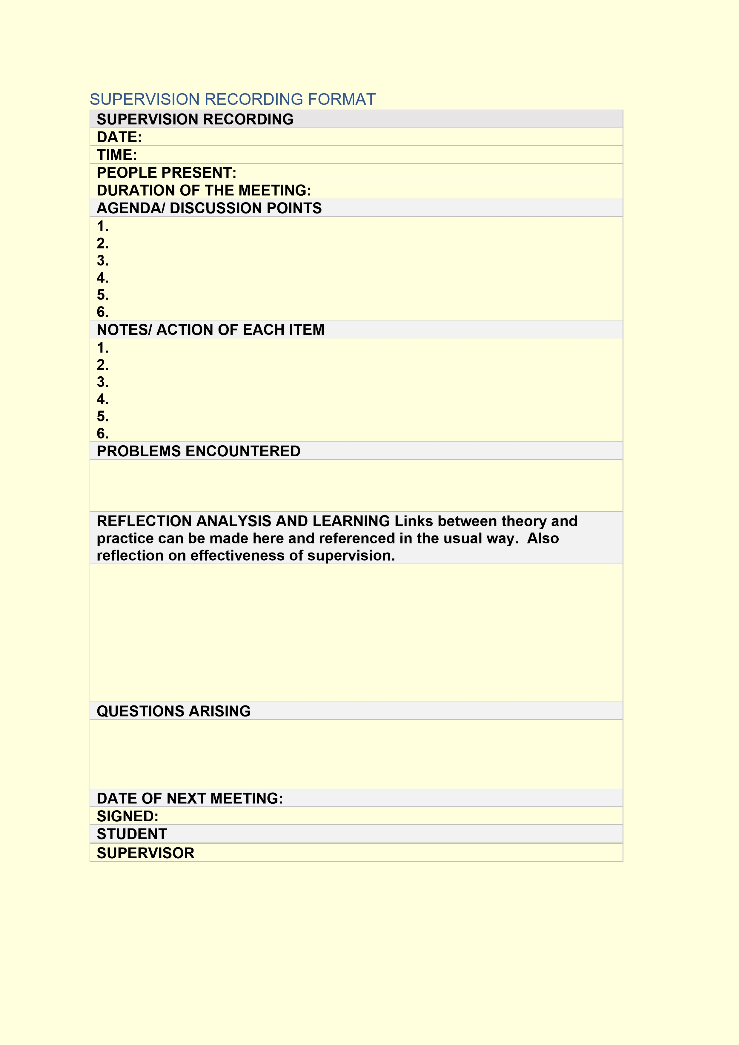
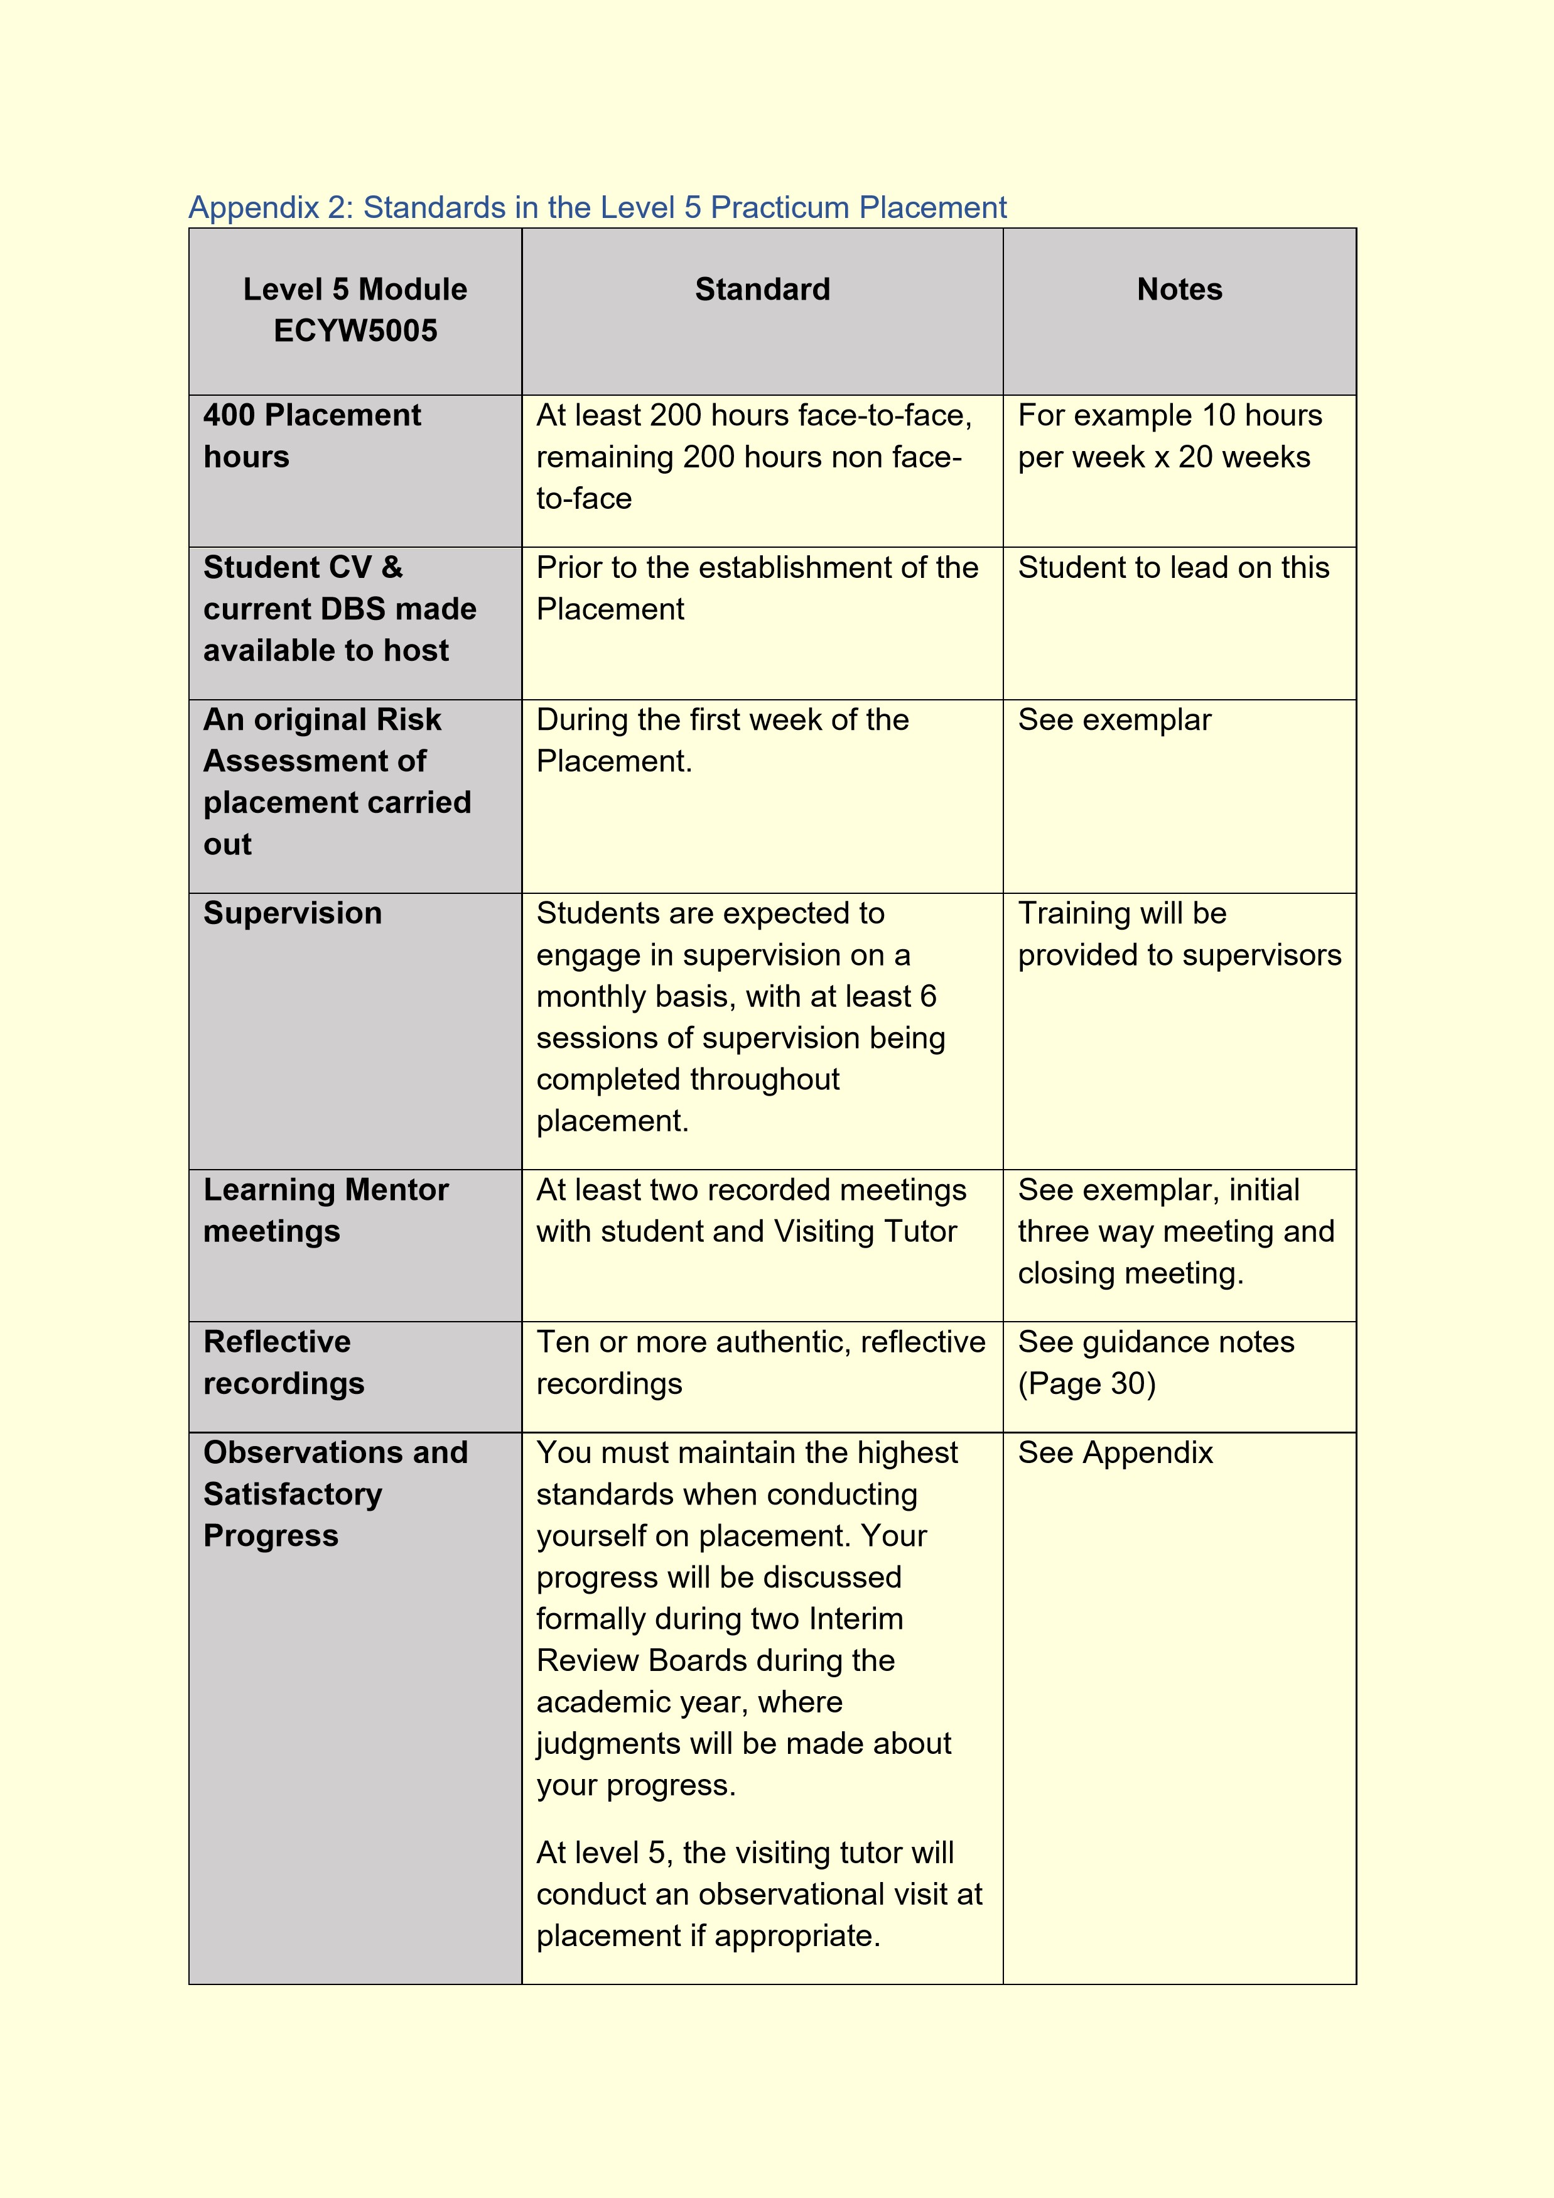

Communication

It is crucial that we
communicate effectively. It is
good practice to keep in regular
contact with tutors, and the
student email is an effective way
to contact tutors. When
contacting tutors avoid using
informal language including
using text speak, and p
lease
remember to identify yourself in
the email. Also it is good
practice to make regular use of
Moodle as a way of keeping up
to date with developments and
announcements.

Please refer to the
policies that refer to
the required processed
when absent from
placement.

Final Reports
provided by the
Learning Mentor
and Practicum
Supervisor

Learning Mentor and Practicum
Supervisors are asked to
consider the level of
competence of a student shown
within placement and
supervision sessions.

Following the completion of
hours and the closing th
r
ee
-
way
meeting, both parties must
provide a final report providing a
grade of the students
’

progress
in line with the marking criteria.

It is the student’s responsibility
to ensure enough notice is given
to
L
earning
M
entor and
P
racticum
S
upervisor, to ensure
an appropriate amount of time is
allowed for the completion and
return of these reports, to meet
the deadline.

The outline and
marking criteria for
these reports can be
provided by the Visiting
Tutor upon completion
of the final meeting.

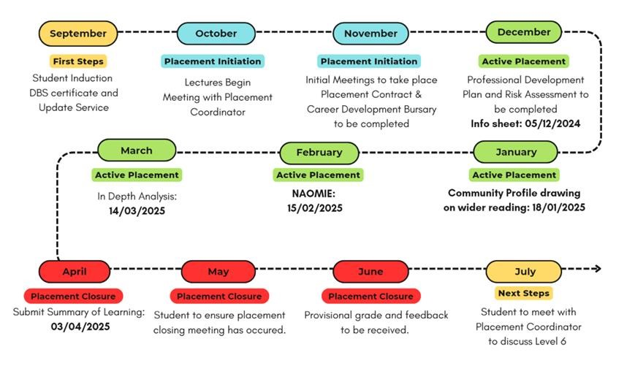

Appendix 2:
ECYW5005
Fieldwork 1, A timeline through the module

Full
-
time student
timeline

Should a student feel they are unable to meet assignment deadlines or experience circumstances that make it
impossible to meet assignment deadlines, they must complete an Extenuating Circumstances form to request an
extension. Students are asked to contact

their module lecturer to discuss issues relating to assignment
deadlines and are personally responsible for submitting their request.

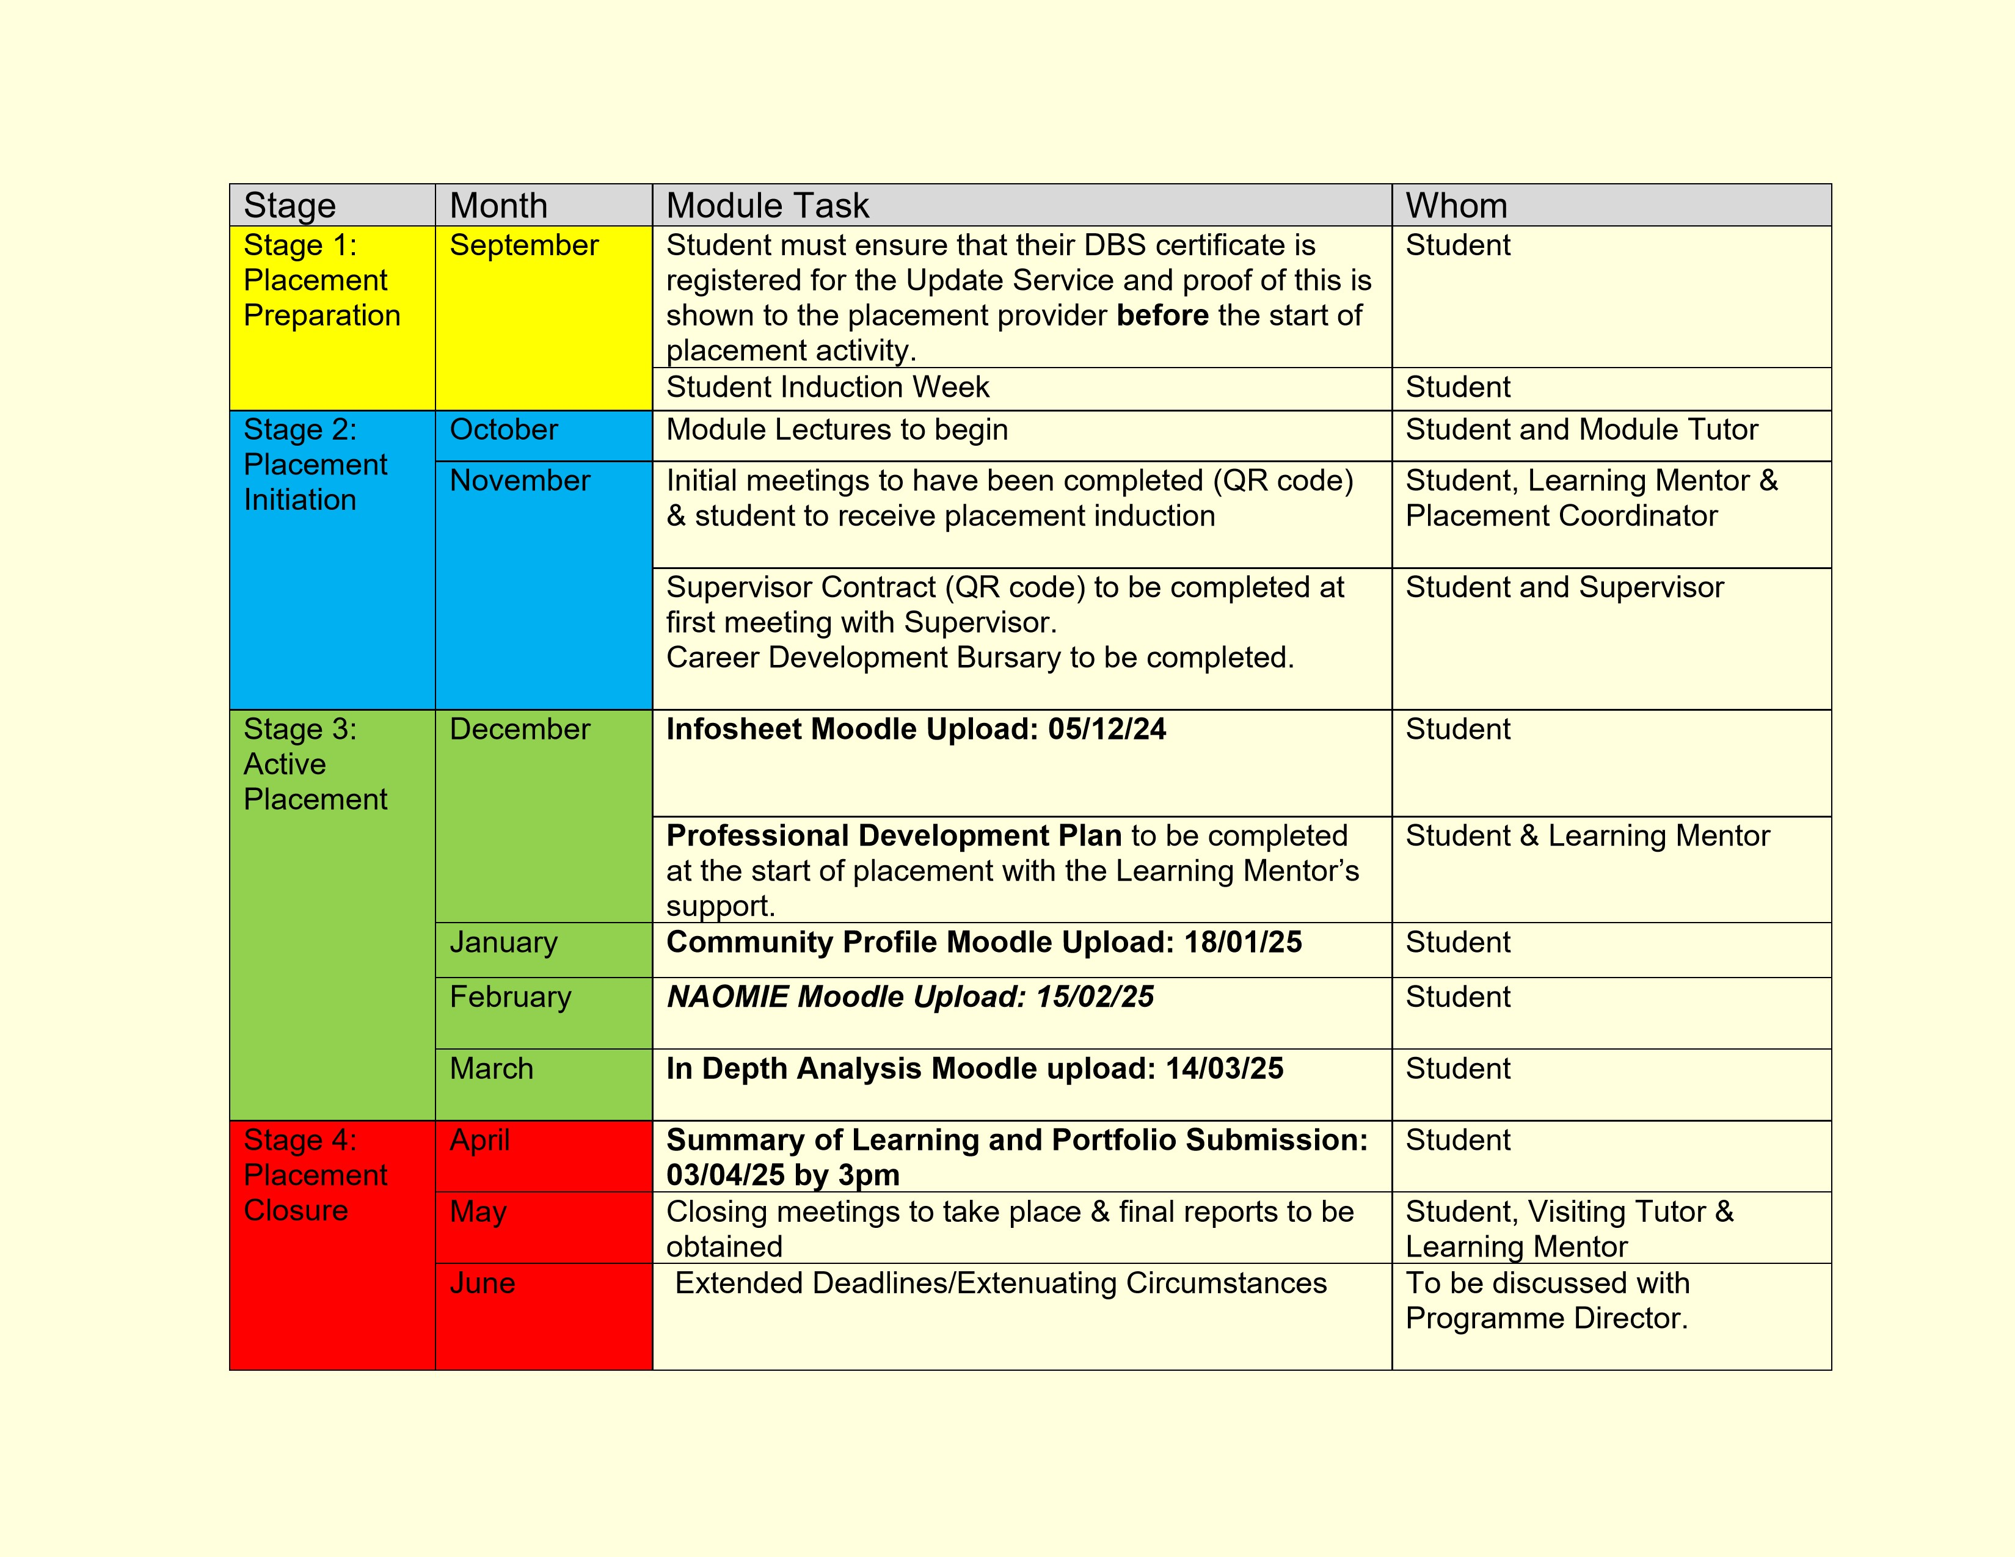
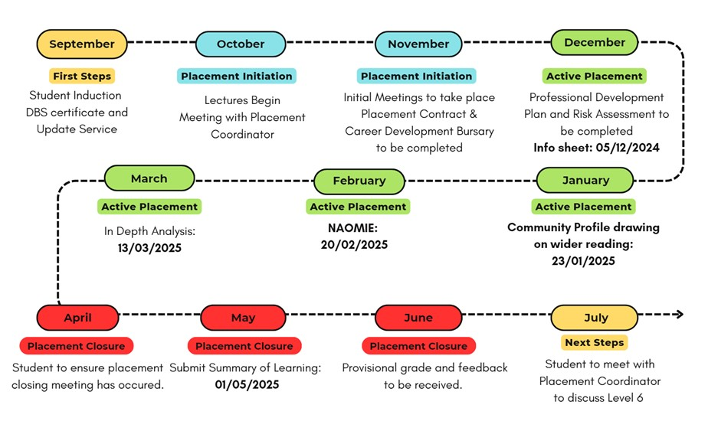

Twilight student timeline

Should a student feel they are unable to meet assignment deadlines or experience circumstances that make it
impossible to meet assignment deadlines, they must complete an Extenuating Circumstances form to request an
extension. Students are asked to contact

their module lecturer to discuss issues relating to assignment
deadlines and are personally responsible for submitting their request
.

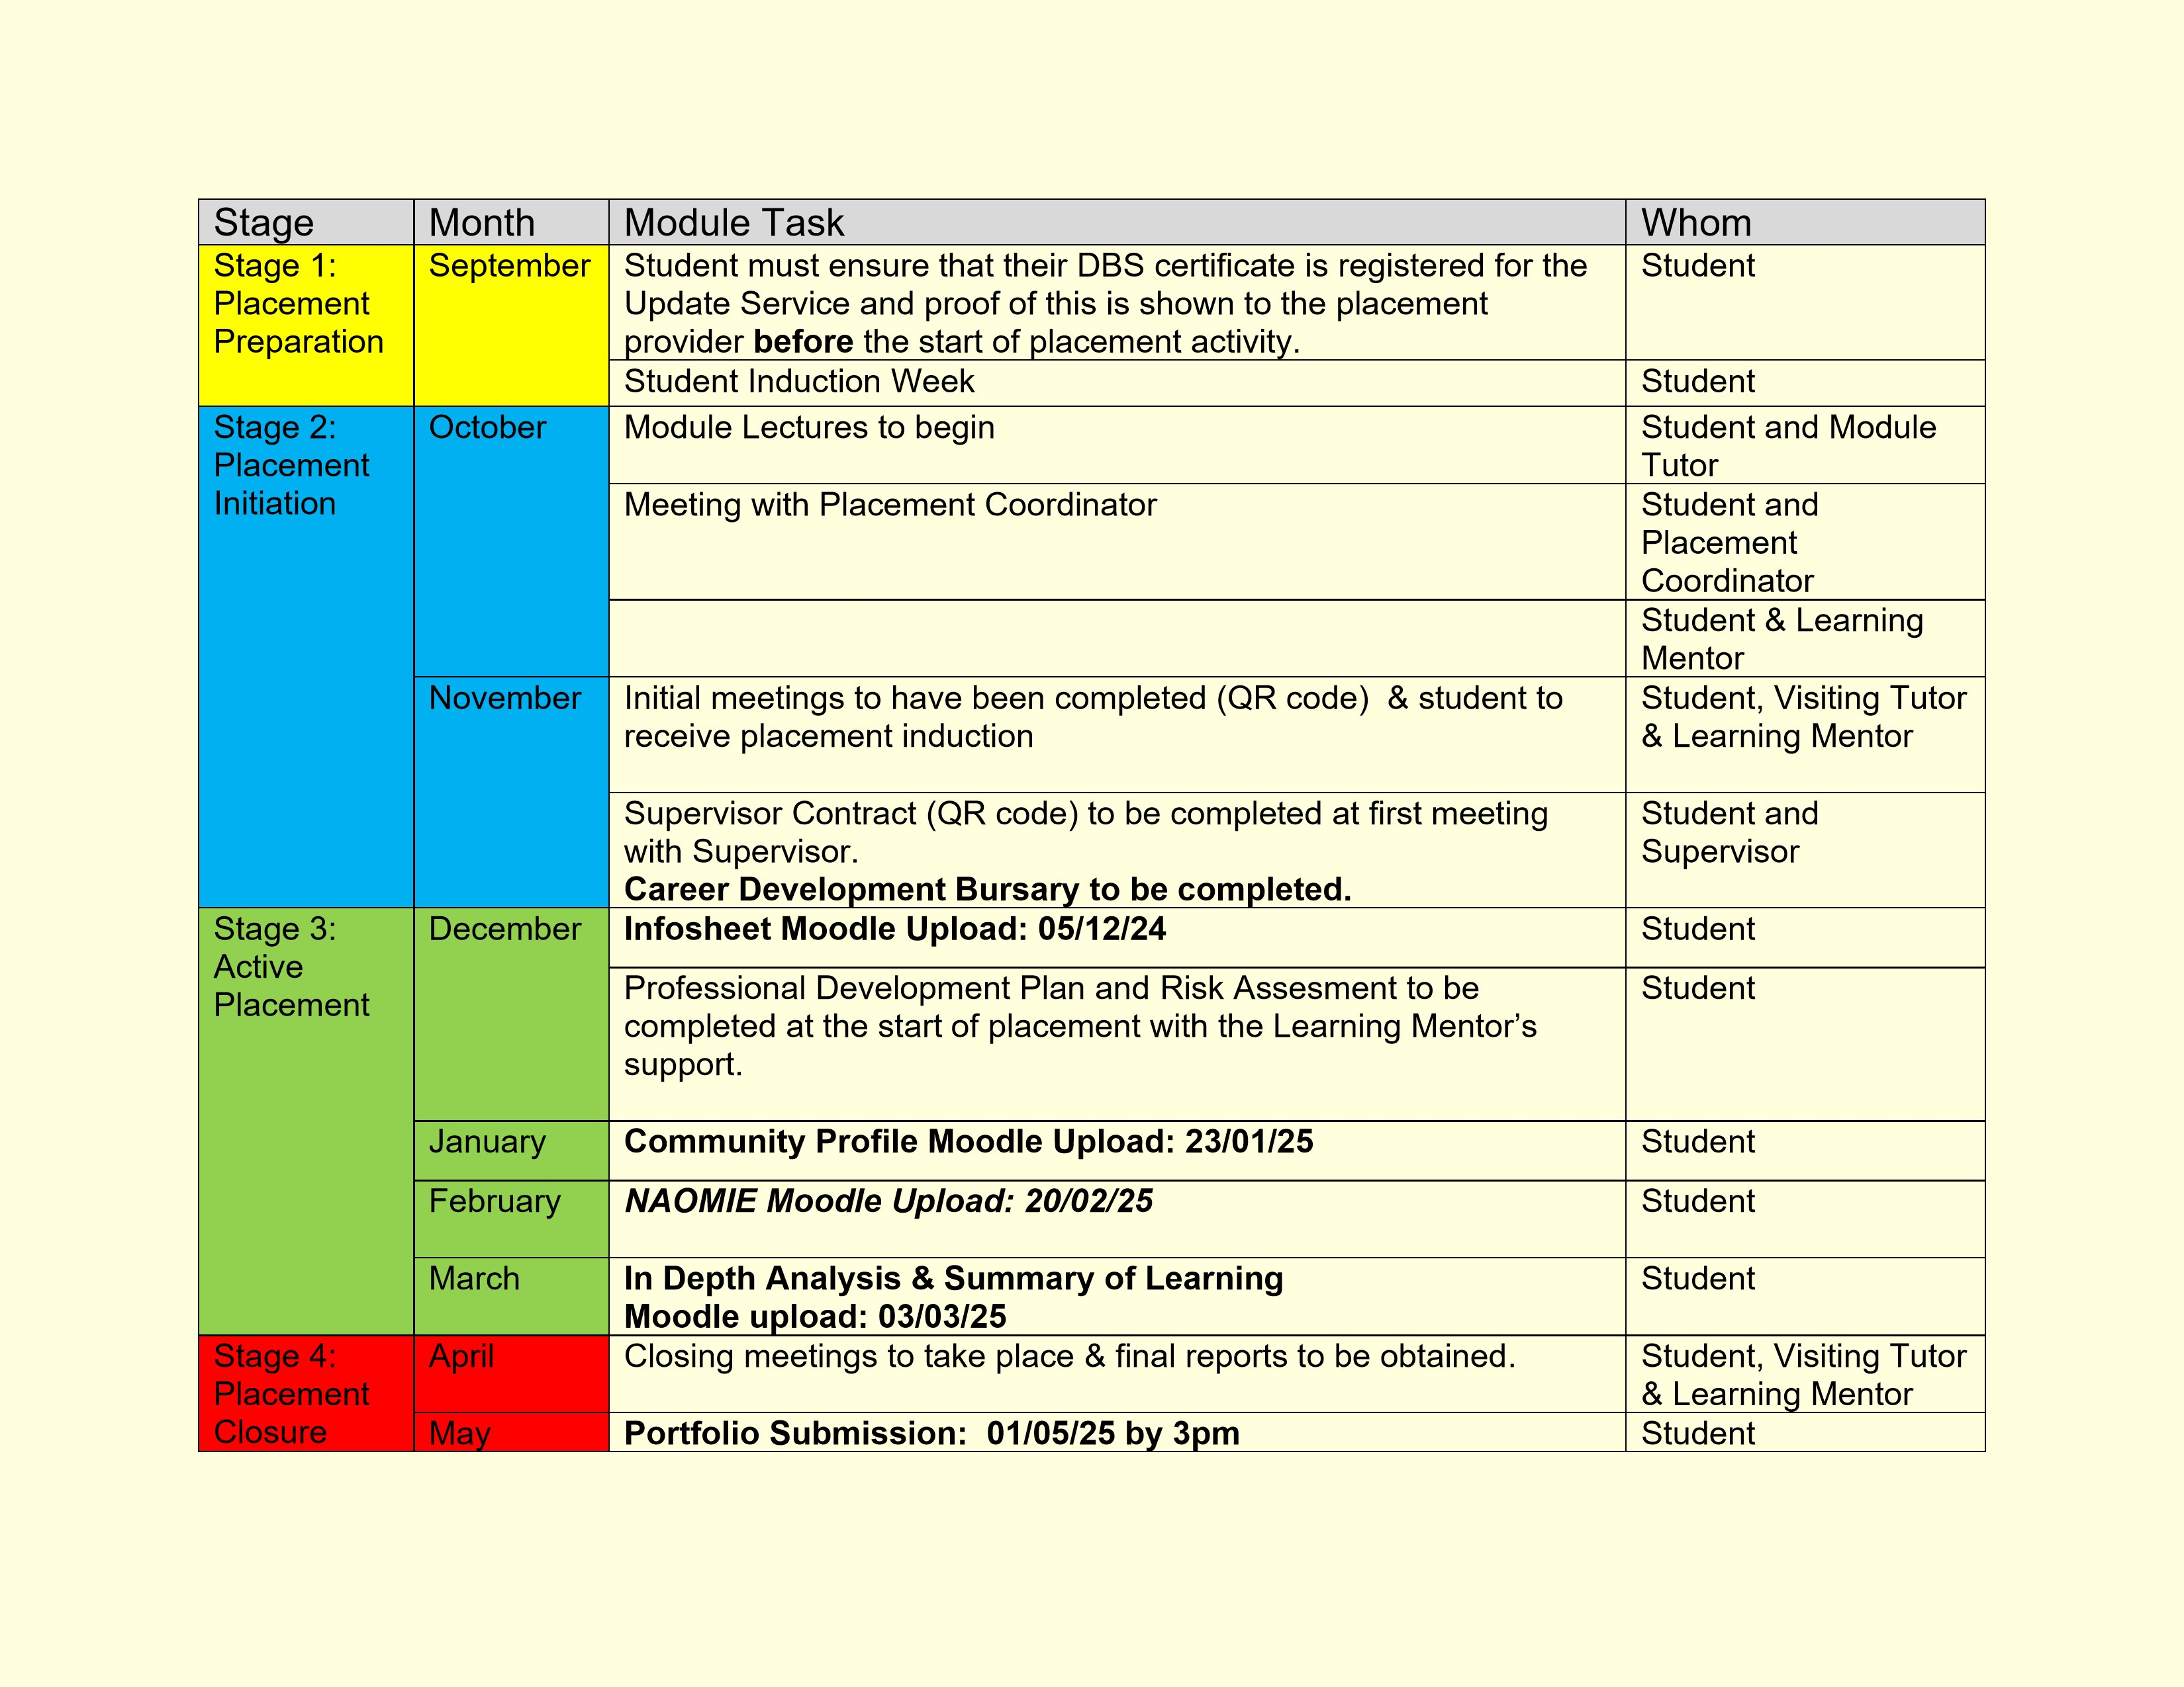
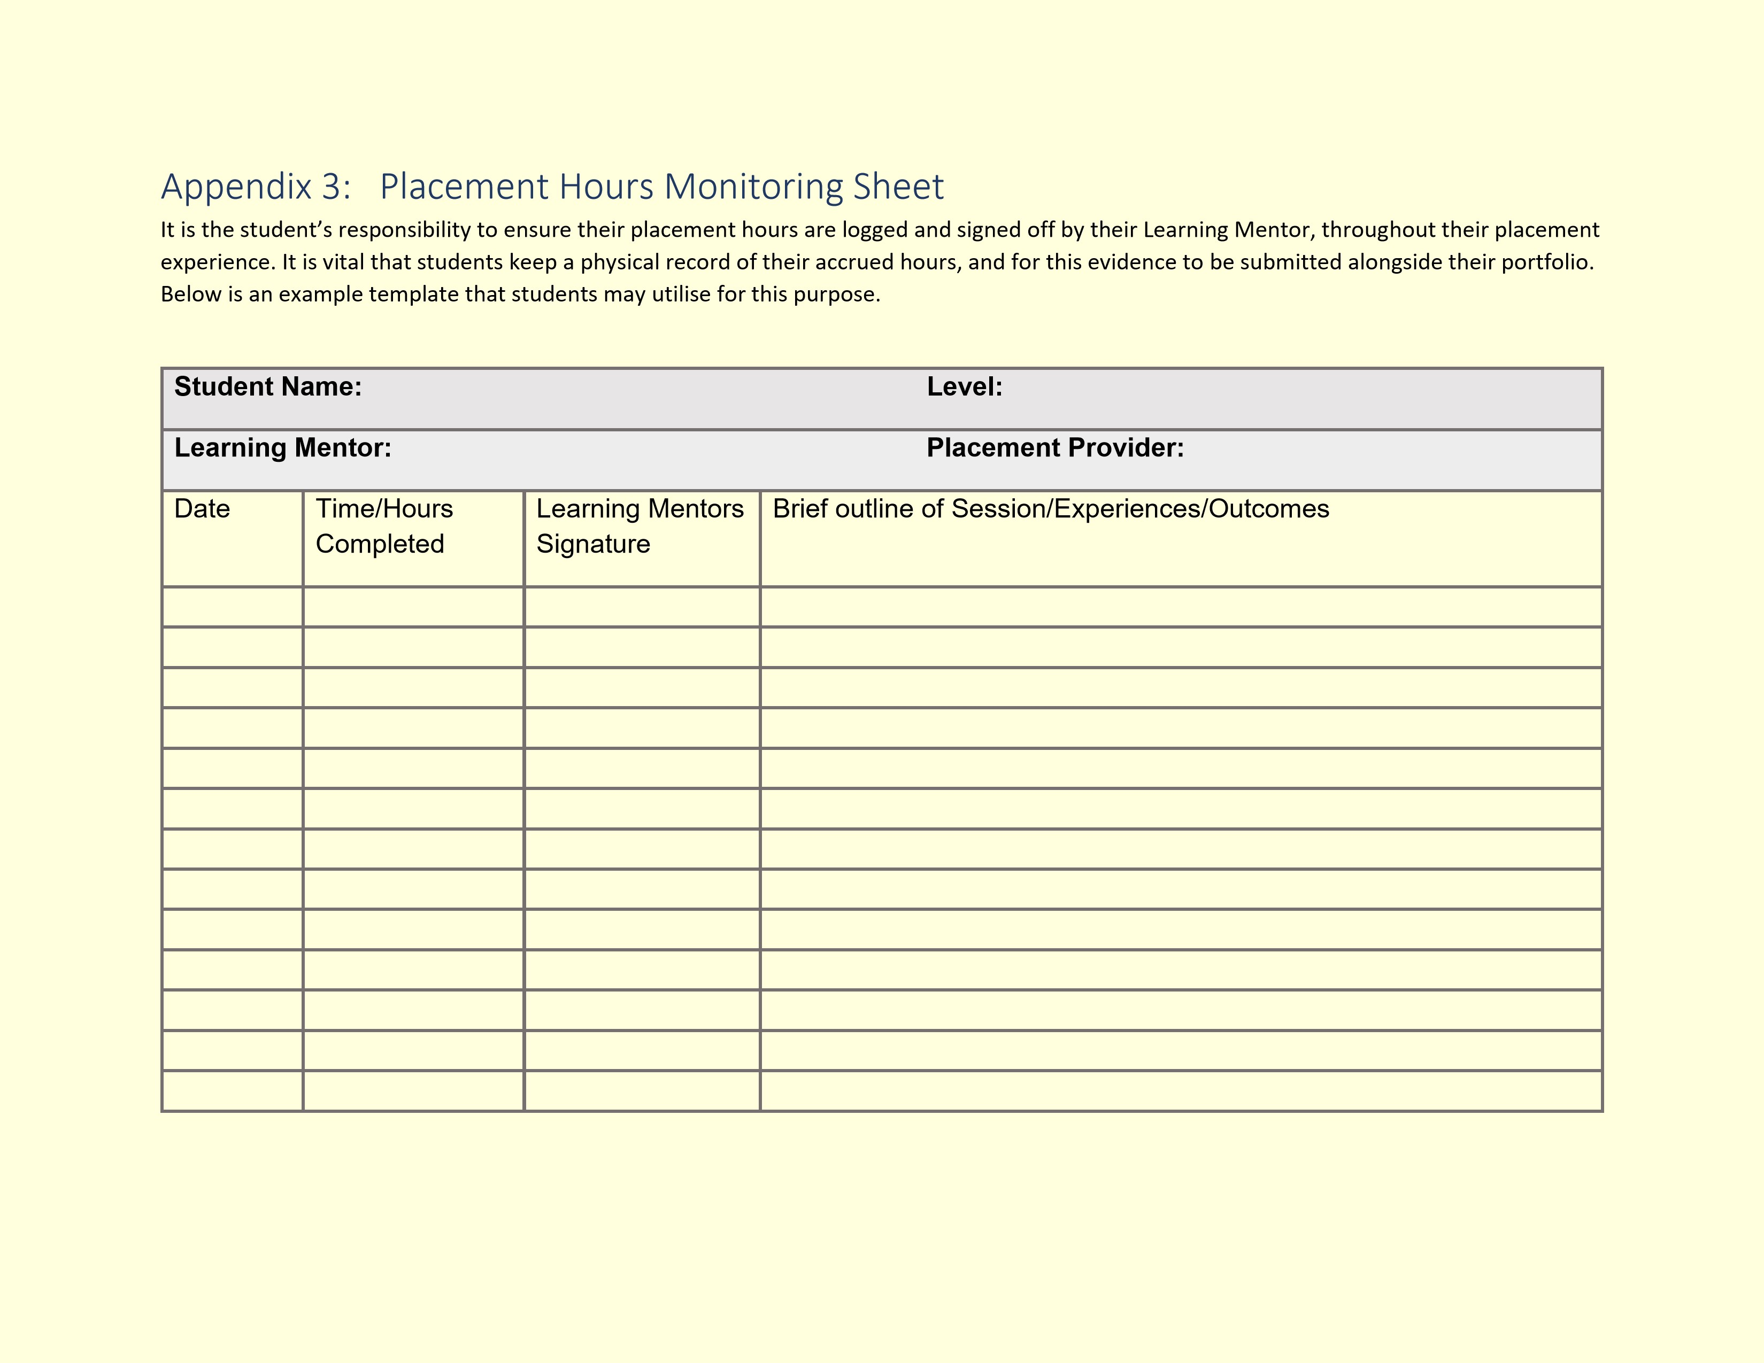

Appendix 4: Final Reports

PRACTICUM SUPERVISORS FINAL REPORT

When considering the level of competence of a student in supervision please refer to the
marking criteria outlined below:

Percentage marks
towards HE
qualification

Description

<
%
70

An exceptional trainee Youth worker who is a reflective practitioner; shows initiative and an
ability to work independently for a sustained period;
demonstrates thoroughness and
commitment to all aspects of professional practice.

60

–

69
%

An effective trainee youth worker who displays a degree of independence and commitment
to further professional development.

50
–

%
59

A satisfactory trainee youth worker who has met the requirements appropriate for a
professionally qualified Youth Worker and with further experience should develop into an
effective youth worker.

40

–

%
49

A rather weak trainee youth worker with a basic level of knowledge or
skill. May be very
poorly organised with very limited understanding of important concepts

<
40
%

A weak trainee youth worker who has been unable or unwilling to meet the required
standard, may demonstrate inappropriate values or lack understanding or attention to
detail.

This section of the report should be completed by the fieldwork supervisor. To complete the report we would like you to
use the headings below giving specific examples to support your observations.

How did the student use supervision and respond to feedback?

Cassie brought examples from placement into the sessions- this allowed for some reflection on situations and exploration of next steps- not only to help Cassie develop individually but also help there practice. They took everything that was suggested on board and was keen to try out the suggestions, of which we then reviewed on in future supervisions.

To what extent did the student seek challenging situations, and how were these worked with?

Its clear that this year has been a challenging one for Cassie with the change of placements. Any change is difficult; however they put every effort into their second placements, trying to build rapport with both young people and staff over an even shorter period of time.

To what extent did the student show enthusiasm and commitment?

Through supervision sessions I have been able to see the enthusiasm and commitment to youth work practice from Cassie. They have explored opportunities to grow and develop, and as a result of their commitment and enthusiasm they we asked to help deliver a revision/home work group, trusted with money to purchases items as well as supported/encourages to run a session based on the needs of the young people.

How well was the student able to relate theory to
practice and reflect on their own practice and that of others?

This is an area I would encourage Cassie to continue to work on, which would increase their grade and benefit their practice as a professionally qualified youth worker. Cassie has shown me that they have the ability to reflect about their practice and of others but only during our last supervision session I was able to see them start to link theory into their practice.

How did the student articulate their own beliefs and values and relate them to the work?

During every supervision session there were opportunities to discuss views, values and beliefs whether sparked from group work with young people, staff on placement or in general. I could sense at times Cassie’s own values were tested on placements, yet through discussions in supervision, they were able to reflect and respond to situations in a professional and proactive way- such as offering education, advice and support to others including myself.

How pro
-
active was the student in demonstrating anti oppressive beliefs, language, and
behaviour?

Cassie was able to channel their experiences in a proactive way both communicating with staff on placement as well as addressing needs of young people- which included the creation of a ‘bands words list’ in there placement following a session they delivered on LGBTQI+ based on an identified need.

In your professional opinion has the student achieved the necessary standards to progress to Level 5?

Yes and to increase their grade I would encourage them to link theory more into practice and take more opportunities where possible to take ownership and leadership in their work. Such as running multiple and varied sessions for young people’s covering a variety of topics, both 1-1 and in group sessions.

Student’s Provisional Grade

(
Please refer to the grading criteria above
)

60%
Signed Supervisor

A H Atkins
Date

30th June 2025

LEARNING
MENTORS FINAL REPORT

The University would like to remind the Learning Mentor of the importance of their role in the assessment of the student.
This role is fundamental in ensuring standards of practice of those working with young people in communities, and cannot
be taken lig
htly.

To ensure the desired results are achieved, all those involved in the placement are required to understand and remain
committed to the process of supervised practice. Issues of competence which might jeopardise a student’s ability to
complete workplace/wo
rk based practice successfully should be identified and communicated to the visiting tutor or
fieldwork coordinator as soon as possible.

After the student’s induction to the placement, the student will have drawn up a
professional development plan balancing
the needs of the student and the requirements of the programme. As Learning Mentor you will have carried out
managerial supervision and an interim review of the placement. This document is the final report, and wil
l include your
final assessment of the standards achieved by the student on placement and an assessment of an observed piece of
youth work practice.

Key areas of competence

When considering the level of competence of a student please refer to the
marking criteria outlined below:

Percentage
marks towards
qualification

Description

Requirements

<
%
70

An exceptional trainee Youth worker who is a reflective
practitioner; shows initiative and an ability to work
independently for a sustained period; demonstrates
thoroughness and commitment to all aspects of
professional practice.



