LEVEL 6 ASSESSMENT
Assignment 1
Programme: International Hotel Management (BA)
Module: International Hotel Management (BA)
Module Code: BMIH6007
Assignment 1: Feasibility Plan for an International Meeting / Event
Name of the Student: Maria Andrei
Student ID: 2243878

Slide 1: Title Slide
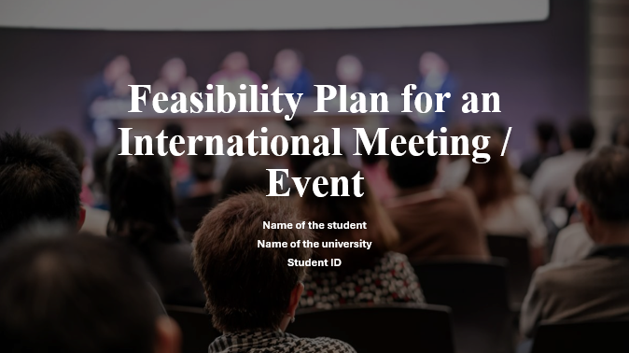

Slide 2: Event Overview
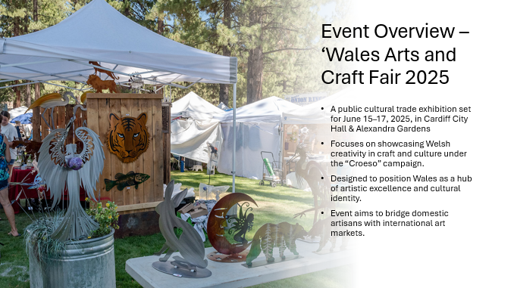
The name of the current event is ‘Wales Arts and Craft Fair 2025”. This event will be a Public Cultural Trade Exhibition event type with an estimated date between June 15 and 17th in 2025. The location of this event will be in Cardiff City Hall & Alexandra Gardens. The theme of this event will be celebrating the creativity of Wales in craft and culture. The focus of this event will be promoting Wales by using the event and the campaign “Croeso”.

Slide 3: Event Objectives
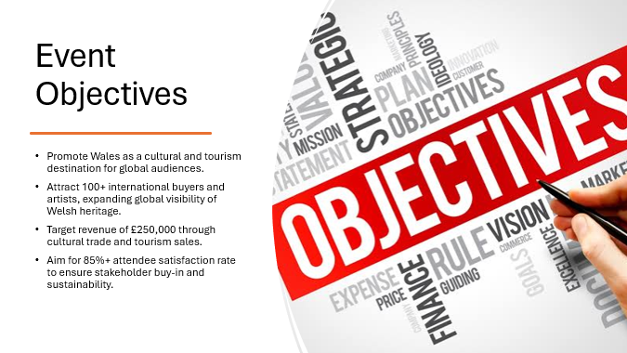
The aim of this event will be to promote Wales as a tourism centre containing global arts and heritage. The main objective of this event will be attracting more than 100 international buyers and artists, along with facilitating the tourism end product sale-related revenue up to £250,000. Not all bad, but another major objective of this event will be to achieve more than 85% of satisfaction rate among the people who will attend this event.

Slide 4: Target Market & Demand
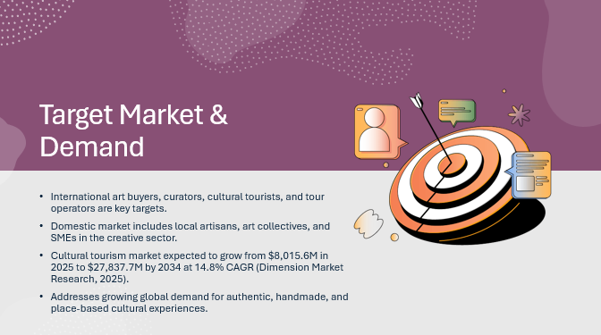
The target market of this event will be the international audience, including the art buyers and curators from different parts of the world, like Japan, the US and Europe. Moreover, the travel and cultural tour operators and the heritage tourists will also be targeted with the help of this event. The domestic audience, including the artisans and cultural business houses in Wales, will also be targeted. In this aspect, the cultural and creative tourism demand in the market could also be highlighted, where the current anticipated value is around USD 8,015.6 million in 2025, which is expected to grow to USD 27,837.7 million by 2034 with a CAGR of 14.8% from 2025 to 2034.

Slide 5: Competition Analysis
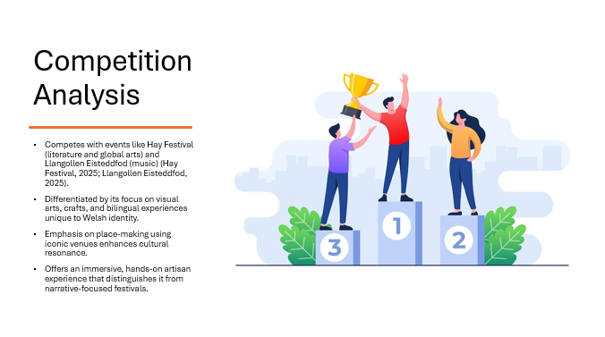
To analyse the competitors of this event, the name of the Hay Festival would be highlighted, which is one of the Famous festivals in Wales that offers a platform to experience art, culture, music, literature and many more from across the globe. On the other hand, another major competitor that could be highlighted is the Llangollen Eisteddfod festival, which focuses on bringing the musical experience to the people of Wales. However, the current event will have some USP, including a focus on the visual arts and crafts of Wales alongside bilingual disc is use of the venue for enhancing the sense of place among the participants.

Slide 6: Location & Venue Feasibility
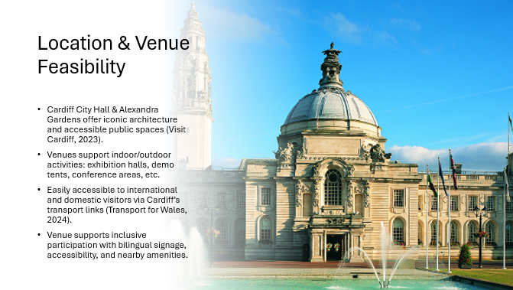
The location of this event will be in Cardiff City Hall and Alexandra Gardens. To justify the choice of this venue, it could be mentioned that Cardiff is the capital city of South Wales, which is a place for immersive art, culture and heritage. The facilities that will be accessible in this venue for the participants include exhibition halls, different booths, hotels at close distances, outdoor craft demo tents and conference rooms.

Slide 7: Operational Feasibility
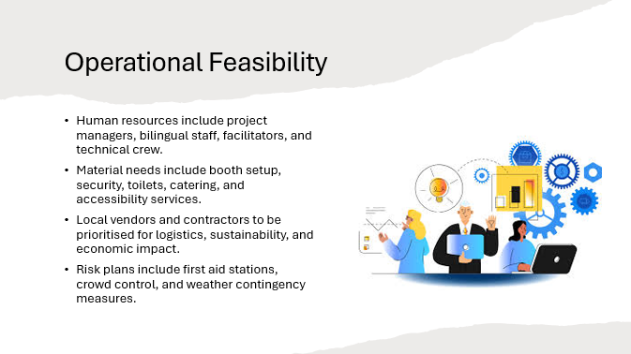
To ensure the seamless operation in this event, the major human resources who will be needed include the project managers, the workshop facilitators, the technical and lighting crew and the bilingual staff. Moreover, the other materialistic resources that will be needed, including the raw materials for setting the booths, security resources, first aid, local catering services, accessible toilets and parking places

Slide 8: Event Itinerary Snapshot
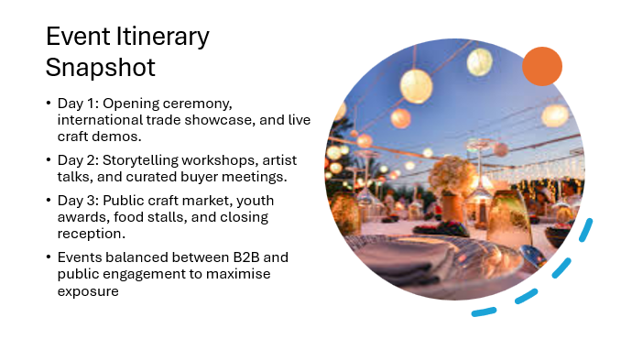
This three-day event will start with an opening ceremony, followed by a trade showcase and press launch. Moreover, there will also be a live woodwork and textile demo on the first day. The second day will include a cultural storytelling workshop alongside painting sessions and buyer meetings. The final day of this event will be a public day with craft sales and food stalls. Awards will be given to music and youth creativity, and finally, a closing reception will also happen.

Slide 9: Marketing & Promotion
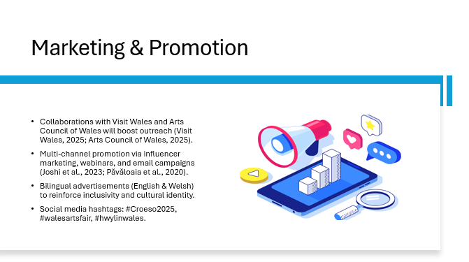
The marketing and promotion of this event will be initiated with different channels, like partnering with the local cultural bodies, like Visit Wales and Arts Council Wales. Moreover, the social media influencer will also be utilised along with pre-event webinars. E-mail campaigns will also be initiated, alongside the bilingual media ads in both English and Welsh. The hashtag that will be used in different social media Posts includes #Croeso2025, #walesartsfair and #hwylinwales.

Slide 10: Financial Feasibility
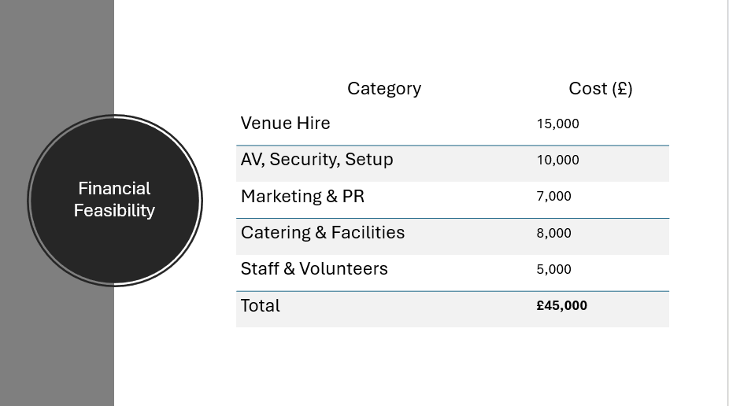
The current slide effectively highlights the estimated budget of this event, which includes different categories like hiring the venue, staff and volunteers, overall event setup, marketing and PR and finally the catering and facilities. Therefore, estimating budgets for all of these different categories highlights a total estimated budget for this wind of around £45,000.

Slide 11: Revenue and Funding
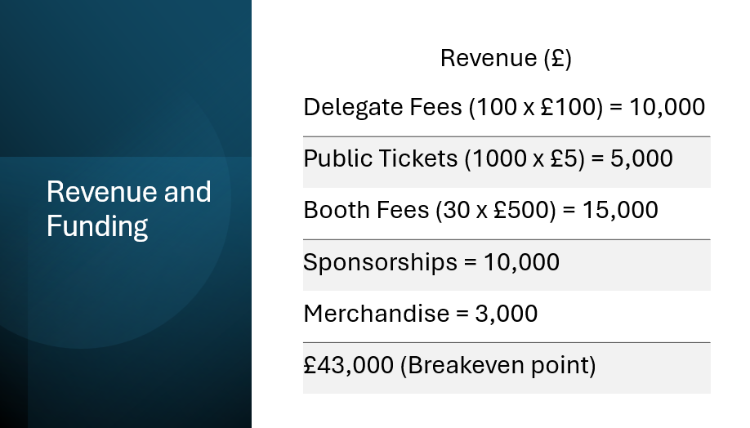
The following slide eventually highlights the scope of generating revenue from different revenue channels, considering the current event. These include the fees from the delegates, the public tickets, the fees of the booths, the merchandise sales and the sponsorships. Therefore, the estimated revenue of this event will be around £43,000, which will be near the breakeven point. Moreover, another major aspect that could be highlighted here is the funding sources of this event, where the government of Wales, alongside different local craft business houses, could be utilised.

Slide 12: Situational Analysis
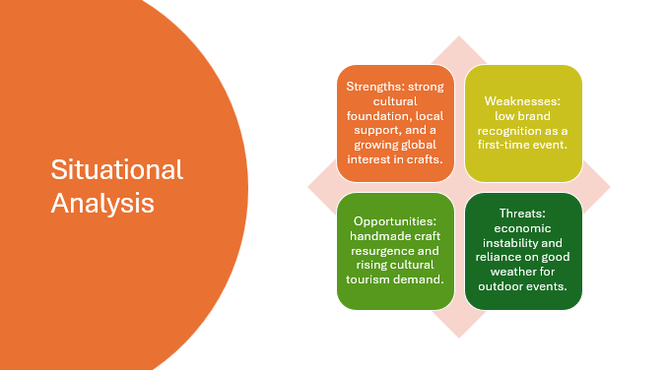
This slide effectively highlights the situational analysis of this event, where the strength of this event will include the cultural depth and strong support from the local people. However, the weakness is in including a low brand recognition due to the novelty of this event. Apart from that, there will be opportunities for event improvement due to a current increase in the interest in handmade crafts across the globe. Finally, the threats of this event are associated with adverse weather in the outdoor venue and economic downturn.

Slide 13: Conclusion & Next Steps
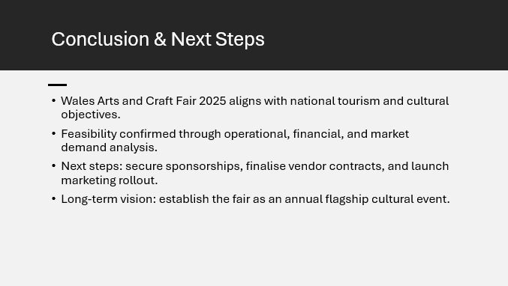
In conclusion, it could be mentioned that this event is feasible with a strong cultural base along with a significant demand in the market for cultural tourism. Moreover, it also effectively aligns with the theme of the Croeso 2025 campaign. Therefore, the next steps that could be taken for such events in the future include the development of a local sponsorship fund alongside contracting with local vendors and artists.

References
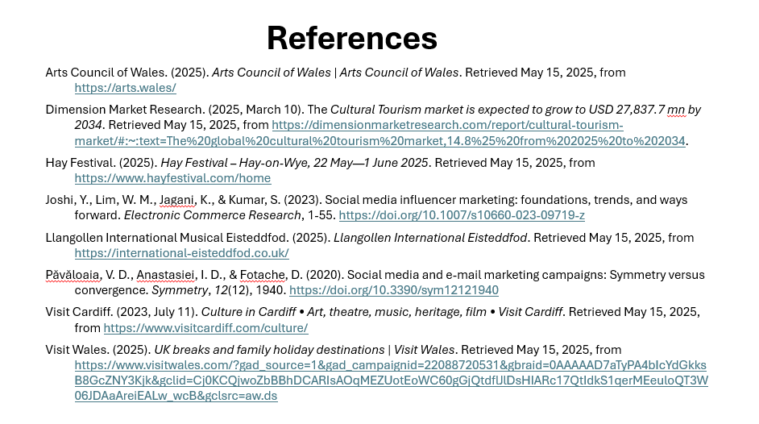
Arts Council of Wales. (2025). Arts Council of Wales | Arts Council of Wales. Retrieved May 15, 2025, from https://arts.wales/
Dimension Market Research. (2025, March 10). The Cultural Tourism market is expected to grow to USD 27,837.7 mn by 2034. Retrieved May 15, 2025, from https://dimensionmarketresearch.com/report/cultural-tourism-market/#:~:text=The%20global%20cultural%20tourism%20market,14.8%25%20from%202025%20to%202034.
Hay Festival. (2025). Hay Festival – Hay-on-Wye, 22 May—1 June 2025. Retrieved May 15, 2025, from https://www.hayfestival.com/home
Joshi, Y., Lim, W. M., Jagani, K., & Kumar, S. (2023). Social media influencer marketing: foundations, trends, and ways forward. Electronic Commerce Research, 1-55. https://doi.org/10.1007/s10660-023-09719-z
Llangollen International Musical Eisteddfod. (2025). Llangollen International Eisteddfod. Retrieved May 15, 2025, from https://international-eisteddfod.co.uk/
Păvăloaia, V. D., Anastasiei, I. D., & Fotache, D. (2020). Social media and e-mail marketing campaigns: Symmetry versus convergence. Symmetry, 12(12), 1940. https://doi.org/10.3390/sym12121940
Visit Cardiff. (2023, July 11). Culture in Cardiff • Art, theatre, music, heritage, film • Visit Cardiff. Retrieved May 15, 2025, from https://www.visitcardiff.com/culture/
Visit Wales. (2025). UK breaks and family holiday destinations | Visit Wales. Retrieved May 15, 2025, from https://www.visitwales.com/?gad_source=1&gad_campaignid=22088720531&gbraid=0AAAAAD7aTyPA4bIcYdGkksB8GcZNY3Kjk&gclid=Cj0KCQjwoZbBBhDCARIsAOqMEZUotEoWC60gGjQtdflJlDsHIARc17QtIdkS1qerMEeuloQT3W06JDAaAreiEALw_wcB&gclsrc=aw.ds

