Liam Thomas (P143797)
Group Project Individual Work

Abstract
Most dairy farms currently store their cattle slurry in large storage tanks, which produce substantial amounts of methane especially in warm conditions. Due to the large amounts of methane produced the risk of asphyxiation is real. The amount of slurry that is produced is large and requires large storage tanks to contain the waste.
Last year’s student’s developed a reactor in an attempt to combat this issue. Using electro kinetic dewatering they were able to extract some of the water from the slurry. However, their design contained several issues causing the reactor to not perform optimally.
Due to flaws in the reactor design it was calculated that 50.07% of the slurry that was loaded into their reactor was not undergoing the electro kinetic process, therefore heavily affecting the efficiency of the design.
The initial design wasn’t implemented due to time constraints, but the secondary design that was implemented still resolved the issues that were present. The issues were resolved by introducing a gravel filter between the bottom of the anode and the mesh filter to prevent the mesh from clogging and adding a cap to the bottom of the anode. This allowed for a greater percentage of the slurry to undergo the process.
Several methods for potential control systems that could be implemented into the new design were discussed, as well as feasibility of renewables to power the process.
The results gained from the new design prove that the issues were resolved. The new design extracted 40.06% more water in 58.43% less time. Over a 90-minute period where 30 Watts of power has been consumed by the reactor, 225ml was collected compared to the result of 49ml from the previous year, resulting in a 456% efficiency increase. The H-S theory explaining the movement of water throughout the reaction, was also proved using the XRF results that showed the distribution of aluminium and iron in the dry and wet samples.
The final tests provided unexpected results due to the exhaustion of the electrodes, causing multiple holes in the walls of the Cathode. For further testing to continue the reactor will require new electrodes as the current electrodes are no longer fit for purpose.

- Contents
Abstract 1
Introduction 3
Background Research 4
Farm (LT) 4
Current Treatment Process and Previous Work (LT) 4
Literature Review 5
Hydraulic Head Pressure (LT) 5
Hydraulic Gradient (LT) 5
Hydro Power (LT) 6
Turbines (LT) 7
Costing Considerations (LT) 11
Environmental Considerations (LT) 11
Conclusion (LT) 12
Test of 2016 – 17 System 13
Hydro (LT) 14
Costing (LT) 14
Considerations (LT) 15
Controlling Flow Rate (LT) 16
Flow Rate (LT) 16
Pressure (LT) 19
Summary (LT) 20
Implementation 21
Purchasing new parts (Group) 21
Disassembly & Reassembly (Group) 23
Preparation (Group) 24
XRF Analysis (Group) 25
Tests & Results 27
Week 1 27
Test 1 (Group) 27
Test 2 (Group) 31
Test 3 (Group) 34
Test 4 (Group) 37
Test 5 (Group) 40
Week One Testing Results (Group) 43
Week One Results Compared to Previous Year’s (Group) 44
Week 2 45
Test 1 (Group) 45
Test 2 (Group) 46
Test 3 (Group) 49
Test 4 (Group) 52
Test 5 (Group) 55
Test 6 (Group) 59
Week 2 Testing Results (Group) 62
Overall XRF Analysis (Group) 62
Reactor (Group) 66
Cathode deteriorating (Group) 68
Conclusions 72
Conclusion 72
Reflection 73
Future Improvements 74
References 76

Introduction
Dairy farms with hundreds of cows produce a lot of slurry, which consists of cattle manure, hay, straw and a large percentage of water that accumulates from the wash down of the milking parlours after each milking. The slurry is then usually stored in tank, where it then collects more water as a result of rainfall entering the slurry drainage system. Storage of this slurry is dangerous as the stored waste can produce large quantities of Methane in warm conditions, the production of Methane results in the presence of a potentially explosive atmosphere. When there is a high percentage of Methane in the atmosphere the risk of asphyxiation is increased providing the airflow to the location is not high enough to vent the gas. The combination of the large volume and the potential hazards mean that the storage and disposal of cattle slurry is costly with this project aimed at reducing the risk and costs by investigating the potential impacts of electro kinetic dewatering of the slurry.
Previous work has been completed to provide potential solutions to the problems discussed above, this included the construction and testing of an electro kinetic dewatering reactor which was built with the aim of reducing the water content of the slurry that was produced on the Gelli Aur Farm in partnership with Power and Water, and UWTSD. With the reduced water content, it is thought that the production of Methane from dewatered waste would be reduced along with the associated hazards and a reduction in the volume of storage area would be achieved.
The aim for this project was to improve on the existing design for electro kinetic dewatering of cattle slurry that was produced by last year’s students and to investigate the potential of the new design over a greater range of operating conditions to highlight the optimum operating limits.
The original design had several issues causing inefficiencies most notably the reaction chamber of the original reactor did not provide a uniform distribution of an electric field in which the saturated waste was exposed to, this resulted in a significant amount of the waste not being subjected to the dewatering process.
The goal was to attempt to remove as many as these inefficiencies as possible by redesigning the current reactor with the main target of producing a reaction chamber that would provide a uniformly distributed electric field in which the waste could dewater in with the greatest efficiency. Further improvements to the original design include designing some potential control systems to maintain a uniform flow of slurry, a consistent supply of current to the electrodes or reversing polarity to extend the lifetime of the electrodes. The design process will also consider various methods of powering the system with renewable energy, to further reduce environmental impact.

Background Research

Farm (LT)
Coleg Sir Gar Gelli Aur farm is a dairy farm is located in the Twyi valley in Llandelio. The farm has over 500 cows, 400 of which are dairy cows which are divided into two 200 herds. There is also a small beef enterprise and 400 breeding Ewes.
Since it is part of Coleg Sir Gar, Gelli Aur is also a place of study where student come to learn agricultural engineering and other countryside related studies. It is also home to the Farm Resource Centre which houses The Dairy Development Centre (DDC). The DDC aims to improve the Welsh dairy industry. (1)

Current Treatment Process and Previous Work (LT)
There is currently no treatment process in place at the farm, the excrement is washed to the end of the barn and then scraped out into channels. The slurry is then pumped into one of two towers, which have a combined volume of 2327.2m³.
Last year’s students designed an Electro kinetic dewatering system. This system would remove the water from the slurry by running an electric current through it using two electrodes. The reactor consisted of an aluminium cylinder being used as the cathode and a smaller diameter steel anode which went inside the cathode. The anode was attached to cathode using a threaded nylon rod. Two flanges then connected the outside electrode to a tap. Above the entrance to the tap was a filter to prevent any solids escaping through the tap.
When powered on the electric current would draw the water towards the cathode, the water would then run down the cathode wall, through the filter and out the tap. There was then a beaker on a weighing scale which would collect and weigh the water extracted from the slurry.
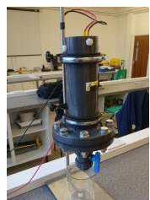
Figure 1 - Last Year’s Reactor (2)

Literature Review

Hydraulic Head Pressure (LT)
Hydraulic head pressure is the measurement of liquid pressure above a single point, not an area. (3) It is a principle used in the development of hydro power stations, particularly dams.
Hydraulic head pressure is measured in meters and is measured from the top of the liquid to the bottom and the total energy at any given point is the sum of the kinetic energy of the fluid, the energy from the pressure of the fluid and the energy from the height of the fluid. (4)
Hydraulic head pressure can be expressed by the following equation:

$$φ= \frac{P}{γ}= \frac{P}{ρg}$$
Equation 1 - Hydraulic Head Pressure
Where:
$$P= gauge pressure=(Force per unit area, often Pa or psi),$$
$$γ=unit weight of the liquid=(Force per unit volume, typically N·m-3 or lbf/ft³),$$
$$ρ= density of the liquid=(Mass per unit volume, frequently kg·m-3), and$$
$g=gravitational acceleration=(velocity change per unit time, often m·s-2)$ (4)

Hydraulic Gradient (LT)
The hydraulic gradient is a vector gradient of each of the individual head measurements over the length of the liquids path. It can be calculated with the following equation.

$$i= \frac{δh}{δl}= \frac{h2-h1}{length}$$
Equation 2 - Hydraulic Gradient
Where:
$$i\left\{\backslash displaystyle i\right\} =hydraulic gradient (dimensionless),$$
$$dh\left\{\backslash displaystyle dh\right\} =difference between two hydraulic heads (Length, usually in m or ft)$$
$dl\left\{\backslash displaystyle dl\right\}= flow path length between the two piezometers (Length, usually in m or ft)$$CITATION Hyd18 \backslash l 2057 (4)$

Hydro Power (LT)
Hydro power has been around for almost a century and therefore the technologies behind it are refined and efficient, with over 90% energy conversion efficiency. (5) Due to the nature of water flow Hydro power can generate electricity 24 hours a day and provided it is a suitable location will generate a substantial amount of electricity even during unideal conditions.
Hydro power contributes to almost 20% of the world's electricity. (6) As of 2012 it contributed to 1.3% of the United Kingdom’s electricity generation. (7)
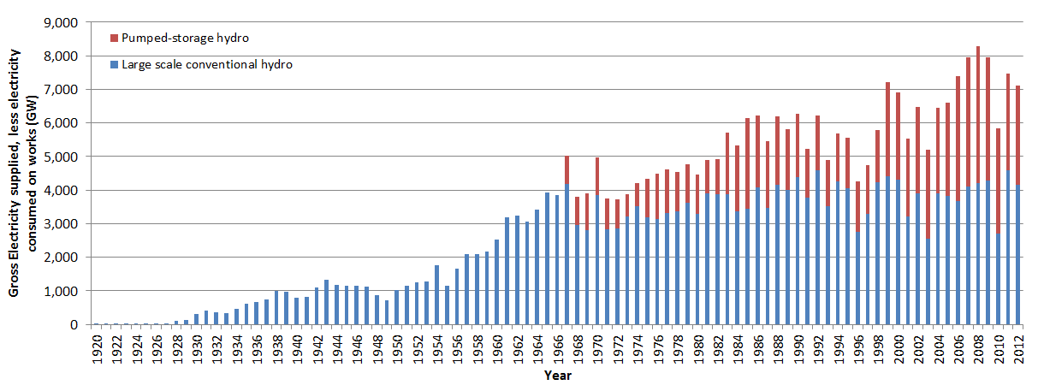
Figure 2 - Hydro Usage in the UK (8)
The above figure shows the gross electricity supplied to the UK through hydropower and it shows that large-scale conventional schemes generation has been constant from 1964 ranging from around 2500GW to 4500GW. Showing that hydropower development has been stagnant within the UK for around 50 years.
Hydroelectricity converts the kinetic energy or gravitational potential energy from water into electrical energy. This energy is converted to electrical energy by use of a turbine. In the UK there are 3 types of hydropower schemes:
- Storage Schemes - A dam creates an artificial lake known as a reservoir, the reservoir provides water to the dam.

- Run-of-river schemes – Rely on the flow of a river, a weir can also be used to adjust the flow rate of the river. Run of river schemes can also be designed using diversion, where water is channelled away from the river.

- Pumped storage - Pumped storage incorporates two reservoirs. When there is low demand, the water is pumped from the lower reservoir to the higher reservoir; the water is then released during times of high demand. Due to the use of electricity this method is not considered to be a renewable energy source. (5)

Turbines (LT)
Turbines use the kinetic energy of the water to drive a generator, converting that energy into electrical energy. There multiple types of turbines, each one having a specific use case.

Archimedean screw (LT)
The Archimedean screw is one of the more modern types of turbine, having only been used within the last decade. The concept has been used for other methods outside of power generation though. (9) They are typically used in low heads of 1.5-5 meters and medium to high flows of 1-20m³/s. (10)
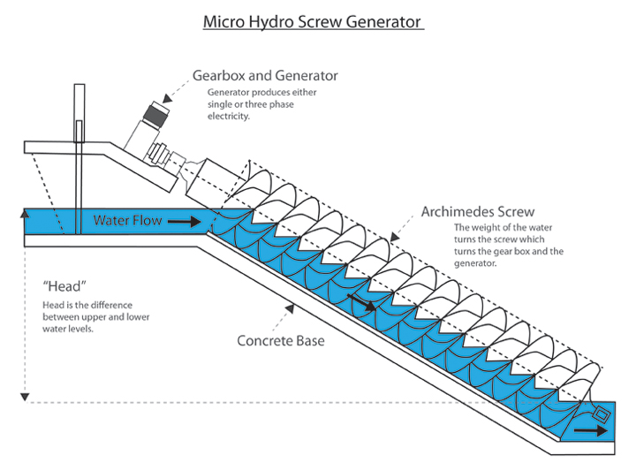a
Figure 3 - Archimedean Screw (11)
In the above figure, you can see the water enters the screw through the top and the weight of the water pushes against the helical fights rotating the screw and allowing the water to flow to the next level. The rotational energy of the screw is then converted using a generator. (9) Archimedean screws are typically used for small-scale hydro schemes with power outputs ranging from 5kW to 500kW.

Cross flow Turbine (LT)
Cross flow Turbines are a common turbine within the UK’s small hydro schemes. (12) They are used for low to medium head of 2-40 meters and low to medium flows of 0.1-5m³/s. (10)
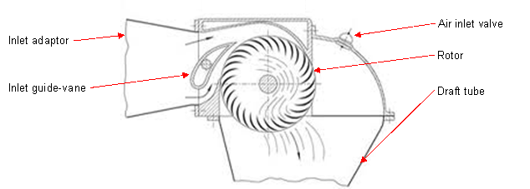
Figure 4 - Crossflow Turbine (12)
The previous figure shows the flow of water through a cross flow turbine. The water flows both under and over the inlet guide vane, which directs the water flow to hit the rotor at the correct angle, maximising efficiency. The water then flows across the upper blades of the rotor, down through the centre and ten across the lower blades. Cross flow turbines typically have a power output between 5kW and 100kW. (12)

Kaplan Turbine (LT)
Kaplan turbines are similar to a propeller except the blades are adjustable. They are typically used on low to medium heads 1.5 – 20 meters and medium to high flows 3-30m³/s, this is due to them being relatively expensive and other options being more suited to high head situations. (13)
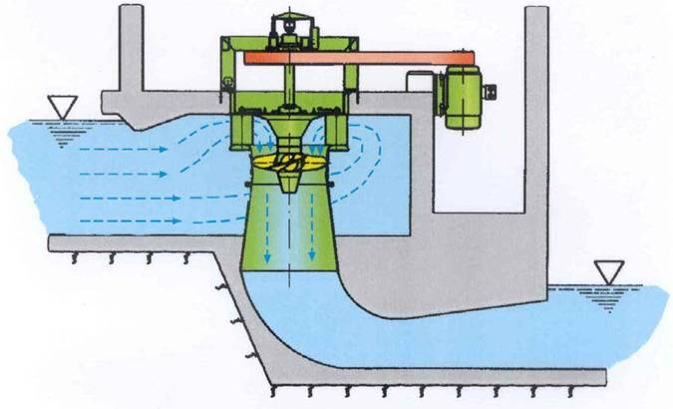
Figure 5 - Kaplan Turbine (13)
Kaplan turbines can be installed in both vertical axis and horizontal axis, within the UK vertical axis is the more common orientation due to its smaller footprint. The water is guided of the entire turbine rather than entering at just one side. The angle of the guide vanes and the rotor blades can be adjusted to suit the flow of water. Vertical Kaplan Turbines can have a power output of up to 3000kW. (14)

Pelton Turbines (LT)
Pelton turbines are used for high heads of greater than 25 meters and low flows of 0.01 – 0.5m³/s. (15) They are compact, and the associated pipework is small making them easier to install than an equivalently powered Kaplan Turbine.
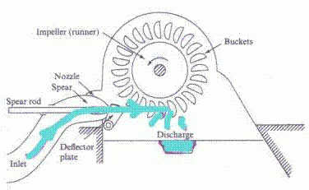
Figure 6 - Pelton Turbine (15)
The above figure shows how a Pelton turbine functions. The water enters on the left hand side and passes through the spear jet. The spear jet allows for the flow rate to be adjusted by moving to spear closer and further away from the nozzle. The water then flows over the rotor converting the kinetic energy into rotational energy.
The Turgo turbine is a development of the Pelton turbine, allowing it to handle higher flow rates than a Pelton of the same size. The only difference in operation is the when the water hits the rotor it exits on the opposite side rather than the bottom. (15)

Francis Turbine (LT)
Francis turbines are no longer commonly used outside of larger storage systems. There are many Francis turbines that have been installed previously. They are most effective with low to medium heads of 1.5-20m and medium flows 0.5-4m³/s. (10)
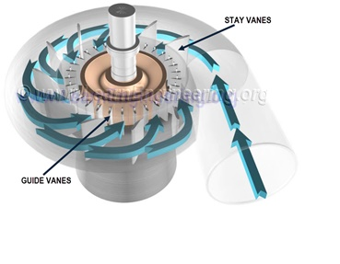
Figure 7 - Francis Turbine (16)
Francis Turbine rotates along the vertical axis. The water flow into the turbine is radial and exits the turbine through the bottom, like the Kaplan turbine.

Summary (LT)
Table 1 - Summary of Turbines
Specification | Archimedean Screw | Crossflow Turbine | Kaplan Turbine | Pelton Turbine | Francis Turbine
Flow (M³/s) | 1-20 | 0.5-5 | 3-30 | 0.01-0.5 | 0.5-4
Head (meters) | 1.5-5 | 2-40 | 1.5-20 | 25+ | 1.5-20
Power Output | 5-500kW | 5-100kW | Up to 3000kW | From several kW to tens of MW | Hundreds of kW to tens of MW

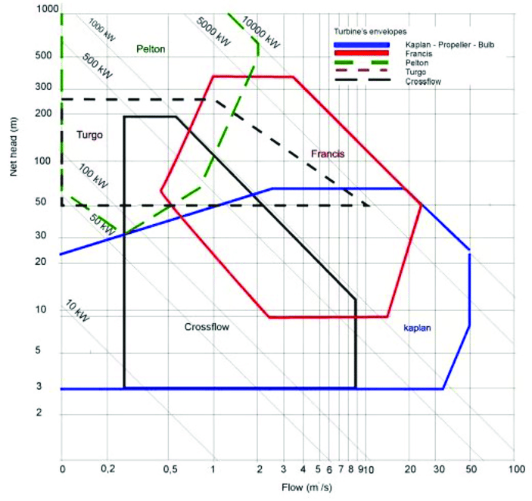
Figure 8 - Turbine Chart Power-Head-Flow (17)

Costing Considerations (LT)
- Development and Implementation – These costs while scale proportionally with the size of the scheme. Larger schemes that require more terraforming will cost considerably more.
- Maintenance – Maintenance costs for all sizes of schemes should be relatively small to begin with since turbines are reliable. As time goes on the maintenance costs will increase as the scheme gets older and the structural integrity diminishes.
- Licensing and Abstraction – Costs will increase if a third party owns the land and will further increase if abstraction is required as an abstraction license is required.

Environmental Considerations (LT)
- Local Wildlife – Fish and other aquatic animals living within the river could be obstructed by the scheme; certain scenarios will require an alternate path upstream for the wildlife.
- Local Plant life – Some plant life will be destroyed during the terraforming and construction of the scheme.
- Pollution – The construction of the scheme will cause substantial pollution but there will also be significant sound pollution when the scheme is running.
- Recreational Activities – Fishing, Kayaking and Swimming activities will be affected.

Conclusion (LT)
Due to hydro power being a well-developed efficient form of renewable energy and the river towy being within a third of a mile of the farm site. This river could have the energy potential for small scale hydro scheme to power the system. The red area highlights the most likely area for the reactor to be built and implemented.
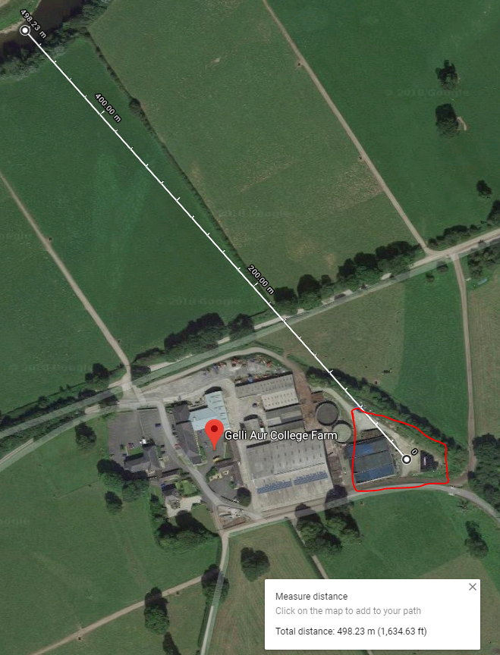
Figure 9 - Gelli Aur (18)

Test of 2016 – 17 System
The previous system was first set up to be operated and tested before any changes were made to the reactor. The water was collected in a beaker placed underneath the reactor and a weighing scale was used to measure the amount of water produced from the reactor.

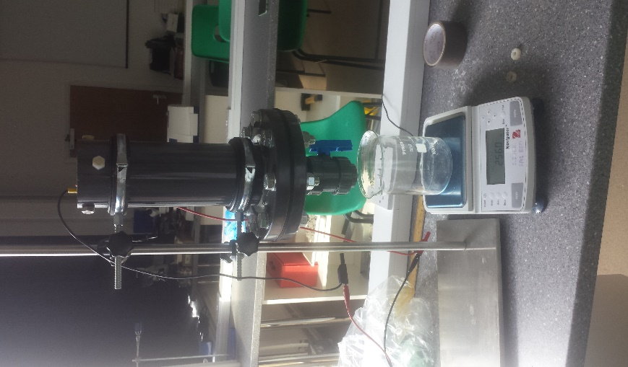
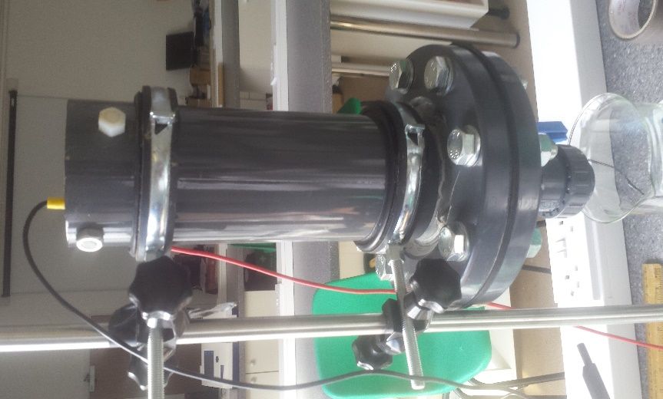

Figure 32 - Beaker & Reactor
Figure 33 – The previous Reactor

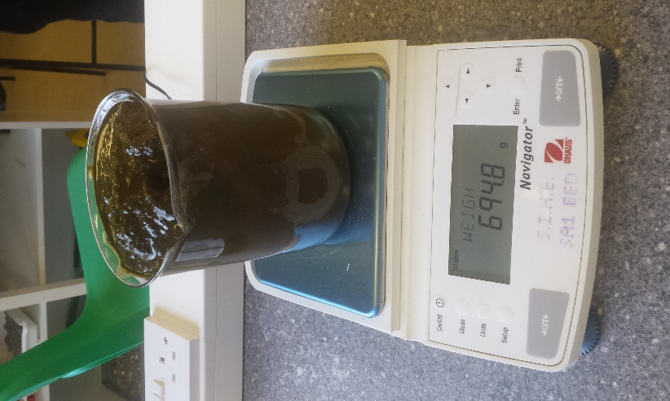
The slurry collected from the farm was weighed before been poured into the system.
Figure 34 - Weighing the Slurry
The entire process was done to check if the system was operating correctly and to also check if there was any damage to the system from the previous tests.

Hydro (LT)
The flow rate of the river Towy is required to conclude which hydro power turbine is most suitable.
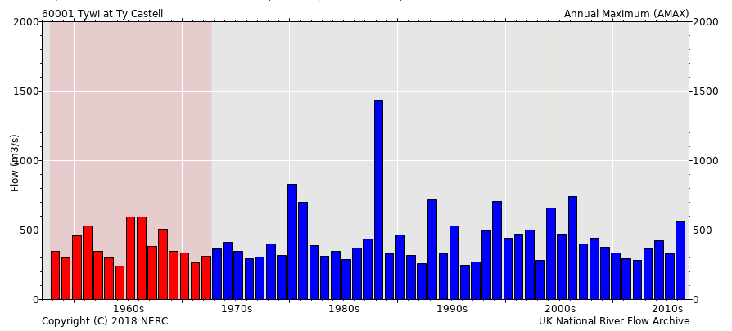
Figure 40 - Annual Max Flow Rates for Towy River at Ty Castell (53)
The above figure shows the annual max flow rates for the river Towy at Ty Castell with is around 10 miles downstream from Gelli Aur. Using this graph, the average flow rate of the river is estimated to be around 150ms⁻³.
Abstracting 10% of the flow rate would provide 15 m³/s to use for hydro power. Based on the low head, high flow nature of the Towy River, 2-3 Archimedean screw turbines at 5m in diameter would be suitable for this process.

Costing (LT)
Despite it being a relatively small scheme that usually means the cost/kW is higher.
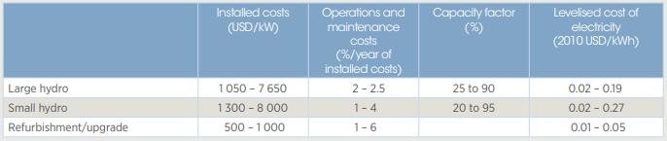
Figure 41 - Installation and Maintenance Costs of Hydro Schemes (54)
As shown in the above figure small scale hydro schemes typically range from 1300-8000 USD/kW installation costs. 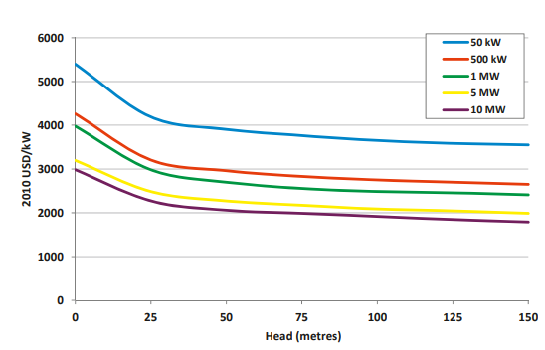
Figure 42 - Installation Costs Compared to Head Height (54)
Using the information in the previous two figures, installing a hydro scheme at Gelli Aur could range from 4000-5500USD/kW. The cost of the installation will be affected largely by how big the scheme is. With the flow rate of the river the scheme has the potential to not only power the process but even part of the farm. If the scheme was large enough it could even be a source of revenue.
Assuming it was to only power the process abstracting less than 10% of the flow rate of the river Towy would be required and using a 20-30kW turbine. The estimated installation price would be 110,000- 165,000USD.

Considerations (LT)
There are several considerations before the installation of a hydro power scheme.
- Planning permission from the council would be required before construction can start
- Abstraction license would be required to divert flow from the river
- Consideration to wildlife, due to there being a high population of salmon in the river Towy, Archimedean screw turbines are considered to be fish friendly
- Consideration of recreational activities such as fishing

Controlling Flow Rate (LT)
The Second method for controlling the system would be controlling the flow rate from the tank into the reactor. As the slurry travels from the tank to the reactor the pressure inside the tank will decrease. Therefore, the flow rate of the slurry through the pipe will also decrease.
If the flow rate within the pipe is monitored the pressure can be adjusted within the tank, whether it be through putting weight on top of the slurry, sealing the tank and pumping air into it or some other method.

Flow Rate (LT)
There are numerous methods of measuring flow rate ranging from pressure differentials to optical sensors.

Pressure Differential (LT)
Flow rate can be measured using differential pressure flow meters, they use Bernoulli’s equation measure the flows of a liquid through a pipe. (62)
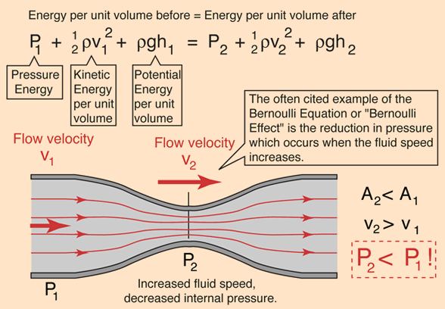
Figure 63- Bernoulli's Equation (63)
To measure flow rate and constriction in the pipe is introduced which creates a pressure drop within the pipe, as flow rate increases the pressure drop in the pipe increases.

Turbine Flow Meter (LT)
A turbine flow meter measures flow rate from the mechanical action of the turbine rotating. The turbine is positioned in the path of the fluid stream and when the fluid impinges on the turbine it begins to rotate. When the rotation has reached a steady speed the rotation velocity is proportional to the fluid velocity.
Turbine flow rate meters are more suitable to higher flow rates than pressure meters since they result in less pressure loss. They are less accurate in low flow rate situations though. (64)
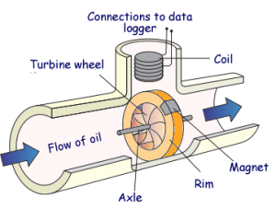
Figure 64 - Turbine Flow Meter (65)

Optical Flow Measurement (LT)
Flow of a fluid can also be measured using light, through use of a laser and optical sensors. Two lasers shine light through the fluid. When a particle passes through the laser the sensor on the opposite side of the pipe detects the refraction and emits a pulse. When the particle passes through the second laser the sensor emits another pulse. The time delay between these two pulses is inversely proportional the velocity of the fluid. (66)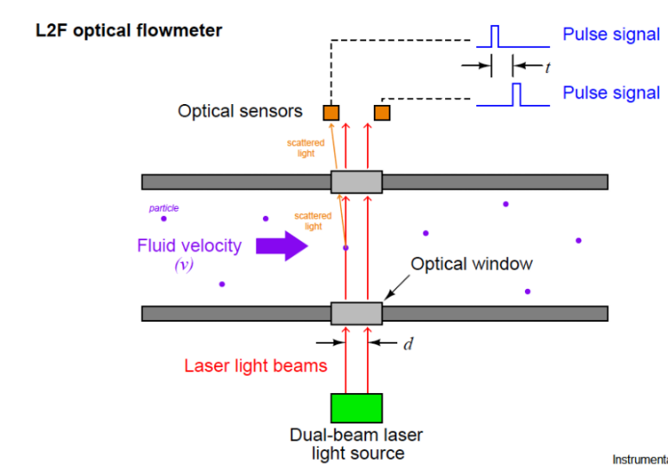
Figure 65 - Optical Flow meter (66)
An alternative method of optical flow rate measurement is by using a probe that is inserted within the pipe. However, this method only measures the velocity at that point and without the addition of temperature and pressure measurements may not be accurate for the entire fluid stream. With all three calculations the Reynolds number for that fluid which will give a representation for how consistent the velocity of the fluid is.
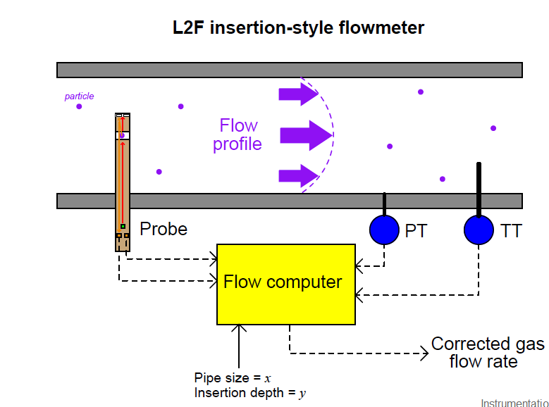
Figure 66 - Insertion Style Optical Flow Meter (66)

Ultrasonic (LT)
Ultrasonic flow rate measurement works similarly to optical flow rate measurement. Instead of reflecting light off particles within the water it uses ultrasound. The meter consists of a transmitting and receiving element. The transmitter emits ultrasonic waves with are then reflected of particles within the fluid, when the waves are reflected the sound wave changes frequency, this frequency change is proportional to the rate of flow of the liquid. It is known as the Doppler Effect.
This technology generally doesn’t work with clean water and requires at least 100 parts per million of suspended solid of which are 100 microns or larger. (67)
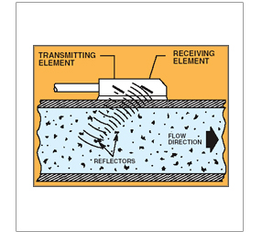
Figure 67 - Ultrasonic Flow Meter (67)

Pressure (LT)
The simplest method to increase the pressure within the tank is to place weight on top of the slurry. The issue with this method is that it cannot be controlled, the only way to reduce the pressure is remove weights manually and the only way to increase pressure is to add weights manually.

Motor (LT)
Instead of adding and removing weights manually, a DC motor attached to the end of threaded rod. A threaded plate would then be on the rod which would raise and lower as the rod is rotated by the motor. Since the motor can be controlled in both directions with the use of H Bridge it would allow for the increasing and decreasing of pressure within the tank.
A stepping motor may be more suitable for this application due to its ability for more precise rotation because it makes use of multiple coil winding pairs for specific rotation angles. This would allow for slower more controlled rotations of threaded rod, which may be required due to the slow flow rate of the slurry.

Hydraulics (LT)
A similar process to the motor and threaded rod design, except the pressure would be applied by using a hydraulic press. This would be significantly more expensive alternative to the motor and threaded rod, it would also be more complicated to control. Both methods require small movements, due to the nature of system. The tank has a larger area than the reactor thus a small movement from the fluid within the tank will result in a large movement of the fluid within the reactor.
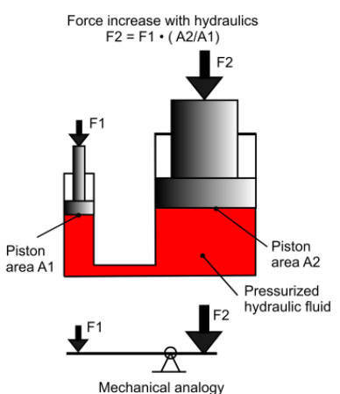
Figure 68 - Hydraulic Force (68)

Air (LT)
Alternatively, air pressure within the tank could be utilised to increase the flow of slurry into the reactor. This could be achieved by sealing tank and either pumping air into the tank or having another tank filled with air and using a valve to control the flow of air into the slurry tank. Using a valve would allow for greater control of airflow into the tank but the air tanks used within this method would require replacing.

Summary (LT)
The most suitable method would be using an impellor within the pipe connecting the slurry tank to the reactor to measure flow rate and a sealed tank using an air pump to increase the pressure within the tank.
This method would be used due to its relative simplicity, the flow rate sensor would be connected to magnet. Each revolution of the sensor would be detected by a Hall Effect sensor which in turn would send a pulse to a microchip. The microchip could then count the number of pulses per second, using the pulses per second and diameter of the pipe the flow rate of the slurry can be calculated. Depending on if the flow rate is above or below the set target the microchip can send out the single to pump more air into the container or drain it out.

Implementation

Purchasing new parts (Group)
In order to make the improvements, additional parts were needed to extend the overall length of the reactor.
Below is an image of the nuts & bolts needed to extend the Reactor, the nuts & bolts are 23mm in diameter while the bolts were 240mm total length.
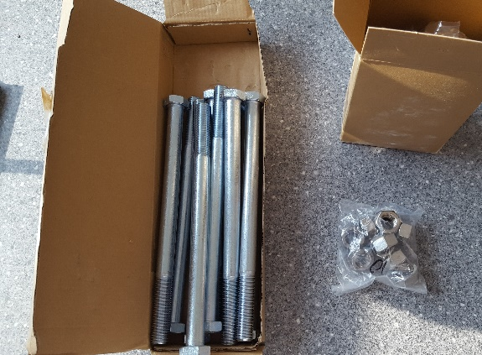
Figure 69: Purchased Nuts & Bolts
Below is an image of the additional pipe needed to extend the reactor, the pipe is made of Mild Steel and is 145mm in length, 101mm in diameter. Only one pipe was used as two were purchased as spare parts.
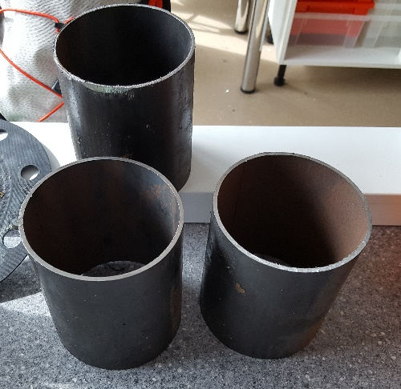
Figure 70: Purchased Outer Pipe

Below is a new electrode to replace the anode used during last year’s testing, the measurements are the same between both electrodes while the new electrode is made from Mild Steel as the material of the previous electrode was undocumented.
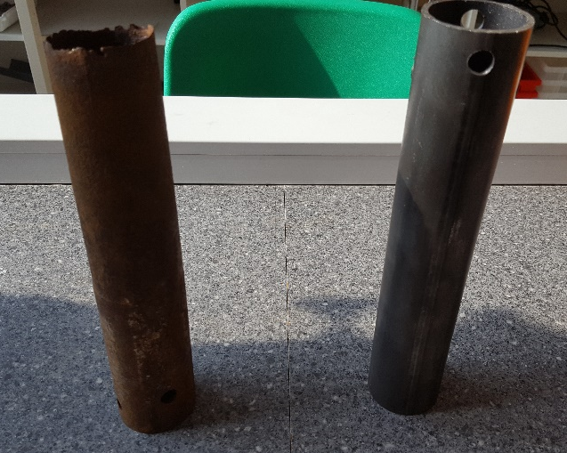
Figure 71: Purchased Anode

Disassembly & Reassembly (Group)
The old reactor was disassembled so that it could be cleaned out and extended by affixing the new pipe in between the top and bottom sections of the reactor by using a strong sealant. This would then be held in place by the purchased nuts & bolts. The system was then checked to ensure that it was watertight by charging the reactor with water. 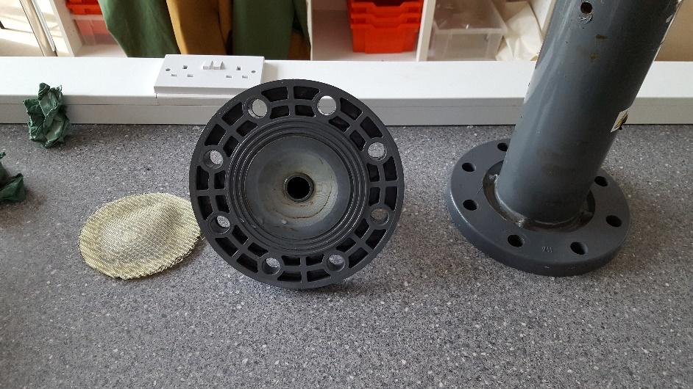
Figure 72: Disassembled Top & Bottom half of the reactor
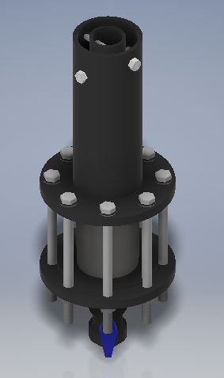
The improved reactor design matches expectations shown in the 3D CAD Drawing made previously along with all the final measurements.
With these improvements, more slurry can be loaded into the reactor as well as allowing additional room for mixed media filters to be used for separating the slurry from the final product.
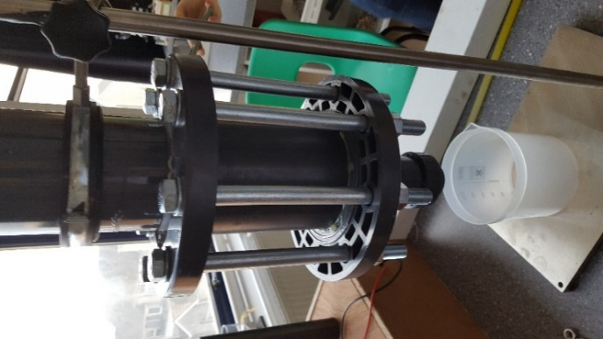
Figure 73: New Reactor Design Constructed

Preparation (Group)
Two sets of slurry samples were collected from the Gelli Aur Farm, each of which were approximately 6 litres. The consistency of the samples shared similar characteristics in terms of the total amount of water present and were both used within 4 days of collection to avoid the build-up of harmful gases.
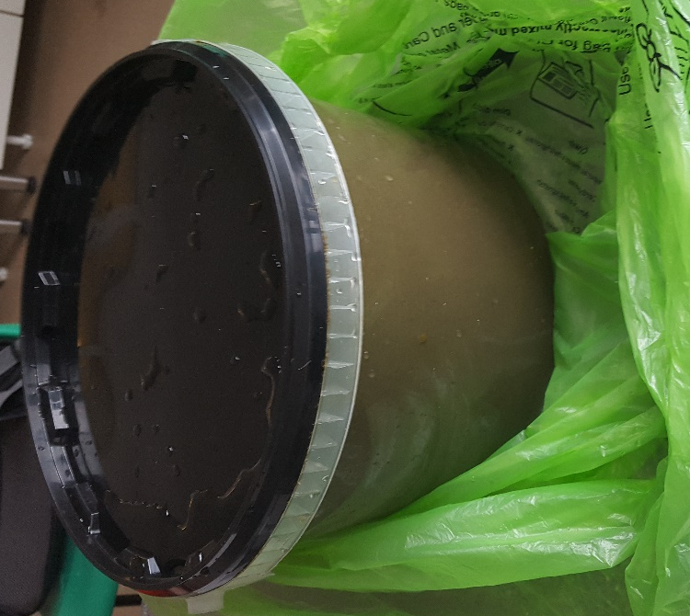
Figure 74 - Slurry Sample

XRF Analysis (Group)
Each sample produce from the tests were collected and placed in small test tubes. These samples were taken for further testing and analysed through X-ray fluorescence (XRF) to determine the chemical composition of each sample.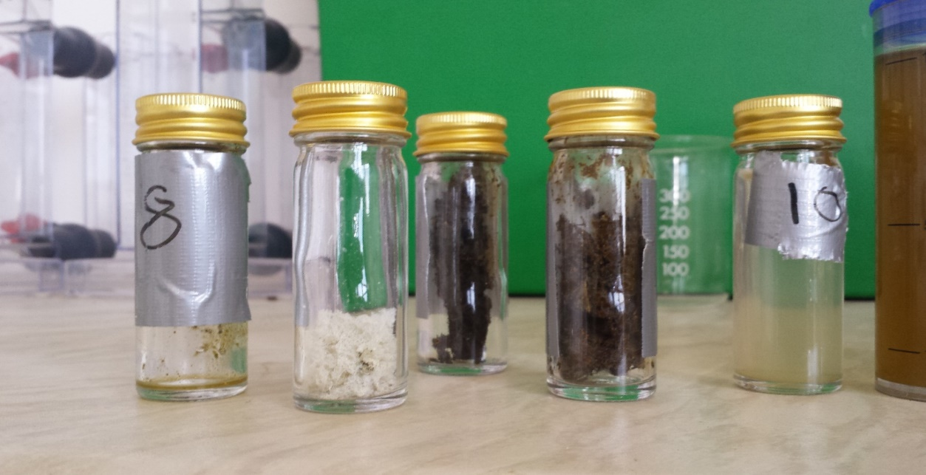
Figure 75 - Samples in test tubes
The samples from the tests were then placed on small XRF disc of 20$μl$ and labelled.
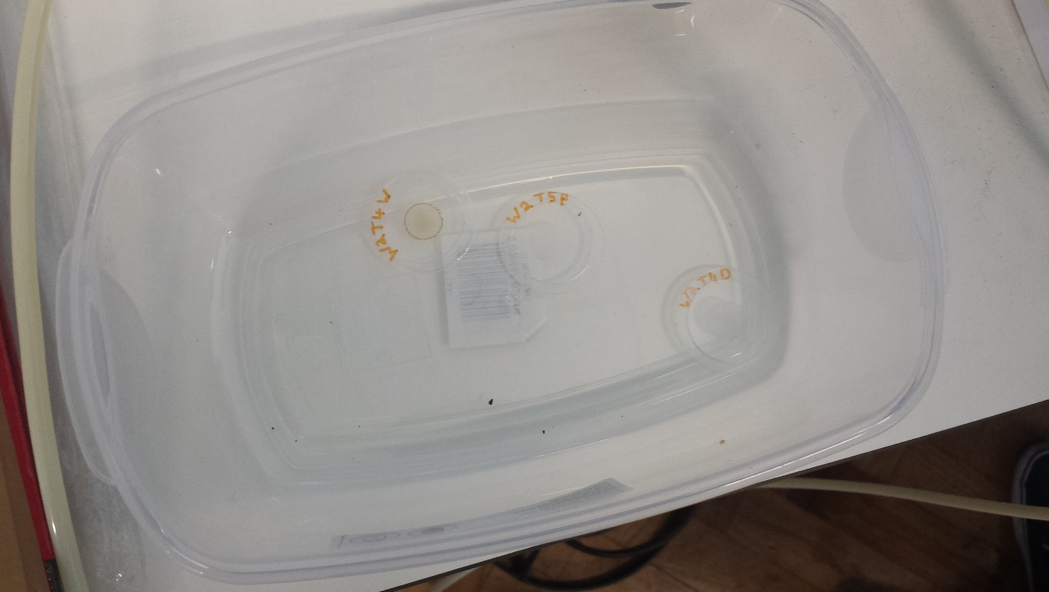
Figure 76 - XRF sample Discs

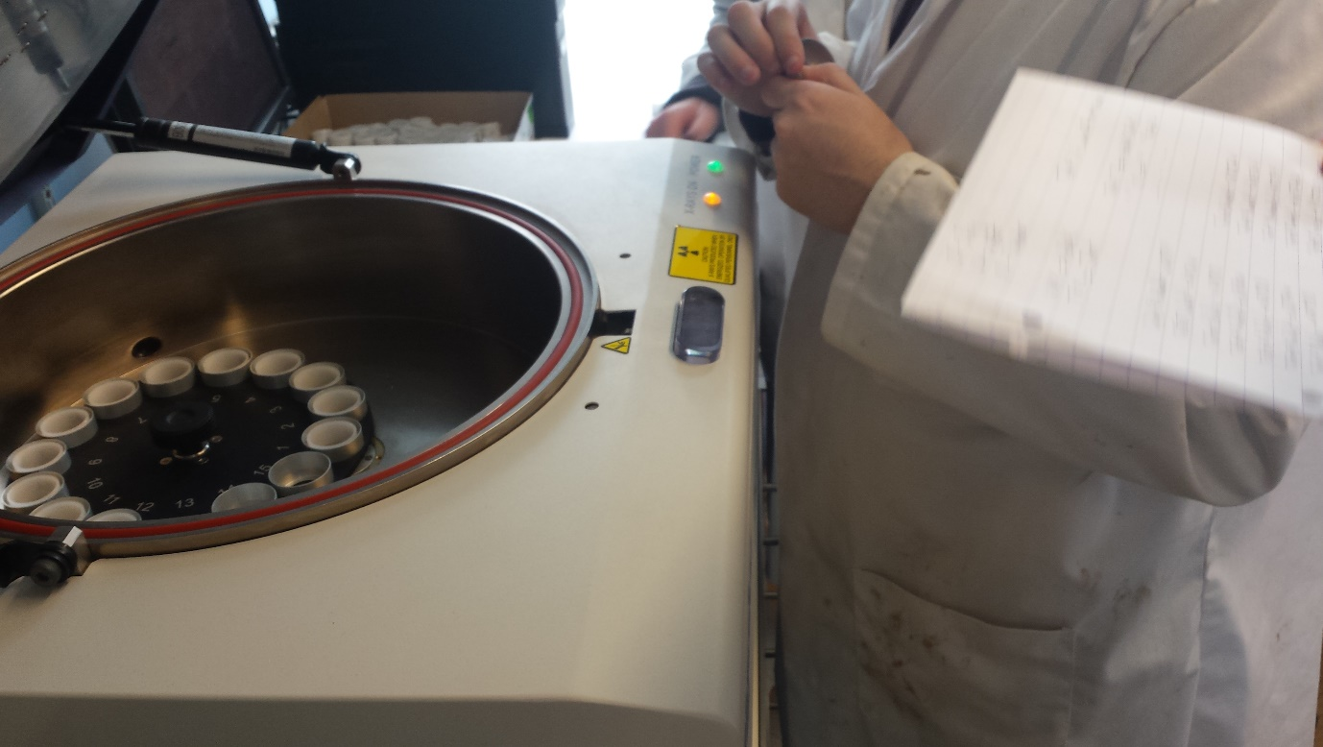
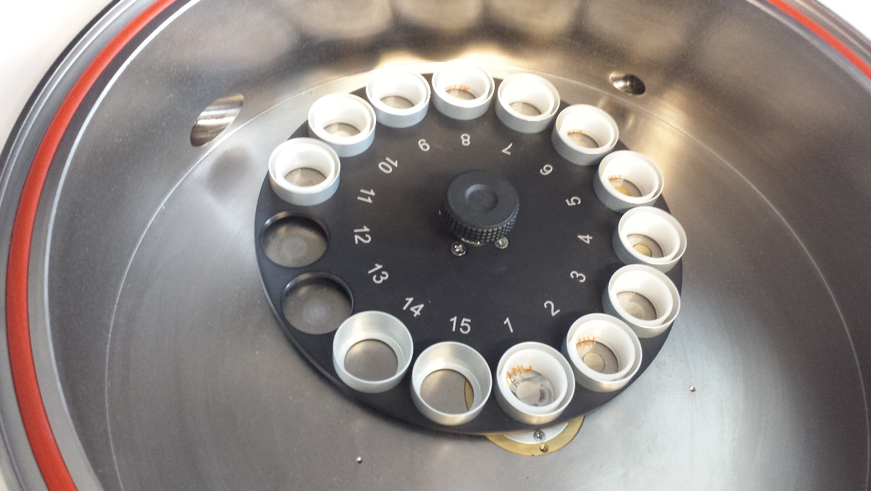
Figure 77 - Inside the XRF machine
Figure 78 - Loading the XRF machine

The XRF discs were placed inside the machine to measure the organic and inorganic matters inside the samples. The XRF scans each disc using X-ray waves and produces different results for each sample.
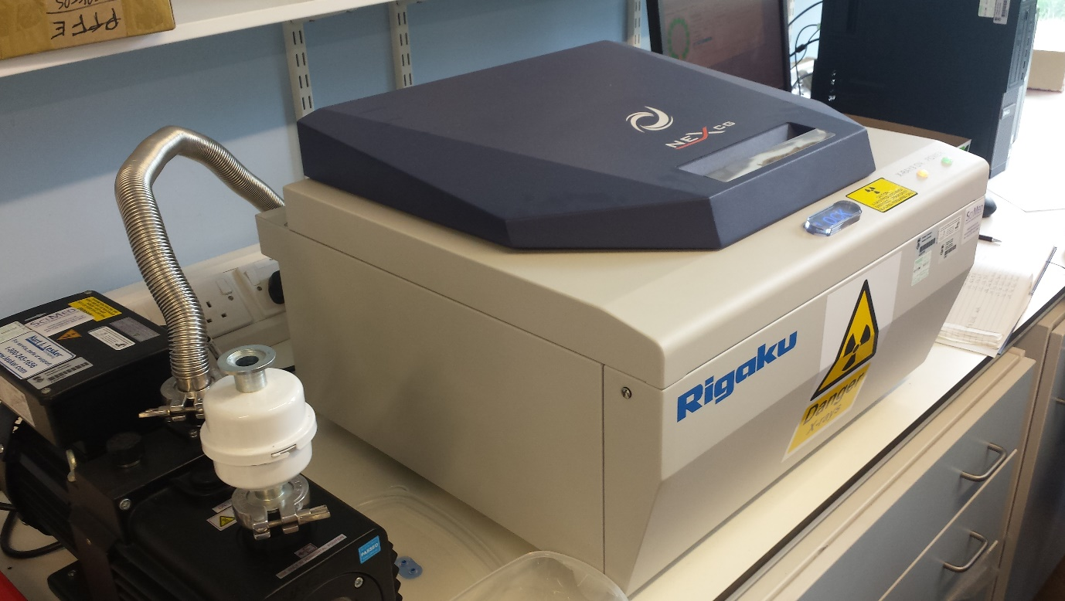
Figure 79 - XRF Machine in operation

Tests & Results

Week 1

Test 1 (Group)
Voltage Cap: 40V Current: 2A Volume of Slurry: 1100ml
Volume of Charge Water: 500ml Gravel Depth: 145mm Date of Sample: 16/04/18
Table 2 - Week 1 Test 1 Results
Day | Time | Time Passed  (Minutes) | Volume Slurry & Charge Water (ml) | Volume of Slurry Water (ml)
Monday | 12:05 (Tap Closed) | 0 | 0 | 0
 | 12:51 (Tap Opened) | 46 | 0 | 0
 | 13:30 | 85 | 575 | 75
 | 14:30 | 145 | 595 | 95
 | 15:00 | 175 | 600 | 100
Tuesday | 10:10 | 1325 | 715 | 215
End Voltage: 40V End Current: 0A
PH at Anode: 8 PH at Cathode: 6.8
Moisture at top: 20% Moisture at bottom: 23%
Figure 80 – Week 1 Test 1 Graph
The first test was ran for just over 22 hours using a sample that was obtained on the 15th April. For the first 45 minutes of the test the reactor was switched on with the tap closed, with the 500ml of water the reactor had been charged which didn’t exit before the reaction had started as the tap was kept closed. After 45 minutes the tap was opened and within half an hour the whole 500ml of fresh water had been drained plus 75ml from the slurry. At the time of the last reading for that day, 100ml of slurry water had been drained which is 46.5% of the total slurry water drained.
At the end of the test the voltage had increased to the maximum cap of 40V and the current had decreased to 0A. Looking inside the reactor the slurry had come away from the outside wall (Cathode), this likely broke the circuit which is why no current was flowing.
Below the dried slurry was a pool of wet slurry sitting on top of the gravel, this was likely due to the surface of the gravel being 70mm lower than the bottom of the anode. This resulted in some slurry never being in contact with the electrodes, hence why it was still so wet. The moisture content of the dryer slurry did increase going down the anode, increasing from 20 % at the top to 23% at the bottom.
The pH of the slurry also got more acidic as it went towards the cathode, with the pH at the anode being 8 and at the cathode being 6.8.
At the top of the anode was a white power, which was collected from analysis, shown on the left-hand side of the figure below. In the centre was the dry slurry sample and the right was the drained water sample.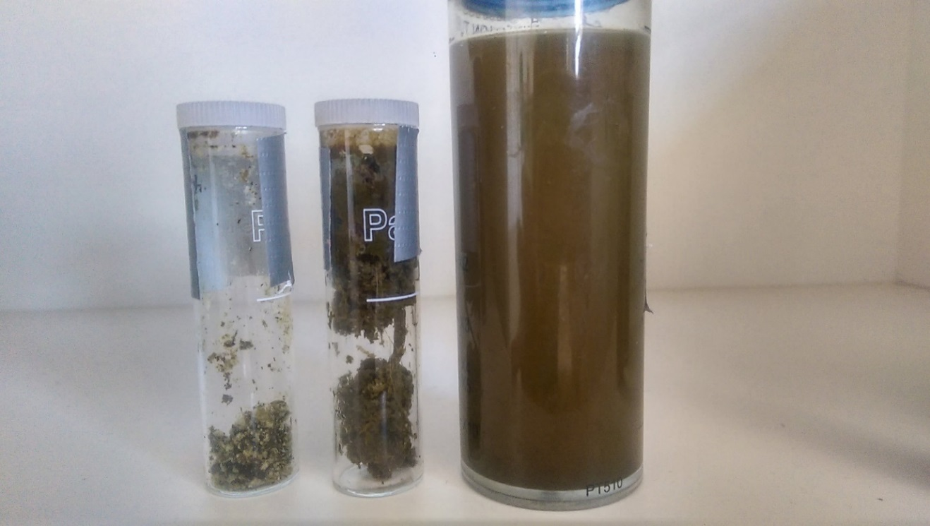
Figure 81 - Week 1 Test 1 Samples
Table 3 - XRF Results Week 1 Test 1
Element | Wet sample (PPM) | Dry Sample (PPM) | Powder Sample (PPM)
Sodium (Na) | 79.1 | ND | ND
Magnesium (Mg) | 75.9 | 188 | 36.5
Aluminium (Al) | 35.5 | 790 | 387
Silicon (Si) | 26.9 | 207 | 41.4
Phosphorus (P) | 14.6 | 37.4 | 11.6
Sulfur (S) | 18.4 | 31.4 | 20.2
Chlorine (Cl) | 111 | 58.7 | 206
Potassium (K) | 365 | 162 | 16.8
Calcium (Ca) | 69.8 | 334 | 45.2
Titanium (Ti) | 0.648 | 2.44 | 0.239
Manganese (Mn) | 0.859 | 10.8 | 1.71
Iron (Fe) | 8.11 | 665 | 180
Cobalt (Co) | 2.07 | ND | 0.534
Copper (Cu) | 0.864 | 2.23 | 1.68
Zinc (Zn) | 1.55 | 3.39 | 1.04
Bromine (Br) | 0.544 | 0.38 | 0.781
Rubidium (Rb) | 0.411 | 0.294 | 0.114
Strontium (Sr) | 0.369 | 1.18 | ND
Tantalum (Ta) | ND | 0.456 | ND
Platinum (Pt) | ND | ND | 0.33
Lead (Pb) | ND | 0.391 | ND
The above table displays the XRF results for the first test of week 1, it contained three samples; one from the water extracted, one from the dried solids and one from the white powder that was present at the top of the reactor.
There is a significant increase in aluminium in both the dry and powder samples compared to the wet sample. From 35.5PPM in the wet sample to 790PPM and 387PPM in the dry and powder samples. This is due to the degradation of the cathode which was made of aluminium. Due to the abundance of aluminium within the white powder, it is safe to assume that the white powder itself is aluminium.
There was also a significant increase of iron again in both the dry and powder samples in comparison to the wet sample. Increasing from 8.11PPM in the wet sample to 665PPM and 180PPM in the dry and powder samples. This is due to the degradation of the anode which was made of steel.

Two of the three elements crucial to plant growth also had significant changes between the dry and wet samples. Potassium had a substantial decrease in the dry sample compared to wet, going from 365PPm to 162PPM. Although, phosphorous increased in the dry sample compared to wet going from 14.6PPM to 37.2PPM.

Test 2 (Group)
Voltage Cap: 25V Current: 2A Volume of Slurry: 1100ml
Volume of Charge Water: 0ml Gravel Depth: 195mm Date of Sample: 17/04/18
Table 4 – Week 1 Test 2 Results
Day | Time | Time Passed  (Minutes) | Volume of Water (ml)
Tuesday | 12:30 | 0 | 0
 | 13:00 | 30 | 80
 | 13:30 | 60 | 90
 | 14:00 | 90 | 100
 | 14:30 | 120 | 110
Wednesday | 10:00 | 1290 | 355
End Voltage: 25V End Current: 0.39A
PH at Anode: 8 PH at Cathode: 5.8
Moisture at top: 30% Moisture at bottom: 35% Volume in Condensation bag: 25ml

Figure 82 – Week 1 Test 2 Graph

The second test was ran for 21 and half hours using the 1 day old sample collected on the 16th April. For this test the tap was opened from the beginning since the system was not charged with water. The gravel depth was also increased from 145mm to 215mm to prevent the puddle of slurry sitting on top of the reactor without being in contact with the electrodes.
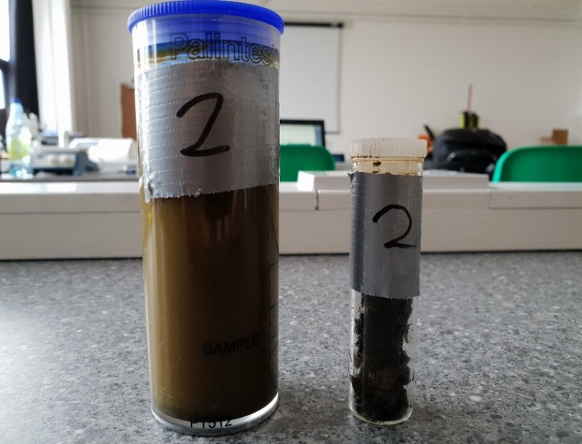
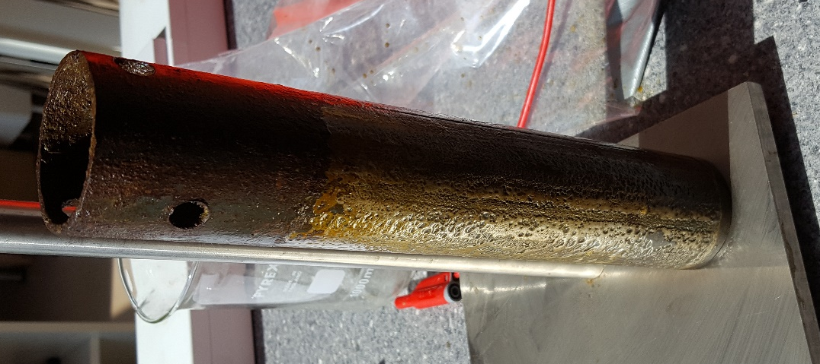
After 2 hours 110ml of water had been drained from the reactor which is 30.9% of the total amount for this test. After a further 19 and half hours another 245ml had been drained in addition to the 25ml collected in the condensation bag, totalling 380ml for the second test. An extra 165ml had been drained compared to the first test which is a 76.7% increase.
Figure 83 - Week 1 Test 2 Wet & Dry Samples
At the end of the test the voltage had reached the cap of 25 but 0.39A was still flowing. After looking inside the reactor the dried slurry was still in contact with both electrodes, which is why there was still a small amount of current flowing.
Increasing the gravel depth successfully filled the gap that was present between the bottom of the anode and the gravel surface in the first test. It is likely the reason for the increase in results, due to more slurry being in contact with the electrodes.
Figure 84 - Anode after Test 2
The image to the left shows that by using a thicker gravel filter of 215mm, the slurry remains in contact with the anode at a higher level.
As with the first test there continued to be a pH gradient present, with the pH at the anode being 8 and the pH at the cathode being 5.8.
Table 5 - XRF Results Week 1 Test 2
Element | Wet sample (PPM) | Dry Sample (PPM)
Sodium (Na) | 471 | ND
Magnesium (Mg) | 110 | 17.4
Aluminium (Al) | 371 | 75.2
Silicon (Si) | 75.7 | 109
Phosphorus (P) | 23.6 | 30.9
Sulfur (S) | 31.4 | 54.2
Chlorine (Cl) | 257 | 615
Potassium (K) | 1500 | 30.2
Calcium (Ca) | 135 | 197
Titanium (Ti) | 1.08 | ND
Manganese (Mn) | 2.21 | 16.3
Iron (Fe) | 17.3 | 3360
Cobalt (Co) | ND | 3.14
Nickel (Ni) | 0.1 | 0.809
Copper (Cu) | 1.23 | 2.13
Zinc (Zn) | 1.89 | 2.61
Gallium (Ga) | 0.143 | ND
Bromine (Br) | 1.14 | 3.55
Rubidium (Rb) | 1.21 | 0.308
Strontium (Sr) | 0.63 | 0.737
Molybdenum (Mo) | 6.63 | ND
Yttrium (Y) | ND | 1.01
The above table displays the XRF results for the second test of week 1. This table contains a wet and a dry sample, taken from the same sources as previous.
Life before, there is a noticeable difference in Aluminium, Sodium and Chlorine content in the Wet sample. There is also a very noticeable amount of Potassium in the wet sample, showing that the nutrients are being contained to the water being removed. There is also a very noticeable amount of Iron in the Dry sample, showing that any iron present is kept to the solids inside the reactor.

Test 3 (Group)
Voltage Cap: 25V Current: 4A Volume of Slurry: 1100ml
Volume of Charge Water: 0ml Gravel Depth: 195mm Date of Sample: 18/04/18

Table 6 – Week 1 Test 3 Results
Day | Time | Time Passed  (Minutes) | Volume of Water (ml)
Wednesday | 12:20 | 0 | 0
 | 12:50 | 30 | 200
 | 13:20 | 60 | 210
 | 13:50 | 90 | 225
 | 14:00 | 120 | 240
 | 14:20 | 150 | 250
 | 14:50 | 180 | 290
Thursday | 09:50 | 1310 | 390
End Voltage: 25V End Current: 0.32A
PH at Anode: 8 PH at Cathode: 6.8
Moisture at top: 45% Moisture at bottom: 56% Volume in Condensation Bag: 30ml

Figure 85 – Week 1 Test 3 Graph
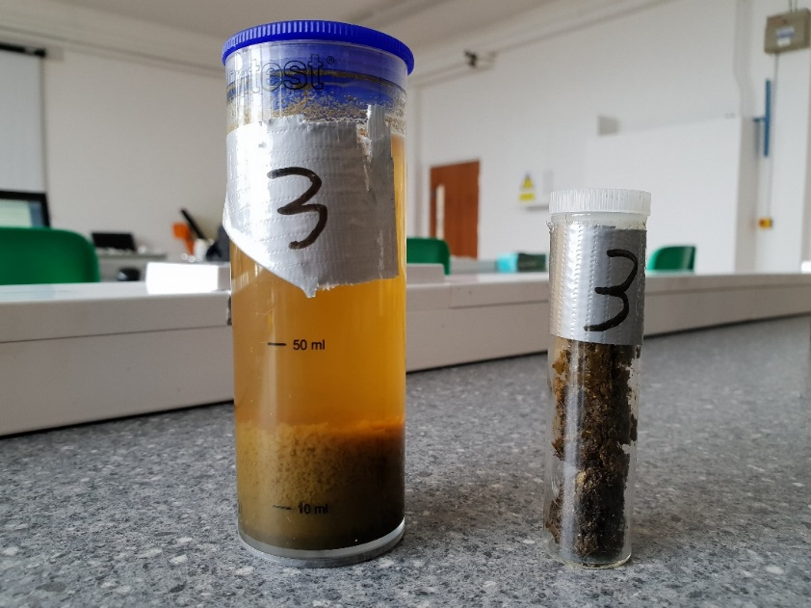
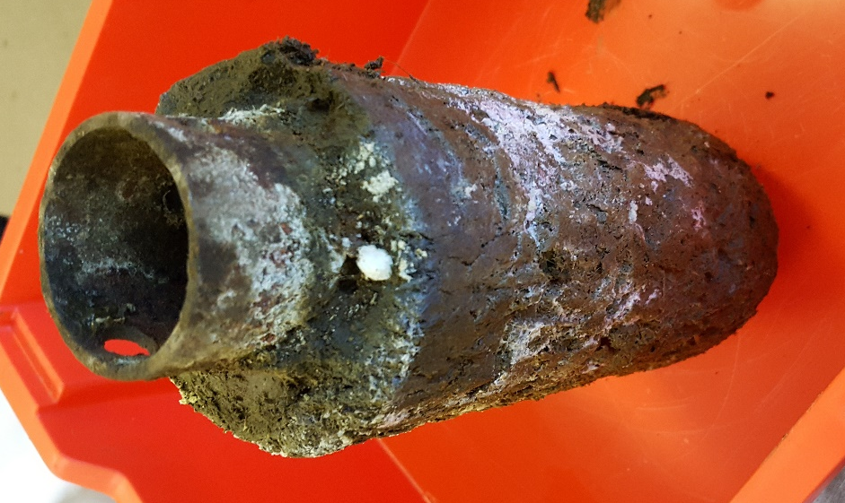
The third test was conducted for 21 and a half hours using the slurry sample obtained on 16th April, which was now 2 days old. The system continued to use a gravel depth of 215mm and was not charged with water since these factors produced better results than the first test.
Figure 86 - Week 1 Test 3 Water and Dry Samples

Figure 87 - Anode after Test 3
After two hours 250ml of water had been drained from the reactor which was 64.1% of the water that had been drained after the test was completed. After the 21 and a half hours a further 140ml had been drained, and there was 30ml in the condensation bag totalling 420ml for the third test. The third test had drained 55ml more than the second test which is a 15.5% increase.
At the end of the test the power supply had reached the set voltage limit of 25V and the current had decreased from 4A to 0.32A.
The image to the left shows the anode removed after conducting the test. Much like the other tests conducted, the dried slurry forms a soft layer surrounding the electrode as well as a white-powder substance forming on the surface.
As with the previous 2 tests there was a pH gradient present, with the pH at the anode being and 6.8 at the cathode.

Table 7 - XRF Results Week 1 Test 3
Element | Wet sample (PPM) | Dry Sample (PPM)
Sodium (Na) | 385 | 18.2
Magnesium (Mg) | 105 | 127
Aluminium (Al) | 951 | 444
Silicon (Si) | 57.1 | 191
Phosphorus (P) | 25.1 | 38.4
Sulfur (S) | 28.1 | 40
Chlorine (Cl) | 105 | 192
Potassium (K) | 1670 | 95.9
Calcium (Ca) | 83.1 | 475
Titanium (Ti) | 0.471 | 2.51
Manganese (Mn) | 1.71 | 13.6
Iron (Fe) | 15.5 | 1830
Cobalt (Co) | ND | 6.72
Copper (Cu) | 1.22 | 2.67
Zinc (Zn) | 1.87 | 2.95
Gallium (Ga) | 0.13 | ND
Arsenic (As) | ND | 0.167
Selenium (Se) | ND | 0.0701
Bromine (Br) | 0.307 | 0.929
Rubidium (Rb) | 0.968 | 0.45
Strontium (Sr) | 0.737 | 0.377
Tantalum (Ta) | ND | 0.694
The above table displays the XRF results for the third test of week 1. This table contains a wet and a dry sample, taken from the same sources as previous.
Life before, there is a noticeable difference in Aluminium & Sodium in the Wet sample with a 507ppm difference between them. Again, there is a very noticeable amount of Potassium in the wet sample, showing that the nutrients are being contained to the water being removed. There is also a very noticeable amount of Iron in the Dry sample, showing that any iron present is kept to the solids inside the reactor.

Test 4 (Group)
Voltage Cap: 25V Current: 3A Volume of Slurry: 1100ml Date of Sample: 19/04/18
Volume of Charge Water: 0ml Gravel Depth: 145mm Sand Depth: 50mm
Table 8 – Week 1 Test 4 Results
Day | Time | Time Passed  (Minutes) | Volume of Water (ml)
Thursday | 11:50 | 0 | 0
 | 12:20 | 30 | 74
 | 12:50 | 60 | 92
 | 13:10 | 80 | 105
 | 13:20 | 90 | 118
 | 13:35 | 105 | 122
 | 13:50 | 120 | 130
 | 14:00 | 130 | 138
 | 14:25 | 155 | 158
 | 14:50 | 180 | 182
 | 15:20 | 210 | 198
 | 15:26 | 216 | 204
Friday | 10:00 | 1330 | 390
End Voltage: 25V End Current: 0.33A
PH at Anode: 8 PH at Cathode: 6.8 Volume in Condensation bag: 40ml

Figure 88 – Week 1 Test 4 Graph
The fourth test was ran for 22 hours using the sample collected on the 16th April. By this point, the same is 3 days old. Again, the system was not charged with water as the results produced suggested that there was no need. The gravel filter was reduced back to 145mm and a new layer of sand was added on top with a depth of 50mm. This was done to observe the behavioural changes between a single media gravel filter and a dual media gravel & sand filter.
After 2 hours, 130ml of water had been drained from the reactor which is 33.3% of the total amount for this test. After a further 20 hours, another 260ml had been drained along with 40ml being collected in the condensation bag, giving a total of 390ml for the fourth test. This is the same amount as the previous test, which used a higher amperage as well as a different filter media.
At the end of the test the voltage had reached the cap of 25V and was generating 0.33A.
Introducing the new sand layer to the filter along with using a lower amperage produces the same end results as the previous test. This is an improvement as less overall power is being used.
As with the previous tests, there is still a pH gradient present within the reactor after the test was finished, with the pH at the anode being 8 and the pH at the cathode being 6.8.
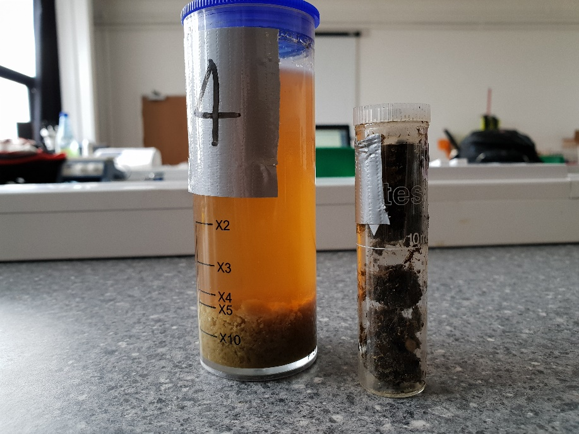
Figure 89 - Week 1 Test 4 Water and Dry Samples

Table 9 - Week 1 Test 4 XRF Results
Element | Wet sample (PPM) | Dry Sample (PPM)
Sodium (Na) | 410 | 15.4
Magnesium (Mg) | 4.56 | 92.6
Aluminium (Al) | 667 | 263
Silicon (Si) | 8.04 | 208
Phosphorus (P) | 4.06 | 41.1
Sulfur (S) | 15.9 | 45
Chlorine (Cl) | 80.4 | 141
Potassium (K) | 2200 | 98
Calcium (Ca) | 9.19 | 420
Titanium (Ti) | ND | 1.94
Manganese (Mn) | ND | 12
Iron (Fe) | 2.87 | 2680
Cobalt (Co) | ND | 1.15
Copper (Cu) | 0.728 | 4.31
Zinc (Zn) | 1.08 | 3.44
Gallium (Ga) | 0.169 | ND
Arsenic (As) | ND | ND
Bromine (Br) | 0.326 | 0.69
Rubidium (Rb) | 1.39 | 0.3
Strontium (Sr) | ND | 2.09
Tantalum (Ta)

The above table displays the results for the XRF analysis of test 3’s wet and dry samples. As with test 2 and test 3 there is more iron in the dry sample and more aluminium in the wet. Both due to the respective electrodes corroding. However, during the process the water is drawn to the outer electrode (cathode) which is made of aluminium and the solid is drawn to the centre electrode (anode) which is made of steel. This explains why there has consistently been higher content of iron and aluminium in the dry and wet samples respectively.

Test 5 (Group)
Voltage Cap: 25V Current: 1A Volume of Slurry: 1100ml Date of Sample: 20/04/18
Volume of Charge Water: 0ml Gravel Depth: 145mm Sand Depth: 50mm
Table 10 - Week 1 Test 5 Results
Day | Time | Time Passed  (Minutes) | Volume of Water (ml)
Friday | 14:27 | 0 | 0
 | 14:43 | 16 | 52
 | 15:03 | 36 | 112
 | 15:34 | 67 | 118
 | 15:50 | 83 | 118
 | 15:58 | 91 | 122
 | 15:18 | 111 | 122
 | 15:28 | 121 | 125
Monday | 10:00 | 4113 | 400

End Voltage: 25V End Current: 0.06A
PH at Anode: 8 PH at Cathode: 6.8 Volume in Condensation bag: 10ml

Figure 90 – Week 1 Test 5 Graph
The fifth test was ran for 68 and a half hours using the sample collected on the 16th April. By this point, the same is 4 days old and has been disposed of due to the gases being generated.
Again, the system was not charged with water as the previous results produced suggested that there was no need. The current was reduced to 1A and the test was extended from the ~22 hour period up to 68 hours. This was done to observe the behavioural changes when the reactor is operated over an extended period of time.
After one hour, 125ml of water had been drained from the reactor which is 31.25% of the total amount for this test. After a further 67 hours, an additional 275ml had been drained along with 10ml being collected in the condensation bag, giving a total of 410ml for the fourth test. These results are similar to previous tests despite the extended period of which the test was conducted. The amount collected in the condensation bag is noticeably less than previous tests, which could suggest some of the water vapour may have dissipated.
At the end of the test the voltage had reached the cap of 25V and was generating 0.06A.
Extending the time in which the reactor is operational yielded a similar amount of water as previous tests, which shows that obtaining additional water after a set point proves difficult due to either the additional power needed.
As with the previous tests, there is still a pH gradient present within the reactor after the test was finished, with the pH at the anode being 8 and the pH at the cathode being 6.8.
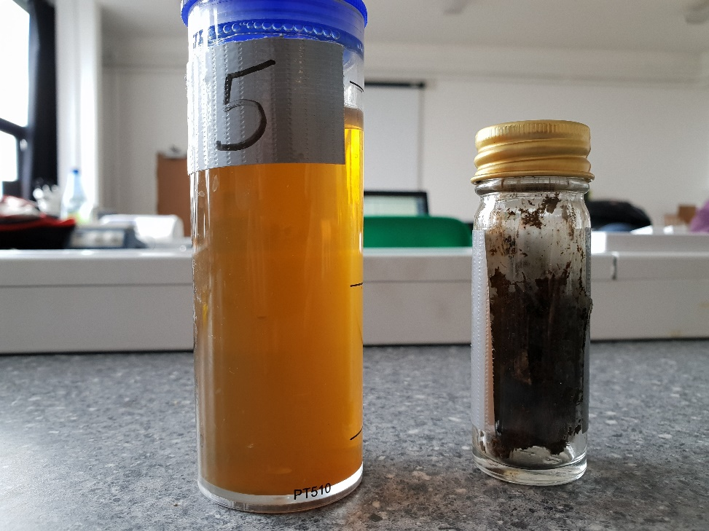
Figure 91 - Week 1 Test 5 Water and Dry samples
Element | Wet sample (PPM) | Dry Sample (PPM)
Sodium (Na) | 820 | 27
Magnesium (Mg) | 7.71 | 186
Aluminium (Al) | 1790 | 526
Silicon (Si) | 16.2 | 328
Phosphorus (P) | 6.88 | 46.1
Sulphur (S) | 12.6 | 45.7
Chlorine (Cl) | 167 | 169
Potassium (K) | 2660 | 124
Calcium (Ca) | 11.8 | 562
Titanium (Ti) | ND | 4.75
Manganese (Mn) | ND | 22
Iron (Fe) | 5.39 | 3270
Cobalt (Co) | ND | 4.25
Copper (Cu) | 0.989 | 3.77
Zinc (Zn) | 1.05 | 5.3
Gallium (Ga) | 0.346 | 0.238
Arsenic (As) | ND | 0.293
Selenium (Se) | ND | ND
Bromine (Br) | 0.234 | 1.15
Rubidium (Rb) | 1.8 | 0.951
Strontium (Sr) | ND | 4.53
Tantalum (Ta) | ND | ND
Table 11 Test 5 XRF results
As is shown from the table above test five indicated the presence of excessive amounts of iron in the dry waste after the test had been completed as the sacrificial cathode eroded due to the ion release from the electrolysis reaction. The iron content of the dry waste was greater than the liquid as the movement of the liquid during the dewatering process is in the direction of the anode and as a result the iron must pass through the solid waste as it is attracted towards the anode, whereas the aluminium that is eroded from the outer anode is constantly subjected to liquid passing over the internal wall of the reactor and as a result removes the oxidised aluminium ions which remain present in the liquid the drains through the reactor.
The dry waste with a higher iron content at the location of the cathode had a lower pH than the waste in contact with the outer anode and as a result showed signs of a pH gradient across the cross-sectional area of the waste. The content of iron and aluminium was of lower ppm in both samples when compared to tests of higher currents as the emission of the ions from the electrodes is directly affected to the strength of the electric field shown in the H-S theory.

Week One Testing Results (Group)
Table 12 - Week 1 Results
The results from the first week of testing show that by increasing the current from 2A to 4A when using a single media gravel filter, a higher yield of water can be obtained. As well as this, the results show that despite using a single media gravel filter of 145mm, or when using a dial media filter with 145mm gravel & 50mm sand, the yield of water can be raised by increasing the amount of current.

Week One Results Compared to Previous Year’s (Group)
Table 13 - Week 1 and Last Year’s Results

When compared to the results obtained from the previous year, the results show an overall improvement from the changes made to the reactor as well as the current used during testing.
The graph shows that a higher yield of water has been obtained in a shorter time frame while also consuming less overall power.

Week 2

Test 1 (Group)
Voltage Cap: 0V Current: 0A Volume of Slurry: 1100ml
Volume of Charge Water: 0ml Gravel Depth: 195mm Date of Sample: 23/04/18
Table 14 – Week 2 Test 1 Results
Day | Time | Time Passed  (Minutes) | Volume of Water (ml)
Monday | 11:40 | 0 | 0
 | 11:50 | 10 | 10
 | 12:00 | 20 | 10
 | 12:10 | 30 | 11
 | 12:20 | 40 | 15
 | 12:30 | 50 | 15
 | 12:40 | 60 | 15
 | 12:50 | 70 | 16
 | 13:00 | 80 | 16
 | 13:10 | 90 | 20

Figure 92 – Week 2 Test 1 Results
Based on the findings obtained from the first week’s results, it was thought to carry out another set of tests on the reactor but using the forces of gravity only. The test was conducted over a 90 minutes period without powering up the reactor. The reactor was first filled with 195mm of gravel, which was acting as the filter and then 1100ml of slurry was added on top of the gravel, as shown in figure.

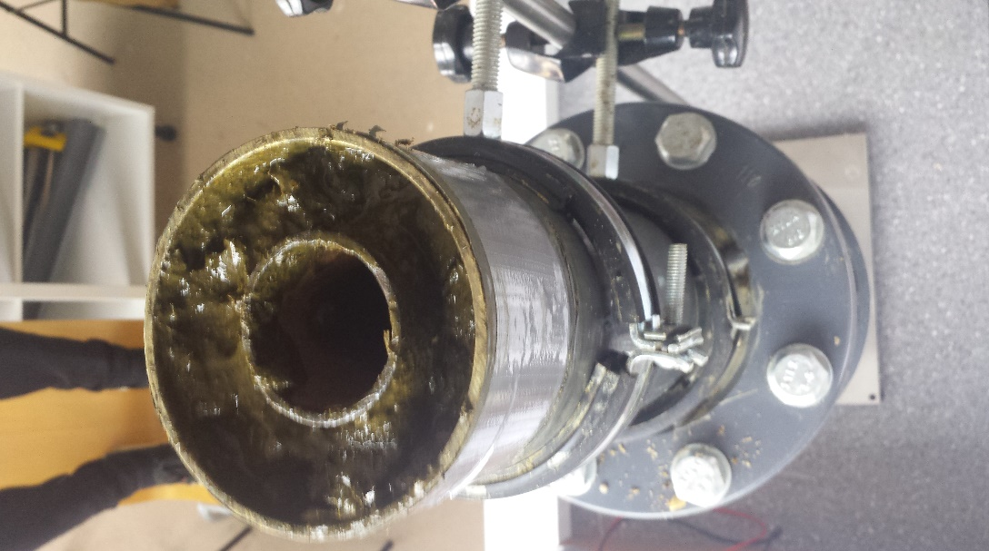
Figure 93 - Reactor Filled with Slurry
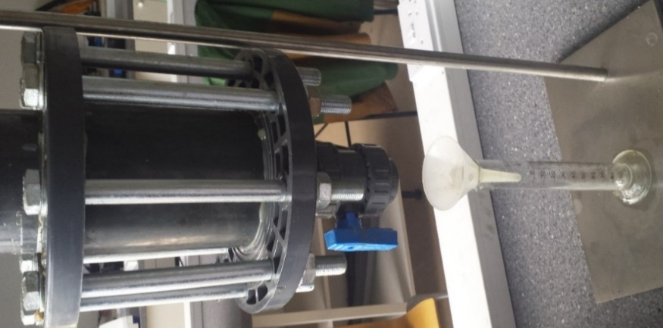

Figure 94 - Reactor Gravity Test
Gradually small drips of water were drained out the slurry and 10ml of water was collected in the first 10 minutes. However, the fact that there was no voltage or current connected to the reactor meant that the volume of water drained out of the slurry was going to be low, compared to the previous test conducted while the reactor was powered up with current.
The results were recorded every 10 minutes. It was found that, slight increases in the drops of water drained from the slurry between 30 - 40 minutes and between 80 - 90 minutes of testing. At the end of the test, the reactor was only able to produce 20ml of water from 1100ml of slurry.

Test 2 (Group)
Voltage Cap: 0V Current: 0A Volume of Slurry: 1100ml Date of Sample: 23/04/18
Volume of Charge Water: 0ml Gravel Depth: 145mm Sand Depth: 50mm
Table 15 - Week 2 Test 2 Results
Day | Time | Time Passed  (Minutes) | Volume of Water (ml)
Monday | 13:40 | 0 | 0
 | 13:50 | 10 | 8
 | 14:00 | 20 | 10
 | 14:10 | 30 | 10
 | 14:20 | 40 | 10
 | 14:30 | 50 | 10
 | 14:40 | 60 | 12
 | 14:50 | 70 | 15
 | 15:00 | 80 | 15
 | 15:10 | 90 | 15

Figure 95 - Week 2 Test 2 Graph

After completing the first gravity test the reactor needed to be cleaned and left to dry thoroughly before conducting the second gravity test. The second test was conducted over the same amount of time, using the same sample which was obtained from the farm. However, as previously mentioned the amount of gravel used in the second gravity test was reduced from 195mm to 145mm of gravel, simply because a new layer of sand was added on top with a depth of 50mm to create a dual media of gravel & sand filter.
Compared to the previous test, the drops of water coming out the reactor were a lot slower. As a result, only 8ml of water was collected in the first ten minutes and it wasn’t until 20 minutes of testing that we were able to reach the 10ml mark. The drops of water increased between 50 – 70 minutes of testing which then caused a 5ml increase. At the end of the test, the reactor was only able to produce 15ml of water from 1100ml of slurry.
It was found that with the addition of sand in the filter, meant that most of the water was been absorbed and only a small amount of it could pass through. As a result, the amount of collected at the end of the test was 5ml less than the gravel only gravity test.

Test 3 (Group)
Voltage Cap: 25V Current: 2A Volume of Slurry: 1100ml Date of Sample: 23/04/18
Volume of Charge Water: 0ml Gravel Depth: 145 mm Sand Depth: 50mm
Table 16 - Week 2 Test 3 Results
Day | Time | Time Passed  (Minutes) | Volume of Water (ml)
Tuesday | 15:40 | 0 | 0
 | 15:50 | 10 | 42
 | 16:00 | 20 | 47
 | 16:10 | 30 | 51
 | 16:20 | 40 | 57
 | 16:30 | 50 | 60
 | 16:40 | 60 | 61
 | 16:50 | 70 | 65
 | 17:00 | 80 | 65
 | 17:10 | 90 | 78
End Voltage: 25V End Current: 0.07A
PH at Anode: 8 PH at Cathode: 7
Moisture at top: Moisture at bottom: Volume in Condensation Bag: 20mg
Figure 96- Week 2 Test 3 Graph
At this point it was decided not to do a sand only gravity test but to re-run the gravel and sand test and power up the reactor using 25 volts and 2 amps. The third test was conducted over the same amount of time, using the same sample as the previous two tests. This was vital that all three tests were conducted in the same manner to ensure that our results were constant and accurate
Just after 10 minutes of testing we were able to collect 42ml amount of water drained from the reactor and this gradually increased over time. After one hour, 61ml of water was drained from the reactor. At the end of the test, the voltage had reached 25V and was generating 0.07A and the reactor produced 78ml of water from 1100ml of slurry.
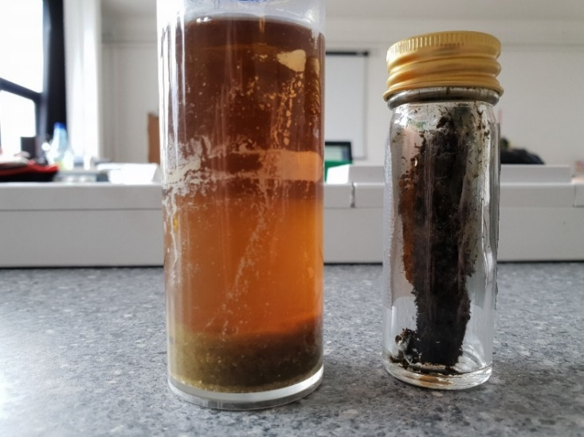
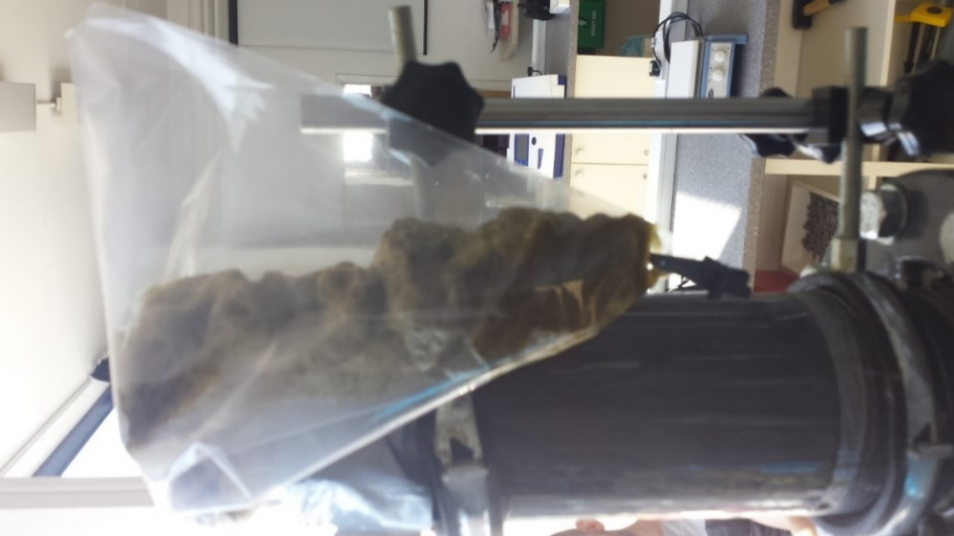
Figure 97 - Week 2 Test 3 Samples
Figure 98 - Reactor covered with Condensation Bag
It was found that with the addition of the condensation bag on top of the reactor, meant that all the form and evaporated water was captured in the bag. Hence, 20ml of the 78ml was collected from the condensation bag.

Element | Wet sample (PPM) | Dry Sample (PPM)
Sodium (Na) | 16.1 | 428
Magnesium (Mg) | 32.3 | 14.3
Aluminium (Al) | 140 | 939
Silicon (Si) | 423 | 21.6
Phosphorus (P) | 47.1 | 7.5
Sulphur (S) | 51.5 | 23.7
Chlorine (Cl) | 309 | 40.6
Potassium (K) | 39 | 3910
Calcium (Ca) | 1030 | 24.8
Titanium (Ti) | 9.82 | ND
Manganese (Mn) | 8.5 | 0.378
Iron (Fe) | 1370 | 6.29
Cobalt (Co) | 3.25 | ND
Copper (Cu) | 3.34 | 2.15
Zinc (Zn) | ND | 0.281
Gallium (Ga) | ND | 0.187
Arsenic (As) | ND | ND
Selenium (Se) | 1.69 | 0.441
Bromine (Br) | 0.462 | 2.26
Rubidium (Rb) | 2.77 | ND
Strontium (Sr) | 16.1 | 428
Tantalum (Ta) | 32.3 | 14.3
Table 17: Week 2 Test 3 XRF
As is seen in previous tests the amount of iron present in the dry sample is far greater than in the wet sample and the aluminium presence in the wet sample is greater than the amount found in the dry sample this is due to the migration of the fluid from the cathode towards the anode.
What is noticeable from this test is the presence of sodium which is much higher than the tests run previously, the abundance of sodium is likely to be from the addition of the sand layer in the filter as the sand is almost certainly from a coastal source and not from an inland source, this addition of sand would almost certainly explain the rapid increase in Sodium levels seen in this test.

Test 4 (Group)
Voltage Cap: 40V Current: 2A Volume of Slurry: 1100ml
Volume of Charge Water: 0ml Gravel Depth: 195mm Date of Sample: 23/04/18
Table 18 - Week 2 Test 4 Results
Day | Time | Time Passed  (Minutes) | Volume of Water (ml)
Tuesday | 12:05 | 0 | 0
 | 12:15 | 10 | 50
 | 12:25 | 20 | 76
 | 12:35 | 30 | 76
 | 12:45 | 40 | 77
 | 12:55 | 50 | 82
 | 13:05 | 60 | 82
 | 13:15 | 70 | 90
 | 13:25 | 80 | 91
 | 13:35 | 90 | 91
End Voltage: 5V End Current: 1.98A
PH at Anode: 5.8 PH at Cathode: 8

Figure 99 - Week 2 Test 4 Graph
This test was run for 90 minutes with on a sample that was collected on the 21st f April, the sample that was collected on this date had a higher viscosity than the previous sample and was expected to yield less liquid than the previous tests at the same current. The rector and the filter were prepared in the same manner as the previous tests.
Over the 90-minute test the liquid rapidly left the reactor initially with the rate of yield decreasing as time increased this is thought to be related to the performance of the membrane that is used to filter the liquid as it exits the reactor. The membrane because of its liquid permeable design will load with liquid then discharge the absorbed liquid rapidly and then require time to re-charge with liquid before releasing the liquid out f the reactor. The gravel depth prevents a layer of waste from forming in an area that is not subjected to the effects of the electrical current within the reactor.
The waste that was removed from the reactor after this test still had a high moisture content as the amount of liquid removed was near the 10% mark of the total moisture content of the 1100ml of waste loaded.
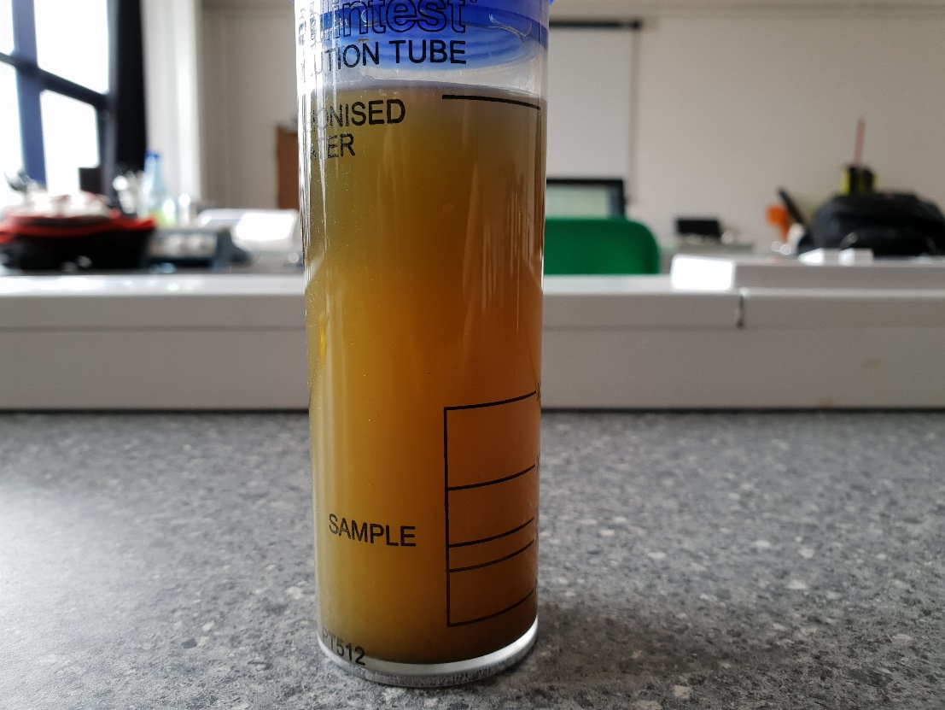
Figure 100 – Week 2 Test 4 Water Sample

Element | Wet sample (PPM) | Dry Sample (PPM)
Sodium (Na) | 81.5 | ND
Magnesium (Mg) | 25.8 | 6.13
Aluminium (Al) | 221 | 51.6
Silicon (Si) | 37.4 | 11.5
Phosphorus (P) | 8.48 | 1.61
Sulphur (S) | 12.9 | 3.98
Chlorine (Cl) | 41 | 9.29
Potassium (K) | 833 | 96.5
Calcium (Ca) | 48.1 | 16.8
Titanium (Ti) | 0.368 | ND
Manganese (Mn) | 0.448 | ND
Iron (Fe) | 9.31 | 2.76
Cobalt (Co) | ND | ND
Copper (Cu) | 1.11 | 2.26
Zinc (Zn) | 1.6 | 1.34
Gallium (Ga) | ND | ND
Arsenic (As) | ND | ND
Selenium (Se) | 0.0524 | ND
Bromine (Br) | 0.264 | ND
Rubidium (Rb) | 0.493 | ND
Strontium (Sr) | ND | ND
Tantalum (Ta) | ND | ND
Table 19 : Week 2 Test 4
From the XRF results for week 2 test 4 there is a noticeable drop in the measurement of iron and aluminium when compared to previous test. As the tests in week two were run for a period of ninety minutes, the time that the electric field was applied to the waste was not sufficient enough to allow the migration of iron through the waste in sufficient quantities as seen in tests run for longer periods.
As a result of the short detention time in the reaction chamber and after the test was completed the reactor was starting to show signs of exhaustion with the outside of the Cathode in particular showing signs of oxidation where the plastic coating began to bubble which could have been a contributing factor to the reduction in iron and aluminium seen in the samples that were taken from the later tests.

Test 5 (Group)
Voltage Cap: 40V Current: 4A Volume of Slurry: 1100ml
Volume of Charge Water: 0ml Gravel Depth: 195mm Date of Sample: 23/04/18
Table 20 - Week 2 Test 5 Results
Day | Time | Time Passed  (Minutes) | Volume of Water (ml)
Tuesday | 14:45 | 0 | 0
 | 14:55 | 10 | 55
 | 15:05 | 20 | 57
 | 15:15 | 30 | 57
 | 15:25 | 40 | 62
 | 15:35 | 50 | 75
 | 15:45 | 60 | 80
 | 15:55 | 70 | 86
 | 16:05 | 80 | 105
 | 16:15 | 90 | 127
Wednesday | 10:00 | 1155 | 336

End Voltage: 25V End Current: 0A
PH at Anode: 8 PH at Cathode: 5.8
Figure 101 - Week 2 Test 5 Graph

Test ten was run with a current of 4 amps and was left to run for a total time of 19 hours and 45 minutes and finished the test with a current of 0 amps and a voltage of 25 as a result of the resistance of the waste increasing as time increased and the connection between the power pack and the anode. As is seen with previous tests the membrane prevents a continuous yield of liquid from being measured evidence of this is the readings of 55,57,57 and 62 ml over the course of 30 minutes, this is thought to be evidence of the time taken for the membrane to become fully saturated with liquid from the reactor process. What is not known is the time that the current across the reactor drops, if the current could potentially be maintained the dewatering of the waste by the reactor may be more successful but also far more efficient as the power consumption could be adjusted and limited to the point until the power consumption to yield ratio becomes too great.
Overnight the yield continued to increase and was measured at 336 ml which was not the greatest yield measured, it is thought that the sample used may have had a lower moisture content than previous samples and also that the reactor during this test was not performing to the same standard as previous tests as a result of the anode and cathode becoming depleted of available ions.
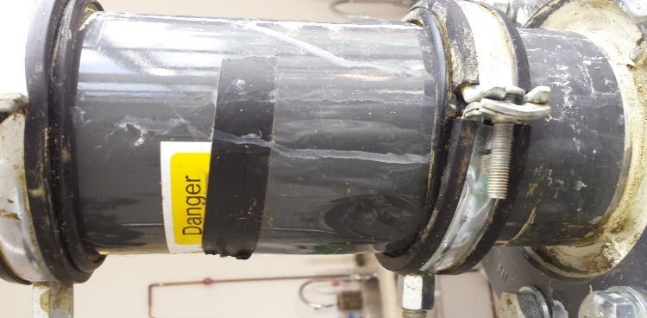
Figure 102 - Cathode Bubbling
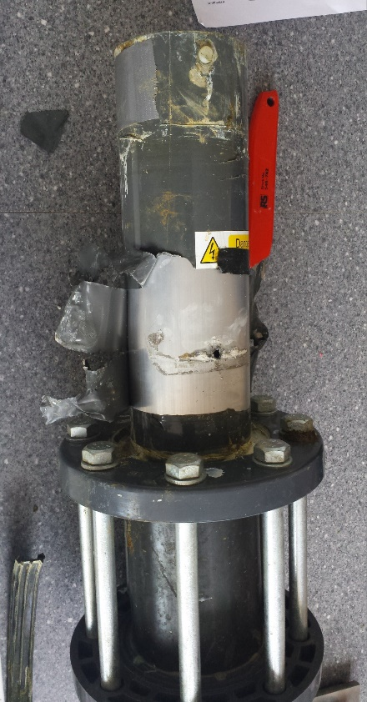
Figure 103 - Hole in the Cathode
Once the testing was completed it was discovered that the material that the cathode was made of had corroded to such an extent that the external wall of the cathode that was structurally integral to supporting the reactor had failed and two holes had appeared, evidence of this was noted before the inspection of the reactor where the liquid that was being released from the process was leaking through the external wall of the reactor and was collecting around the top flange of the reactor.
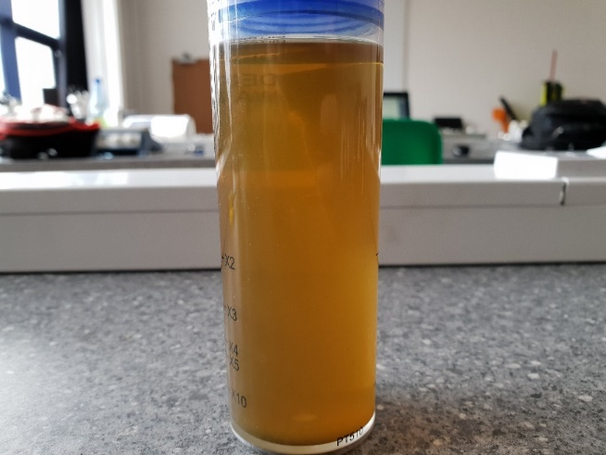
What is noticeable form the results for test ten is that the performance of the reactor up to the 70-minute mark is lower than test nine and test eleven particularly from the ten-minute point to the forty-minute point. It is likely that at this point the pouter wall of the cathode had failed and the liquid that was produced was exiting through the fractures in the material. Up to the seventy-minute mark it is thought that the amount of aluminium oxide produced was not sufficient enough to seal the fracture, once the seventy-minute mark was reached and the aluminium oxide had reached a sufficient volume to act as a barrier to the liquid the performance of the reactor rapidly increased producing a higher yield than any other test run with the same sample for the ninety minutes.
Figure 104 - Week 2 Test 5 Water Sample

Table 21 - Week 2 Test 5 XRF Results
Element | Wet (PPM)
Sodium (Na) | 145
Magnesium (Mg) | ND
Aluminium (Al) | 1230
Silicon (Si) | 10.5
Phosphorus (P) | 3.1
Sulphur (S) | 4.36
Chlorine (Cl) | 18.5
Potassium (K) | 68.4
Calcium (Ca) | 11.7
Titanium (Ti) | ND
Manganese (Mn) | ND
Iron (Fe) | 910
Cobalt (Co) | ND
Copper (Cu) | 0.764
Zinc (Zn) | 0.916
Gallium (Ga) | 0.201
Arsenic (As) | ND
Selenium (Se) | ND
Bromine (Br) | 0.0956
Rubidium (Rb) | 0.903
Strontium (Sr) | ND
Tantalum (Ta) | ND

At this point the reactor had become inefficient as a result of the complete exhaustion of the Cathode exhausting and the inside wall showing signs of heavy oxidation which impacted the current flow through the waste and the H-S theory shows that the impact of a reduced electric field impacts the mobility of the ions in electro osmosis.

Test 6 (Group)
Voltage Cap: 40V Current: 4A Volume of Slurry: 1100ml
Volume of Charge Water: 0ml Gravel Depth: 145mm Date of Sample: 23/04/18
Sand Depth: 50mm
Table 21 - Week 2 Test 6 Results
Day | Time | Time Passed  (Minutes) | Volume of Water (ml)
Wednesday | 12:50 | 0 | 0
 | 13:00 | 10 | 50
 | 13:10 | 20 | 71
 | 13:20 | 30 | 76
 | 13:30 | 40 | 80
 | 13:40 | 50 | 85
 | 13:50 | 60 | 89
 | 14:00 | 70 | 91
 | 14:10 | 80 | 95
 | 14:20 | 90 | 97
End Voltage: 5V End Current: 4A
PH at Anode: 8 PH at Cathode: 5.8
Figure 105 - Week 2 Test 6 Graph

The final test was run for a period of 90 minutes, this test used a filter that was 145mm gravel and 70mm sand with a current of four amps, the previous test showed signs that the reactor was beginning to fail and liquid was leaking from the outside wall. This was witnessed with this test but was not showing the same volume of liquid leaking, this is thought to be a result of the holes that had appeared partially sealing with the aluminium oxide that was present at the time of inspection.
What is noticeable from the test eleven is that the peak that is seen in test tens results towards the end of the ninety-minute test does not appear, this can be linked to the ability of the sand to absorb the liquid produced and release it at a slower rate than a pure gravel filter. Over a ninety-minute test the effect of the membrane becoming saturated with fluid and then discharging relatively quickly is not seen with a sand filter as the sand acts as a damper for the discharged fluid.
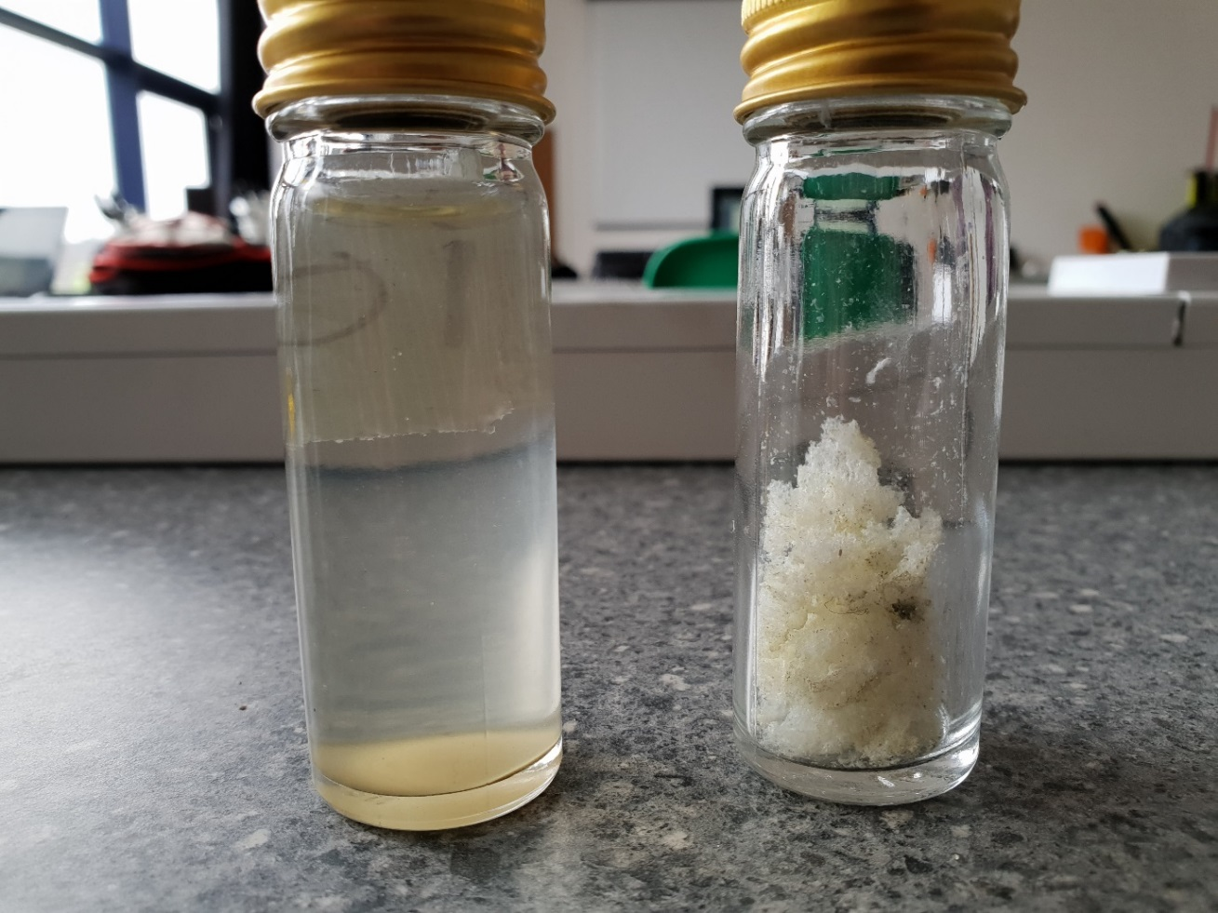
Figure 106 - Week 2 Test 6 Samples
In the figure above, on the left-hand side is a sample of the drainage water and on the right is a sample of the white power that was forming on the top of the electrode.
Table 22 - Week 2 Test 6 XRF Results
Element | Wet sample (PPM) | Powder Sample (PPM)
Sodium (Na) | ND | 29.3
Magnesium (Mg) | ND | 7.66
Aluminium (Al) | 26.2 | 402
Silicon (Si) | 18.6 | 14.6
Phosphorus (P) | 0.592 | 0.893
Sulphur (S) | 5.72 | 4.26
Chlorine (Cl) | 10.6 | 9.51
Potassium (K) | 68.4 | 143
Calcium (Ca) | 11.7 | 16.1
Titanium (Ti) | ND | ND
Manganese (Mn) | 0.127 | ND
Iron (Fe) | 5.48 | 2.96
Cobalt (Co) | ND | ND
Copper (Cu) | 0.57 | 2.7
Zinc (Zn) | 0.956 | 1.29
Gallium (Ga) | ND | ND
Arsenic (As) | ND | ND
Selenium (Se) | ND | ND
Bromine (Br) | ND | 0.0716
Rubidium (Rb) | ND | 0.143
Strontium (Sr) | ND | ND
Tantalum (Ta) | ND | 0.382

The table above shows that test six has very low ppm values for multiple elements in comparison to previous tests. For example, the ppm for Sodium, Magnesium, and Aluminium & Phosphorus is significantly lower than in previous tests where the values were up to twenty times greater. This is especially true for Potassium as in previous tests, it has been proven that the wet sample can be expected to hold values of around 1000ppm or more.
There are also several elements which do not have any recorded data. This can be associated with the fact that after testing, there was a leak discovered underneath the clamp, allowing outside air to enter the middle of the chamber and also allowing fluid to leak from the outer reactor wall. The overall turbidity and colour of water from the test also reflects this as it is noticeably clearer than previous results.

Week 2 Testing Results (Group)
Table 22: Week 2 Results
The results from the second week of testing show that the effect of gravity on the results obtained is significantly low as there is only up to a 20ml difference after 90 minutes. The results also show that by using a higher current, the result can be greater than if a lower current was being used. Finally, it is evident that the type of media filter used also effects the result as the single media gravel filter yielded more water than those that used a mixed gravel & sand filter.

Overall XRF Analysis (Group)
The XRF analysis of all the tests show that during the tests that last for the greatest amount of time resulted in higher amounts of aluminium and iron in both the wet and dry samples, this is thought to be as a result of the time the tests were run for with the tests run for a period of ninety minutes gaining less iron and aluminium than the tests run for 20+ hours.
It has to be noted that the tests that were run in week two were run in a reaction chamber that was showing signs of severe oxidation of the Cathode which resulted in the reaction between the two electrode becoming less efficient as the conductivity of the Cathode reduced as the Oxidation of the Aluminium increased.

Figure 107 : Aluminium Content Dry Sample
The Aluminium content of the week one test one dry waste sample was much higher than the other dry samples, this may have been caused by the reactor producing a layer of aluminium oxide prior to the testing began and resulted in the first test absorbing a greater amount than the other tests.

Figure 108 : Aluminium Content Wet
The aluminium content of the wet samples which were expected to contain more aluminium due to the liquid drawn out of the waste during the reaction was to run down the aluminium cathode and some degree of mixing was occurring. From the wet sample graph for aluminium content the highest values were week 1 test five and week 2 test five with week one test five running for a period of 68 hours which was a test completed over the course of a weekend at a current of 1 amp, week two test five was run for ninety minutes at a current of 4 amps which saw a Al content in the XRF analysis of 1230 ppm compared to 1790 for week one test five. This provides some evidence that the rate of Aluminium oxidation at the cathode is directly related to the electric field strength and the flow of current in the reaction chamber.

Figure 109 : Iron Content Dry

Figure 110 : Iron Content Wet
The Iron content of the dry waste samples were far greater than the Iron contents of the liquid samples, this is evidence to confirm the H-S theory as the sacrificial anode gives up iron ions during the electro kinetic dewatering process, these ions are then available to migrate in the fluid that is drawn towards the Cathode.
During Migration of the fluid from the Anode towards the Cathode the Iron ions which have mixed with the fluid are transported towards the Cathode with the fluid, this transportation through the pores of the solid waste is likely to cause the iron ions to become trapped in the pores that the fluid passes through. As the dewatering process continues the pores that the liquid travels through constrict as a result of the increasing pore pressure caused by the removal of liquid, the iron ions velocity will decrease as the passage through the pores requires greater amounts of pressure energy to migrate, this then results in the iron ions depositing in the dry sample, evidence of this is seen by the high iron content in the dry waste.

Reactor (Group)
Once the inside Anode was washed and thoroughly dried from the final tests. The Anode was then inspected, and it was found that the middle part of the Anode was worn off more compared to the bottom end of the Anode.
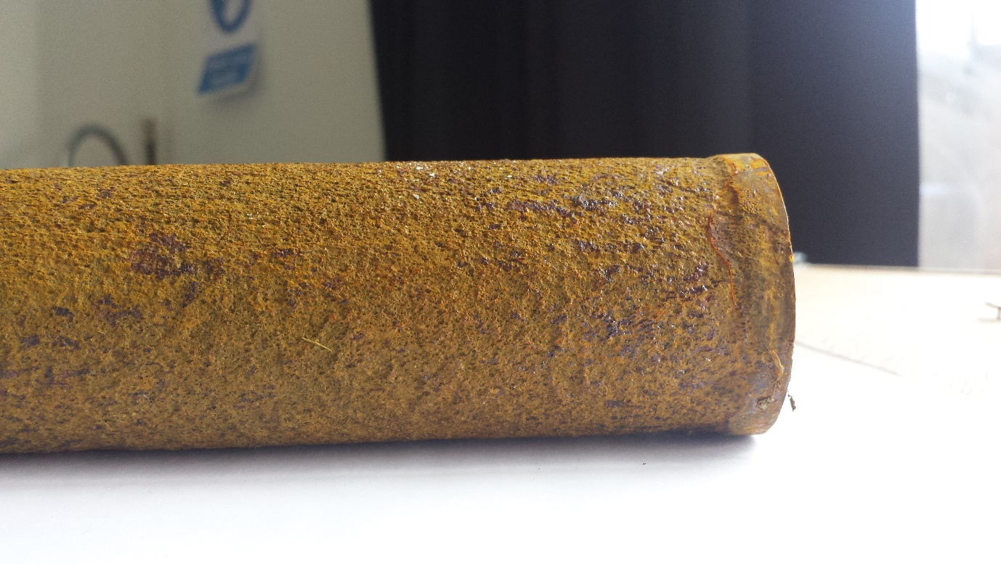

Figure 111 – The Anode

It was believed that, this may have occurred because the bottom end of the Anode was sealed to prevent the slurry from entering the inside the Anode. It was assumed that the layers of the anode were removed due to oxidation reaction occurring which deteriorate the electrode.
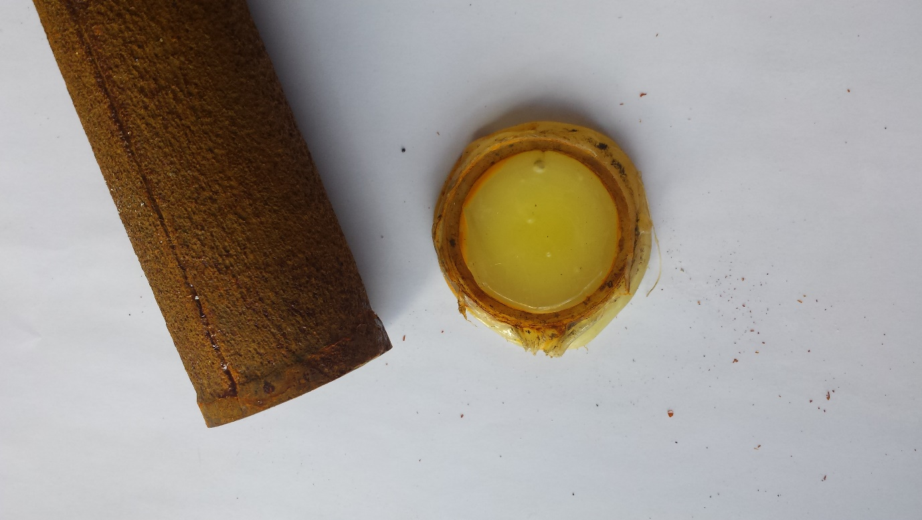
Figure 112 - The Anode & Seal cap off

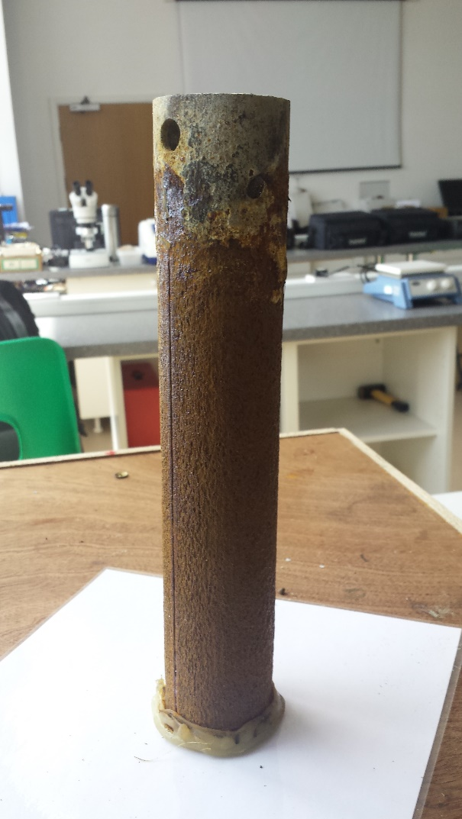
Figure 113 - The Anode & Seal cap on

By adding the seal cap on the bottom of the Anode we managed to prevent the base of the Anode to deteriorate completely and combine with the dry slurry. When compared with the old Anode, the new Anode was corroded far more after final stage of testing as shown in the Figure below.
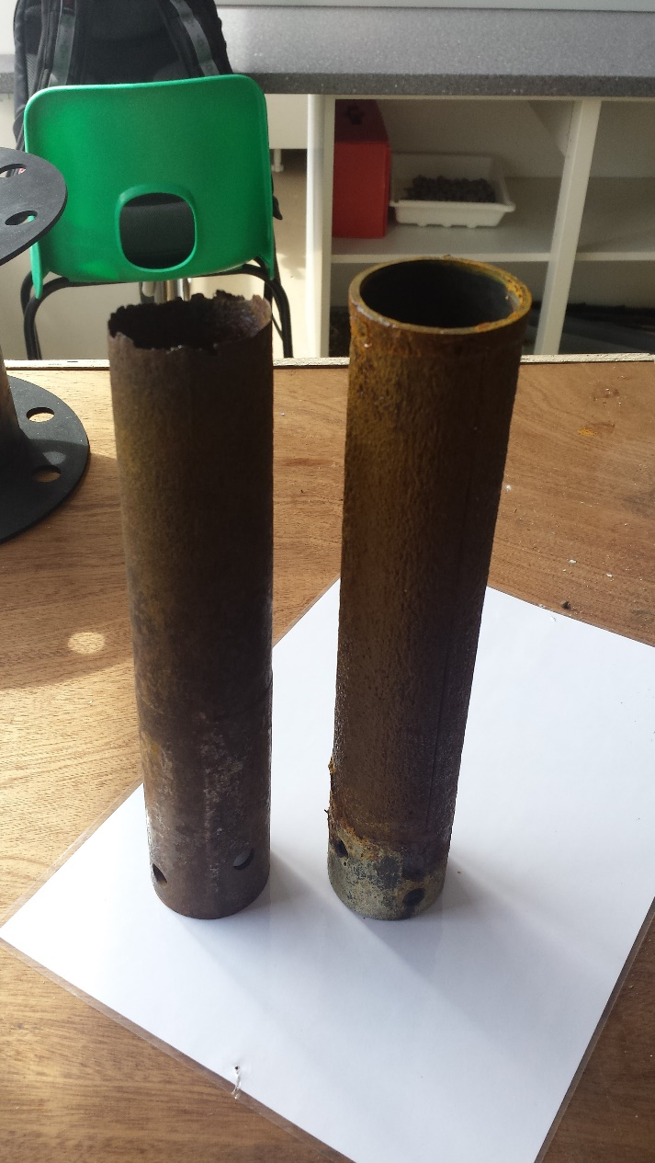

Figure 114 - Old Anode Vs New Anode

Cathode deteriorating (Group)
Although, the top of the reactor was sealed with a plastic bag to capture the evaporated water, it was found that the tape could not prevent some of the water escaping down the side of the reactor.
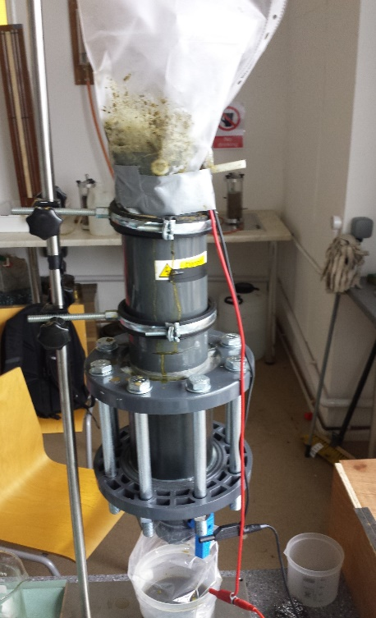
Figure 115 - System Sealed with Duct Tape
After undertaking the final test, it was found that the sides of the reactor were slightly expanded. At first it was though that the heat produced from the reactor may have caused the swellings.
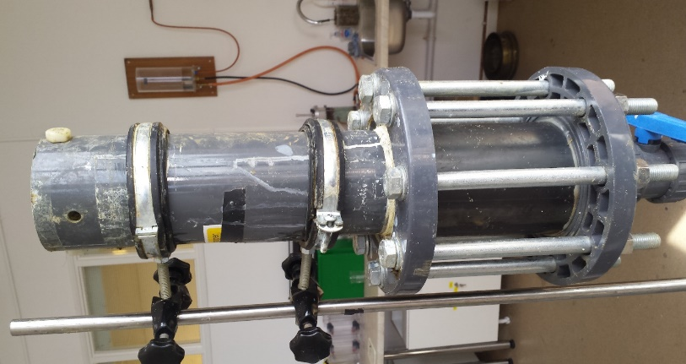
Figure 116 - System without Duct Tape
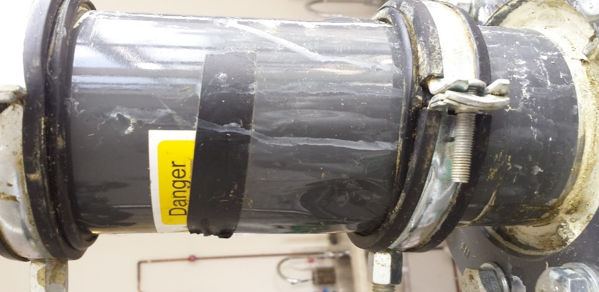
Figure 117 - System Swelling
At this point we wanted to discover the cause of this swelling. The first attempt was to press the swelling to find out, if there was any liquid inside the swelling. However, it was found that there was no liquid inside the swelling.
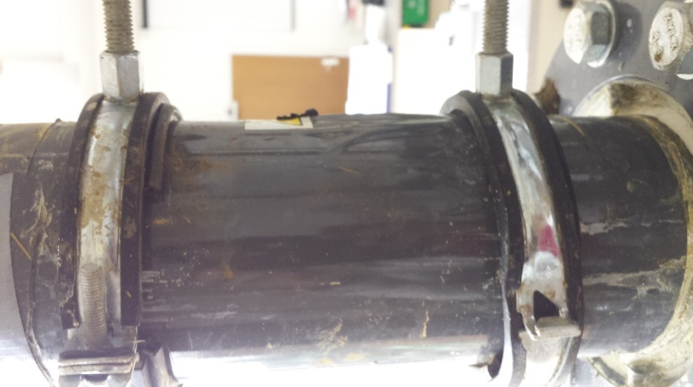
Figure 118 - System Swelling on the Right
The next step was to peel off the outer cover of the reactor to discover the exact cause of the swellings. Once the outer cover was peeled off, a hole was found on the side of the reactor. It was thought to remove cover completely and in doing so, another hole was found almost at an identical place to the first hole. This discovery also explained the reason some dry white substance was found along with the slurry.
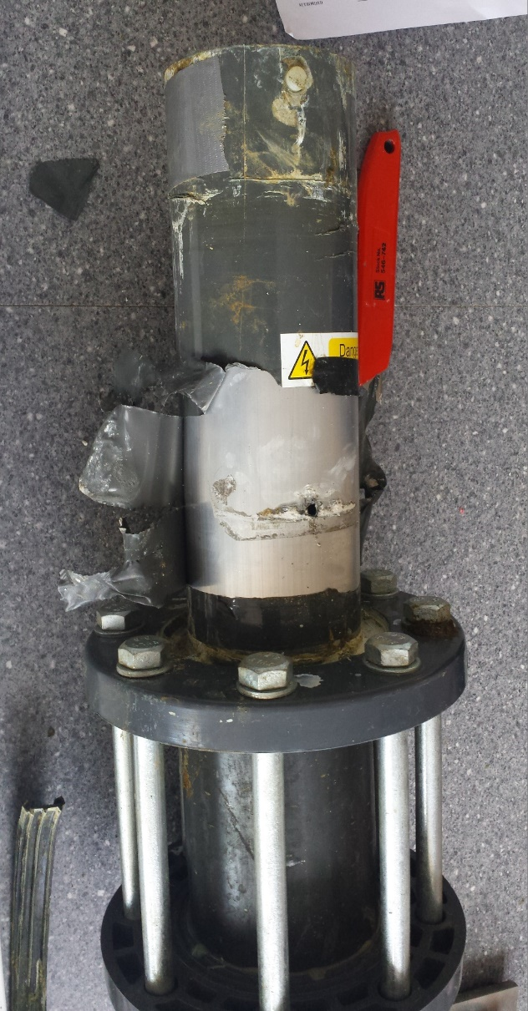
Figure 119 - Hole in the System
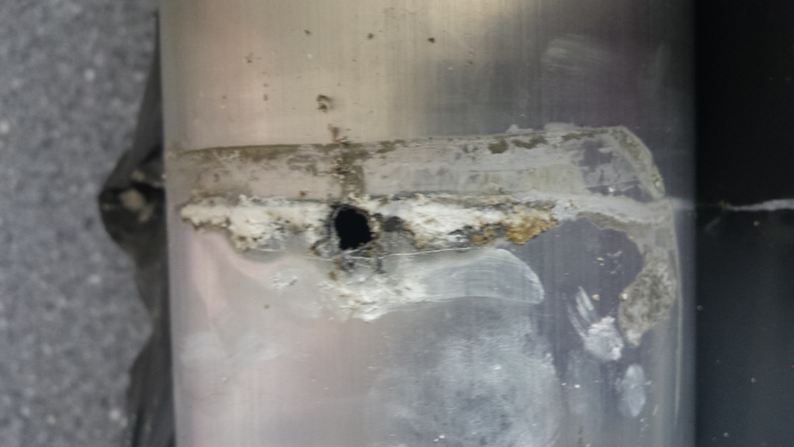
Figure 120 - Another hole on the opposite side of the system
Looking down inside the system, it was clear that the system (cathode) started to deteriorate. This also explained why there was small sounds of crackling while the tests were conducted and even during the cleaning process.

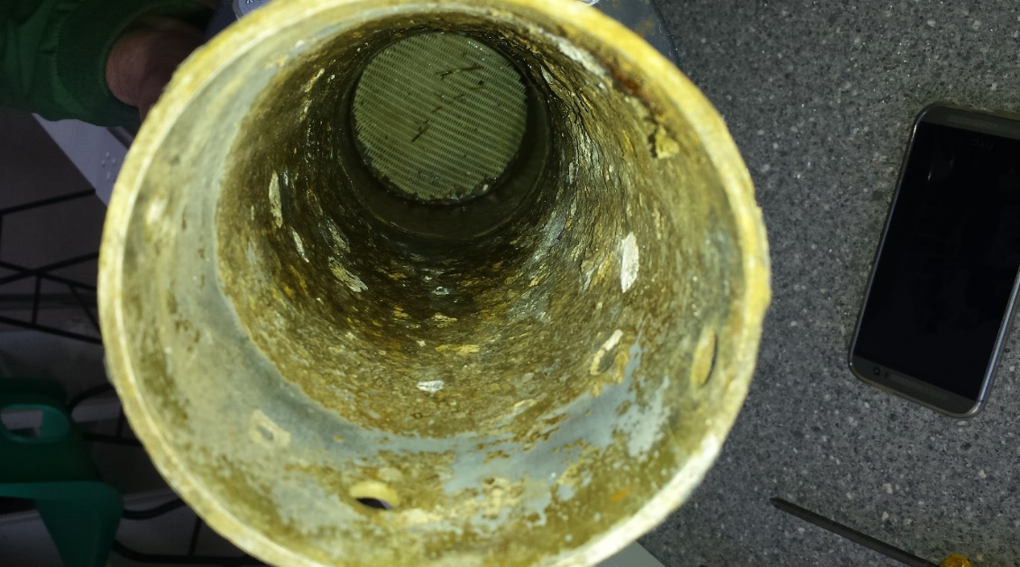
Figure 121 - Inside the system (Cathode)

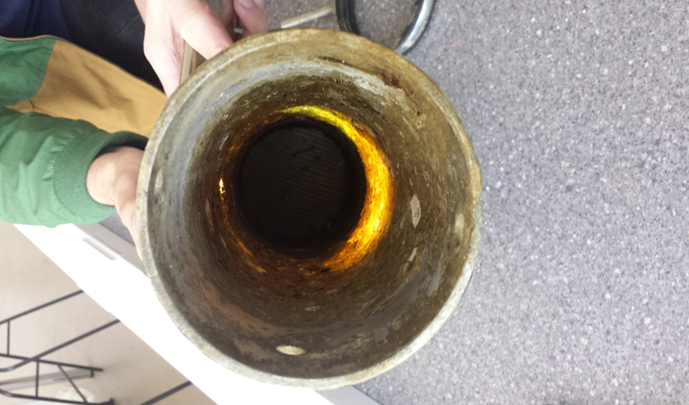
Figure 122 - Shining light through the deteriorated hole

Conclusions

Conclusion
To conclude, the issues that were present in the 2016-17 reactor were solved. By introducing a gravel filer in-between the bottom of the anode and the mesh filter, and adding a cap to the bottom of the anode, the slurry was uniformly distributed across the entire reaction chamber resulting in a significantly higher percentage of the batch undergoing the reaction.
This has been proven by comparing the best result from the previous reactor to the best result from the new design. Last year 307ml was drained in 3200 minutes, this year 430ml was drained in 1330 minutes, which is a 40.06% in water drained and was achieved in 58.43% less time. The power consumption was also improved as the reactor was powered for less time to acquire a greater yield. After 30 Watts have been consumed over 90 minutes, a total of 225ml was collected compared to an amount of 49.3ml from last year, resulting in a 456% increase in efficiency.
With the improved efficiencies that were gained this year, additional issues arose with the reactors design. Most notably the exhaustion of the Aluminium Cathode which eventually eroded to such an extent that the liquid removed during the dewatering process was passing through the external wall of the reactor and was collecting around the base of the Anode.
The collection of the foam that was produced during the dewatering process at lower amperage was produced in a volume that was manageable compared to the amount of foam that was produced during the tests run at higher amperages, with the higher amperage tests foam leaking from the collection bag.
The XRF results confirm the predictions of the H-S theory that the electro osmotic velocity of the particles that are present in the waste will be in the direction of the Cathode. From the XRF analysis the dry waste absorbed greater amounts of the iron ions, which were released as part of the electro kinetic dewatering reaction this indicates the movement of the water migrated in the direction from the Anode towards the Cathode, this is also confirmed by the high Aluminium content of the liquid waste that was produced. As the dry waste did not contain the high level of Aluminium that was measured in the liquid waste it can be predicted that the liquid that was removed had passed over the Cathode and exited the reactor through the media filter and then through the membrane.
The presence of the pH gradient in the dry waste that was collected also showed evidence that the H-S theory was correct and with the dry waste at the Cathode having a pH of around 8 and the pH of the waste near the Anode having a pH of around 6.8. The presence of the pH gradient also provides evidence that the waste that is processed has the potential to be used form multiple purposes if separated, with the potential of increasing the value of the processed waste as fertilizers for different uses.
In addition to developing an improved reactor, a complete control system was designed which can be carried out, implemented and iterated upon for future reactor designs. A complete schematic diagram as well as PCB design was developed which shows all the necessary components to allow for the circuit to function. Similar components can be used as substitutes in the event that the component is no longer available.
The feasibility studies carried out for Hydro, Solar and Wind have shown that from all the possible renewable energy sources that could be used to power the reactor, Hydro was the most achievable as there was a nearby river source with a flow rate of up to 250ms⁻³, of which 10% could be extracted using a 20-30 Kw turbine, and would cost around 110,000 to 165,000 USD. This would provide an ample amount of power for a scaled up version of the improved reactor which could be used commercially to continuously dewater large amount of cow slurry.

Reflection
There are several positive aspects which can be taken away from the project. This includes learning how to adapt our different backgrounds and skillsets to an unfamiliar task as well as gaining knowledge about a new field of work. The experience gained from working alongside Power&Water as well as seeing the problem first-hand at Gelli Aur farm has been valuable and has helped us understand the research that was necessary. All the research conducted has also helped us gain a good understanding of the field and in the end, has allowed us to develop an improved design which meets expectations.
There was also some negative aspects of the project which did not go as planned. This includes the final reactor design not completely matching the intended initial design as the moisture collected was done using an inefficient method. The diameter of the base tank was also decreased and was used to create the gravel filter instead of allowing for more slurry to be stored in the reactor. Also, the reactor was still used to dewater batches of slurry rather than changed to become a continuous process along with installing a second chamber for storing slurry before being moved to the reactor. This would have been done using a compressed air system, which would also require additional materials for implementation.

Future Improvements
Design the initial idea
There is still room for improvement for the project. Initial, we had several ideas of improving the system and these were:
- Extending the base of the reactor
- Adding water on top of the sand filter
- Slurry feeding Tank
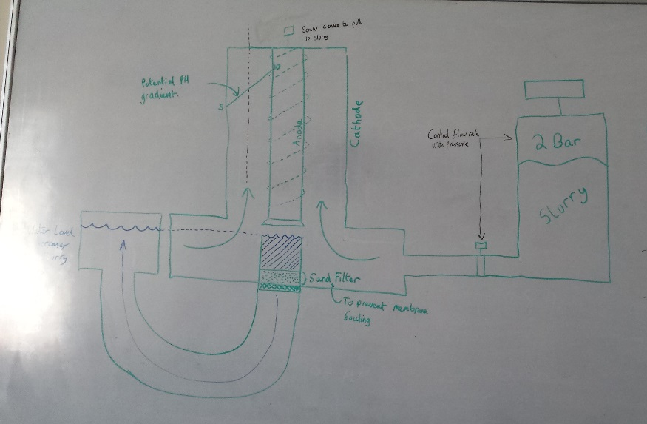

Extending the base of the reactor
The idea of extending the reactor was thought of to ensure there was enough space for the water to sit on top of the filter and enough space to feed the slurry into the reactor.
Water
The idea of adding fresh water in the system is to ensure that the sand filter was kept clean and also to backwash the filter. An additional water tank would be require to level out the water on top of the filter.

Slurry Tank
Another idea that was thought of was to have a small tank filled with slurry and use the forces of pressure to pump the slurry into the system.
Design a continuous process
Another way of improving the system would be to have a continuous process rather than having a batch system. Having a continuous system would be more desirable because it saves time, energy, operation costs and also increases the productivity.
Control system on the system
A control system could be used to control the flow of slurry that is fed into the system and also control the entire system remotely without physically switching the system on or off.
Powering the system using renewable energy
Testing the system using renewable energy would be another future improvement for the system. The entire system could be powered using photovoltaic and several tests could be carried to

References
1. Campuses. Coleg Sir Gar. [Online] [Cited: 13 April 2018.] http://www.colegsirgar.ac.uk/en/about-coleg-sir-gar/campuses.
2. Stephens, Adam Paul, Vismonte, Ryan Anthony and Amoruso, Angelo Michele. An Investigation into the Feasibility of Electrokinetic Dewatering of Cattle Slurry. 2017.
3. Chanson, Hubert. Hydraulics of Open Channel Flow: An Introduction. 2004.
4. Hydraulic Head Pressure. Engineers Edge. [Online] [Cited: 5 March 2018.] https://www.engineersedge.com/hydraulic/hydraulic_head_pressure_10054.htm.
5. Harnessing Hydroelectric Power. Gov UK. [Online] [Cited: 26 February 2018.] https://www.gov.uk/guidance/harnessing-hydroelectric-power.
6. Hydropower. National Geographic. [Online] [Cited: 26 February 2018.] https://www.nationalgeographic.com/environment/global-warming/hydropower/.
7. Hydro Energy. [Online] [Cited: 26 February 2018.] https://web.archive.org/web/20121127194425/http://www.decc.gov.uk/en/content/cms/meeting_energy/hydro/use/use.aspx.
8. Hydro Electricity in the United Kingdom. Wikipedia. [Online] [Cited: 26 February 2018.] https://en.wikipedia.org/wiki/Hydroelectricity_in_the_United_Kingdom#/media/File:UK_hydro_elec_supplied.PNG.
9. Archimedean Screw Turbine. Renewables First. [Online] [Cited: 06 March 2018.] http://www.renewablesfirst.co.uk/hydropower/hydropower-learning-centre/archimedean-screw-hydro-turbine/.
10. Hydro Power Turbines. Renewables First. [Online] [Cited: 06 March 2018.] http://www.renewablesfirst.co.uk/hydropower/hydropower-turbines/.
11. Grid Tied Screw Generator. Green Bug Energy. [Online] [Cited: 06 March 2018.] http://greenbugenergy.com/shop-hydro/shop-hydro-products-services/grid-tied-screw-generators#prettyPhoto.
12. Crossflow Turbines. Renewables First. [Online] [Cited: 06 March 2018.] http://www.renewablesfirst.co.uk/hydropower/hydropower-learning-centre/crossflow-turbines/.
13. Kaplan Turbines. Renewables First. [Online] [Cited: 06 March 2018.] http://www.renewablesfirst.co.uk/hydropower/hydropower-learning-centre/kaplan-turbines/.
14. Kaplan Turbines. Ossberger. [Online] [Cited: 12 March 2018.] http://hts-inc.com/images/S-160.pdf.
15. Pelton Turbines. Renewables First. [Online] http://www.renewablesfirst.co.uk/hydropower/hydropower-learning-centre/pelton-and-turgo-turbines/.
16. Francis Turbine. Brain Kart. [Online] [Cited: 09 March 2018.] http://www.brainkart.com/article/Francis-Turbine_3509/.
17. Radial Turbine Selection Chart. Research Gate. [Online] [Cited: 12 March 2018.] https://www.researchgate.net/figure/Radial-turbine-selection-chart-by-net-head-flow-2_fig1_315922768.
18. Google Maps. Google. [Online] [Cited: 1 May 2018.] https://www.google.co.uk/maps/place/Gelli+Aur+College+Farm/@51.8716154,-4.044875,641m/data=!3m1!1e3!4m5!3m4!1s0x486ee4dcfe64b3a5:0x6ec540a62125c9d6!8m2!3d51.8703909!4d-4.0449228.
19. Tywi at Ty Castell. National River Flow Archive. [Online] [Cited: 03 May 2018.] http://nrfa.ceh.ac.uk/data/station/peakflow/60001.
20. Renewable Energy Cost Analysis: Hydro. International Renewable Energy Agency. [Online] June 2012. [Cited: 11 May 2018.] https://www.irena.org/documentdownloads/publications/re_technologies_cost_analysis-hydropower.pdf.
21. Differential Pressure Flowmeter. Universal Flow Monitors. [Online] [Cited: 09 March 2018.] http://www.flowmeters.com/differential-pressure-technology.
22. Bernoulli Equation. Hyper Physics. [Online] [Cited: 09 March 2018.] http://hyperphysics.phy-astr.gsu.edu/hbase/pber.html.
23. Turbine Flow Meter. Wikipedia. [Online] [Cited: 03 April 2018.] https://en.wikipedia.org/wiki/Flow_measurement.
24. Flow Meter. GPI Flow Meter. [Online] [Cited: 21 May 2018.] http://www.gpiflowmetersuk.co.uk/.
25. Optical Flow Meter Principle. Instrumentation Tools. [Online] [Cited: 04 April 2018.] https://instrumentationtools.com/optical-flow-meter-principle/#.WsSWRYjwaUk.
26. Ultrasonic Flow meter. Omega. [Online] [Cited: 10 April 2018.] https://www.omega.co.uk/prodinfo/ultrasonic-flow-meters.html.
27. Hydraulics. Wikipedia. [Online] [Cited: 30 April 2018.] https://en.wikipedia.org/wiki/Hydraulic_drive_system#/media/File:Hydraulic_Force_Torque_275px.png.

