

LOCATION: Swansea | LLEOLIAD: abertawe
LEVEL 4 | LEFEL 4
EXAMINATION PERIOD | CYFNOD ARHOLIADAU
may 2023 | mai 2023
HND Electrical and Electronic Engineering

MODULE CODE: GOEE4002

Dynamics Control and Instrumentation

TIME: 2 HOURS
answer all Four questions

Equipment or materials required – Calculators are allowed
Adnoddau neu ddefnyddiau sydd eu hangen -

Question One (20 marks)

- A 50 N applied force drags a 20 kg log to the right across a horizontal surface. What is the acceleration of the log if the force of friction is 10 N?
5 Marks.
Answer:
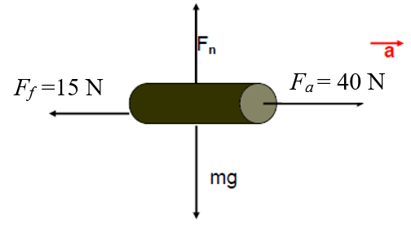
$$F_{net}=ma$$
$$F_{a}-F_{f}=ma$$
$$50-10=10a$$
$$a=\frac{40}{20}=2.0 m/s^{2}$$
- A body travelling at an initial velocity of 25m/s is acted upon by a linear acceleration of 10m/s² .
5 Marks
Calculate:
a Velocity after 5 seconds
b Total distance travelled

Answer:

$S=u+at$ $S=25+(10$)(5) S = 75m/s

$S=\left(\frac{u+v}{2}\right)t$ $S=\left(\frac{25+75}{2}\right)5$ S = 250m

- Using sketches to illustrate your answer, compare and contrast an Open Loop and a Closed Loop system.
4 Marks
Answer:
Sketches

- Mason’s Gain Rule is used to reduce the block diagram to a single transfer function as shown:
$$TF(s)=\frac{1}{∆}\left(\sum_{i}^{n}{P_{i}∆_{i}}\right)$$

Give the definition of each variable in the formal above.
6 Marks
Answer:
Δ = The determinant of the system
n = Number of forward paths
P_{i}= The i^{th} forward-path gain
Δi = The determinant of the i^{th} forward path
Δ = 1 - (Sum of all individual loop gains) + (sum of products of gains of all pairs of non-touching loops) – (sum of products of gains of all three non-touching loops)
Δi = 1 if no non-touching loops on the i^{th} path OR if removing the i^{th} path breaks all the loops.

Question Two (10 Marks)
The figure below shows a step input:
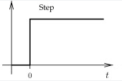
Draw a system time/response graph for the step input shown. Define the following terms and show clearly on the graph:
- Rise time
- Settling time
- Steady state error
- Maximum overshoot
- Delay time

Answer:
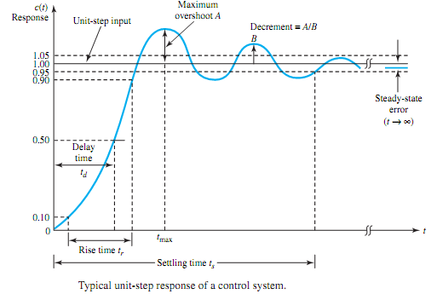

Question Two (20 marks, 5 marks each)
Three particles A, B and C have a motion which can be described by the following expressions:-
For particle A S_{a} = 3t² + 10t - 8
For particle B S_{b} = 7t³ + 4t² + 4
For particle C S_{c} = 10t³ - 30t + 2
Where S = displacement in m, t = time in seconds.
Determine:
- The time when the velocity of particle B is three times that of particle A to 2 decimal places?

Answer:

For particle A $V_{a}=\frac{dS_{a}}{dt}=6t + 10$
For particle B $V_{b}=\frac{dS_{b}}{dt}=21t^{2} + 8t$
The velocity of particle B is 3 times that of particle A, i.e $V_{b}=3V_{a}$

$21t^{2} + 8t=3(6t + 10)$
$21t^{2} + 8t=18t + 30$
$21t^{2}- 10t-30=0$
Then $t=-0.9 ignore,$
$or t=1.46s$ Answer

- The time when the acceleration of particle B is equal to that of particle C to 3 decimal places

Practice B a= 42t + 8
Practice C a = 60t
42t + 8=60t
18t=8
t=8/18=0.444 s

- The distance travelled by each particle in the period from t= 0 to t= 4 seconds

For particle A
$∆S=S_{4}-S_{1}$
∆S={3(4) + 10(4) – 8}-{3(0)2 + 10(0) – 8}= 88 m

For particle B
$∆S=S_{4}-S_{1}$
∆S={7(4)³ + 4(4)² + 4}-{7(0)3 + 4(0)2 + 4}= 512 m

For particle C
$∆S=S_{4}-S_{1}$
∆S={10(4)³ – 30(4) + 2}-{10(0)³ – 30(0) + 2}= 520 m

- The time required for practical B to reach the velocity of 10 ms?

$V_{b}=\frac{dS_{b}}{dt}=21t^{2} + 8t$
$$10=21t^{2} + 8t$$
$21t^{2} + 8t-10$=0
By using factorization we can find that
t=-0.86 ignore,
or t=0.5 s Answer

Queestion Four (20 marks)

For the given system block diagram:
G₃
G₄
G₅₅
H₂
G₂

G₁
H₁
Y(s)
R(s)
+
+
+
_
+
+
_
+
H₃

- Produce a Signal Flow Graph of the system from the block diagram showing all nodes, branches, and gains.
- Apply Masons Gain Formula to determine the transfer function $\frac{Y(s)}{R(s)}$ of the system.

Good luck
End of the exam

