Mobile Application Development II
  - Lecture 15 Lab Tutorial Exercise

The Photo Gallery App Part II

Objectives
In today’s exercise, you will get Photo Gallery to download the thumbnail images from Flickr.

Exercise 1: Creating a new layout for holding the images.
- Open up your app from last week.
- Create a new layout file to hold a single gallery list item with an ImageView as the root element and modify its content as follows:
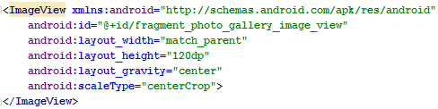
- Adding scaleType as shown will centre the image first before cropping it to fit the display.

Exercise 2: Updating Photo Gallery Fragment

Updating Photo Holder
You will update the photo holder in Photo Gallery fragment to hold an Image View instead of a Text View.
- Open up the Photo Gallery fragment java file.
- Locate the Photo holder nested class.
- Replace the TextView declaration with an ImageView declaration.
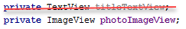
- Update the constructor method to initialise the photo Image View instead of the deleted text view.
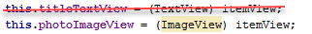
- Delete the current bindGalleryItem method and replace with the following to bind a drawable instead.
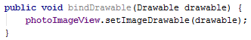

Updating Photo Adapter
Next you need to update the layout for the adapter to use.
- Locate the Photo Adapter nested class

On Create View Holder Method
- Go to the OnCreateViewHolder method.
- Replace the existing code with the following to inflate the activity’s layout with the new layout created instead of a simple text view.
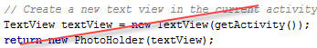
// Get the layout to inflate from the activity
// Inflate the view with the gallery item layout
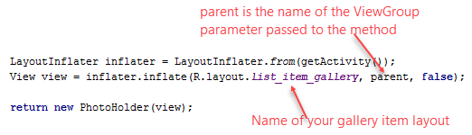

On Bind View Holder Method
- Look for a place holder image to use as a default image and add it to the res\drawable folder. You can try: http://lorempixel.com/
- For now, you will just load the placeholder image.
- Make the following change to the OnBindViewHolder method.
DELETE crossed out line
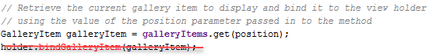
REPLACE with this instead
// Get the place holder image and bind it to the view holder
- Save and test. You should have a nice tiled background display .

Exercise 3: Creating a Background Thread
In this exercise, you will create a separate background thread that will be responsible for downloading the thumbnail images.
- Create a new class called ThumbnailDownloader or whatever you want. The class should extend HandlerThread. Note that, “T” is a generic type, which makes the implementation more flexible.
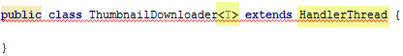
- Leave the error for a moment.
- Add the following variable declarations.
- Add the following constructor method.
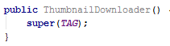

Quit Method
- Generate an override of the quit method. This method indicates when the thread quits.
- Modify the method shown below.
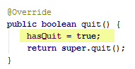

Queue Thumbnail Method
- Create a new method called queueThumbnail as follows.
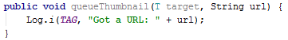

Exercise 4: Using the Thumbnail Downloader Background Thread in the Fragment
- Return to the Photo Gallery Fragment.
- Add the following variable to the class.
- Initialise the Thumbnail Downloader background thread and start it as follows in the OnCreate method after executing the fetch items task.
// Initialise Thumbnail downloader background thread and start it
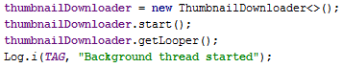
- Override the OnDestroy method in the class.
- Tidy up and quit the thumbnail downloader background thread as shown.
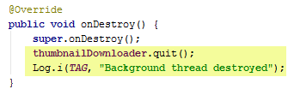

Updating Photo Adapter
- Go to the nested PhotoAdapter class and locate the onBindViewHolder method.
- Here, you will call the queueThumbnail method you created in the Thumbnail Downloader background thread to initiate the background download of the item’s image.
// Initiate background download of image to get image to bind to the view holder
- Run and have a look at the LogCat messages.

Exercise 5: Implementing Messages and Message Handlers
Page 437

Thumbnail Downloader
The next step is to obtain a message from the global Message pool to send a download task to the target handler to send to the messagequeue.
- Open up the thumbnail downloader.
- Add the following variables:
  - A constant that will be the user-defined integer that will identify the message.
  - A reference to the handler responsible for processing and sending messages.
// Reference to handler responsible for queuing download requests as messages on the ThumbnailDownloader background thread
// The handler will also be responsible for processing download requests when pulled off the queue
  - A thread-safe hash map object to store requested download objects until the message queue is ready to process it
// A thread-safe version of HashMap
// Request map is used to store download request message objects until the Message Queue is ready to process them
// T, the key identifies its type, a PhotoHolder object, String is the URL to download
// This ensures you are always downloading the currently requested URL for a view holder

Queue Thumbnail Method
- Locate the queueThumbnail method
- Recall that a recycler view is being used to display items. This means that view holders will change as the user scrolls the screen display. This means that a previously submitted view holder requesting a thumbnail to download may have changed and may now contain a blank URL by the time the message queue is ready to process the message.
- Check if the URL requested for the current photo holder view holder is not null. If it is, remove request, otherwise request a new message to add to the queue.
// Check that the current URL is not null
// If it is null, no need to process, remove from the request map
// If it is not null, add to request map and obtain a new download request message
// to add to the queue for processing and send it to its target
// A call to obtainMessage() automatically sets the target to a handler
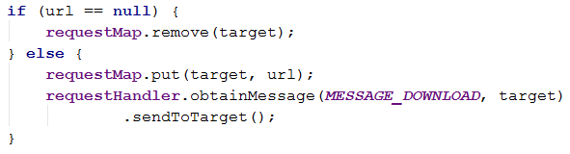

Handle Request Method
This method is used to process the thumbnail download from the URL on the Thumbnail Downloader background thread \when the message queue is ready to process the request.
- Create a new method called handleRequest as follows.
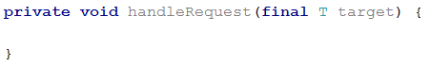
- Add a try { … } catch { … } block.
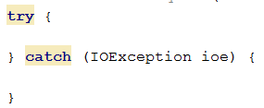
- Add the following steps to the try block.
- The message queue is ready to process the download request, retrieve the URL to download from the request map object.
// The message queue is ready to process download request
// Retrieve the URL to download from the request map
- If the URL is blank, no need to process
// If blank URL, return and exit early, nothing to process
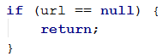
- URL is not blank, use Flickr Fetcher to process the thumbnail download on this background thread.
// URL not blank, use FlickrFetcher to process thumbnail URL download on this background thread
- Use the bitmap factory to convert the bytes into a bitmap.
- Add the following to the Exception block

On Looper Prepared Method
This method is used to execute some extra setup before Looper starts. In this case, call the handle request method created in the last step to process the image download.
- Override the OnLooperPrepared() method.
  - Delete the default call to its superclass method.
  - Initialise the requestHandler variable to a new Handler() object.
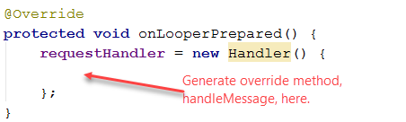
- Generate the override method, handleMessage, in the space indicated.
  - Remove its call to its superclass method.
You should have the following:
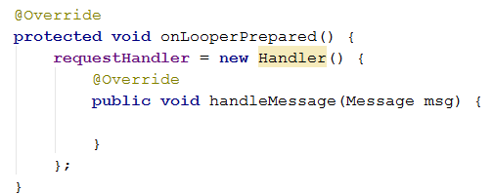
- Check that this is a message marked with MESSAGE_DOWNLOAD identifier and if yes, use the handleRequest() method to process the download.
// Check that the message Looper wants to process is marked with a MESSAGE_DOWNLOAD identifier
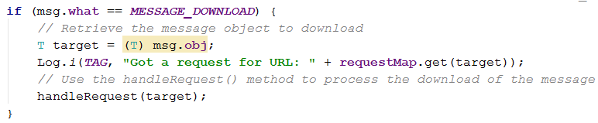
- Save your changes. You can run to see the LogCat messages an confirm that your background thread is setup and working properly.

Exercise 6: Updating the UI with the Bitmap
The previous exercise scheduled work on the background thread from the main thread. In this exercise, you will schedule work on the main thread from the background thread to update the UI.

Thumbnail Downloader
- The main thread is also a Message Loop with handlers and a Looper. When you create a handler in the main thread, you can pass that handler to another thread.
Add the following variable declaration in Thumbnail Downloader to store a reference to the main thread’s handler.
// Reference to main thread's handler
- Replace the current constructor with one that accepts a handler parameter and use this to initialise the variable created in last step.
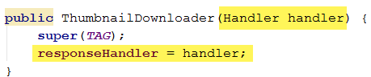

Creating an Interface for Communication between UI Main Thread and Background Thread
- Create a nested interface in Thumbnail Downloader that defines an interface for communication between the UI main thread and the background thread that Photo Gallery Fragment will implement.
The interface contains one method, onThumbnailDownloaded, that any class implementing the interface, Photo Gallery Fragment in this case, will have to implement.
// Any class implementing this interface will have to implement the onThumbnailDownloaded method
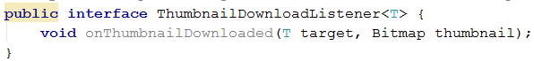
- Now create a variable in Thumbnail Downloader to hold a reference to the listener that has implemented the interface.
// Reference to listener implementing ThumbnailDownloadListener
- Create a method to set the Thumbnail Download Listener – provides controlled access to the field.
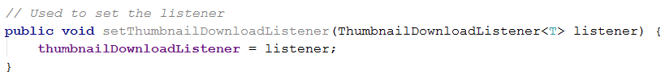

Updating Photo Gallery Fragment
- Now go back to Photo Gallery Fragment

On Create Method
- Go to the onCreate method and create a new Handler for the Thumbnail Downloader Background thread to use and pass it to the constructor method.
// Create a Handler to pass to background thread to use
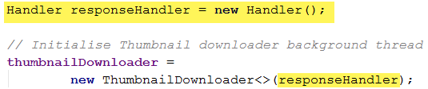
- Implement the Thumbnail Download Listener just after initialising the thumbnailDownloader (above statement) and before calling start as shown below.
Note: Android Studio should automatically generate most of the code for you begin to type new ThumbnailDownloader.set… and select the default option.
// Implement Thumbnail Downloader Listener interface
// Create a drawable for the bitmap
// and bind to the target Photo holder view holder
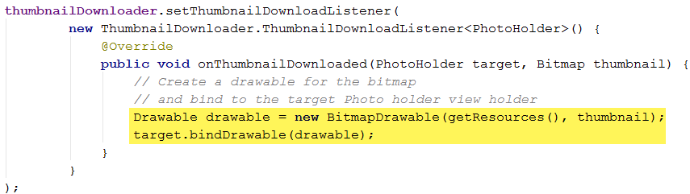

Back to Thumbnail Downloader
- Now return to thumbnail downloader. You need to get it to update the UI by calling the listener’s (main thread) implemented onThumbnailDownloaded method. You will use the handler’s post method for this.

Handle Request Method
- Go back to the handle request method and after creating the bitmap and logging the Bitmap created message, and add the following. Again Android Studio should generate most of the code for you.
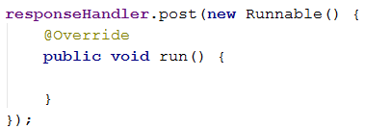
- Add the following to the run method.
- Check if the request still matches the current request and that the thread has not quit.
// if the requested download has changed or the thread has quit
// return and exit early
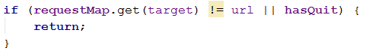
- It is still the current request and thread has not quit, call the UI’s listener method to notify it that the thumbnail has been downloaded and send it the downloaded bitmap.
// Remove the request from the requestMap - request now processed
// Call the UI's listener's method so it can process the downloaded bitmap

Cleanup Method
- Add the following clean up method to clear all the requests out of the queue.
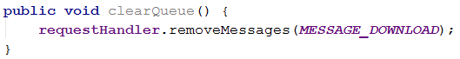

Back to Photo Gallery Fragment
- Go back to Photo Gallery Fragment.
- Generate the following override method: onDestroyView.
- Add the following call to the clean-up method created in the last step to do some final tidying up.
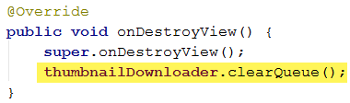
- Save and test.
- That’s all for today

Adapted from Android Programming: The Big Nerd Ranch Guide

