Reflection on early year provision

Student Name: Sonia Moboshir
Student ID: 1808304

Contents
Introduction 3
Element 1 4
Two models of reflection of knowledge and learning 4
Element 2 7
Discussion on importance of reflective practice for maintaining quality services for young children and their family. 7
Element 3 11
Details of contribution of an activity within placement/workplace 11
Element 4 13
Personal Development Plan identifying areas of further development 13
Conclusion 14

Introduction

Learning and development are to key essential part of growth. Learning effective only it is practiced and enhanced through practical means of implementation. Whether it is professional needs or personal needs, learning is a continuous process that starts very early of the life. The needs of reflections of learning is also an immense activity because it contribute to provide quality services for children including their growth of knowledge in the areas of health and safety, risk assessment and management, and safeguarding procedure (Bolton,2014). Learning and development begins with theoretical understanding that complete when individual can apply it in both personal and professional experiences. To be an early year practitioner and to provide evidence of continuing personal and professional development, it needs to reflect all those learning of both theoretical and practical knowledge. This assignment will aims to reflect the needs of reflection in the personal and professional life as a tool for developing and enhancing good practice.

Element 1

Reflective practice is a key tool of both individual and professional learning. Reflective practice ensure a closed relationship with continuous learning. Reflective practice ensure that learner should focus over reflective values and theories of learning over the period of learning and development (Bubb & Earley, 2010). There are different models of reflective learning. Two of the most used models are discussed below:

Two models of reflection of knowledge and learning

Gibbs Reflective Model/Cycle
Gibbs reflective model is one of the most influential cycle of reflection of learning and practices. It has five steps that come in sequence and push the learner to reflect what the courses of learning he/she has abled to learn and what the progression over the years was.

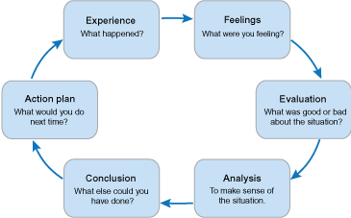

Diagram: Gibbs Model of Reflective Practice
Source: Bubb & Earley, 2010

From the above diagram, it can see that, there are five stages of Gibbs Reflective model that used in the Alphabet house nursery school. In the beginning, the learner is expected to express the learning and share the experiences about the learning time and plans and effectiveness of the tools. Sharing of experience linked with feeling as asked what the feeling are after completion of the learning practice (Canning, 2011).

After that, the learning and knowledge deepness of the learner are evaluated through personal judgment. Whether learning was good or bad. The learned is expected to analysis the learning and growth in conclusion. It needs to state, whether the learning periods and lessons were effective if links with objectives. For example, there are different tools are available to judge the learning at the periods of development. The learned can be asked or can be given to perform a job citing the qualities expected.

It will help both the learner and practitioner to assess the effectiveness of the learning and degree of learning that captured by the learner. And after that, new actions plan are designed to accelerate further development process. New actions plan will be based on the deficiencies and limitations that the learner failed to achieve from the current development plans (Canning, 2011). Limitations will be used as the new plan for new courses of time.

Advantages: The best advantages of using Gibbs reflective model is that, it helps to make understand and realize people that was their goals and how they ended up. It makes some realisation to the learner and show the new areas of development in future. The Gibbs model offer new situations and hypothetical situations to use to give the learner new insights how learning can be practiced and used (Lindon, 2012). In the Alphabet house nursery school , Gibbs learning cycle is mostly practical and that’s why using it seem effective as the learner can learn through observing how particular action or task can be done or achieved within the target.

Disadvantages: Common disadvantages of the Gibbs model is that, the questions are narrow and require professional guidance, in some perspective which is not possible. As the questions are not designed completely, it create a deficiencies among the practitioners and learners. Some areas of assessment remain incomplete even when learners have experiences and ideas about it (MacNaughton and Hughes, 2011). Sometimes assessment turned into uncomfortable when learners are assigned with the practice of self-assessment. This is another drawback of the model.

Kolb’s Learning Cycle

Kolb’s learning cycle concerned much about cognitive behaviours of the learner. Kolb’s learning has four stages that includes concrete learning, reflective observant, abstract conceptualization, and active experimentation. Kolb’s learning cycle used as to assess the progresses of the learner in a sequential meaning. The flexibility of this learning cycle is that, the learner can enter into this cycle in any stage of the cycle.

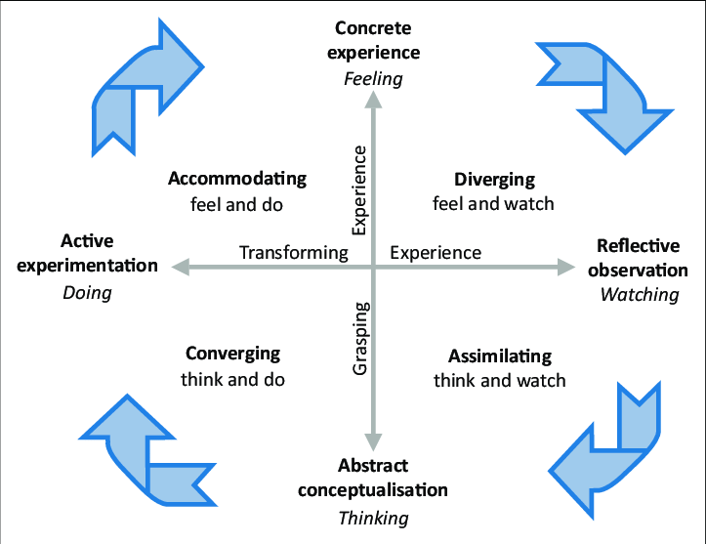

Image: Kolb’s Learning Cycle
Source: (MacNaughton and Hughes, 2011).

From the above cycle, we can see that, four stages of the learning cycle are concrete experience, reflective observation, abstract conceptualization and lastly active experimentation. In the first stage, the learner is offered with the situations and tools to learn and experience. Between theory and practice, the learner is pushed to emphasize much on practical means of learning as it gives instant insights how certain tasks can be done (Miller, 2010).

In the second stage, in Alphabet house nursery school, the learner may provide the opportunity of feeling the situation. It not only allow to see but also allow to experience how certain jobs are done and how much time it takes to complete. Reflective observation is seem more practical than the experimental observation at the time of learning. After that, the third stage begins with giving the chance of thinking about the process or tools or mechanism that used to complete certain task (Mitchell and Lloyd, 2013). It is to encourage the learner to find out new ways if they think certain task can be done.

It provides the opportunity of developing new ways of doing certain task by own mechanism. And in the very last of this learning cycle, learner is advised to do certain task. This is called active experimentation. This is the time when the learner is provided with the chance of applying all the knowledge, theories, and tools that he/she has learned throughout the learning cycle.

Doing practically and actively participation in the learning cycle, gives insights about the limitations of the learner and reflect areas where learners must improve. With that, it can be said that, in the last stage, the learner apply what he/she has learned at the very first time, and it can be expected that, after overall and continuous practice, learner will do better in future courses of time (Mitchell and Lloyd, 2013).

Advantages: The advantages of Kolb’s learning cycle are that, it helps learner to develop more appropriate learning opportunities and target if they seem that current practices and observations tools are not appropriate and do not link with the objectives. This learning cycle help learner in the Alphabet house nursery school to design activities in ways that suit and match with their learning styles and preferences (Moyles, 2010). And mostly, this learning cycle is effective to enable the practitioners and learners to learn only what they needs and demands and can enter into any stage of the learning cycle.

Disadvantages: In Kolb’s learning cycle, test is not reliable and that’s why it is hard to measure the efficiency and effectiveness of the learning that learned and taken by the learner at the time of learning. On the other hand, learning styles of this learning model change based on the environment which is not appropriate in some cases when both learners will be assigned in same task, both will reflect different result (Moyles, 2010). And lastly, most of the experimental tests are expensive in this reflective model in the Alphabet house nursery school.

Element 2

Discussion on importance of reflective practice for maintaining quality services for young children and their family.

Overview of Reflective Practice

Young learner and practitioners to professional, no one can deny the needs of earning efficiency and effectiveness in their way of operations. Effectiveness and efficiency do not come with very easy rather it is matter of practice, learning and again practice on what has been learned. It’s a cycle that has no end and continue over the periods of profession or academic learning.

Reflective practice is a way of using own experiences to increase or upgrade own performance at the workplace in the Alphabet house nursery school. Reflective practice means using own experience, learning, and tools in work as well as keeping learning from the past records (Tarrant, 2012). In the whole process of reflective learning, mission and vision can be included. Inclusion of mission and vision gives the learner a peak point on which he/she must climbs to achieve. In a nutshell, mission and vision will the objective that young learner wants to achieve through the practice.

Reflective learning is considered as way of professional development. Although reflective cycle is appropriate in stage of life and learning. It can be used in academic learning, profession, and practices of both health and other services in the workplace of the Alphabet house nursery school. Reflective practice is a universal tools of developing oneself in the area of his/her interests (Tarrant, 2012).

Reflective practice also encourages self-learning. Where learner will learn from self-motivation to improve in the areas of duties and responsibilities. For example, young learner who learn academic courses also have opportunity of reflective learning. Academic writing, publication, presentation, and report making are some of the key areas where reflective learning can be utilized as a means of developing on how to write good and standard academic writing (Woods, 2014)).

Reflective Practice- Donald Schon

Among the research scholar, one who has vast amount of knowledge and expertness is called Donal Schon. According to the Schon, reflective practice is defined as the bridge that connects implicit knowledge and learning from the experiences. Schon admits that, people need to assess what they should learn and what they have learned. When an individual will be able find out those gaps, only then he/she can minimize through reflective practice.

On the other hand, according to Schon, reflective practice is about ‘knowing in action’. It means individual can learn and assess only their learning is seen in practice.

Novice to expert: Patricia Benner
Clinical competences require a series of skills and experiences that starts but no end. It is well known that, clinical competencies develop over times. Novice is the first and basic stage of the profession, and over the time, individual learn and growth over the periods. Patricia Benner has developed a model that says about the stages of professional growth. According to this model, professional growth and expertness in clinical experiences require plans and achievement in short and long-term in case of the Alphabet house nursery school.

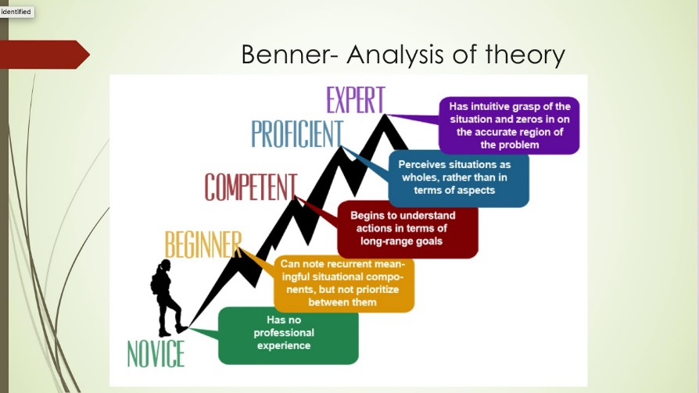

Image: Novice to expert: Patricia Benner
Source: (MacNaughton and Hughes, 2011).

Importance of Reflective Learning

As already mentioned that, reflective learning is a universal tool of learning and development in the areas of personal interests. Individual can learn through practicing and using the past experiences in the future courses of actions.

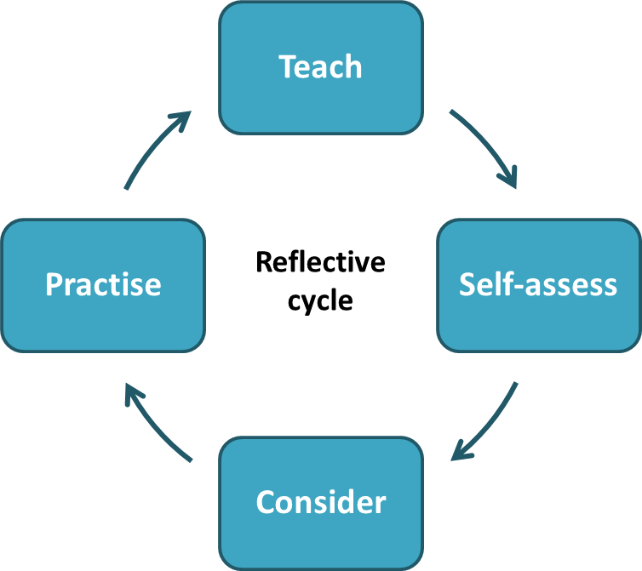

Diagram: Reflective Learning Cycle
Source: Sambell et al, 2010

There are four stage in a typical reflective cycle of learning. In the beginning, the reflective cycle aims to design the learning areas of personal and professional development. Designing and selection of areas of learning is the basics of development as it selects where to be improved (Sambell et al, 2010). After that, the learner receives knowledges, theories and reading on particular matters and assesses the learning he/she obtained.

Self-assessment is to determine the limitations and deficiencies in learning and consider how all those learning can be implemented. Another point of consideration is that, whether the learning have alignment with the objectives that set for practical course of learning. And lastly it is practice. This is the most important part of enhancement of personal learning and development which was emphasized more in the Alphabet house nursery school.

Practice is such of assessment of the level and degree of learning. The learner can apply the knowledge gather and accumulated from the learning. If the practice reflect result that is satisfactory, that might not be the destination. Learner must need to find out the areas where improvement is necessary (Waller, 2009). Finding areas of improvement reflect new areas where there is immense opportunity to develop.

Reflective learning actually open the challenges for young learner on whether they are able to achieve their goals and objectives. Reflective learning that’s why need to be matched with the goals and objectives. And in the whole process, learner need to focus on achievement of desired level of Excellency.

Importance of Reflective Learning

Reflective learning is purpose-oriented journey of developing knowledges. Reflective learning aims to push the learners to develop themselves through the series of learning and development. Some importance of reflective learning are discussed below:

Professional Development: Reflective learning and professional development has direct relationship. Professional development is not a path of one-day training, it requires continuous learning and practicing what the learners know and what needed to know. Say for example, young learner who are new at college or university degrees, may not have enough knowledge how academic writing are to be written (Blandford and Knowles, 2009).

In the Alphabet house nursery school, it is practice and using the lessons from the practice to develop good and proper academic writing. This is same for even health care professionals, social care professional, teachers, and business professionals and other. Prerequisite of professional development is reflection and learning through reflection.

Enhanced Practitioners Understanding: Another advantage of reflective learning is that, it enhance practitioner understanding on limitations and areas of improvement. For example, when professional or young learner do not know where to improve, how they will improve?

Development of personal learning and areas of knowledge require to understand and assess own deficiencies (Blandford and Knowles, 2009). This is where reflective learning is really work good. Reflective learning aims to utilize own learning and also motivate find the areas to improve continuously through self-assessment and practice.

Skill and Quality Development: Whether it is product or service, we know that, people wants quality. People pay for quality, excellence, and standard. This same theory is also applicable for reflective learning. In the Alphabet house nursery school, reflective learning is a continuous process of developing new skills, learning new skills, and intensifying new skills. Quality is a matter of practice.

When certain job will be practiced more and more, quality will be improved. When certain skills will be practiced, learned and again practiced, young learner will find it easy afterwards. Reflective learning is good for this as it provide opportunities of learning to develop skill and quality of own interests (Bleach, 2014).

Maintain professionalism: Professionalism require maintaining a level of quality and standard. Professionalism comes only when young professional and practitioners aim to practice, learn and practice again and again. Practice makes perfect, practice make professional. Reflective learning is the basis of this practice. For example, in Alphabet house nursery school Reflective learning push learner to develop knowledge and earn experience at a level that make them professional in their areas of interests (Bleach, 2014).

Confident and responsible: Another benefit of reflective learning is that, its makes the learner and practitioner responsible to their dreams and objectives. When we set objectives, sometimes it keep with no care.

But reflective learning is a continuous push to the person that, he/she some duties and responsibilities on which he/she development into a level of professionalism. Reflective learning is helpful because it creates confident as learner has practiced it (Bleach, 2014). When learners practice and learn, assess, and again learn and practice, it usually create a series which push into increasing the confidence level. And that’s why reflective learning is consider as the tool of growth of confidence in the Alphabet house nursery school.

Encourage Innovation: Reflective learning encourages innovation in the way of searching new ideas of completing certain task. When young learner and practitioner aims for learning new skills and development areas, they opt for finding new ideas how certain works can be done in alternative ways (Bolton, 2014). This is the door of innovation. Such interest may lead the learner into a new horizon of learning that create interests on emerging thoughts. This is the process of innovation that lead by reflective learning.

Element 3

Details of contribution of an activity within placement/workplace

Disgrifiad byr o’r gweithgaredd (dim mwy na 50 o eiriau
Brief description of the activity (no more than 50 words)
I am the communication strategist Alphabet House Nursery School and have the responsibility to inform different notices, guidelines to the children. As I have to inform about the sports day which will be executed in outdoor.

Nod/Amcan y gweithgaredd Aim/Objective of the activity
The major objectives of the communication strategist to inform the children and guardians. As a communication strategies I have to set the approaches and ways to send the information to receivers. I need to define the approaches like whether I give notice boards or email to the children’s guardian. To execute the sports in outdoor I have the objectives to inform about the sports day.

Eich rôl chi Your role
To execute the sports in outdoor, I have to guide the children, give instructions about the games. I need to inform about different sports rules and responsibilities. The infrastructure to communicate with guardians and children needs to be set by myself.

Agweddau cadarnhaol – pam? Sut gellid datblygu’r rhain ymhellach?
Positive aspects – why? How could these be developed further?
This was outdoor sports where some children and there are some misconducts among the events. There are some ways to manage the programs more effectively in further. There may be the approaches to have feedback from the parents that they get the message and will attend the sports day. I have to define the better ways to manage the programs specially providing the guidelines.

Agweddau heriol – pam? Cysylltwch a’ch arfer eich hunan. Challenging aspects – why? Link to your own practice.
The approaches to managing and informing huge number of children will be challenging for me. To reach every guardians may have the challenging for me as communication strategist. I have to deal with some conflicts among the children and parents regarding they are not doing the appropriate approaches.

Pa wybodaeth wnaethoch chi arddangos?
What knowledge did you demonstrate?
I have to demonstrate some different knowledge about the information and communication management. I need to apply the right languages, easy words and presentable messages. I need exercise technical knowledge about information technology. I need to set the right approaches to reach the recipients. I have to relate with the program schedule and other details to provide the right message.

Pa sgiliau wnaethoch chi arddangos?
What skills did you demonstrate?
I need to exercise the presentation skills about the sports in outdoor. I have to present some technical skills about information systems. As a communication strategie, I need to present my language skills to inform the children and guardians.

Pa werthoedd wnaethoch chi arddangos?
Which values did you demonstrate?
I have to demonstrate the values of ensuring maximum participants. Which means that most of the children and guardians should be present in sports day. I have to focus on the values of understanding capabilities of the respondents. The values of effectiveness can be another which I need to demonstrate. I have to focus on the accuracy of information to ensure the development of communication strategy.

Beth allai cael ei wneud yn wahanol yn y dyfodol? Pam?
What could be done differently in future? Why?
There are some approaches to be done better in future. We need to be more focused on the social media and internet based communication to reach the children and their parents. We can develop a meeting to inform the guardian about sports day. We may connect the students by giving notices and messages. The budget of time and informing about the schedule of sports can be helpful to done the sports in outdoor better in future.

Working as “communication strategist’ in Alphabet house nursery school; one of the best nursery school offering knowledge based education, some experiences have been gathered throughout the years of 2013-2015. All we know that, communication is an important part of organisation regardless of its types and activities. Communication is the key tool that keep organisation informed and update in terms of decision making and strategy building.

Communication strategy involves determining the ways how a school can build and run a network of communication both in-home and out of the organisation. Different partners, guardians, and stakeholders are available and keeping them connected required good communication network. That was the basis of the job of ‘communication strategist’.

Actually it was a journey of making organisation active, performed and energetic in the way of collecting and delivering information to the higher management. Communication was another important task that contributed most to the establishment and development of Alphabet house nursery school communication-based school that emphasis over networking and good relationship with students and guardians.

Communication budget includes forecasting costing for communication for a specific time periods usually one year. Communication, tools, network, network supervisors, and monitoring the whole communication network was the key areas of operations (Brock, 2014). With that, regular collection of data and information from the subordinates and making them information and sending the higher management of the school was so important on which further decision depends.

There was an ‘open line of communication’ has been set up within the school so that, any students and respected guardians can directly contact with required teacher within the shortest moment when they need it (Brock, 2014).

With that, communication with the external parties was another key areas of contribution. Because stakeholders of the school was not an element to be denied. Stakeholder like donors, financier, sponsors, and guardians contribute and impact over the actions and decision of the school. Considering this, designing appropriate way of communication with the stakeholder required to think about their decisions and purposes with the school (Brock, 2014).

In the conclusion, it can be said that, communication regardless of the organisation type, nature, purpose or mission is a universal tool for organisation. As a communication strategist, it required to keep mind all those consideration.

How working as ‘communication strategist’ helped to develop specific skills, values and knowledge

For regardless of the business type and nature, communication is an important aspect. Working as communication strategist helped to nurture my skills and utilizing all those skills into practical aspects. Working as communication strategist provide the chance of knowing how important communication for business and how communication strategies can be developed (Hallett, 2012).

It helped to learn how communication network can be developed and used as a key tool of management. It developed values like valuing information, how to collect and process data for utilizing on decision making process in the context of Alphabet house nursery school. Dissemination of information was a key part of data communication while working in the Alphabet house nursery school (Hallett, 2012).

Without proper management of records, documents, and files it is not possible to produce potential data that is required for business decision. Working as communication strategist in Alphabet house nursery school helped to communicate with other, dealing with external parties of the organisation and helped to accumulate and spread information for the wellbeing of the management.

Element 4

Personal Development Plan identifying areas of further development

Personal development is a continuous process that begins but no ends at all. In the begging to the ends of profession or learning, development is must. Personal development is a proposed and pre-plan to acquire new skills and qualifications that fit individual into his/her goals and objectives (Paige & Craft, 2008).

Personal development can be both short-term and long-term based on the need of the individual (Paige & Craft, 2008). Career related development usually short-term that need to complete within certain time and schedule. A personal development plan is given below mentioning why, how, and time that will be required to finish all those development goals.
As I am a communication strategist in Alphabet house nursery school, I have some scope of personal developments. The given personal development plan will ensure greater scope of development in future.

Area for further development (provide further details) | Why? | How? | Who/Where? | When?
Presentation Skills | To able to present data and information standard and attractive way to the students, guardians, teachers and other staffs in the Alphabet house nursery school. | Through online courses  YouTube Videos  Reading Materials | From training centres,  By teachers, mentors and friends. | Feb-Mar, 2020
Writing Skills | To learn how to write notices, messages and develop schedule of different programs for school in appropriate way. | Practicing  Focusing on the journals and other materials about writing skills. | Through online course  Through reading materials  Guidance from course teacher | Mar-Apr, 2020
Communication Skills | To learn and know to communicate successfully and meaningful way to the students, teachers and guardians. | Through online course  Through reading materials  Guidance from course paid instructor | From the training centres, by the supports of seniors and so. | May-Jun, 2020
Technical skills development | There are some information technologies like internet, social media and so. I want to utilize the information technologies. | From practicing, collecting adequate information, Researching on the information technologies and so. | From Internet, specialists, co-workers and seniors | Mar-Apr, 2020

Conclusion

Knowledge is a key fundamental area of both personal and professional development. When knowledges is practiced or applied into personal and professional activities, it turned to reflect what individual has learned. Reflection of learning in the placement or workplace not only let the uses of knowledges but also ensure that learning was appropriate and consistent with the aims and objectives. Every learning must assess through reflection in the Alphabet house nursery school. When reflection will be regular and appropriate, it will further doors of personal and professional development. Knowledge gathering and sharing is a continuous process that starts and no ends until the end of professional life. Within the periods, learning should be continued along with reflecting all those so that personal development and professional achievement can be accelerated in the Alphabet house nursery school. However, after the completion of this assignment, the author has abled to learn about the needs and tools of reflection of year provision and personal development.

References
- Blandford, S. and Knowles, C. (2009) Developing Professional Practice 0-7. Harlow: Pearson Education.
- Bleach, J. (2014) ‘Developing professionalism through reflective practice and ongoing professional development.’ European Early Childhood Education Research Journal, 2014, Vol.22 (2), pp.185-198.
- Bolton, G. (2014) Reflective Practice. (4th Ed.). London: Sage.
- Bolton, G. (2014) Reflective Practice: Writing and Professional Development (3rd Ed) London: Sage.
- Brock, A. (2014) The Early Years Reflective Practitioner Handbook. London: Routledge.
- Bubb, S. & Earley (2010) Helping Staff develop in Schools London: Sage.
- Canning, N. (2011) Play and Practice in the Early Years Foundation Stage. London: Sage Publications.
- Hallett, E. (2012) The Reflective Early Years Practitioner. London: Sage.
- Lindon, J. (2012) Reflective practice and early years professionalism. (2nd Ed.) Hodder Education: Great Britain.Reed, M. & Canning, N. (Eds) (2011) Reflective Practice in the Early Years (2nd Ed) London: Sage.
- MacNaughton, G. and Hughes, P. (2011) Parents and Professionals in Early Childhood Settings. Oxford: Oxford University Press.
- Miller, S. (2010) Supporting Parents: Improving Outcomes for Children, Families and Communities. Maidenhead: McGraw-Hill/Open University Press.
- Mitchell, H. and Lloyd, I. (2013) ‘Professionalism – raising the stakes in the Early Years: ‘She’s only going to work with little children,’’ In M. Wild and A. Street (2013) Themes and debates in early childhood.’ Sage:London. pp.126-140.
- Moyles, J. (2010) Thinking About Play: Developing a Reflective Approach. Milton Keynes: Open University Press.
- Paige-Smith, A. & Craft, A. (2008) Developing Reflective Practice in the Early Years Maidenhead: Open University Press.
- Sambell, K., Gibson, M. & Miller, S. (2010) Studying Childhood and Early Childhood (2nd Ed) London: Sage.
- Tarrant, P. (2012) Reflective Practice and Professional Development. London: Sage.
- Waller, T. (2009) An Introduction to Early Childhood: A Multidisciplinary Approach London: Sage.
- Woods, A. (2014) The Characteristics of Effective Learning: Creating and Capturing the Possibilities in the Early Years. London: RoutledgeRitchie, C. (Ed) (2014) Challenge and Change in the Early Years Workforce: Working with Children from Birth to 8. London: Routledge.

.

