Contents
- Evaluate the aims and objectives of employment regulation. (AC 1.1)

- Examine the role played by the tribunal and court system in enforcing employment law. (AC 1.2)

- Explain how cases are settled before and during legal procedures. (AC 1.3)

- Advise them on the decision of appointing young men only. (AC 2.1)

- Equal pay (AC 2.2)

- Redundancy (AC 3.1)

- Tupe transfer (AC 3.2)

- Pay rights (AC 4.1)

- Working times (AC 4.2)

- Maternity (AC4.3)

- Flexible working (AC 4.4)

- Evaluate the aims and objectives of employment regulation. (AC 1.1)
Employment regulation encompasses a collection of laws and regulations that regulate the interaction between employers and employees in the workplace. The legislation regulates the expectations that employers can place on employees, the actions that they are permitted to undertake, and the rights of employees in the workplace (CIPD, 2023a). The law of employment is primarily governed by civil law. Nonetheless, there exists criminal law that pertains to employment matters, and as such, the concerns of criminal law cannot be overlooked (Daniels, 2022, p. 4).
One of the primary objectives of employment regulation is to protect the rights of workers. This encompasses ensuring that employees are compensated fairly, are not subjected to discriminatory or harassing practices, and can work in safe and healthy environments (Equality and Human Rights Commission, 2011).
The regulation of employment may also possess certain drawbacks. Compliance with employment regulations can be costly, especially for small and medium-sized organisations. This may put pressure on organisations to reduce the number of employees or outsource work to nations with laxer regulations, which could be detrimental to employees (BBC, 2021).
As stated by Daniels, (2022a, p. 3). No law prohibits employees from engaging in discriminatory or unfair dismissal practices. All societies require rules and agree ways of working, which is what employment law brings to the workplace.
The Equal Pay Act 1970 was enacted to prohibit discrimination against women in terms and conditions of employment (legislation.gov.uk, 2022). It is now replicated as the Equality Act 2010. However not much has changed over the years with regards to men and women being on equal pay. CIPD, (2024) states, the gender pay gap for full-time employees in the UK was 7.7% as of April 2023. This means that the average pay for full-time female employees was 7.7% less than the average pay for full-time male employees, or 92.3 pence for every £1 earned by a full-time female employee.

- Examine the role played by the tribunal and court system in enforcing employment law. (AC 1.2)
The Employment Tribunal consists of an employment judge and two lay members. The Employment Judge is a lawyer who possesses the necessary qualifications to either work full-time as an Employment Judge or engage in law practice part-time. The Employment Tribunal is solely authorized to hear claims arising from employment in the UK. However, employees working overseas for a UK organisation may be covered by the Employment Tribunal process (CIPD, 2023d).
As stated by CIPD, (2023b). Employment tribunals manage claims brought against employers by employees. The most common causes of claims pertain to unfair and wrongful terminations, discrimination, equal pay, and unlawful deductions from wages.
Tribunals function more informally, and cases from employment tribunals that are appealed frequently end up in the Employment Appeals Tribunal, the Court of Appeals, and finally the Supreme Court (Daniels, 2022b, p. 7). It should be noted that cases exceeding £25,000 in value are not eligible for the Employment Tribunal.

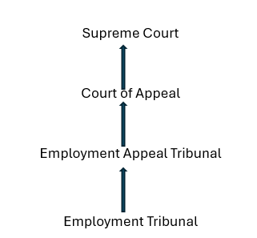
Figure 1 – Court system for employment-related claims.
The reason for the hierarchy is that if an appeal arises in the Employment Tribunal based on legal grounds, it is subsequently referred to the Employment Appeal Tribunal. Any further appeals are directed to the Court of Appeal and then to the Supreme Court (Daniels, 2022c, p. 6-7).

Process of Employment Tribunal –
The claimant would start an Early Conciliation by contacting ACAS. Subsequently, the Employment Tribunal will receive an ET1 claim form (logged 3 months minus 1 day of the alleged incident). The respondent is then sent an ET3 form, which verifies the specifics of the defense, to fill out and return within 28 days of the sent date.
To ensure that everything is covered, a preliminary hearing will be held following the completion and mailing of the forms. After that, the hearing will begin; the duration of the hearing will depend on the number of witnesses and supporting documentation. In the end, the judge will decide who won or lost the case on the spot, or within 28 days in more complicated cases. An application for reconsideration must be submitted within 14 days if the case is to be reviewed. The appeal will be finished in 42 days.
Not all employment-related issues must start with an employment tribunal. Certain instances of unfair dismissal may be brought in the County Court or High Court. County Court can award up to £50,000 for damages for negligence (Daniels, 2022d, p. 22).

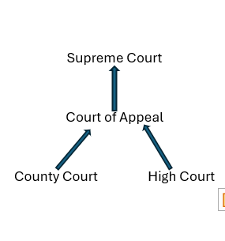

Figure 1.2 – Court structure for civil claims.

3. Explain how cases are settled before and during legal procedures. (AC 1.3)
The Employment Rights Act 1996 outlines the procedures for resolving employment disputes. The claimant can raise the issue with the employer informally by engaging in conversation with them. If that fails, a grievance can be raised. This is where a formal complaint is made to the employer.
The claimant shall be contacted within two working days by an Early Conciliation Officer who shall provide an explanation of the procedure and request additional information regarding the claim. However, at this stage, the claimant has the option of continuing with the early conciliation process or ending it. The individual receiving the claim is subsequently issued with an Early Conciliation number and is subsequently able to proceed with filing a claim with the Employment Tribunal. If the claimant is not interested in proceeding, the claim will be passed to the Conciliation Officer. This officer will contact the employer and they will have six weeks to try and reach a settlement between the two parties (Daniels, 2020e). If both parties reach an agreement, the terms can be recorded on a COT3 form, and the case will be withdrawn from the Employment Tribunal and the COT3 form prohibits either side from pursuing any issues related to the case.
A resolution can also be reached outside of the use of ACAS, specifically through the Enterprise and Regulatory Reform Act 2013 (Gov. UK, 2013). These will have the same status as COT3 forms. A settlement must be in writing and cannot be reached until the claimant has sought advice from a relevant advisor from an independent trade union or a worker at an advice center who has been certified as an advisor for this purpose.
Another method that can be used is Mediation. One of the processes within the alternative dispute resolution (ADR) spectrum, involves a neutral third party bringing two parties together to reach a mutual agreement. Mediation is particularly efficacious when employed during the initial phase of any disagreement before the escalation of conflict within the workplace. An early intervention can prevent both sides from becoming established and the situation from turning into a full-blown dispute. It has been shown to reduce the level of grievances and, where these would have led to a tribunal, it provides a far cheaper response than the employment tribunal process (CIPD, 2013).

- Advise them on the decision of appointing young men only. (AC 2.1)
Advertising and appointing only young males to work is a form of discrimination and is unlawful. The Equality Act 2010 legally safeguards individuals from discrimination in the workplace (Gov. UK, 2015). Employees, workers, contractors, self-employed individuals, job applicants, and former employees (ACAS, 2022) are protected from discrimination by the Equality Act 2010.
As stated by Daniels (2022f, P. 117) there are six different types of discrimination: Direct, Indirect, Associative, Perceptive, Harassment, and Victimisation. If you were to treat someone less favourably or disadvantageously (only appointing young males) due to a "protected characteristic," this is known as direct discrimination (ACAS, 2023).
There are a few Protected Characteristics to keep in mind especially when recruiting and through the employee lifecycle; age, disability, gender reassignment, marriage and civil partnership, pregnancy and maternity, religion or belief, sex, and sexual orientation (Equality and Human Rights Commission, 2011)
The reason behind only wanting to appoint young males because you do not want women to go on maternity leave and must deal with retirement is not an exception. From the list above, there are two protected characteristics, age and sex which are relevant to this matter. The risks of only recruiting young males could lead to an Employment Tribunal case due to others being discriminated. This implies that an individual subjected to discrimination while seeking employment may be able to file a discrimination claim if they can demonstrate that they have been treated unfairly due to a protected characteristic (Morris, 2022).
In: ‘Promoting Younger Staff Sunderland v Superdry plc’ (2022) there was a compensation of £96,000 awarded to an older worker due to being unfairly dismissed and discriminated against due to her age as she was more likely to go and seek employment elsewhere than the younger workers so was not fit for a promotion.
You should choose candidates based on their qualifications and experience to prevent claims of illegal discrimination in hiring, with very few exceptions.

- Equal pay (AC2.2)
Having declined to Kit and the options of granting Cat a pay rise to ensure that she is on the same salary as Kit, and stating to Cat that Kit is entitled to a higher salary of £30,000 as “he deserves it”, leaves you vulnerable to an Employment Tribunal claim from Cat, as she is protected by the Equality Act 2010.
The Equal Pay Act 1970, which addresses the issue of equal pay between men and women, was the initial piece of legislation that specifically addressed issues of discrimination. This is now part of the Equality Act 2010 (Daniels, 2022g, P 131).
Equal pay applies to several types of workers (ACAS, 2022), employees, workers, agency workers, full-time, part-time, or temporary contracts, and self-employed people who are hired to personally do the work. This applies to Cat as she is an employee.
For Cat to be able to make an equal pay claim at an Employment Tribunal she needs a person of the opposite sex as her comparator, in this case, it would be Kit. Cat would then have to show how the comparator (Kit) is engaged in one of the following as stated by Daniels, (2022h, P. 131-135):
Like work - Work that is similar, the Employment Tribunals interpret this idea broadly.
Work rated as equivalent under an analytical job evaluation - Only when an analytical, non-discriminatory job evaluation scheme is in place can work rated as equivalent be used.
Work of equal value - When no comparable work or work is officially rated as equivalent, the work is of equal value. Establishing a case of equal value takes a lot of work and time.
If this does happen your task as the employer would be defending these claims of equal pay, there are three main ways in which this can be done as stated by CIPD (2023b). The claimant and the comparator are not performing equally, and the comparator chosen is not legally valid, for example, they are not in the same employment, or the pay differential is due to a material factor.
In: ‘Noth and others v Dumfired and Galloway Council’ (2013) Over 4,500 female staff members of Birmingham City Council contended that their roles were on par with those of certain male coworkers. After the claim was resolved in the claimant's favour, the Council had to pay about £200 million in damages.
In addition, reviewing Cat's pay to see if it fairly compensates her for her work. Additionally, this will guarantee that she remains focused and productive (Smith, 2023). Having a pay structure within the organisation will prevent any discrimination, is an arrangement of grades, bands, or levels that connect related jobs in a series or hierarchy. It offers a structure for putting reward plans and regulations into action and will ensure that there is no pay discrimination (CIPD, 2022).

- Redundancy (AC 3.1)
As you have decided to close the restaurant down and not renew the lease is there any option of asking the employees if they would like to move to another restaurant? Doing this can save costs and keep employees.
If that is not an option, then you can make your staff redundant so there are no wrongful dismissals for some of your employees. Redundancy is when an organisation is looking to reduce its workforce. The obligations placed on employees to conduct certain types of work or to do so at the place where they work have either stopped, decreased, or are not anticipated to continue (CIPD, 2022).
According to Section 141 of the Employment Rights Act 1966, if the employer offers to extend the employee's contract or reassign them to a new contract when their current one expires or within four weeks of it expiring, and the terms and conditions are the same as those of the previous contract; in either case, the employee may reject both. If the terms and conditions represent an offer of suitable employment. There will be no redundancy payment to the employee and saving the organisation money.

The figure below shows the redundancy process and the steps that must be taken.
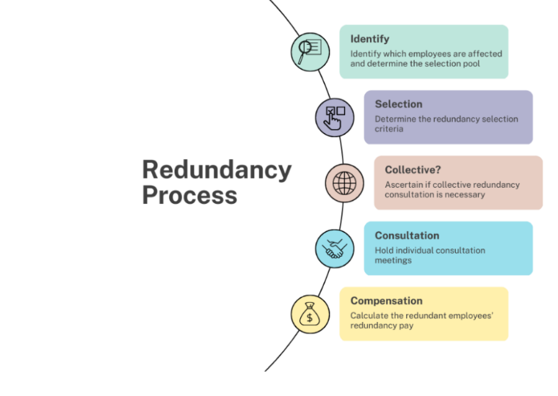
Figure 1.3 – Redundancy process (Ita, 2023)
You must hold consultation meetings with all the employees who will be made redundant. Because there are under twenty employees, you do not need to hold a collective consultation (does not need to have an employee representative). However, you must still consult with all employees individually. There are no rules regarding the length of individual consultation. You must verify whether you have a policy or agreement in place that contains regulations. Consultation is not required to reach an agreement. It is imperative that consultation is meaningful and that you demonstrate genuine consideration of any suggestions or points presented by each employee, even if you do not agree with them (ACAS, 2023b). The right for an employee to have a companion to a meeting is subject to specific regulations. Although an employee's right to be accompanied to all redundancy consultation meetings is not absolute, employers should still grant requests for companionship for employees who desire it (CIPD, 2022).
According to Gov.uk (1992), at the start of the consultation, the employees must be given in writing the following information. The reason for redundancy, how many employees, the description (type of job), the total number of redundancies being made, the proposed method of use, and the calculation of their redundancy payment.
Employees who have been made redundant with two or more years of service are entitled to a minimum statutory redundancy payment based on a prescribed formula, how old an employee is, and how long they have been employed, it is capped at 20 years of employment (ACAS, 2020). This would apply to your Manager Angelica who would receive £8,400 and Supervisor Saffron £1,750 (Gov.uk, n.d) as they both have over 2 years of service. As for your other employees, they are not entitled as they have only 1 years’ service each.
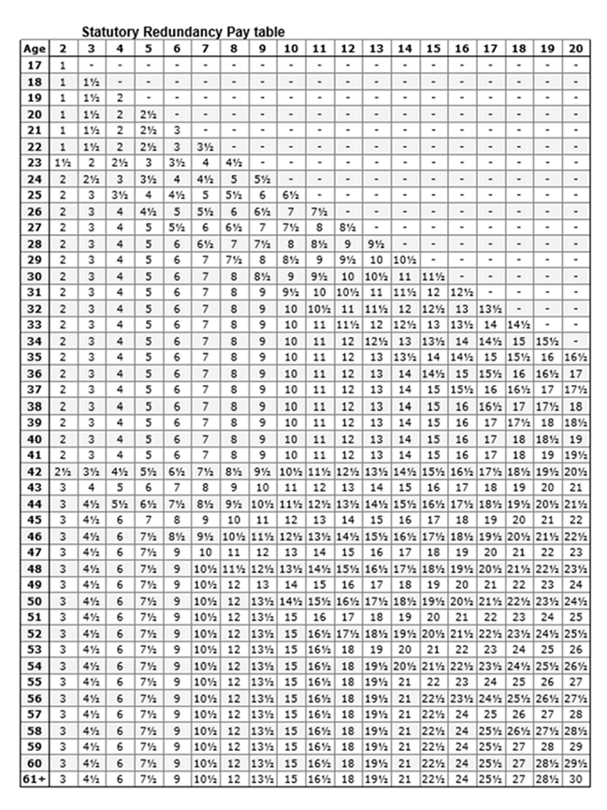 Figure 1.4 Statutory Redundancy Pay table (Solicitor, n.d)
Following the Employment Rights Act 1996, there are statutory notice periods. These are the minimum notice requirements you must provide (ACAS,2020a)
If your employee has been working for you for, 1 month to 2 years – statutory notice is 1 week. 2 to 12 years – statutory notice is 1 week for each full year they have worked. 12 or more – statutory notice is 12 weeks. A week's worth of statutory pay cannot exceed £700. Every year, the rate may fluctuate.

- Tupe transfer (AC 3.2)
Since you wish to offer the 12 Tupe employees the same terms and conditions as the current Peachy Desserts Ltd. employees, this can only be done if it improves the employee's terms and conditions as when a Tupe transfer takes place the new employer is required to adhere to the provisions of the transfer of employment agreement (Daniels, 2022i, p. 207). If not, it would constitute a breach of contract and an employee may be entitled to file a claim with an Employment Tribunal as they are protected under the TUPE regulations 2006 and amendments 2014 (ACAS, 2014).
My advice would be to wait until you receive the ELI (employer liability information) and hold the consultation meetings. The transferor (Crumbly Cakes) is legally required to provide you with information about the employees who are being transferred this is usually within 28 days of the transfer (Daniels, 2022j, p. 207). The information should include all the employees' names, ages, any information on collective agreements, their annual leave entitlement, and if the employee has any grievances raised in the past two years. Employee representatives must receive the necessary information from the transferor "long enough" before the relevant transfer to allow for consultation. You may be forced to pay the employees up to 13 weeks' worth of wages if you do not properly consult (CIPD, 2022).

However, after a TUPE transfer, modifications to contracts are only permissible if the new employer can enhance the terms and conditions of employees, such as by enhancing their annual leave, or there is an ETO (economic, technical, or organisational). ETO reasons include there are fundamental cost-saving requirements, based on economic considerations, the use of new processes or equipment for technical reasons, and the organisation making changes to the structure (ACAS, 2021).
Under TUPE regulations 2006, the new employer assumes responsibility for the employment agreements of its employees, which encompass (Gov.uk, n.d) all the previous terms and conditions of employment, any failures of the previous employer to observe employees’ rights (so employees could claim discrimination against the new employer, even if it took place before the transfer).
In: ‘Taylor v Connex Southeastern Ltd’ (2000), an employee's terms and conditions were modified two years after the transfer. The change was minor, but the employee refused to agree and was dismissed. Even though it had been two years post-transfer, the EAT ruled that it was an unfair dismissal, even though it had been two years post-transfer.

- Pay rights (AC4.1)
As stated by Daniels, (2022m, P. 99), the National Minimum Wage Act 1998 provides workers with the right to receive a minimum hourly wage. As the employer you are required by law to pay a minimum amount for each hour that your employees work on average. There is a National Living Wage (NLW) if you are aged twenty-one or over and then there is a National Minimum Wage (NMW) if you are under twenty-one or an apprentice (ACAS, 2023a).
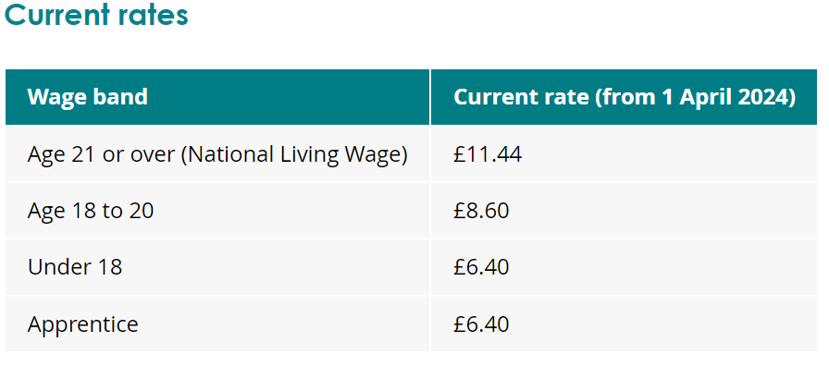 Figure 1.5 Current rates (ACAS, 2023)
The rates apply to anyone who is an employee or worker. Whether they are full-time or part-time, doing training, or working in a small ‘start-up businesses. However self-employed, volunteer, or an agency are not covered by the rates.
If you have employees over 21 years old, you are not paying the correct rate as it stands. They can claim to the Employment Tribunal. This will also have an effect of employee morale and their performance. An employee can ask to view all the payments that should be kept a record of for a minimum of three years by the employer if they believe that they are not being paid correctly.
In May 2015, the Small Business Enterprise and Employment Act 2015 amended the potential fine to a maximum of £20,000 per employee. Furthermore, employers who fail to pay the NMW are subjected to "name and shame" by the government (Daniels, 2022n, p. 99).
You can pay all employees the same rate of pay at the higher end.

- Working times (AC 4.2)
Given that Kit is protected by the Working Time Regulations 1998, which establish a 48-hour maximum for working hours a week over a 17-week reference period, Kit has a legitimate basis for a legal complaint to The Employment Tribunal and could be awarded compensation, if he has not opted out of the weekly limit. Kit can also report it to the Health and Safety Executive or the local authority (ACAS, 2023). It also restricts the working day to an average of eight hours and the right to paid leave (CIPD, 2020).
Kit states that he works 9:30 am– 9:30 pm 5 days a week so his weekly hours total up to sixty and that is without covering for his supervisor. He has also stated he does not have adequate breaks; he should be having 20 minutes of uninterrupted unpaid rest breaks as he works over six hours a day. Kit does not need to take his break but you as the employer must not prevent this. He is entitled to at least 24 hours of uninterrupted rest every seven days (Daniels, 2022o, p. 91).
In: ‘Santos Gomez v. Higher Level Care Ltd.’ (2016). Gomez's employer neglected to give her the 20-minute rest break that the Working Time Regulations of 1998 required. Gomez was awarded £1,220 in compensation for her monetary losses and was also entitled to damages for emotional distress.
If Kit's employment contract does not specify whether you want him to work extra hours, you should work out an arrangement with him. This could be providing Kit with as much notice as possible, justifying the need for the extra hours, and assuring Kit that you will look out for his welfare. (ACAS, 2023a)

- Maternity (AC4.3)
The Employment Rights Act 1996, Maternity and Parental Leave, etc. Regulations 1999, apply to Coco. Coco is eligible for 52 weeks of paid maternity leave, which will be divided into 26 weeks of ordinary maternity leave (OML) and 26 weeks of additional maternity leave (AML). If she decides to take unpaid parental leave at this point, she may also be entitled to an additional 4 weeks (CIPD, 2020).
However Coco must tell you the date she plans to start her maternity leave, this must be no later than 15 weeks before the baby is due, and is entitled to start her maternity from up to 11 weeks before the baby is due or on the day she gives birth (ACAS, 2023).
Coco is also entitled to paid time off for any antennal appointments during working times, if she Is refused this then she can complain to an Employment Tribunal (Daniels, 2022p, p. 105).
Given that Coco has worked for the company for eight years, she qualifies for statutory maternity pay (SMP). For 39 weeks, you, the employer, must pay this. Until Coco begins her maternity leave, this payment cannot begin. For the first six weeks, SMP is paid at 90% of the average weekly earnings; for the next 33 weeks, the payment rate is £151.97 per week (Daniels, 2022q, p. 105). If Coco is refused her maternity leave this could be a form of discrimination and could lead to an Employment Tribunal.
During Coco's maternity leave, she is allowed to work up to 10 KIT days without losing her entitlement to maternity pay. Coco cannot be compelled to work on such days and must not be penalized for refusing (Suff, 2022).
Paternity Leave – As stated by CIPD (2020b), The Employment Act 2002 instituted statutory paternity leave. A person must have worked continuously for at least 26 weeks at the 15th week before the anticipated week of the baby's due date to be eligible for paternity leave. The employee needs to be the child's father, the spouse or partner of the adopter or mother, or someone responsible for the child's upbringing (Daniels, 2022r, p. 105). Employees who meet the requirements are typically eligible for up to four weeks of unpaid parental leave, two weeks of paternity pay, and shared parental leave (SPL). Up until the child turns eighteen, parents are allowed to take a total of 18 weeks of parental leave, with a cap of four weeks per year (unless the employer specifies otherwise). The two-week Statutory Paternity Pay is the rate as the flat rate for maternity pay or 90%.
Adoption leave - A new statutory right to time off in the form of statutory adoption leave was introduced for employees who adopt a child by the Employment Act of 2002. (Daniels, 2020s, p. 106). Adoption leave lasts the same amount of time as maternity, 52 weeks, which is made up of 26 weeks of ordinary adoption leave (OAL) and 26 weeks of additional adoption leave (AOL). The first six weeks the employee will get 90% of average weekly earnings then the following 33 weeks, whichever is lower they will get, £184.03 per week or 90% of average weekly earnings. They must have been employed with you for at least 26 weeks. The employee is allowed paid time off work for five adoption appointments (ACAS, n.d).

- Flexible Working (AC4.4)
By denying Chelsea the opportunity to submit a flexible working request and stating that Peachy Desserts does not accept such requests, you are vulnerable to a claim at an Employment Tribunal as Chelsea is protected by the Flexible Working Regulations 2014. If the Employment Tribunal finds that Peachy Desserts made a mistake in the way the request was handled, then it can go either way; Chelsea could be awarded compensation up to a maximum of eight weeks' pay, and it could make an order for the request to be reconsidered (Daniels, 2022t, p. 73).
I would advise that you get Chelsea to put the request in writing with all the relevant information, including the date of the request, the details of the changes she requires, the date Chelsea wishes the change to take place, and if she has made any previous requests. Employees are allowed to make two stator requests for flexible working within any 12 months (ACAS, 2014).
After you receive the request, you should carefully consider the implications of both the request for Peachy Desserts and Chelsea, as well as any advantages or other effects of granting the requests. According to CIPD, (2024), research shows, that employees who work flexibly report higher levels of commitment, and job satisfaction, and are more likely to put in more discretionary effort than employees who do not. In addition to lowering absenteeism rates, flexible working enables workers to manage chronic illnesses and disabilities while also promoting their mental well-being and stress reduction.
Several flexible working practices could be a consideration for Chelsea, Job-sharing, Annual hours, or a career break. Having the request will show the reasons for the change.
For your knowledge, effective from the 6th of April 2024, the entitlement to request flexible working can be from first day of employment (CIPD, 2024c).

Reference list
ACAS (2014a) Code of Practice on Handling in a Reasonable Manner Requests to Work Flexibly. Available at: https://www.acas.org.uk/acas-code-of-practice-on-flexible-working-requests/html (Accessed 23 April 2024).
ACAS (2014b) Transfer of undertakings (TUPE). Available at: //www.acas.org.uk/index.aspx?articleid=1655 (Accessed 10 April 2024)
ACAS (2020a) Give employees notice of redundancy. Available at: https://www.acas.org.uk/manage-staff-redundancies/give-employees-notice-of-redundancy (Accessed 10 April 2024).
ACAS (2020b) Making a claim to an employment tribunal. Available at: https://www.acas.org.uk/making-a-claim-to-an-employment-tribunal (Accessed 26 March 2024).
ACAS (2020c) Work out Redundancy Pay. Available at: https://www.acas.org.uk/manage-staff-redundancies/work-out-redundancy-pay (Accessed 18 April 2024).
ACAS (2021) Changing an employment contract after a TUPE transfer. Available at: https://www.acas.org.uk/changing-an-employment-contract-after-a-tupe-transfer-employer-responsibilities (Accessed 10 April 2024).
ACAS (2022) Equal pay and the law. Available at: https://www.acas.org.uk/equal-pay/equal-pay-law#:~:text=By%20law%2C%20men%20and%20women (Accessed 2 April 2024).
ACAS (2023a) Direct discrimination: Discrimination and the Equality Act 2010. Available at: https://www.acas.org.uk/discrimination-and-the-law/direct-discrimination (Accessed 2 April 2024).
ACAS (2023b) Taking maternity leave. Available at: https://www.acas.org.uk/your-maternity-leave-pay-and-other-rights/taking-maternity-leave (Accessed 17 April 2024).
ACAS (2023a) National Minimum Wage Entitlement. Available at: https://www.acas.org.uk/national-minimum-wage-entitlement (Accessed 16 April 2024).
ACAS (2023b) Redundancy Consultations. Available at: https://www.acas.org.uk/manage-staff-redundancies/redundancy-consultations (Accessed 2 April 2024).
ACAS (2023c) Redundancy Consultations. Available at: https://www.acas.org.uk/manage-staff-redundancies/redundancy-consultations (Accessed 11 April 2024).
ACAS (n.d.) Giving proof of the adoption or placement. Available at: https://www.acas.org.uk/your-adoption-leave-pay-and-other-rights/giving-proof-of-the-adoption-or-placement (Accessed 17 April 2024).
ACAS (2023) Understanding the Working Time Regulations. Available at: https://www.acas.org.uk/working-time-rules (Accessed 25 April. 2024).
ACAS (2023a) Understanding the Working Time Regulations. Available at: https://www.acas.org.uk/working-time-rules (Accessed 25 April. 2024).

BBC (2021) Employment Law - The impact of legislation on businesses. Available at: https://www.bbc.co.uk/bitesize/guides/z49xxyc/revision/2 (Accessed 11 April 2024).
CIPD (2013) Mediation: an approach to resolving workplace issues. Available at: https://www.cipd.org/uk/knowledge/guides/workplace-mediation/ (Accessed 11 Apr. 2024).
CIPD (2020a) Maternity & Parental Rights. Available at: https://www.cipd.org/uk/knowledge/employment-law/maternity-paternity-rights/ (Accessed 17 April 2024)
CIPD (2020b) Maternity & Parental Rights. Available at: https://www.cipd.org/uk/knowledge/employment-law/maternity-paternity-rights/ (Accessed 17 April 2024)
CIPD (2020c) Working time: UK employment law. Available at: https://www.cipd.org/uk/knowledge/employment-law/working-time/ (Accessed 16 April 2024).
CIPD (2022a) Information on Redundancy. [online] CIPD. Available at: https://www.cipd.org/uk/knowledge/employment-law/redundancy/ [Accessed 18 Apr. 2024].
CIPD (2022b) Redundancy. Available at: https://www.cipd.org/uk/knowledge/factsheets/redundancy-factsheet/#redundancy (Accessed 2 April 2024)
CIPD (2023a) Employment Law. Available at: https://www.cipd.org/uk/knowledge/employment-law/ (Accessed 26 March 2024)
CIPD (2023b) Information on Equal Pay. Available at: https://www.cipd.org/uk/knowledge/employment-law/equal-pay/ (Accessed 2 April 2024)
CIPD (2024a) Gender pay gap reporting. Available at: https://www.cipd.org/uk/knowledge/guides/what-is-the-gender-pay-gap/ (Accessed 18 April 2024)
CIPD. (2023c) Age discrimination. Available at: https://www.cipd.org/uk/knowledge/employment-law/age-discrimination/#case-law (Accessed 19 April 2024(
CIPD. (2023d) Employment Tribunals. Available at: https://www.cipd.org/uk/knowledge/factsheets/tribunals-factsheet/#tribunal (Accessed 23 April 2024)
CIPD. (2024b) Working time. Available at: https://www.cipd.org/uk/knowledge/employment-law/working-time/#legislation-overview (Accessed 16 April 2024)
CIPD. (2024c) Flexible Working. Available at: https://www.cipd.org/uk/knowledge/factsheets/flexible-working-factsheet/#title6 (Accessed 16 April 2024)

Cotton, C. (2022) Pay Structures and Pay Progression. Available at: https://www.cipd.org/uk/knowledge/factsheets/pay-structures-factsheet/ (Accessed 18 April 2024).
Daniels , K. (2022) Introduction to Employment Law : Fundamentals for HR and Business Students. 6th ed. London, United Kingdom ; New York, Ny, Usa: Kogan Page Limited.
Daniels, K. (2022a). Introduction to Employment Law : Fundamentals for HR and Business Students. 6th ed. London, United Kingdom ; New York, Ny, Usa: Kogan Page Limited.
Daniels, K. (2022b). Introduction to Employment Law : Fundamentals for HR and Business Students. 6th ed. London, United Kingdom ; New York, Ny, Usa: Kogan Page Limited.
Daniels, K. (2022c). Introduction to Employment Law : Fundamentals for HR and Business Students. 6th ed. London, United Kingdom ; New York, Ny, Usa: Kogan Page Limited.
Daniels, K. (2022d). Introduction to Employment Law : Fundamentals for HR and Business Students. 6th ed. London, United Kingdom ; New York, Ny, Usa: Kogan Page Limited.
Daniels, K. (2022e). Introduction to Employment Law : Fundamentals for HR and Business Students. 6th ed. London, United Kingdom ; New York, Ny, Usa: Kogan Page Limited.
Daniels, K. (2022f). Introduction to Employment Law : Fundamentals for HR and Business Students. 6th ed. London, United Kingdom ; New York, Ny, Usa: Kogan Page Limited.
Daniels, K. (2022g). Introduction to Employment Law : Fundamentals for HR and Business Students. 6th ed. London, United Kingdom ; New York, Ny, Usa: Kogan Page Limited.
Daniels, K. (2022h). Introduction to Employment Law : Fundamentals for HR and Business Students. 6th ed. London, United Kingdom ; New York, Ny, Usa: Kogan Page Limited.
Daniels, K. (2022i). Introduction to Employment Law: Fundamentals for HR and Business Students. 6th ed. London, United Kingdom ; New York, Ny, Usa: Kogan Page Limited.
Daniels, K. (2022j). Introduction to Employment Law: Fundamentals for HR and Business Students. 6th ed. London, United Kingdom ; New York, Ny, Usa: Kogan Page Limited.
Daniels, K. (2022k). Introduction to Employment Law: Fundamentals for HR and Business Students. 6th ed. London, United Kingdom ; New York, Ny, Usa: Kogan Page Limited.
Daniels, K. (2022l). Introduction to Employment Law: Fundamentals for HR and Business Students. 6th ed. London, United Kingdom ; New York, Ny, Usa: Kogan Page Limited.
Daniels, K. (2022m). Introduction to Employment Law: Fundamentals for HR and Business Students. 6th ed. London, United Kingdom ; New York, Ny, Usa: Kogan Page Limited.
Daniels, K. (2022n). Introduction to Employment Law: Fundamentals for HR and Business Students. 6th ed. London, United Kingdom ; New York, Ny, Usa: Kogan Page Limited.
Daniels, K. (2022o). Introduction to Employment Law: Fundamentals for HR and Business Students. 6th ed. London, United Kingdom ; New York, Ny, Usa: Kogan Page Limited.
Daniels, K. (2022p). Introduction to Employment Law: Fundamentals for HR and Business Students. 6th ed. London, United Kingdom ; New York, Ny, Usa: Kogan Page Limited.
Daniels, K. (2022q). Introduction to Employment Law: Fundamentals for HR and Business Students. 6th ed. London, United Kingdom ; New York, Ny, Usa: Kogan Page Limited.
Daniels, K. (2022r). Introduction to Employment Law: Fundamentals for HR and Business Students. 6th ed. London, United Kingdom ; New York, Ny, Usa: Kogan Page Limited.
Daniels, K. (2022s). Introduction to Employment Law: Fundamentals for HR and Business Students. 6th ed. London, United Kingdom ; New York, Ny, Usa: Kogan Page Limited.
Daniels, K. (2022t). Introduction to Employment Law: Fundamentals for HR and Business Students. 6th ed. London, United Kingdom ; New York, Ny, Usa: Kogan Page Limited.
EMPLOYMENT TRIBUNALS Claimant: Rachel Sunderland Respondent: Superdry PLC RESERVED JUDGMENT Available at: https://assets.publishing.service.gov.uk/media/62bda356e90e075f21bbf137/R_Sunderland_v_Superdry_PLC_-_1406389.2020_-_Reserved_Judgment.pdf (Accessed 23 April 2024).
Equality and Human Rights Commission (2011) Equality Act 2010 Code of Practice. Available at: https://www.equalityhumanrights.com/sites/default/files/employercode.pdf (Accessed 26 March 2024).
GOV.UK (n.d.). Business transfers, takeovers and TUPE. Available at: https://www.gov.uk/transfers-takeovers/transfers-of-employment-contracts (Accessed 10 April 2024).
GOV.UK (2012) Employers: preventing discrimination. Available at: https://www.gov.uk/employer-preventing-discrimination/recruitment (Accessed 2 April 2024).
GOV.UK (2015) Equality Act 2010. Available at: https://www.gov.uk/guidance/equality-act-2010-guidance (Accessed 26 March 2024).
Gov.uk (1992) Trade Union and Labour Relations (Consolidation) Act 1992. Available at: https://www.legislation.gov.uk/ukpga/1992/52/contents (Accessed 10 April 2024).
GOV.UK. (2013) Enterprise and Regulatory Reform Act 2013. Available at: https://www.gov.uk/government/publications/enterprise-and-regulatory-reform-act-2013-a guide#:~:text=The%20Enterprise%20and%20Regulatory%20Reform%20Act%20aims%20to%20cut%20the (Accessed 26 March 2024).
House, F. and Salisbury (2000) EMPLOYMENT APPEAL TRIBUNAL THE HONOURABLE LADY STACEY (SITTING ALONE). Available at: https://assets.publishing.service.gov.uk/media/595e6881e5274a0a6900014c/General_Vending_Services_Ltd__ta_GVS_Assist_v_Mr_Christopher_Schofield_UKEAT_0137_13_MC.pdf. (Accessed 21 April 2024).
Ita, E. (2023) Leading Challenging Change. Available at: https://www.thinkpeople.co.uk/redundancy-planning-for-managers/ (Accessed 3 April 2024).
Legislation.gov.uk. (2022) Equal Pay Act 1970. Available at: https://www.legislation.gov.uk/ukpga/1970/41/enacted#:~:text=An%20Act%20to%20prevent%20discrimination (Accessed 18 April 2024).
Mangion, D. (2024) 12 Notorious UK Discrimination Cases. Available at: https://www.skillcast.com/blog/12-notorious-uk-discrimination-cases#:~:text=An%2089%2Dyear%2Dold%20NHS (Accessed 16 April 2024).
Morris, A. (2022) Avoiding Discrimination in Recruitment. Available at: https://www.davidsonmorris.com/recruitment-discrimination/ (Accessed 2 April 2024).
Smith, N. (2023) 8 Steps to conducting a fair salary review. Available at: https://www.totaljobs.com/recruiter-advice/8-steps-to-conducting-a-fair-salary-review (Accessed 16 April 2024).
Solicitor, H. (n.d.) Compensation / Redundancy Ready Reckoner. Available at: https://www.horizonsolicitors.co.uk/legal-services/employment-law/compensation-redundancy-ready-reckoner/ (Accessed 2 April 2024).
Suff, R. (2022) TUPE (Transfer of Undertakings). Available at: https://www.cipd.org/uk/knowledge/factsheets/tupe-factsheet/ (Accessed 18 April 2024).
Suff, R. (2022) Maternity, Paternity and Adoption Rights. Available at: https://www.cipd.org/uk/knowledge/factsheets/maternity-paternity-rights-factsheet/ (Accessed 25 April 2024).
Trinity Term [2013] UKSC 45 On appeal from: [2011] CSIH 2 JUDGMENT North and others (Appellants) v Dumfries and Galloway Council (Respondent) (Scotland). (2013). Available at: https://www.supremecourt.uk/cases/docs/uksc-2011-0046-judgment.pdf (Accessed 23 April 2024).
GOV.UK (n.d.) Your statutory redundancy payment. Available at: https://www.gov.uk/calculate-your-redundancy-pay/y/2024-04-16/30/5.0/350.0 (Accessed 16 April 2024).
Livingwage (n.d.) What is the real Living Wage. Available at: https://www.livingwage.org.uk/what-real-living-wage?gad_source=1&gclid=CjwKCAjww_iwBhApEiwAuG6ccKk14nbD-j3JVef68KHxBPphnZ9qh_Q5Wf5fTSOVXptO7inRVHpf8BoCMesQAvD_BwE (Accessed 16 April 2024).

