

MSc Software Engineering (Web Development)
Web Development
ACCA7004
Design Patterns in Web Development
James Robert Tudor Jones
P138563

Contents
Abstract 3
1.0 Introduction 3
2.0 Background Research 4
2.1 Architecture layered Research 4
2.11 Presentation Layer 4
2.12 Business layer 4
2.13 Infrastructure layer 5
2.2 ORM (object relational mapping) Research 5
2.21 Hibernate ORM 5
2.22 ORM with Java & Code Example 6
3.0 Repository Pattern Research 7
3.1 Repository per Entity or business Object 7
3.2 Generic Repository Interface 7
4.0 Unit work pattern with Repository 8
4.0 Evaluation 8
4.1 Layered Architecture Pattern 8
4.2 ORM 9
4.3 Repository patterns and unit of work 9
4.0 Conclusion 10
5.0 Reference List 10

Abstract
The purpose of this report is to identify, research and critically evaluate software architecture design patterns which are commonly used by software engineers in web applications today. Software architecture is used to explain high-level designs on software systems. The goal is to examine key advantages and disadvantages of the layered architecture patterns methodology. Further investigating object relational mapping (ORM), repositories and unit working patterns. This report will overview the importance of how these software methodologies can help developers using web applications, allowing easier maintenance with cleaner code and being able to adapt to future changes effectively

1.0 Introduction
T
here are many types of architectural patterns as explained by Chavan, P.U. Murugan, M. ‘An architectural pattern is a set of principles that shape an application. It includes patterns such as client/server, service-oriented architecture (SOA), component-based architecture layered architecture and message bus architecture.’[1] The sheer scale of how many architectural patterns that can be used is almost infinite because so many different representations can be made for the individual end user, therefore the most commonly used as informed by PhD student Vijini Mallawaarachchi:-
- Layered pattern
- Client-server pattern
- Master-slave pattern
- Pipe-filter pattern
- Broker pattern
- Peer-to-peer pattern
- Event-bus pattern
- Blackboard pattern
- Interpreter pattern [2]

Given so many types of styles the engineer or even customer needs to understand which pattern style to use for the best outcome of their project, A. Sharma backs up this by explaining ‘There are several architectural styles and patterns available in the software industry, so there is a need to understand which particular architecture style will be appropriate for his/her project.’[3] The main focus within this report, will be the layered pattern methodology as seen in the above list, looking at how layered patterns work, investigating the value of using this kind pattern for everyday web applications and software engineers, but further into patterns there are also others that will be investigated such as object relational mapping patterns and repository patterns with unit of work patterns which will illustrate different styles that can be implemented.

2.0 Background Research

2.1 Layered Architecture
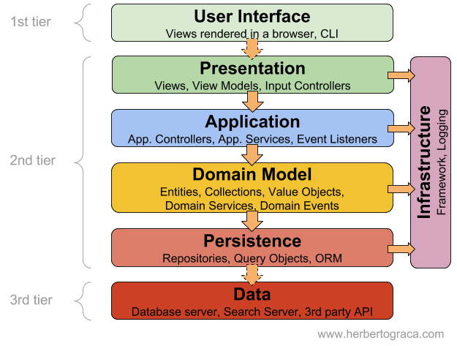
There are many different representations of layered architectural patterns but they all follow the same trivial style with layers that are placed on top of each other. Shaw, Mary explains ‘Often there are layers for basic system-level services’[4] and goes onto reporting ‘Frequently, each class of service is assigned to a layer and several different patterns are used to refine the various layers.’[4]

Figure 1: Layered architecture design Pattern Example
[5]
Fig 1 illustrates layered architecture pattern design, by inspection it is clear to see how the design can be made. The layers are groups which are known to be loosely coupled but have communication factors with each other. M.Kumar states ‘Layered architecture groups the responsibilities of the software into several loosely coupled layers. A system is layered on the basis of separation of concerns. Layers can communicate with each other through well-defined interfaces’.[3] Fig 1 is a good example of a layered architecture pattern but to simplify the layers can be taken down to three main layers.
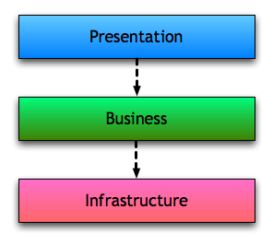

[6]
Figure 2: Three Tiered Layered design

2.11 Presentation Layer
The presentation layer also known as the access layer usually compromises as the layer which comprises the views and user interface. Jreport briefly explains ‘This tier is often built on web technologies such as HTML5, JavaScript, CSS, or through other popular web development frameworks, and communicates with other layers through API calls.’[7] This layer has the functionalities with user interface technologies and co-operates with the system’s business layer.

2.12 Business layer
The business layer is responsible for the specific business rules within the architecture system, Mark Richards clarifies ‘A business layer would be responsible for executing specific business rules associated with the request.’[8] This incorporates the business logic such as domain rules, data structures and application states needed for the system.

2.13 Infrastructure layer
The infrastructure layer is responsible for having different infrastructures that are separated until implemented together at the domain presentation layer, it implements networking, databases and data persistence etc.[9]. This layer can be looked at as the building blocks that decouples software architecture making it easier to switch from one technology to another[9].

2.2 ORM (object relational mapping)
ORM can be explained as an implementation of code that can handover objects to and from a database. C, Richardson supports this claim by stating ‘A major component of most enterprise applications is the code that transfers objects in and out of a relational database. The easiest solution is often to use an ORM (object-relational mapping) framework’[10]. By using an object orientated approach incompatible types of data can be converted to enable them to communicate.
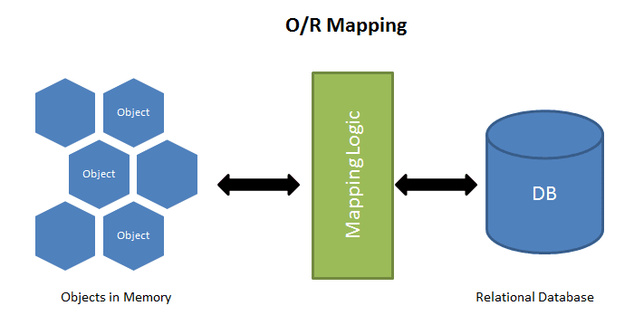
Figure 3: ORM Diagram [11]
There are various, commonly used frameworks that all incorporate the use of ORM with languages such as Java, C#, Python. Examples of these frameworks include hibernate, java API, OpenJPA, EclipseLink and IBM Websphere and newer versions of ORM such as active record for ruby developers and Gorm (Grails Object Relational Mapping) for groovy developers which use a more dynamic development approach.[10] The ORM approach can be seen as very efficient due to the small amount of code needed for it to work effectively and to allow a developer to have a friendly workflow, without the worry of translating languages to work alongside each other.[12] A closer look into a commonly used framework can give an understanding of an ORM approach.

2.21 Hibernate ORM
Hibernate can be viewed as a high powered ORM solution that can allow java classes to be mapped to a database on an object relational persistence level, which provide data queries and data retrievals.[13] Wu, Qinglin and Hu, Yanzhong also explains ‘Hibernate generates the SQL calls and relieves the developer from manual result set handling and object conversion, keeping the application portable to all supported SQL databases, with database portability delivered at very little performance overhead.[13]
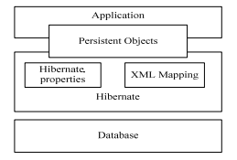
Figure 4: Hibernate Architecture [13]
By using this type of approach the developer is cutting out all the manual handling needed. Hibernate acts as a layer that can do the heavy handling of changing the data from one exemplification to another.
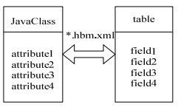

[13]
Figure 5: Hibernate Example
When there is a relationship gap between two languages the void is filled by hibernate to define association between the data.

2.22 ORM with Java & Code Example
Java is known as an object orientated programming language as it is represented by graphs and objects therefore when the use of a database is needed there is the need to have ORM implemented for developers.[14] java provides an API called java database connectivity commonly known as JDBC.[15] This inbuilt system can be used without ORM but major problems can occur because of code change, for example when java encounters changes such as inheritance, composition and abstraction this will lead to mismatch between the java and database relation, this is where ORM steps in as a solution of the mismatch.[14] JDBC is still heavily used in industry and has been used for many years but ORM is becoming more common because of the usefulness it brings, both styles can be investigated.
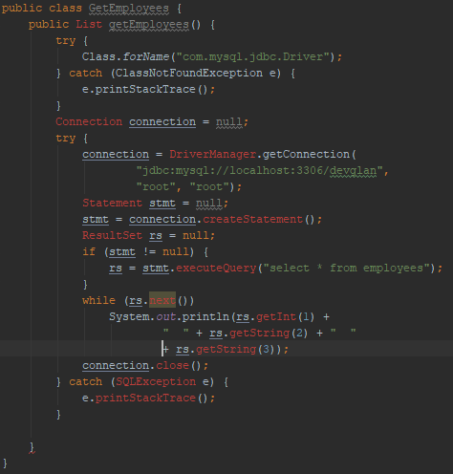
Figure 6: JDBC Coding
Fig 6 has database configurations such as passwords, usernames, addresses is implemented all mixed together in a single method with also the implementation of error handling codes. The code above is completely correct and ok to use but know let’s look at an ORM style.
Session session = sessionFactory.openSession();
(List<Employee>)session.createSQLQuery("SELECT * FROM Employee").addEntity(Employee.class).list();

Figure 7: ORM Code Example
Fig 7 is simply an object graph which allows an ORM tool to do all the work for you any code change with the java object will not affect the relation. When visually inspecting notice the small amount of code needed which helps a coder or developer work efficiently. Concluding with the use of ORM, the system still uses the JDBC in the background as a sort of wrapper easing a developer’s coding struggles.[14]

3.0 Repository Pattern
Repository pattern can be viewed as an abstraction layer between the data access and business logic layer. S.Shekhawat implies ‘The repository pattern is intended to create an abstraction layer between the data access layer and the business logic layer of an application. It is a data access pattern that prompts a more loosely coupled approach to data access.’[16] Instead of having data access logic contained in a controller or business model a separate class called a repository takes on the responsibility of preserving the business models application.[17] W.Romsaiyud leads onto mentioning ‘The repository pattern nicely complements the key design principle of the MVC pattern separation of concerns. By using this pattern, that isolate the data access layer from the rest of the application’.[17]
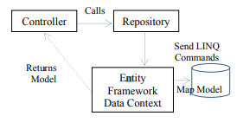

[17]
Figure 8: Repository and controller pattern
Fig 8 represents a block diagram view of where a repository lies, the main feature of having a repository within the system is the use of having the layer for the main data store that can be easily accessed by all other independent components, it ensures data consistency and allows a suitable means of accessing data such as a query of API language. The repository can present transaction mechanisms.[18] The Repository pattern allows straight forward methods which entail adding, removing and updating without database concerns such as commands, readers, cursors and connections.

3.1 Repository per Entity or business Object
A simple repository pattern approach is to have a repository per entity or business object, DevIQ states ‘The simplest approach, especially with an existing system, is to create a new Repository implementation for each business object you need to store to or retrieve from your persistence layer.’[19] Using this approach only certain methods being called in the application, should be implemented.

3.2 Generic Repository Interface
The Generic repository interface approach can be used to constraint a type or even have a certain type of interface.
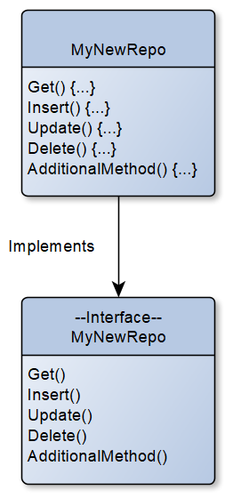

Figure 9: Repository interface

Fig 9 illustrates a repository interface clearly explaining how the typical class is created, the methods noticeably have no implementation on the interface class whereas the repo class has methods with implementation. This system will allow the controller to program to a super type allowing switching between data sources at ease. If for any reason data is changed the only section which will need code change will be in the concrete repo section giving easier change as other code will not be affected.

4.0 Unit work pattern with Repository
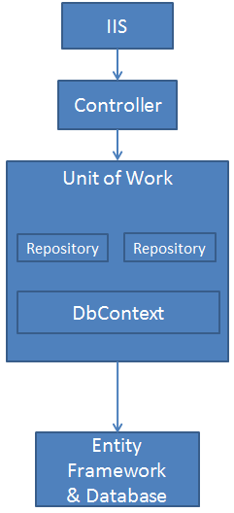
The previous topic of repositories can be benefited with the use of unit of work (UoW). There can be a single repository pattern that connects to a DBcontext which allows the initialising between the controller and the database but if multiple repositories need to be used the use of unit work pattern can be introduced.

[20]
Figure 10: Unit of work
As shown on Fig 10 the unit of work allows a block with DBcontext that can use multiple repositories this provides maintainability and flexibility. Lalanda.P explains ‘We propose a Unit of Work (UoW) modelling as a solution to support transaction of persistence objects at a platform independent level.’[21]

4.0 Evaluation

4.1 Layered Architecture Pattern
Layered architecture provides increased scalability, flexibility and maintainability. Due to the separation of layers, development teams can work off different sections of an application on a parallel basis with minimal dependencies on other teams which is especially important with organisations even more on a large enterprise level. Components can be reused by applications multiple times. Layered architecture pattern benefits from a development system being loosely coupled. Tony.N and Matthew A. Stoecker support ‘if a client application communicates to the server application using only a well-defined web service, the two layers can be said to be loosely coupled.’[22] With a loosely coupled system gives developers a very adaptable environment to work with. Layered architecture can help with time structures due to different parts being able to be independently preserved, organised and updated. The system can also benefit with extra security because each layer can have its own security features which are separate portions of a development. Finally testing each section with layered architecture can be used at an easier level because tests are created for each independent level. Although this system has many benefits there are also arguments that can have a negative impact. The layers can help with large applications but can cause too much complexity for simple applications. The layers can sometimes affect the development of intensive user applications because there is a likely factor that the use of interface components that directly interact with the database can be disallowed. Negative impact can occur on the performance, instead of simply searching directly for a component there is extra processes and overheads that need to be taken.

4.2 ORM
Object relational mapping gives a system which can easily make different level of languages talk to each other when interacting with a database. It allows a section or layer of communication between database data and for example an object orientated language such as C# or Java to stream together collectively without having to overload with extra code, the system can see to act as a key tool for any developer to work effectively in an organisation. The ORM cuts the need of repetitive SQL code and this goes hand in hand with it being very cost effective and have good timescales on systems giving less overhead pressure to developers and a faster efficient working environment. Although the ORM can be a useful to development there is always the issue where developer’s productivity may suffer due to the fact that before the big change of coding was introduced with object orientated in mind, ORM was not really known amongst daily developers.[23] This meant that developers had to completely change the way they previously coded with a new mind set to deal with the ORM’s way of doing things. ORM also creates a situation where developers lose track of what the code is actually achieving because previously a developer had more understanding and control over the SQL code. There are a lot of different views about ORM but with the type of object orientated languages the world uses on a quotidian basis, ORM is a very popular way to act as a middle man to enable an easy connection between databases and other coding languages.

4.3 Repository patterns and unit of work
Unit of work entails multiple operations such as insert, update and delete which involve single transactions, this removes the need to have multiple database transactions, and where there would be separate transactions for each change a unit of work will do every action all together in one single transaction. A unit of work system allows a developer to keep track of all transactions that can affect a database. If a database related operation needs moving with the use of repositories these operations can give performance tuning results along with easy logging.

4.0 Conclusion
Architecture layers give a good working style for large scale organisations and enterprises because it gives a loosely coupled working environment and detaches different areas to work with effectively but this approach may not be the best solution for small developments. Therefore an educated decision on how this approach may help a user or give conflict will need to be addressed. ORM frameworks are widely used for the key helping tool to communicate data between diverse languages. The rise in object orientated type languages has made ORM services more substantial and beneficial but with the ORM tools being a middle man kind of system a developer can lose touch of how the system works and takes away speciality skills with the detachment of direct SQL coding. Unit of work when used with repository pattern allows transactions to be undertaken with all operation in a single action removing the use of multiple transactions for each action. This system creates a centralized store of multiple repositories to receive instances of database context. Due to having the use of multiple repositories with one instance, if for any reason something were to break, the other repositories will not save allowing consistency over the database, therefore when an action is executed correctly all repositories will change together keeping inline and dependable.

5.0 Reference List
[1] P. U. Chavan, M. Murugan, and P. P. Chavan, “A review on software architecture styles with layered robotic software architecture,” in Proceedings - 1st International Conference on Computing, Communication, Control and Automation, ICCUBEA 2015, 2015, pp. 827–831.
[2] Vijini Mallawaarachchi, “10 Common Software Architectural Patterns in a nutshell,” 2017.
[3] A. Sharma, M. Kumar, and S. Agarwal, “ScienceDirect A Complete Survey on Software Architectural Styles and Patterns,” Procedia Comput. Sci., vol. 70, pp. 16–28, 2015.
[4] M. Shaw, “Some Patterns for Software Architectures,” 1995.
[5] ograca.H, “Layered Architecture,” no. August 3, 2017.
[6] Phil Calçado, “Internal Data Transfer Objects,” 2011. [Online]. Available: http://philcalcado.com/2011/08/01/internal_data_transfer_objects.html.
[7] “3-Tier Architecture: A Complete Overview - JReport.” [Online]. Available: https://www.jinfonet.com/resources/bi-defined/3-tier-architecture-complete-overview/.
[8] Mark Richards, Layered Architecture - Software Architecture Patterns. .
[9] “Multilayered Architecture (4) - The Infrastructure Layer.” [Online]. Available: https://www.javacodegeeks.com/2013/06/multilayered-architecture-4-the-infrastructure-layer.html. [Accessed:
[10] C. Richardson, “ORM in dynamic languages,” Commun. ACM, vol. 52, no. 4, p. 174, Apr. 2009.
[11] “ORM Pattern Picture.” [Online]. Available: http://atgcommercenotes.blogspot.com/2015/04/repositories-atgs-object-relational.html. [Accessed: 20-Mar-2019].
[12] T.-H. Chen, W. Shang, J. Yang, A. E. Hassan, M. W. Godfrey, and M. Nasser BlackBerry Ontario, “An Empirical Study on the Practice of Maintaining Object-Relational Mapping Code in Java Systems,” 2016.
[13] Q. Wu, Y. Hu, and Y. Wang, “Research on Data Persistence Layer Based on Hibernate Framework,” in 2010 2nd International Workshop on Intelligent Systems and Applications, 2010, pp. 1–4.
[14] “Object Relational Mapping in Java | DevGlan.” [Online]. Available: https://www.devglan.com/hibernate/object-relational-mapping-in-java.
[15] D. Kramer, “The Java TM Platform A White Paper,” 1996.
[16] S.Shekhawat, “CRUD using the Repository Pattern in MVC,” 2018.
[17] W. Romsaiyud, “Applying MVC data model on hadoop for delivering the business intelligence,” in 2014 Twelfth International Conference on ICT and Knowledge Engineering, 2014, pp. 78–82.
[18] P. Avgeriou and U. Zdun, “Architectural Patterns Revisited-A Pattern Language.”
[19] “Repository Pattern | DevIQ.” [Online]. Available: https://deviq.com/repository-pattern/.
[20] “Implementing the Repository and Unit of Work Patterns in an ASP.NET MVC Application (9 of 10) | Microsoft Docs.” [Online]. Available: https://docs.microsoft.com/en-us/aspnet/mvc/overview/older-versions/getting-started-with-ef-5-using-mvc-4/implementing-the-repository-and-unit-of-work-patterns-in-an-asp-net-mvc-application.
[21] P. Lalanda, “Shared repository pattern.”
[22] M. A. S. Tony Northrup, Designing and Developing Windows® Applications Using Microsoft® .NET Framework 4. 2011.
[23] “The Database Programmer: Historical Perspective of ORM and Alternatives.” [Online]. Available: http://database-programmer.blogspot.com/2010/12/historical-perspective-of-orm-and.html.

marking criteria and Student FEEDBACK

This section details the extent to which the assessment criteria are demonstrated by you, which in turn determines your mark. The marks available for each category of skill are shown. Lecturers will use the space provided to comment on the achievement of the task(s), including those areas in which you have performed well and areas that would benefit from development/improvement.

Common Assessment Criteria Applied (Assignment 1) | Marks available | Marks  awarded
1. Engagement with Literature Skills

A very good range of appropriate literature has been consulted and referenced in the work and the review and discussion of the literature is of a very good standard. Please see your report for the correct way to apply numeric reference in text and try and quote a little bit less in your research sections and write more of your own interpretations and conclusions. This latter comment applies particularly to the sections were you introduce the patterns. (Grade mark: 70.00%) | 15 | 10.5
2. Knowledge and Understanding Skills

A very good discussion of the layered architecture pattern with a good discussion of some of its benefits, but the section on some of the possible disadvantages needs more detail. Very good description of ORM and the description of the repository and unit of work patterns is also very good with some good code examples for the repository pattern. The discussion, however, does not discuss the use of ORM with the repository and unit of work patterns and I would also have liked to see some more discussion of the disadvantages as well as some of the criticism of the use of these patterns with ORM frameworks. (Grade mark: 65.33%) | 75 | 49
3. Cognitive and Intellectual Skills

4. Practical Application Skills

5. Transferable Skills for Life and Professional Practice

The report is well-written and presented. See your report for suggested improvements. (Grade mark: 75.00%) | 10 | 7.5

Assignment Mark (Assessment marks are subject to ratification at the Exam Board. These comments and marks are to give feedback on module work and are for guidance only until they are confirmed. ) | Late Submission Penalties (tick if appropriate) |  | 67%
 | Up to 1 week late (40% Max) |  | 67%
 | Over 1 week late (0%) |  | 67%

