Student Name: Precious Grant Whittaker
Student Number: 2412252
Module Code: BMHP5015
Lecturer Name Olufemi Oluranti
Module Name: Changemaker Building My Personal Brand for Sustainable Employment

Contents Page

Introduction……………………………………………………………………….. Page 3

Job advertisement ………………………………………………………………. Page 4 -9

Job Role Employability Skills…………………………………………………. Page 10 - 11

Evaluate Your Own Skills ……………………………………………………….. Page 12

Create an Action Plan and Timeline …………………………………………… Page 13

Building Your Personal Brand ………………………………………………….. Page 14

Promoting Your Professional Identity ………………………………………….. Page 15

Building a Network for Successful Employment……………………………….. Page 16

Conclusion …………………………………………………………………………….. Page 17

Introduction
This report explores my aspiration to progress into the role of Practice Nurse within a primary care setting, with a specific focus on the vacancy at The Oaks Medical Centre. The Practice Nurse plays a crucial role in delivering high-quality, evidence-based care, supporting patients with long-term conditions, and contributing effectively to multidisciplinary teamwork. This role is central to promoting health, preventing illness, and ensuring safe clinical practice across diverse patient groups (Royal College of Nursing, 2024).
My motivation to pursue this career pathway is driven by my strong commitment to person-centred care, my extensive NHS experience, and my long-term goal of advancing within community-based nursing. As I continue to develop professionally, transitioning into primary care nursing represents a natural progression that aligns with my values, clinical skills, and future ambitions.

Job Advertisement Summary
The job advertisement for the Practice Nurse role at The Oaks Medical Centre outlines a position centred on delivering high-quality, patient-focused care within a busy and dynamic primary care environment. The role requires the successful candidate to undertake a wide range of clinical duties, including wound care, immunisations, cervical screening, chronic disease management, ECGs, health promotion, and supporting patients with long-term conditions (NHS Jobs, 2024). The advert highlights the need for a practitioner who can work autonomously while also contributing effectively to the wider multidisciplinary team.
The Oaks Medical Centre emphasises four core organisational values caring, accountability, supporting, and honesty which underpin the professional behaviours and standards expected from all staff. The job description further states that the Practice Nurse must demonstrate excellent communication skills, strong clinical judgement, and the ability to maintain accurate patient records using SystemOne. Essential requirements include relevant clinical training, experience in primary care procedures, and a commitment to continuous professional development. Desirable skills include women’s health, chronic disease management, and experience delivering NHS vaccination programmes (NHS Jobs, 2024).
This job advertisement provides a clear outline of the expectations for the role and forms a strong foundation for evaluating my own competencies, identifying development needs, and planning my progression into primary care nursing. The competencies described also align closely with the professional standards expected of registered nurses working in primary care (Nursing and Midwifery Council, 2018).

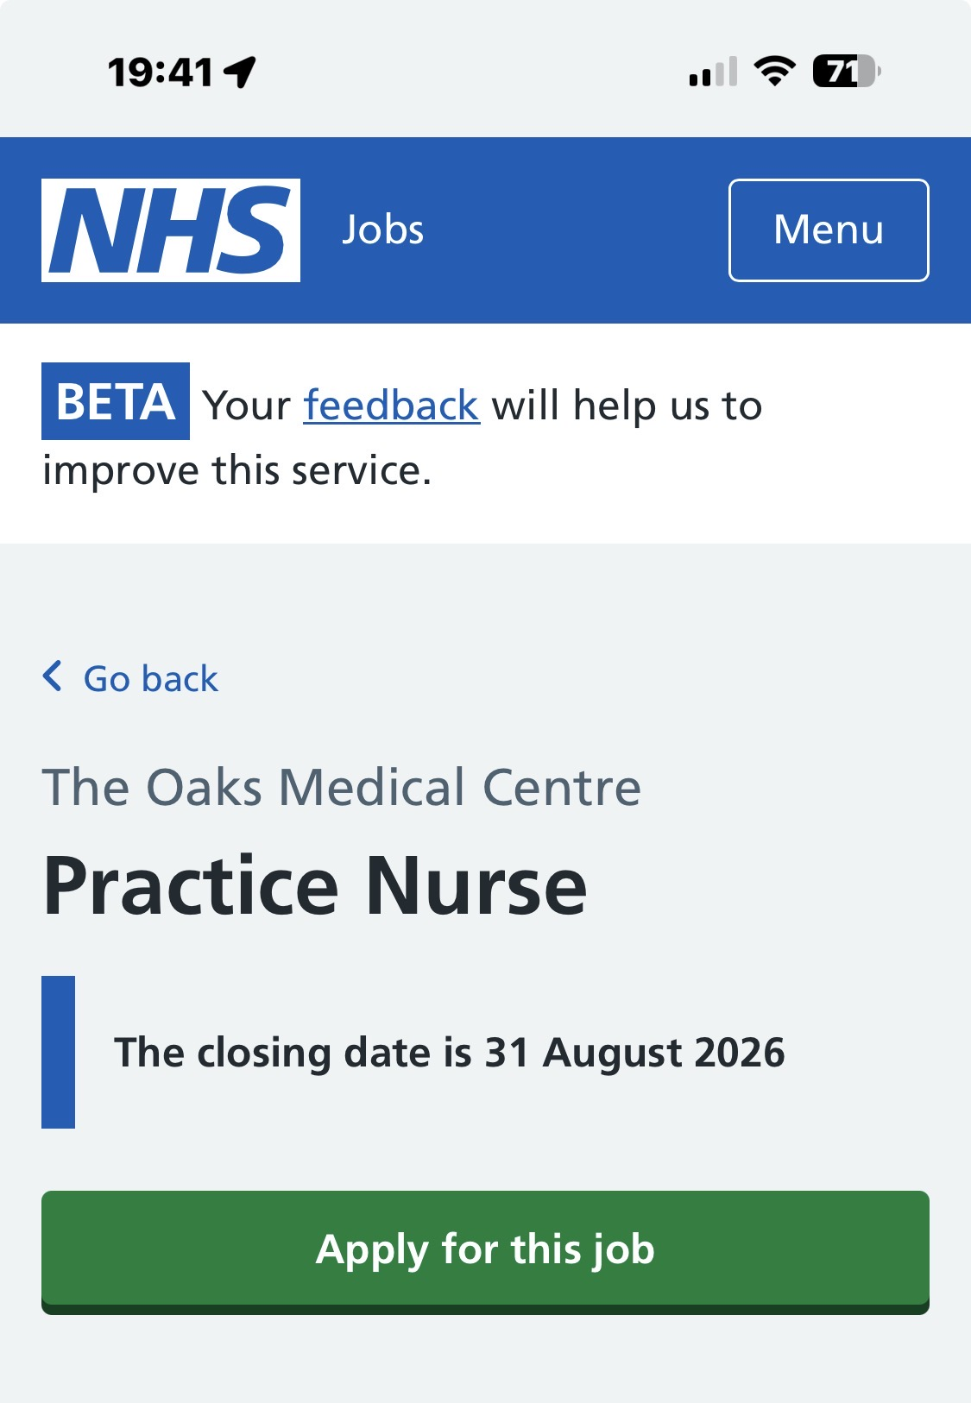

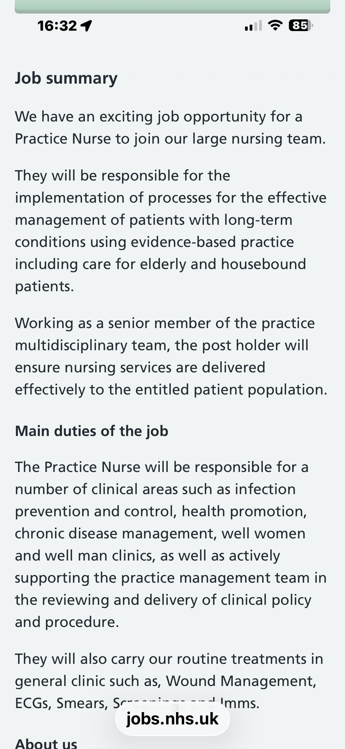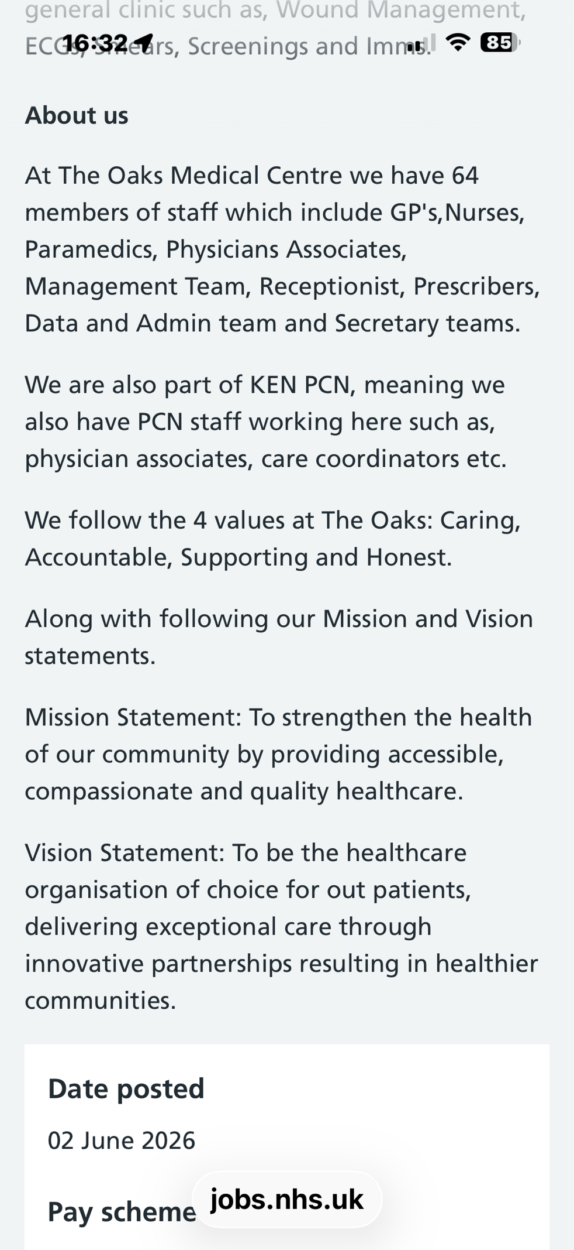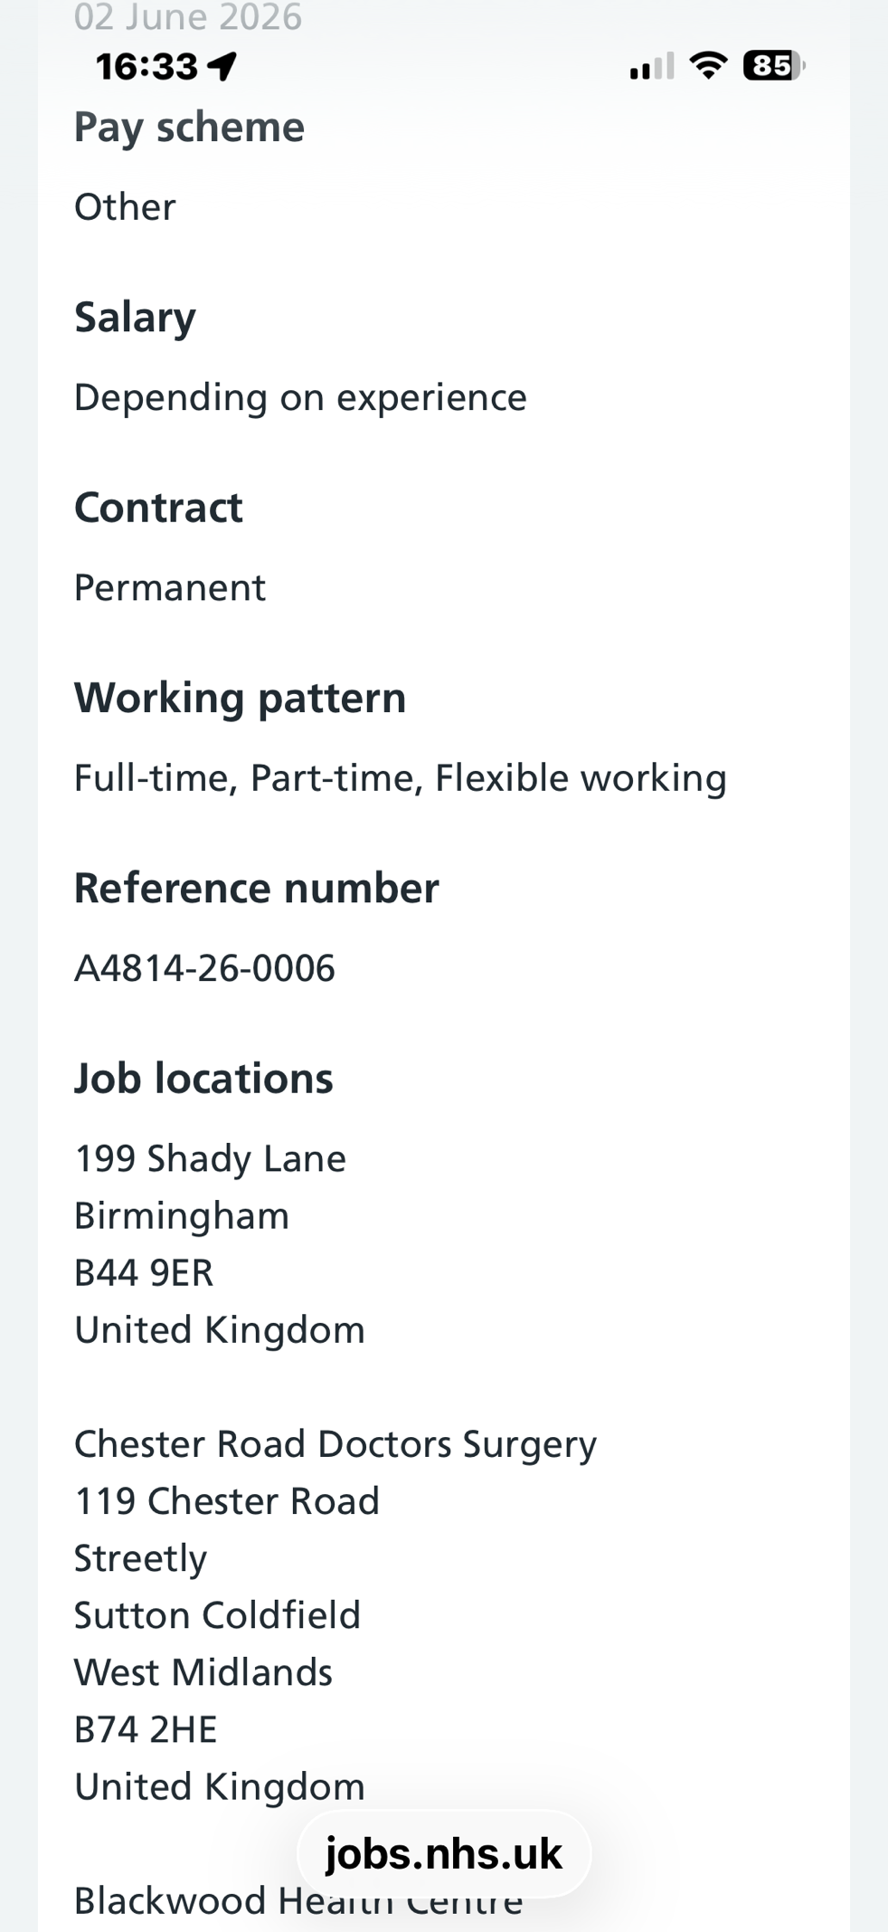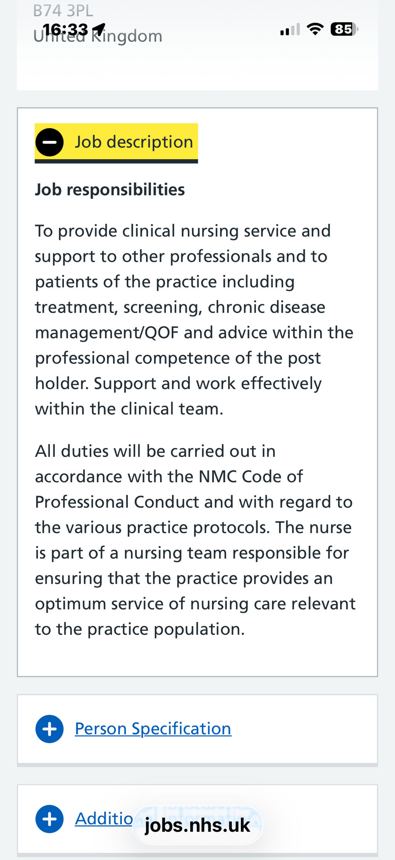

Job Role Employability Skills
The Practice Nurse role at The Oaks Medical Centre requires a broad range of employability skills to ensure safe, effective, and person-centred care within a busy primary care environment. The job description highlights essential competencies, beginning with clinical skills such as wound care, venepuncture, ECGs, immunisations, women’s health, and chronic disease management clinical skills (NHS Jobs, 2024).
These skills are fundamental to delivering routine treatments, supporting long-term condition management, and contributing to high-quality patient outcomes. Effective performance ensures patients receive timely, evidence-based interventions that promote health and prevent deterioration (Royal College of Nursing, 2024).
Autonomous practice is another key employability skill, particularly important in primary care where nurses manage their own clinics and make independent clinical decisions. Working autonomously demonstrates confidence, accountability, and adherence to professional standards such as the NMC Code. This skill is closely linked to problem solving, as Practice Nurses must assess patients, identify risks, and implement appropriate care plans (NHS England, 2024).
In primary care, autonomous decision-making is critical because patients often present with undifferentiated symptoms, requiring nurses to use clinical judgement to prioritise care safely. Strong communication skills are also vital. Practice Nurses interact with patients, families, GPs, paramedics, physician associates, and Primary Care Network (PCN) staff. Clear communication supports patient education, shared decision-making, and effective multidisciplinary teamwork. It also ensures accurate documentation and safe handover of care, which are essential components of professional practice (Nursing and Midwifery Council, 2018).
The role further requires robust infection prevention and control skills, essential for maintaining patient safety and reducing healthcare-associated infections. This is particularly important in general practice, where vulnerable groups such as elderly, frail, and housebound patients are frequently seen. Effective infection control also supports safe delivery of procedures such as wound care and immunisations. (UK Health Security Agency, 2023).
Additional desirable skills include IT literacy, knowledge of SystemOne, and effective resource utilisation. These skills support efficient workflow, accurate record-keeping, and the ability to navigate digital systems used across the NHS digital skills (NHS England, 2023). Digital competence is increasingly important as primary care continues to adopt electronic triage, remote monitoring, and digital patient records. Collectively, these employability skills ensure that the Practice Nurse can deliver compassionate, safe, and effective care while contributing positively to the values and mission of The Oaks Medical Centre.

Evaluate Your Own Skills
My self-assessment shows that I have built a strong foundation for progressing into the Practice Nurse role. My NHS experience, including advanced phlebotomy, has strengthened my practical skills in patient care, infection prevention, communication, and multidisciplinary teamwork. Studying for a BA (Hons) Health and Social Care has further enhanced my understanding of person-centred care, safeguarding, equality, and the professional values required in primary care.
A key strength is my ability to communicate effectively with patients, families, and colleagues. My frontline experience has developed compassion, adaptability, and teamwork, supporting health promotion and collaboration with GPs, paramedics, physician associates, and PCN staff. My competence in venepuncture and clinical observations provides a solid foundation for developing skills in wound care, ECGs, immunisations, and routine screening.
I also demonstrate professionalism and the ability to work independently. Experience in busy clinical environments has strengthened my organisational skills, decision-making, and accountability, reflecting the expectations of the job specification and the NMC Code.
However, I recognise areas for development, including women’s health, chronic disease management, wound care, SystemOne, immunisation training, and cervical screening. To address these gaps, I will seek support from Practice Nurses, clinical educators, mentors, university tutors, and PCN training opportunities. A focused development plan will support my transition into the role and ensure I meet the expectations of The Oaks Medical Centre.

Create an Action Plan and Timeline
Developing a structured action plan is essential for progressing towards the Practice Nurse role and ensuring I gain the clinical competencies, qualifications, and professional experience required in primary care. My plan focuses on building specialist skills, strengthening academic knowledge, and expanding practical experience through targeted training and development.
Short-term goals (0–12 months): My immediate priority is to complete my Health and Social Care degree, providing a strong foundation in person-centred care, safeguarding, equality, and professional values. Alongside this, I will undertake clinical training in wound care, ECG recording, immunisations, and infection prevention and control. I also plan to shadow Practice Nurses within my NHS workplace to gain experience of primary care and chronic disease management. In addition, I will improve my IT skills and complete introductory training in SystemOne.
Medium-term goals (1–3 years): I aim to secure a Band 4 or 5 role within primary care or the community, such as a trainee nursing associate or assistant practitioner. This will help me gain experience in long-term condition management, health promotion, and autonomous practice. I also intend to complete specialist training in women’s health and cervical screening while engaging with mentors, clinical educators, and Primary Care Network training programmes.
Long-term goals (3–5 years): My long-term objective is to become a Practice Nurse. I hope to complete additional qualifications in chronic disease management or family planning while continuing to develop leadership, autonomous decision-making, and clinical skills. Ongoing CPD, reflective practice, and mentorship will help me maintain high professional standards and remain aligned with the values of The Oaks Medical Centre.

Building Your Personal Brand
Building a strong personal brand is essential for progressing into the Practice Nurse role, as it allows me to communicate my professional identity, values, and expertise to employers within the health and social care sector. A personal brand reflects not only clinical competence but also the qualities that define my approach to patient care, such as compassion, accountability, and professionalism all of which align with the values of The Oaks Medical Centre (NHS Jobs, 2024).
To strengthen my brand, I will focus on presenting myself as a committed, patient-centred practitioner with a clear interest in primary care, long-term condition management, and community health (Nursing and Midwifery Council, 2018).
Digital platforms such as LinkedIn provide opportunities to showcase my experience, NHS background, qualifications, and ongoing development. By maintaining an updated profile, sharing reflections on training, and engaging with professional discussions, I can demonstrate my commitment to continuous learning (Skills for Care, 2024). Creating a small professional portfolio or personal website would allow me to highlight certificates, CPD activities, and examples of good practice.
Producing relevant content such as short posts on infection prevention, chronic disease management, or person-centred care will help position me as an emerging practitioner with insight into primary care nursing. Attending networking events, webinars, and local PCN activities will further reinforce my brand and increase visibility within the sector (NHS England, 2024).

Promoting Your Professional Identity
Promoting my professional identity is an essential part of progressing towards the Practice Nurse role, as it enables me to communicate my skills, values, and experiences clearly to potential employers. A strong professional identity demonstrates clinical competence, reliability, compassion, and commitment to high-quality patient care professional identity (Nursing and Midwifery Council, 2018).
One effective way to promote this identity is through well-structured application documents. By tailoring my CV and cover letter (see image 1 & 2) and cover letter to highlight relevant skills such as venepuncture, wound care, communication, and infection prevention application documents (NHS Jobs, 2024). I can align my application with the job description and strengthen my employability (Chartered Institute of Personnel Development, 2024).
Maintaining a professional online presence also enhances visibility within the sector. An updated LinkedIn profile allows me to showcase NHS experience, qualifications, CPD achievements, and ongoing training (NHS Employers, 2024). Sharing evidence-based resources, reflecting on clinical learning, and engaging in primary care discussions demonstrates commitment to continuous development online presence (Royal College of Nursing, 2024). Creating a small digital portfolio or personal website can further support this by presenting certificates, training records, and examples of good practice.
Networking with colleagues, attending PCN events, and engaging with professional groups also reinforces my identity as an emerging Practice Nurse, helping me build meaningful connections and demonstrate dedication to the role (NHS England, 2024).

Building a Network for Successful Employment
Building a strong professional network is essential for securing employment as a Practice Nurse and supporting long-term career development within primary care. Networking provides access to mentorship, clinical learning opportunities, and insight into the expectations of general practice professional network (Royal College of Nursing, 2024).
Within the NHS, networking often begins in current workplaces, where experienced Practice Nurses, GPs, paramedics, and physician associates can offer guidance, supervision, and opportunities to shadow clinics. These relationships help build confidence and provide exposure to chronic disease management, wound care, and women’s health (NHS England, 2024).
Professional associations also play a key role. Organisations such as the Royal College of Nursing, local Primary Care Networks (PCNs), and regional training hubs offer workshops, webinars, and development programmes tailored to general practice nursing. Engaging with these groups helps me stay updated with best practice, clinical guidelines, and emerging roles within community healthcare (Royal College of General Practitioners, 2023). Attending PCN meetings or local practice forums can also help me connect with employers, clinical educators, and mentors who support progression into advanced roles.
Digital networking is equally important. Platforms like LinkedIn allow me to connect with healthcare professionals, follow primary care leaders, and engage with discussions about evidence-based practice. By building both in-person and online networks, I can strengthen my visibility, enhance my professional identity, and increase opportunities for successful employment as a Practice Nurse (Pasquini, 2021).

Conclusion
This report has explored my chosen career pathway of becoming a Practice Nurse, drawing on the job description, person specification, and organisational values of The Oaks Medical Centre. The role requires a wide range of employability skills, including autonomous practice, effective communication, infection prevention, chronic disease management, and competence in essential clinical procedures. Through self-evaluation, I have identified the strengths I already possess from my extensive NHS experience, such as compassion, professionalism, venepuncture skills, and the ability to work confidently within multidisciplinary teams. I have also recognised areas for development, including women’s health, wound care, immunisations, and IT literacy, which are essential for delivering safe and effective care in primary practice.
My action plan outlines clear short, medium and long-term goals to help me gain the qualifications, clinical skills, and experience required for the role. Alongside this, I have reflected on how building a strong personal brand, promoting my professional identity, and developing a supportive network will enhance my employability and visibility within the sector. Overall, I remain highly motivated and committed to pursuing the Practice Nurse role, confident that my values, experience, and development plan align with the expectations of modern primary care nursing.

Reference list
Chartered Institute of Personnel and Development (2024) Employability and careers. Available at: https://www.cipd.org/globalassets/media/knowledge/knowledge-hub/reports/2024-pdfs/8625-good-work-index-2024-summary-report-1-web.pdf (Accessed: 8 July 2026).
Health Education England (2022) General practice nursing workforce development plan. Available at: https://www.hee.nhs.uk/ (Accessed: 8 July 2026).
NHS Employers (2024) Personal development. Available at: https://www.nhsemployers.org/ (Accessed: 8 July 2026).
NHS England (2024) Primary care. Available at: https://www.england.nhs.uk/primary-care/ (Accessed: 8 July 2026).
NHS Jobs (2024) Practice Nurse Vacancy–The Oaks Medical Centre. Available at: https://www.jobs.nhs.uk/candidate/jobadvert/A4814-26-0006?country=GB-ENG&keyword=practice%20Nurse&location=B44%209ER&distance=5&language=en (Accessed: 05 July 2026).
Nursing and Midwifery Council (2018) The Code: Professional standards of practice and behaviour for nurses, midwives and nursing associates. Available at: https://www.nmc.org.uk/standards/code/ (Accessed: 8 July 2026).
Pasquini, L. A. and Eaton, P. W. (2021). ‘Being/becoming professional online: Wayfinding through networked practices and digital experiences’, New Media & Society, 23(5), pp.939-959. Available at: https://doi.org/10.1177/1461444820902449 (Accessed: 07 July 2026).
Royal College of General Practitioners (2023) Primary care workforce and education. Available at: https://www.rcgp.org.uk/ (Accessed: 8 July 2026).
Royal College of Nursing (2024) Nursing careers resource. Available at: Nursing careers resource (Accessed: 8 July 2026).
Skills for Care (2024) Developing yourself and your career. Available at: https://www.skillsforcare.org.uk/news-and-events/blogs/resources-to-support-learning-and-development-in-2024 (Accessed: 8 July 2026).
UK Health Security Agency (2023) National infection prevention and control manual for England. Available at: https://www.england.nhs.uk/wp-content/uploads/2022/04/PRN00908-national-infection-prevention-and-control-manual-for-england-v2.10.pdf (Accessed: 8 July 2026).

Appendix
Tailored CV – Image 1

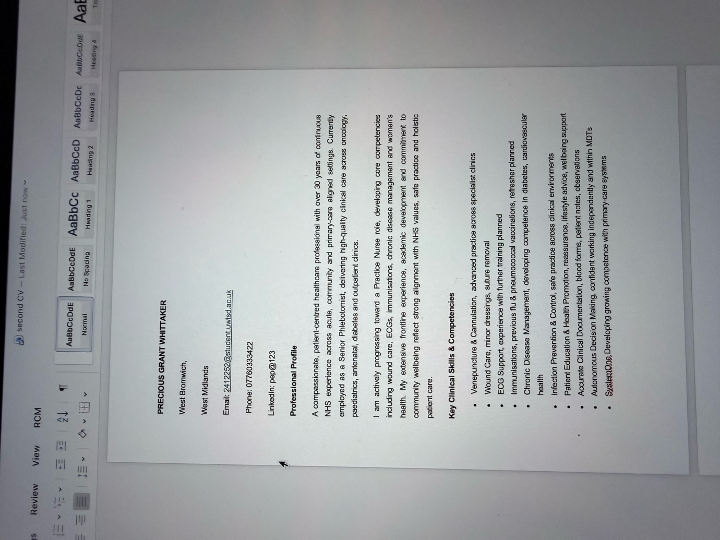

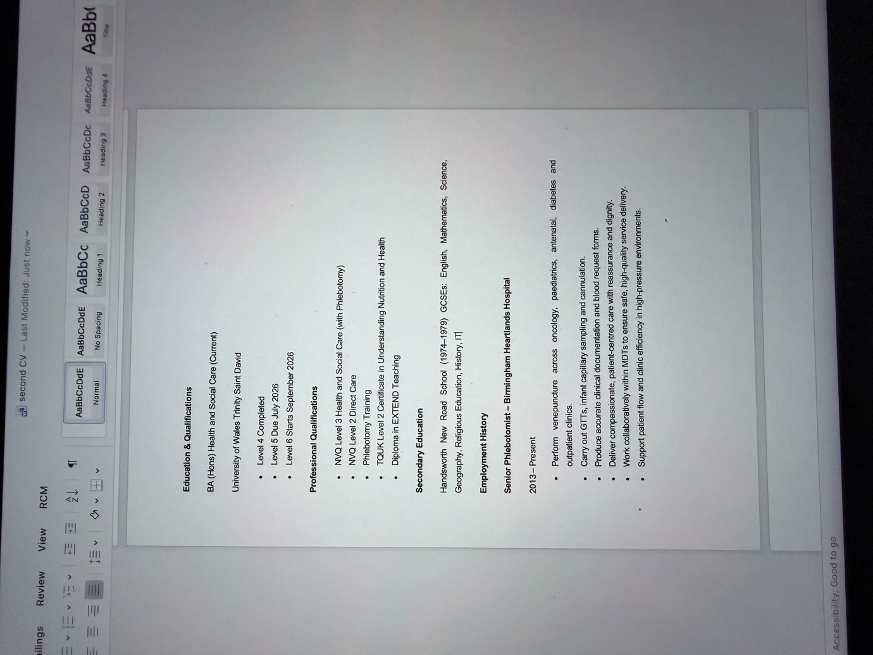

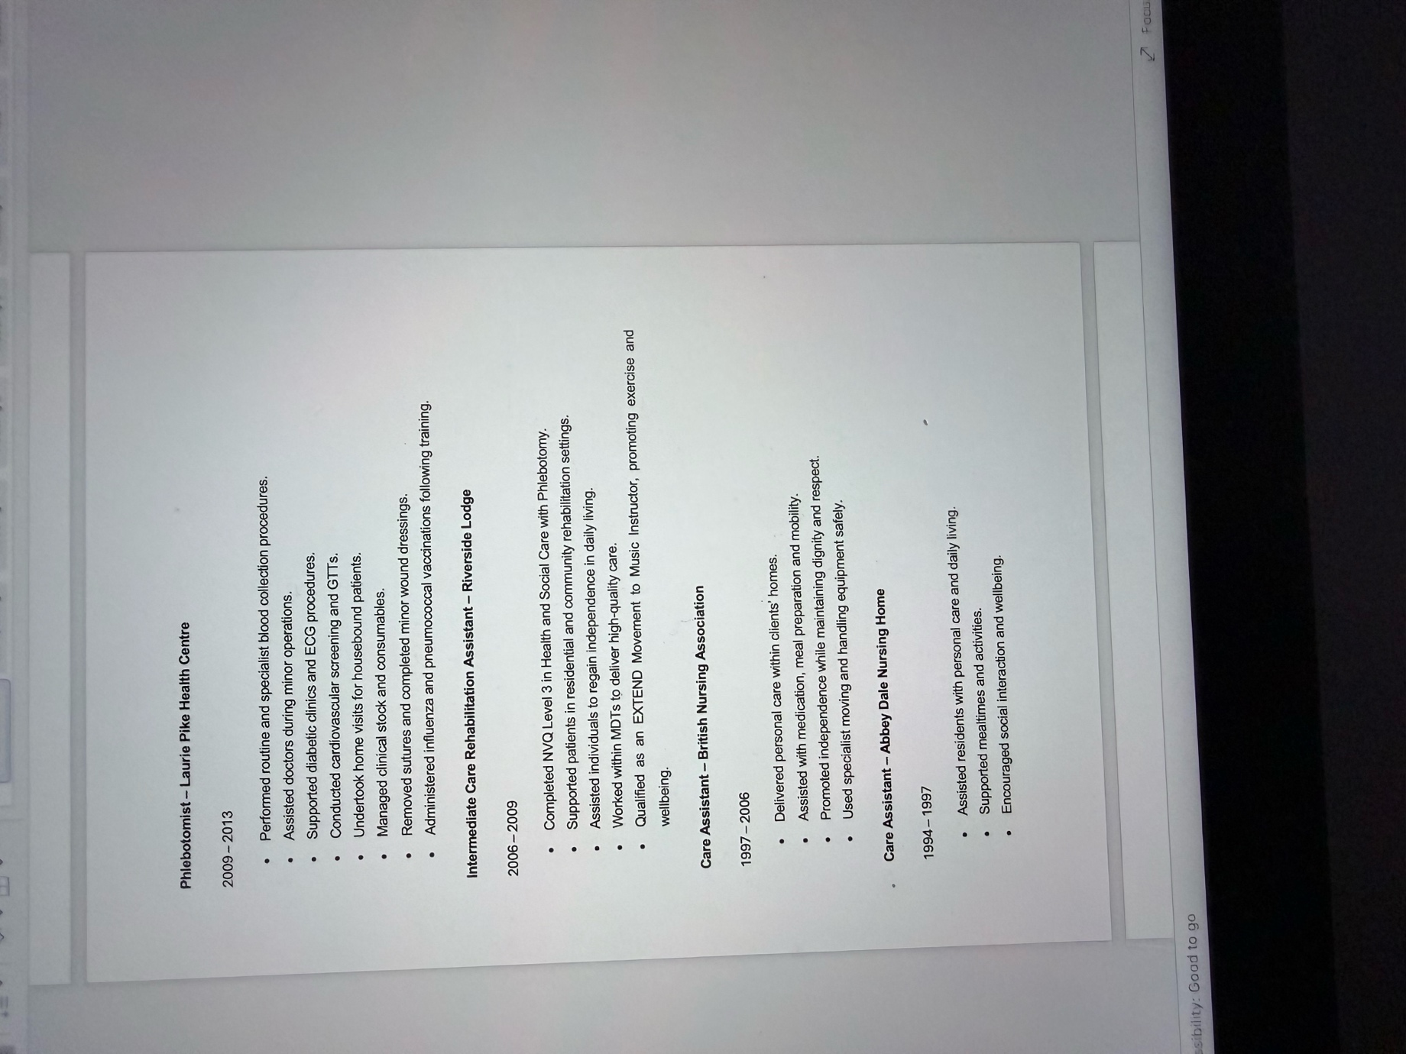

COVER LETTER – Image 2





