Name: Mabel Osemwonyemwen Idukpaye
Student No.: 1805997
Module Title: Knowledge and Information Management
Module Code: (BMSK5106)
Lecturer Name: Dr Mohamed Kalam

2nd TERM
TASK
You are required to produce a 4,000 -5,000 word academic essay/report, employing academic models and theories to examine information and knowledge management process for a chosen organisation.
TASK DESCRIPTION:
Identify a specific organisational context and:
- Demonstrate the importance of understanding that the effective creation, storing, sharing, application and integration of information is an essential prerequisite for good knowledge management development practices.
- Demonstrate an evaluation of the identified scenario within the chosen organisation. Relevant alternative academic theories must be identified and evaluated to check the effectiveness of knowledge and information management culture within the chosen organisation i n terms of creating knowledge asset and maintaining effective customer relationship management,
- Develop a framework for establishing a suitable knowledge management culture for the chosen organisational context by identifying the gap between required knowledge management culture/framework for the current or potential market scenarios and existing knowledge management framework for the chosen organisation.
The learning should be related to the organisation in which you are currently working, if you are not working currently working within an organisation, you may complete this task in relation to an organisation with which you are familiar. This could include work experience in a voluntary capacity.

In choosing the organisation, say why you chose the organisation you are writing on
- Write why you chose the organisation
- Identify academic or organisational tools
- Develop a framework
- Look for some gaps and recommendation how they can improve their knowledge and information management
Main body
3 parts: headings and sub-headings

TABLE OF CONTENT
INTRODUCTION
What is knowledge and information management?
Importance of knowledge and information management in an organisation
How KIM has been used by your chosen Tesco
How KIM is benefiting an organisation.
Executive Summary
PESTEL Analysis of Tesco
RECOMMENDATION
CONCLUSION
REFERENCES

INTRODUCTION
The motivation of this report is to analyse the information and management process for Tesco plc. This would be achieved using academic models and theories to examine/ appraise information and knowledge management process for Tesco.
In this present era of information and knowledge, Knowledge Management is an essential discipline/area that adds value to organisations by easing the acquirement/attainment of its goals (Castaneda, D. I. 2010). Organisations that learn faster and make use of knowledge effectively tend to be leaders (Smith, 2008). Nonetheless Knowledge Management is a lively discipline that has gone through substantial changes in the last two decades and will continue to change in the next decade (Estherby-Smith and Lyles, 2011, p. 1)
Initially, Knowledge Management was portrayed to be a procedure of concern to an orderly viewpoint of capturing, organising, managing, and distributing knowledge all over an organisation in functioning rapidly, reusing the best practices and cutting down of expensive rework from one project to another project.(Ahn and Jeong, 2015 ). Knowledge Management is considered a discipline that aids a combine perspective to identifying, capturing, evaluating, retrieving, and sharing all of an organisation’s information resources/assets. These assets include database, policies, documents, procedures and previously un-captured expertise and experience in individual workers.
Knowledge management has proven to be the most prosperous in executing the foremost practices.
According to ( ) knowledge management
Tesco is not the only organisation embracing/taking up knowledge management. Today, the structured sharing of knowledge is presuming a wider role in different type of organisation in the world. (Luen & Al-Hawamdeh, 2001; world Bank 1999). The knowledge Management initiative in the United Kingdom involves the formation of the position of a Chief Knowledge Officer at NatWest Markets and the Knowledge Officer at the British Council (Skok, 2000).
The potential benefits of Knowledge Management amounts and span from improving customer service, productivity, decision making and innovation. Knowledge is power. Using it is powerful.
Tesco Plc is a general retailer of merchandise and a multinational grocery with its headquarters in Welwyn Garden City, Hertfordshire, United Kingdom. Tesco was founded in 1919 by Jack Cohen. The name was originated in 1924 when he obtained a consignment of tea from Stockwell and attached his surname initials to it. Its First store was opened Burnt Oak in 1931.

EXPLAIN THE RELATIONSHIP BETWEEN DATA, INFORMATION AND KNOWLEDGE
Knowing the relationship between Information and Knowledge is to understand where the information inhabits. It is important to note that information is at its extract a point that is produced projects and circumstances. Information are kept in storage medium such as video tapes, USB, database, prints etc in the form of data or in an individual mind as knowledge. From the above therefore the relationship between Data, information and knowledge is clear because they engage in another space at the same time.

The several kinds of system in Tesco trade off data among one another. The foremost origin of information data for various systems, especially Management Information System (MIS) and Decision Support System (DSS) is the Transactional Processing System (TPS). The transactional Processing System functions well in Tesco as operational level systems that collate transaction data. Payroll or order processing are examples that run the daily business transaction important to Tesco. TPS makes obtainable data that are required by office system, MIS and DSS irrespective of the fact that these systems are might as well provide more data in Tesco. The office information system is not the only running data from TPS but from MIS in addition. DSS does not only use data from TPS but in addition from office systems and management information system. MIS rely mainly on data from Transaction Process System and also use data office system. The Executive support system obtains many of its internal data from management information system and Decision support system.

Data, information and knowledge are essential words and also basic theories in knowledge management. This report comprises/involves the rationale for ambiguity and uncertainty frequently linked with those basic terms, suggested definitions of basic terms, and two models of their transformations and interactions.
MEANING OF DATA
In computational structures data are the coded invariance. In human dialogue, data are that which are stated, for example, by informants in an empirical study. Data are sensory boost that we discern through our senses. Data are records encoded to be utilized in computer, but extensively used to refer statistical inspections and further recording of proof.
INFORMATION

KNOWLEDGE

The definitions of Data, information and knowledge are not only unclear and inexplicit, the relationship between them are not much covered. Choo et al., 2000 always outlines the relationship between them as a hierarchy comprising of data at the rear end followed by information, and with knowledge at the pinnacle. This representation influences two tacit presumptions: first of all, it entails that the relationship is asymmetrical/ uneven/unbalance proposing that data might be converted into information, which in turns might be converted into knowledge. This presumption could be perceived also in table 1(above definition) where respective critics describe information in terms of data and knowledge in terms of information. Apparently, this is inaccurate since in many occasions we all have used our knowledge to acquire information, and produced data out of information.
Furthermore, it suggests the assessment that knowledge more worthy than information, which in turn is higher than data. This also has been confronted.

WHAT IS KNOWLEDGE AND INFORMATION MANAGEMENT?

IMPORTANCE OF KNOWLEDGE AND INFORMATION MANAGEMENT IN AN ORGANISATION
Knowledge management aids in solving many organisation business problems and assist in increasing its benefits by enhancing decisions making in the organisation to hasting access to professionals practices.
Knowledge management is essential because it enhances an organisation’s efficiency in making decision. This ensures that every member of employees have good access to all professionals within the organisation environment, a quicker workforce is bacon on who are able to make fast, well known decisions that the company could benefit from.
There are several reasons why knowledge management is important.
- It ensures all relevant information and resources can be accessed by employees when they need it
- Important knowledge is kept within the business even after employees move on from the business
- It avoids duplicated efforts
- It ensures your organisation effectively takes advantage of existing expertise
- It standardised processes and procedures for knowledge management
This all leads to faster and more effective decision making and easier collaboration. More importantly it stimulates innovation and growth.

RELATIONSHIP BETWEEN INDIVIDUAL AND ORGANISATIONAL KNOWLEDGE
In this current changing and vast world, the essence for organisational knowledge is unblocking. However, in many circumstance, the administration of individual knowledge and competence begin to be analytical. This depends on the essence of the tasks and the essence of communications between people. For instance a task needs a particular competence; a professional could use his or her own knowledge to resolve the issues. Differently, when a task needs the administration of knowledge from distinct scope, individual professional in itself might not be solution to the issue. In this case, how individuals in the organisation communicate and corporate to share their knowledge becomes very significant.
It is understood that knowledge is a result of social associations, designed in a socially established tradition. The foremost aim here is to highlight that individual knowledge is as significant as organisational knowledge and the correlative significance of both relies on the task identity, the degree of training of individual, and motivation, and management’s readiness to avoid many of the cultural tasks to the employee at lower level.

RELATIONSHIP BETWEEN INDIVIDUAL KNOWLEDGE AND ORGANISATIONAL KNOWLEDGE
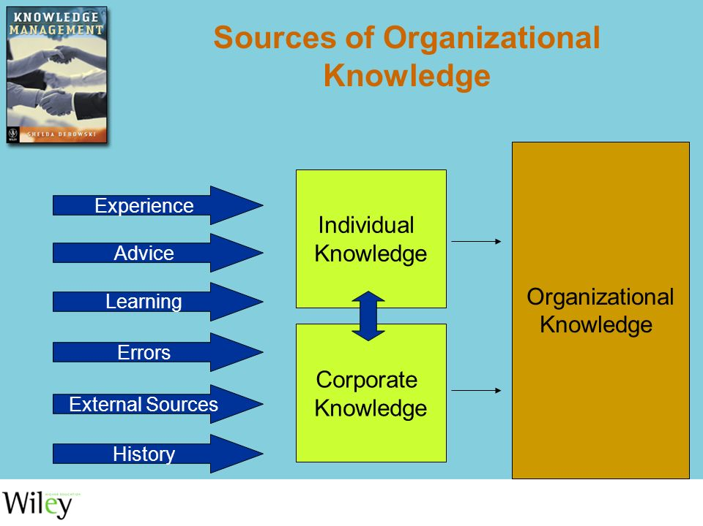
Sourced from: https://www.google.co.uk A ccessed:06/08/20

APPLYING ANAYSIS AND MODELLING TECHNIQUES TO IDENTIFY KNOWLEDGE ASSESTS
According to Nonaka et al (2002) refers to knowledge asset as the basis of knowledge producing procedure and defines it as ‘organisation-specific assets that are essential to produce value for the organisation’ .However, Boisot (1999) defines Knowledge asset as stock of knowledge from which services are anticipated to move for a span of time that might be difficult to identify in the future, with an economic life usage within organisation and labour market. Nonetheless, Nonaka et al (2002) definition of knowledge asset is the more comprehensive. Carucci & Schiuma (2006) have suggested a knowledge assets value that is objected to answer the question of recognising and enhancing knowledge assets.
There are different model of techniques in knowledge assets. The knowledge models are:
- The Von Krogh & Ross model
- Nonaka & Takeuchi (Seci Model)
- The Chao Sense Making Model (Inukshuk model)
- The wig model
- EFQM (European framework Quality Mgt) Model
The Nonaka & Takeuchi model: if organisations are to survive competition in the business environments, the creation of knowledge and management theories are so much essential. The Socialisation-Externalisation-Combination- Internalisation (SECI) model also known as the Nonaka & Takeuchi is one of theoretical model of how the tacit and explicit knowledge are operated within an organisation.
According to Osterloh & Frey (2000), the issue of knowledge as a competitive resource and that it gives a clear difference in the organisation is accepted globally . The focal point on ability growth includes tangible assets. The tangible assets include physical facilities.
The Wiig Model: this model was identified by four majorly stages. Which are: the build, hold, pool apply

EVALUATING ACTUAL AND POTENTIAL KNOWLEDGE ASSESTS

EXPLAINING WHAT IS REQUIRED TO CREATE, STORE, APPLY AND INTEGRATE KNOWLEDGE
The knowledge cycle: there are several knowledge cycle or in other words process perspective in the knowledge management associated literature.
Creating, storing and sharing knowledge essential to knowledge management sharing. This begins with recognising the location of the organisation’s knowledge. Most times this process is referred to as the knowledge map. Creating knowledge map classically includes workflow documentation and decision making processes to recognise the main knowledge employees in the organisation. In other words it can be said that knowledge employees are individuals that create, operate and distribute knowledge.
As soon as a knowledge location is recognised in the form of particular persons or group, it is required to be captured. Knowledge capturing involves collating every important document and arranging them in a meaning way. Knowledge capturing might as well need proactive techniques, such as conducting interviews on chosen persons or groups. Knowledge are basically stored in the form of a knowledge repository including documents, reports and database.
Outlining the essence and impact of the activities of knowledge on knowledge management, different models need more logical model, focused on how knowledge could be effectively managed. However the knowledge management processes/cycle are:
- Knowledge capture
- Knowledge creation
- Knowledge codification
- Knowledge storing
- Knowledge sharing
- Knowledge integration
Knowledge Capture: This knowledge identification involves both the organisation and its surrounding. Different models or approaches are followed for individual needs and organisational needs, but the regular thing is to find the needed knowledge with the best quality price ratio.
Knowledge Creation: This knowledge creation is connected to learning and knowledge assimilation, because learning is a requirement in knowledge creation. Generally, this phase is needed when the existing knowledge is not enough and it is externally not viable and cost much. Knowledge creation is universal in the basis of knowledge businesses as a result of their focus on lasting innovation and the ability to be a speciality to produce new items.
Knowledge Acquisition: This kind of knowledge is essential when it is recognised in the organisation and or individuals outer the organisation. The major role in knowledge acquisition belongs to experts in the units involved in the usage of the particular knowledge.
Knowledge Storage: storing knowledge must be outlined to allow free entrance, accommodating for exploring tools, to decrease the cost of storage and knowledge protection from third parties.
Knowledge Sharing: The sharing of knowledge is one of the hardest and compound phases of the knowledge cycle. Taking advantage of knowledge and its usefulness relies on its access, learning, discussing about them together made by individuals and units responsible. Knowledge sharing is obtained through both formal and informal viewpoints, relating to the real culture of the organisation in the organisation. Showing examples of some managers and professionals.
Knowledge Protection: protection of knowledge is on the increase as a result of the explicit knowledge, mostly as a result of its features to be freely increased and storing it on electronic device, to make it attainable for skilled invader to get access to it. In spite of the organisation measures on protection. The knowledge protection should be styled in a way that is not hindering knowledge sharing and its usage by professionals or else the knowledge will not be productive.
Tesco a world leading Clubcard loyalty scheme has been over the years triumphant. Its data on Clubcard and the warehouse are generated at the Tesco’s retention strategy centre. Tesco in 2003 noticed a forewarning signal that its market dominance was under threat. They acknowledged by running a research to initiate the root cause. The research carried out on customers disclosed that the scheme is required to be updated and fortified. This revealed how Tesco answered to the concerned of customers and reactivated its Clubcard scheme with awesome short and long term outcomes. The number of Tesco transactions recorded through its store checkout and downloaded into its Clubcard database which a main signal of the involvement of customers in the scheme.

Meyer & Zack knowledge management cycle:
This model was evolved in 1999, focusing on the designing of product information, where information actually involves knowledge. Meyer & Zack involves all types of knowledge irrespective of their sources when talking about information products.
Meyer & Zack examined five phases, which are:
- Acquisition
- Refinement
- Storage/retrieval
- Distribution
- Presentation
The Acquisition Phase: This phase protects information and knowledge gathering, the need for excessive quality of its forms as a guide not to compromise the next phases.
The Refinement Phase: explains further procedures knowledge and make it standard through analysing, interpreting, and sintering etc this phrase generates added value in many ways: produce useful information and knowledge, enables adaptable storage of it. In separate format and distinct media.
Storage/Retrieval Phase: this is regarded important because it is imagine as the span between acquisition and refinement phases and the rest stages.
The distribution Phase: this phase handles the delivery of knowledge and extra characteristics such as frequency and substance on distribution of knowledge. The principal notion behind this phase is that an environment and content are connected between each other.
The Presentation Phase: This stage is also known as the Use phase. The phase handles the setting of value of information in the factors of its usage. Meyer and Zack maintain the easy use of of information is as vital as the information usefulness.
Bukowitz & Williams knowledge cycle model
This model establishes a cyclical design of knowledge understandings. The model outlines the procedures through which there are advance asset of knowledge of the organisation. They are both of tactical and strategic importance. This model shares a regular attributes with the Wiig and Meyer & Zack models.
The procedure with which the model works
At the Tactical Level | At the Strategic Level
Capture of knowledge  Use of knowledge learning | Generation of knowledge  Support of knowledge
The actual phase
At the Tactical Level | At the strategic Level
Use  Get  Learn/contribute | Assess  Build/sustain  Divest

At the tactical level
At the strategic level
Capture of knowledge
Use of knowledge
Learning
Generation of
knowledge
Support of
knowledge
The actual stages are:
At the tactical level
At the strategic level
Use
Get
Learn/contribute
Assess
Build/sustain
Divest

- 10.1515/kbo-2016-0031
Downloaded

CONSIDERING THE IMPOTANCE OF INTELLECTUAL PROPERTY RIGHTS
Intellectual property means a number of different types of intangible assets produced by an individual intellect. The intangible assets might be in the structure of creativity, an industrial pattern, or a written etc. Every intellectual property once produced could be protected under defined laws of a nation. The holder of the intellectual property receives a set of special rights referred to as Intellectual Property Rights (IPRs) over its Intellectual Property (IP) under these laws. The usual kind of IPRs involves trademark, industrial design, copy rights, patent, trade secrets, and geographical indication. For the sake of globalisation and enlarged competition in the labour market, IPRs importance has increased in multiples in every area of technology. In the present dispensation, it is essential for organisations to acquire the fundamental IPRs knowledge to nullify any possible losses of their intellectual property rights
EXPLAINING THE CONTRIBUTION OF KNOWLEDGE ASSETS HAVE ON AN ORGANISATION

EVALUATING THE KNOWLEDGE REQUIREMENTS FOR THE ORGANISATION
Organisational knowledge exists in different forms and frame. In an organisation there are two kinds of knowledge expressed. That is the tacit knowledge and explicit knowledge.
- Tacit Knowledge: The Tacit knowledge is known as the ‘know-how’ that reign in an organisation seen in individual stakeholders minds and is mainly on the basis of experience. It is regarded as the most valuable origin of knowledge. It is inherent and difficult to effect knowledge and it is deeply fixed in action and obligation, most times including the connection of a particular persons or group of persons. Examples of tacit knowledge are skills gotten, common knowledge and understanding etc.
- Explicit Knowledge: this kind of knowledge is the ‘know-what’ knowledge which has been definite, effected and most times documented. It is trouble free to identify, store and retrieve, meaning one need to be very careful in the management of this knowledge. The issues lies on the in making sure that individual have entrance to what they actually want. There should be enough storage and protection: there should be a procedure for explicit knowledge to be officially reviewed, modernised or discarded. More so, notes, database, documents and memos are examples of explicit knowledge.
Other types of knowledge includes: strategic knowledge, implicit knowledge, procedural knowledge and declarative knowledge. Tesco’s knowledge requirement was written with the motives of assisting to grow a system of that productively promote and authorise value creation through knowledge. Tesco pursue a knowledge management perspective with consideration to their organisation and operational surroundings, reflecting their particular wants and needed goals.

EVALUATING THE ORGANISATION’S FRAMEWORK FOR ENABLING KNOWLEDGE SHARING

Recommendation
There are some critical matters Tesco needs to look into even though they are doing well in the market. Even when Tesco club card is well liked.

CONCLUSION
This report has examined/explored Data, information and knowledge concentrating on the relationship between them built on examination in Tesco. The report highlights the important role of the user in differentiating Data from information and knowledge and as well their usefulness and functionality. This helps to establish the class of assistance required to lessen the distinction between skilled and beginner designers.
Tesco has benefited from both the transaction processing and management information system. Having been able to achieve these through the automated systems has aided Tesco to efficiently run it business by assisting with replenishing stock, scrutinising sales levels and assist Tesco in getting revenues in millions of pounds.
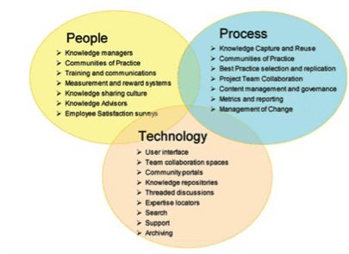
(Source: The Knowledge Network) 05/07/20

REFERENCES
[Online] Available From: https://www.tescoplc.com [Accessed 15/08/20
[Online]Available From: https://www.emarketer.com [Accessed 20 /08/20]
[Online]Available From: https://www.academia.edu [Accessed 04/06/20]

