Using a Research Approach in Human Resources

Report Title: The retention of on-call firefighters in Mid and West Wales Fire and Rescue Service.

Name: Nicola Westcott
Student Number: 1909408
CIPD Membership Number: 55478551

Word count: 2423 words

By signing below, I confirm that the work/evidence presented is my own, unaided work. I understand the regulations pertaining to candidate malpractice and the action that may be taken as a result.

Signed: N Westcott
Date: 28/06/2020




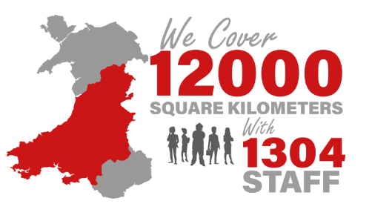

Executive summary
This report is critically analysing the retention of on-call firefighters within Mid and West Wales Fire and Rescue Service (MAWWFRS). Data was collected from 30 exit interviews conducted over the last two years to understand what has led to the individual leaving the Service.

A survey was also issued to the top 10 On-Call stations that had been identified as performing consistently well in terms of appliance availability over the last 4 years. Looking at what motivates individuals to keep the appliance on the run and identifies some key drivers and challenges are behind maintaining appliance availability.

The responses and ratings from both the exit interviews and the survey were analysed within the sections of this report.

The results of the survey showed that the motivators for staff lie in the intrinsic rewards of community spirit, pride and respect, with very few staff motivated by money alone. Key factors behind 100% stations are good leadership, effective communication and positive working relationships, evident in the high level of dedication and flexibility by staff who were willing to help each other out and make sacrifices for the availability of the appliance.

The factors which were demotivating, or challenging included, the recruitment process, a lack of calls and a lack of recognition by the Service for the achievement of 100% availability.

The results of the exit interviews (EI’s) showed that the main reason that the majority of those that left the service was the high levels of commitment required to meet the 75% or 100% contractual requirement. The contracts did not allow for much flexibility and many struggled to maintain a healthy work-life balance. The second reason was difficulties with primary employment or managing a self-employed business alongside. The third reason was pay, with many noting that the time commitment involved was not replicated in the remuneration received.

The report finds that developing various retention strategies will support stations in the retention of on-call employees such as, revising the structure of on-call contracts, reviewing the recruitment process, acknowledge the commitment provided. These measures may assist in increasing the retention of employees, thus maintaining 100% availability. The Service needs to introduce ways of fostering a similar culture and communications style across the Service.

Content Page
- Introduction (terms of reference) 6

- Literature Review 7
2.1 Retention and Turnover 7-8
2.2 Retention and Turnover of On-Call Firefighters 8-10
2.3 Summary of Literature Review 10

- Methodology 11
- Results and Findings 12
4.1 Contracts 12
4.2 Salary 12
4.3 Primary Employment 12
4.4 Recruitment 13
4.5 Expectations 13
4.6 Promotion Prospects 13
4.7 Results figures 14-17

- Conclusion 18

- Recommendations 19
- Referencing 20-21

- Appendices 22-34

List of Tables
Table 1: National Joint Council for Local Authority Fire and Rescue Services Pay Settlement 2019
Table 2: Top 10 On-call station participants
List of Figures
Figure 1: Figure 1 Adapted from: Griffeth, R. and Hom, P. (2001) Retaining Valued Employees
Figure 2: Figure 2 Adapted from: Thewlis, M. (2011) A survey of Retained Duty System personnel
Figure 3: On-call availability
Figure 4: Main reason noted for leaving
Figure 5: Other reasons noted for leaving
Figure 6: Individual motivator
Figure 7: Real reason for leaving
Figure 8: Relationship between length of service/retention
Figure 9: Recruitment process/retention
Figure 10: Primary employment/retention

Appendices
Appendix 1: Survey
Appendix 2: Exit Interview Form
Appendix 3: Average Inclusive Salary based on Contract Variarion

1. Introduction (terms of reference)

MAWWFRS is the third largest Service in the UK, with a vision to be a world leader in Emergency Response and Community Safety.

A major issue the Service faces is the retention of on-call firefighters (turnover approx.13.72% per annum). MAWWFRS currently have 58 stations, (52 of which are on-call stations), 86% of MAWWFRS frontline fire appliances are crewed by on-call personnel and 74% of stations utilise on-call staff.

The dysfunctional turnover of these valued employees places a huge financial strain on the Service’s budget, when considering the high initial training costs/provision of PPE and the negative effects on remaining employees.

Taking a pro-active approach to the turnover, would assist in streamlining/improving frontline service delivery. Ensuring the role of an on-call firefighter is easier to manage alongside the demands of primary employment maintains a healthy work-life balance. Thus, benefiting not only the employee, but a range of stakeholders including their primary employers, the communities they serve, MAWWFRS management and the Fire Authority who are responsible for the overall budget of the Service.
Aims
The aim of this research is to critically analyse trends to identify why there is such a high turnover rate of on-call employees.

Objectives
The objectives are:

- to identify and critically analyse the factors specifically affecting the retention of on-call firefighters.
- to critically analyse the strategies that positively influence the retention of on-call firefighters
- to identify and analyse the factors specifically influencing retention of on-call firefighters at MAWWFRS
- to make recommendations for a retention strategy for possible implementation at MAWWFRS

2. Literature Review

2.1 Retention and turnover

‘Employee retention relates to the extent to which an employer retains their employees over a set time, employee turnover refers to the proportion of employees who leave an organisation over a set period of time’ (CIPD, 2019). Both are shown as a percentage of total workforce numbers. The CIPD believes that turnover can have a negative impact on an organisations performance and employers need to monitor and understand this turnover to recognise how it can affect performance (CIPD, 2019).

This impact depends on the type of market the organisation is in. If recruitment and training is relatively cheap, high levels of service can be maintained, however where the opposite is the case or employees require specialist skills or if the time taken to fill a vacancy is lengthy, turnover can start to become problematic leading to a negative effect on the organisation (CIPD, 2019). This negative effect falls under the term ‘dysfunctional turnover’ (Wilkinson and Taylor, 2016).
According to Griffeth & Hom (2001), the following are some of factors that affect turnover that employers need to consider:

Breaches in the psychological contract ‘individuals’ expectations, beliefs, ambition and obligations, as perceived by the employer and worker’ (CIPD, 2020) are also relevant to turnover. Misleading messages during recruitment could cause people to accept jobs for which they are unsuited (Wilkinson and Talyor, 2016).
Employers should investigate the reasons behind turnover to highlight any issues within the workforce. These should be addressed in order to create a positive working environment for their employees (CIPD, 2019).
Exit interviews is one approach used to ask about the reasons for leaving and should be conducted by someone who is not the manager of the employee. Alternatively, surveys for current employees or those about to leave, are also a way of collecting data and will help identify retention issues (CIPD, 2019).
2.2 Retention and turnover of On-call Firefighters
‘An on-call firefighter is someone who responds to a range of fire and rescue service jobs, these range from emergency calls, working at open days, carrying out work with their local communities and acting as an ambassador for the fire service. (National Fire Chief Council, 2020).
On-call firefighters provide a vital and irreplaceable function for the public in both rural and urban parts of the country. The on-call work pattern is the most widely used pattern of work (FBU, 2004). A shortfall of on-call employees means an effective level of fire cover cannot be maintained, thus leading to the pump being ‘off the run’ as it is unable to mobilise without the minimum crewing levels, placing the public at an increased risk.
FBU MAWWFRS secretary Barrie Davies said ‘The system that we are currently working with was designed in the 1940s. Unfortunately, society has moved on, but the system hasn't’ (BBC, 2012). ‘The FBU believe that it's ‘the low level of wages which is causing on-call firefighters to leave the profession. Every year, between 80 and 100 leave, as fast as they can train them up, they are leaving in their droves’ (BBC, 2012).
The time commitment required to be an on-call firefighter is substantial, a survey undertaken on on-call employment (Thewlis, 2011) found:

Remuneration for on-call employee’s contracts are based on the number of hours cover provided (NJC, 2009):

The Thomas Review (2015), suggested that Services move away from these contracts in order to allow individuals more flexibility. Thewlis, (2011) found that 50% of employees that had left, had struggled with work-life balance due to the hours of cover required. A reduction in the level of cover may have influenced their decision to remain.
Knight (2013), suggested an increase in flexibility could not only assist in retaining current employees but also assist in the recruitment of new employees thus leading to overall savings.
‘The fire service has experienced a prolonged period of budget cuts’ (FBU, 2015). An increase in remuneration may tempt employees to remain with the service. Several reviews suggest an assessment of on-call payment needs to take place (Bains, Lyons & Young, 2002; Government Response to the Select Committee Report, March 2004, cited in the RRT, (2005) and Thomas Review, (2015). On-call employees receive a basic on-call salary and then receive payment for each incident attended.
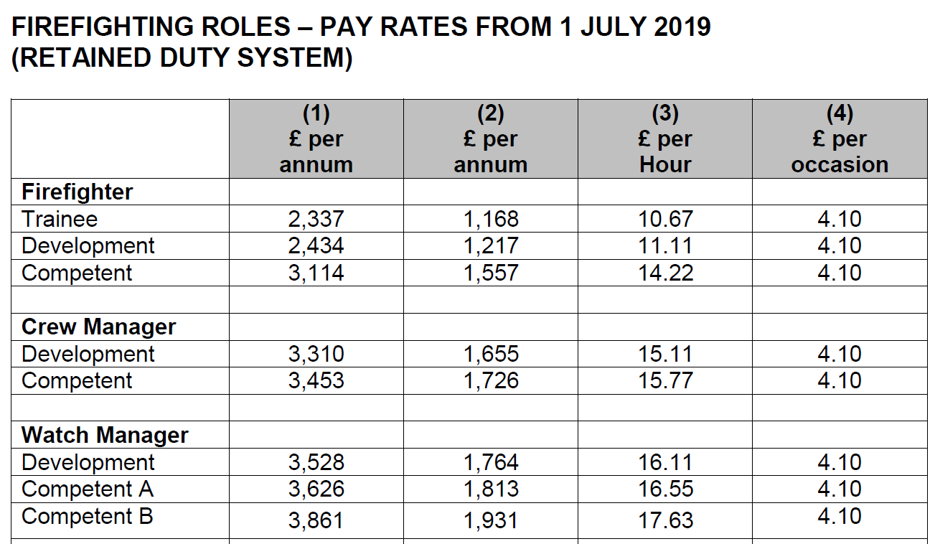
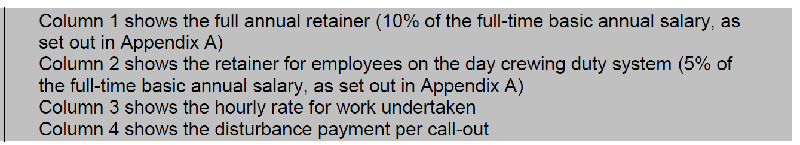
However, research suggests that the level of commitment required for the role is a more influential factor as to why turnover is high, in comparison to pay. Although an increase in pay encourages individuals to remain for longer, ultimately the reasons are linked to the availability and commitment. A survey undertaken by the RFU (2017), also indicated that work-life balance is a key factor in the retention of on-call employees.
On-call employees work elsewhere for their primary employment and are released to respond to calls however, there seems to be little recognition or information provided to these primary employers (Thewlis, 2011). There seems to be no co-ordinated approach to engaging with primary employers (RRT, 2005).

An important factor in the retention of on-call employees is the reliance of primary employers to release individuals. However, a survey by the FBU (FBU, cited in Department for Communities and Local Government, 2006) found that 78% of primary employers are reluctant to release individuals as they say they have not benefitted by doing this.

On-call employees have a variety of skills such as health and safety and medical response training, as well as developing situational awareness, leadership skills and the ability to work under pressure, employers having on-call firefighters within their business can bring advantages (NFCC, 2020).

2.3. Summary of literature review
In conclusion after studying the literature/surveys that have been undertaken over many years, there are many factors that influence turnover; however, a theme seems to exist covering the three main areas listed below:

MAWWFRS require analysis of their own data in order to understand and put measures in place to increase retention.

3. Methodology

The research methods used are data gathered from exit interviews and data from a survey of the top 10 consistently best performing On Call Stations.
The research approach is interpretivist, as it will be understanding the meaning and human interactions of processes within the organisation (Anderson, 2013), rather than positivists which would be collecting facts and drawing generalist conclusions. The data will be qualitative as it will be gathered from employee’s opinions, words and meanings (Bryman and Bell, 2015) from the exit interviews and surveys. Qualitative data can help HR professionals understand why certain things happen in an organisation (Anderson, 2013).

Exit interviews are about listening and understanding what the interviewee is saying (Horn, 2012). Interviews allow the researchers to dig into specific details, opinions and views. Advantages are that a wealth of information can be achieved but disadvantages are the amount of time to organise, administer and analyse the data gathered.

A survey is when the researcher details specific questions for which the respondents provide answers (Bryman and Bell, 2015). Whilst the data gathered from surveys can be useful, there can also drawbacks such as being unable to prompt for more information, difficult to ask complex questions, response rates could be low or respondent may not answer the question (Perkins and Woodhams, 2016).

Surveys (Appendix 1) were issued to 10 on-call stations and the supervisory officers of those stations. 14 responses were received.
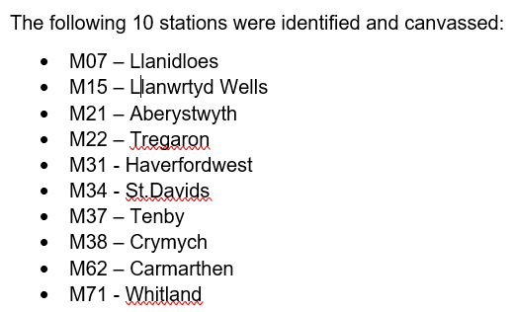

Participants were chosen from the 30 exit interviews that had taken place over the period Jan 2018 to Dec 2019 (Appendix 2).

Data from both the surveys and exit interviews was analysed to identify any trends.

4. Findings/Discussion

4.1. Contracts
The structure of on-call contracts was the main reason identified as to why employees were leaving the Service. This was also highlighted in the surveys as the main reason. The commitment required to meet the hours is challenging and placed a strain on work-life balance, as well as coping with primary employment or being self-employed. Many mentioned the introduction of 50% on-call contracts may assist with a work-life balance.
Another suggestion was to introduce a rota or shifts for the on-call, like the wholetime pattern. Employees would have designated availability hours in a fixed pattern and could plan easier. This would also ensure fairness to all to gain experience. It was noted that those not adhering to their contracted ours were not managed effectively which led to demotivation among those that adhered
4.2. Salary
The survey identified that pay was an issue with retention although the EI’s noted that pay was a factor but wasn’t the main issue, however a more guaranteed regular income may assist as it could be taken considered with mortgage applications. Some noted that an inclusive salary, such as that introduced in South Wales Fire and Rescue maybe more representative of the hours required. The removal of the long service bounty payment in 2007 was also mentioned, which awarded employees who reached 5,10,15,20 years-service. Some would like to see this re-introduced as an incentive to remain with the Service. However, it was also noted that most are not in it for the money but provide a service to the community.

4.3. Primary Employment

Many mentioned that their on-call contracts led to issues being released from their primary employers. Employers considered it detrimental to their businesses employing an on-call firefighter, when taking into account the time away to attend calls/time off when attending courses. From the on-call firefighter point of view within the first 24 months of service there is approx. 5 weeks-worth of full-time courses to attend, exhausting their annual leave entitlement from their main employer or taking unpaid leave.
Those that are self-employed mentioned it ‘doesn’t pay to drop your tools and respond to a call to be paid less’. It was generally thought that more could be done by the Service to support and thank local employers for releasing staff, such as re-introducing the acknowledgment letters that MWWFRS issued to primary employers as a thank you for releasing staff and other incentives such as business fire safety advice/training. EI’s mentioned promotions within their primary employment meant they were no longer able to commit to the Service.

4.4. Recruitment

Survey results showed the view that from the initial expression of interest, to a recruit starting training was considered far too long. It was felt that this lengthy process led to potential recruits losing interest. Some stations felt that they would prefer more local control of recruitment. It was felt that the strongest retention often came by word of mouth around the local community. Many mentioned that it should ‘go back to old school where the applicant attends the station for a few weeks to see the role rather relying on the interview process and using the corporate banding process instead of modern skill set requirements’. Others mentioned systems are not in place to cater for change of circumstances.
4.5. Expectations
An increase in fire prevention has led to a reduction in firecalls across the service, leading to a change on the role of firefighters. Partnership working with the Welsh Ambulance Service is becoming more common with co-responder contracts, especially in the more rural areas. Many stated that the role is not what they expected as a firefighter. Several of the stations surveyed responded that staff had ‘joined to ride the pump’. Others stated that they also did not realise how much administration work would be involved in the role. The service has introduced taster days however, these are practical days and do not reflect the administration required.
4.6. Promotion Prospects
Several current on-call individuals mentioned there seemed to be an inequality between on-call/wholetime employees when it came to promotions within the Service. This point was also noted from the exit interviews where some individuals stated they were not offered the same courses as wholetime, placing them at a disadvantage. It was mentioned in the EI’s that there were inconsistencies across the different command areas in on-call moving across to wholetime roles. This could be due to a communication issue or lack of experience of line managers.

However, others noted that on-call employees were required to undertake too much training, and this caused issues with primary employment due to the need to take annual leave or unpaid leave at specific times.

4.7 Results Figures

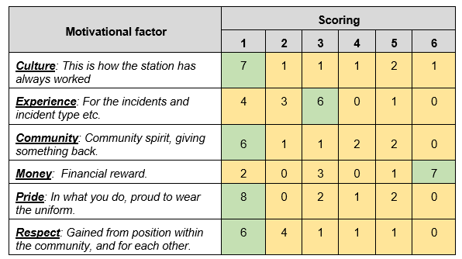

5. Conclusions

Analysing the data gathered from the survey’s/EI’s/literature, most retention issues can be linked back to appliance availability, only achievable if employees can meet their contractual requirements. When employees respond to more calls, this increases experience, competence, motivation and pay.

The motivators for on-call staff lie in the intrinsic rewards of community spirit, pride and respect, generating a high level of commitment to the organisation/community. with very few staff motivated by money alone.
All the stations involved shared the same culture where availability was the priority and effective communication/leadership and positive working relationships were seen as key, evident in the high level of dedication and flexibility by staff who were willing to help each other out, leading to increased retention.
The factors which were seen as demotivating, or challenging in both the EI’s and surveys included, the recruitment process, lack of calls and a lack of recognition. Breaches in the psychological contract resulting from unrealistic expectations often led to retention issues.

Retention strategies need to be introduced to both support on-call stations. The recommendations below identify some areas, which are a ‘step in the right direction’ in terms of removing some of the barriers to availability, recognising good performance and adopting best practice.

6. Recommendations for change
- Contracts – re-structure on-call contracts (50% on-call availability, a more inclusive fixed salary) (Appendix 3).
- Reward and recognition – introduce an acknowledgement payment (similar to old bounty scheme).
- Recruitment - review recruitment process to identify opportunities to involve on-call staff at a local level.
- Realistic expectations - better description of role throughout recruitment.
- Leadership/culture/communications – ensure line manager have the appropriate training and a clear/consistent approach is taken in communications across the service.

Limitations

Not all on-call undertake exit interview for a variety of reasons, therefore there is a loss of potentially valuable information. It also requires those that do partake to provide honest answers.

References

Anderson, V. (2013) Researching Methods in Human Resource Management. 3rd ed. London: Chartered Institute of Personnel and Development.

Bains, G. and Lyons, M. and Young, A., 2002, ‘The Future of the Fire Service: reducing risk, saving lives’ The Independent Review of the Fire Service’. Available at: http://216.129.209.54/files/FutureoftheFireServiceReport.pdf (Accessed 10 Jun 2020).

BBC (2012) Wales firefighters: On-call crew numbers 'lowest since 2004' 28 Nov 2012, [Online article]. Available at: https://www.bbc.co.uk/news/uk-wales-20515419 (Accessed 10 June 2020).

Bryman, A. and Bell, E (2015) Business Research Methods. 4th ed. Oxford: Oxford University Press.
CIPD 2019 Employee retention and turnover [Factsheet] 23 Jul 2019. Available at: https://www.cipd.co.uk/knowledge/strategy/resourcing/turnover-retention-factsheet (Accessed 15 June 2020).

CIPD 2020 The psychological contract [Factsheet] 26 Feb 2020. Available at https://www.cipd.co.uk/knowledge/fundamentals/relations/employees/psychological-factsheet (Accessed 20 Jun 2020).

FBU (2004) Off the Run: Recruitment and Retention of Retained Firefighters [Report] Sept 2004. Available at: https://www.fbu.org.uk/publication/run-recruitment-and-retention-retained-firefighters (Accessed 15 June 2020).

Department for Communities and Local Government, 2006, ‘The Primary Employment Status of Retained Duty System Firefighters’. Crown Copyright 2006.
FBU (2015) The future of the fire and rescue service. Available at: https://www.fbu.org.uk/policy/2015/future-fire-and-rescue-service (Accessed 10 Jun 2020).

GOV.UK (2009) On-call firefighters; fire and rescue toolkit. Available at: https://www.gov.uk/government/publications/on-call-firefighters-fire-and-rescue-service-toolkit (Accessed 20 Jun 2020).

Griffeth, R.W., and Hom, P.W. (2001) Retaining valued employees. Thousand Oaks, California, Sage.
Horn, Roy. (2012) Researching and Writing Dissertations: A Complete Guide for Business and Management Students. 2nd ed. London: Chartered Institute of Personnel and Development.
Knight, K, 2013 ‘Facing the Future: Findings from the review of efficiencies and operations in fire and rescue authorities in England’. Available at: https://www.gov.uk/government/publications/facing-the-future (Accessed 5 June 2020).
Mid & West Wales Fire and Rescue Service Website. Available at: https://www.mawwfire.gov.uk/eng/about-us/our-plans-and-performance/
National Fire Chiefs Council (NFCC) (2020) Website. Available at: https://www.nationalfirechiefs.org.uk/On-call-firefighters Accessed (10 June 2020).

NJC (2009) Scheme of Conditions of Service Sixth Edition 2004 (updated 2009). Available at: https://www.fbu.org.uk/publication/grey-book (Accessed 1 Jun 2020).

Perkins, G. and Woodhams, C. (2016) ‘Using Information Human Resources’, in Taylor, S. and Woodhams, C. (ed) Studying Human Resource Management. 2nd ed. London: Chartered Institute of Personnel and Development.
Retained Review Team (RRT) on behalf of Office of the Deputy Prime Minister: London, 2005, ‘The Fire and Rescue Service Retained Duty System - A Review of the Recruitment and Retention Challenges’ Queen’s Printer and Controller of Her Majesty’s Stationery Office 2005.

RFU (2017) Recruitment and Retention of Retained Firefighters [Survey] Available at: https://www.frsa.org.uk/wp-content/uploads/2017/11/Report-2017.pdf (Accessed 20 Jun 2020).

Thewlis, M. 2011, ‘A survey of Retained Duty System personnel, former Retained Duty System staff and Fire and Rescue Service Managers’ Fire Research Report 4/2011. Employment, Research and Consulting, Department for Communities and Local Government
Thomas Review, (2015) Independent review of conditions of service for fire and rescue staff in England February 2015. Available at: https://www.gov.uk/government/publications/conditions-of-service-for-fire-and-rescue-staff-independent-review (Accessed 10 Jun 2020).
Wilkinson, K. and Taylor, S. (2016) ‘Resourcing and Talent Planning’, in Taylor, S. and Woodhams, C. (ed) Human Resource Management: People and Organisations. 2nd ed. London: Chartered Institute of Personnel and Development.

Appendices

Appendix 1
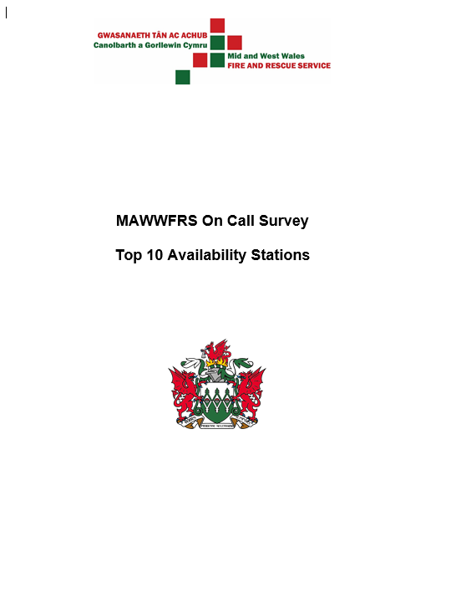

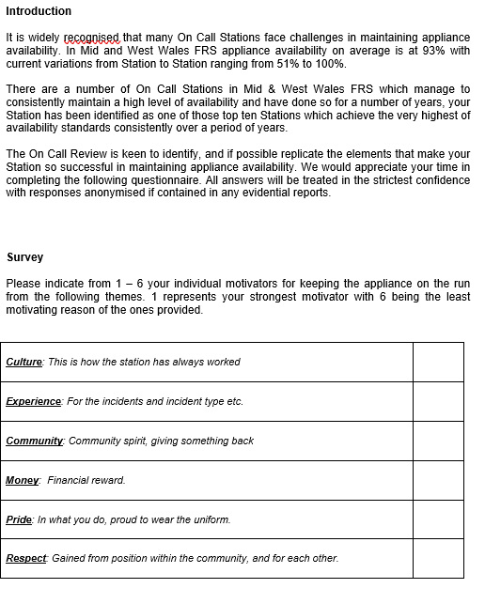

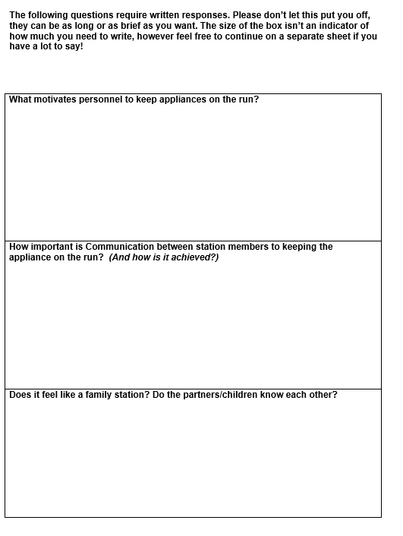
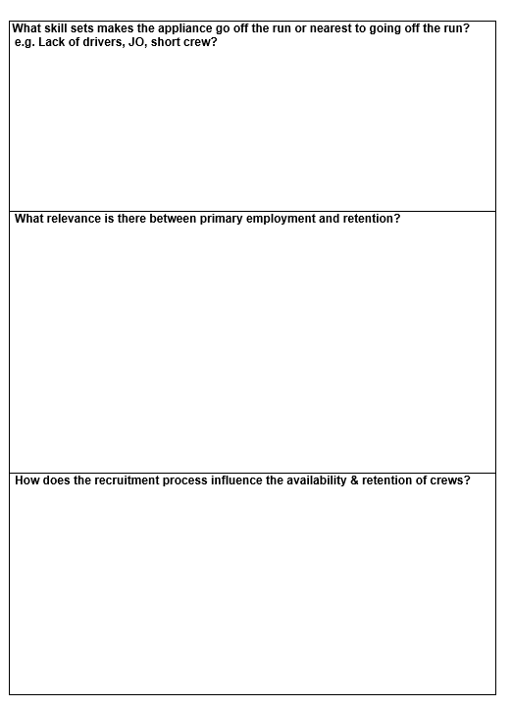

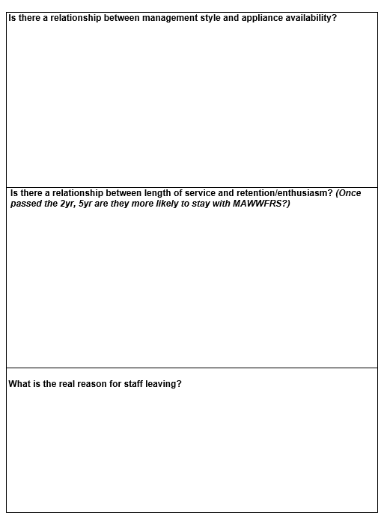



Appendix 2

Appendix 3



