Report about
Virtual learning Environment 

Ivan Celdran Dominguez: 1914237

Digital Skills and Research Methods.
(BMSW4003_LON)

Lecturer: Terry Walcott.

Table of content:

- Abstract…………………………………….Page-1.
- Introduction……………………………...Page-1.
- E-learning…………………………………page-2/3.
- Benefits of E-learning……………….Page-3/4.
- Disadvantages of E-learning…….Page-4/5.
- The impact of the E-learning in today’s world………………………………………..Page-5/6.
- Questionnaire Results………………Page-6-

Abstract
In this report I will discuss virtual learning, also called “E-learning”, and various aspects such as advantages and disadvantages. I will review as well a questionnaire that I made to my classmates regarding the E-learning experience that they had and I will discuss the results.

Introduction

In this century, the information changes constantly and quicker every day, and the need for learning and adapting to this information has made that implementing the new technologies is mandatory to be able to keep track and adapting to it. E-learning is the way that many people is using to learn and study due to the versatility that this method provides, otherwise it won’t be possible to collate their jobs and their life and study at the same time. The fact of having the possibility of learning from anywhere gives the chance of accessing much information, courses, and careers.

The intellectual capital has become an important asset for the organizations and the administration of this a very important activity (Facundo 2013). In relation to this new information and the need of adapting to these needs, social media and the new technologies make possible access to sources of information, impossible to get in old times, from many different and far places (Garcia 1993). Some of these technologies are Computing, a science that manages methods, techniques, and processes in order to store, process, and transmit information and data in digital format and Telematics refers to the combination of information technology and communication technology for sending and receiving data.

E-learning

The definition of “E-learning” is the abbreviation of “Electronic Learning”, which means the process of learning online through internet and the technology.

Nowadays Internet allows to access a formation of any organization of the world whenever we want.
So, the 2 principal benefits of the “E-learning” are:
- The elimination of the physical and temporal barriers, it means, time and place are no longer a problem to access to information.
- And the lifelong learning and adapted to our personal needs.

The triangle of e-leaning theory (Lozano 2002) says that any project of e-learning must have these 3 fundamental pillars, which are interconnected to each other and that one without the other, the learning process won’t have any sense, the student as a centerpiece.

- Technology
Virtual learning platform which are called LMS (Learning Management System). Where the course takes place, the information is transmitted and the communication between the teacher and the students happens.
There are a many types of LMS:
–LMS of proprietary software (Blackboard, E-ducativa, Edmodo, etc).
–Custom designed LMS for a specific company or organization.
–LMS of open source like the most known “Moodle” and there are others like Chamilo or Claroline.

- Content
There are various formats such as: video, pictures, pdf, word, podcast also sources like videoconference, chats, webinar, etc., but the important part is all the content must have behind a pedagogical treatment to ensure to accomplish all the learning objectives for the e-learning.

- Teaching action
The action of the online tutor must be carried out in three areas: content and activity planning, student orientation and knowledge dynamizer. Their role goes from being a transmitter of knowledge to a facilitator of learning.

Benefits of E-learning

So, after all this explanation of e-learning, here are some of the benefits over the traditional way of learning (face-to-face).

- There are no more barriers space time.
- Flexibility and adaptability with the circumstances of the student.
- Real administration of the knowledge.
- A better and more personalized interaction between tutor-student.
- Quick.
- Lower costs.
- Most updated information/content.
- Easier access to the communication between parts.
- More independent learning.

Still there are some people that don’t want to change and adapt to this new way of learning claiming that prefer the face-to-face due to the fact they like to have physical contact with people, but the truth is that the advantages that the e-learning provides makes it better over the face-to-face.

The e-learning has given a chance to many people without resources being more accessible to learn and by consequence helping them to get out of that situation.

Actually, nowadays when doing this report there is a global pandemic and thanks to the technology and the e-learning, everyone can keep studying their careers, high school, etc.

Disadvantages of E-learning

Obviously not everything is good about the virtual learning, there are also things that can be seen as disadvantages in relation with e-learning and here I am going to show you some examples.

- In some places the access to the technology can be difficult.
- The high investment in the equipment such as hardware (pc, phone, tablet, internet, etc.)
- There is little or no human interaction and can be cold and impersonal in some situations, and for the ones that like to have a human contact can be more difficult.
- Some tutors are not updated to the new technologies.
- The content for e-learning can be more difficult and the information must be constantly updated and that requires more work from the tutors.
- It requires more discipline and personal work from the student due to the study is more individual
- It also requires a big commitment from the student to readjust the time to adapt with all the activities.
- Bad communication. Even if the technology has improved a lot, still is not the same to have a conversation face-to-face than by chat, call or videocall.
- Technical issues can difficult the communication or the transmission of information, content, etc.

The Impact of E-learning in Today’s World

After analyzing all this information gathered, we can say that e-learning has generated a great positive impact in the world of learning, giving access to more information than ever before practically instantaneously.
This has covered practically all levels of education.

This has been possible thanks to technological advances that have managed to revolutionize the teaching / learning world, and have proposed new educational methods and how to present knowledge, for example, using audio-visual media and not only through texts and images.
It is true that where it has been most impacted is in the post-university field with specialized programs, Master's in Business Administration for executives and language studies.

Having the possibility of having any specialized information at your fingertips has changed the way of analyzing curricula, the learning structure of educational centers, educational methods and the processes to evaluate.
On the other hand, virtual learning has also generated negative impacts on teaching, since if it has streamlined the learning process, it has also lost the real contact between student and teacher and a greater effort by the teacher to adapt to the new system and in fact they must become experts on the technologies that are needed, and on the part of the student, it requires more effort and, that is not necessarily bad, it can be demotivating.

Questionnaire Results

Here is a questionnaire that I’ve made to my classmates and some other people from my surroundings.
With this questionnaire I try to gather some information in relation to virtual learning, their approach, if they have had any contact with the e-learning and with this, get a conclusion if e-learning can be something good for them or not.

1-Range of Age.
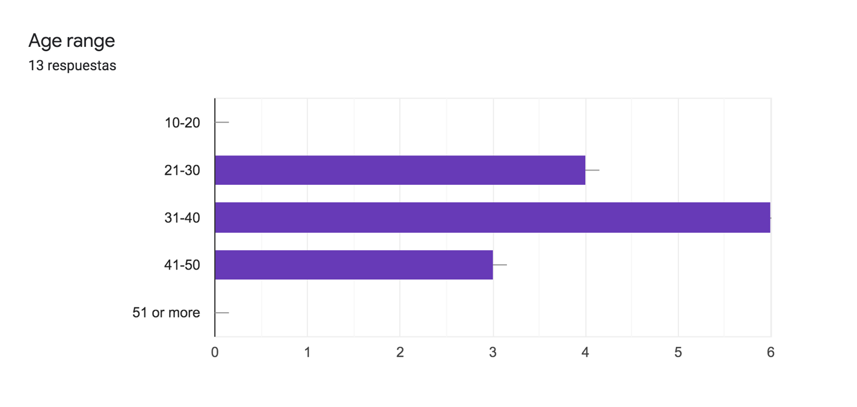
With this question we can see in what range of age the e-learning have more impact and we can see that most of the people doing the survey is in between 31 and 40.

2-Gender
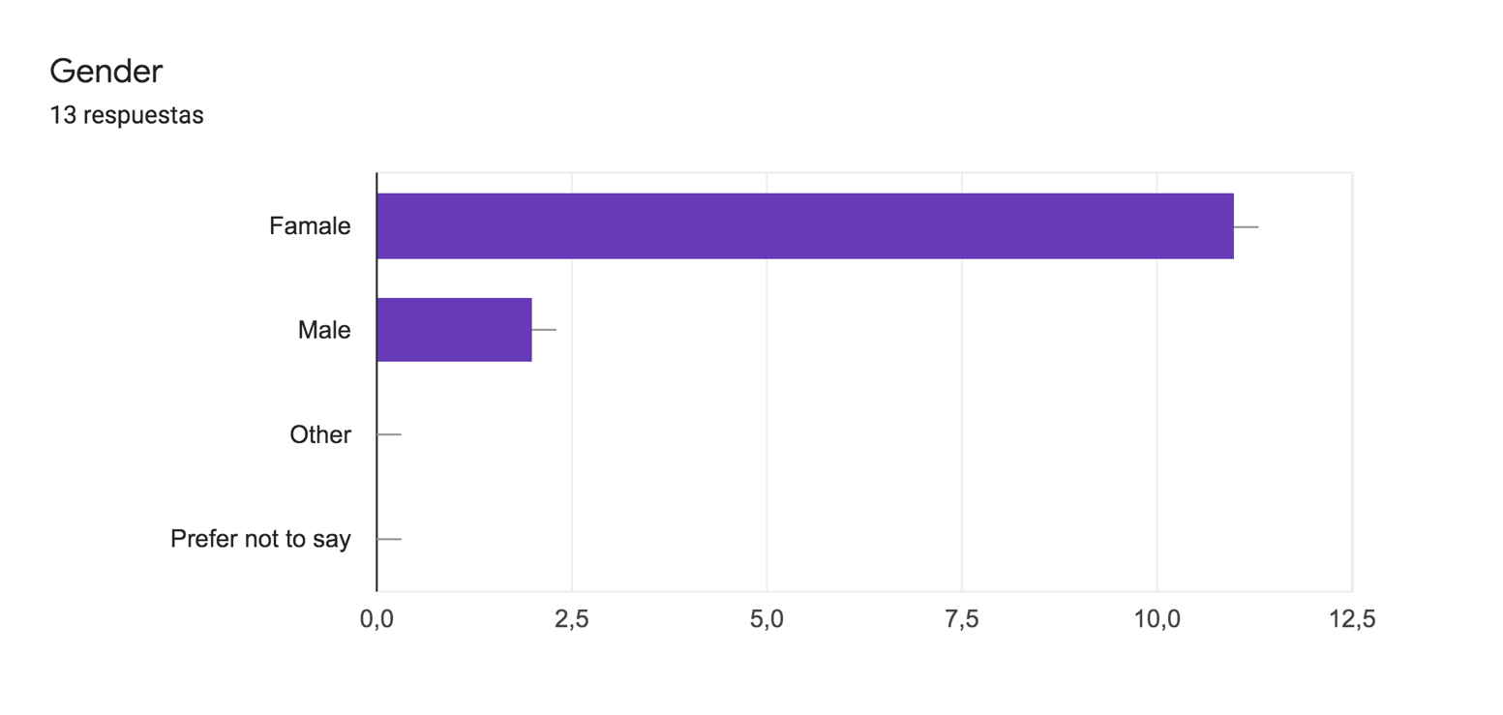
Over 13 answers we can see that 11 are females and 2 males. It means that the majority of the people that filled the survey were women.

3-Are you originally from the UK?
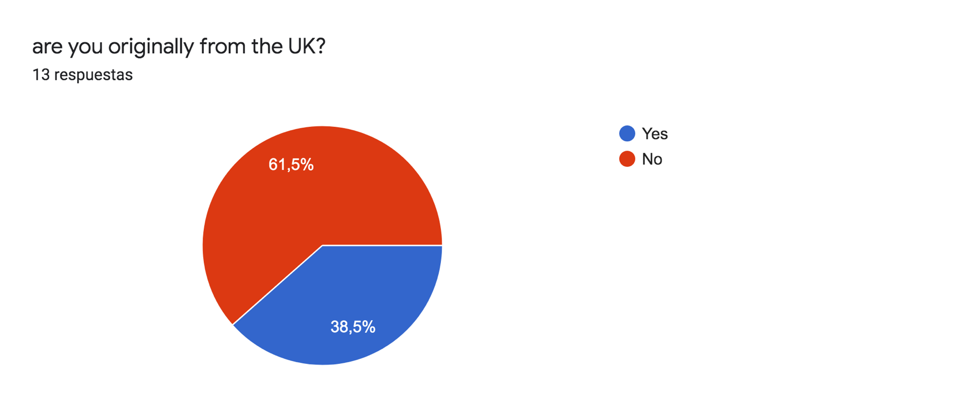
As we can see 61,5% of the people who filled the survey are not from the UK, taking into account that this course that we are doing is London.

4-How many online courses have you done?
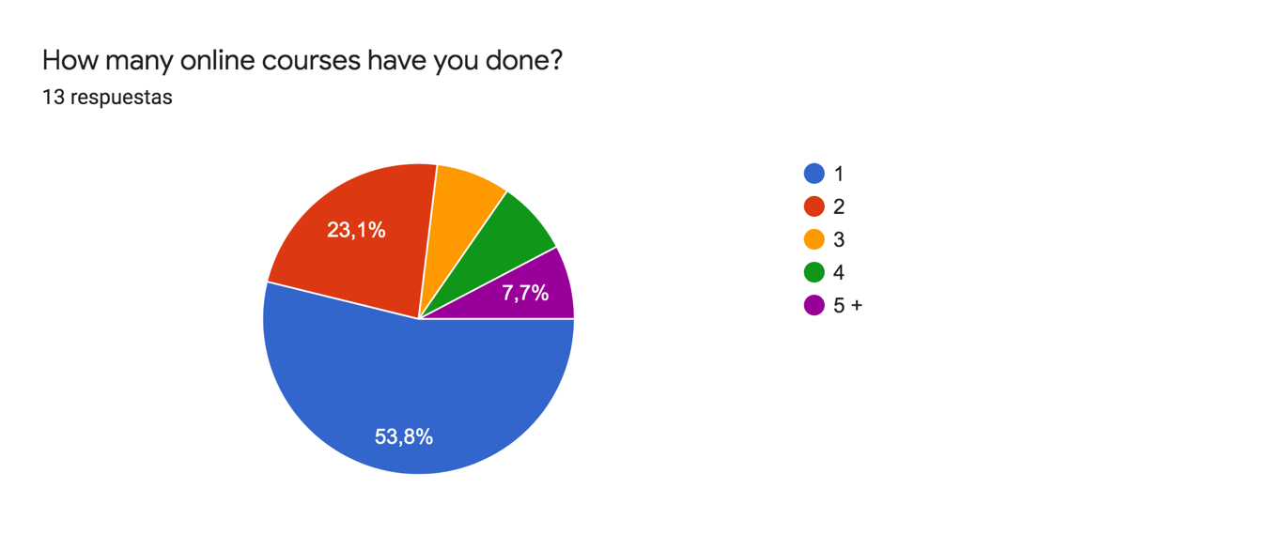

This question reveals that most of the people (7 out of 13) is the first time that they are doing an online course (e-learning) and only one has experience with virtual learning.

5-Do you find useful learning online?
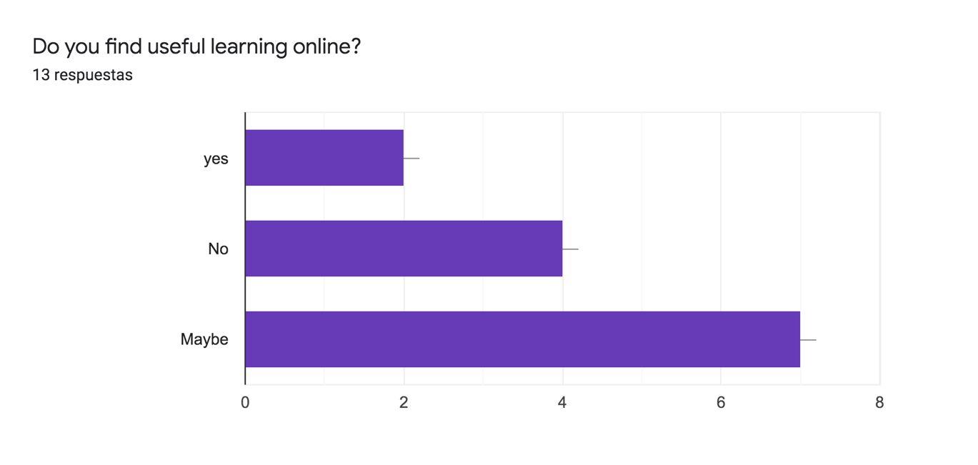

We see in this question that the same amount of people that is the first time doing an online course is confused about doing the classes online is useful or not and only 2 agree and surprisingly 4 say no about it.

6- Do you like having to take online courses?
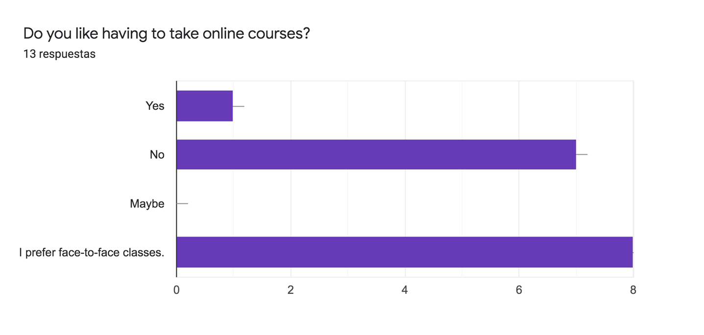
8 out of 13 people interviewed prefer to have face-to-face classes and we find that a few people of the ones that said no also said face-to-face, remarking with their disagreement about it, and only 1 person is happy and like to take online classes.

7- How is communication in online classes?
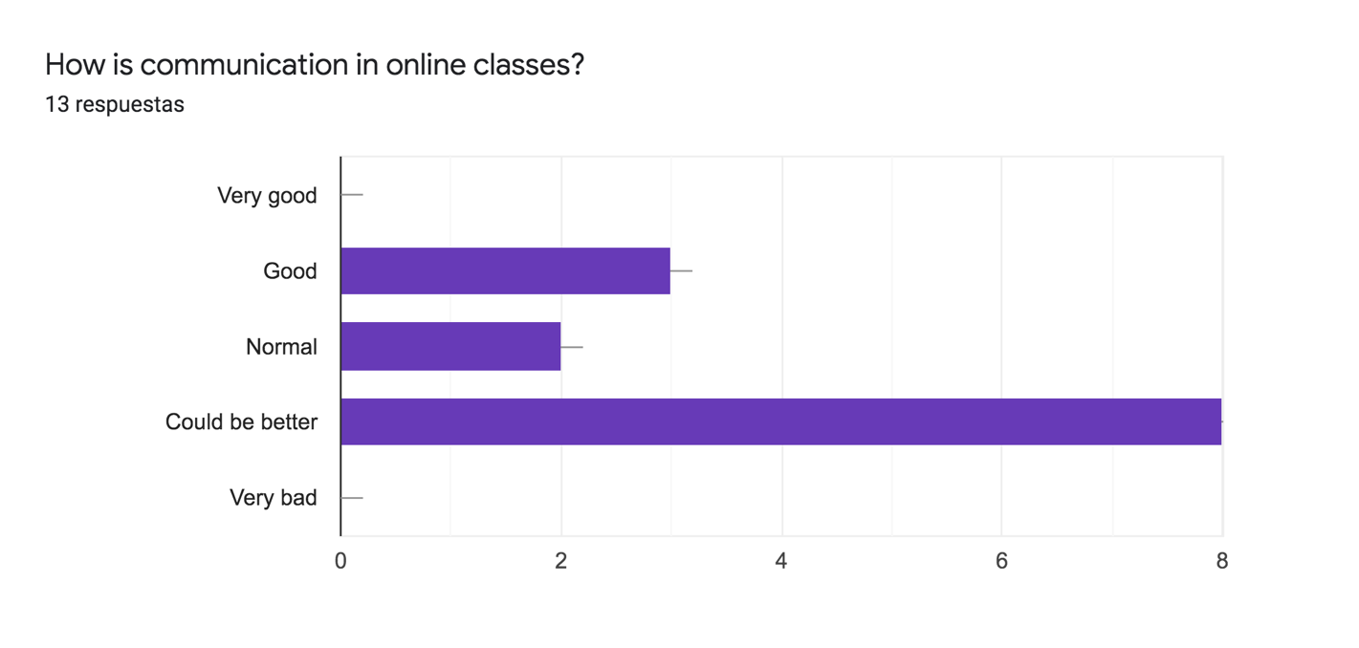
Here we can see one of the problems of the virtual learning, the communication cannot be good enough due to technical problems and impede the proper function and learning process. And here the answers show how 8 people (61.5% of the people) think that the communication could be better 2 say that is normal and 3 that is just good, when to ensure the learning of the students the communication should be very good.

8- How many hours do you spend a day on e-learning?

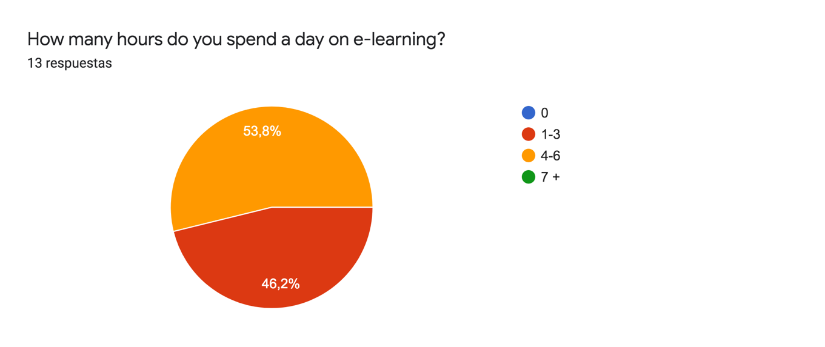
Roughly everyone invests between 1 and 6 hours a day in virtual learning, and 7 out of 13 invest up to 6 hours every day.
Here we can see that the virtual learning requires a lot of individual work in order to perform well.

9- Is it appealing for you the information given in the online courses?
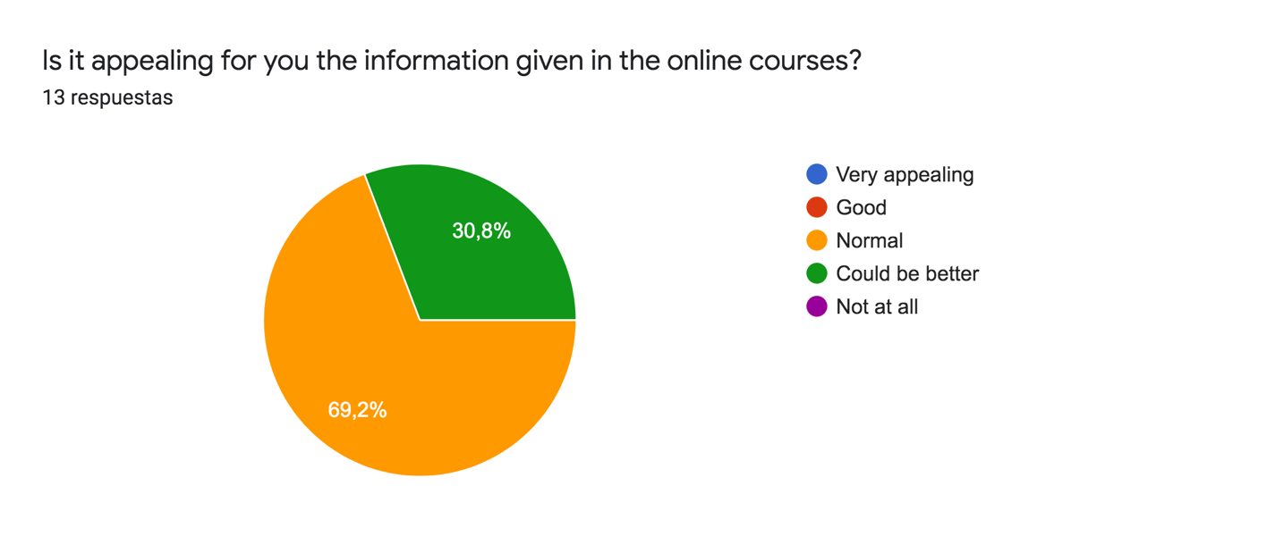
One important part to make sure you keep the attention of the students is to make the information appealing (eye-catching), otherwise the lessons can be very tiresome and that will difficult the learning for the students.

10- Would you recommend taking online classes?
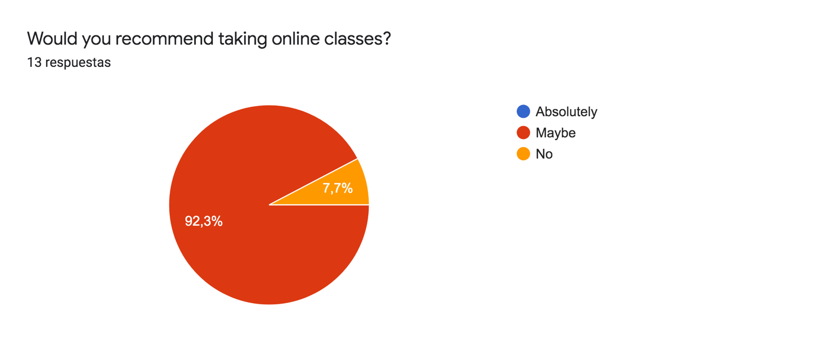
The last question reflect that the people is not sure if the e-learning can be a good option for them and then, they are not sure to recommend it to other people and one person says no straight away.

Conclusion
Finally, e-learning has broken many schemes and has allowed the development of education more in line with our current systems that involve the technologies of the 21st century. As a result, teachers will be much better trained to face the current world and train future generations. It also allows for individual and independent training, something very necessary at this time due to the speed at which information becomes obsolete. Yes, it is true that there are limitations but they will be able to be solved as we advance, and meanwhile, it is a great tool to combine with the traditional teaching method.

References

Sites.google.com. 2020. Impacto Del Aprendizaje Virtual En El Proceso Educativo - Aprendizaje Virtual. [online] Available at: <https://sites.google.com/site/fgtce0406tgi/-cual-ha-sido-el-impacto-que-en-la-actualidad-tiene-el-aprendizaje-virtual-en-el-proceso-educativo> [Accessed 30 August 2020].

Ganduxé, M., 2020. ¿Qué Es El E-Learning? - Elearning Actual. [online] eLearning Actual. Available at: <https://elearningactual.com/e-learning-significado/#Aportamos_las_siguientes_definiciones> [Accessed 28 August 2020].

Martínez Uribe, C. (2008) La educación a distancia: sus características y necesidad en la educación actual, Educación, 17(33). Disponible en: http://revistas.pucp.edu.pe/index.php/educacion/article/view/1532 (Accedido: 29agosto2020).

Moodle2.unid.edu.mx. 2020. [online] Available at: <https://moodle2.unid.edu.mx/dts_cursos_mdl/pos/ED/AV/AM/07/Entornos.pdf> [Accessed 29 August 2020].

Gairín Sallán, Joaquín y (2006), "Las comunidades virtuales de aprendizaje." EDUCAR, Vol. 37, núm. , pp.41-64 [Consultado: 28 de Agosto de 2020]. ISSN: 0211-819X. Disponible en : https://www.redalyc.org/articulo.oa?id=3421/342130826004

