The Global Business Environment

By

Zlatko Nalbanski

Banner ID : 2124047

Executive summary

The entire report suggests the overall global business environment of Audi. The reasons are explained on the basis of which the global marketing chain of the company is growing. The proper analysis can help to identify the external factors and the position of the company in the market. So the lesser the external risk factors greater will be the production. The macro-environmental factors can be reduced to some extent by using different kinds of global business chain theories along with using some models of global business development.

Table of Contents
1.0 Overview of the global business environment in the company 3
1.1 Introduction 3
1.2 Background of Audi 3
1.3 Overview of the global business environment and use of PESTEL analysis on Audi 3
1.4 The global business environment in automobile companies like Audi 5
2. Evaluation of related theories 5
2.1 The theories related to the global business environment 5
2.1.1 Mercantilism 5
2.1.2 Absolute advantage 6
2.1.3 Comparative advantage 6
2.1.4 Heckshir-Ohlin theory 6
2.1.5 Product life cycle theory 7
2.1.6 Global strategic rivalry theory 7
2.1.7 National competitive advantage theory 7
2.2 The concepts and models of the global business environment 7
2.2.1 Porter’s five forces 7
2.2.2 Porter’s diamond model 8
3.0 Value chain model 9
4.0 Conclusion 11

1.0 Overview of the global business environment in the company

1.1 Introduction
The global business environment is the relation of exogenous factors to the endogenous factors of any organization. This is a widely used business strategy for all the worldwide leading companies. The factors are of are mainly of two types- micro and macro, which can influence the atmosphere of working within a firm or an industry. Audi is taken in the study as a premium global automobile company. The report is mainly focused on the external factors which are mostly uncontrollable. The macro-environmental factors can be reduced to some extent by using different kinds of global business chain theories along with using some models of global business development.

1.2 Background of Audi
Audi is one of the leading companies selling premium cars globally. It has the largest chain of business worldwide. Audi is competing with the other companies because of its innovative ideas, human resources and upgraded technologies. This company deals with various difficulties with its competitors but still sustains itself in the global market exclusively for its brand value (Blunck, 2016). So the reasons for Audi’s sustainability in the global market can be elaborated on in the study.

1.3 Overview of the global business environment and use of PESTEL analysis on Audi
The global business is mainly divided into two environments- macro and micro. The macro-environment considers the internal factors like the company, consumers, customers, intermediates etc. whereas the micro-environment is mainly dependent upon the external factors like political, economic, social etc. which can be expressed in the form of PESTEL analysis (Brenner, 2018). The macro-environment comes with certain limitations but the micro-environment has no limitations. The micro-environment of a business can easily be controllable, on the other hand, the macro-environment is not controllable so far. The development of an organisation depends upon the process to overcome and adapt to the external environment as these are not in the control. The study of Pride et al. (2020), states The external environment can be controlled by the well-designed strategies taken by the organisation with a definite aim of resolving and reducing the level of external factors. Identification and determination of risks are the main things to resolve and controlling he external threats.
PESTEL analysis model describes the macro-environment of the company that is associated with the factors like political, economic, social, technological, environmental and legal. It is basically the collection of information about the internal and external factors related to the company. PESTEL analysis is a very handy tool to identify the threats and the risks. The position of the company and the competitors can be identified with this kind of analysis. The risk factors can be reduced by the use of this kind of analysis. As the external threats are not within the control and its limit cannot be judged so PESTEL analysis plays a pivotal role to reduce the problems.
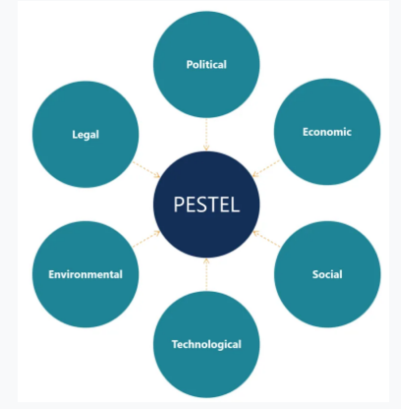
Figure 1.1 PESTEL analysis model
(Source by the researcher)
The PESTEL analysis of Audi has been done by assessing those external factors (Australia, 2017).
- Political- There are different political conditions in different countries. The selling of Audi cars was down in China and USA due to the trade war. Selling the European cars in the USA would be taxable, declared by USA in 2017.
- Economical- As Audi is a premium brand of car manufacturing company so it can be afforded by the economically stable countries. So declination in the global market can affect the marketing of Audi.
- Social- Each country has their own culture so their demand and needs are different. On the basis of this, the Audi is now available in China and India also. But the demand in China market is very much higher than in the Indian market.
- Technological- Technological excellence along with innovative ideas are the main technological things adopted by Audi. Upgraded technology is the main part to accelerate a business. Audi makes improved power delivery as well as improved fuel economy to a different level. Audi recently introduces a virtual cockpit that replaces dial with digital output. Widescreen navigation with google earth is introduced in the new technology.
- Environmental- Audi cars are very much eco-friendly with low emissions of toxic gases and they are making greener manufacturing companies in various places of the world (Team, 2022).
- Legal- As per the reports of Team (2022), 800 million euros have been fined Audi by the German law enforcement authorities to cheat on emission tests. This scandal affects Audi’s market in different countries.

1.4 The global business environment in automobile companies like Audi
The global automobile industries are characterised by production conducted primarily in different regions of the world. The majority of the production of parts, assembling, and cars sales happen mainly in integrated regions of different countries. In this report, Audi is taken for assessment. Audi is one of the most branded automobile companies in the world. It is a global marketing company. Though Audi has already marked itself as a worldwide brand the strategies to reduce the external factors are not changed (Jung and Park., 2017). So it is clear that the risk and threats of external factors vary with the business of the different companies with the size and type of their business.

2. Evaluation of related theories

2.1 The theories related to the global business environment
The global business environment is a mixture of internal and external factors which can affect the process of improvement of a growing business. These depend upon some exogenous factors that can be very hazardous for the organisation (Paik et al., 2015)). The risks can be reduced by using different theories related to the global business environment. There are different types of theories applied in the global business environment those are mercantilism, absolute advantage, comparative advantage, Heckshir-Ohlin theory, product life cycle theory, global strategic rivalry theory and last but not the least national competitive advantage theory.

2.1.1 Mercantilism
Mercantilism is the oldest theory of business which is nothing but the strength of the economy of every country depending on the amount of gold and silver they hold (Magnusson, 2015). The larger the amount larger will be the economic strength of the company. The idea of supporting the greater export and efforts that are promoted to minimize in the same theory. If the companies import the product at a high cost, it will be got from the exported product. It is a very old theory for the business environment.

2.1.2 Absolute advantage
This states the purpose of increasing the efficiencies of the same product from different countries. If both the products of two different countries are the same then the more efficient product will get the more importance and marketing.

2.1.3 Comparative advantage
It favours relative productivity with compare to the absolute advantage. It is the theory that can help to trade the products in different countries for boosting their business.
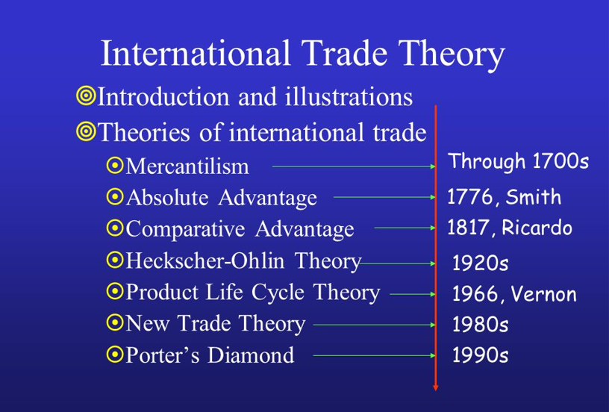
Figure 2.1 The theories related to the global business environment
(Source by the researcher)

2.1.4 Heckshir-Ohlin theory
This theory states the different prices on the difference in the supply and demand of the product (Ito et al. 2017). If the supply and the demand of the product met the target the price will fall and vice-versa.

2.1.5 Product life cycle theory
It is the theory of the product life cycle that states that if the demand for the product in the global market will increase there should be a chance to open local plants in the different small regions to grow the business widely.

2.1.6 Global strategic rivalry theory
This theory depicts about new firms have to optimize a few factors that will lead the brand to overcome all the barriers to establishing themselves in the global market (Lippert et al., 2020). This theory is applied in many multinational companies.

2.1.7 National competitive advantage theory
Innovational ideas and capacities help to grow a business globally and also determine the performance of the company in the global race.
The ideas can be taken from the above-mentioned theories by taking the key points of each theory. So in a highly competitive market, these theories can help Audi to maintain its global business environment by overcoming the risks and the threats.

2.2 The concepts and models of the global business environment
There are various kinds of models to analyse the global business environment to reduce external threats. The main tools are discussed as follows.

2.2.1 Porter’s five forces
Porter’s five forces model is an analysis gear that uses five different forces to determine the margin of profit of an industry that is very important for analysing an organisation’s competitive strategy (Mathooko and Ogutu, 2015). The five forces are industry rivalry, bargaining power of suppliers, bargaining power of threats, the threat of entry of the new product and threat of substitutes. For this kind of analysis, the strategists’ should identify the competition first and the position of the company in relation to the competitors in the market must be assessed. The threat of new entrants will be high if there exists low capital, no Govt. policy, identical products and low customer loyalty. The bargaining power of the suppliers depends on the availability of the raw materials which may depend upon the switching cost of the materials. The bargaining of the buyers will high when there will a minimum number of buyers, a low switching cost and a large quantity of the product. If the competitors are equal in size and the products can be easily differentiated from each other there is a high possibility of a threat of the substitutes.
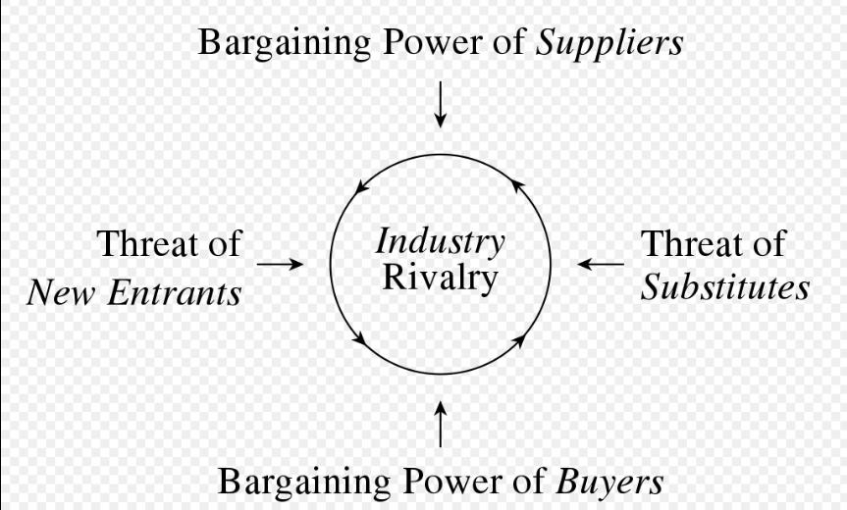
Figure 2.2 Porter’s five forces model
(Source by the researcher)
- The threat of substitutes-Audi belongs to one of the leading automobile industries, which has a huge initial capital. Audi is enriched with qualified resources, high equity value and marketing knowledge. So the threat of substitutes is very low.
- Threats of new entrants-Apart from this brand value, customer loyalty is very high for Audi, so there is almost no chance of the threat of new entrants. Product popularity and product image are the key factors to prevent the risk of substitutes.
- Bargaining power of the customers-The influencing factors such as high switching costs, brand equity, etc. can limit the bargaining power of customers.
- Bargaining power of the suppliers- A few large suppliers may have a chance of bargaining power against Audi, but the fact that the firm collects the raw materials from different suppliers counters this power of bargaining.
- Industry rivalry-Audi can battle against its rivals only for its daily innovative up-gradation. So the impact of this Porter’s five forces model on the market of Audi is very high which has been found from different studies and reports as mentioned above.

2.2.2 Porter’s diamond model
Porter’s Diamond is a diamond-shaped framework that concerns explaining the reasons for the competition between the companies within a particular country that competes internationally (Fang e al., 2018). This model depicts the factor conditions, structure and rivalry, organisation’s strategy, factor conditions, demand conditions and related and supporting companies. Depending on these conditions innovative ideas can influence the companies. The competitiveness which is resulting from this is helpful and even necessary from the international point of view to battle with the largest competitors. This model can be applied in the current study.
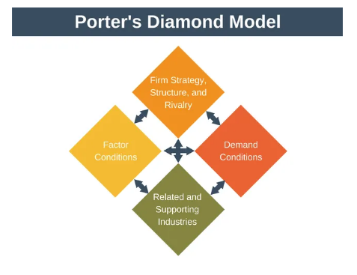

Figure 2.3 Porter’s diamond model
(Source by the researcher)
According to the report of Essay48 (2022), The behavioural patterns of the consumers are also important to predicting and anticipating the psychology and demands of consumers. Firms like Audi can also influence the behaviour of market-specific consumers which differentiates the company from others.

3.0 Value chain model
A value chain concept describes the full chain of activities of a business with respect to the creation of a product. The value chain framework consists of five basic activities- outbound logistics, marketing and sales, inbound operations, service and four secondary activities those are management of the human resources, technological development, procurement and purchasing, and infrastructure of the company. A value chain analysis can assess the dependencies, link with the other companies and other characteristics in the value chain. The value chain concept helps the organizations identify the business functions with respect to the primary and secondary activities (Troncoso et al., 2015). The organisations can easily analyse depending on both the primary and secondary activities which can manage the value chain associated with a stipulated time. It is the process implemented by the organisation to value its own activities.
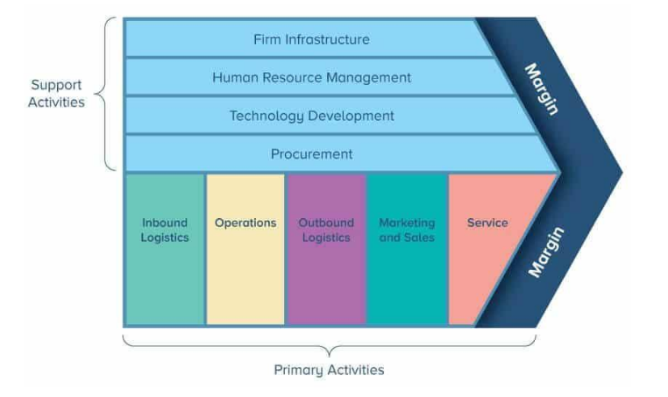

Figure 3.1 Value chain model
(Source by the researcher)

Porter’s value chain model is very much important for Audi,

Primary Activities | Secondary Activities
- Inbound logistics- Inbound logistics requires a great focus on the raw materials to the finished product which may face some difficulties. | - Firm infrastructure- Effective infrastructure of Audi can optimise the whole value chain along with firm structure for the competitive market.
- Operations- Both the manufacturing and service operations are very effective with respect to the productivity of Audi. | - Human resource management- Effective and trained HR is the main key to communication with the consumers.
- Outbound logistics- These are timely managed with maximum costs and the product delivery process put a minimum negative effect on quality. Its increases customer satisfaction. | - Technology development- Upgraded technology of Audi plays a great role in the global business.
- Marketing and Sales- Effective sales and marketing of the product with integrity enhances the marketing of Audi. | - Procurement- Audi may consider its procurement activity to optimize the whole value chain.
- Services- Pre and post selling services are important but the post selling services are very important for the customers.

4.0 Conclusion
The entire report suggests the overall global business environment of Audi. The reasons are explained on the basis of which the global marketing chain of the company is growing. The proper analysis can help to identify the external factors and the position of the company in the market. So the lesser the external risk factors greater will be the production.

Reference list
Australia, M.B., 2017. Change Process.
Blunck, E., 2016. Germany BMW's Sustainability Strategy of Evolution and Revolution Towards a Circular Economy. Towards a circular economy: corporate management and policy pathways. Economic Research Institute for ASEAN and East Asia (ERIA), Jakarta, pp.83-101.
Brenner, B., 2018. Transformative sustainable business models in the light of the digital imperative—A global business economics perspective. Sustainability, 10(12), p.4428.
Essay48. 2022. Porters Diamond Model of Audi. [online] Available at: <https://www.essay48.com/13706-Audi-Porters-Diamond-Model> [Accessed 14 April 2022].
Fang, K., Zhou, Y., Wang, S., Ye, R. and Guo, S., 2018. Assessing national renewable energy competitiveness of the G20: A revised Porter's Diamond Model. Renewable and Sustainable Energy Reviews, 93, pp.719-731.
Ito, T., Rotunno, L. and Vézina, P.L., 2017. Heckscher–Ohlin: Evidence from virtual trade in value added. Review of International Economics, 25(3), pp.427-446.
Jung, J.C. and Park, S.B.A., 2017. Volkswagen’s diesel emissions scandal. Thunderbird International Business Review, 59(1), pp.127-137.
Lippert, B., Perthes, V. and und Politik-SWP-Deutsches, S.W., 2020. Strategic rivalry between United States and China: causes, tragectories, and implications for Europe.
Magnusson, L., 2015. The political economy of mercantilism. Routledge.
Mathooko, F.M. and Ogutu, M., 2015. Porter’s five competitive forces framework and other factors that influence the choice of response strategies adopted by public universities in Kenya. International Journal of Educational Management.
Paik, Y., Kwon, J.W. and Chen, D., 2017. Global business: Connecting theory to reality. Routledge.
Pride, W.M., Hughes, R.J., Kapoor, J.R., Althouse, N.R. and Allan, L.A., 2020. Business. Nelson.
Team, M., 2022. Audi PESTLE Analysis | MBA Skool. [online] MBA Skool. Available at: <https://www.mbaskool.com/pestle-analysis/companies/17945-audi.html> [Accessed 14 April 2022].
Troncoso, J., D’Amours, S., Flisberg, P., Rönnqvist, M. and Weintraub, A., 2015. A mixed integer programming model to evaluate integrating strategies in the forest value chain—a case study in the Chilean forest industry. Canadian Journal of Forest Research, 45(7), pp.937-949.

