

by
Jake Tyrrell

Tutor: Dr Stephen Mosey

July 2018

Remote Sensing and Imaging Assignment Part 2
QinetiQ M6X00945

Table of Contents
1 Purpose 2
2 Introduction 2
3 Methods 3
4 Accuracy 12
5 Discussion 14
6 Bibliography 16
7 References 16

Figure 1 Original Structure Image 6
Figure 2 Original Structure Image with Segmented Image Superimposed 7
Figure 3 Original Structure Segmented Image 8
Figure 4 Original Structure Destroyed 9
Figure 5 Original Structure Destroyed Image with Segmented Image Superimposed 10
Figure 6 Original Structure Destroyed Segmented Image 11
Figure 7 Contrast Comparison 12
Figure 8 Chinese runway construction on Fiery Cross Reef 15

Purpose

This report will discuss the methods used to segment images, looking into areas that affect the machine vision accuracy and also looking into how the before and after images could be used to determine impacts to the photographed area.

Introduction

Distinguishing objects and recognising objects is a function carried out almost instantly by the human eye along with the brain. Dividing images and objects by segmentation, colour, patterns and sizes is all performed automatically. It enables a human being the ability to read depth, direction of travel, differences and recognise the object. It is one of the senses that has allowed the human race to thrive.
Applying this complex ability to a machine, uses the same process to enable it to determine and highlight differences in the images it is presented, with the added benefit of speed.
Video footage was captured through use of a drone on the beach location. The images were extracted from video footage using a pre-defined code written in MATLAB, the two images were then processed, again utilising MATLAB.
The images in Figure 1 and Figure 4 show the before and after the destruction of the sandcastle structure. Unfortunately, the images were not aligned (this is discussed further on in the report).
The following sections provide an overview of the process used, a discussion on accuracy and the uses of machine image learning.

Methods
The following method was used to segment the images:

- The images were imported and the aspect ratio corrected used the code:
Rgb = imread (IMHG_1532(2).jpg’;
Image (rgb);
Axis image;
This enabled the use of the images and put in the correct aspect ratio for the next processes
- The images were then converted to black and white:

I = rgb2gray(rgb);

Changing the image to black and white provides a better definition between most object than the same image in colour. This is also known as greyscale. Greyscale, turns the coloured picture into black and white to pick up finer details of the image, [1] “for every pixel in a red-green-blue (RGB) greyscale image, R = G = B. The lightness of the grey is directly proportional to the number representing the brightness levels of the primary colours.”

- The filter was created to find the horizontal and vertical edges, these were then shown side by side to give an example of the difference, the filters were then finally combined:

Hy = fspecial(‘Sobel);
Hx = Hy’
IY = imfilter(doube(I),Hy,’replicate’);
Figure; subplot(1,2,1): imshow(I); Subplot(1,2,2); imshow(IY)
IX = imfilter(double(I), Hx’replicate’)
Figure; subplot(1,3,1): imshow(I); Subplot(1,3,2); imshow(IY); Subplot(1,3,3); imshow(IX)
Gradmag = sqrt(IX.^2+IY,^2);
Both vertical and horizontal filters were created. These move matrix multiplications up and down the image identifying and picking out the edges in both axes separately. The vertically filtered image and horizontally filtered image are then combined.
- Objects in the foreground were marked:
Se = Strel(‘disk’, 20);
Io = imopen(I,Se);
Iobr = imreconstruct(Ie,I);
Ioc = imclose(Io,Se);
Obrd = imdilate(Iobr,Se);
Iobrcbr = imreconstruct(imcompletement(Iobrd), imcompletement(Iobr));
MATLAB uses a morphological structuring element that helps find the edge, it uses the filtered images and roughly finds the approximate edges. [2] “morphological image processing is a collection of non-linear operations related to the shape, or morphology of features in an image.” The 20 highlighted in blue is the radius of each disk. An opening image is created by reconstruction, this is then dilated, and converted from black and white to white and black.

- The reginal maxima were calculated for the images to obtain foreground markers:

Fgm = imregionalmax(Iobrcbr);
Iz = I;
Iz(fgm) = 255;
This shows and highlights the foreground markers and superimposes the foreground markers on the original image. The 255 highlighted in blue is the colour white, whereas 0 represents black.
- The images went were closed and eroded to clean up the edges a bit:

Se2 = Strel(ones(5,5));
Fgm2 = imclose (fgm, Se2);
Fgm3 = imerode(fgm2, Se2);
Fgm4 = bwareaopen(fgm3, 20)
I3 = I;
I3(fgm4) = 255;

This gets rid of anything below 20 pixels. It also defines the edge more; if the pixels in fgm4 are 0 then they are left, if they are 1 they are set as 255 (white) thus giving the edge more definition. The outcome of this should be that the image is clearer with more pronounced markers in the foreground.

- The background markers are created:

Bw = imbinarize(iobrcbr);
D =Bwdist(bw);
Dl = Watershed(D);
Bgm= DL = = 0;
Gradmag2=imimposemin (gradmag,bgm |fgm4);
L = watershed(gradmag2);
I4= I
I4(imdilate(L = = 0,ones(3,300| bgm | fgm4) = 255;
Lrgb = label2rgb (L,’jet’, ‘w’, ‘shuffle’);

This produces the background markers and shows the watershed ridgelines. The final image will again show colour. K. Parvati, B.S. Prakasa Rao and M. Mariya Das suggest that [3] “marker controlled watershed segmentation has been shown to be a robust and flexible method for segmentation of objects with closed contours, where the boundaries are expressed as ridges.” Unfortunately, on the images processed in Figure 3 and Figure 6 this is not found to be the case, but may be due to lack of clarity of the image (as discussed in section 1.4).

- Changing to show a bit at a time:

Imshow (I);
Hold on;
Himage= imshow (Lrgb);
Himage.AlphaData = 0.3;

The coloured image over the top need to be transparent so the markers can be understood and corrected if necessary.

The MATLAB scripts had 4 main variables:
- Strel Size
- Opening Disc Size
- Dilate Size
- Num Pixels
These were changed to perfect the segmentation. Although the values changed, typical values were:
- Strel Size = 1, or 4
- Opening Disc Size = 6, or 4
- Dilate Size = 3, or, 5 or 7
- Num Pixels = 2, or 7, or 10
Odd numbers were used for dilate size as these were found to be more effective.

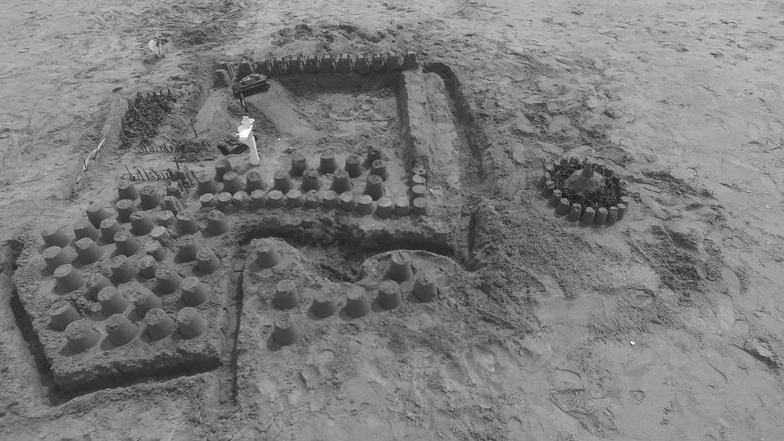
Figure 1 Original Structure Image
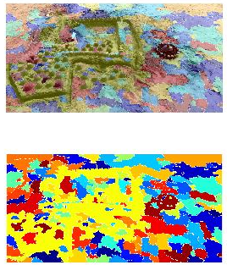
Figure 2 Original Structure Image with Segmented Image Superimposed
Figure 3 Original Structure Segmented Image
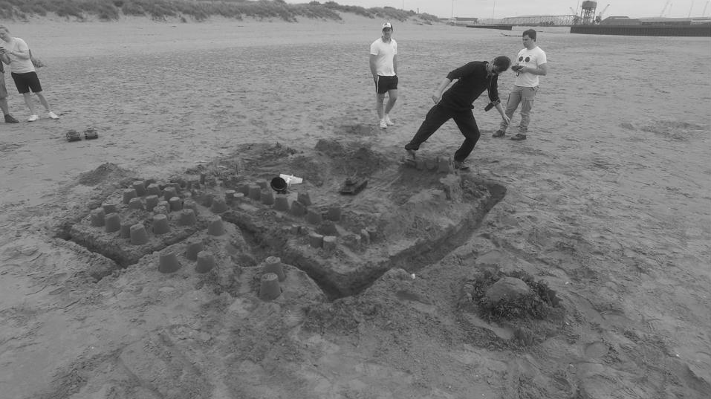
Figure 4 Original Structure Destroyed
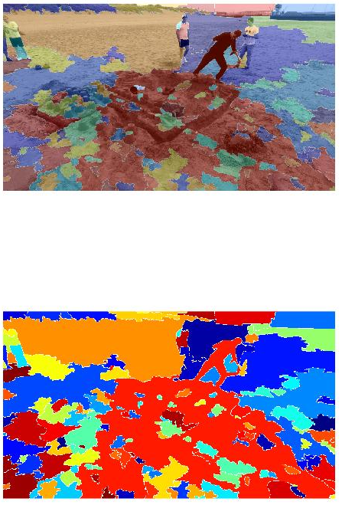
Figure 5 Original Structure Destroyed Image with Segmented Image Superimposed
Figure 6 Original Structure Destroyed Segmented Image

Accuracy
To allow the machine to recognise each object with accuracy the way the two images (before and after destruction) both need to be taken must be consistent.
Both images must be taken from the same point as well as aspect ratio. The closer the aspect ratio between the two images, the more accurate the outcome. [4] “Aspect ratio is an image projection” the difference of angles, height and width of the image will change the outcome. The machine may not pick up subtle differences when the aspect ratio is out, compared to when the aspect ratio is aligned, this is shown in figure 2, 3, 5 and 6.
The resolution of the image must be similar. If the before image is with a high resolution and the after image is low resolution, foreground and background markers that the machine picks up maybe due to the reduced resolution and could inevitably identify that there are changes that do not exist.
Again the clarity of the image is important as the foreground and background markers will pick up on any discrepancies and blur in the image, identifying them as something that they are not.
Adjusting the contrast, allowing the objects that are captured in the image to be highlighted and more easily defined by the machine will enable a greater outcome. It allows the edges to become more easily distinguishable and the objects will then be picked up easier and with potentially more detail. As you can see the contrast enhanced image in figure 7 picks out more detail, but the overall segmented image does not change considerably. This could be due to the resolution, brightness and perhaps because these images were taken from video footage.
Enhanced Contrast | Normal Image
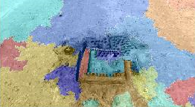 | 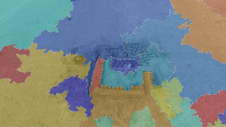
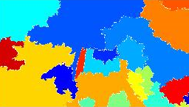 | 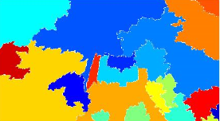
Figure 7 Contrast Comparison
The brightness of the image also counts for the same reason as the contrast, low light images with multiple dark colours will be harder to pick up any major differences and/or even markers.

The differences between images depicted in Figure 3 and Figure 6 show the results of segmentation of both images, but there are no easily distinguishable features to compare between the two, that would highlight that the objects captured in the image are the same (although the after image object would look different after destruction).
This is a result of the aspect ratio and focus differences. The drone that captured the before and after footage did not take the picture from the same location, height, angle and focus. Therefore, the image although usable would not provide enough detail of the differences between the two images captured.

Discussion

The images depicted in figure 3 and 6 can be overlaid to understand the damage that has occurred to the structure. The segmentation will differ and the machine will notice the difference in segmentation between the before and after images, this can be performed at great speed and accuracy. Although the images captured were not from exactly the same location some changes between the two can still be noticed. With a higher resolution image, taken from the same location with the same settings and good clarity, the difference of the before and after with the segmentation technique would be clear to see. Unfortunately, the images provided did not afford this to happen.
Machine learning of images and methods as covered in this report, has improved the accuracy and speed of which two images can be scrutinised to find the differences. The uses for this technology have already and continue to be explored and allows the potential for it to be used in all sorts of scenarios:
- Climate and environmental – Pictures taken year on year of glacier may provide detail for things such as global warming.

- Geological - Pictures taken monthly of a volcano could find differences, or bulging that could highlight unseen activity.

- Emergency response – Pictures taken before and after a tsunami, can help to prepare emergency team for what they might see when they deal with such emergency.

- Security – Pictures taken of field could highlight what crops grow in that field and identify any illegal crops being grown such as cannabis.

- Militarily – Differences in pictures taken at set periods can provide information on what is being constructed and give an idea of how long the construction might take as shown in Figure 8.

[5]
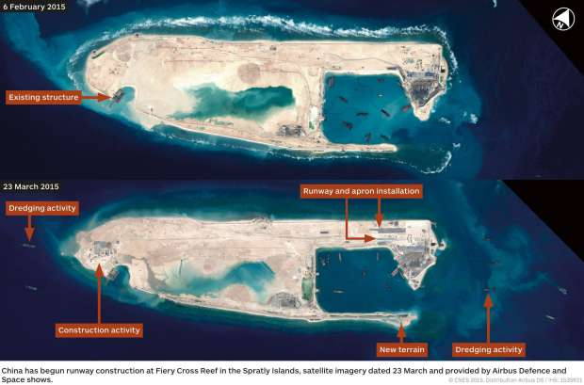
Figure 8 Chinese runway construction on Fiery Cross Reef
One of the situations that this technology has and will continue to be used in is damage reports, whether on cities, rural areas, or landscapes. If a meteor was to hit London. The first thing the authorities would need was a situation report which would include damage report. The damage report would potentially use satellite imagery similar to another image. There pre and post meteor strike images would be processed and segmented to allow the machine to spot the differences, showing which parts of the city had taken the most damage.

Bibliography

N. Efford, Digital Image Processing, A Practical Introduction Using Java, Pearson Education, Year 2000
Marker-Controlled Watershed Segmentation, MathWorks, Online, https://uk.mathworks.com/help/images/examples/marker-controlled-watershed-segmentation.html, Accessed 07/07/18

References

[1] Grayscale, Whatis, Online, https://whatis.techtarget.com/definition/grayscale, Accessed 07/07/18
[2] Morphological Image Processing, Online, https://www.cs.auckland.ac.nz/courses/compsci773s1c/lectures/ImageProcessing-html/topic4.htm, Accessed 07/07/18
[3] K. Parvati, B.S. Prakasa Rao and M. Mariya Das, Image segmentation using Grayscale Morphology and Marker Controller Watershed Transformation, Discrete Dynamics in Nature and Society, Volume 2008, Hindawi
[4] M. Rouse, Aspect Ratio, What is, Online, https://whatis.techtarget.com/definition/aspect-ratio, Accessed 07/07/18
[5] Artificial islands in South China Sea nearly complete allowing China to dominate region: report, National Post, Online https://nationalpost.com/news/world/artificial-islands-in-south-china-sea-nearly-complete-allowing-china-to-dominate-region-report, Accessed 05/07/18

