GRAJ Construction

Prince of Wales docks.
Lock gate replacement works.

Construction Methods and Materials.

TABLE OF CONTENTS

CHAPTER 1
- Pre-construction considerations..………………………………………………………..3
  - Access and site setup.…………………………………...…………………………………………………. 3

CHAPTER 2
- Construction planning and design…………….………………………………………..5
  - Construction design…..…………..……………………………………………………….5
  - Pre-arrangement of construction materials and machinery………………...……………..7
CHAPTER 3
- Construction process…………………………………………..………………………..8
  - Cofferdam……………………..……………………………………………………….…8
  - Dewatering………………………………………………………………..………………9
  - Temporary works- access into the dry lock…………………………………………..….10
  - Removal of the existing lock gates………………………………………………………10
  - Installation of the new lock gates………………………………………………………..11
  - Completion of the works………………………………………………………………...13

CHAPTER 4
- Construction materials………………………………………………………………………………..14

CHAPTER 5
- Additional considerations………………………………………………….………….15

CHAPTER 6
- References………………………………………………………………………………15

- Pre-construction considerations
It is important to gain an early understanding of how the practical requirements of the construction task shall be met, and the timing of these works in the docks will be planned to best manage flood risk. The requirements for temporary works and the efficient use of construction machinery such as cranes will be significant for ensuring the construction process is completed within the specific timeframes that we will be required to work within. It will therefore be vital to arrange early contractor involvement and to consider the construction method of both the temporary works and permanent works at an early stage. In addition to this, coordination with NRW will establish timeframe constraints that will need to be avoided, for example, during periods where particular fish are expected in the area.
Prior to any construction works commencing, the working area will be assessed and a programme of the construction works will be planned, before a risk assessment and method statement will be put together. Ideally this construction process will be undertaken during low flood conditions during the summer months. This will reduce the risks inherent in the construction task.
All necessary applications and permits will be obtained prior to the construction works being carried out, including a shutdown application for the lock gates being replaced. The careful planning of these works is an important factor in ensuring that the works are completed within the period stated within the shutdown application, and prior to any permits expiring.

  - Access and site setup
The site will be set up to allow safe movement of plant, labor and materials, with access and egress routes for the removal of waste and deliveries to site. Due to the construction works involving the water of the docks, environmental impacts will need to be considered during the planning of the site setup.
A sufficiently-sized area will be established to accommodate material storage, car parking and welfare facilities, and one-way systems and turning points will be made available for the maneuvering of plant and heavy vehicles.
Early contractor involvement will be utilized to identify access requirements during the planning stage of the construction works, allowing good time for enabling works, temporary works designs and planning of permanent works.
The public will be kept out of the working site, with information boards provided to satisfy public interest. Clear signage will be used to provide formal diversions of footpaths affected by the site compound.
The construction site will be set up, with hoarding around the perimeter. A location for the crane to be positioned will be determined, with the help of a structural engineer to ensure the ground bearing is suitable. The crane’s size will be determined by its position relative to the dock gates being lifted and replaced, and a suitable drop-off area will be established within the crane’s working zone, where materials will be dropped or lifted by the crane. Access will be obtained via Roberts Road, with access and turning points for HGV’s to easily access the crane’s loading/unloading zones for delivery/removal of materials from site.
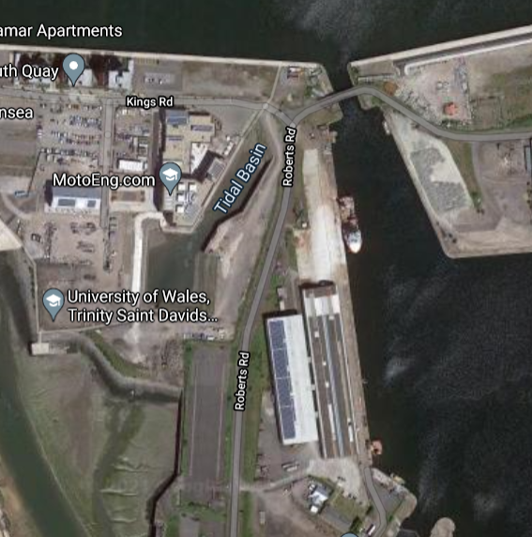
Fig.1.1- Access to the existing lock gates via Roberts Road (Google Maps)

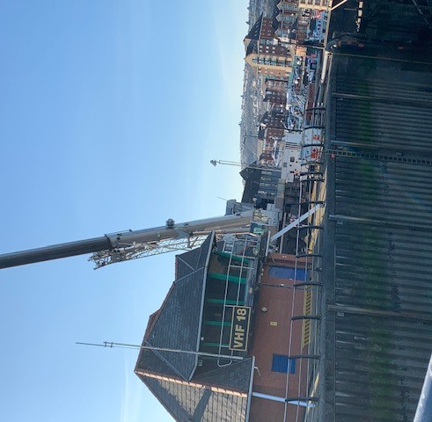
Fig.1.2- Example of a Crane setup alongside the dock walls (Benger, 2021).
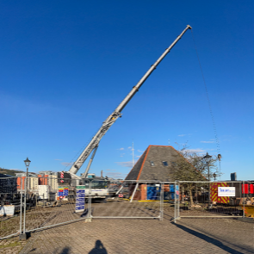
Fig.1.3- Crane and offloading compound example (Benger, 2021)
The crane’s working zone will be further barriered-off using Heras fencing, to prevent any site operatives or the public from entering the crane’s operating zone. A lifting plan will be written up during the planning stage, by an experienced and competent person, and a lift supervisor will overlook the lifting operations to ensure that the process is being carried out to the plan and the risks involved with such operations are controlled. During the production of the lifting plan, the condition of the existing gates will be assessed to ensure that they are lifted out of position safely. It may be the case that their condition prevents us from confidently ensuring that they can be lifted out as whole structures in single lifts, and if so further assessments will be required.

- Construction planning and design
  - Construction design
As requested, the lock gates will replicate those found in Swansea Marina. Known as Sector gates, they will compromise two pairs of quadrants made up of a curved vertical steel outer skin supported by a steel frame and radial arms. The gate structures are operated with hydraulic rams which rotate about a vertical axis into side recesses. They will incorporate walkways above them, so that when the gates are closed, they join to form a seal whilst providing a crossing above for pedestrians. Fig.5 provides a satellite image of the existing lock gates found in Swansea Marina, which our new lock gates will be designed to replicate.

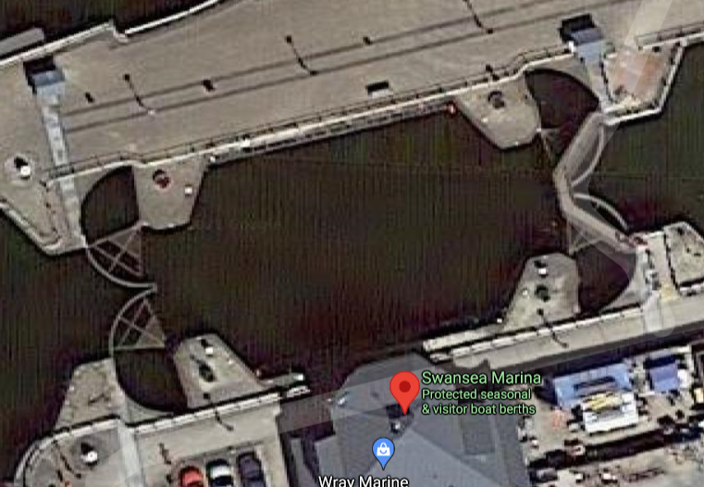
Fig.2.1- A satellite image of the locks gates found in Swansea Marina (Google Maps).
Curved adjacent dock walls allow the gates to open and close into the voids when required, to retain water within the lock when closed, and allow vessels to pass through when open. These gates must be designed to withstand the different water heads that will be expected as the water levels rise and fall.

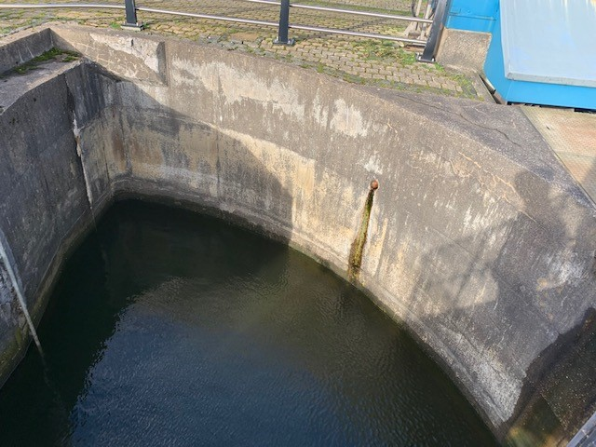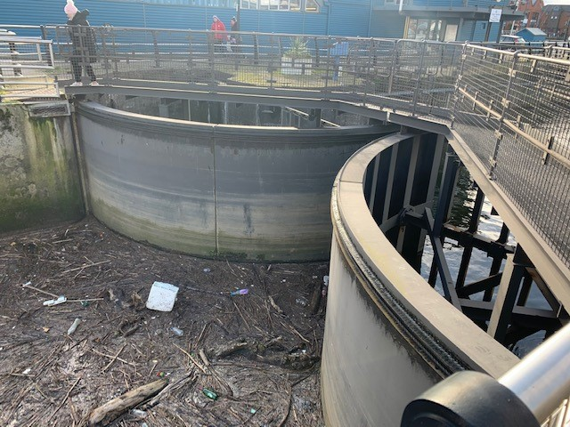
Fig.2.2-2.3- Sector Lock Gate Design- curved voids in the dock
walls allow the lock gates to open and close (Benger, 2021).

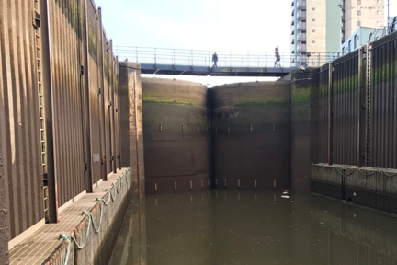
Fig.2.4- The existing Tawe Barrage Lock Gates (Kaymac, 2020).
  - Pre-arrangement of construction materials and machinery
As explained in the previous chapter, a request has been made for the new lock gates to replicate those found in Swansea’s Maria. These are hydraulically-operated curved-faced steel gates that are particularly effective in resisting differential water heads on either side (Royal Haskoning DHV, 2021). The steel gates and their supporting frames can be prefabricated in warehouses and delivered to site in full sections, allowing for a simple and fast installation. GRAJ Construction will coordinate with the supplier to ensure that sufficient notice is provided to ensure that the pre-fabricated sections are available for delivery in accordance with the installation dates stated on the construction programme. Pre-planning tasks like this, and maintaining communication with all necessary parties can help to prevent disruption to the project’s works sequences.
The choice of machinery will be made based on GRAJ construction’s strict belief in sustainable construction, primarily through the selection of the most appropriate machinery to carry out the job efficiently. The following will be required to carry out the lock gate replacement works:-
- Crane- size of crane will be selected based on:-
  - Reach requirements (i.e. further distance from the crane base to the lock gate sections being removed/installed).
  - Total weight of the sections being lifted (removed or installed)- this will include the steel gate sections and their attached frames, if lifted in single whole sections.
  - SWL (Safe Working Load) of the crane- to be compared to the weight of the heaviest load.
Note: The crane will also be equipped with a pile-driving hammer when required, for sheet pile installation.
- 360° Hydraulic Excavator- used for the removal or relocation of sand within the dry lock barrel, in order to provide a safer and more easily accessible working zone.
- Skips- for the removal of sand or waste materials from the dry lock via crane lifting operations, if required.
- Hoists- used to lift or lower materials into the dry lock.
- Tower Scaffolds- used to provide fast and easy temporary access for working at heights, where fixed scaffolds are deemed inappropriate.

- Construction process
Once the site setup has been established and works are ready to commence, the first task will be to dewater the working area required for the removal and replacement of the lock gates, an explanation of the process involved is included in chapters 3.1 to 3.2.
  - Cofferdam
Two options are available for providing a dry working zone for the removal and installation of the new lock gates:-
- A cofferdam will be constructed at either end of the lock barrel, thereby providing a temporary enclosure around the two sets of lock gates, to keep water out and permit dewatering for the construction works to be carried out in dry conditions.
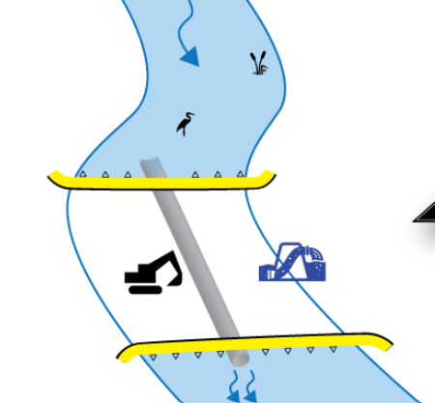
Fig.3.1- Design of a cofferdam (MegaSecurEurope, 2020).

- Half enclosures will be used, whereby one pair of lock gates are kept shup whilst a single water barrier is installed to remove the other pair. This in effect uses the closed pair of lock gates to form a cofferdam together with the single water barrier behind the other pair of gates, which saves on time as well as cost of materials, by allowing for the sheet piles to be reused once one pair of gates has been replaced.
The second option is our preferred method, however this is only achievable if the existing lock gates are in satisfactory condition to be safely used as a barrier for the water being retained from the dry working zone. Due to the high levels of risk associated, a careful assessment of the existing lock gates will be undertaken before making a decision on the method of cofferdam construction.
The cofferdam will be achieved through sheet piling, with its design issued by structural engineers following a site investigation, sampling and relevant tests. Design considerations will need to include the different expected loadings that may be exerted on the cofferdam throughout the construction process due to a number of factors including scour and flooding. The hydrological record and water levels will need to be considered together with an accepted level of risk.
The sheet piles will be set out by the site engineer to ensure they are installed in the correct location. A crane equipped with a vibrating pile-driving hammer will be used to install the steel sheet piles. The sheet piles will be interlocking to provide an impermeable enclosure and a beam and strut system designed by the structural engineers will be added to counter the imposed loads expected from the water pressure exerted on the outside of the enclosure once the inside of the cofferdam has been dewatered. An example of this is shown in the sketch provided in Fig.3.2. These will be fixed above the water level, with the components lifted into place by a crane, and the installation team working off barges to fix them in place.
Once the cofferdam has been installed, a rescue of fish and other species will be required to be undertaken by specialists before the dewatering process may commence. This will prevent species from being trapped once the water within the lock barrel has been removed. The cofferdam structure will be closely monitored throughout to ensure that it is first being installed as planned, and then properly maintained. Upon completion of their installation, the sheet piles will be regularly monitored for any movement. This is required to control the high levels of risk associated with cofferdams, and the severe impact that may occur through failure.
In addition to this, attention to safe working practices on the part of all site operatives will be required, and risk assessments, method statements and toolbox talks will be regularly issued to raise awareness of the dangers involved in the construction process.

  - Dewatering
An agreement will be made during the planning stage as to where the water will be pumped to, for us to provide a dry working zone. The dewatering process will be achieved using suitably-sized submersible pumps, pumping the water out of the enclosed lock barrel and into the previously-agreed location. Sumps will be achieved in the lowest-lying areas, so that any water that ingresses into the cofferdam, for example low volumes of water leaking through the cofferdam’s seals or heavy rainfall, can be pumped out to provide a dry working zone throughout the entire construction process.
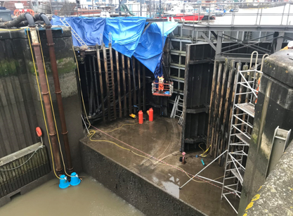
Fig.3.2- The existing Tawe Barrage lock gates when previously
dewatered for maintenance work (Kaymac, 2020).
Once the dewatering process has been completed, works can begin on the removal of the existing lock gates.
  - Temporary works- access into the dry lock
A scaffolding firm will be instructed to install scaffold access from the top walkway down to the floor of the dry lock barrel.
As well as this, tower scaffolds will be used to provide access to the full height of the existing and new gates, providing safe access to the key components of the lock gates for their removal (eg. hinges and other structural joints). Tower scaffolds are a more appropriate means of access in this situation, as a fixed scaffold would need to remain in place during the removal and reinstallation process of the steel lock gates. This would provide an unnecessary obstruction and add an additional risk to the lift process.
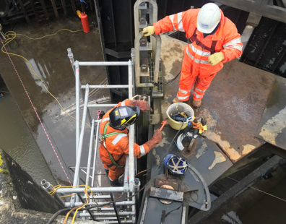
Fig.3.3- A tower scaffold being used for access to the full height of a lock gate (Kaymac, 2020).

  - Removal of the existing lock gates
The walkways above the lock gates will be removed first, with the crane supporting the load whilst operatives dismantle the bolts from the lock gates. Once all fixings have been unfastened, the crane may lift the walkway structures and offload them onto the appropriate drop-off zone. Once the walkways have been moved and there are no further obstructions for the removal of the lock gates, these can then be removed in a similar manner.
The condition of the lock gates will first be assessed before deciding on a method of removal, but we hope to be able to remove the lock gates together with their frames in one single lift, so that they can be dismantled in a safer manner on the ground once offloaded. Additionally, the weight of the gate structures will be acquired through records and calculations, and an assessment will be made based on the crane’s safe working load to determine if they are able to be lifted in single lifts. If this single-lift method is achievable, the lock gates will be removed by, again, first supporting their load in place using the crane, before unbolting them at the hinges and disconnecting them from the hydraulic systems, for their removal in whole single sections.
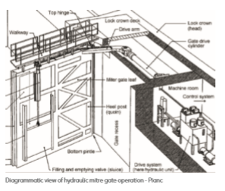
Fig.3.4- Diagramatic View of a hydraulic Mitre Gate (Allianz, 2020).

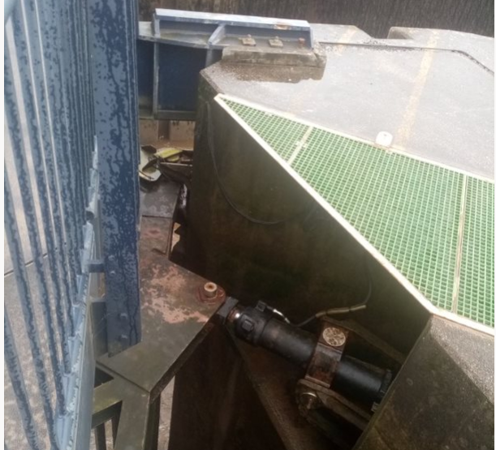
Fig.3.5- Hydraluic rams and fixing components of a lock gate (Askham, 2020).
The removed lock gates will be removed from site by HGV’s immediately after their removal, loaded using the crane. They will be dismantled on the ground within the drop-off zone prior to being removed on site, so that they are split into components that are more suitable for transportation.
  - Installation of the new lock gates
Once the existing lock gates have been removed from site, HGV’s may deliver the new gates to be installed in place immediately. The new gates will be offloaded from the HGV’s by the crane from their drop-off point, and the components will be constructed within the crane’s drop off zone prior to them being lifted into place in whole, single sections. Competent, trained slinger-signalers will carefully position the lifting chains so that the lock gates are lifted level and plumb as required. They may then be guided into place by the signals given to the crane operator, so that the fixers may fix the lock gates into place at their hinges. The bottoms of the sector gates will incorporate rollers that allow for the movement along the concrete base when the gates are opening and closing. As well as this, a rubber seal at the bottom of the gate will prevent water from leaking through.
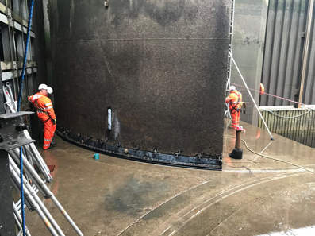
Fig.3.6- A sector lock gate sat on a concrete support (Kaymac, 2020).

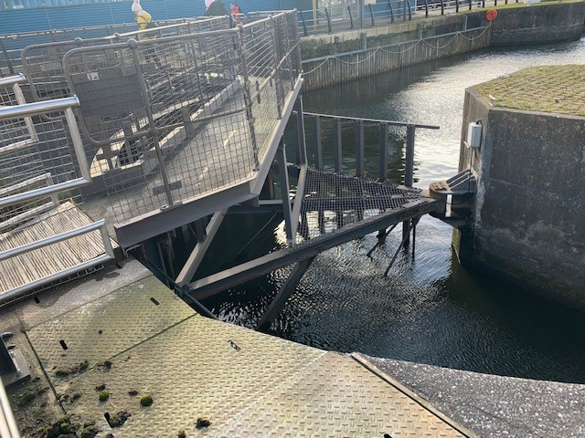
Fig. 3.7- Hinged components fixing the rotating frame of a lock gate to the dock wall (Benger, 2021).

Once the lock gates have been positioned, the walkways can be installed above. Again, these walkways will be prefabricated to reduce the work-load required on site, hence reducing time and cost, and maintaining a safer construction method. As demonstrated in the examples shown in Fig.3.11 and Fig.3.12, 2 separate walkway structures will be constructed for each pair of gates, which will join together when the gates are closed to provide pedestrian access across the dock. The crane will offload the prefabricated walkway structures from the delivery vehicles, and lift directly into place, where the steelworkers will fix it in to place using tower scaffolds as access.

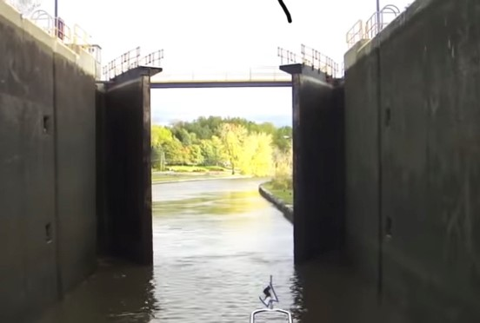
Fig.3.11- Example of an opened lock gate, with separated walkway sections (Pufal (2010).
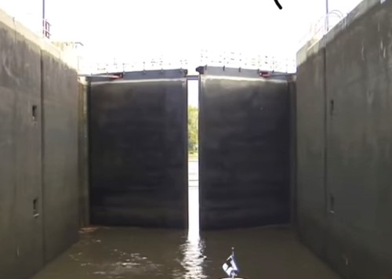
Fig.3.12- Example of a lock gate closing to connect the walkway sections (Pufal, 2010).
Once both pairs of lock gates have been installed, and following acceptance by the engineer commissioning the works, all access equipment may be removed prior to the removal of the cofferdam.
  - Completion of the works
The removal of the cofferdam will be planned and executed with the same degree of care as its installation, on a stage to stage basis. Structural Engineers will also be required to assess the potential effects of the cofferdam removal on the permanent structures in place, and work together with the construction team to plan a safe way of removing the cofferdam. For this reason, it may be necessary that sheet piles extending below the permanent structure are cut off and left in place, since their removal could disturb the foundation soils and gravels in the river bed adjacent to the structure
Upon completion and commissioning of the works by an Engineer, all site materials and machinery will be removed from site, and a site clearance will ensure that no debris/waste materials are left. Additionally, the existing ground within the site compound will be assessed for any damage caused by the construction works, and remediations will be undertaken where required.
- Construction Materials
GRAJ construction aim to undertake the gate replacement works by way of a sustainable, environmentally-friendly and economical procedure, through careful planning of the construction task at hand. Calculated quantities of construction materials, as well as pre-arrangements of temporary works equipment including lifting and access equipment, will be issued to local suppliers to arrange advanced delivery.
Quantities of materials required in bulk, such as fixings for the new lock gates, will be issued to local suppliers to achieve the most desirable offer available for us to pre-order. By procuring quotes from material suppliers, we can save costs by ordering in bulk quantities and accepting the most competitive prices offered. Pre-ordering materials also ensures that they are readily available when we require them, in accordance with the works’ sequence, thus preventing disruption to the construction programme.
The prefabrication element of the lock gate quadrants and their frames will be advantageous in reducing both the working efforts on site, as well as the time taken to install them. Through sufficient coordination with suppliers, the lock gates can be prefabricated during the planning process of the construction project, so that they are ready to be delivered to site as and when the construction team are ready to install them. Depending on the size of the lock gates, and the logistical conditions, the lock gates may be delivered on site readily connected to their frames. Otherwise, once delivered, the quadrant sections can be connected to their frames on site, within a flat, unobstructed working area adjacent to the crane’s compound. This way we can provide a safe working zone for the assembly of the gates that is easily accessible for the crane to lift the full quadrants into place. This process will make the installation of the new lock gates faster, easier and safer to undertake.
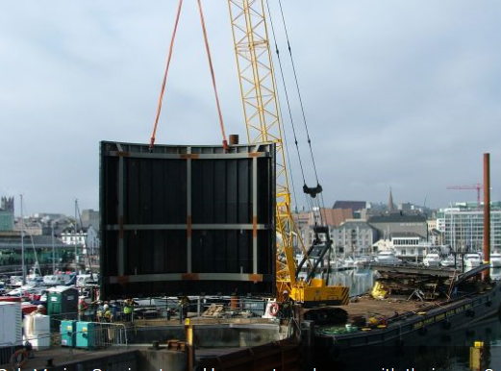
Fig.4.1- Prefabricated lock gates lifted by a crane (Maritime Journal, 2007).

- Additional considerations
Quality control is vital in ensuring the construction process is carried out efficiently and to the required specification. A major aspect of quality control is the establishment of well-defined controls (Hayes, 2020). The following processes are examples of controls that will be implemented to ensure that the construction process is undertaken with efficiency and sustainability as the company’s core objectives:-
- Certified contractors with a proven experience in similar construction projects will be used for all specialized tasks.
- Delivery notes will be checked upon the arrival of all materials to site. This will ensure that the correct specification of materials have been received.
- Strict health and safety rules will be implemented on site throughout the construction project.
- All construction tasks will be executed by trained and competent persons only.
- Extra care will be taken to ensure that all rubber seals to the bottoms and joints of the gate sections are installed as per the design specifications, in order to achieve an effective sealing system and prevent water loss.
- Due to the nature of the works being undertaken within the water of the docks, a strong emphasis on pollution control will ensure that the construction works will have minimal environmental impact.

- References
Allianz (2020). Lock and dock gates: Guidance on types, operating factors, failures and maintenance. Available at: https://www.agcs.allianz.com/content/dam/onemarketing/agcs/agcs/pdfs-risk-advisory/risk-bulletins/ARC-Marine-Lock-and-Dock-Gates.pdf. [Accessed: 17/12/20].
Hayes, A. (2020). Quality Control. Business essentials: guide to mergers and acquisitions.
Kaymac (2020). Tawe barrage lock gate maintenance. Available at: https://www.kaymacmarine.co.uk/projects/bideford-bridge-gas-pipe-removal/. [Accessed: 17/12/20].
Maritime Journal (2007). New lock gates for Sutton Harbour. Available at: https://www.maritimejournal.com/news101/marine-civils/port,-harbour-and-marine-construction/new_lock_gates_for_sutton_harbour. . [Accessed: 24/04/21].
MegaSecurEurope (2020). Dewatering between 2 cofferdams. Available at: https://en.megasecureurope.com/portfolio-items/cofferdam-perpendicular-installation-shallow-slope/. [Accessed: 17/12/20].
Pufal, A. (2010). Erie Canal Locks Time Lapse HD Video. Available at: https://youtu.be/S7_Hr3iCPls. [Accessed: 26/04/21].
Royal Haskoning DHV (2021). Dock & lock gates: Our unique capability is your solution. Available at: royalhaskoningdhv.com/-/media/royalhsakoningdhvcorporate/files/global/literature/dock_and_lock_gates_royal_haskoningdhv_brochure.pdf. [Accessed: 18/04/21].

