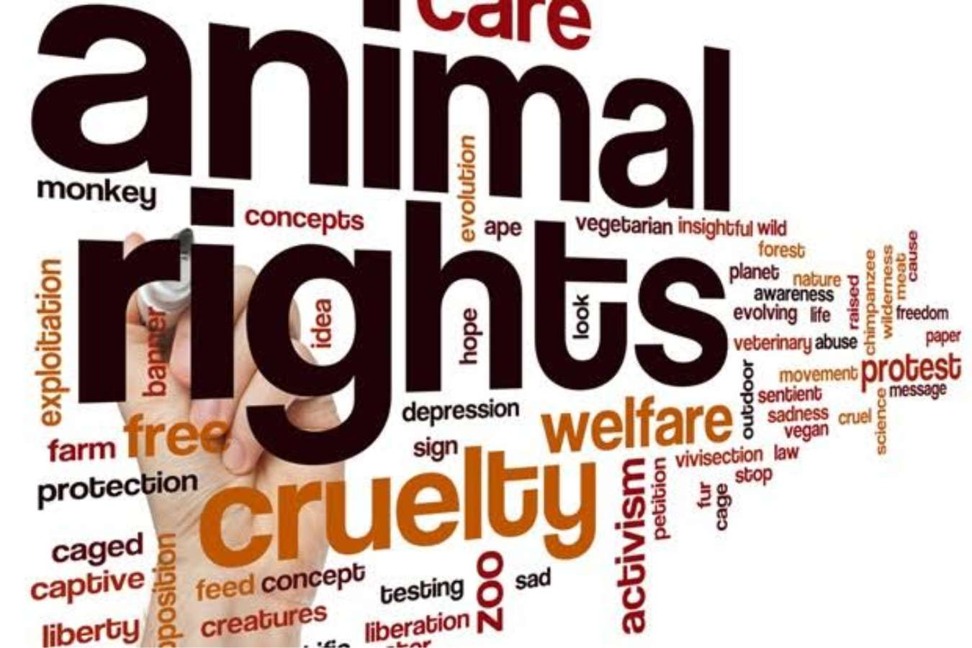

Are Nonhuman Animals Deserving Of Justice?

Xaverna Black | Free-Market Environmentalism, Big Business and Global Politics | 14.3.2023

Are Nonhuman Animals Deserving Of Justice?

For millennia, nonhuman animals have been an integral part of human society, serving various purposes such as food production, clothing, experimentation, entertainment, and championship. Nonetheless, the treatment of these animals has become a pressing ethical concern, sparking debate over whether they deserve justice and legal protection. This issue is multifaceted and contentious, requiring a nuanced understanding of ethical and legal frameworks that govern our treatment of animals, as well as an appreciation for scientific evidence of animal sentience and cognitive ability. While some believe that animals are merely property and can be utilised for human purposes, many philosophers and animal advocates argue that animals have inherent value and should be treated with dignity and respect. In this essay, I will examine the ethical considerations surrounding the question of whether nonhuman creatures are deserving of justice, as well as the arguments for and against extending justice to animals. I will investigate the ramifications of alternative ethical theories and legal frameworks from researchers using interdisciplinary study from philosophy, animal studies, law, and environmental studies. Specifically, I will evaluate the scientific evidence for animal sentience, the ethical implications of animal suffering, the concepts of animal welfare and animal rights, the current state of animal legal protections, and the potential benefits and drawbacks of extending justice to nonhuman animals for society as a whole. Additionally, I will explore alternative animal rights and justice models that could be implemented in the future. Ultimately, this essay will argue that nonhuman animals are indeed deserving of justice and ethical consideration, and that human society has a moral obligation to recognize and respect their rights as well as work towards a more just and equitable society for all sentient beings.
Justice is a complex concept that philosophers and intellectuals have debated throughout history. Justice, at its foundation, refers to the fair and equal treatment of people, as well as the equitable sharing of advantages and obligations in society. According to John Rawls, justice involves a fair allocation of social goods such as money, wealth, and opportunities that benefits everyone in society, particularly those who are disadvantaged (Rawls, 1971). Yet, Aristotle contends that fairness involves more than merely treating everyone equally, but rather treating them according to their own strengths and virtues (Aristotle, 2004). The concept of justice is inextricably tied to the concept of morality, which entails differentiating between right and wrong and good and evil. Justice is necessary for human society because it guarantees that everyone is treated with dignity and respect, and it contributes to social stability, trust, and collaboration. It assures that everyone, regardless of socioeconomic rank, ethnicity, gender, or other traits, is treated fairly and equally. In a fair society, laws and institutions are meant to preserve individuals' rights while also promoting the common benefit of all members of society. In the context of nonhuman animals, justice may be described as equitable treatment and consideration of the interests and well-being of the animals. This entails acknowledging that animals have inherent value and need to be treated with respect and compassion, regardless of their apparent utility to people.
Nonhuman animals, on the other hand, have been excluded from the idea of justice for decades. Traditional Western philosophy has emphasised human beings' rational and autonomous character, leading to the exclusion of non-human animals from moral consideration (Sapontzis, 1987). One argument for the absence of animals from justice is the belief that animals lack moral agency and hence cannot be held morally accountable for their conduct. This viewpoint has led to the idea that animals lack moral status and hence do not merit attention in moral decision-making (Sapontzis, 1987). Rawl's contractarianism excludes animals from deserving fair treatment since they are unable to engage into a contract, whereby concerns of justice are answered by those who are rational in their decision-making and can deliberate behind a "veil of ignorance" (Rawls, 1971 , pp. 118-23). Rawls is of the view that only humans may be included in the field of justice, since they are the only species that have 'a capacity for a feeling of justice and a notion of the good'. Yet, Rawls feels that humans have at least certain obligations to animals, ones of compassion and humanity, and that we should not treat them in any way we like (Attfield & Humphreys, 2017). Another basis for the exclusion of animals from justice is the notion that animals are essentially different from humans and so do not have the same moral position. Animal rights activists say that because animals are capable of experiencing pleasure, pain, and other types of suffering, they need moral concern and protection (Singer, 1975). Biases based on culture and history have also led to the exclusion of animals from justice. Some cultures see animals as sacred or treasured, whilst others regard them as merely resources to be exploited (Nussbaum, 2006). Moreover, Attfield and Humphreys contend that including nonhuman animals into the legal system necessitates a transformation in our cultural views towards animals. They contend that instead of perceiving animals as mere resources, we should recognise their intrinsic value and relevance in our civilizations. According to the authors, incorporating nonhuman animals in our moral and legal concerns necessitates acknowledging their intrinsic worth and value. This means that we should consider the interests of animals in our decision-making processes and seek to prevent needless harm or suffering to animals.
Due to the legal and economic structures that control their treatment, nonhuman animals are frequently regarded as property. Animals are considered property or commodities in many legal systems, which implies they lack legal rights and protection. This permits the exploitation of animals for human purposes such as food, clothing, experimentation, and entertainment, often with little regard for their welfare or interests (Francione, 2008). The view of animals as property can be traced back to historical and cultural attitudes, where animals were seen as resources to use for human advantage. This viewpoint has been fostered by economic systems that value profit and efficiency over animal care, resulting in widespread animal exploitation and cruelty (Nussbaum, 2006). Throughout history, nonhuman animals have been subjected to widespread exploitation and maltreatment. Factory farming, which involves the extreme confinement and exploitation of animals for the production of meat, eggs, and dairy products, is one of the most pervasive forms of animal cruelty. Overcrowding, confinement, mutilation, and other types of physical and psychological pain are frequently inflicted on animals bred under these systems (Broom, 1991). Also, animals are used for experimentation in both medical and non-medical contexts, where they are exposed to invasive treatments and are typically euthanized when the study is over. Millions of animals are employed each year in biomedical and toxicological research (Patterson-Kane & Piper, 2009). There is emerging evidence, however, that animal models are not always effective and that alternate approaches such as computer models, cell cultures, and human clinical trials may be more beneficial (Greek & Shanks, 2009). Animals used in entertainment, such as circuses, zoos, and marine parks, have also been criticised for their possible damage to animals (Bekoff & Jamieson, 1996). In these circumstances, animals are frequently subjected to confinement, social isolation, and physical abuse, resulting in poor health and psychological anguish. According to Tom Regan, a prominent philosopher, animals have intrinsic value and rights and, as such, should be treated with respect and given legal safeguards (Regan, 1983). Regan posits that animals have a fundamental right to live and that harming or killing animals for human advantage is ethically immoral. This argument is founded on the premise that animals, like people, are living individuals with their own experiences and interests that should be considered. Furthermore, Midgley examines the ethical issues surrounding the use of animals for human purposes in her book "Animals and Why They Matter," arguing that these practises are often morally problematic because they treat animals solely as means to human ends rather than recognising their inherent value as sentient beings (Midgley, 1983). Likewise, in my opinion, our treatment of animals is inextricably linked to our moral ideals, and we have a moral imperative to give compassion and respect to all sentient species.
Nonhuman animals are sentient, which means they can feel, perceive, and experience pain and suffering. As Midgley explains, sentience is important because it makes a significant difference in the forms of needs that animals have and the types of harm that may be done to them. According to her, "the obligation that we can owe to particular beings capable of suffering and enjoyment must centre on those capacities" (Midgley, 1983, p.90). Several types of animals, including mammals, birds, fish, and even certain invertebrates, have a sophisticated neurological system that allows them to sense and respond to their surroundings in complicated ways, according to scientific studies. For example, research such as Charles Darwin's suggest that certain animals have cognitive and emotional capacities, such as worry, sadness, and despair, among other things. Darwin also observed that monkeys are capable of deceit (Bekoff, 2007, pp. 31-33). These findings imply that animals are not only automata, but rather complicated creatures capable of a wide range of emotions and feelings. As a result, their handling by humans poses ethical considerations about their well-being. Cows have been proven in studies to build close ties with one another and experiences worry and anguish when separated from their herd members (Phillips, 2011). Similarly, research has shown that chickens are capable of empathy and can recognise and react to the emotions of other chickens (Marino & Colvin, 2015). The acceptance of animal consciousness has significant ramifications for animal welfare. If animals can feel pain and suffer, we have a moral duty to alleviate their suffering and promote their well-being. This necessitates a transformation in our perception of animals, from things to be utilised for human purposes to beings with inherent value and rights. The animal welfare movement has long fought for this change, pushing humane treatment standards in areas such as agriculture, research, and entertainment. These criteria include measures such as providing appropriate food, drink, and shelter, as well as enabling animals to engage in natural behaviours (Fraser & Broom, 1990). While these principles have been adopted to diverse degrees in various situations, they constitute an essential step towards acknowledging animal welfare as a genuine concern.
Additionally, nonhuman animal exploitation has been demonstrated to have major negative environmental and economic consequences, including deforestation, greenhouse gas emissions, and public health problems (FAO, 2006). As a result, recognising animal welfare and justice is critical for the well-being of mankind and the sustainability of our planetary. Animal welfare is the quality of life that animals possess, whereas animal rights is the concept that animals have inherent value and need to be treated with respect and dignity, regardless of their utility to humans. This point of view is founded on the notion of speciesism, which says that people are biased towards their own species and discriminate against other species based on their perceived inferiority (Singer, 1975). The animal rights movement aims to counteract this prejudice by advocating for the acknowledgment of animal rights. There have been several initiatives to award nonhuman creatures legal personality, notably in the field of animal rights. The Nonhuman Rights Project, for example, advocates for chimp legal personhood, stating that they are autonomous people worthy of fundamental rights such as freedom from imprisonment and torture. However, these initiatives have been greeted with opposition, and the legal status of non-human animals in most jurisdictions remains unaltered. Yet, opponents contend that such regulations frequently fail to provide enough animal protection and fail to address the core cause of animal abuse (Bekoff, 2007).
Ethics is crucial in the animal rights debate because it provides a framework for assessing the moral position of nonhuman animals and choosing the best course of action in their care. Utilitarianism, which maintains that acts should be judged based on their potential to maximise enjoyment and minimise suffering, is one of the most prevalent ethical frameworks used to examine animal rights. According to this viewpoint, animals have interests that must be considered and balanced against human interests when making ethical judgements (Singer, 1975). Utilitarianism supports the concept that the well-being of nonhuman animals is fundamentally desirable and necessary for establishing a more just and equitable society. In contrast, deontological ethics is a non-consequentialist ethical theory that stresses moral responsibilities and obligations. Deontological approaches to animal rights highlight the moral value of animals and the obligations humans have to respect their intrinsic worth. Regan (2004) is a leading proponent of deontological animal rights, stating that animals are living beings with intrinsic rights to be treated with respect and dignity. Virtue ethics promotes ethical behaviour by emphasising the development of virtuous character characteristics such as compassion and empathy. In the context of animal rights, virtue ethics advocates for animals to be seen as moral patients worthy of compassion and empathy. According to Nussbaum (2006), the capacity approach, a kind of virtue ethics, emphasises animals' intrinsic value and the need to respect their capabilities for joy and misery. According to the rights-based approach, animals have some intrinsic rights, such as the right to live, freedom from pain, suffering, and exploitation. This approach's proponents claim that these rights should be officially acknowledged and safeguarded (Cavalieri & Singer, 1993). Another perspective that emphasises the connectivity and interdependence of all species on Earth is ecocentrism, which maintains that ethical treatment of animals should be based on a concern for the preservation of ecosystems and biodiversity. Ecocentric strategies prioritise the conservation of animal species and habitats while attempting to reduce human intrusion in natural ecosystems (Taylor, 1986). Ultimately, the abolitionism viewpoint calls for the abolition of all animal usage in human civilizations. Animal rights activists say that animals have the right to spend their lives free of human interference and exploitation, and that using animals for human interests is intrinsically wrong (Francione, 2008).
Extending justice to nonhuman creatures might have substantial societal ramifications, both beneficial and harmful. On the plus side, it would be a step towards recognising non-human animals' moral and legal standing, as well as their rights as sentient creatures. This could lead to better treatment and welfare for them, as well as environmental conservation measures to maintain their habitats. Animal agriculture, for example, contributes significantly to greenhouse gas emissions and deforestation. We may theoretically minimise our reliance on these businesses by recognising the ethical worth of nonhuman animals and reducing their exploitation, which would improve the environment in the long run (Nijidam et al, 2012). Acknowledging the rights of nonhuman creatures may lead to improvements in how humans manage our natural resources, such as habitat protection, pollution reduction, and climate change mitigation. Furthermore, recognising nonhuman animals as legal persons would allow them to acquire legal protection and representation, perhaps leading to increased accountability for animal abuse and exploitation. This would also benefit human health and well-being, as many illnesses are zoonotic in origin, meaning they are passed from animals to humans. By acknowledging the ethical worth of animals and limiting the exploitation of animals in agriculture and other sectors, we could potentially reduce the probability of zoonotic illnesses arising in the first place (Kahn, 2016). On the downside, extending justice to nonhuman creatures may provide economic and cultural obstacles. Businesses that rely on animal exploitation, such as industrial farming, animal experimentation, and entertainment, would have to adapt, perhaps resulting in job losses and economic instability. Furthermore, there may be cultural opposition to modifying long-standing customs that entail the usage of animals, such as hunting or culinary choices based on animals. Additionally, identifying the legal and moral status of different sorts of animals, such as those with higher cognitive capacities or those genetically close to humans, may provide difficulties.
To conclude, the question of whether nonhuman animals are deserving of justice has been contested for several years. Yet, in my opinion, the answer is a resounding yes. Nonhuman animals have a vast spectrum of emotions, cognitive capacities, and social behaviours that humans sometimes overlook or underestimate. They, like us, can feel pain, sadness, and delight. As a result, we have a moral duty to treat them with the same care and compassion that we do other humans. Nonhuman animal justice is not only an ethical concern; it is also a practical requirement. Animal mistreatment has been associated with a range of environmental and public health issues, ranging from the development of zoonotic illnesses to ecosystem deterioration. By implication, extending justice to nonhuman animals, we contribute to a more just and compassionate society for humans. Acknowledging the moral and practical implications of nonhuman animal justice is critical for creating a more equal and sustainable world. We can establish a society that values empathy, kindness, and respect for all forms of life by striving to safeguard the rights and welfare of all animals. While implementing justice may be difficult, the potential advantages to animal welfare, environmental protection, and human health and well-being make it a worthwhile pursuit.

References
Aristotle. (2004). Nicomachean Ethics. Oxford University Press.
Attfield, R. and Humphreys, R., 2016. Justice and non-human animals-part I. Bangladesh Journal of Bioethics, 7(3), pp.1-11.
Attfield, R. and Humphreys, R., 2017. Justice and non-human animals-part II. Bangladesh Journal of Bioethics, 8(1), pp.44-57.
Bekoff, M. (2007). The emotional lives of animals: A leading scientist explores animal joy, sorrow, and empathy-and why they matter. New World Library, pp. 31-33
Bekoff, M., & Jamieson, D. (1996). Ethics and Environmental Policy: Theory Meets Practice. MIT Press.
Broom, D. M. (1991). Animal Welfare: Concepts and Measurement. Journal of Animal Science, 69(10), 4167-4175.
Sunstein, C.R. and Nussbaum, M.C. eds., 2004. Animal rights: Current debates and new directions. Oxford University Press.
Cass Sunstein, L., & Nussbaum, M. C. (2004). Animal rights: A symposium. The Yale Law Journal, 113(6), 1285-1311.
Cavalieri, P. and Singer, P., 1993. The Great Ape Project–and Beyond.
Cohen, C. (1986). The case for the use of animals in biomedical research. New England Journal of Medicine, 315(14), 865-870.
FAO. (2006). Livestock's long shadow: Environmental issues and options. Food and Agriculture Organization of the United Nations.
Francione, G. L. (2008). Animals as Persons: Essays on the Abolition of Animal Exploitation. Columbia University Press
Fraser, D. (2008). Understanding animal welfare. Acta Veterinarian Scandinavica, 50(Suppl 1), S1
Kahn, L. H. (2016). Confronting zoonoses, linking human and veterinary medicine. Emerging infectious diseases, 22(2), 352.
Marino, L., & Colvin, C. M. (2015). Thinking chickens: a review of cognition, emotion, and behavior in the domestic chicken. Animal Cognition, 18(2), 339-363.
Midgley, Mary (1983), Animals and Why They Matter, Harmondsworth: Penguin, p.90.
Midgley, Mary (1983), Animals and Why They Matter, Harmondsworth: Penguin.

Nijdam, D., Rood, T., & Westhoek, H. (2012). The price of protein: Review of land use and carbon footprints from life cycle assessments of animal food products and their substitutes. Food Policy, 37(6), 760-770.
Nussbaum, M. C. (2006). Frontiers of Justice: Disability, Nationality, Species Membership. Harvard University Press.
Patterson-Kane, E. G., & Piper, H. (2009). Animal experimentation and the invasive use of animals for 1P teaching purposes: A critical review of Canadian and US veterinary medical school policies. Journal of Veterinary Medical Education, 36(4), 496-502.
Phillips, C. J. (2011). Cattle behaviour and welfare. John Wiley & Sons.
Rawls, J. (1971). A Theory of Justice. Harvard University Press, pp. 118-23.
Regan, T. (1983). The Case for Animal Rights. University of California Press
Rollin, B. E. (1981). The unheeded cry: Animal consciousness, animal pain, and science. Oxford University Press.
Rowlands, Mark (1998), Animal Rights: A Philosophical Defence, London: Macmillan Press.
Sapontzis, S. F. (1987). Morals, Reason, and Animals. Temple University Press.
Shanks, N., Greek, R. and Greek, J., 2009. Are animal models predictive for humans?. Philosophy, ethics, and humanities in medicine, 4(1), pp.1-20.
Singer, P. (1975). Animal liberation: A new ethics for our treatment of animals. New York Review/Random House.
Singer, P. (2009). Animal Rights: Beyond the Limits of Welfare Approaches. In T. L. Beauchamp & R.G. Frey (Eds.), The Oxford Handbook of Animal Ethics (pp. 49-76). Oxford University
Taylor, P.W., 2011. Respect for nature: A theory of environmental ethics (Vol. 51). Princeton University Press.

