Core Behaviours for People Professionals

- Please explain:
- ‘ethical principles’ and how these can inform the way people behave at work.
- ‘professional values’ and how these can inform the way people behave at work.
(AC 1.1)
Buchanan and Huczynski (2020) stated that ethical principles are the ‘codes of moral principles, values and rules that govern our decisions and actions with respect to what is right and wrong, good and bad’. For example, my organisation has six key values: fairness, quality, integrity, respect, teamwork and work-life balance (Bevan Buckland LLP, 2025). Values need to reflect the actions and behaviours of an organisation, as saying one thing and doing another can harm the organisation’s credibility and lose the trust of staff CIPD (2024). According to CIPD (2019), there are three different types of influence on unethical behaviour: rotten apples, bad barrels and sticky situations.
- Rotten apples describe individual differences, such as personality, peer pressure or moral development. I have noticed in my organisation that people with a longer length of service are more hesitant to change. People professionals can help manage this by creating a positive culture through policies like whistleblowing and empowering employees to raise concerns.
- Bad Barrels refers to organisation - or industry-wide indiscretions, such as levels of trust, leadership methods, and social norms of behaviour. People professionals need to ensure that there is a strong ethical climate, moral leadership, and the social norms in the organisation are ethical by following the FCA guidance.
- Sticky situations are potentially compromising decisions. People professionals must ensure that there are no negative influences on decisions, such as unrealistic goals, time pressure and competition. This can be achieved by designing stimulating jobs with manageable workloads so people do not cut corners or let decisions be driven through competition, e.g., competing for a bonus.
The CIPD (2018) Profession map describes professional values as principles-led, evidence-based and outcomes-driven. Applying these values leads to better long-term and positive decisions. Some key professional values are fairness, openness, transparency, consistency and integrity. Research has shown that CEOs' personal values can significantly influence employees' ethical practices (Chin et al., 2013). Therefore, people professionals ensure senior staff members are professionally values-driven, as this influences all staff underneath them. Integrity is important in an organisation as the key elements are consistency, transparency, independence, responsibility, commitment, learning and emotional, physical and intellectual integration (Robinson and Dowson, 2011). In my organisation, we ensure our senior members of staff show integrity by keeping the whole organisation up to date and being transparent, building an honest, trustworthy reputation. Being value-driven helps employees to be passionate and take pride in their work; this helps to foster unity between all members of the team. as everyone has the same goal and vision (Dexian, 2024).
- Please give three examples of how you, as a member of the people practice team, conform with the Equality Act 2010 (or any updates), or regulation and law relating to ethics and professional practice in your own country. (AC 1.2)

I must conform to many ethics and professional practice laws as a people professional. The Equality Act 2010 was created to promote a fair society and protect individual rights by bringing together more than 100 pieces of legislation. The act is important as it ensures anti-discriminatory practice (Waite et al., 2021, p.75).
In my organisation, we understand that all staff should be treated equally but that does not always mean fairness. It is important to ensure equity, making reasonable adjustments so that individuals can reach an equal outcome, such as hybrid working, flexible working hours/days and flexitime.

I also often read the People Management daily magazine by the CIPD and the ACAS website, as this helps me keep up to date with new legislation that comes into place. PM daily also helps me to keep informed about recent tribunals and studies that have taken place. It is important to keep up to date with recent legislation, such as employment laws to allow our staff their rights. An example of recent legislation that has been passed is flexible working under the Employment Rights Bill. This included day-one rights to request flexible working, stricter consultation rules to make employers follow a specified process when rejecting a request, and protection for parents and carers (UK Government, 2025).

We must also keep current with legislation to ensure our policies are up to date. HR policies guide companies that outline employers' and employees' rights and expectations. The legal terms in policies are constantly evolving and, therefore, need to be kept updated (HR and Talent Solutions, 2023). There are seven key reasons for keeping policies current: compliance with legal rights, protecting employee rights, addressing emerging issues, mitigating legal risks, consistency and transparency, employee engagement and retention and adapting to a changing workforce. These elements will all help to create a positive work culture and increase engagement in the workplace.

In my workplace, we have other laws and regulations to conform to due to being an accountancy firm, such as Financial Reporting Standards (FRS), which ensure financial statements are transparent and The Companies Act 2006, including duties for directors, shareholder rights and financial reporting obligations (ICPA, 2025). As a people professional, I must update policies efficiently and circulate them to staff so that they conform to relevant legislation. We have mandatory training that staff complete every 6 months, and new starters complete on their first day to be constantly aware and updated with the legislation.

- Please summarise different ways people practitioners can demonstrate respectful and inclusive working in relation to:
    - contributing views and opinions
    - clarifying problems or issues
    - working effectively as part of a team (AC 2.1)

Contributing views and opinions
As people professionals, we must speak up and express our views when necessary; this enables employees to trust us and can add value to the organisation (CIPD, 2023). For example, I usually give constructive feedback during performance reviews and often give a differing opinion during group tasks. To be respectful and inclusive when contributing views and opinions people professionals need to:
- Be clear about their motive for contributing views and opinions and what they would like the outcome to be
- Be prepared to rephrase and explain their views if confusion arises
- Recognise and accept that others may have a difference in opinion
During communication, the listener's impression is based on 55% body language, 38% tone, and 7% words, conveying the importance of our emotions, facial expressions and gestures (Mehrabian, A., and Wiener, M., 1967). Therefore, to ensure respectful and inclusive communication, professionals must use body language to show calmness, not shuffling about and being over-animated, which could suggest we are not confident (Waite et al., 2021, p.78).

Clarifying problems or issues
People professionals can demonstrate respectful and inclusive working through excellent listening skills when clarifying problems or issues. During my Mental Health First Aid training, I learnt that often, we do not hear what other people are saying to us, as we are too busy thinking about what we are going to say next. Stephen Covey (1989) stated that there are five types of listening:
- Ignoring: not listening at all
- Pretending: nodding, not engaged
- Selective listening: hearing only certain parts of the conversation
- Attentive listening: paying attention and focusing on the words spoken
- Empathetic listening: understanding how a person feels through their body language, words and tone. Empathy is an important trait in a people professional; it is defined as ‘the ability to sense, perceive or conceptualise how another person experiences the world’ (Duff, S., 2017). In other words, empathy is a strong sense of care for someone in need. Empathy is important to build trust and connections (Skills for Health, 2025).
It is vital that people professionals have efficient questioning skills, being non-directive to help others solve their own problems by reflecting, asking questions and giving feedback rather than being directive- telling, instructing or giving advice for solutions. People professionals can use the funnel technique to ensure that they understand the problem. By firstly asking broad, open-ended questions to gain more depth, then narrow down and gain more detail by asking closed questions to develop a better understanding of the situation (Lee, E., 2025).

Working effectively as part of a team
According to the CIPD Profession map, valuing people and working inclusively are core behaviours for people professionals (CIPD,2023). Working inclusively is defined as ‘working and collaborating across all boundaries, effectively and inclusively, to achieve positive outcomes’ (Waite et al., 2021, p.81). The model developed by Tuckman and Jensen (1977) outlines the stages essential for team growth and enhancing interpersonal relationships. These stages are:
- Forming - finding each other’s strengths and weaknesses and deciding on responsibilities.
- Storming - individuals’ differences in opinions cause discussions, which help to clear the air and dissolve any hidden agendas.
- Norming - the team comes together and supports each other while working effectively in their roles.
- Performing – the team is highly effective, and there is great collaboration and respect.
- Adjourning – the project is coming to an end, so this stage looks at the well-being of the team before moving into different directions
Individual differences in a team are important as they bring different skills, abilities, personalities, and values (Bauer, T., Erdogan, B., 2012). People professionals need to recognise this in group settings, enabling everyone to contribute to the team. Being respectful and inclusive in a team setting can enhance efficiency and improve the work culture (Indeed Editorial Team, 2025).

- Please provide three recommendations for how people practice team members can find out about current issues and developments in the world of work and people practice. (AC 2.2)

Staying updated on current issues and developments is essential for people professionals. External changes to politics, economy, society, technology, law and the environment can significantly impact businesses (BBC, 2025). Keeping updated on these factors ensures policies are always current and helps the business to adapt to change without harming the culture (Waite et al., 2021, p.28).

People professionals can stay informed on current issues and developments using social media. LinkedIn is specifically used for networking, personal branding and job searching. To keep up with developments in people practice, I like to read posts on the HR Professionals UK group. This group often discusses changes to HR legislation and trends and provides professional advice and discussions relevant to my role. For example, there have been many posts and discussions recently about the new legislation for flexible working and how to incorporate this into your policies. Turning on linked-in post notifications has helped me engage more with the posts and keep updated.

The Advisory, Conciliation and Arbitration Service (ACAS) has a website that provides many codes of practice to guide professionals in how to act in many situations. They write statutory codes of practice to cover many procedures such as disciplinary and grievances, settlement agreements and handling flexible working requests. It is vital to use the ACAS website as it outlines legal rights and promotes strategies for resolving conflicts (Njie, L., 2024). This is important as we must ensure we act ethically that our approach is consistent. Ethical approaches in an organisation can create long-lasting positive effects such as improved retention and reputation (Azami, S.,2023)

The method I use most to stay up to date with current developments and issues in HR is through the People Management Daily magazine by the CIPD. If you subscribe to this, you get a hard copy mailed monthly. However, you also get daily emails with recent legislation changes, information about recent employment tribunals and many other topics and stories. This is useful to see what other organisations are incorporating and what they are failing on. I recently read an article about endometriosis and asked the HR team to look at developing a policy covering endometriosis and fertility. This would benefit many individuals in my organisation.

- Briefly explain how people practitioners can be proactive in their approach to continued professional development (CPD), using your own approach as an example. (AC 2.3)

Continuing professional development (CPD) describes the learning activities professionals engage in to enhance and develop their abilities and keep up to date with new information (The CPD Certification Service, 1996). People professionals need to practice CPD for many reasons, such as to keep updated with legislation or to learn new training and management techniques. I am currently undertaking the CIPD level 3 course, which teaches me about the importance of people professionals and how to thrive in this role.

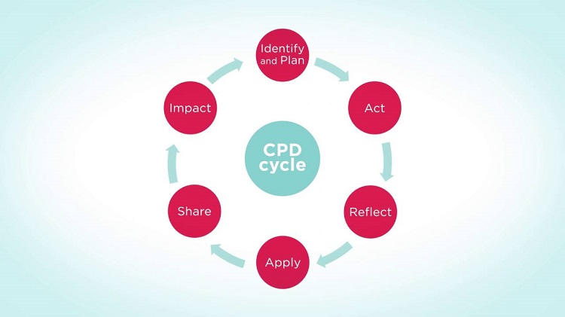
Figure 1

Approaches of CPD are often represented as cycles. Figure 1 shows six stages provided by CIPD (2017); the stages are
- Identify and plan: Identify where you are and plan how to get where you’d like to be.
- Act: Carry out your plan and be open to learning.
- Reflect: Reflection on our behaviour, learning and performance is key to learning. This is done by increasing our understanding of the subject we are studying and better understanding our behaviour, performance, and ability to learn (Waite et al., 2021, p.85). Reflection is an integral part of CPD, and studies have shown that people who reflect on their learning retain more information and are significantly more efficient at applying it to their performance (The Open University, 2024). Gibbs (1998) developed a Reflective Cycle to structure learning from experience—description of the experience, feelings and thoughts, evaluation, analysis, conclusion and action plan. The model offers a framework for examining experiences, and the cyclic nature shows that this can work for repeated experiences. It helps to allow learning from the past and planning for the future.
- Apply: Create opportunities to translate theory into practice.
- Share: Pass on information to other communities to generate greater insight and benefit from the support of your community.
- Impact: Measure the impact your learning has had on your work and community.
People professionals can carry out CPD by undertaking courses, watching webinars, reading articles, and attending conferences. People professionals can sign up for ACAS and CIPD webinars, which will keep them updated with recent legislation and help guide them on subjects such as sexual harassment or employment laws.
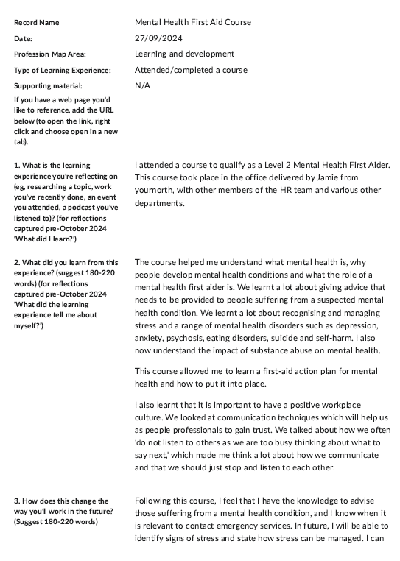

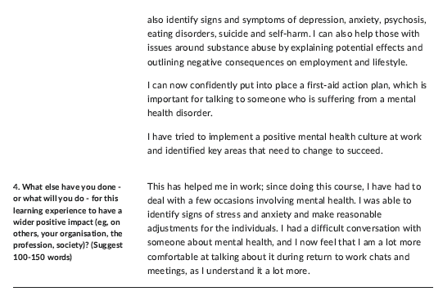

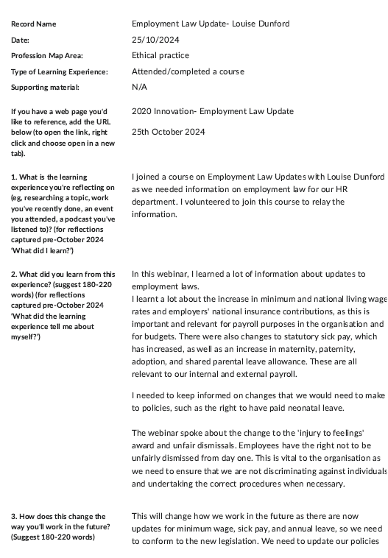

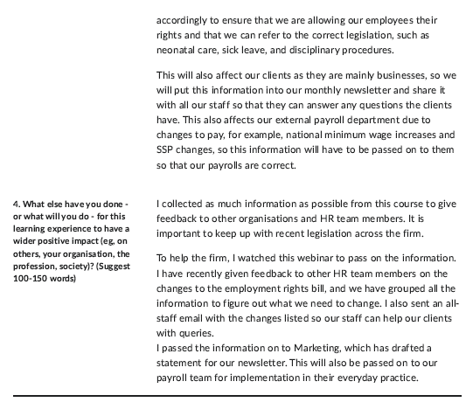
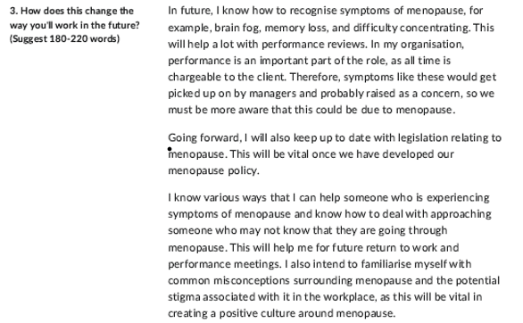
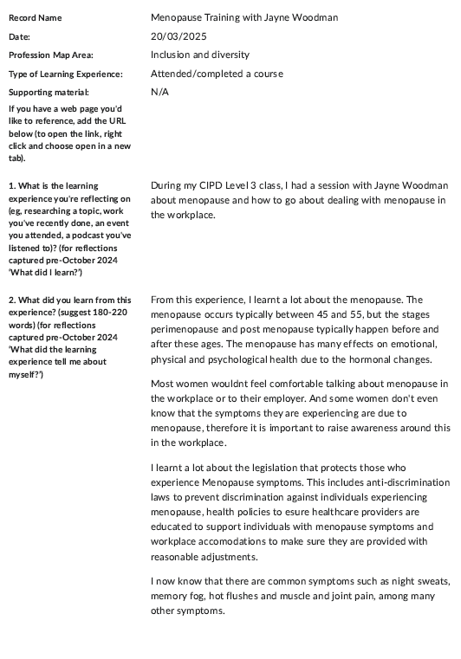

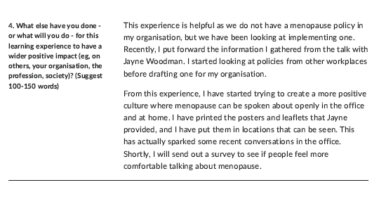

Reference List

Azami, S. (2023) Business Ethics And Its Impact On Employees’ Retention Into An Organisational Environment. Available at: https://ijcrt.org/papers/IJCRT2302140.pdf (Accessed: 2nd April 2025)
Bauer, T., Erdogan, B. (2012) Understanding People at Work: Individual Differences and Perception. An Introduction to Organizational Behavior. Available at: https://2012books.lardbucket.org/books/an-introduction-to-organizational-behavior-v1.1/s01-about-the-authors.html (Accessed: 2nd April 2025)
BBC (2025) External Factors. Available at: https://www.bbc.co.uk/bitesize/guides/zgfrpbk/revision/1 (Accessed: 2nd April 2025)
Bevan Buckland LLP (2025) Our values. Available at: https://bevanbuckland.co.uk/about-us/our-values (Accessed: 21st March 2025)
CIPD (2023) Explore the Profession Map. Available at: https://www.cipd.org/uk/the-people-profession/the-people-profession-map/explore-the-people-profession-map/ (Accessed: 1st April 2025)
CIPD (2023) Valuing People. Available at: https://www.cipd.org/uk/the-people-profession/the-profession-map/explore-the-profession-map/core-behaviours/valuing-people/1 (Accessed: 1st April 2025)
CIPD (2024) Ethical practice and the role of people professionals. Available at: https://www.cipd.org/uk/knowledge/ factsheets/ethics-role-hr-factsheet/ (Accessed: 21st March 2025)
Covey, S. (1989) The 5 Levels of Listening. Available at: https://www.youtube.com/watch?v=wipZ0yY8iN4 (Accessed: 1 April 2025).
Crane, A., & Matten, D. (2016) Business ethics: managing corporate citizenship and sustainability in the age of globalization (Fourth edition.). Oxford University Press.
Dexian (2024) Creating a Values-driven workplace: strategies to align employees and leaders. Available at: https://dexian.com/blog/values-driven-culture/ (Accessed: 21st March 2025)
Duff, S. (2017) Empathy in leadership, Training Journal, pp 9-11
Gibbs G (1998) Learning by doing: A guide to teaching and learning methods. Further Education Unit. Oxford Polytechnic: Oxford
HR and Talent Solutions (2023) The significance of keeping HR policies up to date. Available at: https://www.linkedin.com/pulse/significance-keeping-hr-policies-up-to-date# (Accessed 21st March 2025)
ICPA (2025) Accounting Laws and Regulations. Available at: https://www.icpa.org.uk/news/accounting-laws-and-regulations (Accessed: 1st April 2025)
Indeed Editorial Team (2025) 15 tips for building inclusive teams (plus benefits). Available at: https://uk.indeed.com/career-advice/career-development/inclusive-teams (Accessed: 2nd April 2025)
Lee, E. (2025) Effective Questioning. Available at: https://cpdonline.ao.uk/knowledge-base/business/effective-questioning/ (Accessed:1st April 2025)
Mehrabian, A., & Wiener, M. (1967). Decoding of inconsistent communications. Journal of Personality and Social Psychology, 6(1), 109–114. Available at: https://doi.org/10.1037/h0024532
Njie, L. (2024) What is the function of ACAS. Available at: https://legalvision.co.uk/employment/function-of-acas/ (Accessed 2nd April 2025)
Skills for Health (2025) The importance of Empathy. Available at: https://www.skillsforhealth.org.uk/article/the-importance-of-empathy/ (Accessed: 1st April 2025)
The CPD Accreditation service (1996) What is continuing professional development (CPD)? Available at: https://www.cpduk.co.uk/explained (Accessed: 21st March 2025)
The Open University (2025) Reflective learning. Available at: https://help.open.ac.uk/strategic-study-techniques/reflective-learning (Accessed: 21st March 2025)
Tuckman, B.W., and M.A. Jensen. (1977). Stages of small-group development revisited. Group and Organization Studies 2, no. 4: 419–27.
UK Government (2025) Employment Rights Bill. Available at:https://www.gov.uk/government/publications/employment-rights-bill-factsheets (Accessed: 1st April 2025)
Waite, K. et al. (2021) People practice: a complete guide. London: Kogan Page.

