DS TASK 1

Screenshot/Photo 1
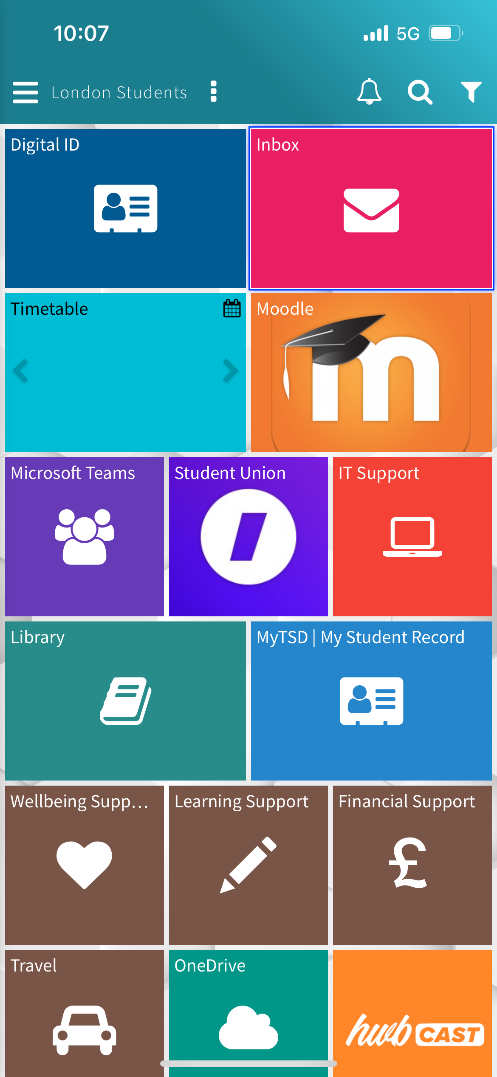
[UWTSD Hwb for Educational Purposes]

Screenshot/Photo 2
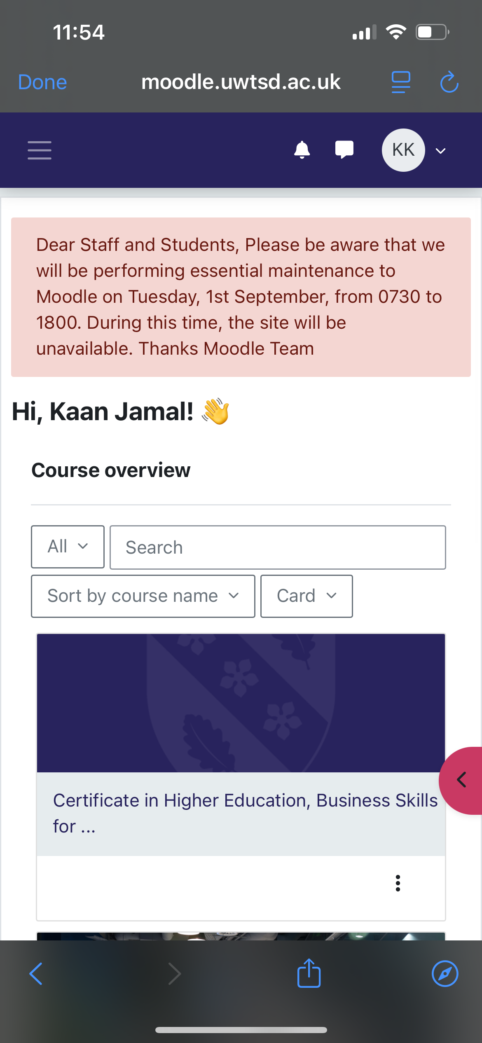
[MOODLE for Educational Purposes]

Screenshot/Photo 3
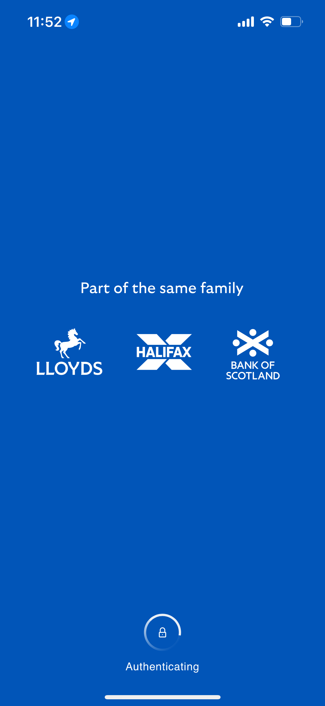
[HALIFAX Banking for Online Banking]

Screenshot/Photo 4
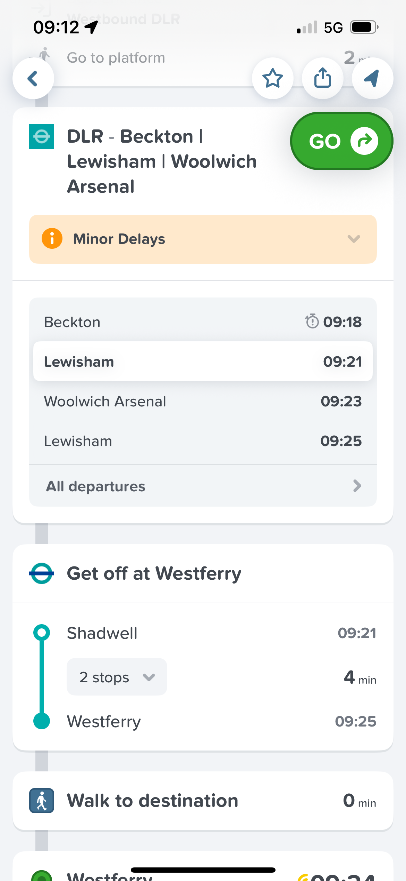
[CITYMAPPER for Navigation]

Screenshot/Photo 5
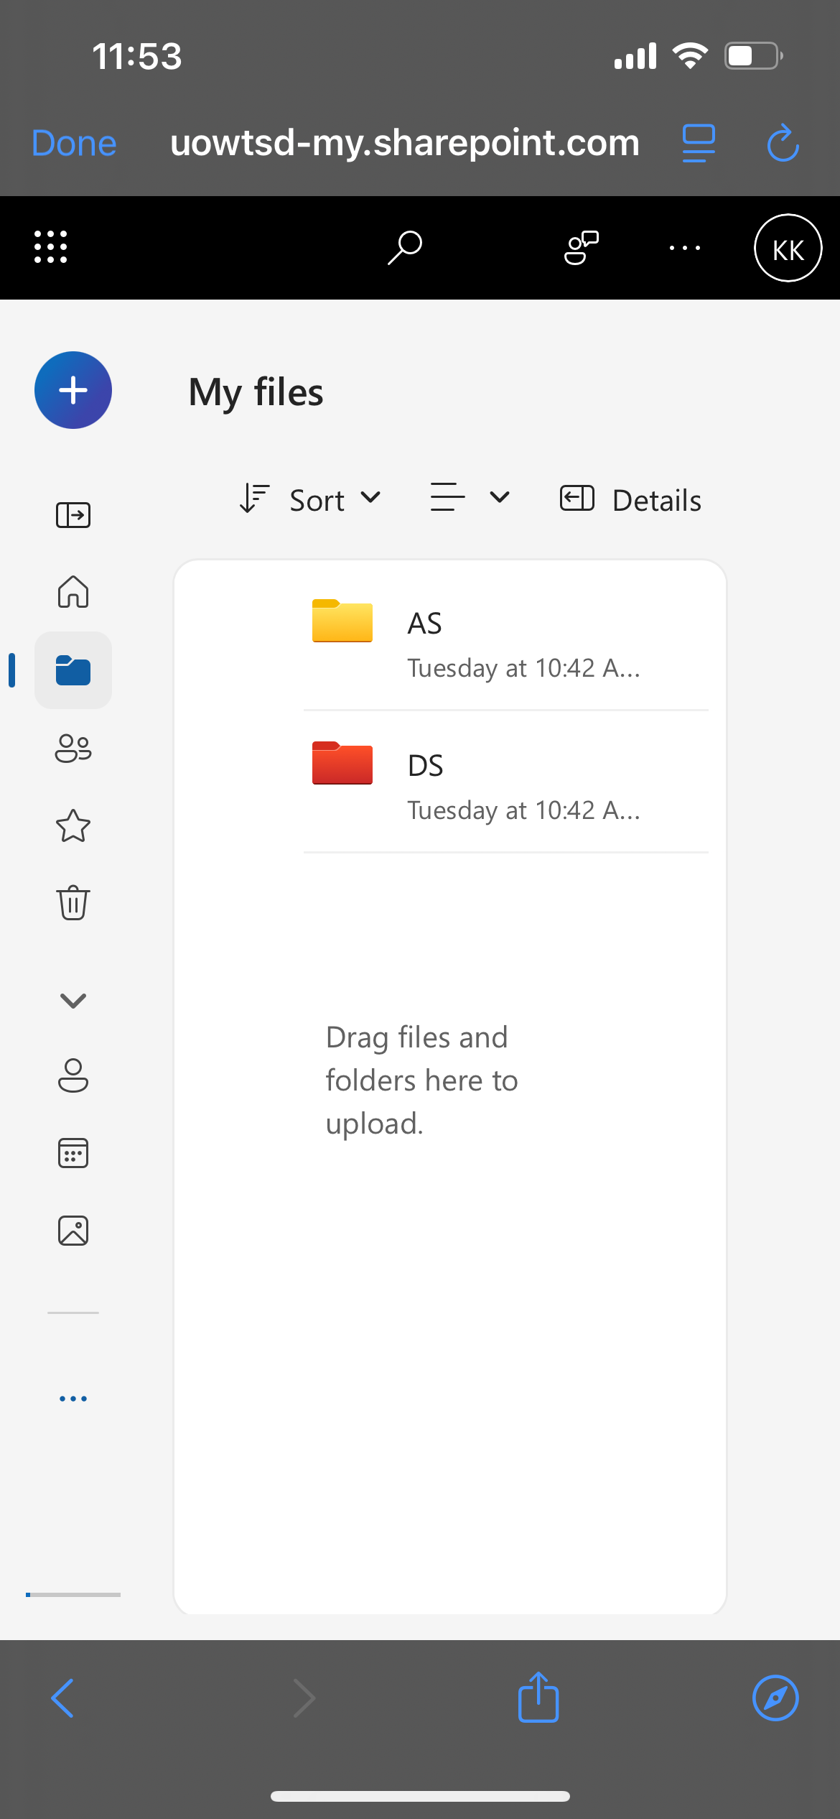
[ONE DRIVE for Educational Purposes]

Screenshot/Photo 6
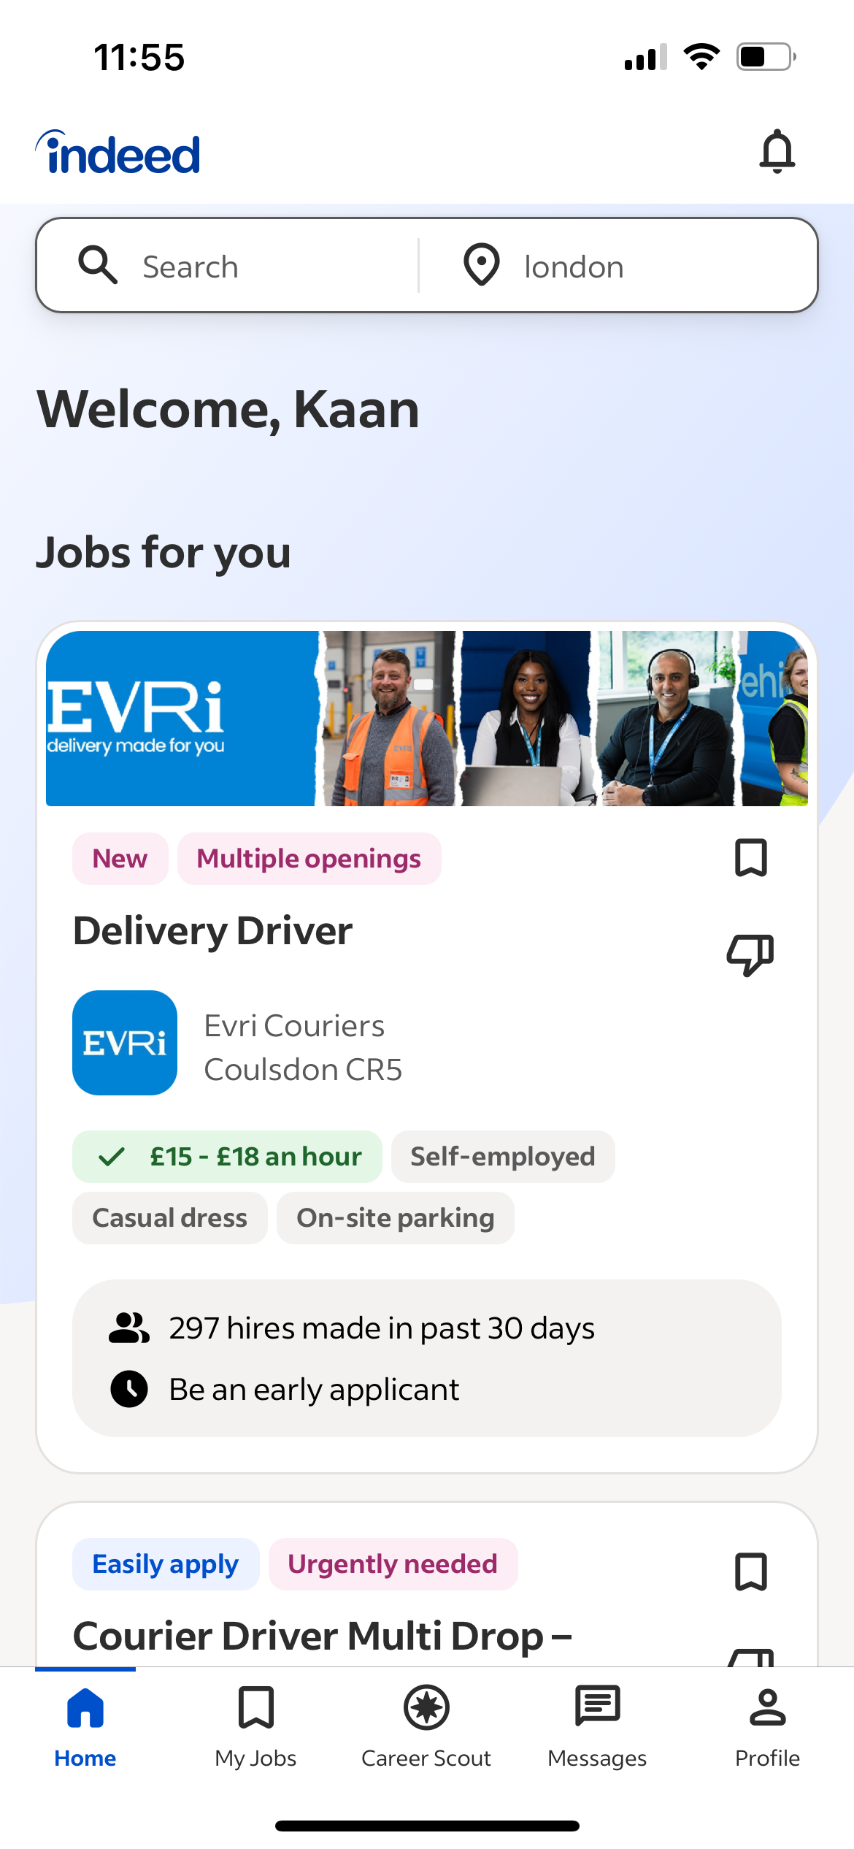
[INDEED for Job Searches & Applications]

My Short Reflection
Digital skills are important for me because digital products and digital methods are now used in most, if not in every aspect of our lives.
I often use these tools:
WhatsApp
Google Maps
Online Banking Apps
UWTSD Hxb
Zoom/Facetime/Discord
TikTok/Instagram/FaceBook/YouTube/SnapChat
And more…
I feel comfortable and confident with most digital platforms and products. I believe I can quickly learn and improve on any digital platform or product I’m completely unfamiliar with.
I hope that with this module I will be able to use my digital skills more professionally and apply them more effectively in my professional life.

