Student: Radu Andreescu 2026729
Lecturer: Dr. Sujeewa Herath
Module: Emergent Leadership Skills in the Workplace (BMSW6101)

Effective Leadership at Workplace
Academical report

Table of Contents
1.1 Introduction 3
2.1 Effective Leadership Skills 3
3.1 Effective leadership styles 6
4.1 Tacking the barriers to leadership in the workplace 8
5.1 Ethical leadership 10
6.1 Conclusion and Recommendations 12
7.1 References 12
8.1 Reflective Essay on Emergent Leadership: 15
8.1.1 Introduction: 15
8.1.2 Leadership Traits: 15
8.1.3 Leadership Styles: 15
8.1.4 Tackling Barriers to Leadership: 16
8.1.5 The Ethical Dimension of Leadership: 16
8.1.6 Emergent Leadership: 16
8.1.7 Significance of Emergent Leadership: 16
8.1.8 Unexplored Aspects: 17
8.1.9 Personal Leadership View & Experience 17
8.1.10 Conclusion: 18
8.1.11 References: 19
9.1 Annex 1 21
10.1 Annex 2 22

Introduction

Leadership is the act of inspiring individuals to perform at their highest level in order to
attain a specific objective. It can be defined as the skill to convince others to willingly adopt new behaviours. Leadership encompasses the tasks of formulating and conveying a future vision, motivating individuals, and ensuring their commitment to the assigned responsibilities (Armstrong, 2016)
Management is the process of achieving goals by acquiring and allocating necessary resources, and ensuring planned activities are executed to reach predetermined objectives according to Armstrong (2016, p.39).
Leaders provide guidance, motivation, and support to individuals or teams. They empower and encourage others to reach their full potential, fostering innovation, and promoting collaboration. Leadership is more about people-oriented skills, such as communication, inspiration, and relationship-building.
While management emphasizes control and maintaining stability, leadership focuses on driving change and navigating uncertainty. Both management and leadership are important in an organization, and effective leaders often possess management skills as well (Rosenbach, 2018)

2.1 Effective Leadership Skills

Prominent qualities identified through various research studies include accomplishment, perseverance, understanding, proactivity, self-assurance, accountability, collaboration, tolerance, influence, sociability, determination, motivation, integrity, confidence, cognitive aptitude, expertise, outgoingness, conscientiousness, and receptiveness. Another studies shows how important for a leader are to mix both skills of logical intelligence and emotional intelligence (Mayer and Caruso, 2002). A sum of six skills was defined as very important by scientist and different research gives as most important different skills. One of them says that the most important ones are commitment, humility, awareness of bias, empathy, cultural intelligence and effective collaboration (Bourke, Titus and Espedido, 2020). What are the most important ones is a matter of who is asking, if is in a leader point of view, or team colleagues or scientist. We will try to focus on those skills in an academical point of view and will have a critical analyse of 6 of them: intelligence, confidence, charisma, determination, sociability and integrity.
Intelligence refers to the capacity to gain and utilize knowledge and skills effectively. It can be enhanced through staying well-informed. This encompasses proficiency in language, perceptual abilities, and logical reasoning It was emphasized in scientific research how those qualities are more and more important for HR departments when recruiting leaders (Drigas and Papoutsi, 2019).
Confidence is the state of being self-assured, harbouring positive feelings about oneself, and refraining from self-doubt. The development of confidence involves acquiring knowledge, seeking guidance from mentors, and engaging in regular practice. How important in different styles of leadership is and how it is useful to build up quality leadership we can read in many scientific published books like Bounazef at all. (2020, pp73-78). This skill is linked to the capacity of creating relationships at workplace. Practice it is a way to build confidence and we have an example of a firefighter’s captain that said if the candidates are fearless, he prefers to do not hire them. They make good dead heroes he said so he is looking for the ones that are afraid of fire and training is starting to teach them to climb a ladder, then a higher one, and higher with a small fire underneath and afterwards increasing the size of ladder and fire. In time confidence is building up making good team leaders aware of dangers for firefighters (Owen, 2020)
Charisma it is an important skill in leadership. It is the charm, the appeal that good leaders have. In the archetypes of leadership four phenotypes of charisma are discussed: heroic, paternalistic, the saviour and the king charisma (Steyrer, 1998) Those skills can improve the leadership quality as it inspires people, it helps people adopt the values of the leader and creates devotion. It is a double-faced skill as it can be negative in the case the leaders are using this devotion to exploit it in their own advantage.
Those are just few examples commonly associated with leadership skills.
Two very well-known theories are primary leadership skills and Katz model of leadership skills.
According to Katz, effective leadership requires a balanced three skill sets as shown in the figure bellow. Leaders need technical skills to understand the operational aspects of their roles, human skills to interact and engage with their team effectively, and conceptual skills to envision the bigger picture and guide the organization towards success (Harrison, Burnard and Paul, 2018).

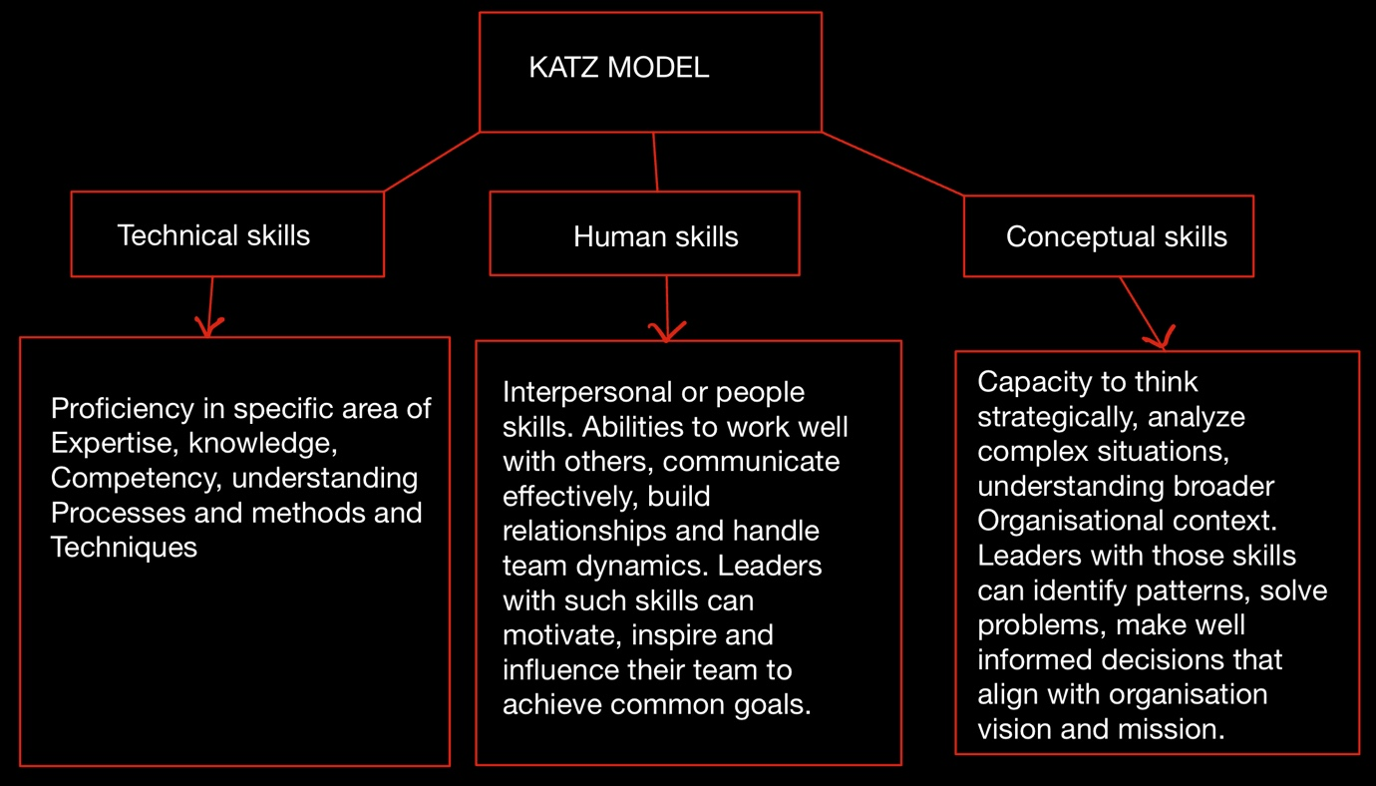

Primary leadership skills, also known as core or essential leadership skills, are the fundamental abilities that effective leaders should possess to succeed in their roles. These skills are essential for leading and influencing others, and they form the foundation for more specialized leadership traits.

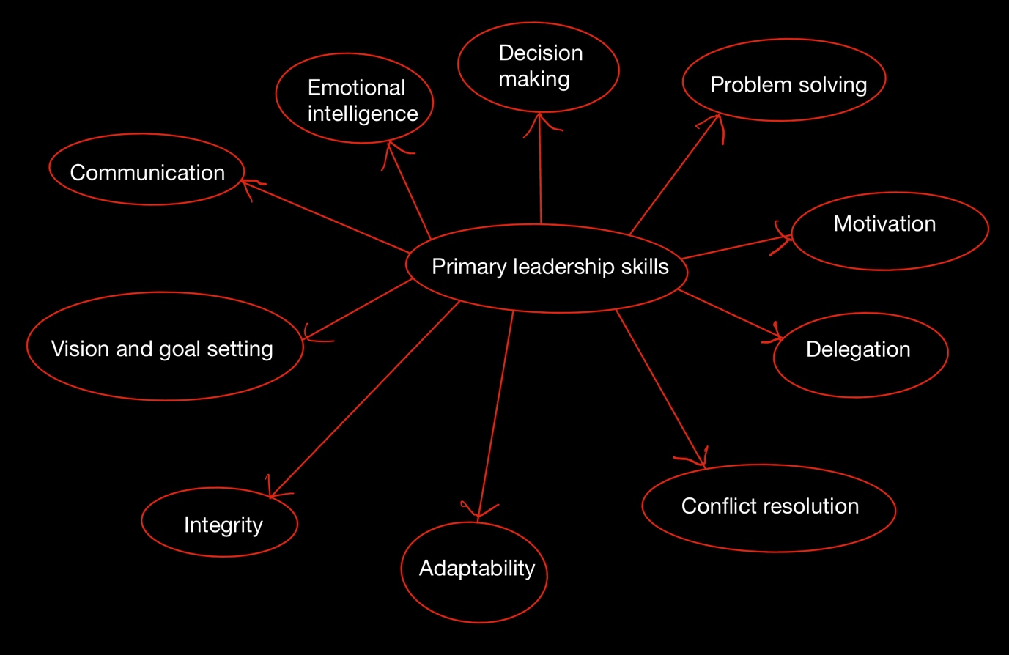

Primary leadership skills are more detailed and narrowed than Katz theory. We can easily group them in Kats classification as follows:
- Technical or administrative skills: managing people, managing resources, technical competence.
- Interpersonal skills: emotional intelligence, interpersonal conflict (conflict resolution), emphatic.
- Conceptual skills: vision, strategic planning, problem solving.

Both the primary leadership skills theory and Katz's theory offer valuable insights into
essential leadership skills. The primary theory focuses on a concise list of interpersonal and cognitive skills applicable to leadership in diverse contexts. In contrast, Katz's theory presents a more structured model that categorizes leadership skills into technical, human, and conceptual domains, with a specific focus on managerial roles. Leaders can benefit from considering elements of both theories to develop a well-rounded skill set that aligns with their roles and organizational contexts.

Effective leadership styles

In leadership theory X and Y, leadership styles are associated with different assumptions about human nature and work attitudes (McGregor, 1960).
In theory X, leaders believe that employees are inherently lazy, dislike work, and need close supervision and control. This belief leads to a task-oriented leadership style, where leaders prioritize setting strict rules and monitoring employee performance. The focus is on maintaining control and ensuring tasks are completed efficiently. However, this approach often leads to reduced employee morale, creativity, and job satisfaction.

On the other hand, theory Y assumes that employees are self-motivated, enjoy their work, and can be trusted to take responsibility and initiative. This perspective encourages a people-oriented leadership style, where leaders focus on building positive relationships, empowering employees, and fostering a supportive work environment. This leadership approach enhances employee engagement, commitment, and creativity.

Now, let's critically analyse autocratic, democratic, and laissez-faire leadership styles:

Autocratic Leadership:
Autocratic leadership is a highly task-oriented style where the leader maintains full control and makes decisions without involving the team. The leader exercises authority and rarely seeks input from subordinates (Jony at al., 2019). This style can be effective in situations where quick decisions are required or in certain crisis scenarios. However, it often leads to low employee morale, reduced job satisfaction, and stifles creativity and innovation. Employees may feel undervalued and disengaged due to the lack of involvement in decision-making processes.
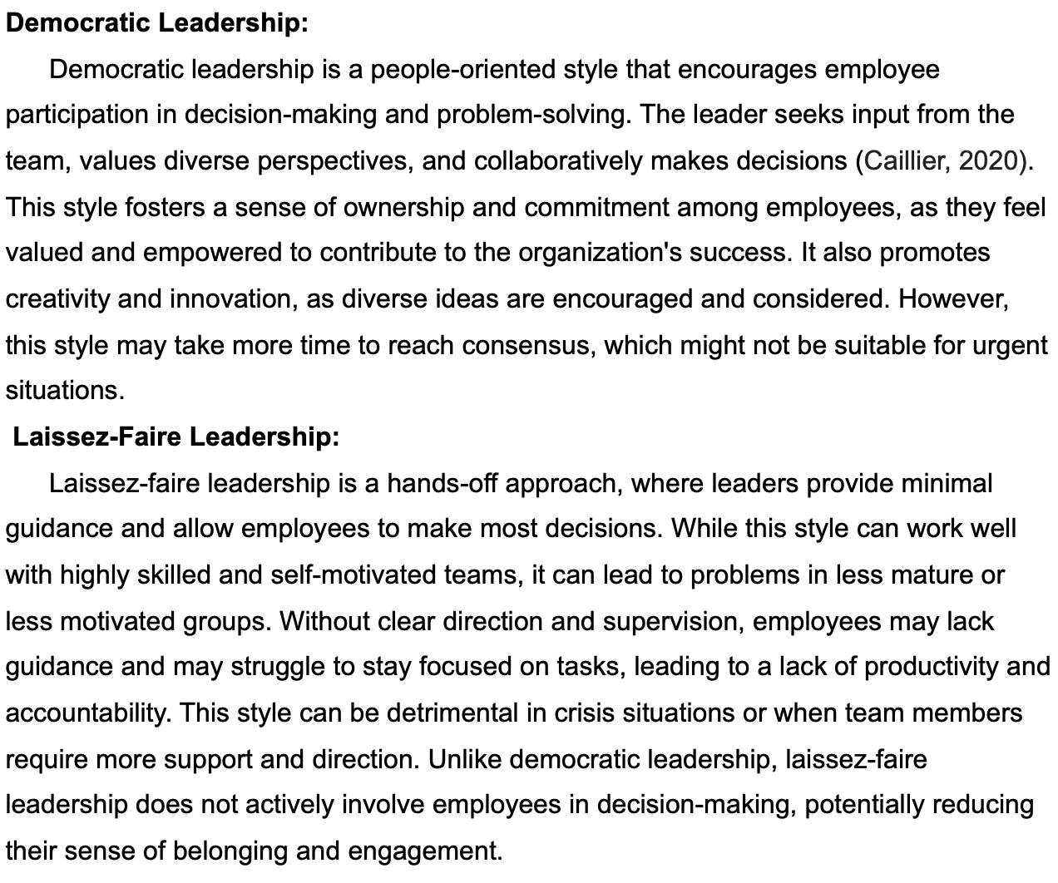

Transactional and Transformational Leadership:

Transactional leadership is primarily focused on the exchange of rewards and punishments for performance. Leaders employing this style set clear expectations, establish goals, and define specific rewards for achieving them. They also identify consequences for failing to meet expectations. Transactional leaders monitor their team members closely and intervene when necessary to correct deviations from set standards. While this style can promote adherence to rules and short-term task completion, it may not foster creativity, intrinsic motivation, or long-term engagement among employees (Afsar at al.,2017).

Transformational leadership, on the other hand, goes beyond simple transactions and seeks to inspire and elevate the collective vision of the team. Transformational leaders exhibit charisma, enthusiasm, and a compelling vision for the future. They inspire and empower their followers to surpass their own self-interests for the greater good of the organization. Transformational leaders encourage innovation and risk-taking, challenging the status quo to promote growth and development. They build strong emotional connections with their team members, fostering trust and loyalty. The focus on personal growth and development in transformational leadership leads to increased job satisfaction and a sense of purpose among employees, which, in turn, can lead to higher levels of commitment and productivity (Ramset at al., 2017).

Leadership styles based on theory X tend to be more task-oriented and controlling, while those aligned with theory Y are people-oriented and empowering. Autocratic leadership can be efficient in certain situations but may hinder employee morale and creativity. Democratic leadership fosters employee engagement and creativity but may take more time to reach decisions. Laissez-faire leadership can work with self-motivated teams, but it can be counterproductive in less mature groups. Transactional leadership focuses on rewards and punishments, while transformational leadership inspires and empowers employees. Successful leaders understand the strengths and limitations of each style and adapt their approach to fit the specific needs and circumstances of their teams and organizations (Nanjundeswaraswamy and Swamy, 2014).

4.1 Tacking the barriers to leadership in the workplace

Embracing Agile Leadership

In today's fast-paced and digitally transforming world, the concept of leadership has evolved significantly. Agile leaders are those who understand the importance of connection - not just with their teams and colleagues but also with customers, stakeholders, and societal trends (Hayward, 2021). They recognize the dynamic nature of the external environment, which presents new opportunities and potential threats that can quickly reshape entire industries. To succeed in this new reality, organizations must break through barriers to leadership and embrace agility as a core value.

One of the critical barriers to effective leadership is the resistance to change and the fear of disruption. Traditional leadership models may struggle to respond promptly to emerging threats and challenges, especially in a rapidly evolving digital landscape. Companies like Millers Oils, British American Tobacco South Asia, Thames Valley Police, Crime Reduction Initiatives, and the Port of Felixstowe have all recognized the need to address these barriers and adopt a more agile approach to leadership (CIPD | Tackling Barriers to Leadership Case Studies | Reports | CIPD, May 2014).

Agile leaders are connected leaders. They communicate effectively with their teams, customers, and stakeholders. They also keep track of societal trends and technological advancements that can impact their business. As seen in the case studies, organizations like Millers Oils and Thames Valley Police focused on developing leadership capabilities at all levels to create a more agile and responsive workforce. This approach allowed employees to take ownership of their roles and make informed decisions, thus fostering a more dynamic and adaptable organizational culture.

The fear of competition and obsolescence can make difficult leadership growth. British American Tobacco South Asia's case study demonstrated the importance of cultural change to remain competitive. By investing in leadership development programs and fostering a culture of continuous improvement, the organization empowered its employees to respond proactively to challenges and customer demands.

Organizational structure and resistance to change are common barriers to leadership. Crime Reduction Initiatives and the Port of Felixstowe both addressed these challenges by restructuring their organizations and empowering front-line supervisors. The new structures enabled managers to focus on leading their teams, while employees took on more ownership of their roles, fostering a sense of accountability and responsiveness to change.

To tackle barriers to leadership effectively, organizations must embrace agility and create an environment that encourages learning and adaptation (Drysdale and Gurr, 2017). Agile leadership is about staying ahead of the curve, embracing uncertainty, and making strategic choices that lead to success. It requires a balance between stable foundations and flexible ways of working, empowering employees at all levels to be proactive and responsive.

The case studies of Millers Oils, British American Tobacco South Asia, Thames Valley Police, Crime Reduction Initiatives, and the Port of Felixstowe illustrate the importance of embracing agile leadership to overcome barriers to success. By fostering a culture of continuous improvement, investing in leadership development, and restructuring to enable effective leadership, these organizations have embraced agility and demonstrated its transformative power. As the business landscape continues to evolve, agile leadership remains relevant and essential for organizations to thrive amidst disruption and uncertainty.

5.1 Ethical leadership

Ethical leadership is a leadership approach that places a strong emphasis on moral principles and values. It is characterized by the leader's commitment to integrity, fairness, and transparency in their decision-making and actions. Ethical leaders not only act as role models for their followers but also strive to create an ethical culture within their organizations. Several factors contribute to ethical leadership, including the character, actions, goals, honesty, power, and values of the leader. Important factor is, the ethical leader increases the satisfaction of the fallowers (Brown and Treviño, 2006).

The character of the leader is at the core of ethical leadership. Ethical leaders possess strong moral values and demonstrate consistency in adhering to these values. They exhibit traits such as trustworthiness, responsibility, fairness, empathy, citizenship, and respect for others. Their personal integrity inspires trust and confidence among their followers, which is vital for ethical leadership.

The actions of the leader are equally important in ethical leadership. Ethical leaders lead by example and demonstrate ethical behavior in all aspects of their professional and personal lives. They do not compromise their principles or engage in unethical practices, even when faced with difficult decisions. Instead, they make choices that align with ethical standards and the best interests of their stakeholders. Their actions show respect, justice and serving others.

The goals of the leader also play a significant role in ethical leadership. Ethical leaders prioritize the welfare of their followers and the broader community over their personal gains. They set goals that are not solely focused on financial success but also take into account the impact of their actions on society, the environment, and the well-being of others.

Honesty is a fundamental characteristic of ethical leadership. Ethical leaders are transparent in their communication and do not engage in deceitful or manipulative tactics to achieve their objectives. They value honesty and foster a culture of open and candid communication within their organizations. Dishonesty ruins the trust.

The power that leaders hold can influence ethical decision-making. Ethical leaders are mindful of their power and use it responsibly. They avoid abusing their authority and instead use it to promote fairness, equality, and justice. They empower their followers and encourage their participation in decision-making processes.

The values of the leader also shape their ethical leadership. Ethical leaders have a strong sense of purpose and deeply held values that guide their actions. They prioritize ethical considerations in their decision-making, ensuring that their choices align with their values and the values of the organization.
-Ethical Values: Principles and beliefs that guide a leader's decision-making and actions, emphasizing integrity, fairness, honesty, and respect for others.

-Modal Values: The most common or prevalent values held by a leader, which may vary based on cultural, societal, or organizational norms.

-End Values: The ultimate goals and outcomes that a leader seeks to achieve, reflecting their long-term vision and purpose for their leadership role. These values drive the leader's actions and decisions.

Ethical leadership is a multifaceted approach that encompasses the character, actions, goals, honesty, power, and values of the leader. Ethical leaders are guided by strong moral principles and prioritize the welfare of their followers and the broader community. They lead by example and demonstrate ethical behavior in all aspects of their lives. Ethical leaders also use their power responsibly, prioritize honesty and transparency, and promote a culture of integrity and ethical decision-making within their organizations. By embodying these factors, ethical leaders inspire trust, loyalty, and commitment among their followers and contribute to the creation of a more just and ethical society (Ahmad at al.,2019).

6.1 Conclusion and Recommendations

Effective leadership is a multifaceted journey that encompasses a diverse range of skills, styles, and values. Leadership skills are not merely confined to traditional attributes like decision-making and communication; they extend to emotional intelligence, adaptability, and the ability to foster innovation. Combining these skills allows leaders to inspire and guide their teams towards success.

Leadership styles vary based on situations and organizational needs. Transformational leaders can cultivate an atmosphere of motivation and growth, while democratic leaders foster collaboration and inclusivity. Understanding the context and adopting the most suitable style can maximize a leader's impact.

However, barriers to leadership can impede progress. From hierarchical structures to lack of empowerment, these obstacles need to be addressed proactively. Embracing agile leadership principles can empower leaders to adapt swiftly to change and create flexible, high-performing teams.

Ethical leadership is the cornerstone of sustainable success. Leaders who uphold ethical values, honesty, and integrity earn trust and respect from their teams and stakeholders. Embodying ethical leadership enhances organizational reputation and ensures that decisions align with long-term goals and societal responsibilities.

In conclusion, successful leadership transcends rigid boundaries and evolves with the times. By honing essential skills, embracing diverse leadership styles, tackling barriers, and embracing ethical principles, leaders can pave the way for thriving organizations and positive impacts on their communities. The journey to exceptional leadership is ongoing, and continuous growth and learning are essential to staying at the forefront of this dynamic and impactful role.

7.1 References

Afsar, B., Badir, Y.F., Saeed, B.B. and Hafeez, S., 2017. Transformational and transactional leadership and employee’s entrepreneurial behavior in knowledge–intensive industries. The International Journal of Human Resource Management, 28(2), pp.307-332.

Ahmad, I., Donia, M.B., Khan, A. and Waris, M., 2019. Do as I say and do as I do? The mediating role of psychological contract fulfillment in the relationship between ethical leadership and employee extra-role performance. Personnel review, 48(1), pp.98-117.

Armstrong, M., 2016. Armstrong's handbook of management and leadership for HR: Developing effective people skills for better leadership and management. Kogan Page Publishers.

Brown, M.E. and Treviño, L.K., 2006. Ethical leadership: A review and future directions. The leadership quarterly, 17(6), pp.595-616.

Bounazef, D., Salaouatchi, H.S., Crutzen, N. and Vancallie, D., 2020. Post-New Public Management: explorer les liens entre la responsabilisation partagée et le leadership transversal. Gestion et management public [Post-New Public Management: Exploring the Links Between Shared Accountability and Cross-Cutting Leadership. management and public administration], 8(1), pp.73-87.

Bourke, J., Titus, A. and Espedido, A., 2020. The key to inclusive leadership. Harvard Business Review, 6.

Caillier, J.G., 2020. Testing the influence of autocratic leadership, democratic leadership, and public service motivation on citizen ratings of an agency head’s performance. Public Performance & Management Review, 43(4), pp.918-941.

CIPD | Tackling Barriers to Leadership Case Studies | Reports | CIPD (no date). Available at: https://www.cipd.org/uk/knowledge/reports/leadership-barriers-report/.

Drigas, A. and Papoutsi, C., 2019. Emotional Intelligence as an Important Asset for HR in Organizations: Leaders and Employees. International Journal of Advanced Corporate Learning, 12(1).

Drysdale, L. and Gurr, D., 2017. Leadership in uncertain times. International Studies in educational administration, 45(2), pp.131-159.

Harrison, C., Burnard, K. and Paul, S., 2018. Entrepreneurial leadership in a developing economy: a skill-based analysis. Journal of Small Business and Enterprise Development, 25(3), pp.521-548.

Hayward, S., 2021. The agile leader: How to create an agile business in the digital age. Kogan Page Publishers.

Jony, M.T.I., Alam, M.J., Amin, M.R. and Jahangir, M., 2019. The impact of autocratic, democratic and laissez-faire leadership styles on the success of the organization: A study on the different popular restaurants of Mymensingh, Bangladesh. Canadian Journal of Business and Information Studies, 1(6), pp.28-38.

MacGregor, D., 1960. The human side of enterprise (Vol. 21, No. 166.1960). McGraw‐Hill: New York.

Mayer, J.D. and Caruso, D., 2002. The effective leader: Understanding and applying emotional intelligence. Ivey business journal, 67(2), pp.1-5.

Nanjundeswaraswamy, T.S. and Swamy, D.R., 2014. Leadership styles. Advances in management, 7(2), p.57.

Owen, J., 2020. The leadership skills handbook: 100 essential skills you need to be a leader. Kogan Page Publishers.

Ramsey, J.R., Rutti, R.M., Lorenz, M.P., Barakat, L.L. and Sant’anna, A.S., 2017. Developing global transformational leaders. Journal of World Business, 52(4), pp.461-473.

Rosenbach, W.E., 2018. Contemporary issues in leadership. Routledge.

Steyrer, J., 1998. Charisma and the archetypes of leadership. Organization Studies, 19(5), pp.807-828.

8.1 Reflective Essay on Emergent Leadership:

8.1.1 Introduction:

Leadership is an ever-evolving concept that continually adapts to the changing landscape of society and organizations. Many businesses fails not because they do something wrong or mediocre but because they do what was right for too long (Doz and Kosonen, 2010). As I reflect on the myriad traits, styles, and values discussed about leadership, I am drawn to the idea of emergent leadership dynamic approach that allows leaders to navigate complex challenges with agility, authenticity, and ethical fortitude. In this reflective essay, I will synthesize the key aspects of leadership traits and styles, exploring the significance of emergent leadership and identifying any crucial aspects not previously mentioned.

8.1.2 Leadership Traits:

Effective leadership goes beyond conventional skills, delving into the realm of emotional intelligence, empathy, and adaptability (Kickul and Neuman, 2000). Reflecting on the traits of successful leaders, I realize that self-awareness plays a pivotal role. Leaders who comprehend their strengths and weaknesses can make informed decisions and empower others to contribute to collective goals. Additionally, resilience and a growth mindset enable leaders to embrace failure as an opportunity for learning and growth (Shelton, Hein and Phipps, 2022).

8.1.3 Leadership Styles:

Leadership styles are diverse and adaptable, catering to different contexts and team dynamics. Democratic leadership encourages collaboration and empowers team members to participate in decision-making (Hilton, Arkorful and Martins, 2021). Meanwhile, transformational leadership fosters inspiration and innovation, motivating individuals to go beyond their own capabilities (Bastari, Eliyana and Wijayanti, 2020). These styles, coupled with situational leadership, allow leaders to tailor their approach according to the needs and challenges at hand.

8.1.4 Tackling Barriers to Leadership:

Tackling barriers to leadership is vital for unlocking a leader's true potential. Hierarchical structures can harden communication and stifle creativity (Attar and Abdul-Kareem, 2020), making agile leadership a key concept to embrace. By promoting an open and inclusive environment, leaders can encourage diverse perspectives and adapt swiftly to emerging challenges. Empowering employees to take ownership of their roles fosters a sense of ownership and accountability, propelling the organization forward (Yin, Wang and Lu, 2019).

8.1.5 The Ethical Dimension of Leadership:

Ethics lie at the heart of exemplary leadership, ensuring decisions align with long-term goals and societal responsibilities. Ethical leaders possess strong character, honesty, and integrity, generating trust and respect among their team members (Saha et al., 2020). Embracing ethical values is not only essential for organizational reputation but also for cultivating a positive impact on communities and the world entirely (Ferrell et al., 2019).

8.1.6 Emergent Leadership:

Emergent leadership emerges as a holistic approach to leadership, amalgamating the discussed traits, styles, and values. It is a dynamic response to the fast-paced and interconnected world we live in (Hanna et al., 2021). Emergent leaders are flexible and responsive, capable of adapting their approach to varying circumstances. They nurture a culture of innovation, promoting continuous learning and embracing change as an opportunity for progress (Gahan et al., 2021).

8.1.7 Significance of Emergent Leadership:

The significance of emergent leadership lies in its potential to navigate complexity, uncertainty, and constant change. As leaders encounter unprecedented challenges, emergent leadership empowers them to make quick, yet thoughtful decisions (Bohl, 2019). It fosters collaboration, inclusivity, and a deep sense of purpose, uniting teams behind shared visions and goals. By embracing emergent leadership, leaders can create adaptive organizations that thrive in the face of disruption.

8.1.8 Unexplored Aspects:

While the previous discussions covered essential aspects of leadership, one aspect not explicitly mentioned is the concept of servant leadership. Servant leaders prioritize the well-being of their team members, aiming to uplift and support them in achieving their goals. This approach promotes empathy, humility, and a commitment to serve others, a quality that can elevate the effectiveness of leadership even further (Keith, 2023).
In the realm of leadership, there are two unexplored aspects that merit further research and attention: cultural differences and the management of leadership change in culturally binding contexts.
Firstly, cultural differences play a pivotal role in leadership dynamics. As organizations become increasingly globalized, leaders must navigate diverse cultural norms, values, and communication styles. Understanding how cultural differences impact leadership effectiveness is essential for building inclusive and harmonious work environments (Crede, Jong and Harms, 2019). Research exploring the influence of cultural backgrounds on leadership decision-making, conflict resolution, and team dynamics can provide valuable insights to create culturally intelligent leaders.
Secondly, managing the change of leadership types in culturally binding positions presents a unique challenge. In some cultures, leadership is closely tied to tradition and societal values, making it difficult for organizations to implement new leadership styles that may be more suited to the demands of the modern world (Khaliq, Usman and Ahmed, 2021). Exploring strategies to facilitate a smooth transition from traditional leadership approaches to more adaptive and agile styles can foster sustainable organizational growth and success.

Addressing these unexplored aspects of leadership research can enrich our understanding of leadership practices in diverse and complex environments. It will equip leaders with the knowledge and skills to navigate cultural nuances and lead with authenticity, fostering an inclusive, dynamic, and resilient leadership culture.

8.1.9 Personal Leadership View & Experience

In my personal leadership style, I prioritize behavior, skill, process, relationship, and traits in that order. I believe that embodying the right behavior is essential for setting a positive example and fostering a conducive work environment. Next, I emphasize skill development, recognizing that a team's collective capabilities are the foundation of success. Efficient processes are crucial to ensure smooth operations and maximize productivity.

Building strong relationships with my team members is a fundamental aspect of my leadership approach. I value open communication, active listening, and empathy, as I understand that supporting their growth and well-being contributes to overall success. My preference for duty ethics and justice ethics equally guides my decision-making, ensuring fairness and moral responsibility in all actions.

My experience in the business environment allowed me to lead in a democratic manner, encouraging collaboration and empowering team members. I respected their expertise and sought to help them upskill and develop professionally, creating a motivated and dedicated workforce.

More recently, I had the opportunity to lead in humanitarian crises and war zones, where authoritarian leadership became necessary to address emergencies and save lives. This context demanded quick decision-making and a focus on skills and knowledge to effectively respond to critical situations.

Currently, as a leader in a project in Africa's Burundi, where malnourished children are involved, I recognize the urgency and the importance of being an authoritative figure to manage emergencies. However, I also remain mindful of the need for skilful execution to ensure the project's success and the well-being of the vulnerable children.

Overall, my leadership style is adaptable, drawing from different approaches depending on the context and requirements. Whether it is in a business setting, a humanitarian crisis, or a project involving vulnerable populations, I prioritize the well-being of my team, the importance of skills, and a sense of duty and justice to achieve positive outcomes.

8.1.10 Conclusion:

Reflecting on the diverse facets of leadership traits, styles, and values, I find emergent leadership to be an integrative approach that harnesses the best of these elements. Effective leaders must be agile, ethical, and adaptable, embracing change as an opportunity for growth. By nurturing emergent leadership, leaders can lead their teams towards a prosperous future, steering organizations through the uncharted waters of tomorrow's challenges. As I continue my own journey in leadership, I am inspired to embody emergent leadership and make a positive impact on both my team and society.

8.1.11 References:

Attar, M. and Abdul-Kareem, A., 2020. The role of agile leadership in organisational agility. In Agile business leadership methods for industry 4.0 (pp. 171-191). Emerald Publishing Limited.

Bastari, A., Eliyana, A. and Wijayanti, T., 2020. Effects of transformational leadership styles on job performance with job motivation as mediation: A study in a state-owned enterprise. Management Science Letters, 10(12), pp.2883-2888.

Bohl, K.W., 2019. Leadership as phenomenon: Reassessing the philosophical ground of leadership studies. Philosophy of Management, 18(3), pp.273-292.

Crede, M., Jong, J. and Harms, P., 2019. The generalizability of transformational leadership across cultures: A meta-analysis. Journal of Managerial Psychology, 34(3), pp.139-155.

Doz, Y.L. and Kosonen, M., 2010. Embedding strategic agility: A leadership agenda for accelerating business model renewal. Long range planning, 43(2-3), pp.370-382.

Ferrell, O.C., Harrison, D.E., Ferrell, L. and Hair, J.F., 2019. Business ethics, corporate social responsibility, and brand attitudes: An exploratory study. Journal of Business Research, 95, pp.491-501.

Gahan, P., Theilacker, M., Adamovic, M., Choi, D., Harley, B., Healy, J. and Olsen, J.E., 2021. Between fit and flexibility? The benefits of high‐performance work practices and leadership capability for innovation outcomes. Human Resource Management Journal, 31(2), pp.414-437.

Hanna, A.A., Smith, T.A., Kirkman, B.L. and Griffin, R.W., 2021. The emergence of emergent leadership: A comprehensive framework and directions for future research. Journal of Management, 47(1), pp.76-104.

Hilton, S.K., Arkorful, H. and Martins, A., 2021. Democratic leadership and organizational performance: the moderating effect of contingent reward. Management Research Review, 44(7), pp.1042-1058.

Khaliq, M., Usman, A. and Ahmed, A., 2021. Effect of leadership style on working culture and employees motivation. The Journal of Educational Paradigms, 3(1), pp.166-170.

Keith, K., 2023. The case for servant leadership. Terrace Press.

Kickul, J. and Neuman, G., 2000. Emergent leadership behaviours: The function of personality and cognitive ability in determining teamwork performance and KSAs. Journal of Business and Psychology, 15, pp.27-51.

Saha, R., Shashi, Cerchione, R., Singh, R. and Dahiya, R., 2020. Effect of ethical leadership and corporate social responsibility on firm performance: A systematic review. Corporate Social Responsibility and Environmental Management, 27(2), pp.409-429.

Shelton, C.D., Hein, S.D. and Phipps, K.A., 2022. Positive and proactive leadership: disentangling the relationships between stress, resilience, leadership style and leader satisfaction/well-being. International Journal of Organizational Analysis, 30(2), pp.408-429.

Yin, Y., Wang, Y. and Lu, Y., 2019. Antecedents and outcomes of employee empowerment practices: A theoretical extension with empirical evidence. Human Resource Management Journal, 29(4), pp.564-584.

9.1 Annex 1
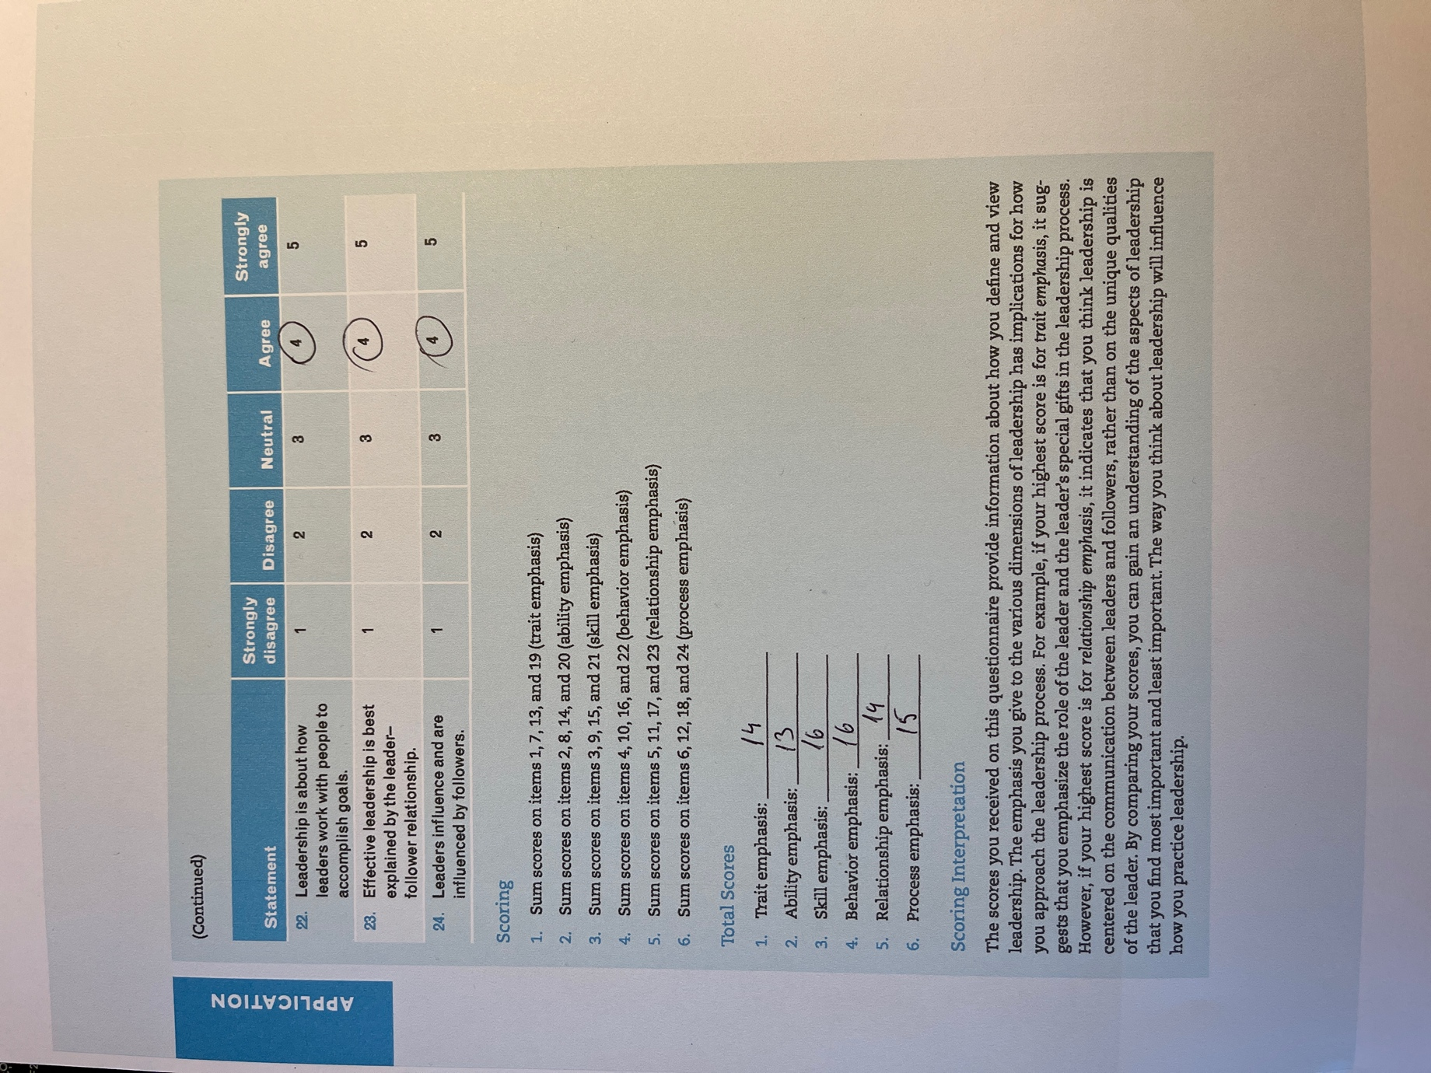

10.1 Annex 2



