
BSc Health and Social Care

STUDENT NAME: Mabel Tiwaah Ankomah

STUDENT NUMBER: 1905514

MODULE TITLE: Community Care and Development

MODULE CODE: BMHP6022

ASSIGNMENT TITLE: Assessment Component 2 Written Assignment (Report)

MODULE LECTURER: Chizoba Esio-Bassey

Table of Contents

- Introduction
2 The Croydon borough profile
3 Challenges or social issues in Croydon
3.1 The two initiatives of solving the challenges
3.2 Methods of communication
4. The UK Policies and
4.1theories impacting the initiatives
5.Recommendations
6.Conclusion
7.Reference list

1.Introduction
The main purpose of this academic report is to examine community development strategies. This will also identify a community and provide its features and demographics. For this report, Croydon will be chosen as the focus community. The report will also look at two different development initiatives in the chosen community and investigate the ways this information was shared. This academic report will end with a conclusion and suggestions for how to make things better. A community is a group of people with different traits who have social ties, share ideas, and work together in real life or online (MacQueen et al,2001).
Community development is a process in which individuals collaborate to address issues that are important to them (SCDC, 2022).
  - Croydon Borough Profile
Croydon is the southernmost borough of London, England. Croydon is located on the southern outskirts of the city in the historic county of Surrey. Croydon was founded in 1965 and, formerly a modest market town, grew into one of the most populated boroughs on the outskirts of London (Greater London Authority, 2022). In 1965, the previous county borough of Croydon was merged with the neighbouring districts of Coulsdon and Purley to form the modern borough. It includes parts of Upper Norwood, Norbury, South Norwood, Thornton Heath, Benham Manor, West Thornton, Selhurst, Woodside, Broad Green, Addiscombe, Ashburton, and Waddon. The socially and culturally diverse population the borough presents has seen a huge increase in the past decade. In fact, according to a 2022 report by the Office for National Statistics (ONS), Croydon is the most populous of the London boroughs, with around 390,800 inhabitants (ONS, 2022). A quarter of this number (25%) consists of individuals under the age of 19 years old. About one in seven (13.6%) inhabitants is at least 65 years old. The borough's population rose from 330,587 in the 2001 census to 363,378 in the 2011 census. By 2050, Croydon's population is projected to reach slightly more than half a million people, up from an estimated 390,800 people in 2021 (Croydon Observatory, 2022).
Croydon’s population has an increase of 7.5% between 2011 and 2021, which is above the average population growth of 6.6% across all boroughs within the UK for the same period (ONS, 2022). According to 2011-2020 Croydon births and deaths, babies born averaged 5,600 a year from 2010 to 2020. The same period averaged 2,500 deaths. Deaths increased by 21% owing to COVID-19, but births decreased slightly. Most of the residents declared themselves to be Christians during the 2011 census (Croydon Observatory, 2022). In terms of immigration, in 2020, 22,865 migrants entered Croydon but 24,314 left to live elsewhere in the UK. Croydon's migrant inflows outnumbered its outflows. The ONS predicted that 34.6% of Croydon's population will be foreign-born in 2020, which is less than the 35.9% who were born outside of the UK in 2019 (Croydon Observatory, 2022). Croydon has challenges with inequality and poverty, including health, education, and housing, among many others. The Council is taking steps to deal with these differences and make sure that everyone in the borough can benefit (Croydon Observatory, 2022).
Figure 1: Age and gender profile in Croydon (Croydon Observatory, 2022).
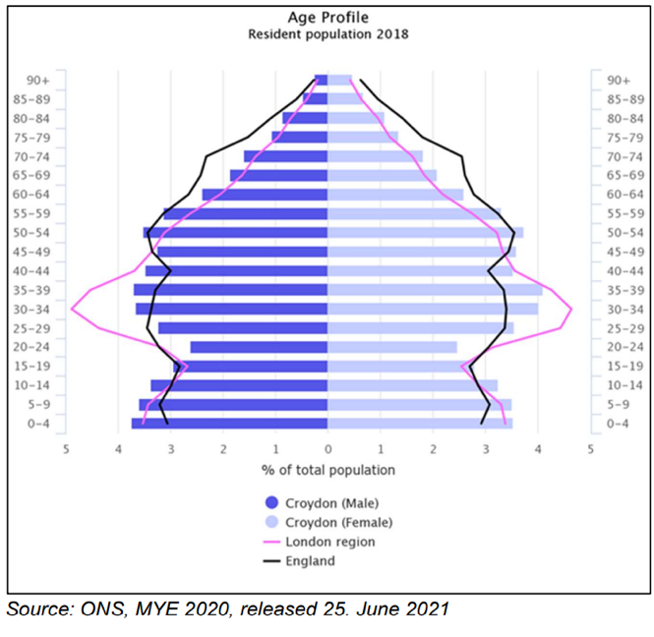
As shown in figure 1, in the 0-19 age group, the proportion of men is greater than that of females. However, there is no difference in the proportions of males and females in the 20-39 and 40-64 age groups. 13.9 percent of Croydon's population is comprised of people aged 65 and over. This proportion is 12.2% lower in London than it is in England at 19.6%. Croydon has the fourth highest number of young people in London, which means that the borough needs different kinds of services for young people (Croydon Observatory, 2022).
Croydon has a greater percentage of residents from BAME populations than the national average. In 2011, the younger age group population in Croydon was more diverse. Consequently, the proportion of Asian and black Croydon inhabitants has increased since the 2011 Census. By 2021, the white population percentage is projected to fall by about 10% in London. 50.7 percent of Croydon's population of all ages is BAME. This will be 55.6 percent by 2025 (Public Health Croydon, 2022). Figure 2 displays the most recent demographic forecasts. Consequently, the proportion of Asian and black Croydon inhabitants has increased since the 2011 Census. By 2021, the white population share is projected to fall by about 10% (Croydon Observatory, 2021).
Figure 2:
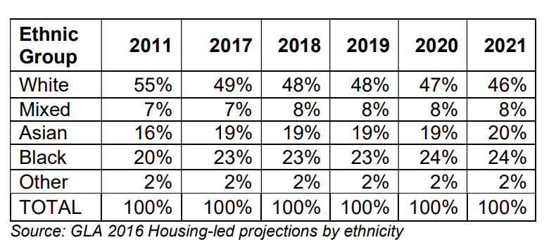
(Croydon Observatory,2021).
3 Challenges in Croydon
3.1 Homelessness According to the 2018 Homelessness Review Strategy, homeless families in Croydon consisted of single parents with dependent children. In Croydon, social housing was only granted to those with the greatest housing need. Moreover, half (52%) of Croydon's homeless population is aged between 25 and 44, according to the most recent yearly statistics for 2020/21. For quite some time, the number of homeless households in Croydon has been over 2,000. Croydon's black population continues to have a disproportionately high rate of homelessness relative to other areas (Croydon Observatory, 2020).
3.2 Climate Emergency Crisis: The Croydon Council declared a climate emergency in July 2019. The Croydon Climate Crisis Commission was established to direct the response to the climate disaster. In June 2021, they put out a report with ideas that will help the borough become carbon neutral by 2030 (Croydon gov.uk, 2021).
3.3. Obesity Health Crisis: According to the 2015 public health report by Croydon's director of public health, the prevalence of obesity doubles between four and five years of age and between ten and eleven years of age. The situation is complicated by the fact that half of parents are unaware that their children are overweight or obese, and that 97% of overweight or obese children have overweight parents (insidecroydon, 2015).
3.4 Knife’s crime: Croydon has the greatest population under the age of 18 of any London boroughs, with around 94,000 people. 49% of knife crimes in London are committed by teens or younger, so supporting them is crucial (Croydon.gov.uk, 2019).
4.The initiatives
For this report, two initiatives that have tackled two of the challenges in Croydon borough, namely 1. Carbon Action Plan 2. Homelessness will be examined as follows:
4.1 Croydon Climate Change Mitigation Action Plan
The first initiative by the Croydon Borough examined in this report is the Croydon climate change mitigation action plan, set out in 2005. NASA (2019) defines carbon mitigation as "reducing and stabilising the concentrations of heat-trapping greenhouse gases in the atmosphere." The borough of Croydon has set a long-term goal of a 34% decrease in CO2 emissions by 2025. It establishes the short-and long-term goals for Croydon and the strategic framework through which the Environment and Climate Change Partnership (ECCP) will undertake work to minimise climate change risks across all sectors in the borough (Croydon Council, 2022d). The ECCP aims to reduce CO2 by 34% by 2025. This helps the London mayor achieve his goal of cutting CO2 by 60% by 2025 and 80% nationally by 2050. This is a continuous process, and the actions outlined in this plan will allow more refined and action-specific objectives to be established in the future for certain sectors, such as transport and the business sector. Where applicable, national contributions to local CO2 reduction have been equated to compute the needed local contribution for regional objectives (Strategic Partnership Croydon, 2010). In addition to meeting this objective, the climate change mitigation action plan aims to provide extra advantages for Croydon residents, such as encouraging individuals to make sustainable forms of transport, including cycling, walking, and public transport as part of their everyday routines. By making this as a daily practice, individuals may avoid polluting the atmosphere (Strategic Partnership Croydon,2010). This strategy is on-going and is impacting the Croydon community. However, a lot needs to be done.
In July of 2019, Croydon Council declared a climate change emergency. The Citizens' Assembly on Climate Change was established to examine how the community might minimise carbon emissions (The Campaign Company, 2020). This is an indication that the climate change mitigation strategy still needs more strategic and comprehensive measures that aim to educate the public and raise awareness about the benefits of reducing CO2 emissions.
4.1.2. Methods of Communication
The Council developed a communication plan to inform the public of the initiative's progress. The channels listed below may all be utilised to target audiences. By utilising local media, London-based and national print and television media, existing newsletters, advertising and poster campaigns, direct email, events, websites, social media, and other peer-to-peer marketing tools (The Campaign Company, 2020).
4.1.3 INITIATIVES' THEORIES
Social Learning Theory by Albert Bandura: In this context, social learning theory may be used to teach individuals positive behaviours. This theory may be used to educate residents on how positive character traits can be utilised to promote desirable behaviour and promote social change (Cherry, 2021). For example, the inhabitants of Croydon were advised to walk or use bikes instead of driving to reduce gas emissions (Croydon.gov.uk, 2022b).
4.1.4 policies
Human Rights Law 1998 :The Human Rights Act 1998, article two, declares that everyone has the right to life. A polluted environment can have an adverse effect on food, air, and water, which are the basic needs for life. All humans must be treated the same; to live safely and freely and to be protected by their government. So many of our human rights, like the right to live, be healthy, and have food, can be damaged by neglecting carbon emissions directives (Greenpeace International, 2018).
4.2 HOMELESSNESS
The second initiative to tackle one of the challenges of Croydon is homelessness. Croydon Borough Council has secured funding from the government to help stop people becoming homeless and reduce rough sleeping in the borough (Hay-Justice, 2021). In each year of the Ministry of Housing, Communities, and Local Government's (MHCLG) Rough Sleeper Initiative, which was launched in 2018, funding is provided to councils avoiding homelessness through immediate and personalised relocate assistance, especially for people at risk. The council's exceptional rough sleeping team collaborates with local organisations and charity to offer a variety of programmes to help homeless individuals leave the streets permanently. The government granted £316 million Homelessness Prevention Grant funding that would prevent homelessness for tens of thousands of individuals through the councils were to utilise the funds to assist individuals in finding a new home, gaining access to assistance for unexpected evictions, and securing temporary housing where necessary. There are an extra £5.8 million in the funding to help people who are homeless because of domestic violence (GOV.UK, 2021c). Croydon Council, on their part, have collaborated with Crisis to advance a shared strategy to abolish homelessness by 2029. Croydon Council accepts referrals to provide shelter to the homeless, The Severe Weather Emergency Protocol (SWEP) seeks to safeguard and care for vulnerable individuals during severe weather (Croydon Council, 2022). After obtaining government grants for the rough sleeping project, Croydon Council has been able to house the homeless and minimise rough sleeping (Moreira Da Costa, 2021). Despite numerous assistances from the government, and charitable organizations, homelessness in Croydon remains high.
4.2.2 Methods of Communication
The Croydon Council has provided a communication channel to provide support when needed. There are helplines that assist people who need emergency bed and breakfast or hostel accommodation with information and guidance. In addition to websites and brochures for general information (Croydon Council, 2022b),
4.2.3 The UK's policies
In England, the legislation on homelessness has been updated. The Homelessness Reduction Act of 2017 says that all homeless people, whether they are single or have children, will be able to get help from their local council (Crisis UK, 2022).
The Equality Act 2010 expects everyone to be treated the same irrespective of their background (Equality and Human Rights Commission, 2018). Croydon has a higher record of ethnic diversity. In making decisions about homelessness, the public sector has a duty under section 149 of the Equality Act 2010 to consider a person's protected characteristics, which include age, disability, gender reassignment, pregnancy and maternity, race, religion or belief, sex, and sexual orientation. It can be a breach if thorough checks are ignored, and one mistakenly considers someone pretending as a homeless person (SHELTER, 2021).
4.2.4 THEORIES
The Theory of Maslow's Hierarchy of Needs: Maslow's hierarchy of needs theory of motivation suggests that five different types of human needs influence a person's behaviour (Cherry, 2022). According to Abraham Maslow, self-actualization is an innate human urge. However, to reach this final objective, several more basic needs must be accomplished. These include the desires for food, security, affection, and self-respect. After these basic needs are met, homeless people deserve to be loved, have fun, and make progress in every stage of their lives.

5.Recommendations
Although incentives, motivation, and education help people to change their behaviour and participate in community projects, sanctions from the authorities can contribute to the achievement of the objectives of the Climate Change Mitigation Action Plan.
Providing accommodation is not the only solution to homelessness, rather dealing with the root causes such as unemployment, abuse, and health conditions, may permanently solve the issue of homelessness.
6 Conclusion
Croydon is the borough of London, England, that is the farthest south. Croydon was started in the year 1965. Croydon has the fourth most young people of any place in London. BAME people make up 50.7% of Croydon's population, and by 2025, this number will rise to 55.6%. The borough has set a long-term goal of a 34% decrease in CO2 emissions by 2025.
The plan to stop climate change still needs more strategic and all-encompassing steps. The government has allocated £316 million in funding to help stop people from becoming homeless. The Council are also working with Crisis and other charity organisations to advance a shared strategy to abolish homelessness by 2029.

7.References

Cherry, K. (2021) How Social Learning Theory Works [Online]. Available at https://www.verywellmind.com/social-learning-theory-2795074 (Accessed 16 August 2022).
Cherry, K. (2022) The Five Levels of Maslow’s Hierarchy of Needs [Online]. Available at https://www.verywellmind.com/what-is-maslows-hierarchy-of-needs-4136760 (Accessed 19 August 2022).
Crisis UK (2022) Homelessness Legislation | Crisis UK [Online]. Available at https://www.crisis.org.uk/ending-homelessness/law-and-rights/homelessness-legislation/?gclid=CjwKCAjw6fyXBhBgEiwAhhiZskGO2ccU60hV9rASmiRWCHkMiDb2W2F5Pp9TUH4aAog9DfhljTEWKhoCyNQQAvD_BwE (Accessed 20 August 2022).
Croydon Council (2020) Agenda Item - Homelessness Strategy [Online]. Available at https://democracy.croydon.gov.uk/mgAi.aspx?ID=7129 (Accessed 20 August 2022).
Croydon Council (2022a) Homelessness - Public Body Referral | Croydon Council [Online]. Available at https://www.croydon.gov.uk/housing/housing-support/homelessness/homelessness-public-body-referral (Accessed 20 August 2022).
Croydon Council (2022b) Emergency Accommodation Advice Pack | Croydon Council [Online]. Available at https://www.croydon.gov.uk/housing/housing-support/homelessness/emergency-accommodation-advice-pack (Accessed 20 August 2022).
Croydon Council (2022c) Homelessness | Croydon Council [Online]. Available at https://www.croydon.gov.uk/housing/housing-support/homelessness (Accessed 20 August 2022).
Croydon Council (2022d) Energy and CO2 Reduction | Croydon Council [Online]. Available at https://www.croydon.gov.uk/planning-and-regeneration/planning-policy/planning-evidence-and-information/local-plan-evidence-topic/energy-and-co2-reduction#:~:text=Climate%20change%20mitigation%20and%20action (Accessed 18 August 2022).
Croydon.gov.uk (2018) PLAN FOR CROYDON OUR 2 0 1 8 -2 0 2 2, [Online]. Available at https://www.croydon.gov.uk/sites/default/files/articles/downloads/Corporate%20Plan%202018-22.pdf (Accessed 20 August 2022).
Croydon gov.uk (2022) Sustainability in Croydon | Croydon Council [Online]. Available at https://www.croydon.gov.uk/environment/sustainable-development/sustainability-croydon#:~:text=Climate%20crisis%20response (Accessed 15 August 2022).
Croydon.gov.uk (2022a) The Delivering for Croydon Programme | Croydon Council. Available at https://www.croydon.gov.uk/planning-and-regeneration/regeneration/regeneration-projects-croydon/delivering-croydon-overview#:~:text=Already%20London (Accessed 13 August 2022).
Croydon Observatory (2020) Croydon Observatory – Population [Online]. Available at https://www.croydonobservatory.org/population/#/view-report/63aeddf1d7fc44b8b4dffcd868e84eac/___iaFirstFeature/G3 (Accessed 12 August 2022).
Croydon Observatory (2022) Croydon Borough Profile, [Online]. Available at https://www.croydonobservatory.org/wp-content/uploads/2022/07/BOROUGH-PROFILE_Jun2022.pdf (Accessed 11 August 2022).
Croydon Observatory (2020) BOROUGH PROFILE, [Online]. Available at https://www.croydonobservatory.org/wp-content/uploads/2021/01/BOROUGH-PROFILE_DEC2020.pdf (Accessed 14 August 2022).
Croydon observatory (2021) CROYDON BOROUGH PROFILE, [Online]. Available at https://www.croydonobservatory.org/wp-content/uploads/2021/09/BOROUGH-PROFILE_JUN2021-LBCR0008802.pdf (Accessed 16 August 2022).
Equality and Human Rights Commission (2018) The Human Rights Act | Equality and Human Rights Commission [Online]. Available at https://www.equalityhumanrights.com/en/human-rights/human-rights-act (Accessed 15 August 2022).
GOV.UK (2021a) £316 Million Government Funding Boost to Tackle Homelessness [Online]. Available at https://www.gov.uk/government/news/316-million-government-funding-boost-to-tackle-homelessness (Accessed 20 August 2022).
Greater London Authority (2022) Croydon [Online]. Available at https://www.london.gov.uk/in-my-area/croydon (Accessed 23 April 2022).
Greenpeace International (2018) Greenpeace International [Online]. Available at https://www.greenpeace.org/international/story/19885/what-does-climate-change-have-to-do-with-human-rights/ (Accessed 16 August 2022).
Hay-Justice, P. (2021) Funding Boost for Croydon’s Rough Sleeping Prevention Work [Online]. Available at https://news.croydon.gov.uk/funding-boost-for-croydons-rough-sleeping-prevention-work/ (Accessed 20 August 2022).
insidecroydon (2015) Croydon’s Children among the Most Obese in Country [Online]. Available at https://insidecroydon.com/2015/12/21/croydons-children-among-the-most-obese-in-country/ (Accessed 18 August 2022).
MacQueen, K. M., McLellan, E., Metzger, D. S., Kegeles, S., Strauss, R. P., Scotti, R., Blanchard, L. and Trotter, R. T. (2001) ‘What is community? An evidence-based definition for participatory public health’, American journal of public health, © American Journal of Public Health 2001, vol. 91, no. 12, pp. 1929–38 [Online]. DOI: 10.2105/ajph.91.12.1929.
Moreira Da Costa, M. (2021) How Croydon Is Tackling Rough Sleeping – Eastlondonlines [Online]. Available at https://www.eastlondonlines.co.uk/2021/05/how-croydon-is-tackling-rough-sleeping/ (Accessed 15 August 2022).
NASA (2019) Global Climate Change Adaptation and Mitigation [Online]. Available at https://climate.nasa.gov/solutions/adaptation-mitigation/ (Accessed 20 August 2022).
Office for National Statistics (2022) How the Population Changed in Croydon, Census 2021 - ONS [Online]. Available at https://www.ons.gov.uk/visualisations/censuspopulationchange/E09000008/ (Accessed 13 August 2022).
Public Health Croydon (2022) w e r e c r o y d o n, [Online]. Available at https://democracy.croydon.gov.uk/documents/s1572/Annual%20Report%20of%20the%20Director%20of%20Public%20Health%202017%20-%20draft.pdf.
Scottish Community Development Centre (2022) What Is Community development? [Online]. Available at https://www.scdc.org.uk/who/what-is-community-development#:~:text=Community%20development%20is%20a%20process (Accessed 31 July 2022).
SHELTER (2021) Shelter Legal England - Local Authority Inquiries into Intentional Homelessness [Online]. Available at https://england.shelter.org.uk/professional_resources/legal/homelessness_applications/intentional_homelessness/local_authority_inquiries_into_intentional_homelessness#:~:text=The%20public%20sector%20equality%20duty (Accessed 20 August 2022).
Strategic Partnership Croydon (2010) Croydon Climate Change Mitigation Action Plan Croydon Environment and Climate Change Partnership Contents, [Online]. Available at https://www.croydon.gov.uk/sites/default/files/2022-01/climate-change-mitigation-action-plans.pdf (Accessed 22 July 2022).
The Campaign Company (2020) A Report of the Work of the Croydon Citizens’ Assembly on Climate Change [Online]. Available at https://democracy.croydon.gov.uk/mgConvert2PDF.aspx?ID=22183 (Accessed 20 August 2022).

