Data Handling & Business Intelligence

Assessment 1
Individual Written Report

Module code: LCBB5000
Student Name: Marina Cretu
Student ID: 2122650

Introduction
Modern businesses are already unthinkable without tools to support managerial decision-making, and here we are talking about business intelligence. BI-system (Business Intelligence) is a set of tools and technologies that includes dashboards, graphs, tables, and reports, all necessary for collecting, analyzing, visualizing, and processing business data, needed to combine information from several channels in a single analysis. Business Intelligence systems are used for deeper analysis and effective management decisions such as accounting for expenses, determining revenue, and profit, to analyze applications and product traffic. The main tasks of BI are, collecting, structuring, and storing relevant data in a single database, and analyzing large amounts of data from the same or multiple sources to generate reports and make business decisions. Search for risk areas and identify new business opportunities, improving data quality by eliminating duplication, inconsistencies, and errors. The operation of the BI system is based on a simple mechanism of combining information sources. All data enters a large storage space for further processing and reporting on various indicators. Different services serve as such sources:
- Cloud systems Microsoft Azure, Google BigQuery;
- XML, PDF, and Excel file systems;
- Relational systems MySQL, Oracle, SQL Server.
BI systems are used both in ​ the commercial sector, as well as in the public sector. A company should use a BI system in the following cases:
- Integrating information from multiple sources
- Increasing the number of users of information for analytical purposes
- Ensuring prompt access to corporate data
- Ease of introducing new products
- Updating the IT environment of the company
- Difficulty keeping track of work in certain areas
- Rapid growth and development of the company

The most important 5 Business Intelligence Trends in the field of sales
To choose the software for the rapid implementation of a BI system, it is necessary to know not only the largest providers of BI tools, such as Qlik, Microsoft, Sisense, Tableau, Zoomdata, and Information Builders but also some essential factors such as:
- Advanced Analytics
- Advanced Data Management
- Processing of texts in natural languages
- Self-service
- Mobile BI

As an example, we will take Boots UK Limited, a British health and beauty retail company with a chain of pharmacies that also operates internationally.



The company was founded in 1849 and currently owns around 3,063 stores in six countries. Currently, throughout the UK, the company owns 2,200 stores and around 56,000 employees, providing a wide range of products and services, such as:
Prescription drugs
Medicines of first necessity (without a medical prescription)
Health and beauty products
Food and drink
Opticians
Hearing care
We will analyze the company through the lens of these factors, how they are used, what their function is, and how effective their application is in a business.

Advanced Analytics
Advanced analytics is a combination of technologies used to prepare data, generate insights and interpret them. In other words, it empowers people to explore and analyze data in analytics and BI platforms. For example, Boots management can track on the dashboard the summary statistics of the subsidiaries: the number of requests, the time required to process requests, and the number of contracts concluded. The data visualization allows them to visually compare the numbers and see the problems. For example, in one of the branches, the processing of requests takes longer because there are more the same number of employees than in other branches.

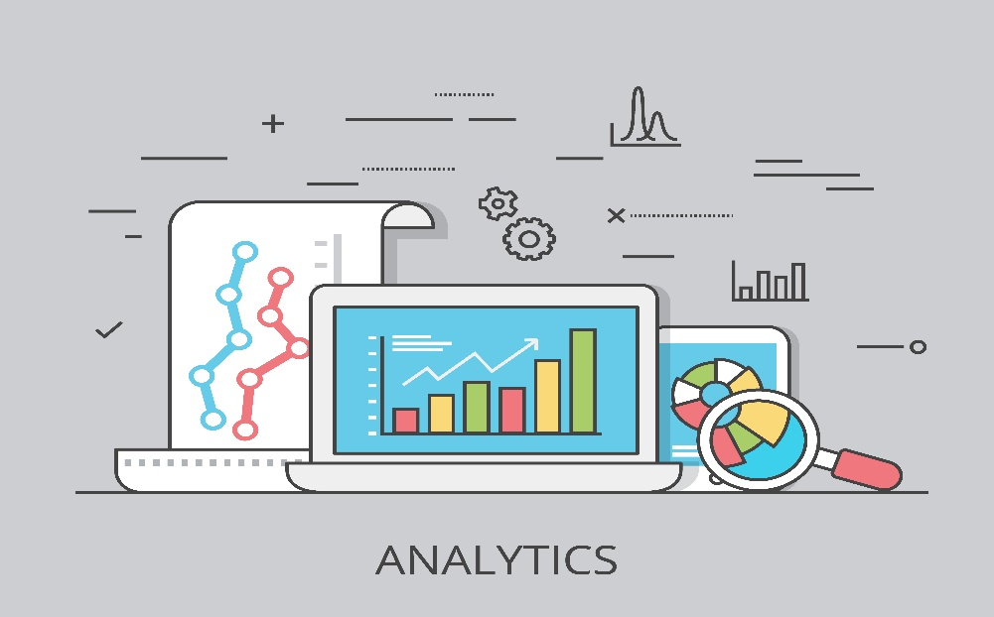
Source: freepik.com

Advanced-Data Management
Master data management is the main corporate information (about customers, products, services, technologies, materials, etc.), regulatory reference information (INS), which is of strategic importance for making prompt and effective management decisions. Namely, this function helps the company, in this case, Boots, to collect and accumulate up-to-date data that establish the key parameters of the work. Cleaning the basic data management system of unnecessary and outdated information. Comparing the basic data received by the system with the existing requirements. Timely distribution and information of employees on basic data.

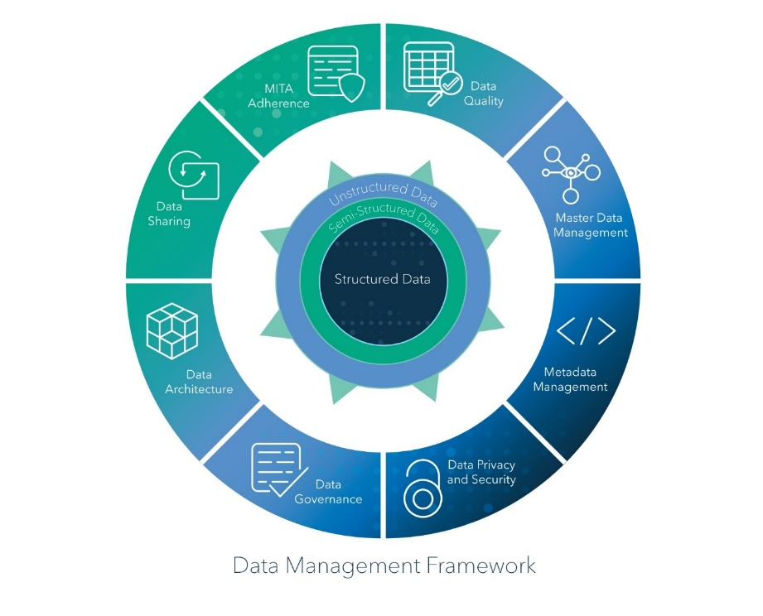

Processing of texts in natural languages
Natural language processing (NLP) is a set of techniques that help a computer system understand human speech. Using this trend, Boots management can obtain solutions to various tasks, such as search, division into categories of reviews, and comments about products or services. Algorithms for classifying incoming calls by content. Automation of interaction with customers.

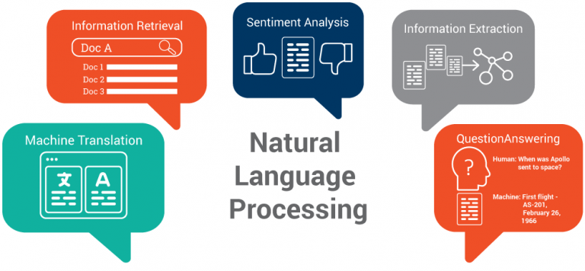
Source: Top 5 Semantic Technology Trends to Look for in 2017

Self-service
Focused on the comfort and independent work of the end user. A dashboard can have a single table with multiple filters. An employee can set the parameters and upload the data needed for the job without the involvement of an analyst. For example, for a report, an accountant of the company Boots needs data on payments to outsourced employees for the last two years, or you need to calculate the company's income for the year. This tool greatly facilitates the physical work of an accountant in the given case.

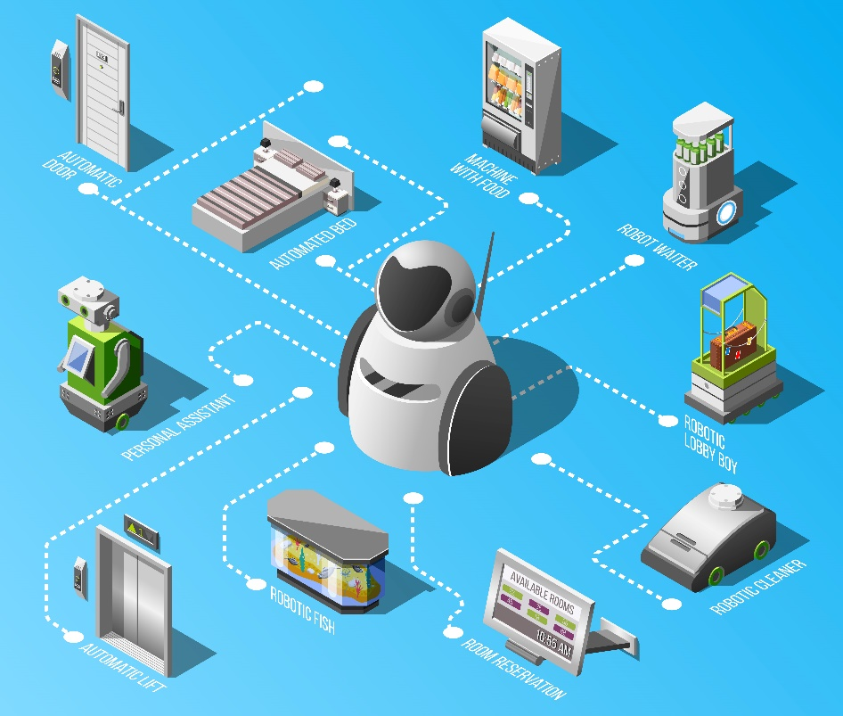
Source: freepik.com

Mobile BI
Any business needs to have access to information anywhere. If you have a simple mobile version of the system, you can very quickly make reports and share them with other users. It can provide business intelligence and data analysis services to mobile/portable devices and/or remote users. MBI enables users with computing disabilities to use and receive the same or similar features, capabilities, and processes found in a desktop-based business intelligence software solution.

Conclusion
In conclusion, the above trends only include purely technological trends, but there are equally important ones related, in particular, to digital ethics and data literacy. All these business intelligence tools offer deep feature sets for enterprises, having a set of benefits, such as the exclusion of the human factor from routine tasks, the optimization of the company's usual expenses, the management of sales efficiency - expenses, profit, traffic of financial resources, ease of use by staff, low costs for integration and subsequent service. To keep up with ever-changing marketing trends, decision-makers need to gain insight into big data.

References
Eckerson, W.W. (2011) Performance dashboards measuring, monitoring, and managing your business. 2nd ed. Hoboken, N.J: Wiley.
Marr, B. (2015) Big data : using SMART big data, analytics and metrics to make better decisions and improve performance. Chichester: John Wiley & Sons.
Howson, C. (2008) Successful business intelligence : secrets to making BI a killer app. New York, NY. ; McGraw-Hill.
https://www.boots-uk.com/about-boots-uk/company-information/boots-media-group
Hammergren, T. and Simon, A. (2009) Data warehousing for dummies. 2nd ed. Hoboken, N.J: Wiley Pub.
Larson, D. and Chang, V. (2016) ‘A review and future direction of agile, business intelligence, analytics and data science’, International journal of information management, 36(5), pp. 700–710. Available at: https://doi.org/10.1016/j.ijinfomgt.2016.04.013

