Hybrid Working

and

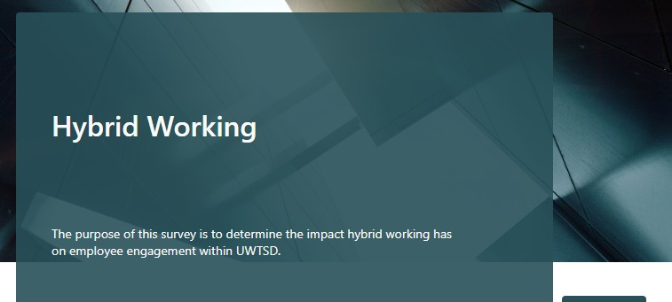

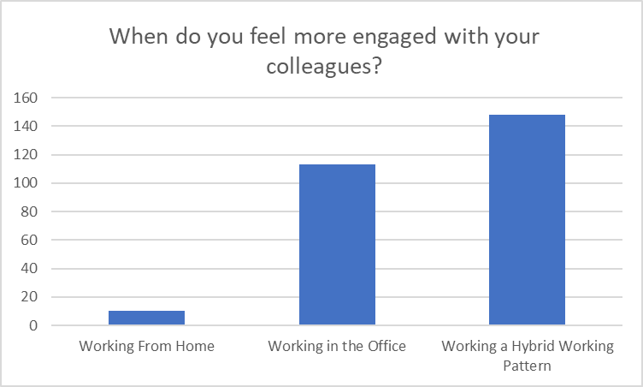
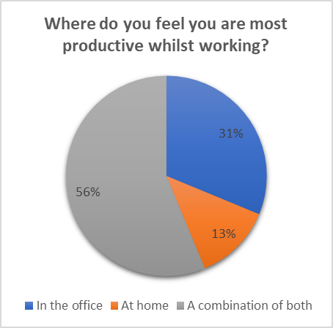
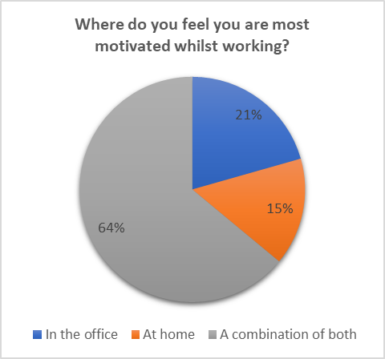


Employee Engagement

1 2
What does the literature say about
hybrid working?

INTRODUCTION LITERATURE REVIEW

In June 2022, CIPD reported that more than 75% of organisations, including UWTSD, had adopted a hybrid working model.

During the Vice Chancellor’s briefings in September 2022, it was proposed that staff would be returning to the office full-time. The pandemic caused employee expectations to shift and therefore primary and secondary research suggest moving to the office full time may raise concerns among members of staff.

In order to determine if this decision is wise, the report analyses the impact of hybrid working on employee engagement.

3

METHODOLOGY
Interviews were firstly considered as a research method due to their ability
to provide an in-depth analysis of an individual’s response (McGrath, Palmgren and Liljedahl, 2019). However, interviews are mostly targeted to gain an understanding of an individual’s personal opinion rather than determine a consensus of a larger sample group (Schultze & Avital, 2011).

It was decided that distributing surveys to 600 administrative staff members was most appropriate as it enabled the ability to reach a larger population. In order to ensure the data collected was valid, the sample chosen represented a clearly refined and defined population (Wu, Zhao & Fils-Aime, 2022).
Research surrounding hybrid working primarily focuses on the increase in productivity and motivation among staff (Vyas, 2022)

Studies refer to improvements in work-life balance and its ability to create a greater integration between work and family life (Sullivan & Lewis, 2001).

More recent studies challenge earlier research and have identified that hybrid working does not affect everyone in the same way and that some benefit from it but it can hinder others (Nimrod, 2022).

Factors such as access to resources and the assurance of trust between a line manager and their member of staff all impact the effectiveness of this mode of working.

4

FINDINGS
The findings from the primary research suggested that UWTSD should
not offer full-time remote working as 3.6% reported they were the least engaged with their colleagues when working from home. The majority of the respondents felt they were more engaged with colleagues when working a hybrid pattern, indicating that employees are engaged at different times.

Microsoft Forms was used to formulate, distribute and analyse the data and enabled the survey to be presented in a professional and clear format.

See for yourself!

5

CONCLUSION
Primary and secondary research show that there are both benefits and
limitations to offering a hybrid working pattern and the general consensus is that it benefits staff in different ways.

A future direction for the research could be to examine the effects of hybrid working on employee wellbeing.

Please refer to the supplementary notes (report format) and presentation which contains recommendations for UWTSD along with an implementation plan.

Figure 1 – Graph demonstrating when UWTSD administrative staff feel more engaged with their colleagues.

The findings reveal that employees feel most productive and motivated when working a hybrid model which highlights that UWTSD are most likely to reach their strategic goals when allowing staff to work with more flexibility.

Figure 2 & 3 – Pie charts demonstrating when UWTSD administrative staff feel most productive and motivated

The results revealed that UWTSD staff work differently under different circumstances. Therefore, staff have the ability to choose when to work in the office or at home, which provides benefits to the employees including work-life balance and the ability to switch off at the end of the working day. It is also clear that UWTSD staff feel trusted by their line managers when working from home which research has shown is a large contributor to the effectiveness of hybrid working.

CIPD (2022) Three-quarters of employers now offer hybrid working bus employers are split whether it will last. Available at: www.cipd.org/uk/about/press-releases/270622-cipd-hybrid-working-splits- employers/#:~:text=New%20data%20from%20the%20CIPD,pre%2Dpandemic%20ways%20of%20working. (Accessed: 12 September 2023)
McGrath, C., Palmgren, P.J. and Liljedahl, M. (2019) ‘Twelve tips for conducting qualitative research interviews’, Medical teacher, 41(9), pp.1002-1006. Available at: doi.org/10.1080/0142159X.2018.1497149 (Accessed: 3 August 2023)
Nimrod, G. (2022) ‘Technostress in a hostile world: older internet users before and during the Covid-19 pandemic’, Aging and Mental Health, 26(3), pp. 526–533. Available at: doi: 10.1080/13607863.2020.1861213 (Accessed: 1 August 2023) Schultze, U., & Avital, M. (2011) ‘Designing interviews to generate rich data for information systems research’ Information and Organization, 21(1), pp. 1–16. Available at: doi:10.1016/ j.infoandorg.2010.11.001 (Accessed: 3 August 2023) Sullivan, C. and Lewis, S. (2001) ‘Home-based Telework, Gender, and the Synchronization of Work and Family: Perspectives of Teleworkers and their Co-residents’, Gender, work, and organization, 8(2), pp. 123–145. Available at: doi.org/10.1111/1468-0432.00125 (Accessed: 10 July 2023)
Vyas, L.. (2022) ‘”New normal” at work in a post-COVID world: work–life balance and labor markets’, Policy and Society, 41(1), pp.155-167. Available at: doi.org/10.1093/polsoc/puab011(Accessed 6 August 2023)
I would like to express my gratitude to the University of Wales Trinity Saint David for permitting me to undertake this research, to the staff at UWTSD who completed the survey and finally to my supervisor, Natasha Davies for your support throughout the whole process.

Wu, M.J., Zhao, K. and Fils-Aime, F. (2022) ‘Response rates of online surveys in published research: A meta-analysis’, Computers in Human Behavior Reports, 7, p.100206. Available at: doi.org/10.1016/j.chbr.2022.100206 (Accessed: 10 August 2023) 613 WORDS

